**ALL INDIA INSTITUTE OF SPEECH AND HEARING, MYSURU-6**

**अखिल भारतीय वाक श्रवण संस्थान, मैसूर-६**

**DEPARTMENT OF SPECIAL EDUCATION**

**विशेषशिक्षाविभाग**

**MONTHLY REPORT – June 2018**

1. **ACADEMIC ACTIVITIES**
2. **Orientation Programs (For outsiders):**The following orientation programswere conducted to orient about the activities of the departmentand also to provide the knowledge about the educational facilities and welfare measures for children with special needs. : NIL

**Dr.Pushpavathi M, HOD – Special Education**

**Faculty report**

|  |  |  |  |  |  |  |
| --- | --- | --- | --- | --- | --- | --- |
| **Name of the Faculty** | | **Dr.Alok Kumar** | **Dr. G. Malar** | **Dr.Prithi**  **Venkatesh** | **Dr. P. Vijetha** | **Ms.LakshmiPrabha J.K** |
| **Clinics** | | | | | |  |
| **No. of cases evaluated at SEA-U** | | 26 | * Screening: 44 clients in 44 sessions * Assessment: 9 clients in 43 sessions | She is on Maternity leave | 15 | * Screening: 6 clients in 6 sessions |
| **No. of cases supervised individually** | | 02 | * 28 children in 6 groups |  | 23 |  |
| **No. of groups supervised** | | NIL | * 8 – Aambal I, Chambarthi I, Kanikonna, Pineapple, Yellow II, Drakshi, Papaya & Sevanthi I |  | Nil |  |
| **No. of meeting with parents** | | NIL | * C/d not be conducted as final list was yet to be ready |  | Nil |  |
| **Educational Guidance** | | 02 | * 18 clients * 18 sessions |  | 3 (6 sessions) |  |
| **Academics** | | | | | | |
| **Classes taken** | | | | | |  |
| **B.Ed.**  **Spl.Edn.(HI)** | **Theory** | 2 hours | * 5 (including 1 extra) |  | 3 classes |  |
| **Practical** | 10 hours | * 15 hours (regular postings – 5½ & vacation postings 9) |  | 20 hours  (Micro teaching and CSS observation postings of B.Ed. trainees) | 7 hours ( Micro Teaching Skill Practice ) |
| **Any others** |  |  |  |  | Was a member for admission and counselling to PGDFSS &T and B.Ed Spl.Edn. (HI) |  |
| **Any other** | | | | | |  |
| **Meeting held** | | PPEP Guideline purpose |  |  | * On 25th June 2018, submitted two project proposals for seeking ARF funds. |  |
| **Meeting attended** | | Attended to orientation program 2 days “Educating the Educator”, AIISH, Mysuru, 10th – 11th May 2018 | * 3 Meetings with the Director regarding B.Ed.Spl.Ed. (HI) programme * 3 Meetings with HOD regarding B.Ed.Spl.Ed. (HI) programme & other departmental affairs   Interactive meeting b/w LD Clinic, DCS & Unit for Services of School-aged Children, Department of Special Education |  | * On 5th June 2018, from 3 to 4pm orientated LD clinic staff about school aged services being offered at the department. | * 2 meetings with HOD regarding “U-SAFE” project ( Feel my Home) and UGC inspection Feedback” * 2 meetings with HOD and Staff members regarding Plan of Action for strengthening the Research & projects in the department and promotion of DECSE, B.Ed.Spl.Ed and M.Ed.Spl.Ed programs |
| **Brouchre** | |  |  |  |  |  |
| **Serve as Resource person** | | Resource Person for One day State Seminar on “Early Identification and Intervention of Children with Hearing Impairment “at Raipur on 22nd June 2018 | Completed pending session of inter-departmental orientation about Department of Special Education on 07.06.2018 to staff of DMD and L&IC |  |  |  |
| **Roles & Responsibilities** | | | | | |  |
| **Co-ordination** | | Parent Infant Program Unit  Preschool Parent Enrichment Program Unit | * CBCS Coordinator for I& II B.Ed.Spl.Ed. (HI) * Compilation of M.S.Ed. Student Dissertation-based Articles 2014-15 * Intra-Department * SEA-U * Research & Database Unit |  | 1. **Services for School age children**  * Lesson plans and children availing services have been checked. * Follow up with LD clinic for protocol development has been made.  1. **Preschool services**  * Coordinated and completed the admission work of Preschool with different teams as per the schedule for the academic year 2018-19.  1. **Others**  * Coordinated for wall mounted cabinets in Preschool classrooms and handed over the keys to the teachers. * Installation of interactive boards and demo of the same for the teachers in preschool classrooms was completed. * On 21.06.2018, coordinated with the team teachers for **International Yoga Day celebrations at AIISH and SGS Ashram, Mysore.** * On 12th June 2018, submitted my details for revised recruitment rules format.   Purchase indents (I quarter) converted to Local purchase indents and submitted to the HOD along with concerned teachers. |  |
| **Member secretary** | | Pre School | * Services for School-Aged Children (in Department of Special Education) |  | NIL |  |
| **Member in** | | Special education assessment Unit and Assistan warden | * TCPD * LD Clinic (in DCS) * Product Development Cell * Preschool Supervision * Allied member of ISHA * Life member of NCED |  | SEA-U |  |
| **Mentor** | | M.Sc 2year Audiology | * Mentor for I & II B.Ed.Spl.Ed. (HI) |  |  |  |
| **AV preparation** | |  |  |  |  | * One PPT on Plan of Action for strengthening the Research & projects in the department and promotion of DECSE, B.Ed.Spl.Ed and M.Ed.Spl.Ed programs |

1. Clinical /Educational Observation Postings of Students from other Institutes:NIL

Following are the details of students posted for observation/ practice teaching

|  |  |  |  |  |
| --- | --- | --- | --- | --- |
| **Sl.No.** | **Name of the Institute** | **Programme/Course** | **Number of Students** | **Dates** |

1. Seminars/Conferences/**Workshops**/Training Programs:NIL
2. Staff Enrichment / **In-house training Programmes***(For own staff members)* : NIL

|  |  |  |  |  |  |
| --- | --- | --- | --- | --- | --- |
| **Theme/Topic** | **Resource Person** | **Coordinator** | **Objectives** | **Targeted Audience** | **Date** |

1. **Guest Lectures :**
2. Additional Academic Services rendered by the Faculty and Staff
3. **Invited Talks: 01**

|  |  |  |  |  |
| --- | --- | --- | --- | --- |
| **Staff** | **Topic** | **Date** | **Programme** | **Institution** |
| Dr Alok kumar Upadhyay | Tips for how to teach children with Hearing Impairment | 22.06.2018 | State Seminar on early Identification and Intervention of CWHI | State Child welfare Council,Raipur,Chattisgarh |

1. **Curriculum Development:**

**Dr. Palnaty Vijetha**

On 28th June 2018, Reviewed and submitted the syllabus and structure of one year certification program in the area of teacher training from SMIORE (*Sandur Manganese and Iron Ore Limited*) Academy of Teachers Training, Sandur, Bellary, North Karnataka.

1. Development of Material to Support Learning : NIL
2. Service in Academic Bodies of other Organizations
3. Participation in Committees/Taskforce and Panels setup by other organizations/agencies:

|  |  |  |  |  |  |  |
| --- | --- | --- | --- | --- | --- | --- |
| **Sl No** | **Name of the staff** | **Name of Organization/Agency** | **Participation in Committees/**  **Taskforce** | **Programme** | **Name of Institute Visited** | **Date of Visit** |
| 1- | Dr Alok Kumar upadhyay | Ram Krishna Mission vivekanand University,Coimbatore | Board of studies of Special Education | B.Ed-M.Ed Special edn. integrate programme | Faculty of special Education | 02/06/2018 |

1. **Any Others (Please Specify)**

|  |  |
| --- | --- |
| Name of the faculty/ staff | Ms Meera Ravishankar Mother of Vinay (ID) |
| Name/Topic of the Program | Parents help parents programme(PHPP) for Parents of children |
| Coordinator | Ms.Leena C C , Ms.Latha C |
| Objectives | * To help instil confidence in the parents/caregivers handling their child. * To train the parents in managing their stress levels while dealing with their child. * To motivate the parents for working more efficiently with their child. * To empower the parents regarding different aspects of training |
| Organized by Department/Section/Unit | Department of Special Education |
| Targeted Audience | Parents of Special Children |
| Date | 27.06.2018 |
| No.of beneficiaries | 69 |
| Photo  C:\Users\User\Pictures\Picasa\Collages\PHPP.jpg | |

1. Research Projects (ARF)
2. Completed - NIL
3. New Research Projects- NIL
4. **Ongoing Research Projects –02**
5. **Title of ARF** - Development and Evaluation of Indigenous curriculum oriented computer based tutor for concept learning in preschool children with special needs.

Principal Investigator – Ms. P.V. Ramanakumari

Co-Investigators – Dr.Ajish K Abraham and Ms. P.V. Manjula

Research Assistant – Mr. Anil Abbur R.

Date of Starting – 18th January 2017

1. **Title**: Effect of Resource Materials on Impact of Inclusive Education in Children with Intellectual Disabilities (ID) and Learning Disabilities (LD)

Investigators: Dr. G. Malar, Ms. S. Prathima & Mr. D. Gururaj

Duration: 12 months from January 2017

Budget: Rs. 3,85,000/-

1. Postgraduate Research Completed:- NIL
2. C. Postgraduate Research ongoing: NIL
3. D**.** Research Papers presented at National/International Conferences/Seminars :- NIL

E. Research Papers Published

i**)** Papers published in National / International Journals: NIL

ii) Abstracts published in Conference / Seminar Proceedings: NIL

F. Books published (in APA format)

1. Books published: NIL

G.**Book chapters published (in APA format): 01**

Kadambari.N. (2018). Stress and anxiety among parents of children with communication disorders. Handbook of Research on Psychosocial Perspectives of Human Communication Disorders. IGI Global. Pg.141-156.

10. Books/Manuals/Seminar

H .Books/Manuals/Seminar Proceedings edited: NIL

1. Journal Editorship: NIL

J. Scholarly Reviewing Activities:

1. Special Educational Services Offered through Teacher Trainees Outside Campus: NIL

**III CLINICAL SERVICES**

1. General Clinical Services: **Not Applicable**
2. Specialized Clinical/ Educational Services
3. **Preschool Training and Special Education**

**Educational services for children with special needs**

|  |  |  |  |  |  |  |  |  |  |  |  |  |
| --- | --- | --- | --- | --- | --- | --- | --- | --- | --- | --- | --- | --- |
| **S. No.** | **Nature of Services (I/C)** | | | | | | | | | | | |
| 1. Special Educational Assessment Services (Dr. G. Malar) | | | | | | | | | | | | |
|  |  | Nature of Special Need  Language | ASD / PDD NOS | Hearing Loss | Intellectual Disability | Learning Disability | Motor Problems | Multiple Disabilities | Others | No. of Clients | No. of Sessions | ***Total No. of Sessions*** |
| 1. | Screening & Referral | Kannada | 4 | 21 | 11 | 0 | 1 | 14 | 7 | ***58*** | ***58*** | ***103*** |
| Malayalam | 1 | 6 | 4 | 0 | 0 | 3 | 6 | ***20*** | ***20*** |
| Hindi | 1 | 4 | 1 | 0 | 0 | 1 | 0 | ***7*** | ***7*** |
| Urdu | 0 | 0 | 0 | 0 | 0 | 0 | 0 | ***0*** | ***0*** |
| English | 1 | 1 | 3 | 5 | 0 | 1 | 0 | ***11*** | ***11*** |
| Telugu | 1 | 1 | 0 | 0 | 0 | 0 | 0 | ***2*** | ***2*** |
| Tamil | 2 | 1 | 2 | 0 | 0 | 0 | 0 | ***5*** | ***5*** |
| Any Other | 0 | 0 | 0 | 0 | 0 | 0 | 0 | ***0*** | ***0*** |
| ***Total No. of Clients*** | ***10*** | ***34*** | ***21*** | ***5*** | ***1*** | ***19*** | ***13*** | ***103*** | ***103*** |
| 2. | Assessment & Report | Kannada | 0 | 3 | 1 | 0 | 0 | 2 | 0 | ***6*** | ***25*** | ***54*** |
| Malayalam | 0 | 0 | 0 | 0 | 0 | 1 | 0 | ***1*** | ***4*** |
| Hindi | 0 | 0 | 0 | 0 | 0 | 0 | 0 | ***0*** | ***0*** |
| Urdu | 0 | 0 | 0 | 0 | 0 | 0 | 0 | ***0*** | ***0*** |
| English | 0 | 0 | 2 | 2 | 0 | 0 | 0 | ***4*** | ***17*** |
| Telugu | 0 | 0 | 0 | 0 | 0 | 0 | 0 | ***0*** | ***0*** |
| Tamil | 1 | 0 | 1 | 0 | 0 | 0 | 0 | ***2*** | ***8*** |
| Any Other | 0 | 0 | 0 | 0 | 0 | 0 | 0 | ***0*** | ***0*** |
| ***Total No. of Clients*** | ***1*** | ***3*** | ***4*** | ***2*** | ***0*** | ***3*** | ***0*** | ***13*** | ***54*** |
| Places from which seen: (1)Karnataka: 72 (2)Kerala: 20 (3)AP: 01 (4)Telengana: Nil (5)TN: 04 (6)Other Parts of India: 6 (2 from Maharashtra & 1 each from Assam, Bihar, Jharkhand & New Delhi) (7) Any other: Nil | | | | | | | | | | | |
| Age groups seen:(1)Birth to 2.5yrs: 08 (2)2.5+ to 6 yrs: 38 (3)6yrs+ to 16 years: 56 (4)16yrs+: 01 | | | | | | | | | | | |
| Total No. of Referrals: (1)Educational Assessment: 13 (2)Educational Guidance: 18 (3)PIP: 09 (4)PPEP/ PBC/ GECS: 55 (5)CSS/IEP/NFE/DET: 18 (6)Any Other Services at AIISH: 03 (7)Any Other Services Outside AIISH: 09 (7 – mainstreaming & 2 – vocational training) | | | | | | | | | | | |
| No. of Reports Issued/Ready for Issue: (1) School Readiness: 02 (3) Curriculum-Based Assessment: 03 (4) Post-School: Nil | | | | | | | | | | | |

|  |
| --- |
| **Preschool Training:Preparatory programme for schooling providing training in self-help, cognitive, language and (pre) academic skills, Preschool Supplementary Services (PSS)** |
| |  |  |  |  | | --- | --- | --- | --- | | **Language & Disability** | **No. of Groups** | **No. of Children** | | |  |  | MALE | FEMALE | | Kannada ASD & ID &MD | 15 | 50 | 25 | | Kannada HL | 8 | 43 | 21 | | Malayalam HL | 1 | 3 | 4 | | Malayalam ASD & ID & MD | 8 | 19 | 13 | | Hindi HL | 2 | 9 | 6 | | Hindi MD & ID & ASD | 2 | 7 | 3 | | English ID, ASD | 1 | 3 | 2 | | Telugu ASD & ID & MD | 1 | 6 | 3 | | TOTAL Number of children | **38** | **140** | **77** | | **TOTAL No. Groups** | **38** | **217** | | | **Sessions** | **3344 ( Groupwise)** | | | |

|  |  |  |  |  |  |
| --- | --- | --- | --- | --- | --- |
| **Curricular Support Services – Supportive training to augment education in mainstream school/ other educational programmes** | **Language** | **HL** | **ID/CP/ASD/MD/LD/DD** | **Total No. of clients** | **No. Of sessions** |
| Kannada | 6 | 11 | 17 | 80 |
| Malayalam | - | 1 | 1 | 6 |
| Hindi | 1 | 2 | 3 | 6 |
| English | - | 9 | 9 | 28 |
| Telugu | - | 1 | 1 | 5 |
| Tamil | - | - | - | - |
| **Total** | | | | **31** | **125** |
| |  |  |  |  |  |  | | --- | --- | --- | --- | --- | --- | | **Individualised Educational Programme (IEP) – Training in functional academics for out of school individuals** | **Language** | **HL** | **ID/CP/ASD/MD/LD/DD** | **Total No. of clients** | **No. Of sessions** | | Kannada | 3 | 10 | 13 | 61 | | Malayalam | - | 2 | 2 | 6 | | Hindi | 1 | 1 | 1 | 4 | | English | - | - | - | - | | Telugu | - | - | - | - | | Tamil | - | - | - | - | | **Total** | - | - | **16** | **71** | | | | | | |
| |  |  |  |  |  |  | | --- | --- | --- | --- | --- | --- | | **Demonstration Educational Training – Short-term demonstration to caregivers in any of the above** | **Language** | **HL** | **ID/CP/ASD/MD/LD/DD** | **Total No. of clients** | **No. Of sessions** | | Kannada | 1 | 6 | 7 | 26 | | Malayalam | - | 2 | 2 | 2 | | Hindi | - | 1 | 1 | - | | English | - | 3 | 3 | 5 | | Telugu | - | - | - | - | | Tamil | - | - | - | - | | **Total** | - | - | **13** | **33** | | | | | | |
| **Total clients:60**  **Old clients:- 51**  **New clients: - 09**  **Discharged(DET):- 11**  **Discharged(CSS):- 05**  **Discharged(IEP):- 02**  **Discontinued(DET):- 01**  **Discontinued(CSS):- 01**  **Discontinued(IEP):- 01**  **Promoted from CSS/IEP/DET to PPEP: NIL**  **No. of remaining clients: 57** | | | | | |

|  |  |  |  |  |  |  |  |  |  |  |  |
| --- | --- | --- | --- | --- | --- | --- | --- | --- | --- | --- | --- |
| **Preschool Parent Empowerment Programme – PPEP** | | | | | | | | | | | |
|  | **Language** | **HL** | **ID** | **CP** | **ASD** | **MD** | **LD** | **DD** | **SLD** | **VI** | **Total No. of clients** | **No. Of sessions** |
| Kannada | 48 | 20 | 08 | 12 | 10 | --- | 04 | 04 | --- | 106 | 100 |
| Malayalam | 13 | 09 | 05 | 13 | 14 | --- | 07 | 03 | 01 | 65 | 80 |
| Hindi | 11 | 03 | --- | 01 | --- | --- | --- | --- | --- | 15 | 40 |
| English | 05 | 01 | --- | 01 | --- | --- | 01 | --- | --- | 08 | 20 |
| Telugu | 04 | 01 | 01 | 01 | --- | --- | --- | 03 | --- | 10 | 20 |
| Tamil | 01 | 03 | --- | --- | --- | --- | --- | 04 | --- | 08 | 20 |
| **Total** | | | | | | | | | | **212** | | **380** |
| No. of clients promoted to the next higher level (Preschool) of service: 91  No. Of discharged : 09  No. Of discontinued: 58  No. Of New clients (June) : 01  Shifted from PPEP to PIP:02  No. of remaining cilents:52 | | | | | | | | | | | | |

|  |  |  |  |  |  |
| --- | --- | --- | --- | --- | --- |
| **Parent-Infant Programme – PIP(Birth to 2 ½ years)** | | | | | |
| Parent-Infant Programme | **Language** | **HL** | **ID/CP/ASD/MD/LD/DD** | **Total No. of clients** | **Total No. Of sessions** |
| Kannada | 07 | 06 | 13 | 52 |
| Malayalam | 06 | 15 | 21 | 55 |
| Hindi | 01 | 01 | 02 | --- |
| English | --- | --- | --- | --- |
| Telugu | --- | --- | --- | --- |
| Tamil | 01 | --- | 01 | 02 |
|  | **Total** | | | **37** | **109** |
| No. of Old clients :32  No. of New clients enrolled: 05  Total cilents:37  No. discharged : 0  No. discontinued:03  No. of Promoted to next level: 01  No. of Remaining:34 | | | | | |

|  |  |  |
| --- | --- | --- |
| **Library of Books & Toys** – LiBoToy  Services issuing educational toys & books for home-based training. | Total number of members enrolled –243  No. of new members: - 09  Amount – 450/-  Total number of sessions –24 | |
| **Age group** | **Total number** |
| 0-2.6 yrs | 15 |
| 2.6-4 yrs | 69 |
| 4.0-6yrs | 144 |
| 6 yrs and above | 15 |

|  |  |  |
| --- | --- | --- |
| **Services** | **Number of Clients** | **Number of Sessions** |
| Co-Curricular Training | 217 | 20 |

**Supports for Empowering Caregivers**

|  |  |  |  |
| --- | --- | --- | --- |
| Name of Training Unit | No. of Parent  Beneficiaries | No. of Sessions | Content of Training |
| Caregiver Computer Training Unit | -- | -- | -- |
| Caregiver Literacy Training Unit | -- | -- | -- |

1. Clinical Support Services to Clients and Family
2. **Counselling and guidance**

|  |  |
| --- | --- |
| No. of Clients | Sessions |
| 152 | 86 |

1. U-SAFE

|  |  |
| --- | --- |
| No. of Clients | Sessions |
| -- | -- |

1. Details of Certificates Issued:NIL

|  |  |  |  |
| --- | --- | --- | --- |
| **Sl.No.** | **Nature of Special Needs in Clients** | **No. of Certificates Issued** | **Purpose** |

1. Financial Aid- NIL
2. Legal advice -NIL
3. Any other(Please Specify):
4. Parent enrichment programs (PEP): NIL - This program aims to enrich knowledge of the caregivers of CWSN by experts from various fields.

|  |  |  |  |  |  |
| --- | --- | --- | --- | --- | --- |
| Theme/Topic | Coordinator | Objectives | Targeted Audience | Date | Photo |

1. **Staff Enrichment Program (SEP):- 02**

|  |  |  |  |  |
| --- | --- | --- | --- | --- |
| **Theme/Topic** | **Coordinator** | **Objectives** | **Targeted Audience** | **Date** |
| Orientation: Shuttering Characteristics and Guidance to teachers by Dr. Sangeetha M | Ms. Sreevidya M S  Mr. Sharanaiah M M |  | 30 | 13.06.2018 |
| Orientation: Chochlear Implant by Dr. Ganapathy M K | Ms. Sreevidya M S  Mr. Sharanaiah M M |  | 30 | 22.06.2018 |
| **C:\Users\User\Pictures\Picasa\Collages\Dr Sangeetha.jpg**C:\Users\User\Pictures\Picasa\Collages\Ganapathy.jpg | | | | |

**Attended to workshop/Seminar/Orientation program in AIISH institute 2017-18:NIL**

|  |  |  |
| --- | --- | --- |
| **Name of Staff** | **Attended to workshop title name** | **Date** |
|  |  |  |

**Attended to workshop/Seminar/Orientation program in Outside institute 2017-18:NIL**

|  |  |  |
| --- | --- | --- |
| **Name of Staff** | **Attended to workshop title name** | **Date** |
|  |  |  |

EXTENSION ACTIVITIES

1. Public Lecture Series
   * 1. TECHNLOGICAL CONSULTANCY SERVICES: Not applicable
        1. CENTRAL FACILITIES
        2. Library and Information Services
        3. Public Information Activities
        4. **Major Events of the Year with a brief account:01**

**Event:** International yoga day celebrations on 21.06.2018 organized by Datta Kriya Yoga International, Sri Ganapathy Sachidananda Ashrama, Mysuru.

**Cooridnators:** Ms. Ramanakumari P. V**,** Ms. Manjula P .V

|  |  |
| --- | --- |
| C:\Users\User\Desktop\International Yoga Day\Photos\WhatsApp Image 2018-06-21 at 11.09.08 AM.jpeg | C:\Users\User\Desktop\International Yoga Day\Photos\WhatsApp Image 2018-06-21 at 11.09.19 AM.jpeg |
| C:\Users\User\Desktop\International Yoga Day\Photos\WhatsApp Image 2018-06-21 at 12.40.16 PM(2).jpeg | C:\Users\User\Desktop\International Yoga Day\Photos\WhatsApp Image 2018-06-21 at 12.40.17 PM(1).jpeg |
| C:\Users\User\Desktop\International Yoga Day\Photos\WhatsApp Image 2018-06-21 at 12.56.45 PM.jpeg | C:\Users\User\Desktop\International Yoga Day\Photos\WhatsApp Image 2018-06-21 at 12.57.11 PM.jpeg |

* + - 1. **Press Releases and Media Coverage:**
* 23rd June 2018 – Haribhoomi *Need for Multi speciality speech therapy and rehabilitation centre at Raipur* in various newspapers was published.
* 23rd June 2018 – Navabharat *Need for Multi speciality speech therapy and rehabilitation centre at Raipur* was in various newspapers was published.

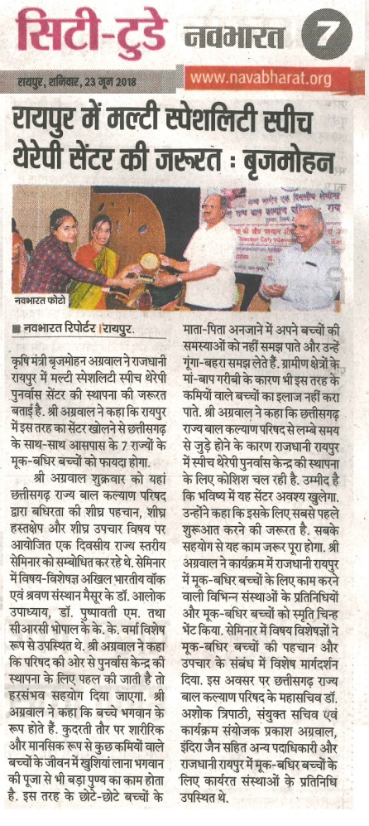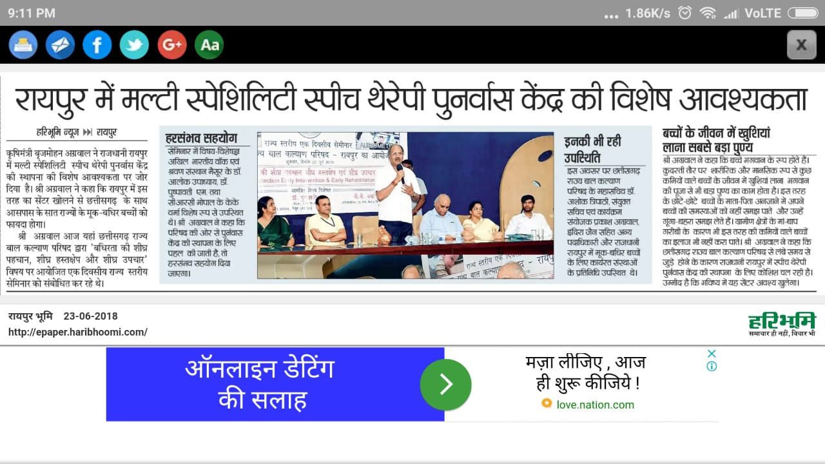

**C) Material Development :**The following Teaching Learning Materials and Prepare for training children with various communication disorders an preschool.

|  |  |  |  |
| --- | --- | --- | --- |
| **Sl.**  **No.** | **Nature of**  **Teaching-Learning**  **Materials** | **Skill** | **Number** |
| 1. | Flash cards | For all skill areas | 56 |
| 2. | Work Cards | For all skill areas | 69 |
| 3. | Charts | For all skill areas | 10 |
| 4. | PPT | For all skill areas | 105 |
| 5. | Models | For all skill areas | 64 |
| 6. | Sentence strips | For all skill areas | 45 |
| 7. | Story cards | For all skill areas | 76 |
| 8 | Others | For all skill areas | -- |

1. **AWARDS AND HONORS RECEIVED BY FACULTY AND STAFF**
2. EXTRA CURRICULAR ACTIVITIES
   * + - 1. AIISH Gymkhana
3. EMINENT VISITORS:

XI. **ANY OTHER**

* **Official Language Implementation:**
* Hindi Word a day
* No of notings/letters (**June 2018**): **48**

Sd/-

HOD- Special Education