**ALL INDIA INSTITUTE OF SPEECH AND HEARING, MYSURU-6**

**अखिल भारतीय वाक श्रवण संस्थान, मैसूर-६**

**DEPARTMENT OF SPECIAL EDUCATION**

**विशेषशिक्षाविभाग**

**MONTHLY REPORT - May 2018**

1. **ACADEMIC ACTIVITIES**
2. **Orientation Programs (For outsiders):**The following orientation programswere conducted to orient about the activities of the departmentand also to provide the knowledge about the educational facilities and welfare measures for children with special needs. :

|  |  |  |  |  |
| --- | --- | --- | --- | --- |
| **Sl. No.** | **Coordinator** | **Targeted Audience** | **Number**  **of Participants** | **Date** |
|  | Dr. Malar G | Staffs, DCS, AIISH, Mysuru | 10 | 18.05.2018 |
|  | Dr. Malar G | Staffs, DMD & LIO, AIISH, Mysuru | 10 | 21.05.2018 |
|  | Dr. Vijetha P | Staffs, Admin block & SLP, AIISH & BASLP students from Mangalore | 14 | 23.05.2018 |
| C:\Users\User\Desktop\May month Gallery\Dr. vijehta (Orientation for other dept staffs)\P_20180522_122333_vHDR_Auto.jpg | | | | |
|  | Dr. Alok Kumar U | Staff, POCD, AIISH | 01 | 23.05.2018 |
| C:\Users\User\Desktop\May month Gallery\Dr. Alok\P_20180523_122009_vHDR_Auto.jpg | | | | |
|  | Ms. Lakshmi Prabha J K | Staffs, Electronics dept & SLS, AIISH | 06 | 24.05.2018 |

**Dr.Pushpavathi M, HOD – Special Education**

* Held meeting with staff to discuss the issues related to improving the admission to UG, PG and diploma programs .
* Conducted meeting with faculty to discuss about the intra and extra mural projects
* Supervised the summer camp programs and valedictory programs .

**Faculty report**

|  |  |  |  |  |  |  |
| --- | --- | --- | --- | --- | --- | --- |
| **Name of the Faculty** | | **Dr.Alok Kumar** | **Dr. G. Malar** | **Dr.Prithi**  **Venkatesh** | **Dr. P. Vijetha** | **Ms.LakshmiPrabha J.K** |
| **Clinics** | | | | | |  |
| **No. of cases evaluated at SEA-U** | | 10 | * Screening: 25 clients in 25 sessions * Assessment: 6 clients in 20 sessions | She is on Maternity leave | 21 | * Screening: 6 clients in 6 sessions |
| **No. of cases supervised individually** | | 01 | * Nil |  | 02 |  |
| **No. of groups supervised** | | NIL | * Summer vacation in preschool |  | Nil |  |
| **No. of meeting with parents** | | NIL | * Summer vacation in preschool |  | NIL |  |
| **Educational Guidance** | | 03 | * 23 clients * 28 sessions |  | 2 (7 sessions) |  |
| **Academics** | | | | | | |
| **Classes taken** | | | | | |  |
| **B.Ed.**  **Spl.Edn.(HI)** | **Theory** | NIL | * Inter-semester vacation |  | NIL |  |
| **Practical** | 10 hours | * 34 hours (supervising vacation – 21½ & compensatory 13½ postings) |  | 10 hours  (Micro teaching of B.Ed. trainees) | 7 hours ( Micro Teaching Skill Practice ) |
| **Any others** |  |  | * Invigilation duty for PG Entrance Exams on 26.05.18 * Invigilation duty for PG even semester exams on 22 & 28.05.18 |  | * On 23rd & 26th May 2018 served as invigilator. |  |
| **Any other** | | | | | |  |
| **Meeting held** | |  | * Meetings with the Director regarding B.Ed.Spl.Ed. (HI) vacation postings & LD-Clinic participation in workshop in Gangothri Public School * 4 Meetings with HOD regarding preparations for Deemed University status & NAAC inspection, future PoA for Department, etc. |  | * On 15th May 2018 at 3:30 pm, discussed about IEP project with the team. |  |
| **Meeting attended** | | Attended to orientation program 2 days “Educating the Educator”, AIISH, Mysuru, 10th – 11th May 2018 |  |  | * On 9th May 2018, attended Peer review of Dept. of Clinical Psychology. | * 2 meetings with HOD regarding “U-SAFE” project ( Feel my Home) and UGC inspection Feedback” * 2 meetings with HOD and Staff members regarding Plan of Action for strengthening the Research & projects in the department and promotion of DECSE, B.Ed.Spl.Ed and M.Ed.Spl.Ed programs |
| **Brouchre** | |  | Tamil translation of brochure on special education programmes – along with Ms. Lakshmi Prabha J. K. & Ms. J. Subalakshmi |  | * Special Education academic programs pamphlet has been updated for wide publicity. |  |
| **Serve as Resource person** | |  | * Staff Refresher Workshop at Gangothri Public School on 18.05.2018 * Inter-Departmental Orientation, Department of Special Education, AIISH on 18 & 21.05.2018 |  |  |  |
| **Roles & Responsibilities** | | | | | |  |
| **Co-ordination** | | Parent Infant Program Unit  Preschool Parent Enrichment Program Unit | * CBCS Coordinator for I& II B.Ed.Spl.Ed. (HI) * Compilation of M.S.Ed. Student Dissertation-based Articles 2014-15 * Intra-Department * SEA-U * Research & Database Unit |  |  |  |
| **Member secretary** | | Pre School | * Services for School-Aged Children (in Department of Special Education) |  | NIL |  |
| **Member in** | | Special education assessment Unit and Assistan warden | * TCPD * LD Clinic (in DCS) * Product Development Cell * Preschool Supervision * Allied member of ISHA * Life member of NCED |  | SEA-U |  |
| **Mentor** | | M.Sc 2year Audiology | * Mentor for I & II B.Ed.Spl.Ed. (HI) |  |  |  |
| **AV preparation** | |  |  |  |  | * One PPT on Plan of Action for strengthening the Research & projects in the department and promotion of DECSE, B.Ed.Spl.Ed and M.Ed.Spl.Ed programs |

1. Clinical /Educational Observation Postings of Students from other Institutes:NIL

Following are the details of students posted for observation/ practice teaching

|  |  |  |  |  |
| --- | --- | --- | --- | --- |
| **Sl.No.** | **Name of the Institute** | **Programme/Course** | **Number of Students** | **Dates** |
|  | Mount Carmel College, Bengaluru | Master’s degree student in Human resource development | 01 | 16th April 2018 to 29th May 2018 |
|  | St. Agnes College, Mangalore | M. Sc. Psychology students | 08 | 22.05.2018 |

1. Seminars/Conferences/**Workshops**/Training Programs:NIL
2. Staff Enrichment / **In-house training Programmes***(For own staff members)* : NIL

|  |  |  |  |  |  |
| --- | --- | --- | --- | --- | --- |
| **Theme/Topic** | **Resource Person** | **Coordinator** | **Objectives** | **Targeted Audience** | **Date** |

1. **Guest Lectures :**

A Summer camp was held from 01.05.2018 to 31.05.2018 wherein 100 participants were part of the camp activities. The following experts served as resource persons.

|  |  |  |
| --- | --- | --- |
| **Name, Designation, Institutional affiliation of Lecturer** | **Topic of Lecture** | **Date** |
| Dr. Shiva Prakash, Mr. Srichitta, Madhavi Jagadish | Kriya Yoga | 4.5.18 |
| Ms. Sheetal, Mr. Lokeshwar and Mr. Shivaprasad | Crafts | 7.5.18 – 16.5.18 |
| Mr. Dharma M. A. & Mr.Dhanush | Wushu | 9.5.18 – 17.05.18 |
| Mr. Dharma M. A. & Ms. Dakshitha | Dance | 1.5.18 – 31.5.18 |
| Mr. Nataraju | Drama | 1.5.18 – 31.5.18 |

1. Additional Academic Services rendered by the Faculty and Staff
2. Invited Talks: 01

|  |  |  |  |  |
| --- | --- | --- | --- | --- |
| **Staff** | **Topic** | **Date** | **Programme** | **Institution** |
| G.Malar | Classroom Management & Instruction Adaptation for Children with LD | 18.05.2018 | Refresher Workshop for Teachers | Gangothri Public School, Mysuru, Karnataka |

1. Curriculum Development: NIL
2. **Development of Material to Support Learning : G. Malar – Revision of Training Manual – Visual Arts for Preschoolers**
3. Service in Academic Bodies of other Organizations
4. Participation in Committees/Taskforce and Panels setup by other organizations/agencies: NIL

|  |  |  |  |  |  |  |
| --- | --- | --- | --- | --- | --- | --- |
| **Sl No** | **Name of the staff** | **Name of Organization/Agency** | **Participation in Committees/**  **Taskforce** | **Programme** | **Name of Institute Visited** | **Date of Visit** |

1. **Any Others (Please Specify)**
2. Research Projects (ARF)
3. Completed - NIL
4. New Research Projects- NIL
5. **Ongoing Research Projects –02**
6. **Title of ARF** - Development and Evaluation of Indigenous curriculum oriented computer based tutor for concept learning in preschool children with special needs.

Principal Investigator – Ms. P.V. Ramanakumari

Co-Investigators – Dr.Ajish K Abraham and Ms. P.V. Manjula

Research Assistant – Mr. Anil Abbur R.

Date of Starting – 18th January 2017

1. **Title**: Effect of Resource Materials on Impact of Inclusive Education in Children with Intellectual Disabilities (ID) and Learning Disabilities (LD)

Investigators: Dr. G. Malar, Ms. S. Prathima & Mr. D. Gururaj

Duration: 12 months from January 2017

Budget: Rs. 3,85,000/-

1. Postgraduate Research Completed:- NIL
2. C. Postgraduate Research ongoing: NIL
3. D**.** Research Papers presented at National/International Conferences/Seminars :- NIL

E. Research Papers Published

i**) Papers published in National / International Journals: 01**

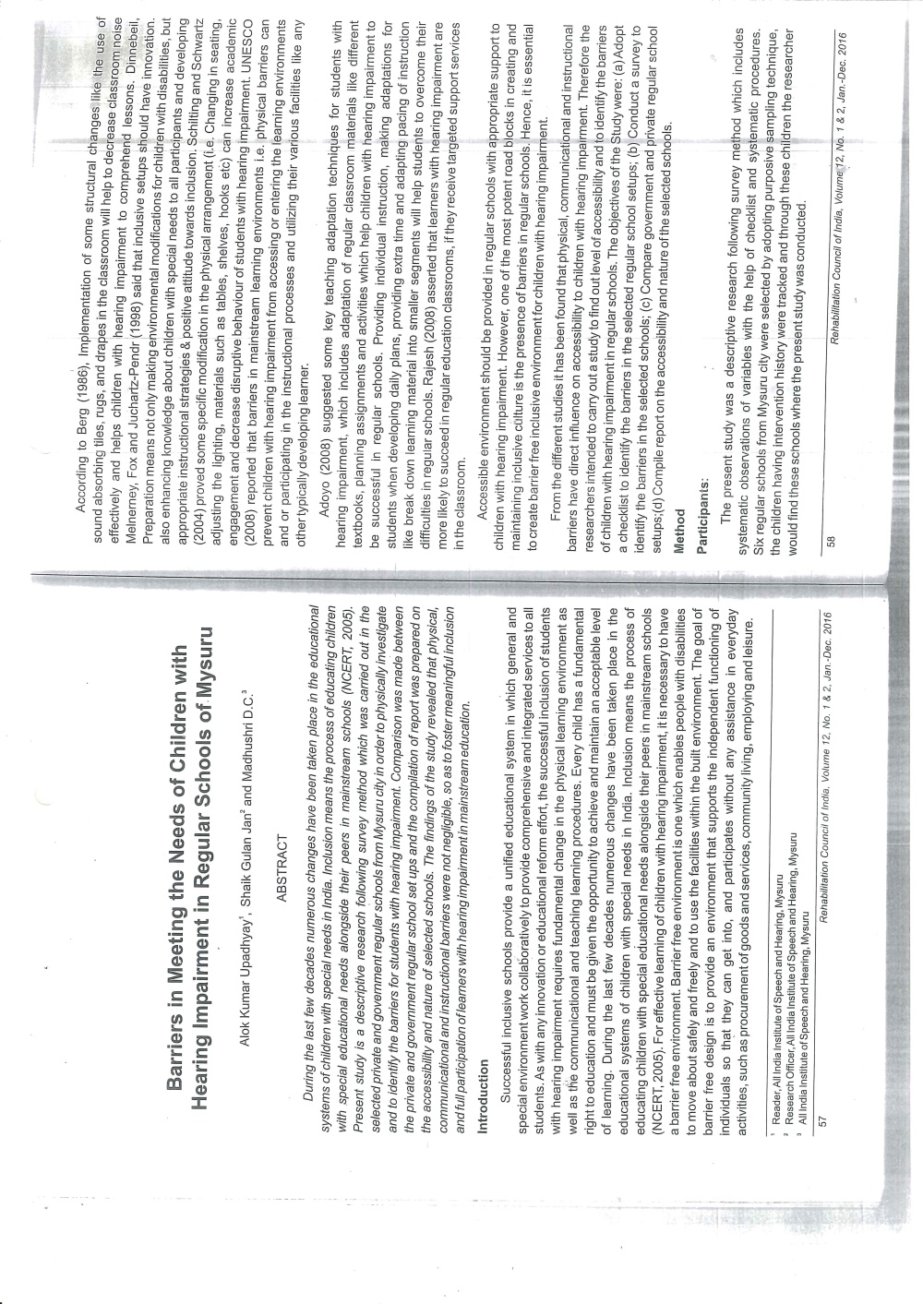***Upadhyay A.K.****,Jan S.G. & Mudhushri D.C****.***(2018). Barriers in Meeting the Needs of Children with Hearing Impairment in regular Schools of Mysuru, *Journal of Rehabilitation Council of India,* 12(1&2):57-66.

ii) Abstracts published in Conference / Seminar Proceedings: NIL

F. Books published (in APA format)

1. Books published: NIL

G.Book chapters published (in APA format): NIL

H .Books/Manuals/Seminar Proceedings edited: NIL

1. Journal Editorship: NIL

J. Scholarly Reviewing Activities:

1. Special Educational Services Offered through Teacher Trainees Outside Campus: NIL

**III CLINICAL SERVICES**

1. General Clinical Services: **Not Applicable**
2. Specialized Clinical/ Educational Services
3. **Preschool Training and Special Education**

**Educational services for children with special needs**

|  |  |  |  |  |  |  |  |  |  |  |  |  |
| --- | --- | --- | --- | --- | --- | --- | --- | --- | --- | --- | --- | --- |
| **S. No.** | **Nature of Services (I/C)** | | | | | | | | | | | |
| 1. Special Educational Assessment Services (Dr. G. Malar) | | | | | | | | | | | | |
|  |  | Nature of Special Need  Language | ASD / PDD NOS | Hearing Loss | Intellectual Disability | Learning Disability | Motor Problems | Multiple Disabilities | Others | No. of Clients | No. of Sessions | ***Total No. of Sessions*** |
| 1. | Screening & Referral | Kannada | 7 | 45 | 20 | 4 | 2 | 7 | 1 | ***86*** | ***86*** | ***136*** |
| Malayalam | 3 | 2 | 5 | 0 | 0 | 4 | 2 | ***16*** | ***16*** |
| Hindi | 1 | 7 | 3 | 0 | 0 | 0 | 0 | ***11*** | ***11*** |
| Urdu | 0 | 0 | 0 | 0 | 0 | 0 | 0 | ***0*** | ***0*** |
| English | 1 | 1 | 3 | 14 | 1 | 0 | 1 | ***21*** | ***21*** |
| Telugu | 0 | 1 | 0 | 0 | 0 | 0 | 0 | ***1*** | ***1*** |
| Tamil | 1 | 0 | 0 | 0 | 0 | 0 | 0 | ***1*** | ***1*** |
| Any Other | 0 | 0 | 0 | 0 | 0 | 0 | 0 | ***0*** | ***0*** |
| ***Total No. of Clients*** | ***13*** | ***56*** | ***31*** | ***18*** | ***3*** | ***11*** | ***4*** | ***136*** | ***136*** |
| 2. | Assessment & Report | Kannada | 6 | 34 | 7 | 0 | 1 | 5 | 0 | ***53*** | ***231*** | ***337*** |
| Malayalam | 2 | 0 | 3 | 0 | 0 | 3 | 2 | ***10*** | ***43*** |
| Hindi | 1 | 6 | 1 | 0 | 0 | 0 | 0 | ***8*** | ***26*** |
| Urdu | 0 | 0 | 0 | 0 | 0 | 0 | 0 | ***0*** | ***0*** |
| English | 1 | 1 | 3 | 3 | 0 | 0 | 1 | ***9*** | ***37*** |
| Telugu | 0 | 0 | 0 | 0 | 0 | 0 | 0 | ***0*** | ***0*** |
| Tamil | 0 | 0 | 0 | 0 | 0 | 0 | 0 | ***0*** | ***0*** |
| Any Other | 0 | 0 | 0 | 0 | 0 | 0 | 0 | ***0*** | ***0*** |
| ***Total No. of Clients*** | **10** | **41** | **14** | **3** | **1** | **8** | **3** | **80** | **337** |
| Places from which seen: (1)Karnataka: 115 (2)Kerala: 19 (3)AP: Nil (4)Telengana: Nil (5)TN: 02 (6)Other Parts of India: Nil (7)Any other: Nil | | | | | | | | | | | |
| Age groups seen:(1)Birth to 2.5yrs: 02 (2)2.5+ to 6 yrs: 55 (3)6yrs+ to 16 years: 73 (4)16yrs+: 05 | | | | | | | | | | | |
| Total No. of Referrals: (1)Educational Assessment: 82 (2)Educational Guidance: 92 (3)PIP: 02 (4)PPEP/ PBC/ GECS: 21 (5)CSS/IEP/NFE/DET: 29 (6)Any Other Services at AIISH: 16 (7)Any Other Services Outside AIISH: 03 (4 – special school; part-time individualised education – 11 & 67 –mainstreaming) | | | | | | | | | | | |
| No. of Reports Issued/Ready for Issue: (1) School Readiness: 02 (3) Curriculum-Based Assessment: 03 (4) Post-School: Nil | | | | | | | | | | | |

|  |
| --- |
| **Preschool Training:Preparatory programme for schooling providing training in self-help, cognitive, language and (pre) academic skills, Preschool Supplementary Services (PSS)** |
| Summer camp 2018   |  |  |  |  |  |  |  | | --- | --- | --- | --- | --- | --- | --- | | **Language** | **HI** | **ID** | **Autism** | **MD** | **Others** | **Normal** | | Kannada | 15 | 18 | 5 | 4 | 6 | 5 | | Malayalam | 6 | 9 | 5 | 3 | 3 | 2 | | Telugu | 1 | 0 | 0 | 3 | 0 | 0 | | English | 2 | 0 | 0 | 0 | 0 | 0 | | Tamil | 1 | 1 | 0 | 0 | 0 | 1 | | Hindi | 3 | 3 | 5 | 0 | 3 | 1 | |

|  |  |  |  |  |  |
| --- | --- | --- | --- | --- | --- |
| **Curricular Support Services – Supportive training to augment education in mainstream school/ other educational programmes** | **Language** | **HL** | **ID/CP/ASD/MD/LD/DD** | **Total No. of clients** | **No. Of sessions** |
| Kannada | 5 | 12 | 17 | 49 |
| Malayalam | 1 | 1 | 2 | - |
| Hindi | 1 | 1 | 2 | - |
| English | 1 | 9 | 10 | 16 |
| Telugu | - | - | - | - |
| Tamil | - | - | - | - |
| **Total** | | | | **31** | **65** |
| |  |  |  |  |  |  | | --- | --- | --- | --- | --- | --- | | **Individualised Educational Programme (IEP) – Training in functional academics for out of school individuals** | **Language** | **HL** | **ID/CP/ASD/MD/LD/DD** | **Total No. of clients** | **No. Of sessions** | | Kannada | 4 | 9 | 13 | 28 | | Malayalam | - | 2 | 2 | - | | Hindi | 1 | 2 | 3 | 10 | | English | - | - | - | - | | Telugu | - | - | - | - | | Tamil | - | - | - | - | | **Total** | - | - | **18** | **38** | | | | | | |
| |  |  |  |  |  |  | | --- | --- | --- | --- | --- | --- | | **Demonstration Educational Training – Short-term demonstration to caregivers in any of the above** | **Language** | **HL** | **ID/CP/ASD/MD/LD/DD** | **Total No. of clients** | **No. Of sessions** | | Kannada | 2 | 7 | 9 | 29 | | Malayalam | - | 4 | 4 | 9 | | Hindi | - | 1 | 1 | 1 | | English | - | 1 | 1 | 2 | | Telugu | - | - | - | - | | Tamil | - | - | - | - | | **Total** | - | - | **15** | **41** | | | | | | |
| **Total clients:64**  **Old clients:- 55**  **New clients: - 09**  **Discharged(DET):- 03**  **Discharged(CSS):- 04**  **Discharged(IEP):- 01**  **Discontinued(DET):- 02**  **Discontinued(CSS):- 03**  **Discontinued(IEP):- 02**  **Promoted from CSS/IEP/DET to PPEP: NIL**  **No. of remaining clients: 49** | | | | | |

|  |  |  |  |  |  |  |  |  |  |  |  |
| --- | --- | --- | --- | --- | --- | --- | --- | --- | --- | --- | --- |
| **Preschool Parent Empowerment Programme – PPEP** | | | | | | | | | | | |
|  | **Language** | **HL** | **ID** | **CP** | **ASD** | **MD** | **LD** | **DD** | **SLD** | **VI** | **Total No. of clients** | **No. Of sessions** |
| Kannada | 48 | 36 | -- | 09 | 15 | -- | 04 | -- | -- | 112 | 200 |
| Malayalam | 18 | 14 | 02 | 13 | 11 | -- | 05 | 01 | 01 | 65 | 80 |
| Hindi | 10 | 03 | -- | 01 | -- | -- | -- | -- | -- | 14 | 40 |
| English | 02 | 03 | -- | 02 | 01 | -- | -- | -- | -- | 8 | 20 |
| Telugu | 05 | 02 | 01 | 01 | -- | -- | -- | -- | -- | 9 | 20 |
| Tamil | 01 | 05 | -- | -- | 01 | -- | -- | -- | -- | 7 | 20 |
| **Total** | | | | | | | | | | **215** | | **380** |
| No. of clients promoted to the next higher level (Preschool) of service: 90  No. Of discharged : 07  No. Of discontinued: 67  No. Of New clients (**May**) : 16 clients  Shifted from PPEP to PIP: 01  No. of remaining cilents:**50** | | | | | | | | | | | | |

|  |  |  |  |  |  |
| --- | --- | --- | --- | --- | --- |
| **Parent-Infant Programme – PIP(Birth to 2 ½ years)** | | | | | |
| Parent-Infant Programme | **Language** | **HL** | **ID/CP/ASD/MD/LD/DD** | **Total No. of clients** | **Total No. Of sessions** |
| Kannada | 10 | 07 | 17 | 44 |
| Malayalam | 07 | 18 | 25 | 37 |
| Hindi | 1 | 1 | 2 | - |
| English | - | - | - | - |
| Telugu | - | - | - | - |
| Tamil | 01 | - | 01 | 3 |
|  | **Total** | | | **45** | **84** |
| Specific age range:  No. of Old clients :**43**  No. of New clients enrolled: **02**  Total cilents:**45**  No. discharged :**04**  No. discontinued:**05**  No. of Promoted to next level: **04**  No. of Remaining:**32** | | | | | |

|  |  |  |
| --- | --- | --- |
| **Library of Books & Toys** – LiBoToy  Services issuing educational toys & books for home-based training. | Total number of members enrolled –243  No. of new members: - 09  Amount – 450/-  Total number of sessions –24 | |
| **Age group** | **Total number** |
| 0-2.6 yrs | 15 |
| 2.6-4 yrs | 69 |
| 4.0-6yrs | 144 |
| 6 yrs and above | 15 |

|  |  |  |
| --- | --- | --- |
| **Services** | **Number of Clients** | **Number of Sessions** |
| Co-Curricular Training | 216 | 20 |

**Supports for Empowering Caregivers**

|  |  |  |  |
| --- | --- | --- | --- |
| Name of Training Unit | No. of Parent  Beneficiaries | No. of Sessions | Content of Training |
| Caregiver Computer Training Unit | -- | -- | -- |
| Caregiver Literacy Training Unit | -- | -- | -- |

1. Clinical Support Services to Clients and Family
2. **Counselling and guidance**

|  |  |
| --- | --- |
| No. of Clients | Sessions |
| 100 | 85 |

1. U-SAFE

|  |  |
| --- | --- |
| No. of Clients | Sessions |
| -- | -- |

1. Details of Certificates Issued:NIL

|  |  |  |  |
| --- | --- | --- | --- |
| **Sl.No.** | **Nature of Special Needs in Clients** | **No. of Certificates Issued** | **Purpose** |

1. Financial Aid- NIL
2. Legal advice -NIL
3. Any other(Please Specify):
4. Parent enrichment programs (PEP): NIL - This program aims to enrich knowledge of the caregivers of CWSN by experts from various fields.

|  |  |  |  |  |  |
| --- | --- | --- | --- | --- | --- |
| Theme/Topic | Coordinator | Objectives | Targeted Audience | Date | Photo |

1. **Staff Enrichment Program (SEP):- 07**

|  |  |  |  |  |
| --- | --- | --- | --- | --- |
| **Theme/Topic** | **Coordinator** | **Objectives** | **Targeted Audience** | **Date** |
| Orientation: Cleft of lip and palate by Deepthi K. J., JRF | Ms. Leena C C  Ms. Latha C |  | 30 | 18.05.2018 |
| C:\Users\User\Pictures\Picasa\Collages\Deepthi K J.jpg | | | | |
| “Voice Care for Special Educators” by Mr. Gopi Kishore | Ms. Sreevidya M. S  Mr. Sharanaiah M M |  | 30 | 21.05.2018 |
|  | C:\Users\User\Desktop\SEP PPTs\Gopikishore\Gopikishore.jpg | | |
| “Dysphagia” by Gayathri Krishan |  | 30 | 23.05.2018 |
|  | C:\Users\User\Desktop\SEP PPTs\Gayathri\Gayathri.jpg | | |
| “Augmentative and Alternative Communication Unit” by Ms.Aruna Kamath |  | 30 | 23.05.2018 |
|  | C:\Users\User\Desktop\SEP PPTs\Aruna kama\Aruna kama.jpg | | |
| “Activities of Occupatinal and Physio Thearapy Unit” by Mr. Sohan Singh and Ms.Barathi |  | 30 | 24.05.2018 |
|  | C:\Users\User\Desktop\SEP PPTs\DCS\IMG_20180524_165142.jpg | | |
| “Learning Dissability” by Dr. Jayashree. C.Shanbal |  | 30 | 25.05.2018 |
|  | C:\Users\User\Desktop\SEP PPTs\Dr.Jayashree.C.Shanbal\Dr.Jayashree.C.jpg | | |
| “Activities of Department of Clinical Services” by Mr. Reubin.T.Varghese |  | 30 | 29.05.2018 |
|  |  | C:\Users\User\Pictures\Picasa\Collages\Reuben.jpg | | |

**Attended to workshop/Seminar/Orientation program in AIISH institute 2017-18:NIL**

|  |  |  |
| --- | --- | --- |
| **Name of Staff** | **Attended to workshop title name** | **Date** |
|  |  |  |

**Attended to workshop/Seminar/Orientation program in Outside institute 2017-18:NIL**

|  |  |  |
| --- | --- | --- |
| **Name of Staff** | **Attended to workshop title name** | **Date** |
|  |  |  |

EXTENSION ACTIVITIES

1. Public Lecture Series
   * 1. TECHNLOGICAL CONSULTANCY SERVICES: Not applicable
        1. CENTRAL FACILITIES
        2. Library and Information Services
        3. Public Information Activities
        4. **Major Events of the Year with a brief account:NIL**

**Event:** Inaugution function of Summer Camp 2018 and Summer Camp Activities

**Cooridnators:** Ms. Manjula P .V , Ms. Sumana H.P , Ms. Leena C.C, Mr . Rajkumar R,

Ms. Sreevidya M.S.

|  |  |
| --- | --- |
| C:\Users\User\Desktop\PPT Summer Camp\Slide1.JPG | C:\Users\User\Desktop\PPT Summer Camp\Slide4.JPG |
| *C:\Users\User\Desktop\PPT Summer Camp\Slide2.JPG* | C:\Users\User\Desktop\PPT Summer Camp\Slide6.JPG |
| C:\Users\User\Desktop\PPT Summer Camp\Slide7.JPG | C:\Users\User\Desktop\PPT Summer Camp\Slide8.JPG |
| C:\Users\User\Desktop\PPT Summer Camp\Slide9.JPG | C:\Users\User\Desktop\PPT Summer Camp\Slide10.JPG |
| C:\Users\User\Desktop\PPT Summer Camp\Slide12.JPG | C:\Users\User\Desktop\PPT Summer Camp\Slide13.JPG |

* + - 1. **Press Releases and Media Coverage:**

**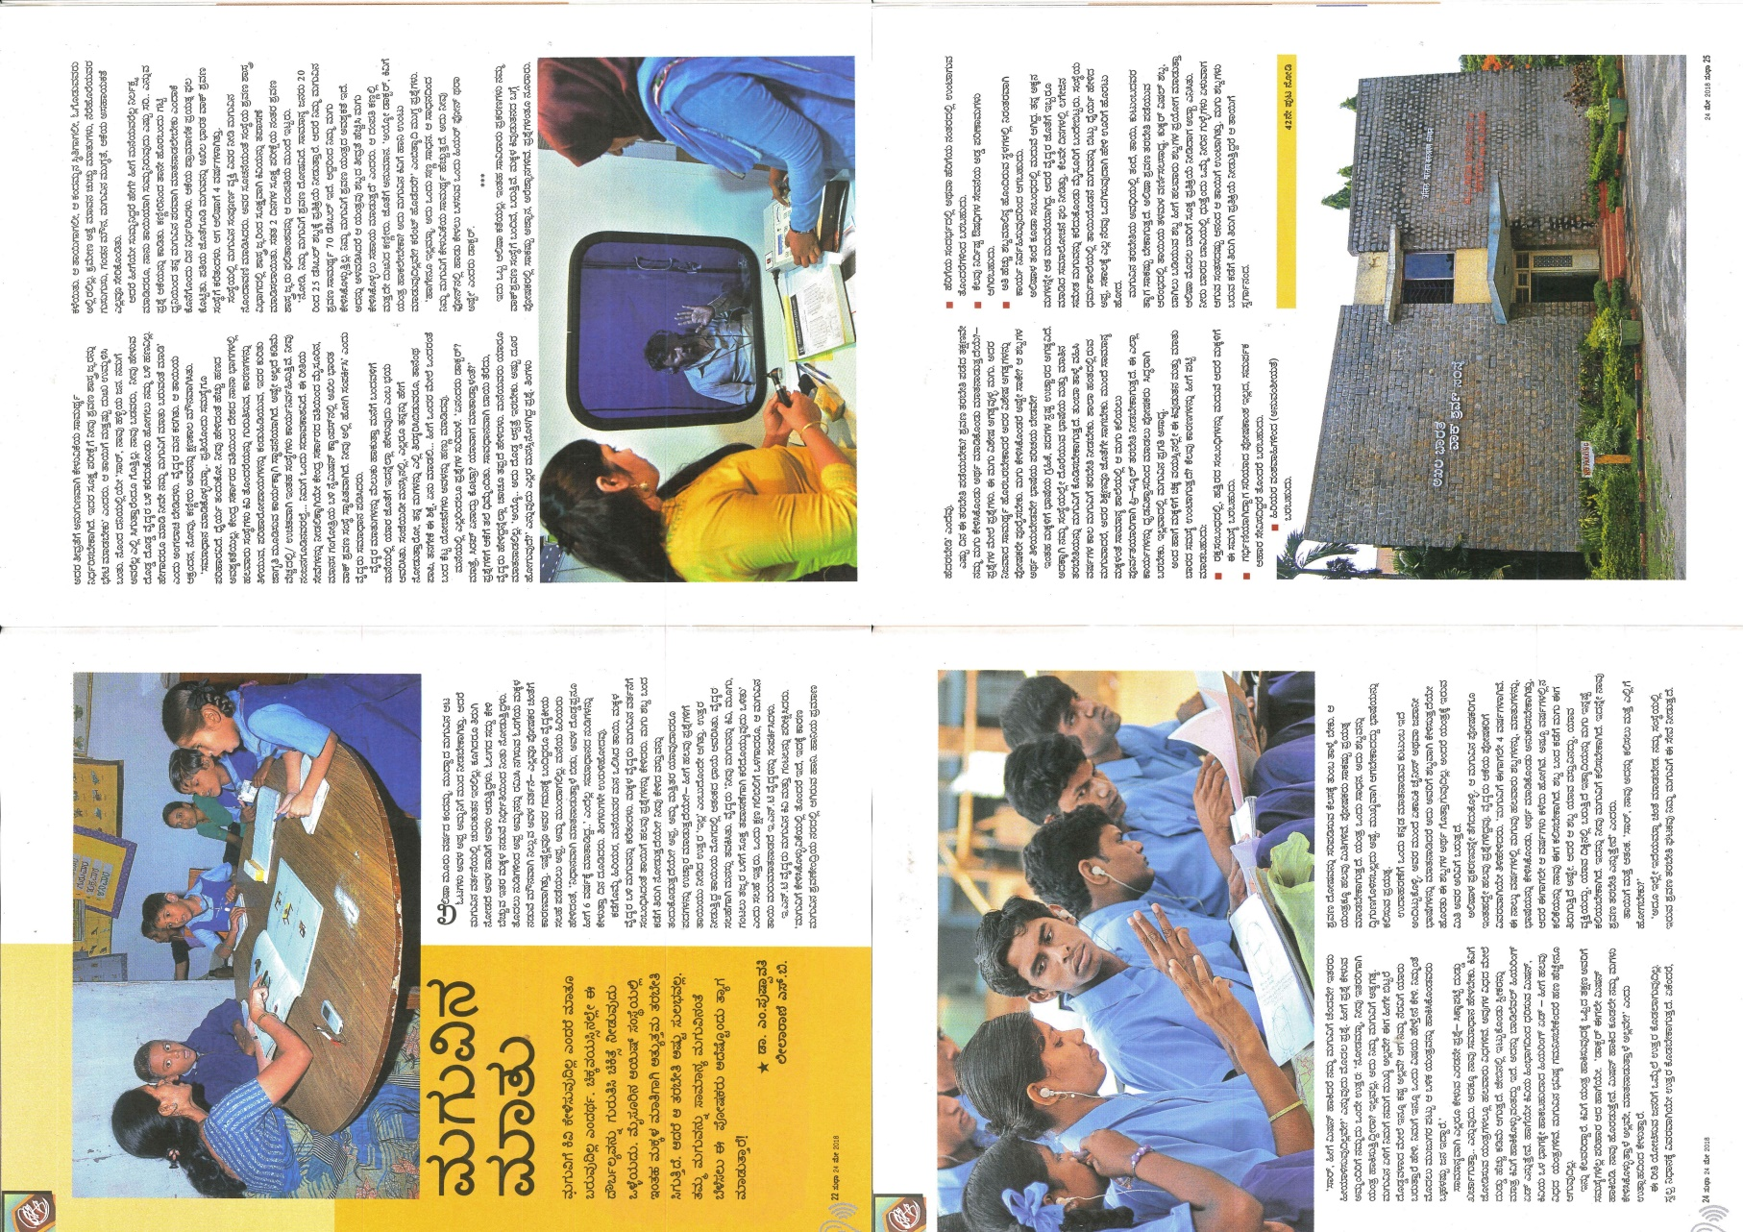**

**C) Material Development :**The following Teaching Learning Materials and Prepare for training children with various communication disorders an preschool.

|  |  |  |  |
| --- | --- | --- | --- |
| **Sl.**  **No.** | **Nature of**  **Teaching-Learning**  **Materials** | **Skill** | **Number** |
| 1. | Flash cards | For all skill areas | -- |
| 2. | Work Cards | For all skill areas | -- |
| 3. | Charts | For all skill areas | 55 |
| 4. | PPT | For all skill areas | -- |
| 5. | Models | For all skill areas | -- |
| 6. | Sentence strips | For all skill areas | -- |
| 7. | Story cards | For all skill areas | -- |
| 8 | Others | For all skill areas | -- |

1. **AWARDS AND HONORS RECEIVED BY FACULTY AND STAFF**
2. EXTRA CURRICULAR ACTIVITIES
   * + - 1. **AIISH Gymkhana**

**Event:** Preschool Graduation Day 2018

**Cooridnators:** Dr. Pushpavathi M., Dr. Palnaty Vijetha and Ms. Lakshmi Prabha J.K.

**Benefits:** 78 Children with various communication disorders were graduated on 27th April 2018. Chief guest *Dr. K.R .Ramesh, Assistant Director, Sri Chamarajendra Zoological Gardens, Mysuru and Director Dr. S.R Savithri* graced the function.

**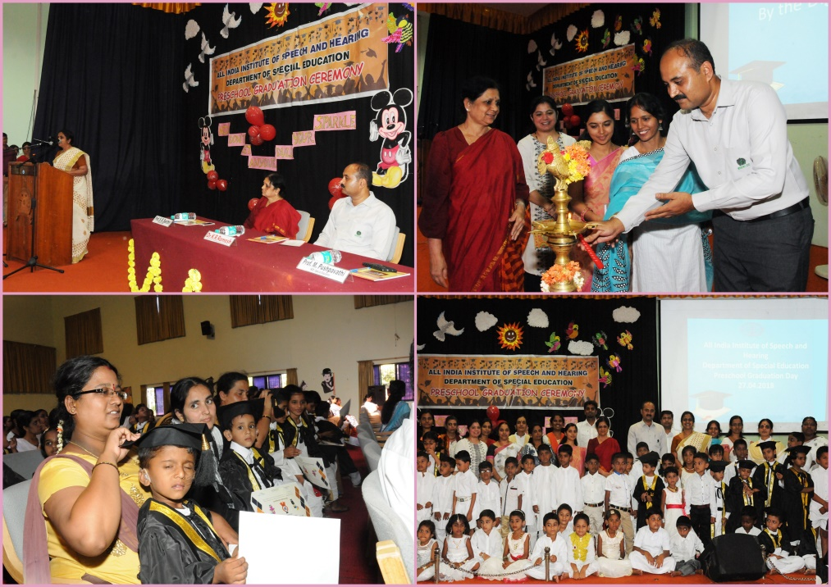**

1. EMINENT VISITORS:

XI. **ANY OTHER**

* **Official Language Implementation:**
* Hindi Word a day
* No of notings/letters (**May 2018**): **55**

Sd/-

HOD- Special Education