**ALL INDIA INSTITUTE OF SPEECH AND HEARING, MYSURU-6**

**अखिल भारतीय वाक श्रवण संस्थान, मैसूर-६**

**DEPARTMENT OF SPECIAL EDUCATION**

**विशेषशिक्षाविभाग**

**MONTHLY REPORT December 2017**

**मासिक रिपोर्टअक्टूबर** दिसंबर **2017**

1. **ACADEMIC ACTIVITIES**
2. **Orientation Programs (For outsiders):**The following orientation programswere conducted to orient about the activities of the departmentand also to provide the knowledge about the educational facilities and welfare measures for children with special needs. : **NIL**
3. **Posting (For outsiders): 02**

|  |  |  |  |  |
| --- | --- | --- | --- | --- |
| **SL No.** | **Coordinator** | **Targeted Audience** | **Number**  **of Participants** | **Date** |
| 1 | Maharaja’s College, University of Mysore | MA Psychology | 1 | 8th December 2017 to 29th December 2017. |
| 2 | St.Philomena’s College, Mysore | BA psychology | 1 | 20th December 2017 to 3rd January 2018. |

**Faculty report**

|  |  |  |  |  |  |
| --- | --- | --- | --- | --- | --- |
| **Name of the Faculty** | | **Dr.Alok Kumar** | **Dr. G. Malar** | **Dr.PrithiVenkatesh** | **Dr. P. Vijetha** |
| **Clinics** | | | | | |  |
| **No. of cases evaluated at SEA-U** | | 12 | * Screening: 7 clients in 7 sessions * Assessment: 1 client in 1 session | SEAU-Evaluation: 22  Educational Assessment: 1 child (Ongoing)  Number of Sessions: 4 | 04 |
| **No. of cases supervised individually** | | NIL | * 18 children through 3 classroom observations of 3 preschool groups | 07 | NIL |
| **No. of groups supervised** | | 05 | * 10 preschool groups | 10 | 14 |
| **No. of meeting with parents** | | 06 | * 10 meetings in 10preschool groups | 10 | 08 |
| **Educational Guidance** | | 01 | * 2 clients * 2 sessions |  | NIL |
| **Academics** | | | | | |
| **Classes taken** | | | | | |
| **B.Ed.**  **Spl.Edn.(HI)** | **Theory** | 32 Classes | * 27 (including 3 extra) | IV Semester: Practical postings  (Lesson Planning Discussion and guidance for four B.Ed.Spl.Edn-HI trainees)  II Semester:  Pedagogy of teaching school subjects-Science  **(Classes commenced from 30.11.2017: Number of classes taken: 13** | 21 classes |
| **Practical** | 04 hours | * 64 hours |  | 15 hours |
| **Any others** |  |  |  |  | 1. On 14th December 2017, send Criteria for Evaluation for B.Ed. program. 2. On 23rd December 2017, invigilation duty was carried out. |
| **Any other** | | | | | |  |
| **Meeting held** | |  | * Meetings with I & II B.Ed.Spl.Ed. (HI) students as mentor   10 meetings with preschool parents |  | * updated information related to department website along with Mr.Sandesh. |
| **Meeting attended** | |  | * 4 meetings with HOD and/or other members regarding seminar s/workshops |  |  |
| **AV preparation** | |  | * 1PPT on pedagogy of teaching English |  |  |
| **Workshop** | | Served as a coordinator for Two National Workshops held at AIISH,Mysuru on 6-7 Dec and 14-15 Dec2017 | * Workshop on ‘Use of Music in Education of CWSN’ on 06 & 07.12.2017 * Workshop on ‘Importance & Practice of ISL’ on 14 & 15.12.2017 | Attended workshop on ‘Use of Music in the Education of Children with Special Needs’on 4th and 5th December 2017 and served as chairperson in the catering committee.  Attended workshop on ‘National Workshop on Importance and Practices of Indian Sign Language ‘on 14th and 15th December 2017 and served as chairperson for stage committee. | Attended workshop on ‘Use of Music in the Education of Children with Special Needs’on 4th and 5th December 2017 and served as chairperson in the stage committee.  Attended workshop on ‘National Workshop on Importance and Practices of Indian Sign Language ‘on 14th and 15th December 2017 and served as chairperson for catering committee. |
| **Serve as Resource person** | |  | * Workshop on ‘Use of Music in Education of CWSN’ on 07.12.2017   Workshop on ‘Importance & Practice of ISL’ on 14.12.2017 |  |  |
| **Roles & Responsibilities** | | | | | |  |
| **Co-ordination** | | Parent Infant Program Unit  Preschool Parent Enrichment Program Unit | * CBCS Coordinator for I& II B.Ed.Spl.Ed. (HI) * Compilation of M.S.Ed. Student Dissertation-based Articles 2014-15 * Intra-Department * SEA-U   Research & Database Unit | Coordinated International Day of Persons with Disabilities to be held on 8th December 2017.  Prepared the proposal and budget for Department of Special Education Programme.  Cordinating activities and other details with DCS. | 1. ISO 2. Services for School age children |
| **Member secretary** | | Pre School | * LD Clinic (in DCS) * Services for School-Aged Children (in Department of Special Education) |  | NIL |
| **Member in** | | Special education assessment Unit | * TCPD * Product Development Cell * Preschool Supervision * Allied member of ISHA * Life member of NCED |  | SEA-U |
| **Mentor** | | M.Sc 2year Audiology | * Mentor for I & II B.Ed.Spl.Ed. (HI) | I M.Sc SLP (B Section) | Mentor - II BASLP section A  Submitted attendance. |

1. Clinical /Educational Observation Postings of Students from other Institutes:NIL

Following are the details of students posted for observation/ practice teaching

|  |  |  |  |  |
| --- | --- | --- | --- | --- |
| **Sl.No** | **Name of the Institute** | **Programme/Course** | **Number of Students** | **Dates** |

1. Seminars/Conferences/**Workshops**/Training Programs:02

|  |  |
| --- | --- |
| **Theme/topic** | National workshop on use of music in the education of children with special needs |
| **Coordinator** | Ms. P.V. Ramanakumari, Ms.Manjula P.V |
| **Resource Persons** | Ms. Tara Kini, Dr. T V Sairam, Dr.P.V.Phanishree, Ms.RumaChakravarty, Dr.NarendraKaur, Ms.UtkalaMaringanti, Dr.G.Malar |
| **Objectives** | * The techniques of musical intervention in children with special needs. * Overcoming fear , anxiety and low esteem using Music. |
| **Targeted Audience** | Professoinal, students and special Ëducators |
| **Number of Participants** | 160 |
| **Date** | 6-7, December 2017 |
| **Photo**  C:\Users\User\Pictures\Picasa\Collages\New folder2.jpg | |

|  |  |
| --- | --- |
| **Theme/topic** | National Workshop on “Importance and Practices of Indian Sign Language” |
| **Coordinator** | Dr.Alok Kumar Upadhyay, Mr.Suresh C. B., Mr.Rajkumar R |
| **Resource Persons** | Ms.KripaDamas, Mr. Ramakrishna Chandra Reddy, Mr.Nidheesh David Kuruvila, Mr.Rajkumar R., Dr. Malar G |
| **Objectives** | * Enable the participants to acquire practical aspects of Indian Sign Language * Use proficiently ISL in their day to day conversation with Hearing Impaired |
| **Targeted Audience** | Professoinal, students and special Educators |
| **Number of Participants** | 160 |
| **Date** | 14-15, December 2017 |
| **Photo**  C:\Users\User\Pictures\Picasa\Collages\New folder (2)1.jpg | |

|  |  |
| --- | --- |
| **Theme/topic** | Meeting for Special Olympic Bharath |
| **Coordinator** | Ms.Vijayalakshmi S, Mr.Subramanya K R |
| **Resource Persons** | Sri.Vasanth Kumar Shetty |
| **Objectives** | To introduce the district incharge and assistant district incharge to the Special schools of mysore district.  To orient the special schools staff regarding district and state level Special Olympics sports. |
| **Targeted Audience** | School teachers |
| **Number of Participants** | 30 |
| **Date** | 27th December 2017 |
| **Photo**  C:\Users\User\Pictures\Picasa\Collages\New folder (6).jpg | |

1. Staff Enrichment / **In-house training Programmes***(For own staff members)* : NIL

|  |  |  |  |  |  |
| --- | --- | --- | --- | --- | --- |
| **Theme/Topic** | **Resource Person** | **Coordinator** | **Objectives** | **Targeted Audience** | **Date** |

1. **Guest Lectures :NIL**

|  |  |  |  |
| --- | --- | --- | --- |
| **Name, Designation, Institutional affiliation of Lecturer** | **Organized by Department/Section/Unit** | **Topic of Lecture** | **Date** |
|  |  |  |  |

1. **Additional Academic Services rendered by the Faculty and Staff**
2. **Invited Talks**:

|  |  |  |  |  |
| --- | --- | --- | --- | --- |
| **Staff** | **Topic** | **Date** | **Programme** | **Institution** |
| G. Malar | Presentation about AIISH & Departmental Activities | 07.12.2017 | Workshop on ‘Use of Music in Education of CWSN’ | Department of Special Education, AIISH |
| G. Malar | Communication Options in Education of Children with HI | 15.12.2017 | National Workshop on ‘Importance & Practices of ISL’ | Department of Special Education, AIISH |

1. Curriculum Development: NIL
2. Development of Material to Support Learning : G. Malar – Revision of Training Manual – Visual Arts for Preschoolers
3. **Service in Academic Bodies of other Organizations:**
4. Dr.Alok Kumar Upadhyay

Member of Board of studies(BOS) in three Universities:

1-Ramkrishna Mission VivekanandUniversity,Coimbatore

2- JRH University,Chitrakoot

3- NGB University,Allahabad

Member of Board of Examination (BOE): Mysore University

1. G. Malar – BOE–Special Education of University of Mysore
2. **Any Others (Please Specify)**

**RESEARCH ACTIVITIES (2016-17)**

1. Research Projects (ARF)
2. Completed -NIL
3. New Research Projects- NIL
4. **Ongoing Research Projects –02**
   * 1. **Title of ARF** - Development and Evaluation of Indigenous curriculum oriented computer based tutor for concept learning in preschool children with special needs.

Principal Investigator – Ms. P.V. Ramanakumari

Co-Investigators – Dr.Ajish K Abraham and Ms. P.V. Manjula

Research Assistant – Mr. Anil Abbur R.

Date of Starting – 18th January 2017

* + 1. **Title**: Effect of Resource Materials on Impact of Inclusive Education in Children with Intellectual Disabilities (ID) and Learning Disabilities (LD)

Investigators: Dr. G. Malar, Ms. S. Prathima&Mr. D. Gururaj

Duration: 12 months from January 2017

Budget: Rs. 3,85,000/-

Process: * Video recording for ID completed and commenced editing

* Tools provided for validation to 10 professionals

*Continuing with RoL & translation of tools

*Work order to DMD placed for translation of resource material PPTs

1. Postgraduate Research Completed:- NIL
2. C. Postgraduate Research ongoing: NIL
3. **D. Research Papers presented at National/International Conferences/Seminars :- 01**

Upadhyay A.K., *a paradigm shift in pre service teacher education in india* Presented in IATE National conference at Madurai- KamrajUniversity,Madurai on 22-23 Dec 2017

E.Research Papers Published

i**)** Papers published in National / International Journals: NIL

ii) Papers published in Conference / Seminar Proceedings: NIL

F. Books published (in APA format)

1. Books published: NIL

G.Book chapters published (in APA format): NIL

H .Books/Manuals/Seminar Proceedings edited: NIL

1. Journal Editorship: NIL

J. Scholarly Reviewing Activities:

1. **Special Educational Services Offered through Teacher Trainees Outside Campus:**

**Dr.Alok Kumar Upadhyay and Dr. Malar G**

|  |  |  |  |
| --- | --- | --- | --- |
| **S. No.** | **Nature of Activity** | **Services Provided** | **Details of Beneficiaries** |
| 1. | Educational Assessment | --- | --- |
| 2. | Practice-Teaching in Mainstream Schools/ Institutions | Observation of B.EdSplEdn 2nd year students at GangothriVidyashala and Mansagangothri school | --- |
|  | Teaching to typically developing learners along with children with special needs like HI & ID in 2 mainstream schools | Approximate aggregate of 275 children along with 6 children with HI, 1 with ID and 1 with HL & ID |
| 3. | Practice-Teaching in Special Schools/ Institutions | -- | -- |

**III CLINICAL SERVICES**

1. General Clinical Services: **Not Applicable**
2. Specialized Clinical/ Educational Services
3. **Preschool Training and Special Education**

**Educational services for children with special needs**

|  |  |  |  |  |  |  |  |  |  |  |  |  |
| --- | --- | --- | --- | --- | --- | --- | --- | --- | --- | --- | --- | --- |
| **S. No.** | **Nature of Services (I/C)** | | | | | | | | | | | |
| 1. Special Educational Assessment Services (Dr. G. Malar) | | | | | | | | | | | | |
|  |  | Nature of Special Need  Language | ASD / PDD NOS | Hearing Loss | Intellectual Disability | Learning Disability | Motor Problems | Multiple Disabilities | Others | No. of Clients | No. of Sessions | ***Total No. of Sessions*** |
| 1. | Screening & Referral | Kannada | 02 | 06 | 07 | 04 | - | - | 10 | ***29*** | ***29*** | ***41*** |
| Malayalam | - | 03 | 04 | - | - | - | 04 | ***07*** | ***07*** |
| Hindi | - | 02 | - | - | 01 | - | - | ***03*** | ***03*** |
| Urdu | - | - | - | - | - | - | - | ***-*** | ***-*** |
| English | - | - | - | - | - | - | - | ***-*** | ***-*** |
| Telugu | - | 01 | - | - | - | - | 01 | ***02*** | ***02*** |
| Tamil | - | - | - | - | - | - | - | ***-*** | ***-*** |
| Any Other | - | - | - | - | - | - | - | ***-*** | ***-*** |
| ***Total No. of Clients*** | ***02*** | ***12*** | ***11*** | ***-*** | ***01*** | ***-*** | ***15*** | ***41*** | ***41*** |
| 2. | Assessment & Report | Kannada | 01 | - | - | - | - | - | - | ***01*** | ***01*** | ***06*** |
| Malayalam | - | - | - | - | - | - | - | ***-*** | ***-*** |
| Hindi | - | - | - | - | - | - | - | ***-*** | ***-*** |
| Urdu | - | - | - | - | - | - | - | ***-*** | ***-*** |
| English | 01 | - | - | - | - | - | - | ***01*** | ***05*** |
| Telugu | - | - | - | - | - | - | - | ***-*** | ***-*** |
| Tamil | - | - | - | - | - | - | - | ***-*** | ***-*** |
| Any Other | - | - | - | - | - | - | - | ***-*** | ***-*** |
| ***Total No. of Clients*** | ***01*** | ***-*** | ***-*** | ***-*** | ***-*** | ***-*** | ***-*** | ***02*** | ***06*** |
| Places from which seen: (1)Karnataka: 33 (2)Kerala: 11 (3)AP: 02 (4)Telengana: Nil (5)TN: Nil (6)Other Parts of India: Nil (7)Any other: Nil | | | | | | | | | | | |
| Age groups seen:(1)Birth to 2.5yrs: 06 (2)2.5+ to 6 yrs: 24 (3)6yrs+ to 16 years: 15 (4)16yrs+: Nil | | | | | | | | | | | |
| Total No. of Referrals: (1)Educational Assessment: 02 (2)Educational Guidance: 03 (3)PIP: 07 (4)PPEP/ PBC/ GECS: 24 (5)CSS/IEP/NFE/DET: 11 (6)Any Other Services at AIISH: Nil (7)Any Other Services Outside AIISH: 01 (mainstreaming) | | | | | | | | | | | |
| No. of Reports Issued/Ready for Issue: (1) School Readiness: 01 (3) Curriculum-Based Assessment: 01 (4) Post-School: Nil | | | | | | | | | | | |

|  |
| --- |
| **PreschoolTraining:Preparatory programme for schooling providing training in self-help, cognitive, language and (pre) academic skills, Preschool Supplementary Services (PSS)** |
| |  |  |  |  | | --- | --- | --- | --- | | **Language & Disability** | **No. of Groups** | **No. of Children** | | |  |  | MALE | FEMALE | | Kannada ASD & ID &MD | 14 | 51 | 19 | | Kannada HL | 8 | 44 | 20 | | Malayalam HL | 1 | 2 | 1 | | Malayalam ASD & ID & MD | 10 | 30 | 18 | | Hindi HL | 2 | 6 | 5 | | Hindi MD & ID & ASD | 2 | 5 | 3 | | English ID, ASD | 1 | 4 | 0 | | Telugu ASD & ID & MD | 1 | 6 | 2 | | TOTAL Number of children |  | **148** | **68** | | **TOTAL No. Groups** | **39** | **216** | | | **Sessions** | **3120 (Group wise) 20 days** | | | |

|  |  |  |  |  |  |
| --- | --- | --- | --- | --- | --- |
| **Curricular Support Services – Supportive training to augment education in mainstream school/ other educational programmes** | **Language** | **HL** | **ID/CP/ASD/MD/LD/DD** | **Total No. of clients** | **No. Of sessions** |
| Kannada | 3 | 12 | 15 | 91 |
| Malayalam | 1 | 1 | 02 | 7 |
| Hindi | 1 | 2 | 03 | 3 |
| English | 1 | 6 | 07 | 24 |
| Telugu | - | - | - | - |
| Tamil | - | - | - | - |
| **Total** | | | | **27** | **125** |
| |  |  |  |  |  |  | | --- | --- | --- | --- | --- | --- | | **Individualised Educational Programme (IEP) – Training in functional academics for out of school individuals** | **Language** | **HL** | **ID/CP/ASD/MD/LD/DD** | **Total No. of clients** | **No. Of sessions** | | Kannada | 4 | 9 | 13 | 45 | | Malayalam | - | 3 | 3 | 16 | | Hindi | - | 2 | 2 | 8 | | English | - | 1 | 1 | 5 | | Telugu | - | - | - | - | | Tamil | - | - | - | - | | **Total** | - | - | **19** | **74** | | | | | | |
| |  |  |  |  |  |  | | --- | --- | --- | --- | --- | --- | | **Demonstration Educational Training – Short-term demonstration to caregivers in any of the above** | **Language** | **HL** | **ID/CP/ASD/MD/LD/DD** | **Total No. of clients** | **No. Of sessions** | | Kannada | 1 | 2 | 3 | 25 | | Malayalam | - | 1 | 1 | 5 | | Hindi | 1 | - | 1 | 2 | | English | - | - | - | - | | Telugu | - | - | - | - | | Tamil | - | - | - | - | | **Total** | - | - | **5** | **32** | | | | | | |
| **Total cilents: 51**  **Old clients:- 47**  **New clients: - 04**  **Discharged(DET):- NIL**  **Discharged(CSS):- NIL**  **Discharged(IEP):- Nil**  **Discontinued(DET):- 01**  **Discontinued(CSS):- 02**  **Discontinued(IEP):- 01**  **No. of remaining cilents: 47** | | | | | |

|  |  |  |  |  |  |  |  |  |  |  |  |
| --- | --- | --- | --- | --- | --- | --- | --- | --- | --- | --- | --- |
|  | **Preschool Parent Empowerment Programme – PPEP** | | | | | | | | | | |
|  | **Language** | **HL** | **ID** | **CP** | **ASD** | **MD** | **LD** | **DD** | **SLD** | **Total No. of clients** | **No. Of sessions** |
| Kannada | 22 | 21 | 01 | 04 | 13 | -- | -- | -- | 61 | 220 |
| Malayalam | 09 | 10 | 01 | 02 | 09 | -- | -- | 01 | 32 | 100 |
| Hindi | 04 | 01 | -- | 01 | -- | -- | -- | -- | 06 | 40 |
| English | 01 | 03 | -- | 01 | 01 | -- | -- | -- | 06 | 20 |
| Telugu | 02 | 01 | 01 | -- | -- | -- | -- | -- | 04 | 20 |
| Tamil | 01 | 03 | -- | -- | 01 | -- | -- | -- | 05 | 20 |
| **Total** | | | | | | | | |  | **114** | **420** |
| No. of clients promoted to the next higher level(Preschool) of service: NIL  No. Of discharged : NIL  No. Of discontinued: NIL  No. Of New clients (**December**) : 21 clients  Shifted from PIP to PPEP: NIL  Shifted to from PPEP to PIP : Nil  No. of remaining cilents:**114** | | | | | | | | | | | |

|  |  |  |  |  |  |
| --- | --- | --- | --- | --- | --- |
| **Parent-Infant Programme – PIP(Birth to 2 ½ years)** | | | | | |
| Parent-Infant Programme | **Language** | **HL** | **ID/CP/ASD/MD/LD/DD** | **Total No. of clients** | **Total No. Of sessions** |
| Kannada | 9 | 7 | 16 | 58 |
| Malayalam | 6 | 19 | 25 | 70 |
| Hindi | 2 | 1 | 3 | 04 |
| English | - | - | -- |  |
| Telugu | 1 | 1 | 2 | 07 |
| Tamil | - | - | -- | -- |
|  | **Total** | | | **46** | **139** |
| Specific age range:  No. of Old clients :**42**  No. of New clients enrolled: **04**  Total cilents:**46**  No. discharged :**NIL**  No. discontinued:**01**  No. of Promoted to next level: **02**  No. of Remaining:**43** | | | | | |

|  |  |  |
| --- | --- | --- |
| **Library of Books & Toys** – LiBoToy  Services issuing educational toys & books for home-based training. | Total number of members enrolled –203  No. of new members: - 07  Amount – 350/-  Total number of sessions –22 | |
| **Age group** | **Total number** |
| 0-2.6 yrs | 11 |
| 2.6-4 yrs | 45 |
| 4.0-6yrs | 139 |
| 6 yrs and above | 08 |

|  |  |  |
| --- | --- | --- |
| **Services** | **Number of Clients** | **Number of Sessions** |
| Co-Curricular Training | 216 | 20 |

**Supports for Empowering Caregivers**

|  |  |  |  |
| --- | --- | --- | --- |
| Name of Training Unit | No. of Parent  Beneficiaries | No. of Sessions | Content of Training |
| Caregiver Computer Training Unit | -- | -- | -- |
| Caregiver Literacy Training Unit | -- | -- | -- |

1. Clinical Support Services to Clients and Family
2. **Counselling and guidance**

|  |  |
| --- | --- |
| No. of Clients | Sessions |
| 68 | 59 |

1. **U-SAFE**

|  |  |
| --- | --- |
| No. of Clients | Sessions |
| -- | -- |

1. Details of Certificates Issued: NIL
2. Financial Aid- NIL
3. Legal advice -NIL
4. **Any other(Please Specify):**

**Attended to workshop/Seminar/Orientation program in AIISH institute 2017:01**

|  |  |  |
| --- | --- | --- |
| **Name of Staff** | **Attended to workshop title name** | **Date** |
| Dr. Alok Kumar Upadhyay  Ms. P.V. Ramanakumari | Training on Public Financial Management System (PFMS) | 28-29, December 2017 |

EXTENSION ACTIVITIES

1. Public Lecture Series
   * 1. TECHNLOGICAL CONSULTANCY SERVICES: Not applicable
        1. CENTRAL FACILITIES
        2. Library and Information Services
        3. Public Information Activities
        4. **Major Events of the Year with a brief account:02**

**Event:** Inaugural function of national workshop on use of music in the education of children

with special needs.

**Cooridnators:** Ms. P.V. Ramanakumari, Ms.Manjula P.V

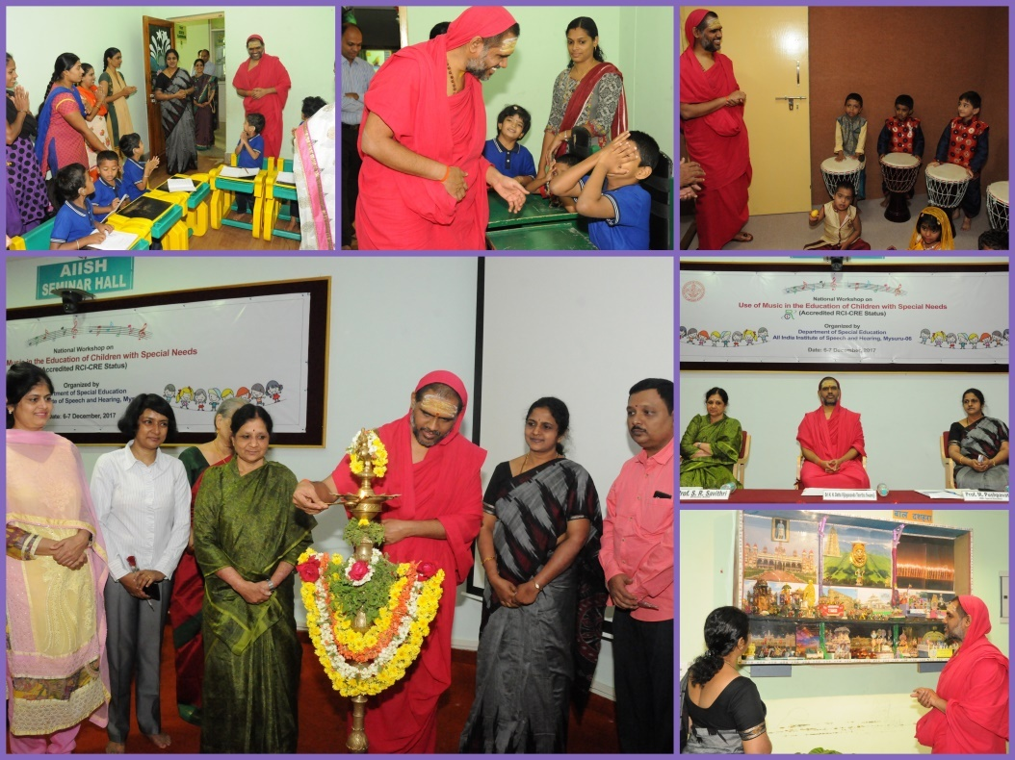

**Event:** Inaugural function of National Workshop on “Importance and Practices of Indian Sign

Language”

**Cooridnators:** Dr.Alok Kumar Upadhyay, Mr.Suresh C. B., Mr.Rajkumar R

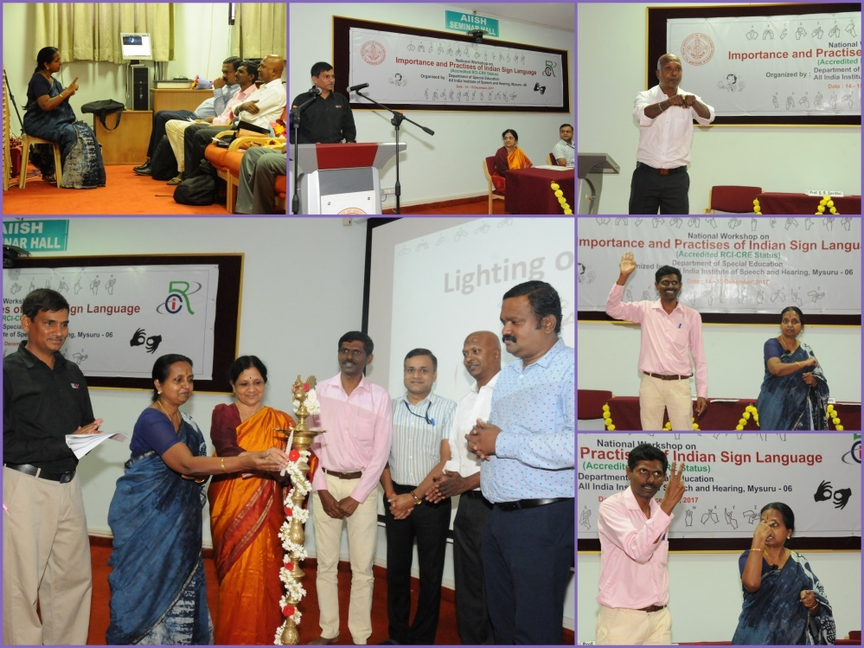

* + - 1. **Press Releases and Media Coverage: 08**
* 6th December 2017- Star of Mysore workshop program at AIISH was published.

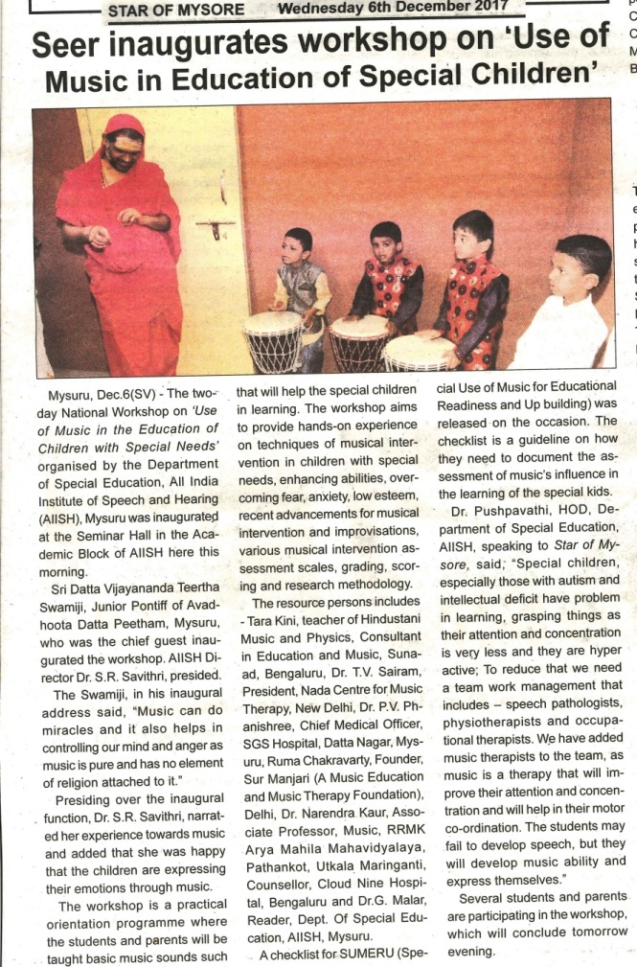

**C) Material Development :**The following Teaching Learning Materials and Prepare for training children with various communication disorders an preschool.

|  |  |  |  |
| --- | --- | --- | --- |
| **Sl.**  **No.** | **Nature of**  **Teaching-Learning**  **Materials** | **Skill** | **Number** |
| 1. | Flash cards | For all skill areas | 198 sets |
| 2. | Work Cards | For all skill areas | 70sets |
| 3. | Charts | For all skill areas | 55 |
| 4. | PPT | For all skill areas | 10 |
| 5. | Models | For all skill areas | 8 |
| 6. | Sentence strips | For all skill areas | 45 sets |
| 7. | Others | For all skill areas | - |

1. **AWARDS AND HONORS RECEIVED BY FACULTY AND STAFF**
2. EXTRA CURRICULAR ACTIVITIES
   * + - 1. **AIISH Gymkhana**

**Parent Help Parents Program (PHPP): 1**

|  |  |
| --- | --- |
| Name of the faculty/ staff | Mr.Umesh M , Parent of Haripriya and Supriya |
| Name/Topic of the Program | Parents help parents programme(PHPP) for Parents of children |
| Coordinator | Ms.Leena C C , Ms.Latha C |
| Objectives | * To help instil confidence in the parents/caregivers handling their child. * To train the parents in managing their stress levels while dealing with their child. * To motivate the parents for working more efficiently with their child. * To empower the parents regarding different aspects of training |
| Organized by Department/Section/Unit | Department of Special Education |
| Targeted Audience | Parents of Special Children |
| Date | 20.12.2017 |
| No.of beneficiaries | 60 |
| C:\Users\User\Pictures\Picasa\Collages\New folder (3)1.jpgPhoto | |

1. EMINENT VISITORS:

XI. **ANY OTHER**

* **OfficialLanguage Implementation:**
* Hindi Word a day
* No of notings/letters (**December 2017**): **65**

Sd/-

HOD- Special Education