**ALL INDIA INSTITUTE OF SPEECH AND HEARING, MYSURU-6**

**अखिल भारतीय वाक श्रवण संस्थान, मैसूर-६**

**DEPARTMENT OF SPECIAL EDUCATION**

**विशेषशिक्षाविभाग**

**MONTHLY REPORT November 2017**

**मासिक रिपोर्टअक्टूबर नवंबर 2017**

1. **ACADEMIC ACTIVITIES**
2. **Orientation Programs (For outsiders):** The following orientation programswere conducted to orient about the activities of the departmentand also to provide the knowledge about the educational facilities and welfare measures for children with special needs.

|  |  |  |  |  |
| --- | --- | --- | --- | --- |
| **SL No.** | **Coordinator** | **Targeted Audience** | **Number**  **of Participants** | **Date** |
| 01 | Dr. Vijetha P | MSc students, AIISH | 20 students | 02.11.2017 |
| 02 | Mr. Gururaj D | Students and staffs, Govt. Teacher’s Training Centre, Tilak nagar, Mysuru | 15 students. 1 staff | 02.11.2017 |
| 03 | Mr. Gururaj D | Students and staffs, Shree Shambhulingeshwara college of Education, Jayanthinagar, Pandavapura, Mandya | 35 students, 2 staffs | 03.11.2017 |
| 04 | Ms. Dhivya D | Students and staffs, KVM college of Special Education, KVM trust, Cherthala, Alappuzha | 97 students, 7 staffs | 08.11.2017 |
| 05 | Mr. Gururaj D | Students and faculty, S R Kanthi P G Centre Anubhava Sangam, Bagalkot | 12 students , 1 faculty | 08.11.2017 |
| 06 | Mr. Gururaj D | Students, RIMSE, Mysuru | 45 students | 16.11.2017 |
| 07 | Mr.Gururaj D | Nursing students, Govt. school of Nursing, K R Hospital, Mysuru | 35 students. 1 staff | 24.11.2017 |

1. **Posting (For outsiders): NIL**

|  |  |  |  |  |
| --- | --- | --- | --- | --- |
| **SL No.** | **Coordinator** | **Targeted Audience** | **Number**  **of Participants** | **Date** |

**Faculty report**

|  |  |  |  |  |  |
| --- | --- | --- | --- | --- | --- |
| **Name of the Faculty** | | **Dr.Alok Kumar** | **Dr. G. Malar** | **Dr.PrithiVenkatesh** | **Dr. P. Vijetha** |
| **Clinics** | | | | | |  |
| **No. of cases evaluated at SEA-U** | | 17 | * Screening: 17 clients in 17 sessions * Assessment: 1 client in 1 sessions | 04 | 04 |
| **No. of cases supervised individually** | | 04 | * 98 (aggregate 56) children through 20 classroom observations of 10 preschool groups * 6 children through 6 CSS/IEP sessions |  | NIL |
| **No. of groups supervised** | | 06 | * 10 preschool groups | 10 | 16 |
| **No. of meeting with parents** | | 03 | * 10 meetings in preschool groups | 10 | 09 |
| **Educational Guidance** | | 01 | * 10 clients * 11 sessions |  | NIL |
| **Academics** | | | | | |
| **Classes taken** | | | | | |
| **B.Ed.**  **Spl.Edn.(HI)** | **Theory** | 01 | * 01 | IV Semester: Practical postings  (Lesson Plan Discussion of two B.Ed.Spl.Edn-HI trainees)  II Semester:  Pedagogy of teaching school subjects-Science  **(Classes commenced from 30.11.2017: Taken one class on 30.11.2017)** | 01 |
| **Practical** |  | * 30 hours (during compensatory & vacation postings) | Student trainees had examinations, hence not posted |  |
| **Any others** |  |  |  |  | 1. On 10th & 13th November 2017, carried out invigilation duty for UG examinations. 2. Submitted inputs for changes in Indian Sign language course of B.Ed Spl. Edn. (HI) syllabus for BOS- Special Education |
| **Any other** | | | | | |  |
| **Meeting held** | |  | * 2 meetings with I & II B.Ed.Spl.Ed. (HI) students as mentor * 10 meetings with preschool parents * 3 meetings for coordination of national seminar on ASD |  |  |
| **Meeting attended** | |  | * 4 meetings with HOD regarding general departmental affairs, B.Ed.Spl.Ed. (HI) vacation & compensatory postings & forthcoming seminar s/workshops |  |  |
| **AV preparation** | |  | * 1PPT on visual arts in education for II B.Ed.Spl.Ed. (HI) * 1 supplementary English reader for preschool child Charan |  |  |
| **Brochures** | |  |  |  |  |
| **Workshop** | |  | * Workshop on Biofeedback – An Art & Science – organised by Department of Clinical Psychology on 03 & 04.11.17 * Webinar on ‘Cyber Security’ from TCPD, AIISH coordinated under Digital India on 08.11.17. |  |  |
| **Serve as Resource person** | |  | PEP on Pre-reading & Pre-writing Skills on 16.11.17 at Department of Special Education, AIISH | Provided an orientation programme to M.Sc. students about Special Education Departmental services. |  |
| **Roles & Responsibilities** | | | | | |  |
| **Co-ordination** | | PARENTINFANT PROGRAM UNIT  PRESCHOOL PARENT INRICHMMENT PROGRAM UNIT | * CBCS Coordinator for I & II B.Ed.Spl.Ed. (HI) * Compilation of M.S.Ed. Student Dissertation-based Articles 2014-15 * Intra-Department * SEA-U   Research & Database Unit | * Coordinating International Day of Persons with Disabilities to be held on 8th December 2017. | 1. **ISO** 2. **Services for School age children**  * Checked the lesson plans and discussed with respective teachers. * Carried out supervision as per the schedule provided. * On 29th Nov 2017, discussed and divided the responsibilities among team members. |
| **Member secretary** | | PRESCHOOL | * LD Clinic (in DCS) * Services for School-Aged Children (in Department of Special Education) |  | NIL |
| **Member in** | | SPECIAL EDUCATION ASSESSMENT UNIT | * TCPD * Product Development Cell * Preschool Supervision * Allied member of ISHA * Life member of NCED |  | SEA-U |
| **Mentor** | | M.Sc 2 year-Audiology | * Mentor for I & II B.Ed.Spl.Ed. (HI) | I M.Sc SLP (B Section) | Mentor - II BASLP section A  Submitted attendance. |

1. Clinical /Educational Observation Postings of Students from other Institutes:NIL

Following are the details of students posted for observation/ practice teaching

|  |  |  |  |  |
| --- | --- | --- | --- | --- |
| **Sl.No** | **Name of the Institute** | **Programme/Course** | **Number of Students** | **Dates** |

1. Seminars/Conferences/**Workshops**/Training Programs:NIL

|  |  |
| --- | --- |
| **Theme/topic** |  |
| **Coordinator** |  |
| **Resource Person** |  |
| **Objectives** |  |
| **Targeted Audience** |  |
| **Number of Participants** |  |
| **Date** |  |
| **Photo** | |

1. Staff Enrichment / **In-house training Programmes***(For own staff members)* : NIL

|  |  |  |  |  |  |
| --- | --- | --- | --- | --- | --- |
| **Theme/Topic** | **Resource Person** | **Coordinator** | **Objectives** | **Targeted Audience** | **Date** |

1. **Guest Lectures :NIL**

|  |  |  |  |
| --- | --- | --- | --- |
| **Name, Designation, Institutional affiliation of Lecturer** | **Organized by Department/Section/Unit** | **Topic of Lecture** | **Date** |
|  |  |  |  |

1. **Additional Academic Services rendered by the Faculty and Staff**
2. **Invited Talks: 2**

|  |  |  |  |  |
| --- | --- | --- | --- | --- |
| **Staff** | **Topic** | **Date** | **Programme** | **Institution** |
| G. Malar | Pre-Reading & Pre-Writing Skills | 16.11.2017 | Parent Enrichment Programme | Department of Special Education, AIISH |
| Dr. Palnaty Vijetha | Sharing experiences of working with the Deaf | 18th November 2017 | Workshop on “Sharing experiences of working with the Deaf” | Sheila Kothavala school for the deaf, Bengaluru organized by Deaf Aid Society in view of 50th Golden Jubilee Celebrations. |

1. Curriculum Development: NIL
2. **Development of Material to Support Learning :** G. Malar – Revision of Training Manual – Visual Arts for Preschoolers
3. **Service in Academic Bodies of other Organizations:**
4. Dr. Alok Kumar Upadhyay

Member of Board of studies(BOS) in three Universities:

1- Ramkrishna Mission Vivekanand University,Coimbatore

2- JRH University,Chitrakoot

3- NGB University,Allahabad

Member of Board of Examination (BOE): Mysore University

1. G. Malar – BOE–Special Education of University of Mysore
2. Participation in Committees/Taskforce and Panels setup by other organizations/agencies:NIL

|  |  |  |  |  |  |  |
| --- | --- | --- | --- | --- | --- | --- |
| **Sl No** | **Name of the staff** | **Name of Organization/Agency** | **Participation in Committees/Taskforce** | **Programme** | **Name of Institute Visited** | **Date of Visit** |
|  |  |  |  |  |  |  |

1. **Any Others (Please Specify)**

**RESEARCH ACTIVITIES (2016-17)**

1. Research Projects (ARF)
2. Completed -NIL
3. New Research Projects- NIL
4. **Ongoing Research Projects –02**
   * 1. **Title of ARF** - Development and Evaluation of Indigenous curriculum oriented computer based tutor for concept learning in preschool children with special needs.

Principal Investigator – Ms. P.V. Ramanakumari

Co-Investigators – Dr. Ajish K Abraham and Ms. P.V. Manjula

Research Assistant – Mr. Anil Abbur R.

Date of Starting – 18th January 2017

* + 1. **Title**: Effect of Resource Materials on Impact of Inclusive Education in Children with Intellectual Disabilities (ID) and Learning Disabilities (LD)

Investigators: Dr. G. Malar, Ms. S. Prathima & Mr. D. Gururaj

Duration: 12 months from January 2017

Budget: Rs. 3,85,000/-

Process: \* Video recording of 3 snippets with CwID & 6 snippets with CwLD \* Finalised 4 sets of tools with Kannada translation (provided to DMD for improvisation) \*Continuing with RoL

1. Postgraduate Research Completed:- NIL
2. C. Postgraduate Research ongoing: NIL
3. **D. Research Papers presented at National/International Conferences/Seminars :- NIL**

E.Research Papers Published

i**)** Papers published in National / International Journals: NIL

ii) Papers published in Conference / Seminar Proceedings: NIL

F. Books published (in APA format)

1. Books published: NIL

G.Book chapters published (in APA format)-NIL

H .Books/Manuals/Seminar Proceedings edited: NIL

1. Journal Editorship: NIL

J. Scholarly Reviewing Activities:

1. **Special Educational Services Offered through Teacher Trainees Outside Campus:**

**Dr.Malar**

|  |  |  |  |
| --- | --- | --- | --- |
| **S. No.** | **Nature of Activity** | **Services Provided** | **Details of Beneficiaries** |
| 1. | Educational Assessment | --- | --- |
| 2. | Practice-Teaching in Mainstream Schools/ Institutions | -- | --- |
| 3. | Practice-Teaching in Special Schools/ Institutions | -- | -- |

**III CLINICAL SERVICES**

1. General Clinical Services: **Not Applicable**
2. Specialized Clinical/ Educational Services
3. **Preschool Training and Special Education**

**Educational services for children with special needs**

|  |  |  |  |  |  |  |  |  |  |  |  |  |
| --- | --- | --- | --- | --- | --- | --- | --- | --- | --- | --- | --- | --- |
| **S. No.** | **Nature of Services (I/C)** | | | | | | | | | | | |
| 1. Special Educational Assessment Services (Dr. G. Malar) | | | | | | | | | | | | |
|  |  | Nature of Special Need  Language | ASD / PDD NOS | Hearing Loss | Intellectual Disability | Learning Disability | Motor Problems | Multiple Disabilities | Others | No. of Clients | No. of Sessions | ***Total No. of Sessions*** |
| 1. | Screening & Referral | Kannada | 01 | 10 | 05 | - | 02 | - | 06 | ***24*** | ***24*** | ***42*** |
| Malayalam | 03 | 02 | 01 | - | 04 | 01 | 01 | ***12*** | ***12*** |
| Hindi | 01 | 02 | 01 | - | - | - | - | ***04*** | ***04*** |
| Urdu | - | - | - | - | - | - | - | ***-*** | ***-*** |
| English | - | - | - | - | - | - | - | ***-*** | ***-*** |
| Telugu | - | - | - | - | - | - | - | ***-*** | ***-*** |
| Tamil | - | - | - | - | - | - | - | ***-*** | ***-*** |
| Any Other | - | - | - | - | - | - | - | ***-*** | ***-*** |
| ***Total No. of Clients*** | ***05*** | ***14*** | ***09*** | ***-*** | ***06*** | ***01*** | ***07*** | ***42*** | ***42*** |
| 2. | Assessment & Report | Kannada | - | 01 | 01 | - | - | 01 | - | ***01*** | ***12*** | ***16*** |
| Malayalam | - | - | 02 | - | - | - | - | ***01*** | ***03*** |
| Hindi | - | - | - | - | - | - | - | ***-*** | ***-*** |
| Urdu | - | - | - | - | - | - | - | ***-*** | ***-*** |
| English | - | - | - | - | - | - | - | ***-*** | ***-*** |
| Telugu | - | - | - | - | - | - | - | ***-*** | ***-*** |
| Tamil | - | - | 01 | - | - | - | - | ***01*** | ***01*** |
| Any Other | - | - | - | - | - | - | - | ***-*** | ***-*** |
| ***Total No. of Clients*** | ***-*** | ***01*** | ***01*** | ***-*** | ***-*** | ***-*** | ***-*** | ***-*** | ***13*** |
| Places from which seen: (1)Karnataka: 28 (2)Kerala: 10 (3)AP: Nil (4)Telengana: Nil (5)TN: 03 (6)Other Parts of India: 01 (7)Any other: Nil | | | | | | | | | | | |
| Age groups seen:(1)Birth to 2.5yrs: 05 (2)2.5+ to 6 yrs: 28 (3)6yrs+ to 16 years: 06 (4)16yrs+: 03 | | | | | | | | | | | |
| Total No. of Referrals: (1)Educational Assessment: 02 (2)Educational Guidance: 02 (3)PIP: 06 (4)PPEP/ PBC/ GECS: 27 (5)CSS/IEP/NFE/DET: 08 (6)Any Other Services at AIISH: Nil (7)Any Other Services Outside AIISH: 01 (mainstreaming) | | | | | | | | | | | |
| No. of Reports Issued/Ready for Issue: (1) School Readiness: 03 (3) Curriculum-Based Assessment: 03 (4) Post-School: 01 | | | | | | | | | | | |

|  |
| --- |
| **Preschool Training:Preparatory programme for schooling providing training in self-help, cognitive, language and (pre) academic skills, Preschool Supplementary Services (PSS)** |
| |  |  |  |  | | --- | --- | --- | --- | | **Language & Disability** | **No. of Groups** | **No. of Children** | | |  |  | MALE | FEMALE | | Kannada ASD & ID &MD | 14 | 47 | 15 | | Kannada HL | 8 | 36 | 23 | | Malayalam HL | 1 | 2 | 1 | | Malayalam ASD & ID & MD | 10 | 25 | 11 | | Hindi HL | 2 | 7 | 4 | | Hindi MD & ID & ASD | 2 | 7 | 2 | | English ID, ASD | 1 | 5 | 0 | | Telugu ASD & ID & MD | 1 | 5 | 2 | | TOTAL Number of children |  | **134** | **58** | | **TOTAL No. Groups** | **39** | **192** | | | **Sessions** | **3276(Group wise) 21 days** | | | |

|  |  |  |  |  |  |
| --- | --- | --- | --- | --- | --- |
| **Curricular Support Services – Supportive training to augment education in mainstream school/ other educational programmes** | **Language** | **HL** | **ID/CP/ASD/MD/LD/DD** | **Total No. of clients** | **No. Of sessions** |
| Kannada | 3 | 12 | 15 | 91 |
| Malayalam | - | 1 | 01 | 7 |
| Hindi | 1 | 2 | 03 | 3 |
| English | 1 | 7 | 08 | 24 |
| Telugu | - | - | - | - |
| Tamil | - | - | - | - |
| **Total** | | | | **27** | **125** |
| |  |  |  |  |  |  | | --- | --- | --- | --- | --- | --- | | **Individualised Educational Programme (IEP) – Training in functional academics for out of school individuals** | **Language** | **HL** | **ID/CP/ASD/MD/LD/DD** | **Total No. of clients** | **No. Of sessions** | | Kannada | 2 | 8 | 10 | 45 | | Malayalam | - | 3 | 3 | 16 | | Hindi | - | 2 | 2 | 8 | | English | - | 1 | 1 | 5 | | Telugu | - | - | - | - | | Tamil | - | 1 | 1 | - | | **Total** | - | - | **17** | **74** | | | | | | |
| |  |  |  |  |  |  | | --- | --- | --- | --- | --- | --- | | **Demonstration Educational Training – Short-term demonstration to caregivers in any of the above** | **Language** | **HL** | **ID/CP/ASD/MD/LD/DD** | **Total No. of clients** | **No. Of sessions** | | Kannada | 1 | 4 | 5 | 25 | | Malayalam | - | 1 | 1 | 5 | | Hindi | 1 | - | 1 | 2 | | English | - | - | - | - | | Telugu | - | - | - | - | | Tamil | - | - | - | - | | **Total** | - | - | **7** | **32** | | | | | | |
| **Total cilents: 51**  **Old clients:- 47**  **New clients: - 04**  **Discharged(DET):- 02**  **Discharged(CSS):- NIL**  **Discharged(IEP):- Nil**  **Discontinued(DET):- NIL**  **Discontinued(CSS):- 01**  **Discontinued(IEP):- NIL**  **No. of remaining cilents: 48** | | | | | |

|  |  |  |  |  |  |  |  |  |  |  |  |
| --- | --- | --- | --- | --- | --- | --- | --- | --- | --- | --- | --- |
|  | **Preschool Parent Empowerment Programme – PPEP** | | | | | | | | | | |
|  | **Language** | **HL** | **ID** | **CP** | **ASD** | **MD** | **LD** | **DD** | **SLD** | **Total No. of clients** | **No. Of sessions** |
| Kannada | 40 | 22 | 02 | 08 | 14 | -- | 01 | -- | 87 | 220 |
| Malayalam | 13 | 20 | 04 | 07 | 14 | -- | 01 | 01 | 60 | 100 |
| Hindi | 06 | 05 | -- | 01 | 01 | -- | -- | -- | 13 | 40 |
| English | 01 | 04 | -- | 03 | 01 | -- | -- | -- | 9 | 20 |
| Telugu | 03 | 01 | -- | -- | -- | -- | -- | -- | 4 | 20 |
| Tamil | 03 | 03 | -- | -- | 01 | -- | -- | -- | 7 | 20 |
| **Total** | | | | | | | | |  | **180** | **420** |
| No. of clients promoted to the next higher level(Preschool) of service: 40  No. Of discharged : 02  No. Of discontinued: 40  No. Of New clients (**November**) : 23 clients  Shifted from PIP to PPEP: 01  Shifted to from PPEP to PIP : Nil  No. of remaining cilents: **138** | | | | | | | | | | | |

|  |  |  |  |  |  |
| --- | --- | --- | --- | --- | --- |
| **Parent-Infant Programme – PIP(Birth to 2 ½ years)** | | | | | |
| Parent-Infant Programme | **Language** | **HL** | **ID/CP/ASD/MD/LD/DD** | **Total No. of clients** | **Total No. Of sessions** |
| Kannada | 7 | 8 | 15 | 67 |
| Malayalam | 6 | 19 | 25 | 89 |
| Hindi | 2 | 1 | 3 | 11 |
| English | - | - | -- | -- |
| Telugu | 1 | 1 | 2 | 07 |
| Tamil | - | - | -- | -- |
|  | **Total** | | | **45** | **174** |
| Specific age range:  No. of Old clients :**40**  No. of New clients enrolled: **05**  Total cilents:**45**  No. discharged :**NIL**  No. discontinued:**01**  No. of Promoted to next level: **01**  No. of Remaining:**43** | | | | | |

|  |  |  |
| --- | --- | --- |
| **Library of Books & Toys** – LiBoToy  Services issuing educational toys & books for home-based training. | Total number of members enrolled –196  No. of new members: - 09  Amount – 450/-  Total number of sessions –25 | |
| **Age group** | **Total number** |
| 0-2.6 yrs | 10 |
| 2.6-4 yrs | 43 |
| 4.0-6yrs | 135 |
| 6 yrs and above | 08 |

|  |  |  |
| --- | --- | --- |
| **Services** | **Number of Clients** | **Number of Sessions** |
| Co-Curricular Training | 198 | 22 |

**Supports for Empowering Caregivers**

|  |  |  |  |
| --- | --- | --- | --- |
| Name of Training Unit | No. of Parent  Beneficiaries | No. of Sessions | Content of Training |
| Caregiver Computer Training Unit | 4 | 6 | MS-Paint |
| Caregiver Literacy Training Unit | -- | -- | -- |

1. Clinical Support Services to Clients and Family
2. **Counselling and guidance**

|  |  |
| --- | --- |
| No. of Clients | Sessions |
| 75 | 68 |

1. **U-SAFE**

|  |  |
| --- | --- |
| No. of Clients | Sessions |
| -- | -- |

1. **Details of Certificates Issued:**

**Details of Bonafide Certificates Issued:**

|  |  |  |  |
| --- | --- | --- | --- |
| **Sl.No.** | **Nature of Special Needs in Clients** | **No. of Certificates Issued** | **Purpose** |
|  |  |  |  |
|  |  |  |  |

1. Financial Aid- NIL
2. Legal advice -NIL
3. **Any other(Please Specify):**

**Attended to workshop/Seminar/Orientation program in AIISH institute 2017**

|  |  |  |
| --- | --- | --- |
| **Name of Staff** | **Attended to workshop title name** | **Date** |
| Dr. Alok Kumar  Dr. Kadambari | “Translation of Public Education Material in Hindi-Phase-II” | 28.11.2017 |

EXTENSION ACTIVITIES

1. Public Lecture Series
   * 1. TECHNLOGICAL CONSULTANCY SERVICES: Not applicable
        1. CENTRAL FACILITIES
        2. Library and Information Services
        3. Public Information Activities
        4. Major Events of the Year with a brief account

**Event:** Children Day 2017

**Cooridnators:** Dr. Prithi Venkatesh and Dr. Vijetha P

**FEW GLIMPSES OF CHILDREN’S DAY EVENTS-HEALTH CAMP, INAUGURATION OF THEME BASED EDUCATIONAL MODELS AND SPECIAL PLAY AREA HELD ON 14TH NOVEMBER 2017 AT THE DEPARTMENT OF SPECIAL EDUCATION**

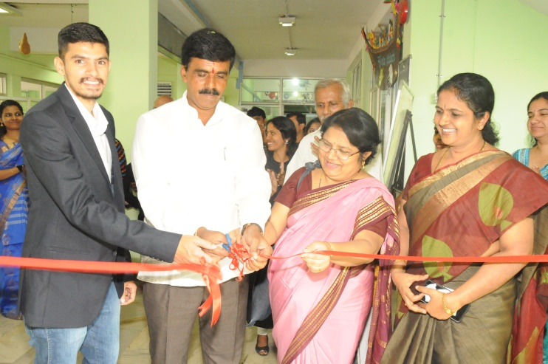

**Inauguration of theme based educational models by Chief Guest and Guest of Honour on 14th November on the occasion of Children’s Day 2017**

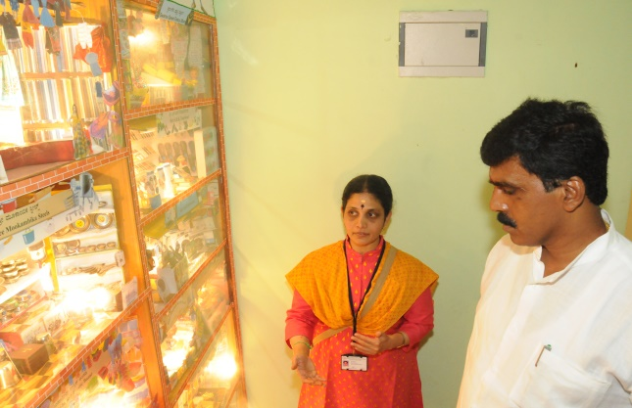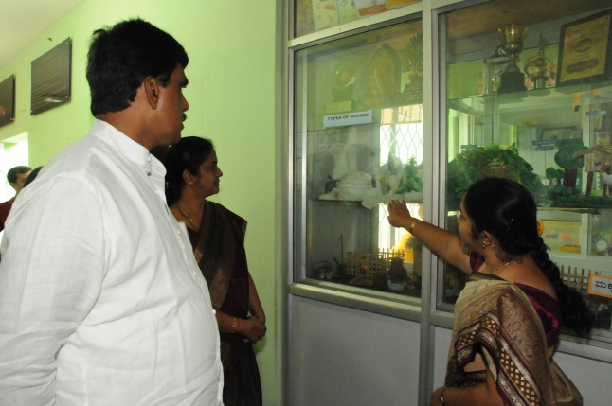

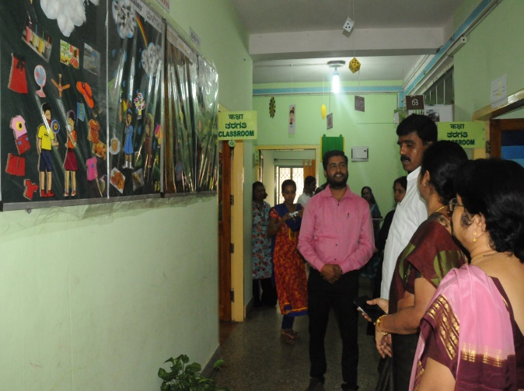

**Explanation of theme based educational models by special educators**

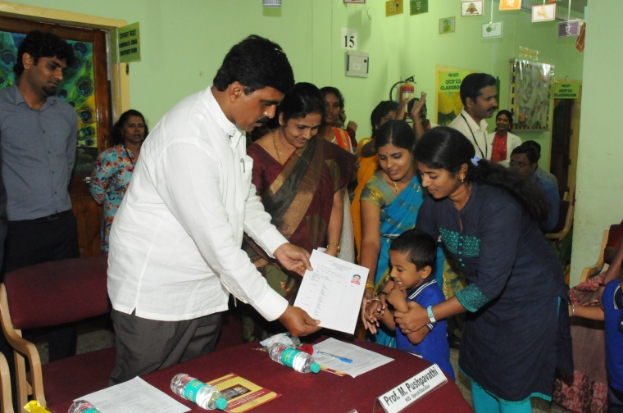

**Inauguration of Health Camp**

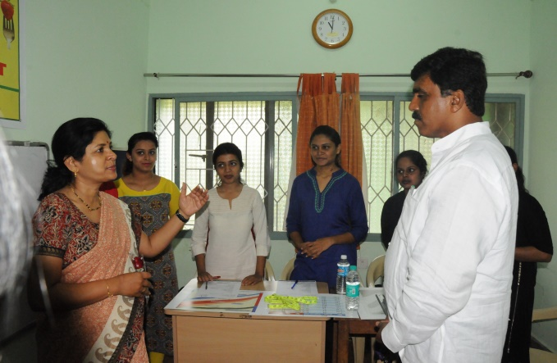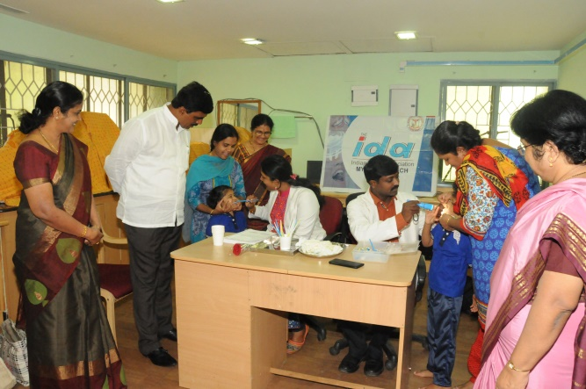

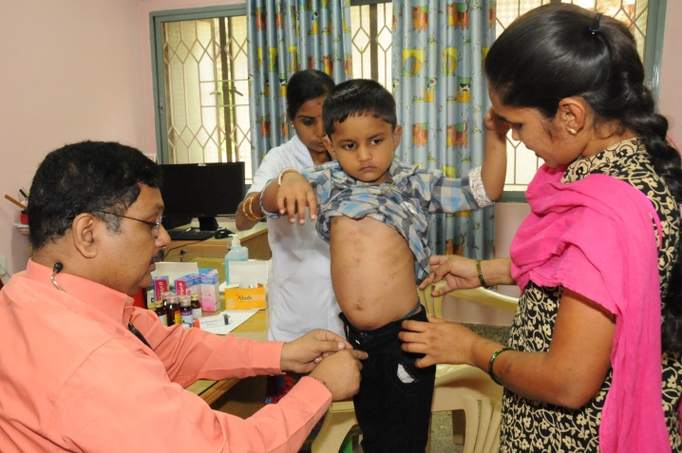

**Doctors rendering their services during health camp**

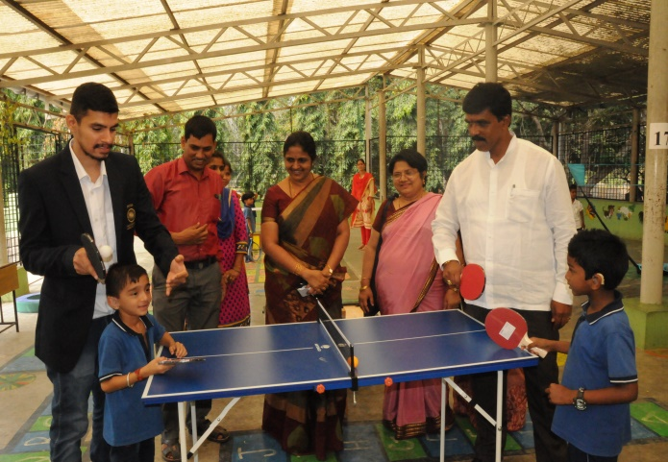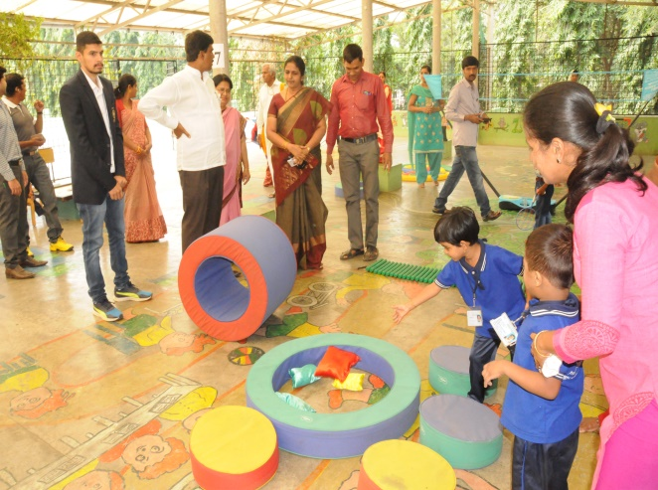

**Special play area for children with special needs**

* + - 1. **Press Releases and Media Coverage: 08**
* 14th November 2017- Star of Mysore Children’s day program at AIISH was published.
* 15th November 2017– Adolana Children’s day program at AIISH was published.
* 15th November 2017– Samyuktha Karnataka Children’s day program at AIISH was published.
* 15th November 2017– Kannada prabha Children’s day program at AIISH was published.
* 15th November 2017– Prajanudi Children’s day program at AIISH was published.
* 15th November 2017– The Hindu Children’s day program at AIISH was published.
* 15th November 2017– Vijayakarnataka Children’s day program at AIISH was published.
* 15th November 2017– Vijayavani Children’s day program at AIISH was published.

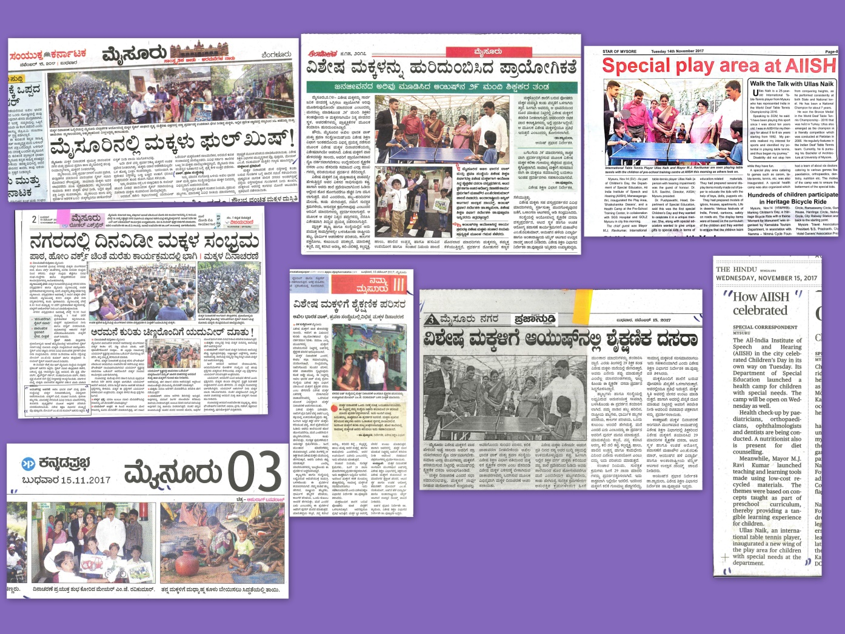

**C) Material Development :**The following Teaching Learning Materials and Prepare for training children with various communication disorders an preschool.

|  |  |  |  |
| --- | --- | --- | --- |
| **Sl.**  **No.** | **Nature of**  **Teaching-Learning**  **Materials** | **Skill** | **Number** |
| 1. | Flash cards | For all skill areas | 226 sets |
| 2. | Work Cards | For all skill areas | 86 sets |
| 3. | Charts | For all skill areas | 69 |
| 4. | PPT | For all skill areas | 15 |
| 5. | Models | For all skill areas | 9 |
| 6. | Sentence strips | For all skill areas | 65 sets |
| 7. | Others | For all skill areas | - |

1. **AWARDS AND HONORS RECEIVED BY FACULTY AND STAFF**
2. EXTRA CURRICULAR ACTIVITIES
   * + - 1. **AIISH Gymkhana**

**Parent Enrichment Program (PEP): 1**

|  |  |
| --- | --- |
| Name of the Resource Person | Dr. Malar G, Reader in Special Educaton |
| Name/Topic of the Program | Parent Enrichment Program (PEP) for Parents of children |
| Coordinator | Ms. Latha C., Ms. Leena C C |
| Objectives | * To help instil confidence in the parents/caregivers handling their child. * To train the parents in managing their stress levels while dealing with their child. * To motivate the parents for working more efficiently with their child. * To empower the parents regarding different aspects of training |
| Organized by Department/Section/Unit | Department of Special Education |
| Targeted Audience | Parents of Special Children |
| Date | 16.11.2017 |
| No.of beneficiaries | 125 |
| Photo | **C:\Users\User\Downloads\SHAREit\ASUS_Z012DB\photo\P_20171116_113522_vHDR_Auto.jpg**  **C:\Users\User\Downloads\SHAREit\ASUS_Z012DB\photo\P_20171116_113612_vHDR_Auto.jpg** |

1. EMINENT VISITORS:

XI. **ANY OTHER**

* **OfficialLanguage Implementation:**
* Hindi Word a day
* No of notings/letters (**November 2017**): **60**

Sd/-

HOD- Special Education