**ALL INDIA INSTITUTE OF SPEECH AND HEARING, MYSURU-6**

**अखिल भारतीय वाक श्रवण संस्थान, मैसूर-६**

**DEPARTMENT OF SPECIAL EDUCATION**

**विशेषशिक्षाविभाग**

**MONTHLY REPORT October2017**

**मासिक रिपोर्टअक्टूबर 2017**

1. **ACADEMIC ACTIVITIES**
2. **Orientation Programs (For outsiders):04**

The following orientation programswere conducted to orient about the activities of the departmentand also to provide the knowledge about the educational facilities and welfare measures for children with special needs.

|  |  |  |  |  |
| --- | --- | --- | --- | --- |
| **SL No.** | **Coordinator** | **Targeted Audience** | **Number**  **of Participants** | **Date** |
| 01 | Mr. Gururaj D | Students, NIE Institute of Technology (ECE Department), #50, next to BEML , Koorgalli, Mysuru |  | 05.10.2017 |
| 02 | Mr. Gururaj D | Students and staffs, BGS BE.d College, Mysuru | 180 students, 8 staffs | 06.10.2017 |
| 03 | Mr. Gururaj D | Students, SM Lingappa College of Education, Mandya, Karnataka | 38 students, 4 staffs | 09.10.2017 |
| 04 | Dr. Prithi V | MSc students, AIISH | 32 students | 26.10.2017 |

1. **Posting (For outsiders): NIL**

|  |  |  |  |  |
| --- | --- | --- | --- | --- |
| **SL No.** | **Coordinator** | **Targeted Audience** | **Number**  **of Participants** | **Date** |

**Faculty report**

**Dr. M. Pushpavathi**, HOD in Special Education

* **Attended purchase meeting**
* Coordinated for the work related to inauguration of special Olympics program held on 9th and 10th
* Supervised the work related to development of resource material based on different concepts

|  |  |  |  |  |  |
| --- | --- | --- | --- | --- | --- |
| **Name of the Faculty** | | **Dr.Alok Kumar** | **Dr. G. Malar** | **Dr.PrithiVenkatesh** | **Dr. P. Vijetha** |
| **Clinics** | | | | | |  |
| **No. of cases evaluated at SEA-U** | | 12 | * Screening: 11 clients in 11 sessions * Assessment: 3 clients in 10 sessions |  | 19 |
| **No. of cases supervised individually** | | nil | * 25 children through 4 classroom observations of 4 preschool groups |  | 01 |
| **No. of groups supervised** | | 09 | * 10 preschool groups |  | 26 |
| **No. of meeting with parents** | | 07 | * 10 meetings in preschool groups |  | 09 |
| **Educational Guidance** | | 01 | * 8 clients * 10 sessions |  | 1 (7) |
| **Academics** | | | | | |
| **Classes taken** | | | | | |
| **B.Ed.**  **Spl.Edn.(HI)** | **Theory** | 20 classes | * 20 (including 5 extra) | III Semester: Communication Options: Manualism: 7 classes  Reading and Reflection of text: 6 classes  I Semester:  Assessment and Identification of Needs: 5 classes | 8 classes |
| **Practical** | 10 hour | * 39 hours | 6 hours | 18 hours  (Model teaching, supervision and guidance for micro teaching was carried out for I B.Ed. trainees and ISL for III B.Ed. trainees) |
| **Any others** |  |  |  |  |  |
| **Any other** | | | | | |  |
| **Meeting held** | |  | * 4 meetings with I & II B.Ed.Spl.Ed. (HI) students as mentor * 10 meetings with preschool parents * 1 meeting for coordination of workshop on ASD |  | 1. On 6th October 2017, safety mats purchase indent was re-sent. 2. On 12th October 2017, submitted list of journals and books to the Library. 3. Drafted and submitted the workshop proposal with program schedule and budget on *Inclusive Education t*o the Director and sent an email to the Resource person.   Coordinated in drafting proposal and budget for upcoming children’s day celebrations |
| **Meeting attended** | |  | * 1 meeting with HOD regarding B.Ed.Spl.Ed. (HI) vacation & compensatory postings |  | On 11th October 2017, attended peer review meeting of TCPD and also on ORS and Mera hospital |
| **AV preparation** | |  |  |  |  |
| **Brochures** | |  |  |  |  |
| **Workshop** | |  |  |  |  |
| **Serve as Resource person** | |  |  | Provided an orientation programme to M.Sc. students about Special Education Departmental services. |  |
| **Roles & Responsibilities** | | | | | |  |
| **Co-ordination** | | PARENTINFANT PROGRAM UNIT  PRESCHOOL PARENT INRICHMMENT PROGRAM UNIT |  |  | 1. **ISO** 2. **Services for School age children**  * Discussed the minutes of the meeting & issues with the HOD. * Carried out supervision as per the schedule provided. * Working on streamlining of service delivery process. |
| **Member secretary** | | PRESCHOOL |  |  | NIL |
| **Member in** | | SPECIAL EDUCATION ASSESSMENT UNIT |  |  | SEA-U |
| **Mentor** | | M.Sc 2 year-Audiology |  | I M.Sc SLP (B Section) | Mentor - II BASLP section A  Submitted attendance. |

1. Clinical /Educational Observation Postings of Students from other Institutes:NIL

Following are the details of students posted for observation/ practice teaching

|  |  |  |  |  |
| --- | --- | --- | --- | --- |
| **Sl.No** | **Name of the Institute** | **Programme/Course** | **Number of Students** | **Dates** |

1. Seminars/Conferences/**Workshops**/Training Programs:01

|  |  |
| --- | --- |
| **Theme/topic** | Workshop on ‘*Young Athlete Training Programme’* |
| **Coordinator** | Ms. S. Vijayalakshmi and Mr. Subramanya K. R |
| **Resource Person** | Mr. Vasanthkumar Shetty, Area Director, SOB-Karnataka |
| **Objectives** | To impart knowledge about the special Olympics and Paralympics to caregivers and special children. |
| **Targeted Audience** | Caregivers, Special children and Special Educators |
| **Number of Participants** | 130 |
| **Date** | 9-10, October 2017 |
| **Photo**  C:\Users\User\Pictures\Picasa\Collages\drive-download-20171025T101041Z-001.jpg | |

1. Staff Enrichment / **In-house training Programmes***(For own staff members)* : NIL

|  |  |  |  |  |  |
| --- | --- | --- | --- | --- | --- |
| **Theme/Topic** | **Resource Person** | **Coordinator** | **Objectives** | **Targeted Audience** | **Date** |

1. **Guest Lectures :NIL**

|  |  |  |  |
| --- | --- | --- | --- |
| **Name, Designation, Institutional affiliation of Lecturer** | **Organized by Department/Section/Unit** | **Topic of Lecture** | **Date** |

1. **Additional Academic Services rendered by the Faculty and Staff**
2. **Invited Talks:**

|  |  |  |  |  |
| --- | --- | --- | --- | --- |
| **Staff** | **Topic** | **Date** | **Programme** | **Institution** |
| Dr. Kadambari N | “A Study on Self Concept and Academic Anxiety among Adolescent Children with Hearing Impairment” | 10-11, October 2017 | National Conference on “Inclustion: Issues Challenges and Possibilities”, | University of Delhi, New Delhi. |
| Ms. Shobha B N | “Role of special educator in management of Children with Cerebral palsy in a regular classroom, and available assistive devices to enhance reading and writing skill” | 06.10.2017 | World Cerebral palsy day | AIISH |

1. Curriculum Development: NIL
2. **Development of Material to Support Learning : 07**

* **Theme “***DevelopingResource Materials for Children”*

**The following materials have been developed to teach different concepts**

1. **Pre-Academic**

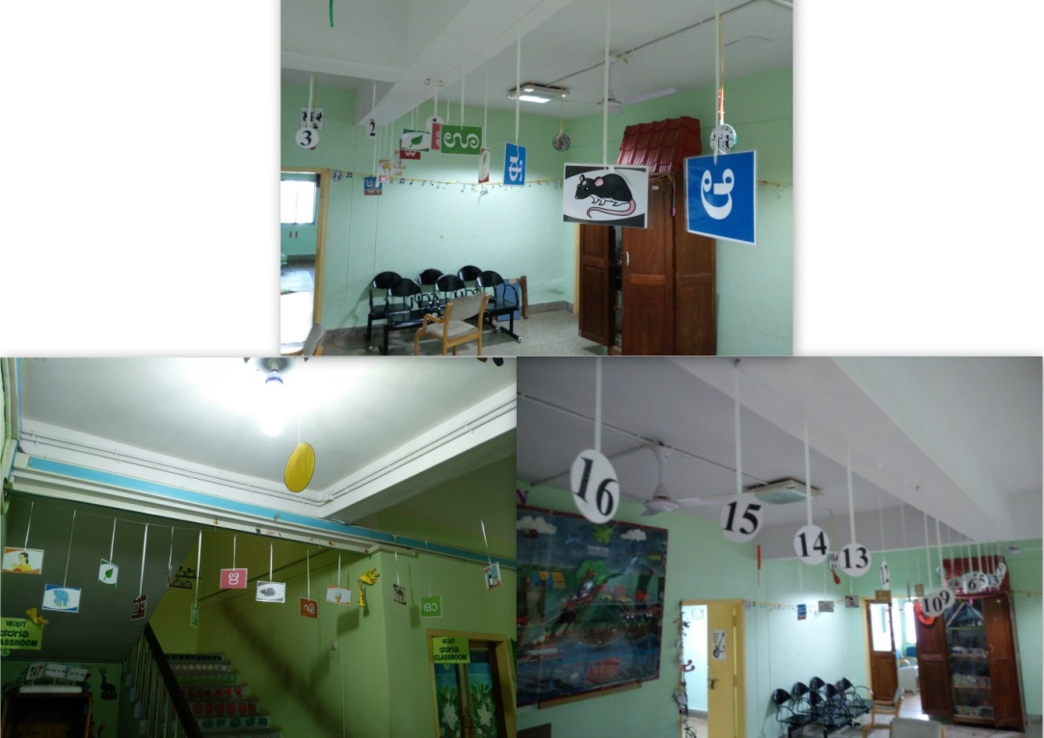

1. 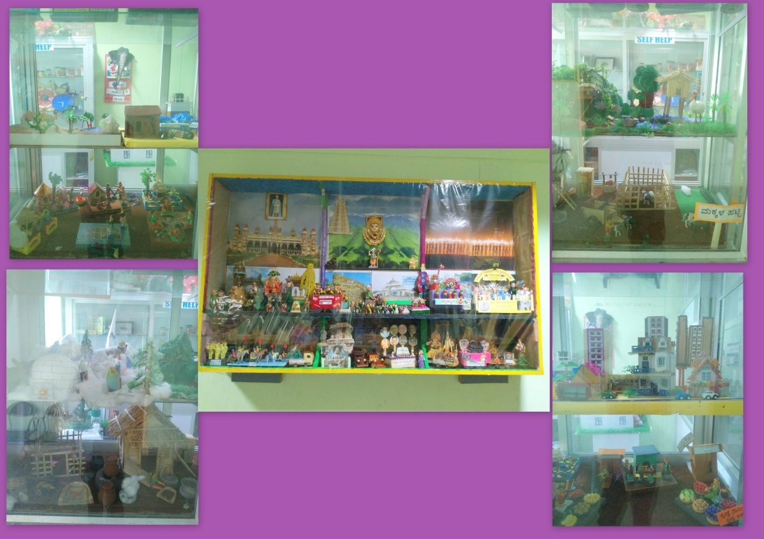**Landscape and House and Dasara concept**
2. 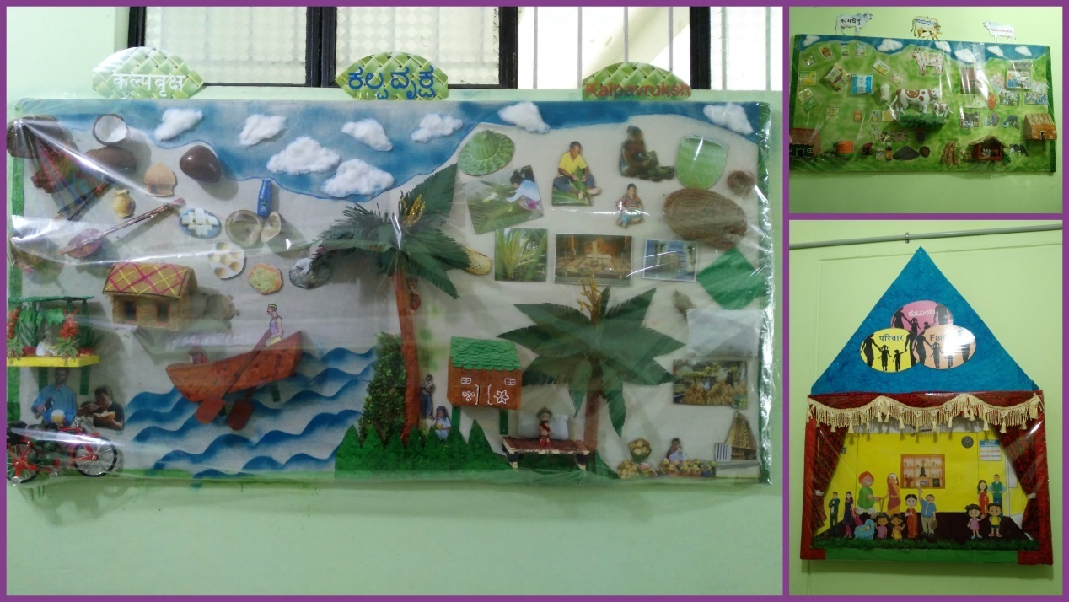**K3 - Kutumba Kama Dhenu Kalpa Vruksha**
3. **Seasons**

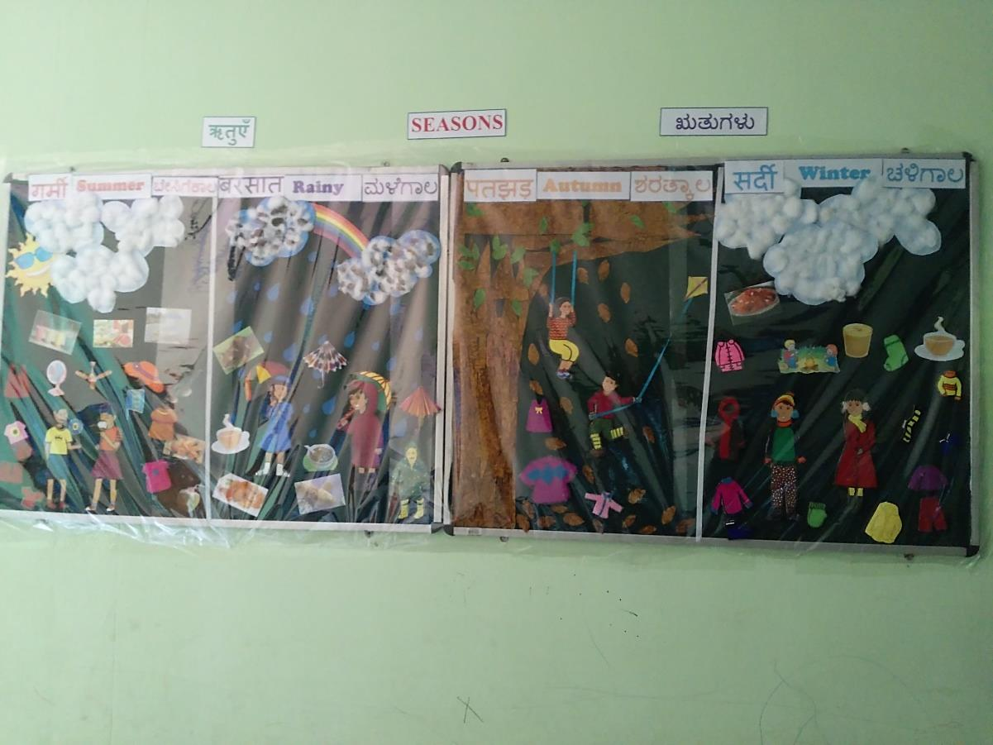

1. **Safety measures for children**

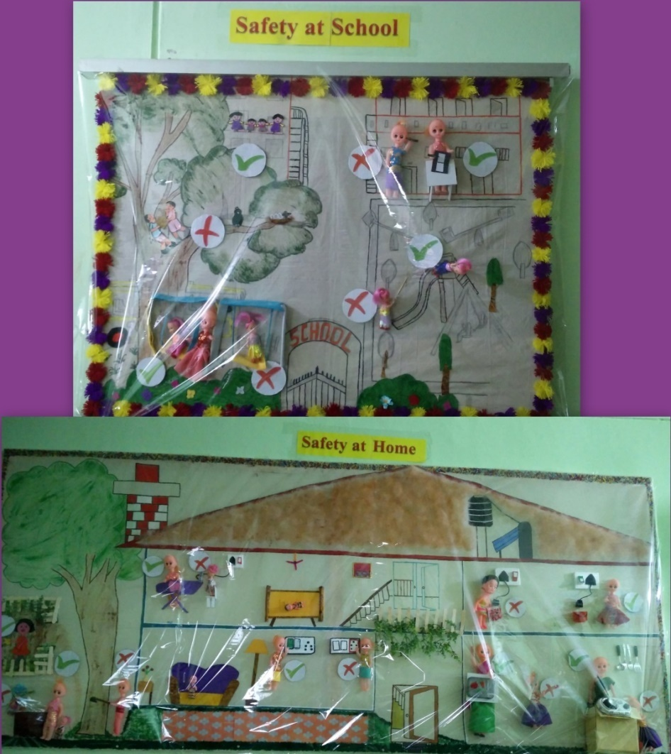

1. **Market**

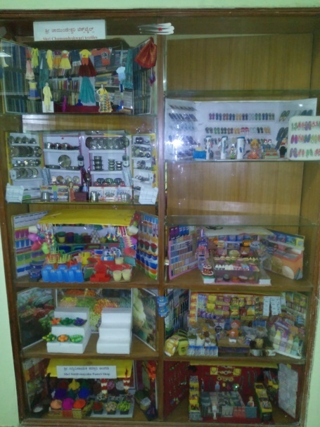

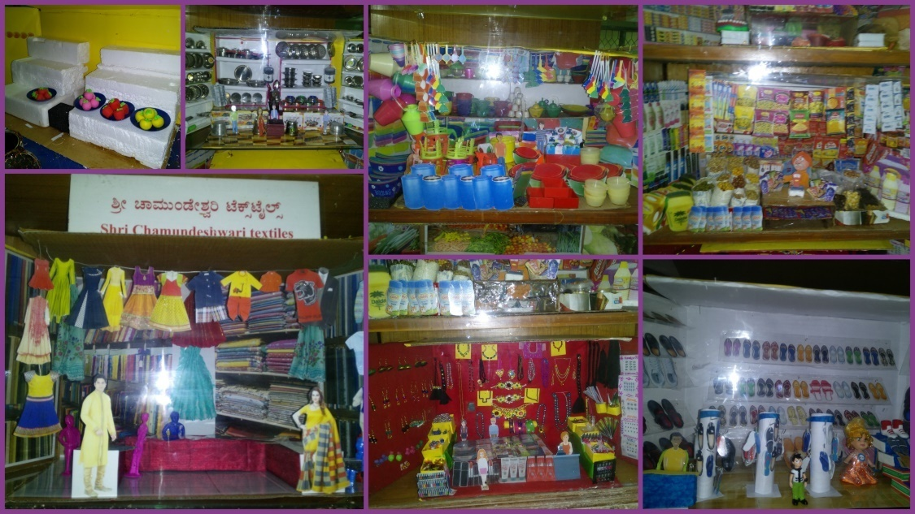

1. **Transportation**

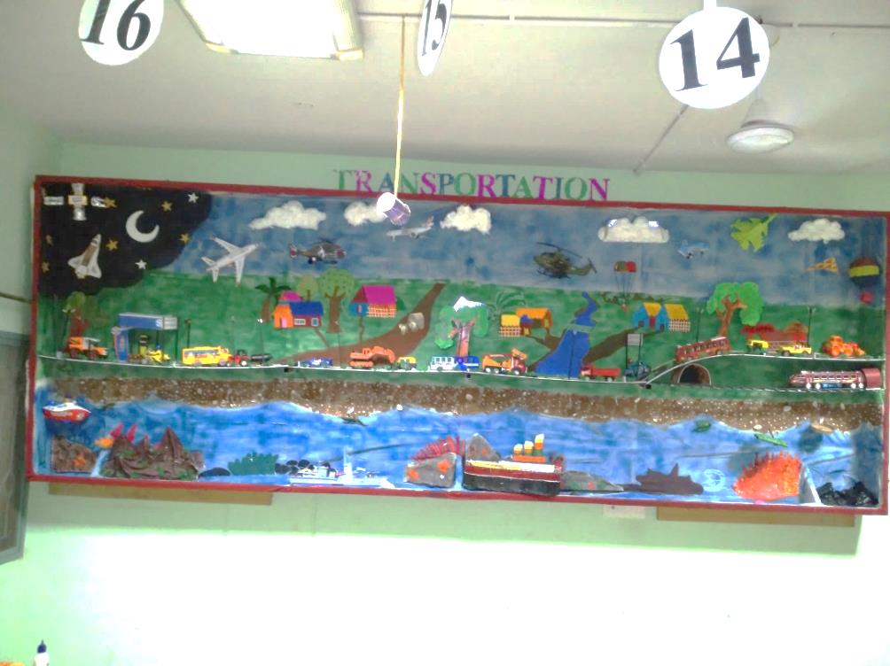

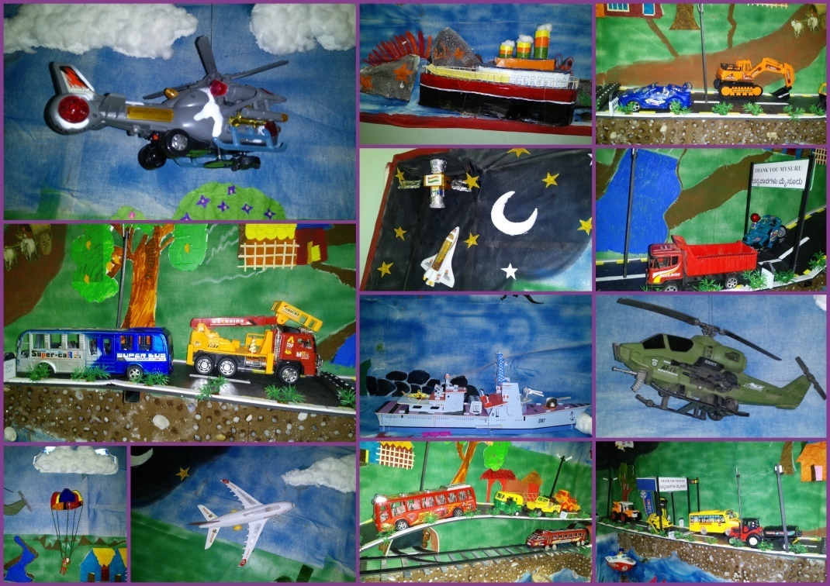

1. Service in Academic Bodies of other Organizations:
2. Dr. Alok Kumar Upadhyay

Member of Board of studies(BOS) in three Universities:

1- Ramkrishna Mission Vivekanand University,Coimbatore

2- JRH University,Chitrakoot

3- NGB University,Allahabad

Member of Board of Examination (BOE): Mysore University

1. G. Malar – BOE–Special Education of University of Mysore
2. **Participation in Committees/Taskforce and Panels setup by other organizations/agencies:01**

|  |  |  |  |  |  |  |
| --- | --- | --- | --- | --- | --- | --- |
| **Sl No** | **Name of the staff** | **Name of Organization/Agency** | **Participation in Committees/Taskforce** | **Programme** | **Name of Institute Visited** | **Date of Visit** |
| 1 | Dr Alok Kumar Upadhyay | Ramkrishna Mission Vivekanand University,Coimbatore | **B**oard of Studies (BOS) | THREE YEAR BEd-Med Special Education Intgrated program Curriculum | Faculty of Special Education ,Ramkrishna Mission Vivekanand University,Coimbatore | 26/10/2017 |

1. **Any Others (Please Specify)**

**RESEARCH ACTIVITIES (2016-17)**

1. Research Projects (ARF)
2. Completed -NIL
3. New Research Projects- NIL
4. **Ongoing Research Projects –02**
   * 1. **Title of ARF** - Development and Evaluation of Indigenous curriculum oriented computer based tutor for concept learning in preschool children with special needs.

Principal Investigator – Ms. P.V. Ramanakumari

Co-Investigators – Dr. Ajish K Abraham and Ms. P.V. Manjula

Research Assistant – Mr. Anil Abbur R.

Date of Starting – 18th January 2017

* + 1. **Title**: Effect of Resource Materials on Impact of Inclusive Education in Children with Intellectual Disabilities (ID) and Learning Disabilities (LD)

Investigators: Dr. G. Malar, Ms. S. Prathima & Mr. D. Gururaj

Duration: 12 months from January 2017

Budget: Rs. 3,85,000/-

Process: Video recording with children with ID – 2 snippets completed & RoL

1. Postgraduate Research Completed:- NIL
2. C. Postgraduate Research ongoing: NIL
3. **D. Research Papers presented at National/International Conferences/Seminars :- 01**

B.N. Shobha, Kadambari, N.(2017). **A Study on Self Concept and Academic Anxiety among Adolescent Children with Hearing Impairment** Paper presented at the *National Conference on “Inclustion: Issues Challenges and Possibilities*, University of Delhi, New Delhi. 10-11,October 2017.

E.Research Papers Published

i**) Papers published in National / International Journals: 01**

Upadhyay A.K., Pandey N (2017). **Effectiveness of Play way technique to teach prepositions to children with hearing impairment at primary school level**, International Journal of Education and Psychological Research. 6(3):24-26.

ii) Papers published in Conference / Seminar Proceedings: NIL

F. Books published (in APA format)

1. Books published: NIL

G.Book chapters published (in APA format)-NIL

H .Books/Manuals/Seminar Proceedings edited: NIL

1. Journal Editorship: NIL

J. Scholarly Reviewing Activities:

1. **Special Educational Services Offered through Teacher Trainees Outside Campus:**

**Dr.Malar**

|  |  |  |  |
| --- | --- | --- | --- |
| **S. No.** | **Nature of Activity** | **Services Provided** | **Details of Beneficiaries** |
| 1. | Educational Assessment | --- | --- |
| 2. | Practice-Teaching in Mainstream Schools/ Institutions | -- | --- |
| 3. | Practice-Teaching in Special Schools/ Institutions | -- | -- |

**III CLINICAL SERVICES**

1. General Clinical Services: **Not Applicable**
2. Specialized Clinical/ Educational Services
3. **Preschool Training and Special Education**

**Educational services for children with special needs**

|  |  |  |  |  |  |  |  |  |  |  |  |  |
| --- | --- | --- | --- | --- | --- | --- | --- | --- | --- | --- | --- | --- |
| **S. No.** | **Nature of Services (I/C)** | | | | | | | | | | | |
| 1. Special Educational Assessment Services (Dr. G. Malar) | | | | | | | | | | | | |
|  |  | Nature of Special Need  Language | ASD / PDD NOS | Hearing Loss | Intellectual Disability | Learning Disability | Motor Problems | Multiple Disabilities | Others | No. of Clients | No. of Sessions | ***Total No. of Sessions*** |
| 1. | Screening & Referral | Kannada | 02 | 08 | 03 | 01 | 02 | 03 | 03 | ***22*** | ***22*** | ***44*** |
| Malayalam | - | 02 | 04 | 01 | - | 01 | 04 | ***12*** | ***12*** |
| Hindi | - | 02 | 01 | - | - | - | - | ***03*** | ***03*** |
| Urdu | - | - | - | - | - | - | - | ***-*** | ***-*** |
| English | 01 | - | - | - | - | - | - | ***01*** | ***01*** |
| Telugu | 01 | 01 | - | 01 | - | - | 01 | ***04*** | ***04*** |
| Tamil | - | - | 01 | - | - | - | 01 | ***02*** | ***02*** |
| Any Other | - | - | - | - | - | - | - | ***-*** | ***-*** |
| ***Total No. of Clients*** | ***04*** | ***13*** | ***09*** | ***03*** | ***02*** | ***04*** | ***09*** | ***44*** | ***44*** |
| 2. | Assessment & Report | Kannada | - | 01 | - | - | - | 01 | - | ***02*** | ***07*** | ***17*** |
| Malayalam | - | - | - | - | - | - | - | ***-*** | ***-*** |
| Hindi | - | 01 | - | - | - | - | - | ***01*** | ***07*** |
| Urdu | - | - | - | - | - | - | - | ***-*** | ***-*** |
| English | - | - | - | 01 | - | - | - | ***01*** | ***03*** |
| Telugu | - | - | - | - | - | - | - | ***-*** | ***-*** |
| Tamil | - | - | - | - | - | - | - | ***-*** | ***-*** |
| Any Other | - | - | - | - | - | - | - | ***-*** | ***-*** |
| ***Total No. of Clients*** | ***-*** | ***02*** | ***-*** | ***01*** | ***-*** | ***01*** | ***-*** | ***04*** | ***17*** |
| Places from which seen: (1)Karnataka: 28 (2)Kerala: 12 (3)AP: 02 (4)Telengana: Nil (5)TN: 01 (6)Other Parts of India: 01 (Gujarat) (7)Any other: Nil | | | | | | | | | | | |
| Age groups seen:(1)Birth to 2.5yrs: 06 (2)2.5+ to 6 yrs: 21 (3)6yrs+ to 16 years: 14 (4)16yrs+: 03 | | | | | | | | | | | |
| Total No. of Referrals: (1)Educational Assessment: 05 (2)Educational Guidance: 05 (3)PIP: 04 (4)PPEP/ PBC/ GECS: 21 (5)CSS/IEP/NFE/DET: 11 (6)Any Other Services at AIISH: 02 (speech-language therapy) (7)Any Other Services Outside AIISH: 01 (services of NISH) | | | | | | | | | | | |
| No. of Reports Issued/Ready for Issue: (1) School Readiness: 03 (3) Curriculum-Based Assessment: 02 (4) Post-School Preparedness: Nil | | | | | | | | | | | |

|  |
| --- |
| **Preschool Training:Preparatory programme for schooling providing training in self-help, cognitive, language and (pre) academic skills, Preschool Supplementary Services (PSS)** |
| |  |  |  |  | | --- | --- | --- | --- | | **Language & Disability** | **No. of Groups** | **No. of Children** | | |  |  | MALE | FEMALE | | Kannada ASD & ID &MD | 14 | 48 | 15 | | Kannada HL | 8 | 37 | 25 | | Malayalam HL | 1 | 2 | 1 | | Malayalam ASD & ID & MD | 10 | 25 | 11 | | Hindi HL | 2 | 7 | 4 | | Hindi MD & ID & ASD | 2 | 7 | 2 | | English ID, ASD | 1 | 5 | 0 | | Telugu ASD & ID & MD | 1 | 5 | 2 | | TOTAL Number of children |  | **136** | **60** | | **TOTAL No. Groups** | **39** | **196** | | | **Sessions** | **3120(Group wise) 20 days** | | | |

|  |  |  |  |  |  |
| --- | --- | --- | --- | --- | --- |
| **Curricular Support Services – Supportive training to augment education in mainstream school/ other educational programmes** | **Language** | **HL** | **ID/CP/ASD/MD/LD/DD** | **Total No. of clients** | **No. Of sessions** |
| Kannada | 6 | 17 | 23 | 126 |
| Malayalam | - | 1 | 01 | - |
| Hindi | 1 | 1 | 02 | 20 |
| English | - | 7 | 07 | 32 |
| Telugu | - | - | - | 10 |
| Tamil | - | - | - | 04 |
| **Total** | | | | **33** | **192** |
| |  |  |  |  |  |  | | --- | --- | --- | --- | --- | --- | | **Individualised Educational Programme (IEP) – Training in functional academics for out of school individuals** | **Language** | **HL** | **ID/CP/ASD/MD/LD/DD** | **Total No. of clients** | **No. Of sessions** | | Kannada | 2 | 6 | 8 | 45 | | Malayalam | - | 4 | 4 | 23 | | Hindi | - | 2 | 2 | 19 | | English | - | - | - | - | | Telugu | - | - | - | - | | Tamil | - | 1 | 1 | 10 | | **Total** | - | - | **15** | **97** | | | | | | |
| |  |  |  |  |  |  | | --- | --- | --- | --- | --- | --- | | **Demonstration Educational Training – Short-term demonstration to caregivers in any of the above** | **Language** | **HL** | **ID/CP/ASD/MD/LD/DD** | **Total No. of clients** | **No. Of sessions** | | Kannada | 2 | 5 | 4 | 31 | | Malayalam | - | - | - | - | | Hindi | - | - | - | - | | English | - | 1 | 1 | 02 | | Telugu | - | - | - | - | | Tamil | - | - | - | - | | **Total** | - | - | **5** | **33** | | | | | | |
| **Total cilents: 53**  **Old clients:- 46**  **New clients: - 07**  **Discharged(DET):- 02**  **Discharged(CSS):- 01**  **Discharged(IEP):- Nil**  **Discontinued(DET):- NIL**  **Discontinued(CSS):- 02**  **Discontinued(IEP):- 01**  **No. of remaining cilents: 47** | | | | | |

|  |  |  |  |  |  |  |  |  |  |  |  |
| --- | --- | --- | --- | --- | --- | --- | --- | --- | --- | --- | --- |
|  | **Preschool Parent Empowerment Programme – PPEP** | | | | | | | | | | |
|  | **Language** | **HL** | **ID** | **CP** | **ASD** | **MD** | **LD** | **DD** | **SLD** | **Total No. of clients** | **No. Of sessions** |
| Kannada | 32 | 17 | 00 | 08 | 13 | -- | 01 | -- | 71 | 220 |
| Malayalam | 13 | 19 | 03 | 05 | 13 | -- | 01 | 01 | 55 | 100 |
| Hindi | 06 | 04 | -- | 01 | 01 | -- | -- | -- | 12 | 40 |
| English | 01 | 03 | -- | 03 | 01 | -- | -- | -- | 8 | 20 |
| Telugu | 03 | 01 | -- | -- | -- | -- | -- | -- | 4 | 20 |
| Tamil | 03 | 03 | -- | -- | 01 | -- | -- | -- | 7 | 20 |
| **Total** | | | | | | | | |  | **157** | **420** |
| No. of clients promoted to the next higher level of service: NIL  No. Of discharged : NIL  No. Of discontinued: 01  No. Of New clients (**October**) : 18 clients  Shifted from PIP to PPEP: 01  Shifted to from PPEP to PIP : Nil | | | | | | | | | | | |

|  |  |  |  |  |  |
| --- | --- | --- | --- | --- | --- |
| **Parent-Infant Programme – PIP(Birth to 2 ½ years)** | | | | | |
| Parent-Infant Programme | **Language** | **HL** | **ID/CP/ASD/MD/LD/DD** | **Total No. of clients** | **Total No. Of sessions** |
| Kannada | 6 | 8 | 14 | 69 |
| Malayalam | 6 | 21 | 27 | 76 |
| Hindi | 1 | 1 | 2 | 08 |
| English | - | - | -- | -- |
| Telugu | 1 | 1 | 2 | 6 |
| Tamil | - | - | -- | -- |
|  | **Total** | | | **45** | **159** |
| Specific age range:  No. of Old clients :**41**  No. of New clients enrolled: **04**  Total cilents:**45**  No. discharged :**NIL**  No. discontinued:**04**  No. of Promoted to next level: **01**  No. of Remaining:**40** | | | | | |

|  |  |  |
| --- | --- | --- |
| **Library of Books & Toys** – LiBoToy  Services issuing educational toys & books for home-based training. | Total number of members enrolled –187  No. of new members: - 13  Amount – 650/-  Total number of sessions –24 | |
| **Age group** | **Total number** |
| 0-2.6 yrs | 07 |
| 2.6-4 yrs | 40 |
| 4.0-6yrs | 133 |
| 6 yrs and above | 07 |

|  |  |  |
| --- | --- | --- |
| **Services** | **Number of Clients** | **Number of Sessions** |
| Co-Curricular Training | 198 | 12 |

**Supports for Empowering Caregivers**

|  |  |  |  |
| --- | --- | --- | --- |
| Name of Training Unit | No. of Parent  Beneficiaries | No. of Sessions | Content of Training |
| Caregiver Computer Training Unit | 4 | 6 | MS-Paint |
| Caregiver Literacy Training Unit | -- | -- | -- |

1. Clinical Support Services to Clients and Family
2. **Counselling and guidance**

|  |  |
| --- | --- |
| No. of Clients | Sessions |
| 60 | 56 |

1. **U-SAFE**

|  |  |
| --- | --- |
| No. of Clients | Sessions |
| -- | -- |

1. **Details of Certificates Issued:**

**Details of Bonafide Certificates Issued: 02**

|  |  |  |  |
| --- | --- | --- | --- |
| **Sl.No.** | **Nature of Special Needs in Clients** | **No. of Certificates Issued** | **Purpose** |
| 01 | SLD with MR | 01 | Aadhar Card/ Driving Licence |
| 02 | DSL with ID | 01 | Driving Licence |

1. Financial Aid- NIL
2. Legal advice -NIL
3. **Any other(Please Specify):**
4. Ms. Shobha B N Served as External Examiner for DEd students of DRC, Thilak Nagar at Marcy Convent- (11.10.2017 and 12.10.2017)
5. Attended to workshop/Seminar/Orientation program in Outside Institute:01

|  |  |  |
| --- | --- | --- |
| **Name of Staff** | **Attended to workshop title name** | **Date** |
| Ms. Latha C  Ms. Sharanaiah M M  Ms. Asha S. A | CRE program“ Introduction and  challenges to Inclusive Education”, Davanagere | 9-11, October 2017 |

EXTENSION ACTIVITIES

1. Public Lecture Series
   * 1. TECHNLOGICAL CONSULTANCY SERVICES: Not applicable
        1. CENTRAL FACILITIES
        2. Library and Information Services
        3. Public Information Activities
        4. Major Events of the Year with a brief account
        5. Press Releases and Media Coverage:

* 9th October 2017- Star of Mysore the Special Olympics program at AIISH titled *“Young Athlete Training Programme”*was published.
* 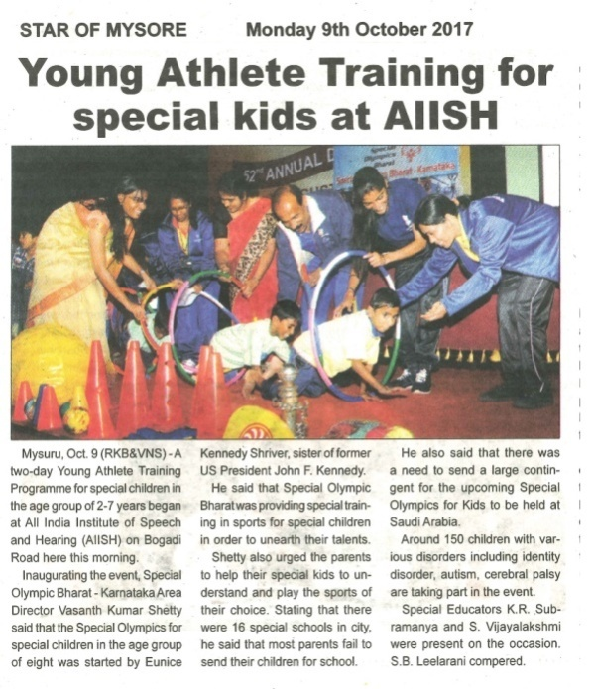10th October 2017 – Adolana the Special Olympics program at AIISH titled *“Young Athlete Training Programme”*was published.

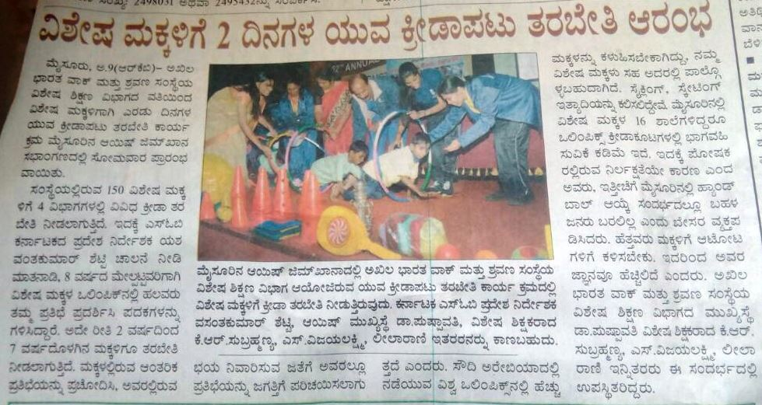

**C) Material Development :**The following Teaching Learning Materials and Prepare for training children with various communication disorders an preschool.

|  |  |  |  |
| --- | --- | --- | --- |
| **Sl.**  **No.** | **Nature of**  **Teaching-Learning**  **Materials** | **Skill** | **Number** |
| 1. | Flash cards | For all skill areas | 205 sets |
| 2. | Work Cards | For all skill areas | 96 sets |
| 3. | Charts | For all skill areas | 60 |
| 4. | PPT | For all skill areas | 18 |
| 5. | Models | For all skill areas | 9 |
| 6. | Sentence strips | For all skill areas | 98 sets |
| 7. | Others | For all skill areas | - |

1. **AWARDS AND HONORS RECEIVED BY FACULTY AND STAFF**
2. EXTRA CURRICULAR ACTIVITIES
   * + - 1. **AIISH Gymkhana**

* winner of wantei memorial football tournment 2017 (Mr.Gururaj and team)

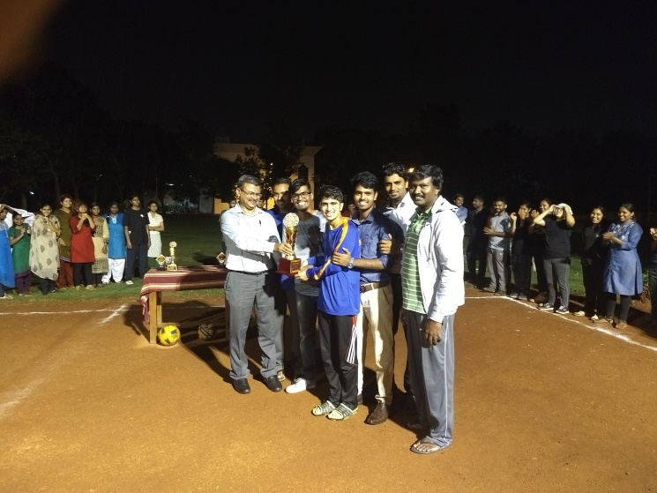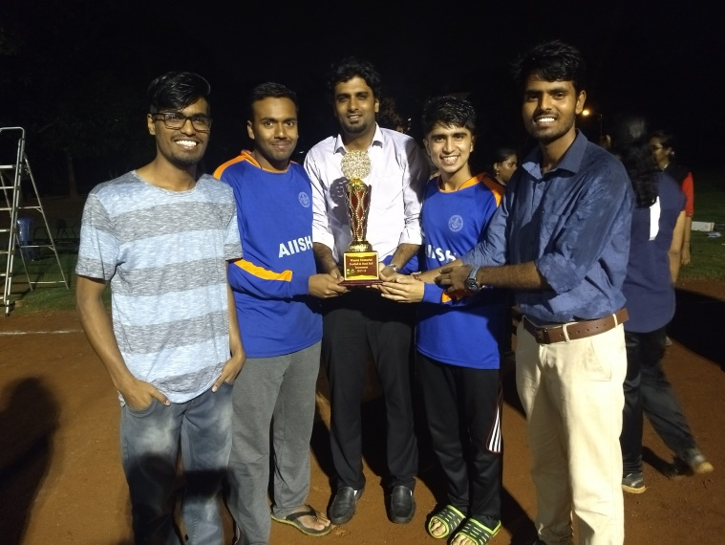

* AIISH Gymkhana Winner of Volly ball 2017 (Mr.Subramanya K R and team)

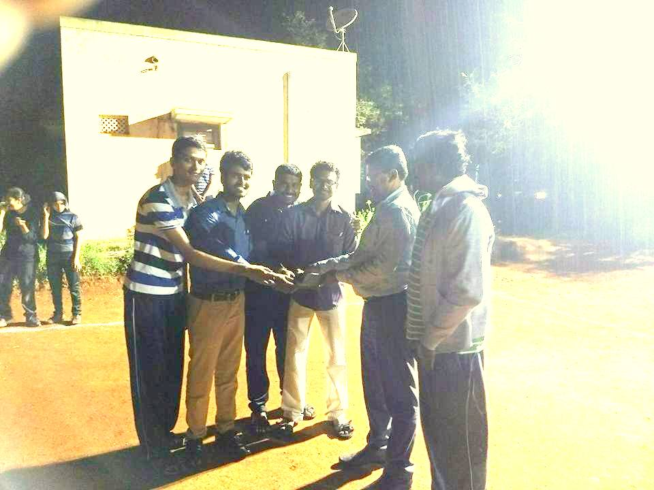

* + - * 1. **Others: Purchased New sports items**

|  |  |  |  |
| --- | --- | --- | --- |
| **Group** | **Theme** | **Objectives** | **Model** |
| Mr. Rajkumar  Mr. Gururaj  Mr. Sharanaiah | Special games and sports for CWSN | To make them aware and get first hand experience about diffeternt games and sports they can participate to develop different skills. | C:\Users\User\Desktop\Sports items.jpg |

**Parent Help Parents Program (PHPP): 1**

|  |  |
| --- | --- |
| Name of the Resource Person | Dr.Sushma Appaiah, Nutrition counsellor and food scientist, Founder and CEO Giggles of livez, #1286, 15th A Cross, Roopanagar, Mysuru - 26 |
| Name/Topic of the Program | Parents help parents programme(PHPP) for Parents of children |
| Coordinator | Ms. Latha C., Ms. Leena C C |
| Objectives | * To help instil confidence in the parents/caregivers handling their child. * To train the parents in managing their stress levels while dealing with their child. * To motivate the parents for working more efficiently with their child. * To empower the parents regarding different aspects of training |
| Organized by Department/Section/Unit | Department of Special Education |
| Targeted Audience | Parents of Special Children |
| Date | 24.10.2017 |
| No.of beneficiaries | 113 |
| Photo | C:\Users\User\Pictures\Picasa\Collages\drive-download-20171025T113619Z-001.jpg |

1. EMINENT VISITORS:

XI. **ANY OTHER**

* **OfficialLanguage Implementation:**
* Hindi Word a day
* No of notings/letters (**October 2017**): **59**

Sd/-

HOD- Special Education