DEPARTMENT OF PREVENTION OF COMMUNICATION DISORDERS (POCD)
MONTHLY REPORT- SEPTEMBER 2017

- ACADEMIC ACTIVITIES
- No. of short-term training programs organized: Nil
- No. of orientation/Sensitization programs organized: 05
As part of primary prevention activities, several orientation/Sensitization programs are being conducted regularly. The objective of the orientation programs was to create awareness among general public and various other professionals such as Medical doctors, Nurses, Health related workers, teachers, school students etc., on different types of communication disorders, its prevention and early identification methods and their appropriate referral and timely management. Table 1& 2 shows the details of the orientation programs conducted by the dept. of POCD.
Table 1: Orientation Programs conducted by the department of POCD in the month of September 2017.
I. Orientation Programs at POCD
Theme/Topic of the program: Prevention & early identification of communication disorders
Coordinators: Dr. Animesh Barman & Mr. Arunraj K.
S.No | Date | Name of the institute/  Hospital | Target group | Total participants | Oriented by
1. | 01.09.2017 | St. Fransis School, Jettihundi, Bogadi, Mysuru | Class VII Students | 40 | Ms. Latika P & Ms. YashaswiniB C
2. | 04.09.2017 | St. Fransis School, Jettihundi, Bogadi, Mysuru | Class VIII Students | 30 | Ms. Anusha K P &Yashaswinin B C
3. | 08.09.2017 | St. Fransis School, Jettihundi, Bogadi, Mysuru | Class IX Students | 26 | Ms. Shruthi G R & Ms. Nirupama S
4. | 08.09.2017 | St. Fransis School, Jettihundi, Bogadi, Mysuru | Class X Students | 17 | Ms. Latika P & Mr. PothaSoundar Raj
II. Orientation Programs at NBS centers
Theme/Topic of the program: Prevention & early identification of communication disordersCoordinators: Dr. Animesh Barman & NBS coordinator
5. | 23/09/2017 | New bornScreening  Guidelines  and High  Risk Register | 1styear Nursing student of SPSINP Ranchi | 11 |  | Mr. Mukesh Kumar
III. Orientation Programs at OSCs: Nil
Theme/Topic of the program: Prevention & early identification of communication disorders
Coordinators: Dr. Animesh Barman & OSC coordinator
Total |  |  |  | 124

Table 2: Total number of participants oriented in the month of September 2017.
S.No | Target group | Gender Groups |  | Total number of Participants
 |  | Male | Female
 | School Students | 66 | 47 | 113
 | Nursing Students | 01 | 10 | 11
 | Total | 67 | 57 | 124

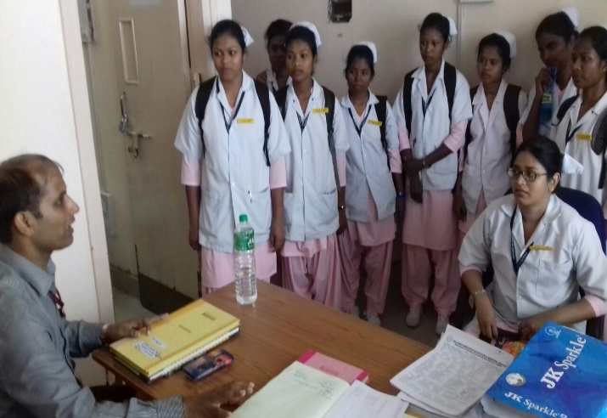 | 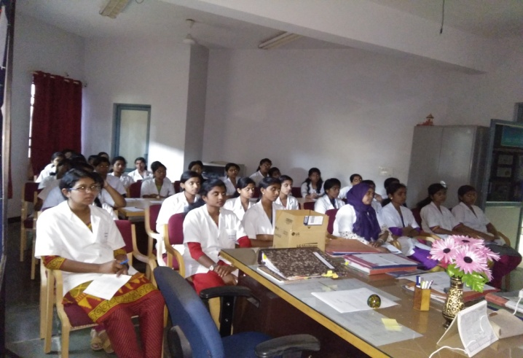

ii.Training programs conducted: Nil

- Clinical Observation postings of students from other institutes: 01
Sl.no | Date of Postings | Name of the Students/No.of students | Desingation | Institute/University
1. | 05.09.2017 | 01  Ms.Ida Sylvia Menezes | M.A.Psychology students | Bangalore University

v. No. of Seminars/ Conferences /Lectures /Workshop organized by the dept- Nil
vi. No. of Seminars/ Conferences /Lectures /Workshop attended by the staff of the Dept-Nil
vii.No. of Guest Lectures organized: Nil
viii. No. of Invited Talks delivered by faculty and staff: Nil
ix. Any other:
- Student clinical training: As part of human resource development, clinical training for Undergraduates (B.Sc Speech & Hearing), Postgraduates (M.Sc SLP & AUD) & Internship students on early identification, prevention & rehabilitation of communication disorders and Community based rehabilitation at OSCs were carried out. The details on the number of students who had undergone training are given below.
B.Sc students | 10
M.Sc students | 12
Internship students | 13
Total | 35

- Staff Enrichment Programs: 01
Theme/Topic: TEOAE and DPOAE outcomes from a Three-stage Newborn Hearing Screening Protocol
Coordinators: Dr. Animesh Barman & Mr. Arunraj K
Sl.no | Date of Postings | Topic | Presenter | Staff
1. | 15.09.2017 | TEOAE and DPOAE outcomes from a Three-stage Newborn Hearing Screening Protocol | Ms. Yashaswini B C & Ms. Pavana M | Dr.Animesh Barman  Mr.Arunraj K  Ms. Akshatha Y  Ms. Latika P  Ms. Laxmishree P  Ms. Nirupama S  Mr. PothaSoundar Raj  Ms. Supreetha L  Ms. Yashaswini B C

2. RESEARCH ACTIVITIES
  - Research Projects :Nil
  - Doctoral and Post-Doctoral Programs: Nil
  - Research papers presented in National conferences/seminars: Nil
  - Research papers presented at International conferences/seminars: Nil
  - Research Papers published in National Conference/Seminar Proceedings: Nil
  - Research Papers published in International Conference/Seminar Proceedings:Nil
  - Research Papers published in National Journals: Nil
  - Research Papers published in International Journals: Nil
  - Book / Chapters Published:Nil
  - Books / Manuals/ Seminar proceedings Edited: Nil
  - Scholarly Reviewing Activities: Nil
  - Research Proposal:Nil

3. CLINICAL SERVICES
- General Clinical Services
- Follow-up evaluation- Detailed evaluation
The newborns/infants referred during the newborn screening were followed up through telephone calls to parents/caregivers of infants. A complete test battery was administered for those clients who came for follow-up. Table 4 (a) & (b) depicts the statistics related to this activity.
Table 4 (a): Details of the results of follow-up evaluation for newborns and infants.
Categories | AIISH + Cheluvamba | OSC Sarguru | OSC-Sagara | Ajmer | Cuttack | Imphal | Puducherry | Ranchi | Jabalpur | Total
Normal | 13 | - | 04 | 12 | 03 | 14 | 20 | 07 | 0 | 73
ENT disorders | 0 | - | 0 | 0 | 0 | 0 | 0 | 0 | 0 | 0
Auditory Maturation delay | 0 | - | 0 | 0 | 0 | 0 | 0 | 0 | 0 | 0
Hearing disorder | 02 | - | 0 | 0 | 04 | 01 | 02 | 0 | 0 | 9
Speech & language disorder | 0 | - | 0 | 0 | 0 | 0 | 0 | 0 | 07 | 07
Multiple Disorder | 0 | - | 0 | 0 | 0 | 0 | 0 | 0 | 0 | 0
Incomplete testing | 02 | - | 0 | 0 | 01 | 0 | 07 | 0 | 0 | 10
Total | 17 | - | 04 | 20 | 08 | 15 | 29 | 07 | 07 | 107

The at-risk babies were monitored regularly by administering the speech-language & hearing checklist through phone call in Mysuru centre. The babies who are identified with delay in the milestones were referred to AIISH/concern NBS centre for detailed evaluation.

Table 4(b): Follow-up evaluation- Phone follow-up
Categories | Mysuru Centre (POCD)  No. attended / Total no. phone calls made | NBS Centers | OSC Centers
Normal speech, language & hearing milestones | 48/69 | 85 | -
Referred for detailed evaluation | 0 | 0 | -
Total | 48 | 85 | -

- Hearing evaluation of industrial workers at AIISH: Nil
- Specialized Clinical services: Nil
- Clinical Support Services to Patients and Family: Nil
- Clinical Electronic Services: Nil
B) EXTENSION ACTIVITIES
- Newborn screening for Communication Disorders
The department of POCD is actively involved in carrying out various extension activities such as screening, diagnostic and rehabilitation services outside the institute campus. The activities include newborn/infant screening, screening of school children, screening of elderly citizens, screening of industrial workers, conducting camps and also clinical services offered at the outreach service centers of AIISH.
Table 5: Total number of newborns/infants screened and identified at-risk for
communication disorders.

SN | Hospitals/Immunization Centers | Total births | Total No. Screened |  |  |  | Total No. at risk
 |  |  | Male | Female |  | Total | Male | Female | Total
 |  | AIISH- Mysuru
 | Basappa Memorial Hospital (BMH) | 07 | 03 | 01 |  | 04 | 0 | 0 | 0
 | Combined Hospital (CH) | 41 | 07 | 13 |  | 20 | 0 | 0 | 0
 | Harsha Hospital (HH) | 0 | 0 | 0 |  | 0 | 0 | 0 | 0
 | Kamakshi Hospital (KH) | 177 | 37 | 67 |  | 104 | 0 | 0 | 0
 | KR Hospital (KRH)- Cheluvamba | 782 | 353 | 298 |  | 651 | 09 | 04 | 13
 | Makkalakoota Immunization Center (MIC) | No deliveries | 09 | 13 |  | 22 | 0 | 0 | 0
 | Mission Hospital (MH) | 67 | 28 | 25 |  | 53 | 02 | 0 | 02
 | Immunization Center at Mission Hospital (ICMH) | No deliveries | 0 | 0 |  | 0 | 0 | 0 | 0
 | N.P.C Hospital | 26 | 04 | 04 |  | 08 | 0 | 0 | 0
 | S.M.T.D.H Hospital | 33 | 10 | 22 |  | 32 | 0 | 0 | 0
 | Railway Hospital (RH) | 09 | 05 | 03 |  | 8 | 0 | 0 | 0
 | Employees State Insurance (ESI) Hospital | 01 | 0 | 01 |  | 01 | 0 | 0 | 0
 | Ashwini Nursing Home (ANH) | 12 | 03 | 07 |  | 10 | 0 | 0 | 0
 | Shree Devi Nursing Home (SNH) | 21 | 03 | 05 |  | 08 | 0 | 0 | 0
 | GopalaGowdaShanthaveri Memorial Hospital (GGSMH) | 11 | 0 | 03 |  | 03 | 0 | 0 | 0
 | Mahadeshwara Nursing Home (MNH) | 38 | 05 | 06 |  | 11 | 0 | 0 | 0
 | Sigma Hospital (SH) | 50 | 29 | 18 |  | 47 | 0 | 01 | 01
 | Total (Mysuru hospitals) | 1275 | 496 | 486 |  | 982 | 11 | 05 | 16
Outreach Servcie centers (OSCs)
18. | Sub-divisional hospital, K R Nagar Taluk | 92 | 29 | 31 |  | 60 | 0 | 0 | 0
19. | Sub-divisional hospital, T NarsipuraTaluk | 77 | 19 | 14 |  | 33 | 0 | 0 | 0
20. | Sub-divisional Hospital, SagaraTaluk | 97 | 53 | 33 |  | 86 | 06 | 02 | 08
21 | Sub-divisional hospital, Sarguru | 49 | 26 | 18 |  | 44 | 08 | 05 | 13
22. | Community Health Centre (CHC), Hullahalli | 22 | 12 | 06 |  | 18 | 0 | 0 | 0
23. | Community Health Centre (CHC), Santhemarahalli | 0 | 0 | 0 |  | 0 | 0 | 0 | 0
24. | Primary Health Centre (PHC), Akkihebbalu | 12 | 04 | 05 |  | 09 | 0 | 0 | 0
 | Total (OSCs) | 349 | 143 | 107 |  | 250 | 14 | 7 | 21
Newbron screening centers (NBS centers)
25. | Sri RamachandraBhanj Medical College and Hospital (SCB MCH), Cuttack | 403 | 210 | 78 | 288 |  | 20 | 05 | 25
26. | Regional Institute of Medical Sciences (RIMS), Imphal | 311 | 156 | 150 | 306 |  | 08 | 06 | 14
27. | Janana Hospital & JLNMCH, Ajmer | 580 | 196 | 217 | 413 |  | 03 | 02 | 05
28. | JIPMER, Puducherry | 1432 | 697 | 667 | 1364 |  | 70 | 56 | 126
29. | NetajiSubhash Chandra Bose Medical College (NSCB), Jabalpur | 512 | 240 | 176 | 416 |  | 27 | 11 | 38
30. | Rajendra Institute of Medical Sciences, Baritayu, Ranchi | 439 | 193 | 152 | 345 |  | 11 | 06 | 17
 | Total (NBS centers) | 3677 | 1692 | 1440 | 3132 |  | 139 | 86 | 225
 | Overall Total | 4780 | 2331 | 2033 | 4364 |  | 164 | 98 | 262

- School screening: No. of school screened: 02
Screening of preschool, primary school children was conducted focusing on the early identification of communication disorders and early rehabilitation of children at risk for communication disorders.
Table 6 : Total number of children screened for communication disorders and
identified.
Date | Name of the School | Total screened | Total identified with communication disorders
 |  |  | Ear related disorder | Hearing loss | Speech language disorders
01.09.2017 | St. Fransis School, Jettihundi, Bogadi, Mysore | 46 | 0 | 01 | 13
04.09.2017 |  | 75 | 0 | 0 | 08
08.09.2017 |  | 116 | 01 | 01 | 07
16.09.2017 & 17.09.2017 | School Screening Camp, with NSS in Sarguru | 300 | 08 | 10 | 09
Total |  | 237 | 01 | 02 | 28

- Hearing screening of Industrial employees: Nil
- Clinical services for the Elderly citizens: 01
Date | Place | Total screened | Total identified with communication disorders |  |  | Hearing Aids Dispensed
 |  |  | Ear related disorder  (ear-wise) | Hearing loss  (ear-wise) | Speech language disorders
22.09.2017 | Green Dot Trust  (Neleoldage home) | 15 | 0 | 15 | 04 | 05
Total |  | 15 | 0 | 15 | 04 | 05

- Camps: 01
- Hearing screening camp organized by Newborn Hearing Screening centre RIMS, IWCTC, Thangmeiband, Imphal, Manipur on 29.9.17.
Type of disorder | Total screened | Total referred
 | 47
Hearing evaluation |  | 09
Speech language Disorder |  | 0
Total | 47 | 09

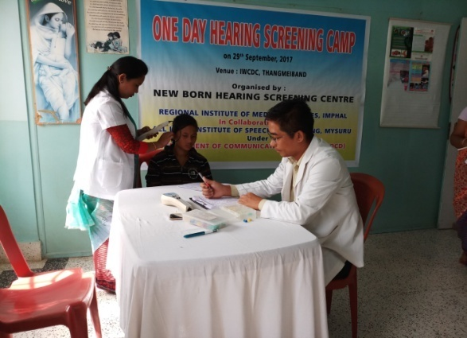 | 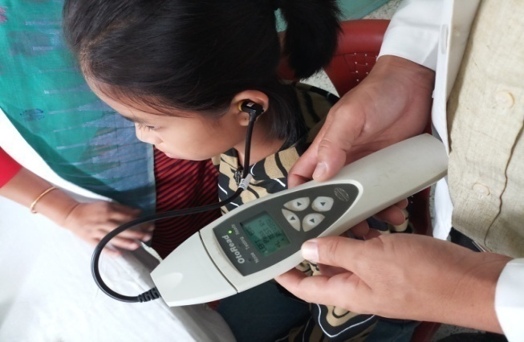

vii.Clinical Services at Outreach Service Centers (OSCs):

The clinical activities are not only restricted to in and around Mysore, but also extended to rural areas where facilities for clinical services for persons with communication disorders were meager. Currently 05OSCs (01 VMH, Saragur, HD Kote; 01 Sub-divisional taluk hospital at Sagara taluk, Shivamogga District; 03 Primary Health Centre - PHC at Hullahalli, Mysuru district; Akkihebbalu, Mandya district &Karuna trust, Gumballi, Chamarajanagara district; were initiated to meet the objective of extending the services of the institute to rural areas. The OSCs are functioning as a well-equipped unitfor screening, diagnostics and therapeutic services for persons with communication disorders. The services include screening, diagnostic and rehabilitation which includes newborn/infant screening, screening of school children, Speech and Language evaluation, Audiological evaluation, ENT evaluation, Speech-Language therapy, issue of free body level hearing aids and ear molds, and counseling and guidance to individuals with communication disorders. The other details are tabulated below in tables 8, 9 & 10.
Table 8: Details of clients identified with communication disorders at the OSCs.
OSC | Total Registered | ENT Evaluation  Registered=117 |  |  | Hearing Evaluation  Registered=27 |  | Speech & Language Evaluation  Registered= 12
 |  | Normal (Ear Wise) | Disorder (Ear wise) | ENT related  Others | Normal (Ear Wise) | Disorder (Ear wise) | Normal (Individuals) | Disorder (Individuals)
Primary Health Centre (PHC), Hullahalli | 40 | 21 | 33 | 10 | 0 | 08 | 0 | 01
Primary Health Centre (PHC), Akkihebbalu | 33 | 19 | 29 | 07 | 0 | 04 | 0 | 0
Primary Health Centre (PHC), Gumballi | 56 | 29 | 41 | 14 | 0 | 02 | 0 | 0
Sub-divisional Hospital (PHC), Sagara | 18 | 0 | 0 | 0 | 0 | 26 | 0 | 05
VMH, Sarguru | 13 | 0 | 0 | 0 | 02 | 12 | 01 | 05
Total | 160 | 69 | 103 | 31 | 02 | 52 | 01 | 11

Table 8a. : Details of clients followed up (Old clients) at the OSCs.
OSC | Total Follow up | ENT Evaluation = 51 |  |  | Hearing Evaluation=20 |  | Speech & Language Evaluation= 04
 |  | Normal (Ear Wise) | Disorder (Ear wise) | ENT related  Others | Normal (Ear Wise) | Disorder (Ear wise) | Normal (Individuals) | Disorder (Individuals)
Primary Health Centre (PHC), Hullahalli | 06 | 05 | 05 | 01 | 0 | 0 | 0 | 0
Primary Health Centre (PHC), Akkihebbalu | 11 | 10 | 02 | 04 | 0 | 02 | 0 | 0
Primary Health Centre (PHC), Gumballi | 43 | 24 | 26 | 10 | 0 | 14 | 0 | 0
Sub-divisional Hospital (PHC), Sagara | - | - | - | - | - | - | - | -
VMH, Sarguru | 16 | 0 | 0 | 0 | 01 | 23 | 0 | 04
Total | 76 | 39 | 33 | 15 | 01 | 39 | 0 | 04

Table 9: Details of clients identified with different types communication disorders across OSCs.
Type of Disorders | OSC
 | Primary Health Centre (PHC), Hullahalli | Primary Health Centre (PHC), Akkihebbalu | Primary Health Centre (PHC), Gumballi | Sub-divisional Hospital, Sagara (PHC) Taluk | VMH,Sarguru
Hearing disorders (Ear-wise data)

Normal | 0 | 0 | 0 | 0 | 02
Conductive | 02 | 0 | 02 | 02 | 03
Sensori- neural | 02 | 04 | 20 | 08 | 13
Mixed | 03 | 02 | 02 | 03 | 09
Profound | 01 | 0 | 04 | 0 | 10
Total (ears) | 08 | 06 | 28 | 13 | 37
Speech &Language disorders (Individuals)
Voice | 0 | 0 | 0 | 0 | 01
Fluency | 0 | 0 | 0 | 02 | 0
Articulation disorders | 0 | 0 | 0 | 0 | 0
Language disorders | 01 | 0 | 0 | 03 | 08
Total (Individuals) | 01 | 0 | 0 | 05 | 09

Table 10: Rehabilitation services provided at Outreach service centres
OSC | Hearing Aids Dispensed | Speech-language therapy |  | Medical Line of Treatment
 |  | No. of clients | No. of sessions
Primary Health Centre (PHC), Hullahalli | 04 | 02 | 02 | 28
Primary Health Centre (PHC), Akkihebbalu | 04 | 03 | 03 | 25
Primary Health Centre (PHC), Gumballi | 09 | 03 | 03 | 57
Sub-divisional Hospital, Sagara (PHC) Taluk | 01 | 39 | 176 | 0
VMH, Sarguru | 0 | 18 | 48 | 0
Total | 18 | 65 | 232 | 110

4.CENTRAL FACILITIES
- Library and information services – Nil
- Public Information Activities – 01
Street Play- 02
The Department of POCD conducted two street plays on various communication disorders in the rural villages, emphasizing on prevention and early identification of communication disorders.
Coordinators: Dr. Animesh Barman, Dr. Jayashree C. Shanbal &Mr. Arunraj K.
In charge: Ms. Akashatha Y & Ms. Yashaswini B C
Target group: General Public
Sl. No | Date | Place | Total participants | Enactors
1 | 23.09.2017 | Virajpet | 23 (students)+11 (staffs) | Interns
1 | 23.09.2017 | Gonikoppa | 23 (students)+11 (staffs) | Interns

- Exhibition: Nil
- Material Development: Nil
- Public education pamphlets :
  - A PEM on “NIHL” was designed in Kannada andEnglish.
- Press Releases and Media Coverage: Nil
- Public Lecture Series: Nil
- AWARDS AND HONOURS RECEIVED BY FACULTY AND STAFF: Nil
- TECNOLOGICAL CONSULTANCY SERVICES: Nil
- EXTRA CURRICULLAR ACTIVITIES: Nil
- VISITORS: Nil
- MAJOR EVENTS OF THE MONTH:Nil

- OTHERS:
- Dept. Related
S.No | Particulars
 | Computerization activities |  |  | Two Meeting wereheld on1st,4th, & 26thSeptember 2017 with NIC team (Mr.Devraj&his team members) and demonstrated the developed software (NBS program) to Head-POCD, Dr.Jayashree C. Shanbal&Mr.Arunraj K. Modifications were suggested related to the NBS and also school screening program to the NIC team.
 | Purchase meeting |  |  | Meeting attended on 15.09.2017 regarding new indenting rules by Dr.Animesh Barman.
 | RajyaBhasha Meeting |  |  | RajyaBhasha meeting was attended by Ms. Latika P on 26.09.2017 from 2:30 to 3:30pm regaring celebration of ‘Hindi Week’.
 | Epidemology Related |  |  | 250 case files related to pediatric population were reviewed as part of epidemiology unit activities.
 | Visit to VMH-Sarguru |  |  | Mr. Arunraj K & Mr. Soundar Raj Potha visited Sargurucentre for setting up the NBS & OSC on 11.09.2017
 | New proposal |  |  | Standard Finance Committee (SFC) proposal for expansion of outreach centers was sent to Director.
2. OSC Related-Nil
 |  | Sports day celebration, Sarguru, H. D. Kote Taluk |  | Sports day celebration for Cerebral Palsy was held on 18.09.2017.
3. NBS related- Nil
b |  |  | Initiation of NBScentre in Bhagalpur. |  | Meeting was held for setting up of NBS centre Jwaharlal Nehru Medical college and hospital Bhagalpur on 06.09.2017 at 12:30 pm.

- Following staffs were relieved from the department: 01
Sl.No | Name of the staff | Designation | Reliving date
1. | Niharikha | Speech and Hearing Assistant | 06.09.2017

- Following staffs were newly recruited to the department: Nil

Sd/-
Head, Dept. of POCD

