**ALL INDIA INSTITUTE OF SPEECH & HEARING: MYSORE – 570 006**

**DEPARTMENT OF SPECIAL EDUCATION**

**MONTHLY REPORT August 2017**

1. **ACADEMIC ACTIVITIES**
2. **Orientation Programs (For outsiders):01**

The following orientation programswere conducted to orient about the activities of the departmentand also to provide the knowledge about the educational facilities and welfare measures for children with special needs.

|  |  |  |  |  |
| --- | --- | --- | --- | --- |
| **SL No.** | **Coordinator** | **Targeted Audience** | **Number**  **of Participants** | **Date** |
|  | Mr. Gururaj D | Staff & Students, Ajay Leela Special Teacher Training College, Jodhpur | 23 | 03.08.17 |

1. **Posting (For outsiders): 01**

|  |  |  |  |  |
| --- | --- | --- | --- | --- |
| **SL No.** | **Coordinator** | **Targeted Audience** | **Number**  **of Participants** | **Date** |
|  | Dr.Prithi V | MA Psychology Student of IGNOU Study centre-1344,CMR Institute of management Studies, Bangalore | 1 | 23.08.2017-04.09.2017 |

**Faculty report**

Dr. M. Pushpavathi, HOD in Special Education

* Coordinated conducting cultural program for annual day and independence day
* Briefed about the activities of the deparment to RCI expeters on 4.8.17
* Presented the department activity in department peer review meeting on 16.8.17

|  |  |  |  |  |  |
| --- | --- | --- | --- | --- | --- |
| **Name of the Faculty** | | **Dr. Alok Kumar** | **Dr. G. Malar** | **Dr. Prithi Venkatesh** | **Dr. P. Vijetha** |
| **Clinics** | | | | | |  |
| **No. of cases evaluated at SEA-U** | | 22 | * Screening: 13 * Assessment: Nil | 14 | 09 |
| **No. of cases supervised individually** | |  | * 18 through 3 classroom observations in 3 groups |  | NIL |
| **No. of groups supervised** | |  | * 10 | 10 | 15 |
| **No. of meeting with parents** | | 10 | * 10 | 10 monthly meetings | 09 |
| **Educational Guidance** | | 01 | * Clients: 12 * Sessions: 12 |  | NIL |
| **Academics** | | | | | |
| **Classes taken** | | | | | |
| **B.Ed.**  **Spl.Edn.(HI)** | **Theory** | 36 classes | * 27 sessions (including 3 extra) | 11 classes : Reading and Reflecting on Text  classes: Communication Options: Manual (ISL) | 16 classes |
| **Practical** | 28 hours | * 35 hours | Coordinating trial teaching at Puttaveeramma school for III Semester Students. In this connection spoke to the Principal for topics | 2 hours |
| **Any others** |  |  |  |  | **Mentor - II BASLP**  On 31st August , conducted class meeting |
| **Research** | | | | | |  |
| **Paper published** | | 01 |  |  |  |
| **Paper in press projects** | | 03  1. Barriers in Meeting the Needs of Children with hearing Impairment in Regular Schools of Mysuru  2-Issues on Emerging and Sustainable Practices of Inclusive Education in India |  |  |  |
| **Paper presentation** | |  |  |  |  |
| **Any other** | | | | | |  |
| **Meeting held** | |  | * 10 parent-teacher meetings in preschool |  | * On 9th August, catering committee responsibilities were carried out. * Worked on purchase indent of safety mats. * On 10th August, attended meeting with HOD regarding Dept. Peer review. * On 11th August, submitted C1 marks of the III B.Ed. trainees * Completed the work related to RE-BE of CSS unit as assigned by HOD of the department * Submitted B.Ed. practicum module to HOD * On 30th August, submitted the work of NAAC- AQAR of the department as assigned by HOD. * Prepared lesson plan formats and blue print for Social sciences and oriented B.Ed. trainees.   On 30th August, attended meeting with HOD – started working with groups 4 & 5 for different themes. |
| **Meeting attended** | |  | * 1 meeting with HOD – Special Education regarding theme-based TLM preparation * 2 meetings with team members |  |  |
| **AV preparation** | |  | * 3 PPTs on visual arts in education for II B.Ed.Spl.Ed. (HI) & 7 PPTs for locomotor disabilities for I B.Ed.Spl.Ed. (HI) |  |  |
| **Brochures** | |  | * 1brochure – as guide for teachers of children with LD | Prepared draft poster about information about preschool services to be displayed at department of clinical services. The work order for final preparation of the poster is sent to department of DMD. |  |
| **Roles & Responsibilities** | | | | | |  |
| **Co-ordination** | | Infant & Toddler Unit | * CBCS Coordinator for I & II B.Ed. Spl.Ed. (HI) * Mentor for I & II B.Ed.Spl.Ed. (HI) * Compilation of M.S.Ed. Student Dissertation-based Articles 2014-15 * Intra-Department * SEA-U * EduTechLab   Research & Database Unit |  | **ISO**  **Servics for School age children**  Discussed the updates made with the team members  Carried out supervision as per the schedule provided.  Working on streamlining of service delivery process.  On 31st August , conducted team meeting and discussed the agenda points |
| **Member secretary** | | Preschool | * LD Clinic (in DCS)   Services for School-Aged Children (in Department of Special Education) |  | Service for Infant and Toddlers |
| **Member in** | | SEA-U | * TCPD * Product Development Cell * Preschool Supervision | SEA –U | SEA –U |
| **Mentor** | | M.Sc. -1st Year -Audiology |  |  |  |

1. Clinical /Educational Observation Postings of Students from other Institutes:NIL

Following are the details of students posted for observation/ practice teaching

|  |  |  |  |  |
| --- | --- | --- | --- | --- |
| Sl.No | Name of the Institute | Programme/Course | Number of Students | Dates |

1. Seminars/Conferences/Workshops/Training Programs:NIL

|  |  |
| --- | --- |
| Theme/topic |  |
| Coordinator |  |
| Objectives |  |
| Targeted Audience |  |
| Number of Participants |  |
| Date |  |
| Photo |  |

1. Staff Enrichment / **In-house training Programmes***(For own staff members)* : NIL

|  |  |  |  |  |
| --- | --- | --- | --- | --- |
| **Theme/Topic** | **Coordinator** | **Objectives** | **Targeted Audience** | **Date** |

1. **Guest Lectures :NIL**

|  |  |  |  |
| --- | --- | --- | --- |
| **Name, Designation, Institutional affiliation of Lecturer** | **Organized by Department/Section/Unit** | **Topic of Lecture** | **Date** |

1. Additional Academic Services rendered by the Faculty and Staff
2. **Invited Talks: 02**

|  |  |  |  |  |
| --- | --- | --- | --- | --- |
| **Staff** | **Topic** | **Date** | **Programme** | **Institution** |
| Dr. Malar G | Instructional Adaptation for Children with Learning Disabilities | 08.08.2017 | Parent Enlightenment and Remediation for Learning Problems (PEaRL) – monthly caregiver orientation programme at LD Clinic | Department of Clinical Services, AIISH |
| Dr. Malar G | Multiple Disabilities: Definition, Causes, Characteristics, Identification & Strategies to be Adopted by Teachers | 18.08.2017 | 3-Day Training Programme for Kendriya Vidyalaya Teachers for Identifying and Handling Children with Learning Disabilities | Zonal Institute of Educational Training, Kendriya Vidyalaya Sanghatan, Mysuru |

1. Curriculum Development: NIL
2. Development of Material to Support Learning
3. Service in Academic Bodies of other Organizations
4. Participation in Committees/Taskforce and Panels setup by other organizations/agencies

|  |  |  |  |  |  |  |
| --- | --- | --- | --- | --- | --- | --- |
| Sl No | Name of the staff | Name of Organization/Agency | Participation in Committees/Taskforce | Programme | Name of Institute Visited | Date of Visit |

1. **Any Others (Please Specify)**
   * + 1. **Parent Enrichment Programs (PEP): NIL** - This program aims to enrich knowledge of the caregivers of CWSN by experts from various fields.

|  |  |  |  |  |
| --- | --- | --- | --- | --- |
| **Theme/Topic** | **Coordinator** | **Objectives** | **Number**  **of Participants** | **Date** |

**RESEARCH ACTIVITIES (2016-17)**

1. Research Projects (ARF)
2. Completed -NIL
3. New Research Projects- NIL
4. **Ongoing Research Projects –02**
   * 1. **Title of ARF** - Development and Evaluation of Indigenous curriculum oriented computer based tutor for concept learning in preschool children with special needs.

Principal Investigator – Ms. P.V. Ramanakumari

Co-Investigators – Dr. Ajish K Abraham and Ms. P.V. Manjula

Research Assistant – Mr. Anil Abbur R.

Date of Starting – 18th January 2017

Progress –

* Review of literature.
* Preparation of additional exercises for each concept.
* Reviewing the script and making modifications.
* 24th August 2017 - Updated and took permission from Director Madam for out-sourcing for developing the CBT.
  + 1. **Title**: Effect of Resource Materials on Impact of Inclusive Education in Children with Intellectual Disabilities (ID) and Learning Disabilities (LD)

Investigators: Dr. G. Malar, Ms. S. Prathima & Mr. D. Gururaj

Duration: 12 months from January 2017

Budget: Rs. 3,85,000/-

Progress: Video recording with children with ID in mainstream settings – 7

snippets completed.

1. Postgraduate Research Completed:- NIL
2. C. Postgraduate Research ongoing: NIL
3. D Research Papers presented at National/International Conferences/Seminars :- NIL

E.Research Papers Published

i**) Papers published in National / International Journals: 01**

Upadhyay A.K. (2017),Effectiveness of Touch Math Method in PromotingNumeracy skills in Preschool children having difficulty in numbers..International Education and Research Journal,3 :46-47.

ii) Papers published in Conference / Seminar Proceedings: NIL

F. Books published (in APA format)

1. **Books published: 02**

Malar, G. (2017). *Train your child in attention and concentration skills* (English & Hindi versions – Hindi Translation by Chandini Jain). Mysuru, India: AIISH.

Malar, G. (2017). *Train your child in pre-academic skills* (Hindi version – translated by Chandini Jain). Mysuru, India: AIISH.

G.Book chapters published (in APA format)-NIL

H .Books/Manuals/Seminar Proceedings edited: NIL

1. Journal Editorship: NIL

J. Scholarly Reviewing Activities:

* G. Malar – Review of 3 chapters for “Handbook of Research on Psychosocial Perspectives of Human Communication Disorders” to be published by IGI Global.

1. **Special Educational Services Offered through Teacher Trainees Outside Campus:**

**Dr.Malar**

|  |  |  |  |
| --- | --- | --- | --- |
| **S. No.** | **Nature of Activity** | **Services Provided** | **Details of Beneficiaries** |
| 1. | Educational Assessment | --- | --- |
| 2. | Practice-Teaching in Mainstream Schools/ Institutions | Curricular instruction in English, Science & Social Science Subjects | Approx. 50 typically developing higher primary children |
| 3. | Practice-Teaching in Special Schools/ Institutions | Curricular instruction in English | Approx. 60 students with HI at senior-secondary level |

**III CLINICAL SERVICES**

1. General Clinical Services: **Not Applicable**
2. Specialized Clinical/ Educational Services
3. **Preschool Training and Special Education**

**Educational services for children with special needs**

|  |  |  |  |  |  |  |  |  |  |  |  |  |
| --- | --- | --- | --- | --- | --- | --- | --- | --- | --- | --- | --- | --- |
| **S. No.** | **Nature of Services (I/C)** | | | | | | | | | | | |
| 1. Special Educational Assessment Services (Dr. G. Malar) | | | | | | | | | | | | |
|  |  | Nature of Special Need  Language | ASD / PDD NOS | Hearing Loss | Intellectual Disability | Learning Disability | Motor Problems | Multiple Disabilities | Others | No. of Clients | No. of Sessions | ***Total No. of Sessions*** |
| 1. | Screening & Referral | Kannada | 03 | 12 | 05 | - | - | 03 | 01 | ***24*** | ***24*** | ***58*** |
| Malayalam | 02 | 03 | 06 | - | - | 03 | 04 | ***18*** | ***18*** |
| Hindi | 01 | 01 | 02 | - | 01 | - | - | ***05*** | ***05*** |
| Urdu | - | - | - | - | - | - | - | ***-*** | ***-*** |
| English | - | - | 01 | - | - | 01 | 02 | ***04*** | ***04*** |
| Telugu | - | 02 | 02 | - | - | - | - | ***04*** | ***04*** |
| Tamil | 01 | 01 | - | - | - | - | - | ***02*** | ***02*** |
| Any Other | 01 | - | - | - | - | - | - | ***01*** | ***01*** |
| ***Total No. of Clients*** | ***08*** | ***19*** | ***16*** | ***-*** | ***01*** | ***07*** | ***07*** | ***58*** | ***58*** |
| 2. | Assessment & Report | Kannada | - | - | - | - | - | - | - | ***-*** | ***-*** | ***-*** |
| Malayalam | - | - | - | - | - | - | - | - | - |
| Hindi | - | - | - | - | - | - | - | ***-*** | ***-*** |
| Urdu | - | - | - | - | - | - | - | ***-*** | ***-*** |
| English | - | - | - | - | - | - | - | ***-*** | ***-*** |
| Telugu | - | - | - | - | - | - | - | ***-*** | ***-*** |
| Tamil | - | - | - | - | - | - | - | ***-*** | ***-*** |
| Any Other | - | - | - | - | - | - | - | ***-*** | ***-*** |
| ***Total No. of Clients*** | ***-*** | ***-*** | ***-*** | ***-*** | ***-*** | ***-*** | - | - | - |
| Places from which seen: (1)Karnataka: 35 (2)Kerala: 18 (3)AP: 02 (4)Telengana: Nil (5)TN: Nil (6)Other Parts of India: 03 (W. Bengal – 1 & Odisha – 2) (7)Any other: Nil | | | | | | | | | | | |
| Age groups seen:(1)Birth to 2.5yrs: 08 (2)2.5+ to 6 yrs: 23 (3)6yrs+ to 16 years: 27 (4)16yrs+: Nil | | | | | | | | | | | |
| Total No. of Referrals: (1)Educational Assessment: Nil (2)Educational Guidance: 05 (3)PIP: 09 (4)PPEP/ PBC/ GECS: 26 (5)CSS/IEP/NFE/DET: 18 (6)Any Other Services at AIISH: 01 (speech-language therapy) (7)Any Other Services Outside AIISH: Nil | | | | | | | | | | | |
| No. of Reports Issued/Ready for Issue: NIL | | | | | | | | | | | |

|  |
| --- |
| **Preschool Training:Preparatory programme for schooling providing training in self-help, cognitive, language and (pre) academic skills, Preschool Supplementary Services (PSS)** |
| |  |  |  |  | | --- | --- | --- | --- | | **Language & Disability** | **No. of Groups** | **No. of Children** | | |  |  | MALE | FEMALE | | Kannada ASD & ID &MD | 14 | 47 | 19 | | Kannada HL | 8 | 37 | 25 | | Malayalam HL | 1 | 2 | 1 | | Malayalam ASD & ID & MD | 10 | 25 | 13 | | Hindi HL | 2 | 7 | 4 | | Hindi MD & ID & ASD | 2 | 7 | 2 | | English ID, ASD | 1 | 5 | 0 | | Telugu ASD & ID & MD | 1 | 5 | 2 | | TOTAL Number of children |  | **135** | **66** | | **TOTAL No. Groups** | **39** | **201** | | | **Sessions** | **3120(Group wise) 20 days** | | | |

|  |  |  |  |  |  |
| --- | --- | --- | --- | --- | --- |
|  | | | | | |
| **Curricular Support Services – Supportive training to augment education in mainstream school/ other educational programmes** | **Language** | **HL** | **ID/CP/ASD/MD/LD/DD** | **Total No. of clients** | **No. Of sessions** |
| Kannada | 8 | 19 | 27 | 120 |
| Malayalam | - | - | - | - |
| Hindi | 1 | - | 1 | 8 |
| English | - | 7 | 07 | 26 |
| Telugu | - | 2 | 02 | 10 |
| Tamil | - | 1 | 1 | 1 |
| **Total** | | | | **38** | **165** |
| |  |  |  |  |  |  | | --- | --- | --- | --- | --- | --- | | **Individualised Educational Programme (IEP) – Training in functional academics for out of school individuals** | **Language** | **HL** | **ID/CP/ASD/MD/LD/DD** | **Total No. of clients** | **No. Of sessions** | | Kannada | 2 | 5 | 7 | 34 | | Malayalam | - | 4 | 4 | 18 | | Hindi | - | 2 | 2 | 02 | | English | - | - | - | - | | Telugu | - | - | - | - | | Tamil | - | 1 | 1 | 1 | | **Total** | - | - | **14** | **53** | | | | | | |
| |  |  |  |  |  |  | | --- | --- | --- | --- | --- | --- | | **Demonstration Training – Short-term demonstration to caregivers in any of the above** | **Language** | **HL** | **ID/CP/ASD/MD/LD/DD** | **Total No. of clients** | **No. Of sessions** | | Kannada | 1 | 4 | 4 | 15 | | Malayalam | - | - | - | - | | Hindi | - | - | - | - | | English | - | 1 | 1 | 03 | | Telugu | - | 1 | - | 08 | | Tamil | - | - | - | - | | **Total** | - | - | **5** | **26** | | | | | | |
| **Total cilents: 57**  **Old clients:- 41**  **New clients: - 16**  **Discharged(DET):- 01**  **Discharged(CSS):- 06**  **Discharged(IEP):- Nil**  **Discontinued(DET):- 02**  **Discontinued(CSS):- 03**  **Discontinued(IEP):- 01**  **No. of remaining cilents:44** | | | | | |

|  |  |  |  |  |  |  |  |  |  |  |  |
| --- | --- | --- | --- | --- | --- | --- | --- | --- | --- | --- | --- |
|  | **Preschool Parent Empowerment Programme – PPEP** | | | | | | | | | | |
|  | **Language** | **HL** | **ID** | **CP** | **ASD** | **MD** | **LD** | **DD** | **SLD** | **Total No. of clients** | **No. Of sessions** |
| Kannada | 26 | 14 | 00 | 06 | 09 | -- | 01 | -- | 56 | 204 |
| Malayalam | 08 | 15 | 03 | 04 | 08 | -- | 01 | 01 | 40 | 124 |
| Hindi | 04 | 03 | -- | 01 | -- | -- | -- | -- | 8 | 21 |
| English | 01 | 02 | -- | 01 | -- | -- | -- | -- | 4 | 21 |
| Telugu | 03 | -- | -- | -- | -- | -- | -- | -- | 3 | 21 |
| Tamil | 03 | 03 | -- | -- | 01 | -- | -- | -- | 7 | 21 |
| **Total** | | | | | | | | |  | **118** | **412** |
|  | No. of clients promoted to the next higher level of service: NIL  No. Of discharged : NIL  No. Of discontinued: 02  No. Of New clients (**August**) : 23 clients  Shifted from PIP to PPEP: Nil  Shifted to from PPEP to PIP : Nil | | | | | | | | | | |

|  |  |  |  |  |  |
| --- | --- | --- | --- | --- | --- |
| **Parent-Infant Programme – PIP(Birth to 2 ½ years)** | | | | | |
| Parent-Infant Programme | **Language** | **HL** | **ID/CP/ASD/MD/LD/DD** | **Total No. of clients** | **Total No. Of sessions** |
| Kannada | 6 | 8 | 14 | 77 |
| Malayalam | 7 | 16 | 23 | 80 |
| Hindi | 1 | 1 | 2 | 15 |
| English | - | - | -- | -- |
| Telugu | 1 | - | 1 | 6 |
| Tamil | - | - | -- | -- |
|  | **Total** | | | **40** | **178** |
| Specific age range:  No. of Old clients :35  No. of New clients enrolled: **05**  No. discharged :**NIL**  No. discontinued:**NIL**  No. of Promoted to next level: **01**  No. of Remaining:**39** | | | | | |

|  |  |  |
| --- | --- | --- |
| **Library of Books & Toys** – LiBoToy  Services issuing educational toys & books for home-based training. | Total number of members enrolled –167  No. of new members: - 39  Amount – 1950/-  Total number of sessions –24 | |
| **Age group** | **Total number** |
| 0-2.6 yrs | 05 |
| 2.6-4 yrs | 29 |
| 4.0-6yrs | 130 |
| 6 yrs and above | 03 |

|  |  |  |
| --- | --- | --- |
| **Services** | **Number of Clients** | **Number of Sessions** |
| Co-Curricular Training | 216 | 24 |

**Supports for Empowering Caregivers**

|  |  |  |  |
| --- | --- | --- | --- |
| Name of Training Unit | No. of Parent  Beneficiaries | No. of Sessions | Content of Training |
| Caregiver Computer Training Unit | -- | -- | -- |
| Caregiver Literacy Training Unit | -- | -- | -- |

1. Clinical Support Services to Clients and Family
2. **Counselling and guidance**

|  |  |
| --- | --- |
| No. of Clients | Sessions |
| 60 | 63 |

1. **U-SAFE**

|  |  |
| --- | --- |
| No. of Clients | Sessions |
| -- | -- |

1. **Details of Certificates Issued:**

**Details of Bonafide Certificates Issued: 03**

|  |  |  |  |
| --- | --- | --- | --- |
| **Sl.No.** | **Nature of Special Needs in Clients** | **No. of Certificates Issued** | **Purpose** |
| 01 | DSL with MD | 01 | Transfer |
| 02 | DSL with ID | 01 | Pension |
| 03 | DSL with ADHD | 01 | School propose |

1. Financial Aid- NIL
2. Legal advice -NIL
3. **Any other(Please Specify):**

**Orientation Programs: NIL**

EXTENSION ACTIVITIES

1. Public Lecture Series
   * 1. TECHNLOGICAL CONSULTANCY SERVICES: Not applicable
        1. CENTRAL FACILITIES
        2. Library and Information Services
        3. Public Information Activities
        4. Major Events of the Year with a brief account

* **Name of the Programme/ Event:** Annual Day 2017
* **Date:** 09.08.2017
* **Coordinated by: -** AIISH

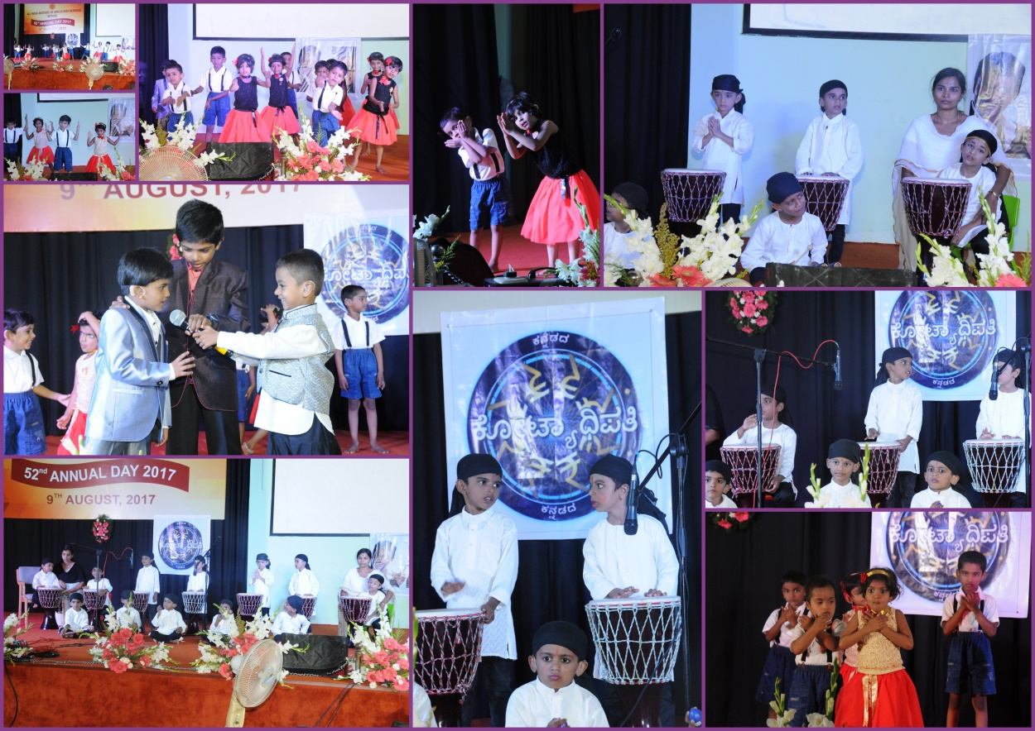

* **Name of the Programme/ Event:** Independence day 2017
* **Date:** 15.08.2017
* **Coordinated by: -** Ms. Manjula P.V, Ms. Asha S.A., Ms. Anjana K., Ms. Subalakshmi.

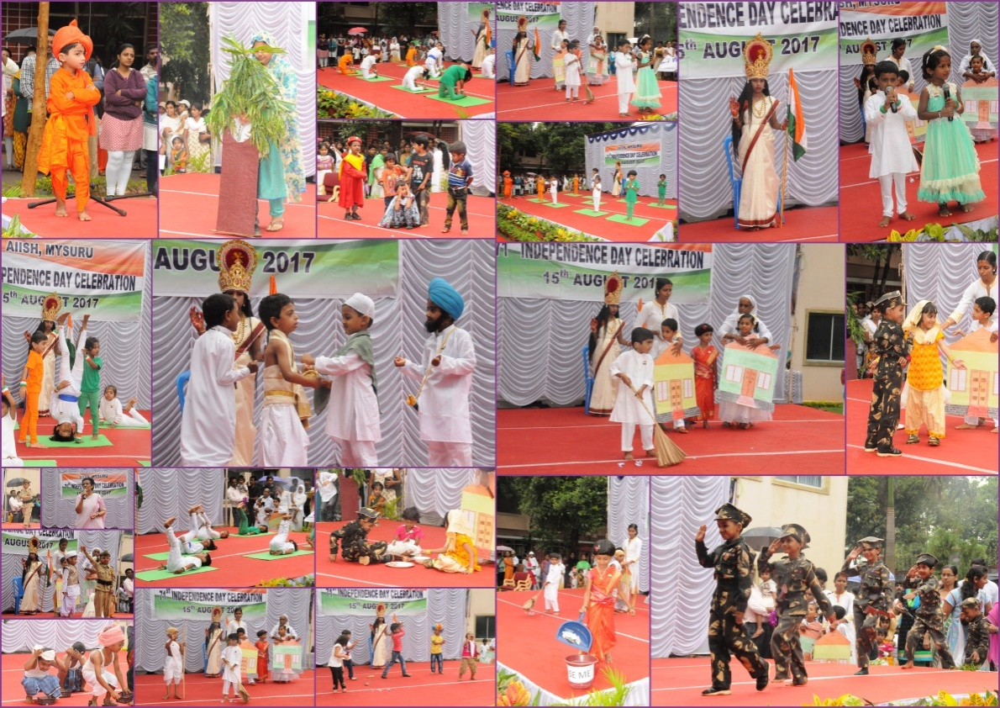

* **Name of the Programme/ Event:** Onam & Eid Celebration 2017
* **Date:** 29.08.2017
* **Coordinated by: -**Mr. Suresh C.B, Ms. Srividya, Ms. Anjana, Ms.Dhivya, Mr. Murshidul Alam.

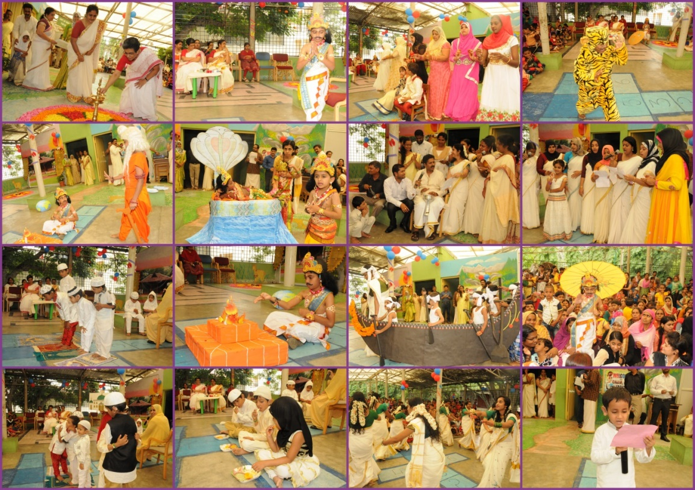

* **Name of the Programme/ Event:** Ganesha Festival in Preschool& Ganeasha Gowri idol prepared by parents with children.
* **Date:** 22.08.2017
* 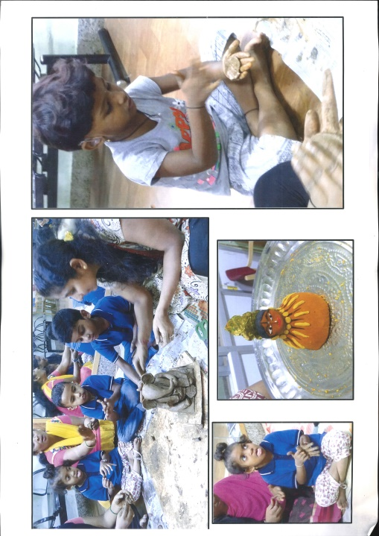**Coordinated by: -** Dr. Pushpavathi M and Preschool Parents

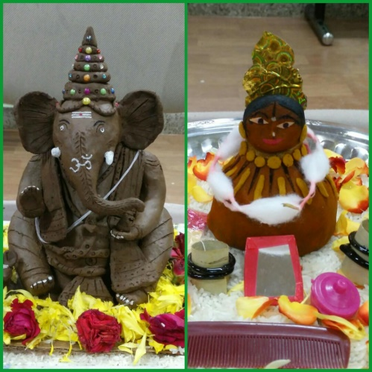

* + - 1. Press Releases and Media Coverage

**C) Material Development :**The following Teaching Learning Materials and Prepare for training children with various communication disorders an preschool.

|  |  |  |  |
| --- | --- | --- | --- |
| **Sl.**  **No.** | **Nature of**  **Teaching-Learning**  **Materials** | **Skill** | **Number** |
| 1. | Flash cards | For all skill areas | 312 sets |
| 2. | Work Cards | For all skill areas | 126 sets |
| 3. | Charts | For all skill areas | 60 |
| 4. | PPT | For all skill areas | 30 |
| 5. | Models | For all skill areas | 6 |
| 6. | Sentence strips | For all skill areas | 125 sets |
| 7. | Others | For all skill areas | - |

1. **AWARDS AND HONORS RECEIVED BY FACULTY AND STAFF**
2. EXTRA CURRICULAR ACTIVITIES
   * + - 1. **AIISH Gymkhana**
         2. NSS
         3. Others:
3. EMINENT VISITORS:

XI. **ANY OTHER**

* **OfficialLanguage Implementation:**
* Word a day
* No of notings/letters (July 2017): **36**

Sd/-

HOD- Special Education