**ALL INDIA INSTITUTE OF SPEECH & HEARING: MYSORE – 570 006**

**DEPARTMENT OF SPECIAL EDUCATION**

**MONTHLY REPORT May2017**

1. **ACADEMIC ACTIVITIES**
2. **Orientation Programs (For outsiders):03**

The following orientation programswere conducted to orient about the activities of the departmentand also to provide the knowledge about the educational facilities and welfare measures for children with special needs.

|  |  |  |  |  |
| --- | --- | --- | --- | --- |
| **SL No.** | **Coordinator** | **Targeted Audience** | **Number**  **of Participants** | **Date** |
|  | Mr. Gururaj D | Students, M.sc Clinical Psychology, ST. Agnes Centre for post graduate studies | 5 | 05.05.17 |
|  | Mr. Gururaj D | Ms. Anupriya, manager, listening ears, Key Acc. Manager – Starkey India | 1 | 26.05.17 |
|  | Mr. Gururaj D | Students, Sri KagineleB.Ed College, Kuvempunagar, Mysuru | 40 | 26.05.17 |

**Faculty report**

**Dr. Pushpavathi M., HOD in Special Education**

* Coordinated for the valedictory function of summer camp 2017
* Coordinated with NSS students of AIISH to get the theme based painting work done in the department of special education
* Auditee for the ISO for the department of special education .
* Coordinated for the arranging summer camp inauguration by Director, AIISH.

|  |  |  |  |  |  |
| --- | --- | --- | --- | --- | --- |
| **Name of the Faculty** | | **Dr. Alok Kumar** | **Dr. G. Malar** | **Dr. Prithi Venkatesh** | **Dr. P. Vijetha** |
| Clinics | | | | | |  |
| **No. of cases evaluated at SEA-U** | | 15 | * Screening: 40 * Assessment: 2 | **5** | 16 |
| **No. of cases supervised individually** | |  | * Nil (summer vacation in preschool) |  |  |
| **No. of groups supervised** | |  | **8** |  |
| **No. of meeting with parents** | |  |  |  |
| **Educational Guidance** | | 02 | * Clients:19 * Sessions:21 |  |  |
| Academics | | | | | |
| **Classes taken** | | | | | |
| **B.Ed.**  **Spl.Edn.(HI)** | **Theory** |  | 7 sessions (including 2 extra class) |  | 03 |
| **Practical** | **10** | 7 hour |  | NIL |
| **DECSE(HI)** | **Theory** |  |  |  | 06 |
| **Practical** |  |  |  | NIL |
| **Any others** |  |  |  | * Served as Deputy Chief Superintendent for B.ASLP, M.Sc (Audiology and Speech) Entrance Examination for Mumbai Centre on 27th May 2017. * Conducted Inspection of three institutes in Chennai as a part of RCI Inspection from 30th May to 31st May 2017. * Served as Internal auditor for 8th ISO Auditing in the Department of Speech –Language Sciences | * On 5th May 2017, oriented PG students of M.Sc. Psychology from St. Agnes centre for PG students and Research, Mangalore. * On 5th May 2017, attended “Stress Management” by Sister Manjula from Brahmakumaris. * On 11th May 2017, invigilation duty was carried out in the forenoon session. * On 17th May 2017, attended peer review meeting of SLS. * On 18th May 2017, attended E3 * by Dr. Pushpavathi on Research Framework. * Worked on photos to be sent to DMD for Digital Library with Mr. Sandesh. * On 29th May 2017, prepared and submitted ARF project proposal. * Oriented Ms. Anupriya from Starkey about departmental activities. |
| Research | | | | | |  |
| **Paper published** | |  |  |  |  |
| **Paper in press projects** | | 04 |  |  |  |
| **Paper presentation** | |  |  |  |  |
| Any other | | | | | |  |
| **Meeting held** | |  | * 4 monthly meetings (2 each) with I & II B.Ed. students * 2 formal meetings with ‘B’ team for wall-space arrangements in preschool |  | * Was a part of Group D Summer camp craft work |
| **Workshops** | |  |  |  |  |
| **Meeting attended** | |  | * 4 meetings with HOD – regarding B.Ed.Spl.Ed. (HI) course, ISO audit, mural arrangements in preschool, etc. * 1 meeting for entrance exam * 1 meeting of CSS team |  |  |
| **AV preparation** | |  | * 1 PPT of 5 concept maps for I B.Ed.Spl.Ed. (HI) students on pedagogy of Instruction in English |  |  |
| **Brochures** | |  | * Nil |  |  |
| Roles & Responsibilities | | | | | |  |
| **Co-ordination** | | Infant & Toddler Unit | * CBCS Coordinator for I& II B.Ed. Spl.Ed. (HI) * Mentor for I & II B.Ed.Spl.Ed. (HI) * Compilation of M.S.Ed. Student Dissertation-based Articles 2014-15 * Intra-Department * SEA-U * EduTechLab   Research & Database Unit |  | **ISO**   * Served as an ISO internal auditor for ENT department for 8th Internal ISO audit. * Format for student feedback prepared. * Collected student feedback of practical postings from students for ISO Audit. * For ISO audit process, had gone through the new process manual and made appropriate changes. * Oriented staff about Upcoming ISO audit. * On 17th May 2017arrangements were made for 8th ISO internal audit of the department. * Compiled ISO Risk assessment and analysis and submitted.   **Service for School aged children**   * On 2nd and 9th May 2017, conducted meeting with the team members.   For CSS unit meeting with HOD, prepared the necessary draft copies as mentioned by HOD. |
| **Member secretary** | | Preschool | * LD Clinic (in DCS) * Services for School-Aged Children (in Department of Special Education) |  | * Service for Infant and Toddlers |
| **Member in** | | SEA-U | * TCPD * Product Development Cell * Preschool Supervision |  | **SEA –U** |
| **Mentor** | | M.Sc. -1st Year -Audiology |  |  |  |

1. Clinical /Educational Observation Postings of Students from other Institutes:NIL

Following are the details of students posted for observation/ practice teaching

|  |  |  |  |  |
| --- | --- | --- | --- | --- |
| Sl.No | Name of the Institute | Programme/Course | Number of Students | Dates |

1. Seminars/Conferences/Workshops/Training Programs:NIL

|  |  |
| --- | --- |
| Theme/topic |  |
| Coordinator |  |
| Objectives |  |
| Targeted Audience |  |
| Number of Participants |  |
| Date |  |
| Photo |  |

1. Staff Enrichment / In-house training Programmes *(For own staff members)* : **03**

|  |  |  |  |  |
| --- | --- | --- | --- | --- |
| **Theme/Topic** | **Coordinator** | **Objectives** | **Number**  **of Participants** | **Date`** |
| Stress Management by B K Manjula | Mr. Harish Kumar | To orient special educators | 30 | 05.05.2017 |
| Human Values by B K Manjula | Mr. Harish Kumar | To orient special educators | 30 | 08.05.2017 |
| “Research Framework” by Prof. M. Pushpavathi | Mr. Suresh C. B. | To Educate Educators in Education | 30 | 18.05.2017 |

1. **Guest Lectures :NIL**

**Served as Resource Person:-**

|  |  |  |  |
| --- | --- | --- | --- |
| **Name, Designation, Institutional affiliation of Lecturer** | **Organized by Department/Section/Unit** | **Topic of Lecture** | **Date** |

1. Additional Academic Services rendered by the Faculty and Staff
2. **Invited Talks: 02**

|  |  |  |  |  |
| --- | --- | --- | --- | --- |
| **Staff** | **Topic** | **Date** | **Programme** | **Institution** |
| Ms. Ramankumari P. V & Ms. Manjula P. V | *Inclusive Education* | 09.05.2017 | Orientation program to B.Ed trainees | The Institute of Education, OnkarmalSomani College of Education, Mysuru |
| Mr. Suresh C. B. & Dr. Kadambari. N | *Educational Management of CW-ASD* | 13.05.2017 | workshop on*“Educational management of children with ASD”* | ShanthiSadan school, Purakkad, Kerala |

A Summer camp was held from 01.05.2017 to 25.05.2017 wherein 130 participants were part of the camp activities. The following experts served as resource persons.

|  |  |  |
| --- | --- | --- |
| **Name, Designation, Institutional affiliation of Lecturer** | **Topic of Lecture** | **Date** |
| His Holiness Dr. Sri GanapathySachchidanandaSwamiji , Founder, DattaKriya Yoga International Center, SGS Ashrama, Mysuru | Kriya Yoga | 01.05.17 to 05.05.17 |
| Ms. B.K. Manjula, PBKIVV Ashram | Stress Management | 09.05.17 to 11.05.17 |
| Mr. Dharma | Wushu | 08.05.17 to 11.05.17 |
| Mr. Dharma | Dance | 15.05.17 to 19.05.17 |
| Dr. Rathna, Former Director , AIISH  Mr. Basavaraj, Well known theatre director | Drama | 15.05.17 to 30.05.17 |

1. Curriculum Development: NIL
2. Development of Material to Support Learning
3. Service in Academic Bodies of other Organizations
4. Participation in Committees/Taskforce and Panels setup by other organizations/agencies

|  |  |  |  |  |  |  |
| --- | --- | --- | --- | --- | --- | --- |
| Sl No | Name of the staff | Name of Organization/Agency | Participation in Committees/Taskforce | Programme | Name of Institute Visited | Date of Visit |

1. **Any Others (Please Specify)**
   * + 1. **Parent Enrichment Programs (PEP): 02** - This program aims to enrich knowledge of the caregivers of CWSN by experts from various fields.

|  |  |  |  |  |
| --- | --- | --- | --- | --- |
| **Theme/Topic** | **Coordinator** | **Objectives** | **Targeted Audience** | **Date** |
| Human Values by B K Manjula | Mr. Harish Kumar | To orient Parents | 30 | 05.05.2017 to 08.05.2017 |
| Stress Management by B K Manjula | Mr. Harish Kumar | To orient Parents | 30 | 09.05.2017 to 11.05.2017 |

**RESEARCH ACTIVITIES (2016-17)**

1. Research Projects (ARF)
2. Completed -NIL
3. New Research Projects- NIL
4. **Ongoing Research Projects –02**
   1. **Title of ARF -** Development and Evaluation of Indigenous curriculum oriented computer based tutor for concept learning in preschool children with special needs.

Principal Investigator – Ms. P.V.Ramanakumari

Co-Investigators – Dr. Ajish K Abraham and Ms. P.V.Manjula

Research Assistant – Mr. Anil Abbur R.

Date of Starting – 18th January 2017

Progress –

* Story board writing of Food we eat.
* Gave 5 story boards for validation
* On 20th April 2017 attended mid-term review meeting

On 26th April 2017 attended ethical committee meeting.

* 1. **ARF Project No. 65**

Title of ARF - Development and Evaluation of Indigenous curriculum oriented computer based tutor for concept learning in preschool children with special needs.

Principal Investigator – Ms. P.V.Ramanakumari

Co-Investigators – Dr. Ajish K Abraham and Ms. P.V.Manjula

Research Assistant – Mr. Anil Abbur R.

Date of Starting – 18th January 2017

Progress –

* Story board writing of Food we eat.
* Started review of literature.
* Gave 1 story board for validation

1. Postgraduate Research Completed:- NIL
2. C. Postgraduate Research ongoing: NIL
3. D Research Papers presented at National/International Conferences/Seminars :- NIL

E.Research Papers Published

i) Papers published in National / International Journals: NIL

ii) Papers published in Conference / Seminar Proceedings: NIL

F. Books published (in APA format)

1. Books published: NIL

G.Book chapters published (in APA format)-NIL

H .Books/Manuals/Seminar Proceedings edited: NIL

1. Journal Editorship: NIL

J. Scholarly Reviewing Activities: NIL

**III CLINICAL SERVICES**

1. General Clinical Services: **Not Applicable**
2. Specialized Clinical/ Educational Services
3. **Preschool Training and Special Education**

**Educational services for children with special needs**

|  |  |  |  |  |  |  |  |  |  |  |  |  |  |  |  |
| --- | --- | --- | --- | --- | --- | --- | --- | --- | --- | --- | --- | --- | --- | --- | --- |
| **S. No.** | **Nature of Services (I/C)** | | | | | | | | | | | | | | |
| 1. Special Educational Assessment Services (Dr. G. Malar) | | | | | | | | | | | | | | | |
|  |  | Nature of Special Need  Language | | ASD / PDD NOS | Hearing Loss | Intellectual Disability | | Learning Disability | Motor Problems | | Multiple Disabilities | Others | No. of Clients | No. of Sessions | ***Total No. of Sessions*** |
| 1. | Screening & Referral | Kannada | | - | 14 | 21 | | 6 | - | | 2 | 8 | ***51*** | ***51*** | ***78*** |
| Malayalam | | - | 3 | 1 | | 1 | - | | - | - | ***5*** | ***5*** |
| Hindi | | 1 | 2 | 2 | | - | - | | - | 1 | ***6*** | ***6*** |
| Urdu | | - | - | - | | - | - | | - | - | ***-*** | ***-*** |
| English | | 1 | 1 | 3 | | 1 | - | | - | 3 | ***9*** | ***9*** |
| Telugu | | - | - | 3 | | - | - | | - | - | ***3*** | ***3*** |
| Tamil | | - | - | 1 | | 1 | - | | - | - | ***2*** | ***2*** |
| Any Other | | 2 | - | - | | - | - | | - | - | ***2*** | ***2*** |
| ***Total No. of Clients*** | | ***4*** | ***20*** | ***31*** | | ***9*** | ***-*** | | ***2*** | ***12*** | ***78*** | ***78*** |
| 2. | Assessment & Report | Kannada | | - | 1 | 2 | | 1 | - | | - | - | ***4*** | ***13*** | ***18*** |
| Malayalam | | - | - | - | | - | - | | - | - | ***-*** | ***-*** |
| Hindi | | - | - | - | | - | - | | - | - | ***-*** | ***-*** |
| Urdu | | - | - | - | | - | - | | - | - | ***-*** | ***-*** |
| English | | - | 1 | - | | - | - | | - | - | ***1*** | ***5*** |
| Telugu | | - | - | - | | - | - | | - | - | ***-*** | ***-*** |
| Tamil | | - | - | - | | - | - | | - | - | ***-*** | ***-*** |
| Any Other | | - | - | - | | - | - | | - | - | ***-*** | ***-*** |
| ***Total No. of Clients*** | | ***-*** | ***2*** | ***2*** | | ***1*** | ***-*** | | ***-*** | ***-*** | ***5*** | ***18*** |
| Places from which seen: (1)Karnataka: 60 (2)Kerala: 5 (3)AP: 3 (4)Telengana: Nil (5)TN: 4 (6)Other Parts of India: 6 (7)Any other: Nil | | | | | | | | | | | | | | |
| Age groups seen:(1)Birth to 2.5yrs: 6 (2)2.5+ to 6 yrs: 25 (3)6yrs+ to 16 years: 40 (4)16yrs+: 7 | | | | | | | | | | | | | | |
| Total No. of Referrals: (1)Educational Assessment: 7 (2)Educational Guidance: 22 (3)PIP: 5 (4)PPEP/ PBC/ GECS: 21 (5)CSS/IEP/NFE/DET: 30 (6) Any Other Services at AIISH: Nil (7) Any Other Services Outside AIISH: 2 | | | | | | | | | | | | | | |
| No. of Reports Issued: (1) School Readiness: 3 (3) Curriculum-Based Assessment: Nil (4) Post-School Preparedness: Nil | | | | | | | | | | | | | | |
| 3. | On-going Assessment (as part of service delivery) | |  | | | | | | | | | | | | |
|  | **Details of Assessments** | | **No. of Children** | | | | **No. of Assessment Sessions** | | | **No. of Reports** | | | | | |
| As part of Parent-Infant Programme: | | Nil | | | | Nil | | | Nil | | | | | |
| As part of Preschool Parent-Empowerment Programme: | | Nil | | | | Nil | | | Nil | | | | | |
| As part of Preschool Training Programme &  As part of Preschool Bridge Course Programme: | | Nil | | | | Nil | | | Nil | | | | | |
| As part of CSS/ IEP/NFE: | | Nil | | | | Nil | | | Nil | | | | | |

|  |
| --- |
| **Preschool Training:Preparatory programme for schooling providing training in self-help, cognitive, language and (pre) academic skills, Preschool Bridge course** |
| Summer camp 2017   |  |  |  |  |  |  |  | | --- | --- | --- | --- | --- | --- | --- | | **Language** | **HI** | **ID** | **Autism** | **MD** | **Others** | **Normal** | | Kannada | 11 | 15 | 13 | 4 | 13 | 14 | | Malayalam | 2 | 10 | 6 | 1 | 8 | 0 | | Telugu | 1 | 2 | 1 | 0 | 0 | 4 | | English | 0 | 1 | 0 | 1 | 2 | 0 | | Hindi | 9 | 0 | 2 | 2 | 2 | 2 | |

|  |  |  |  |  |  |  |  |  |  |  |  |  |  |  |
| --- | --- | --- | --- | --- | --- | --- | --- | --- | --- | --- | --- | --- | --- | --- |
| * **Curricular Support Services – Supportive training to augment education in mainstream school/ other educational programmes** * **Individualised Educational Programme (IEP) – Training in functional academics for out of school individuals** * **Demonstration Training – Short-term demonstration to caregivers in any of the above** | | | | | | | | | | | | | | |
| **Language and Disability** | **Number of Clients and type of service** | | | | | | | | | | | | **Total**  **Clients** | **Total Sessions** |
| **Old** | | | **New** | | | **Discharged** | | | **Discontinued** | | |
| **C** | **I** | **D** | **C** | **I** | **D** | **C** | **I** | **D** | **C** | **I** | **D** |
| Kannada HI | 4 | 1 | - | - | - | - | - | - | - | - | - | 2 | 26 | **CSS- 86**  **IEP – 29**  **DET - 80** |
| Kannada ID (CP/ Down’s) | 7 | 5 | 6 | - | - | - | - | 1 | 2 | 1 | 1 | 1 |
| Kannada MD | - | - | - | - | - | - | - | - | - | - | - | - |
| Kannada LD | 2 | - | 1 | - | - | - | - | - | 1 | - | - | - |
| Kannada PDD/ASD | 2 | - | - | - | - | - | - | - | - | - | - | - |
| Malayalam HI | 1 | - | 2 | - | - | - | - | - | - | - | - | - | 10 |
| Malayalam ID (CP/ Down’s) | 1 | 2 | 2 | - | - | - | - | - | 1 | - | - | - |
| Malayalam MD | - | - | - | - | - | - | - | - | - | - | - | - |
| Malayalam LD | - | - | - | - | - | - | - | - | - | - | - | - |
| Malayalam PDD /ASD | - | 1 | 1 | - | - | - | - | - | - | - | - | - |
| Hindi HI | - | - | - | - | - | - | - | - | - | - | - | - | 2 |
| Hindi ID (CP/Down’s) | - | 1 | - | - | - | - | - | - | - | - | - | - |
| Hindi MD | - | - | - | - | - | - | - | - | - | - | - | - |
| Hindi LD | 1 | - | - | - | - | - | - | - | - | 1 | - | - |
| Hindi PDD/ASD | - | - | - | - | - | - | - | - | - | - | - | - |
| English HI | 2 | - | - | - | - | - | - | - | - | - | - | - | 12 |
| English ID (CP/Down’s) | 4 | - | 1 | - | - | - | - | - | - | - | - | - |
| English MD | - | - | 1 | - | - | - | - | - | - | - | - | - |
| English LD | 2 | - | - | - | - | - | - | - | - | - | - | - |
| English PDD/ASD | 2 | - | - | - | - | - | - | - | - | - | - | - |
| Tamil HI | - | - | - | - | - | - | - | - | - | - | - | - | 0 |
| Tamil ID (CP/Down’s) | - | - | - | - | - | - | - | - | - | - | - | - |
| Tamil MD | - | - | - | - | - | - | - | - | - | - | - | - |
| Tamil LD | - | - | - | - | - | - | - | - | - | - | - | - |
| Tamil PDD/ASD | - | - | - | - | - | - | - | - | - | - | - | - |
| Telugu HI | - | - | - | - | - | - | - | - | - | - | - | - | 1 |
| Telugu ID (CP/Down’s) | - | - | - | - | - | - | - | - | - | - | - | - |
| Telugu MD | - | - | - | - | - | - | - | - | - | - | - | - |
| Telugu LD | 1 | - | - | - | - | - | - | - | - | - | - | - |
| Telugu PDD/ASD | - | - | - | - | - | - | - | - | - | - | - | - |
| **Total** | | | | | | | | | | | | | **51** | **195** |
| **Old clients:- 36**  **New clients: - 15**  **Discharged:- 05**  **Discontinued:- 06** | | | | | | | | | | | | |  |  |

|  |  |  |  |  |  |  |  |  |  |  |
| --- | --- | --- | --- | --- | --- | --- | --- | --- | --- | --- |
| **Preschool Parent Empowerment Programme – PPEP** | | | | | | | | | | |
| Buffer programme for children awaiting for preschool admission | **Language** | **HL** | **ID** | **CP** | **ASD** | **MD** | **LD** | **DD** | **Total No. of clients** | **No. Of sessions** |
| Kannada | 36 | 22 | -- | 12 | 06 | -- | -- | 76 | 151 |
| Malayalam | 02 | 15 | -- | 09 | 05 | 01 | -- | 32 | 09 |
| Hindi | 08 | 02 | -- | -- | 01 | -- | -- | 11 | 22 |
| English | 01 | 02 | -- | 02 | -- | -- | -- | 05 | 22 |
| Telugu | -- | 04 | -- | -- | 02 | -- | -- | 06 | 20 |
| Tamil | 03 | 03 | -- | 01 | 01 | -- | -- | 08 | 04 |
| **Total** | | | | | | | | | **138** | **228** |
| No. of clients promoted to the next higher level of service: 00  No. Of discharged : Nil  No. Of discontinued: 12 (Kannada: MD = 01), (Malayalam: CP= 01, HL= 02) (Telugu – HL- 06), (Tamil : HL-02)  No. Of new clients : 31 (Kannada-12, Malayalam-05, Hindi-02, English-02, Telugu-06, Tamil-04) | | | | | | | | | | |

|  |  |  |  |  |  |  |  |  |  |  |  |  |  |  |  |  |  |  |  |  |  |  |  |  |  |  |  |  |  |  |  |  |  |  |  |  |  |  |  |  |  |  |  |  |  |  |  |  |  |  |  |  |  |  |  |  |  |  |  |  |  |  |  |  |  |  |  |  |  |  |  |  |  |  |  |  |  |  |  |  |  |  |  |  |  |  |  |  |  |  |  |  |  |  |  |  |  |  |  |  |  |  |  |  |
| --- | --- | --- | --- | --- | --- | --- | --- | --- | --- | --- | --- | --- | --- | --- | --- | --- | --- | --- | --- | --- | --- | --- | --- | --- | --- | --- | --- | --- | --- | --- | --- | --- | --- | --- | --- | --- | --- | --- | --- | --- | --- | --- | --- | --- | --- | --- | --- | --- | --- | --- | --- | --- | --- | --- | --- | --- | --- | --- | --- | --- | --- | --- | --- | --- | --- | --- | --- | --- | --- | --- | --- | --- | --- | --- | --- | --- | --- | --- | --- | --- | --- | --- | --- | --- | --- | --- | --- | --- | --- | --- | --- | --- | --- | --- | --- | --- | --- | --- | --- | --- | --- | --- | --- | --- |
| |  |  |  |  |  |  |  |  |  |  |  | | --- | --- | --- | --- | --- | --- | --- | --- | --- | --- | --- | | **Parent-Infant Programme – PIP . (Birth to 2 ½ years)** | | | | | | | | | | | | Early stimulation programme for infants & toddlers with communication disorders | **Language** | **HL** | **ID** | **CP** | **ASD** | **MD** | **LD** | **DD** | **Total No. of clients** | **Total No. Of sessions** | | Kannada | 8 | 4 | - | 1 | 4 | - | - | 18 | 90 | | Malayalam | 2 | 10 | - | 1 | 5 | - | - | 18 | 85 | | Hindi | 3 | - | - | - | 1 | - | - | 4 | 21 | | English | - | - | - | - | - | - | - | - | - | | Telugu | - | - | - | - | - | - | - | - | - | | Tamil | - | - | - | - | - | - | - | - | - | |  | **Total** | | | | | | | | **43** | **134** | | Specific age range:  No. of Old clients :39  No. of New clients enrolled: 04  No. discharged : NIL  No. discontinued:01  No. of Promoted to next level: 01 | | | | | | | | | | | |

|  |  |  |
| --- | --- | --- |
| **Library of Books & Toys** – LiBoToy  (Ms. P. V. Ramanakumari & Ms. P. V. Manjula): Services issuing educational toys & books for home-based training | Total number of members enrolled - NIL  No. of new members: - NIL  Amount – NIL  Total number of sessions –NIL | |
| **Age group** | **Total number** |
| 0-2.6 yrs | - |
| 2.6-4 yrs | - |
| 4.0-6yrs | - |
| 6 yrs and above | - |

|  |  |  |
| --- | --- | --- |
| **Services** | **Number of Clients** | **Number of Sessions** |
| Co-Curricular Training | 14 | 14 |

**Supports for Empowering Caregivers**

|  |  |  |  |
| --- | --- | --- | --- |
| Name of Training Unit | No. of Parent  Beneficiaries | No. of Sessions | Content of Training |
| Caregiver Computer Training Unit | -- | -- | -- |
| Caregiver Literacy Training Unit | -- | -- | -- |

1. Clinical Support Services to Clients and Family
2. **Counselling and guidance**

|  |  |
| --- | --- |
| No. of Clients | Sessions |
| 130 | 63 |

1. **U-SAFE**

|  |  |
| --- | --- |
| No. of Clients | Sessions |
| -- | -- |

1. **Details of Certificates Issued:**

**Details of Bonafide Certificates Issued:**

|  |  |  |  |
| --- | --- | --- | --- |
| **Sl.No.** | **Nature of Special Needs in Clients** | **No. of Certificates Issued** | **Purpose** |

1. Financial Aid- NIL
2. Legal advice -NIL
3. **Any other(Please Specify):**

**Orientation Programs: NIL**

The program aims to adopt and support mainstream schools integrating children with communication disorders.Theteachers of these schools are oriented periodically on identification of special needs in children, consequent supports like referral services, curricular adaptation and management, and guidance regarding availing educational welfare measures among others. Beyond these, need-based guidance is extended to teachers in managing practical hitches in the process of inclusion. In the course of action the programme also endeavours to mould positive attitudes among the teachers. The following are the details of the orientation programmes carried out during 2017-18:

|  |  |  |  |  |
| --- | --- | --- | --- | --- |
| Sl. No | Details of Schools Adopted | No. of Staff in the Schools | Resource Persons from AIISH | Dates of Orientation Programmes |

* + 1. EXTENSION ACTIVITIES

1. Public Lecture Series
   * 1. TECHNLOGICAL CONSULTANCY SERVICES: Not applicable
        1. CENTRAL FACILITIES
        2. Library and Information Services
        3. Public Information Activities
        4. **Major Events of the Year with a brief account**

* **Name of the Programme/ Event:** Activities of Summer Camp 2017
* **Date:** 01.05.2017-31.05.2017
* **Coordinated by: -** Ms. Ramanakumari P.V., Mr. HarishKumar, Ms. Leelarani S. B, Ms. Dhivya D., Mr. MurshidulAlam.

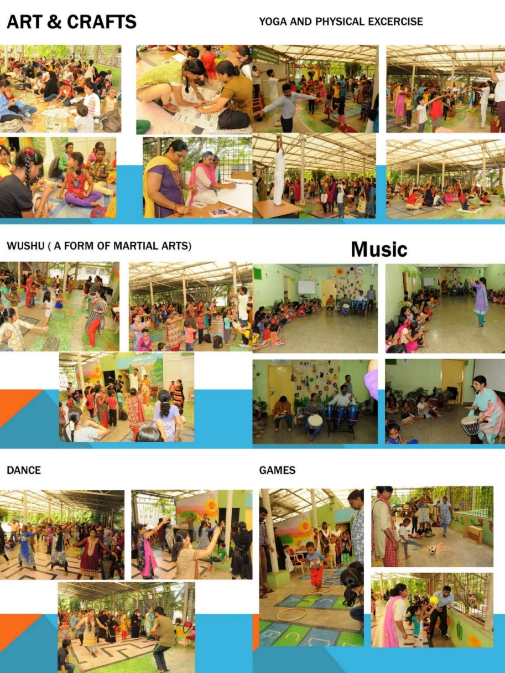

* **Name of the Programme/ Event:** Valedictory function of Summer Camp 2017
* **Date:** 31.05.2017
* **Coordinated by: -** Ms. Ramanakumari P.V., Mr. Harish Kumar, Ms. Leelarani S. B, Ms. Dhivya D., Mr. MurshidulAlam.

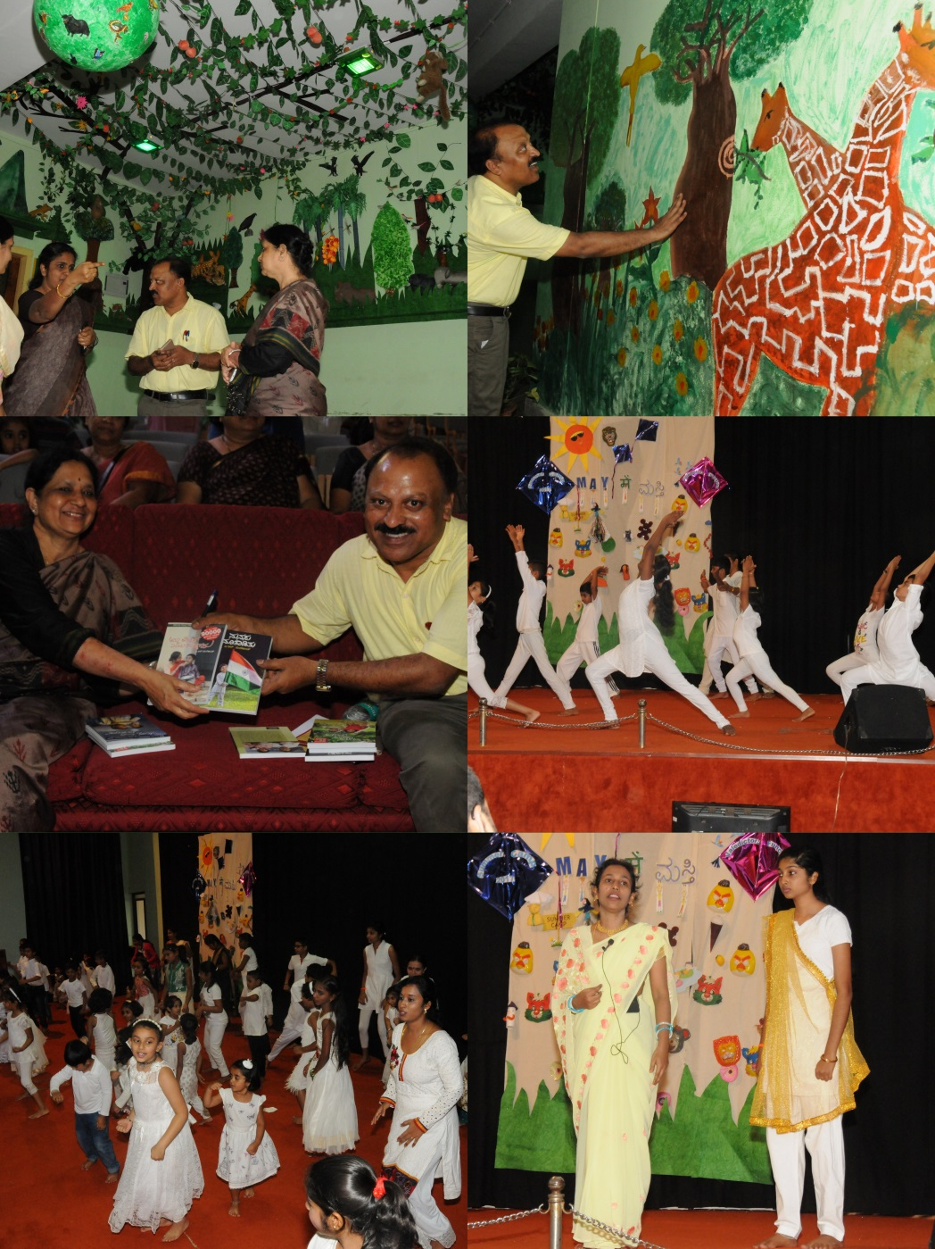

1. **Press Releases and Media Coverage**

* 02June 2017 – Udayavani Preschool Summer Camp valedictory function was in various newspapers was published.

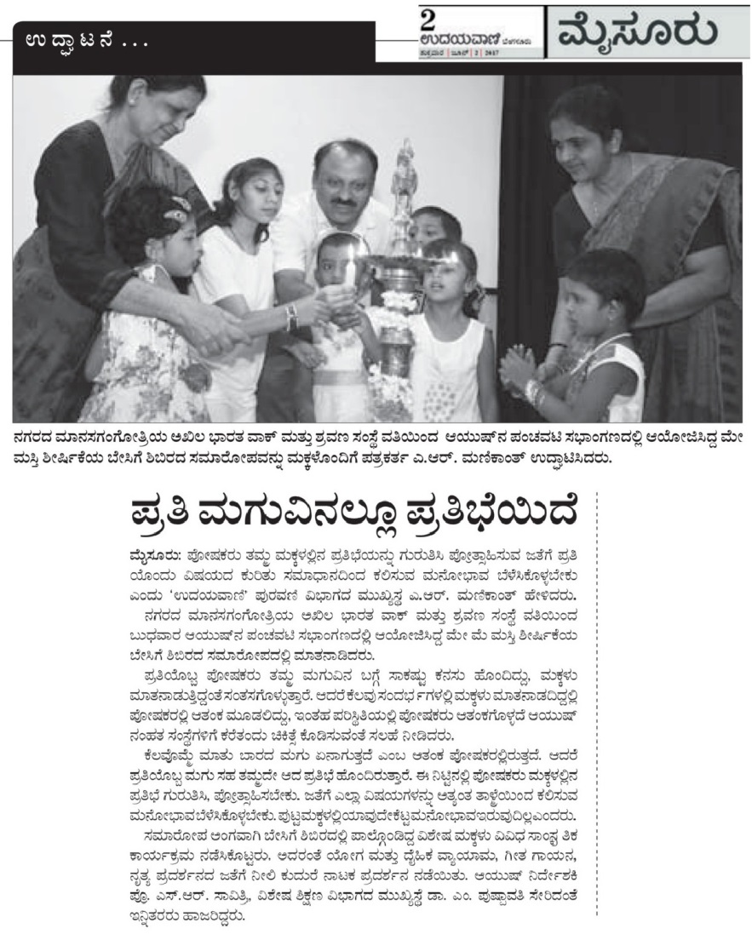

**C) Material Development :**The following Teaching Learning Materials and Prepare for training children with various communication disorders an preschool.

|  |  |  |  |
| --- | --- | --- | --- |
| **Sl.**  **No.** | **Nature of**  **Teaching-Learning**  **Materials** | **Skill** | **Number** |
| 1. | Flash cards | For all skill areas | NIL |
| 2. | Work Cards | For all skill areas | NIL |
| 3. | Charts | For all skill areas | 100 |
| 4. | PPT | For all skill areas | NIL |
| 5. | Models | For all skill areas | NIL |
| 6. | Sentence strips | For all skill areas | NIL |
| 7. | Others | For all skill areas | NIL |

1. **AWARDS AND HONORS RECEIVED BY FACULTY AND STAFF**
2. EXTRA CURRICULAR ACTIVITIES
   * + - 1. **AIISH Gymkhana**
         2. NSS
         3. Others:
3. EMINENT VISITORS:

XI. **ANY OTHER**

* **OfficialLanguage Implementation:**
* Word a day
* No of notings/letters (May 2017): **34**

Sd/-

HOD- Special Education