**ALL INDIA INSTITUTE OF SPEECH AND HEARING, MYSURU-6**

**अखिल भारतीय वाक श्रवण संस्थान, मैसूर-६**

**DEPARTMENT OF SPECIAL EDUCATION**

**विशेषशिक्षाविभाग**

**MONTHLY REPORT March 2017**

**मासिकरिपोर्टअक्टूबरफरवरीजुलूस2017**

1. **ACADEMIC ACTIVITIES**
2. **Orientation Programs (For outsiders):**The following orientation programswere conducted to orient about the activities of the departmentand also to provide the knowledge about the educational facilities and welfare measures for children with special needs. :

|  |  |  |  |  |
| --- | --- | --- | --- | --- |
| **SL No.** | **Coordinator** | **Targeted Audience** | **Number**  **of Participants** | **Date** |
| 1 | Ms.Anjana K | Co-ordinators, Department of Higher Secondar Education, Kerala | 43 | 01.03.2018 |
| 2 | Mr.Gururaj | Students, JSS D.Ed College, Saraswathipuram, Mysuru | 23 students | 01.03.2018 |
| 3 | Mr.Gururaj | DHLS students, AIISH, Mysuru | 16 students | 13.03.2018 |

1. **Posting (For outsiders):01**

|  |  |  |  |  |
| --- | --- | --- | --- | --- |
| **SL No.** | **Coordinator** | **Targeted Audience** | **Number**  **of Participants** | **Date** |
| 01 | Mr.Gururaj D. | D.Ed Students, Government Teacher Training Centre, Mysuru | 16 | 23rd, 26th& 27th March 2018 (3 days) |
| 02 | Dr. Malar G | Dr. T. Jayasudha, Director,National Institute for the Empowerment of Persons with Intellectual Disabilities (Formerly National Institute for the Mentally Handicapped),  Chennai. | 01 | 26.03.2018 |

**Dr.Pushpavathi M, HOD – Special Education**

* Coordinating the work related to UGC inspection . conducted three meetings
* Supervising the work related to summer camp , preparation of resource materials and teaching aids

**Faculty report**

|  |  |  |  |  |  |  |
| --- | --- | --- | --- | --- | --- | --- |
| **Name of the Faculty** | | **Dr.Alok Kumar** | **Dr. G. Malar** | **Dr.PrithiVenkatesh** | **Dr. P. Vijetha** | **Ms.LakshmiPrabha J.K** |
| **Clinics** | | | | | |  |
| **No. of cases evaluated at SEA-U** | | 15 | * Screening: 10 clients in 10 sessions * Assessment: 3 clients in 14 sessions | She is on Maternity leave | 10 | * Screening: 12 clients in 12 sessions |
| **No. of cases supervised individually** | | Nil | * 21 children through 5 classroom observations |  | 40 |  |
| **No. of groups supervised** | | 08 | * 10 preschool groups |  | 12 |  |
| **No. of meeting with parents** | | 08 | * 10 meetings in 10preschool groups |  | 09 |  |
| **Educational Guidance** | | 01 | * 8 clients * 8 sessions |  | NIL | * 2 clients in 3 sessions |
| **Academics** | | | | | | |
| **Classes taken** | | | | | |  |
| **B.Ed.**  **Spl.Edn.(HI)** | **Theory** | 20 Classes | * 29 (including 3 extra) |  | 24 classes | 5 hours |
| **Practical** | 10 hours | * 40 hours |  | 68 hours | 6 hours |
| **Any others** |  | Assistant Warden |  |  | * On 5th March 2018 as a **member of BOE** attended meeting at AIISH. * Submitted C2 marks for theory and practical works. |  |
| **Any other** | | | | | |  |
| **Meeting held** | |  | * Meetings with I& II B.Ed.Spl.Ed. (HI) students as mentor * 10 meetings with preschool parents |  | * On 13th March 2018 at 10:00am, stock verification (DCS) meeting was held with the team members.   Initiated stock verification work in DCS. |  |
| **Meeting attended** | |  | * Institute meeting w.r.t mock inspection for deemed University status * 4 meetings with HOD regarding preparations for Deemed University status |  | * Attended Faculty Meeting with HOD for UGC expert committee inspection work. * Assisted in preparing PPT of Research work for UGC inspection.   Indent work related to Safety mats is being processed and being followed up with purchase section. | * 2 meetings with HOD regarding preparation of PPT for UGC Expert Committee, * 2 meetings with faculty regarding preparation of PPT for UGC Expert Committee, and * 2 meetings with Special Educators regarding Graduation Day program |
| **Brouchre** | |  | Follow up & update of brochure on SEA-U services following HOD’s feedback |  |  |  |
| **Serve as Resource person** | |  |  |  |  |  |
| **Roles & Responsibilities** | | | | | |  |
| **Co-ordination** | | Parent Infant Program Unit  Preschool Parent Enrichment Program Unit | * CBCS Coordinator for I& II B.Ed.Spl.Ed. (HI) * Compilation of M.S.Ed. Student Dissertation-based Articles 2014-15 * Intra-Department * SEA-U * Research & Database Unit |  | 1. **ISO**  * Inputs for the 11th MRM meeting work were submitted. * On 7th Feb, Served as an ISO Internal auditor for the Dept. of Clinical Psychology. |  |
| **Member secretary** | | Pre School | * Services for School-Aged Children (in Department of Special Education) |  | NIL |  |
| **Member in** | | Special education assessment Unit and Assistan warden | * TCPD * LD Clinic (in DCS) * Product Development Cell * Preschool Supervision * Allied member of ISHA * Life member of NCED |  | SEA-U |  |
| **Mentor** | | M.Sc 2year Audiology | * Mentor for I & II B.Ed.Spl.Ed. (HI) |  |  |  |

1. Clinical /Educational Observation Postings of Students from other Institutes:NIL

Following are the details of students posted for observation/ practice teaching

|  |  |  |  |  |
| --- | --- | --- | --- | --- |
| **Sl.No** | **Name of the Institute** | **Programme/Course** | **Number of Students** | **Dates** |

1. Seminars/Conferences/**Workshops**/Training Programs:NIL
2. Staff Enrichment / **In-house training Programmes***(For own staff members)* : NIL

|  |  |  |  |  |  |
| --- | --- | --- | --- | --- | --- |
| **Theme/Topic** | **Resource Person** | **Coordinator** | **Objectives** | **Targeted Audience** | **Date** |

1. **Guest Lectures :NIL**

|  |  |  |  |
| --- | --- | --- | --- |
| **Name, Designation, Institutional affiliation of Lecturer** | **Organized by Department/Section/Unit** | **Topic of Lecture** | **Date** |
|  |  |  |  |

1. **Additional Academic Services rendered by the Faculty and Staff**
2. **Invited Talks**: **NIL**

|  |  |  |  |  |
| --- | --- | --- | --- | --- |
| **Staff** | **Topic** | **Date** | **Programme** | **Institution** |

1. Curriculum Development: NIL
2. **Development of Material to Support Learning :**G. Malar – Revision of Training Manual – Visual Arts for Preschoolers.
3. Service in Academic Bodies of other Organizations
4. Participation in Committees/Taskforce and Panels setup by other organizations/agencies:

|  |  |  |  |  |  |  |
| --- | --- | --- | --- | --- | --- | --- |
| **Sl No** | **Name of the staff** | **Name of Organization/Agency** | **Participation in Committees/Taskforce** | **Programme** | **Name of Institute Visited** | **Date of Visit** |
|  |  |  |  |  |  |  |

1. **Any Others (Please Specify)**

**Parent Help Parents Program (PHPP): 1**

|  |  |
| --- | --- |
| Name of the faculty/ staff | Ms.IDA Harsha , Parent of Dhivya and Deepa |
| Name/Topic of the Program | Parents help parents programme(PHPP) for Parents of children |
| Coordinator | Ms.Leena C C , Ms.Latha C |
| Objectives | * To help instil confidence in the parents/caregivers handling their child. * To train the parents in managing their stress levels while dealing with their child. * To motivate the parents for working more efficiently with their child. * To empower the parents regarding different aspects of training |
| Organized by Department/Section/Unit | Department of Special Education |
| Targeted Audience | Parents of Special Children |
| Date | 13.03.2018 |
| No.of beneficiaries | 76 |
| Photo | |

**RESEARCH ACTIVITIES (2016-17)**

1. Research Projects (ARF)
2. Completed -NIL
3. New Research Projects- NIL
4. **Ongoing Research Projects –02**
   * 1. **Title of ARF** - Development and Evaluation of Indigenous curriculum oriented computer based tutor for concept learning in preschool children with special needs.

Principal Investigator – Ms. P.V. Ramanakumari

Co-Investigators – Dr.Ajish K Abraham and Ms. P.V. Manjula

Research Assistant – Mr. Anil Abbur R.

Date of Starting – 18th January 2017

* + 1. **Title**: Effect of Resource Materials on Impact of Inclusive Education in Children with Intellectual Disabilities (ID) and Learning Disabilities (LD)

Investigators: Dr. G. Malar, Ms. S. Prathima&Mr. D. Gururaj

Duration: 12 months from January 2017

Budget: Rs. 3,85,000/-

Process: * Completed pre-intervention data collection

*Continuing with RoL& finalisation of resource material

1. Postgraduate Research Completed:- NIL
2. C. Postgraduate Research ongoing: NIL
3. **D. Research Papers presented at National/International Conferences/Seminars :- 03**

Raj kumar, R.(2018).*Inclutive Education for Children with Special Needs: Role of Early Childhood Educational Program.*A paper presented at the National Seminar on Persons with Disabilites:Perspectives, Problems an d Protection, Andhra University, Visakhapatnam. March 16-17, 2018.

Raj kumar, R.(2018).*Knowledge and Attitudes of Special Teachers towards the Indian Sign Language.*A paper presented at the National Seminar on Persons with Disabilites:Perspectives, Problems an d Protection, Andhra University, Visakhapatnam. March 16-17, 2018.

Raj kumar, R.(2018).*A Comparative Study on Knowledge among Parents of Intellectually Challenged Children about Early Intervention on their Years of Experience.*A paper presented at the National Seminar on Persons with Disabilites:Perspectives, Problems an d Protection, Andhra University, Visakhapatnam. March 16-17, 2018.

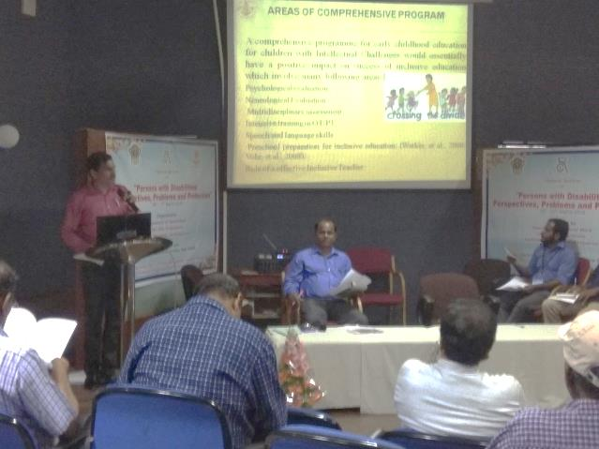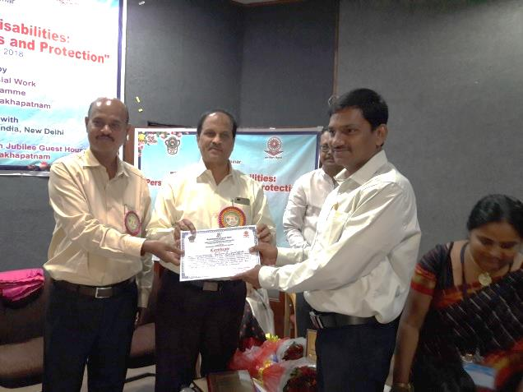

E.Research Papers Published

i**) Papers published in National / International Journals:**

Prithi. V. & Kadambari. N (2017).Knowledge and Attitude of Teachers Towards Government Initiatives for Children with Hearing Impairment. *Journal of National Convention of Educators of the Deaf (JNCED)*.*9(1).*34-40.

ii) **Abstracts published in Conference / Seminar Proceedings: 03**

Raj kumar, R. &B. N. Shobha(2018).Inclutive Education for Children with Special Needs: Role of Early Childhood Educational Program*.Souvenir ofNational Seminar on Persons with Disabilites:Perspectives, Problems an d Protection, Andhra University, Visakhapatnam*. March 16-17,2018 (42) ISBN No: 978-81-936731-6-4.

Raj kumar, R., Suresh., C. B. &Nidheesh, D. K.(2018).Knowledge and Attitudes of Special Teachers towards the Indian Sign Language*.Souvenir ofNational Seminar on Persons with Disabilites:Perspectives, Problems an d Protection, Andhra University, Visakhapatnam*. March 16-17,2018 (48) ISBN No: 978-81-936731-6-4.

Raj kumar, R., D. Dhivya&Subramanya, K. R(2018).A Comparative Study on Knowledge among Parents of Intellectually Challenged Children about Early Intervention on their Years of Experience*.Souvenir ofNational Seminar on Persons with Disabilites:Perspectives, Problems an d Protection, Andhra University, Visakhapatnam*. March 16-17,2018 (91) ISBN No: 978-81-936731-6-4.

F. Books published (in APA format)

1. Books published: NIL

G.Book chapters published (in APA format): NIL

H .Books/Manuals/Seminar Proceedings edited: NIL

1. Journal Editorship: NIL

J. Scholarly Reviewing Activities:

1. Special Educational Services Offered through Teacher Trainees Outside Campus: NIL

**III CLINICAL SERVICES**

1. General Clinical Services: **Not Applicable**
2. Specialized Clinical/ Educational Services
3. **Preschool Training and Special Education**

**Educational services for children with special needs**

|  |  |  |  |  |  |  |  |  |  |  |  |  |
| --- | --- | --- | --- | --- | --- | --- | --- | --- | --- | --- | --- | --- |
| **S. No.** | **Nature of Services (I/C)** | | | | | | | | | | | |
| 1. Special Educational Assessment Services (Dr. G. Malar) | | | | | | | | | | | | |
|  |  | Nature of Special Need  Language | ASD / PDD NOS | Hearing Loss | Intellectual Disability | Learning Disability | Motor Problems | Multiple Disabilities | Others | No. of Clients | No. of Sessions | ***Total No. of Sessions*** |
| 1. | Screening & Referral | Kannada | 2 | 10 | 8 | 1 | - | 3 | 1 | ***25*** | ***25*** | ***48*** |
| Malayalam | 1 | 4 | 3 | - | 1 | 1 | 3 | ***13*** | ***13*** |
| Hindi | - | - | 1 | - | - | - | - | ***1*** | ***1*** |
| Urdu | - | 1 | - | - | - | - | - | ***1*** | ***1*** |
| English | - | - | 1 | 1 | - | - | 4 | ***6*** | ***6*** |
| Telugu | - | - | - | - | - | - | - | ***-*** | ***-*** |
| Tamil | - | 1 | - | - | - | - | - | ***1*** | ***1*** |
| Any Other | - | - | 1 | - | - | - | - | ***1*** | ***1*** |
| ***Total No. of Clients*** | ***3*** | ***16*** | ***4*** | ***2*** | ***1*** | ***4*** | ***8*** | ***48*** | ***48*** |
| 2. | Assessment & Report | Kannada | 1 | 1 | 1 | - | - | - | - | ***3*** | ***11*** | ***17*** |
| Malayalam | - | - | 1 | - | - | - | - | ***1*** | ***4*** |
| Hindi | - | - | - | - | - | - | - | ***-*** | ***-*** |
| Urdu | - | - | - | - | - | - | - | ***-*** | ***-*** |
| English | - | - | - | - | - | - | 1 | ***1*** | ***5*** |
| Telugu | - | - | - | - | - | - | - | ***-*** | ***-*** |
| Tamil | - | - | - | - | - | - | - | ***-*** | ***-*** |
| Any Other | 1 | 1 | 2 | - | - | - | 1 | ***5*** | ***20*** |
| ***Total No. of Clients*** | ***01*** | ***-*** | ***01*** | ***01*** | ***-*** | ***-*** | ***-*** | ***04*** | ***17*** |
| Places from which seen: (1)Karnataka: 33 (2)Kerala: 13 (3)AP: Nil (4)Telengana: Nil (5)TN: 01 (6)Other Parts of India: 01 (Sikkim) (7)Any other: Nil | | | | | | | | | | | |
| Age groups seen:(1)Birth to 2.5yrs: 03 (2)2.5+ to 6 yrs: 27 (3)6yrs+ to 16 years: 17 (4)16yrs+: 01 | | | | | | | | | | | |
| Total No. of Referrals: (1)Educational Assessment: 05 (2)Educational Guidance: 06 (3)PIP: 05 (4)PPEP/ PBC/ GECS: 23 (5)CSS/IEP/NFE/DET: 11 (6)Any Other Services at AIISH: Nil (7)Any Other Services Outside AIISH: 2 (mainstreaming) & 1 (vocational training) | | | | | | | | | | | |
| No. of Reports Issued/Ready for Issue: (1) School Readiness: 03 (3) Curriculum-Based Assessment: 02 (4) Post-School: 01 | | | | | | | | | | | |

|  |
| --- |
| **PreschoolTraining:Preparatory programme for schooling providing training in self-help, cognitive, language and (pre) academic skills, Preschool Supplementary Services (PSS)** |
| |  |  |  |  | | --- | --- | --- | --- | | **Language & Disability** | **No. of Groups** | **No. of Children** | | |  |  | MALE | FEMALE | | Kannada ASD & ID &MD | 14 | 48 | 18 | | Kannada HL | 8 | 44 | 17 | | Malayalam HL | 1 | 2 | 1 | | Malayalam ASD & ID & MD | 10 | 29 | 18 | | Hindi HL | 2 | 5 | 5 | | Hindi MD & ID & ASD | 2 | 5 | 3 | | English ID, ASD | 1 | 4 | 0 | | Telugu ASD & ID & MD | 1 | 6 | 2 | | TOTAL Number of children |  | **143** | **64** | | **TOTAL No. Groups** | **39** | **207** | | | **Sessions** | **3120 (Group wise) 20 days** | | | |

|  |  |  |  |  |  |
| --- | --- | --- | --- | --- | --- |
| **Curricular Support Services – Supportive training to augment education in mainstream school/ other educational programmes** | **Language** | **HL** | **ID/CP/ASD/MD/LD/DD** | **Total No. of clients** | **No. Of sessions** |
| Kannada | 6 | 12 | 18 | 93 |
| Malayalam | 1 | 1 | 2 | - |
| Hindi | 1 | 1 | 2 | 6 |
| English | - | 8 | 8 | 31 |
| Telugu | - | - | - | - |
| Tamil | - | - | - | - |
| **Total** | | | | **30** | **130** |
| |  |  |  |  |  |  | | --- | --- | --- | --- | --- | --- | | **Individualised Educational Programme (IEP) – Training in functional academics for out of school individuals** | **Language** | **HL** | **ID/CP/ASD/MD/LD/DD** | **Total No. of clients** | **No. Of sessions** | | Kannada | 4 | 9 | 13 | 48 | | Malayalam | - | 4 | 4 | - | | Hindi | - | 2 | 2 | 8 | | English | - | - | - | - | | Telugu | - | - | - | - | | Tamil | - | - | - | - | | **Total** | - | - | **19** | **56** | | | | | | |
| |  |  |  |  |  |  | | --- | --- | --- | --- | --- | --- | | **Demonstration Educational Training – Short-term demonstration to caregivers in any of the above** | **Language** | **HL** | **ID/CP/ASD/MD/LD/DD** | **Total No. of clients** | **No. Of sessions** | | Kannada | 2 | 3 | 5 | 4 | | Malayalam | - | 2 | 2 | - | | Hindi | 1 | - | 1 | 3 | | English | - | 1 | 1 | - | | Telugu | - | - | - | - | | Tamil | - | - | - | - | | **Total** | - | - | **9** | **7** | | | | | | |
| **Total clients: 58**  **Old clients:- 49**  **New clients: - 09**  **Discharged(DET):- 01**  **Discharged(CSS):- NIL**  **Discharged(IEP):- NIL**  **Discontinued(DET):- NIL**  **Discontinued(CSS):- NIL**  **Discontinued(IEP):- NIL**  **Promoted from CSS/IEP/DET to PPEP: NIL**  **No. of remaining clients: 57** | | | | | |

|  |  |  |  |  |  |  |  |  |  |  |  |
| --- | --- | --- | --- | --- | --- | --- | --- | --- | --- | --- | --- |
| **Preschool Parent Empowerment Programme – PPEP** | | | | | | | | | | | |
|  | **Language** | **HL** | **ID** | **CP** | **ASD** | **MD** | **LD** | **DD** | **SLD** | **VI** | **Total No. of clients** | **No. Of sessions** |
| Kannada | 38 | 30 | -- | 08 | 14 | -- | -- | -- | -- | 90 | 220 |
| Malayalam | 16 | 10 | 02 | 09 | 10 | -- | 04 | 01 | 01 | 53 | 100 |
| Hindi | 08 | 02 | -- | 01 | -- | -- | -- | -- | -- | 11 | 40 |
| English | 02 | 03 | -- | 02 | 01 | -- | -- | -- | -- | 8 | 20 |
| Telugu | 04 | 02 | 01 | 01 | -- | -- | -- | -- | -- | 8 | 20 |
| Tamil | 01 | 05 | -- | -- | 01 | -- | -- | -- | -- | 7 | 20 |
| **Total** | | | | | | | | | | **177** | | **420** |
| No. of clients promoted to the next higher level(Preschool) of service: NIL  No. Of discharged : NIL  No. Of discontinued: NIL  No. Of New clients (**March**) : 16 clients  Shifted from PIP to PPEP: 03  Shifted to from PPEP to IEP : 01  No. of remaining cilents:**176+1**(PPEP to IEP)**=177** | | | | | | | | | | | | |

|  |  |  |  |  |  |
| --- | --- | --- | --- | --- | --- |
| **Parent-Infant Programme – PIP(Birth to 2 ½ years)** | | | | | |
| Parent-Infant Programme | **Language** | **HL** | **ID/CP/ASD/MD/LD/DD** | **Total No. of clients** | **Total No. Of sessions** |
| Kannada | 09 | 07 | 16 | 78 |
| Malayalam | 07 | 18 | 25 | 74 |
| Hindi | 1 | 1 | 2 | 7 |
| English | - | - | - | - |
| Telugu | - | - | - | - |
| Tamil | - | - | -- | -- |
|  | **Total** | | | **43** | **159** |
| Specific age range:  No. of Old clients :**39**  No. of New clients enrolled: **04**  Total cilents:**43**  No. discharged :**NIL**  No. discontinued:**01**  No. of Promoted to next level: **01**  No. of Remaining:**41** | | | | | |

|  |  |  |
| --- | --- | --- |
| **Library of Books & Toys** – LiBoToy  Services issuing educational toys & books for home-based training. | Total number of members enrolled –243  No. of new members: - 09  Amount – 450/-  Total number of sessions –24 | |
| **Age group** | **Total number** |
| 0-2.6 yrs | 15 |
| 2.6-4 yrs | 69 |
| 4.0-6yrs | 144 |
| 6 yrs and above | 15 |

|  |  |  |
| --- | --- | --- |
| **Services** | **Number of Clients** | **Number of Sessions** |
| Co-Curricular Training | 216 | 20 |

**Supports for Empowering Caregivers**

|  |  |  |  |
| --- | --- | --- | --- |
| Name of Training Unit | No. of Parent  Beneficiaries | No. of Sessions | Content of Training |
| Caregiver Computer Training Unit | 05 | 06 | Painting and typing words in Ms word |
| Caregiver Literacy Training Unit | -- | -- | -- |

1. Clinical Support Services to Clients and Family
2. **Counselling and guidance**

|  |  |
| --- | --- |
| No. of Clients | Sessions |
| 80 | 89 |

1. **U-SAFE**

|  |  |
| --- | --- |
| No. of Clients | Sessions |
| -- | -- |

1. **Details of Certificates Issued:08**

|  |  |  |  |
| --- | --- | --- | --- |
| **Sl.No.** | **Nature of Special Needs in Clients** | **No. of Certificates Issued** | **Purpose** |
| 1 | SLD/ASD | 2 | Driving Licence |
| 2 | HL | 4 | Railway ID |
| 3 | HL | 1 | E-ABR |
| 4 | Developmental Disability | 1 | School Permission |

1. Financial Aid- NIL
2. Legal advice -NIL
3. **Any other(Please Specify):**

**Attended to workshop/Seminar/Orientation program in AIISH institute 2017-18:NIL**

|  |  |  |
| --- | --- | --- |
| **Name of Staff** | **Attended to workshop title name** | **Date** |
|  |  |  |

**Attended to workshop/Seminar/Orientation program in Outside institute 2017-18:NIL**

|  |  |  |
| --- | --- | --- |
| **Name of Staff** | **Attended to workshop title name** | **Date** |
|  |  |  |

EXTENSION ACTIVITIES

1. Public Lecture Series
   * 1. TECHNLOGICAL CONSULTANCY SERVICES: Not applicable
        1. CENTRAL FACILITIES
        2. Library and Information Services
        3. Public Information Activities
        4. **Major Events of the Year with a brief account:01**

**Event:** Celebration of Holi and Ugadi Festival on 09.03.2018

**Cooridnators:** Preschool Parents, Dr.Kadambari and Ms.Dhivya D.

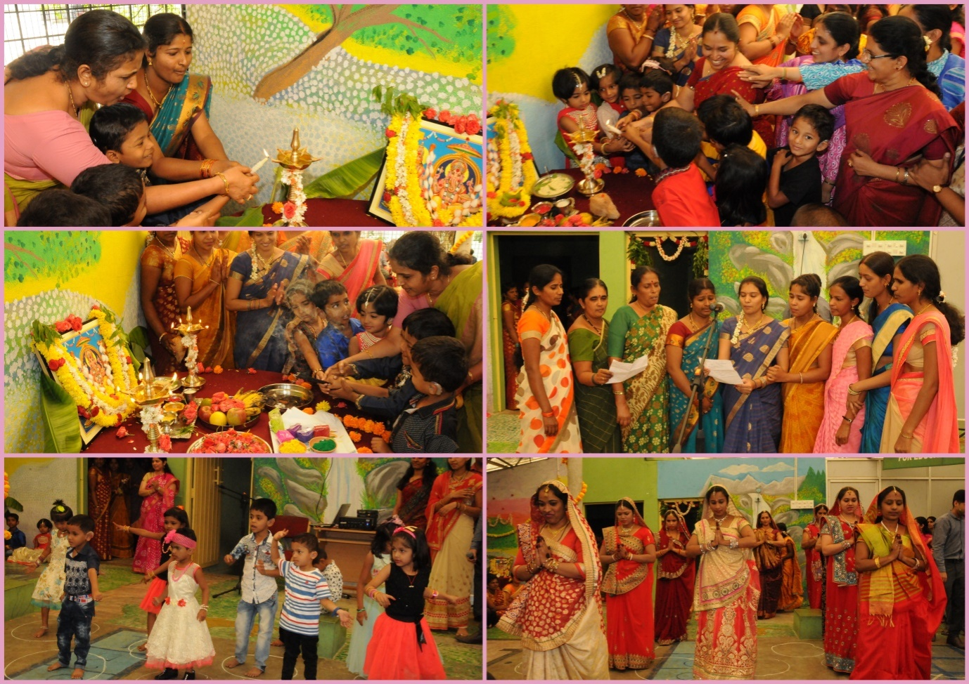

* + - 1. **Press Releases and Media Coverage: NIL**

**C) Material Development :**The following Teaching Learning Materials and Prepare for training children with various communication disorders an preschool.

|  |  |  |  |
| --- | --- | --- | --- |
| **Sl.**  **No.** | **Nature of**  **Teaching-Learning**  **Materials** | **Skill** | **Number** |
| 1. | Flash cards | For all skill areas | 302 sets |
| 2. | Work Cards | For all skill areas | 62sets |
| 3. | Charts | For all skill areas | 59 |
| 4. | PPT | For all skill areas |  |
| 5. | Models | For all skill areas | 9 |
| 6. | Sentence strips | For all skill areas | 62 sets |
| 7. | Others | For all skill areas | - |

1. **AWARDS AND HONORS RECEIVED BY FACULTY AND STAFF**
2. EXTRA CURRICULAR ACTIVITIES
   * + - 1. **AIISH Gymkhana**
3. EMINENT VISITORS:

XI. **ANY OTHER**

* **OfficialLanguage Implementation:**
* Hindi Word a day
* No of notings/letters (**March 2018**): **68**

Sd/-

HOD- Special Education