**ALL INDIA INSTITUTE OF SPEECH AND HEARING, MYSURU-6**

**अखिल भारतीय वाक श्रवण संस्थान, मैसूर-६**

**DEPARTMENT OF SPECIAL EDUCATION**

**विशेषशिक्षाविभाग**

**MONTHLY REPORTFebruary2017**

**मासिकरिपोर्टअक्टूबरफरवरी2017**

1. **ACADEMIC ACTIVITIES**
2. **Orientation Programs (For outsiders):**The following orientation programswere conducted to orient about the activities of the departmentand also to provide the knowledge about the educational facilities and welfare measures for children with special needs. :

|  |  |  |  |  |
| --- | --- | --- | --- | --- |
| **SL No.** | **Coordinator** | **Targeted Audience** | **Number**  **of Participants** | **Date** |
| 1 | Dr.Prithi V &  Mr.Gururaj | Students, Terrsian college, Mysuru | 22 students | 13.02.2018 |
| 2 | Mr.Gururaj | Students, Sathanysanjeevanikendra | 27 students | 16.02.2018 |
| 3 | Mr.Gururaj | Snehasadan College | 50 students, 4 staffs | 21.02.2018 |

1. **Posting (For outsiders): 01**

|  |  |  |  |  |
| --- | --- | --- | --- | --- |
| **SL No.** | **Coordinator** | **Targeted Audience** | **Number**  **of Participants** | **Date** |
| 1 | I Can Learning Centre, Mysore(Inclusive School) | II B.Ed.Spl.Edn.  IV Semester | 09 | 19th February to 2nd March 2018 |

**Dr.Pushpavathi M, HOD – Special Education**

* Attended a meeting related to Deemed to be university om 21.2.18
* Coordinated the work related to preparation of documents for Denova university

**Faculty report**

|  |  |  |  |  |  |  |
| --- | --- | --- | --- | --- | --- | --- |
| **Name of the Faculty** | | **Dr.Alok Kumar** | **Dr. G. Malar** | **Dr.PrithiVenkatesh** | **Dr. P. Vijetha** | **Ms.LakshmiPrabha J.K** |
| **Clinics** | | | | | |  |
| **No. of cases evaluated at SEA-U** | | 07 | * Screening: 16 clients in 16 sessions * Assessment: 4 clients in 17 sessions | She is on Maternity leave | 04 | * Screening: 16 clients in 16 sessions |
| **No. of cases supervised individually** | | Nil |  |  | NIL |  |
| **No. of groups supervised** | | 07 | * 10 preschool groups |  | 14 |  |
| **No. of meeting with parents** | | 05 | * 10 meetings in 10preschool groups |  | 08 |  |
| **Educational Guidance** | | 01 | * 9 clients * 9 sessions |  | NIL |  |
| **Academics** | | | | | | |
| **Classes taken** | | | | | |  |
| **B.Ed.**  **Spl.Edn.(HI)** | **Theory** | 15Classes | * 26 (including 2 extra) |  | 21 classes |  |
| **Practical** | nil | * 35 hours |  | 15 hours | 6 hours |
| **Any others** |  |  |  |  |  |  |
| **Any other** | | | | | |  |
| **Meeting held** | |  | * Meetings with I& II B.Ed.Spl.Ed. (HI) students as mentor * 10 meetings with preschool parents |  |  |  |
| **Meeting attended** | |  | * 2 meetings with HOD regarding deemed university status & other upcoming programmes |  |  |  |
| **AV preparation** | |  | * 1PPT on pedagogy of teaching English |  |  | One PPT on Checklist to assess different domains in preschool children with communication disorders (0-6 years)  One PPT on Core Services of Department of Special Education  ( For UGC Expert Committee ) |
| **Workshop** | | Served as a coordinator for Two National Workshops held at AIISH,Mysuru on 6-7 Dec and 14-15 Dec2017 | * **Coordinated:** Organisation of National Seminar on ‘Traversing Frontiers of Mainstream with ASD’ on 01 & 02.02.2018 |  | Bills related to the Seminar on “Traversing the frontiers of Mainstream with Autism Spectrum Disorders” held on 1st & 2nd February 2018 is settled |  |
| **Serve as Resource person** | |  |  |  |  |  |
| **Roles & Responsibilities** | | | | | |  |
| **Co-ordination** | | Parent Infant Program Unit  Preschool Parent Enrichment Program Unit | * CBCS Coordinator for I& II B.Ed.Spl.Ed. (HI) * Compilation of M.S.Ed. Student Dissertation-based Articles 2014-15 * Intra-Department * SEA-U   Research & Database Unit |  | 1. **ISO**  * Preparations for the 9th internal audit on 8th Feb of the departmental activities have been made. * On 7th Feb, Served as an ISO Internal auditor for the Dept. of Clinical Psychology.  1. **Services for School age children**  * Checked the lesson plans and a circular were sent. * On 14.02.2018, conducted a meeting with the team and issues were discussed.  1. Verified the statistics |  |
| **Member secretary** | | Pre School | * LD Clinic (in DCS) * Services for School-Aged Children (in Department of Special Education) |  | NIL |  |
| **Member in** | | Special education assessment Unit and Assistan warden | * TCPD * Product Development Cell * Preschool Supervision * Allied member of ISHA * Life member of NCED |  | SEA-U |  |
| **Mentor** | | M.Sc 2year Audiology | * Mentor for I & II B.Ed.Spl.Ed. (HI) |  | Submitted theory and practical attendance of BASLP A section students. |  |

1. Clinical /Educational Observation Postings of Students from other Institutes:NIL

Following are the details of students posted for observation/ practice teaching

|  |  |  |  |  |
| --- | --- | --- | --- | --- |
| **Sl.No** | **Name of the Institute** | **Programme/Course** | **Number of Students** | **Dates** |

1. Seminars/Conferences/**Workshops**/Training Programs:01

|  |  |
| --- | --- |
| **Theme/topic** | National Seminar on ***‘Traversing the frontiers of Mainstreaming with Autism Spectrum Disorder’*** |
| **Coordinator** | Ms.Vijetha P, Dr. Malar G, Mr. Suresh C. B, Ms.Sreevidya M S and Ms.Subalakshmi J. |
| **Resource Persons** | 1. Dr.PrathibaKaranth, Director, COMDEALL, Bengaluru 2. Dr.Srinivas, Scientist, Human Genetics Unit, AIISH 3. Ms.Sarbhani, Bubbles - Centre for Autism, Bengaluru 4. Ms. S Prathima, IST, Department of Clinical Services, AIISH 5. Dr.Jayashree C Shanbal, HOD Speech Language Pathology 6. Prof. S Venkatesan,HOD - Clinical Psychology, AIISH 7. Ms. Audrey, I Can Learning CenterF/O of Pranav, CSS Client, AIISH 8. Ms. Mila, Occupational Therapist, AIISH 9. Dr.Kadambari N, Special Educator, AIISH 10. Ms.SwapnaThambi Nair, Special Education Professional and Human Rights lawyer, Chennai 11. Caregivers of clients with ASD – 2 persons |
| **Objectives** |  |
| **Targeted Audience** | Professoinal, students and special Ëducators |
| **Number of Participants** | 160 |
| **Date** | 1-2, February 2018 |
| **Photo**  C:\Users\User\Pictures\Picasa\Collages\workhsop.jpg | |

1. Staff Enrichment / **In-house training Programmes***(For own staff members)* : NIL

|  |  |  |  |  |  |
| --- | --- | --- | --- | --- | --- |
| **Theme/Topic** | **Resource Person** | **Coordinator** | **Objectives** | **Targeted Audience** | **Date** |

1. **Guest Lectures :NIL**

|  |  |  |  |
| --- | --- | --- | --- |
| **Name, Designation, Institutional affiliation of Lecturer** | **Organized by Department/Section/Unit** | **Topic of Lecture** | **Date** |
|  |  |  |  |

1. **Additional Academic Services rendered by the Faculty and Staff**
2. **Invited Talks**: **02**

|  |  |  |  |  |
| --- | --- | --- | --- | --- |
| **Staff** | **Topic** | **Date** | **Programme** | **Institution** |
| Dr.Kadambari N | Considerations in Adapting Mainstream Instruction for Learners with ASD | 02.02.2018 | National Seminar on ***‘****Traversing the frontiers of Mainstreaming with Autism Spectrum Disorder’* | AIISH, Mysuru |
| Dr.Alok Kumar Upadhyay | Strengthening Early Intervention and School Readiness: Practices in AIISH Mysuru | 22.02.2018 | NCED International conference | D.S.M.N.R.University,Lucknow |

1. Curriculum Development: NIL
2. **Development of Material to Support Learning :**G. Malar – Revision of Training Manual – Visual Arts for Preschoolers.
3. Service in Academic Bodies of other Organizations
4. Participation in Committees/Taskforce and Panels setup by other organizations/agencies:

|  |  |  |  |  |  |  |
| --- | --- | --- | --- | --- | --- | --- |
| **Sl No** | **Name of the staff** | **Name of Organization/Agency** | **Participation in Committees/Taskforce** | **Programme** | **Name of Institute Visited** | **Date of Visit** |
|  | Dr Alok kr. upadhyay | NCED India | Co chairperson of a Session | NCED International conference | DSMNR University,Lucknow | 21.02.18 |

1. **Any Others (Please Specify)**

**Parent Enrichment Program (PEP): 1**

|  |  |
| --- | --- |
| **Name of the Resource Person** | Dr. Priya M.B, Lecturer in speech language pathology and Ms. Gayathri Krishnan, Lecturer in speech language pathology |
| **Name/Topic of the Program** | Parent Enrichment Program (PEP) for Parents of children |
| **Coordinator** | Ms.Latha C., Ms.Leena C C |
| **Objectives** | * To help instil confidence in the parents/caregivers handling their child. * To train the parents in managing their stress levels while dealing with their child. * To motivate the parents for working more efficiently with their child. * To empower the parents regarding different aspects of training |
| **Organized by Department/Section/Unit** | Department of Special Education |
| **Targeted Audience** | Parents of Special Children |
| **Date** | 20.02.2018 |
| **No.of beneficiaries** | 126 |
| C:\Users\User\Pictures\Picasa\Collages\New folder3.jpgPhoto | |

**Department staffs visited to Science park at SVYM Sargur, HD Kote on 17.02.2018.**

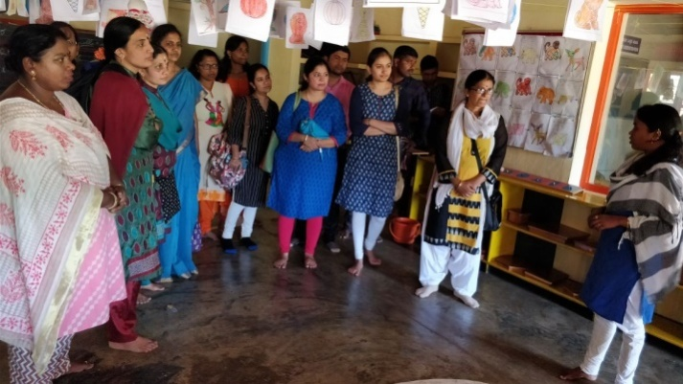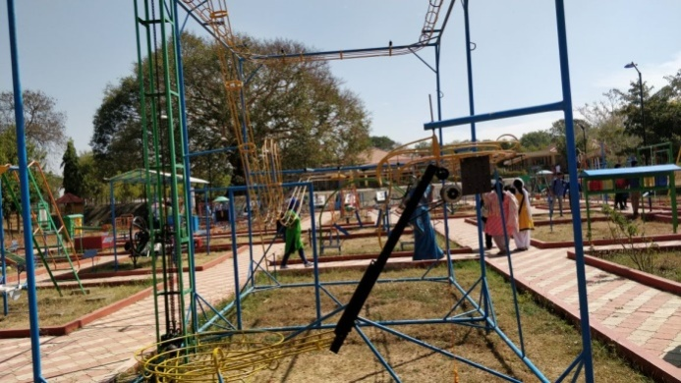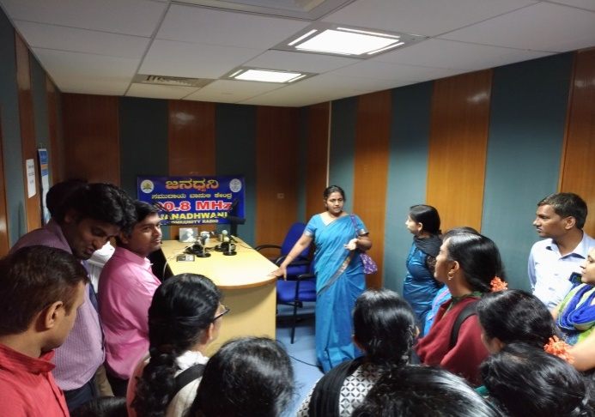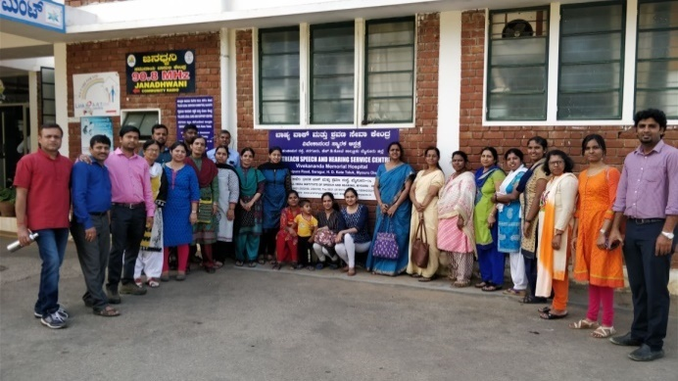

**RESEARCH ACTIVITIES (2016-17)**

1. Research Projects (ARF)
2. Completed -NIL
3. New Research Projects- NIL
4. **Ongoing Research Projects –02**
   * 1. **Title of ARF** - Development and Evaluation of Indigenous curriculum oriented computer based tutor for concept learning in preschool children with special needs.

Principal Investigator – Ms. P.V. Ramanakumari

Co-Investigators – Dr.Ajish K Abraham and Ms. P.V. Manjula

Research Assistant – Mr. Anil Abbur R.

Date of Starting – 18th January 2017

* + 1. **Title**: Effect of Resource Materials on Impact of Inclusive Education in Children with Intellectual Disabilities (ID) and Learning Disabilities (LD)

Investigators: Dr. G. Malar, Ms. S. Prathima&Mr. D. Gururaj

Duration: 12 months from January 2017

Budget: Rs. 3,85,000/-

Process: * Completed pre-intervention data collection

*Continuing with RoL& finalisation of resource material

1. Postgraduate Research Completed:- NIL
2. C. Postgraduate Research ongoing: NIL
3. **D. Research Papers presented at National/International Conferences/Seminars :- 07**

Upadhyay, A.K., Alam, Murshidul(2018).*Efficacy of sight word reading in promoting reading skills in preschool children with hearing impairment.*A paper presented at the National Convention of Educators of the Deaf (NCED) India, Lucknow. February 21-23, 2018.

Vijetha., P(2018). *Formative Assessment Practices of children with hearing impairment in special schools in Mysore.* A paper presented at the National Convention of Educators of the Deaf (NCED) India, Lucknow. February 21-23, 2018.

Anjana, K., Kadambari, N. &Shobha, B. N.(2018). *Cognitive Capabilities among Kindergarten, anganwadi, Montessori and Special preschool for Children with Hearing impairment-A comparative study*.A paper presented at the National Convention of Educators of the Deaf (NCED) India, Lucknow. February 21-23, 2018.

Manjula, P.V., Ramanakumari, P.V., & Anil Abbur R. (2018).*Quality of Life of Caregiversof Children with Hearing Impairment*. Presented at 83rd NCED- India Annual International Conference on 21st February 2018 held at Lucknow, Uttar Pradesh, 21st to 23rd February, 2018.

Manjula, P.V., &Ramanakumari, P.V. (2018).*Profile of parameters of intelligence in preschool children with hearing impairment*. Presented at 83rd NCED- India Annual International Conference on 22nd February 2018 held at Lucknow, Uttar Pradesh, 21st to 23rd February, 2018.

Dhivya, D., Subramanya, K. R., (2018). *A Comparative study on Knowledge among Parents of hearing Impaired Children about early intervention on the years of experience.*Presented at 83rd NCED- India Annual International Conference on 22nd February 2018 held at Lucknow, Uttar Pradesh, 21st to 23rd February, 2018.

Subramanya, K. R., Dhivya, D. (2018). *Attitude and awareness about early intervention for children with hearing impaired by asha workers.*Presented at 83rd NCED- India Annual International Conference on 22nd February 2018 held at Lucknow, Uttar Pradesh, 21st to 23rd February, 2018.

E.Research Papers Published

i**) Papers published in National / International Journals: 02**

Upadhyay, A.K.& Jan, S.G. (2017).Effectiveness of multimedia as teaching learning material in instruction of environmental science to children with hearing impairment at primary level, *Journal of National Convention of Educators of Deaf,* 9(1):12-18.

Manjula, P.V., &Ramanakumari, P.V. (2017).Caregivers' Knowledge and Use of Available Apps, tools and Software in Training their Wards with Hearing Impairment.*Journal of National Convention of Educators of the Deaf (JNCED)*.*9(1).*29-33.

ii) **Abstracts published in Conference / Seminar Proceedings: 09**

Upadhyay A.K., Alam, Murshidul(2018).Efficacy of sight word reading in promoting reading skills in preschool children with hearing impairment*.Souvenir of 83rd NCED- India Annual International Conference* held at Lucknow, Uttar Pradesh, 21st to 23rd February, 2018 (70).

Vijetha, P. (2018). Formative Assessment Practices of Teacher’s of Children with Hearing Impairment in Special Schools in Mysore. *Souvenir of 83rd NCED- India Annual International Conference* held at Lucknow, Uttar Pradesh, 21st to 23rd February, 2018 (68).

Ramanakumari, P.V.&Manjula, P.V.(2018). Study of the Effective of Computer Aided Insturction for Teaching the Concept of Place-value to primary school children with Hearing Impairment.*Souvenir of 83rd NCED- India Annual International Conference* held at Lucknow, Uttar Pradesh, 21st to 23rd February, 2018 (79-80).

Manjula, P.V., Ramanakumari, P.V., & Anil Abbur, R. (2018). Quality of Life of Caregiversof Children with Hearing Impairment. *Souvenir of 83rd NCED- India Annual International Conference* held at Lucknow, Uttar Pradesh, 21st to 23rd February, 2018 (64-65).

Manjula, P.V., &Ramanakumari, P.V. (2018).Determining the governing intelligence in preschool children with hearing impairement and to create a suitable intelligence profile for better inclustion.*Souvenir of 83rd NCED- India Annual International Conference* held at Lucknow, Uttar Pradesh, 21st to 23rd February, 2018 (78-79).

Anjana, K., Kadambari, N. &Shobha, B. N.(2018). Cognitive Capabilities among Kindergarten, anganwadi, Montessori and Special preschool for Children with Hearing impairment-A comparative study.*Souvenir of 83rd NCED- India Annual International Conference* held at Lucknow, Uttar Pradesh, 21st to 23rd February, 2018 (52).

V, Prithi.,Subramanya, K. R. &Dhivya, D. (2018). Concerns in Teacher Training Programme affecting sustainability in human resource development.*Souvenir of 83rd NCED- India Annual International Conference* held at Lucknow, Uttar Pradesh, 21st to 23rd February, 2018 (71).

Sharanaiah, M. M., Subramanya, K. R., Dhivya, D. & M, Lakshmi(2018). Attitude and awareness about early intervention for children with hearing impaired by asha workers*.Souvenir of 83rd NCED- India Annual International Conference* held at Lucknow, Uttar Pradesh, 21st to 23rd February, 2018 (74).

Rajkumar, R., C.B., Suresh &Nidheesh, D. Kuruvila(2018). Knowledge and attitude among teachers of children with Hearing Impairment towards Indian Sign Language*.Souvenir of 83rd NCED- India Annual International Conference* held at Lucknow, Uttar Pradesh, 21st to 23rd February, 2018 (64).

**Department Poster presentation in NCED Conference, Lucknow**

V, Prithi.,Subramanya, K. R. &Dhivya, D. (2018). *Concerns in Teacher Training Programme affecting sustainability in human resource development.*Presented poster at 83rd NCED- India Annual International Conference on 22nd February 2018 held at Lucknow, Uttar Pradesh, 21st to 23rd February, 2018.

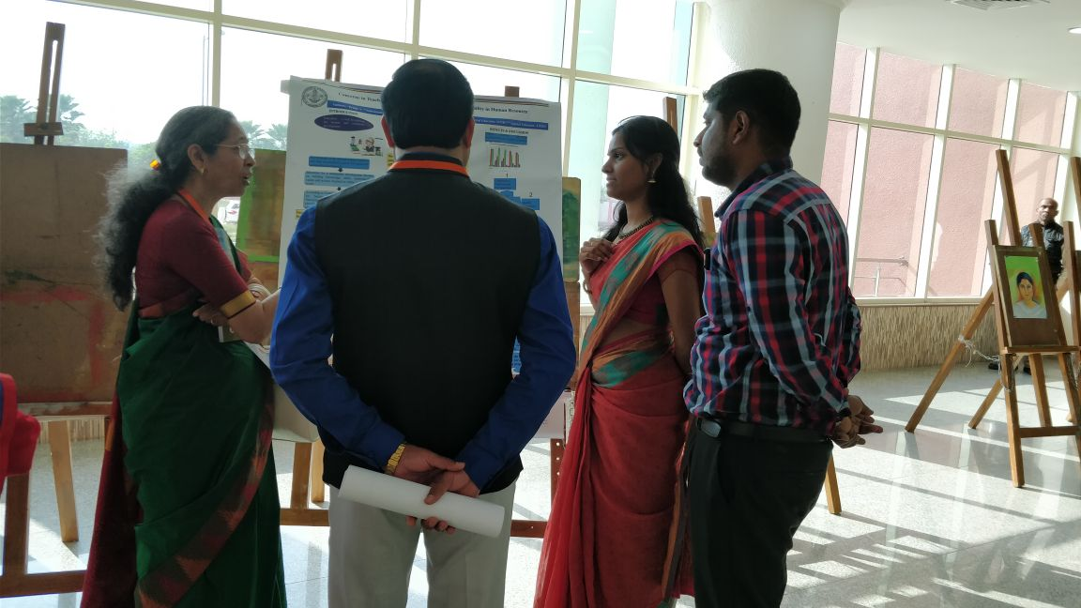

F. Books published (in APA format)

1. Books published: NIL

G.Book chapters published (in APA format): NIL

H .Books/Manuals/Seminar Proceedings edited: NIL

1. Journal Editorship: NIL

J. Scholarly Reviewing Activities:

1. Special Educational Services Offered through Teacher Trainees Outside Campus:

**Dr. Malar G**

|  |  |  |  |
| --- | --- | --- | --- |
| **Sl. No.** | **Nature of Activity** | **Services Provided** | **Details of Beneficiaries** |
| 1. | Educational Assessment | Nil | Nil |
| 2. | Practice-Teaching in Mainstream Schools/ Institutions | Nil | Nil |
| 3. | Practice-Teaching in Special Schools/ Institutions | Teaching to children with hearing impairment in 2 special high schools for children with HI | Approximate aggregate of 110 children with HI |

**III CLINICAL SERVICES**

1. General Clinical Services: **Not Applicable**
2. Specialized Clinical/ Educational Services
3. **Preschool Training and Special Education**

**Educational services for children with special needs**

|  |  |  |  |  |  |  |  |  |  |  |  |  |
| --- | --- | --- | --- | --- | --- | --- | --- | --- | --- | --- | --- | --- |
| **S. No.** | **Nature of Services (I/C)** | | | | | | | | | | | |
| 1. Special Educational Assessment Services (Dr. G. Malar) | | | | | | | | | | | | |
|  |  | Nature of Special Need  Language | ASD / PDD NOS | Hearing Loss | Intellectual Disability | Learning Disability | Motor Problems | Multiple Disabilities | Others | No. of Clients | No. of Sessions | ***Total No. of Sessions*** |
| 1. | Screening & Referral | Kannada | 1 | 10 | 12 | 1 | 1 | - | 1 | ***26*** | ***26*** | ***43*** |
| Malayalam | 1 | 1 | 6 | 1 | 1 | - | - | ***10*** | ***10*** |
| Hindi | - | - | 1 | 1 | - | - | - | ***2*** | ***2*** |
| Urdu | - | - | - | - | - | - | - | ***-*** | ***-*** |
| English | - | - | - | - | - | - | - | ***-*** | ***-*** |
| Telugu | 1 | 1 | 1 | - | - | - | - | ***3*** | ***3*** |
| Tamil | - | 1 | - | - | - | - | - | ***1*** | ***1*** |
| Any Other | 1 | - | - | - | - | - | - | ***1*** | ***1*** |
| ***Total No. of Clients*** | ***04*** | ***13*** | ***20*** | ***03*** | ***02*** | ***-*** | ***01*** | ***43*** | ***43*** |
| 2. | Assessment & Report | Kannada | - | - | 1 | - | - | - | - | ***1*** | ***4*** | ***17*** |
| Malayalam | - | - | - | - | - | - | - | ***-*** | ***-*** |
| Hindi | - | - | - | - | - | - | - | ***-*** | ***-*** |
| Urdu | - | - | - | - | - | - | - | ***-*** | ***-*** |
| English | - | - | - | 2 | - | - | - | ***2*** | ***11*** |
| Telugu | - | - | - | - | - | - | - | ***-*** | ***-*** |
| Tamil | - | - | - | - | - | - | - | ***-*** | ***-*** |
| Any Other | 1 | - | - | - | - | - | - | ***1*** | ***2*** |
| ***Total No. of Clients*** | ***01*** | ***-*** | ***01*** | ***01*** | ***-*** | ***-*** | ***-*** | ***04*** | ***17*** |
| Places from which seen: (1)Karnataka: 28 (2)Kerala: 11 (3)AP: 3 (4)Telengana: Nil (5)TN: Nil (6)Other Parts of India: 01 (7)Any other: Nil | | | | | | | | | | | |
| Age groups seen:(1)Birth to 2.5yrs: 02 (2)2.5+ to 6 yrs: 28 (3)6yrs+ to 16 years: 12 (4)16yrs+: 01 | | | | | | | | | | | |
| Total No. of Referrals: (1)Educational Assessment: 03 (2)Educational Guidance: 04 (3)PIP: 04 (4)PPEP/ PBC/ GECS: 22 (5)CSS/IEP/NFE/DET: 08 (6)Any Other Services at AIISH: 01 (7)Any Other Services Outside AIISH: Nil | | | | | | | | | | | |
| No. of Reports Issued/Ready for Issue: (1) School Readiness: 02 (3) Curriculum-Based Assessment: 02 (4) Post-School: 01 | | | | | | | | | | | |

|  |
| --- |
| **PreschoolTraining:Preparatory programme for schooling providing training in self-help, cognitive, language and (pre) academic skills, Preschool Supplementary Services (PSS)** |
| |  |  |  |  | | --- | --- | --- | --- | | **Language & Disability** | **No. of Groups** | **No. of Children** | | |  |  | MALE | FEMALE | | Kannada ASD & ID &MD | 14 | 49 | 19 | | Kannada HL | 8 | 44 | 18 | | Malayalam HL | 1 | 2 | 1 | | Malayalam ASD & ID & MD | 10 | 29 | 18 | | Hindi HL | 2 | 5 | 5 | | Hindi MD & ID & ASD | 2 | 5 | 3 | | English ID, ASD | 1 | 4 | 0 | | Telugu ASD & ID & MD | 1 | 6 | 2 | | TOTAL Number of children |  | **144** | **66** | | **TOTAL No. Groups** | **39** | **210** | | | **Sessions** | **3120 (Group wise) 20 days** | | | |

|  |  |  |  |  |  |
| --- | --- | --- | --- | --- | --- |
| **Curricular Support Services – Supportive training to augment education in mainstream school/ other educational programmes** | **Language** | **HL** | **ID/CP/ASD/MD/LD/DD** | **Total No. of clients** | **No. Of sessions** |
| Kannada | 6 | 12 | 18 | 93 |
| Malayalam | 1 | 1 | 2 | 6 |
| Hindi | 1 | - | 1 | 7 |
| English | - | 6 | 6 | 42 |
| Telugu | - | - | - | - |
| Tamil | - | - | - | - |
| **Total** | | | | **27** | **148** |
| |  |  |  |  |  |  | | --- | --- | --- | --- | --- | --- | | **Individualised Educational Programme (IEP) – Training in functional academics for out of school individuals** | **Language** | **HL** | **ID/CP/ASD/MD/LD/DD** | **Total No. of clients** | **No. Of sessions** | | Kannada | 4 | 9 | 14 | 76 | | Malayalam | - | 4 | 4 | 2 | | Hindi | - | 2 | 2 | 15 | | English | - | 1 | 1 | - | | Telugu | - | - | - | - | | Tamil | - | - | - | - | | **Total** | - | - | **21** | **93** | | | | | | |
| |  |  |  |  |  |  | | --- | --- | --- | --- | --- | --- | | **Demonstration Educational Training – Short-term demonstration to caregivers in any of the above** | **Language** | **HL** | **ID/CP/ASD/MD/LD/DD** | **Total No. of clients** | **No. Of sessions** | | Kannada | 2 | 2 | 4 | 34 | | Malayalam | - | 2 | 2 | 15 | | Hindi | - | - |  | - | | English | - | - |  | 49 | | Telugu | - | - | - | - | | Tamil | - | - | - | - | | **Total** | - | - | **6** | **49** | | | | | | |
| **Total clients: 54**  **Old clients:- 48**  **New clients: - 06**  **Discharged(DET):- NIL**  **Discharged(CSS):- NIL**  **Discharged(IEP):- 01**  **Discontinued(DET):- 01**  **Discontinued(CSS):- 01**  **Discontinued(IEP):- 02**  **Promoted from CSS/IEP/DET to PPEP: NIL**  **No. of remaining clients: 49** | | | | | |

|  |  |  |  |  |  |  |  |  |  |  |  |
| --- | --- | --- | --- | --- | --- | --- | --- | --- | --- | --- | --- |
|  | **Preschool Parent Empowerment Programme – PPEP** | | | | | | | | | | |
|  | **Language** | **HL** | **ID** | **CP** | **ASD** | **MD** | **LD** | **DD** | **SLD** | **VI** | **Total No. of clients** | **No. Of sessions** |
| Kannada | 34 | 29 | -- | 05 | 14 | -- | -- | -- | -- | 82 | 220 |
| Malayalam | 14 | 9 | 01 | 08 | 10 | -- | 02 | 01 | 01 | 46 | 100 |
| Hindi | 08 | 02 | -- | 01 | -- | -- | -- | -- | -- | 11 | 40 |
| English | 02 | 03 | -- | 02 | 01 | -- | -- | -- | -- | 8 | 20 |
| Telugu | 04 | 02 | 01 | 01 | -- | -- | -- | -- | -- | 8 | 20 |
| Tamil | 01 | 04 | -- | -- | 01 | -- | -- | -- | -- | 6 | 20 |
| **Total** | | | | | | | | | | **161** | | **420** |
| No. of clients promoted to the next higher level(Preschool) of service: NIL  No. Of discharged : NIL  No. Of discontinued: NIL  No. Of New clients (**January**) : 24 clients  Shifted from PIP to PPEP: 03  Shifted to from PPEP to IEP : 01  No. of remaining cilents:**161-1**(PPEP to IEP)**=160** | | | | | | | | | | | | |

|  |  |  |  |  |  |
| --- | --- | --- | --- | --- | --- |
| **Parent-Infant Programme – PIP(Birth to 2 ½ years)** | | | | | |
| Parent-Infant Programme | **Language** | **HL** | **ID/CP/ASD/MD/LD/DD** | **Total No. of clients** | **Total No. Of sessions** |
| Kannada | 06 | 07 | 13 | 81 |
| Malayalam | 10 | 16 | 26 | 78 |
| Hindi | 1 | 1 | 2 | 8 |
| English | - | - | - | - |
| Telugu | - | 2 | 2 | 7 |
| Tamil | - | - | -- | -- |
|  | **Total** | | | **43** | **174** |
| Specific age range:  No. of Old clients :**41**  No. of New clients enrolled: **02**  Total cilents:**43**  No. discharged :**NIL**  No. discontinued:**01**  No. of Promoted to next level: **03**  No. of Remaining:**39** | | | | | |

|  |  |  |
| --- | --- | --- |
| **Library of Books & Toys** – LiBoToy  Services issuing educational toys & books for home-based training. | Total number of members enrolled –234  No. of new members: - 15  Amount – 750/-  Total number of sessions –24 | |
| **Age group** | **Total number** |
| 0-2.6 yrs | 15 |
| 2.6-4 yrs | 63 |
| 4.0-6yrs | 144 |
| 6 yrs and above | 12 |

|  |  |  |
| --- | --- | --- |
| **Services** | **Number of Clients** | **Number of Sessions** |
| Co-Curricular Training | 216 | 20 |

**Supports for Empowering Caregivers**

|  |  |  |  |
| --- | --- | --- | --- |
| Name of Training Unit | No. of Parent  Beneficiaries | No. of Sessions | Content of Training |
| Caregiver Computer Training Unit | 05 | 06 | Painting and typing words in Ms word |
| Caregiver Literacy Training Unit | -- | -- | -- |

1. Clinical Support Services to Clients and Family
2. **Counselling and guidance**

|  |  |
| --- | --- |
| No. of Clients | Sessions |
| 76 | 61 |

1. **U-SAFE**

|  |  |
| --- | --- |
| No. of Clients | Sessions |
| -- | -- |

1. **Details of Certificates Issued: 07**

|  |  |  |  |
| --- | --- | --- | --- |
| **Sl.No.** | **Nature of Special Needs in Clients** | **No. of Certificates Issued** | **Purpose** |
| 1 | SLD/ASD | 2 | School admission |
| 2 | SLD/ADHD | 1 | School Admission |
| 3 | SLD/ID | 1 | Driving Lience |
| 4 | HL | 2 | Railway ID |
| 5 | Developmental Disability | 1 | Driving Lience |

1. Financial Aid- NIL
2. Legal advice -NIL
3. **Any other(Please Specify):**

**Attended to workshop/Seminar/Orientation program in AIISH institute 2017-18**

|  |  |  |
| --- | --- | --- |
| **Name of Staff** | **Attended to workshop title name** | **Date** |
| Dr. Malar G | *workshop on* **"Genetic Analysis"** | 20.02.2018 |

**Attended to workshop/Seminar/Orientation program in Outside institute 2017-18**

|  |  |  |
| --- | --- | --- |
| **Name of Staff** | **Attended to workshop title name** | **Date** |
| Dr.Alok Kumar Upadhyay | National Outreach Programme on Inclusion of Children with Special Needs(CSWN) at the Regional Level meeting in Bengaluru | 15.02.2018 |

EXTENSION ACTIVITIES

1. Public Lecture Series
   * 1. TECHNLOGICAL CONSULTANCY SERVICES: Not applicable
        1. CENTRAL FACILITIES
        2. Library and Information Services
        3. Public Information Activities
        4. **Major Events of the Year with a brief account:01**

**Event:** Inaugural function of National Seminar on ***‘Traversing the frontiers Mainstreaming with Autism Spectrum Disorder’***

**Cooridnators:** Ms.Vijetha P, Dr. Malar G, Mr. Suresh C. B, Ms.Sreevidya M S and Ms.Subalakshmi J.

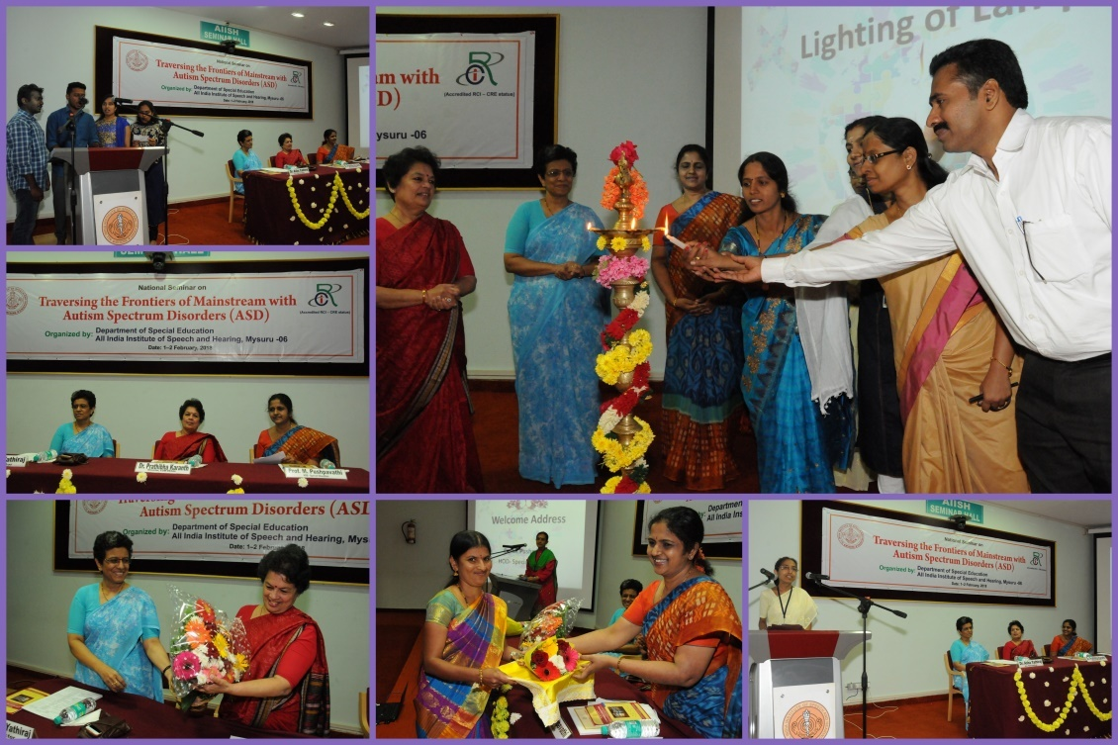

* + - 1. **Press Releases and Media Coverage: 08**
* 2nd February 2018- Vijayavaniworkshop program at AIISH was published.
* 2nd February 2018- Anodanaworkshop program at AIISH was published.
* 2nd February 2018- Udayavaniworkshop program at AIISH was published.

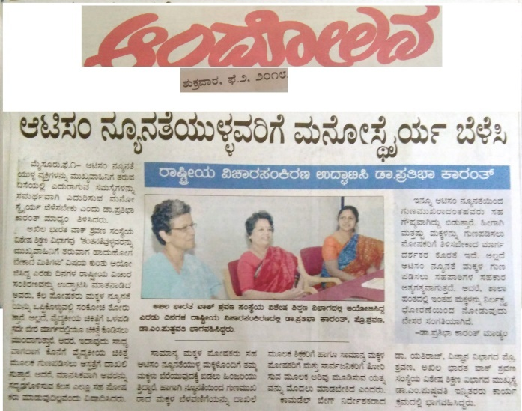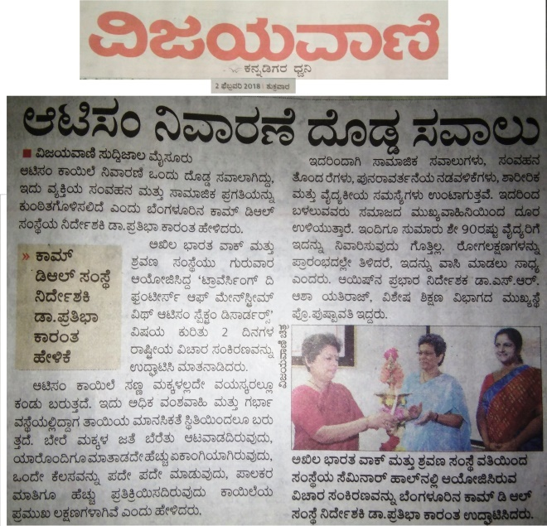

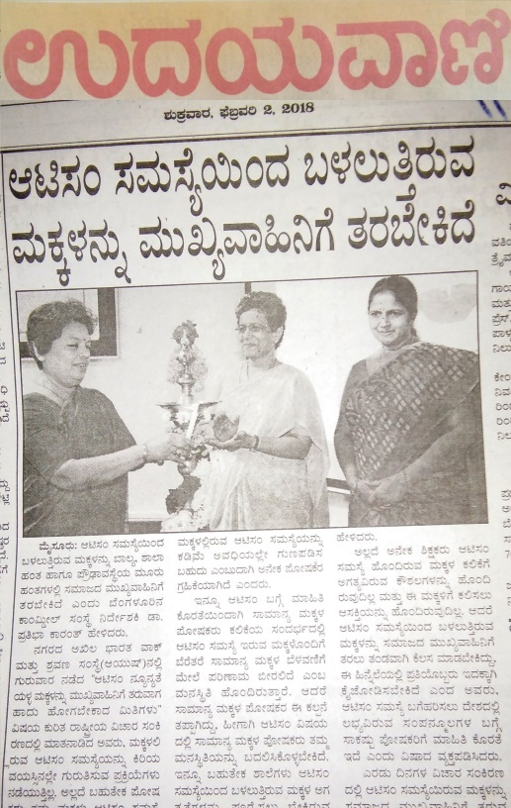

**C) Material Development :**The following Teaching Learning Materials and Prepare for training children with various communication disorders an preschool.

|  |  |  |  |
| --- | --- | --- | --- |
| **Sl.**  **No.** | **Nature of**  **Teaching-Learning**  **Materials** | **Skill** | **Number** |
| 1. | Flash cards | For all skill areas | 206 sets |
| 2. | Work Cards | For all skill areas | 51 sets |
| 3. | Charts | For all skill areas | 54 |
| 4. | PPT | For all skill areas | 12 |
| 5. | Models | For all skill areas | 9 |
| 6. | Sentence strips | For all skill areas | 62 sets |
| 7. | Others | For all skill areas | - |

1. **AWARDS AND HONORS RECEIVED BY FACULTY AND STAFF**

Ms.RamankumariP. V, Manjula P. V.andMr. Anil Abbur received A.C. Sen Award for best theme paper for the paper titled “Quality of life of caregivers of CWHI”.

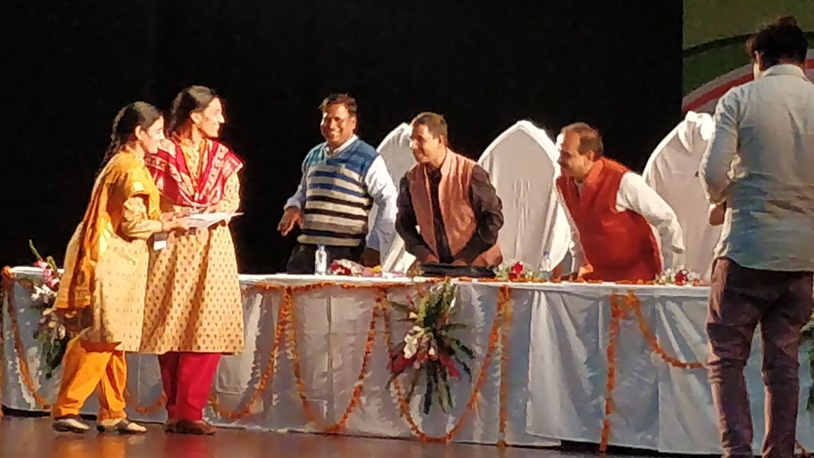

Dr.PrithiVentakesh, Mr.Subramanya K R and Ms.Dhivya Dreceived All India Teachers Association for Deaf Award for Best Poster

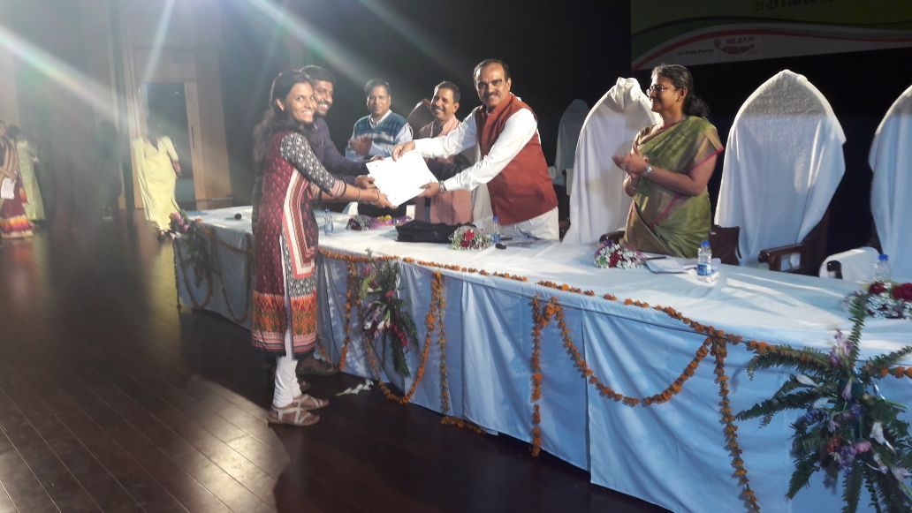

1. EXTRA CURRICULAR ACTIVITIES
   * + - 1. **AIISH Gymkhana**
2. EMINENT VISITORS:

XI. **ANY OTHER**

* **OfficialLanguage Implementation:**
* Hindi Word a day
* No of notings/letters (**February 2018**): **61**

Sd/-

HOD- Special Education