**ALL INDIA INSTITUTE OF SPEECH AND HEARING, MYSURU-6**

**अखिल भारतीय वाक श्रवण संस्थान, मैसूर-६**

**DEPARTMENT OF SPECIAL EDUCATION**

**विशेषशिक्षाविभाग**

**MONTHLY REPORT January 2018**

**मासिक रिपोर्टअक्टूबर जनवरी 2018**

1. **ACADEMIC ACTIVITIES**
2. **Orientation Programs (For outsiders):** The following orientation programswere conducted to orient about the activities of the departmentand also to provide the knowledge about the educational facilities and welfare measures for children with special needs.

|  |  |  |  |  |
| --- | --- | --- | --- | --- |
| **SL No.** | **Coordinator** | **Targeted Audience** | **Number**  **of Participants** | **Date** |
| 01 | Mr. Gururaj D | Students and staffs, Sri Kaginele mahasamsthma Kanaka Guru peeta college of Education, Mysuru | 14 students | 08.01.18 |
| 02 | Mr. Gururaj D | Students and staffs, Regional Center of AYJNISHD NIMH Building, Gautam Budh Nagar,Noida | 20 students and 2 staffs | 08.01.18 |
| 03 | Ms. Anjana K | Students, BEd College, Kerala | 4 students | 17.01.18 |
| 04 | Mr. Gururaj D  Mr. Suresh C B  Ms. Manjula P V | Students, Vidya Vikas Institute of Engineering & Technology, Mysuru | 6 students | 29.01.18 |

1. **Posting (For outsiders): NIL**

|  |  |  |  |  |
| --- | --- | --- | --- | --- |
| **SL No.** | **Coordinator** | **Targeted Audience** | **Number**  **of Participants** | **Date** |
|  |  |  |  |  |

**Faculty report**

Dr.Pushpavathi M, HOD – Special Education

* Supervision and coordination of various events held .

|  |  |  |  |  |  |
| --- | --- | --- | --- | --- | --- |
| **Name of the Faculty** | | **Dr.Alok Kumar** | **Dr. G. Malar** | **Dr.PrithiVenkatesh** | **Dr. P. Vijetha** |
| **Clinics** | | | | | |  |
| **No. of cases evaluated at SEA-U** | | 15 | * Screening: 12 clients in 12 sessions * Assessment: 2 client in 10 sessions | SEAU-Evaluation: 12  Educational Assessment: 1 child (Assessment Completed- Report yet to be submitted)  Number of Sessions: 4 | 04 |
| **No. of cases supervised individually** | | Nil | * 29 children through 2 classroom observations of 4 preschool groups | 04 | NIL |
| **No. of groups supervised** | | 07 | * 10 preschool groups | 10 | 02 |
| **No. of meeting with parents** | | 08 | * 10 meetings in 10preschool groups | 10 | 03 |
| **Educational Guidance** | | 01 | * 20 clients * 22 sessions | SEAU-Evaluation: 12  Educational Assessment: 1 child (Assessment Completed- Report yet to be submitted)  Number of Sessions: 4 | NIL |
| **Academics** | | | | | |
| **Classes taken** | | | | | |
| **B.Ed.**  **Spl.Edn.(HI)** | **Theory** | 31Classes | * 26 (including 1 extra) | IV Semester: Practical postings  (Field Engagement: Special School for Hearing Impairment-AIISH Preschool Training Centre  64 hours  Coordinated practical activity like teacher assistance, and other preschool work related work pertaining to practical postings)  II Semester:  Pedagogy of teaching school subjects-Science  **(Classes commenced Number of classes taken: 10)** | 25 |
| **Practical** | 12 hours | * 58 hours |  | 2 hours |
| **Any others** |  |  |  |  | On 25th January 2018, Submitted C1 marks of LTA and Social sciences courses of B.Ed program. |
| **Any other** | | | | | |  |
| **Meeting held** | |  | * Meetings with I & II B.Ed.Spl.Ed. (HI) students as mentor * 10 meetings with preschool parents |  | 1. As per instructions of HOD, visited DCS for OK play materials along with Dr. Prithi were discussed and indented. 2. Submitted online application for NCED 2018. 3. Meeting with staff and HOD were held regarding National Seminar on ASD |
| **Meeting attended** | |  | * 4 meetings with HOD, 3 meetings with faculty & 4meetings regarding seminar |  | On 11th January 2018, attended Faculty Meeting with HOD for Deemed university work. |
| **AV preparation** | |  | * 2PPTs on pedagogy of teaching English * 2 PPTs on inclusive education |  |  |
| **Brochures** | |  |  |  |  |
| **Workshop** | |  |  |  | Was actively involved in organising workshop on “Traversing the frontiers of Mainstream with Autism Spectrum Disorders” on 1st & 2nd February 2018 |
| **Serve as Resource person** | |  |  | Provided an orientation programme to M.Sc. students about Special Education Departmental services. |  |
| **Roles & Responsibilities** | | | | | |  |
| **Co-ordination** | | PARENTINFANT PROGRAM UNIT  PRESCHOOL PARENT INRICHMMENT PROGRAM UNIT | * CBCS Coordinator for I & II B.Ed.Spl.Ed. (HI) * Compilation of M.S.Ed. Student Dissertation-based Articles 2014-15 * Intra-Department * SEA-U   Research & Database Unit | * Coordinating International Day of Persons with Disabilities to be held on 8th December 2017. | 1. **ISO**   Preparing for upcoming 9th audit   1. **Services for School age children**  * Checked the lesson plans. |
| **Member secretary** | | Preschool | * LD Clinic (in DCS) * Services for School-Aged Children (in Department of Special Education) |  |  |
| **Member in** | | Special education assessment unit | * TCPD * Product Development Cell * Preschool Supervision * Allied member of ISHA * Life member of NCED |  | SEA-U |
| **Mentor** | | M.Sc 2 year-Audiology | * Mentor for I & II B.Ed.Spl.Ed. (HI) | I M.Sc SLP (B Section) | Submitted theory and practical attendance of BASLP (A section) students |

1. Clinical /Educational Observation Postings of Students from other Institutes:NIL

Following are the details of students posted for observation/ practice teaching

|  |  |  |  |  |
| --- | --- | --- | --- | --- |
| **Sl.No** | **Name of the Institute** | **Programme/Course** | **Number of Students** | **Dates** |
| 1 | St.Philomena’s College, Mysore | BA psychology | 1 | 20th December 2017 to 3rd January 2018. |

1. Seminars/Conferences/**Workshops**/Training Programs:NIL
2. Staff Enrichment / **In-house training Programmes***(For own staff members)* : NIL
3. Guest Lectures : NIL
4. Additional Academic Services rendered by the Faculty and Staff
5. Invited Talks: NIL
6. Curriculum Development: NIL
7. **Development of Material to Support Learning** : G. Malar – Revision of Training Manual – Visual Arts for Preschoolers.
8. Service in Academic Bodies of other Organizations: NIL
9. Participation in Committees/Taskforce and Panels setup by other organizations/agencies:NIL
10. **Any Others (Please Specify)**
    * + 1. **Parent Enrichment Programs (PEP): 01**- This program aims to enrich knowledge of the caregivers of CWSN by experts from various fields.

|  |  |  |  |  |
| --- | --- | --- | --- | --- |
| **Theme/Topic** | **Coordinator** | **Objectives** | **Number**  **of Participants** | **Date** |
| Parent Enrichment Programs (PEP) | Ms. Leena C C and Ms. Latha C | Empowering the Parents in the field of Special Education | 91 | 24.01.18 |
| Photo  C:\Users\User\Pictures\Picasa\Collages\New folder (3)2.jpg | | | | |

**RESEARCH ACTIVITIES (2016-17)**

1. Research Projects (ARF)
2. Completed -NIL
3. New Research Projects- NIL
4. **Ongoing Research Projects –02**
   * 1. **Title of ARF** - Development and Evaluation of Indigenous curriculum oriented computer based tutor for concept learning in preschool children with special needs.

Principal Investigator – Ms. P.V. Ramanakumari

Co-Investigators – Dr. Ajish K Abraham and Ms. P.V. Manjula

Research Assistant – Mr. Anil Abbur R.

Date of Starting – 18th January 2017

Process:

* Review of literature.
* Voice recording of the story dialogues.
* Reviewing the script and making modifications.
  + 1. **Title**: Effect of Resource Materials on Impact of Inclusive Education in Children with Intellectual Disabilities (ID) and Learning Disabilities (LD)

Investigators: Dr. G. Malar, Ms. S. Prathima & Mr. D. Gururaj

Duration: 12 months from January 2017

Budget: Rs. 3,85,000/-

Process: * Post validation revision, translationi & finalisation of tools; * Commenced with pre-intervention data collection

*Continuing with RoL & translation of tools

1. Postgraduate Research Completed:- NIL
2. C. Postgraduate Research ongoing: NIL
3. D.Research Papers presented at National/International Conferences/Seminars :- NIL

E.Research Papers Published

i**)** Papers published in National / International Journals: NIL

ii) Papers published in Conference / Seminar Proceedings: NIL

F. Books published (in APA format)

1. Books published: NIL

G.Book chapters published (in APA format): NIL

H .Books/Manuals/Seminar Proceedings edited: NIL

1. Journal Editorship: NIL

J. Scholarly Reviewing Activities:

1. **Special Educational Services Offered through Teacher Trainees Outside Campus:**

**Dr.Alok**

|  |  |  |  |
| --- | --- | --- | --- |
| **S. No.** | **Nature of Activity** | **Services Provided** | **Details of Beneficiaries** |
| 1. | Educational Assessment | --- | --- |
| 2. | Practice-Teaching in Mainstream Schools/ Institutions | Observation of B.Ed Spl Edn 2nd year students at Puteveramma school and Seventh day adventist school,Kollegal | 08 |
| 3. | Practice-Teaching in Special Schools/ Institutions | -- | -- |

**III CLINICAL SERVICES**

1. General Clinical Services: **Not Applicable**
2. Specialized Clinical/ Educational Services
3. **Preschool Training and Special Education**

**Educational services for children with special needs**

|  |  |  |  |  |  |  |  |  |  |  |  |  |
| --- | --- | --- | --- | --- | --- | --- | --- | --- | --- | --- | --- | --- |
| **S. No.** | **Nature of Services (I/C)** | | | | | | | | | | | |
| 1. Special Educational Assessment Services (Dr. G. Malar) | | | | | | | | | | | | |
|  |  | Nature of Special Need  Language | ASD / PDD NOS | Hearing Loss | Intellectual Disability | Learning Disability | Motor Problems | Multiple Disabilities | Others | No. of Clients | No. of Sessions | ***Total No. of Sessions*** |
| 1. | Screening & Referral | Kannada | 2 | 9 | 5 | 2 | 1 | - | 4 | ***23*** | ***23*** | ***47*** |
| Malayalam | 5 | 3 | 3 | 2 | - | - | 2 | ***15*** | ***15*** |
| Hindi | - | 2 | - | 1 | - | - | 1 | ***4*** | ***4*** |
| Urdu | - | - | 1 | - | - | - | - | ***1*** | ***1*** |
| English | - | - | - | 1 | - | - | - | ***1*** | ***1*** |
| Telugu | - | 1 | 1 | - | - | - | - | ***2*** | ***2*** |
| Tamil | 1 | - | - | - | - | - | - | ***1*** | ***1*** |
| Any Other | - | - | - | - | - | - | - | ***-*** | ***-*** |
| ***Total No. of Clients*** | ***8*** | ***15*** | ***10*** | ***06*** | ***01*** | ***-*** | ***07*** | ***47*** | ***47*** |
| 2. | Assessment & Report | Kannada | - | - | - | - | - | - | - | ***-*** | ***-*** | ***10*** |
| Malayalam | - | - | - | - | - | - | - | ***-*** | ***-*** |
| Hindi | - | - | - | - | - | - | - | ***-*** | ***-*** |
| Urdu | - | - | - | - | - | - | - | ***-*** | ***-*** |
| English | - | - | 01 | - | - | - | 01 | ***02*** | ***10*** |
| Telugu | - | - | - | - | - | - | - | ***-*** | ***-*** |
| Tamil | - | - | - | - | - | - | - | ***-*** | ***-*** |
| Any Other | - | - | - | - | - | - | - | ***-*** | ***-*** |
| ***Total No. of Clients*** | ***-*** | ***-*** | ***01*** | ***-*** | ***-*** | ***-*** | ***01*** | ***02*** | ***10*** |
| Places from which seen: (1)Karnataka: 32 (2)Kerala: 15 (3)AP: Nil (4)Telengana: Nil (5)TN: Nil (6)Other Parts of India: Nil (7)Any other: Nil | | | | | | | | | | | |
| Age groups seen:(1)Birth to 2.5yrs: 02 (2)2.5+ to 6 yrs: 34 (3)6yrs+ to 16 years: 09 (4)16yrs+: 02 | | | | | | | | | | | |
| Total No. of Referrals: (1)Educational Assessment: 03 (2)Educational Guidance: 06 (3)PIP: 02 (4)PPEP/ PBC/ GECS: 30 (5)CSS/IEP/NFE/DET: 09 (6)Any Other Services at AIISH: 02 (7)Any Other Services Outside AIISH: Nil | | | | | | | | | | | |
| No. of Reports Issued/Ready for Issue: (1) School Readiness: 03 (3) Curriculum-Based Assessment: 01 (4) Post-School: Nil | | | | | | | | | | | |

|  |
| --- |
| **PreschoolTraining:Preparatory programme for schooling providing training in self-help, cognitive, language and (pre) academic skills, Preschool Supplementary Services (PSS)** |
| |  |  |  |  | | --- | --- | --- | --- | | **Language & Disability** | **No. of Groups** | **No. of Children** | | |  |  | MALE | FEMALE | | Kannada ASD & ID &MD | 14 | 50 | 19 | | Kannada HL | 8 | 44 | 19 | | Malayalam HL | 1 | 2 | 1 | | Malayalam ASD & ID & MD | 10 | 29 | 18 | | Hindi HL | 2 | 5 | 5 | | Hindi MD & ID & ASD | 2 | 5 | 3 | | English ID, ASD | 1 | 4 | 0 | | Telugu ASD & ID & MD | 1 | 6 | 2 | | TOTAL Number of children |  | **145** | **67** | | **TOTAL No. Groups** | **39** | **212** | | | **Sessions** | **3276 (Group wise) 21 days** | | | |

|  |  |  |  |  |  |
| --- | --- | --- | --- | --- | --- |
| **Curricular Support Services – Supportive training to augment education in mainstream school/ other educational programmes** | **Language** | **HL** | **ID/CP/ASD/MD/LD/DD** | **Total No. of clients** | **No. Of sessions** |
| Kannada | 4 | 13 | 17 | 98 |
| Malayalam | 1 | 1 | 02 | 3 |
| Hindi | 1 | 1 | 02 | 4 |
| English | 1 | 6 | 07 | 32 |
| Telugu | - | - | - | - |
| Tamil | - | - | - | - |
| **Total** | | | | **28** | **137** |
| |  |  |  |  |  |  | | --- | --- | --- | --- | --- | --- | | **Individualised Educational Programme (IEP) – Training in functional academics for out of school individuals** | **Language** | **HL** | **ID/CP/ASD/MD/LD/DD** | **Total No. of clients** | **No. Of sessions** | | Kannada | 4 | 10 | 14 | 71 | | Malayalam | - | 3 | 3 | 16 | | Hindi | - | 2 | 2 | 3 | | English | - | 1 | 1 | 5 | | Telugu | - | - | - | - | | Tamil | - | - | - | - | | **Total** | - | - | **20** | **95** | | | | | | |
| |  |  |  |  |  |  | | --- | --- | --- | --- | --- | --- | | **Demonstration Educational Training – Short-term demonstration to caregivers in any of the above** | **Language** | **HL** | **ID/CP/ASD/MD/LD/DD** | **Total No. of clients** | **No. Of sessions** | | Kannada | 1 | 2 | 3 | 26 | | Malayalam | - | 1 | 1 | 6 | | Hindi | 1 | - | 1 | 5 | | English | - | 1 | 1 | - | | Telugu | - | - | - | - | | Tamil | - | - | - | - | | **Total** | - | - | **6** | **37** | | | | | | |
| **Total clients: 54**  **Old clients:- 47**  **New clients: - 07**  **Discharged(DET):- 02**  **Discharged(CSS):- 03**  **Discharged(IEP):- Nil**  **Discontinued(DET):- NIL**  **Discontinued(CSS):- NIL**  **Discontinued(IEP):- NIL**  **Promoted from CSS/IEP/DET to PPEP: 01**  **No. of remaining clients: 48** | | | | | |

|  |  |  |  |  |  |  |  |  |  |  |  |
| --- | --- | --- | --- | --- | --- | --- | --- | --- | --- | --- | --- |
|  | **Preschool Parent Empowerment Programme – PPEP** | | | | | | | | | | |
|  | **Language** | **HL** | **ID** | **CP** | **ASD** | **MD** | **LD** | **DD** | **SLD** | **VI** | **Total No. of clients** | **No. Of sessions** |
| Kannada | 25 | 24 | 01 | 04 | 13 | -- | 02 | -- | -- | 69 | 220 |
| Malayalam | 13 | 10 | 01 | 06 | 10 | -- | 02 | 01 | 01 | 44 | 100 |
| Hindi | 07 | 01 | -- | 01 | -- | -- | -- | -- | -- | 9 | 40 |
| English | 02 | 03 | -- | 01 | 01 | -- | -- | -- | -- | 7 | 20 |
| Telugu | 03 | 02 | 01 | -- | -- | -- | -- | -- | -- | 6 | 20 |
| Tamil | 01 | 03 | -- | -- | 01 | -- | -- | -- | -- | 5 | 20 |
| **Total** | | | | | | | | | | **140** | | **420** |
| No. of clients promoted to the next higher level(Preschool) of service: NIL  No. Of discharged : NIL  No. Of discontinued: NIL  No. Of New clients (**January**) : 26 clients  Shifted from PIP to PPEP: NIL  Shifted to from PPEP to PIP : 01  No. of remaining cilents:**114** | | | | | | | | | | | | |

|  |  |  |  |  |  |
| --- | --- | --- | --- | --- | --- |
| **Parent-Infant Programme – PIP(Birth to 2 ½ years)** | | | | | |
| Parent-Infant Programme | **Language** | **HL** | **ID/CP/ASD/MD/LD/DD** | **Total No. of clients** | **Total No. Of sessions** |
| Kannada | 11 | 7 | 18 | 89 |
| Malayalam | 7 | 19 | 26 | 87 |
| Hindi | 1 | 1 | 2 | 14 |
| English | - | - | -- | -- |
| Telugu | 1 | 1 | 2 | 9 |
| Tamil | - | - | -- | -- |
|  | **Total** | | | **48** | **199** |
| Specific age range:  No. of Old clients :**43**  No. of New clients enrolled: **05**  Total cilents:**48**  No. discharged :**01**  No. discontinued:**05**  No. of Promoted to next level: **01**  No. of Remaining:**41** | | | | | |

|  |  |  |
| --- | --- | --- |
| **Library of Books & Toys** – LiBoToy  Services issuing educational toys & books for home-based training. | Total number of members enrolled –219  No. of new members: - 16  Amount – 800/-  Total number of sessions –24 | |
| **Age group** | **Total number** |
| 0-2.6 yrs | 11 |
| 2.6-4 yrs | 54 |
| 4.0-6yrs | 144 |
| 6 yrs and above | 10 |

|  |  |  |
| --- | --- | --- |
| **Services** | **Number of Clients** | **Number of Sessions** |
| Co-Curricular Training | 198 | 22 |

**Supports for Empowering Caregivers**

|  |  |  |  |
| --- | --- | --- | --- |
| Name of Training Unit | No. of Parent  Beneficiaries | No. of Sessions | Content of Training |
| Caregiver Computer Training Unit | 4 | 6 | MS-Paint |
| Caregiver Literacy Training Unit | -- | -- | -- |

1. Clinical Support Services to Clients and Family
2. **Counselling and guidance**

|  |  |
| --- | --- |
| No. of Clients | Sessions |
| 75 | 68 |

1. **U-SAFE**

|  |  |
| --- | --- |
| No. of Clients | Sessions |
| -- | -- |

1. **Details of Certificates Issued:**

**Details of Bonafide Certificates Issued: 05**

|  |  |  |  |
| --- | --- | --- | --- |
| **Sl.No.** | **Nature of Special Needs in Clients** | **No. of Certificates Issued** | **Purpose** |
| 1 | SLD/ASD | 1 | Taking leave |
| 2 | SLD/ID/CP | 1 | Driving liecence |
| 3 | SLD/ID | 1 | Bank Purpose |
| 4 | HL | 1 | Aadhar |
| 5 | Downs’syndrome | 1 | Aadhar |

1. Financial Aid- NIL
2. Legal advice -NIL
3. Any other(Please Specify):

EXTENSION ACTIVITIES

1. Public Lecture Series
   * 1. TECHNLOGICAL CONSULTANCY SERVICES: Not applicable
        1. CENTRAL FACILITIES
        2. Library and Information Services
        3. Public Information Activities
        4. Major Events of the Year with a brief account

**Event:** New year and Chirstmas Celebrations 2018

**Cooridnators: Ms. Sumana H P, Ms. Asha S.A and Preschool parents**

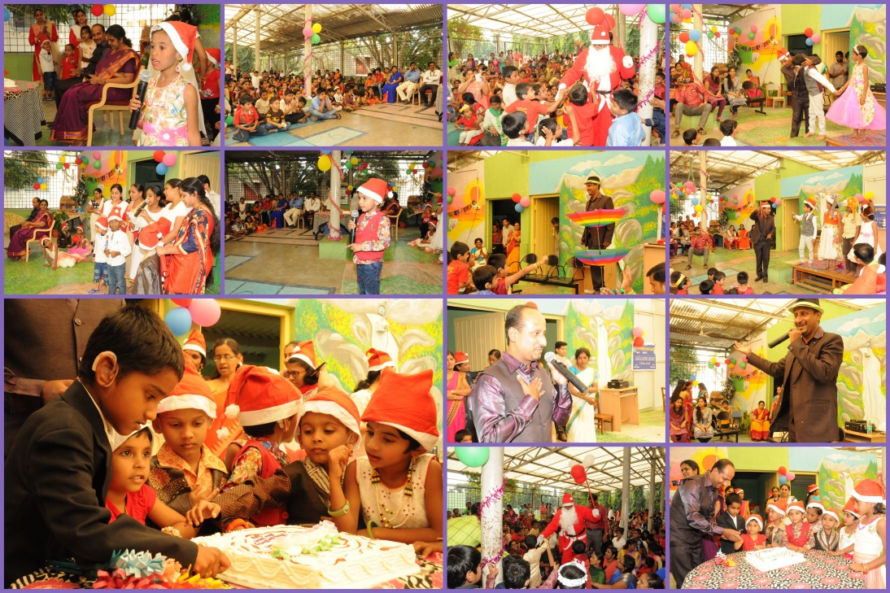

**Event:** Republic Day 2018

**Cooridnators: Mr. Suresh C B, Ms. Anjana K and Ms. Raksha Anand**

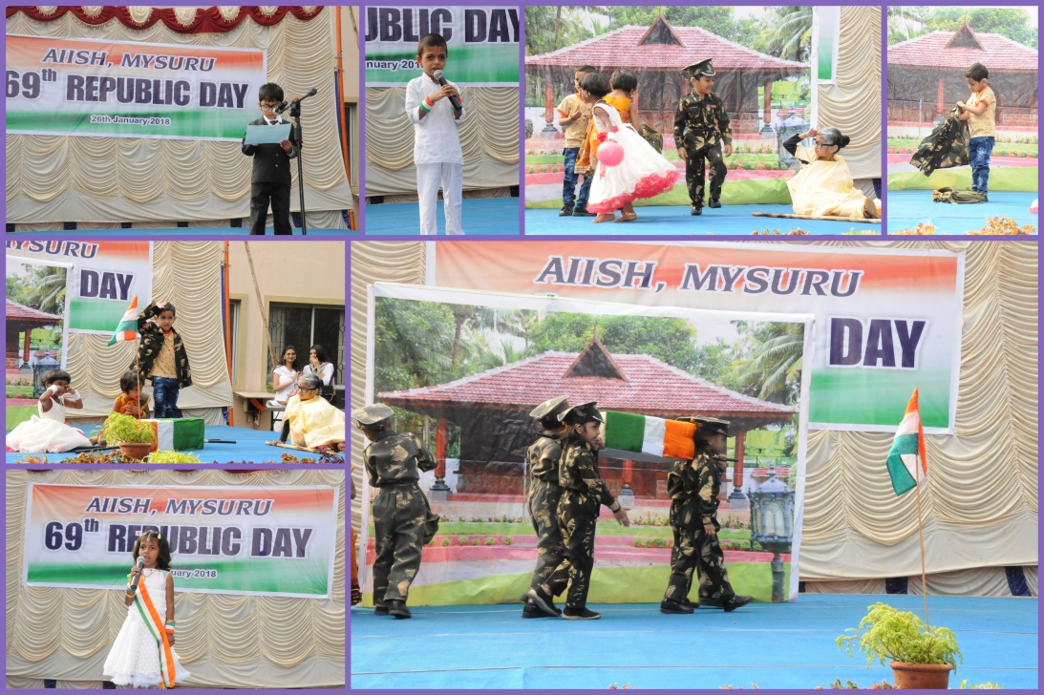

**Event:** Navu Visesha program by Karunamayi foundation

Children secured 1st prize in fancy dress.

**Cooridnators: Ms. Latha C, Mr. Subramanya K R**

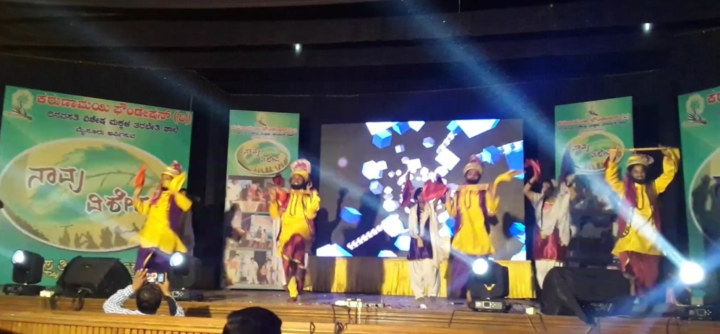

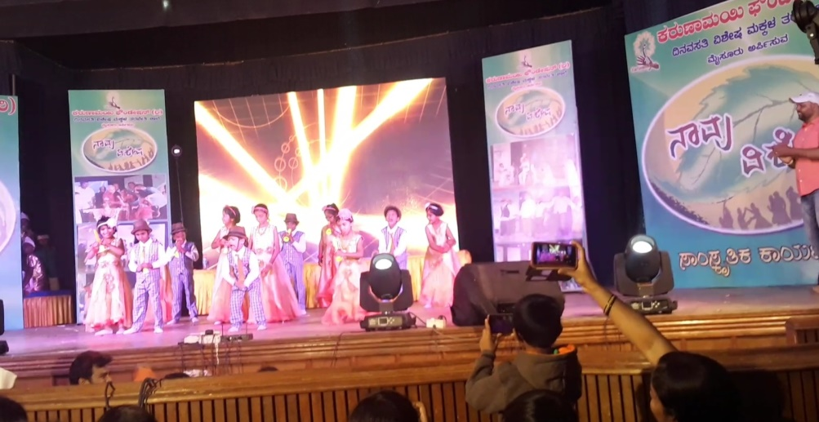

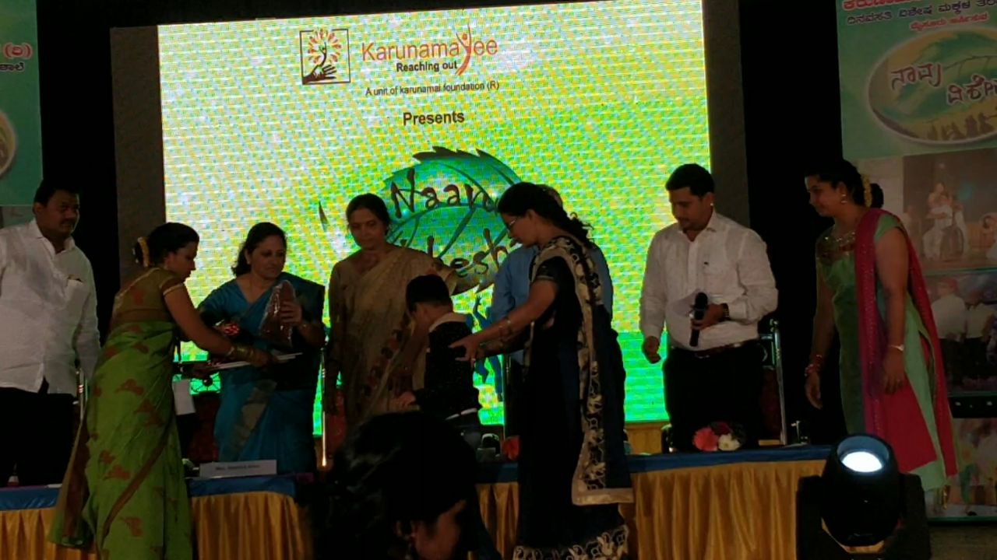

* + - 1. **Press Releases and Media Coverage: NIL**

**C) Material Development :**The following Teaching Learning Materials and Prepare for training children with various communication disorders an preschool.

|  |  |  |  |
| --- | --- | --- | --- |
| **Sl.**  **No.** | **Nature of**  **Teaching-Learning**  **Materials** | **Skill** | **Number** |
| 1. | Flash cards | For all skill areas | 198 sets |
| 2. | Work Cards | For all skill areas | 75 sets |
| 3. | Charts | For all skill areas | 35 |
| 4. | PPT | For all skill areas | 12 |
| 5. | Models | For all skill areas | 8 |
| 6. | Sentence strips | For all skill areas | 55 sets |
| 7. | Others | For all skill areas | - |

1. **AWARDS AND HONORS RECEIVED BY FACULTY AND STAFF**

* **Received best teacher award on 19th January 2018 from Karunamayee Foundation at Jagan Mohan Palace.**

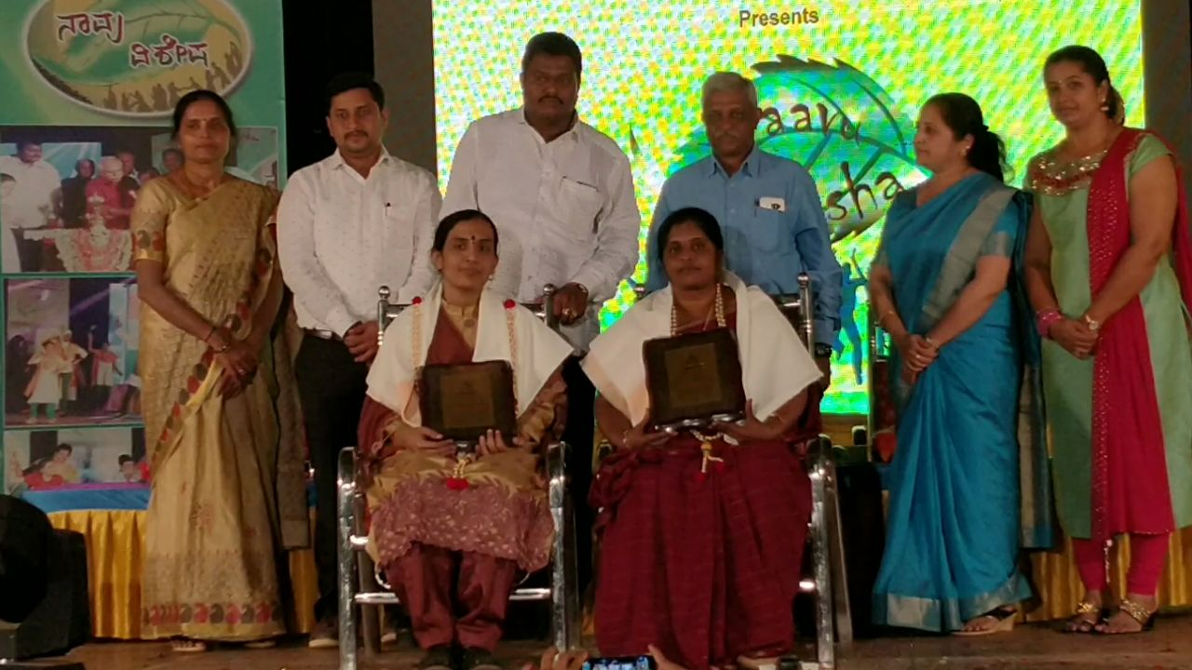

1. EXTRA CURRICULAR ACTIVITIES
   * + - 1. **AIISH Gymkhana**

* 21st January 2018 - Participated in AAPL-4 cricket tournament from the Department of Special Education (Mr. Anil) men's team and the team was winner in men's AAPL- 4

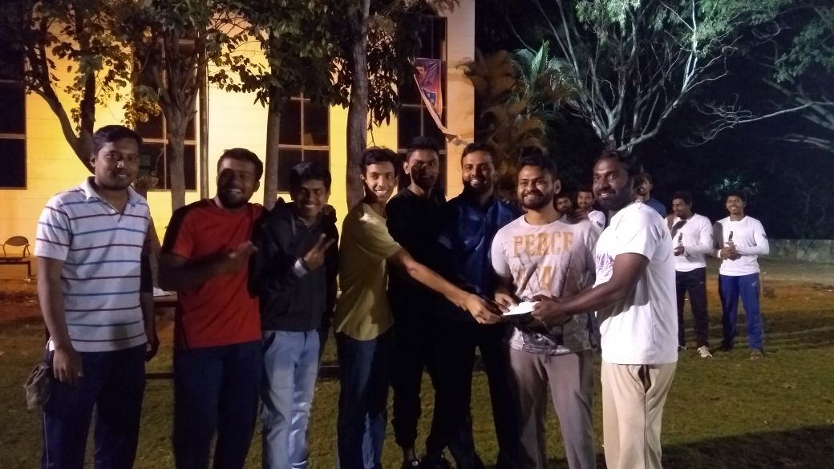

* 21st January 2018 - Participated in AAPL-4 cricket tournament from the Department of Special Education women's team and the team was runner up in women's AAPL- 4

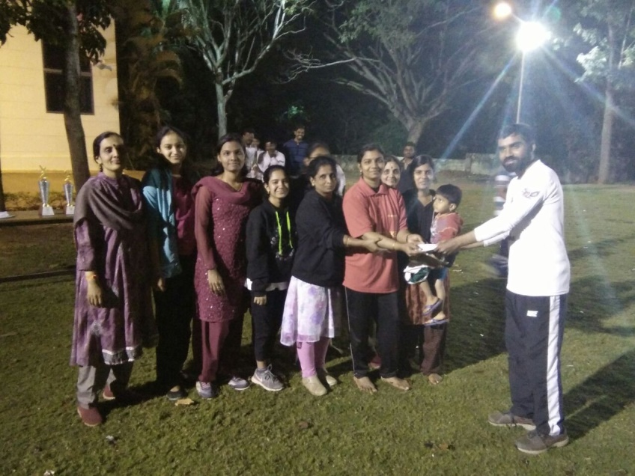

1. EMINENT VISITORS:

XI. **ANY OTHER**

* **OfficialLanguage Implementation:**
* Hindi Word a day
* No of notings/letters (**January 2018**): 58

Sd/-

HOD- Special Education