DEPARTMENT OF PREVENTION OF COMMUNICATION DISORDERS (POCD)
MONTHLY REPORT- APRIL 2017

- ACADEMIC ACTIVITIES
- No. of short-term training programs organized: Nil
- No. of orientation/Sensitization programs organized: 02
As part of primary prevention activities, several orientation/Sensitization programs are being conducted regularly. The objective of the orientation programs was to create awareness among general public and various other professionals such as Medical doctors, Nurses, Health related workers, teachers, school students etc., on different types of communication disorders, its prevention and early identification methods and their appropriate referral and timely management. Table 1& 2 shows the details of the orientation programs conducted by the dept. of POCD.
Table 1: Orientation Programs conducted by the department of POCD in the month of April 2017.
SN | Date | Theme/Topic of the program |  | Coordina-tor | Name of the institute/  Hospital | Target group | Total participants | Oriented by
 | 26.04.2017 | ‘Prevention, early identification and management of communication disorders” |  | HOD-POCD | Primary Health Centre, Hullahalli | ASHA Workers | 17 | Ms. Shruthi G.R.
By NBS/OSC Staff members
 | 28/04/201  7 |  | ‘Prevention, early identification and management of communication disorders” | NBS-Coordinator | NBS Centre, RIMS Ranchi  (Florence  College of  Nursing, Irba,  Ranchi) | 1st B.Sc &  GNM  Nursing students | 25 | Mr. Mukesh Kumar
 | Total number of participants |  |  |  |  |  | 42

Table 2: Total number of participants oriented in the month of April 2017.
S.No | Target group | Gender Groups |  | Total number of Participants
 |  | Male | Female
 | ASHA Workers | - | 17 | 17
 | Nursing students | 05 | 20 | 25
 | Total | 05 | 38 | 42

- Training programs conducted: Nil
- Clinical Observation postings of students from other institutes:01
Sl.no | Date of Postings | Name of the Students | Designation | Institute/University
1. | 26.04.2017 | Lissiue Maria | Psychology student | Christ University, Bengaluru

V. No. of Seminars/ Conferences /Lectures /Workshop organized by the dept–Nil
Vi. No. of Seminars/ Conferences /Lectures /Workshop attended by the staff of the Dept- 01
- Workshop attended by Staff of POCD: 01
Date | Title of the program | Organized by | Venue | Staff attended
6th & 7th April 2017 | National Workshop on Assessment & Management on Vestibular disorders | Department of Audiology | AIISH, Seminar hall | Mr.Arunraj K &  Ms.Akshatha Y

Vii. No. of Guest Lectures organized: Nil

Viii. No. of Invited Talks delivered by faculty and staff: 01
Faculty/ Staff members | Program | Topic | Date &Venue
Dr. Animesh Barman | National Workshop on Assessment & Management on Vestibular disorders | Functional Anatomy of Vestibular System | 6th & 7th April 2017  AIISH seminar hall

ix. Any other:
- Student clinical training: As part of human resource development, clinical training for Undergraduates (B.Sc Speech & Hearing), Postgraduates (M.Sc SLP & AUD) & Internship students on early identification, prevention & rehabilitation of communication disorders and Community based rehabilitation at OSCs were carried out. The details on the number of students who had undergone training are given below.
B.Sc students | 07
M.Sc students | 11
Internship students | 08
Total | 26

- Staff Enrichment Programs: 04
Table 3: Details of Staff enrichment program organized during April 2017
Sl.no | Date | Title of the program | Presenter | Staff members
 | 7.04.2017 | Newborn Hearing Screening & Early diagnosis in the NICU | Ms. Eliza & Ms. Sesashri, I MSc.SLP students | Dr. Animesh Barman  Mr. Arunraj K  Ms.Sunitha E  Ms.Supreetha  Ms.Nirupama  Ms. Shruthi  Ms.Lathika  Ms.Anusha  Mr.Potha Soundar Raj
 | 10.4.2017 | School Entry Level Tele Hearing-Screening in a town in south India-2016 | Ms. Runali, Ms. Reshmitha & Ms.Jyotsna , I MSc.SLP students | Dr. Animesh Barman  Mr. Arunraj K  Ms.Sunitha E  Ms.Yashaswini  Ms.Supreetha  Ms.Nirupama  Ms.Rashmi  Ms. Shruthi  Ms.Laxmishree  Ms.Lathika
 | 12.04.2017 | Auditory Toxicity in date Pre-term and Term neonates with Severe Jaundice | Ms. Jnanita & Ms. Rakshatha  I MSc. SLP students | Dr. Animesh Barman  Mr. Arunraj K  Ms.Sunitha E  Ms.Yashaswini  Ms.Nirupama  Ms.Laxmishree  Ms.Lathika  Ms.Shruthi  Mr.Potha Soundar Raj
 | 28.04.2017 | A Study on Neonatal Hearing Loss using Transient Evoked Oto-acoustic Emission | Ms.Vasupradaa & Mr. Sumanth  I MSc. SLP students | Dr. Animesh Barman  Mr. Arunraj K  Ms.Sunitha E  Ms.Yashaswini  Ms.Nirupama  Ms.Akshatha  Ms.Rashmi  Ms.Lathika  Mr.Potha Soundar Raj

2. RESEARCH ACTIVITIES
  - Research Projects :Nil
  - Doctoral and Post-Doctoral Programs: Nil
  - Research papers presented in National conferences/seminars: Nil
  - Research papers presented at International conferences/seminars: Nil
  - Research Papers published in National Conference/Seminar Proceedings: Nil
  - Research Papers published in International Conference/Seminar Proceedings: Nil
  - Research Papers published in National Journals: Nil
  - Research Papers published in International Journals: Nil
  - Book / Chapters Published: Nil
  - Books / Manuals/ Seminar proceedings Edited: Nil
  - Scholarly Reviewing Activities: Nil

- CLINICAL SERVICES
- General Clinical Services
- Follow-up evaluation- Detailed evaluation
The newborns/infants referred during the newborn screening were followed up through telephone calls to parents/caregivers of infants. A complete test battery was administered for those clients who came for follow-up. Table 4 (a) & (b) depicts the statistics related to this activity.
Table 4 (a): Details of the results of follow-up evaluation for newborns and infants.
Categories | AIISH + Cheluvamba | OSC-Sagara | Ajmer | Cuttack | Imphal | Puducherry | Ranchi | Jabalpur | Total
Normal | 11 | 05 | 03 | 10 | 07 | 15 | - | - | 51
ENT disorders | - | - | - | - |  | - | - | - | -
Auditory Maturation delay | - | - | - |  |  | - | - | - | -
Hearing disorder | - | - | 05 | 11 | 03 | 02 | - | - | 21
Speech & language disorder | - | - | - | - |  | - | - | - | -
Multiple Disorder | - | - | - | - |  | - | - | - | -
Incomplete testing | - | 05 | - |  | 01 | 19 | - | - | 25
Total | 11 | 10 | 08 | 21 | 11 | 36 | - | - | 97

Table 4(b): Follow-up evaluation- Phone follow-up
The at-risk babies were monitored regularly by administering the speech-language & hearing checklist through a phone call in Mysuru center. The babies who are identified with delay in the milestones were referred to AIISH/concern NBS center for detailed evaluation.
Categories | Mysuru Centre (POCD) | NBS Centers | OSC Centers
Normal speech, language & hearing milestones | 84 | 29 | -
Referred for detailed evaluation | 03 | 05 | -
Total | 87 | 34 | -

- Hearing evaluation of industrial workers at AIISH: Nil
- Specialized Clinical services: Nil
- Clinical Support Services to Patients and Family: Nil
- Clinical Electronic Services: Nil
B) EXTENSION ACTIVITIES
- Newborn screening for Communication Disorders
The department of POCD is actively involved in carrying out various extension activities such as screening, diagnostic and rehabilitation services outside the institute campus. The activities include newborn/infant screening, screening of school children, screening of elderly citizens, screening of industrial workers, conducting camps and also clinical services offered at the outreach service centers of AIISH.
Table 5: Total number of newborns/infants screened and identified at-risk for communication disorders.
SN | Hospitals/Immunization Centers | Total births | Total No. Screened |  |  | Total No. at risk
 |  |  | Male | Female | Total | Male | Female | Total
 |  | AIISH- Mysuru
 | Basappa Memorial Hospital (BMH) | 16 | 6 | 8 | 14 | 0 | 0 | 0
 | Combined Hospital (CH) | 40 | 8 | 9 | 17 | 0 | 0 | 0
 | Harsha Hospital (HH) | 01 | 0 | 0 | 0 | 0 | 0 | 0
 | Kamakshi Hospital (KH) | 182 | 29 | 28 | 57 | 0 | 0 | 0
 | KR Hospital (KRH)- Cheluvamba | 1045 | 311 | 301 | 612 | 2 | 3 | 5
 | Makkalakoota Immunization Center (MIC) | No deliveries | 11 | 9 | 20 | 0 | 1 | 1
 | Mission Hospital (MH) | 83 | 42 | 26 | 68 | 6 | 1 | 7
 | Immunization Center at Mission Hospital (ICMH) | No deliveries | 3 | 0 | 3 | 0 | 0 | 0
 | N.P.C Hospital | 32 | 2 | 6 | 8 | 0 | 0 | 0
 | S.M.T.D.H Hospital | 59 | 24 | 16 | 40 | 0 | 0 | 0
 | Railway Hospital (RH) | 04 | 3 | 1 | 4 | 0 | 0 | 0
 | Employees State Insurance (ESI) Hospital | 01 | 0 | 0 | 0 | 0 | 0 | 0
 | Ashwini Nursing Home (ANH) | 19 | 5 | 6 | 11 | 0 | 1 | 1
 | Shree Devi Nursing Home (SNH) | 43 | 9 | 5 | 14 | 0 | 0 | 0
 | GopalaGowdaShanthaveri Memorial Hospital (GGSMH) | 09 | 2 | 3 | 5 | 0 | 0 | 0
 | Mahadeshwara Nursing Home (MNH) | 35 | 6 | 6 | 12 | 0 | 0 | 0
 | Sigma Hospital (SH) | 39 | 20 | 13 | 33 | 0 | 0 | 0
 | Total (Mysuru hospitals) | 1608 | 481 | 437 | 918 | 8 | 6 | 14
OSCs
18. | Sub-divisional hospital, K R Nagar Taluk | 56 | 22 | 13 | 35 | 0 | 0 | 0
19. | Sub-divisional hospital, T NarsipuraTaluk | 93 | 22 | 26 | 48 | 2 | 3 | 5
20. | Sub-divisional Hospital, SagaraTaluk | 148 | 69 | 67 | 136 | 4 | 5 | 9
21. | Community Health Centre (CHC), Hullahalli | 30 | 8 | 15 | 23 | 0 | 0 | 0
22. | Community Health Centre (CHC), Santhemarahalli | 37 | 7 | 4 | 11 | 0 | 0 | 0
23. | Primary Health Centre (PHC), Akkihebbalu | 05 | 2 | 2 | 4 | 0 | 0 | 0
 | Total (OSCs) | 369 | 130 | 127 | 257 | 6 | 8 | 14
 |  | NBS of AIISH
24. | Sri RamachandraBhanj Medical College and Hospital (SCB MCH), Cuttack | 523 | 155 | 48 | 203 | 11 | 6 | 17
25. | Regional Institute of Medical Sciences (RIMS), Imphal | 305 | 152 | 148 | 300 | 8 | 7 | 15
26. | Janana Hospital & JLNMCH, Ajmer | 749 | 135 | 97 | 232 | 2 | 2 | 4
27. | JIPMER, Puducherry | 943 | 233 | 252 | 475 | 35 | 28 | 63
28. | NetajiSubhash Chandra Bose Medical College (NSCB), Jabalpur | 348 | 201 | 124 | 325 | 30 | 15 | 45
29. | Rajendra Institute of Medical Sciences, Baritayu, Ranchi | 460 | 142 | 128 | 270 | 02 | 02 | 04
 | Total (NBS centre’s) | 3328 | 1018 | 797 | 1805 | 88 | 60 | 148
 | Overall Total | 5305 | 1629 | 1361 | 2980 | 102 | 74 | 176

- School screening: Nil

- Hearing screening of Industrial employees: 01
Date | Name of the Industry | Total screened | Total identified with communication disorders
 |  |  | Ear related disorder  (ears) | Normal  (ears) | Disorders (ear wise)
03.04.2017 | Rane Madras Industry, Mysuru | 74 | 02 | 54 | 92
Total |  | 74 | 02 | 54 | 92

- Clinical services for the Elderly citizens: Nil
- Camps: 04
Camps attended by Dr.Mahadevappa on 10.04.2017, 21.04.2017, 24.04.2017 & 28.04.2017
- Udigala PHC, Chamarajanagar on 10.04.2017
- H. K Halli, Hunsur Taluk, Mysuru on 21.04.2017
- Sunkatonnuru , Mandya on 24.04.2017
- Kattemalavadi, Mandya on 28.04.2017
Name of the Place | Total Evaluated | Total identified
 |  | Normal (ears) | Disordered (ears) | Others (Individuals)
Udigala PHC, Chamarajanagar | 156 | 183 | 103 | 01
H. K Halli, Hunsur Taluk, Mysuru | 95 | 104 | 64 | 04
Sunkatonnuru, Mandya | 113 | 127 | 79 | 06
Kattemalavadi, Mandya | 147 | 92 | 138 | 26
Total | 511 | 506 | 384 | 37

vii. Clinical Services at Outreach Service Centers (OSCs):

The clinical activities are not only restricted to in and around Mysore, but also extended to rural areas where facilities for clinical services for persons with communication disorders were meager. Currently 04 OSCs (01 Sub-divisional taluk hospital at Sagara taluk, Shivamogga District; 03 Primary Health Centre - PHC at Hullahalli, Mysuru district; Akkihebbalu, Mandya district &Karuna trust, Gumballi, Chamarajanagara district were initiated to meet the objective of extending the services of the institute to rural areas. The OSCs are functioning as a well-equipped unitfor screening, diagnostics and therapeutic services for persons with communication disorders. The services include screening, diagnostic and rehabilitation which includes newborn/infant screening, screening of school children, Speech and Language evaluation, Audiological evaluation, ENT evaluation, Speech-Language therapy, issue of free body level hearing aids and ear molds, and counseling and guidance to individuals with communication disorders. The other details are tabulated below in tables 8, 9& 10.

Table 8: Details of clients identified with communication disorders at the OSCs.
OSC | Total Registered | ENT Evaluation  Registered=77 |  |  | Hearing Evaluation  Registered=58 |  | Speech & Language Evaluation  Registered=04
 |  | Normal (Ear Wise) | Disorder (Ear wise) | ENT related  Others | Normal (Ear Wise) | Disorder (Ear wise) | Normal (Individuals) | Disorder (Individuals)
Primary Health Centre (PHC), Hullahalli | 37 | 32 | 22 | 04 | - | 12 | - | 02
Primary Health Centre (PHC), Akkihebbalu | 40 | 23 | 20 | 08 | - | 16 | - | 01
Primary Health Centre (PHC), Gumballi | 47 | 33 | 30 | 20 | - | 10 | - | -
Sub-divisional Hospital (PHC), Sagara | 21 | - | - | - | 06 | 36 | - | 01
Total | 145 | 88 | 72 | 32 | 06 | 74 | - | 04

Table 8a. : Details of clients followed up at the OSCs.
OSC | Total Follow up | ENT Evaluation |  |  | Hearing Evaluation |  | Speech & Language Evaluation
 |  | Normal (Ear Wise) | Disorder (Ear wise) | ENT related  Others | Normal (Ear Wise) | Disorder (Ear wise) | Normal (Individuals) | Disorder (Individuals)
Primary Health Centre (PHC), Hullahalli | 09 | 06 | 08 | - | - | 02 | - | -
Primary Health Centre (PHC), Akkihebbalu | 24 | 12 | 10 | 04 | - | 02 | - | -
Primary Health Centre (PHC), Gumballi | 19 | 04 | 04 | 03 | 01 | 05 | - | -
Total | 52 | 22 | 22 | 7 | 1 | 9 | - | -

Table 9: Details of clients identified with different types communication disorders across OSCs.
Type of Disorders | OSC
 | Primary Health Centre (PHC), Hullahalli | Primary Health Centre (PHC), Akkihebbalu | Primary Health Centre (PHC), Gumballi | Sub-divisional Hospital, Sagara (PHC) Taluk
Hearing disorders

Normal | - | - | 01 | 06
Conductive | 04 | - | 01 | 14
Sensori- neural | 03 | 12 | 12 | 15
Mixed | 07 | 08 | - | 07
Profound | - | - | - | -
Total (ears) | 14 | 20 | 14 | 43
Speech & Language disorders
Voice |  | - | - | -
Fluency |  | - | - | -
Articulation disorders |  | - | - | 01
Language disorders | 02 | 01 | - | -
Total (Individuals) | 02 | 01 | - | 01

Table 10: Rehabilitation services provided at Outreach service centres
OSC | Hearing Aids Dispensed | Speech-language therapy
 |  | No. of clients | No. of sessions
Primary Health Centre (PHC), Hullahalli | 09 | 06 | 19
Primary Health Centre (PHC), Akkihebbalu | - | 10 | 34
Primary Health Centre (PHC), Gumballi | 02 | 05 | 07
Sub-divisional Hospital, Sagara (PHC) Taluk | 04 | 04 | 48
Total | 15 | 25 | 108

4. CENTRAL FACILITIES
- Library and information services – Nil
- Public Information Activities – 01
A Jatha and street play was organized by Dr. Animesh Barman, Head-POCD and Dr. Jayashree C Shanbal, Reader in language Pathology (Deputed), in association with ASD unit, Dept. of SLP to mark on Autism Awareness Month on 22.04.2017. The overall program was co-ordinated by Mr. Arunraj K Clinical Assistant, Ms.Yashaswini B.C SLP Grade I and Ms.Akshatha Y Audiologist Grade I. Approximately 28 internship students along with faculty & staffs of POCD participated in the program. Dr. Jayashree C Shanbal, Reader in language Pathology & Mr. Arunraj K, along with other POCD staffs flags-off the Jatha from the footsteps of Chamundi hill at 4:30 p.m. All the staffs and students climbed the chamundi hill thereby marking on autism awareness month. The jatha got wide coverage in the press. Later, the internship students enacted street play at the chamundi hill premises on early identification and prevention of autism spectrum disorders and other communication disorders.
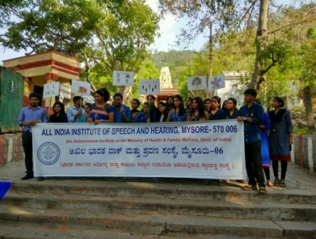 | 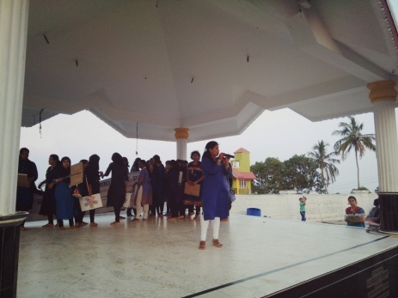 | 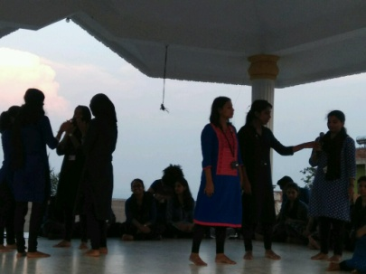
Jatha at foot hills | Interaction with public | Enacting in street play( Autism Awareness)
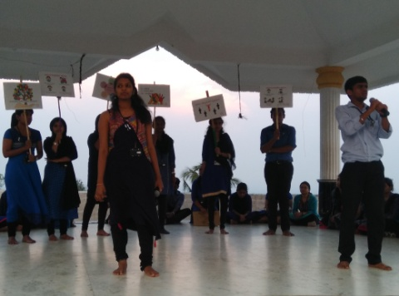 | 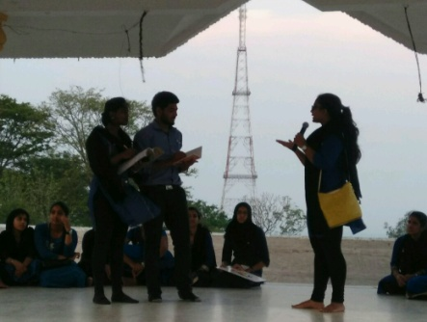 | 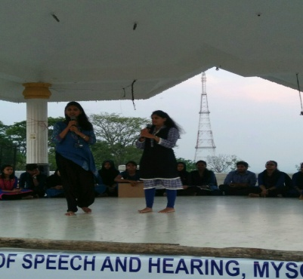
Orienting public( Autism Awareness) | Enacting street play ( learning disability) | Enacting street play (voice disorders)
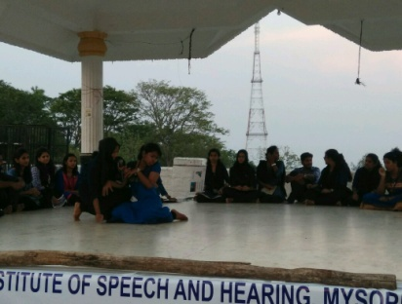 | 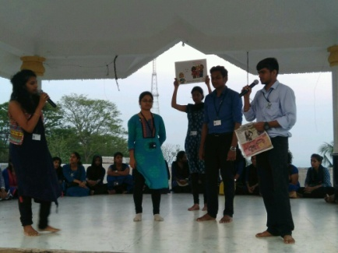 | 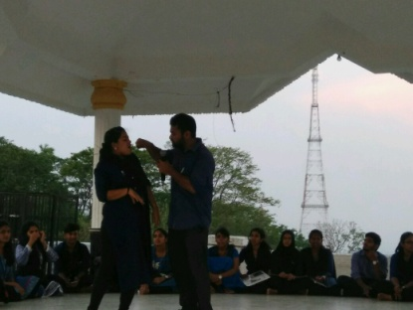
Enacting street play ( Cerebral Palsy) | Enacting street play ( Stuttering) | Enacting street play (Adult speech and language disorders)
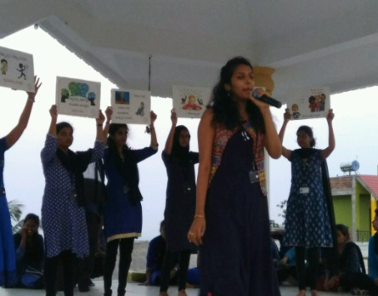 | 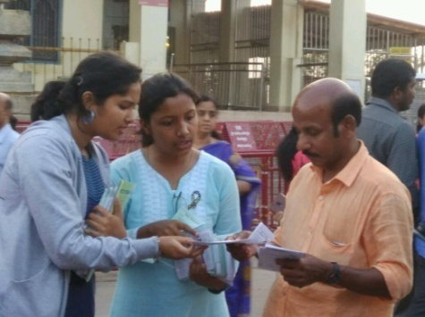 | 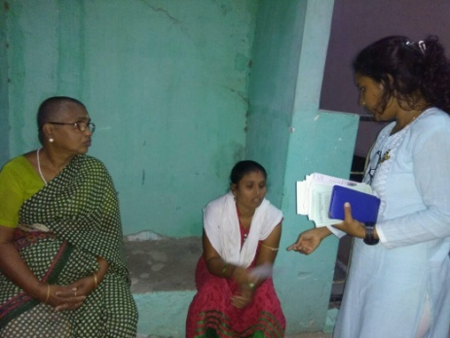
Orienting public regarding other communication disorders | Distribution of PEP s | Distribution of PEP s
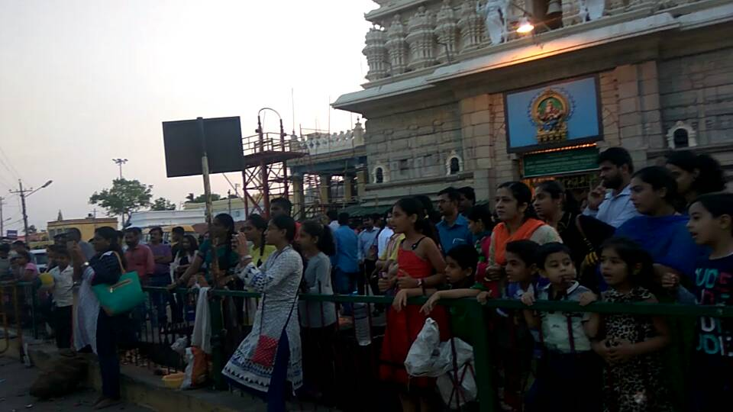
Public Gathering

- Exhibition: Nil
- Material Development: 01
- A PEM titled ‘Does your Child have Autism?’ has been prepared and set for release.
- Public education pamphlets Status :
- A PEM on “FAQs on NIHL” has been finalized and designed in English language. The reverse translation of PEM “FAQs on NIHL” is under process of reverse translation in six Indian languages (kannada, tamil, telugu, malayalam, hindi and Marathi) . However reverse translation is completed in kannada, tamil and Malayalam and other three languages are under process.

- Press Releases and Media Coverage: 01
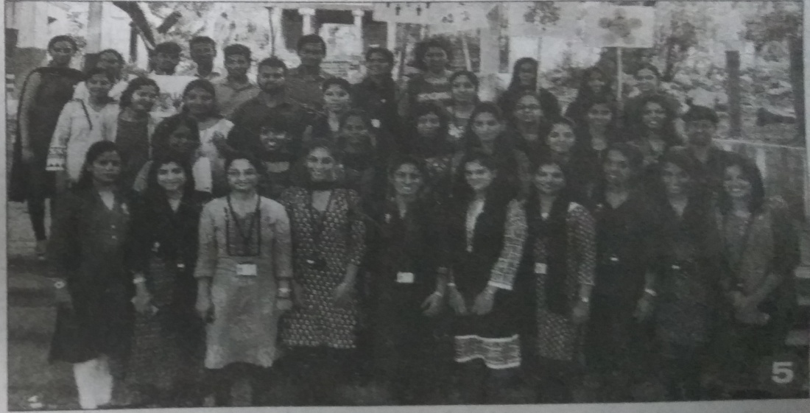
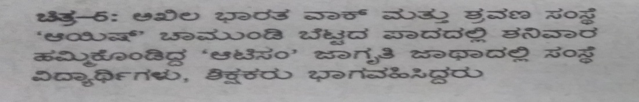
‘PRAJAVANI’

- Public Lecture Series: Nil
- AWARDS AND HONOURS RECEIVED BY FACULTY AND STAFF: Nil
- TECNOLOGICAL CONSULTANCY SERVICES: Nil
- EXTRA CURRICULLAR ACTIVITIES: Nil
- VISITORS: Nil
- MAJOR EVENTS OF THE MONTH:
- A Jatha conducted on 22.04.2017 from the footsteps of Chamundi hill at 4:30 p.m followed by street play at the chamundi hill premises on early identification and prevention of autism spectrum disorders and other communication disorders.
IX. OTHERS:
- Dept. Related:
- Computerization activities: Staff members of POCD were assigned duties regarding the activities related to Computerization. In Phase I, the Newborn screening program is finalized in draft stage and was handed to Mr. Devaraj for further process.
- ISO: A meeting was held with Director & Management representative ISO cell on 27.04.2017 at the Board room between 11:30 a.m to 12:00 p.m regarding the finalization of process manual of the department.
- Tri Monthly Meeting: HOD-POCD presented the statistics of the clinical activities held in the month of Feb, Mar & April 2017 in the HOD meeting on 27.04.2017 at 4:30 p.m. in the board room.
- OSC Related: Nil
- NBS Related:
- Initiation of NBS: First level of meeting was conducted with King George's Medical University, Lucknow by the Director & HOD-POCD (through video conference) on 21.04.2017 to discuss on requirements to establish the set up.
- AABR screening was initiated at the Mission & Sigma Hospital, Mysuru in the month of April 2017.
- Individual Staff Performance:
Faculty/Staff | Duties carried out
Dr. Animesh Barman | - Organized the street play and Jatha on 23.4.2017 at Chamundi hill regarding Autism awareness month.  - Finalized and Drafted official letters through Director to the concerned authorities for organizing the street play, reply letter to Sohum innovation lab, Initiation of AABR at Sigma.  - Finalization of MoU Saragur  - Finalization of Minutes of meeting lucknow with Director  - Finalization of SFC proposal and submitted to the Director  - Finalization of ISO process manual  - Attended tri-monthly meeting
Dr.Jayashree C Shanbal | - Organized the street play and Jatha on 23.4.2017 at Chamundi hill by coordinating with HOD-POCD & Chairperson ASD unit regarding Autism awareness month.  - Verified official letters drafted to the concerned authorities for organizing the street play  - Verification of report on street play and bill settlement.  - Provided inputs in preparation of the ISO Process Manual
Mr. Arunraj K | - Facilitated stock verification of furniture’s & Equipments at POCD.  - Assisted in organizing the street play at chamundi hill premises  - Assisted in drafting letters regarding release of funds at NBS Imphal, reply letter to Sohum innovation lab ,Minutes of meeting lucknow, Initiation of AABR at Sigma & finalization of MoU Sargur  - Verification of Tri-Monthly report, Monthly report & Annual report  - Assisted in preparation of SFC proposal  - Assisted in preparation of ISO Manual  - Verification of report of NBS & OSC centers
- Following staffs were relieved from the department: Nil
- Following staffs were newly recruited to the department: Nil

Sd/-
Head, Dept. of POCD

DEPARTMENT OF PREVENTION OF COMMUNICATION DISORDERS (POCD)

CUMMILATIVE REPORT

APRIL 2017 TO MARCH 2018

- ACADEMIC ACTIVITIES
- Orientation/Short-term Training Programs:
- No. of orientation/Sensitization programs organized: 02
As part of primary prevention activities, several orientation/Sensitization programs were conducted regularly. The objective of this orientation programs was to create awareness among general public and various other professionals such as Medical doctors, Nurses, Health related workers, teachers, school students etc., on different types of communication disorders, its prevention and early identification methods and their appropriate referral and timely management. The table below shows the details of the orientation programs conducted by the dept. of POCD, OSCs & NBS centers.
Sl. No | Date | Theme/Topic of the program | Name of the institute/  Hospital | Target group | Total participants | Oriented by
Organized by dept. of POCD
Coordinators: Dr. Animesh Barman & Mr. Arunraj K
1. | 26.04.2017 | Prevention, early identification and management of communication disorders” | Primary Health Centre, Hullahalli | ASHA Workers | 17 | Ms.Shruthi G.R.
Organized by OSC, Sagara
Coordinators: Dr. Animesh Barman &AMO, Sagara
- | - | - | - | - | - | -
Organized by NBS centers
Coordinators: Dr. Animesh Barman &NBS coordinator
3. | 28/04/2017 | Prevention, early identification and management of communication disorders” | NBS Centre, RIMS Ranchi  (Florence  College of  Nursing, | Ist B.Sc &  GNM  Nursing students | 25 | Mr. Mukesh Kumar
Total Participants |  |  |  |  | 42

Table 1 (b): Total number of target groups oriented during the year 2017-18.
Sl. No | Target group | Male | Female | Total number of Participants
 | ASHA/Anganwadi workers | - | 17 | 17
 | Nursing students/staff | 05 | 20 | 25
 | Total | 05 | 38 | 42

- Clinical Observation postings of students:
- From other institutes:
Sl.no | Date of Postings | Name of the Students | Desingation | Institute/University
1. | 26.04.2017 | Lissiue Maria | Psychology student | Christ University, Bengaluru

- From AIISH: As part of human resource development, Clinical training for under graduates (B.Sc Speech & Hearing), Post graduates (M.Sc- SLP) & Internship students on Early identification, prevention & rehabilitation of communication disorders and Community based rehabilitation at OSCs were carried out. The details on number of students who had undergone training are given below.
Course/Specializations | Total Students trained
B.Sc students | 07
M.Sc students | 11
Internship students | 08
Total | 26

- No. of Seminars/ Conferences /Lectures /Workshop/Training program: Nil
- Workshops organized by the Department: Nil
- Conferences organized by the Department: Nil
- Training programs conducted: Nil
- Seminars attended by the Staff of POCD: Nil
- Conferences attended by Staff of POCD: Nil
- Workshops attended by Staff of POCD: 01
Date | Title of the program | Organized by | Venue | Staff attended
6th & 7th April 2017 | National Workshop on Assessment & Management on Vestibular disorders | Department of Audiology | AIISH, Seminar hall | Mr.Arunraj K &  Ms.Akshatha Y

- Guest Lectures attended by Staff of POCD: Nil
- Training programs attended by Staff of POCD: Nil
- Orientation attended by staff of POCD:Nil
- Staff Enrichment Programs:
- Theme/Topic: Newborn Hearing Screening & Early diagnosis in the NICU
Coordinator: Dr.Animesh Barman & Mr.Arunraj K
Presenters: Ms. Eliza & Ms. Sesashri, I MSc.SLP students
Number of Participants: Dr. Animesh Barman, Mr. Arunraj K, Ms.Sunitha E, Ms.Supreetha, Ms.Nirupama, Ms. Shruthi, Ms.Lathika, Ms.Anusha , Mr.Potha Soundar Raj
Date: 7.04.2017
- Theme/Topic: School Entry Level Tele Hearing-Screening in a town in south India-2016
Coordinator: Dr.Animesh Barman & Mr.Arunraj K
Presenters: Ms. Runali, Ms. Reshmitha & Ms.Jyotsna , I MSc.SLP students
Number of Participants: Dr. Animesh Barman, Mr. Arunraj K, Ms.Sunitha E, Ms.Supreetha, Ms.Nirupama, Ms. Shruthi, Ms.Lathika, Ms.Anusha , Mr.Potha Soundar Raj
Date: 10.04.2017

- Theme/Topic: Auditory Toxicity in date Pre-term and Term neonates with Severe Jaundice
Coordinator: Dr.Animesh Barman & Mr.Arunraj K
Presenters: Ms. Jnanita & Ms. Rakshatha, I MSc. SLP students
Number of Participants: Dr. Animesh Barman, Mr. Arunraj K, Ms.Sunitha E, Ms.Supreetha, Ms.Nirupama, Ms. Shruthi, Ms.Lathika, Ms.Anusha , Mr.Potha Soundar Raj
Date: 12.04.2017

- Theme/Topic: A Study on Neonatal Hearing Loss using Transient Evoked Oto-acoustic Emission
Coordinator: Dr.Animesh Barman & Mr.Arunraj K
Presenters: Ms.Vasupradaa & Mr. Sumanth I MSc. SLP students
Number of Participants: Dr. Animesh Barman, Mr. Arunraj K, Ms.Sunitha E, Ms.Supreetha, Ms.Nirupama, Ms. Shruthi, Ms.Lathika, Ms.Anusha , Mr.Potha Soundar Raj
Date: 28.04.2017
- No. of Guest Lectures organized: Nil

- Additional Academic Services rendered by the Faculty and Staff
- No. of Invited Talks delivered by faculty and staff: 01
Faculty/ Staff members | Program | Topic | Date &Venue
Dr. Animesh Barman | National Workshop on Assessment & Management on Vestibular disorders | Functional Anatomy of Vestibular System | 6th & 7th April 2017  AIISH seminar hall

- Curriculum Development: Nil
- Development of Materials to support learning: Nil
- Service in Academic bodies of other organizations:
- Participation in committees/Task forces and panels set up by other organization/ agencies
- Any other: Nil

- RESEARCH ACTIVITIES
- Extra Mural projects: Nil
- Postgraduate Research Completed: NA
- Postgraduate Research ongoing: NA
- Research papers presented in National/International conferences/Seminars:
- Research Papers published:
- Paper published in National/International Journals:
- Paper published in National Conference/Seminar Proceedings:
- Book Published:
- Book Chapters Published: Nil
- Books / Manuals/ Seminar proceedings Edited:
- Journal Editorship: NA
- Scholarly Reviewing Activities: NA
- CLINICAL SERVICES
- General Clinical Services
- Newborn Follow-up evaluation:
- Phone follow-up
The at-risk babies were monitored regularly through a virtual mode (Phone call) by administrating Speech-language & hearing developmental checklist. The babies who are identified with delay in any of the developmental milestones were referred to AIISH/concern center for detailed evaluation.
Table 1: Details of the Phone follow-up of newborns and infants
Centers | Pass (Normal Milestones) | Referred  (Delayed Milestones) | Total
AIISH | 84 | 03 | 87
OSCs | - | - | -
Ajmer NBS | 03 | 05 | 08
Cuttack NBS | - | - | -
Imphal NBS | 06 | - | 06
Jabalpur NBS | - | - | -
Puducherry NBS | - | - | -
Ranchi NBS | 20 | - | -
Total | 107 | 08 | 121

- Detailed Assessment
The newborns/infants referred during the newborn screening were followed up through telephone calls to parents/caregivers of infants. Those who had referred through phone follow up and also referred through newborn screening program were advised for detailed evaluation at AIISH/NBS centers/OSCs. A complete test battery was administered for those clients who came for follow-up. Table 2a & 1b depicts the statistics related to this activity.
Table 2a: Details of the overall results of follow-up evaluation for newborns and infants
Categories | Total
Clinically Normal (CN) | 51
ENT disorders (ENT) | -
Auditory Maturation delay (AMD) | -
Hearing disorder (HI) | 21
Speech &language disorder (SLD) | -
Multiple disorder (MD) | -
Incomplete testing (IT) | 25
Total registered for follow up testing | 97

Table 2b: Details of the overall test results of follow up program at each NBS & OSC centers
Centers | CN | ENT | AMD | HI | SLD | MD | IT | Total
AIISH | 11 | - | - | - | - | - | - | 11
OSCs | 05 | - | - | - | - | - | 05 | 10
Ajmer NBS | 03 | - | - | 05 | - | - | - | 08
Cuttack NBS | 10 | - | - | 11 | - | - | - | 21
Imphal NBS | 07 | - | - | 03 | - | - | 01 | 11
Jabalpur NBS | - | - | - | - | - | - | - | -
Puducherry NBS | 15 | - | - | 02 | - | - | 19 | 36
Ranchi NBS | - | - | - | - | - | - | - | -
Total | 51 | - | - | 21 | - | - | 25 | 97

Table 2c: Details of the Phone follow up program at each NBS & OSC centers
Categories | Mysuru Centre (POCD) | NBS Centers | OSC Centers
Normal speech, language & hearing milestones | 84 | 20 | -
Referred for detailed evaluation | 03 | - | -
Total | 87 | 20 | -

- Hearing evaluation of industrial workers at AIISH:
- Specialized Clinical services: Nil
- Clinical Support Services to Patients and Family: Nil
- Clinical Electronic Services: Nil
- EXTENSION ACTIVITIES
- Rehabilitation and Education through Distant Mode: Nil
- Prevention of Communication Disorders
The department of POCD is actively involved in carrying out various extension activities such as screening, diagnostic and rehabilitation services outside the institute campus. The activities include newborn/infant screening, screening of school children, screening of elderly citizens, screening of industrial workers, conducting camps and also clinical services offered at the outreach service centers of AIISH.
- Newborn Screening for communication disorders: Newborn screening is conducted in various hospitals in and around Mysuru; in Outreach Service centers of AIISH (Mysuru, Mandya, Chamarajanagara & Shivamogga districts); and in Newborn screening centers of AIISH (Ajmer, Cuttack, Imphal, Jabalphur, Ranchi and Puducherry)
Table 4: Total number of newborns/infants screened and identified at-risk for communication disorders.
SN | Hospitals/Immunization Centers | Total births | Total No. Screened |  |  | Total No. at risk
 |  |  | Male | Female | Total | Male | Female | Total
 |  | AIISH- Mysuru
 | Basappa Memorial Hospital (BMH) | 16 | 6 | 8 | 14 | 0 | 0 | 0
 | Combined Hospital (CH) | 40 | 8 | 9 | 17 | 0 | 0 | 0
 | Harsha Hospital (HH) | 01 | 0 | 0 | 0 | 0 | 0 | 0
 | Kamakshi Hospital (KH) | 182 | 29 | 28 | 57 | 0 | 0 | 0
 | KR Hospital (KRH)- Cheluvamba | 1045 | 311 | 301 | 612 | 2 | 3 | 5
 | Makkalakoota Immunization Center (MIC) | No deliveries | 11 | 9 | 20 | 0 | 1 | 1
 | Mission Hospital (MH) | 83 | 42 | 26 | 68 | 6 | 1 | 7
 | Immunization Center at Mission Hospital (ICMH) | No deliveries | 3 | 0 | 3 | 0 | 0 | 0
 | N.P.C Hospital | 32 | 2 | 6 | 8 | 0 | 0 | 0
 | S.M.T.D.H Hospital | 59 | 24 | 16 | 40 | 0 | 0 | 0
 | Railway Hospital (RH) | 04 | 3 | 1 | 4 | 0 | 0 | 0
 | Employees State Insurance (ESI) Hospital | 01 | 0 | 0 | 0 | 0 | 0 | 0
 | Ashwini Nursing Home (ANH) | 19 | 5 | 6 | 11 | 0 | 1 | 1
 | Shree Devi Nursing Home (SNH) | 43 | 9 | 5 | 14 | 0 | 0 | 0
 | GopalaGowdaShanthaveri Memorial Hospital (GGSMH) | 09 | 2 | 3 | 5 | 0 | 0 | 0
 | Mahadeshwara Nursing Home (MNH) | 35 | 6 | 6 | 12 | 0 | 0 | 0
 | Sigma Hospital (SH) | 39 | 20 | 13 | 33 | 0 | 0 | 0
 | Total (Mysuru hospitals) | 1608 | 481 | 437 | 918 | 8 | 6 | 14
18. | Sub-divisional hospital, K R Nagar Taluk | 56 | 22 | 13 | 35 | 0 | 0 | 0
19. | Sub-divisional hospital, T NarsipuraTaluk | 93 | 22 | 26 | 48 | 2 | 3 | 5
20. | Sub-divisional Hospital, SagaraTaluk | 148 | 69 | 67 | 136 | 4 | 5 | 9
21. | Community Health Centre (CHC), Hullahalli | 30 | 8 | 15 | 23 | 0 | 0 | 0
22. | Community Health Centre (CHC), Santhemarahalli | 37 | 7 | 4 | 11 | 0 | 0 | 0
23. | Primary Health Centre (PHC), Akkihebbalu | 05 | 2 | 2 | 4 | 0 | 0 | 0
 | Total (OSCs) | 369 | 130 | 127 | 257 | 6 | 8 | 14
 |  | NBS of AIISH
24. | Sri RamachandraBhanj Medical College and Hospital (SCB MCH), Cuttack | 523 | 155 | 48 | 203 | 11 | 6 | 17
25. | Regional Institute of Medical Sciences (RIMS), Imphal | 305 | 152 | 148 | 300 | 8 | 7 | 15
26. | Janana Hospital & JLNMCH, Ajmer | 749 | 135 | 97 | 232 | 2 | 2 | 4
27. | JIPMER, Puducherry | 943 | 233 | 252 | 475 | 35 | 28 | 63
28. | NetajiSubhash Chandra Bose Medical College (NSCB), Jabalpur | 348 | 201 | 124 | 325 | 30 | 15 | 45
29. | Rajendra Institute of Medical Sciences, Baritayu, Ranchi | 460 | 142 | 128 | 270 | 02 | 02 | 04
 | Total (NBS centre’s) | 3328 | 1018 | 797 | 1805 | 88 | 60 | 148
 | Overall Total | 5305 | 1629 | 1361 | 2980 | 102 | 74 | 176

- Screening of School children for communication disorders: Nil
- Hearing screening of Industrial employees:01
All the industrial employees were screened for hearing loss and those were referred are advised for detailed evaluation at AIISH. Employees and employers are also oriented on harmful effects of Noise on hearing, importance of hearing conservation program and also use of hearing protective devices in noisy areas.
Table 6: Total number of employees screened and identified with hearing loss
Month | Name of the Industry | Total Registered | Total no. of individuals ears identified with Hearing impairment | Total no. of individuals with normal ears | Total no. of individuals ears identified with ENT disorders
03.04.2017 | Rane Madras Industry, Mysuru | 74 | 92 | 54 | 02
Total |  | 74 | 92 | 54 | 02

- Clinical services for the elderly citizens: Nil

- Clinical Services at Outreach Service Centers (OSCs):

The clinical activities are not only restricted to in and around Mysuru, but also extended to rural areas where facilities for clinical services for persons with communication disorders were meager. Currently 04 OSCs (01 sub-divisional taluk hospital at Sagara taluk, Shivamogga District; 01 Community Health Center (CHC) at Hullahalli, Mysuru district, Primary Health Centre (PHC) at Akkihebbalu, Mandya district &Primary Health Centre (PHC) at Gumballi, Chamarajanagara district) were initiated to meet the objective of extending the services of the institute to rural areas. The details of those who were registered and availed various services/benefits at the OSCs are tabulated below in tables 8 & 9.

Table 8: Details of clients identified with communication disorders at the OSCs.
OSC | Total registered | ENT Evaluation |  | Hearing Evaluation |  | Speech & Language Evaluation
 |  | Normal  ears | Disorder  ears | Normal  ears | Disorder  ears | Normal Individuals | Disorder Individuals
CHC, Hullahalli | 37 | 32 | 22 | - | 12 | - | 02
PHC, Akkihebbalu | 40 | 23 | 20 | - | 16 | - | 01
PHC, Gumballi | 47 | 33 | 30 | - | 10 | - | -
Sub-divisional Hospital, Sagara | 21 | - | - | 06 | 36 | - | 01
Total | 145 | 88 | 72 | 06 | 74 | - | 04
Table 8a. : Details of clients followed up at the OSCs.
OSC | Total Follow up | ENT Evaluation |  |  | Hearing Evaluation |  | Speech & Language Evaluation
 |  | Normal (Ear Wise) | Disorder (Ear wise) | ENT related  Others | Normal (Ear Wise) | Disorder (Ear wise) | Normal (Individuals) | Disorder (Individuals)
Primary Health Centre (PHC), Hullahalli | 09 | 06 | 08 | - | - | 02 | - | -
Primary Health Centre (PHC), Akkihebbalu | 24 | 12 | 10 | 04 | - | 02 | - | -
Primary Health Centre (PHC), Gumballi | 19 | 04 | 04 | 03 | 01 | 05 | - | -
Total | 52 | 22 | 22 | 7 | 1 | 9 | - | -

Table 9: Details of clients identified with different types communication disorders across OSCs.
Type of Disorders | OSC
 | Primary Health Centre (PHC), Hullahalli | Primary Health Centre (PHC), Akkihebbalu | Primary Health Centre (PHC), Gumballi | Sub-divisional Hospital, Sagara (PHC) Taluk
Hearing disorders
Normal | - | - | 01 | 06
Minimal | - | - | - | -
Conductive | 04 | - | 01 | 14
Sensori- neural | 03 | 12 | 12 | 15
Mixed | 07 | 08 | - | 07
Profound | - | - | - | -
Total (ears) | 14 | 20 | 14 | 43
Speech & Languaue disorders
Voice |  | - | - | -
Fluency |  | - | - | -
Articulation disorders |  | - | - | 01
Language disorders | 02 | 01 | - | -
Total (Individuals) | 02 | 01 | - | 01

Table 10: Rehabilitation services provided at Outreach service centers
OSC | Hearing Aids Dispensed | Speech-language therapy
 |  | No. of clients | No. of sessions
CHC, Hullahalli | 09 | 06 | 19
PHC, Akkihebbalu | - | 10 | 34
PHC, Gumballi | 02 | 05 | 07
Sub-divisional Taluk Hospital, Sagara | 04 | 04 | 48
Total | 15 | 25 | 108

- Communication Disorders Screening Camps: Nil
- Organized by the Plan Project of AIISH: 04 camps
The ENT services were provided by the Dr.T.M.Mahadevappa ENT suregeon (on contract) department of POCD for the camp organized by the plan project of AIISH and the details of those who availed the services are listed in table 10b.
Table 10b: Details of individuals registered for ENT services at camp.
Date & Place | Total registered | ENT Evaluation
 |  | Normal (ears) | Disorder  (ears) | Others (Individuals)
10.04.2017  Udigala PHC, Chamarajanagar | 156 | 183 | 103 | 01
21.04.2017  H. K Halli, Hunsur Taluk | 95 | 104 | 64 | 04
24.04.2017  Sunkatonnuru, Mandya | 113 | 127 | 79 | 06
28.04.2017 Kattemalavadi, Mandya | 147 | 92 | 138 | 26
Total | 511 | 506 | 384 | 37

- TECHNOLOGICAL CONSULTANCY SERVICES-Nil
- CENTRAL FACILITIES-
- Library and information services – Nil
- Public Information Activities –
- Exhibition- Nil
- Radio talks- Nil
- Rallies: Nil
- Street Plays- 01
The Department of POCD conducted four street plays on various communication disorders in the rural villages, emphasizing on prevention and early identification of communication disorders. Details of the program are mentioned below and in table 11.
Theme/Title of the Street plays: ‘Jatha’ conducted on 22.04.2017 at Chamundi hill
Coordinators: Dr. Animesh Barman, Dr. Jayashree C. Shanbal & Arunraj K.
In charge: Ms. Akashatha Y & Ms. Yashaswini B C
Target group: General Public

Table 11: Details of street play program conducted
Sl. No | Date | Place | Total participants (appx.) | Enactors
1 | 22.04.2017 | Chamundi Hills, Mysuru | 28 (students)+10 (staffs) | Interns

4. Public Lecture Series: Nil

5. Press Releases and Media Coverage: 01
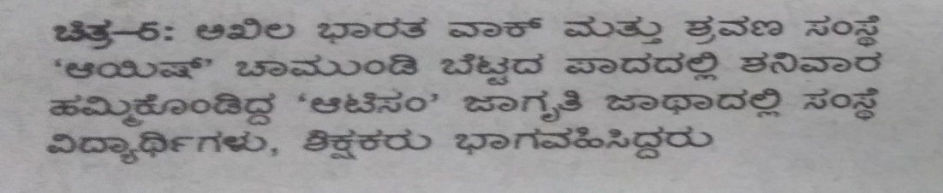
‘PRAJAVANI’

- Material Development– 01
- A PEM titled ‘Does your Child have Autism?’ has been prepared and set for realease
- AWARDS AND HONOURS RECEIVED BY FACULTY AND STAFF:
- EXTRA CURRICULLAR ACTIVITIES:
- AIISH Gymkhana:
- NSS:
- Others: Nil
- MAJOR EVENTS OF THE YEAR:
- EMINENT VISITORS-
- ANYOTHERS:
      - Dept. Related:
  - Computerization activities: Also the staff members of POCD were assigned duties regarding the activities related to Computerization. In Phase I, the Newborn screening program is finalized in draft stage and was hand to Mr. Devaraj for further process.
  - ISO: An meeting was held with Director & Management representative ISO cell on 27.04.2017 at the Board room between 11:30 a.m to 12:00 p.m regarding the finalization of process manual of the department.
  - Tri Monthly Meeting: An HODs meeting was held on 27.04.2017 at 4:30 p.m. in the board room. HOD-POCD presented the statistics of the clinical activities held in the month of Feb, Mar & April 2017.
- OSC related- Nil
- NBS related –
- Initiation of NBS: First level of meeting was conducted with King George's Medical University, Lucknow by the Director & HOD-POCD (through video conference) on 21.04.2017 to discuss on requirements to establish the set up.
- AABR screening was initiated at the Mission & Sigma Hospital, Mysuru in the month of April 2017.

- Recruitment/Relief of duties for the reporting year: Nil

Sd/-
Head, Dept. of POCD

