**ALL INDIA INSTITUTE OF SPEECH & HEARING: MYSORE – 570 006**

**DEPARTMENT OF SPECIAL EDUCATION**

**MONTHLY REPORTApril 2017**

1. **ACADEMIC ACTIVITIES**
2. **Orientation Programs (For outsiders):05**

The following orientation programswere conducted to orient about the activities of the departmentand also to provide the knowledge about the educational facilities and welfare measures for children with special needs.

|  |  |  |  |  |
| --- | --- | --- | --- | --- |
| **SL No.** | **Coordinator** | **Targeted Audience** | **Number**  **of Participants** | **Date** |
|  | Dr. Prithi V & Mr. Gururaj | Students, St. Philomena's college, Mysuru | 02 | 05.04.2017 |
|  | Mr. Suresh C. B | DIET, Lecturers, Malappuram, Nilambur Block panchayath, Kerala | 16 | 06.04.2017 |
|  | Mr. Gururaj D | Students and faculties, S. R Kanthi. P.G. Centre “ AnubhavaSangma”, Bagalkot. | 14 | 24.04.2017 |
|  | Mr. Gururaj D | Students, Mysore University, Department of food science and nutrition. | 08 | 24.04.2017 |
|  | Mr. Gururaj D | Students, VatsalyaB.Ed College, Shree hesmutt, Mysore | 06 | 26.04.2017 |

**Faculty report**

**Dr. Pushpavathi M., HOD in Special Education**

* Conducted meeting related to summer camp issues
* Finalized the indents for the first quartery year
* Supervised the work related to graduation day

|  |  |  |  |  |  |
| --- | --- | --- | --- | --- | --- |
| **Name of the Faculty** | | **Dr. Alok Kumar** | **Dr. G. Malar** | **Dr. Prithi Venkatesh** | **Dr. P. Vijetha** |
| Clinics | | | | | |  |
| **No. of cases evaluated at SEA-U** | | 10 | * Screening: 65 * Assessment: 2 + 36 (in coordination with special educators) |  | 12 |
| **No. of cases supervised individually** | |  | * Nil (as term-end exams were going on) |  | NIL |
| **No. of groups supervised** | |  | * 10 |  | NIL |
| **No. of meeting with parents** | |  | * 11 |  | 07 |
| **Educational Guidance** | | 24 | * Clients:16 * Sessions:17 |  | NIL |
| Academics | | | | | |
| **Classes taken** | | | | | |
| **B.Ed.**  **Spl.Edn.(HI)** | **Theory** | 09 | 27 sessions (including 1 extra class) |  | 30 classes |
| **Practical** |  | 1 hour |  | 05 hours |
| **DECSE(HI)** | **Theory** |  |  |  | 17 classes |
| **Practical** |  |  |  | NIL |
| **Any others** |  |  |  |  | 1. On 10th April 2017, compiled and submitted Annual Report 2016-17 of the department along with Ms. Manjula P.V. 2. On 27th April 2017, conducted Viva-voce for B.Ed. IV semester trainees for two practical components. 3. Coordinated the school readiness assessment sessions of B.Ed. IV semester (HI) trainees in Preschool as a part of their practicum. 4. Conducted meetings and carried out stock verification work of POCD. On 22nd April 2017, compiled and submitted stock verification report of my team as assigned. 5. On 24th April 2017, submitted C2 marks of B.Ed. Spl.Edn. II and IV semester trainees. 6. On 12th April 2017, oriented outgoing parents on the topic “Adaptation of a textbook lesson” 7. On 12th April 2017, attended peer review meeting of Department of Speech Language Sciences. 8. Summer camp - planned the craft work to be done as a part of Group D with the team. 9. On 28th April 2017, coordinated the farewell function for B.Ed. IV semester trainees on behalf of the department. |
| Research | | | | | |  |
| **Paper published** | |  |  |  | NIL |
| **Paper in press projects** | | 03 |  |  | NIL |
| **Paper presentation** | |  |  |  | NIL |
| Any other | | | | | |  |
| **Meeting held** | |  | * 2 monthly meetings with I & II B.Ed. students * 5 meetings regarding ARF project * 8 meeting with class teachers of out-going preschool children regarding preparation of reports for discharge & school readiness assessment |  | On 27th April 2017, Attended meeting with HOD for Group D, Summer camp craft work. |
| **Workshops** | |  |  |  |  |
| **Meeting attended** | |  | * 4 meetings with HOD – regarding arrangements for II B.Ed.Spl.Ed. (HI) viva-voce, mural decorations in preschool & farewell for B.Ed. students |  |  |
| **AV preparation** | |  | * 3 PPTs for IB.Ed.Spl.Ed. (HI) |  |  |
| **Brochures** | |  | * Nil |  |  |
| Roles & Responsibilities | | | | | |  |
| **Co-ordination** | | Infant & Toddler Unit | * CBCS Coordinator for I& II B.Ed. Spl.Ed. (HI) * Mentor for I & II B.Ed.Spl.Ed. (HI) * Compilation of M.S.Ed. Student Dissertation-based Articles 2014-15 * Intra-Department * SEA-U * EduTechLab   Research & Database Unit |  | ISO   * Worked & verified ISO process manual changes. * On 26th April 2017, met director along with HOD to discuss about ISO process manual changes.   Service for School aged children   * On10th April 2017, a small meeting with Ms. Shobha B.N. was conducted. |
| **Member secretary** | | Preschool | * LD Clinic (in DCS)   Services for School-Aged Children (in Department of Special Education) |  | Service for Infant and Toddlers |
| **Member in** | | SEA-U | * TCPD * Product Development Cell * Preschool Supervision |  | SEA –U  Was a part of preparation of 13 school readiness reports of outgoing children in preschool |
| **Mentor** | | M.Sc. -1st Year -Audiology |  |  |  |

1. Clinical /Educational Observation Postings of Students from other Institutes:NIL

Following are the details of students posted for observation/ practice teaching

|  |  |  |  |  |
| --- | --- | --- | --- | --- |
| Sl.No | Name of the Institute | Programme/Course | Number of Students | Dates |

1. Seminars/Conferences/Workshops/Training Programs:NIL

|  |  |
| --- | --- |
| Theme/topic |  |
| Coordinator |  |
| Objectives |  |
| Targeted Audience |  |
| Number of Participants |  |
| Date |  |
| Photo |  |

1. Staff Enrichment / In-house training Programmes *(For own staff members)* : NIL

|  |  |  |  |  |
| --- | --- | --- | --- | --- |
| Theme/Topic | Coordinator | Objectives | Number  of Participants | Date |

1. **Guest Lectures :01**

**Served as Resource Person:-**

|  |  |  |  |
| --- | --- | --- | --- |
| **Name, Designation, Institutional affiliation of Lecturer** | **Organized by Department/Section/Unit** | **Topic of Lecture** | **Date** |
| Dr. Kadambari N., Special Educator, AIISH, Mysuru | Dept of Clinical Psychology, AIISH, Mysuru | Behavioural Techniques in Teaching and Managing Children with Developmental Disabilities in Classroom | 28.04.2017 |

1. Additional Academic Services rendered by the Faculty and Staff
2. **Invited Talks:05**

|  |  |  |  |  |
| --- | --- | --- | --- | --- |
| **Staff** | **Topic** | **Date** | **Programme** | **Institution** |
| Dr. Alok Kumar | *‘Barrier free environment for children with special needs in inclusive setup’* | 12.04.2017 | *Parent Enrichment Programme – PEP* | AIISH Preschool, Mysuru |
| Dr. G. Malar | *‘Decision Making for School Placement’* | 12.04.2017 | *Parent Enrichment Programme – PEP* | AIISH Preschool, Mysuru |
| Dr. G. Malar | *‘Adaptation of Curricular Content for Children with Learning Disabilities’* | 12.04.2017 | *Parent Empowerment and Remedy for Literacy – PEaRL Programme* | LD Clinic, AIISH, Mysuru |
| Dr. Vijetha P. | ‘*Adaptation of a textbook lesson’* | 12.04.2017 | *Parent Enrichment Programme – PEP* | AIISH Preschool, Mysuru |
| Dr. Prithi Venkatesh | *‘Tips for pre-reading, pre-writing and pre-arithmetic skills’* | 12.04.2017 | *Parent Enrichment Programme – PEP* | AIISH Preschool, Mysuru |

1. Curriculum Development: NIL
2. **Development of Material to Support Learning**

* Development of academic screening checklist for higher primary school science and social science subjects at LD Clinic

1. Service in Academic Bodies of other Organizations
2. Participation in Committees/Taskforce and Panels setup by other organizations/agencies

|  |  |  |  |  |  |  |
| --- | --- | --- | --- | --- | --- | --- |
| Sl No | Name of the staff | Name of Organization/Agency | Participation in Committees/Taskforce | Programme | Name of Institute Visited | Date of Visit |

1. **Any Others (Please Specify)**
   * + 1. **Parent Enrichment Programs (PEP): 01** - This program aims to enrich knowledge of the caregivers of CWSN by experts from various fields.

|  |  |  |  |  |
| --- | --- | --- | --- | --- |
| **Theme/Topic** | **Coordinator** | **Objectives** | **Targeted Audience** | **Date** |
| Appropriate School Placement | Mr. Subramanya K. R | To enrich the out goingpre school parents | 60 outgoing preschool parents | 12.04.2017 |
| Barrier free environment for children with special needs in inclusive setup |
| Curriculum Adaptation for children with Special Needs |
| Tips for pre-reading, pre-writing and pre-arithmetic skills |
| **C:\Users\User\Desktop\PEP april 2017.jpg** | | | | |

* + - 1. **Stock verification of POCD, DHLS and SLS were carried out –** Dr. Vijetha P.,

Mr. Harish Kumar.

* + - 1. **Stock verification of Ladies hostel was carried out –** Ms. Sumana H P
      2. **Stock vertification of Admin Block was carried out** – Ms. Srividya M. S.
      3. **Stock vertification ofClininal Services was carried out –** Mr. Suresh C. B.
      4. **Stock vertification of ENT was carried out –** Dr. Kadambari N.
      5. **Stock vertification ofClininal Psychology& Garden Tools was carried out –**

Mr. Rajkumar R.

**RESEARCH ACTIVITIES (2016-17)**

1. Research Projects (ARF)
2. Completed -NIL
3. New Research Projects- NIL
4. **Ongoing Research Projects –02**
   1. **Title of ARF -** Development and Evaluation of Indigenous curriculum oriented computer based tutor for concept learning in preschool children with special needs.

Principal Investigator – Ms. P.V.Ramanakumari

Co-Investigators – Dr. Ajish K Abraham and Ms. P.V.Manjula

Research Assistant – Mr. Anil Abbur R.

Date of Starting – 18th January 2017

Progress –

* Story board writing of Food we eat.
* Gave 5 story boards for validation
* On 20th April 2017 attended mid-term review meeting

On 26th April 2017 attended ethical committee meeting.

* 1. **ARF Project No. 65**

Title: Effect of Resource Materials on Impact of Inclusive Education in Children with Intellectual Disabilities (ID) and Learning Disabilities (LD)

Duration: 12 months from January 2017

Budget: Rs. 3,85,000/-

Progress: Completed preparation of –

* Development Resource Material
* Informational PPT
* On ID – 2 (English & Kannada); On LD – 1 (English) & Resource Mobilisation for IE – 1 (English)
* Descriptive Outline for Video Clips
* 30 Clips on ID
* Development of tools
* Objective knowledge test – 1: Common for ID & LD – 50 MCQs
* Attitudinal rating scale – 2: 1 each for ID & LD – 40 statements
* Observation checklist – 2: 1 each for ID & LD – 40 behaviours/skills
* CWSN data proforma – 1
* Other Preparations
* Tentative consent from 4 schools
* Identification of evaluators for validation of informational content & tools
* Submission of first quarterly report

1. Postgraduate Research Completed:- NIL
2. C. Postgraduate Research ongoing: NIL
3. D Research Papers presented at National/International Conferences/Seminars :- NIL

E.Research Papers Published

i) Papers published in National / International Journals: NIL

ii) Papers published in Conference / Seminar Proceedings: NIL

F. Books published (in APA format)

1. Books published: NIL

G.Book chapters published (in APA format)-NIL

H .Books/Manuals/Seminar Proceedings edited: NIL

1. Journal Editorship: NIL

J. Scholarly Reviewing Activities: NIL

**III CLINICAL SERVICES**

1. General Clinical Services: **Not Applicable**
2. Specialized Clinical/ Educational Services
3. **Preschool Training and Special Education**

**Educational services for children with special needs**

|  |  |  |  |  |  |  |  |  |  |  |  |  |  |  |  |
| --- | --- | --- | --- | --- | --- | --- | --- | --- | --- | --- | --- | --- | --- | --- | --- |
| **S. No.** | **Nature of Services (I/C)** | | | | | | | | | | | | | | |
| 1. Special Educational Assessment Services (Dr. G. Malar) | | | | | | | | | | | | | | | |
|  |  | Nature of Special Need  Language | | ASD / PDD NOS | Hearing Loss | Intellectual Disability | | Learning Disability | Motor Problems | | Multiple Disabilities | Others | No. of Clients | No. of Sessions | ***Total No. of Sessions*** |
| 1. | Screening & Referral | Kannada | | 5 | 41 | 18 | | 2 | 2 | | 8 | 7 | ***83*** | ***83*** | ***136*** |
| Malayalam | | 2 | 13 | 8 | | - | - | | 8 | 1 | ***32*** | ***32*** |
| Hindi | | - | 5 | 3 | | - | - | | 1 | - | ***09*** | ***09*** |
| Urdu | | - | - | - | | - | - | | - | - | ***-*** | ***-*** |
| English | | - | 2 | 1 | | 1 | 1 | | 1 | 4 | ***10*** | ***10*** |
| Telugu | | - | - | 1 | | - | - | | - | - | ***1*** | ***1*** |
| Tamil | | - | - | - | | - | - | | 1 | - | ***1*** | ***1*** |
| Any Other | | - | - | - | | - | - | | - | - |  |  |
| ***Total No. of Clients*** | | ***07*** | ***61*** | ***31*** | | ***03*** | ***03*** | | ***19*** | ***12*** | ***136*** | ***136*** |
| 2. | Assessment & Report | Kannada | | - | 35 | 14 | | - | 1 | | 5 | 1 | ***56*** | ***135*** | ***293*** |
| Malayalam | | 1 | 5 | 2 | | - | - | | 4 | - | ***12*** | ***95*** |
| Hindi | | 1 | 4 | 2 | | - | - | | 1 | - | ***08*** | ***48*** |
| Urdu | | - | - | - | | - | - | | - | - | ***-*** | ***-*** |
| English | | 3 | - | - | | - | - | | - | 02 | ***05*** | ***15*** |
| Telugu | | - | - | - | | - | - | | - | - | ***-*** | ***-*** |
| Tamil | | - | - | - | | - | - | | - | - | ***-*** | ***-*** |
| Any Other | | - | - | - | | - | - | | - | - | ***-*** | ***-*** |
| ***Total No. of Clients*** | | ***05*** | ***44*** | ***18*** | | ***-*** | ***01*** | | ***10*** | ***03*** | ***81*** | ***293*** |
| Places from which seen: (1)Karnataka: 99 (2)Kerala: 30 (3)AP: 1 (4)TN: 3 (5)Other Parts of India: 3 (6)Any other: Nil | | | | | | | | | | | | | | |
| Age groups seen:(1)Birth to 2.5yrs: 8 (2)2.5+ to 6 yrs: 53 (3)6yrs+ to 16 years: 69 (4)16yrs+: 6 | | | | | | | | | | | | | | |
| Total No. of Referrals: (1)Educational Assessment: 81 (2)Educational Guidance: 9 (3)PIP: 8 (4)PPEP/ PBC/ GECS: 23 (5)CSS/IEP/NFE/DET: 15 (6) Any Other Services at AIISH: 26 (7) Any Other Services Outside AIISH: 79 | | | | | | | | | | | | | | |
| No. of Reports Issued: (1) School Readiness: 79 (3) Curriculum-Based Assessment: 02 (4) Post-School Preparedness: Nil | | | | | | | | | | | | | | |
| 3. | On-going Assessment (as part of service delivery) | | Figure: | | | | | | | | | | | | |
|  | **Details of Assessments** | | **No. of Children** | | | | **No. of Assessment Sessions** | | | **No. of Reports** | | | | | |
| As part of Parent-Infant Programme: | | Nil | | | | Nil | | | Nil | | | | | |
| As part of Preschool Parent-Empowerment Programme: | | Nil | | | | Nil | | | Nil | | | | | |
| As part of Preschool Training Programme &  As part of Preschool Bridge Course Programme: | | 206 | | | | 120 | | | 206 | | | | | |
| As part of CSS/ IEP/NFE: | | 21 | | | | 22 | | | Nil | | | | | |

|  |
| --- |
| **Preschool Training (Ms. Prithi Venkatesh):Preparatory programme for schooling providing training in self-help, cognitive, language and (pre) academic skills, Preschool Bridge course** |
| |  |  |  |  | | --- | --- | --- | --- | | **Language & Disability** | **No. of Groups** | **No. of Children** | | |  |  | MALE | FEMALE | | Kannada ASD & ID &MD | 14 | 44 | 18 | | Kannada HI | 10 | 41 | 28 | | Malayalam HI | 1 | 3 | 2 | | Malayalam ASD & ID & MD | 10 | 23 | 14 | | Hindi HL | 1 | 7 | 0 | | Hindi MD & ID & ASD | 2 | 6 | 2 | | English ID, ASD | 2 | 5 | 3 | | TOTAL Number of children |  | **129** | **67** | | **TOTAL No. Groups** | **40** | **196** | | | Sessions | 1. **(Group wise) 14 days** | | | |

|  |  |  |  |  |  |  |
| --- | --- | --- | --- | --- | --- | --- |
| **Curricular Support Services – Supportive training to augment education in mainstream school/ other educational programmes – Mr.Harish** | | | | | | |
|  | **Language** | **HL** | **MR/CP/Down’s/LD** | **PDD** | **Total No.of clients** | **No. Of sessions** |
| **Kannada** | 04 | 09 | 02 | 15 | 56 |
| **Malayalam** | 1 | 01 | - | 02 | 9 |
| **Hindi** | 0 | 0 |  | 0 | 0 |
| **English** | 03 | 06 | - | 09 | 39 |
| **Telugu** | - | 01 | - | 01 | 06 |
| **Tamil** | - | - | - | - | - |
| **Total** | | | | **27** | **110** |
| No. of clients promoted to the next higher level of service:  No. discharged : 03  No. of Old clients :09  No. of New clients enrolled: 18  No. discontinued: Nil | | | | | | |

|  |  |  |  |  |  |  |
| --- | --- | --- | --- | --- | --- | --- |
| **Individualised Educational Programme (IEP) – Training in functional academics for out of school individuals– Mr. Harish** | | | | | | |
|  | **Language** | **HL** | **MR/CP/Down’s/LD** | **PDD** | **Total No.of clients** | **No. Of sessions** |
| **Kannada** | 01 | 03 | 0 | 04 | 16 |
| **Malayalam** | - | 01 |  | 01 | 06 |
| **Hindi** | -- | -- | -- | -- | -- |
| **English** | -- | -- | -- | -- | -- |
| **Telugu** | -- | -- | -- | -- | -- |
| **Tamil** | -- | -- | -- | -- | -- |
| **Total** | | | | 05 | 22 |

|  |  |  |  |  |  |
| --- | --- | --- | --- | --- | --- |
| **Demonstration Training – Short-term demonstration to caregivers in any of the above –**  **Mr. Harish** | | | | | |
| **Language** | **HL** | **MR/CP/Down’s/LD** | **PDD** | **Total No.of clients** | **No. Of sessions** |
| **Kannada** | -- | 03 | -- | 03 | 23 |
| **Malayalam** | 01 | 01 | 01 | 03 | 11 |
| **Hindi** | -- | -- | -- | -- | -- |
| **English** | 01 | 02 | 01 | 04 | 30 |
| **Telugu** | -- | -- | -- | -- | -- |
| **Tamil** | -- | -- | -- | -- | -- |
| **Total** | | | | **10** | **64** |
| |  |  |  |  |  |  |  |  |  |  |  | | --- | --- | --- | --- | --- | --- | --- | --- | --- | --- | --- | | **Preschool Parent Empowerment Programme – PPEP (Mr. MurshidulAlam):** | | | | | | | | | | | | Buffer programme for children awaiting for preschool admission | **Language** | **HL** | **ID** | **CP** | **ASD** | **MD** | **LD** | **DD** | **Total No. of clients** | **No. Of sessions** | | Kannada | 34 | 18 | 00 | 06 | 07 | -- | -- | 65 | 191 | | Malayalam | 04 | 12 | 01 | 08 | 05 | -- | -- | 30 | 94 | | Hindi | 08 | 01 | -- | -- | -- | -- | -- | 09 | 38 | | English | 01 | 02 | -- | -- | -- | -- | -- | 03 | 19 | | Telugu | 06 | -- | -- | -- | -- | -- | -- | 06 | 19 | | Tamil | 05 | -- | -- | -- | 01 | -- | -- | 06 | 18 | | **Total** | | | | | | | | | **119** | **379** | | No. of clients promoted to the next higher level of service: 00  No. Of discharged : Nil  No. Of discontinued: 11 (Kannada: HL = 05, ID=01), (Malayalam: ID= 03, HL= 01, ASD=01)  No. Of new clients : 17 | | | | | | | | | | | | | | | | | |

|  |  |  |  |  |  |  |  |  |  |  |  |  |  |  |  |  |  |  |  |  |  |  |  |  |  |  |  |  |  |  |  |  |  |  |  |  |  |  |  |  |  |  |  |  |  |  |  |  |  |  |  |  |  |  |  |  |  |  |  |  |  |  |  |  |  |  |  |  |  |  |  |  |  |  |  |  |  |  |  |  |  |  |  |  |  |  |  |  |  |  |  |  |  |  |  |  |  |  |  |  |  |  |  |  |
| --- | --- | --- | --- | --- | --- | --- | --- | --- | --- | --- | --- | --- | --- | --- | --- | --- | --- | --- | --- | --- | --- | --- | --- | --- | --- | --- | --- | --- | --- | --- | --- | --- | --- | --- | --- | --- | --- | --- | --- | --- | --- | --- | --- | --- | --- | --- | --- | --- | --- | --- | --- | --- | --- | --- | --- | --- | --- | --- | --- | --- | --- | --- | --- | --- | --- | --- | --- | --- | --- | --- | --- | --- | --- | --- | --- | --- | --- | --- | --- | --- | --- | --- | --- | --- | --- | --- | --- | --- | --- | --- | --- | --- | --- | --- | --- | --- | --- | --- | --- | --- | --- | --- | --- | --- |
| |  |  |  |  |  |  |  |  |  |  |  | | --- | --- | --- | --- | --- | --- | --- | --- | --- | --- | --- | | **Parent-Infant Programme – PIP (Ms. Leelarani) . (Birth to 2 ½ years)** | | | | | | | | | | | | Early stimulation programme for infants & toddlers with communication disorders | **Language** | **HL** | **ID** | **CP** | **ASD** | **MD** | **LD** | **DD** | **Total No. of clients** | **Total No. Of sessions** | | Kannada | 8 | 4 | - | 1 | 4 | - | - | 18 | 90 | | Malayalam | 2 | 10 | - | 1 | 5 | - | - | 18 | 85 | | Hindi | 3 | - | - | - | 1 | - | - | 4 | 21 | | English | - | 1 | - | - | - | - | - | 1 | 1 | | Telugu | - | - | - | - | - | - | - | - | - | | Tamil | - | - | - | - | - | - | - | - | - | |  | **Total** | | | | | | | | **40** | **196** | | Specific age range:  No. of Old clients :35  No. of New clients enrolled: 05  No. discharged : NIL  No. discontinued:NIL  No. of Promoted to next level: 01 | | | | | | | | | | | |

|  |  |  |
| --- | --- | --- |
| **Library of Books & Toys** – LiBoToy  (Ms. P. V. Ramanakumari & Ms. P. V. Manjula): Services issuing educational toys & books for home-based training | Total number of members enrolled - 136  No. of new members: - NIL  Amount – NIL  Total number of sessions –24 | |
| **Age group** | **Total number** |
| 0-2.6 yrs | 12 |
| 2.6-4 yrs | 14 |
| 4.0-6yrs | 98 |
| 6 yrs and above | 12 |

|  |  |  |
| --- | --- | --- |
| **Services** | **Number of Clients** | **Number of Sessions** |
| Co-Curricular Training | 14 | 14 |

**Supports for Empowering Caregivers**

|  |  |  |  |
| --- | --- | --- | --- |
| Name of Training Unit | No. of Parent  Beneficiaries | No. of Sessions | Content of Training |
| Caregiver Computer Training Unit | -- | -- | -- |
| Caregiver Literacy Training Unit | -- | -- | -- |

1. Clinical Support Services to Clients and Family
2. **Counselling and guidance**

|  |  |
| --- | --- |
| No. of Clients | Sessions |
| 60 | 63 |

1. **U-SAFE**

|  |  |
| --- | --- |
| No. of Clients | Sessions |
| -- | -- |

1. **Details of Certificates Issued:**

**Details of Bonafide Certificates Issued:**

|  |  |  |  |
| --- | --- | --- | --- |
| **Sl.No.** | **Nature of Special Needs in Clients** | **No. of Certificates Issued** | **Purpose** |
| 1 | DSL,HL | 01 | * For applying DL |

1. Financial Aid- NIL
2. Legal advice -NIL
3. **Any other(Please Specify):**

**Orientation Programs: NIL**

The program aims to adopt and support mainstream schools integrating children with communication disorders.The teachers of these schools are oriented periodically on identification of special needs in children, consequent supports like referral services, curricular adaptation and management, and guidance regarding availing educational welfare measures among others. Beyond these, need-based guidance is extended to teachers in managing practical hitches in the process of inclusion. In the course of action the programme also endeavours to mould positive attitudes among the teachers. The following are the details of the orientation programmes carried out during 2017-18:

|  |  |  |  |  |
| --- | --- | --- | --- | --- |
| Sl. No | Details of Schools Adopted | No. of Staff in the Schools | Resource Persons from AIISH | Dates of Orientation Programmes |

* + 1. EXTENSION ACTIVITIES

1. Public Lecture Series
   * 1. TECHNLOGICAL CONSULTANCY SERVICES: Not applicable
        1. CENTRAL FACILITIES
        2. Library and Information Services
        3. Public Information Activities
        4. **Major Events of the Year with a brief account**

**Name of the Programme/ Event:** Preschool Graduation ceremony 2017

**Date:** 21.04.2017

**Coordinated by: -** Ms. Shobha B.N , Ms. Sreevidhya M S & Ms. Leena C C

**Brief note:** 110 Children with various communication disorders were graduated on 21 April 2017. Chief guest *Dr. N. Rathna, Former Director – AIISH & AYJNIHH and Director Dr. S.R Savithri* graced the function. A book titled “ Survey of Communication Disorders a report” was released.

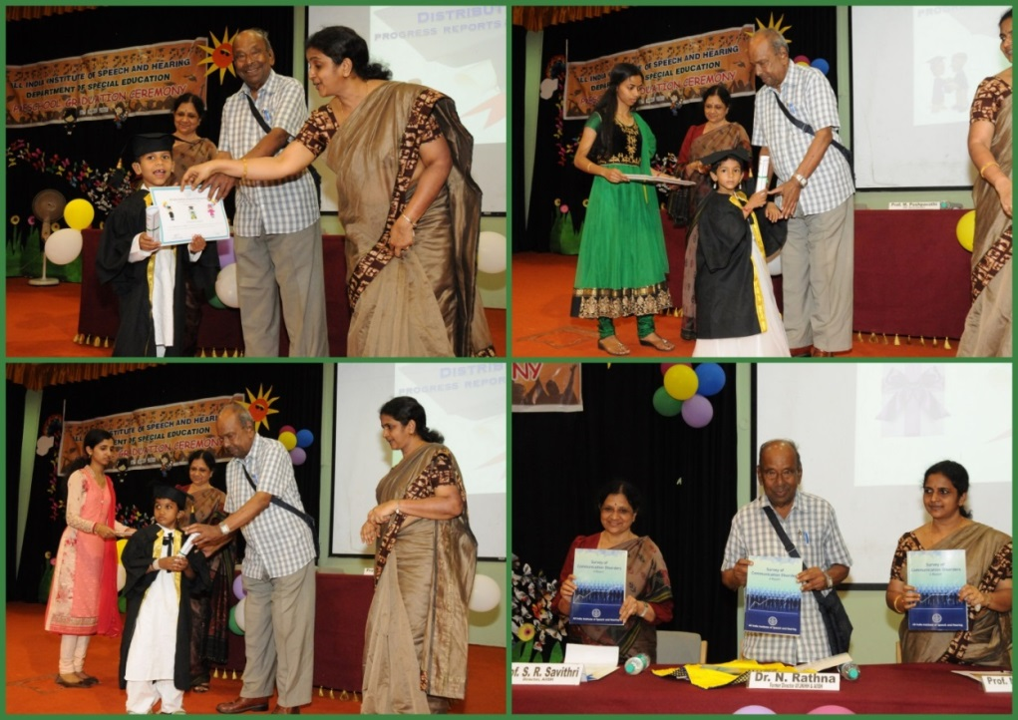

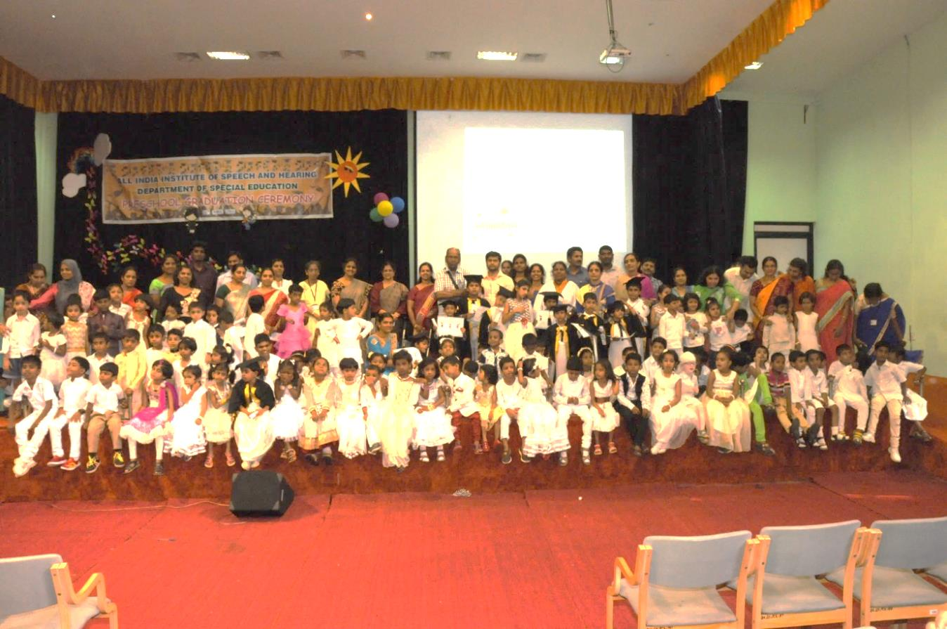

1. **Press Releases and Media Coverage**

* 27, April 2017 – Prajavani Preschool Graduation was in various newspapers was published.
* 26,April 2017 – VijayavaniPreschool Graduation was in various newspaperswas published.

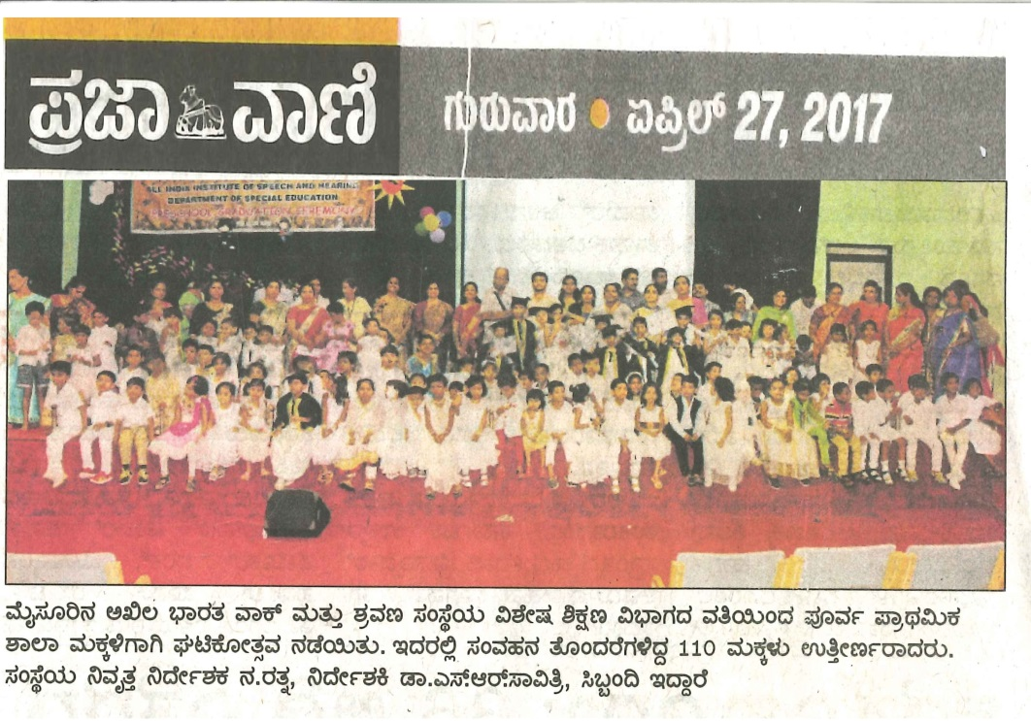

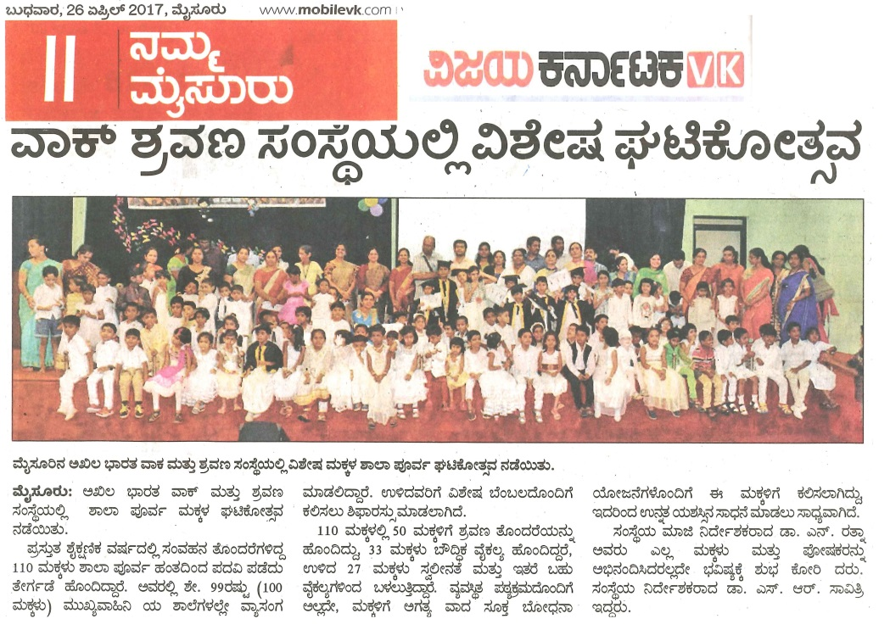

**C) Material Development :**The following Teaching Learning Materials and Prepare for training children with various communication disorders an preschool.

|  |  |  |  |
| --- | --- | --- | --- |
| **Sl.**  **No.** | **Nature of**  **Teaching-Learning**  **Materials** | **Skill** | **Number** |
| 1. | Flash cards | For all skill areas | 152 |
| 2. | Work Cards | For all skill areas | 120 |
| 3. | Charts | For all skill areas | 87 |
| 4. | PPT | For all skill areas | 150 |
| 5. | Models | For all skill areas | 160 |
| 6. | Sentence strips | For all skill areas | 176 |
| 7. | Others | For all skill areas | 20 |

1. **AWARDS AND HONORS RECEIVED BY FACULTY AND STAFF**
2. EXTRA CURRICULAR ACTIVITIES
   * + - 1. **AIISH Gymkhana**
         2. NSS
         3. Others:Following are the awards won by the staff for sports conducted by AIISH gymkhana on 02.04.2017:-

* **AIISH Alumni Premium Legue 2017 Cricket Winner**

Mr. Subramanya. K. R. Team

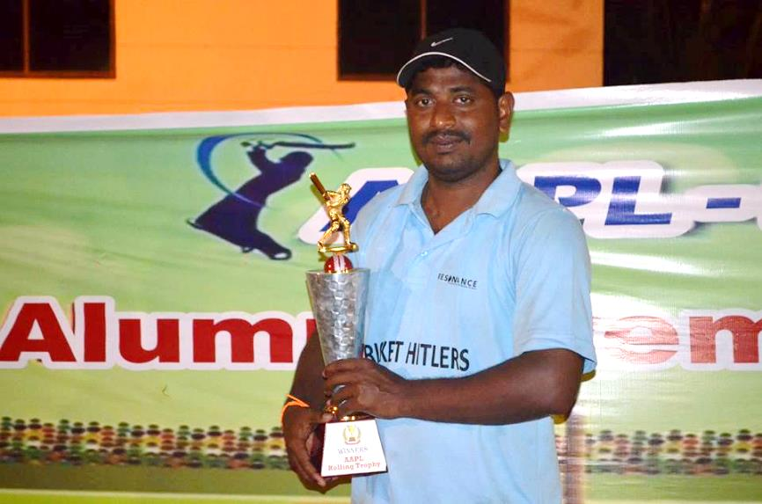

* **AIISH Alumni Premium Legue 2017 Cricket Woman Best bowler:**Ms. Srividya M. S.

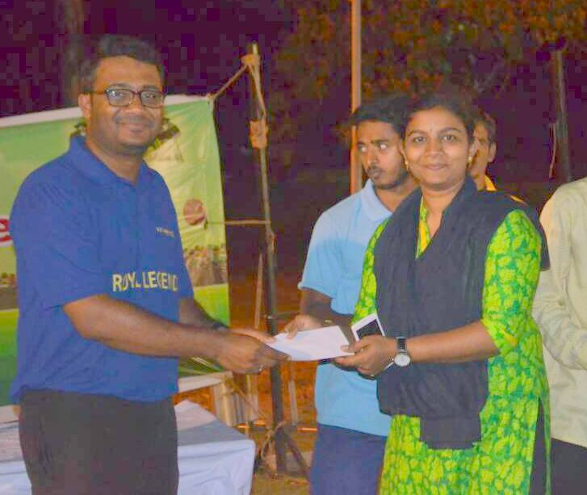

* **AIISH Fareware Cup 2017 winner on 23.04.2017**

Mr. Subramanya. K. R. Team

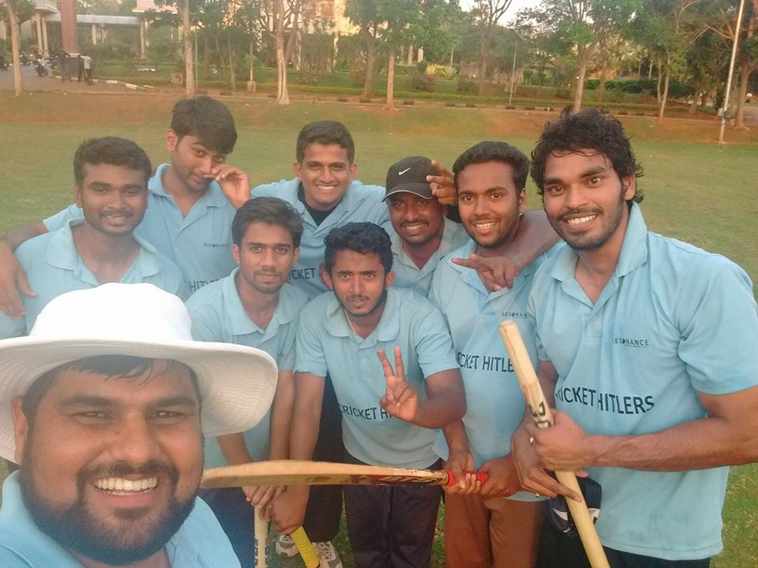

1. EMINENT VISITORS:

XI. **ANY OTHER**

* **OfficialLanguage Implementation:**
* Word a day
* Quarterly report from Dec 2016 to March 2017 was sent to OLI Section on **06.04.2017**.
* No of notings/letters (April 2017): **30**

Sd/-

HOD- Special Education