ALL INDIA INSTITUTE OF SPEECH & HEARING: MYSORE – 570 006
DEPARTMENT OF SPECIAL EDUCATION
अखिल भारतीय वाक श्रवण संस्थान, मैसूर- ५७०००६
विशेष शिक्षा विभाग
May Monthly Report 2016

- ACADEMIC ACTIVITIES
- Short-term Training Programs: NIL
- Orientation Programs: NIL
- Clinical/Special Educational services- Observation Posting of Students from other Institutes
- Seminars/Conferences/Workshops: NIL
- In- house training Programs:
- E³ : Empowering Educators in Education: NIL
- Staff Enrichment Programs (SEP’s) :
- Name of the Programme/ Event: “Stress Management and Human Values”following meditation by Ms. B.K. Yogeshwari.
- Date: 18.05.2016

- Guest Lectures :
- Invited Talks: 05 as a part of summer camp the following resource persons conduced the various program.
Event | Resource person | Title of the lecture | Venue & address | Beneficiaries | Organizer | Date
Summer camp | Mr. Deepak | Karate Training | Preschool | 61 CWSN & 29 Typically developing Children | Dept. of Special Education | 03rd - 31th May, 2016
Summer camp | Mr. Dharmaraj | Dance Training | Preschool | 61 CWSN & 29 Typically developing Children | Dept. of Special Education | 17th – 30th May, 2016
Summer camp | Mr. Natraj | Drama Training | Preschool | 61 CWSN & 29 Typically developing Children | Dept. of Special Education | 11th – 30th May, 2016
Summer camp | Mr. Sharath | Craft Training | Preschool | 61 CWSN & 29 Typically developing Children | Dept. of Special Education | 9th – 30th May, 2016
Summer camp | Ms. B.K. Yogeshwari | Meditation | Preschool | Caregivers | Dept. of Special Education | 2nd – 6th May, 2016

ii.
Name of the staff | G. Malar
Topic of presentation | Peers in Inclusive Education: Boon or Bane?
Name of the seminar/symposium/ conference/workshop | Monthly Public Lecture
Organizer | Dr. M. Santosh
Venue | Seminar Hall, AIISH
Date | 28.05.2016

- Development of Materials to Support Learning
- Service in Academic bodies of other Organizations- NIL
- Membership in Professional Organizations/Associations - NIL
- Participation in Committees/Taskforce and Panels setup by other organizations/agencies
- Any Other(Please Specify) - NIL

- RESEARCH ACTIVITIES
- Research Projects
- Completed Research Projects
- New Research Projects:
- On-going Research Project : 01
Investigators | Title & Other important details | Progress
PI :  Dr. Palnaty Vijetha  CIs:  Dr. G. Malar  Mr. Rajkumar R. ,  Ms. Leelarani S.B.  RO: Ms. Shaik Gulab Jan | Efficacy of self-learning adapted social studies lessons in Kannada and Telugu for children with hearing impairment at Secondary School Level’  Duration: One year  Date of commencement: 8th January 2016-04-15  Budget sanctioned: Rupees 3,25,000/ | - Contacted Telugu experts for validation  - Discussions among investigators have been made regarding the progress made.  - Progress came as satisfactory regarding the presentation made in the review meeting about the progress made on 28th April 2016.  - Distributed adapted SLMS to all the Kannada and Telugu Experts.  - Literature Review first draft is prepared.  - Started with Introduction chapter.  - Contacted and received final exam marks of children from special schools in Ananthapur

- Doctoral and Post-Doctoral Programs
- Degree Awarded
- Thesis awarded:
- Thesis Submitted:
- Under Progress: 04
Name of the student | Title | External/internal | Guide | Date of initiation | Status
Deepak Kr. Tripathi | Uttar Pradesh kevisheshthathasamekithvidyalayon me adhyanthathshravanachambalankokibhashavikaskatulnathmakahyan | External | Dr.Alok Kr. Upadhyay | 2011 | In Progress
VijetaRai | Effect of peer tutoring and curriculum adaptation for  D.H.H. children in inclusive steps: an experimental study | External | Dr.Alok Kr. Upadhyay | 2012 | In Progress
Neetu  Pandey | A study on communication options for Deaf & Hard of  Hearing used in Inclusive and Non-inclusive set up. | External | Dr.AlokKr. Upadhyay | 2012 | In Progress
Niranjan  Singh | Uttar Pradesh keSamavesibatavaran main adhayanratshravanachamchatrao main manobagyanikprakriyasambandhi vicar se utapansakshiksamasayaonkaadhyan. | External | Dr.Alok Kr. Upadhyay | 2012 | In Progress
- Research Papers presented at National/International Conferences/Seminars.
- Research Papers Published(in APA format):NIL
    - Papers published in Conference/Seminar Proceedings
    - Research Papers in press- NIL
    - Research Papers published in Journals:
    - No. of in-house journal articles:

- Books published.
- Book chapters published(in APA format)-NIL
- Books in press :
- Books/Manuals/Seminar Proceedings edited
- Journal Editorship
- Scholarly Reviewing Activities
- Reviewer for Scholarly Journals
- M.S.Ed (HI) Dissertations Guided by Faculty
- SPECIAL EDUCATIONAL SERVICES
- Pre-School Training and Special Education
  - Monthly Statistics Special Educational Services

S. No. | Nature of Services (I/C)
Special Educational Assessment Services (Dr. G. Malar)
 |  | Nature of Special Need  Language |  |  |  |  |  |  |  | ASD / PDD NOS |  |  | Hearing Loss |  |  |  | Intellectual Disability |  |  | Learning Disability |  |  | Motor Problems |  |  | Multiple Disabilities |  |  |  | Others | No. of Clients | No. of Sessions |  | Total No. of Sessions
1. | Screening & Referral | Kannada |  |  |  |  |  |  |  | 2 |  |  | 34 |  |  |  | 10 |  |  | - |  |  | - |  |  | 4 |  |  |  | 3 | 53 | 53 |  | 88
1. | Screening & Referral | Malayalam |  |  |  |  |  |  |  | 6 |  |  | 7 |  |  |  | 2 |  |  | - |  |  | - |  |  | 5 |  |  |  | 1 | 21 | 21 |  | 88
1. | Screening & Referral | Hindi |  |  |  |  |  |  |  | - |  |  | 1 |  |  |  | - |  |  | - |  |  | - |  |  | 2 |  |  |  | - | 3 | 3 |  | 88
1. | Screening & Referral | Urdu |  |  |  |  |  |  |  | - |  |  | - |  |  |  | - |  |  | - |  |  | - |  |  | - |  |  |  | - | - | - |  | 88
1. | Screening & Referral | English |  |  |  |  |  |  |  | - |  |  | 4 |  |  |  | 1 |  |  | - |  |  | - |  |  | 1 |  |  |  | - | 6 | 6 |  | 88
1. | Screening & Referral | Telugu |  |  |  |  |  |  |  | - |  |  | - |  |  |  | - |  |  | - |  |  | - |  |  | 1 |  |  |  | 2 | 3 | 3 |  | 88
1. | Screening & Referral | Tamil |  |  |  |  |  |  |  | - |  |  | - |  |  |  | - |  |  | - |  |  | - |  |  | 1 |  |  |  | - | 1 | 1 |  | 88
1. | Screening & Referral | Any Other |  |  |  |  |  |  |  | - |  |  | 1 |  |  |  | - |  |  | - |  |  | - |  |  | - |  |  |  | - | 1 | 1 |  | 88
1. | Screening & Referral | Total No. of Clients |  |  |  |  |  |  |  | 8 |  |  | 47 |  |  |  | 13 |  |  | - |  |  | - |  |  | 14 |  |  |  | 6 | 88 | 88 |  | 88
2. | Assessment & Report | Kannada |  |  |  |  |  |  |  | 1 |  |  | 23 |  |  |  | 4 |  |  | - |  |  | - |  |  | 2 |  |  |  | 1 | 31 | 93 |  | 141
2. | Assessment & Report | Malayalam |  |  |  |  |  |  |  | 6 |  |  | 6 |  |  |  | - |  |  | - |  |  | - |  |  | 4 |  |  |  | - | 16 | 48 |  | 141
2. | Assessment & Report | Hindi |  |  |  |  |  |  |  | - |  |  | - |  |  |  | - |  |  | - |  |  | - |  |  | - |  |  |  | - | - | - |  | 141
2. | Assessment & Report | Urdu |  |  |  |  |  |  |  | - |  |  | - |  |  |  | - |  |  | - |  |  | - |  |  | - |  |  |  | - | - | - |  | 141
2. | Assessment & Report | Telugu |  |  |  |  |  |  |  | - |  |  | 2 |  |  |  | - |  |  | - |  |  | - |  |  | - |  |  |  | - | 2 | 7 |  | 141
2. | Assessment & Report | Tamil |  |  |  |  |  |  |  | - |  |  | - |  |  |  | - |  |  | - |  |  | - |  |  | - |  |  |  | - | - | - |  | 141
2. | Assessment & Report | Any Other |  |  |  |  |  |  |  | - |  |  | - |  |  |  | - |  |  | - |  |  | - |  |  | - |  |  |  | - | - | - |  | 141
2. | Assessment & Report | Total No. of Clients |  |  |  |  |  |  |  | - |  |  | - |  |  |  | - |  |  | - |  |  | - |  |  | - |  |  |  | - | - | -
2. | Places from which seen: (1)Karnataka: 58 (2)Kerala: 22 (3)AP: 1 (4)TN: 4 (5)Other Parts of India: 1 3 (Punjab, Rajasthan & W. Bengal) (6)Any other: Nil
2. | Age groups seen:(1)Birth to 2.5yrs: 3 (2)2.5⁺ to 6 yrs: 38 (3)6yrs⁺ to 16 years: 46 (4)16yrs⁺: 1
2. | Total No. of Referrals: (1)Educational Assessment: 49 (2)Educational Guidance: 3 (3)PIP: 5 (4)PPEP: 15 (5)PBC/GECS: 1 (6)CSS/IEP/NFE/DET: 61 (7) Any Other Services at AIISH: 48 (Clinical Therapy) (8) Any other Services outside AIISH: 48 (Mainstreaming)
2. | No. of Reports Issued: (1) Early Development Skills: Nil (2) School Readiness: 47 (3) Curriculum-Based Assessment: 1 (4) Post-School Preparedness: Nil
3. | On-going Assessment (as part of service delivery) |  |  |  | Figure:  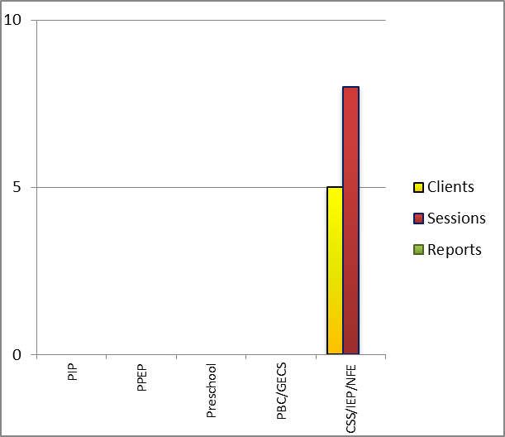
 | Details of Assessments |  |  |  | No. of Children |  |  |  |  |  |  |  |  |  |  | No. of Assessment Sessions |  |  |  |  |  |  |  |  |  |  | No. of Reports
 | As part of Parent-Infant Programme: |  |  |  | Nil |  |  |  |  |  |  |  |  |  |  | Nil |  |  |  |  |  |  |  |  |  |  | Nil
 | As part of Preschool Parent-Empowerment Programme: |  |  |  | Nil |  |  |  |  |  |  |  |  |  |  | Nil |  |  |  |  |  |  |  |  |  |  | Nil
 | As part of Preschool Training Programme: |  |  |  | Nil |  |  |  |  |  |  |  |  |  |  | Nil |  |  |  |  |  |  |  |  |  |  | Nil
 | As part of Preschool Bridge Course Programme: |  |  |  | Nil |  |  |  |  |  |  |  |  |  |  | Nil |  |  |  |  |  |  |  |  |  |  | Nil
 | As part of CSS/ IEP/NFE: |  |  |  | 04 |  |  |  |  |  |  |  |  |  |  | 05 |  |  |  |  |  |  |  |  |  |  | Nil
Parent-Infant Programme – PIP (Birth to 2 ½ years)
Early stimulation programme for infants & toddlers with communication disorders |  |  |  | Language |  |  | HL |  | IC |  | CP |  |  | ASD |  |  |  | MD |  |  | LD |  |  | DD |  |  |  | Total No. of clients |  |  |  |  | Total No. Of sessions
 |  |  |  | Kannada |  |  | 06 |  | -- |  | 01 |  |  | -- |  |  |  | 02 |  |  | -- |  |  | 03 |  |  |  | 12 |  |  |  |  | 54
 |  |  |  | Malayalam |  |  | 06 |  | -- |  | 02 |  |  | -- |  |  |  | 02 |  |  | -- |  |  | 05 |  |  |  | 15 |  |  |  |  | 48
 |  |  |  | Hindi |  |  | -- |  | -- |  | -- |  |  | -- |  |  |  | -- |  |  | -- |  |  | 01 |  |  |  | 01 |  |  |  |  | 00
 |  |  |  | English |  |  | 01 |  | -- |  | -- |  |  | -- |  |  |  | -- |  |  | -- |  |  | -- |  |  |  | 01 |  |  |  |  | 02
 |  |  |  | Telugu |  |  | -- |  | -- |  | -- |  |  | -- |  |  |  | -- |  |  | -- |  |  | -- |  |  |  | 00 |  |  |  |  | 00
 |  |  |  | Tamil |  |  | -- |  | -- |  | -- |  |  | -- |  |  |  | -- |  |  | -- |  |  | -- |  |  |  | 00 |  |  |  |  | 00
 |  |  |  | Total |  |  |  |  |  |  |  |  |  |  |  |  |  |  |  |  |  |  |  |  |  |  |  | 29 |  |  |  |  | 104
Specific age range:
No. Of New clients enrolled: 03
No. discharged : NIL
No. discontinued: NIL
No. of Promoted to next level: NIL
Preschool Parent Empowerment Programme – PPEP (Ms. Kumudha R.):
Buffer programme for children awaiting for preschool admission |  |  | Language |  |  | HL |  | ID |  |  |  | CP |  |  | ASD |  |  |  | MD |  |  | LD |  |  | DD |  |  |  | Total No. of clients |  |  |  | No. Of sessions
 |  |  | Kannada |  |  | 50 |  | 13 |  |  |  | 02 |  |  | 02 |  |  |  | 09 |  |  | -- |  |  | -- |  |  |  | 76 |  |  |  | 44
 |  |  | Malayalam |  |  | 10 |  | 08 |  |  |  |  |  |  | 07 |  |  |  | 05 |  |  | -- |  |  | -- |  |  |  | 30 |  |  |  | 44
 |  |  | Hindi |  |  | 09 |  | 02 |  |  |  |  |  |  |  |  |  |  |  |  |  |  |  |  |  |  |  |  | 11 |  |  |  | 44
 |  |  | English |  |  | 01 |  | 02 |  |  |  |  |  |  | 2 |  |  |  |  |  |  |  |  |  |  |  |  |  | 5 |  |  |  | 44
 |  |  | Telugu |  |  | 06 |  | -- |  |  |  | -- |  |  | -- |  |  |  | -- |  |  | -- |  |  | -- |  |  |  | 6 |  |  |  | 22
 |  |  | Tamil |  |  | 04 |  | -- |  |  |  | -- |  |  | -- |  |  |  | -- |  |  | -- |  |  | -- |  |  |  | 4 |  |  |  | 22
Total |  |  |  |  |  |  |  |  |  |  |  |  |  |  |  |  |  |  |  |  |  |  |  |  |  |  |  |  | 132 |  |  |  | 220
No. of clients promoted to the next higher level of service: NIL
No. discharged : NIL
No. discontinued: 01

Services for Preschool-aged Children (2+ to 6 years)
Group Educational Guidance & Counselling Services – GEGCS (Mr.Rajkumar.R): Non-formal preschool training children with communication disorders for schooling | Language | HL | IC | CP | ASD | MD | LD | DD | Total No. of clients | No. Of sessions
 | Kannada | -- | -- | -- | -- | -- | -- | -- | -- | --
 | Malayalam | -- | -- | -- | -- | -- | -- | -- | -- | --
 | Hindi | -- | -- | -- | -- | -- | -- | -- | -- | --
 | English | -- | -- | -- | -- | -- | -- | -- | -- | --
 | Telugu | 2 | 1 |  | 2 | 1 |  |  | 6 | 1
 | Tamil | -- | -- | -- | -- | -- | -- | -- | -- | --
Total |  |  |  |  |  |  |  |  | 6 | 1
No. discharged : NIL
No. discontinued: NIL

Curricular Support Services – Supportive training to augment education in mainstream school/ other educational programmes |  | Language |  |  | HL |  |  | MR/CP/Down’s/LD |  | PDD |  |  |  | Total No. of clients |  |  | No. Of sessions
 |  | Kannada |  |  | 10 |  |  | 6 |  | 1 |  |  |  | 17 |  |  | 32
 |  | Malayalam |  |  |  |  |  | 5 |  |  |  |  |  | 05 |  |  | 19
 |  | Hindi |  |  | - |  |  | 1 |  | - |  |  |  | - |  |  | 00
 |  | English |  |  | 2 |  |  |  |  |  |  |  |  | 01 |  |  | 03
 |  | Telugu |  |  | - |  |  | - |  | - |  |  |  | - |  |  | -
 |  | Tamil |  |  | -
Total |  |  |  |  |  |  |  |  |  |  |  |  |  | 23 |  |  | 54
Individualised Educational Programme (IEP) – Training in functional academics for out of school individuals |  | Language |  | HL |  |  | MR/CP/Down’s/LD |  |  |  | PDD |  | Total No.of clients |  |  | No. Of sessions
 |  | Kannada |  | 01 |  |  | 4 |  |  |  |  |  | 5 |  |  | 10
 |  | Malayalam |  |  |  |  | 3 |  |  |  | 1 |  | 4 |  |  | 14
 |  | Hindi |  | - |  |  | - |  |  |  | - |  | - |  |  | -
 |  | English |  | - |  |  | - |  |  |  | - |  | - |  |  | -
 |  | Telugu |  | - |  |  | - |  |  |  | - |  | - |  |  | -
Total |  |  |  |  |  |  |  |  |  |  |  |  | 09 |  |  | 24
Non-Formal Educational (NFE) | Language |  | HL |  |  | MR/CP/Down’s/LD |  |  | PDD |  |  | Total No.of clients |  |  | No. Of sessions
supports – Supportive training for children/ adolescents pursuing open schooling | Kannada
 | Malayalam
 | Hindi |  |  |  |  |  |  |  | NIL
 | English
 | Telugu
Demonstration Training – Short-term demonstration to caregivers in any of the above | Language |  | HL |  |  | MR/CP/Down’s/LD |  |  | PDD |  |  | Total No.of clients |  |  | No. Of sessions
 | Kannada |  | 01 |  |  | 04 |  |  | 02 |  |  | 07 |  |  | 46
 | Malayalam |  | 01 |  |  | 04 |  |  |  |  |  | 05 |  |  | 41
 | Bengali |  |  |  |  | 01 |  |  |  |  |  |  |  |  | 10
 | English |  |  |  |  | 01 |  |  |  |  |  |  |  |  | 05
 | Telugu |  | 01 |  |  |  |  |  |  |  |  |  |  |  | 09
 |  |  |  |  |  | Total |  |  |  |  |  | 14 |  |  | 111

Library of Books & Toys – LiBoToy (Ms. P. V. Ramanakumari & Ms. P. V. Manjula): Services issuing educational toys & books for home-based training | - NIL

Preschool Training (Ms. Prithi Venkatesh): Summer camp 2016
Language & Disability | No. of Children
Kannada ID | 14
Kannada MD | 2
Kannada ASD | 9
Kannada HI | 12
Kannada DD/DS/DSL/LD | 3
Malayalam HI | 3
Malayalam ASD | 3
Malayalam MD | 1
Malayalam ID | 4
Malayalam DD/DS/DSL | 6
Hindi ID | 2
English MD | 1
English HI | 1
Typically Developing Children of various languages | 29
TOTAL Number of children | 90
*85 children from preschool are graduated

Services | Number of Clients | Number of Sessions
Guidance & Counselling | 39 | 53
Co-Curricular Training | -- | --
U-SAFE | -- | --

- Clinical Support Services to Patients and Family
- Details of Certificates Issued:
Details of Bonafide Certificates Issued: NIL
- Clinical Electronic Services: NIL
V) CENTRAL FACILITIES
      - Library and Information Services
      - Public Information Activities
- Major Events of the Year with a brief account
- Press Releases and Media Coverage
- Institute Publications
- Material Development
- AWARDS AND HONORS RECEIVED BY FACULTY AND STAFF
- EXTRA CURRICULAR ACTIVITIES
- Name of the Programme/ Event: Summer Camp
Date: 02.05.16 – 31.05.16
Coordinated by: - Ms. Kumudha R, Ms. K. Anjana, Mr. Harish kumar, Ms. Asha S A, Ms. Subhalakshmi
Photo:
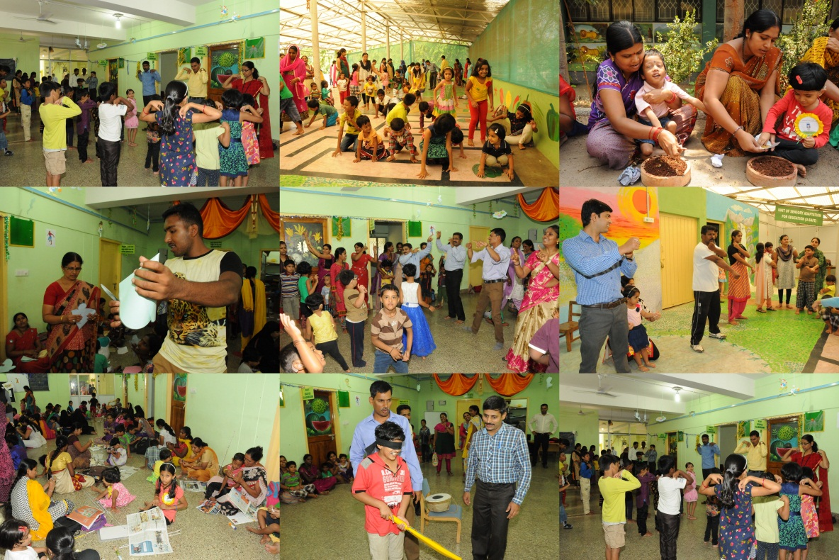

- 02. 05.2016 – 13. 05.2016 meditation classes for stress management were conducted for 60 care givers of children with special needs and various competition like mehandi, hair style were held for parents with special children.
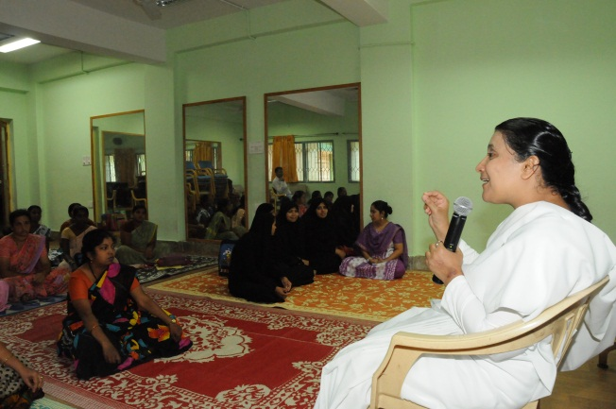
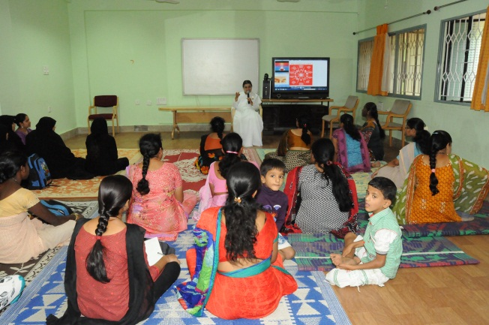

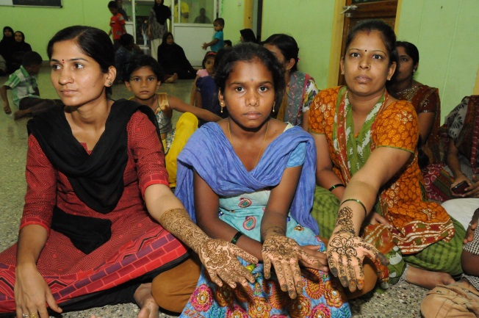
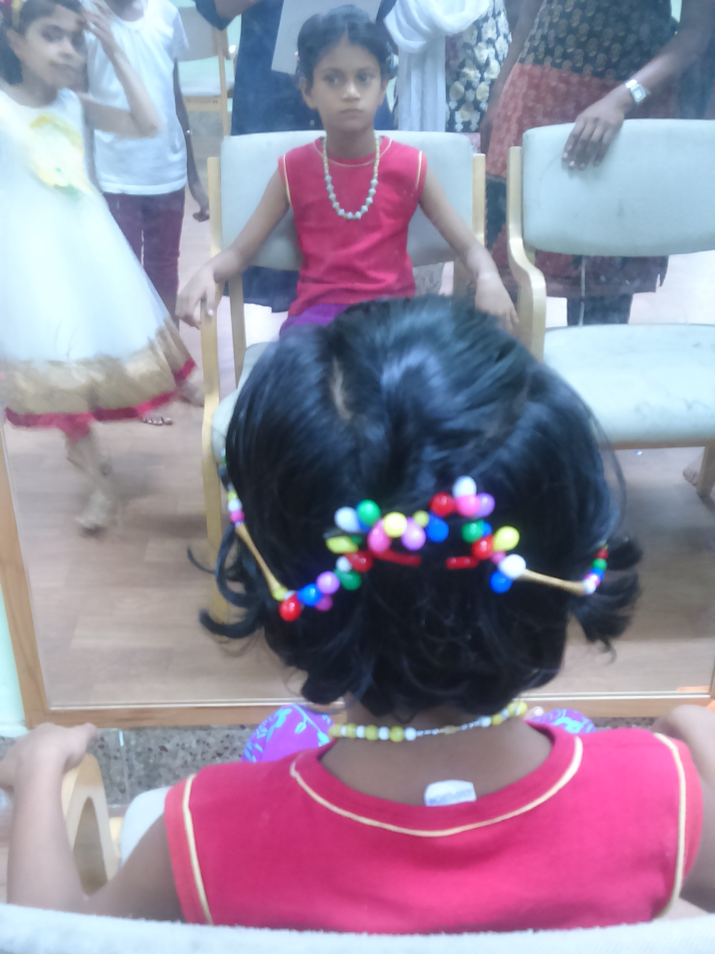

- Summer camp children were taken to Sri Ganapathy Sachchidananda Ashrama on 20.05.2016.
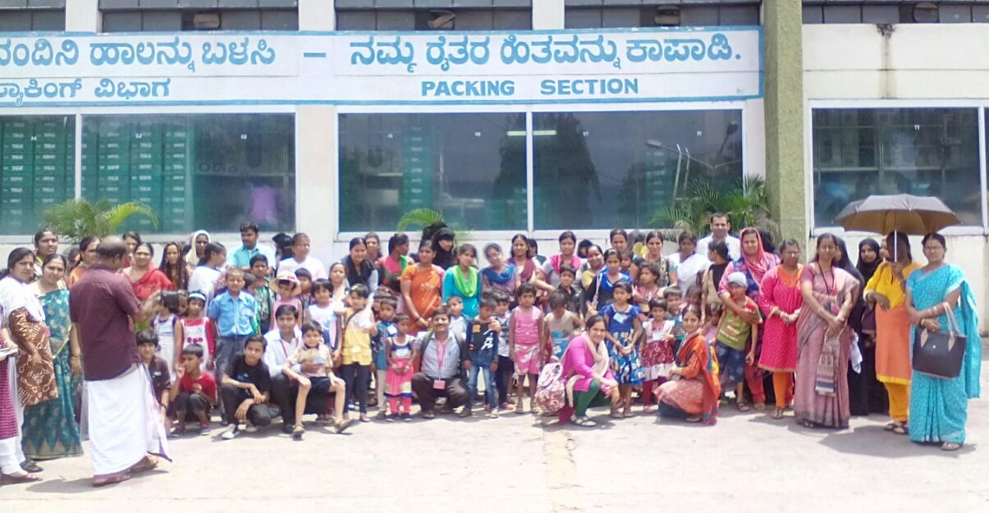
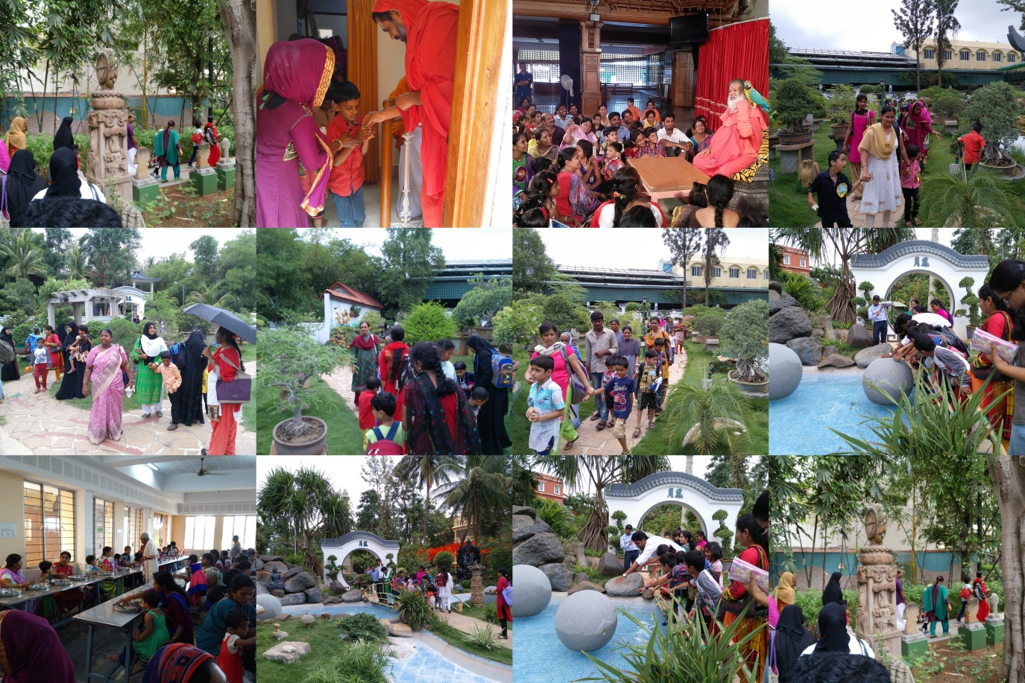
- Summer camp children were taken to MYMUL Mysore Milk Union Limited & Regional Museum of Natural History, Mysuru on 27.05.2016
    - EMINENT VISITORS

X. ANY OTHER
- Official Language Implementation:
- One word a day in Hindi.
- Civil work: NIL
Sd/-
Dr. M. Pushpavathi
HOD – Special Education

