DEPARTMENT OF PREVENTION OF COMMUNICATION DISORDERS (POCD)
MONTHLY REPORT- MARCH 2017

- ACADEMIC ACTIVITIES
- No. of short-term training programs organized: Nil
- No. of orientation/Sensitization programs organized: 10
As part of primary prevention activities, several orientation/Sensitization programs are being conducted regularly. The objective of the orientation programs was to create awareness among general public and various other professionals such as Medical doctors, Nurses, Health related workers, teachers, school students etc., on different types of communication disorders, its prevention and early identification methods and their appropriate referral and timely management. Table 1& 2 shows the details of the orientation programs conducted by the dept. of POCD.
Table 1: Orientation Programs conducted by the department of POCD in the month of March 2017.
SN | Date | Theme/Topic of the program |  | Coordina-tor | Name of the institute/  Hospital | Target group | Total participants | Oriented by
 | 3.03.2017 | ‘Prevention, early identification and management of communication disorders” |  | HOD-POCD | Govt.High School Vinayaka Nagar | Lion Club members& Teachers | 8 &  13 | Ms.Rashmi & Ms.Shruthi
 | 3.03.2017 | ‘Prevention, early identification and management of communication disorders” |  | HOD-POCD | Govt.High School Vinayaka Nagar | Students | 31 | Ms.Rashmi & Ms.Shruthi
 | 6.03.2017 | ‘Prevention, early identification and management of communication disorders” |  | HOD-POCD | Giri Stone Production, Hebbal | Industrail workers | 24 | Ms.Shruthi
 | 13.03.2017 | ‘Prevention, early identification and management of communication disorders” |  | HOD-POCD | Maharani’s College | Pyschology students | 7 | Ms.Supreetha & Ms.Akshatha
 | 14.03.2017 | ‘Prevention, early identification and management of communication disorders” |  | HOD-POCD | Anganwadi Centre, Akkihebbalu | Parents | 20 | Ms.Sunitha & Ms.Lathika P
 | 15.03.2017 | ‘Prevention, early identification and management of communication disorders” |  | HOD-POCD | University of Mysuru | Pyschology students | 5 | Ms.Yashaswini
 | 17.03.2017 | ‘Prevention, early identification and management of communication disorders” |  | HOD-POCD | St.Johns Baptist College of Special Education | Special Educators | 4 | Ms.Yashaswini & Ms.Lathika
 | 30.3.2017 | ‘Prevention, early identification and management of communication disorders” |  | HOD-POCD | Government primary school, Hullahalli | School teachers | 08 | Ms.Rashmi
By NBS/OSC Staff members
 | 10.3.2017 |  | ‘Prevention, early identification and management of communication disorders” | AMO, Sagara | Sub-divisional hospital, sagara | Nurses | 52 | Mr. Mohandas & Mr.Mohahmed Thareeqee
 | 24.03.2017 |  | ‘Prevention, early identification and management of communication disorders” | NBS-Coordinator | RIMS, Ranchi | Nursing students | 21 | Mr. Mukesh Kumar & Mr. Deoraj Saraswathi
 | Total number of participants |  |  |  |  |  | 193

Table 2: Total number of participants oriented in the month of March 2017.
S.No | Target group | Gender Groups |  | Total number of Participants
 |  | Male | Female
 | Lion Club members | 7 | 1 | 8
 | Teachers | 4 | 17 | 21
 | Students | 7 | 24 | 31
 | Industrail workers | 24 | - | 24
 | Pyschology | 5 | 7 | 12
 | Special Educators | - | 4 | 4
 | Parents | - | 20 | 20
 | Nurses | 2 | 71 | 73
 | Total | 49 | 144 | 193

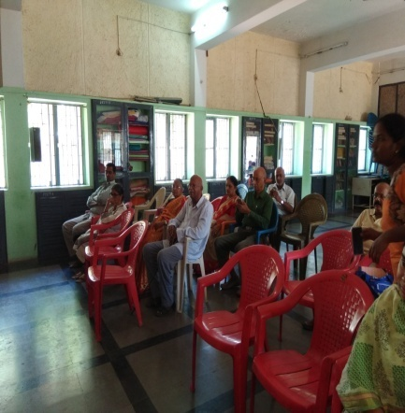 | 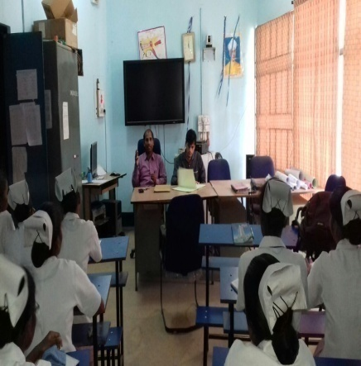
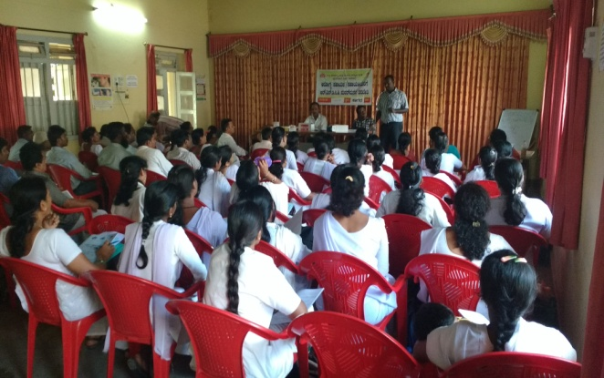

iii.Training programs conducted: Nil
- Clinical Observation postings of students from other institutes:
Sl.no | Date of Postings | Name of the Students | Desingation | Institute/University
1. | 13.03.2017 | Madhuporna  Swathi.S  Ashika Balu  Alaijia S. Nath  Akilha Ragh R.S.  Bherya D.L  Shalini N.Chawala | Pyschology Internship students | Maharani’s College, Mysuru
2. | 15.03.2017 | Anthony Arulraj.T  Mayank Thakur  Jeril Joseph  Kiran K.M.  Ensermu Fekadu. H | Pyschology Internship students | Psychology branch, University of Mysuru
3. | 17.03.2017 | Athira Devraj  Siji Susan Thomas  Jinu Mol George  Sinsy Sebastin | Special Educators | St. John’s Baptist College of Special Education, Kottayam, Kerala.

V. No. of Seminars/ Conferences /Lectures /Workshop organized by the dept–Nil
Vi. No. of Seminars/ Conferences /Lectures /Workshop attended by the staff of the Dept-
- Seminars attended by Staff of POCD: 02
Date | Title of the program | Organized by | Venue | Staff attended
07.03.2017 | National Seminar on Voice assessment | Department of Speech-Language Sciences | AIISH, Seminar hall | Ms. Laxmishree P & Ms. Shruthi G R
15.03.2017 | Virtual Seminar- Apps for Tele-rehabilitation | Tele Centre for Persons with Communication Disorders (TCPD) | AIISH, Seminar hall | Ms. Rashmi E &  Ms. Supreetha L

- Workshop attended by Staff of POCD: 01
Date | Title of the program | Organized by | Venue | Staff attended
24.03.2017 | National Workshop on Co-articulation | Department of Clinical Services | AIISH, Seminar hall | Ms. Supreetha L & Ms. Shruthi G R

- Training programs attended by Staff of POCD : 01
Date | Title of the program | Organized by | Venue | Staff attended
23.03.2017 & 24.03.2017 | ISO 9001:2015 Internal Auditor Training Program | ISO Cell | AIISH, Seminar hall | Dr. Animesh Barman  Mr. Arunraj K

Vii. No. of Guest Lectures organized: Nil
Viii. No. of Invited Talks delivered by faculty and staff: Nil
ix. Any other: Nil
- Student clinical training: As part of human resource development, clinical training for Undergraduates (B.Sc Speech & Hearing), Postgraduates (M.Sc SLP & AUD) & Internship students on early identification, prevention & rehabilitation of communication disorders and Community based rehabilitation at OSCs were carried out. The details on the number of students who had undergone training are given below.
B.Sc students | 08
M.Sc students | 11
Internship students | 13
Total | 22

- Staff Enrichment Programs: 01
Table 3: Details of Staff enrichment program organized during March 2017
Sl.no | Date | Title of the program | Presenter | Staff members
 | 10.03.2017 | Newborn Screening-Primtive Reflexes & Speech Languaue developmental milestones. | Ms. Shruthi G.R. | Dr. Animesh Barman  Dr. Jayashree C Shanbal  Mr. Arunraj K  Ms.Sunitha E  Ms.Akshatha Y  Ms.Yashaswini  Ms.Supreetha  Ms.Nirupama  Ms.Rashmi  Ms.Laxmishree  Ms.Lathika

2. RESEARCH ACTIVITIES
  - Research Projects :Nil
  - Doctoral and Post-Doctoral Programs: Nil
  - Research papers presented in National conferences/seminars: Nil
  - Research papers presented at International conferences/seminars: Nil
  - Research Papers published in National Conference/Seminar Proceedings: Nil
  - Research Papers published in International Conference/Seminar Proceedings: Nil
  - Research Papers published in National Journals: Nil
  - Research Papers published in International Journals: Nil
  - Book / Chapters Published:Nil
  - Books / Manuals/ Seminar proceedings Edited: 01
- Proceedings of the National Seminar on “Newborn Screening: Initiatives towards prevention and early identification of communication disorders” which held on 6th October 2016 has been prepared and Submitted to ICMR, New Delhi in the month of March 2017.
Prepared by: Dr.Animesh Barman, Dr. Jayashree C Shanbal, Mr. Arunraj K, & Ms. Sunitha E.
k. Scholarly Reviewing Activities: Nil
3.CLINICAL SERVICES
- General Clinical Services
- Follow-up evaluation- Detailed evaluation
Table 4 (a): Details of the results of follow-up evaluation for newborns and infants.
Categories | AIISH + Cheluvamba | OSC-Sagara | Ajmer | Cuttack | Imphal | Puducherry | Ranchi | Jabalpur | Total
Normal | 12 | 17 | - | 08 | 04 | 08 | 16 | - | 65
ENT disorders | - | - | - | - | - | - | - | -
Auditory Maturation delay | - | - | - | - | - | - | - | -
Hearing disorder | 02 | - | - | 03 | 03 | - | - | - | 8
Speech & language disorder | - | - | - | - | - | - | - | -
Multiple Disorder | - | - | - | - |  | - | - | -
Incomplete testing | - | - | - | 01 |  | 13 | - | - | 14
Total | 14 | 17 | - | 12 | 7 | 21 | 16 | - | 87

The newborns/infants referred during the newborn screening were followed up through telephone calls to parents/caregivers of infants. A complete test battery was administered for those clients who came for follow-up. Table 4 (a) & (b) depicts the statistics related to this activity.
Table 4(b): Follow-up evaluation- Phone follow-up
The at-risk babies were monitored regularly by administering the speech-language & hearing checklist through a phone call in Mysurucentre. The babies who are identified with delay in the milestones were referred to AIISH/concern NBS centre for detailed evaluation.
Categories | Mysuru Centre (POCD) | NBS Centers | OSC Centers
Normal speech, language & hearing milestones | 28 | 20 | 10
Referred for detailed evaluation | 01 | - | -
Total | 29 | 20 | 10

- Hearing evaluation of industrial workers at AIISH: Nil
- Specialized Clinical services: Nil
- Clinical Support Services to Patients and Family: Nil
- Clinical Electronic Services: Nil
B) EXTENSION ACTIVITIES
- Newborn screening for Communication Disorders
The department of POCD is actively involved in carrying out various extension activities such as screening, diagnostic and rehabilitation services outside the institute campus. The activities include newborn/infant screening, screening of school children, screening of elderly citizens, screening of industrial workers, conducting camps and also clinical services offered at the outreach service centers of AIISH.
Table 5: Total number of newborns/infants screened and identified at-risk for communication disorders.
SN | Hospitals/Immunization Centers | Total births | Total No. Screened |  |  | Total No. at risk
 |  |  | Male | Female | Total | Male | Female | Total
 |  | AIISH- Mysuru
 | Basappa Memorial Hospital (BMH) | 16 | 3 | 6 | 9 | 0 | 0 | 0
 | Combined Hospital (CH) | 57 | 7 | 8 | 15 | 0 | 0 | 0
 | Harsha Hospital (HH) | 01 | 1 | 0 | 1 | 0 | 0 | 0
 | Kamakshi Hospital (KH) | 182 | 39 | 35 | 74 | 1 | 1 | 2
 | KR Hospital (KRH)- Cheluvamba | 1121 | 361 | 340 | 701 | 5 | 2 | 7
 | Makkalakoota Immunization Center (MIC) | No deliveries | 17 | 11 | 28 | 0 | 0 | 0
 | Mission Hospital (MH) | 82 | 40 | 25 | 65 | 1 | 0 | 1
 | Immunization Center at Mission Hospital (ICMH) | No deliveries | 1 | 2 | 3 | 0 | 0 | 0
 | N.P.C Hospital | 30 | 2 | 0 | 2 | 0 | 0 | 0
 | S.M.T.D.H Hospital | 50 | 20 | 16 | 36 | 0 | 0 | 0
 | Railway Hospital (RH) | 7 | 2 | 4 | 6 | 0 | 0 | 0
 | Employees State Insurance (ESI) Hospital | 2 | 1 | 0 | 1 | 0 | 0 | 0
 | Ashwini Nursing Home (ANH) | 13 | 8 | 5 | 13 | 0 | 0 | 0
 | Shree Devi Nursing Home (SNH) | 39 | 11 | 9 | 20 | 0 | 0 | 0
 | GopalaGowdaShanthaveri Memorial Hospital (GGSMH) | 16 | 4 | 1 | 5 | 0 | 0 | 0
 | Mahadeshwara Nursing Home (MNH) | 31 | 6 | 4 | 10 | 0 | 0 | 0
 | Sigma Hospital (SH) | 45 | 24 | 20 | 44 | 1 | 0 | 1
 | Total (Mysuru hospitals) | 1692 | 547 | 486 | 1033 | 8 | 3 | 11
18. | Sub-divisional hospital, K R Nagar Taluk | 51 | 17 | 19 | 36 | 0 | 0 | 0
19. | Sub-divisional hospital, T NarsipuraTaluk | 110 | 28 | 32 | 60 | 3 | 0 | 3
20. | Sub-divisional Hospital, SagaraTaluk | 106 | 75 | 81 | 156 | 11 | 6 | 17
21. | Community Health Centre (CHC), Hullahalli | 22 | 5 | 15 | 20 | 0 | 2 | 2
22. | Community Health Centre (CHC), Santhemarahalli | 60 | 7 | 8 | 15 | 0 | 0 | 0
23. | Primary Health Centre (PHC), Akkihebbalu | 08 | 0 | 3 | 3 | 0 | 0 | 0
 | Total (OSCs) | 357 | 132 | 158 | 290 | 14 | 8 | 22
 |  | NBS of AIISH
24. | Sri RamachandraBhanj Medical College and Hospital (SCB MCH), Cuttack | 534 | 174 | 56 | 230 | 14 | 5 | 19
25. | Regional Institute of Medical Sciences (RIMS), Imphal | 309 | 149 | 159 | 304 | 5 | 7 | 12
26. | Janana Hospital & JLNMCH, Ajmer | 700 | 88 | 78 | 166 | 2 | 6 | 8
27. | JIPMER, Puducherry | 1175 | 389 | 353 | 742 | 26 | 36 | 62
28. | NetajiSubhash Chandra Bose Medical College (NSCB), Jabalpur | 348 | 187 | 128 | 315 | 25 | 13 | 38
29. | Rajendra Institute of Medical Sciences, Baritayu, Ranchi | 470 | 109 | 92 | 201 | 01 | 01 | 02
 | Total (NBS centre’s) | 3536 | 1096 | 866 | 1958 | 73 | 68 | 141
 | Overall Total | 5585 | 1775 | 1510 | 3281 | 95 | 79 | 174

- School screening:
Screening of preschool, primary school children was conducted focusing on the early identification of communication disorders and early rehabilitation of children at risk for communication disorders.
Table 06 : Total number of children screened for communication disorders and
identified.
Date | Name of the School | Total screened | Total identified with communication disorders
 |  |  | Ear related disorder  (ears) | Hearing loss  (ears) | Speech language disorders
3.03.2017 | Government High School, Vinayaka Nagar, Mysuru | 87 | - | - | 14
14.03.2017 | Anganwadi, Akkihebal, Mandya | 21 | - | - | 01
Total |  | 108 | - | - | 15

- Hearing screening of Industrial employees: 01
Date | Name of the Industry | Total screened | Total identified with communication disorders
 |  |  | Ear related disorder  (ears) | Normal  (ears) | Disorders (ear wise)
6.03.2017 | Giri Stone Production, Hebbal, Mysuru | 30 | - | 35 | 25
Total |  | 30 | - | 35 | 25

- Clinical services for the Elderly citizens:
Table 07 : Total number of elderly popluation screened for communication disorders and
Identified.
Date | Name of the Place | Total screened | Total identified with communication disorders
 |  |  | Ear related disorder (ears) | Hearing loss (ears) | Speech language disorders
12.03.2017 | Elder Citizen Council, Parkinson’s Association, Jayalakshmipuram, Mysuru | 18 | 03 | 12 | 04
Total |  | 18 | 03 | 12 | 04

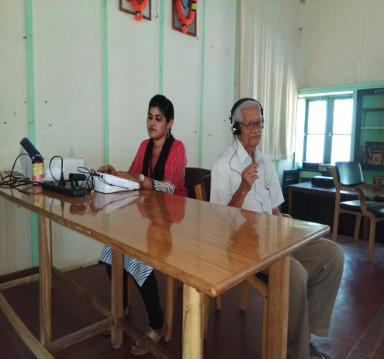

V. Camps: 04
- Camps attended by Dr.Mahadevappa on 10th, 17th and 24th March 2016

Name of the Place | Total Evalutaed | Total identified
 |  | Normal (ears) | Disordered(ears)
10th March 2017 at Bellale, PHC,Mandya dist | 129 | 117 | 106
17th March 2017 at Bellale, PHC,Mandya dist | 114 | 91 | 95
24th March 2017, Hirikyathanahalli, Hunsur taluk, Mysuru dist | 131 | 115 | 119
Total | 374 | 323 | 320

- NSS camp at Saragur, H.D.kote taluk, Mysuru district on 26th & 27th March 2016.
Name of the Place | Total screened | Total identified with communication disorders
 |  | Ear related disorder (ears) | Hearing loss (ears) | Speech language disorders (Individuals)
Saragur, H.D.kote taluk, Mysuru district | 340 | 340 | 688 | 112
Total | 340 | 340 | 688 | 112

vii. Clinical Services at Outreach Service Centers (OSCs):

The clinical activities are not only restricted to in and around Mysore, but also extended to rural areas where facilities for clinical services for persons with communication disorders were meager. Currently 04 OSCs (01 Sub-divisional taluk hospital at Sagarataluk, Shivamogga District; 03 Primary Health Centre - PHC at Hullahalli, Mysuru district; Akkihebbalu, Mandya district &Karuna trust, Gumballi, Chamarajanagara district were initiated to meet the objective of extending the services of the institute to rural areas. The OSCs are functioning as a well-equipped unitfor screening, diagnostics and therapeutic services for persons with communication disorders. The services include screening, diagnostic and rehabilitation which includes newborn/infant screening, screening of school children, Speech and Language evaluation, Audiological evaluation, ENT evaluation, Speech-Language therapy, issue of free body level hearing aids and ear molds, and counseling and guidance to individuals with communication disorders. The other details are tabulated below in tables 8, 9& 10.
Table 8: Details of clients identified with communication disorders at the OSCs.
OSC | Total Registered | ENT Evaluation  Registered=106 |  |  | Hearing Evaluation  Registered=32 |  | Speech & Language Evaluation  Registered=02
 |  | Normal (Ear Wise) | Disorder (Ear wise) | ENT related  Others | Normal (Ear Wise) | Disorder (Ear wise) | Normal (Individuals) | Disorder (Individuals)
Primary Health Centre (PHC), Hullahalli | 39 | 14 | 30 | 07 | - | 04 | - | 02
Primary Health Centre (PHC), Akkihebbalu | 39 | - | 34 | 08 | - | 06 | - | -
Primary Health Centre (PHC), Gumballi | 30 | 15 | 32 | 06 | - | 04 | - | -
Sub-divisional Hospital (PHC), Sagara | 25 | - | - | - | 4 | 46 | - | -
Total | 133 | 29 | 96 | 21 | 4 | 60 | - | 02

Table 8a. : Details of clients followed up at the OSCs.
OSC | Total Follow up | ENT Evaluation |  |  | Hearing Evaluation |  | Speech & Language Evaluation
 |  | Normal (Ear Wise) | Disorder (Ear wise) | ENT related  Others | Normal (Ear Wise) | Disorder (Ear wise) | Normal (Individuals) | Disorder (Individuals)
Primary Health Centre (PHC), Hullahalli | 21 | 9 | 23 | 5 | - | 6 | - | -
Primary Health Centre (PHC), Akkihebbalu | 17 | - | 16 | - | - | 4 | - | -
Primary Health Centre (PHC), Gumballi | 13 | 06 | 12 | 3 | - | 06 | - | -
Sub-divisional Hospital (PHC), Sagara | - | - | - | - | - | - | - | -
Total | 51 | 15 | 51 | 8 |  | 16 | - | -

Table 9: Details of clients identified with different types communication disorders across OSCs.
Type of Disorders | OSC
 | Primary Health Centre (PHC), Hullahalli | Primary Health Centre (PHC), Akkihebbalu | Primary Health Centre (PHC), Gumballi | Sub-divisional Hospital, Sagara (PHC) Taluk
Hearing disorders

Normal | - | - | - | 6
Minimal | 01 | - | - | -
Conductive | - | - |  | 12
Sensori- neural | 02 | 04 | 06 | 23
Mixed | 05 | 04 | 03 | 9
Profound | 02 | 02 | 01 | -
Total (ears) | 10 | 10 | 10 | 50
Speech & Languaue disorders
Voice | - | - | - | -
Fluency | - | - | - | -
Articulation disorders | - | - | - | -
Language disorders | 02 | - | - | -
Total (Individuals) | 02 | - | - | -

Table 10: Rehabilitation services provided at Outreach service centres
OSC | Hearing Aids Dispensed | Speech-language therapy
 |  | No. of clients | No. of sessions
Primary Health Centre (PHC), Hullahalli | - | 04 | 12
Primary Health Centre (PHC), Akkihebbalu | - | 08 | 36
Primary Health Centre (PHC), Gumballi | - | 01 | 01
Sub-divisional Hospital, Sagara (PHC) Taluk | 5 | 16 | 53
Total | 05 | 29 | 102

4.CENTRAL FACILITIES-
- Library and information services – Nil
- Public Information Activities – Nil
- Exhibition- Nil
- Material Development – 01
- A PEM titled ‘Does your Child have Autism?’ has been prepared and set for realease on Autism Awareness Month of April 2017.
- Public education pamphlets :
- Reverse translation of the following PEPs were done in 11 Indian languages:

Sl.no | Name of the PEPs | Languages
 |  | Assm | Ben | Hin | Kan | Mal | Mani | Marti | Odi | Pun | Tam | Tel
1. | ADHD | √ | - | - | √ | - | - | - | - | - | - | -
2. | Aphsia | √ | - | - | - | - | - | √ | - | √ | - | -
3. | Atriculation disorder | √ | - | - | √ | - | - | √ | - | √ | - | -
4. | Autism | √ | √ | √ | √ | √ | √ | √ | √ | √ | √ | √
5. | CLP | - | - | √ | √ | - | - | - | - | √ | - | -
6. | Dysarthria | - | - | - | √ | √ | - | - | - | √ | - | -
7. | Laryngectomy | - | - | - | √ | - | - | - | - | - | - | -
8. | DD | - | - | - | √ | - | - | - | - | - | √ | -
9. | Stuttering | - | - | - | √ | - | - | - | - | √ | - | -
10. | Ear discharge | - | - | - | - | √ | - | - | - | - | - | -
11. | CP | - | - | - | - | - | - | - | - | √ | - | -
12. | CD in elderly | - | - | - | - | - | - | - | - | √ | - | -
13. | Dementia | - | - | - | - | - | - | - | - | √ | - | -
14. | FAQ on NBS | - | - | - | - | - | - | - | - | √ | - | -
15. | Feeding tips | - | - | - | - | - | - | - | - | √ | - | -
16. | SLI | - | - | - | - | - | - | - | - | - | √ | -

- Press Releases and Media Coverage– Nil
- Public Lecture series- Nil
- AWARDS AND HONOURS RECEIVED BY FACULTY AND STAFF: Nil
- TECNOLOGICAL CONSULTANCY SERVICES: Nil
- EXTRA CURRICULLAR ACTIVITIES: Nil
- VISITORS: Nil
- MAJOR EVENTS OF THE MONTH: Nil
IX. OTHERS:
- Dept. Related:
- Computerization activities: The staff members of POCD were assigned duties regarding the activities related to Computerization. In Phase I, the Newborn screening program is finalized in draft stage.
- Mr. Devaraj P.A. program analyst of NIC accompanied newly recruited staff (the previous staff who was appointed on Feb 2016 was relieved from the duties). Mr. Devaraj was provided the NBS computerization draft (both hard & soft copy.
- Bill Settlement of National Seminar: An amount of Rs. 40000.00 was sanctioned from ICMR towards the national seminar on “Newborn screening: initiatives towards prevention and early identification of communication disorders” held on 6th October 2016. The settlement of the bill is completed and same has been submitted to the ICMR New delhi in the month of March 2017.
- OSC Related:
- Initiation of OSC: Approval from the Standing Finance Committee (SFC) of the institute was received to initiate the NBS & OSC centre. In this regard, an proposal was prepared and sent to the Vivekananda Memorial Hospital Sargur. Based upon the positive response, a meeting was held by the Director AIISH & Head-POCD with the Dr. Subramanya Secretary & CEO, Dr.Kumar G.S, Director and other staff members of Vivekananda Memorial Hospital (VMH), Sargur on 22.03.2017 regarding the initiation of NBS & OSC centers at the Vivekananda Memorial Hospital (VMH), Sargur.
- NBS Related:
- Initiation of NBS: Approval from the Standing Finance Committee (SFC) of the Institute was received to initiate the NBS program at Jawaharlal Nehru Medical College and Hospital, Bhagalpur & King George's Medical University, Lucknow DHLS centers of AIISH, Mysuru. In this regard, an proposal was prepared and was sent to the respective centers. The meeting will be planned in the month of April 2017.
- Following staffs were relieved from the department: Nil
- Follwing staffs were newly recruited to the department: 03
Sl.No | Name of the staff | Designation | Joining date
 | Mr. Mukesh Kumar | Audiologist Grade I | 02.03.2017
 | Mr. Deoraj Saraswathi | Speech & Hearing Assisstant | 02.03.2017
 | Mr. Sarooj Sahoo | Audiologist Grade I | 08.03.2017

Sd/-
Head, Dept. of POCD

DEPARTMENT OF PREVENTION OF COMMUNICATION DISORDERS (POCD)

CUMMILATIVE REPORT

APRIL 2016 TO MARCH 2017

- ACADEMIC ACTIVITIES
- No. of short-term training programs organized: Nil
- No. of orientation/Sensitization programs organized: 97
As part of primary prevention activities, several orientation/Sensitization programs were conducted regularly. The objective of this orientation programs was to create awareness among general public and various other professionals such as Medical doctors, Nurses, Health related workers, teachers, school students etc., on different types of communication disorders, its prevention and early identification methods and their appropriate referral and timely management. Table 1 (a) shows the details of the orientation programs conducted by the dept. of POCD.
Table 1(a): Orientation Programs conducted by the department of POCD at AIISH during 2016-2017
Sl.No | Date | Theme/Topic of the program | Coordinator | Name of the institute/  Hospital | Target group | Total participants | Oriented by
 | 4th April 2016 | Prevention and early identification of communication disorders | OSC Sagara | Sub-divisional hospital, OSC Sagara | ASHA and Anganvadi Workers | 70 | Mr. Mohandas  &Mr.Thareeque
 | 4th April 2016 | Harmful effects of noise and its ill effects | Raj auto garage | Auto mobile Workers | Harmful effects of noise and its ill effects | 07 | Ms. Suman&  Ms. Manjula
 | 11th April 2016 | Harmful effects of noise and its ill effects | POCD, AIISH | Bannariamman Sugar factory | Industrial workers | 05 | Ms. Zeena&  Mr. Kapali
 | 29th April 2016 | Newborn screening guidelines and high risk register | NBS Centre, Ranchi | RIMS, Ranchi | Nursing staff | 11 | Mr. Mukesh Kumar
 | 29th April 2016 | Prevention and early identification of communication disorders | POCD, AIISH | Basappa Memorial Hospital | Nursing students | 32 | Mr. Kapali&  Ms. Zeena
 | 2nd May 2016 | Prevention and early identification of communication disorders | NBS,  Jabalpur | NSCBMC | Nursing students | 08 | Ms. TulsiSahoo
 | 24th May 2016 | Prevention and early identification of communication disorders | NBS,  Puducherry | JIPMER | Nursing students | 05 | Ms. Praveena
 | 25th May 2016 | Prevention and early identification of communication disorders | NBS, Imphal | RIMS | ASHA Workers | 71 | Ms. MeenakshiChanu
 | 30th May  2016 | Harmful effects of noise and its ill effects | GRS Engineering Pvt.Ltd | Forgining division Belagola Industrial area,  Mysore. | Industrial workers | 17 | Ms. Zeena  Ms. Manjula  Ms. Sunitha  Ms.Rekha
 | 31st May 2016 | Prevention and early identification of communication disorders | NBS, Ranchi | RIMS | Nursing staff | 24 | Mr. Mukesh Kumar
 | 6th June 2016 | Harmful effects of noise and its ill effects | GRS Engineering Pvt.Ltd | Forgining Division Belagola Industrial area, Mysuru | Industrial Employes | 16 | Ms.Zeena
 | 6th June 2016 | Prevention and early identification of communication disorders | Head Master | GHPS, Sathgalli,  Mysore | School teachers | 04 | Ms. Thanzeem
 | 7th June 2016 | Prevention and early identification of communication disorders | Head Master | GHPS, Jyothinagar,  Mysore | School teachers | 04 | Ms. Sunitha E
 | 8th June 2016 | Prevention and early identification of communication disorders | Head Master | Government Residential school for special category,  Mysuru | School Teachers | 08 | Ms. Manjula
 | 9th June 2016 | Prevention and early identification of communication disorders | Head Master | Government Lower Primary school,  Mysuru | School Teachers | 03 | Mr.Kapali
 | 10th June 2016 | Prevention and early identification of communication disorders | Head Master | Government Higher Primary school  KalyangiriMysuru | School Teachers | 07 | Ms.Suman
 | 13th June  2016 | Prevention and early identification of communication disorders | Head Master | Government Higher Primary school,  Mysuru | School Teachers | 05 | Ms.Thanzeem
 | 14th June  2016 | Prevention and early identification of communication disorders | Head Master | Government Lower Primary school,  KalyangiriMysuru | School Teachers | 03 | Ms. Kavya. S
 | 15th June 2016 | Harmful effects of noise and its ill effects | Manager | Hindustan Petroleum,  Mysuru | Industrial Employes | 32 | Mr.Madhu S Reddy
 | 17th  June 2016 | Prevention and early identification of communication disorders | In charge person | BelakuVasthalyadhamaOldage Home,  Mysuru | Elderly citizens | 07 | Mr. kapali
 | 17th June 2016 | Prevention and early identification of communication disorders | Head Master | GHPS, Medhars Block,  Mysore | School teachers | 06 | Mr. Madhu S Reddy
 | 20th June 2016 | Harmful effects of noise and its ill effects | GRS Engineering Pvt.Ltd | Forgining Division Belagola Industrial area, Mysuru | Industrial Employes | 19 | Ms.Sandra
 | 22nd June 2016 | Prevention and early identification of communication disorders | Manager | Hindustan Petroleum,  Mysuru | Industrial Employes | 40 | Ms. Zeena. V.P
 | 23rd June 2016 | Prevention and early identification of communication disorders | NBS coordinator | NSCBMC, Jabalpur | BASLP 1st year students | 09 | Ms. Tulsi Sao
 | 27th June 2016 | Harmful effects of noise and its ill effects | GRS Engineering Pvt.Ltd | Forgining Division Belagola Industrial area, Mysuru | Industrial Employes | 24 | Ms.Jahnvi
 | 28th June 2016 | New born Screening Guidelines and High Risk Register | NBS coordinator | RIMS, Ranchi | Nursing students | 41 | Mr. Mukesh Kumar
 | 29th June 2016 | Prevention and early identification of communication disorders | Manager | Govt. text book printing Press | Printing Employes | 39 | Mr. Kapali
 | 4th July 2016 | Harmfull effects of noise and its ill effects | GRS Eng PVT ltd | Metagalli | Industrial Workers | 29 | Ms.Manjula
 | 6th July 2016 | Harmfull effects of noise and its ill effects | Govt Printing press | ManasaGangotri | Industrial Workers | 57 | Ms.Rekha
 | 11th July 2016 | Harmfull effects of noise and its ill effects | GRS Eng PVT ltd | Metagalli | Industrial Workers | 33 | Ms.Sandra
 | 12th July 2016 | Prevention and early identification of communication disorders | Head, POCD | GHPS, Padavarahalli, Mysore | School teachers | 04 | Ms. Rekha.D
 | 16th July 2016 | Prevention and early identification of communication disorders | NBS coordinator | RIMS, Imphal | Nursing students | 06 | Ms. Tulsi Sao
 | 18th July | Harmfull effects of noise and its ill effects | GRS Eng PVT ltd | Metagalli | Industrial Workers | 30 | Ms.Sunitha
 | 20th July 2016 | Harmfull effects of noise and its ill effects | Govt Printing press | ManasaGangotri | Industrial Workers | 09 | Ms.Thanzeem
 | 22nd July 2016 | Harmfull effects of noise and its ill effects | Govt Printing press | ManasaGangotri | Industrial Workers | 35 | Ms.Zeena
 | 28th July 2016 | Prevention and early identification of communication disorders | Head, POCD | GHPS, Vontikoppal | School teachers | 08 | Ms. Tanzeem& Ms. Sandra
 | 28th July 2016 | New born Screening Guidelines and High Risk Register | NBS coordinator | RIMS, Ranchi | Nursing staff members | 15 | Mr. Mukesh Kumar
 | 29th July 2016 | Prevention and early identification of communication disorders | Head, POCD | GHPS, Yadavagiri | School teachers | 04 | Ms. Jahnavi
 | 4th August | Prevention and early identification of communication disorders | Head, POCD | OSC Sagara | Taluk Health officer, PHC Doctors, ASHA Workers, Health Workers & Nursing staffs | 70 | Mr.Mohan Das
 | 8th Aug 2016 | Prevention and early identification of communication disorders | Head, POCD | GHPS,  Mysore | School teachers | 09 | Ms.Sandra  Ms.Sunitha
 | 19th Aug  2016 | Prevention and early identification of communication disorders | Head, POCD | GHPS,Tilaknagar,Mysore | School teachers | 04 | Ms.Jahnvi
 | 22nd Aug  2016 | Prevention and early identification of communication disorders | Head, POCD | UrduGHPS,Mysore | School teachers | 02 | Ms.Jahnvi
 | 24th Aug  2016 | Prevention and early identification of communication disorders | Head, POCD | VivekanandaGHPS, Mysore | School teachers | 08 | Ms.Manjula  Mr.Kapali
 | 26th Aug  2016 | New born Screening Guidelines and High Risk Register | Head, POCD | RIMS, Ranchi | Nursing student | 48 | Mr.Mukesh Kumar
 | 27th Aug  2016 | Prevention and early identification and management of communication disorders | Head, POCD | Jabalpur | 1st Year students | 07 | Ms.Tulsi Sao
 | 8th Sept 2016 | Prevention and early identification of communication disorders | Head, POCD | GHPS,  Hullahalli | School teachers | 06 | Ms.Thanzeem
 | 15th Sept 2016 | Prevention and early identification of communication disorders | Head, POCD | GHPS,Tilaknagar,Mysore | School teachers | 03 | Ms.Zeena
 | 16th Sept 2016 | Prevention and early identification of communication disorders | Head, POCD | GHPS  Peoples park Mysuru | School teachers | 03 | Mr.Kapali  Ms.Thanzeem
 | 24th Sept | Prevention and early identification of communication disorders | NBS Coordinator | Kendriya-Vidyalaya  Ajmer | School Teachers | 45 | Ms.Rashika Sharma
 | 30th Sept 2016 | New born Screening Guidelines and High Risk Register | NBS Coordinator | RIMS, Ranchi | 2nd Year Nursing students of Sai Abdul Razzak Nursing College, Irba, Ranchi | 24 | Mr.Mukesh Kumar
 | 22nd Oct 2016 | Prevention and early identification of communication disorders | NBS Coordinator | Ryan International School, Ajmer | School teachers | 31 | Ms.Rashika Sharma
 | 24th Oct 2016 | Prevention and early identification of communication disorders | NBS Coordinator | Wanjing Centre, Baptist church, Thoubal dist. Manipur | Anganwadiworkers | 50 | Ms.P. MeenakshiChanu
 | 25th Oct 2016 | Prevention and early identification of communication disorders | Head, POCD | Excel Public School | School students | Batch I  44 | Ms.Sunitha E
 | 25th Oct 2016 | Prevention and early identification of communication disorders | Head, POCD | Excel Public School | School students | Batch II  44 | Ms.Sunitha E
 | 28th Oct 2016 | Prevention and early identification of communication disorders | NBS Coordinator | RIMS,Ranchi | Nursing Sudents | 27 | Mr.Mukesh Kumar
 | 4th Nov 2016 | Prevention and early identification of communication disorders | Head, POCD | Government higher primary school, kumarabidu, Mysuru | School teachers | 03 | Ms. Zeena& Ms. Laxmishree P
 | 16th Nov 2016 | Prevention and early identification of communication disorders | Head, POCD | Government Lower  primary school,  Sahukarahundi , Mysuru | School teachers | 03 | Ms.Shruthi&Ms.Yashaswini
 | 21st  Nov 2016 | Prevention and early identification of communication disorders | Head, POCD | Sajjantrust, J.P.Nagar, Mysuru | School teachers | 17 | Ms.Anusha&Ms.Akashatha
 | 24th Nov 2016 | Prevention and early identification of communication disorders | NBS Coordinator | RIMS, Ranchi | Nursing students | 33 | Mr.Mukesh Kumar
 | 25th Nov 2016 | Prevention and early identification of communication disorders | Head, POCD | Government Lower  primary school, Doddahattihundi, Mysuru | School teachers | 03 | Ms.Yashaswini&Ms.Lathika
 | 1st Dec 2016 | Prevention and early identification of communication disorders | AMO, OSC Sagara | OSC Sagara | ASHA &Anganwadi workers | 94 | Mr. Mohan Dass&Mr.MohamhedThareequee
 | 8th Dec 2016 | Prevention and early identification of communication disorders | Head, POCD | S.S.B.Ed College, Pandavapura | B.Ed students | Batch I  23 | Ms. Supreetha&Ms.Rashmi
 | 8th Dec 2016 | Prevention and early identification of communication disorders | Head, POCD | S.S.B.Ed College, Pandavapura | B.Ed students | Batch II  23 | Ms. Supreetha&Ms.Rashmi
 | 9th Dec 2016 | Prevention and early identification of communication disorders | Head, POCD | GovernmentHigh School  Kailasapuram, Mysuru | School teachers | 07 | Ms.Rashmi& Ms. Akashatha
 | 15th Dec 2016 | Prevention and early identification of communication disorders | Head, POCD | Government PU college, Akkihebbalu | College lecturers | 07 | Ms.Shruthi&Ms.Rashmi
 | 16th Dec 2016 | Prevention and early identification of communication disorders | Head, POCD | Government higher  primary school, Maratikyanthalli, Mysuru | School teachers | 03 | Ms.Nirupama& Ms. Shruthi
 | 19th Dec 2016 | Prevention and early identification of communication disorders | Head, POCD | Government higher  Primary,  K.Hemmanahalli, Mysuru | School teachers | 03 | Ms.Laxmishree P & Ms.Rashmi
 | 22nd Dec 2016 | Prevention and early identification of communication disorders | Head, POCD | Mandya Institute of Medical Sciences, Mandya | PG Community Medicine doctors | 08 | Ms. Sunitha
 | 23rd Dec 2016 | Prevention and early identification of communication disorders | Head, POCD | Government lower  Primary,  Kailasapuram, Mysuru | School teachers | 02 | Ms.Supreetha
 | 28th Dec 2016 | Prevention and early identification of communication disorders | NBS Co-ordinator | RIMS Ranchi | 2nd & 3rd Year Nursing students (JNM) of School of Nursing, RIMS, Ranchi | 41 | Mr. Mukesh Kumar
 | 29th Dec 2016 | Prevention and early identification of communication disorders | Head, POCD | Adishakti, ITI College,  Akkihebbalu | ITI, Students & teachers | 227 | Ms.Anusha
 | 3rd Jan 2017 | Prevention and early identification of communication disorders | Head, POCD | Bhavani ITI College, K.R.pete | ITI students | 30 | Ms.Laxmishree P &  Ms. Supreetha
 | 18th Jan 2017 | Prevention and early identification of communication disorders | Head, POCD | Belaku Vatsalyadhama, Mysuru | Care takers of elderly citizens (at oldage home) | 05 | Ms.Shruthi
 | 19th Jan 2017 | Prevention and early identification of communication disorders | Head, POCD | Govt. Lower primary school, Sahukuarhundi, Mysuru | Parents | 17 | Ms.Nirupama
 | 21st Jan 2017 | Prevention and early identification of communication disorders | Head, POCD | Hello Kids, J.P.Nagar, Mysuru | School teachers | 03 | Ms.Akshatha
 | 23rd Jan 2017 | Prevention and early identification of communication disorders | Head, POCD | Devagalli, Lower primary School | School teachers | 02 | Ms.Yashaswini
 | 24th Jan 2017 | Prevention and early identification of communication disorders | Head, POCD | Govt. First grade college, Hullahalli | College Students  (UG) | 79 | Ms.Sunitha & Mr.Potha Soundar Raj
 | 30th Jan 2017 | Prevention and early identification of communication disorders | Head, POCD | Govt. high school, Beerihundi, Mysuru | School teachers | 11 | Ms.Supreetha & Ms.Anusha
 | 30th Jan 2017 | Prevention and early identification of communication disorders | Head, POCD | District Institute of Education and Training, Mysuru & Kerala | D.Ed students | 30 | Mr.Potha Soundar Raj & Ms.Rashmi
 | 30th Jan 2017 | Prevention and early identification of communication disorders | Head, POCD | District Institute of Education and Training, Mysuru & Kerala | D.Ed students | 26 | Mr.Potha Soundar Raj & Ms.Rashmi
 | 30th Jan 2017 | Prevention and early identification of communication disorders | Head, POCD | District Institute of Education and Training, Mysuru & Kerala | College Lecturers | 10 | Mr.Potha Soundar Raj & Ms.Rashmi
 | 30th Jan 2017 | Prevention and early identification of communication disorders | NBS Co-ordinator | Tribal college of nursing Sindrol, Namkum, Ranchi | 3rd Year Nursing students | 17 | Mr. Mukesh Kumar
 | 1st Feb 2017 | Prevention and early identification of communication disorders | NBS Co-ordinator | Moreh, General hospital, Imphal | ASHA Workers | 165 | Ms.MeenakshiChanu
 | 22nd Feb 2017 | Prevention and early identification of communication disorders | Head, POCD | Dasthi Institute of Paramedical Sciences | Health Inspectors & lab technician students | 28 & 15 | Ms.Sunitha&Ms.Lathika
 | 22 nd Feb 2017 | Prevention and early identification of communication disorders | Head, POCD | Elderly Citizen Council | Elderly Citizens | 17 | Ms.Nirupama& Ms. Akshatha
 | 27th Feb 2017 | Prevention and early identification of communication disorders | Head, POCD | D.Salhundi, Govt. high school | Batch I  School students | 32 | Ms.Nirupama& Ms. Akshatha
 | 27th Feb 2017 | Prevention and early identification of communication disorders | Head, POCD | D.Salhundi, Govt. high school | Batch II  School students | 45 | Ms.Nirupama& Ms. Akshatha
 | 3rd Mar 2017 | ‘Prevention, early identification and management of communication disorders” | HOD-POCD | Govt.High School Vinayaka Nagar | Lion Club members& Teachers | 8 &  13 | Ms.Rashmi & Ms.Shruthi
 | 3rd Mar 2017 | ‘Prevention, early identification and management of communication disorders” | HOD-POCD | Govt.High School Vinayaka Nagar | Students | 31 | Ms.Rashmi & Ms.Shruthi
 | 6th Mar 2017 | ‘Prevention, early identification and management of communication disorders” | HOD-POCD | Giri Stone Production, Hebbal | Industrail workers | 24 | Ms.Shruthi
 | 10th Mar 2017 | Prevention, early identification and management of communication disorders” | AMO,Sagara | Sub-divisional hospital, sagara | Nurses | 52 | Mr.Mohandas & Mr.Mohahmed Thareeqee
 | 13th Mar 2017 | ‘Prevention, early identification and management of communication disorders” | HOD-POCD | Maharani’s College | Pyschology students | 7 | Ms.Supreetha & Ms.Akshatha
 | 14th Mar 2017 | ‘Prevention, early identification and management of communication disorders” | HOD-POCD | Anganwadi Centre, Akkihebbalu | Parents | 20 | Ms.Sunitha & Ms.Lathika P
 | 15th Mar 2017 | ‘Prevention, early identification and management of communication disorders” | HOD-POCD | University of Mysuru | Pyschology students | 5 | Ms.Yashaswini
 | 17th Mar 2017 | ‘Prevention, early identification and management of communication disorders” | HOD-POCD | St.Johns Baptist College of Special Education | Special Educators | 4 | Ms.Yashaswini & Ms.Lathika
 | 24th Mar 2017 | ‘Prevention, early identification and management of communication disorders” | NBS-Co-ordinator | RIMS, Ranchi | Nursing students | 21 | Mr.Mukesh Kumar & Mr.Deoraj Saraswathi
 | 30th Mar 2017 | ‘Prevention, early identification and management of communication disorders” | HOD-POCD | Government primary school, Hullahalli | School teachers | 08 | Ms.Rashmi
 | Total number participants |  |  |  |  | 2394

Table 1 (b): Total number of target groups oriented during the year 2016-17.
Sl.No | Target group | Total number of Participants
 | ASHA/Anganwadi workers | 450
 | College Students | 438
 | Industrial Workers | 416
 | Nursing students/staff | 405
 | School teachers | 245
 | School students | 196
 | Doctors | 78
 | Parents | 37
 | Health Inspectors | 28
 | Elderly Population | 24
 | College Lectures | 17
 | BASLP Students | 16
 | Lab technician | 15
 | Psychology students | 12
 | Lion Club members | 8
 | Care takers | 5
 | Special educators | 4
 | Total | 2394

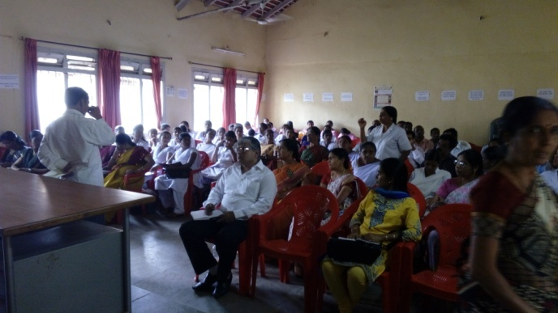 | 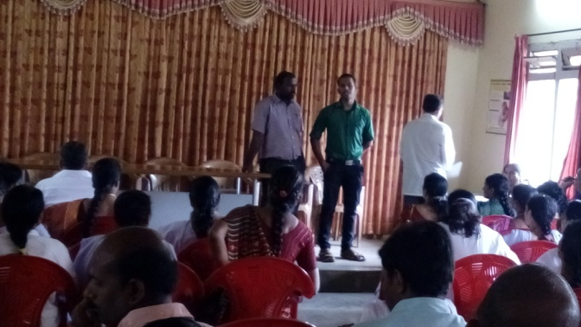 | 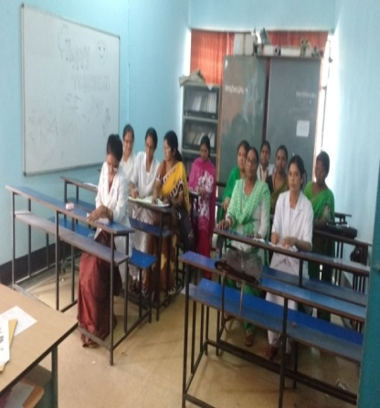
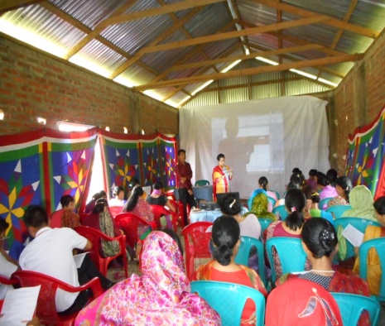 | 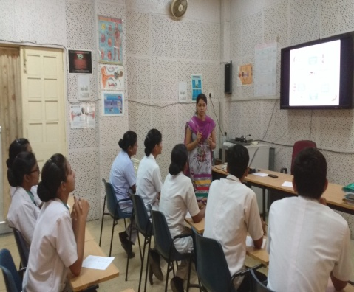 | 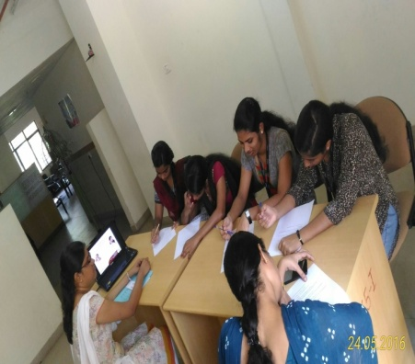
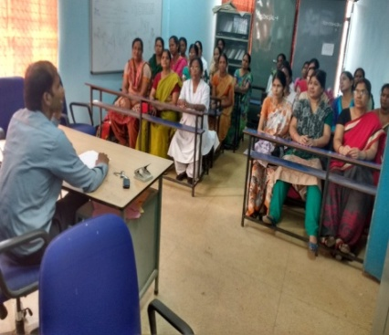 | 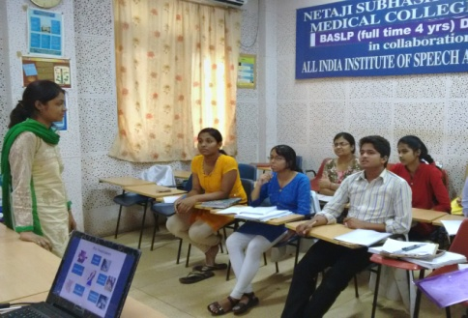 | 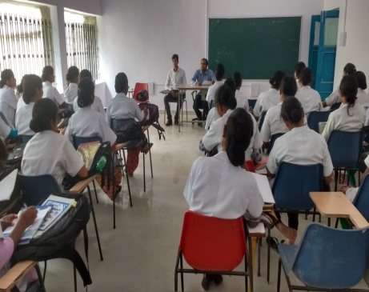
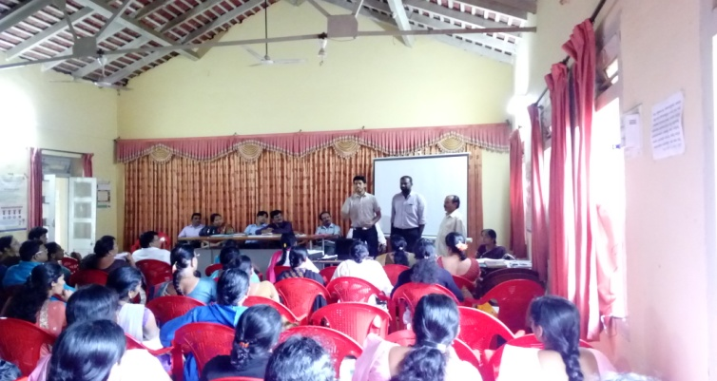 | 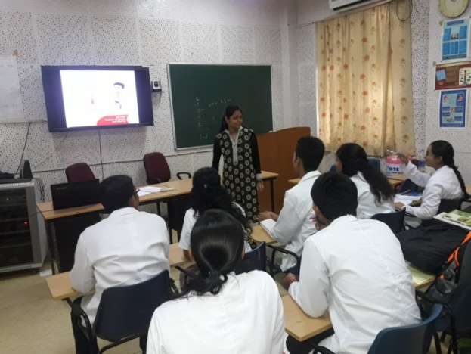 |  | 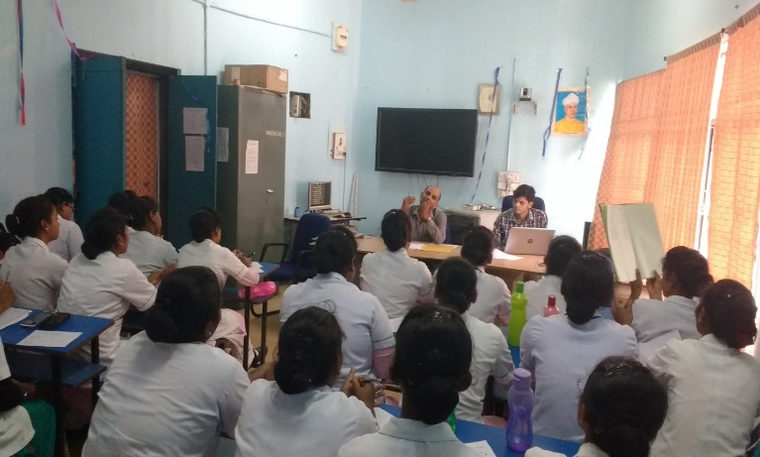
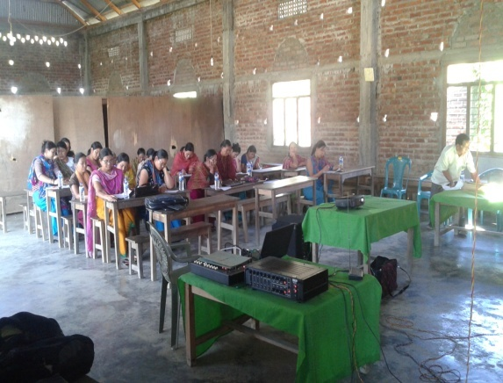 | 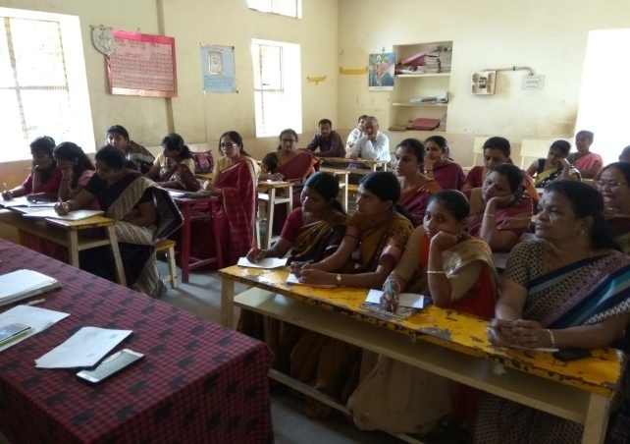 |  |  | 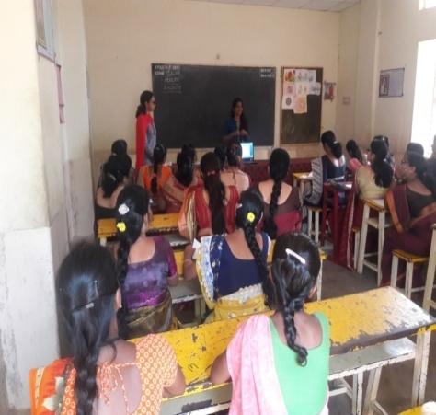
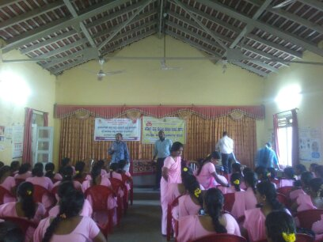 | 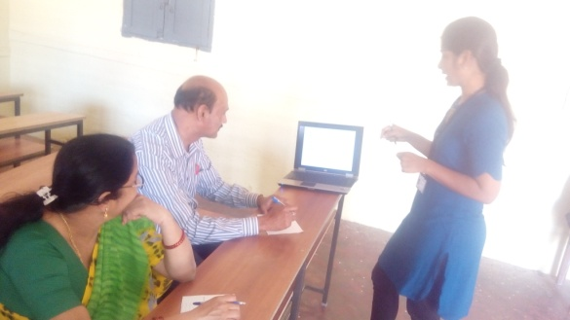 |  |  | 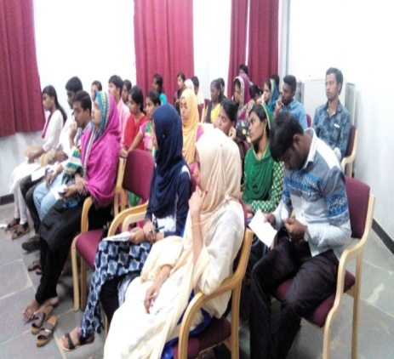
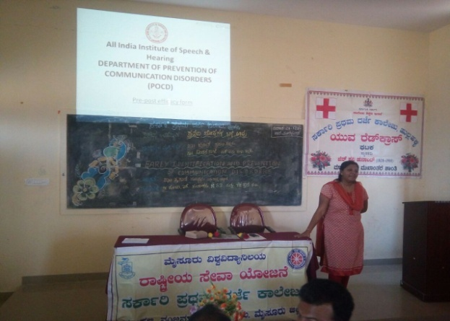 | 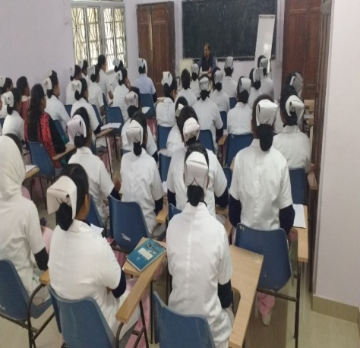 |  |  | 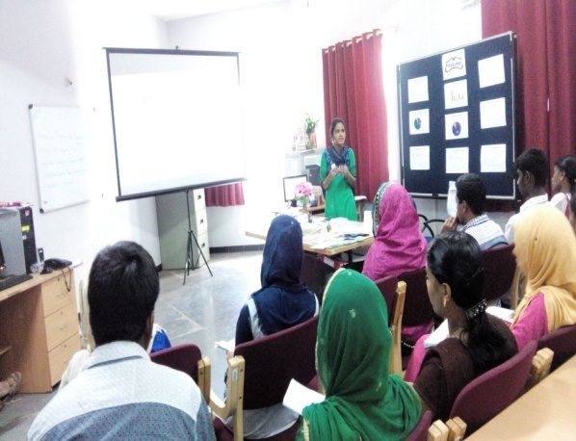
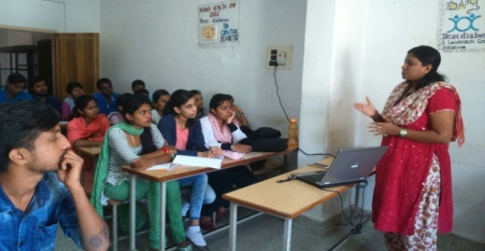
- Training programs conducted: 01
- At AIISH:
Table 2: Details of the training programs conducted during the year 2016-2017.
Sl. N | Date | Title of the training program | Target group | Resource persons | Organizers & Venue | Feed back
1. | 27.4.2016 | Induction training program for Professionals on Newborn Screening Program & Communication Disorders IV (through Skype) | Audiologists (Newly appointed NBS Staff members ) | Mr. Arunraj K.  & Ms. Sunitha. E | Dept of POCD & Audio visual Room | -

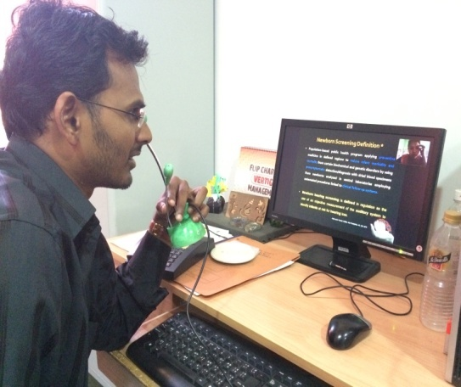 | 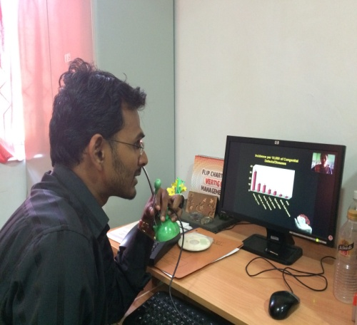

- Clinical Observation postings of students from other institutes: 03
Table 3: Details of the Clinical Observation Postings during the year 2016-2017.
Sl.no | Date of Postings | Name of the Students | Desingation | Institute/University
1. | 13.03.2017 | Madhuporna  Swathi.S  Ashika Balu  Alaijia S. Nath  Akilha Ragh R.S.  Bherya D.L  Shalini N.Chawala | Pyschology Internship students | Maharani’s College, Mysuru
2. | 15.03.2017 | Anthony Arulraj.T  Mayank Thakur  Jeril Joseph  Kiran K.M.  Ensermu Fekadu. H | Pyschology Internship students | Psychology branch, University of Mysuru
3. | 17.03.2017 | Athira Devraj  Siji Susan Thomas  Jinu Mol George  Sinsy Sebastin | Special Educators | St. John’s Baptist College of Special Education, Kottayam, Kerala.

- No. of Seminars/ Conferences /Lectures /Workshop organized by the dept-01

- Seminars organized by the Department: 01
- Details of the seminar:
- Title of the Seminar: Newborn Screening: Initiatives towards Prevention and Early Identification of Communication Disorders
- Organizing department: Department of Prevention of Communication Disorders
- Program Coordinators: Dr. Animesh Barman, Dr. Jayashree C Shanbal& Mr. Arunraj K.
- Supporting Staff members: Ms. Sunitha E, Ms. Rekha, Ms. Kavya, Ms. Suman, Ms. Manjula, Ms. Thanzeem, Ms. Jhanavi, Ms. Zeena, Ms. Sandra, Mr. Kapali, & Ms. Preethi
- Resource Persons: Dr. Animesh Barman., Dr. Jayashree C. Shanbal., & Mr. Arunraj K., & Ms. Sunitha, E.
- Fund:Rs. 40,000.00 from Indian Council of Medical Research (ICMR), New Delhi.
- Total Participants:
Particulars | Total participants
Medical Doctors | 33
Post graduate Students | 3
Speech & Hearing Proffesionals | 24
Others | -
Total | 60

- Brief overview of the seminar:
The National Seminar on Newborn Screening: Initiatives towards Prevention and Early Identification of Communication Disorders commenced with the inaugural function.
- Dr. Animesh Barman, Head-Dept. of Prevention of Communication Disorders formally welcomed the participants for the seminar.
- Dr. B. Krishnamurthy, Dean and Director of Mysuru Medical College and Research Institute (MMC&RI),Mysuruwas the Chief Guest for the seminar. He addressed the gathering regarding the need and implication of Newborn screening program activities in India.
- Dr. Sudha Rudrappa, Head – Department of Peadiatrics (MMC&RI) talked about the collaboration between AIISH and Cheluvamba hospital for carryiong out newborns screening program at their hospital. She briefed about the current status of the NBS activities at Cheluvamba hospital and also thanked AIISH for the collaboration.
- Dr. S. R. Savithri, Director, AIISH,presided the inaugural function and addressed the gathering on Newborn screening program and its importance of early identification and rehabilitation as a take home message.
- Dr. Jayashree C. Shanbal, Overall DHLS Co-coordinator thanked the digniteries, Participants and the organizers of the seminar during the inaugural function.
- Following the inaugural program, a total of 06 talks were delivered by the resource persons to the participants as listed below.
Sl. No | Title of the lecture | Faculty with designation
 | Communication disorders and its Importance of early identification & intervention | Dr. Jayashree C. Shanbal, Reader in Language Pathology & DHLS Overall Co-coordinator, AIISH, Mysore
 | Potential risk factors for Communication disorders in newborns | Mr. Arunraj K, Clinical Assistant, AIISH Mysore
 | Tracking tools for early identification of Communication disorders | Dr. Animesh Barman, Professor of Audiology & Head, Dept. of POCD, AIISH, Mysore
 | Appropriate referral and management options for newborns with communication disorders | Mr. Arunraj K ,Clinical Assistant, AIISH Mysore
 | Challenges & opportunities for Newborn Screening Programs in India | Dr. Animesh Barman, Professor of Audiology & Head, Dept. of POCD, AIISH, Mysore
 | Outreach facilities of AIISH - An overview | Ms. Sunitha E, Speech-Language Pathologist & Audiologist, AIISH, Mysore

- The valedictory function had a brief discussion on the seminar, their requirements, and the problems in their set up in carrying out NBS activities. The program was concluded by taking the feedback from the participants and thanking them for active participation and their contribution in the seminar.
Glimpse of the inaugural program…….
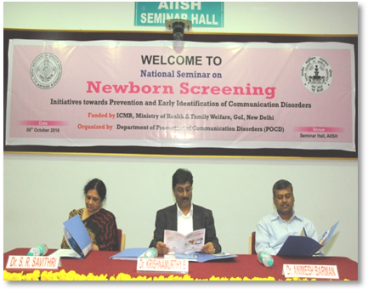 | 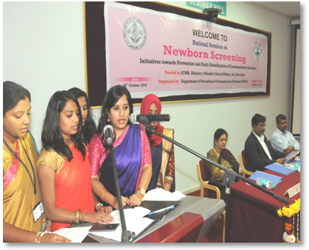
Dignitaries of the program | Invocation song
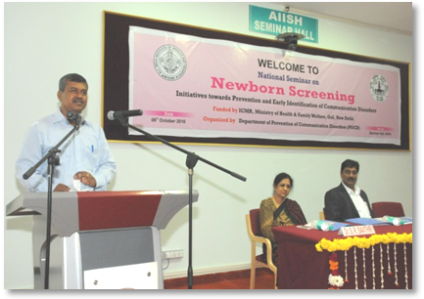 | 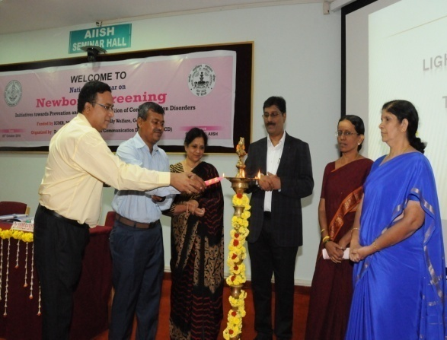
Welcome Speech by  Dr. Animesh Barman | Lighting the lamp by the Dignitaries
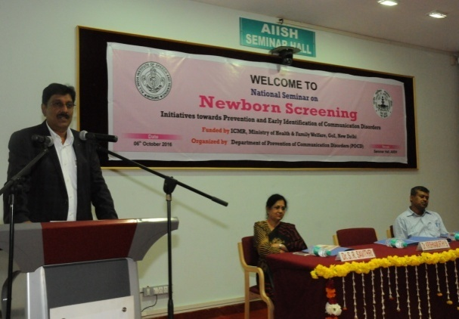 | 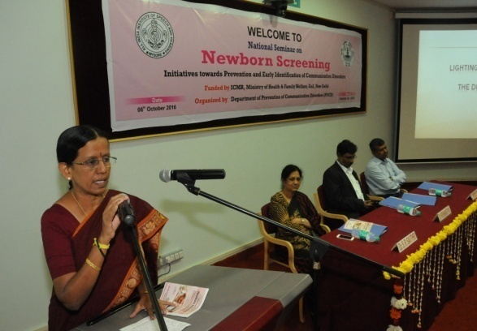
Address by Dr. B. Krishnamurthy | Address by Dr. SudhaRudrappa
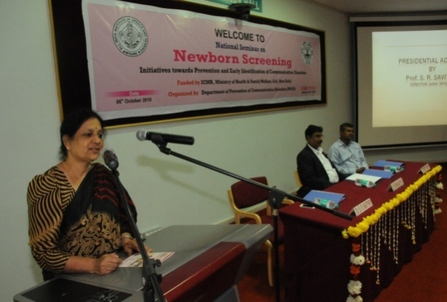 | 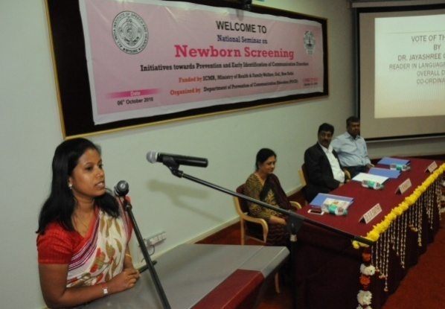
Presidential address by  Dr. S. R. Savithri | Vote of Thanks by  Dr. Jayashree C. Shanbal
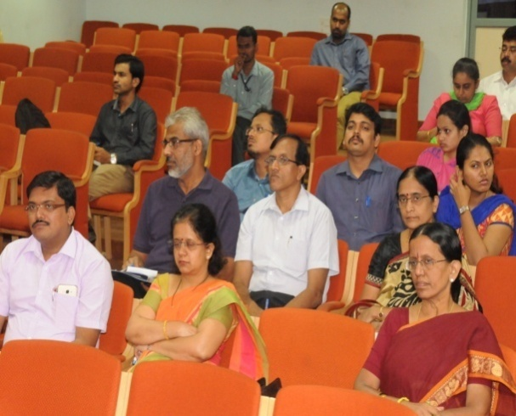 | 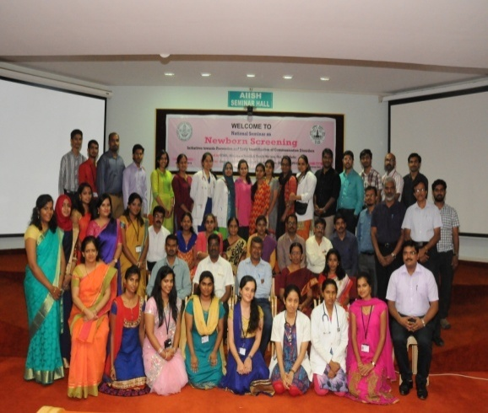
Participants
Feedback was collected from the participants after the seminar. All the participants provided appropriate feedback against each contribute and rating scale from 5 (Excellent) to 0 (Poor). Details are mentioned in table.
Table 4: Details of the feedback collected from the National seminar on “Newborn Screening: Initiatives towards prevention and early identification of communication disorders”.
Name of the Resource Persons | Clarity & Content of the Lectures Ratings
 | Excellent | Very Good | Good | Average | Below Average | Poor
Dr. Jayashree C Shanbal | 46.66% | 46.66% | 6.66% | - | - | -
Mr.Arunraj.K | 33.33% | 40% | 26.66% | - | - | -
Dr. Animesh Barman | 46.66% | 53.33% | - | - | - | -
Ms.Sunitha E | 33.33% | 60% | 6.6% | - | - | -
* 0= Poor; 1= Below Average; 2= Average; 3= Good; 4= Very Good; 5= Excellent

Table 5: Details of the feedback collected from the National seminar on “Newborn Screening: Initiatives towards prevention and early identification of communication disorders”on food and overall organiztaion.
S.No |  | Very much (%) | Somewhat (%) | Not at all (%) | Poor (%)
1 | Did the this workshop give sufficient information about the topic | 60% | 40% | - | -
2 | Overall organization of the workshop | 73.33% | 26.66% | - | -
3 | Food/hospitality | 93.33% | 6.66% | - | -

- Workshops organized by the Department: Nil
- Conferences organized by the Department: Nil
- No. of Seminars/ Conferences /Lectures /Workshop attended by the staff of the Dept
- Seminars attended by Staff of POCD: 06
Sl. No. | Date | Title of the program | Organized by | Staff attended
 | 16th August 2016 | National Seminars on “Recent advancements in Implantable Hearing aids | Dept .of Audiology | Ms.Manjula C &Ms.Suman.S
 | 17th August 2016 | National Seminars on “Optimization of Hearing aids. | Dept .of Audiology | Mr.ArunRaj.K& Ms.Zeena.V.P
 | 8th& 9th Sept  2016 | National Seminar on ‘Directions in Assessment and Management of Tinnitus’ | Department of Audiology | Ms. Suman S &  Ms. Manjula C
 | 1st& 2nd October 2016 | National Seminar on Clinical Aphasiology | Department of Speech-Language Pathology | Ms. Kavya S & Ms. ThanzeemRazak
 | 7th March 2017 | National Seminar on Voice assessment | Department of Speech-Language Sciences | Ms. Laxmishree P & Ms. Shruthi G R
 | 15th March 2017 | Virtual Seminar- Apps for Tele-rehabilitation | Tele Centre for Persons with Communication Disorders (TCPD) | Ms. Rashmi E &  Ms. Supreetha L

- Conferences attended by Staff of POCD: Nil

- Workshops attended by Staff of POCD: 04
Sl. No. | Date | Title of the program | Organized by | Staff attended
1. | 13th  Sept  2016 | Workshop on ‘Advancements in Audiometric Calibration’ | Department of Electronics | Dr. Animesh Barman &  Mr.Arunraj K
2. | 30th Nov 2016 | Workshop on “Basics of Translation” | Department of Material Development | Ms.LathikaPrabhu
3. | 3rd  Febuaury  2017 | Workshop on ‘Diet for children with communication problems & its effect on their ehavior’ | Department of Audiology | Ms.Nirupama&  Ms.Sunitha E
4. | 24th March 2017 | National Workshop on Co-articulation | Department of Clinical Services | Ms. Supreetha L & Ms. Shruthi G R

- Guest Lectures attended by Staff of POCD: 01
Date | Title of the program | Organized by | Venue | Staff attended
10.2.2017 | Psycho Neurolinguistics | Department of Speech-Language Pathology | AIISH Seminar hall | Mr. Potha Soundar Raj

- Training programs attended by Staff of POCD : 01
Sl | Date | Title of the program | Organized by | Staff attended
1. | 23rd & 24th March 2017 | ISO 9001:2015 Internal Auditor Training Program | ISO Cell | Dr. Animesh Barman  Mr. Arunraj K

- No. of Guest Lectures organized: Nil

- No. of Invited Talks delivered by faculty and staff: 10
Faculty/ Staff members | Program | Topic | Date &Venue
Dr. Animesh Barman | National Seminar on Newborn Screening: Initiatives towards of prevention and early identification of communication disorders | - Tracking tools for early identification of Communication disorders.  - Challenges & opportunities for Newborn Screening Programs in India. | 6th October 2016  AIISH seminar hall
 | Senitization program for Doctors and Audiologists at the Medical College  ( Level I) , under NPPCD | - Hearing evaluation: screening, diagnostic, hearing evaluation in camps & Referral. | 19th& 20th October 2016  AIISH seminar hall
 | Senitization program for Doctors and Audiologists at the Medical College  ( Level II) , under NPPCD | - Overview of Role of hearing and its structures , hearing impairment and early identification of hearing loss.
Dr. Jayashree C Shanbal | National Seminar on Newborn Screening: Initiatives towards of prevention and early identification of communication disorders | - Communication disorders and its Importance of early identification & intervention. | 6th October 2016  AIISH seminar hall
Mr. Arunraj K | National Seminar on Newborn Screening: Initiatives towards of prevention and early identification of communication disorders | - Potential risk factors for Communication disorders in newborns.  - Appropriate referral and management options for newborns with communication disorders. | 6th October 2016  AIISH seminar hall
 | Senitization program for Doctors and Audiologists at the Medical College  ( Level II), under NPPCD | - Video screening/ demonstration on hearing screening. | 20th October 2016 AIISH seminar hall
Ms. Sunitha E | National Seminar on Newborn Screening: Initiatives towards of prevention and early identification of communication disorders | - Outreach facilities of AIISH - An overview | 6th October 2016  AIISH seminar hall
 | Senitization program for Doctors and Audiologists at the Medical College  ( Level II), under NPPCD | - Video screening/ demonstration on hearing screening | 20th October 2016 AIISH seminar hall
- Orientation attended by staff of POCD: 01
Date | Title of the program | Organized by | Venue | Staff attended
2.1.2017 | Orientation Program on ‘Med-El Rahab Academy | Dept.of Audiology | AIISH Seminar hall | Ms.Lathika.P & Ms.Yashaswini BC

- Any other:
- Student clinical training: As part of human resource development, Clinical training for under graduates (B.Sc Speech & Hearing), Post graduates (M.Sc- SLP) & Internship students on Early identification, prevention & rehabilitation of communication disorders and Community based rehabilitation at OSCs were carried out. The details on number of students who had undergone training are given below.
B.Sc students | 73
M.Sc students | 111
Internship students | 125

- Staff Enrichment Programs: 01
Table 6: Details of Staff enrichment program organized during the year 2016-2017
Sl.no | Date | Title of the program | Presenter | Staff members
 | 10.03.2017 | Newborn Screening-Primtive Reflexes & Speech Languaue developmental milestones. | Ms.Shruthi G.R. | Dr.Animesh Barman  Dr.Jayashree C Shanbal  Mr.Arunraj K  Ms.Sunitha E  Ms.Akshatha Y  Ms.Yashaswini B C  Ms.Supreetha L  Ms.Nirupama S  Ms.Rashmi E  Ms.Laxmishree P  Ms.Lathika P

- RESEARCH ACTIVITIES
- Research Projects – Nil
- Doctoral and Post-Doctoral Programs: Nil
- Research papers presented in National conferences/seminars: 01
Shanbal, J.C, & Arunraj, K. (2016). An Innovative Computerized Screening Tool for Infant Cry Analysis in Detection of Communication Disorders – A Pilot Study. Presented at Digital India and Make in India theme in the Young Scientist Conclave (YSC) in India International Science Festival (IISF) organized by the Indian Council of Scientific & Industrial Research, Ministry of Science & Technology, Ministry of Earth Sciences, Vijnana Bharati, The Indian Council of Agriculture Research, and The National Physical Laboratory, New Delhi between 7⁻ 11th December 2016.
d. Research papers presented at International conferences/seminars: Nil
e. Research Papers published in National Conference/Seminar Proceedings: 01
Sreedevi N., Shanbal, J.C., Arunraj, K., Neethu, T., & Akshay, M. An Innovative Computerized Screening Tool for Infant Cry Analysis in Detection of Communication Disorders – A Pilot Study.Proceedings of India International Science Festival (IISF) 2016 under Young Scientist Conclave Make in India and Digital India, pg 145-146.
f. Research Papers published in International Conference/Seminar Proceedings: Nil
g. Research Papers published in National Journals: 01
Shanbal, J. C., Arunraj. K., & Reddy, M. S. (2016). Distribution of communication disorders in primary school children, Journal of All India Institute of Speech and Hearing, 34, 128-133.
h. Research Papers published in International Journals: 01
- Reddy, M.S.B., Amulya.P.Rao.,& Swapna.N. (2016). “Narrative Discourse in Persons with Parkinson’s Disease”, Speech Language and Hearing Journal (SLHJ), 19 (1), 1-9.ISSN: 2050-571X (Print) 2050-5728 (Online).
- Book / Chapters Published: 02
- “Newborn screening from Communication disorders: Occurrence of high risk factors for communication disorders using prospective and retrospective exploratory study – An outcome of NBS program” was prepared and was set to release for 9th August 2016 – Annual day celebrations of the institute.
Editors: Dr. S. R. Savithri, Dr. Animesh Barman & Dr. Jayashree C. Shanbal
Prepared by: Mr. Arunraj K, Mr. MadhuSudharshan Reddy & Ms. Sunitha E.
- “School screening: Distribution of communication disorders in school children” was prepared and was set to release for 9th August 2016 – Annual day celebrations of the institute
Editors: Dr. S. R. Savithri, Dr. Jayashree C. Shanbal& Dr. Animesh Barman
Prepared by: Mr. Arunraj K, Mr. MadhuSudharshan Reddy &Ms.Sunitha E.
j. Books / Manuals/ Seminar proceedings Edited: 01
Proceedings of the National Seminar on “Newborn Screening: Initiatives towards prevention and early identification of communication disorders” which held on 6th October 2016 has been prepared and submitted on March 2017 to ICMR, New Delhi.
Prepared by: Dr.Animesh Barman, Dr.Jayashree C Shanbal, Mr. Arunraj K, & Ms.Sunitha E.
k. Scholarly Reviewing Activities: Nil
- CLINICAL SERVICES
- General Clinical Services
- Follow-up evaluation
The newborns/infants referred during the newborn screening were followed up through telephone calls to parents/caregivers of infants. A complete test battery was administered for those clients who came for follow-up. Table 6 depicts the statistics related to this activity.
Table 7a.: Details of the results of follow-up evaluation for newborns and infants
Categories | AIISH + Cheluvamba | OSC-Sagara | Ajmer | Cuttack | Imphal | Puducherry | Ranchi | Jabalpur | Total
Normal | 325 | 11 | 25 | 39 | 50 | 101 | 65 | 13 | 629
ENT disorders | 02 |  | 4 |  | 6 |  | 6 |  | 18
Auditory Maturation delay | - | - | - | - | - | - | - | 1 | 1
Hearing disorder | 91 | 01 | 34 | 38 | 52 | 27 | 15 | 24 | 282
Speech and language disorder | 04 | - | 1 | - | 14 | - | 2 | 19 | 40
Multiple | - | - | 1 | - | - | - | 4 | 4 | 9
Incomplete testing | 32 |  | 1 | 6 | 4 | 53 |  | 41 | 137
Total infants tested | 454 | 12 | 66 | 83 | 126 | 181 | 92 | 102 | 1116

- Follow-up evaluation- Phone follow-up
The at-risk babies were monitored regularly by administering the speech-language & hearing checklist through a phone call. The babies who are identified with delay in the milestones were referred to AIISH/concern centre for detailed evaluation
Table 7b : Details of the Phone follow-up of newborns and infants
Categories | Mysore | OSC-Sagara | Ajmer | Cuttack | Imphal | Puducherry | Ranchi | Jabalpur | Total
Normal speech, language and hearing milestone | 571 | 10 | 42 | - | 50 | - | 23 | 02 | 668
Referred for detailed evaluation | 22 | - | - | - | 2 | - | 05 | - | 29
Total | 593 | 10 | 42 |  | 52 | - | 28 | 2 | 697

- Hearing evaluation of industrial workers at AIISH:
Employees from different industries had undergone hearing evaluation at AIISH. All the registered employees were counseled regarding the importance of hearing protection devices and its need to use regularly in noisy conditions to protect their hearing ability. The details of the hearing evaluation of the employees are represented in Table 7.
Table 8: Number of ears identified as having hearing impairment
Month | Name of the Industry | Total Registered | Total no of ears identified as Hearing impairment | Normal (Ear wise)
April 2016 | Rane MadraPvt.Ltd, Mysore | 8 | 8 | 0
July 2016 | KSIC, Mysore | 23 | 35 | 11
August2016 | KSIC, Mysore | 71 | 138 | 04
September  2016 | KSIC, Mysore | 122 | 104 | 18
October 2016 | KSIC, Mysore | 60 | 49 | 11
November 2016 | KSIC, Mysore | 32 | 31 | 29
Overall Total |  | 316 | 365 | 73

- Specialized Clinical services: Nil
- Clinical Support Services to Patients and Family: Nil
- Clinical Electronic Services: Nil
B)EXTENSION ACTIVITIES
- Rehabilitation and Education through Distant Mode: Nil

- Prevention of Communication Disorders

The department of POCD is actively involved in carrying out various extension activities such as screening, diagnostic and rehabilitation services outside the institute campus. The activities include newborn/infant screening, screening of school children, screening of elderly citizens, screening of industrial workers, conducting camps and also clinical services offered at the outreach service centers of AIISH.
Table 5: Total number of newborns/infants screened and identified at-risk for communication disorders.
SN | Hospitals/Immunization Centers | Total birth | Total No. Screened |  |  | Total No. at risk
 |  |  | Male | Female | Total | Male | Female |  | Total
 |  | AIISH- Mysore
1 | Apollo BGS Hospital (BAH), | 56 | 156 | 126 | 282 | 14 |  | 15 | 29
2 | Basappa Memorial Hospital (BMH) | 44 | 86 | 83 | 169 | 3 |  | 2 | 5
3 | Combined Hospital (CH) | 295 | 155 | 136 | 291 | 20 |  | 24 | 43
4 | Harsha Hospital (HH) | 14 | 24 | 38 | 62 | 1 |  | 4 | 5
5 | Kamakshi Hospital (KH) | 1080 | 466 | 403 | 869 | 56 |  | 57 | 113
6 | KR Hospital (KRH)- Cheluvamba | 3795 | 5816 | 5172 | 10988 | 640 |  | 615 | 1255
7 | Makkalakoota Immunization Center (MIC) | No deliveries | 170 | 145 | 272 | 9 |  | 18 | 27
8 | Mission Hospital (MH) | 543 | 484 | 419 | 903 | 92 |  | 77 | 169
9 | Immunization Center at Mission Hospital (ICMH) | No deliveries | 51 | 35 | 86 | 7 |  | 11 | 17
10 | N.P.C Hospital | 407 | 54 | 51 | 105 | 3 |  | 5 | 8
11 | S.M.T.D.H Hospital | 352 | 465 | 410 | 875 | 32 |  | 35 | 67
12 | Railway Hospital (RH) | 70 | 33 | 30 | 63 | 2 |  | 4 | 6
13 | Employees State Insurance (ESI) Hospital | 19 | 10 | 6 | 16 | 0 |  | 0 | 0
14 | Ashwini Nursing Home (ANH) | 72 | 94 | 70 | 164 | 8 |  | 11 | 19
15 | Shree Devi Nursing Home (SNH) | 171 | 119 | 105 | 224 | 11 |  | 17 | 28
16 | GopalaGowdaShanthaveri Memorial Hospital (GGSMH) | 234 | 53 | 33 | 86 | 4 |  | 3 | 7
17 | Family Planning Association Immunization (FPAI) center | 19 | 8 | 5 | 13 | 0 |  | 0 | 0
18 | Mahadeshwara Nursing Home (MNH) | 469 | 78 | 87 | 165 | 14 |  | 15 | 12
19 | Sigma Hospital (SH) | 247 | 276 | 204 | 480 | 25 |  | 19 | 44
 | Total (Mysore hospitals) | 7887  (collected from oct 2016) | 8598 | 7558 | 16113 | 941 |  | 932 | 1854
 |  | OSCs of AIISH
20 | Sub-divisional hospital, K R Nagar Taluk | 292 | 254 | 261 | 515 | 24 | 25 |  | 49
21 | Sub-divisional hospital, T NarsipuraTaluk | 451 | 221 | 207 | 428 | 25 | 29 |  | 54
22 | Sub-divisional Hospital, SagaraTaluk | 815 | 852 | 842 | 1694 | 80 | 54 |  | 134
23 | Community Health Centre (CHC), Hullahalli | 168 | 196 | 180 | 378 | 45 | 14 |  | 59
24 | Community Health Centre (CHC), Santhemarahalli | 282 | 135 | 113 | 248 | 20 | 6 |  | 26
25 | Primary Health Centre (PHC), Akkihebbalu | 28 | 1 | 3 | 4 | 0 | 0 |  | 0
 | Total (OSCs) | 2036 | 1659 | 1606 | 3267 | 194 | 128 |  | 322
 |  | NBS of AIISH
26 | Sri RamachandraBhanj Medical College and Hospital (SCB MCH), Cuttack | 5991 | 2091 | 1392 | 3483 | 355 | 255 |  | 610
27 | Regional Institute of Medical Sciences (RIMS), Imphal | 2828 | 2232 | 2168 | 4396 | 114 | 117 |  | 231
28 | Janana Hospital & JLNMCH, Ajmer | 7465 | 2801 | 2600 | 5409 | 502 | 424 |  | 926
29 | JIPMER, Puducherry | 9672 | 6507 | 5938 | 12445 | 651 | 514 |  | 1165
30 | NetajiSubhash Chandra Bose Medical College (NSCB), Jabalpur | 2910 | 2758 | 2236 | 4994 | 388 | 203 |  | 591
31 | Rajendra Institute of Medical Sciences, Baritayu, Ranchi | 5341 | 2714 | 2341 | 5055 | 96 | 85 |  | 181
 | Total (NBS centre’s) | 34207 | 19103 | 16675 | 35782 | 2106 | 1598 |  | 3704
Overall Total |  | 44130 | 29360 | 25839 | 55162 | 3241 | 2658 |  | 5880

- School screening :

Screening of preschool, primary school children were conducted focusing on the early identification of communication disorders and early rehabilitation of children at risk for communication disorders.
Table 6: Total number of children screened for communication disorders and identified.
Date | School | Total screened | Total identified with communication disorders
 |  |  | Ear related disorder | Hearing loss | Speech language disorders
20th April 2016 | AshadayakaSeva trust, Metgalli, Mysore | 24 | 01 | 0 | 02
3rd June 2016 | Government Resedential School for special category | 92 | 24 | 01 | 07
6th June 2016 | Govt.Higher primary school | 41 | 05 | 00 | 01
7th June 2016 | Govt.Higher primary school, Jyothinagar | 88 | 08 | 00 | 11
9th June 2016 | Govt.Higher primary school, Gokulam | 28 | 06 | 00 | 01
10th June 2016 | Govt.Higher primary school, Jyothinagar,GiriyaPalya | 114 | 01 | 00 | 05
13th June 2016 | Govt.Higher primary school, Jyothinagar | 76 | 09 | 00 | 01
14th June 2016 | Govt.Lowerprimary school | 58 | 02 | 00 | 07
17th June 2016 | Govt.Higher primary school,Medar’s block | 83 | 07 | 00 | 08
1st July 2016 | GHPS, Medar’sBlcok, Mysore | 83 | 0 | 0 | 5
12th July 2016 | GHPS, Padavaralli | 22 | 0 | 3 | 1
16th& 28th July 2016 | GLPS, Vontikoppal | 175 | 0 | 5 | 14
8th August 2016 | GHPS 3rd Infantry | 89 | 06 | - | 09
19th August 2016 | GHPS Tilaknagar | 61 | 05 | - | 11
22nd August 2016 | Urdu GHPS,Udaygiri | 68 | - | - | 02
26th August 2016 | Vivekananda GHPS | 114 | 24 | 05 | 07
26th August 2016 | Nagarthanhalli GHPS | 53 | 19 | 07 | 07
26th August 2016 | Mooganahalli GHPS | 53 | 22 | 02 | 04
29th August 2016 | M.G.Koppal GHPS | 187 | 00 | 00 | 06
16th September  2016 | GHPS  Peoples park  Mysuru | 32 | 01 | 02 | 02
22nd October 2016 | Ryan InterntaionalSchoo,  Ajmer | 08 | - | 05 | 03
4thNovemeber 2016 | Government higher primary school, kumarabeedu, Mysuru | 39 | - | - | 09
16thNovemeber 2016 | Government lower primary school, Savakarahundi,  Mysuru | 53 | - | 02 | 12
21stNovemeber 2016 | Bhavani, lower primary school, (Sajjan Trust) vishweshwara Nagar, Mysuru | 154 | 04 | 02 | 35
25th November 2016 | Government, Doddahattihundi,  Mysuru | 61 | - | 04 | 07
9th December 2016 | Government High School, Kailasapura, Mysuru | 51 | 01 | 04 | 16
16th December 2016 | Government Higher Primary School, MaratiKyathanahalli, Mysuru | 61 | 00 | 04 | 16
19th December 2016 | Government Higher Primary School, K.Hemmanahall, Mysuru | 144 | 02 | 03 | 20
23rd December 2016 | Government Primary School, Kailasapura,Mysuru | 46 | 01 | 02 | 10
27th December 2016 | Government Urdu Higher Primary School, Akkihebbalu, Mandya | 30 | 04 | 00 | 03
20th Jan 2017 | Hello Kids, J.P.Nagar, Mysuru | 26 | - | - | 02
23rd Jan 2017 | Govt.Lower primary school, Devagahalli, MysuruTaluk | 22 | 02 | - | -
30th Jan 2017 | Govt.High School, Beerihundi | 117 | - | 02 | 16
17th Feb 2017 | Govt.higher primary school  D.Salhundi | 78 | 04 | 00 | 14
20th Feb 2017 | Govt.higher primary school  D.Salhundi | 122 | 57 | 02 | 25
27th Feb 2017 | Govt.higher primary school  D.Salhundi | 82 | 07 | 04 | 11
3rd March 2017 | Government High School, Vinayaka Nagar, Mysuru | 87 | - | - | 14
14th March 2017 | Anganwadi, Akkihebal, Mandya | 21 | - | - | 1
Total |  | 2743 | 222 | 59 | 325

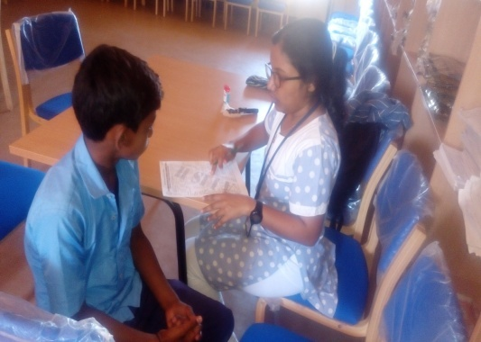 | 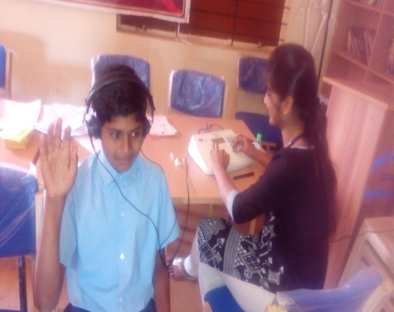
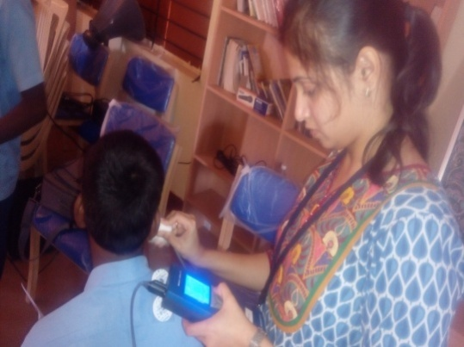 | 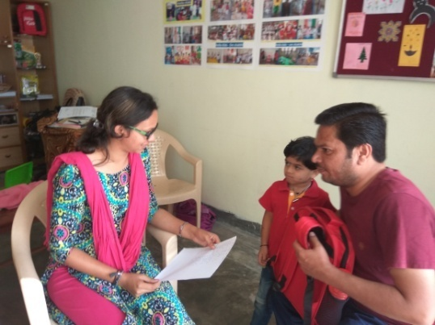

- Hearing screening of Industrial employees:
Month | Name of the Industry | Total Registered | Total no of ears identified as Hearing impairment | Normal (Ear wise)
May 2016 | GRS Engineering Pvt Ltd. | 17 | 20 | 14
6th 20th& 27th June 2016 | GRS Engineering Pvt Ltd, Mysore | 60 | 61 | 59
8th June 2016 | Hindustan Petroleum Pvt Ltd, Mysore | 115 | 66 | 164
29th June 2016 | Government Printing press, Mysore | 39 | 20 | 58
6th July 2016 | GRS Engineering pvt.Ltd | 92 | 66 | 118
20th July 2016 | Govt. Printing Press | 72 | 66 | 78
6th March 2017 | Giri Stone Production, Hebbal, Mysuru | 30 | 25 | 35
Total |  | 425 | 324 | 526

V. Clinical services for the elderly citizens:
The elderly individuals may show a gradual decline in their hearing, cognition, speech and language abilities due to aging or any other conditions such as stroke (CVA), Alzheimer’s disease, Parkinson’s disease, etc. This program is regularly conducted to facilitate identification and rehabilitation of any form of communication disorders in the elderly individuals. Clinical services were offered at various old-age homes in terms of identification of communication disorders, rehabilitation through speech and language therapy, guidance and distribution of free body level hearing aids.
Table 7: Total number of elderly citizens screened, identified and rehabilitated for Communication disorders
Date | Old age homes | Total screened | Total identified with communication disorders
 |  |  | Hearing disorders | Speech language disorders | Multiple disorders | Hearing aids issued
13th April 2016 | ChayamathaVrudhashrama trust, Mysore | 07 | 05 | 00 | 00 | 03
15th April 2016 | Nele Old age home, Mysore | 13 | 11 | 01 | 00 | 03
20th May 2016 | ShaliniOldage Home, Mysore | 07 | 05 | 00 | 00 | 01
16th June 2016 | BelakuVasthalyadhamaOldage home | 06 | 04 | 00 | 00 | 00
27th July 2016 | Vasavishanthidhama | 17 | 06 | 04 | 00 | 00
18th Jan 2017 | BelakuVatsalyadhama,Mysuru | 11 | 04 | 00 | 04 | 00
18th Jan 2017 | ArogyaAshrayadhama, Mysuru | 08 | 02 | 00 | 04 | 00
22nd Feb 2017 | Elder Citizen Council, Jayalakshmipuram, Mysuru | 14 | 12 | 0 | 0 | 0
12th Mar 2017 | Elder Citizen Council, Parkinson’s Association, Jayalakshmipuram, Mysuru | 18 | 12 | 04 | 00 | 00
 | Total | 101 | 61 | 9 | 8 | 7

vi. Camps: 10
Places | Total registered | ENT Evaluation |  | Hearing Evaluation |  | Speech & Language Evaluation
 |  | Normal (Ear Wise) | Disorder (Ear wise) | Normal (Ear Wise) | Disorder (Ear wise) | Normal (Individuals) | Disorder (Individuals)
28th May 2016 Sub-divisional Hospital (PHC), Sagara | 53 | 75 | 29 | 62 | 42 | 0 | 1
11th July 2016 (Hunsur) | 36 | 72 | 0 | 45 | 27 | 46 | 26
16th July 2016 (Mariyanikathana) | 56 | 112 | 0 | 41 | 71 | 06 | 50
22nd July 2016 (Nanjangud) | 28 | 37 | 0 | 16 | 31 | 17 | 11
23rd July 2016 (K.R.Nagar) | 21 | 42 | 0 | 12 | 29 | 01 | 20
31st August 2016 (Osc Sagara) | 24 | 22 | 0 | - | - | - | 4
26th October 2016 (J.P Nagara, Mysuru) | 15 | - | 1 | - | 14 | - | -
8th December 2016 Akkana Balaga Veerashyva Trust, Sagara | 56 | - | 13 |  | 42 | - | 01
21st December 2016 ,Sub Divisional Hospital , Sagara | 27 | - | - | - | 20 | - | 07
10th March 2017 at Bellale, PHC,Mandya dist | 129 | 117 | 106 | - | - | - | -
17th March 2017 at Bellale, PHC,Mandya dist | 114 | 91 | 95 | - | - | - | -
24th March 2017, Hirikyathanahalli, Hunsur taluk, Mysuru dist | 131 | 115 | 119 | - | - | - | -
26th & 27th March 2017  NSS Camp, Saragur | 340 | - | 340 | - | 688 | - | 112
Total | 1030 | 683 | 703 | 176 | 964 | 70 | 232

Camps attended by Dr.Mahadevappa from the Dept in the month of July, August, September 2016 & March 2017 :
Date | Total registered | ENT Evaluation
 |  | Normal (Ear Wise) | Disorder (Ear wise)
1st July 2016 (Chamarajanagar) | 96 | 00 | 80
8th July 2016 (Hunsur) | 108 | 00 | 89
15th July 2016 (Pandavapura) | 121 | 00 | 102
22nd July 2016 (Chamarajanagar) | 99 | 00 | 76
29th July 2016 (Hunsur) | 188 | 00 | 161
5th August 2016 | 172 | 10 | 57
12th August 2016 | 156 | 6 | 44
19th August 2016 | 192 | 7 | 95
16th September 2016 | 127 | 48 | 72
10th March 2017 | 129 | 117 | 106
17th March 2017 | 114 | 91 | 95
24th March 2017 | 131 | 115 | 119
Total | 1633 | 394 | 1096

vii. Clinical Services at Outreach Service Centers (OSCs):

The clinical activities are not only restricted to in and around Mysore, but also extended to rural areas where facilities for clinical services for persons with communication disorders were meager. Currently 04 OSCs (01 sub-divisional taluk hospital at Sagarataluk, Shivamogga District; 03 Primary Health Centre - PHC at Hullahalli, Mysuru district; Akkihebbalu, Mandya district &Karuna trust, Gumballi, Chamarajanagara district) were initiated to meet the objective of extending the services of the institute to rural areas. The OSCs are functioning as a well-equipped unitfor screening, diagnostics and therapeutic services for persons with communication disorders. The services include screening, diagnostic and rehabilitation which includes newborn/infant screening, screening of school children, Speech and Language evaluation, Audiological evaluation, ENT evaluation, Speech-Language therapy, issue of free body level hearing aids and ear molds, and counseling and guidance to individuals with communication disorders. The other details are tabulated below in tables 13 & 14.
Table 8: Details of clients identified with communication disorders at the OSCs.
OSC | Total registered | ENT Evaluation |  | Hearing Evaluation |  | Speech & Language Evaluation
 |  | Normal (Ear Wise) | Disorder (Ear wise) | Normal (Ear Wise) | Disorder (Ear wise) | Normal (Individuals) | Disorder (Individuals)
Primary Health Centre (PHC), Hullahalli | 673 | 343 | 519 | 02 | 121 | 0 | 11
Primary Health Centre (PHC), Akkihebbalu | 459 | 208 | 319 | 02 | 76 | 0 | 07
Primary Health Centre (PHC), Gumballi | 750 | 543 | 184 | 12 | 190 | 0 | 16
Sub-divisional Hospital (PHC), Sagara | 748 | - | - | 414 | 528 | 31 | 39
Total | 2630 | 1094 | 1022 | 430 | 915 | 31 | 73

Table 9: Rehabilitation services provided at Outreach service centres
OSC | Hearing Aids Dispensed | Speech-language therapy
 |  | No. of clients | No. of sessions
Primary Health Centre (PHC), Hullahalli | 09 | 21 | 57
Primary Health Centre (PHC), Akkihebbalu | 06 | 64 | 224
Primary Health Centre (PHC), Gumballi | 06 | 30 | 52
Sub-divisional Hospital, Sagara (PHC) Taluk | 25 | 171 | 798
Total | 46 | 286 | 1131

4. CENTRAL FACILITIES-
- Library and information services – Nil
- Public Information Activities –

- Exhibition- 01
Department of Prevention of Communication Disorders was actively involved in “The Bharat Scouts & Guides 17th National Jamborre 2017” which was held on 30th December 2016 to 4thJanuaury 2017 at Adakanahalli, Nanjangudtaluk, Mysuru district. Various display materials depicting prevention activities such as primary, secondary and tertiary prevention for communication disorders apart from normal aspects of speech, language and hearing development were emphasized in the stall. The focus of the stall also highlighted on early identification of speech, language and hearing disorders and rehabilitation services available at the institute and outreach service centers of AIISH. Public education materials such as “Test yourself”, “Young girls and Expecting Mothers”, Speech and Langauge developmental milestones and Ear and Hearing care” Charts were distributed in Kannada language. The details of the staff members deputed are listed below.
Sl No. | Date | Staffs
1. | 30.12.2016 | Ms.Akashatha Y &Ms.Supreetha L
2. | 31.12.2016 | Ms.Rashmi
3. | 01.01.2017 | Ms.Yashaswini.B.C
4. | 02.01.2017 | Ms.Nirupama.S
5. | 03.01.2017 | Mr.PothaSoundar Raj
6. | 04.01.2017 | Ms.Shruthi.G.R

- All India radio talks- 01
- Dr. Jayashree C Shanbal, Reader, dept of SLP delivered a talk on “communication disorders in school children” on 23.3.2016 in the All India Radio (AIR-100.6 MHz) which was broadcasted on 8th April 2015 at 4.00 PM.
- Street Plays- 04
The Department of POCD conducted Seven street plays on various disorders to the public emphasizing on prevention and early identification of communication disorders in the reported year. Details are mentioned below.
Sl.No | Date | Theme of the Street Play | Target group | Total | Place | Enactors
1 | 30th  April 2016 | Prevention of Communication Disorders | General Public | 60 | T.N.Pura | Internship Students batch 2015-2016
2 | 30th  April 2016 | Prevention of Communication Disorders | General Public | 70 | Talakadu | Internship Students batch 2015-2016
3 | 19th Nov 2016 | Prevention and early identification of Communication Disorders | General Public | 60 | Malavalli town | Internship Students batch 2016-2017
4 | 19th Nov 2016 | Prevention and early identification of Communication Disorders | General Public | 80 | Haadli village, malavallitaluk | Internship Students batch 2016-2017

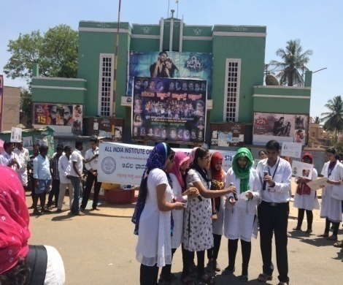 | 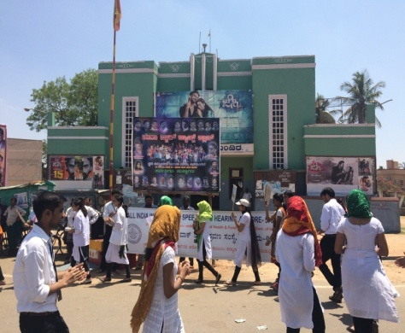 | 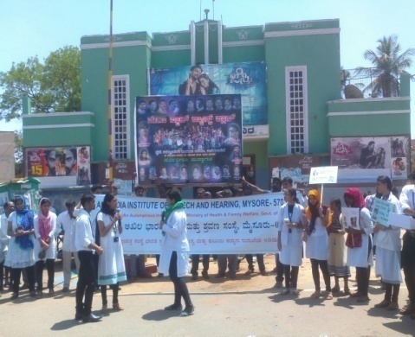
Introductory note | Gathering public | Enacting in street play
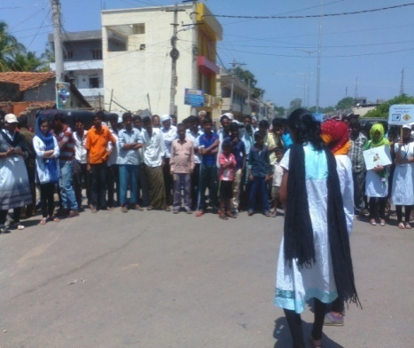 | 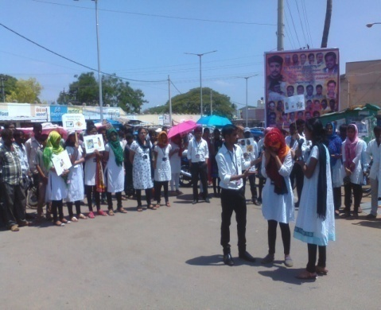 | 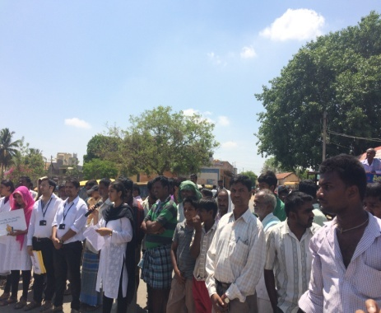
Enacting in street play | Enacting in street play | General public
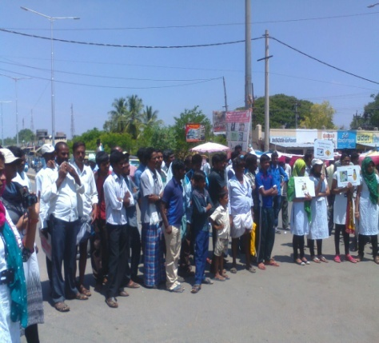 | 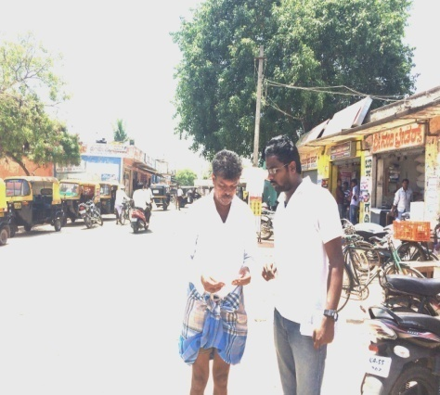 | 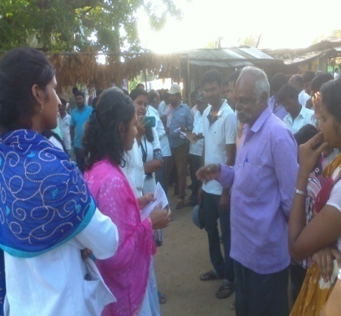
General public | Distribution of PEPs | Interaction with public
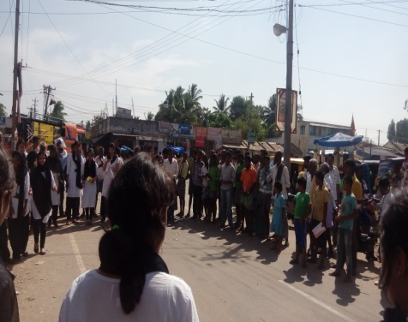 | 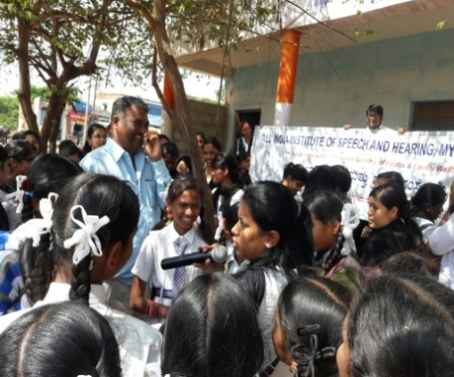 | 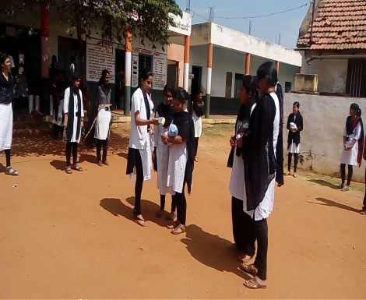
Gathering public | Interaction with school students. | Enacting in street play( new born screening)
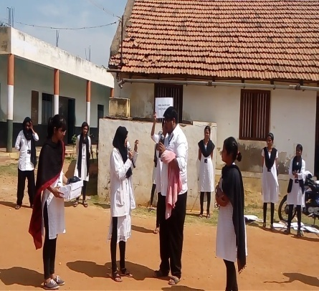 | 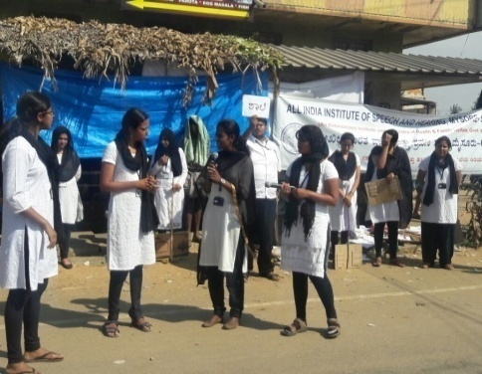 | 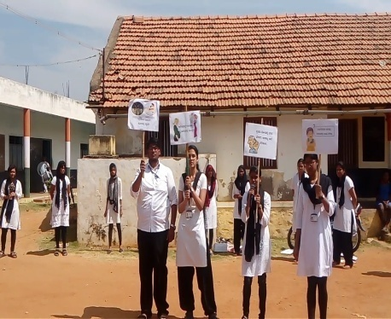
Enacting in street play( EPD’s importance) | Enacting street play ( School orientation) | Enacting street play (summary of skit)
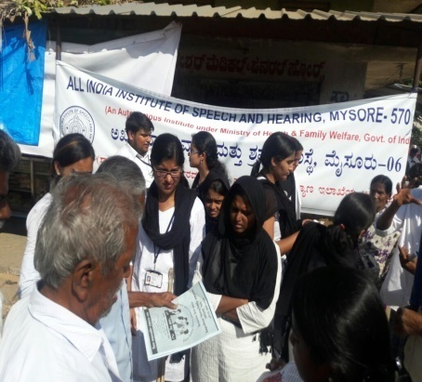 | 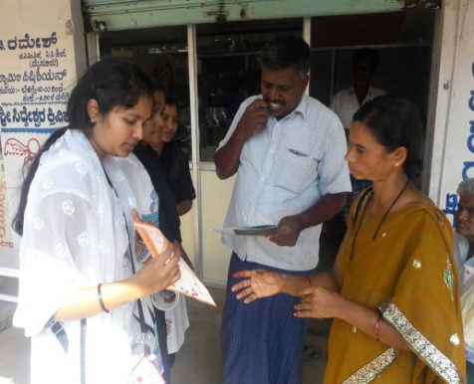 | 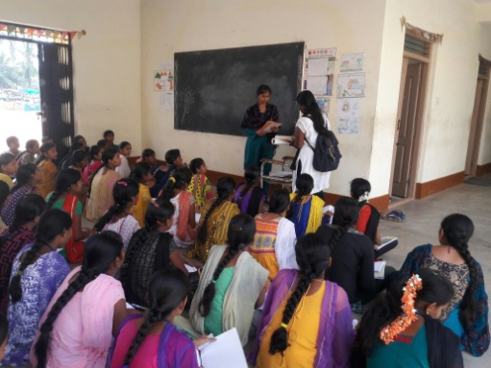
Distribution of PEPs | Distribution of PEPs | Distribution of PEP’s to college students

4. Public Lecture Series: Nil
5. Press Releases and Media Coverage: Nil
iii. Material Development–
- Public education pamphlets : 06

- Two pamphlets named “Fluency & its disorders” & “Developmental delay” was designed in the month of April 2016.
- Four pamphlets named Ear Discharge & its Prevention, Fluency Disorders, Attention Deficit Hyperactivity Disorder and Learning Disability & Aphasia were designed in the month of August 2016.
- Content of the Public Education Materials were transformed into the designed layout in Kannada language for 06 PEMs - ADHD, Learning disability, Articulation disorders, Autism Spectrum disorders, and Fluency disorders in tne month of October 2016.
- Content, Pictures and alignment modifications of the Public Education Materials were incorporated in English language for 06 PEMs - Articulation disorders, Autism Spectrum disorders, Cleft lip and palate, Dysrathria, Suttering, Say no to consanguineous and child marriage in the month of November 2016 .

- Designing of Proceedings for National seminar on Newborn Screening: initiatives towards prevention and early identification of communication disorders in the month of November 2016 .

- Final designing of 05 Public Education Materials in English language such as Articulation disorders, Autism Spectrum disorders, Cleft lip and palate, Dysathria, Stuttering is completed and indented for printing in larger scale in the month of December 2016.

- Six Public education materials of various types of communication disorders were reverse translated such as ADHD, Aphasia, Articulation in Marathi, Cleft lip & palate in Hindi, Dysarthria and Ear discharge and its prevention in Malayalam languages respectively in month of Feb 2017

- The 5 PEMs such as articulation disorder, Dysarthria, How to prevent Cleft lip and Palate, Aphasia and Suttering was prepared and set for release on 3rd Febuaury 2017.

- ‘Does your chilh have autism’ has been prepared and set for release on autism awareness month of April 2017.

- AWARDS AND HONOURS RECEIVED BY FACULTY AND STAFF:
- Dr. Jayashree C Shanbal (Reader in Language Pathology) secured II prize in Hindi dictation& III prize in Hindi singing competition .
- Ms.Zeena V.P. secured II prize in Hindi Singing Competition.
- Ms. Akshatha Y Audiologist Grade I, secured 2nd prize in Solo singing Competition held on behalf of Kannada Rajyotsava celebrations held at AIISH seminar hall.
- Dr.Jayashree C Shanbal, Reader in Language Pathology received award as Best Presenter under the category of Digital India and Make in India theme in the Young Scientist Conclave (YSC) in India International Science Festival (IISF) 2016, New Delhi which was held during 7th -11th Dec 2016.

iv. TECNOLOGICAL CONSULTANCY SERVICES: Nil
v. EXTRA CURRICULLAR ACTIVITIES: 01
- Staff of POCD department participated in Group singing competition on behalf of kannadaRajyotsava celebrations held at AIISH seminar hall.
- The 05 staff members of POCD dept actively participated in the Cricket on 10th& 11th Feb 2017 organized by the AIISH Gymkhana.
vi. VISITORS-
Date | Name of the Visitors | Designation
26.4.2016 | Mr. Shankar | Central Auditor, AIISH, Mysore
18.5.2016 | Shri. R S.Negi | Member Secretary, MoH& FW, GOI.
9.08.2016 | Dr. Prakash  Dr. Gangadhar | Former director, CFTRI  Director, NIMHANS
12.08.2016 | Dr. VinodAggarwal  Dr. Subodth Kumar | Chairperson – RCI & Secretary, Dept. of empowerment of PWD, New Delhi  Ex-Member Secretary, RCI
4.10.2016 | Smt.Umashree | Minister of Women & Child Welfare, Kannada & Culture, Govt.of Karnataka
08.02.2017 | Shri. Sanjiva Kumara | Additonal Secretary, Department of Health & Family Welfare, Govt. of India

Viii. MAJOR EVENTS OF THE YEAR:
- Released 02 statistical reports during 9th August 2016 on the occasion of Annual day
- NBS report titled “Newborn screening from Communication disorders: Occurrence of high risk factors for communication disorders using prospective and retrospective exploratory study – An outcome of NBS program” coordinated by Dr. Animesh Barman
- School Screening report titled “School screening: Distribution of communication disorders in school children” coordinated by Dr. Jayashree C. Shanbal
- Release of Public Education Materials in various events organized by the institute.
- 05 PEMs such as Ear Discharge & its Prevention, Fluency Disorders, Attention Deficit Hyperactivity Disorder, Learning Disability & Aphasia was released in English language on 9th August 2016
- The 05 PEM’s such as Articulation disorders, Dysarthria, How to prevent Cleft lip & Palate, Aphasia and Stuttering was released in English language on the occasion of Open day celebrations at the Institute on 3rd February 2017.
- National Seminar on Newborn Screening: Initiatives towards prevention and early identification of communication disorders for Postgraduate Medical students and doctors was held on 6th October 2016 at AIISH, Mysuru.
- Public Information Related Activites
- Staff of POCD & Internship students actively participated in 04 street palys organized by the Department of POCD at T.Narsipura & Talakadu of Mysuru district and Malavalli town & Haadli Village Mandya district in the month of April and November 2016.
- Staff of POCD & Internship Students participated in the radio drama on Prevention and Early identification of Communication disorders on Stuttering, Learning disability and Mental Disabilitiesrecorded at the All India Radio (AIR-100.6 MHz) on 4.02.2017 and was broadcasted on 17.02.2017 & 24.02.2017 at 8 p.m.
- A cyclothon was conducted by the Dept. of POCD to mark on Stroke Awareness Month with the theme ‘Prevent Stroke and Preserve Communication’ in association with AIISH Gymkhana on 18.02.2017. Aproximately 300 students including staffs of POCD participated in the program. Dr. S.P.Goswami, Prof & HOD-SLP inaugurated the Cyclothon. Dr.Animesh Barman HOD-POCD & AIISH Gymkhana Vice -Presdient was also present in the occassion. Dr. S.P.Goswami flagged of the Cyclists between 7:15 am at the Mysore one Center near brand factory. The Cyclothon was concluded at the same place by 8:30 am. The rally got wide coverage in the print media.

ix. OTHERS:
      - Dept. Related:
- The ISO Certifying Agency visited the department for Surveillance Audit -2 on 4.04.2016.
- MoU has been received from NBS-Cuttack centre in the month of April 2016.
- ABR testing has been initiated in Cheluvamba Hospital with effective from 18th May 2016.
- Sent a request to ICMR for granting funds to organize a national level seminar onNewborn screening: Initiatives towards early identification and prevention of communication disorders funds from ICMR were approvedorganize a national level seminar on Newborn screening: Initiatives towards early identification and prevention of communication disorders
- Departmental Peer review Meetings was held on 19.10.2016.
- Management review Meetings held on 18.11.2016 at board room, AIISH Mysuru
- Drafted official letters to DHO Mysuru on information on birth statistics and initation of newborn screening program at Jayanagar maternity hospital.
- Drafted official letter to Mr.Krishnamurthy Dean & Director MMC&RI, regarding utilization of ABR room by AIISH staff only.
- Referral booklet: Initiated distribution of Referral booklet to all the hospitals/ doctors for referring the clients with communication disorders. Currently distributed 40 booklets to the hospitals in and around Mysuru under NBS program.
- Birth rate: DHO permitted to collect Birth rate from all the hospitals on requisition.
- Inclusion of Government Maternity hospital for NBS: DHO permitted to initiate Newborn screening in Government Maternity hospital in Jaya Nagar, Mysuru. Currently in communication with the AMO of Jaya Nagar hospital for initiation.
- Screening results in Medical records: The 13 hospitals (Cheluvamba, Mission, Harsha, Sigma, Kamakshi, ANH, MNH, GGH, Railway, SNH, SMTDH, ESI, and BMH) except Combined & NPC government hospitals located in Mysuru have permitted the institute to mention the results of screening test in the patient’s medical records.
- Computerization of POCD activities(Epidemiological):
- Partial amount has been transferred to NIC for computerization of POCD activities. First meeting was held with NIC team on 23rd Dec. 2016 regarding the terms and conditions of Purchase order. Next consecutive meetings are fixed on 2nd Jan. 2017 & 12th Jan 2017 for start of the Phase I computerization.
- Mr.Devaraj P.A program analyst of NIC accompanied Smt.JowaharNaaz (appointed for carrying out the computerization work related to the institute from NIC) visited POCD department on 8.02.2017. The SPSS data of Newborn& school screening, OSCs& Camps were shown to them.
- The staff members of POCD were assigned duties regarding the activities related to Computerization. In Phase I, the Newborn screening program is finalized in draft stage in the month of March 2017.
- Mr. Devaraj P.A. program analyst of NIC accompanied newly recruited staff( the previous staff who was appointed on Feb 2016 was relieved from the duties). Mr.Devaraj was provided the NBS computerization draft (both hard & soft copy
- NBS Seminar: KLE University’s Jawaharlal Nehru Medical College, Belagavi had requestd to organize seminar on Newborn Screening in their hospital. However, Institute had agreed to conduct NBS seminar only at AIISH.
- Bill Settlement of National Seminar: An amount of Rs. 40000.00 was sanctioned from ICMR towards the national seminar on “Newborn screening: initiatives towards prevention and early identification of communication disorders” held on 6th October 2016. The settlement of the bill is completed and same has been submitted to the ICMR New delhi in the month of March 2017.

- OSC related-
- Initiation of OSC:
- Request received from KLE University’s Jawaharlal Nehru Medical College, Belagavi and District hospital, Tumkuru for initiation of OSC. Positive response has been sent to the hospitals.
- Approval from the Standing Finance Committee (SFC) of the institute was received to initiate the NBS & OSC centre. In this regard, an proposal was prepared and sent to the Vivekananda Memorial Hospital Sargur. Based upon the positive response, a meeting was held by the Director AIISH & Head-POCD with the Dr. Subramanya Secretary & CEO, Dr.Kumar G.S, Director other staff members of Vivekananda Memorial Hospital (VMH), Sargur on 22.03.2017 regarding the initiation of NBS & OSC centers at the Vivekananda Memorial Hospital (VMH), Sargur.
- NBS related - Presented the Statistics of NBS Centers regarding Newborn screening program at DHLS Coordinators meet held at Board Room on 17.10.2016.
- Initiation of NBS:
- Request received from Bhagalpur, Delhi and Shimla DHLS study centers to initiate NBS centers. Positive response has been sent to the concern hospitals.
- Approval from the Standing Finance Committee (SFC) of the Institute was received to initiate the NBS program at Jawaharlal Nehru Medical College and Hospital, Bhagalpur & King George's Medical University, Lucknow DHLS centers of AIISH, Mysuru. In this regard, an proposal was prepared and was sent to the respective centers. The meeting will be planned in the month of April 2017.
3. Recruitment/Relief of duties-
- The following staff members completed their contract term and were relieved from their duties in the Department of POCD

Staff on contract basis | Designation | Relieved on
Ms. Praveena. J | Audiologist grade I | 30.03.2016
Ms. SuchiSoni | Audiologist grade I | 24.06.2016
Mr.MadhuSudharshan Reddy | SLP Grade I | 10.08.2016
Ms. Kavya S, | SLP Grade I | 13.10.2016.
Ms. Jhanvi S Prasad, | ASLP Grade II, | 14.10.2016
Ms. Rekha D | SLP Grade I | 18.10.2016
Ms. Sandra Sebastin | ASLP Grade II, | 18.10.2016
Mr. Kapali S Nayak | SLP Grade I | 20.10.2016.
Ms. ThanzeemRazak | SLP Grade I | 20.10.2016.
Ms. Suman S | Audiologist Grade I | 20.10.2016.
Ms. Manjula C | Audiologist Grade I | 20.10.2016.
Mr. Jithin P Jacob, | Audiologist Grade I | 25.10.2016.
Ms. TulsiSahoo | Audiologist Grade I | 08.10.2016
Ms.RashikaShrama | Audiologist Grade II | 29.10.2016
Mr.MohahmedThareequee | Audiologist Grade I | 05.11.2016
Ms.Zeena V.P | Audiologist Grade I | 09.11.2016
Mr.BarsaBanaliMohanty | Speech and Hearing Assistant | 15.11.2016
Mr.Jithesh Prasad Sahoo | Audiologist Grade I | 22.11.2016
Ms. Sunitha E | ASLP Grade II | 23.12.2016
Ms. P. MeenakshiChanu | ASLP Grade I | 09.01.2017
Ms. Praveena J | ASLP Grade I | 16.01.2017
Dr. T.M.Mahadevappa | ENT Surgeon | 09.02.2017
Mr. Mohan Das M | ASLP Grade I | 09.02.2017
Mr.Mukesh Kumar | Audiologist Grade I | 17.02.2017
Mr. DeorajSaraswathi | Speech & Hearing Assisstant | 21.02.2017

- The following staff members were recruited on contract basis in the Department of POCD
Staff on contract basis | Designation | Reported on
Ms. Praveena. J | Audiologist grade I | 6th April 2016
Mr. AravindPalaria | Speech and Hearing assistant | 19th April 2016
Ms. StephyLancy | ASLP Grade II | 04th August 2016
Ms. Yashaswini B C | SLP Grade I | 17.10.2016.
Ms. Shruthi G R | ASLP Grade II | 17.10.2016.
Ms. Anusha K P | SLP Grade I | 19.10.2016.
Ms. Laxmishree P | ASLP Grade II | 19.10.2016.
Mr. PothaSoundar Raj | SLP Grade I | 21.10.2016.
Ms. Nirupama.S | Audiologist Grade I | 21.10.2016.
Ms. PrabhuLatika | Audiologist Grade I | 21.10.2016.
Ms. Supreetha L | SLP Grade I | 21.10.2016.
Ms. Rashmi E | Audiologist Grade I | 26.10.2016
Ms.AkashathaYogendra | Audiologist Grade I | 10.11.2016
Mr.BarsaBanaliMohanty | Speech & Hearing Assistant | 21.11.2016
Mr.MohahmedThareequee | Audiologist Grade I | 29.11.2016
Ms. Sunitha E | ASLP Grade II | 30.12.2016
Ms. P. MeenakshiChanu | ASLP Grade I | 16.01.2017
Mr. ElangbhamDilip Singh | Speech & Hearing Assisstant | 01.02.2017
Ms.Greeshma M S | Speech Language Pathologist Grade I | 8.02.2017
Dr. T.M. Mahadevappa | ENT Surgeon | 15.02.2017
Mr. Mohan Das M | ASLP Grade I | 17.02.2017
Mr.Mukesh Kumar | ASLP Grade I | 02.03.2017
Mr.Deoraj Saraswathi | Speech & Hearing Assistant | 02.03.2017
Mr.Sarooj Sahoo | Audiologist Grade I | 8.03.2017

5. Staff duties related:
Major events/duties carried out by staff of POCD
Dr. Animesh Barman | - Organizing and conducted street play under the theme “Prevention of Communication disorders” on 30th April 2016.  - Attended the External ISO Surveillance Audit -2 which was done on 04.04.2016 for the department.  - Attended Bi-monthly HOD meeting and presented the statistics for the months of March & April 2016.  - Preparation of RE-BE 2016-17 & 2017-18  - Preparation of Project Proposal for New OSC at Saragur  - Preparation of approval letter for outsourcing the Public Education Materials  - Prepration of letters for national seminar on “Newborn screening: initiatives towards prevention and early identification of communication disorders” for obtaining CME & CRE status.  - Verification and signing of No-dues certificates for the staffs of department after their completion of bond period  - Preparation of letters to DHO regarding birth statistics, initation of newborn screening program at Jayanagar government hospital, Mysuru and Utilization of room at KR hospital to the Dean of MMC&RI.  - Based upon the request received from Bhagalpur, Delhi , Shimla, Belagavi&Tumkuru regarding the Initation of OSC/NBS centers- A positive reply via letter has been drafted to respective hospitals.  - Preparation of letter to KLE’s University JLMC Belagavi regarding organizing national seminar related to newborn screening at AIISH only.  - Meeting with Mr.Devaraj P.A. regarding computerization of records  - Preparation of Proposal letters to the Sargur for initaition of OSC & NBS, Bhagalpur and lucknow for NBS program  - Meeting with OSC Sarguru CEO, Director and other staff members regarding Initiation of OSC &NBS centre at Saragur, H.D.Kote taluk, Mysuru Dist.
Dr. Jayshree C Shanbal | - Assisted in preparation and finalization of scripts for street play under the theme “Prevention of Communication disorders” which was enacted on 30th April 2016.  - Assisted in preparation of NBS report  - Attended the External ISO Surveillance Audit -2 which was done on 04.04.2016 for the department.  - Assisted in preparation of outsourcing the Public Education Materials  - Assisted in preparation of NBS report  - Assissted HOD in preparation of letters for national seminar on “Newborn screening: initiatives towards prevention and early identification of communication disorders” for obtaining CME & CRE status.  - Assissted HOD in verification and signing the no dues forPEMs and SPSS Data entires related to the activites carried out by bond staffs who had completed their tenures.  - Attending MRM meetings on behalf of HOD-POCD on 18.11.2016 at board room  - Served as In-charge HOD during the absence of Head-POCD between 26.12.2016 to 3.01.2016.
Mr. Arunraj.K | - Delivered a talk on “Protocols for newborn screening and its referral criteria” through Skype/team vieweron 27th April 2016.  - Attended the External ISO Surveillance Audit -2 which was done on 04.04.2016 for the department.  - Assisted in preparation of RE-BE 2016-17 & 2017-18  - Assisted in Project Proposal for New OSC at Saragur  - Assisted in Preparation of NBS training report  - Preparation of NBS staffs performance analysis report through NBS program  - Assissted HOD in verification and signing the no dues related to theactivitescarried out by bond staffs who had who had completed their tenures.  - Assisted HOD in drafting letters related to the Newborn screening programs  - Assissted HOD in preapartion of MRM inputs and outputs for MRM meeting on 18.11.2016  - Assissted HOD in drafting letters related to the Initation of OSC/NBS centers based upon the request received from the following hospitals/institutes such as Bhagalpur, Delhi , Shimla, Belagavi&Tumkuru  - Assissted HOD in drafting letter to KLE’s University JLMC Belagavi, to organize the national seminar on newborn screening at AIISH only.  - Assissted HOD in distribution of Refferal booklets to all doctors of various hospitals located in amd outside Mysuru.  - Assissted in Preparation of Proposal letters to the Sargur for initaition of OSC & NBS, Bhagalpur and lucknow for NBS program
Mr. MadhuSudharshan Reddy | - Assisted in preparation of NBS report  - Attended the External ISO Surveillance Audit -2 which was done on 04.04.2016 for the department.  - Assisted in preparation of RE-BE 2016-17 & 2017-18  - Assisted in Project Proposal for New OSC at Saragur  - Assisted in Preparation of NBS & School screening report  - Scientific papers published in international journal-  - Reddy, M.S.B.,Amulya. P.R.,&Swapna. N. (2016). “Narrative Discourse in Persons with Parkinson’s Disease”, Speech Language and Hearing Journal (SLHJ), 19 (1), 1-9.ISSN: 2050-571X (Print) 2050-5728 (Online).
Ms. Sunitha. E | - Assisted in preparation of stock verification report of OSC & NBS centres  - Delivered a talk on “Primitive reflexes, follow-up program and record.maintenance” through Skype/team vieweron 27th April 2016.  - Organized NBS monthly meeting through video conferencing on 22nd April 2016  - Oriented the activities of dept to Mr. Shankar, central auditor, AIISH, Mysore  - Attended the External ISO Surveillance Audit -2 which was done on 04.04.2016 for the department.  - Assisted in preparation of RE-BE 2016-17 & 2017-18  - Assisted in preparation of project Proposal for New OSC at Saragur  - Assisted in Preparation of NBS training report which was held on 27th April 16  - Assisted in preparation of NBS staffs performance analysis report  - Assisted in preparation of approval letter for outsourcing PEP’s.  - Assissted HOD in verification of Registers related to the department activites for the bond staffs to obtain the no dues.  - Assisted HOD in drafting letters related to the Newborn screening programs  - Assissted HOD in preapartion of MRM inputs and outputs for MRM meeting on 18.11.2016.  - Assissted HOD in drafting letters related to the Initation of OSC/NBS centers based upon the request received from the following hospitals/institutes such as Bhagalpur, Delhi , Shimla, Belagavi&Tumkuru.  - Assissted in Preparation of Proposal letters to the Sargur for initaition of OSC & NBS, Bhagalpur and lucknow for NBS program
Ms. Zeena. V.P | - Writing of Justification to organize the “National Workshop on Effects of Noise & implementation of Hearing Conservation Program”
Sd/-
Head, Dept. of POCD

