DEPARTMENT OF PREVENTION OF COMMUNICATION DISORDERS (POCD)
MONTHLY REPORT- AUGUST 2016

- ACADEMIC ACTIVITIES

- No. of short-term training programs organized: Nil
- No. of orientation/Sensitization programs organized: 07
As part of primary prevention activities, several orientation/Sensitization programs are being conducted regularly. The objective of the orientation programs was to create awareness among general public and various other professionals such as Medical doctors, Nurses, Health related workers, teachers, school students etc., on different types of communication disorders, its prevention and early identification methods and their appropriate referral and timely management. Table 1 & 2 shows the details of the orientation programs conducted by the dept. of POCD.
Table 1: Orientation Programs conducted by the department of POCD in the month of August 2016.
S.No | Date | Theme/Topic of the program | Coordinator | Name of the institute/  Hospital |  | Target group | Total participants | Oriented by
 | 8th August 2016 | Prevention and early identification of communication disorders | Head, POCD | GHPS,  Mysore |  | School teachers | 09 | Ms.Sandra  Ms.Sunitha
 | 19th August 2016 | Prevention and early identification of communication disorders | Head, POCD | GHPS,Tilak nagar,Mysore |  | School teachers | 04 | Ms.Jahnvi
 | 22nd August 2016 | Prevention and early identification of communication disorders | Head, POCD | UrduGHPS,Mysore |  | School teachers | 02 | Ms.Jahnvi
 | 24th 2016 | Prevention and early identification of communication disorders | Head, POCD | VivekanandaGHPS, Mysore |  | School teachers | 08 | Ms.Manjula  Mr.Kapali
By NBS/OSC Staff members
 | 4th August | Prevention and early identification of communication disorders | Head, POCD | OSC Sagara | Taluk Health officer, PHC Doctors, ASHA Workers, Health Workers & Nursing staffs |  | 70 | Mr.Mohan Das
 | 27th August | Prevention and early identification and management of communication disorders | NBS Coordinator &Head, POCD | Jabalpur | 1st Year students |  | 07 | Ms.Tulsi Sao
 | 26th August | New born Screening Guidelines and High Risk Register | NBS Coordinator & Head, POCD | RIMS, Ranchi | Nursing student |  | 48 | Mr.Mukesh Kumar
 | Total number participants |  |  |  |  |  | 148

Table 2: Total number of participants oriented in the month of August 2016.
S.No | Target group | Total number of Participants
1 | College students | 07
2 | Nursing students & staff | 75
3 | School Teachers | 23
4 | General Public | -
5 | Doctors | 11
6 | ASHA Workers | 32
7 | NGO Members | -
8 | ASHA/Anganwadi workers | -
9 | Industrial/Automobile workers | -
10 | Elderly citizens | -
11 | BASLP students | -
 | Total | 148
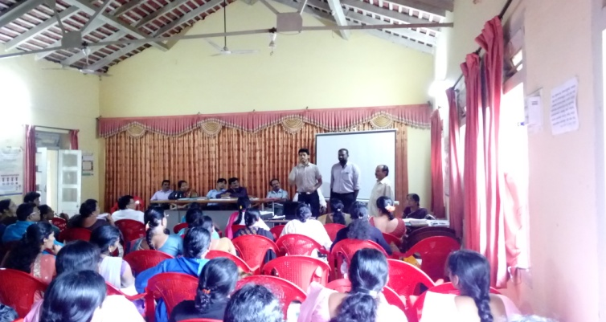 | 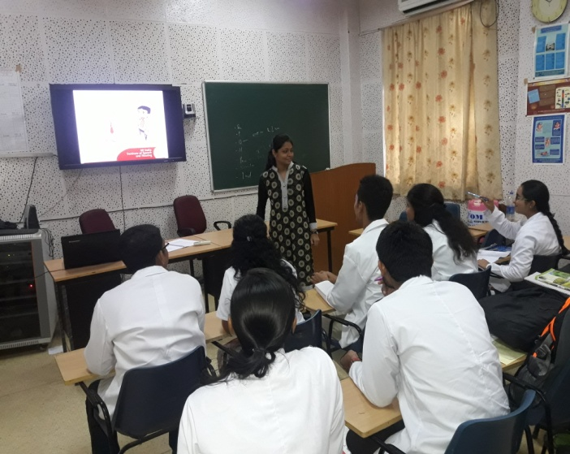

iii. Training programs conducted: Nil
iv. Clinical Observation postings of students from other institutes: Nil
V. No. of Seminars/ Conferences /Lectures /Workshop organized by the dept -
- Seminars organized by the Department: Nil
- Workshops organized by the Department: Nil
- Conferences organized by the Department: Nil

Vi. No. of Seminars/ Conferences /Lectures /Workshop attended by the staff of the Dept -
- Seminars attended by Staff of POCD: 02
Sl. No. | Date | Title of the program | Organized by | Staff attended
1 | 16th August 2016 | National Seminars on “Recent advancements in Implantable Hearing aids | Dept .of Audiology | Ms. Manjula C & Ms. Suman.S
2 | 17th August 2016 | National Seminars on “Optimization of Hearing aids. | Dept .of Audiology | Mr. Arunraj K. & Ms. Zeena.V.P

- Conferences attended by Staff of POCD: Nil
- Workshops attended by Staff of POCD: Nil
Vii. No. of Guest Lectures organized: Nil
Viii. No. of Invited Talks delivered by faculty and staff: Nil
vii. Any other:
- Student clinical training: As part of human resource development, clinical training for Undergraduates (B.Sc Speech & Hearing), Postgraduates (M.Sc- SLP & AUD) & Internship students on early identification, prevention & rehabilitation of communication disorders and Community based rehabilitation at OSCs were carried out. The details on the number of students who had undergone training are given below.
B.Sc students | 07
M.Sc students | 10
Internship students | 12
Total | 29

- Staff Enrichment Programs: Nil

2. RESEARCH ACTIVITIES

a. Research Projects – Nil
b. Doctoral and Post-Doctoral Programs: Nil
c. Research papers presented in National conferences/seminars: Nil
d. Research papers presented at International conferences/seminars: Nil
e. Research Papers published in National Conference/Seminar Proceedings: Nil
f. Research Papers published in International Conference/Seminar Proceedings: Nil
g. Research Papers published in National Journals: 01
Shanbal, J. C., Arunraj. K., & Reddy, M. S. (2016). Distribution of communication disorders in primary school children, Journal of All India Institute of Speech and Hearing, 34, 128-133.
h. Research Papers published in International Journals: Nil
i. Book / Chapters Published: 02
- “Newborn screening from Communication disorders: Occurrence of high risk factors for communication disorders using prospective and retrospective exploratory study – An outcome of NBS program” was prepared and was set to release for 9th August 2016 – Annual day celebrations of the institute
Editors: Dr. S. R. Savithri, Dr. Animesh Barman & Dr. Jayashree C. Shanbal
Prepared by: Mr. Arunraj K, Mr. Madhu Sudharshan Reddy & Ms. Sunitha E.

- “School screening: Distribution of communication disorders in school children” was prepared and was set to release for 9th August 2016 – Annual day celebrations of the institute
Editors: Dr. S. R. Savithri, Dr. Jayashree C. Shanbal & Dr. Animesh Barman
Prepared by: Mr. Arunraj K, Mr. Madhu Sudharshan Reddy & Ms.Sunitha E.

j. Books / Manuals/ Seminar proceedings Edited: Nil
k. Scholarly Reviewing Activities: Nil

3. CLINICAL SERVICES

- General Clinical Services

- Follow-up evaluation- Detailed evaluation

The newborns/infants referred during the newborn screening were followed up through telephone calls to parents/caregivers of infants. A complete test battery was administered for those clients who came for follow-up. Table 3 (a) & (b) depicts the statistics related to this activity.
Table 3(a): Details of the results of follow-up evaluation for newborns and infants
Categories | AIISH + Cheluvamba | OSC-Sagara | Ajmer | Cuttack | Imphal | Puducherry | Ranchi | Jabalpur | Total
Normal | 67 | 01 | 10 | 6 | - | 12 | - | - | 96
ENT disorders | 15 | - | - | - | - | - | - | - | 15
Noisy | - | - | - | - | - | - | - | - | -
Auditory Maturation delay | - | - | - | - | - | - | - | - | -
Hearing disorder | 10 | - | 5 | 11 | 02 | 03 | 03 | 02 | 36
Speech and language disorder | 05 | - | - | - | - | - | - | 02 | 07
Multiple | - | - | - | - | - | - | - | -
Incomplete testing | 06 | - | - | - | - | 05 | - | - | 11
Total | 103 | 01 | 15 | 17 | 02 | 20 | 03 | 04 | 165

Table 3(b) Follow-up evaluation- Phone follow-up

The at-risk babies were monitored regularly by administering the speech-language & hearing checklist through a phone call in Mysuru centre. The babies who are identified with delay in the milestones were referred to AIISH/concern centre for detailed evaluation.

Categories | Mysuru centre (POCD)
Normal speech, language & hearing milestones | 297
Referred for detailed evaluation | 48
Total | 345

- Hearing evaluation of industrial workers at AIISH:
Employees from different industries had undergone hearing evaluation at AIISH. All the registered employees were counseled regarding the importance of hearing protection devices and its need to use regularly in noisy conditions to protect their hearing ability. The details of the hearing evaluation of the employees were represented in Table 7.
Table 7: Number of ears identified as having hearing impairment
Month | Name of the Industry | Total Registered | Total no of ears identified as Hearing impairment | Normal  (Ear wise)
August2016 | KSIC, Mysore | 71 (142 ears) | 138 | 04

- Specialized Clinical services: Nil
- Clinical Support Services to Patients and Family: Nil
- Clinical Electronic Services: Nil
B) EXTENSION ACTIVITIES
- Newborn screening for Communication Disorders
The department of POCD is actively involved in carrying out various extension activities such as screening, diagnostic and rehabilitation services outside the institute campus. The activities include newborn/infant screening, screening of school children, screening of elderly citizens, screening of industrial workers, conducting camps and also clinical services offered at the outreach service centers of AIISH.
Table 4: Total number of newborns/infants screened and identified at-risk for communication disorders.
SN | Hospitals/Immunization Centers | Total births | Total No. Screened |  |  | Total No. at risk
 |  |  | Male | Female | Total | Male | Female | Total
 |  | AIISH- Mysore
1 | Apollo BGS Hospital (BAH), | 56 | 11 | 5 | 16 | 1 | 0 | 1
2 | Basappa Memorial Hospital (BMH) | Not available | 9 | 8 | 17 | 0 | 0 | 0
3 | Combined Hospital (CH) | Not available | 11 | 16 | 27 | 0 | 6 | 6
4 | Harsha Hospital (HH) | Not available | 1 | 0 | 1 | 0 | 0 | 1
5 | Kamakshi Hospital (KH) | Not available | 24 | 15 | 39 | 3 | 3 | 6
6 | KR Hospital (KRH)- Cheluvamba | Not available | 376 | 355 | 731 | 78 | 76 | 154
7 | Makkalakoota Immunization Center (MIC) | Not available | 7 | 7 | 14 | 1 | 1 | 2
8 | Mission Hospital (MH) | 74 | 20 | 30 | 50 | 5 | 9 | 14
9 | Immunization Center at Mission Hospital (ICMH) | Not available | 10 | 2 | 12 | 0 | 0 | 0
10 | N.P.C Hospital | 209 | 3 | 6 | 9 | 0 | 0 | 0
11 | S.M.T.D.H Hospital | 60 | 35 | 29 | 56+8 | 2 | 3 | 5
12 | Railway Hospital (RH) | 32 | 2 | 5 | 7 | 1 | 0 | 1
13 | Employees State Insurance (ESI) Hospital | 14 | 0 | 0 | 0 | 0 | 0 | 0
14 | Ashwini Nursing Home (ANH) | Not available | 5 | 9 | 14 | 0 | 1 | 1
15 | Shree Devi Nursing Home (SNH) | Not available | 11 | 2 | 13 | 1 | 1 | 2
16 | GopalaGowdaShanthaveri Memorial Hospital (GGSMH) | 16 | 3 | 1 | 4 | 1 | 0 | 1
17 | Family Planning Association Immunization (FPAI) center | 19 | 0 | 0 | 0 | 0 | 0 | 0
18 | Mahadeshwara Nursing Home (MNH) | 31 | 5 | 2 | 7 | 0 | 0 | 0
19 | Sigma Hospital (SH) | 32 | 24 | 29+8 | 37 | 2 | 2 | 4
 | Total (Mysore hospitals) | 960 | 557 | 505 | 1062 | 95 | 102 | 198
 |  | OSCs of AIISH
20 | Sub-divisional hospital, K R Nagar Taluk | Not available | 15 | 11 | 26 | 1 | 0 | 1
21 | Sub-divisional hospital, T Narsipura Taluk | 90 | 14 | 11 | 25 | 1 | 3 | 4
22 | Sub-divisional Hospital, Sagara Taluk | 91 | 41 | 50 | 91 | 3 | 4 | 7
23 | Community Health Centre (CHC), Hullahalli | 18 | 11 | 11 | 22 | 2 | 0 | 2
24 | Community Health Centre (CHC), Santhemarahalli | Not available | 10 | 3 | 13 | 1 | 0 | 1
25 | Primary Health Centre (PHC), Akkihebbalu | Not available | 0 | 0 | 0 | 0 | 0 | 0
 | Total (OSCs) | 199 | 91 | 86 | 177 | 8 | 7 | 15
 |  | NBS of AIISH
26 | Sri RamachandraBhanj Medical College and Hospital (SCB MCH), Cuttack | 498 | 137 | 110 | 247 | 28 | 28 | 56
27 | Regional Institute of Medical Sciences (RIMS), Imphal | 175 | 81 | 89 | 170 | 1 | 2 | 3
28 | Janana Hospital & JLNMCH, Ajmer | 825 | 240 | 201 | 241 | 29 | 27 | 56
29 | JIPMER, Puducherry | 1148 | 597 | 531 | 1128 | 57 | 47 | 104
30 | Netaji Subhash Chandra Bose Medical College (NSCB), Jabalpur | 473 | 247 | 226 | 473 | 24 | 16 | 40
31 | Rajendra Institute of Medical Sciences, Baritayu, Ranchi | 626 | 165 | 160 | 325 | 10 | 08 | 18
 | Total (NBS centre’s) | 3745 | 1386 | 1228 | 2414 | 148 | 126 | 274
 | Overall Total | 4904 | 2034 | 1819 | 3653 | 251 | 235 | 487

- School screening : 07
Screening of preschool, primary school children was conducted focusing on the early identification of communication disorders and early rehabilitation of children at risk for communication disorders.
Table 5: Total number of children screened for communication disorders and
identified.
Date | Name of the School | Total screened | Total identified with communication disorders
 |  |  | Ear related disorder | Hearing loss | Speech language disorders
8th August 2016 | GHPS 3rd Infantry | 89 | 06 | - | 09
19th August 2016 | GHPS Tilak nagar | 61 | 05 | - | 11
22nd August 2016 | Urdu GHPS,Udaygiri | 68 | - | - | 02
26th August 2016 | Vivekananda GHPS | 114 | 24 | 05 | 07
26th August 2016 | Nagarthanhalli GHPS | 53 | 19 | 07 | 07
26th August 2016 | Mooganahalli GHPS | 53 | 22 | 02 | 04
29th August 2016 | M.G.Koppal GHPS | 187 | 00 | 00 | 06
Total |  | 625 | 76 | 14 | 46

- Hearing screening of Industrial employees: nil
- Clinical services for the elderly citizens: nil
V. Camps: 01

Date | Total registered | ENT Evaluation |  | Hearing Evaluation |  | Speech & Language Evaluation
 |  | Normal (Ear Wise) | Disorder (Ear wise) | Normal (Ear Wise) | Disorder (Ear wise) | Normal (Individuals) | Disorder (Individuals)
31st August 2016 (Osc Sagara) | 24 | 22 | 0 | - | - | - | 4
Total | 24 | 22 | 0 | - | - | - | 4

AIISH Plan Project: attended by Dr.Mahadevappa, ENT specialist from the Dept:03

Date | Total registered | ENT Evaluation registered=219
 |  | Normal (Ear Wise) | Disorder (Ear wise)
5th August 2016 | 172 | 10 | 57
12th August 2016 | 156 | 6 | 44
19th August 2016 | 192 | 7 | 95
Total | 520 | 23 | 196

vii. Clinical Services at Outreach Service Centers (OSCs):

The clinical activities are not only restricted to in and around Mysore, but also extended to rural areas where facilities for clinical services for persons with communication disorders were meager. Currently 04 OSCs (01 sub-divisional taluk hospital at Sagara taluk, Shivamogga District; 03 Primary Health Centre - PHC at Hullahalli, Mysuru district; Akkihebbalu, Mandya district & Karuna trust, Gumballi, Chamarajanagara district) were initiated to meet the objective of extending the services of the institute to rural areas. The OSCs are functioning as a well-equipped unit for screening, diagnostics and therapeutic services for persons with communication disorders. The services include screening, diagnostic and rehabilitation which includes newborn/infant screening, screening of school children, Speech and Language evaluation, Audiological evaluation, ENT evaluation, Speech-Language therapy, issue of free body level hearing aids and ear molds, and counseling and guidance to individuals with communication disorders. The other details are tabulated below in tables 7 & 8.
Table 8: Details of clients identified with communication disorders at the OSCs.

OSC | Total Registered | ENT Evaluation  Registered=101 |  | Hearing Evaluation  Registered=45 |  | Speech & Language Evaluation registered=7
 |  | Normal (Ear Wise) | Disorder (Ear wise) | Normal (Ear Wise) | Disorder (Ear wise) | Normal (Individuals) | Disorder (Individuals)
Primary Health Centre (PHC), Hullahalli | 53 | 04 | 47 | 04 | 12 | - | 00
Primary Health Centre (PHC), Akkihebbalu | 26 | 2 | 22 | 2 | 06 | - | 04
Primary Health Centre (PHC), Gumballi | 64 | 04 | 69 | 04 | 30 | - | 02
Sub-divisional Hospital (PHC), Sagara | 96 | 42 | 22 | 07 | 25 | - | 01
Total | 239 | 52 | 160 | 17 | 73 | 137 | 7
Table 9: Rehabilitation services provided at Outreach service centres
OSC | Hearing Aids Dispensed | Speech-language therapy
 |  | No. of clients | No. of sessions
Primary Health Centre (PHC), Hullahalli | 01 | - | -
Primary Health Centre (PHC), Akkihebbalu | - | 05 | 39
Primary Health Centre (PHC), Gumballi | - | - | -
Sub-divisional Hospital, Sagara (PHC) Taluk | 01 | 16 | 82
Total | 02 | 21 | 121

4. CENTRAL FACILITIES-
- Library and information services – Nil
- Public Information Activities – Nil
- Material Development – Nil
- Public education pamphlets : Following PEP’s were released on 9th August 2016 on the occasion of the Institute (Annual) day
- Ear Discharge & its Prevention,
- Fluency Disorders,
- Attention Deficit Hyperactivity Disorder,
- Learning Disability &
- Aphasia
- Designed referral sheets & referral seals for
iv. AWARDS AND HONOURS RECEIVED BY FACULTY AND STAFF: Nil
V. TECNOLOGICAL CONSULTANCY SERVICES: Nil
Vi. EXTRA CURRICULLAR ACTIVITIES: Nil
Vii. VISITORS
- Dr. Praksah, Former director, CFTRI & Dr. Gangadhar, Director, NIMHANS, Bangalore visited the department on 9th August 2016 – Annual day celebration chief guests. Mr. Arunraj K explained the outreach activities of the department during their visit.
- Dr. Vinod Aggarwal, Chairperson – RCI & Secretary, Dept. of empowerment of PWD, New Delhi & Dr. Subodth Kumar, Ex-Member Secretary, RCI visited the department on 12th August 2016. Prof. Animesh Barman explained about the outreach activities of the department during their visit.

Viii. MAJOR EVENTS OF THE MONTH:
- Released 02 statistical reports during 9th August 2016 on the occasion of Annual day
- NBS report titled “Newborn screening from Communication disorders: Occurrence of high risk factors for communication disorders using prospective and retrospective exploratory study – An outcome of NBS program” coordinated by Dr. Animesh Barman
- School Screening report titled “School screening: Distribution of communication disorders in school children” coordinated by Dr. Jayashree C. Shanbal
- Released 04 PEPs in English on various communication disorders coordinated by Dr. Jayashree C. Shanbal

ix. OTHERS:
- 1 Dept. Related: Sent a request to ICMR for granting funds to organize a national level seminar on Newborn screening: Initiatives towards early identification and prevention of communication disorders
2. OSC related- Nil
3. NBS related - Nil
4 Extension of Contract/Relief of duties-
- The following staff members completed their contract term and were relieved from their duties in the Department of POCD

Staff on contract basis | Designation | Relieved on
Mr.Madhu Sudharshan Reddy | SLP Grade I | 10th August 2016

- The following staff members extended their contract in the Department of POCD
Staff on contract basis | Designation | Reported on
Ms. Stephy Lancy | ASLP Grade II | 04th August 2016
Head, Dept. of POCD

CUMULATIVE REPORT

DEPARTMENT OF PREVENTION OF COMMUNICATION DISORDERS (POCD)

ANNUAL REPORT APRIL 2016 TO MARCH 2017

I. ACADEMIC ACTIVITIES
- No. of short-term training programs organized: Nil

- No. of orientation/Sensitization programs organized: 05
As part of primary prevention activities, several orientation/Sensitization programs were conducted regularly. The objective of this orientation programs was to create awareness among general public and various other professionals such as Medical doctors, Nurses, Health related workers, teachers, school students etc., on different types of communication disorders, its prevention and early identification methods and their appropriate referral and timely management. Table 1 (a) shows the details of the orientation programs conducted by the dept. of POCD.
Table 1(a): Orientation Programs conducted by the department of POCD at AIISH during 2015-2016
S.No | Date | Theme/Topic of the program | Coordinator | Name of the institute/  Hospital | Target group | Total participants | Oriented by
1 | 4th April 2016 | Prevention and early identification of communication disorders | OSC Sagara | Sub-divisional hospital, OSC Sagara | ASHA and Anganvadi Workers | 70 | Mr. Mohandas  & Mr.Thareeque
2 | 4th April 2016 | Harmful effects of noise and its ill effects | Raj auto garage | Auto mobile Workers | Harmful effects of noise and its ill effects | 07 | Ms. Suman &  Ms. Manjula
3 | 11th April 2016 | Harmful effects of noise and its ill effects | POCD, AIISH | Bannariamman Sugar factory | Industrial workers | 05 | Ms. Zeena &  Mr. Kapali
4 | 29th April 2016 | Newborn screening guidelines and high risk register | NBS Centre, Ranchi | RIMS, Ranchi | Nursing staff | 11 | Mr. Mukesh Kumar
5 | 29th April 2016 | Prevention and early identification of communication disorders | POCD, AIISH | Basappa Memorial Hospital | Nursing students | 32 | Mr. Kapali &  Ms. Zeena
 | 2nd May 2016 | Prevention and early identification of communication disorders | NBS,  Jabalpur | NSCBMC | Nursing students | 08 | Ms. Tulsi Sahoo
 | 24th May 2016 | Prevention and early identification of communication disorders | NBS,  Puducherry | JIPMER | Nursing students | 05 | Ms. Praveena
 | 25th May 2016 | Prevention and early identification of communication disorders | NBS, Imphal | RIMS | Doctors, Nurses & ASHA Workers | 71 | Ms. Meenakshi Chanu
 | 30th May  2016 | Harmful effects of noise and its ill effects | GRS Engineering Pvt.Ltd | Forgining division Belagola Industrial area,  Mysore. | Industrial workers | 17 | Ms. Zeena  Ms. Manjula  Ms. Sunitha  Ms.Rekha
 | 31st May 2016 | Prevention and early identification of communication disorders | NBS, Ranchi | RIMS | Nursing staff | 24 | Mr. Mukesh Kumar
 | 6th June 2016 | Harmful effects of noise and its ill effects | GRS Engineering Pvt.Ltd | Forgining Division Belagola Industrial area, Mysuru | Industrial Employes | 16 | Ms.Zeena
 | 8th June 2016 | Prevention and early identification of communication disorders | Head Master | Government Residential school for special category,  Mysuru | School Teachers | 08 | Ms. Manjula
 | 9th June 2016 | Prevention and early identification of communication disorders | Head Master | Government Lower Primary school,  Mysuru | School Teachers | 03 | Mr.Kapali
 | 13th June2016 | Prevention and early identification of communication disorders | Head Master | Government Higher Primary school,  Mysuru | School Teachers | 05 | Ms.Thanzeem
 | 14th June2016 | Prevention and early identification of communication disorders | Head Master | Government Lower Primary school,  Kalyangiri Mysuru | School Teachers | 03 | Ms. Kavya. S
 | 10th June 2016 | Prevention and early identification of communication disorders | Head Master | Government Higher Primary school  Kalyangiri Mysuru | School Teachers | 07 | Ms.Suman
 | 15th June 2016 | Harmful effects of noise and its ill effects | Manager | Hindustan Petroleum,  Mysuru | Industrial Employes | 32 | Mr.Madhu S Reddy
 | 20th June 2016 | Harmful effects of noise and its ill effects | GRS Engineering Pvt.Ltd | Forgining Division Belagola Industrial area, Mysuru | Industrial Employes | 19 | Ms.Sandra
 | 27th June 2016 | Harmful effects of noise and its ill effects | GRS Engineering Pvt.Ltd | Forgining Division Belagola Industrial area, Mysuru | Industrial Employes | 24 | Ms.Jahnvi
 | 17th  June 2016 | Prevention and early identification of communication disorders | In charge person | Belaku Vasthalyadhama Oldage Home,  Mysuru | Elderly citizens | 07 | Mr. kapali
 | 6th June 2016 | Prevention and early identification of communication disorders | Head Master | GHPS, Sathgalli,  Mysore | School teachers | 04 | Ms. Thanzeem
 | 7th June 2016 | Prevention and early identification of communication disorders | Head Master | GHPS, Jyothinagar,  Mysore | School teachers | 04 | Ms. Sunitha E
 | 17th June 2016 | Prevention and early identification of communication disorders | Head Master | GHPS, Medhars Block,  Mysore | School teachers | 06 | Mr. Madhu S Reddy
 | 22nd June 2016 | Prevention and early identification of communication disorders | Manager | Hindustan Petroleum,  Mysuru | Industrial Employes | 40 | Ms. Zeena. V.P
 | 29th June 2016 | Prevention and early identification of communication disorders | Manager | Govt. text book printing Press | Printing Employes | 39 | Mr. Kapali
 | 23rd June 2016 | Prevention and early identification of communication disorders | NBS coordinator | NSCBMC, Jabalpur | BASLP 1st year students | 09 | Ms. Tulsi Sao
 | 28th June 2016 | New born Screening Guidelines and High Risk Register | NBS coordinator | RIMS, Ranchi | Nursing students | 41 | Mr. Mukesh Kumar
 | 4th July 2016 | Harmfull effects of noise and its ill effects | GRS Eng PVT ltd | Metagalli | Industrial Workers | 29 | Ms.Manjula
 | 6th July 2016 | Harmfull effects of noise and its ill effects | Govt Printing press | Manasa Gangotri | Industrial Workers | 57 | Ms.Rekha
 | 11th July 2016 | Harmfull effects of noise and its ill effects | GRS Eng PVT ltd | Metagalli | Industrial Workers | 33 | Ms.Sandra
 | 12th July 2016 | Prevention and early identification of communication disorders | Head, POCD | GHPS, Padavarahalli, Mysore | School teachers | 04 | Ms. Rekha.D
 | 18th July | Harmfull effects of noise and its ill effects | GRS Eng PVT ltd | Metagalli | Industrial Workers | 30 | Ms.Sunitha
 | 20th July 2016 | Harmfull effects of noise and its ill effects | Govt Printing press | Manasa Gangotri | Industrial Workers | 9 | Ms.Thanzeem
 | 22nd July 2016 | Harmfull effects of noise and its ill effects | Govt Printing press | Manasa Gangotri | Industrial Workers | 35 | Ms.Zeena
 | 28th July 2016 | Prevention and early identification of communication disorders | Head, POCD | GHPS, Vontikoppal | School teachers | 08 | Ms. Tanzeem & Ms. Sandra
 | 29th July 2016 | Prevention and early identification of communication disorders | Head, POCD | GHPS, Yadavagiri | School teachers | 04 | Ms. Jahnavi
 | 16th July 2016 | Prevention and early identification of communication disorders | NBS coordinator | RIMS, Imphal | Nursing students | 06 | Ms. Tulsi Sao
 | 28th July 2016 | New born Screening Guidelines and High Risk Register | NBS coordinator | RIMS, Ranchi | Nursing staff members | 15 | Mr. Mukesh Kumar
 | 8th August 2016 | Prevention and early identification of communication disorders | Head, POCD | GHPS,  Mysore | School teachers | 09 | Ms.Sandra  Ms.Sunitha
 | 19th August 2016 | Prevention and early identification of communication disorders | Head, POCD | GHPS,Tilak nagar,Mysore | School teachers | 04 | Ms.Jahnvi
 | 22nd August 2016 | Prevention and early identification of communication disorders | Head, POCD | UrduGHPS,Mysore | School teachers | 02 | Ms.Jahnvi
 | 24th 2016 | Prevention and early identification of communication disorders | Head, POCD | VivekanandaGHPS, Mysore | School teachers | 08 | Ms.Manjula  Mr.Kapali
 | 4th August | Prevention and early identification of communication disorders | Head, POCD | OSC Sagara | Taluk Health officer, PHC Doctors, ASHA Workers, Health Workers & Nursing staffs | 70 | Mr.Mohan Das
 | 27th August | Prevention and early identification and management of communication disorders | Head, POCD | Jabalpur | 1st Year students | 07 | Ms.Tulsi Sao
 | 26th August | New born Screening Guidelines and High Risk Register | Head, POCD | RIMS, Ranchi | Nursing student | 48 | Mr.Mukesh Kumar
 | Total number participants |  |  |  |  | 895

Table 1 (b): Total number of target groups oriented during the year 2015-16.
S.No | Target group | Total number of Participants
1 | College students | 07
2 | Nursing students & staff | 253
3 | School Teachers | 79
4 | General Public | -
5 | Doctors | 16
6 | ASHA Workers | 62
7 | NGO Members | -
8 | ASHA/Anganwadi workers | 70
9 | Industrial/Automobile workers | 392
10 | Elderly citizens | 07
11 | BASLP students | 09
 | Total | 895

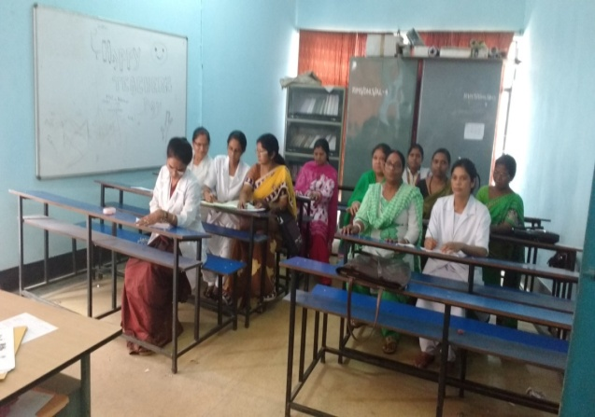 | 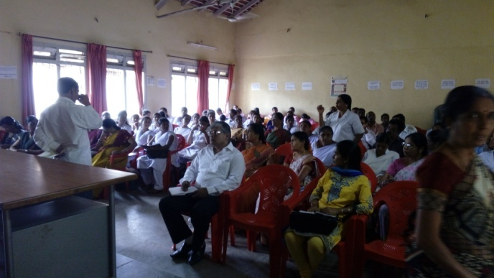 |  | 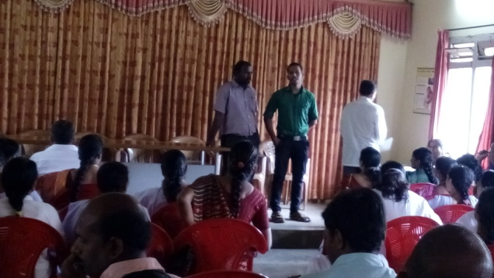
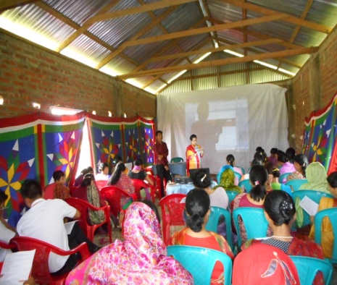 | 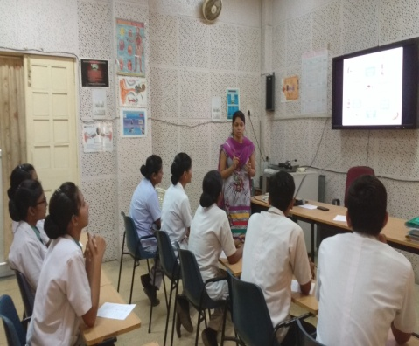 |  | 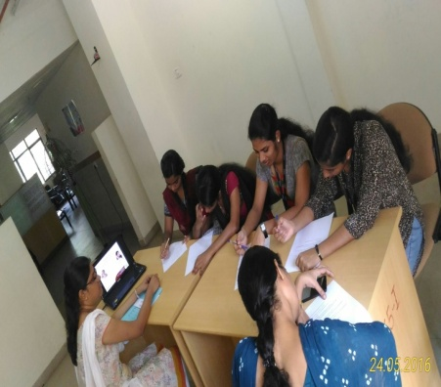
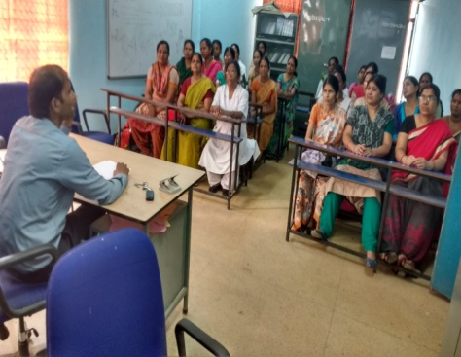 | 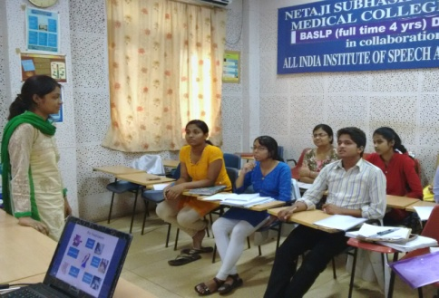 |  | 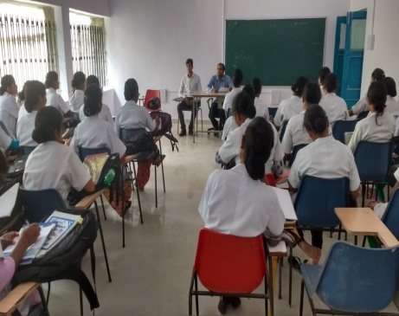

- Training programs conducted: 01
- At AIISH:
Table 2: Details of the training programs conducted during the year.
S. N | Date | Title of the training program | Target group | Resource persons | Organizers & Venue | Feed back
1 | 27.4.2016 | Induction training program for Professionals on Newborn Screening Program & Communication Disorders IV (through Skype) | Audiologists (Newly appointed NBS Staff members ) | Mr. Arunraj.K  & Ms. Sunitha. E | Dept of POCD & Audio visual Room | -

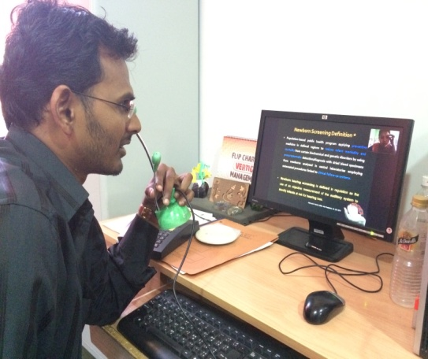 | 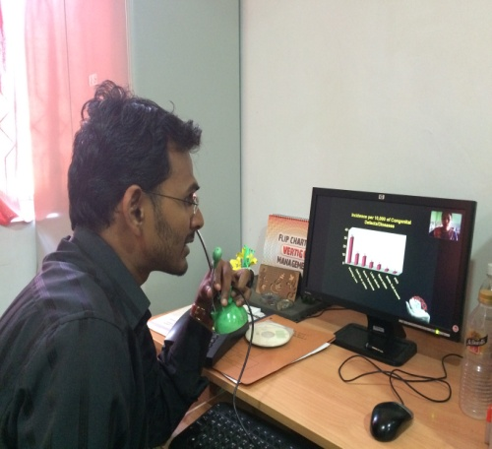

- Clinical Observation postings of students from other institutes: Nil

- No. of Seminars/ Conferences /Lectures /Workshop organized by the dept
- Seminars organized by the Department: Nil
- Workshops organized by the Department: Nil
- Conferences organized by the Department: Nil

E. No. of Seminars/ Conferences /Lectures /Workshop attended by the staff of the Dept
- Seminars attended by Staff of POCD: 02
Sl. No. | Date | Title of the program | Organized by | Staff attended
1 | 16th August 2016 | National Seminars on “Recent advancements in Implantable Hearing aids | Dept .of Audiology | Ms.Manjula C &Ms.Suman.S
2 | 17th August 2016 | National Seminars on “Optimization of Hearing aids. | Dept .of Audiology | Mr.Arun Raj.K & Ms.Zeena.V.P

- Conferences attended by Staff of POCD: Nil
- Workshops attended by Staff of POCD: Nil
F. No. of Guest Lectures organized: Nil

G. No. of Invited Talks delivered by faculty and staff: Nil

H. Any other:

- Student clinical training: As part of human resource development, Clinical training for under graduates (B.Sc Speech & Hearing), Post graduates (M.Sc- SLP) & Internship students on Early identification, prevention & rehabilitation of communication disorders and Community based rehabilitation at OSCs were carried out. The details on number of students who had undergone training are given below.
B.Sc students | 21
M.Sc students | 31
Internship students | 52

- Staff Enrichment Programs: Nil

- RESEARCH ACTIVITIES
a. Research Projects – Nil
b. Doctoral and Post-Doctoral Programs: Nil
c. Research papers presented in National conferences/seminars: Nil
d. Research papers presented at International conferences/seminars: Nil
e. Research Papers published in National Conference/Seminar Proceedings: Nil
f. Research Papers published in International Conference/Seminar Proceedings: Nil
g. Research Papers published in National Journals: 01
Shanbal, J. C., Arunraj. K., & Reddy, M. S. (2016). Distribution of communication disorders in primary school children, Journal of All India Institute of Speech and Hearing, 34, 128-133.

h. Research Papers published in International Journals: 01
- Reddy, M.S.B., Amulya.P.Rao., & Swapna.N. (2016). “Narrative Discourse in Persons with Parkinson’s Disease”, Speech Language and Hearing Journal (SLHJ), 19 (1), 1-9. ISSN: 2050-571X (Print) 2050-5728 (Online).
- Book / Chapters Published:02
“Newborn screening from Communication disorders: Occurrence of high risk factors for communication disorders using prospective and retrospective exploratory study – An outcome of NBS program” was prepared and was set to release for 9th August 2016 – Annual day celebrations of the institute
Editors: Dr. S. R. Savithri, Dr. Animesh Barman & Dr. Jayashree C. Shanbal
Prepared by: Mr. Arunraj K, Mr. Madhu Sudharshan Reddy & Ms. Sunitha E.

“School screening: Distribution of communication disorders in school children” was prepared and was set to release for 9th August 2016 – Annual day celebrations of the institute
Editors: Dr. S. R. Savithri, Dr. Jayashree C. Shanbal & Dr. Animesh Barman
Prepared by: Mr. Arunraj K, Mr. Madhu Sudharshan Reddy & Ms.Sunitha E.

j. Books / Manuals/ Seminar proceedings Edited:

k. Scholarly Reviewing Activities: Nil

- CLINICAL SERVICES

- General Clinical Services

- Follow-up evaluation

The newborns/infants referred during the newborn screening were followed up through telephone calls to parents/caregivers of infants. A complete test battery was administered for those clients who came for follow-up. Table 6 depicts the statistics related to this activity.
Table 3: Details of the results of follow-up evaluation for newborns and infants
Categories | AIISH + Cheluvamba | OSC-Sagara | Ajmer | Cuttack | Imphal | Puducherry | Ranchi | Jabalpur | Total
Normal | 149 | 1 | 24 | 23 | 14 | 44 | 23 | 13 | 291
ENT disorders | 15 | - | 4 | - | 06 | - | 6 | - | 31
Noisy | 12 | - | - | - | - | - |  | - | 12
Auditory Maturation delay | - | - | - | - | - | - | - | - | -
Hearing disorder | 48 | - | 18 | 25 | 31 | 10 | 03 | 16 | 151
Speech and language disorder | 07 | - | - | - | 10 | - | 2 | 10 | 29
Multiple | - | - | - | - | - | - | 4 | 4 | 8
Incomplete testing | 16 | - | 1 | 4 | 3 | 19 | - | - | 43
Total | 247 | 1 | 47 | 52 | 64 | 73 | 38 | 43 | 565

- Follow-up evaluation- Phone follow-up
The at-risk babies were monitored regularly by administering the speech-language & hearing checklist through a phone call. The babies who are identified with delay in the milestones were referred to AIISH/concern centre for detailed evaluation

Categories | Mysore | OSC-Sagara | Ajmer | Cuttack | Imphal | Puducherry | Ranchi | Jabalpur | Total
Normal speech, language and hearing milestones | 107 | - | 42 | - | - | - | 12 | - | 149
Referred for detailed evaluation | 5 | - | - | - | 2 | - | 02 | - | 07
Total | 112 | - | 42 | - | 2 | - | 14 | - | 126

- Hearing evaluation of industrial workers at AIISH:

Employees from different industries had undergone hearing evaluation at AIISH. All the registered employees were counseled regarding the importance of hearing protection devices and its need to use regularly in noisy conditions to protect their hearing ability. The details of the hearing evaluation of the employees are represented in Table 7.
Table 4: Number of ears identified as having hearing impairment
Month | Name of the Industry | Total Registered | Total no of ears identified as Hearing impairment | Normal (Ear wise)
April 2016 | Rane Madra Pvt.Ltd, Mysore | 8 | 8 | 0
July 2016 | KSIC, Mysore | 23 | 35 | 11
August2016 | KSIC, Mysore | 71 | 138 | 04

- Specialized Clinical services: Nil
- Clinical Support Services to Patients and Family: Nil
- Clinical Electronic Services: Nil
B) EXTENSION ACTIVITIES
- Rehabilitation and Education through Distant Mode: Nil

- Prevention of Communication Disorders
The department of POCD is actively involved in carrying out various extension activities such as screening, diagnostic and rehabilitation services outside the institute campus. The activities include newborn/infant screening, screening of school children, screening of elderly citizens, screening of industrial workers, conducting camps and also clinical services offered at the outreach service centers of AIISH.
Table 5: Total number of newborns/infants screened and identified at-risk for communication disorders.
SN | Hospitals/Immunization Centers |  | Total birth | Total No. Screened |  |  | Total No. at risk
 |  |  |  | Male | Female | Total | Male | Female | Total
 |  | AIISH- Mysore
1 | Apollo BGS Hospital (BAH), |  | 56 | 121 | 79 | 200 | 11 | 8 | 19
2 | Basappa Memorial Hospital (BMH) |  | Not available | 61 | 54 | 115 | 2 | 0 | 2
3 | Combined Hospital (CH) |  | Not available | 63 | 58 | 121 | 8 | 12 | 20
4 | Harsha Hospital (HH) |  | Not available | 19 | 28 | 47 | 0 | 2 | 2
5 | Kamakshi Hospital (KH) |  | Not available | 256 | 189 | 445 | 17 | 29 | 46
6 | KR Hospital (KRH)- Cheluvamba |  | Not available | 3443 | 3034 | 6477 | 311 | 355 | 666
7 | Makkalakoota Immunization Center (MIC) |  | Not available | 69 | 69 | 136 | 1 | 5 | 6
8 | Mission Hospital (MH)/ |  | 74 | 284 | 228 | 512 | 51 | 45 | 96
9 | Immunization Center at Mission Hospital (ICMH) |  | Not available | 14 | 2 | 20 | 0 | 0 | 0
10 | N.P.C Hospital |  | 209 | 33 | 24 | 57 | 0 | 0 | 0
11 | S.M.T.D.H Hospital |  | 60 | 321 | 265 | 586 | 22 | 21 | 43
12 | Railway Hospital (RH) |  | 32 | 16 | 15 | 33 | 0 | 2 | 2
13 | Employees State Insurance (ESI) Hospital |  | 14 | 8 | 4 | 12 | 0 | 0 | 0
14 | Ashwini Nursing Home (ANH) |  | Not available | 67 | 43 | 110 | 8 | 8 | 16
15 | Shree Devi Nursing Home (SNH) |  | Not available | 77 | 58 | 135 | 5 | 9 | 14
16 | GopalaGowdaShanthaveri Memorial Hospital (GGSMH) |  | 160 | 35 | 21 | 56 | 1 | 0 | 1
17 | Family Planning Association Immunization (FPAI) center |  | 19 | 6 | 4 | 10 | 0 | 0 | 0
18 | Mahadeshwara Nursing Home (MNH) |  | 304 | 36 | 56 | 92 | 6 | 10 | 0
19 | Sigma Hospital (SH) |  | 32 | 158 | 99 | 257 | 12 | 12 | 16
 | Total (Mysore hospitals) |  | 960 | 5087 | 4330 | 9421 | 455 | 518 | 949
 |  | OSCs of AIISH
20 | Sub-divisional hospital, K R Nagar Taluk |  | Not available | 171 | 159 | 330 | 19 | 10 | 29
21 | Sub-divisional hospital, T Narsipura Taluk |  | 90 | 130 | 107 | 237 | 7 | 19 | 26
22 | Sub-divisional Hospital, Sagara Taluk |  | 91 | 417 | 462 | 879 | 41 | 32 | 73
23 | Community Health Centre (CHC), Hullahalli |  | 18 | 145 | 129 | 274 | 18 | 10 | 28
24 | Community Health Centre (CHC), Santhemarahalli |  | Not available | 94 | 69 | 163 | 13 | 2 | 15
25 | Primary Health Centre (PHC), Akkihebbalu |  | Not available | 0 | 0 | 0 | 0 | 0 | 0
 | Total (OSCs) |  | 199 | 957 | 926 | 1883 | 98 | 73 | 171
 |  | NBS of AIISH
26 | Sri RamachandraBhanj Medical College and Hospital (SCB MCH), Cuttack |  | 2005 | 1169 | 874 | 2043 | 254 | 176 | 430
27 | Regional Institute of Medical Sciences (RIMS), Imphal |  | 773 | 1220 | 1156 | 2376 | 74 | 76 | 150
28 | Janana Hospital & JLNMCH, Ajmer |  | 2178 | 1640 | 1504 | 3144 | 328 | 266 | 476
29 | JIPMER, Puducherry |  | 4374 | 4255 | 3875 | 8130 | 425 | 339 | 764
30 | Netaji Subhash Chandra Bose Medical College (NSCB), Jabalpur |  | 473 | 1665 | 1328 | 2993 | 264 | 134 | 398
31 | Rajendra Institute of Medical Sciences, Baritayu, Ranchi |  | 1745 | 1817 | 1516 | 3333 | 84 | 76 | 776
 | Total (NBS centre’s) |  | 11548 | 11766 | 10253 | 22019 | 1429 | 1067 | 2994
 | Overall Total |  | 12707 | 17810 | 15509 | 33323 | 1982 | 1658 | 4114

- School screening :

Screening of preschool, primary school children were conducted focusing on the early identification of communication disorders and early rehabilitation of children at risk for communication disorders.
Table 6: Total number of children screened for communication disorders and identified.
Date | School | Total screened | Total identified with communication disorders
 |  |  | Ear related disorder | Hearing loss | Speech language disorders
20th April 2016 | Ashadayaka Seva trust, Metgalli, Mysore | 24 | 01 | 0 | 02
3rd June 2016 | Government Resedential School for special category | 92 | 24 | 01 | 07
6th June 2016 | Govt.Higher primary school | 41 | 05 | 00 | 01
7th June 2016 | Govt.Higher primary school, Jyothi nagar | 88 | 08 | 00 | 11
9th June 2016 | Govt.Higher primary school, Gokulam | 28 | 06 | 00 | 01
10th June 2016 | Govt.Higher primary school, Jyothi nagar,Giriya Palya | 114 | 01 | 00 | 05
13th June 2016 | Govt.Higher primary school, Jyothi nagar | 76 | 09 | 00 | 01
14th June 2016 | Govt.Lowerprimary school | 58 | 02 | 00 | 07
17th June 2016 | Govt.Higher primary school,Medar’s block | 83 | 07 | 00 | 08
1st July 2016 | GHPS, Medar’s Blcok, Mysore | 83 | 0 | 0 | 5
12th July 2016 | GHPS, Padavaralli | 22 | 0 | 3 | 1
16th & 28th July 2016 | GLPS, Vontikoppal | 175 | 0 | 5 | 14
8th August 2016 | GHPS 3rd Infantry | 89 | 06 | - | 09
19th August 2016 | GHPS Tilak nagar | 61 | 05 | - | 11
22nd August 2016 | Urdu GHPS,Udaygiri | 68 | - | - | 02
26th August 2016 | Vivekananda GHPS | 114 | 24 | 05 | 07
26th August 2016 | Nagarthanhalli GHPS | 53 | 19 | 07 | 07
26th August 2016 | Mooganahalli GHPS | 53 | 22 | 02 | 04
29th August 2016 | M.G.Koppal GHPS | 187 | 00 | 00 | 06
Total |  | 1509 | 139 | 23 | 109
iv. Hearing screening of Industrial employees:
Month | Name of the Industry | Total Registered | Total no of ears identified as Hearing impairment | Normal (Ear wise)
May 2016 | GRS Engineering Pvt Ltd. | 17 | 20 | 14
6th 20th & 27th June 2016 | GRS Engineering Pvt Ltd, Mysore | 60 | 61 | 59
8th June 2016 | Hindustan Petroleum Pvt Ltd, Mysore | 115 | 66 | 164
29th June 2016 | Government Printing press, Mysore | 39 | 20 | 58
6th July 2016 | GRS Engineering pvt.Ltd | 92 | 66 | 118
20th July 2016 | Govt. Printing Press | 72 | 66 | 78
Total |  | 395 | 299 | 491

V. Clinical services for the elderly citizens:
The elderly individuals may show a gradual decline in their hearing, cognition, speech and language abilities due to aging or any other conditions such as stroke (CVA), Alzheimer’s disease, Parkinson’s disease, etc. This program is regularly conducted to facilitate identification and rehabilitation of any form of communication disorders in the elderly individuals. Clinical services were offered at various old-age homes in terms of identification of communication disorders, rehabilitation through speech and language therapy, guidance and distribution of free body level hearing aids.
Table 7: Total number of elderly citizens screened, identified and rehabilitated for Communication disorders
Old age homes | Date | Total screened | Total identified with communication disorders
 |  |  | Hearing disorders | Speech language disorders | Multiple disorders | Hearing aids issued
Chayamatha Vrudhashrama trust, Mysore | 13th April 2016 | 07 | 05 | 0 | 0 | 03
Nele Old age home, Mysore | 15th April 2016 | 13 | 11 | 1 | 0 | 03
Shalini Oldage Home, Mysore | 20th May 2016 | 07 | 05 | 0 | 0 | 01
Belaku Vasthalyadhama Oldage home | 16th June 2016 | 06 | 04 | 0 | 0 | 0
Vasavishanthidhama | 27.07.2016 | 17 | 06 | 04 | 00 | 00
Total |  | 50 | 31 | 5 | 0 | 7

vi. Camps:
- Camp has been conducted at Ramkrishna Mission School, Sagara organized by bharateshwara charitable trust on 28.5.2016. Mr. Mohan Das and Mr. Thareeque attended the camp. Details are mentioned below.

OSC, Sagara | Total registered | ENT Evaluation |  | Hearing Evaluation |  | Speech & Language Evaluation
 |  | Normal (Ear Wise) | Disorder (Ear wise) | Normal (Ear Wise) | Disorder (Ear wise) | Normal (Individuals) | Disorder (Individuals)
Sub-divisional Hospital (PHC), Sagara | 53 | 75 | 29 | 62 | 42 | 0 | 1
11th July 2016 (Hunsur) | 36 | 72 | 0 | 45 | 27 | 46 | 26
16th July 2016 (Mariyanikathana) | 56 | 112 | 0 | 41 | 71 | 06 | 50
22nd July 2016 (Nanjangud) | 28 | 37 | 0 | 16 | 31 | 17 | 11
23rd July 2016 (K.R.Nagar) | 21 | 42 | 0 | 12 | 29 | 01 | 20
31st August 2016 (Osc Sagara) | 24 | 22 | 0 | - | - | - | 4
Total | 165 | 283 | 00 | 126 | 187 | 71 | 111

Camps attended by Dr.Mahadevappa from the Dept in the month of July:
Date | Total registered | ENT Evaluation
 |  | Normal (Ear Wise) | Disorder (Ear wise)
1st July 2016 (Chamarajanagar) | 96 | 00 | 80
8th July 2016 (Hunsur) | 108 | 00 | 89
15th July 2016 (Pandavapura) | 121 | 00 | 102
22nd July 2016 (Chamarajanagar) | 99 | 00 | 76
29th July 2016 (Hunsur) | 188 | 00 | 161
5th August 2016 | 172 | 10 | 57
12th August 2016 | 156 | 6 | 44
19th August 2016 | 192 | 7 | 95
Total | 1132 | 23 | 704

vii. Clinical Services at Outreach Service Centers (OSCs):

The clinical activities are not only restricted to in and around Mysore, but also extended to rural areas where facilities for clinical services for persons with communication disorders were meager. Currently 04 OSCs (01 sub-divisional taluk hospital at Sagara taluk, Shivamogga District; 03 Primary Health Centre - PHC at Hullahalli, Mysuru district; Akkihebbalu, Mandya district & Karuna trust, Gumballi, Chamarajanagara district) were initiated to meet the objective of extending the services of the institute to rural areas. The OSCs are functioning as a well-equipped unit for screening, diagnostics and therapeutic services for persons with communication disorders. The services include screening, diagnostic and rehabilitation which includes newborn/infant screening, screening of school children, Speech and Language evaluation, Audiological evaluation, ENT evaluation, Speech-Language therapy, issue of free body level hearing aids and ear molds, and counseling and guidance to individuals with communication disorders. The other details are tabulated below in tables 13 & 14.

Table 8: Details of clients identified with communication disorders at the OSCs.
OSC | Total registered | ENT Evaluation |  | Hearing Evaluation |  | Speech & Language Evaluation
 |  | Normal (Ear Wise) | Disorder (Ear wise) | Normal (Ear Wise) | Disorder (Ear wise) | Normal (Individuals) | Disorder (Individuals)
Primary Health Centre (PHC), Hullahalli | 272 | 55 | 280 | 11 | 70 | 53 | 02
Primary Health Centre (PHC), Akkihebbalu | 169 | 23 | 184 | 3 | 34 | 22 | 05
Primary Health Centre (PHC), Gumballi | 332 | 99 | 344 | 6 | 151 | 62 | 11
Sub-divisional Hospital (PHC), Sagara | 456 | 414 | 365 | 45 | 297 | 1 | 9
Total | 1229 | 591 | 1173 | 65 | 552 | 138 | 27

Table 9: Rehabilitation services provided at Outreach service centres
OSC | Hearing Aids Dispensed | Speech-language therapy
 |  | No. of clients | No. of sessions
Primary Health Centre (PHC), Hullahalli | 08 | 8 | 18
Primary Health Centre (PHC), Akkihebbalu | 06 | 19 | 76
Primary Health Centre (PHC), Gumballi | 06 | 13 | 11
Sub-divisional Hospital, Sagara (PHC) Taluk | 12 | 63 | 342
Total | 32 | 103 | 447

4. CENTRAL FACILITIES-

- Library and information services – Nil
- Public Information Activities –

- Exhibition- Nil
- All India radio talks- 01
- Dr. Jayashree C Shanbal, Reader, dept of SLP delivered a talk on “communication disorders in school children” on 23.3.2016 in the All India Radio (AIR-100.6 MHz) which was broadcasted on 8th April 2015 at 4.00 PM.
- Street Plays- 02
The Department of POCD conducted Seven street plays on various disorders to the public emphasizing on prevention and early identification of communication disorders in the reported year. Details are mentioned below.
Sl.No | Date | Theme of the Street Play | Target group | Total | Place | Enactors
1 | 30th  April 2016 | Prevention of Communication Disorders | General Public | 60 | T.N.Pura | Internship Students batch 2015-2016
2 | 30th  April 2016 | Prevention of Communication Disorders | General Public | 70 | Talakadu | Internship Students batch 2015-2016

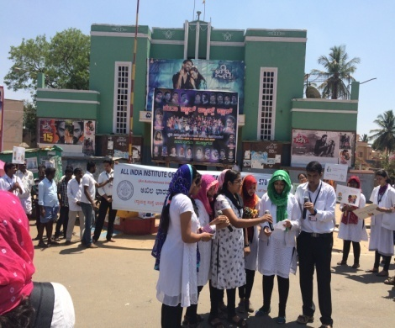 | 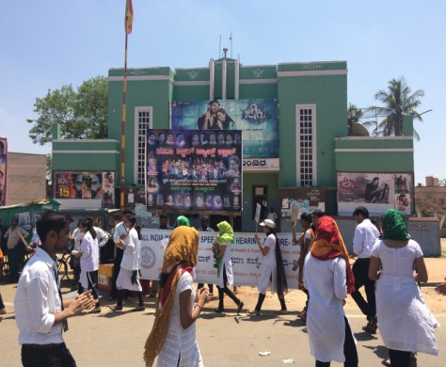 | 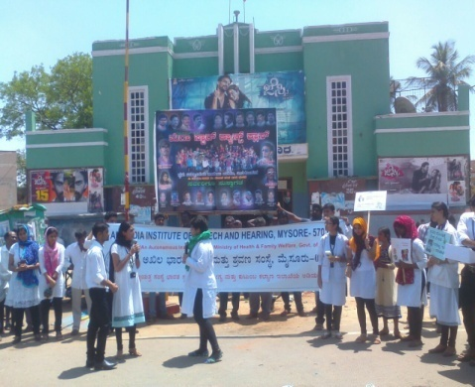
Introductory note | Gathering public | Enacting in street play
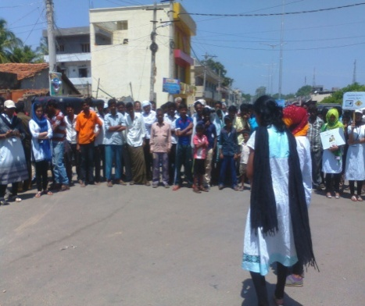 | 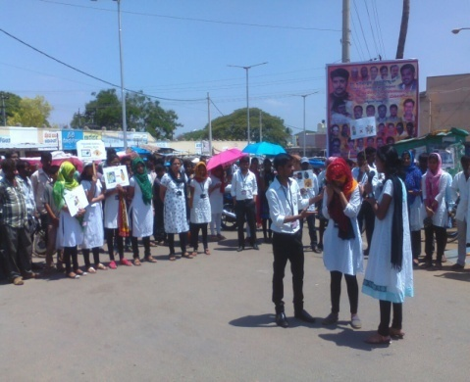 | 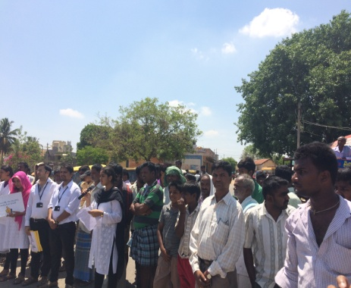
Enacting in street play | Enacting in street play | General public
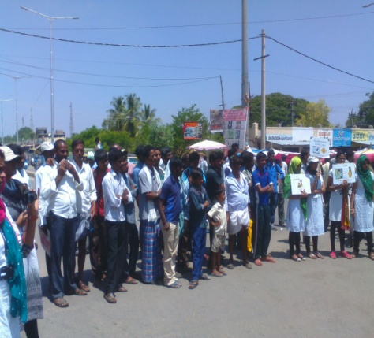 | 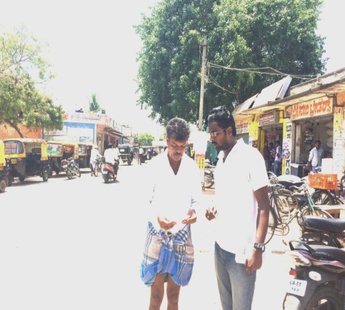 | 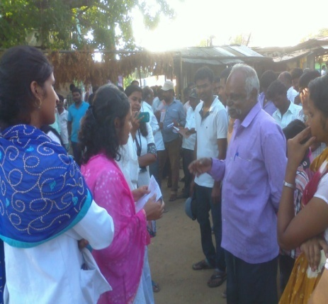
General public | Distribution of PEPs | Interaction with public

4. Public Lecture Series: Nil
5. Press Releases and Media Coverage: Nil
iii. Material Development–
- Public education pamphlets : 06

Two pamphlets named “Fluency & its disorders” & “Developmental delay” was designed in the month of April 2016.
Four pamphlets named Ear Discharge & its Prevention, Fluency Disorders, Attention Deficit Hyperactivity Disorder and Learning Disability & Aphasia were designed in the month of August 2016.

iv. AWARDS AND HONOURS RECEIVED BY FACULTY AND STAFF:
V. TECNOLOGICAL CONSULTANCY SERVICES: Nil
Vi. EXTRA CURRICULLAR ACTIVITIES: Nil
Vii. VISITORS-
Date | Name of the Visitors | Designation
26.4.2016 | Mr. Shankar | Central Auditor, AIISH, Mysore
18.5.2016 | Shri. R S.Negi | Member Secretary, MoH & FW, GOI.
9.08.2016 | Dr. Praksah  Dr. Gangadhar | Former director, CFTRI  Director, NIMHANS
12.08.2016 | Dr. Vinod Aggarwal  Dr. Subodth Kumar | Chairperson – RCI & Secretary, Dept. of empowerment of PWD, New Delhi  Ex-Member Secretary, RCI

Viii. MAJOR EVENTS OF THE MONTH:
- Released 02 statistical reports during 9th August 2016 on the occasion of Annual day
- NBS report titled “Newborn screening from Communication disorders: Occurrence of high risk factors for communication disorders using prospective and retrospective exploratory study – An outcome of NBS program” coordinated by Dr. Animesh Barman
- School Screening report titled “School screening: Distribution of communication disorders in school children” coordinated by Dr. Jayashree C. Shanbal
- Released 05 PEPs in English on various communication disorders coordinated by Dr. Jayashree C. Shanbal

ix. OTHERS:
1 Dept. Related:
- The ISO Certifying Agency visited the department for Surveillance Audit -2 on 04.04.2016.
- MoU has been received from NBS-Cuttack centre in the month of April 2016.
- ABR testing has been initiated in Cheluvamba Hospital with effective from 18th May 2016.
- Sent a request to ICMR for granting funds to organize a national level seminar on Newborn screening: Initiatives towards early identification and prevention of communication disorders
2. OSC related- Nil
3. NBS related - Nil
4. Recruitment/Relief of duties- Nil
- The following staff members completed their contract term and were relieved from their duties in the Department of POCD
Staff on contract basis | Designation | Relieved on
Ms. Praveena. J | Audiologist grade I | 30th March 2016
Ms. Suchi Soni | Audiologist grade I | 24th June 2016
Mr.Madhu Sudharshan Reddy | SLP Grade I | 10th August 2016

- The following staff members were recruited on contract basis in the Department of PoCD
Staff on contract basis | Designation | Reported on
Ms. Praveena. J | Audiologist grade I | 6th April 2016
Mr. Aravind Palaria | Speech and Hearing assistant | 19th April 2016
Ms. Stephy Lancy | ASLP Grade II | 04th August 2016

5. Staff duties related:
Major events/duties carried out by staff of POCD
Dr. Animesh Barman | - Organizing and conducted street play under the theme “Prevention of Communication disorders” on 30th April 2016.  - Attended the External ISO Surveillance Audit -2 which was done on 04.04.2016 for the department.  - Attended Bi-monthly HOD meeting and presented the statistics for the months of March & April 2016.  - Preparation of RE-BE 2016-17 & 2017-18  - Preparation of Project Proposal for New OSC at Saragur  - Preparation of approval letter for outsourcing the Public Education Materials
Dr. Jayshree C Shanbal | - Assisted in preparation and finalization of scripts for street play under the theme “Prevention of Communication disorders” which was enacted on 30th April 2016.  - Assisted in preparation of NBS report  - Attended the External ISO Surveillance Audit -2 which was done on 04.04.2016 for the department.  - Assisted in preparation of outsourcing the Public Education Materials  - Assisted in preparation of NBS report
Mr. Arunraj.K | - Delivered a talk on “Protocols for newborn screening and its referral criteria” through Skype/team viewer on 27th April 2016.  - Attended the External ISO Surveillance Audit -2 which was done on 04.04.2016 for the department.  - Assisted in preparation of RE-BE 2016-17 & 2017-18  - Assisted in Project Proposal for New OSC at Saragur  - Assisted in Preparation of NBS training report  - Preparation of NBS staffs performance analysis report through NBS program
Mr. Madhu Sudharshan Reddy | - Assisted in preparation of NBS report  - Attended the External ISO Surveillance Audit -2 which was done on 04.04.2016 for the department.  - Assisted in preparation of RE-BE 2016-17 & 2017-18  - Assisted in Project Proposal for New OSC at Saragur  - Assisted in Preparation of NBS & School screening report  - Scientific papers published in international journal-  - Reddy, M.S.B., Amulya. P.R., & Swapna. N. (2016). “Narrative Discourse in Persons with Parkinson’s Disease”, Speech Language and Hearing Journal (SLHJ), 19 (1), 1-9. ISSN: 2050-571X (Print) 2050-5728 (Online).
Ms. Sunitha. E | - Assisted in preparation of stock verification report of OSC & NBS centres  - Delivered a talk on “Primitive reflexes, follow-up program and record maintenance” through Skype/team viewer on 27th April 2016.  - Organized NBS monthly meeting through video conferencing on 22nd April 2016  - Oriented the activities of dept to Mr. Shankar, central auditor, AIISH, Mysore  - Attended the External ISO Surveillance Audit -2 which was done on 04.04.2016 for the department.  - Assisted in preparation of RE-BE 2016-17 & 2017-18  - Assisted in preparation of project Proposal for New OSC at Saragur  - Assisted in Preparation of NBS training report which was held on 27th April 16  - Assisted in preparation of NBS staffs performance analysis report  - Assisted in preparation of approval letter for outsourcing PEP’s.
Ms. Zeena. V.P | - Writing of Justification to organize the “National Workshop on Effects of Noise & implementation of Hearing Conservation Program”
Head, Dept. of POCD

