ALL INDIA INSTITUTE OF SPEECH & HEARING: MYSORE – 570 006
DEPARTMENT OF SPECIAL EDUCATION
April Monthly Report 2016
- ACADEMIC ACTIVITIES
- Short-term Training Programs: NIL
- Orientation Programs: 02
Name/Topic of the Program | Coordinator | Objectives | Targeted Audience | Number of Participants | Date
- Orientation on Preschool Training for Children with Communication Disorders | Mr.Harish Kumar Mr. Gururaj D., Mr.Subramanya, Mr. Sharanaiah M.M. | Developing awareness on preschools education for Children With Special Needs | Mainstream school teachers | 125 teachers | 01.04.2016
- Orientation on Preschool Training for Children with Communication Disorders | Mr. Gururaj D., | Developing awareness on preschools education for Children With Special Needs | B.Ed students, Bharathi B.Ed college, K.M. Doddi, Mandya | 60 students and 4 staffs | 01.04.2016
- Clinical/Special Educational services- Observation Posting of Students from other Institutes: NIL
- Students of RIE observed prayer, pre-academic session of Ms. Vijayalakshmi and Knowledge sessions of Ms. Manjula P.V on 5th May, 2016.
- Seminars/Conferences/Workshops: NIL
- In- house training Programs:
Theme/title of the event | Facilitating for successive transition from Pre-  School to Mainstream School
Coordinator | Ms. Vijayalakshmi. S, Ms. Sreevidya, Ms. Asha Suresh. E.G,  Mr. Subramanyya K.R
Objectives | To Empower the parents of the outgoing batch children regarding transition from Pre-school to Mainstream school
Targeted Audience | Caregivers of outgoing children
Number of Participants | 85
Date | 28.04.2016
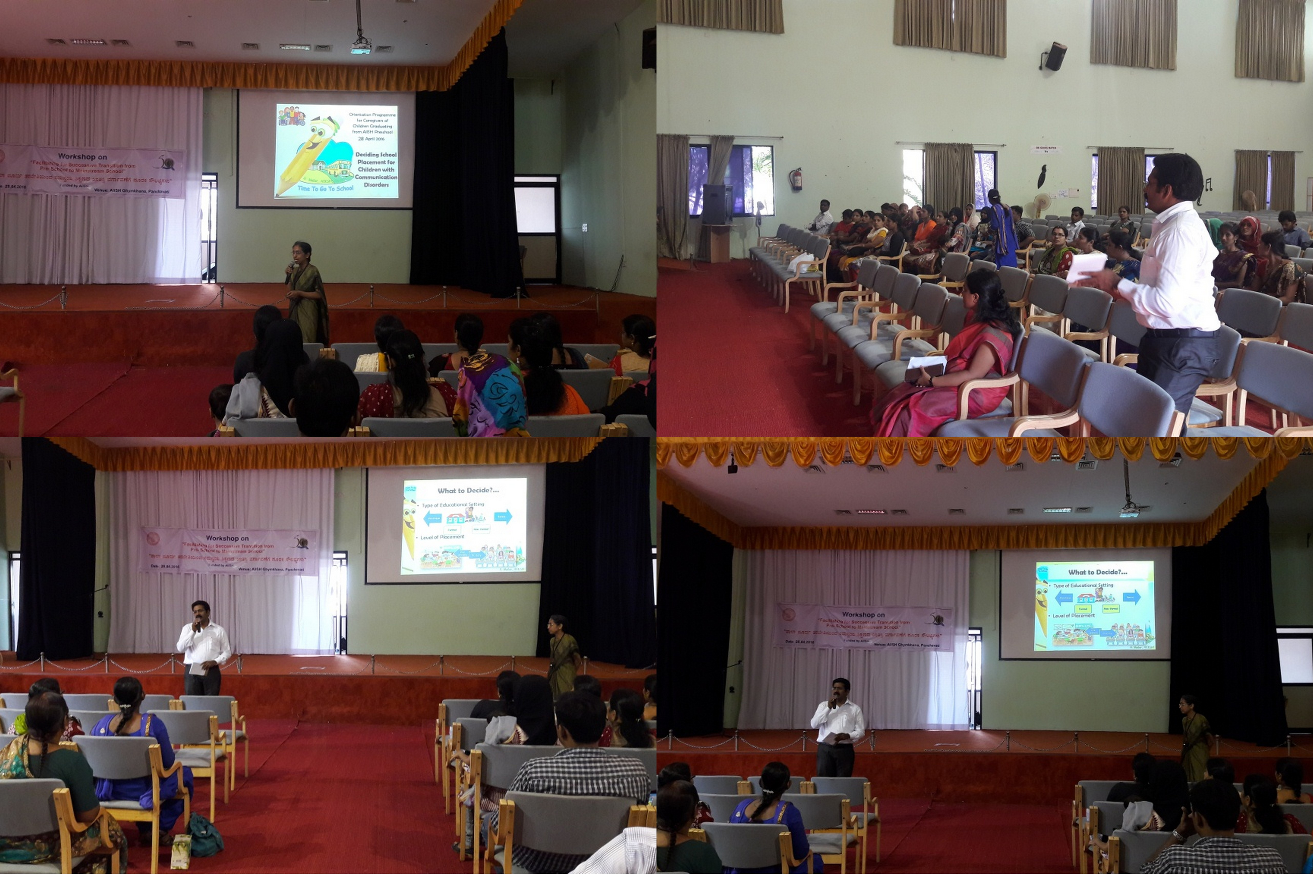
- E³ : Empowering Educators in Education: NIL
- Staff Enrichment Programs (SEP’s) : NIL
- Guest Lectures :
Workshop for Facilitating Successful Transition from Preschool to Mainstream School of Outgoing Children of Preschool was held on 28.04.2015. The following faculties served as resource person.

SL No. | Resource person | Topic
1 | Dr. Ajish K. Abraham | Trouble shooting of hearing aids in the inclusive classroom set-up
2 | Mr. Freddy Antony | Stress management
3 | Ms. Geetha C. | Listening skill in inclusive classroom set up
4 | Ms. Prathima | Tips to facilitate Speech, Language in the inclusive classroom setup
5 | Ms. Yashashwini | Tele Rehabilitation
- Invited Talks:

Workshop for Facilitating Successful Transition from Preschool to Mainstream School of Outgoing Children of Preschool was held on 28.04.2015. The following faculties served as resource person.
SL No. | Resource person | Topic
1 | Dr. G. Malar | Appropriate School Placement
2 | Dr. Prithi Venkatesh | Barriers in school environment and management of those barriers
3 | Mr. Gururaj D. | Welfare measure available for children with special needs

- Development of Materials to Support Learning
- Dr. Malar G.
- Training materials in primary school mathematics during postings at TCPD
- Service in Academic bodies of other Organizations- NIL
- Membership in Professional Organizations/Associations - NIL
- Participation in Committees/Taskforce and Panels setup by other organizations/agencies
Sl No | Name of the staff | Name of Organization/Agency | Participation in Committees/Taskforce | Programme | Name of Institute Visited | Date of Visit
1 | Dr. Alok Kumar Upadhyay | Rehabilitation Council of India, New Delhi | As visiting expert of Inspection Committee | B.Ed Spl Edn(HI)  M.Ed Spl Edn (HI) | Ali Yavar Jung National Institute for Hearing Handicapped, Bandra, Mumbai | 04.04.2016

- Any Other(Please Specify) - NIL
- RESEARCH ACTIVITIES
- Research Projects
- Completed Research Projects
- New Research Projects:
- On-going Research Project : 01
Investigators | Title & Other important details | Progress
PI :  Dr. Palnaty Vijetha  CIs:  Dr. G. Malar  Mr. Rajkumar R. ,  Ms. Leelarani S.B.  RO: Ms. Shaik Gulab Jan | Efficacy of self-learning adapted social studies lessons in Kannada and Telugu for children with hearing impairment at Secondary School Level’  Duration: One year  Date of commencement: 8th January 2016-04-15  Budget sanctioned: Rupees 3,25,000/ | - Contacted selected schools and oral permission has been sought  - Literature review is being carried out  - First drafts of Adapted materials in Kannada and Telugu is being prepared  - Letters request for data collection to school principals is sought  - Discussed about method with Reader in Statistics (Dr. Vasanthalakshmi)

- Doctoral and Post-Doctoral Programs
- Degree Awarded
Thesis awarded:
- Thesis Submitted:
- Under Progress: 04
Name of the student | Title | External/internal | Guide | Date of initiation | Status
Deepak Kr. Tripathi | Uttar Pradesh kevisheshthathasamekithvidyalayon me adhyanthathshravanachambalankokibhashavikaskatulnathmakahyan | External | Dr.Alok Kr. Upadhyay | 2011 | In Progress
VijetaRai | Effect of peer tutoring and curriculum adaptation for  D.H.H. children in inclusive steps: an experimental study | External | Dr.Alok Kr. Upadhyay | 2012 | In Progress
Neetu  Pandey | A study on communication options for Deaf & Hard of  Hearing used in Inclusive and Non-inclusive set up. | External | Dr.AlokKr. Upadhyay | 2012 | In Progress
Niranjan  Singh | Uttar Pradesh keSamavesibatavaran main adhayanratshravanachamchatrao main manobagyanikprakriyasambandhi vicar se utapansakshiksamasayaonkaadhyan. | External | Dr.Alok Kr. Upadhyay | 2012 | In Progress
- Research Papers presented at National/International Conferences/Seminars.
- Research Papers Published(in APA format):NIL
    - Papers published in Conference/Seminar Proceedings
    - Research Papers in press- NIL
    - Research Papers published in Journals:
    - No. of in-house journal articles:

- Books published.
- Book chapters published(in APA format)-NIL
- Books in press :
- Books/Manuals/Seminar Proceedings edited
- Journal Editorship
- Scholarly Reviewing Activities
- Reviewer for Scholarly Journals
- M.S.Ed (HI) Dissertations Guided by Faculty
- SPECIAL EDUCATIONAL SERVICES
- Pre-School Training and Special Education
  - Monthly Statistics Special Educational Services

S. No. | Nature of Services (I/C)
Special Educational Assessment Services (Dr. G. Malar)
 |  | Nature of Special Need  Language |  |  |  |  |  |  |  | ASD / PDD NOS |  |  | Hearing Loss |  |  |  | Intellectual Disability |  |  | Learning Disability |  |  | Motor Problems |  |  | Multiple Disabilities |  |  |  | Others | No. of Clients | No. of Sessions |  | Total No. of Sessions
1. | Screening & Referral | Kannada |  |  |  |  |  |  |  | 2 |  |  | 18 |  |  |  | 3 |  |  | - |  |  | 2 |  |  | 9 |  |  |  | 8 | 42 | 42 |  | 69
1. | Screening & Referral | Malayalam |  |  |  |  |  |  |  | 1 |  |  | 2 |  |  |  | 6 |  |  | - |  |  | 2 |  |  | 3 |  |  |  | 3 | 17 | 17 |  | 69
1. | Screening & Referral | Hindi |  |  |  |  |  |  |  | - |  |  | 4 |  |  |  | - |  |  | - |  |  | 1 |  |  | - |  |  |  | - | 5 | 5 |  | 69
1. | Screening & Referral | Urdu |  |  |  |  |  |  |  | - |  |  | - |  |  |  | - |  |  | - |  |  | - |  |  | - |  |  |  | - | - | - |  | 69
1. | Screening & Referral | English |  |  |  |  |  |  |  | - |  |  | - |  |  |  | - |  |  | - |  |  | - |  |  | - |  |  |  | 2 | 2 | 2 |  | 69
1. | Screening & Referral | Telugu |  |  |  |  |  |  |  | - |  |  | 2 |  |  |  | - |  |  | - |  |  | - |  |  | - |  |  |  | - | 2 | 2 |  | 69
1. | Screening & Referral | Tamil |  |  |  |  |  |  |  | 1 |  |  | - |  |  |  | - |  |  | - |  |  | - |  |  | - |  |  |  | - | 1 | 1 |  | 69
1. | Screening & Referral | Any Other |  |  |  |  |  |  |  | - |  |  | - |  |  |  | - |  |  | - |  |  | - |  |  | - |  |  |  | - | - | - |  | 69
1. | Screening & Referral | Total No. of Clients |  |  |  |  |  |  |  | 4 |  |  | 28 |  |  |  | 9 |  |  | - |  |  | 5 |  |  | 12 |  |  |  | 13 | 69 | 69 |  | 69
2. | Assessment & Report | Kannada |  |  |  |  |  |  |  | - |  |  | 10 |  |  |  | - |  |  | - |  |  | 1 |  |  | 4 |  |  |  | - | 15 | 45 |  | 72
2. | Assessment & Report | Malayalam |  |  |  |  |  |  |  | - |  |  | - |  |  |  | 5 |  |  | - |  |  | - |  |  | 1 |  |  |  | - | 6 | 18 |  | 72
2. | Assessment & Report | Hindi |  |  |  |  |  |  |  | - |  |  | 2 |  |  |  | - |  |  | - |  |  | 1 |  |  | - |  |  |  | - | 3 | 9 |  | 72
2. | Assessment & Report | Urdu |  |  |  |  |  |  |  | - |  |  | - |  |  |  | - |  |  | - |  |  | - |  |  | - |  |  |  | - | - | - |  | 72
2. | Assessment & Report | Telugu |  |  |  |  |  |  |  | - |  |  | - |  |  |  | - |  |  | - |  |  | - |  |  | - |  |  |  | - | - | - |  | 72
2. | Assessment & Report | Tamil |  |  |  |  |  |  |  | - |  |  | - |  |  |  | - |  |  | - |  |  | - |  |  | - |  |  |  | - | - | - |  | 72
2. | Assessment & Report | Any Other |  |  |  |  |  |  |  | - |  |  | - |  |  |  | - |  |  | - |  |  | - |  |  | - |  |  |  | - | - | - |  | 72
2. | Assessment & Report | Total No. of Clients |  |  |  |  |  |  |  | - |  |  | - |  |  |  | - |  |  | - |  |  | - |  |  | - |  |  |  | - | 24 | 72
2. | Places from which seen: (1)Karnataka: 45 (2)Kerala: 18 (3)AP: 3 (4)TN: 2 (5)Other Parts of India: 1 (W. Bengal) (6)Any other: Nil
2. | Age groups seen:(1)Birth to 2.5yrs: 10 (2)2.5+ to 6 yrs: 16 (3)6yrs+ to 16 years: 19 (4)16yrs+: Nil
2. | Total No. of Referrals: (1)Educational Assessment: 26 (2)Educational Guidance: 3 (3)PIP: 10 (4)PPEP: 14 (5)PBC/GECS: Nil (6)CSS/IEP/NFE/DET: 40 (7) Any Other Services at AIISH: 24 (clinical therapy) (8) Any other Services outside AIISH: 24 (Mainstreaming)
2. | No. of Reports Issued: (1) Early Development Skills: Nil (2) School Readiness: 24 (3) Curriculum-Based Assessment: Nil (4) Post-School Preparedness: Nil
3. | On-going Assessment (as part of service delivery) |  |  |  | Figure: 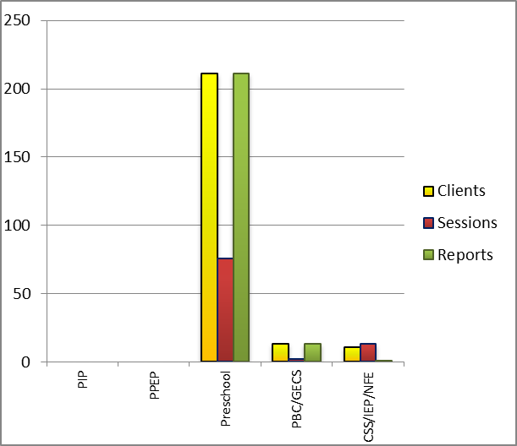
 | Details of Assessments |  |  |  | No. of Children |  |  |  |  |  |  |  |  |  |  | No. of Assessment Sessions |  |  |  |  |  |  |  |  |  |  | No. of Reports
 | As part of Parent-Infant Programme: |  |  |  | Nil |  |  |  |  |  |  |  |  |  |  | Nil |  |  |  |  |  |  |  |  |  |  | Nil
 | As part of Preschool Parent-Empowerment Programme: |  |  |  | Nil |  |  |  |  |  |  |  |  |  |  | Nil |  |  |  |  |  |  |  |  |  |  | Nil
 | As part of Preschool Training Programme: |  |  |  | 211 |  |  |  |  |  |  |  |  |  |  | 76 |  |  |  |  |  |  |  |  |  |  | 211
 | As part of Preschool Bridge Course Programme: |  |  |  | 13 |  |  |  |  |  |  |  |  |  |  | 2 |  |  |  |  |  |  |  |  |  |  | 13
 | As part of CSS/ IEP/NFE: |  |  |  | 04 |  |  |  |  |  |  |  |  |  |  | 05 |  |  |  |  |  |  |  |  |  |  | Nil
Parent-Infant Programme – PIP (Birth to 2 ½ years)
Early stimulation programme for infants & toddlers with communication disorders |  |  |  | Language |  |  | HL |  | IC |  | CP |  |  | ASD |  |  |  | MD |  |  | LD |  |  | DD |  |  |  | Total No. of clients |  |  |  |  | Total No. Of sessions
 |  |  |  | Kannada |  |  | 06 |  | -- |  | 01 |  |  | 01 |  |  |  | 02 |  |  | -- |  |  | 02 |  |  |  | 12 |  |  |  |  | 58
 |  |  |  | Malayalam |  |  | 06 |  | -- |  | -- |  |  | -- |  |  |  | 03 |  |  | -- |  |  | 06 |  |  |  | 15 |  |  |  |  | 43
 |  |  |  | Hindi |  |  | -- |  | -- |  | -- |  |  | -- |  |  |  | -- |  |  | -- |  |  | 01 |  |  |  | 01 |  |  |  |  | 04
 |  |  |  | English |  |  | 01 |  | -- |  | -- |  |  | -- |  |  |  | -- |  |  | -- |  |  | -- |  |  |  | 01 |  |  |  |  | 08
 |  |  |  | Telugu |  |  | -- |  | -- |  | -- |  |  | -- |  |  |  | -- |  |  | -- |  |  | -- |  |  |  | 00 |  |  |  |  | 00
 |  |  |  | Tamil |  |  | -- |  | -- |  | -- |  |  | -- |  |  |  | -- |  |  | -- |  |  | -- |  |  |  | 00 |  |  |  |  | 00
 |  |  |  | Total |  |  |  |  |  |  |  |  |  |  |  |  |  |  |  |  |  |  |  |  |  |  |  | 29 |  |  |  |  | 113
Specific age range:
No. Of New clients enrolled: 08
No. discharged : NIL
No. discontinued: NIL
No. of Promoted to next level: NIL
Preschool Parent Empowerment Programme – PPEP (Ms. Kumudha R.):
Buffer programme for children awaiting for preschool admission |  |  | Language |  |  | HL |  | ID |  |  |  | CP |  |  | ASD |  |  |  | MD |  |  | LD |  |  | DD |  |  |  | Total No. of clients |  |  |  | No. Of sessions
 |  |  | Kannada |  |  | 47 |  | 09 |  |  |  | 02 |  |  | 02 |  |  |  | 09 |  |  | -- |  |  | -- |  |  |  | 69 |  |  |  | 38
 |  |  | Malayalam |  |  | 11 |  | 08 |  |  |  |  |  |  | 07 |  |  |  | 05 |  |  |  |  |  |  |  |  |  | 31 |  |  |  | 38
 |  |  | Hindi |  |  | 07 |  | 02 |  |  |  |  |  |  |  |  |  |  |  |  |  |  |  |  |  |  |  |  | 09 |  |  |  | 38
 |  |  | English |  |  | 01 |  | 01 |  |  |  |  |  |  | 2 |  |  |  |  |  |  |  |  |  |  |  |  |  | 04 |  |  |  | 38
 |  |  | Telugu |  |  | 06 |  | -- |  |  |  | -- |  |  | -- |  |  |  | -- |  |  | -- |  |  | -- |  |  |  | 06 |  |  |  | 19
 |  |  | Tamil |  |  | 03 |  | -- |  |  |  | -- |  |  | -- |  |  |  | -- |  |  | -- |  |  | -- |  |  |  | 03 |  |  |  | 19
Total |  |  |  |  |  |  |  |  |  |  |  |  |  |  |  |  |  |  |  |  |  |  |  |  |  |  |  |  | 122 |  |  |  | 190
No. of clients promoted to the next higher level of service: NIL
No. discharged : NIL
No. discontinued: 01

Services for Preschool-aged Children (2+ to 6 years)
Group Educational Guidance & Counselling Services – GEGCS (Mr.Rajkumar.R): Non-formal preschool training children with communication disorders for schooling | Language | HL | IC | CP | ASD | MD | LD | DD | Total No. of clients | No. Of sessions
 | Kannada | -- | -- | -- | -- | -- | -- | -- | -- | --
 | Malayalam | -- | -- | -- | -- | -- | -- | -- | -- | --
 | Hindi | -- | -- | -- | -- | -- | -- | -- | -- | --
 | English | -- | -- | -- | -- | -- | -- | -- | -- | --
 | Telugu | 2 | 1 |  | 2 | 1 |  |  | 6 | 21
 | Tamil | -- | -- | -- | -- | -- | -- | -- | -- | --
Total |  |  |  |  |  |  |  |  | 6 | 21
No. discharged : NIL
No. discontinued: NIL

Curricular Support Services – Supportive training to augment education in mainstream school/ other educational programmes |  | Language |  |  | HL |  |  | MR/CP/Down’s/LD |  | PDD |  |  |  | Total No. of clients |  |  | No. Of sessions
 |  | Kannada |  |  | 10 |  |  | 6 |  | 1 |  |  |  | 17 |  |  | 85
 |  | Malayalam |  |  |  |  |  | 5 |  |  |  |  |  | 05 |  |  | 24
 |  | Hindi |  |  | - |  |  | 1 |  | - |  |  |  | - |  |  | 06
 |  | English |  |  | 2 |  |  |  |  |  |  |  |  | 01 |  |  | 05
 |  | Telugu |  |  | - |  |  | - |  | - |  |  |  | - |  |  | -
 |  | Tamil |  |  | - |  |  | - |  | - |  |  |  | - |  |  | -
Total |  |  |  |  |  |  |  |  |  |  |  |  |  | 23 |  |  | 120
Individualised Educational Programme (IEP) – Training in functional academics for out of school individuals |  | Language |  | HL |  |  | MR/CP/Down’s/LD |  |  |  | PDD |  | Total No.of clients |  |  | No. Of sessions
 |  | Kannada |  | 01 |  |  | 1 |  |  |  |  |  | 2 |  |  | 10
 |  | Malayalam |  |  |  |  | 2 |  |  |  | 1 |  | 3 |  |  | 14
 |  | Hindi |  | - |  |  | - |  |  |  | - |  | - |  |  | -
 |  | English |  | - |  |  | - |  |  |  | - |  | - |  |  | -
 |  | Telugu |  | - |  |  | - |  |  |  | - |  | - |  |  | -
Total |  |  |  |  |  |  |  |  |  |  |  |  | 07 |  |  | 24
Non-Formal Educational (NFE) | Language |  | HL |  |  | MR/CP/Down’s/LD |  |  | PDD |  |  | Total No.of clients |  |  | No. Of sessions
supports – Supportive training for children/ adolescents pursuing open schooling | Kannada
 | Malayalam
 | Hindi |  |  |  |  |  |  |  | NIL
 | English
 | Telugu
Demonstration Training – Short-term demonstration to caregivers in any of the above | Language |  | HL |  |  | MR/CP/Down’s/LD |  |  | PDD |  |  | Total No.of clients |  |  | No. Of sessions
 | Kannada |  | 1 |  |  | - |  |  | - |  |  | 1 |  |  | 3
 | Malayalam |  | - |  |  | 3 |  |  |  |  |  | 3 |  |  | 9
 | Bengali |  | - |  |  | - |  |  | - |  |  | - |  |  | -
 | English |  | - |  |  | - |  |  | - |  |  | - |  |  | -
 | Telugu |  | - |  |  | - |  |  | - |  |  | - |  |  | -
 |  |  |  |  |  | Total |  |  |  |  |  | 4 |  |  | 12

Library of Books & Toys – LiBoToy (Ms. P. V. Ramanakumari & Ms. P. V. Manjula): Services issuing educational toys & books for home-based training | Total number of members enrolled - 192  No. of new members: - 2  Amount – Rs. 200/-  Total number of sessions –26
 | Age group | Total number
 | 0-2.5 yrs | 10
 | 2.5-3 yrs | 66
 | 2.5-6yrs | 106
 | 6 yrs and above | 10

Preschool Training (Ms. Prithi Venkatesh):Preparatory programme for schooling providing training in self-help, cognitive, language and (pre) academic skills, Preschool Bridge course
Language & Disability | No. of Groups | No. of Children
 |  | MALE | FEMALE
Kannada ID | 11 | 26 | 14
Kannada MD | 11 | 10 | 4
Kannada ASD | 2 | 10 | 0
Kannada HI | 10 | 42 | 35
Malayalam HI | 2 | 6 | 4
Malayalam ASD | 3 | 14 | 6
Malayalam MD | 7 | 5 | 5
Malayalam ID | 7 | 11 | 9
Hindi HL | 1 | 2 | 3
Hindi MD | 2 | 1 | 1
Hindi ID | 2 | 2 | 0
Hindi ASD | 2 | 3 | 0
English ASD + ID | 1 | 2 | 3
TOTAL Number of children |  | 134 | 84
TOTAL No. Groups | 39 | 224
Sessions | 1872 (Group wise)

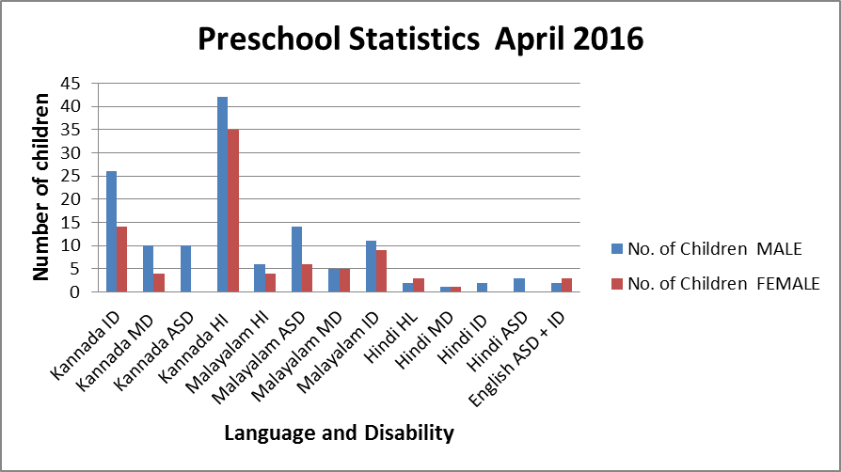

Services | Number of Clients | Number of Sessions
Guidance & Counselling | 73 | 43
Co-Curricular Training | 140 | 18
U-SAFE | 27 | 5

Supports for Empowering Caregivers
Name of Training Unit | No. of Parent  Beneficiaries | No. of Sessions | Content of Training
Caregiver Computer Training Unit | -- | No classes because the children had exam | Moving mouse, painting, typing speed, internet browsing
Caregiver Literacy Training Unit | -- | -- | Meaningful reading and writing.

- Clinical Support Services to Patients and Family
- Details of Certificates Issued:

Details of Bonafide Certificates Issued: NIL

Sl.No. | Nature of Special Needs in Clients | No. of Certificates Issued | Purpose
1
2
- Clinical Electronic Services: NIL

V) CENTRAL FACILITIES
      - Library and Information Services
      - Public Information Activities
- Major Events of the Year with a brief account
- Press Releases and Media Coverage
- 1st April 2016 – Mysore Mitra the preschool kids program at Nireekshe titled “Navu Vishesha” was published.
- 5th April 2016- Star of Mysore the preschool kids program at Nireekshe titled “Navu Vishesha” was published.
- 30th April 2016 – Vijayavani Preschool Graduation was in various newspapers.

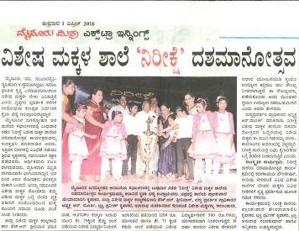
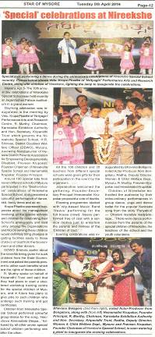

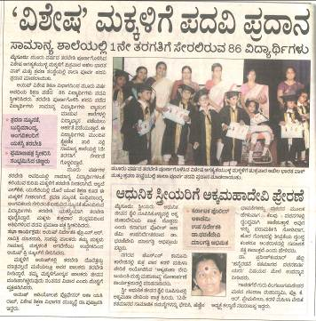

- Institute Publications
- Material Development
Sl.  No. | Nature of Teaching-Learning Materials | Skill | Number
1. | Flash cards | For all skill areas | 95 sets
2. | Work Cards | For all skill areas | 53 sets
3. | Charts | For all skill areas | -
4. | PPT | For all skill areas | 6
5. | Models | For all skill areas | -
6. | Sentence strips | For all skill areas | 62 sets
7. | Others | For all skill areas | -

Parent Enrichment Programs (PEP’s): NIL
Parent Help Parents Program (PHPP): 1
Name of the faculty/ staff | Mrs. Roopa, Parent of Ms. Shreya
Name/Topic of the Program | Parents help parents programme(PHPP) for Parents of children with Hearing Impairment
Coordinator | Ms. Latha C., Ms. Anjana K., Mr. Harish Kumar,  Mr. Raj kumar, Mr. Gururaj D.
Objectives | - To help instil confidence in the parents/caregivers handling their child.  - To train the parents in managing their stress levels while dealing with their child.  - To motivate the parents for working more efficiently with their child.  - To empower the parents regarding different aspects of training
Organized by Department/Section/Unit | Department of Special Education
Targeted Audience | Parents of children with intellectual deficit
Date | 26.04.2016
No.of beneficiaries | 45
Photo | 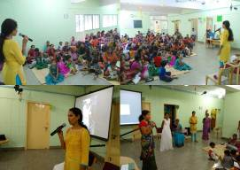

- AWARDS AND HONORS RECEIVED BY FACULTY AND STAFF

- EXTRA CURRICULAR ACTIVITIES
- Others: The preschool children participated in the following extracurricular activities/celebrations

- Name of the Programme/ Event: Celebration of Ugadi in preschool
Date: 07.04.2016
Coordinated by: - Ms. Shobha B.N & Ms. Sumana H.P
Brief note: For creating awareness among children about the festivals celebrated in India, Ugadi Festival was celebrated at the department. The importance of the festival and having Bevu Bella was explained to the children. Sweets and khara were distributed, which were sponsored by Dr. Vasanthalakshmi, Reader in Biostatistics, Dept of Speech Language Pathology.
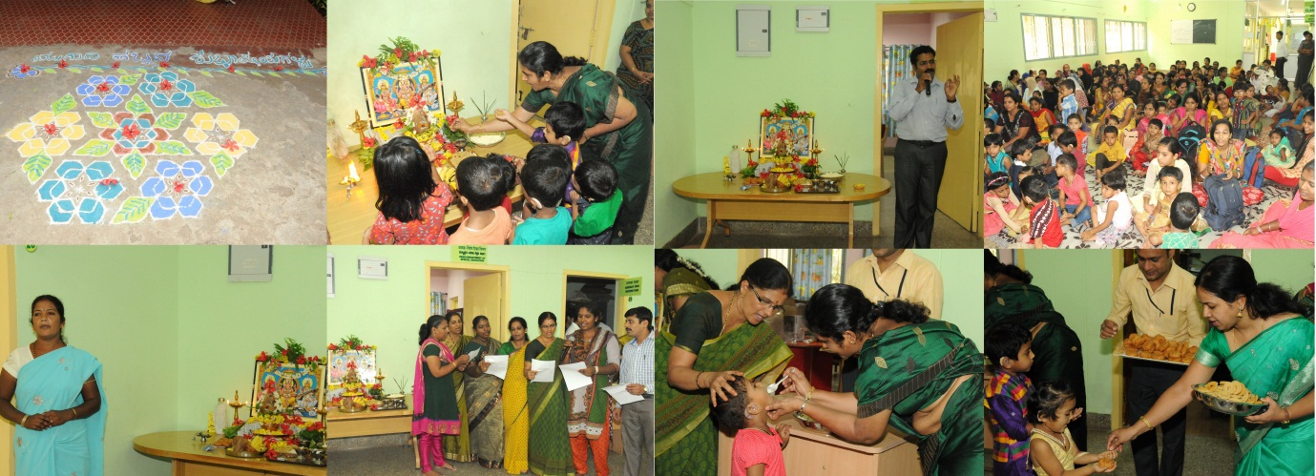
- Name of the Programme/ Event: Celebration of Saraswathi Pooja
Date: 07.04.2016
Coordinated by: - Outgoing parents of Preschool
Brief note: To pay gratitude to the mother of knowledge and to the institution that has supported in bringing up the children, parents of outgoing children have organized Saraswathi Pooja at the department. Saraswathi Pooja was performed and sweets were distributed to the children by the parents of outgoing children.
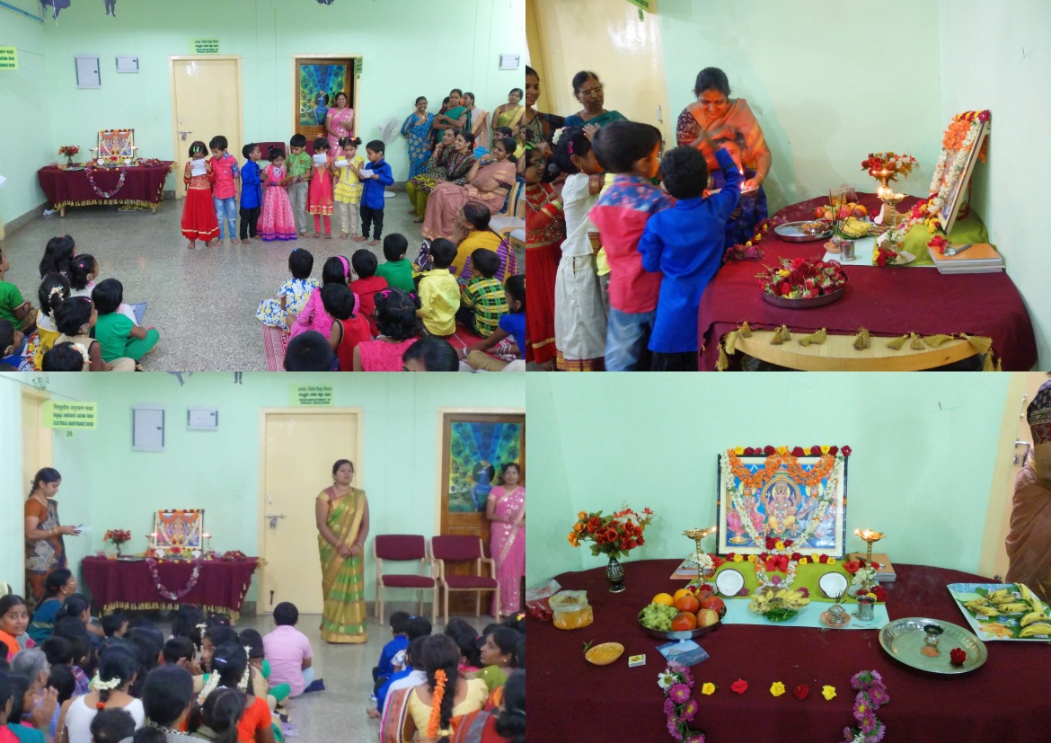

- Name of the Programme/ Event: 85 Children with various communication disorders were graduated on 29 April 2016. Chief guest Dr. Asha Yatiraj, Professor in Audiology preceded the function.
Date: April 29th 2016
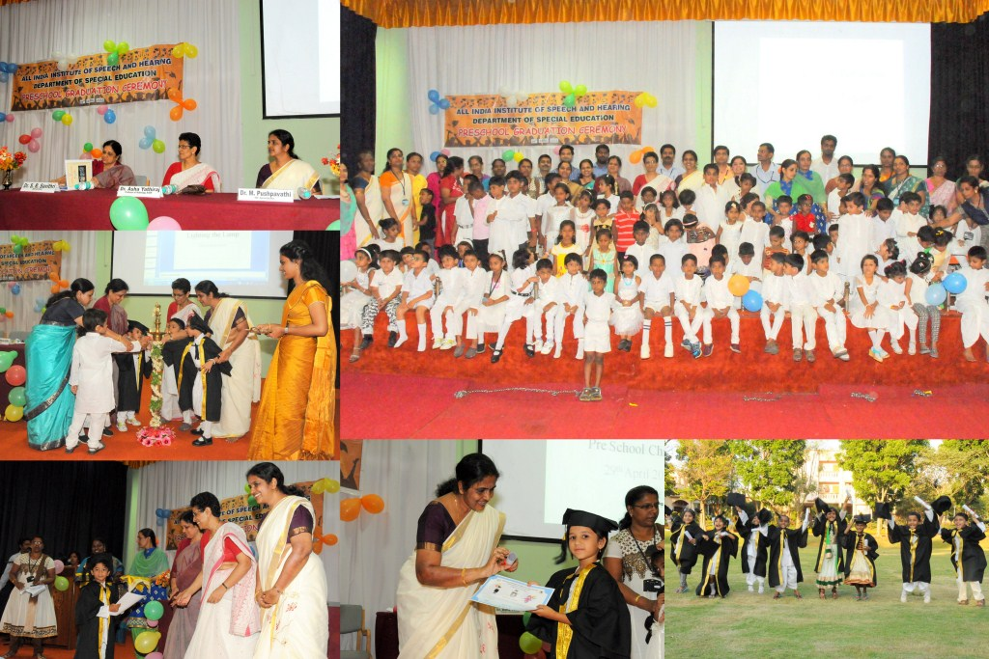

IX. EMINENT VISITORS
X. ANY OTHER
- Official Language Implementation:
- One word a day in Hindi.
- Sent quarterly report on Official Language Implementation.
- Proof reading of Hindi translation for material on “Introduction to learning disabilities”.

- Civil work: NIL

Sd/-
Dr. M. Pushpavathi
HOD – Special Education

