**ALL INDIA INSTITUTE OF SPEECH AND HEARING, MYSURU - 6**

**अखिल भारतीय वाक श्रवण संस्थान, मैसूर-६**

**DEPARTMENT OF SPECIAL EDUCATION**

**विशेषशिक्षाविभाग**

**MONTHLY REPORT – December 2018**

1. **ACADEMIC ACTIVITIES**

**Faculty report**

**Therory classes (no. of hours)**

|  |  |  |  |
| --- | --- | --- | --- |
| 1. **SL Faculty name** | **DECSE-HI** | **B.Ed.Spl.Ed. (HI)** | **Total** |
| Dr.Alok Kumar Upadhyay | - | 20 | **20** |
| Dr.Prithi V | 6 | 14 | **20** |
| Dr.PalnatyVijetha | - | 30 | **30** |
| Dr. G. Malar | 17 | 28 | **45** |
| Ms. Lakshmi Prabha | 06 | 12 | **18** |

**Practical Classess (In Hours)**

|  |  |  |  |
| --- | --- | --- | --- |
| **Faculty** | **DECSE-HI** | **B.Ed.Spl.Ed. (HI)** | **Total** |
| Dr.Prithi V | **-** | 4 hours of supervision in school  9 hours of lesson plan discussion  5 hours of observation while delivering lesson | **18** |
| Dr.PalnatyVijetha | **-** | 12 | **12** |
| Dr. G. Malar | 2 | 61 | **63** |
| Ms. Lakshmi Prabha | - | 05 | **05** |

1. Educational Observation Postings of Students from other Institutes:

Following are the details of students posted for observation/ practice teaching

|  |  |  |  |  |
| --- | --- | --- | --- | --- |
| **Sl.No** | **Name of the Institute** | **Programme/Course** | **Number of Students** | **Dates** |
|  | St. Philomena’s College, Mysuru | II year B.A. Psychology | 1 | 21.12.2018 to  10. 01. 2019 |

1. Seminars/Conferences/**Workshops**/Training Programs:NIL
2. Staff Enrichment / **In-house training Programmes***(For own staff members)* : NIL

|  |  |  |  |  |  |
| --- | --- | --- | --- | --- | --- |
| **Theme/Topic** | **Resource Person** | **Coordinator** | **Objectives** | **Targeted Audience** | **Date** |

1. Guest Lectures : NIL
2. Additional Academic Services rendered by the Faculty and Staff:
3. **Invited Talks:05**

|  |  |  |  |  |
| --- | --- | --- | --- | --- |
| **Sl. No.** | **Name, Designation, Institutional affiliation of Lecturer** | **Organized by Department/ Section/ Unit/ Organisation** | **Topic of Lecture** | **Date/s** |
|  | Dr.PalnatyVijetha,  Reader | RCI-CRE workshop in Dr.Chandrashekar Institute of Speech and Hearing, Bangalore | Usefulness of Latest methods of Teaching language to children with Hearing impairment | 14.12. 2018 |
|  | Dr.AlokkumarUpadhyay,  Associate Professor | Faculty Development Centre  Allahabad University, Prayagraj (Allahabad) | 1-Contribution Of Department Of Special Education For Education Of Children With Special Needs  2-Communication Disorders And Intervention Strategies for Education | 15.12.2018 |
|  | Dr.Alok Kumar Upadhyay,  Associate Professor | Faculty Development Centre  Allahabad University, Prayagraj (Allahabad) | 3-Professional Collaboration  For Inclusive Education  4-Tests And Tools For Assessment | 16.12.2018 |
|  | Dr.AlokkumarUpadhyay,  Associate Professor | One day Workshop, RajbhashaSection, AIISH, Mysuru | दिव्यांगजनकोसरकारद्वारादीजारहीसुबिधायेंऔरउनकेप्राप्तिकेतरीके | 21.12.2018 |
|  | Dr G. Malar,  Reader in Special Education, AIISH | KendriyaVidyalayaSangathan – Zonal Institute of Educational Training (KVS-ZIET), Mysuru | Education of the Physically Challenged and Socially Disadvantaged Students in Inclusive System | 30.11.18 |

1. **Resource person during interaction program:** NIL
2. **Curriculum Development (in progress):** 01

The faculty members of the department were involved in revision of regulations and syllabus of B.Ed.Spl.Edn.(HI), as per new regulations of University of Mysore.

.

1. **Development of Material to Support Learning:**NIL
2. **Service in Academic Bodies of other Organizations:**
3. **Dr Alok Kumar Upadhyay**

* Member, Board of Studies (BOS):
* RamkrishnaMission Vivekananda University, Coimbatore: Diploma, U.G & P.G
* N.G.B. University, Allahabad: for U.G & P.G
* J.R.H. University, Chitrakoot: for U.G & P.G
* Member, Board of Examiners (BOE) for UG Special Education of University of Mysore.

1. **Dr. G. Malar**

* Member, BOE–UG Special Education of University of Mysore.

1. **Dr. PrithiVenkatesh**

Member, BOE–UG Special Education of University of Mysore

1. **Dr. PalnatyVijetha**

Member, BOE–UG Special Education of University of Mysore

1. **Participation in Committees/Taskforce and Panels set up by other organizations/agencies**: NIL
2. **Any Others (Please Specify)**
3. Research Projects (ARF)
4. **Completed – 01 no.**

|  |  |
| --- | --- |
| **Title** | Development and Evaluation of Indigenous Curriculum Oriented Computer Based Tutor for Concept Learning in Preschool Children with Special Needs. |
| **Objectives** | *Phase I:* To develop story boards for 6 concepts viz. My Family, My Body, Things we use, Animals and Birds, Food we eat and My Journey in Kannada.  *Phase II*: To develop indigenous computer based tutor for the 6 concepts based on the story board in Kannada and integrating it with the multimedia content and devising reinforcement mechanism.  *Phase III:* To evaluate the performance of the developed computer based tutor. |
| **Department** | Special Education |
| **Principal Investigator &**  **Co-Investigator** | *Principal Investigator* - Ms.P.V.Ramanakumari, Special Educator  *Co-Investigator* – Dr.Ajish K. Abraham, Professor in Electronics & Ms.P.V.Manjula, Special Educator |
| **Funding Agency** | AIISH |
| **Date of initiation of the project** | 18th January 2017 |
| **Amount** | Rs. 3,85,000/- |
| **Status** | * Data collection is completed. * Analysis to be done. * Report is yet to be submitted. |

1. **New Research Projects – 03 nos.**

**Project 1**

|  |  |
| --- | --- |
| **Title** | Efficacy of Developing Skills through Curricular Activities among Preschool Children with Hearing Impairment at AIISH |
| **Objectives** | To investigate the effectiveness of curricular activities in developing:   * Cognitive skills * Language Arts * Pre-academic skills (pre-reading, pre-writing, pre-arithmetic) among children with hearing impairment |
| **Department** | Special Education |
| **Principal Investigator &**  **Co-Investigator** | **Principal Investigator**  Dr.Alok Kumar Upadhyay  Associate Professor in Special Education  AIISH, Manasagangotri, Mysore: 570 006  **Co-Investigator**  Dr.PalnatyVijetha  Reader in special Education  AIISH, Manasagangothri, Mysore: 570 006 |
| **Funding Agency** | AIISH Research Fund (ARF) |
| **Date of initiation of the project** | 09.10.2018 (approval date) |
| **Amount** | Rs. 3,80,000/- |
| **Status** | Under Process of Initiation |

**Project 2**

|  |  |
| --- | --- |
| **Title** | Development of Grade Level Assessment Tools in Social Science (GLAT_SS) of Karnataka State Education Board. |
| **Objectives** | The Present study is being initiated with the aim to develop and standardize Grade Level Assessment Tool in Social Sciences (GLAT-SS) at GRADE VI of Karnataka State Education Board in English and Kannada. |
| **Department** | Special Education |
| **Principal Investigator &**  **Co-Investigator** | **Principal Investigator**  Dr.PalnatyVijetha  Reader in special Education  AIISH, Manasagangothri, Mysore: 570006  **Co-Investigators**   1. Dr.Alok Kumar Upadhyay   Associate Professor in Special Education  AIISH, Manasagangotri, Mysore: 570006   1. Ms.Lakshmi Prabha J.K.   Lecturer in Special Education  AIISH, Manasagangotri, Mysore: 570006 |
| **Funding Agency** | AIISH Research Fund (ARF) |
| **Date of initiation of the project** | 09.10.2018 (approval date) |
| **Amount** | Rs. 3,85,000/- |
| **Status** | Under Process of Initiation |

**Project 3**

|  |  |
| --- | --- |
| **Title** | Development of grade level Assessment test in Science for Upper Primary School Children (VI-VIII) |
| **Objectives** | The aim of the study is to develop grade level assessment test for upper primary school children (VI-VIII) in science subject.  The study will be taken up with the following objectives in mind:   1. To develop grade level assessment test in Science for upper primary school children (VI-VIII) 2. To verify the reliability and validity of the test 3. To establish the norms for the test 4. To test its applicability with learners with hearing impairment 5. To compare the performance of the learners with hearing impairment on the test. |
| **Department** | Department of Special Education |
| **Principal Investigator &**  **Co-Investigator** | Dr.PrithiVenkatesh  Reader in special Education  AIISH, Manasagangothri, Mysore: 570006 |
| **Funding Agency** | AIISH Research Fund (ARF) |
| **Date of initiation of the project** | 09.10.2018 |
| **Amount** | Rs.4,00,000/- |
| **Status** | Yet to Initiate the project, recruitment of the staff under progress. |

1. **Ongoing Research Projects - 01**

**Title**: Effect of Resource Materials on Impact of Inclusive Education in Children with Intellectual Disabilities (ID) and Learning Disabilities (LD)

Investigators: Dr. G. Malar, Ms. S. Prathima & Mr. D. Gururaj

Duration: 12 months from January 2017

Budget: Rs. 3,85,000/-

Progress: Project recommenced with reappointment of research assistance in December 2018. Translation of tools into Kannada completed. And video recording of practical demonstrations in progress. Commenced second round of data collection in two schools serving as control fields.

1. Postgraduate Research Completed: NA
2. C. Postgraduate Research ongoing: NA
3. D**.** Research Papers presented at National/International Conferences/Seminars: NIL

E. Research Papers Published

i) Papers published in National / International Journals: NIL

ii) Abstracts published in Conference / Seminar Proceedings: NIL

F. **Books published (in APA format)**

1. *Books published: NIL*

* *Books in press:*

G.Book chapters published (in APA format): NIL

H .Books/Manuals/Seminar Proceedings edited: NIL

1. Journal Editorship: NIL

J. Scholarly Reviewing Activities:

1. Special Educational Services Offered through Teacher Trainees Outside Campus: NIL

**III CLINICAL/EDUCATIONAL SERVICES**

1. General Clinical Services: **Not Applicable**
2. Specialized Clinical/ Educational Services
3. **Pre-school Training and Special Education**

**Educational services for children with special needs**

|  |  |  |  |  |  |  |  |  |  |  |  |  |
| --- | --- | --- | --- | --- | --- | --- | --- | --- | --- | --- | --- | --- |
| **S. No.** | **Nature of Services (In charge staff)** | | | | | | | | | | | |
| 1. Special Educational Assessment Unit (SEA-U) | | | | | | | | | | | | |
|  |  | Nature of Special Need  Language | ASD / PDD NOS | Hearing Loss | Intellectual Disability | Learning Disability | Motor Problems | Multiple Disabilities | Others | No. of Clients | No. of Sessions | ***Total No. of Sessions*** |
| 1. | Screening & Referral | Kannada | 3 | 15 | 10 | 5 | 0 | 1 | 8 | ***42*** | ***42*** | ***65*** |
| Malayalam | 2 | 3 | 2 | 0 | 2 | 4 | 2 | ***15*** | ***15*** |
| Hindi | 1 | 0 | 2 | 0 | 0 | 0 | 0 | ***3*** | ***3*** |
| Urdu | 0 | 0 | 0 | 0 | 0 | 0 | 0 | ***0*** | ***0*** |
| English | 0 | 1 | 1 | 0 | 0 | 0 | 0 | ***2*** | ***2*** |
| Telugu | 0 | 0 | 2 | 0 | 0 | 0 | 0 | ***2*** | ***2*** |
| Tamil | 1 | 0 | 0 | 0 | 0 | 0 | 0 | ***1*** | ***1*** |
| Any Other | 0 | 0 | 0 | 0 | 0 | 0 | 0 | ***0*** | ***0*** |
| ***Total No. of Clients*** | ***7*** | ***19*** | ***17*** | ***5*** | ***2*** | ***5*** | ***10*** | ***65*** | ***65*** |
| 2. | Assessment & Report | Kannada | 0 | 1 | 0 | 0 | 0 | 0 | 0 | ***1*** | ***4*** | ***14*** |
| Malayalam | 0 | 0 | 0 | 0 | 0 | 0 | 0 | ***0*** | ***0*** |
| Hindi | 0 | 0 | 0 | 0 | 0 | 0 | 0 | ***0*** | ***0*** |
| Urdu | 0 | 0 | 0 | 0 | 0 | 0 | 0 | ***0*** | ***0*** |
| English | 0 | 0 | 2 | 2 | 1 | 0 | 0 | ***5*** | ***10*** |
| Telugu | 0 | 0 | 0 | 0 | 0 | 0 | 0 | ***0*** | ***0*** |
| Tamil | 0 | 0 | 0 | 0 | 0 | 0 | 0 | ***0*** | ***0*** |
| Any Other | 0 | 0 | 0 | 0 | 0 | 0 | 0 | ***0*** | ***0*** |
| ***Total No. of Clients*** | ***0*** | ***1*** | ***2*** | ***2*** | ***1*** | ***0*** | ***0*** | ***6*** | ***14*** |
| Places from which seen: (1)Karnataka: 46 (2)Kerala: 15 (3)AP: 02 (4)Telangana: Nil (5)TN: 01 (6)Other Parts of India: 01(Allahabad, UP) (7)Any other: Nil | | | | | | | | | | | |
| Age groups seen:(1)Birth to 2.5yrs: 06 (2)2.5+ to 6 yrs: 30 (3)6yrs+ to 16 years: 28 (4)16yrs+: 01 | | | | | | | | | | | |
| Total No. of Referrals: (1)Educational Assessment: 06 (2)Educational Guidance: Nil (3)PIP: 09 (4)PPEP/ PBC/ GECS: 36 (5)CSS/IEP/NFE/DET: 11 (6)Any Other Services at AIISH: 01 (speech-language therapy) (7)Any Other Services Outside AIISH: 01 (NIEPID, Secunderabad) | | | | | | | | | | | |
| No. of Reports Issued/Ready for Issue: (1) School Readiness: 03 (3) Curriculum-Based Assessment: 03 (4) Post-School: Nil | | | | | | | | | | | |

|  |
| --- |
| **Pre-school Training: Preparatory programme for schooling providing training in self-help, cognitive, language and (pre) academic skills, Preschool Supplementary Services (PSS)** |
| |  |  |  |  | | --- | --- | --- | --- | | **Language & Disability** | **No. of Groups** | **No. of Children** | | |  |  | MALE | FEMALE | | Kannada ASD & ID &MD | 15 | 49 | 26 | | Kannada HL | 8 | 39 | 24 | | Malayalam HL | 1 | 3 | 3 | | Malayalam ASD & ID & MD | 9 | 28 | 15 | | Hindi HL | 2 | 12 | 4 | | Hindi MD & ID & ASD | 2 | 9 | 1 | | English ID, ASD | 1 | 2 | 3 | | Telugu ASD & ID & MD& HL | 1 | 5 | 3 | | TOTAL Number of children |  | **147** | **79** | | **TOTAL No. Groups** | **39** | **226** | | | **Sessions** | **3120 ( Group-wise)** | | | |

|  |  |  |  |  |  |
| --- | --- | --- | --- | --- | --- |
| **Curricular Support Services – Supportive training to augment education in mainstream school/ other educational programmes** | **Language** | **HL** | **ID/CP/ASD/MD/LD/DD** | **Total No. of clients** | **No. Of sessions** |
| Kannada | 6 | 11 | 17 | 55 |
| Malayalam | 1 | - | 1 | - |
| Hindi | - | - | - | - |
| English | 2 | 8 | 10 | 47 |
| Telugu | - | 2 | 2 | 13 |
| Tamil | - | - | - | - |
| **Total** | | | | **30** | **115** |
| |  |  |  |  |  |  | | --- | --- | --- | --- | --- | --- | | **Individualised Educational Programme (IEP) – Training in functional academics for out of school individuals** | **Language** | **HL** | **ID/CP/ASD/MD/LD/DD** | **Total No. of clients** | **No. Of sessions** | | Kannada | 2 | 8 | 10 | 56 | | Malayalam | 1 | 2 | 3 | 6 | | Hindi | 1 | - | 1 | 6 | | English | - | - |  | - | | Telugu | 1 | - | 1 | - | | Tamil | - | - |  | - | | Total | - | - | **15** | **68** | | | | | | |
| |  |  |  |  |  |  | | --- | --- | --- | --- | --- | --- | | **Demonstration Educational Training – Short-term demonstration to caregivers in any of the above** | **Language** | **HL** | **ID/CP/ASD/MD/LD/DD** | **Total No. of clients** | **No. Of sessions** | | Kannada | - | 1 | 1 | 4 | | Malayalam | - | 1 | 1 | 4 | | Hindi | - | - | - | - | | English | - | - | - | - | | Telugu | - | - | - | - | | Tamil | - | - | - | - | | **Total** | - | - | **2** | **8** | | | | | | |
| **Total clients: 47**  **Old clients:- 51**  **New clients:- 01**  **Discharged (DET):-NIL**  **Discharged (CSS):- NIL**  **Discharged (IEP):- NIL**  **Discontinued (DET):- NIL**  **Discontinued (CSS):- NIL**  **Discontinued (IEP):- NIL** | | | | | |

|  |  |  |  |  |  |  |  |  |  |  |  |
| --- | --- | --- | --- | --- | --- | --- | --- | --- | --- | --- | --- |
| **Pre-school Parent Empowerment Programme – PPEP** | | | | | | | | | | | |
|  | **Language** | **HL** | **ID** | **CP** | **ASD** | **MD** | **LD** | **DD** | **SLD** | **VI** | **Total No. of clients** | **Group** | **No. Of sessions** |
| Kannada | 27 | 21 | 3 | 11 | 5 | -- | 4 | 2 | -- | 73 | 11 | 220 |
| Malayalam | 15 | 8 | 2 | 2 | 2 | -- | 6 | -- | -- | 35 | 5 | 100 |
| Hindi | 4 | 4 | -- | 1 | 1 | -- | 1 | -- | -- | 11 | 2 | 40 |
| English | -- | 1 | -- | 1 | 1 | -- | -- | -- | -- | 3 | 1 | 20 |
| Telugu | 1 | -- | -- | 1 | -- | -- | -- | -- | -- | 2 | 1 | 20 |
| Tamil | 2 | -- | -- | 2 | 1 | -- | -- | -- | -- | 5 | 1 | 20 |
| **Total** | | | | | | | | | | **129** | | **20** | **420** |
| No. of clients promoted to the next higher level(Preschool) of service: 18  No. Of discharged :04  No. Of discontinued: 14  No. Of New clients (Dec) : 32  Shifted from PPEP to PIP: 3 | | | | | | | | | | | | | |

|  |  |  |  |  |  |
| --- | --- | --- | --- | --- | --- |
| **Parent Infant Programme – PIP(Birth to 2 ½ years)** | | | | | |
| Parent-Infant Programme | **Language** | **HL** | **ID/CP/ASD/MD/LD/DD** | **Total No. of clients** | **Total No. Of sessions** |
| Kannada | 16 | 10 | 26 | 77 |
| Malayalam | 11 | 12 | 23 | 58 |
| Hindi | 01 | 01 | 02 | 03 |
| English | 00 | 01 | 01 | 06 |
| Telugu | 00 | 00 | 00 | 00 |
| Tamil | 01 | 01 | 02 | 05 |
|  | **Total** | | | **54** | **149** |
| No. of Old clients: 46  No. of New clients enrolled: 08  Total clients: 54  No. discharged : Nil  No. discontinued: 03  No. of Promoted to next level: 03  No. of Remaining: 48 | | | | | |

|  |  |  |
| --- | --- | --- |
| **Library of Books & Toys** – LiBoToy  Services issuing educational toys & books for home-based training. | Total number of members enrolled –205  No. of new members: - 21  Amount – 1050/-  Total number of sessions – 24 | |
| **Age group** | **Total number** |
| 0 - 2.6 yrs | 8 |
| 2.6 - 4 yrs | 55 |
| 4.0 - 6 yrs | 135 |
| 6 yrs and above | 7 |

|  |  |  |
| --- | --- | --- |
| **Services** | **Number of Clients** | **Number of Sessions** |
| Co-Curricular Training | 226 | 20 |

**Supports for Empowering Caregivers**

|  |  |  |  |
| --- | --- | --- | --- |
| *Name of Training Unit* | *No. of Parent*  *Beneficiaries* | *No. of Sessions* | *Content of Training* |
| Caregiver Computer Training Unit | -- | -- | -- |
| Caregiver Literacy Training Unit | -- | -- | -- |

1. Support Services to Clients and Family
2. **Counselling and guidance**

|  |  |
| --- | --- |
| No. of Clients | Sessions |
| 226 | 96 |

1. **U-SAFE**

|  |  |
| --- | --- |
| No. of Clients | Sessions |
| -- | -- |

1. **SUMERU**

|  |  |
| --- | --- |
| No. of Clients | Sessions |
| -- | -- |

1. Details of Certificates Issued:NIL
2. Financial Aid- NIL
3. Legal advice -NIL
4. Any other(Please Specify):

**Attended workshop/Seminar/Orientation program in AIISH institute 2018-19: 04 staff**

|  |  |  |
| --- | --- | --- |
| **Name of Staff** | **Attended to workshop title name** | **Date** |
| Mr.Sandesh S C  Ms.RakshaAnand | Third Hindi workshop | 21.12.2018 |
| Dr. G. Malar  Mr.MurshidulAlam | Workshop on ‘Listening Skills in Counselling: An Indian Perspective' | 28.12.2018 |

**Attended workshop/Seminar/Orientation program in Outside institute 2018-19: 01 staff**

|  |  |  |
| --- | --- | --- |
| **Name of Staff** | **Attended to workshop title name** | **Date** |
| Mr. Suresh C B | ICSFP 2018 & Annual meet of ASFP-I at Bangalore | 12-15, December 2018 |

EXTENSION ACTIVITIES

1. Public Lecture Series: Nil
   * + 1. TECHNLOGICAL CONSULTANCY SERVICES: NIL
       2. CENTRAL FACILITIES
       3. Library and Information Services
       4. Public Information Activities

**Orientation Programs (For outsiders):** The following orientation programs were conducted to orient about the activities of the department and also to provide knowledge about the educational facilities and welfare measures for children with special needs. : 02

|  |  |  |  |  |
| --- | --- | --- | --- | --- |
| **SL No.** | **Coordinator** | **Targeted Audience** | **Number**  **of Participants** | **Date** |
| 1 | Ms.LakshmiPrabha J.K | Project manager of Akkara Foundations, Kerala | 1 | 12.12.2018 |
| 2 | Dr.PrithiVenkatesh | Teacher trainees and faculty from Government Teacher Training College | 16 | 28.12.2018 |

* + - 1. Major Events of the Year with a brief account:
* **Name of the Programme/ Event:** Christmas & New Year celebrations
* **Date:** 31.12.2018
* **Coordinated by:** Mr. Suresh CB, Mr.Rajkumar, Ms.RakshaAnand

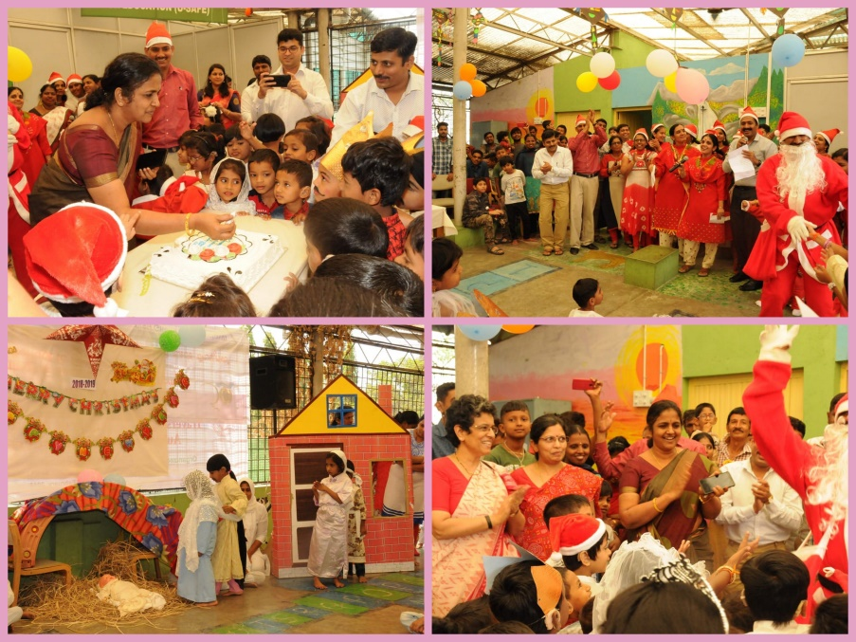

* **Name of the Programme/ Event:** World Disabled Day 2018
* **Date:** 20.12.2018
* 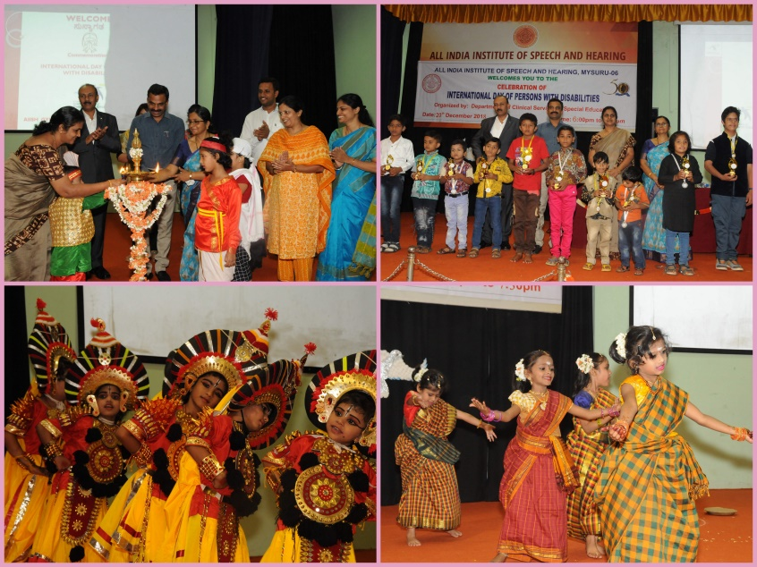**Coordinated by:** 
  + - 1. Press Releases and Media Coverage: NIL

**C) Material Development :**The following Teaching Learning Material and Prepare for training children with various communication disorders in preschool.

|  |  |  |  |
| --- | --- | --- | --- |
| **Sl.**  **No.** | **Nature of**  **Teaching-Learning**  **Materials** | **Skill** | **Number** |
| 1. | Flash cards | For all skill areas | 64 |
| 2. | Work Cards | For all skill areas | 86 |
| 3. | Charts | For all skill areas | 34 |
| 4. | PPT | For all skill areas | 142 |
| 5. | Models | For all skill areas | 54 |
| 6. | Sentence strips | For all skill areas | 48 |
| 7. | Story cards | For all skill areas | 79 |
| 8 | Others | For all skill areas | -- |

1. **AWARDS AND HONORS RECEIVED BY FACULTY AND STAFF:**

Dr. ALOK KUMAR UPADHYAY has received Award for **Outstanding Performance in the field of Empowerment of Persons with Disabilities** by KALYANAM KAROTI Organization, Mathura (U.P.) on World Disability Day 03.12.2018

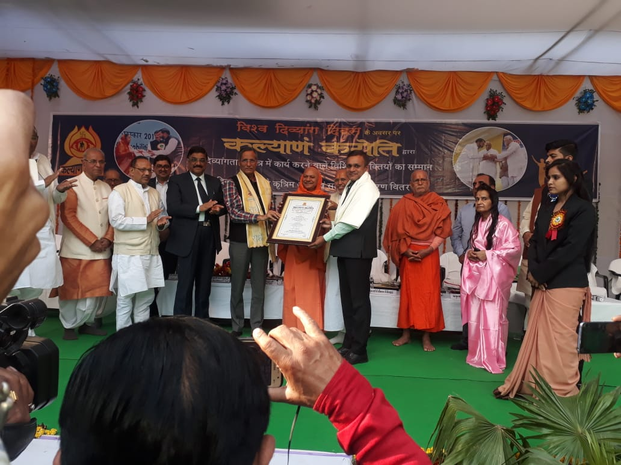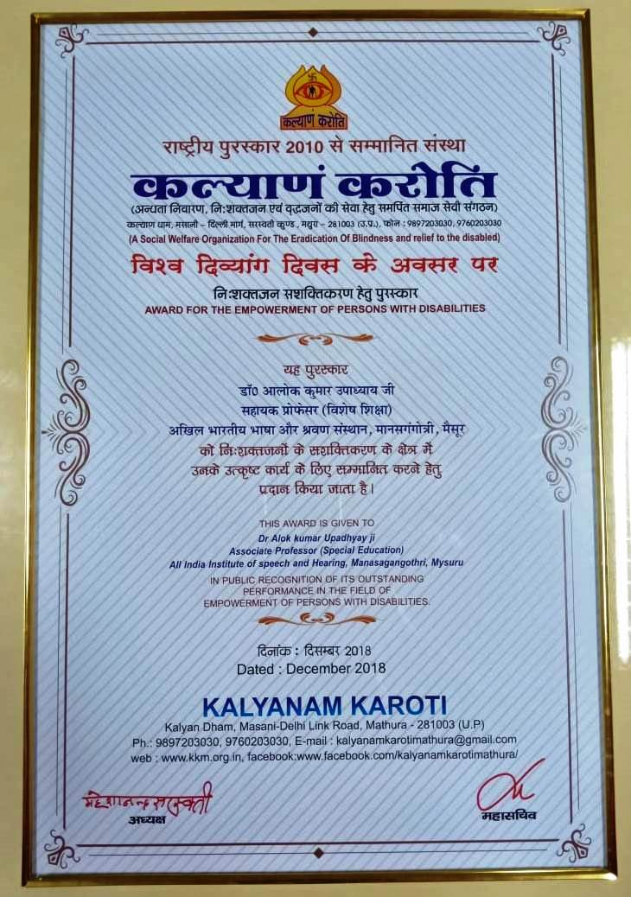

1. EXTRA CURRICULAR ACTIVITIES: Nil
   * + - 1. AIISH Gymkhana
2. **EMINENT VISITORS:** Nil

XI. **ANY OTHER**

* **OfficialLanguage Implementation:**
* Hindi Word a day
* No. of notings/letters (**December2018**): Hindi: 110, English: 20

Sd/-

HOD- Special Education