ALL INDIA INSTITUTE OF SPEECH AND HEARING, MYSURU-6
DEPARTMENT OF CLINICAL SERVICES

MONTHLY REPORT / STATISTICS FOR THE MONTH OF DECEMBER 2018 (26.11.2018 to 25.12.2018)

- REGISTRATION AT THE DEPARTMENT

- Number of Clients registered
 | Speech Language OPD | 487
 | Audiology OPD | 1293
 | New Cases | 1780
 | Retrieval of repeat case files | 4643
 | Total Cases | 6423
 | No. of Working days | 21

- Details of Registration

Total requests for new registration | 1900
Total registered as new clients | 1780
*No. of cases Rejected | 120
Case files requested for revisit | 4746
Case files retrieved for revisit | 4643
Case files requested for clinical purpose | 465
Case files retrieved for clinical purpose | 465
Case files requested for research purpose | 303
Case files retrieved for research purpose | 303
Case files requested for academic purpose | 70
Case files retrieved for academic purpose | 70
Case files requested for Legal purpose (Court) | 00
Case files retrieved for Legal purpose (Court) | 00
Total Requests for Medical Records Corrections | 16
Total Corrections done in the Medical Records | 16
Total Case files requested  (Revisit, clinical purpose, research purpose, academic purpose) | 7500
Total Case files retrieved  (Revisit, clinical purpose, research purpose, academic purpose) | 7277

*Rejected – Not reported as communication disorders (Non Sp & Hg problems)

Date wise statistics for the month of December, 2018
Sl. No | Dates | New Cases | Repeat Cases | Total Cases
 | 26 - Nov -18 | 83 | 281 | 364
 | 27- Nov -18 | 89 | 317 | 406
 | 28 - Nov -18 | 104 | 229 | 333
 | 29 - Nov -18 | 84 | 159 | 243
 | 30 - Nov - 18 | 80 | 138 | 218
 | 01- Dec - 18 | 00 | 00 | 00
 | 02- Dec -18 | 00 | 00 | 00
 | 03- Dec -18 | 114 | 300 | 414
 | 04- Dec -18 | 81 | 286 | 367
 | 05- Dec -18 | 77 | 283 | 360
 | 06- Dec -18 | 72 | 180 | 252
 | 07- Dec -18 | 50 | 166 | 216
 | 08- Dec -18 | 00 | 00 | 00
 | 09- Dec -18 | 00 | 00 | 00
 | 10- Dec -18 | 116 | 294 | 410
 | 11- Dec -18 | 95 | 227 | 322
 | 12- Dec -18 | 75 | 203 | 278
 | 13- Dec -18 | 57 | 154 | 211
 | 14- Dec -18 | 74 | 123 | 197
 | 15- Dec -18 | 00 | 00 | 00
 | 16- Dec -18 | 00 | 00 | 00
 | 17- Dec -18 | 129 | 300 | 429
 | 18- Dec -18 | 80 | 267 | 347
 | 19- Dec -18 | 77 | 221 | 298
 | 20- Dec -18 | 67 | 148 | 215
 | 21- Dec -18 | 61 | 126 | 187
 | 22- Dec -18 | 00 | 00 | 00
 | 23 - Dec -18 | 00 | 00 | 00
 | 24 - Dec -18 | 115 | 241 | 356
 | 25 - Dec - 18 | 00 | 00 | 00
Total |  | 1780 | 4643 | 6423

District wise distribution of cases (Karnataka) registered during the month of December, 2018

Sl. No | Districts Descriptions | Male Cases | Female Cases | Total Cases
 | Bagalkote | 11 | 03 | 14
 | Bangalore | 40 | 16 | 56
 | Belgaum | 03 | 07 | 10
 | Bellary | 09 | 04 | 13
 | Bidar | 01 | 00 | 01
 | Bijapur | 08 | 04 | 12
 | Chamarajanagar | 65 | 36 | 101
 | Chikkaballapur | 02 | 01 | 03
 | Chikkmagalore | 18 | 10 | 28
 | Chitradurga | 06 | 05 | 11
 | Coorg | 23 | 15 | 38
 | Dakshina Kannada | 02 | 00 | 02
 | Davangere | 06 | 03 | 09
 | Dharwad | 02 | 06 | 08
 | Gadag | 02 | 00 | 02
 | Gulbarga | 10 | 02 | 12
 | Hassan | 45 | 27 | 72
 | Haveri | 11 | 03 | 14
 | Kolar | 10 | 03 | 13
 | Koppala | 04 | 01 | 05
 | Mandya | 110 | 50 | 160
 | Mysore City | 379 | 316 | 695
 | Mysore District | 184 | 139 | 323
 | Raichur | 6 | 03 | 09
 | Ramanagara | 13 | 08 | 21
 | Shivamoga | 04 | 01 | 05
 | Tumkur | 22 | 06 | 28
 | Udupi | 00 | 00 | 00
 | Uttar kannada | 02 | 02 | 04
 | Yadagiri | 03 | 00 | 03
 | Total | 1001 | 671 | 1672

States wise distribution of cases registered during the month of December, 2018

Sl. No | States Descriptions |  | Male Cases | Female Cases | Total Cases
 | Andra Pradesh |  | 06 | 06 | 12
 | Arunachal Pradesh |  | 00 | 00 | 00
 | Assam |  | 04 | 01 | 05
 | Bihar |  | 01 | 01 | 02
 | Chattisgarh |  | 00 | 00 | 00
 | Delhi |  | 00 | 01 | 01
 | Goa |  | 00 | 00 | 00
 | Gujarat |  | 00 | 00 | 00
 | Hariyana |  | 00 | 00 | 00
 | Himachal Pradesh |  | 00 | 00 | 00
 | Jarkhand |  | 03 | 02 | 05
 | Karnataka |  | 1001 | 671 | 1672
 | Kashmir |  | 00 | 00 | 00
 | Kerala |  | 40 | 26 | 66
 | Madhya Pradesh |  | 00 | 01 | 01
 | Maharastra |  | 01 | 01 | 02
 | Manipur |  | 00 | 00 | 00
 | Meghalaya |  | 00 | 00 | 00
 | Nagaland |  | 00 | 00 | 00
 | Mizoram |  | 00 | 00 | 00
 | Orissa |  | 00 | 00 | 00
 | Punjab |  | 00 | 00 | 00
 | Rajasthan |  | 00 | 00 | 00
 | Sikkim |  | 00 | 00 | 00
 | Tamil Nadu |  | 04 | 06 | 10
 | Telangana |  | 00 | 00 | 00
 | Tripur |  | 00 | 00 | 00
 | Union Territories |  | 01 | 00 | 01
 | Uttar Pradesh |  | 00 | 00 | 00
 | Uttaranchal |  | 00 | 00 | 00
 | West Bengal |  | 02 | 01 | 03
Total |  |  | 1063 | 717 | 1780
Sl.No |  | Over Seas | Male Cases | Female Cases | Total
1 |  | - | - | - | -
Total |  |  | 1063 | 717 | 1780

II. DIAGNOSTIC AND THERAPY SERVICES

- SPEECH-LANGUAGE EVALUATIONS

EVALUATIONS |  | PEDIATRIC  (0-15YRS) |  | ADULT  (15-50YRS) |  | GERIATRIC  (50 & ABOVE) |  | TOTAL |  | HINDI CASES
 |  | M | F | M | F | M | F | NEW | REPEAT | HINDI CASES
Language | CLD | 179 | 99 | 00 | 00 | 00 | 00 | 278 | 176 | 41
Language | ALD | 00 | 00 | 26 | 08 | 05 | 02 | 41 | 04 | 41
Articulation |  | 10 | 03 | 04 | 01 | 00 | 00 | 18 | 06 | 41
Voice |  | 05 | 07 | 16 | 06 | 09 | 05 | 48 | 08 | 41
Fluency |  | 18 | 07 | 22 | 02 | 00 | 00 | 49 | 04 | 41
Multiple |  | 00 | 00 | 00 | 00 | 00 | 00 | 00 | 00 | 41
Normal |  | 00 | 00 | 00 | 00 | 00 | 00 | 00 | 00 | 41
TOTAL M/F |  | 212 | 116 | 68 | 17 | 14 | 07 | 434 | 198 | 41
Over all Total New |  | 328 |  | 85 |  | 21 |  | 434 | 198 | 41
Overall Total New |  | 434 |  |  |  |  |  |  |  | 41
Overall Total Repeat |  | 198 |  |  |  |  |  |  |  | 41
Overall Total New & Repeat |  | 632

Evaluations | No. of Clients seeking | No. of Clients successfully completed | Percentage (%)
Speech-Language Evaluation | 463 | 434 | 94%
Re-evaluation | 202 | 198 | 98%
Referrals from OPD:

POCD | 05
TCPD | 01
Internship centers | 28
Others | 17
Case History ( Speech OPD) | 481
Evaluation | 632
Counselling | 235
*Not reported in Speech Language OPD | 06

III. PT/OT EVALUATION

EVALUATION | PEDIATRIC  (0-15 YEARS) | ADULT  (16- 50 YEARS) | GERIATRIC  (50& ABOVE) | TOTAL
Physiotherapy evaluation | 54 | 03 | 07 | 64
Occupational therapy evaluation | 74 | 02 | 05 | 81
TOTAL | 128 | 05 | 12 | 145

Diagnostics | No. of clients seeking evaluation | No. of Clients successfully evaluated | No. of clients recommended for re-evaluation | No. of clients successfully re-evaluated
Physiotherapy | 64 | 64 | 07 | 07
Occupational Therapy | 81 | 81 | 23 | 23

PT/OT THERAPY SESSION
Therapy | Pediatric  (0-15 Years) |  | Adult  (16- 50 Years) |  | Geriatric  (50& Above) |  | Total No. of Case For PT/OT | Total No of Therapy Session
Therapy | Cases | Sessions | Cases | Sessions | Cases | Sessions | Total No. of Case For PT/OT | Total No of Therapy Session
Physiotherapy | 66 | 560 | 05 | 48 | 02 | 19 | 73 | 627
Occupational Therapy | 67 | 466 | 02 | 04 | 01 | 08 | 70 | 478
Preschool PT | 01 | 10 |  |  |  |  | 01 | 10
Preschool OT | 20 | 137 |  |  |  |  | 20 | 137
Total | 154 | 1173 | 07 | 52 | 03 | 27 | 164 | 1252

PT – OT | Physiotherapy |  | Occupational therapy
PT – OT | New | Old | New | Old
No. of Clients Seeking therapy | 21 | 58 | 24 | 66
No. of Clients availed therapy | 18 | 56 | 24 | 66
No. of Clients D.N.R | 01 | 02 | 00 | 00
No. of Clients discontinued | 02 | 02 | 02 | 01
No. of Clients successfully discharged | 03 | 09 | 01 | 04
No. of sessions allotted | 683 |  | 676
No. of sessions present | 627 |  | 615
No. of Sessions absent | 56 |  | 61
Percentage PT/OT sessions | 91.80% |  | 91%
No. of Session – Daily average | 30 |  | 29
Percentage PT/OT sessions average | 91%
No. of Session – over all average | 59

IV. VISITING CONSULTANTS

Plastic Surgeon | 15
Phonosurgeon | 19
Pediatrician | 09
Neurologist | -
Prosthodontist | -
Orthodontist | 13
V. Special Clinic/ Units: (Evaluations)
Special Clinic/ Unit |  | PEDIATRIC  (0-15 YEARS) | ADULT  (15-50 YEARS) | GERIATRIC  (50&ABOVE) | Total
AAC | Evaluations | 02 | 01 | - | 03
*ASD |  | 32 | - | - | 32
Voice Clinic |  | 09 | 27 | 19 | 55
CAEPLD |  | - | - | - | -
*USOFA |  | 12 | 02 | - | 14
*MSD |  | 09 | - | - | 09
LD Clinic |  | 15 | - | - | 15
Phonology Clinic |  | 04 | - | - | 04
*Also depicted in the activities of Dept. of SLP

VI. SPEECH AND LANGUAGE THERAPY CASES

Summary of speech language therapy statistics

Sl. No | Particulars | Total
 | Total number of cases attended therapy | 364
 | Total number of individual sessions | 1537
 | Daily average sessions | 73
 | Total number of sessions absent | 123
 | Total Number sessions (attended + absent) | 1660
 | A) Percentage sessions attended | 92.5
 | B) Percentage sessions absent | 7.5
 | Total number of Appointment given | 318
 | Therapy appointment on daily average | 15

Details of number of clients attending Speech Language Therapy

Disorders |  | PEDIATRIC  (0-15 YRS) |  | ADULT  (15-50YRS) |  | GERIATRIC  (50 & ABOVE) |  | Total | NEW HINDI  CASE | DT
 |  | M | F | M | F | M | F |  | 15 | 55
Lang | CLD | 219 | 107 | 00 | 00 | 00 | 00 | 323 | 15 | 55
Lang | ALD | 00 | 00 | 05 | 00 | 02 | 02 | 09 | 15 | 55
Articulation/Phonology |  | 01 | 00 | 03 | 00 | 01 | 00 | 05 | 15 | 55
Voice |  | 00 | 06 | 08 | 09 | 00 | 01 | 24 | 15 | 55
Multiple |  | 00 | 00 | 00 | 00 | 00 | 00 | 00 | 15 | 55
Total |  | 220 | 113 | 16 | 09 | 03 | 03 | 361 | 15 | 55
G. Total |  | 333 |  | 25 |  | 06 |  | 361
Over All Total |  | 364
Over All Total New |  | 172
Over All Total Repeat |  | 192
- Total no of sessions reduced because regular UG batch (2nd and 3rd B.ASLP) started on 03.12.2018
- Holiday on 25th December 2018 (Christmas)
Speech Language Therapy Statistics:

Speech Language Therapy | New | Old | Total | Percentage of New Cases (%) | Percentage of Old Cases (%)
No. of Client Assigned (appointment given) | 172 | 146 | 318 | 54 | 46
No. of Clients attended therapy sessions | 170 | 194 | 364 | 46.7 | 53.3

Summary of Special Clinics therapy statistics

Sl. No | Particulars | Total
1 | Total number of cases attended therapy | 97
2 | Total number of individual sessions | 420
3 | Daily average sessions | 20
4 | Total number of sessions absent | 20
 | Total Number of sessions Absent + Attended | 440
5 | A) Percentage sessions attended | 95.45
 | B) Percentage sessions absent | 4.55
6 | Total number of Therapy Appointment given | 92
7 | Therapy appointment on daily average (Round off) | 04

No. of Clients attending therapy in Special Clinics

Disorders | PEDIATRIC  (0-15 YRS) |  | ADULT  (15-50YRS) |  | GERIATRIC  (50 & ABOVE) |  | Total | HINDI  CASE | DT
Disorders | M | F | M | F | M | F |  | 09 | 17
Fluency disorders | 16 | 03 | 15 | 01 | 00 | 00 | 35 | 09 | 17
Autism | 44 | 08 | 00 | 00 | 00 | 00 | 52 | 09 | 17
U-SOFA | 03 | 01 | 00 | 00 | 00 | 00 | 04 | 09 | 17
AAC | 14 | 06 | 00 | 00 | 00 | 00 | 20 | 09 | 17
ISL | 00 | 01 | 00 | 00 | 00 | 00 | 01 | 09 | 17
Others (ADHD) | 05 | 00 | 00 | 00 | 00 | 00 | 05 | 09 | 17
Total | 82 | 19 | 15 | 01 | 00 | 00 | 117 | 09 | 17
G. Total | 101 |  | 16 |  | 00 |  | 117 | 09 | 17
Over all Total | 117
Over all Total New
Over all Total repeat

Details of number of sessions attended by the clients in Special Units/Clinics

Disorders | PEDIATRIC  (0-15 YRS) |  | ADULT  (15-50YRS) |  | GERIATRIC  (50 & ABOVE) |  | Total
Disorders | M | F | M | F | M | F | Total
Fluency disorders | 65 | 12 | 65 | 04 | 00 | 00 | 146
Autism | 199 | 42 | 00 | 00 | 00 | 00 | 241
Repaired cleft lip and Palate | 15 | 01 | 00 | 0 | 00 | 00 | 16
AAC | 51 | 24 | 02 | 00 | 00 | 00 | 77
ISL | 00 | 14 | 00 | 00 | 00 | 00 | 14
Other (ADHD) | 14 | 00 | 00 | 00 | 00 | 00 | 14
Total | 344 | 93 | 67 | 4 | 00 | 00 | 508
G. Total | 437 |  | 71 |  | 00 |  | 508
Total Sessions: | 508

Special Clinic Therapy Statistics:

Special Clinic Therapy | New | Old | Total | Percentage of New Cases (%) | Percentage of Old Cases (%)
No. of Clients Assigned (appointment given) | 40 | 52 | 92 | 43.4 | 56.6
No. of Clients attended | 40 | 57 | 97 | 41.2 | 58.8

Number of Clients attending Group Therapy:
Sl. No | Speech Language Group therapy sessions | Total
 | Total groups attended | 39
 | Total number of Children attending group therapy | 227
 | Total number of Children reported | 153
 | Total number of group therapy sessions allotted | 240
 | Total number of group therapy sessions attended | 138
 | Daily average group sessions | 30

Number of Group Therapy Sessions (26th Nov 2018- 25th Dec 2018)
Details of Speech Language Individual Therapy Sessions
Child Language Disorders | Kannada |  | Malayalam |  |  | Hindi |  | English |  | Telugu
Child Language Disorders | Total groups | Sessions  Attended | Total groups | Sessions  Attended |  | Total groups | Sessions  Attended | Total groups | Sessions  Attended | Total groups | Sessions  Attended
Hearing Loss | 08 | 32 | 01 | 05 |  | 02 | 13 | 00 | 00 | 00 | 00
ASD | 04 | 09 | 02 | 07 | 02 |  | 10 | 01 | 03 | 00 | 00
MR | 09 | 26 | 05 | 16 | 01 |  | 06 | 00 | 00 | 00 | 00
Multiple disability | 03 | 04 | 03 | 07 | 00 |  | 00 | 00 | 00 | 01 | 00
Total group session |  | 71 |  | 35 |  |  | 29 |  | 03 |  | 00
Total no of groups | 138
Note – Group therapy sessions allotment and therapy began on 13th December, 2018. Many of them reported late and many were absent as the children were practising for IDPWD cultural programs.
.
VII. Overall statistics of individuals availing therapeutic services in the Dept. of Clinical Services

Sl. No | Particulars | SLT | Special Clinics | PT-OT | Grand Total
1 | Total number of cases who attended therapy | 364 | 97 | 164 | 625
2 | Therapy appointment on daily average | 42 | 5 | 8 | 55
3 | Total number of individual sessions | 1537 | 420 | 1252 | 3209
4 | Daily average (Sessions) | 73 | 20 | 60 | 153

VIII. OTHER ACTIVITIES
- Reports and certificate issued

Sl. No | Particulars | Total
 | Transfer certificate issued | 07
 | Evaluation reports issued (English + Hindi) | 44
 | Attendance certificates | 02
 | School admission certificate/  Language exemption certificate issued | 04
 | Gen Correspondences (official purpose)(English + Hindi) | 15
 | Correspondence by e-mail in English(official purpose) | 07
 | IST Details:  General correspondence for the public(through email) | 04

- List of Items Condemned: Nil
- List of items received:
- Steel cupboards – 1set.
- WAB complete kit
{{{
- Eminent Visitors: Nil {{
- Short Term Training Programs/ Allied professionals (ENT, B.S.Ed etc...)
No. of orientation conducted (for outsiders):
Sl. No. | Date | Name of the Institute/College | No. of Participants
 | 1st Dec | Astavakrainst of rehabilitation sciences and research ,Delhi | 4 Interns
 | 1st Dec | JIPMER | 1 Intern student
 | 1st Dec | NSCB,Jabalpur | 2 Interns
 | 1st Dec | B.S.Ed (HI)AIISH | 6
 | 10th Dec | Mandya Institute of medical Sciences, Mandya | 1 PG ENT
 | 18th Dec | SS institute of Medical Sciences Davangere. | 1 PG ENT

Public Education:

- Visitors: (6 group, 207 visitors)
Sl. No. | Name of the College | Target Group | No. of students | Dates
 | Kendriya Vidyalaya Mysore | Teachers | 24 | 28.11.2018
 | St.Joseph Teachers Training Institute,Thrissur,Kerala | Diploma Students | 26 | 11.12.2018
 | Akkara Foundation,Kasargod. | Project Manager | 01 | 12.12.2018
 | ISAAD Participents | B.Ed students | 100 | 14.12.2018
 | Sahyadri College,Shivamogga | Bachular Students | 50 | 17.12.2018
 | AYJNISHD,Odisha | DHLS Students | 06 | 21.12.2018

Details of Counseling & Guidance carried out by MSW.

Govt Concession /Certificate Counseling | 187
CWF Counseling | 245
Family & Individual Counseling | 25
Referral & Guidance | 305
CWF follow up | 09
Discharge planning | 24

- Follow up of clients who availed DT in SLT:

Follow up | First time
To be followed up | 48
Follow up done (phone) | 39
Follow up of discontinued cases | 09
Counseling regarding school placement | 04

- Discharge planning: Counseled and issued discharge summary reports – 37

- SEEK (Student Enrichment and Expansion of Knowledge) – Gyan Program – Nil

- REACH: Nil

- Revenue generated/collected for the month of December,2018

Charges | Amount
Medical records | 53,370.00
Therapy charges | 50,055.00
Certificate/evaluations | 23,950.00
Payment of Hearing aids | 29,06,677.00
Soft tube/ mould | 48,340.00
Miscellaneous | 7,065.00
Total | 30,89,457.00

- Seminars /Workshops/Invited talk/Guest Lecture/Orientation Program: 6 Nos.

- Mr. Pradeep Kumar P, served as resource person in the workshop on Learning Disability and delivered a talk on Dyslexia, Dyscalculia, Aphasia, Dyspraxia, Dysgraphia, ADHD- definition characteristics Identification and strategies on 28.11.2018 at KVS, ZIET, Mysuru.
- Dr.R.Gopi Sankar served as resource person in the workshop on Learning Disability and delivered a talk on Speech Disorders characteristics Identification and strategies on 29.11.2018 at KVS, ZIET, and Mysuru.
- Ms. Prathima S - Served as a resource person and presented a topic titled “Multiple disability: Definition, identification characteristics, identification and strategies” in the teachers training program on “Workshop on Learning Disability” for KV teachers on 29.11.2018 at the KVS-ZIET, Mysuru.
- Ms. Prathima S - Served as a resource person and presented a topic titled “Classroom adaptations for children with communication disorders” in the orientation program on “Communication disorders and classroom adaptations” for teacher trainees of Mysuru on 14.12.2018 at the All India Institute of Speech & Hearing, Mysuru
- Ms. Deepa Anand - Served as a resource person and presented a topic titled “A peep into different communication disorders and its identification” in the orientation program on “Communication disorders and classroom adaptations” for teacher trainees of Mysuru on 14.12.2018 at the All India Institute of Speech & Hearing, Mysuru.
- Mr Prashanth. R. - Served as a resource person and presented a topic titled “Concessions & Benefits for children with Communication disorders” in the orientation program on “Communication disorders and classroom adaptations” for teacher trainees of Mysuru on 14.12.2018 at the All India Institute of Speech & Hearing, Mysuru.

7(a). Orientation Program: 02 No.
- Orientation Program for Teacher trainees-2018
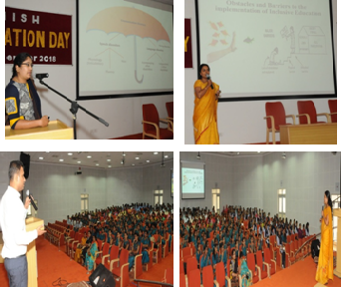
Orientation Program for teacher trainees was conducted on 14th December 2018 in the seminar hall of Knowledge Park from 2.00 PM to 5.30 PM. The orientation program was organised by the Department of Clinical Services. The objective of the orientation program was to create awareness on different communication disorders, classroom adaptations for children with special needs and concessions/facilities available for children with communication disorders. The target group for the program included 280 teacher trainees from BGS B.Ed college and Sharada Vilas B.Ed. College, Mysore. The program was coordinated by Ms. Prathima, S., Itinerant Speech Therapist under the guidance of Dr. N. Sreedevi., HOD- Clinical services.
Resource persons for the program included Ms. Deepa Anand., Research Assistant, Ms. Prathima S., Itinerant Speech Therapist and Mr. Prashanth R., Medico Social Worker.
The orientation lecture series by the resource persons began at 2.00 PM. Firstly, Ms. Deepa Anand, Research Assistant, oriented the target group on “Identification of children with communication disorders in regular class rooms”. Second, Ms. Prathima, S., Itinerant Speech Therapist, addressed the audience regarding “Classroom adaptations for children with communication disorders”. Following this, Mr. Prashanth, R., MSW, emphasized on “Welfare measures for persons with communication disorders.
The participants interacted actively with the resource persons and clarified their doubts. A feedback form was obtained from the participants about the lectures delivered. The graphical representation of the rating for each of the resource person is shown in figure 1. The analysis of the overall scores revealed that majority of the participants rated excellent, followed by very good and good.
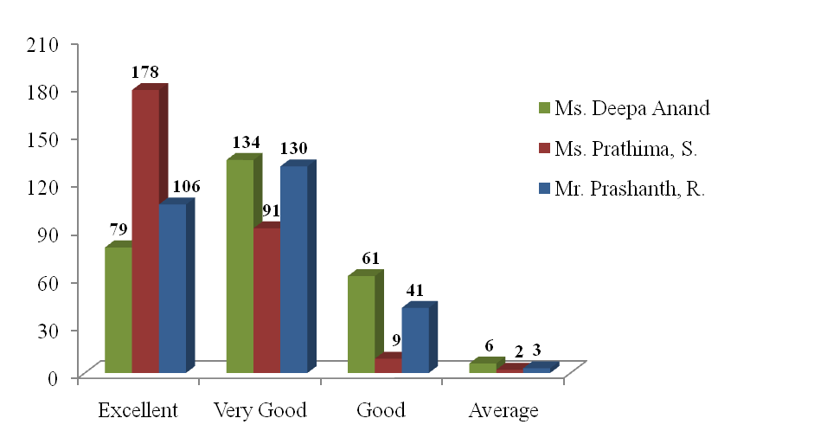
Figure 1: Rating scores for the resource persons
All participants gave positive feedback and were very happy about the program. However, few suggestions to improve the program were as follows:
- To conduct such programs in large numbers to create awareness among teacher trainees about communication disorders in children.
- To educate D.Ed students also.
At the end of the session, participants were divided into 7 batches and they visited the Departments of Clinical Services and Special Education.
A total of Rs. 5,000/- was sanctioned for the refreshments and an amount of Rs. 4,550/- was spent for the same.

- Commemoration of International Day for Persons with Disabilities on 20.12.2018

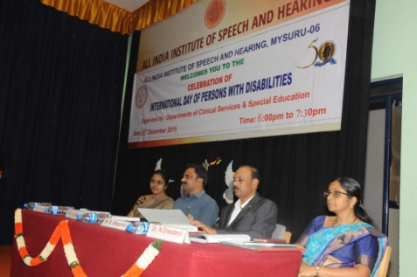
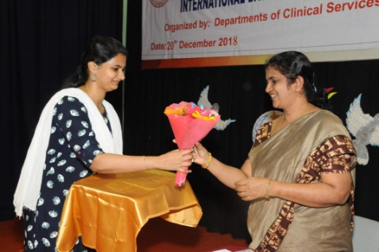
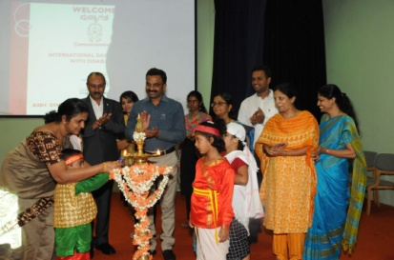
The All India Institute of Speech and Hearing, Mysuru is a premier institute in the country, imparting training, assessment and rehabilitation in the field of Speech-Language and Hearing. The institute deals with identifying and treating various communication disorders in individuals of all ages. These communication disorders hamper the activities and participation of persons with such conditions. In order to empower persons with disabilities, it is essential to inculcate confidence in ones’ own abilities to lead independent lives. The International Day of Persons with Disabilities provides an opportunity to promote participation of persons with disabilities. It aims to promote awareness regarding disability issues and the fundamental rights of persons with disabilities. The UN General Assembly had launched World Program of Action for Disabled Persons in the year 1982. The UN seeks equal rights for all humans irrespective of their religion, caste, economic condition and physical ability. In connection with this, the All India Institute of Speech and Hearing, Mysuru celebrated “The International Day of Persons with Disabilities” on 20.12.2018. On this occasion, a public function for the caregivers and their children attending therapy and preschool was organized by the Department of Clinical Services and the Department of Special Education. The general public was also invited to join for the good cause.

The programme commenced at 6:00 pm at the AIISH Panchavati campus and Ms. Divyashree K.N. compeered the program. The program was coordinated by Mr. Prashanth R and Mr. Pradeep Kumar P. A total of 900 participants participated in the program. Mr.K.H.Jagadeesha, Commissioner, Mysruru City Corporation, Mysuru was the chief guest on this occasion Mr. B. Elangovan, Principal, JSS Polytechnic for the Differentially Abled was the guest of honour for the occasion. The program commenced with invocation, followed by the HOD-Clinical Services, Dr. N.Sreedevi welcomed the gathering.

The special achievers Ms. Sandhya, Mr. Raghu T., Ms. Spoorthy B. S. and Mr. Dilip Kumar R. were felicitated by the chief guest. The details of felicitation and their achievements were compeered by Ms. Seema M.

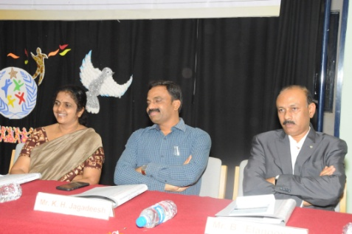
Ms. Sandhya, took rehabilitation services at AIISH for her poor speech and language skills and completed SSLC through National Open School. Presently is working in Vinyas Innovative Technologies Private Limited, Mysuru as Production assistant. Sri. Raghu T as young as four years of age underwent speech and language training at AIISH. He studied in Kannada Medium at a regular school up to 10th standard and secured 70% in SSLC. Currently, he’s posted in Vijaya bank, Santhepet Branch in Mysore Region. Ms. Spoorthy B. S. has been diagnosed as hearing impairment. Inspite of her condition she has reached heights. She completed S.S.L.C from CKC High school, Mysore with 81.75% in 2008 and PU in Computer Science from Kautilya Vidyalaya, Mysore with 69.8% in 2010. Further, Bachelor of Engineering in Computer Sciences from NIE, Mysore with 75.5% in 2014 and Master of Technology in Computer Engineering from SJCE, Mysore with 68.2% in 2016. Currently, she is working as software engineer in Arwizon Digital Private Limited, Bengaluru (since one year). Sri. Dilip Kumar R. aged 32 years has been diagnosed as Mild Intellectual disability. Since May 2007 he started working in Vinyas Innovative Technologies Private Limited, Mysuru as Production assistant. In the year 2010, he has been awarded as “Best worker” from Rotary Central Mysore.

Smt. Aysha M, mother of master Muhammed Rabeeh M and Muhammed Lahal Shaad who is diagnosed as SLD with ID and SLD with DD respectively was awarded the “Best mother of the year-2018”. All these individuals were awarded “Empowered achievers for the year 2018” People like them are the ones who have proved themselves in their functional area and succeeded to bring over social change in the society and to reframe the terminology ‘disabled’ to ‘differentially abled’.
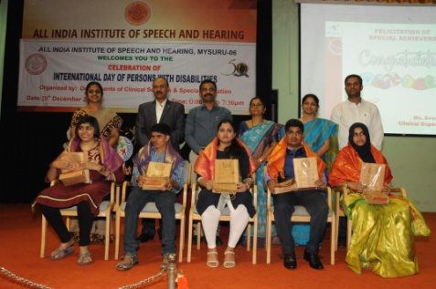

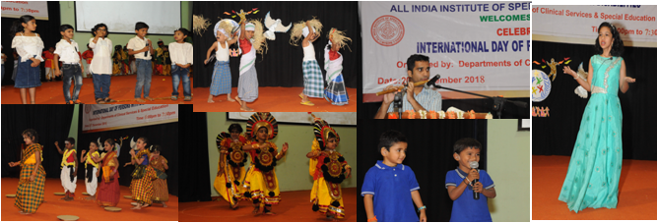
The chief guest Mr. K. H. Jagadeesha, in his inaugural address explained about the 3% fund reservation, available for the differently Abled to purchase aids and appliances. He also said that MCC has allocated Rs.3.65 crores for the welfare of differently Abled for the financial year 2018-19, out of which only 30% has been utilized due to the lack of awareness of people and he also requested the differently Abled to come and directly approach him to avail the welfare measures of Mysuru City corporation. The guest of honour Mr.B.Elangovan, Principal, JSS Polytechnic for the Differentially Abled also gave his valuable guidance to the care givers and asked everyone to treat the differentially abled normally and to be more empathic. Dr. M. Pushpavathi, Director, AIISH, Mysuru, in her presidential address stressed about the importance of caregivers in the process of rehabilitation of differently abled. The function concluded with vote of thanks by Mr. Prashanth R.

Client attending therapy at the Dept. of Clinical Services entertained the audience with their talents by performing flute play and Children attending preschool at the Dept. of Special Education entertained the audience with their talents by performing group dance and group song.

- Budget Approved - Rs. 65,150/-
- Total Expenditure - Rs. 53,516/-

- Staff Enrichment Program: Nil

- Others:

- OLI
Region A | -
Region B | -
Region C | 23
Others | -

- Client Welfare Fund - 21
- Certificate Issued - 13
- CWF 100% Free hearing aid (Volta) -00
- Display of clinician’s names in Hindi-English bilingual form – 50
- Display of client’s names in Hindi-English bilingual form – 172
- Signing assessment formats - 00

- Material Development: Nil

XI. Research
- Research projects - 8 Nos
Sl. No | Title | Investigator/ Co-Investigator | Funding agency | Remarks
 | Genetics insight of Cerebral palsy using massively parallel sequencing | Dr. N. Sreedevi - PI  Dr. N. Swapna  Dr. K. Srinivas | ARF | Report to be submitted  Term over
 | Motor equivalence and speech kinematics in normal and pathological speech production | Dr. N. Sreedevi - PI  Dr. Ganesh Sinisetty - Co-PI  Dr. Irfana M – Co PI | ARF | Report to be submitted  Term over
 | Frequency of occurrence of phonemes in Hindi | Dr. N. Sreedevi – PI  Dr. Irfana M – Co PI | ARF | Report to be submitted  Term over
 | Phonological Encoding in Bilingual Adults with Stuttering. | Dr. Sangeetha M - PI | ARF | Project term completed on 31.10.2018  Report finalization is in progress.
 | Effect of combined tactile, thermal and gustatory stimulation on feeding and swallowing in children with cerebral palsy | Dr. Swapna N - PI  Ms. Prathima S Co - PI | ARF | Ongoing
 | Effect of Resource Material on Impact of Inclusive Education in Children with Intellectual Disabilities and Learning Disabilities | Dr. Malar G  Ms. Prathima S Co - PI | ARF | Term completed. However, request for extension is in process
 | Development of a test for Assessment of Prosody in Children | Dr. N. Sreedevi  Dr. Sangeetha M Co-PI | ARF | Approved  2018-19
 | Development and Standardization of Reading Passages for Children in Kannada | Dr. Sangeetha M | ARF | Approved  2018-19

- Doctoral thesis - Ongoing - 5 nos
Sl. No. | Title | Name of the Candidate | Guide
 | Effect of Phoneme Context and Position on Articulation in Kannada Speaking Children with Speech Sound Disorders | Ms. Amulya P Rao  Submitted | Submitted  Dr. N Sreedevi  Ongoing
 | Effect of vowel context and phoneme position on correct articulation of phonemes in children with Down syndrome in Malayalam: pre post therapy comparison | Ms. Anita Naitee Abraham | Submitted  Dr. N Sreedevi  Ongoing
 | Acoustic and articulatory characteristics of cochlear implantees in Malayalam | Ms. Deepthy Anne joy | Submitted  Dr. N Sreedevi  Ongoing
 | A Comparative study of phonological representations in native Malayalam speaking typically developing children and children with speech sound disorders. | Ms. Ranjitha R | Submitted  Dr. N Sreedevi  Ongoing
 | Enrolled for Ph.D program (Sp & Hg) | Ms. Seema M | Submitted  Dr. N Sreedevi  Ongoing

- Dissertation Program – 03

Sl. No. | Title | Name of the Candidate | Guide
 | Phonotactic Development in 2-5 years old Native Malayalam Speaking Children | Ms. Jijina T | Dr. N. Sreedevi
 | Phonetic influences in Adults with Stuttering | Ms. Shishira S | Dr. Sangeetha M
 | Assessment of effective factors in Children with Stuttering | Ms. Krishnendu | Dr. Sangeetha M

Paper Published: 02

- Alexei, K., Tabain, M., N Sreedevi & Beare, R. (2018) Manner and place differences in Kannada coronal consonants: articulatory and acoustic results, The Journal of the Acoustical Society of America, 144, 3221 (2018); https://doi.org/10.1121/1.5081686
- Akshay, M M ., Sreedevi, N., Arun, K. & Shanbal, J .(2018). Infant Screening System based on cry analysis. International Annals of Science, 6(1), 1-7. ISSN: 2456-7132.

Paper Presentation: Nil

X. CLINIC STAFF ACTIVITIES

Sl. No | Staff | Diagnostics | Therapy |  | CPC  Class
Sl. No | Staff | Diagnostics | Lang | Special Clinic | CPC  Class
 | Dr. N. Sreedevi | 05 | 05 | 01 | NA
 | Dr. Sangeetha M | 08 | 10 | 03 | NA
 | Dr. Preethi. Thomas | 89 | 15 | - | NA
 | Ms. Geetha M.P | 27 | 25 | 02 | -
 | Dr. R. Gopi Sankar | 15 | 05 | 19 | -
 | Ms. Seema M | 25 | 16 | 19 | 05
 | Ms. Prathima .S | 20 | 22 | 06 | -
 | Mr. Pradeep Kumar | 20 | 44 | 11 | -
 | Ms. Deepa Anand | 34 | 04 | 16 | -
 | Ms. Aruna Kamath | 04 | - | 25 | 04
 | Ms. Divyashree K.N. | - | 11 | NA | NA
 | Ms. Akrithi Kumar |  |  | NA | NA
 | Ms. Reshmitha R | - | - | 10 | NA
 | Mr. Sumanth P | - | 11 | - | NA
 | Ms. Divya Vinod K |  |  |  | NA
 | Ms. Pooja S | - | 12 | - | NA
 | Staff | Diagnostic | Therapy |  | NA
 | Mr. Sohan Singh | 37 | 33 |  | NA
 | Ms. Vidhathri D S | 20 | 44 |  | NA
 | Ms. Meela P | 20 | 41 |  | NA
 | Ms. Barathi K | 27 | 44 |  | NA
*Not applicable

- Dr. N. Sreedevi - Professor in Speech Sciences and Head- Dept. of Clinical Services

- Has been officiating as HOD- DCS
- Has been serving as Chairperson of Phonology clinic/Voice clinic.
- Has been serving as PI for 2 ARF projects.
- Serving as chairperson of purchase review committee.
- Conducted Purchase committee meeting on 28.11.2018 and 19.12.2019.
- Overall coordination of commemoration of IDPWD on 20.12.2018.
- Attended Condemnation committee meeting on 20.12.2018.
- Coordinated AIISH Gymkhana meeting on 24.12.2018.
- Guiding 5 PhD students.
- Guiding 1 dissertation student.
- Submitted C3 dissertation marks on 20.12.2018.
- Serving as committee member for research proposal of 12 PhD candidates and and as guide for one candidate on 21.12.2018 and 28.12.2018
- Prepared questions for entrance exam
- Reviewed 3 articles submitted to NSA 17 for publication

- Dr. Sangeetha Mahesh- Clinical Reader

- Teaching course “Fluency and its disorders – 4 hours/week
- Attended demo session on Sonako sign lab- ISL videos by Mr. Sunil and Mr. Ramelingam, Bridge people, Bangalore.
- Submitted current responsibilities at the institute online portal.
- Attended meeting with director and discussed videos to be developed at DCS.
- Ms. Sabeena, Research officers joined on 29.11.2018 to ARF project – Development and standardization of ready passages in Kannada for children.
- Submitted the initial ARF project report titled “Phonological encoding of bilingual Adults with Stuttering” ARF 2017-18 as soft copy along with account details on 30.11.2018.
- Submitted the agenda for 57th EC from the department of Clinical Services.
- Coordinated the finalization of best clinician award 2017-18.
- Finalized the best mother awardee and special achievers, assisting in coordinating IDPWD 2018.
- Served as resource person and delivered lecture on “Role of teachers in the management of children with stuttering” on 14.12.2018 as a part of communication of stuttering awareness day.
- Submitted C3 marks for dissertation work.
- Submitted problem based MCQS with answers and references with respect to entrance examination on fluency and its disorders.
- Attended National workshop on systematic reviews and meta-analysis on 08.12.2018.

- Dr. Preethi T. Thomas – SLP Gr – I

- Ms. Geetha M.P – SLP Gr - I

- Attended work shop on “National workshop on “Listening Skills in Counseling –An Indian Perspective”on 28th December 2018.
- Preparation of PG vacation posting schedule
- Member of Fluency Unit
- ISO member for Department of Clinical Services (Tire 2)
- Preparation of MD work schedule for PG students
- Correction of PG work of UG students during their vacation postings
- Maintenance and Preparation of monthly reports and statistics of Speech-Language Therapy Unit and Special Clinics
- Preparation of Therapy Supervisors list for the month of December-18
- Follow up on the work orders of both SLT and SCT sections

- Dr. R. Gopi Sankar – Research Officer

- Serving member secretary for USOFA, Voice Clinic
- Coordinating the ongoing Department Computerization.
- Verification of CPC for M.Sc 2016-2018.
- Verification of CPC for B.Sc 2014-2018.
- Reviewed ISHA abstract, conference 2019
- Verified 16 purchase files of the department.
- Nominated to co-ordinate the video recording by director.
- Verification of internship students’ documents – ongoing.
- Attended Condemnation committee meeting on 20.12.2018.

- Ms. Seema .M – Clinical Supervisor

- Maintenance and Preparation of monthly reports and statistics of and Special Clinics.
- Follow up on uploading recorded communication disorders samples from Audio/Video recorder to external hard disk
- Member of Fluency and ASD unit.
- Follow up on the work orders of both SLT and SCT sections
- Verifying and preparation of 06 discharge summary reports at special unit for the month of Dec -18
- Follow up on uploading recorded communication disorders samples from Audio/Video recorder to external hard disk.
- Served as comparer for ISAD 2018, as a member of fluency unit.
- Served as resource person and delivered a talk on “Fluency and its disorders” in ISAD 2018 held on 14.12.2018.
- In-charge for clinical mentor for I.BASLP .
- Served as comparer for IDPWD special achievers announcement and also as catering in-charge for IDPWD 2018.
- Responsible for clinical assessment/supervision (OPD) on every Tuesday F/N
- Responsible for clinical assessment/supervision at ASD unit on every Monday F/N
- Counselling and guidelines to the parents of children with communication disorders
- Recording done during the month of 26th Nov 2018- 25th Dec. 2018

Sl.No | Stuttering | voice | USOFA | OTHERS
1. | 13 | 0 | 07 | 03

15. Short Term Training Programs/ Allied professionals (ENT, B.S.Ed etc..)
Sl. No. | Date | Name of the Institute/College | No. of Participants
1. | 1.10.18 | Astavakrainstof rehabilitation sciences and research ,Delhi | 4
2. | 1.10.18 | Intern, JIPMER | 1
3. | 1.12.18 | Intern, NSCB,Jabalpur | 2
4. | 1.12.18 | B.S.Ed (HI)AIISH | 6

- Ms. Rubby

- Details of sign language case handled for the month of December.
Sl. No. | Case Name | Case No. | Age/Gender | No. of Sessions | Total No.
1. | Sneha | 291723 | 10yrs./Female | 14/16 | 14
 |  |  | Total |  | 14
Recording of 5 ISL videos with Mr. Shivaprasad M- Graphic Designer. (Namely
Months, Week, Colours, States & Place, Family Relationship)
Recording of 5 ISL videos with Mr. Shivaprasad M- Graphic Designer. (Namely
Months, Week, Colours, States & Place, Family Relationship)
- Taught months and week name in sign language to the client’s mother. (Client Name – Inchra, Case No. 403236)
Recording of 5 ISL videos with Mr. Shivaprasad M- Graphic Designer. (Namely
Months, Week, Colours, States & Place, Family Relationship)
Recording of 5 ISL videos with Mr. Shivaprasad M- Graphic Designer. (Namely
Months, Week, Colours, States & Place, Family Relationship)
Recording of 5 ISL videos with Mr. Shivaprasad M- Graphic Designer. (Namely
Months, Week, Colours, States & Place, Family Relationship)
- The ISL certificate was sent by e-mail to the staff and students participating in Indian Sign Language classes, during August-September 2018.
- Writing word a day in Hindi on office board.
- Attended meeting with AAC Chairperson- Dr. Sangeetha M., Ms. Aruna Kamath & staff from Bridge People (Mr. Ramalingam and Mr. Preetham) Bangalore on 27.11.2018 at DCS regarding demonstration of sign lab.
- +$#- 9
- /.-1
- Attended the 3rd Meeting of the committee of OLI Nodal Officers 2018-19 was held on 27.11.2018 from 2.30 p.m. to 3.30 p.m. at Meeting Hall, 2nd Floor, Administrative Block for discussion on compliance of Instruction on OL Implementation.
- Downloaded 1200 words sign video from ISLRTC website.

- +$#- 9
- /.-1AAC Awareness week certificate was sent by e-mail on 22.11.2018 to the Staff/
- Ms. Prathima S - IST

- Verified 32 overall clinical documents of III B. Sc (speech and hearing)
- Served as coordinator in organizing the orientation program for on “Communication disorders and classroom adaptations” for teacher trainees of Mysuru on 14.12.2018 at the All India Institute of Speech & Hearing, Mysuru
- Served as a resource person and presented a topic titled “Multiple disability: Definition, identification characteristics, identification and strategies” in the teachers training program on “Workshop on Learning Disability” for KV teachers on 29.11.2018 at the KVS-ZIET, Mysuru.
- Served as a resource person and presented a topic titled “Classroom adaptations for children with communication disorders” in the orientation program on “Communication disorders and classroom adaptations” for teacher trainees of Mysuru on 14.12.2018 at the All India Institute of Speech & Hearing, Mysuru

- School visits in Mysore district:
Sl  No. | School address | Date of visit | No. of children followed up | No. of children referred to AIISH | Guidelines given to teachers
 | Mysore West Lions Sevanikethan School, Gokulam, Mysore | 12.12.2018 | Referred to POCD for school screening |  | 2
 | Saraswathi Primary School, Saraswathipuram, Mysore | 13.12.2018 | - | 2 | 4
 | Nrupatunga Kannada Shale, Ramakrishna Nagar, Mysore | 18.12.2018 | - | 9 | 10
 | Mahavir Vidhya Mandir, Srirampura, Mysore | 19.12.2018 | - | 3 | 5
 | Mahabodhi School, Saraswathipuram, Mysore | 20.12.2018 | - | 3 | 5
 | Total visits: 5  Total No. of schools visited:4 |  | No. of children followed up: 0 | No. of children referred to AIISH:17 | Teachers: 26

- Mr. Pradeep Kumar– SLP Gr. II

12) Ms. Aruna Kamath – SLP Gr I (Contract)

  - Therapy evaluation report and lesson plan for the clients.
  - Guidance to B.Sc Intern and B. Sc III students
  - On 27-11-18 meeting with Chair person Ms. Sangeetha Mahesh , Ms. Rubby, and Staff of Bridge people (Mr. Ramalingam, and Mr. Preetham from Chennai), regarding Sign Lab
  - On 14-12-18 sent softcopy of specifications to chair person AAC Unit and DCS for all the 8 new items that are to be indented for this year
  - On 17-12-18, Meeting in AAC Unit with the Director Dr. Pushpavathi, Dr. Sangeetha Mahesh Chair person of AAC regarding requirements in AAC unit and other modifications that needs to be implemented in the unit

Sl. No. | Date | Name of the Institute/College | No. of Participants
 | 10.12.2018 | orientation and sensitization about AAC and its activities for PG ENT Dr. Ravi Ambewadi from Mandya Institute of medical Sciences, Mandya. | 1
 | 18.12.2018 | Orientation and sensitization for PG ENT Dr. Sajitha SS institute of Medical Sciences Davangere. | 1

- Ms. Deepa Anand – Research Assistant

- Compiled attendance of UG, PG and Internship students attendance until December 28th 2108.
- II B.Sc. students module work distribution and correction
- ASD unit statistics
- Prepared slides for IDPWD 2018 celebrated on 20.12.2018
- Work record of II B.Sc. students was checked.
- Served as a resource person and presented a topic titled “A peep into different communication disorders and its identification” in the orientation program on “Communication disorders and classroom adaptations” for teacher trainees of Mysuru on 14.12.2018 at the All India Institute of Speech & Hearing, Mysuru.

- Mr. Prashanth .R – Medical Social Worker

- Member for Adult and Elderly Persons with Language Disorder (*CAEPLD*) 1 Case
- Member of Client Welfare fund. (Totally 21 Cases settled for the month of December 2018) Report *Enclosed*
- Follow up calls to the beneficiaries of client welfare fund and maintenance of CWF follow up register (" 9 Cases)
- Discharge planning : Counselling and client feedback
- General maintenance of the department and monitoring. Various work orders issued
- Compilation,processing & analysis of Overall client feedback forms of the institute.
- Providing referral services to clients : Issuing and referring the client to speech and hearing centres and special school
- and Govt Organizations
- Compilation,processing & analysis of client Therapy feedback forms(Regular therapy, demonstration therapy, Change Of Therapist ,PT/OT Therapy) of the DCS.
- General letter correspondence
- Delivered a lecture on welfare measures for persons with communication disorders in International Stuttering awareness day on 14.12.2018.
- Coordinator for IDPWD commemoration held on 20th Dec 2018 AIISH GYMKHANA.
- Drafting and preparation of various letters for internal and external correspondence.

Client Welfare Fund for the month of December, 2018
CWF – December, 2018
Clients seeking | 245
Clients rejected | 172
Clients availed | 21
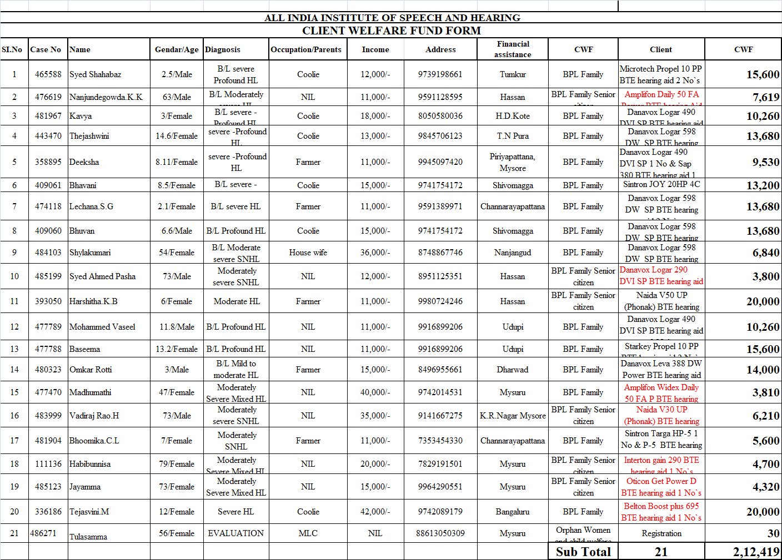

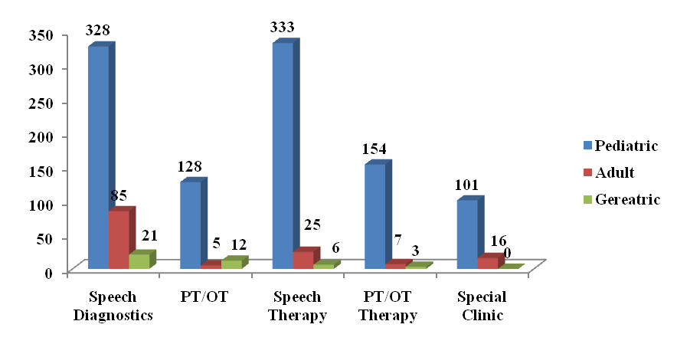
Number of Diagnostic and therapeutic cases seen during the month of December 2018

Total number of therapy cases for the month of December 2018

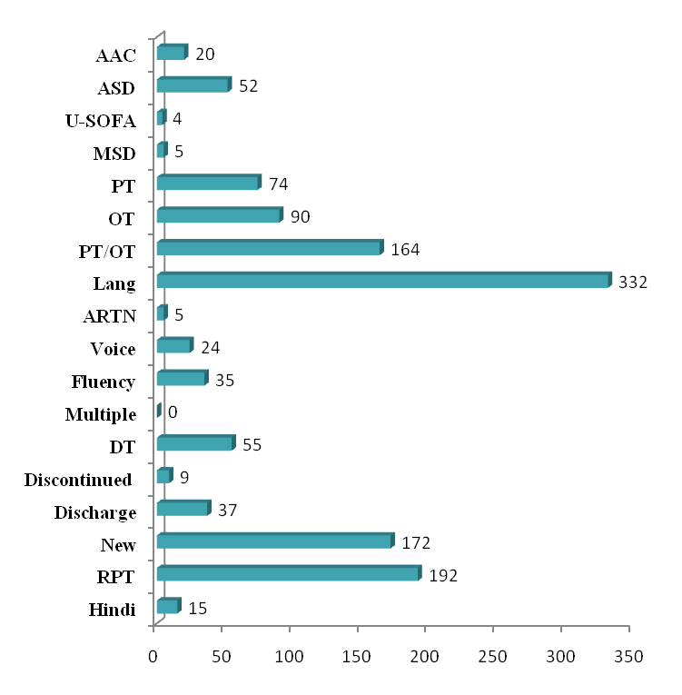

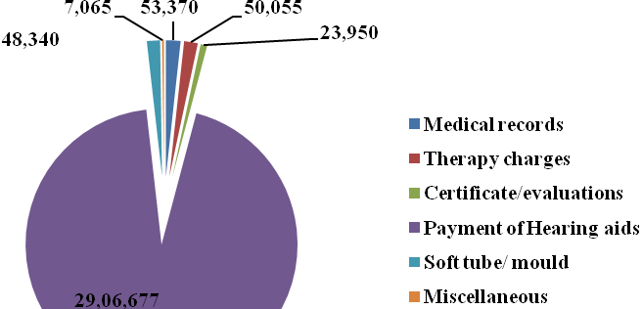
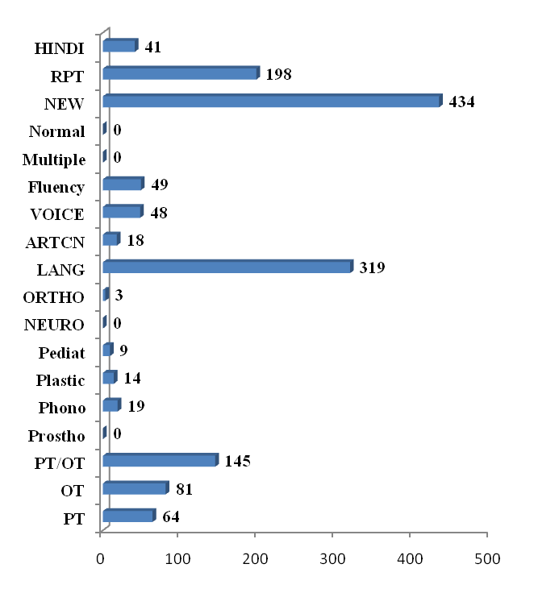
Total Number of Diagnostic cases attended for the month of December 2018
Revenue Generated at DCS

Clinical Services rendered/ No. of Cases registered/files retrieved at AIISH for the month of November 2018

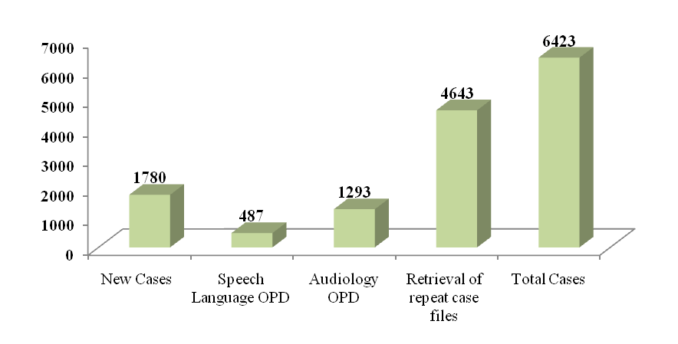

ALL INDIA INSTITUTE OF SPEECH & HEARING: MYSURU- 6
अखिल भारतीय वाक श्रवण संस्थान: मैसूर-६
DEPARTMENT OF CLINICAL SERVICES
चिकित्सा सेवा विभाग
SH/DCS/Monthly-Stat/2018-19 07.01.2019
एसहेच/दिसिस/मासिक रिपोर्ट/२०१८-१९

Submitted to the Director:
निदेशक को प्रस्तुत:

Sub: Monthly Report of December, 2018.
विषय: दिसेम्बर की मासिक विवरण - के बारे में

With reference to the above please find herewith monthly report of Department of Clinical Services for the month of December, 2018. This is placed for your kind information.

Verified by, HOD- Clinical Services
विभागध्यक्ष- चिकित्सा सेवा विभा

