**ALL INDIA INSTITUTE OF SPEECH AND HEARING, MYSURU-6**

**अखिल भारतीय वाक श्रवण संस्थान, मैसूर-६**

**DEPARTMENT OF SPECIAL EDUCATION**

**विशेषशिक्षा विभाग**

**MONTHLY REPORT – November 2018**

1. **ACADEMIC ACTIVITIES**

**Faculty report**

**Therory classes**

|  |  |  |  |
| --- | --- | --- | --- |
| 1. **SL Faculty name** | **DECSE-HI** | **B.Ed.Spl.Ed. (HI)** | **Total** |
| Dr.Alok Kumar Upadhyay | NIL | NIL | NIL |
| Dr. Prithi V | 8 classes | NIL  (inter-semester vacation) | 8 classes |
| Dr. Palnaty Vijetha | NIL | NIL  (inter-semester vacation) | NIL |
| Dr. G. Malar | 16  (including 2 extra) | NIL  (inter-semester vacation) | 16 |
| Ms. Lakshmi Prabha | 07 | NIL  (inter-semester vacation) | 07 |

**Practical Classess (In Hours)**

|  |  |  |  |
| --- | --- | --- | --- |
| **Faculty** | **DECSE-HI** | **B.Ed.Spl.Ed. (HI)** | **Total** |
| Dr. G. Malar | 26 | 30  (in compensatory & vacation postings) | 56 |

1. Educational Observation Postings of Students from other Institutes: NIL

Following are the details of students posted for observation/ practice teaching

1. Seminars/Conferences/**Workshops**/Training Programs: NIL
2. Staff Enrichment / **In-house training Programmes***(For own staff members)* : NIL

|  |  |  |  |  |  |
| --- | --- | --- | --- | --- | --- |
| **Theme/Topic** | **Resource Person** | **Coordinator** | **Objectives** | **Targeted Audience** | **Date** |

1. Guest Lectures : NIL
2. Additional Academic Services rendered by the Faculty and Staff
3. **Invited Talks: 01**

|  |  |  |  |  |
| --- | --- | --- | --- | --- |
| **Sl. No.** | **Name, Designation, Institutional affiliation of Lecturer** | **Organized by Department/ Section/ Unit/ Organisation** | **Topic of Lecture** | **Date/s** |
| 01. | Dr G. Malar, Reader in Special Education, AIISH | Kendriya Vidyalaya Sangathan – Zonal Institute of Educational Training (KVS-ZIET), Mysuru | Education of the Physically Challenged and Socially Disadvantaged Students in Inclusive System | 30.11.18 |

1. **Resource person during interaction program: NIL**
2. **Curriculum Development:**

*Dr G. Malar*

* *Assisted HOD–Special Education in gathering information about necessary revisions of B.Ed.Spl.Ed. (HI) syllabus.*

1. Development of Material to Support Learning: NIL
2. **Service in Academic Bodies of other Organizations:**
3. **Dr Alok Kumar Upadhyay**

Board of Studies (BOS) Member in three University:

* RamkrishnaMission Vivekananda University, Coimbatore: BOS Member for Diploma, U.G & P.G
* N.G.B. University, Allahabad: BOS Member for U.G & P.G
* J.R.H. University, Chitrakoot: BOS Member for U.G & P.G

Member of Board of examination (BOE)

* 1. Mysore University, Mysuru

1. **Dr G. Malar**

* BOE–UG Special Education of University of Mysore.

1. **Dr PrithiVenkatesh**

* Member in board of examiners, University of Mysore

1. **Dr PalnatyVijetha**

* BOE–UG Special Education of University of Mysore.

1. **Ms Lakshmi Prabha J. K. : NIL**
2. Participation in Committees/Taskforce and Panels setup by other organizations/agencies: NIL
3. **Any Others (Please Specify)**

**Parent enrichment programs (PEP): 01- This program aims to enrich knowledge of the caregivers of CWSN by experts from various fields.**

|  |  |  |  |  |
| --- | --- | --- | --- | --- |
| Theme/Topic | Coordinator | Objectives | Targeted Audience | Date |
| Dental care | Ms. Leena & Ms. Latha | To empower the parents/care givers of children with communication disorders I order to improve the quality of children with communication disorders | 96 parents/care givers | 27.11.18  (2 hours) |
| C:\Users\User\Pictures\Picasa\Collages\Photos1.jpg | | | | |

1. Research Projects (ARF)
2. Completed - NIL
3. New Research Projects - NIL
4. **Ongoing Research Projects - 02**
5. **Title of ARF** - Development and Evaluation of Indigenous curriculum oriented computer based tutor for concept learning in preschool children with special needs.

Principal Investigator – Ms. P.V. Ramanakumari

Co-Investigators – Dr.Ajish K Abraham and Ms. P.V. Manjula

Research Assistant – Mr. Anil Abbur R.

Date of Starting – 18th January 2017

Progress –

* Review of literature.
* Voice recording of the story dialogues.
* Gave module 7 for animation developing (out sourcing).
* Administration of Module 6 is being carried out.

1. **Title**: Effect of Resource Materials on Impact of Inclusive Education in Children with Intellectual Disabilities (ID) and Learning Disabilities (LD)

Investigators: Dr. G. Malar, Ms. S. Prathima&Mr. D. Gururaj

Duration: 12 months from January 2017

Budget: Rs. 3,85,000/-

Progress: Suspended till appointment of staff for extension 2018

1. Postgraduate Research Completed: NA
2. C. Postgraduate Research ongoing: NA
3. D**.** Research Papers presented at National/International Conferences/Seminars :- NIL

E.Research Papers Published

i) Papers published in National / International Journals: NIL

ii) Abstracts published in Conference / Seminar Proceedings: NIL

F. **Books published (in APA format)**

1. *Books published: NIL*

* *Books in press: Malar, G., & Asha, S. A. (in press). Visual arts for preschoolers (2nd ed.) Mysuru, India: AIISH.*

*Submitted to Product Development Cell in August 2018.*

G.Book chapters published (in APA format): NIL

10. Books/Manuals/Seminar

H .Books/Manuals/Seminar Proceedings edited: NIL

1. Journal Editorship: NIL

J. Scholarly Reviewing Activities:

1. Special Educational Services Offered through Teacher Trainees Outside Campus: NIL

**III CLINICAL/EDUCATIONAL SERVICES**

1. General Clinical Services: **Not Applicable**
2. Specialized Clinical/ Educational Services
3. **Pre-school Training and Special Education**

**Educational services for children with special needs**

|  |  |  |  |  |  |  |  |  |  |  |  |  |
| --- | --- | --- | --- | --- | --- | --- | --- | --- | --- | --- | --- | --- |
| **S. No.** | **Nature of Services (In charge staff)** | | | | | | | | | | | |
| 1. Special Educational Assessment Services (Dr. G. Malar) | | | | | | | | | | | | |
|  |  | Nature of Special Need  Language | ASD / PDD NOS | Hearing Loss | Intellectual Disability | Learning Disability | Motor Problems | Multiple Disabilities | Others | No. of Clients | No. of Sessions | ***Total No. of Sessions*** |
| 1. | Screening & Referral | Kannada | 0 | 14 | 5 | 0 | 2 | 6 | 3 | ***30*** | ***30*** | ***50*** |
| Malayalam | 0 | 6 | 3 | 0 | 0 | 2 | 3 | ***14*** | ***14*** |
| Hindi | 0 | 1 | 1 | 0 | 0 | 0 | 0 | ***2*** | ***2*** |
| Urdu | 0 | 1 | 0 | 0 | 0 | 0 | 0 | ***1*** | ***1*** |
| English | 1 | 0 | 0 | 0 | 0 | 0 | 0 | ***1*** | ***1*** |
| Telugu | 0 | 1 | 0 | 0 | 0 | 0 | 0 | ***1*** | ***1*** |
| Tamil | 1 | 0 | 0 | 0 | 0 | 0 | 0 | ***1*** | ***1*** |
| Any Other | 0 | 0 | 0 | 0 | 0 | 0 | 0 | ***0*** | ***0*** |
| ***Total No. of Clients*** | ***2*** | ***23*** | ***9*** | ***0*** | ***2*** | ***8*** | ***6*** | ***50*** | ***50*** |
| 2. | Assessment & Report | Kannada | 0 | 2 | 0 | 0 | 0 | 0 | 0 | ***2*** | ***9*** |  |
| Malayalam | 0 | 0 | 1 | 0 | 0 | 0 | 0 | ***1*** | ***6*** |
| Hindi | 0 | 0 | 0 | 0 | 0 | 0 | 0 | ***0*** | ***0*** |
| Urdu | 0 | 0 | 0 | 0 | 0 | 0 | 0 | ***0*** | ***0*** |
| English | 0 | 0 | 1 | 1 | 1 | 1 | 0 | ***4*** | ***13*** |
| Telugu | 0 | 0 | 0 | 0 | 0 | 0 | 0 | ***0*** | ***0*** |
| Tamil | 0 | 0 | 0 | 0 | 0 | 0 | 0 | ***0*** | ***0*** |
| Any Other | 0 | 0 | 0 | 0 | 0 | 0 | 0 | ***0*** | ***0*** |
| ***Total No. of Clients*** | ***0*** | ***2*** | ***2*** | ***1*** | ***1*** | ***1*** | ***0*** | ***7*** | ***28*** |
| Places from which seen: (1)Karnataka: 35 (2)Kerala: 13 (3)AP: Nil (4)Telangana: Nil (5)TN: 01 (6)Other Parts of India: 1(Bihar) (7)Any other: Nil | | | | | | | | | | | |
| Age groups seen:(1)Birth to 2.5yrs: 06 (2)2.5+ to 6 yrs: 32 (3)6yrs+ to 16 years: 10 (4)16yrs+: 02 | | | | | | | | | | | |
| Total No. of Referrals: (1)Educational Assessment: 06 (2)Educational Guidance: 02 (3)PIP: 03 (4)PPEP/ PBC/ GECS: 35 (5)CSS/IEP/NFE/DET: 06 (6)Any Other Services at AIISH: Nil (7)Any Other Services Outside AIISH: Nil | | | | | | | | | | | |
| No. of Reports Issued/Ready for Issue: (1) School Readiness: 03 (3) Curriculum-Based Assessment: 02 (4) Post-School: Nil | | | | | | | | | | | |

|  |
| --- |
| **Pre-school Training: Preparatory programme for schooling providing training in self-help, cognitive, language and (pre) academic skills, Preschool Supplementary Services (PSS)** |
| |  |  |  |  | | --- | --- | --- | --- | | **Language & Disability** | **No. of Groups** | **No. of Children** | | |  |  | MALE | FEMALE | | Kannada ASD & ID &MD | 15 | 48 | 20 | | Kannada HL | 8 | 34 | 20 | | Malayalam HL | 1 | 2 | 2 | | Malayalam ASD & ID & MD | 8 | 14 | 12 | | Hindi HL | 2 | 8 | 5 | | Hindi MD & ID & ASD | 2 | 7 | 3 | | English ID, ASD | 1 | 3 | 2 | | Telugu ASD & ID & MD& HL | 1 | 5 | 3 | | TOTAL Number of children | **-** | **121** | **67** | | **TOTAL No. Groups** | **38** | **188** | | | **Sessions** | **2888 ( Group-wise)** | | | |

|  |  |  |  |  |  |
| --- | --- | --- | --- | --- | --- |
| **Curricular Support Services – Supportive training to augment education in mainstream school/ other educational programmes** | **Language** | **HL** | **ID/CP/ASD/MD/LD/DD** | **Total No. of clients** | **No. Of sessions** |
| Kannada | 9 | 14 | 23 | 89 |
| Malayalam |  | 1 | 1 | 4 |
| Hindi | 1 | - | 1 | 16 |
| English | 3 | 6 | 9 | 29 |
| Telugu |  | 1 | 1 | 7 |
| Tamil |  |  |  | - |
| **Total** | | | | **34** | **145** |
| |  |  |  |  |  |  | | --- | --- | --- | --- | --- | --- | | **Individualised Educational Programme (IEP) – Training in functional academics for out of school individuals** | **Language** | **HL** | **ID/CP/ASD/MD/LD/DD** | **Total No. of clients** | **No. Of sessions** | | Kannada | 2 | 7 | 9 | 50 | | Malayalam | 1 | 2 | 3 | 6 | | Hindi | 1 | 1 | 2 | 8 | | English | - | - |  |  | | Telugu | 1 | - | 1 | 3 | | Tamil |  | - | - | - | | **Total** | - | - | **15** | **67** | | | | | | |
| |  |  |  |  |  |  | | --- | --- | --- | --- | --- | --- | | **Demonstration Educational Training – Short-term demonstration to caregivers in any of the above** | **Language** | **HL** | **ID/CP/ASD/MD/LD/DD** | **Total No. of clients** | **No. Of sessions** | | Kannada | - | - | - | - | | Malayalam | - | 2 | 2 | 8 | | Hindi | - | - | - | - | | English | - | - | - | - | | Telugu | - | - | - | - | | Tamil | - | - | - | - | | **Total** | - | - | **2** | **8** | | | | | | |
| **Total clients:51**  **Old clients:- 48**  **New clients:- 05**  **Discharged(DET):-NIL**  **Discharged(CSS):- 01**  **Discharged(IEP):- NIL**  **Discontinued(DET):- NIL**  **Discontinued(CSS):- 01**  **Discontinued(IEP):- NIL** | | | | | |

|  |  |  |  |  |  |  |  |  |  |  |  |
| --- | --- | --- | --- | --- | --- | --- | --- | --- | --- | --- | --- |
| **Pre-school Parent Empowerment Programme – PPEP** | | | | | | | | | | | |
|  | **Language** | **HL** | **ID** | **CP** | **ASD** | **MD** | **LD** | **DD** | **SLD** | **VI** | **Total No. of clients** | **Group** | **No. Of sessions** |
| Kannada | 34 | 23 | 2 | 9 | 7 | -- | 3 | 2 | -- | 80 | 11 | 209 |
| Malayalam | 11 | 9 | 1 | 4 | 4 | -- | 6 | -- | -- | 35 | 5 | 95 |
| Hindi | 4 | 2 | -- | 3 | -- | -- | 1 | -- | -- | 10 | 2 | 38 |
| English | 1 | 1 | -- | 2 | 2 | -- | -- | -- | -- | 6 | 1 | 19 |
| Telugu | 2 | -- | -- | 2 | -- | -- | -- | -- | -- | 4 | 1 | 19 |
| Tamil | 2 | -- | -- | 1 | 1 | -- | -- | -- | -- | 4 | 1 | 19 |
| **Total** | | | | | | | | | | **139** | | **20** | **399** |
| No. of clients promoted to the next higher level(Preschool) of service: 40  No. Of discharged:NIL  No. Of discontinued: 12  No. Of New clients (Nove) : 32  Shifted from PPEP to PIP: NIL | | | | | | | | | | | | | |

|  |  |  |  |  |  |
| --- | --- | --- | --- | --- | --- |
| **Parent Infant Programme – PIP(Birth to 2 ½ years)** | | | | | |
| Parent-Infant Programme | **Language** | **HL** | **ID/CP/ASD/MD/LD/DD** | **Total No. of clients** | **Total No. Of sessions** |
| Kannada | 15 | 10 | 25 | 111 |
| Malayalam | 13 | 15 | 28 | 74 |
| Hindi | 02 | 01 | 03 | 05 |
| English | 00 | 01 | 01 | 02 |
| Telugu | 00 | 00 | 00 | 00 |
| Tamil | 02 | 01 | 03 | 02 |
|  | **Total** | | | **60** | **194** |
| No. of Old clients:56  No. of New clients enrolled: 04  Total clients:60  No. discharged: Nil  No. discontinued:05  No. of Promoted to next level: Nil  No. of Remaining:55 | | | | | |

|  |  |  |
| --- | --- | --- |
| **Library of Books & Toys** – LiBoToy  Services issuing educational toys & books for home-based training. | Total number of members enrolled –184  No. of new members: - 19  Amount – 950/-  Total number of sessions –20 | |
| **Age group** | **Total number** |
| 0-2.6 yrs | 5 |
| 2.6- 4 yrs | 45 |
| 4.0 – 6yrs | 128 |
| 6 yrs and above | 6 |

|  |  |  |
| --- | --- | --- |
| **Services** | **Number of Clients** | **Number of Sessions** |
| Co-Curricular Training | 188 | 20 |

**Supports for Empowering Caregivers**

|  |  |  |  |
| --- | --- | --- | --- |
| Name of Training Unit | No. of Parent  Beneficiaries | No. of Sessions | Content of Training |
| Caregiver Computer Training Unit | -- | -- | -- |
| Caregiver Literacy Training Unit | 06 | 20 |  |

1. Support Services to Clients and Family
2. **Counselling and guidance**

|  |  |
| --- | --- |
| No. of Clients | Sessions |
| 190 | 98 |

1. **U-SAFE**

|  |  |
| --- | --- |
| No. of Clients | Sessions |
| 42 | 14 |

1. **SUMERU**

|  |  |
| --- | --- |
| No. of Clients | Sessions |
| 30 | 06 |

1. Details of Certificates Issued: 04

|  |  |  |  |
| --- | --- | --- | --- |
| **Sl.No.** | **Nature of Special Needs in Clients** | **No. of Certificates Issued** | **Purpose** |
| 01 | SLD with ID | 02 | Aadhar |
| 02 | SLD with HI | 01 | Scholarship |
| 03 | SLD with ASD | 01 | Scholarship |

1. Financial Aid- NIL
2. Legal advice -NIL
3. Any other(Please Specify):

**Attended to workshop/Seminar/Orientation program in AIISH institute 2018-19: 01**

|  |  |  |
| --- | --- | --- |
| **Name of Staff** | **Attended to workshop title name** | **Date** |
| Dr. Prithi V  Ms. Sumana H P | Workshop on 'Simple Hand Drawings' | 30.11.2018 |

**Attended workshop/Seminar/Orientation program in Outside institute 2018-19: NIL**

|  |  |  |
| --- | --- | --- |
| **Name of Staff** | **Attended to workshop title name** | **Date** |
| - | - | - |

EXTENSION ACTIVITIES

1. Public Lecture Series: Nil
   * + 1. TECHNLOGICAL CONSULTANCY SERVICES: NIL
       2. CENTRAL FACILITIES
       3. Library and Information Services
       4. Public Information Activities

**Orientation Programs (For outsiders):** The following orientation programs were conducted to orient about the activities of the department and also to provide knowledge about the educational facilities and welfare measures for children with special needs. : 02

|  |  |  |  |  |
| --- | --- | --- | --- | --- |
| **SL No.** | **Coordinator** | **Targeted Audience** | **Number**  **of Participants** | **Date** |
| 1 | Dr.Alok Kumar Upadhyay | Students, Govt. Special teachers training center, Kasaragod, Kerala | 19 | 22.11.2018 |
| 2 | Dr.Prithi Venkatesh | 24 participants & 3 teachers, Zonal Institute of Education, Training (Kendra Vidyalaya-teachers Training Centre | 27 | 28.11.2018 |

* + - 1. Major Events of the Year with a brief account:
* **Name of the Programme/ Event:** Children’s day & Health Camp
* **Date:** 14.11.2018& 15.11.2018
* **Coordinated by:** Dr. Prithi V., Ms. Shobha B N.

The Department of Special Education organized two days free health camp for children availing different educational services at the Department of Special Education on 15th and 16th November 2018. Approximately 330 children with communication disorders were provided with free medical check-up by a team of expert doctors from Swami Narahari Teertha Medical Mission Trust, SGS Hosptial, Mysuru 25. The following doctors served as team of experts:

1. Dr.P.V.Phanishree, Paediatrician
2. Dr.Jagannatha Setty, H.V., Opthalmologist
3. Dr.A.Satyanarayana, General Physician
4. Dr. Vanitha S Bhat, Cardiologist
5. Dr.C.Prakash, Orthopaedic Surgeon
6. Dr.N S.Shreyas, Dermatologist
7. Dr. Bharath kumar Garla, Dentist
8. Dr. Prathibha Garla, Dentist
9. Dr. Monisha C, Dentist

**Few Glimpses of the Programme**

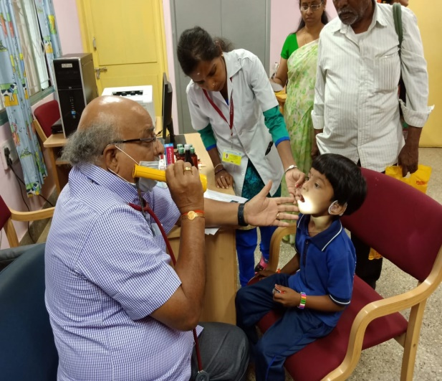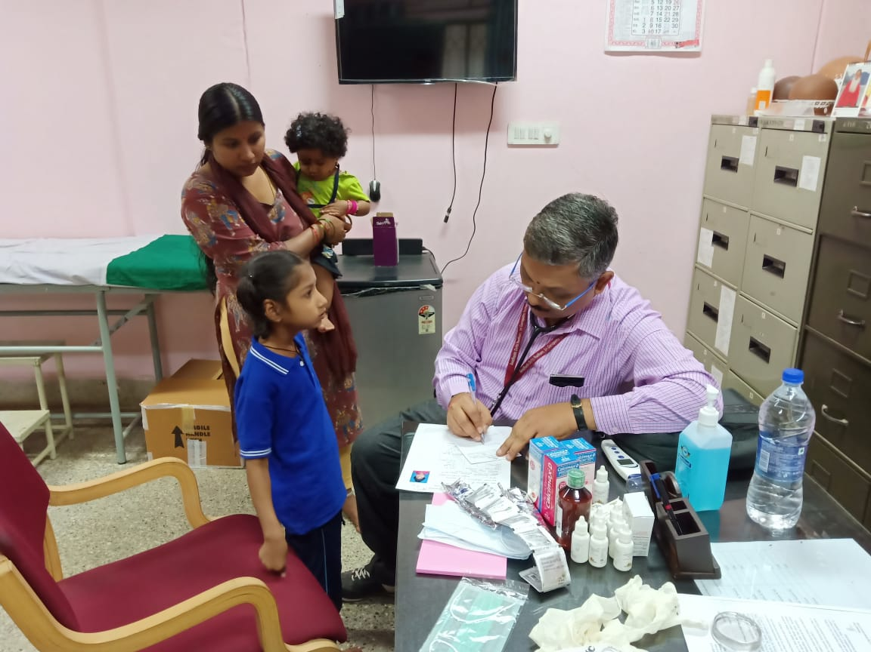

**General physician doing the overall check-up**

**Paediatrician examining the over-all well-being of the child**

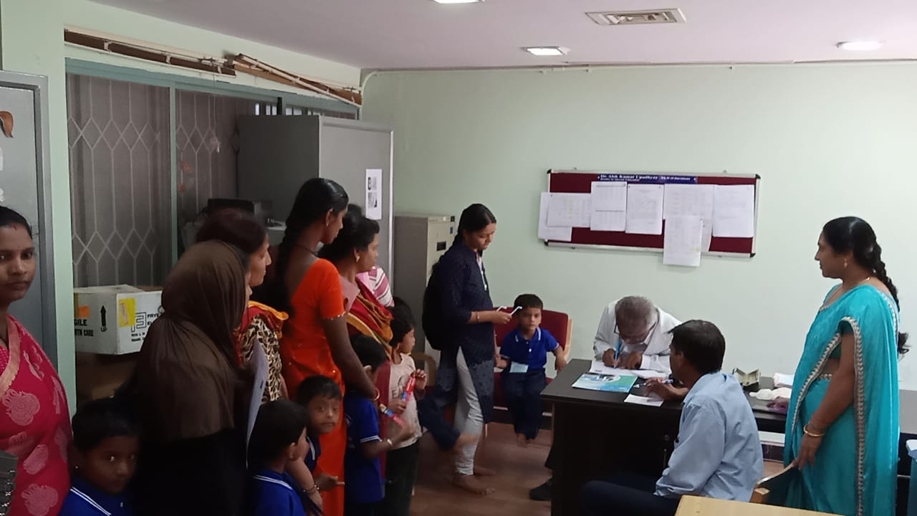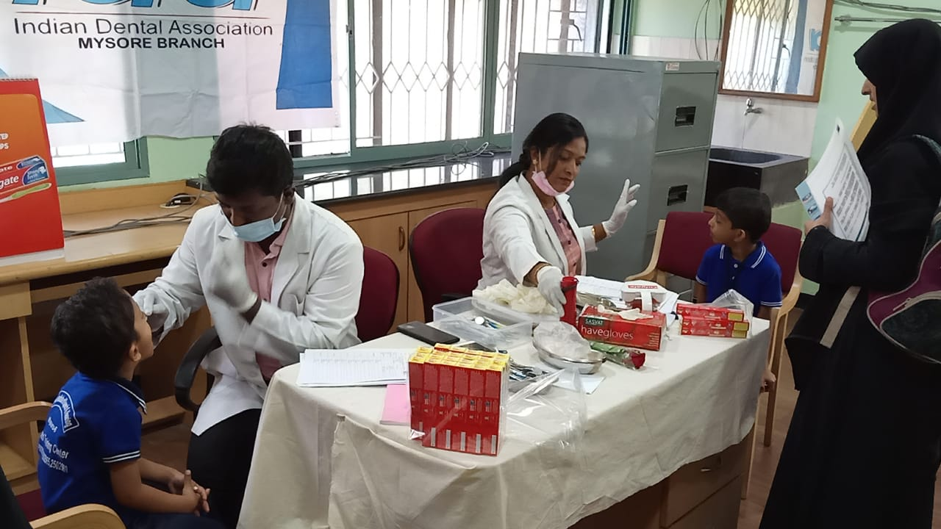

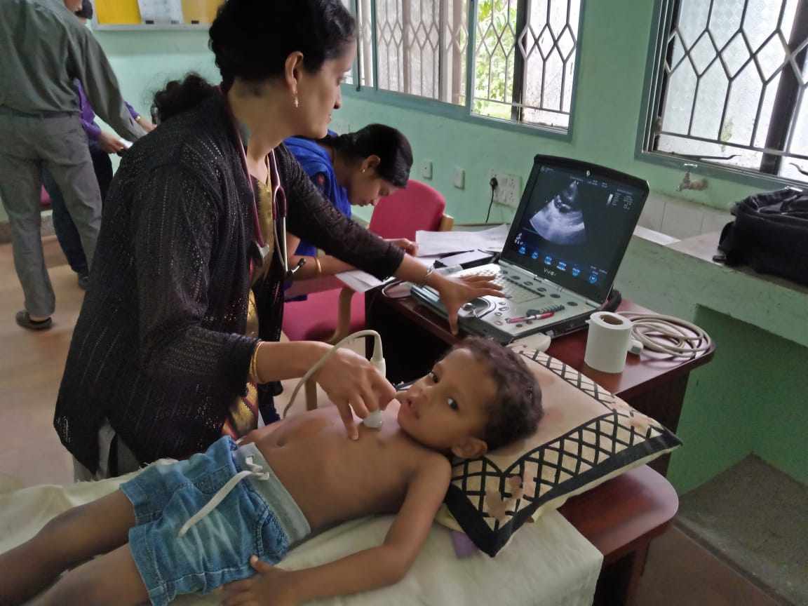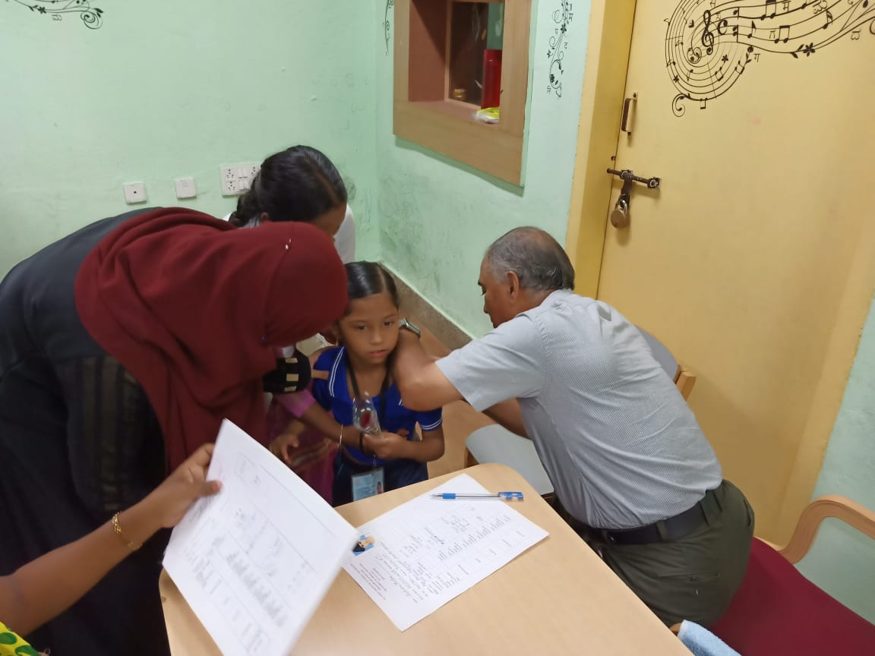

**Eye testing being carried out**

**Dental check-up under progress**

**ECG carried out by cardiologist**

**Orthopaedic Surgeon checking the bone strength**

* + - 1. Press Releases and Media Coverage:
* 27th November 2018 – **Vijayakarnataka** About AIISH was in various newspapers was published.
* 28th November 2018 – **The Times of India** About AIISH was in various newspapers was published.
* 27th November 2018 – **Indian Express** About AIISH was in various newspapers was published.

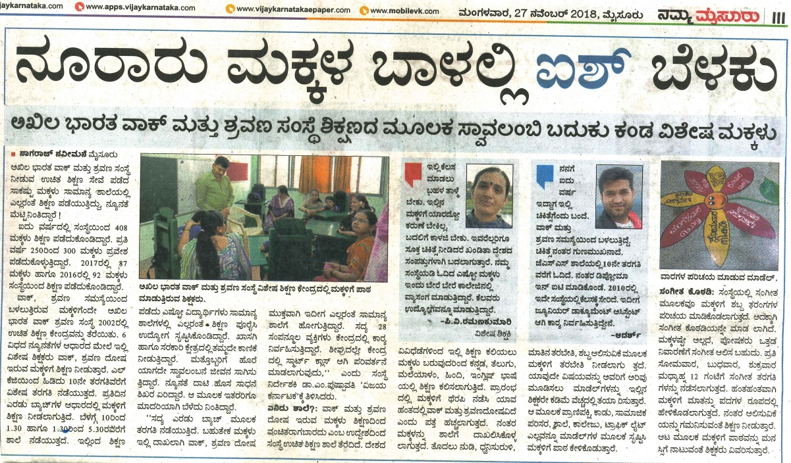

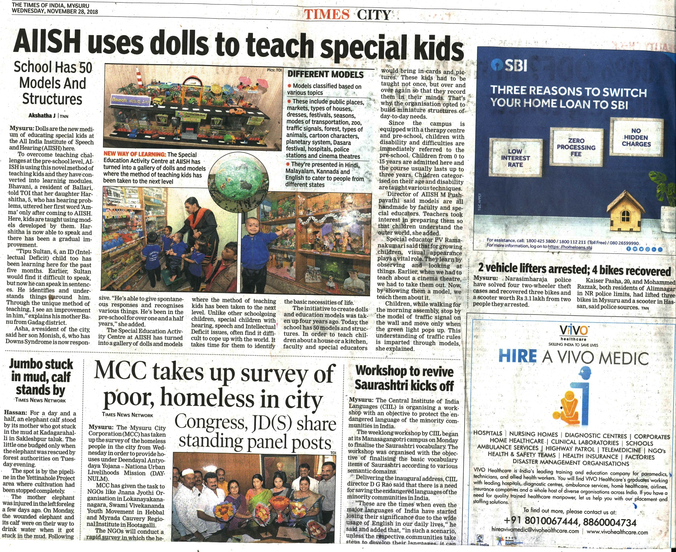

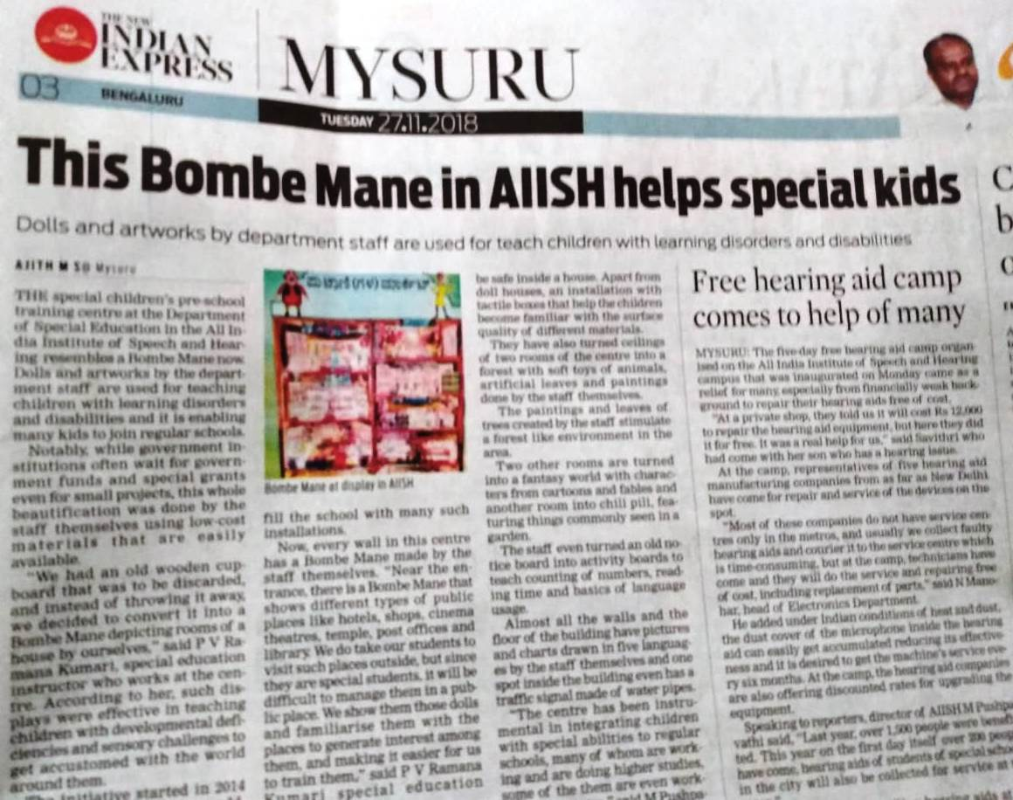

**C) Material Development :** The following Teaching Learning Materials and Prepare for training children with various communication disorders in preschool.

|  |  |  |  |
| --- | --- | --- | --- |
| **Sl.**  **No.** | **Nature of**  **Teaching-Learning**  **Materials** | **Skill** | **Number** |
| 1. | Flash cards | For all skill areas | 68 |
| 2. | Work Cards | For all skill areas | 84 |
| 3. | Charts | For all skill areas | 36 |
| 4. | PPT | For all skill areas | 158 |
| 5. | Models | For all skill areas | 68 |
| 6. | Sentence strips | For all skill areas | 58 |
| 7. | Story cards | For all skill areas | 76 |
| 8 | Others | For all skill areas | -- |

1. **AWARDS AND HONORS RECEIVED BY FACULTY AND STAFF:** NIL
2. EXTRA CURRICULAR ACTIVITIES: Nil
   * + - 1. AIISH Gymkhana
3. **EMINENT VISITORS: Dr. Padma Prabha, ISH, Bangalore**

XI. **ANY OTHER**

* **Official Language Implementation:**
* Hindi Word a day
* No of notings/letters (**November 2018**): Hindi: 65, English: 20

Sd/-

HOD- Special Education