DEPARTMENT OF PREVENTION OF COMMUNICATION DISORDERS (POCD)

**MONTHLY REPORT**- **October-2018**

**1 ACADEMIC ACTIVITIES**

1. **No. of short-term training programs organized: Nil**
2. **a. No. of orientation: 8**

As part of primary prevention activities, several orientation/Sensitization programs are being conducted regularly. The objective of the orientation programs was to create awareness among general public and various other professionals such as Medical doctors, Nurses, Health related workers, teachers, school students etc., on different types of communication disorders, its prevention and early identification methods and their appropriate referral and timely management. Table 1& 2 shows the details of the orientation programs conducted by the dept. of POCD.

Table 1: Orientation Programs conducted by the Department of POCD in the month of October 2018.

|  |  |  |  |  |  |  |  |  |  |
| --- | --- | --- | --- | --- | --- | --- | --- | --- | --- |
| **I. Orientation Programs at POCD : 04** | | | | | | | | | |
| Theme/Topic of the program: Prevention & early identification of communication disorders  Coordinators: Dr. Swapna. N, Dr. Prawin Kumar & Mr. Arunraj K. | | | | | | | | | |
| **Sl.No** | | **Date** | **Name of the institute/**  **Hospital** | | | **Target group** | **Total participants** | **Oriented by** | |
| 1. | | 06.10.2018 | Govt High school,  Hardnahalli, Chamarajanagar | | | High School Students | 43 | Ms. Divya  Ms. Dabitha | |
| 2. | | 06.10.2018 | Govt. Composite PU college (High school section)Amachavadi, Chamarajanagar | | | High school students | 37 | Ms. Aparna  Ms. Prathibha K.S  Ms. Vijeshwari | |
| 3. | | 06.10.2018 | Govt. Composite PU college  Chamarajanagar | | | students | 36 | Ms. Malvika  Ms. Abna | |
| 4. | | 22.10.2018 | Akkihebalu, Anganavadi Worker | | | - | 07 | Ms. Kusuma  Ms. Abna | |
| **II. Orientation Programs at NBS centres:2** | | | | | | | | | |
| Theme/Topic of the program: Prevention & early identification of communication disorders Coordinators: Dr. Swapna. N, , Dr. Prawin Kumar & Mr. Arunraj K. | | | | | | | | | |
| 1. | 24/10/2018 | | | RIMS, Ranchi | 3rd year B. Sc nursing student of Florence college of Nursing, Ranchi. | | 10 | Mr. Mukesh Kumar  (Audiologist) | |
| 2. | 25/10/2018 | | | RIMS, Ranchi | 3rd year GNM nursing student of Florence college of Nursing, Ranchi. | | 12 | Mr. Mukesh Kumar  (Audiologist) | |
|  |  | | |  |  | |  |  | |
| **III. Orientation Programs at OSC centres: 2** | | | | | | | | | |
| Theme/Topic of the program: Prevention & early identification of communication disorders Coordinators: Dr. Swapna. N, , Dr. Prawin Kumar & Mr. Arunraj K. | | | | | | | | | |
|  | | 04/10/2018 | Ramnagara anganwadi general camp | | | Public | 30 | | Mr. Mohan Dass |
|  | | 04.10.2018 | VMH, Saragur | | | Aganawadi workers | 41 | | Ms. Lavanya |
| **Total** | | | | | | | **194** | | |

Table 2: Total number of participants oriented in the month of October 18.

|  |  |  |
| --- | --- | --- |
| **S.No** | **Target group** | **Total number of Participants** |
|
|  | Public | 30 |
|  | Anganwadi workers | 48 |
|  | Students | 138 |
| **Total** | | **216** |

**b. Sensitization programs organized: NIL**

**iii.Training programs conducted: Nil**

**iv.Clinical Observation postings of students from other Institutes:2**

|  |  |  |  |  |
| --- | --- | --- | --- | --- |
| Sl.No | Date of Postings | UG/PG Students | Designation | Institute/University |
| 1 | 01.10.2018-15.10.2018 | Intern | B.ASLP | [Ashtavakra Institute of Rehabilitation Sciences](http://int.search.myway.com/search/GGmain.jhtml?ct=ARS&n=781c55df&p2=%5EGR%5Exdm731%5ETTAB02%5Ein&pg=GGmain&pn=1&ptb=FF220395-40C6-4664-A316-6878D1E3B162&qs=&si=YLyHErnWXd&ss=sub&st=tab&trs=wtt&searchfor=Ashtavakra+Institute+of+Rehabilitation+Sciences&feedurl=ars%252Ffeedback%253ForiginalQuery%253Dashtavakra%252Buniversity%2526relatedQuery%253Dashtavakra%252Binstitute%252Bof%252Brehabilitation%252Bsciences&tpr=jrel3) and research,  Delhi |
| 2 | 17.10.2018-29.10.2018 | Intern | B.ASLP | [Ashtavakra Institute of Rehabilitation Sciences](http://int.search.myway.com/search/GGmain.jhtml?ct=ARS&n=781c55df&p2=%5EGR%5Exdm731%5ETTAB02%5Ein&pg=GGmain&pn=1&ptb=FF220395-40C6-4664-A316-6878D1E3B162&qs=&si=YLyHErnWXd&ss=sub&st=tab&trs=wtt&searchfor=Ashtavakra+Institute+of+Rehabilitation+Sciences&feedurl=ars%252Ffeedback%253ForiginalQuery%253Dashtavakra%252Buniversity%2526relatedQuery%253Dashtavakra%252Binstitute%252Bof%252Brehabilitation%252Bsciences&tpr=jrel3) and research,  Delhi |

V. No. of Seminars/ Conferences /Lectures /**Workshop organized** by the Dept.

The World cerebral palsy day was celebrated on **5.10.2018.** This was organized by the Special clinic for Motor speech disorders which is a part of Dept. of Speech-Language Pathology and the Department of Prevention of Communication Disorders. The main objective of celebration of this day was to generate awareness and share information in the community about cerebral palsy. The inaugural program was followed by an orientation program for the village Rehabilitation workers and mutispeciality rehabilitation workers**.** The staff of AIISH delivered lectures on relevant topics. About 185 participants attended the orientation program.

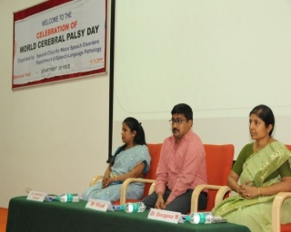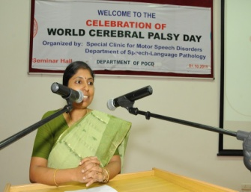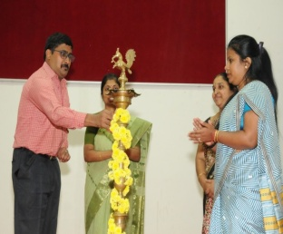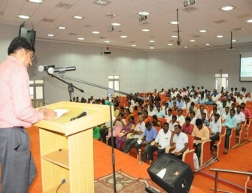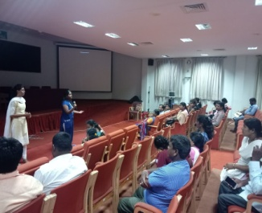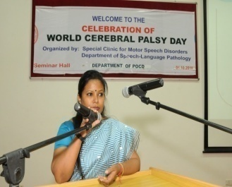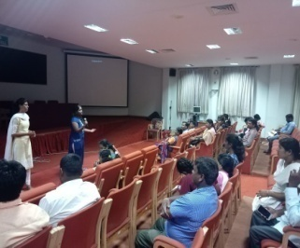

Vi. No. of Seminars/ Conferences /Lectures /Workshop attended by the staff of the Dept

* No. of Conferences attended by Staff of POCD: Nil
* Workshops attended by Staff of POCD: NIL
* Seminars attended by Staff of POCD: Nil
* Guest Lectures attended by staff of POCD: Nil

vii. No. of Guest Lectures organized: Nil

viii. No. of Invited Talks delivered by faculty and staff: **Invited talks were given by the following staff on account of celebration of World CP day**

|  |  |
| --- | --- |
| **Topic** | **Individuals involved / Resource persons** |
| Orientation to POCD activities and Visit to Depts. of DCS and Audiology | Staff of POCD |
| Early identification of CP and its prevention | Dr. Swapna. N, Chairperson, Special clinic for Motor Speech Disorders and Associate prof. in speech pathology, Dept. of Speech-language Pathology, AIISH, Mysore. |
| Prevention and early identification of speech and language disorders | Ms. Yashaswini B.C, staff, Dept. of POCD |
| Prevention and early identification of hearing disorders | Ms. Nayana, staff, Dept. of POCD |

ix. Any other:

* Student clinical training: As part of human resource development, clinical training for Undergraduates (B.Sc Speech & Hearing), Postgraduates (M.Sc SLP & AUD) & Internship students on early identification, prevention & rehabilitation of communication disorders and Community based rehabilitation at OSCs were carried out. The details on the number of students who had undergone training are given below.

|  |  |  |
| --- | --- | --- |
| **Internal (AIISH)** | | |
| **Class** | **No of students Newly posted** | **No of Students continuing** |
| II B.ASLP students | 5 | 0 |
| I M.Sc (Speech ) students | 5 | 0 |
| I M.Sc (Audiology) students | 4 | 4 |
| B.ASLP Internship students | 6 | 2 |
| **Total** | **20** | **6** |
| **External** | | |
| BASLP Student (Intern) | 2 | 0 |
| **Total** | **2** | **0** |

* **Staff/Student Enrichment Programs: Nil**

1. **Research Projects: Nil**
2. **Doctoral and Post-Doctoral Programs:** Nil
3. **Research papers presented in National conferences/seminars:**

**Papers accepted for presentation in the forth coming ISHACON**

|  |  |  |  |
| --- | --- | --- | --- |
| **Faculty/ Staff members** | **Program** | **Topic** | **Date of acceptance** |
| Dr. Prawin kumar  Dr. Swapna N  Mr. Arunraj  Ms Akshatha Y | 51st ISHACON | “Effect of occupation noise on audiometric thresholds in industrial workers” | 30th October |
| Dr. Prawin kumar  Dr. Swapna N  Ms Nayana M  Ms. Tejaswini S  Ms. Devamma V | 51st ISHACON | “Prevalence 0f Hearing impairment and risk factors in newborns under neonatal hearing screening program in southern city of Karnataka ” | 30th October |
| Dr. Prawin kumar  Dr. Swapna N  Dr. Subrat Kumar Behara  Mr. Saroj Sahoo | CIGICON  2018 | “Newborn hearing screening and its associated risk factors - a preliminary data from government hospital, Cuttack” | 15th October |

1. **Research papers presented at International conferences/seminars:**

|  |  |  |  |
| --- | --- | --- | --- |
| **Faculty/ Staff members** | **Program** | **Topic** | **Date &Venue** |
| Mr. Arunraj K.  Dr. Swapna N  Dr. Prawin kumar  Ms. Yashaswini B C  Ms Meghana | 4th India International Science festival (IISF) | “Outreach Service Model To Increase Access To The Person With Communication Disorders In Remote And Rural Areas Of Karnataka” | 13-16th Oct 2018 at Lucknow |

1. **Research Papers published in National Conference/Seminar Proceedings:** Nil
2. **Research Papers published in International Conference/Seminar Proceedings:** Nil
3. **Research Papers published in National Journals:** Nil
4. **Research Papers published in International Journals:** Nil
5. **Book / Chapters Published:** Nil
6. **Books / Manuals/ Seminar proceedings Edited: NIL**
7. **Scholarly Reviewing Activities:** Nil
8. **Research Proposal:** Nil

3. CLINICAL SERVICES

1. General Clinical Services
2. Follow-up evaluation- Detailed evaluation

The newborns/infants referred during the newborn screening were followed up through telephone calls to parents/caregivers of infants. A complete test battery was administered for those clients who came for follow-up. Table 4 (a) & (b) depicts the statistics related to this activity.

Table 4 (a): Details of the results of follow-up evaluation for newborns and infants.

|  |  |  |  |  |  |  |  |  |  |  |  |
| --- | --- | --- | --- | --- | --- | --- | --- | --- | --- | --- | --- |
| **Categories** | **AIISH + Cheluvamba** | **OSC Sarguru** | **OSC-Sagara** | **Ajmer** | **Cuttack** | **Imphal** | **Puducherry** | **Ranchi** | **Jabalpur** | **Lucknow** | **Total** |
| **Normal** | 2 | 13 | 1 | 2 | 03 | 6 | 19 | 05 | - | - | **49** |
| **ENT disorders** |  |  | 0 | - | 00 | 5 |  | 10 | - | - | **15** |
| **Auditory Maturation delay** |  | 0 | 0 | - | 00 |  |  | 00 | - | - | **-** |
| **Hearing impairment** | 1 | 0 | 0 | 8 | 06 | 0 | 12 | 10 | - | - | **36** |
| **Speech & language disorder** |  | 0 | 0 | - | 00 | 5 | 01 | 15 | - | - | **21** |
| **Multiple Disorder** | 0 | 0 | 0 | - | 00 |  |  | 01 | - | - | **1** |
| **Incomplete testing** | 0 | 0 | 0 | 6* | 00 | 0 | 03 | 00 | - | - | **9** |
| **Total** | **3** | **13** | 1 | **10** | **9** | **16** | **35** | **41** | **-** | **-** | **125** |

The at-risk babies were monitored regularly by administering the speech-language & hearing checklist through phone call. The babies who are identified with delay in the milestones were

referred to AIISH/concern NBS center for detailed evaluation.

Table 4(b)**:** Follow-up evaluation- Phone follow-up

|  |  |  |  |
| --- | --- | --- | --- |
| **Categories** | **Mysuru Centre (POCD)** | **OSC Centers** | **NBS** |
| Normal speech, language & hearing milestones | 0 | 0 | 161 |
| Referred for detailed evaluation | 0 | 0 | 0 |
| **Total Phone follow up** | **0** | 0 | **161** |

ii) Hearing evaluation of industrial workers at AIISH: Nil

iii) Specialized Clinical services: Nil

iv) Clinical Support Services to Patients and Family: Nil

v)Clinical Electronic Services: Nil

B) EXTENSION ACTIVITIES

i) Newborn screening for Communication Disorders

The department of POCD is actively involved in carrying out various extension activities such as screening, diagnostic and rehabilitation services outside the institute campus. The activities include newborn/infant screening, screening of school children, screening of elderly citizens, screening of industrial workers, conducting camps and also clinical services offered at the outreach service centers of AIISH.

Table 5: Total number of newborns/infants screened and identified at-risk for Communication disorders.

|  |  |  |  |  |  |  |  |  |  |
| --- | --- | --- | --- | --- | --- | --- | --- | --- | --- |
| **SN** | **Hospitals/Immunization Centers** | **Total births** | **Total No. Screened** | | | | **Total No. at risk** | | |
| **Male** | **Female** | | **Total** | **Male** | **Female** | **Total** |
|  |  | **AIISH- Mysuru** | | | | | | |  |
|  | Combined Hospital (CH) | **-** | **13** | **10** | | **23** | **1** | **0** | **1** |
|  | Kamakshi Hospital (KH) | - | **52** | **46** | | **98** | **1** | **2** | **3** |
|  | KR Hospital (KRH)- Cheluvamba | **-** | **411** | **406** | | **817** | **7** | **14** | **21** |
|  | Mission Hospital (MH) | **-** | **13** | **9** | | **22** | **1** | **2** | **3** |
|  | S.M.T.D.H Hospital | **-** | **19** | **9** | | **28** | **0** | **1** | **1** |
|  | Ashwini Nursing Home (ANH) | **-** | **7** | **6** | | **13** | **0** | **1** | **1** |
|  | Shree Devi Nursing Home (SNH) | **-** | **7** | **9** | | **16** | **0** | **0** | **0** |
|  | Gopala Gowda Shanthaveri Memorial Hospital (GGSMH) | **-** | **10** | **10** | | **20** | **0** | **0** | **0** |
|  | Mahadeshwara Nursing Home (MNH) | **-** | **6** | **5** | | **11** | **0** | **0** | **0** |
|  | Sigma Hospital (SH) | **-** | **23** | **13** | | **36** | **1** | **0** | **1** |
|  | Brindavan Hospital | **-** | **6** | **1** | | **7** | **2** | **0** | **2** |
|  | **Total (Mysuru hospitals)** |  | 567 | 524 | | 1091 | 13 | 20 | 33 |
|  | | | | | | | | | |
| 1. 18. | Sub-divisional hospital, K R Nagar Taluk | **-** | **12** | **12** | | **24** | **1** | **0** | **1** |
| 1. 19. | Sub-divisional hospital, T NarsipuraTaluk | **-** | **2** | **8** | | **10** | **0** | **0** | **0** |
| 1. 20. | Sub-divisional Hospital, SagaraTaluk | **-** | - | - | | **-** | - | - | **-** |
| 1. 21 | Sub-divisional hospital, Sarguru |  | **150** | **140** | | **289** | **7** | **4** | **11** |
| Immunization* | **-** | - | - | | **-** | - | - | **-** |
| 1. 22. | Community Health Centre (CHC), Hullahalli | **-** | **5** | **8** | | **13** | **0** | **0** | **0** |
| 1. 23. | Community Health Centre (CHC), Santhemarahalli | **-** | **0** | **2** | | **2** | **0** | **0** | **0** |
| 1. 24. | Primary Health Centre (PHC), Akkihebbalu | **-** | - | - | | **-** | - | - | **-** |
|  | **Total (OSCs)** |  | **169** | **170** | | **338** | **8** | **4** | **12** |
| **Screening at NBS Centers** | | | | | | | | | |
| 1. 25. | Sri RamachandraBhanj Medical College and Hospital (SCB MCH), Cuttack | **334** | 125 | 78 | **203** | | 15 | 12 | **27** |
| 1. 26. | Regional Institute of Medical Sciences (RIMS), Imphal | **332** | 160 | 167 | **327** | | 8 | 9 | **17** |
| 1. 27. | Janana Hospital & JLNMCH, Ajmer | **805** | 371 | 349 | **720** | | 10 | 18 | **28** |
| 1. 28. | JIPMER, Puducherry | **1535** | 595 | 520 | **1115** | | 36 | 26 | **62** |
| 1. 29. | Netaji Subhash Chandra Bose Medical College (NSCB), Jabalpur | Birth rate is not calculated in OBG department | 78 | 59 | **137** | | 9 | 10 | **19** |
| 1. 30. | Rajendra Institute of Medical Sciences, Baritayu, Ranchi | **543** | 206 | 192 | **398** | | 28 | 13 | **41** |
| 1. 31. | Kings George’s Medical University, Lucknow | **-** | - | - | **-** | | - | - | **-** |
|  | **Total (NBS centers)** | **-** | 1250 | 1120 | 2370 | | 83 | 67 | 150 |
|  | **Overall Total** | **-** | **1986** | **1814** | **3799** | | **103** | **91** | **195** |

**ii) School/ Anganawadi screening: Nil**

|  |  |  |  |  |  |  |  |  |  |
| --- | --- | --- | --- | --- | --- | --- | --- | --- | --- |
| **Sl. No** | **Date** | **Name of the Anganawadi/ School** | **Total screened** | **Total identified with communication disorders** | | | | | |
| **Ear related disorder** | **Hearing loss** | **Speech language disorders** | | | |
| **Fluency** | **voice** | **language** | **Articulation** |
| 1. | 03.10.2018 | Althalhundi | 12 | 0 | 0 | - | - | 2 | - |
| 2. | 17.10.2018 | Sagare (3 anganawadis) | 40 | 0 | 0 | - | - | 7 | - |
| 3. | 03.10.18 | Government school, Kattemanuganahalli | 12 | 1 | - | - | - | 3 | - |
|  | **Total** | | **64** | **1** | **-** | **12** | | | |

**iii)Hearing screening of Industrial employees: NIL**

**iv) Clinical services for the Elderly citizens: Nil**

**v)**. **Clinical Services at Outreach Service Centers (OSCs):**

The clinical activities are not only restricted to in and around Mysore, but also extended to rural areas where facilities for clinical services for persons with communication disorders were meager. Currently 05 OSCs (01 VMH, Saragur, HD Kote; 02 Sub-divisional taluk hospital at Sagara taluk, Shivamogga District; 03 Primary Health Centre - PHC at Hullahalli, Mysuru district; 04 Akkihebbalu, Mandya district & 05 Karuna trust, Gumballi, Chamarajanagara district) were initiated to meet the objective of extending the services of the institute to rural areas. The OSCs are functioning as a well-equipped unit for screening, diagnostics and therapeutic services for persons with communication disorders. The services include screening, diagnostic and rehabilitation which includes newborn/infant screening, screening of school children, Speech and Language evaluation, Audiological evaluation, ENT evaluation, Speech-Language therapy, issue of free body level hearing aids and ear molds, and counseling and guidance to individuals with communication disorders. The other details are tabulated below in tables 8, 9 & 10.

Table 8: Details of clients identified with communication disorders at the OSCs.

|  |  |  |  |  |  |  |  |  |
| --- | --- | --- | --- | --- | --- | --- | --- | --- |
| **OSC** | **Total Registered** | **ENT Evaluation=60+20+41** | | | **Hearing Evaluation=1+0+4** | | **Speech & Language Evaluation+2** | |
| **Normal (Ear Wise)** | **Disorder (Ear wise)** | **ENT related**  **Others** | **Normal (Ear Wise)** | **Disorder (Ear wise)** | **Normal (Individuals)** | **Disorder (Individuals)** |
| **Primary Health Centre (PHC), Hullahalli** | **61** | 27 | 69 | 12 | 0 | 2 | 0 | 0 |
| **Primary Health Centre (PHC), Akkihebbau** | **20** | 5 | 23 | 6 | 0 | 0 | 0 | 0 |
| **Primary Health Centre (PHC), Gumballi** | **47** | 16 | 46 | 10 | 0 | 8 | 0 | 2 |
| **Sub-divisional Hospital (PHC), Sagara** | 25 | - | - | - | 9 | 35 | 0 | 3 |
| **VMH, Sarguru** | **29** | **-** | **-** | **-** | **6** | **16** | **0** | **18** |
| **Total** | **182** | **48** | **138** | **28** | **6** | **61** | **0** | **23** |

Table 8a.: Details of clients followed up (Old clients) at the OSCs.

|  |  |  |  |  |  |  |  |  |
| --- | --- | --- | --- | --- | --- | --- | --- | --- |
| **OSC** | **Total Follow up** | **ENT Evaluation =13+6+14** | | | **Hearing Evaluation=3+** | | **Speech & Language Evaluation=** | |
| **Normal (Ear Wise)** | **Disorder (Ear wise)** | **ENT related**  **Others** | **Normal (Ear Wise)** | **Disorder (Ear wise)** | **Normal (Individuals)** | **Disorder (Individuals)** |
| **Primary Health Centre (PHC), Hullahalli** | **13** | 3 | 13 | 5 | 0 | 0 | 0 | 0 |
| **Primary Health Centre (PHC), Akkihebbalu** | **6** | 4 | 8 | 0 | 0 | 0 | 0 | 0 |
| **Primary Health Centre (PHC), Gumballi** | **17** | 6 | 22 | 0 | 0 | 6 | 0 | 0 |
| **Sub-divisional Hospital (PHC), Sagara** | **-** | - | - | - | 0 | 0 | 0 | 0 |
| **VMH, Sarguru** | **9** |  |  |  | **6** | **8** | **0** | **2** |
| **Total** | **45** | **13** | **43** | **5** | **6** | **14** | **0** | **2** |

Table 9: Details of clients identified with different types of communication disorders across OSCs (New and old cases)

|  |  |  |  |  |  |
| --- | --- | --- | --- | --- | --- |
| **Type of Disorders** | **OSC** | | | |  |
| Primary Health Centre (PHC), Hullahalli | Primary Health Centre (PHC), Akkihebbalu | Primary Health Centre (PHC), Gumballi | Sub-divisional Hospital, Sagara (PHC) Taluk | VMH,Sarguru |
| **Hearing disorders (Ear-wise data)** | | | | | |
| Normal | 0 | 0 | 0 | 9 | 6 |
| Conductive | 0 | 0 | 0 | 9 | 5 |
| Sensorineural | 2 | 0 | 12 | 8 | 6 |
| Mixed | 0 | 0 | 0 | 12 | 3 |
| Profound | 0 | 0 | 4 | 6 | 0 |
| **Total (ears)** | **2** | **0** | **16** | **44** | **22** |
| **Speech &Language disorders (Individuals)** | | | | | |
| Voice | 0 | 0 | 0 | 1 | 0 |
| Fluency | 0 | 0 | 0 | 1 | 0 |
| Articulation disorders | 0 | 0 | 0 | 1 | 3 |
| Language disorders | 0 | 0 | 2 | **3** | 15 |
| Normal | 0 | 0 | 0 | 1 | - |
| **Total (Individuals)** | **0** | **0** | **2** | 7 | **18** |

Table 10**:** Rehabilitation services provided at Outreach service centers

|  |  |  |  |  |
| --- | --- | --- | --- | --- |
| **OSC** | **Hearing Aids Dispensed** | **Speech-language therapy** | | **Medical Line of Treatment** |
| **No. of clients** | **No. of sessions** |
| Primary Health Centre (PHC), Hullahalli | 0 | 2 | 8 | 73 |
| Primary Health Centre (PHC), Akkihebbalu | 0 | 4 | 12 | 26 |
| Primary Health Centre (PHC), Gumballi | 0 | 3 | 12 | 58 |
| Sub-divisional Hospital, Sagara (PHC) Taluk | 1 | 24 | 111 | - |
| VMH, Sarguru | **3** | **12** | **35** | **-** |
| **Total** | 4 | 45 | 178 | 157 |

C) Communication Disorders Screening Camps: Nil

i. Organized by the Institute/POCD/ Others: Nil

D. SPECIAL ACTIVITIES

1. Library and information services – Nil
2. Public Information Activities –
3. **Exhibition- Nil**
4. **Radio talks-** Radio talk programme was organized at Akashavani, Mysuru on 31th October 2018. The talk on **“Identification and early intervention of hearing impairment”** was delivered by Ms. Apoorva, Ms. Kusuma, Ms. Kavitha , Ms. Thanuja , Ms. Kajol, Mr Mithun and Mr. Prithvik (Internship students)

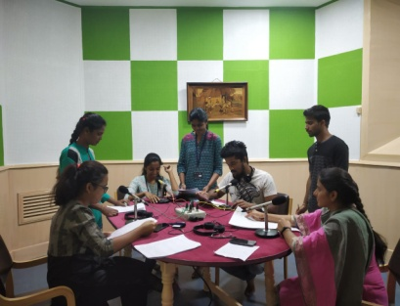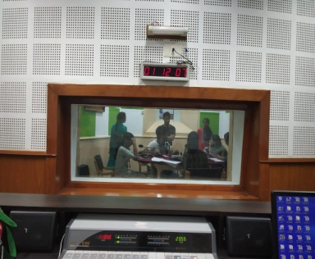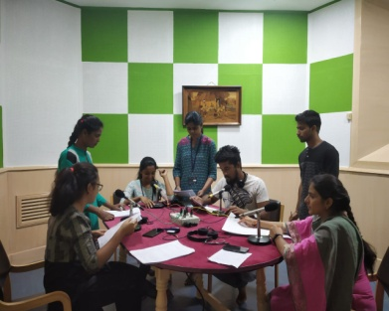

1. **Rallies: Nil**
2. **Street Plays-** The Department of POCD conducted street plays on various communication disorders in two villages in Kollegal district on 13.10.2018, emphasizing on prevention and early identification of communication disorders. The major topic covered under street play included the following:
3. Importance of early identification and rehabilitation of Autism, Hearing Impairment, Intellectual disability, Stuttering, Cleft lip and palate and Aphasia.
4. Importance of critical age period
5. Misconceptions surrounding various communication disorders

**Coordinators:** Dr. Swapna N, Dr. Prawin Kumar & Mr. Arunraj K.

**In charge:** Ms. Usharani N S, Ms. Bincy R Kalam & Ms. Anju V A

**Target group:** General Public

Table: Details of street play program conducted

|  |  |  |  |
| --- | --- | --- | --- |
| **Sl. No** | **Date** | **Place** | **Members** |
| 1 | 13.10.2018 | Hale Hanagalli | 30 (students)+11 (staffs) |
| 2 | 13.10.2018 | Kunthur | 30 (students)+11 (staffs) |

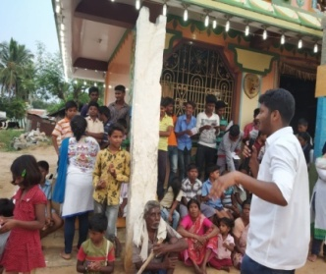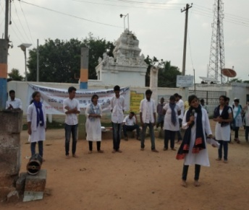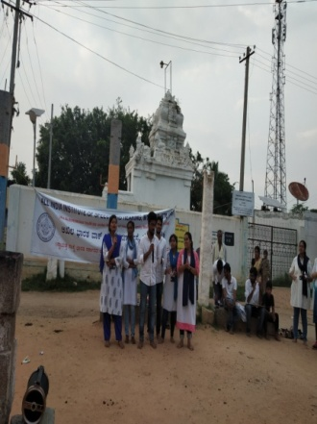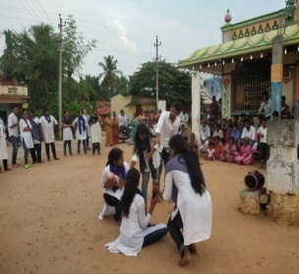

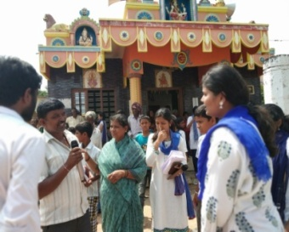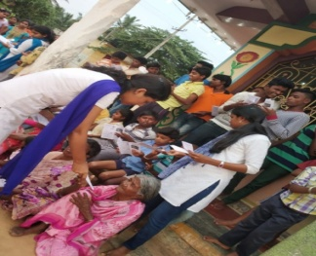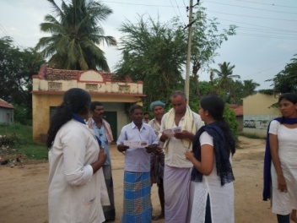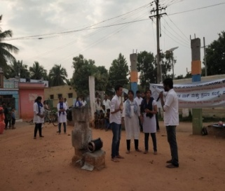

1. Material Development: Nil

v) PUBLIC LECTURE SERIES: Nil

vi) AWARDS AND HONOURS RECEIVED BY FACULTY AND STAFF: Nil

vii) TECNOLOGICAL CONSULTANCY SERVICES: Nil

viii) EXTRA CURRICULLAR ACTIVITIES: Nil

ix) VISITORS: Nil

x) MAJOR EVENTS OF THE MONTH: Nil

**xi) OTHERS:**

|  |  |  |
| --- | --- | --- |
| Dept. Related | | |
| Sl.No | Particulars |  |
| a | Computerization activities | Computerization of OSC is in process. |
| b | OSC Related- | NIL |
| c | NBS related- | NIL |

**xii) Following staffs were relieved from the department: 9 members**

**xiii) Following staffs were newly recruited to the department: Nil**

|  |  |  |  |
| --- | --- | --- | --- |
| **xiv)Activities carried out by the following staffs from the department** | | | |
| **Sl. No** | **Name of the staff** | **Designation** | **Activities** |
|  | Dr. Swapna. N | Associate Professor in Speech Pathology | Organized world cerebral palsy day on 5th October 2018.  Participated in street play activity on 13.10.18.  Organized radio talk on 31.10.18 |
|  | Dr. Prawin Kumar | Associate Professor in Audiology | Guiding research papers as a part of epidemiogical unit activity   1. “Effect of occupation noise on audiometric thresholds in industrial workers” 2. “Prevalence 0f Hearing impairment and risk factors in newborns under neonatal hearing screening program in southern city of Karnataka ”   Verification of Newborn hearing screening Data entry. |
|  | Arunraj. K | Clinical Assistant | Organized world cerebral palsy day on 5th October 2018.  Participated in street play activity on 13.10.18 |
|  | Ms. Sreelakshmi H D | Audiologist Grade I | Participated in world cerebral palsy day on 5th October 2018.  Participated in street play activity on 13.10.18. |
|  | Mr. Rajith B N | Audiologist Grade I | Participated in world cerebral palsy day on 5th October 2018.  Participated in street play activity on 13.10.18. |
|  | Ms. Yashawini B S | Audiologist Grade I | Participated in world cerebral palsy day on 5th October 2018 |
| **7.** | Ms. Akshatha Y | Audiologist Grade I | Participated in world cerebral palsy day on 5th October 2018  Working on research paper title “Effect of occupation noise on audiometric thresholds in industrial workers” |
|  | Nayana M | Audiologist Grade I | Participated in world cerebral palsy day on 5th October 2018  Working on research paper title “Prevalence of Hearing impairment and risk factors in newborns under neonatal hearing screening program in southern city of Karnataka ” |
|  | Devamma V | Audiologist Grade I | Participated in world cerebral palsy day on 5th October 2018.  Participated in street play activity on 13.10.18. |
|  | Bincy R Kalam | Speech Language Pathologist Grade I | Participated in world cerebral palsy day on 5th October 2018.  Organized street play activity on 13.10.18.  Organized radio talk on 31.10.18. |
|  | Pavana Mohan | Audiologist Grade II | Participated world cerebral palsy day on 5th October 2018.  Participated in street play activity on 13.10.18. |
|  | Usharani N S | Audiologist Grade II | Participated in world cerebral palsy day on 5th October 2018.  Organized street play activity on 13.10.18.  Organized radio talk on 31.10.18. |
|  | Anju V A | Speech Language Pathologist Grade II | Participated in world cerebral palsy day on 5th October 2018.  Organized street play activity on 13.10.18.  Organized radio talk on 31.10.18. |
|  | Ms. Tejaswini | Audiologist Grade I | Participated in world cerebral palsy day on 5th October 2018.  Participated in street play activity on 13.10.18.  Working on research paper title “Prevalence of Hearing impairment and risk factors in newborns under neonatal hearing screening program in southern city of Karnataka ” |

**Sd/-**

**Head, Dept. of POCD**