**ALL INDIA INSTITUTE OF SPEECH AND HEARING, MYSURU-6**

**अखिल भारतीय वाक श्रवण संस्थान, मैसूर-६**

**DEPARTMENT OF SPECIAL EDUCATION**

**विशेषशिक्षाविभाग**

**MONTHLY REPORT–September 2018**

1. **ACADEMIC ACTIVITIES**
2. **Orientation Programs (For outsiders):**The following orientation programswere conducted to orient about the activities of the departmentand also to provide the knowledge about the educational facilities and welfare measures for children with special needs. :

|  |  |  |  |  |
| --- | --- | --- | --- | --- |
| **Sl. No.** | **Coordinator** | **Targeted Audience** | **Number**  **of Participants** | **Date** |
|  | Dr. Vijetha P | Retired Principal, B.Ed college, Holinarasipur, Hassan | 02 | 06.09.2018 |
|  | Dr. Vijetha P | B.Ed trinees, AWH college, Calicut, Kerala | 23 | 11.09.2018 |
|  | Dr. Prithi V | Students, RIE, Mysuru | 35 | 12.09.2018 |
|  | Dr. Alok U | Assistant Professor and students, SSET College, Mandya | 37 | 20.09.2018 |
|  | Ms. Lakshmi Prabha J K | Students & Staffs, S M Lingappa college of education, K R Pet | 35 | 24.09.2018 |
|  | Dr. Vijetha P | Kendriya Vidyalaya teachers Kerala region, Kerala | 20 | 25.09.2018 |
|  | Dr. Prithi V | Rajkumar Choulapalh, Enable India, Bangalore | 01 | 28.09.2018 |

**Dr.Pushpavathi M, HOD – Special Education**

**Faculty report**

|  |  |  |  |  |  |  |
| --- | --- | --- | --- | --- | --- | --- |
| **Name of the Faculty** | | **Dr.Alok Kumar** | **Dr. G. Malar** | **Dr.Prithi**  **Venkatesh** | **Dr. P. Vijetha** | **Ms.LakshmiPrabha J.K** |
| **Clinics** | | | | | |  |
| **No. of cases evaluated at SEA-U** | | 10 | * Screening: 9 clients in 9 sessions * Assessment: 2 clients in 9 sessions | SEAU-Evaluation: **5**  Educational Assessment: 2 children(Assessment Completed )  (Report preparation –ongoing)  Number of Sessions: Child number 1: 8  Child number 2: 10 | 14 | * Screening: 16 clients in 16sessions * Assessment: 1 client in 4 sessions |
| **No. of cases supervised individually** | | NIL | * 20 children in 4 groups | 06 groups (Supervision as a part of preschool observation) | 71 | 6 preschool groups |
| **No. of groups supervised** | | 09 | * 8 | 7 | 14 | 6 meetings in 6preschool groups |
| **No. of meeting with parents** | | 07 | * 5 meetings in 5 groups | 6  (One group only one child is coming  Class teacher submitted children discontinuation letter) | 8 |  |
| **Educational Guidance** | | 01 | * 2 clients * 2 sessions |  | 1 client (4 sessions) |  |
|  | | | | | | |
| **Classes taken** | | | | | |  |
| **B.Ed.**  **Spl.Edn.(HI)** | **Theory** | 22 classes | * 24 (including 2 extra) sessions | **I Semester:**  Total Number of Theory Classes taken: 9 (Name of the Course) Assessment and Identification of Needs)  **III Semester:** Total number of theory classes taken: **10**  (Name of the Course: Reading and reflecting on text) | 11classes | 22 hours |
| **Practical** | 21 hours | * 32 hours | B.Ed.Spl.Edn (HI) I Semester: **10 hours of practical session:** Visit to Special Educational Set-up  DECSE (HI) **44 hours of practical session**.( 1. Practical session of observation of home training video and discussion about the same  2. Observation and collecting details about admission and children proforma from parents) | 3 hours | 13 hours (Indian Sign Language II year B.Ed.Spl.Ed (HI) students)  44 hours ( Home activities for HI children) |
| **DECSE (HI)** |  |  | * 10 sessions | Total Number of theory classes taken: **4**  (Early intervention leading to integration) | Served as paper setter for UG exams |  |
| **Any others** |  |  |  |  | II BASLP A section  Submitted September month Theory attendance |  |
| **Any other** | | | | | |  |
| **Meeting held** | |  | * 1 monthly meeting each with I & II B.Ed. Spl.Ed. (HI) * 5 monthly meetings with 5 preschool groups |  | * Attended peer review meeting 12th September 2018 | * 6 meetings with preschool parents |
| **Meeting attended** | |  | * 1 meeting of Research & Database Unit regarding e-registry of client details | Attended confidential meeting pertaining to University of Mysore examination on 17th September 2018. |  | * 1 meetings with HOD and all staff members regarding miniature model preparation * 1 meeting with faculty members regarding data entry format |
| **Brouchre** | |  |  |  |  |  |
| **Roles & Responsibilities** | | | | | |  |
| **Co-ordination** | | Parent Infant Program Unit  Preschool Parent Enrichment Program Unit | * CBCS Coordinator for I& II B.Ed.Spl.Ed. (HI) * Compilation of M.S.Ed. Student Dissertation-based Articles 2014-15 * Intra-Department * SEA-U * Research & Database Unit | Currently serving as pre-school in-charge | **Services for School age children**   * Lesson plans and children availing services have been checked. * Teachers schedule of clients prepared for supervision * Conducted monthly meeting on 25th September 2018. * Three new admissions have been made. * Planned for parents meeting with the HOD and team members. |  |
| **Member secretary** | | Pre School | * Services for School-Aged Children (in Department of Special Education) |  | NIL |  |
| **Member in** | | Special education assessment Unit and Assistan warden | * TCPD * LD Clinic (in DCS) * Product Development Cell * Preschool Supervision * Allied member of ISHA * Life member of NCED |  | SEA-U |  |
| **Mentor** | | M.Sc 2year Audiology | * Mentor for I & II B.Ed.Spl.Ed. (HI) |  | II BASLP A section  Conducted meeting on 31st August 2018 |  |

1. Clinical /Educational Observation Postings of Students from other Institutes:NIL

Following are the details of students posted for observation/ practice teaching

1. Seminars/Conferences/**Workshops**/Training Programs:NIL
2. Staff Enrichment / **In-house training Programmes***(For own staff members)* : NIL

|  |  |  |  |  |  |
| --- | --- | --- | --- | --- | --- |
| **Theme/Topic** | **Resource Person** | **Coordinator** | **Objectives** | **Targeted Audience** | **Date** |

1. **Guest Lectures :**
2. Additional Academic Services rendered by the Faculty and Staff
3. **Invited Talks: 01**

|  |  |  |  |  |
| --- | --- | --- | --- | --- |
| **Staff** | **Topic** | **Date** | **Programme** | **Institution** |
| G. Malar | * Education of Physically & Socially Challenged Children in Inclusive Settings | 27.09.2018 | Workshop on Learning Disabilities for Kendriya Vidyalaya Teachers | Kendriya Vidyalaya Zonal Institute for Education & Training, Mysuru |

1. Curriculum Development: NIL
2. Development of Material to Support Learning :NIL
3. Service in Academic Bodies of other Organizations: NIL
4. Participation in Committees/Taskforce and Panels setup by other organizations/agencies:

|  |  |  |  |  |  |  |
| --- | --- | --- | --- | --- | --- | --- |
| **Sl No** | **Name of the staff** | **Name of Organization/Agency** | **Participation in Committees/**  **Taskforce** | **Programme** | **Name of Institute Visited** | **Date of Visit** |
|  |  |  |  |  |  |  |

1. **Any Others (Please Specify)**
   * + 1. **Parent Enrichment Programs (PEP): 01**- This program aims to enrich knowledge of the caregivers of CWSN by experts from various fields.

|  |  |  |  |  |
| --- | --- | --- | --- | --- |
| **Theme/Topic** | **Coordinator** | **Objectives** | **Number**  **of Participants** | **Date** |
| Parent Enrichment Programs (PEP)  ‘Trouble shooting of Hearing aids’ by Ms. Renuka. C, Lecturer in Electronics | Ms. Leena C C and Ms. Latha C | Empowering the Parents in the field of Special Education | 57 | 19.10.18 |
| Photo  C:\Users\User\Pictures\Picasa\Collages\PEP2.jpg | | | | |

1. Research Projects (ARF)
2. Completed -NIL
3. New Research Projects- NIL
4. **Ongoing Research Projects –02**
5. **Title of ARF** - Development and Evaluation of Indigenous curriculum oriented computer based tutor for concept learning in preschool children with special needs.

Principal Investigator – Ms. P.V. Ramanakumari

Co-Investigators – Dr.Ajish K Abraham and Ms. P.V. Manjula

Research Assistant – Mr. Anil Abbur R.

Date of Starting – 18th January 2017

Progress –

* Review of literature.
* Voice recording of the story dialogues.
* Gave module 4 for animation developing (out sourcing).
* Administration of Module 3.
* Checking of Module 4

1. **Title**: Effect of Resource Materials on Impact of Inclusive Education in Children with Intellectual Disabilities (ID) and Learning Disabilities (LD)

Investigators: Dr. G. Malar, Ms. S. Prathima&Mr. D. Gururaj

Duration: 12 months from January 2017

Budget: Rs. 3,85,000/-

Progress: Suspended till appointment of staff for extension 2018

1. Postgraduate Research Completed:- NIL
2. C. Postgraduate Research ongoing: NIL
3. D**.** Research Papers presented at National/International Conferences/Seminars :- NIL

E.Research Papers Published

i) Papers published in National / International Journals: NIL

ii) Abstracts published in Conference / Seminar Proceedings: NIL

F. **Books published (in APA format)**

1. Books published: NIL

G.Book chapters published (in APA format): NIL

10. Books/Manuals/Seminar

H .Books/Manuals/Seminar Proceedings edited: NIL

1. Journal Editorship: NIL

J. Scholarly Reviewing Activities:

1. Special Educational Services Offered through Teacher Trainees Outside Campus: NIL

**III CLINICAL SERVICES**

1. General Clinical Services: **Not Applicable**
2. Specialized Clinical/ Educational Services
3. **Preschool Training and Special Education**

**Educational services for children with special needs**

|  |  |  |  |  |  |  |  |  |  |  |  |  |
| --- | --- | --- | --- | --- | --- | --- | --- | --- | --- | --- | --- | --- |
| **S. No.** | **Nature of Services (I/C)** | | | | | | | | | | | |
| 1. Special Educational Assessment Services (Dr. G. Malar) | | | | | | | | | | | | |
|  |  | Nature of Special Need  Language | ASD / PDD NOS | Hearing Loss | Intellectual Disability | Learning Disability | Motor Problems | Multiple Disabilities | Others | No. of Clients | No. of Sessions | ***Total No. of Sessions*** |
| 1. | Screening & Referral | Kannada | 1 | 8 | 6 | 0 | 0 | 3 | 3 | ***21*** | ***21*** | ***46*** |
| Malayalam | 0 | 3 | 6 | 1 | 0 | 3 | 2 | ***15*** | ***15*** |
| Hindi | 1 | 0 | 0 | 0 | 0 | 0 | 2 | ***03*** | ***03*** |
| Urdu | 0 | 0 | 0 | 0 | 0 | 0 | 0 | ***0*** | ***0*** |
| English | 0 | 0 | 1 | 4 | 0 | 0 | 0 | ***5*** | ***5*** |
| Telugu | 1 | 0 | 0 | 0 | 0 | 0 | 0 | ***1*** | ***1*** |
| Tamil | 0 | 0 | 0 | 0 | 0 | 1 | 0 | ***1*** | ***1*** |
| Any Other | 0 | 0 | 0 | 0 | 0 | 0 | 0 | ***0*** | ***0*** |
| ***Total No. of Clients*** | ***3*** | ***11*** | ***13*** | ***5*** | ***0*** | ***7*** | ***7*** | ***46*** | ***46*** |
| 2. | Assessment & Report | Kannada | 0 | 1 | 1 | 0 | 0 | 0 | 0 | 0 | ***8*** | ***38*** |
| Malayalam | 0 | 0 | 0 | 0 | 0 | 0 | 0 | 0 | ***0*** |
| Hindi | 0 | 0 | 0 | 0 | 0 | 0 | 0 | 0 | ***0*** |
| Urdu | 0 | 0 | 0 | 0 | 0 | 0 | 0 | 0 | ***0*** |
| English | 0 | 0 | 1 | 4 | 0 | 0 | 0 | 0 | ***26*** |
| Telugu | 0 | 0 | 0 | 1 | 0 | 0 | 0 | 0 | ***4*** |
| Tamil | 0 | 0 | 0 | 0 | 0 | 0 | 0 | 0 | ***0*** |
| Any Other | 0 | 0 | 0 | 0 | 0 | 0 | 0 | 0 | ***0*** |
| ***Total No. of Clients*** | ***0*** | ***0*** | ***2*** | ***5*** | ***0*** | ***0*** | ***0*** | ***0*** | ***38*** |
| Places from which seen: (1)Karnataka: 28 (2)Kerala: 15 (3)AP: 01 (4)Telengana: Nil (5)TN: 01 (6)Other Parts of India: 1(Jharkhand) (7)Any other: Nil | | | | | | | | | | | |
| Age groups seen:(1)Birth to 2.5yrs: 02 (2)2.5+ to 6 yrs: 21 (3)6yrs+ to 16 years: 22(4)16yrs+: 01 | | | | | | | | | | | |
| Total No. of Referrals: (1)Educational Assessment: 06 (2)Educational Guidance: 02 (3)PIP: 02 (4)PPEP/ PBC/ GECS: 27 (5)CSS/IEP/NFE/DET: 09 (6)Any Other Services at AIISH: 01 (LTU) (7)Any Other Services Outside AIISH: Nil | | | | | | | | | | | |
| No. of Reports Issued/Ready for Issue: (1) School Readiness: 01 (3) Curriculum-Based Assessment: 03 (4) Post-School: Nil | | | | | | | | | | | |

|  |
| --- |
| **PreschoolTraining:Preparatory programme for schooling providing training in self-help, cognitive, language and (pre) academic skills, Preschool Supplementary Services (PSS)** |
| |  |  |  |  | | --- | --- | --- | --- | | **Language & Disability** | **No. of Groups** | **No. of Children** | | |  |  | MALE | FEMALE | | Kannada ASD & ID &MD | 15 | 49 | 23 | | Kannada HL | 8 | 40 | 20 | | Malayalam HL | 1 | 2 | 3 | | Malayalam ASD & ID & MD | 8 | 17 | 13 | | Hindi HL | 2 | 8 | 5 | | Hindi MD & ID & ASD | 2 | 7 | 3 | | English ID, ASD | 1 | 3 | 2 | | Telugu ASD & ID & MD | 1 | 6 | 3 | | TOTAL Number of children |  | **132** | **72** | | **TOTAL No. Groups** | **38** | **204** | | | **Sessions** | **2736 ( Groupwise)** | | | |

|  |  |  |  |  |  |
| --- | --- | --- | --- | --- | --- |
| **Curricular Support Services – Supportive training to augment education in mainstream school/ other educational programmes** | **Language** | **HL** | **ID/CP/ASD/MD/LD/DD** | **Total No. of clients** | **No. Of sessions** |
| Kannada | 7 | 14 | 21 | 97 |
| Malayalam | 1 | 2 | 3 | 16 |
| Hindi | 1 | 1 | 2 | 11 |
| English | - | 9 | 9 | 42 |
| Telugu | - | 2 | 2 | 10 |
| Tamil | - | 1 | 1 | 1 |
| **Total** | | | | **38** | **177** |
| |  |  |  |  |  |  | | --- | --- | --- | --- | --- | --- | | **Individualised Educational Programme (IEP) – Training in functional academics for out of school individuals** | **Language** | **HL** | **ID/CP/ASD/MD/LD/DD** | **Total No. of clients** | **No. Of sessions** | | Kannada | 5 | 4 | 9 | 52 | | Malayalam | - | 2 | 2 | 3 | | Hindi | 1 | 1 | 2 | 14 | | English | - | - | - | - | | Telugu | - | - | - | - | | Tamil | - | - | - | - | | **Total** | - | - | **13** | **69** | | | | | | |
| |  |  |  |  |  |  | | --- | --- | --- | --- | --- | --- | | **Demonstration Educational Training – Short-term demonstration to caregivers in any of the above** | **Language** | **HL** | **ID/CP/ASD/MD/LD/DD** | **Total No. of clients** | **No. Of sessions** | | Kannada | - | 1 | 1 | 06 | | Malayalam | - | - | - |  | | Hindi | - | - | - | - | | English | - | - | - | - | | Telugu | - | - | - | - | | Tamil | - | - | - | - | | **Total** | - | - | **1** | **06** | | | | | | |
| **Total clients:52**  **Old clients:- 55**  **New clients: - 03**  **Discharged(DET):-NIL**  **Discharged(CSS):- NIL**  **Discharged(IEP):- NIL**  **Discontinued(DET):- NIL**  **Discontinued(CSS):- 01**  **Discontinued(IEP):- NIL**  **Promoted from CSS/IEP/DET to PPEP: NIL**  **No. of remaining clients: 52** | | | | | |

|  |  |  |  |  |  |  |  |  |  |  |  |
| --- | --- | --- | --- | --- | --- | --- | --- | --- | --- | --- | --- |
| **Preschool Parent Empowerment Programme – PPEP** | | | | | | | | | | | |
|  | **Language** | **HL** | **ID** | **CP** | **ASD** | **MD** | **LD** | **DD** | **SLD** | **VI** | **Total No. of clients** | **Group** | **No. Of sessions** |
| Kannada | 32 | 19 | - | 10 | 9 | -- | 4 | -- | -- | 74 | 11 | 231 |
| Malayalam | 11 | 8 | 2 | 7 | 2 | -- | 6 | -- | -- | 36 | 5 | 105 |
| Hindi | 9 | -- | -- | 3 | 1 | -- | 1 | -- | -- | 14 | 2 | 42 |
| English | 1 | 1 | -- | 3 | 2 | -- | 1 | -- | -- | 8 | 1 | 21 |
| Telugu | -- | 3 | -- | -- | -- | -- | -- | -- | -- | 3 | 1 | 21 |
| Tamil | -- | 2 | -- | 1 | -- | -- | -- | -- | -- | 3 | 1 | 21 |
| **Total** | | | | | | | | | | **138** | | **20** | **441** |
| No. of clients promoted to the next higher level(Preschool) of service: NIL  No. Of discharged : NIL  No. Of discontinued: 08  No. Of New clients (September) : 23  Shifted from PPEP to PIP: NIL  No. of remaining cilents: 138 | | | | | | | | | | | | | |

|  |  |  |  |  |  |
| --- | --- | --- | --- | --- | --- |
| **Parent-Infant Programme – PIP(Birth to 2 ½ years)** | | | | | |
| Parent-Infant Programme | **Language** | **HL** | **ID/CP/ASD/MD/LD/DD** | **Total No. of clients** | **Total No. Of sessions** |
| Kannada | 12 | 11 | 23 | 100 |
| Malayalam | 11 | 18 | 29 | 91 |
| Hindi | 01 | 01 | 02 | 00 |
| English | 00 | 01 | 01 | 05 |
| Telugu | -- | -- | -- | -- |
| Tamil | 01 | 01 | 02 | 06 |
|  | **Total** | | | **57** | **202** |
| No. of Old clients :53  No. of New clients enrolled: 04  Total cilents:57  No. discharged :nil  No. discontinued:nil  No. of Promoted to next level: nil  No. of Remaining:56 | | | | | |

|  |  |  |
| --- | --- | --- |
| **Library of Books & Toys** – LiBoToy  Services issuing educational toys & books for home-based training. | Total number of members enrolled –127  No. of new members: - 34  Amount – 1700/-  Total number of sessions –24 | |
| **Age group** | **Total number** |
| 0-2.6 yrs | 4 |
| 2.6-4 yrs | 15 |
| 4.0-6yrs | 105 |
| 6 yrs and above | 3 |

|  |  |  |
| --- | --- | --- |
| **Services** | **Number of Clients** | **Number of Sessions** |
| Co-Curricular Training | 215 | 21 |

**Supports for Empowering Caregivers**

|  |  |  |  |
| --- | --- | --- | --- |
| Name of Training Unit | No. of Parent  Beneficiaries | No. of Sessions | Content of Training |
| Caregiver Computer Training Unit | 01 | 10 | Painting, typing in word, shut down and on |
| Caregiver Literacy Training Unit | 06 | 20 |  |

1. Clinical Support Services to Clients and Family
2. **Counselling and guidance**

|  |  |
| --- | --- |
| No. of Clients | Sessions |
| 195 | 85 |

1. U-SAFE

|  |  |
| --- | --- |
| No. of Clients | Sessions |
| -- | -- |

1. Details of Certificates Issued:NIL

|  |  |  |  |
| --- | --- | --- | --- |
| **Sl.No.** | **Nature of Special Needs in Clients** | **No. of Certificates Issued** | **Purpose** |
|  |  |  |  |

1. Financial Aid- NIL
2. Legal advice -NIL
3. Any other(Please Specify):

**Special Educational Services Offered through Teacher Trainees Outside Campus:**

|  |  |  |  |
| --- | --- | --- | --- |
| **Sl. No.** | **Nature of Activity** | **Services Provided** | **Details of Beneficiaries** |
| 1. | Educational Assessment | * Nil | * Nil |
| 2. | Practice-Teaching in Mainstream Schools/ Institutions | * Nil | * Nil |
| 3. | Practice-Teaching in Special Schools/ Institutions | * Smt. Puttveeramma Special Residential School for Deaf Girls * JSS Polytechnic for the Differently-Able | * 41 children with hearing impairment * 63 differently-able adolescents (with hearing & orthopaedic impairments) |

1. **Staff Enrichment Program (SEP):- NIL**

|  |  |  |  |  |
| --- | --- | --- | --- | --- |
| **Theme/Topic** | **Coordinator** | **Objectives** | **Targeted Audience** | **Date** |

**Attended to workshop/Seminar/Orientation program in AIISH institute 2018-19:01**

|  |  |  |
| --- | --- | --- |
| **Name of Staff** | **Attended to workshop title name** | **Date** |
|  |  |  |

**Attended to workshop/Seminar/Orientation program in Outside institute 2018-19:NIL**

|  |  |  |
| --- | --- | --- |
| **Name of Staff** | **Attended to workshop title name** | **Date** |
|  |  |  |

EXTENSION ACTIVITIES

1. Public Lecture Series
   * 1. TECHNLOGICAL CONSULTANCY SERVICES: Not applicable
        1. CENTRAL FACILITIES
        2. Library and Information Services
        3. Public Information Activities
        4. Major Events of the Year with a brief account:

* **Name of the Programme/ Event:** Ganesha & Gowri Festival
* **Date:** 20.09.2018
* **Coordinated by: -** Ms. Asha S A & Ms. Sumana H P

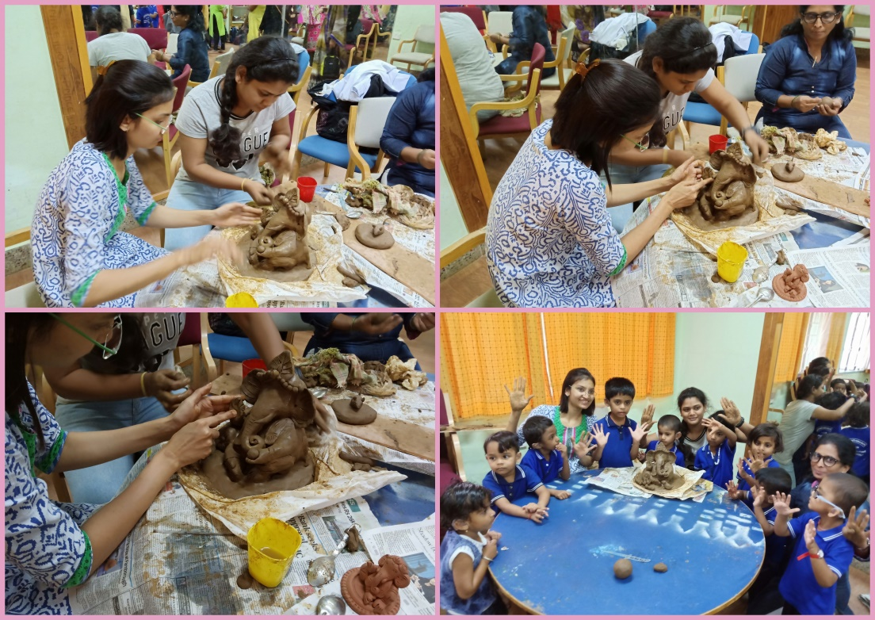

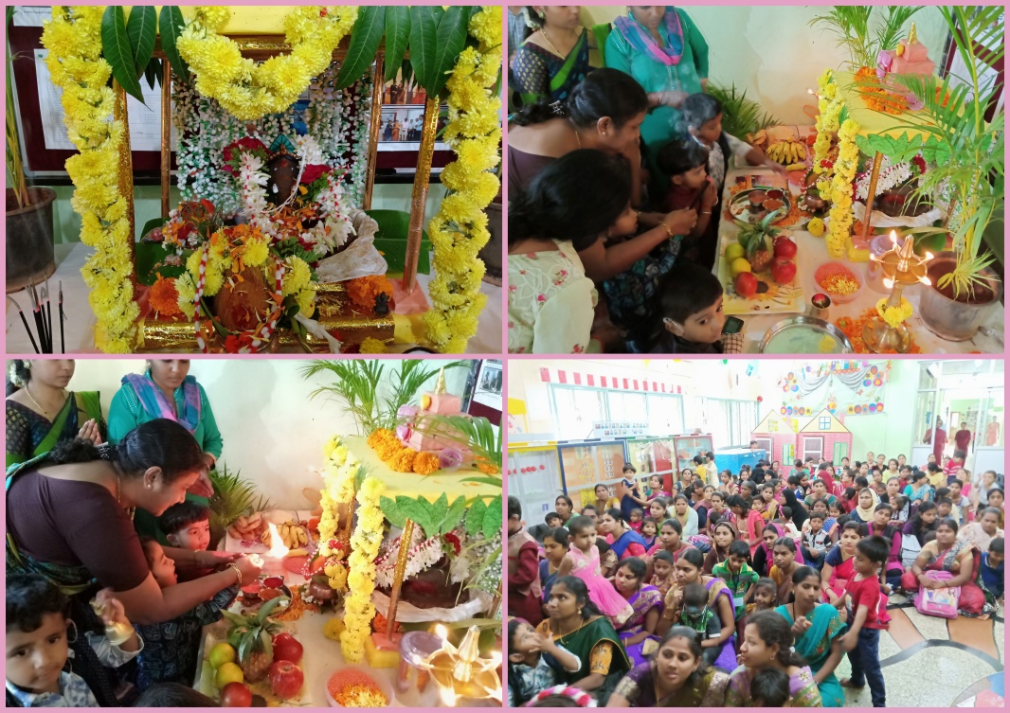

* **Name of the Programme/ Event:** Swachhta Hi Sewa program
* **Date:** 28.09.2018
* **Coordinated by: -** Dr. Prithi V & Enginneer section staffs

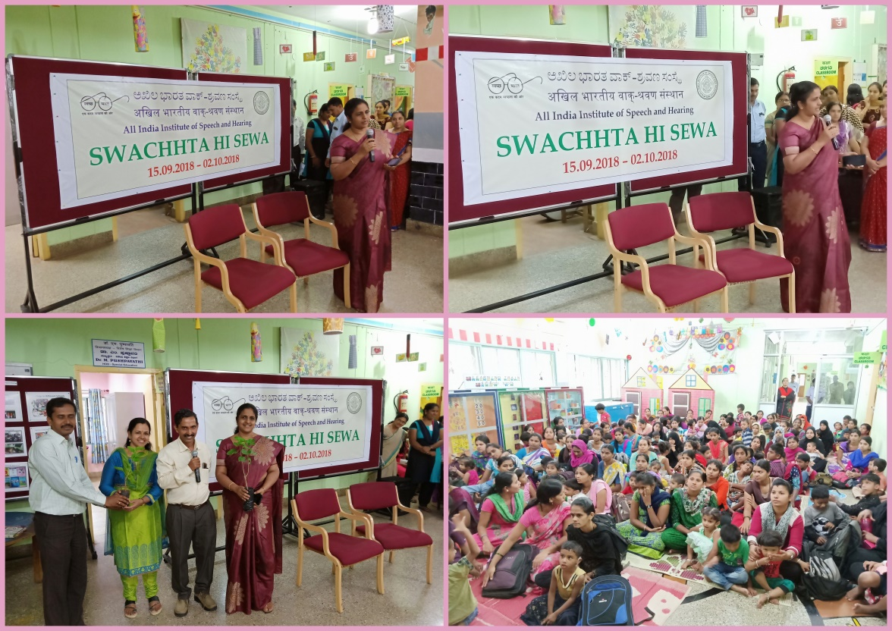

* + - 1. Press Releases and Media Coverage: NIL

**C) Material Development :**The following Teaching Learning Materials and Prepare for training children with various communication disorders an preschool.

|  |  |  |  |
| --- | --- | --- | --- |
| **Sl.**  **No.** | **Nature of**  **Teaching-Learning**  **Materials** | **Skill** | **Number** |
| 1. | Flash cards | For all skill areas | 61 |
| 2. | Work Cards | For all skill areas | 78 |
| 3. | Charts | For all skill areas | 26 |
| 4. | PPT | For all skill areas | 149 |
| 5. | Models | For all skill areas | 53 |
| 6. | Sentence strips | For all skill areas | 51 |
| 7. | Story cards | For all skill areas | 72 |
| 8 | Others | For all skill areas | -- |

1. **AWARDS AND HONORS RECEIVED BY FACULTY AND STAFF**
2. EXTRA CURRICULAR ACTIVITIES
   * + - 1. AIISH Gymkhana
3. EMINENT VISITORS:

XI. **ANY OTHER**

* **Official Language Implementation:**
* Hindi Word a day
* No of notings/letters (**September 2018**): Hindi: 31, English: 06

**Teaching Materials**

NSS Voulneers helped with painting on floors and Making Teaching Learning Materials in preschool on 15.09.2018.

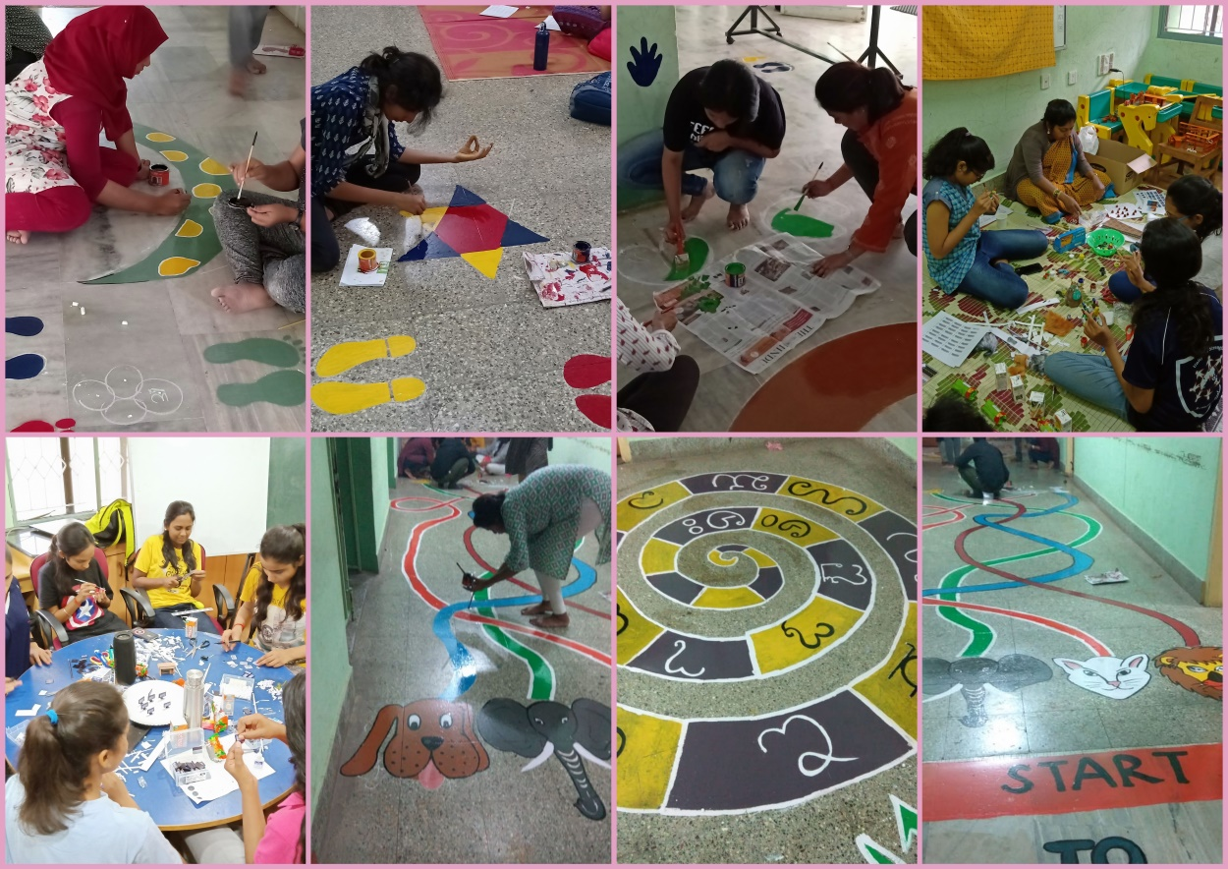

Sd/-

HOD- Special Education