ALL INDIA INSTITUTE OF SPEECH AND HEARING, MYSURU-6
अखिल भारतीय वाक श्रवण संस्थान, मैसूर-६
DEPARTMENT OF SPECIAL EDUCATION
विशेषशिक्षाविभाग
MONTHLY REPORT–July2018

- ACADEMIC ACTIVITIES
- Orientation Programs (For outsiders):The following orientation programswere conducted to orient about the activities of the departmentand also to provide the knowledge about the educational facilities and welfare measures for children with special needs. : 03
Sl. No. | Coordinator | Targeted Audience | Number  of Participants | Date
 | Dr. Palnaty Vijetha | Staffs, NGO for Visually Impaired | 02 | 12.07.2018
 | Dr. Alok Kumar U | Students, Vidya Vardhaka College of Engineering, Mysuru | 05 | 17.07.2018
 | Ms. Lakshmi Prabha | In service teachers, Kendriya Vidyalaya (KVS) Teacher institute, Hassan | 28 | 25.07.2018

Dr.Pushpavathi M, HOD – Special Education

- Supervised the work related to model prepration
- REBE was submitted
Faculty report

Name of the Faculty |  | Dr.Alok Kumar | Dr. G. Malar | Dr.Prithi  Venkatesh | Dr. P. Vijetha | Ms.LakshmiPrabha J.K
Clinics
No. of cases evaluated at SEA-U |  | 14 | - Screening: 22 clients in 22 sessions  - Assessment: 4 clients in 16 sessions | She is on Maternity leave | 15 | - Screening: 25 clients in 25sessions  Assessment: 3 client in 22 sessions
No. of cases supervised individually |  | 02( It took 8 hours)Administered Educational assessment tool | - 30 children in 6 groups |  | 25 | - 16 children through 3 classroom observations of 3 preschool groups
No. of groups supervised |  | 07 | - 8 |  | 16 | - 11preschool groups
No. of meeting with parents |  | 06 | - 8 meetings in 8 groups |  | 8+2* | - 11 meetings in 11preschool groups
Educational Guidance |  | 01 | - 7 clients  - 8 sessions |  | 4 clients (8 sessions)
Academics
Classes taken
B.Ed.  Spl.Edn.(HI) | Theory | 24 hours | - 31 (including 8 extra) |  | 20 classes | - 11 hours
 | Practical | 40 hours | - 16 hours |  | 12 hours | - 24 hours (Preschool Observation posting in Colour group (ASD))
Any others |  |  |  |  | Submitted format for evaluation for B.Ed I year trainees on 23rd July 2018
Any other
Meeting held |  |  | 1 monthly meeting each with I & II B.Ed. Spl.Ed. (HI)  - 8 monthly meetings with 8 preschool groups |  | - From 18th to 20th July 2018, stock verification of Library books has been carried out and report submitted on 31st July 2018. | - 11 meetings with preschool parents
Meeting attended |  |  | - 3 Meetings with the Director regarding B.Ed.Spl.Ed. (HI) programme & ARF Project  - 3 Meetings with HOD regarding B.Ed.Spl.Ed. (HI) programme & other departmental affairs  - Meeting on OLI on 20.07.18 |  | - On 20th July 2018, from 12 to 12:30pm attended OLI Hindi meeting | - 2 meetings with HOD and Staff members regarding few issues  - One meeting with faculty regarding RE BE  - One meeting regarding OLI
Brouchre
Serve as Resource person |  |  | - Workshop on LD for KV school teachers at KV ZIET, Mysuru
Roles & Responsibilities
Co-ordination |  | Parent Infant Program Unit  Preschool Parent Enrichment Program Unit | - CBCS Coordinator for I& II B.Ed.Spl.Ed. (HI)  - Compilation of M.S.Ed. Student Dissertation-based Articles 2014-15  - Intra-Department  - SEA-U  - Research & Database Unit |  | - Services for School age children  - Lesson plans and children availing services have been checked.  - List of equipment and TLMs available has been submitted  - Conducted monthly meeting on 31st July 2018.  - 22 new admissions have been made.  - RE- BE has been prepared, discussed and submitted.  - Preschool services  - Coordinating for uniforms and admission work of Preschool with concerned teachers for the academic year 2018-19.  - Conducted two PTMs of *Dr. Prithi’s group.  - Others  Coordinated for purchase indent of printer with purchase section.
Member secretary |  | Pre School | - Services for School-Aged Children (in Department of Special Education) |  | NIL
Member in |  | Special education assessment Unit and Assistan warden | - TCPD  - LD Clinic (in DCS)  - Product Development Cell  - Preschool Supervision  - Allied member of ISHA  - Life member of NCED |  | SEA-U | Cultural Activities committee member, Annual Day - August 2018
Mentor |  | M.Sc 2year Audiology | - Mentor for I & II B.Ed.Spl.Ed. (HI) |  | II BASLP A section

- Clinical /Educational Observation Postings of Students from other Institutes:NIL
Following are the details of students posted for observation/ practice teaching
Sl.No. | Name of the Institute | Programme/Course | Number of Students | Dates

- Seminars/Conferences/Workshops/Training Programs:NIL
- Staff Enrichment / In-house training Programmes(For own staff members) : NIL
Theme/Topic | Resource Person | Coordinator | Objectives | Targeted Audience | Date
- Guest Lectures :

- Additional Academic Services rendered by the Faculty and Staff

- Invited Talks: 01
Staff | Topic | Date | Programme | Institution
G. Malar | - Education of Physically & Socially Challenged Children in Inclusive Settings | 27.07.2018 | Workshop on Learning Disabilities for Kendriya Vidyalaya Teachers | Kendriya Vidyalaya Zonal Institute for Education & Training, Mysuru

- Curriculum Development: NIL
- Development of Material to Support Learning :NIL
- Service in Academic Bodies of other Organizations: 01
- Dr. Palnaty Vijetha served as diploma Paper examiner of RCI(GTTCHH)
- Participation in Committees/Taskforce and Panels setup by other organizations/agencies:
Sl No | Name of the staff | Name of Organization/Agency | Participation in Committees/  Taskforce | Programme | Name of Institute Visited | Date of Visit
- Any Others (Please Specify)

- Research Projects (ARF)
- Completed -NIL
- New Research Projects- NIL
- Ongoing Research Projects –02
- Title of ARF - Development and Evaluation of Indigenous curriculum oriented computer based tutor for concept learning in preschool children with special needs.
Principal Investigator – Ms. P.V. Ramanakumari
Co-Investigators – Dr.Ajish K Abraham and Ms. P.V. Manjula
Research Assistant – Mr. Anil Abbur R.
Date of Starting – 18th January 2017

- Title: Effect of Resource Materials on Impact of Inclusive Education in Children with Intellectual Disabilities (ID) and Learning Disabilities (LD)
Investigators: Dr. G. Malar, Ms. S. Prathima&Mr. D. Gururaj
Duration: 12 months from January 2017
Budget: Rs. 3,85,000/-
Progress: Suspended till appointment of staff for extension in July & August 2018

- Postgraduate Research Completed:- NIL
- C. Postgraduate Research ongoing: NIL
- D. Research Papers presented at National/International Conferences/Seminars :- NIL
E.Research Papers Published
i) Papers published in National / International Journals: NIL
ii) Abstracts published in Conference / Seminar Proceedings: NIL
F. Books published (in APA format)
- Books published: NIL
G.Book chapters published (in APA format): NIL
10. Books/Manuals/Seminar
H .Books/Manuals/Seminar Proceedings edited: NIL
- Journal Editorship: NIL
J. Scholarly Reviewing Activities:
- Special Educational Services Offered through Teacher Trainees Outside Campus: NIL

III CLINICAL SERVICES
- General Clinical Services: Not Applicable
- Specialized Clinical/ Educational Services
- Preschool Training and Special Education
Educational services for children with special needs
S. No. | Nature of Services (I/C)
- Special Educational Assessment Services (Dr. G. Malar)
 |  | Nature of Special Need  Language | ASD / PDD NOS | Hearing Loss | Intellectual Disability | Learning Disability | Motor Problems | Multiple Disabilities | Others | No. of Clients | No. of Sessions | Total No. of Sessions
1. | Screening & Referral | Kannada | 3 | 18 | 9 | 0 | 1 | 7 | 6 | 44 | 44 | 76
 |  | Malayalam | 1 | 2 | 1 | 0 | 0 | 5 | 1 | 10 | 10
 |  | Hindi | 0 | 1 | 1 | 0 | 0 | 1 | 2 | 5 | 5
 |  | Urdu | 0 | 0 | 0 | 0 | 0 | 0 | 0 | 0 | 0
 |  | English | 1 | 0 | 3 | 3 | 0 | 2 | 4 | 13 | 13
 |  | Telugu | 0 | 0 | 0 | 1 | 0 | 1 | 1 | 3 | 3
 |  | Tamil | 1 | 0 | 0 | 0 | 0 | 0 | 0 | 1 | 1
 |  | Any Other | 0 | 0 | 0 | 0 | 0 | 0 | 0 | 0 | 0
 |  | Total No. of Clients | 6 | 21 | 14 | 4 | 1 | 16 | 14 | 76 | 76
2. | Assessment & Report | Kannada | 0 | 3 | 1 | 0 | 0 | 2 | 0 | 6 | 25 | 54
 |  | Malayalam | 0 | 0 | 0 | 0 | 0 | 1 | 0 | 1 | 4
 |  | Hindi | 0 | 0 | 0 | 0 | 0 | 0 | 0 | 0 | 0
 |  | Urdu | 0 | 0 | 0 | 0 | 0 | 0 | 0 | 0 | 0
 |  | English | 0 | 0 | 2 | 2 | 0 | 0 | 0 | 4 | 17
 |  | Telugu | 0 | 0 | 0 | 0 | 0 | 0 | 0 | 0 | 0
 |  | Tamil | 1 | 0 | 1 | 0 | 0 | 0 | 0 | 2 | 8
 |  | Any Other | 0 | 0 | 0 | 0 | 0 | 0 | 0 | 0 | 0
 |  | Total No. of Clients | 1 | 3 | 4 | 2 | 0 | 3 | 0 | 13 | 54
 | Places from which seen: (1)Karnataka: 61 (2)Kerala: 11 (3)AP: 1 (4)Telengana: Nil (5)TN: 02 (6)Other Parts of India: 1(UP) (7)Any other: Nil
 | Age groups seen:(1)Birth to 2.5yrs: 04 (2)2.5⁺ to 6 yrs: 34 (3)6yrs⁺ to 16 years: 37 (4)16yrs⁺: 01
 | Total No. of Referrals: (1)Educational Assessment: 09 (2)Educational Guidance: 06 (3)PIP: 09 (4)PPEP/ PBC/ GECS: 41 (5)CSS/IEP/NFE/DET: 19 (6)Any Other Services at AIISH: 01(7)Any Other Services Outside AIISH: 05 (4–mainstreaming & 1–non-formal education and/or vocational training)
 | No. of Reports Issued/Ready for Issue: (1) School Readiness: 02 (3) Curriculum-Based Assessment: 03 (4) Post-School: Nil

PreschoolTraining:Preparatory programme for schooling providing training in self-help, cognitive, language and (pre) academic skills, Preschool Supplementary Services (PSS)
Language & Disability | No. of Groups | No. of Children
 |  | MALE | FEMALE
Kannada ASD & ID &MD | 15 | 50 | 25
Kannada HL | 8 | 43 | 21
Malayalam HL | 1 | 3 | 4
Malayalam ASD & ID & MD | 8 | 18 | 13
Hindi HL | 2 | 8 | 6
Hindi MD & ID & ASD | 2 | 7 | 3
English ID, ASD | 1 | 3 | 2
Telugu ASD & ID & MD | 1 | 6 | 3
TOTAL Number of children | 38 | 138 | 77
TOTAL No. Groups | 38 | 215
Sessions | 3192 ( Groupwise)

Curricular Support Services – Supportive training to augment education in mainstream school/ other educational programmes | Language | HL | ID/CP/ASD/MD/LD/DD | Total No. of clients | No. Of sessions
 | Kannada | 9 | 17 | 26 | 102
 | Malayalam | 1 | 1 | 2 | 6
 | Hindi | -- | -- | -- | -
 | English | 1 | 10 | 11 | 64
 | Telugu | - | 2 | 2 | 6
 | Tamil | - | - | - | -
Total |  |  |  | 41 | 178
Individualised Educational Programme (IEP) – Training in functional academics for out of school individuals | Language | HL | ID/CP/ASD/MD/LD/DD | Total No. of clients | No. Of sessions
 | Kannada | 5 | 13 | 18 | 58
 | Malayalam | - | 1 | 1 | 6
 | Hindi | 1 | 2 | 3 | 9
 | English | - | 1 | 1 | 6
 | Telugu | - | - | - | -
 | Tamil | - | - | - | -
 | Total | - | - | 23 | 79

Demonstration Educational Training – Short-term demonstration to caregivers in any of the above | Language | HL | ID/CP/ASD/MD/LD/DD | Total No. of clients | No. Of sessions
 | Kannada | 2 | 7 | 9 | 16
 | Malayalam | - | 4 | 4 | 9
 | Hindi | 1 | 2 | 3 | -
 | English | 1 | - | 1 | -
 | Telugu | - | - | - | -
 | Tamil | - | - | - | -
 | Total | - | - | 17 | 25

Total clients:81
Old clients:- 59
New clients: - 22
Discharged(DET):-04
Discharged(CSS):- 02
Discharged(IEP):- 01
Discontinued(DET):- 04
Discontinued(CSS):- NIL
Discontinued(IEP):- 02
Promoted from CSS/IEP/DET to PPEP: NIL
No. of remaining clients: 68

Preschool Parent Empowerment Programme – PPEP
 | Language | HL | ID | CP | ASD | MD | LD | DD | SLD | VI | Total No. of clients | Group | No. Of sessions
 | Kannada | 25 | 13 | -- | 8 | 8 | -- | 4 | -- | -- | 59 | 11 | 231
 | Malayalam | 6 | 1 | 1 | 2 | 4 | -- | 2 | -- | -- | 16 | 5 | 105
 | Hindi | 6 | 3 | -- | 1 | -- | -- | -- | -- | -- | 10 | 2 | 42
 | English | 1 | 1 | -- | 1 | -- | -- | -- | -- | -- | 3 | 1 | 21
 | Telugu | -- | 2 | -- | -- | -- | -- | -- | -- | -- | 2 | 1 | 21
 | Tamil | 2 | 2 | -- | 2 | -- | -- | -- | -- | -- | 6 | 1 | 21
Total |  |  |  |  |  |  |  |  |  | 95 |  | 20 | 441
No. of clients promoted to the next higher level(Preschool) of service:
No. Of discharged :
No. Of discontinued:
No. Of New clients (June) :
Shifted from PPEP to PIP:
No. of remaining cilents:

Parent-Infant Programme – PIP(Birth to 2 ½ years)
Parent-Infant Programme | Language | HL | ID/CP/ASD/MD/LD/DD | Total No. of clients | Total No. Of sessions
 | Kannada | 11 | 08 | 19 | 81
 | Malayalam | 10 | 14 | 24 | 101
 | Hindi | 01 | 01 | 00 | 08
 | English | 01 | 00 | 01 | 00
 | Telugu | 00 | 00 | 00 | 00
 | Tamil | 01 | 01 | 02 | 05
 | Total |  |  | 46 | 195
No. of Old clients : 37
No. of New clients enrolled: 12
Total cilents:46
No. discharged :01
No. discontinued:nil
No. of Promoted to next level: 01
No. of Remaining:44

Library of Books & Toys – LiBoToy  Services issuing educational toys & books for home-based training. | Total number of members enrolled –93  No. of new members: - 93  Amount – 4650/-  Total number of sessions –26
 | Age group | Total number
 | 0-2.6 yrs | 3
 | 2.6-4 yrs | 6
 | 4.0-6yrs | 81
 | 6 yrs and above | 3

Services | Number of Clients | Number of Sessions
Co-Curricular Training | 215 | 21

Supports for Empowering Caregivers
Name of Training Unit | No. of Parent  Beneficiaries | No. of Sessions | Content of Training
Caregiver Computer Training Unit | -- | -- | --
Caregiver Literacy Training Unit | -- | -- | --

- Clinical Support Services to Clients and Family
- Counselling and guidance
No. of Clients | Sessions
158 | 88
- U-SAFE
No. of Clients | Sessions
-- | --

- Details of Certificates Issued:NIL
Sl.No. | Nature of Special Needs in Clients | No. of Certificates Issued | Purpose

- Financial Aid- NIL
- Legal advice -NIL
- Any other(Please Specify):
- Parent enrichment programs (PEP): 01- This program aims to enrich knowledge of the caregivers of CWSN by experts from various fields.
Theme/Topic | Coordinator | Objectives | Targeted Audience | Date | Photo
Li Bo Toy information | Ms. Leena & Ms. Latha | The programme is to empower the parents of children with communication disorders about the services available in preschool for their children | 125 | 19.07.2018
SUMERU information | Ms. Leena & Ms. Latha |  | 125 | 19.07.2018
U-SAFE | Ms. Leena & Ms. Latha |  | 125 | 19.07.2018
CLTU / CCTP | Ms. Leena & Ms. Latha |  | 125 | 19.07.2018
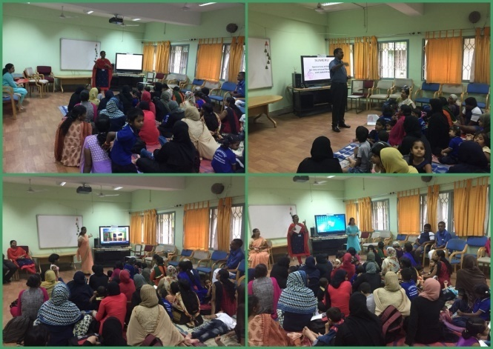
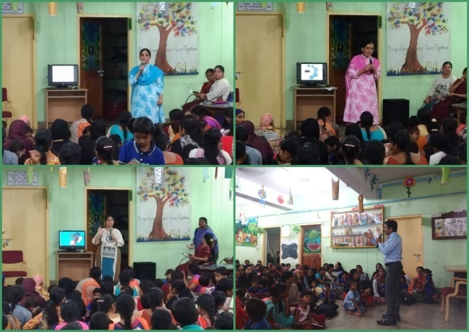
- Staff Enrichment Program (SEP):- 01

Theme/Topic | Coordinator | Objectives | Targeted Audience | Date
Orientation: “Behavior management” by Prof. S.Venkatesan from Psychology | Ms. Sreevidya M S  Mr. Sharanaiah M M | The programme is to empower the Staff of the Department of Special Education | 30 | 28/06/2018, 05/07/2018 and 12/07/2018 (3 sessions- 11.30am to 1.00pm)
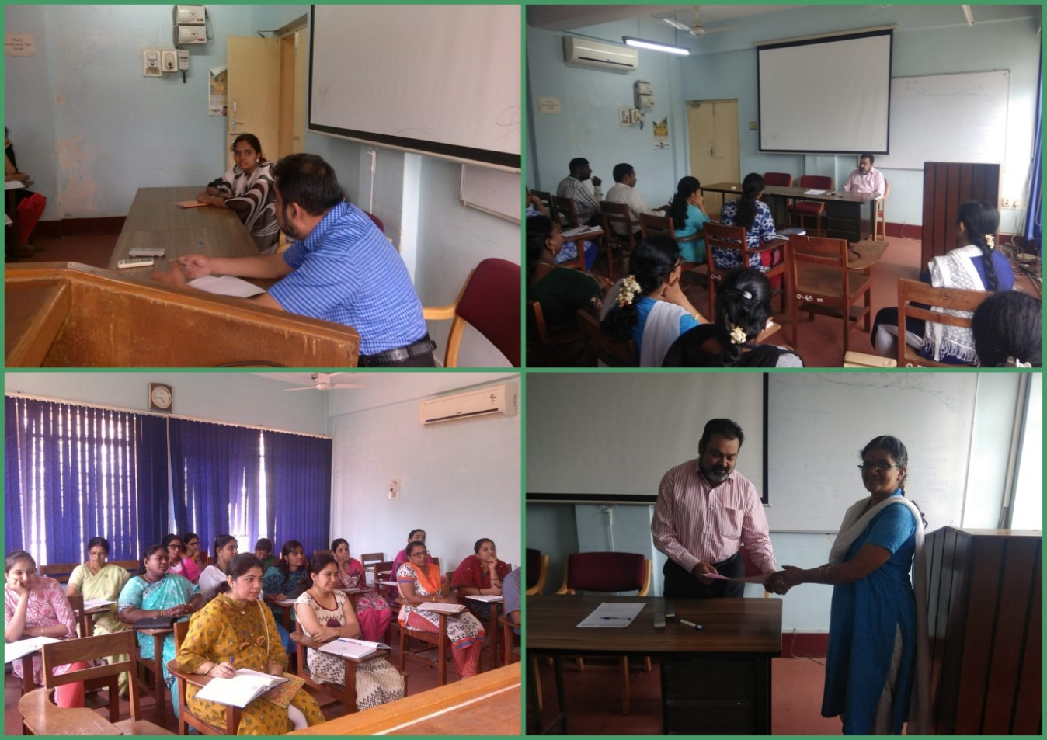

Attended to workshop/Seminar/Orientation program in AIISH institute 2018-19:01
Name of Staff | Attended to workshop title name | Date
Dr. G. Malar | Workshop on Safe and Effective Utilisation of Information & Communication Technology,  Department of Electronics, AIISH | 28.07.2018

Attended to workshop/Seminar/Orientation program in Outside institute 2018-19:NIL
Name of Staff | Attended to workshop title name | Date

EXTENSION ACTIVITIES
- Public Lecture Series
    - TECHNLOGICAL CONSULTANCY SERVICES: Not applicable
      - CENTRAL FACILITIES
      - Library and Information Services
      - Public Information Activities
      - Major Events of the Year with a brief account:NIL
      - Press Releases and Media Coverage: NIL
C) Material Development :The following Teaching Learning Materials and Prepare for training children with various communication disorders an preschool.
Sl.  No. | Nature of  Teaching-Learning  Materials | Skill | Number
1. | Flash cards | For all skill areas | 56
2. | Work Cards | For all skill areas | 69
3. | Charts | For all skill areas | 10
4. | PPT | For all skill areas | 105
5. | Models | For all skill areas | 64
6. | Sentence strips | For all skill areas | 45
7. | Story cards | For all skill areas | 76
8 | Others | For all skill areas | --

- AWARDS AND HONORS RECEIVED BY FACULTY AND STAFF
Ms. Ramankumari P. V & Ms. Manjula P V
- Qualified Karnataka State Eligibility Test (KSET) for Lectureship / Assistant professor Entrance exam organized by university of Mysore.
- EXTRA CURRICULAR ACTIVITIES
        - AIISH Gymkhana
- EMINENT VISITORS:
XI. ANY OTHER
- OfficialLanguage Implementation:
- Hindi Word a day
- No of notings/letters (July2018): Hindi: 45, English: 15

Sd/-
HOD- Special Education

