**DEPARTMENT OF PREVENTION OF COMMUNICATION DISORDERS (POCD)**

**MONTHLY REPORT**- **March-2019**

**1. ACADEMIC ACTIVITIES**

1. **No. of short-term training programs organized: Nil**
2. **a. No. of orientation: 10**

As part of primary prevention activities, several orientation/Sensitization programs are being conducted regularly. The objective of the orientation programs was to create awareness among general public and various other professionals such as Medical doctors, Nurses, Health related workers, teachers, school students etc., on different types of communication disorders, its prevention and early identification methods and their appropriate referral and timely management. Table 1& 2 shows the details of the orientation programs conducted by the dept. of POCD.

Table 1: Orientation Programs conducted by the Department of POCD in the month March, 2019.

|  |  |  |  |  |  |  |  |  |  |  |  |  |  |  |
| --- | --- | --- | --- | --- | --- | --- | --- | --- | --- | --- | --- | --- | --- | --- |
| **I. Orientation Programs at POCD : 03** | | | | | | | | | | | | | | |
| Theme/Topic of the program: Prevention & early identification of communication disorders  Coordinators: Dr. Swapna. N, Dr. Prawin Kumar & Mr. Arunraj K. | | | | | | | | | | | | | | |
| **Sl.No** | | **Date** | | | **Name of the institute/**  **Hospital** | | **Target group** | | **Total participants** | | | **Oriented by** | | |
| 1. | | 08.03.2019 | | | St. Anne’s English higher primary school, Mysore | | School Teachers | | 27 | | | Ms. Namitha and Ms.Zohra  (Intern students) | | |
| 2. | | 15.03.2019 | | | Farooqia girls high school, Laskar Mohall ,Mysore | | School Teachers and students | | 166 | | | Ms.Rachana, Ms.Architaa, Ms.Arpita, Mr. Ansuman  (Intern students) | | |
| 3. | | 08.03.2019 | | | Maria Nikethana school, Gaddige, Mysore | | School Teachers and students | | 336 | | | Ms.Prakruthi, Ms.Rashmi, Mr.Prateek, and Mr.Sunny (Intern students) | | |
| **II. Orientation Programs at NBS centres: 04** | | | | | | | | | | | | | | |
| Theme/Topic of the program: Prevention & early identification of communication disorders Coordinators: Dr. Swapna. N, , Dr. Prawin Kumar & Mr. Arunraj K. | | | | | | | | | | | | | | |
| **Sl.No** | **Date** | | **Name of the institute/**  **Hospital** | | | | | **Target group** | | **Total participants** | | | | **Oriented by** |
| 1. | 04.03.2019 | | Kidzee Playschool, Ajmer | | | | | Parents and Teachers | | 15 | | | | Mr. Ehteshaam Khatri  (Aud Grade 1) |
| 2. | 08.03.2019 | | KGMU, Lucknow | | | | | Professional working at Different districts hospitals in UP | | 7 | | | | Mangal Chandra Yadav  (Aud Grade 1)  Dharm Pal Singh  (SHT) |
| 3. | 09.03.2019 | | NSCBMCH, Jabalpur | | | | | Anganwadi worker | | 15 | | | | Mr. Anup Ghimire  (Aud Grade 1) |
| 4. | 27.03.2019 | | RIMS, Ranchi | | | | | 1st year GNM Nursing student of Hill View Nursing School, Bariatu, Ranchi | | 36 | | | | Mr. Mukesh Kumar  (Audiologist) |
| **III. Orientation Programs at OSC centres: 03** | | | | | | | | | | | | | | |
| Theme/Topic of the program: Prevention & early identification of communication disorders Coordinators: Dr. Swapna. N, , Dr. Prawin Kumar & Mr. Arunraj K. | | | | | | | | | | | | | | |
| **Sl.No** | **Date** | | | **Name of the institute/**  **Hospital** | | **Target group** | | | | | **Total participants** | | **Oriented by** | |
| 1. | 13.03.2019 | | | Periyapatna, Mysuru | | School Teachers | | | | | 08 | | Ms. Reshli Y V  (SLP Grade 1) | |
| 2. | 15.03.2019 | | | Varuna, Mysuru | | School Teachers | | | | | 12 | | Ms.Ananya Basappa  (Aud Grade 1) | |
| 3. | 28.03.2019 | | | Bannuru,  Mysuru | | Parents of Children with Cerebral Palsy | | | | | 14 | | Ms. Reshli Y V  (SLP Grade 1) | |
| **Overall Total** | | | | | | | | | | | **09 Orientations;**  **621 participants** | | | |

Table 2: Total number of participants oriented in the month of March ‘19.

|  |  |  |  |  |
| --- | --- | --- | --- | --- |
| **S.No** | **Target group** | **Gender** | | **Total number of Participants** |
| **Male** | **Female** |
| **1.** | Anganwadi Workers | 7 | 98 | **105** |
| **4.** | Students | 294 | 187 | **481** |
| **5.** | Nursing Students | 06 | 30 | **36** |
| **6.** | School Teachers | 42 | 31 | **73** |
| **7.** | Nurses | 06 | 30 | **36** |
| **8.** | Parents | 4 | 6 | **10** |
| **9.** | Parents of Children with Cerebral Palsy | 9 | 5 | **14** |
| **10.** | Professional working at Different districts hospitals in UP | 6 | 1 | **7** |
| **Total** | | **374** | **388** | **752** |

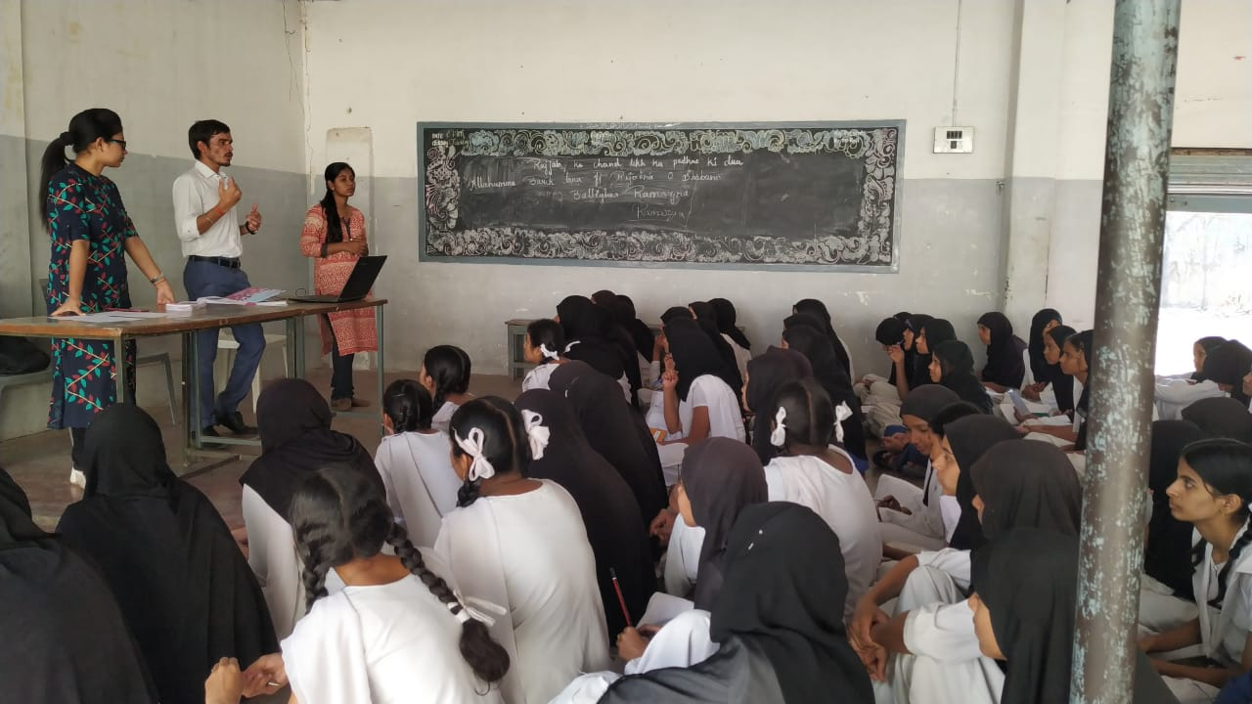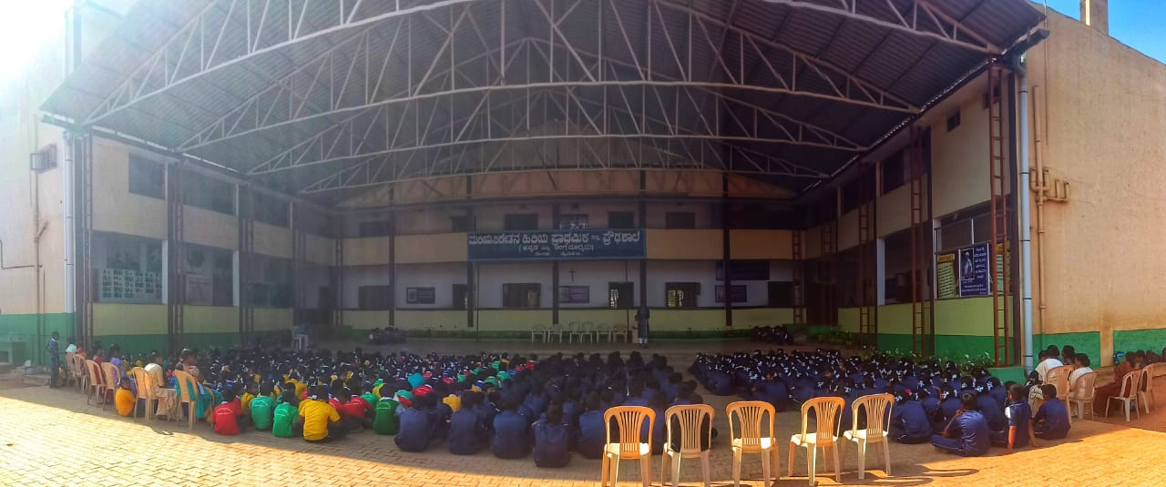

**b. Sensitization programs organized:**

**iii. Training programs conducted: 1**

**iv. Clinical Observation postings of students from other Institutes: Nil**

V. No. of Seminars/ Conferences /Lectures /**Workshop organized** by the Dept.: **Nil**

Vi. No. of Seminars/ Conferences /Lectures /Workshop attended by the staff of the Dept: **3**

* No. of Conferences attended by Staff of POCD: **1**

|  |  |  |  |  |
| --- | --- | --- | --- | --- |
| Sl. No. | Date | Event | Venue/  Organizers | Staff |
| 1. | 16th and 17th March 2019 | BISHACON | Bodh Gaya, Bihar Speech and Hearing Association | Mr. Mukesh Kumar  (Audiologist) |
| 2. | 16th and 17th March 2019 | BISHACON | Bodh Gaya, Bihar Speech and Hearing Association | Mr. Anup Ghimire  (Aud Grade 1) |
| 3. | 16th and 17th March 2019 | BISHACON | Bodh Gaya, Bihar Speech and Hearing Association | Mr. Ehteshaam Khatri  (Aud Grade 1) |

* No of Seminars attended by Staff of POCD:
* Guest Lectures attended by staff of POCD: **Nil**
* No of workshops attended by the staff of POCD:

vii. No. of Guest Lectures organized: **Nil**

viii. No. of Invited Talks delivered by faculty and staff: **Nil**

ix. Any other:

* **Student clinical training**: As part of human resource development, clinical training for Undergraduates (B.Sc Speech & Hearing), Postgraduates (M.Sc SLP & AUD) & Internship students on early identification, prevention & rehabilitation of communication disorders and Community based rehabilitation at OSCs were carried out. The details on the number of students who had undergone training are given below.

|  |  |  |
| --- | --- | --- |
| **Internal (AIISH)** | | |
| **Class** | **No of students Newly posted** | **No of Students continuing** |
| II B.ASLP students | 05 | 05 |
| I M.Sc (Speech ) students | 05 | 00 |
| I M.Sc (Audiology) students | 05 | 05 |
| B.ASLP Internship students | 08 | 04 |
| **Total** | **23** | **14** |
| **External \*** | | |
| BASLP Student (Intern) | 00 | 00 |
| ENT PG Student | 01 | 0 |
| **Total** | **01** | **0** |

*\*ENT PG was posted from KLE Ayurvedic Medical College, Belgavi on 22nd March 2019.*

* **Staff/Student Enrichment Programs: 1**

1. **Research Projects: ARF Project**

|  |  |
| --- | --- |
| **Title** | **Development and Validation of a Screening Tool for Detection of Dysphagia in Neonates** |
| **Objectives** | The main aim of the study was to develop and validate a screening tool for the early identification of dysphagia in neonates. The specific objectives of the study were to   1. To develop a screening tool for the early identification of dysphagia. 2. To assess the content validity of the developed tool. 3. To standardize the developed tool by administering it on the healthy full term and high risk infants. 4. To assess the clinical validity of the tool by administering the same on high risk neonates |
| **Principal and co- Investigator(s)** | Dr. Swapna. N |
| **Funding Agency** | AIISH, ARF |
| **Fund** | Rs.4,93,000 |
| **Status** | The research officer (Ms. Seshasri. D.) joined on 5.12.2019  ***Phase 1 of Data Collection is completed.*** |

1. **Doctoral and Post-Doctoral Programs:** Nil
2. **Research papers presented in National conferences/seminars: 02**

|  |  |  |  |  |  |
| --- | --- | --- | --- | --- | --- |
| **Sl. No.** | **Date** | **Event** | **Title of Presentation** | **Venue/**  **Organizers** | **Staff/Authors** |
| 1. | 16th and 17th March 2019 | BISHACON | New born Hearing screening in India: Current Status in NBS NSCBNC, Jabalpur | Bodh Gaya, Bihar Speech and Hearing Association | Mr. Anup Gimire,  Dr. Kavitha Sachdeva,  Dr. Prawin Kumar, Dr. Swapna N |
| 2. | 16th and 17th March 2019 | BISHACON | Comparison Between Government and Private Hospitals Outcome in Connection with Newborn Hearing Screening in Mysore city. | Bodh Gaya, Bihar Speech and Hearing Association | Mr. Ehteshaam Khatri,  Ms. Pavana Mohan,  Dr. Prawin Kumar,  Dr. Swapna N, |

1. **Research papers presented at International conferences/seminars: 03**
2. **Research Papers published in National Conference/Seminar Proceedings:** Nil
3. **Research Papers published in International Conference/Seminar Proceedings:** Nil
4. **Research Papers published in National Journals:** Nil
5. **Research Papers published in International Journals:** Nil
6. **Book / Chapters Published:** Nil
7. **Books / Manuals/ Seminar proceedings Edited:** Nil
8. **Scholarly Reviewing Activities:** Nil
9. **Research Proposal:** Nil

3. CLINICAL SERVICES

1. General Clinical Services
2. Follow-up evaluation- Detailed evaluation

The newborns/infants referred during the newborn screening were followed up through telephone calls to parents/caregivers of infants. A complete test battery was administered for those clients who came for follow-up. Table 4 (a) & (b) depicts the statistics related to this activity.

Table 4 (a): Details of the results of follow-up evaluation for newborns and infants.

The at-risk babies were monitored regularly by administering the speech-language & hearing checklist through phone call. The babies who are identified with delay in the milestones were

referred to AIISH/concern NBS center for detailed evaluation.

|  |  |  |  |  |  |  |  |  |  |  |  |
| --- | --- | --- | --- | --- | --- | --- | --- | --- | --- | --- | --- |
| **Categories** | **AIISH + Cheluvamba** | **OSC Sarguru** | **OSC-Sagara** | **Lucknow** | **Cuttack** | **Imphal** | **Puducherry** | **Ranchi** | **Jabalpur** | **Ajmer** | **Total** |
| **Normal** | 05 | 02 | 00 | 24 | 00 | 19 | 16 | 00 | 05 | 15 | **86** |
| **ENT disorders** | 00 | 00 | 00 | 00 | 01 | 01 | 00 | 00 | 00 | 00 | **02** |
| **Auditory Maturation delay** | 00 | 00 | 00 | 00 | 01 | 00 | 00 | 00 | 00 | 00 | **01** |
| **Hearing impairment** | 00 | 01 | 00 | 03 | 02 | 00 | 10 | 01 | 05 | 04 | **26** |
| **Speech & language disorder** | 00 | 01 | 00 | 00 | 00 | 01 | 00 | 12 | 02 | 00 | **16** |
| **Multiple Disorder** | 00 | 00 | 00 | 01 | 05 | 00 | 00 | 00 | 00 | 00 | **06** |
| **Incomplete testing** | 02 | 00 | 00 | 00 | 00 | 00 | 06 | 00 | 00 | 00 | **08** |
| **Total** | **07** | **04** | **00** | **28** | **09** | **21** | **32** | **13** | **12** | **19** | **145** |

Table 4(b): Follow-up evaluation- Phone follow-up

|  |  |  |  |
| --- | --- | --- | --- |
| Categories | Mysuru Centre (POCD) | OSC Centers | NBS Centers |
| Normal speech, language & hearing milestones | 0 | 0 | 103 |
| Referred for detailed evaluation | 0 | 0 | 7 |
| Total Phone follow up | 0 | 0 | 110 |

ii) Hearing evaluation of industrial workers at AIISH: Nil

iii) Specialized Clinical services: Nil

iv) Clinical Support Services to Patients and Family: Nil

v) Clinical Electronic Services: Nil

B) EXTENSION ACTIVITIES

i) Newborn screening for Communication Disorders

The department of POCD is actively involved in carrying out various extension activities such as screening, diagnostic and rehabilitation services outside the institute campus. The activities include newborn/infant screening, screening of school children, screening of elderly citizens, screening of industrial workers, conducting camps and also clinical services offered at the outreach service centers of AIISH.

Table 5: Total number of newborns/infants screened and identified at-risk for Communication disorders.

|  |  |  |  |  |  |  |  |  |  |
| --- | --- | --- | --- | --- | --- | --- | --- | --- | --- |
| **SN** | **Hospitals/Immunization Centers** | **Total births** | **Total No. Screened** | | | | **Total No. at risk** | | |
| **Male** | **Female** | **Total** | | **Male** | **Female** | **Total** |
|  |  | **AIISH- Mysuru** | | | | | | |  |
|  | Combined Hospital (CH) | 52 | 20 | 23 | 43 | | 1 | 1 | 2 |
|  | Kamakshi Hospital (KH) | **162** | 57 | 65 | 122 | | 0 | 3 | 3 |
|  | KR Hospital (KRH)- Cheluvamba | **1121** | 418 | 387 | 805 | | 16 | 16 | 32 |
|  | Mission Hospital (MH) | 63 | 27 | 32 | 59 | | 5 | 4 | 9 |
|  | S.M.T.D.H Hospital | **39** | 24 | 20 | 44 | | 1 | 0 | 1 |
|  | Ashwini Nursing Home (ANH) | **26** | 11 | 8 | 19 | | 1 | 0 | 1 |
|  | Shree Devi Nursing Home (SNH) | **37** | 8 | 10 | 18 | | 0 | 0 | 0 |
|  | Gopala Gowda Shanthaveri Memorial Hospital (GGSMH) | 17 | 3 | 7 | 10 | | 0 | 0 | 0 |
|  | Mahadeshwara Nursing Home (MNH) | **49** | 13 | 19 | 32 | | 0 | 0 | 0 |
|  | Sigma Hospital (SH) | **47** | 18 | 29 | 47 | | 1 | 0 | 1 |
|  | Brindavan Hospital | **45** | 12 | 10 | 22 | | 0 | 0 | 0 |
|  | **Total (Mysuru hospitals)** | **1589** | **611** | **610** | **1221** | | **25** | **24** | **49** |
|  | | | | | | | | | |
| 1. 18. | Sub-divisional hospital, K R Nagar Taluk | **176** | 18 | 32 | 50 | | 0 | 0 | 0 |
| 1. 19. | Sub-divisional hospital, T NarsipuraTaluk | **51** | 9 | 5 | 14 | | 1 | 0 | 1 |
| 1. 20. | Sub-divisional Hospital, SagaraTaluk | 153 | 63 | 68 | 131 | | 5 | 7 | 12 |
|  | Vivekananda Memorial hospital, NBS, H. D. kote Sarguru | **312** | **181** | **156** | **337** | | **13** | **5** | **18** |
| Taluk Hospital, H. D. Kote- Immunization | --- | 15 | 17 | 32 | | 1 | 1 | 2 |
| 1. 22. | Community Health Centre (CHC), Hullahalli | --- | 3 | 5 | 8 | | 0 | 0 | 0 |
| 1. 23. | Community Health Centre (CHC), Santhemarahalli | **10** | 4 | 1 | 5 | | 0 | 0 | 0 |
| 1. 24. | Primary Health Centre (PHC), Akkihebbalu | --- | 0 | 0 | 0 | | 0 | 0 | 0 |
|  | **Total (OSCs)** | **702** | **293** | **284** | **577** | | **20** | **13** | **33** |
| **Screening at NBS Centers** | | | | | | | | | |
| 1. 25. | Sri RamachandraBhanj Medical College and Hospital (SCB MCH), Cuttack | **327** | 150 | 90 | | **240** | 13 | 14 | **27** |
| 1. 26. | Regional Institute of Medical Sciences (RIMS), Imphal | **311** | 165 | 153 | | **318** | 9 | 7 | **2** |
| 27. | Janana Hospital & JLNMCH, Ajmer | **1110** | 153 | 163 | | **316** | 6 | 8 | **14** |
| 1. 28. | JIPMER, Puducherry | **1191** | 502 | 515 | | **1017** | 22 | 20 | **42** |
| 1. 29. | Netaji Subhash Chandra Bose Medical College (NSCB), Jabalpur | Birth rate is not calculated in OBG department | 320 | 293 | | **613** | 114 | 85 | **199** |
| 1. 30. | Rajendra Institute of Medical Sciences, Baritayu, Ranchi | **518** | 152 | 157 | | **309** | 29 | 25 | **54** |
| 1. 31. | Kings George’s Medical University, Lucknow | - | 152 | 139 | | **291** | 17 | 15 | **32** |
|  | JLNMCH, Bhagalpur | **294** | 99 | 99 | | 198 | 35 | 19 | 54 |
|  | **Total (NBS centres)** | **3751** | 1693 | 1609 | | 3302 | 245 | 193 | 438 |
|  | **Overall Total** | **6042** | **2597** | **2503** | | **5100** | **290** | **230** | **520** |

1. **School screening (at OSC)**

|  |  |  |  |  |  |
| --- | --- | --- | --- | --- | --- |
| **Date** | **Name of the School** | **Total screened** | **Total identified with communication disorders** | | |
| **Ear related disorder** | **Hearing loss** | **Speech language disorders** |
| 13.03.19 | Periyapatna | 40 | 0 | 0 | 2 |
| 15.03.19 | Government school, Varuna | 90 | 0 | 2 | 1 |
| 20.03.19 | Kallahalli | 46 | 6 | 0 | 1 |
| 23.03.19 | Thalakadu | 80 | 0 | 3 | 1 |
|  | | **256** | **6** | **5** | **5** |
| **Overall Total** | | **256** | **16** | | |

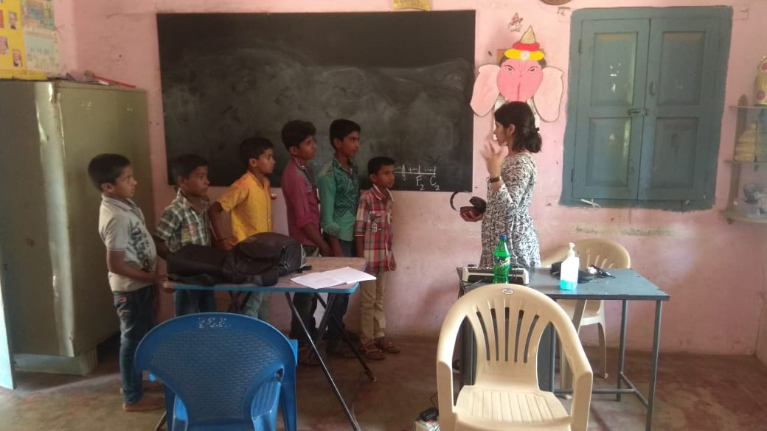

**\*Anganwadi Screening at/by OSC Centers**

|  |  |  |  |  |  |
| --- | --- | --- | --- | --- | --- |
| **Date** | **Name of the Anganawadi** | **Total screened** | **Total identified with communication disorders** | | |
| **Ear related disorder** | **Hearing loss** | **Speech language disorders** |
| 01.03.2019 | Joseph Nagara Anganwadi | 31 | 0 | 0 | 0 |
| 06.03.2019 | Gurupura | 40 | 2 | 0 | 4 |
| 06.03.2019 | Thumbsoge | 30 | 0 | 0 | 0 |
| 13.03.2019 | Periyapatna | 65 | 0 | 0 | 5 |
| 15.03.2019 | Varuna,Mysuru | 117 | 0 | 2 | 3 |
| 20.03.2019 | Kallahalli | 65 | 10 | 0 | 3 |
| 23.03.2019 | Thalakadu | 163 | 6 | 3 | 9 |

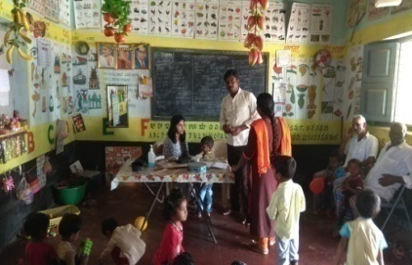

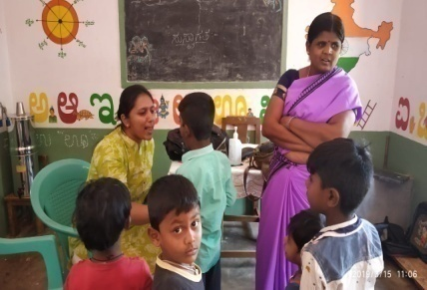

1. **Clinical services for the Elderly citizens: screening**
2. **Industrial Screening:**

**v)**. **Clinical Services at Outreach Service Centers (OSCs):**

The clinical activities are not only restricted to in and around Mysore, but also extended to rural areas where facilities for clinical services for persons with communication disorders were meager. Currently 05 OSCs (01 VMH, Saragur, HD Kote; 02 Sub-divisional taluk hospital at Sagara taluk, Shivamogga District; 03 Primary Health Centre - PHC at Hullahalli, Mysuru district; 04 Akkihebbalu, Mandya district & 05 Karuna trust, Gumballi, Chamarajanagara district) were initiated to meet the objective of extending the services of the institute to rural areas. The OSCs are functioning as a well-equipped unit for screening, diagnostics and therapeutic services for persons with communication disorders. The services include screening, diagnostic and rehabilitation which includes newborn/infant screening, screening of school children, Speech and Language evaluation, Audiological evaluation, ENT evaluation, Speech-Language therapy, issue of free body level hearing aids and ear molds, and counseling and guidance to individuals with communication disorders. The other details are tabulated below in tables 8, 9 & 10.

Table 8: Details of clients identified with communication disorders at the OSCs.

|  |  |  |  |  |  |  |  |  |
| --- | --- | --- | --- | --- | --- | --- | --- | --- |
| **OSC** | **Total Registered** | **ENT Evaluation=81** | | | **Hearing Evaluation=50** | | **Speech & Language Evaluation=18** | |
| **Normal (Ear Wise)** | **Disorder (Ear wise)** | **ENT related**  **Others** | **Normal (Ear Wise)** | **Disorder (Ear wise)** | **Normal (Individuals)** | **Disorder (Individuals)** |
| **Primary Health Centre (PHC), Hullahalli** | **39** | **14** | **20** | **14** | **0** | **18** | **0** | **0** |
| **Primary Health Centre (PHC), Akkihebbalu** | 20 | 04 | 08 | 07 | 0 | 06 | 0 | 01 |
| **Primary Health Centre (PHC), Gumballi** | 41 | 16 | 31 | 12 | 0 | 6 | 0 | 2 |
| **Sub-divisional Hospital (PHC), Sagara** | 15 | 0 | 0 | 0 | 1 | 27 | 0 | 1 |
| **VMH, Sarguru** | **56** | **1** | **1** | **00** | **06** | **36** | **01** | **13** |
| **Total** | **171** | **35** | **60** | **33** | **07** | **93** | **01** | **17** |

Table 8a. Details of clients followed up (Old clients) at the OSCs.

|  |  |  |  |  |  |  |  |  |
| --- | --- | --- | --- | --- | --- | --- | --- | --- |
| **OSC** | **Total Follow up cases** | **ENT Evaluation = 53** | | | **Hearing Evaluation= 03** | | **Speech & Language Evaluation=15** | |
| **Normal (Ear Wise)** | **Disorder (Ear wise)** | **ENT related**  **Others** | **Normal (Ear Wise)** | **Disorder (Ear wise)** | **Normal (Individuals)** | **Disorder (Individuals)** |
| **Primary Health Centre (PHC), Hullahalli** | 13 | **01** | **9** | **4** | **0** | **0** | **0** | **0** |
| **Primary Health Centre (PHC), Akkihebbalu** | 10 | 04 | 04 | 04 | **0** | 02 | 0 | 01 |
| **Primary Health Centre (PHC), Gumballi** | 15 | 09 | 15 | 3 | 0 | 0 | 0 | 0 |
| **Sub-divisional Hospital (PHC), Sagara** | 1 | 0 | 0 | 0 | 0 | 2 | 0 | 0 |
| **VMH, Sarguru** | **14** | 15 | 15 | 6 | **0** | **1** | **2** | **12** |
| **Total** | **53** | **29** | **43** | **17** | **00** | **05** | **02** | **13** |

Table 9: Details of clients identified with different types of communication disorders across OSCs (New and old cases)

|  |  |  |  |  |  |
| --- | --- | --- | --- | --- | --- |
| **Type of Disorders** | **OSC** | | | |  |
| Primary Health Centre (PHC), Hullahalli | Primary Health Centre (PHC), Akkihebbalu | Primary Health Centre (PHC), Gumballi | Sub-divisional Hospital, Sagara (PHC) Taluk | VMH, Sarguru |
| **Hearing disorders (Ear-wise data)** | | | | | |
| Normal | 0 | 0 | 0 | 1 | 08 |
| Conductive | 0 | 0 | 0 | 2 | 10 |
| Sensorineural | 16 | 8 | 6 | 13 | 30 |
| Mixed | 0 | 0 | 2 | 14 | 04 |
| Profound | 2 | 0 | 0 | 0 | 02 |
| **Total (ears)** | **18** | **8** | **8** | 30 | **56** |
| **Speech &Language disorders (Individuals)** | | | | | |
| Voice | 0 | 0 | 0 | 0 | 1 |
| Fluency | 0 | 2 | 1 | 0 | 2 |
| Articulation disorders | 0 | 0 | 0 | 0 | 4 |
| Language disorders | 0 | 0 | 0 | 1 | 7 |
| Normal | 0 | 0 | 0 | 1 | **21** |
| **Total (Individuals)** | **0** | **2** | 1 | **2** | **28** |

Table 9a: Details of clients followed up with different types of communication disorders across OSCs.

|  |  |  |  |  |  |
| --- | --- | --- | --- | --- | --- |
| **Type of Disorders** | **OSC** | | | |  |
| Primary Health Centre (PHC), Hullahalli | Primary Health Centre (PHC), Akkihebbalu | Primary Health Centre (PHC), Gumballi | Sub-divisional Hospital, Sagara (PHC) Taluk | VMH,Sarguru |
| **Hearing disorders (Ear-wise data)** | | | | | |
| Normal | 0 | 0 | 0 | 0 | 2 |
| Conductive | 0 | 0 | 0 | 0 | 1 |
| Sensori- neural | 0 | 2 | 0 | 0 | 10 |
| Mixed | 0 | 0 | 0 | 2 | 1 |
| Profound | 0 | 0 | 0 | 0 | 0 |
| **Aud-Total (ears)** | **0** | **2** | **0** | **2** | **14** |
| **Aud-Total (Individuals)** | **0** | **1** | **0** | **1** | **7** |
|  | | | | | |
| Voice | *0* | *0* | *0* | 0 | 0 |
| Fluency | 0 | 1 | 0 | 0 | 0 |
| Articulation disorders | 0 | 0 | 0 | 0 | 1 |
| Language disorders | 0 | 0 | 0 | 0 | 0 |
| **Sp & Lg -Total (Individuals)** | **0** | 1 | 0 | **0** | **1** |

Table 10**:** Rehabilitation services provided at Outreach service centers.

|  |  |  |  |  |
| --- | --- | --- | --- | --- |
| **OSC** | **Hearing Aids Dispensed** | **Speech-language therapy** | | **Medical Line of Treatment** |
| **No. of clients** | **No. of sessions** |
| Primary Health Centre (PHC), Hullahalli | 0 | 01 | 03 | 0 |
| Primary Health Centre (PHC), Akkihebbalu | 0 | 01 | 01 | 0 |
| Primary Health Centre (PHC), Gumballi | 0 | 08 | 17 | 01 (CI surgery  Ref to AIISH) |
| Sub-divisional Hospital, Sagara (PHC) Taluk | 0 | 12 | 96 | 0 |
| VMH, Sarguru | **1** | **14** | **37** | 0 |
| **Total** | **1** | **36** | **181** | **1** |

C) Communication Disorders Screening Camps:

* 1. **4 Days Residential Camp for children with Cerebral Palsy and developmental delay (along with their parents) at Kenchanahalli, H. D. Kote Taluk**
  2. **(25.2.2019- 28.2.2019):**

|  |  |  |  |  |  |
| --- | --- | --- | --- | --- | --- |
| **Date** | **Place** | **Activity** | **No. of CP/DD children** | **No.of Family Members** | **Total Participants** |
| 27.03.2019 | Bannuru. Taluk-Mysuru | * Orientation * Speech-Language evaluation * Demonstration oro-motor exercises. * Demonstration oro-motor kit. * Individual training. * Counseling and Home training advice. * Valedictory function | 14 | 18 | **32** |
| 30.03.2019 | Bettadapura Periyapatna Taluk- | * Speech-Language evaluation, * Demonstration oro-motor exercises | 09 | 10 | **19** |

|  |  |  |  |  |  |  |  |
| --- | --- | --- | --- | --- | --- | --- | --- |
| **SN** | **Camp places** | **Total No. Screened** | | | **Total No. referred** | | |
| **Male** | **Female** | **Total** | **Male** | **Female** | **Total** |
| 1 | Pediatric camp- Beemanahalli H D Kote | **25** | **28** | **53** | **1** | **2** | **3** |
| 2 | Udburu | **3** | **5** | **8** | **3** | **5** | **8** |
| 3 | Talakadu-Community Camp | **7** | **2** | **9** | **7** | **2** | **9** |

D. SPECIAL ACTIVITIES

1. Library and information services – Nil
2. Public Information Activities – Nil
3. Exhibition: Nil
4. Material Development: Nil

v) PUBLIC LECTURE SERIES: Nil

vi) AWARDS AND HONOURS RECEIVED BY FACULTY AND STAFF:

vii) TECNOLOGICAL CONSULTANCY SERVICES: Nil

viii) EXTRA CURRICULLAR ACTIVITIES: Nil

ix) VISITORS

x) MAJOR EVENTS OF THE MONTH:

a. The **World Hearing Day** was organized by the department of POCD and celebrated on ***March 4th, 5th and 6th of March 2019*** at the All India Institute of Speech and Hearing. On account of this, the following activities were done

* Hearing screening camp
* Radio Talk
* Promotions through print and digital media
* Short movie competition

|  |  |  |  |  |  |  |
| --- | --- | --- | --- | --- | --- | --- |
| **S.No.** | **Date** | **Total No. Cases** | **Total No. referred** | **ENT related** | **Hearing loss** | **Speech & Language issues** |
| 1. | 04.03.2019 | 215 | 24 | 16 | 2 | 6 |
| 2. | 06.03.2019 | 45 | 2 | 2 | 0 | 0 |
| **Total** | | **256** | **26** | **18** | **2** | **6** |

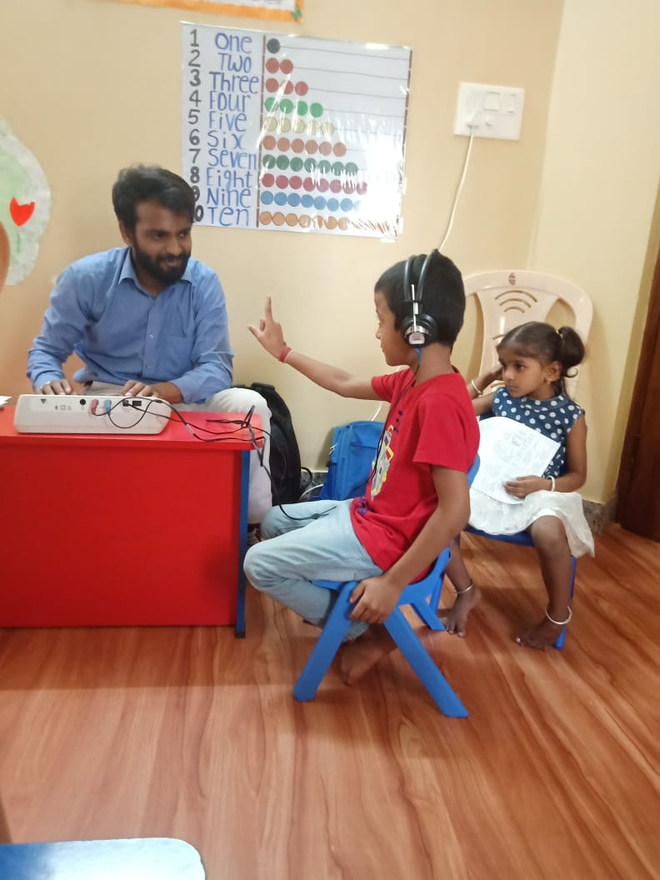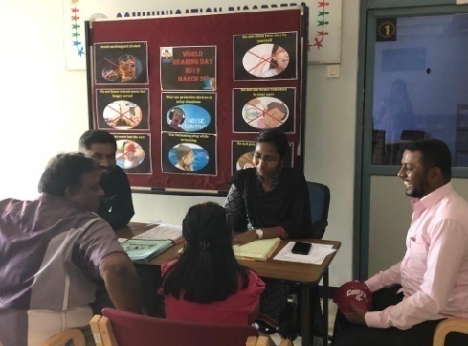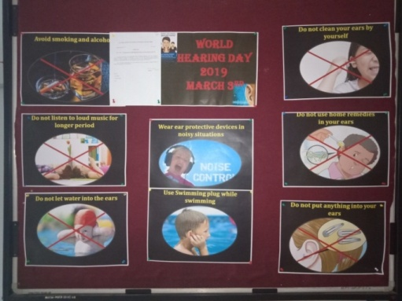

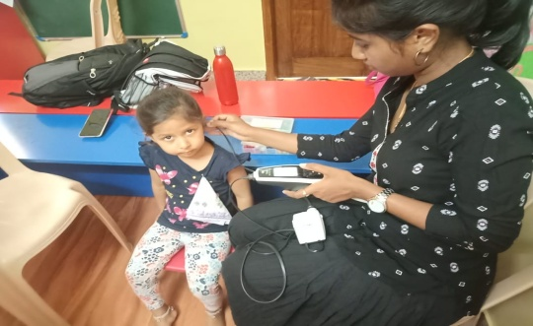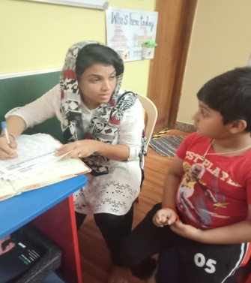

* 1. Ms. Bincy R Kalam (SLP Grade I) & Ms. Pavana Mohan (Aud Grade I) participated in “Zumba” as a part of International Women’s day on 10th March 2019 and distributed public education pamphlets on communication disorders to the public

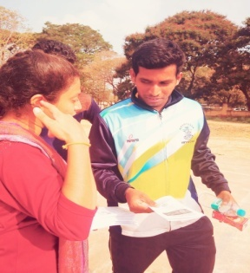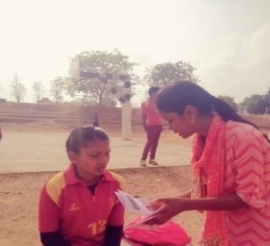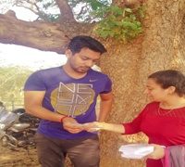

**xi) OTHERS:**

|  |  |  |
| --- | --- | --- |
| Dept. Related | | |
| S.No | Particulars |  |
| a | Computerization activities | Computerization of OSC is in process. |
| b | OSC Related- | NIL |
| c | NBS related- | NIL |

**xii) Following staffs were relieved from the department: 00**

**xiii) Following staffs were newly recruited to the department: 00**

**xiv) Activities carried out by the staff of the department:**

|  |  |  |  |
| --- | --- | --- | --- |
| **Sl.No.** | **Name of the staff** | **Designation** | **Activities** |
|  | Dr. Swapna. N. | * Associate Professor in Speech Pathology * HOD – POCD | Coordinated events for observation of World Hearing Day on 4th March 2019. |
|  | Dr. Prawin Kumar | Associate Professor in Audiology | HOD-POCD In charge.  Attended MRM meeting in Board room  Attended Purchase committee meeting in Board room  Submitted manuscript for publication  NBS data for Sept, 2018 month verified and asked to correct the error noticed in the output to Mr. Jayaram. |
|  | Mr. Arunraj. K | Clinical Assistant | Drafted letters for clarifications in MoU with Mumbai.  Verification of student data. |
|  | Ms. Bincy R Kalam | Speech Language Pathologist Grade I | Participated in free hearing camp, which was conducted at the institute premises on account of World Hearing Day on 4th March, 2019.  Participated in Zumba as a part of International Women’s day on 10th March 2019 and distributed pamphlets on communication disorders to the public.  Attended orientation program on Turnitin Software on 22nd March 2019.  Attended National Workshop on Recent Advancements & Practices of Indian Sign Language in a Clinical Setup on 29th and 30th March 2019.  Attended meeting with the computerization team to verify the formats of all the modules developed till March 2019. |
|  | Ms. Pavana Mohan | Audiologist Grade I | Participated in free hearing camp, which was conducted at the institute premises on account of World Hearing Day on 4th March, 2019.  Participated in Zumba as a part of International Women’s day on 10th March 2019 and distributed pamphlets on communication disorders to the public.  Served as Co-author in the titled “*Comparison between government and private hospitals outcome in connection with newborn hearing screening in Mysore city*”for the secondIndian Speech and Hearing Association, Bihar Chapter Conference, Bodhgaya.  Attended meeting with the computerization team to verify the formats of all the modules developed till March 2019. |
|  | Ms. Juanita Sharon George | Speech Language Pathologist – Grade I | Aided in drafting letter for MoU corrections with AIIPMR, Mumbai.  Prepared minutes of meeting for the ‘All India Annual NBS Coordinators Meet’.  Compilation and organization of department data for Annual Report.  Prepared Monthly Report for month of Feb 2019. |
|  | Ms. Prithivi. T. | Audiologist Grade I | Participated in free hearing camp, which was conducted at the institute premises on account of World Hearing Day on 4th March, 2019.  On behalf of the celebration, attended free hearing screening camp conducted at Ninos Nest Pre School on the 6th of March 2019.  Attended orientation program on Turnitin Software on 22nd March 2019.  Delivered a talk in the orientation program conducted at Dept. of POCD, AIISH, Mysore on 22ndMarch, 2019 to   * Intern students from Agriculture institute Dharward * ENT PG student, Belagavi Medical College   Oriented about activities carried out in Department of POCD on 22nd March 2019.  Drafted letter for initiation of OSCs across India. |
|  | Ms. Nayana P.V. | Audiologist Grade I | Participated in free hearing camp, which was conducted at the institute premises on account of World Hearing Day on 4th March, 2019.  Prepared monthly NBS hospital reports for the month of March 2019. |
|  | Ms. Ameena Subhakani | Speech Language Pathologist – Grade I | Participated in free hearing camp, which was conducted at the institute premises on account of World Hearing Day on 4th March, 2019.  Attended Seventh Lecture Series of *SEEK gyan titled* ‘Symbolic play and cognitive linguistic development’ held on 21.03.2019  Attended National Workshop on Recent Advancements & Practices of Indian Sign Language in a Clinical Setup on 29th and 30th March 2019. |
|  | Mr. Sujan M.J. | Audiologist – Grade I | Participated in free hearing camp, which was conducted at the institute premises on account of World Hearing Day on 4th March, 2019. |
|  | Ms. Shruthi | Audiologist – Grade I | Participated in free hearing camp, which was conducted at the institute premises on account of World Hearing Day on 4th March, 2019.  Prepared NBS coordinators meeting report held on 28th Feb 2019.  Attended orientation program on Turnitin Software on 22nd March 2019. |
|  | Ms. Thasni Jahan K | Speech Language Pathologist – Grade II | Organized World hearing day events held from 4th March 2019 to 6th March 2019.  Participated in free hearing camp, which was conducted at the institute premises on account of World Hearing Day on 4th March, 2019.  Prepared public education material regarding hearing problem provided for community radio stations across Karnataka.  Prepared slides on free hearing screening at the institute to display in the Public information Platform (Bus Stand & Railway Stations, LED displays located in Mysore).  On behalf of the celebration, attended free hearing screening camp conducted at Ninos Nest Pre School on the 6th of March 2019.  Prepared World Hearing day report. |
|  | Mr. Harish Kumar M.K. | Audiologist – Grade II | Organized World hearing day events held from 4th March 2019 to 6th March 2019.  Participated in free hearing camp, which was conducted at the institute premises on account of World Hearing Day on 4th March, 2019.  Delivered live radio talk interview at Radio Active (90.4 MHz) on 4th March 2019 regarding frequently asked question about hearing problems, suggestions and guidelines provided were conveyed to the public through radio for the same.  Prepared public education material regarding hearing problem provided for community radio stations across Karnataka.  Prepared slides on free hearing screening at the institute to display in the Public information Platform (Bus Stand & Railway Stations, LED displays located in Mysore).  Prepared World Hearing day report. |
|  | Ms. Angeline K | Audiologist – Grade II | Participated in free hearing camp, which was conducted at the institute premises on account of World Hearing Day on 4th March, 2019.  Delivered a talk in the orientation program conducted at Dept. of POCD, AIISH, Mysore on 22ndMarch, 2019 to   * Intern students from Agriculture institute Dharward * ENT PG student, Belagavi Medical College   On behalf of the celebration, attended free hearing screening camp conducted at Ninos Nest Pre School on the 6th of March 2019. |

|  |
| --- |
| **Sd/-**  **Head, Dept. of POCD** |