**ALL INDIA INSTITUTE OF SPEECH AND HEARING, MYSURU - 6**

**अखिल भारतीय वाक श्रवण संस्थान, मैसूर - ६**

**DEPARTMENT OF SPECIAL EDUCATION**

**विशेष शिक्षा विभाग**

**MONTHLY REPORT: March 2019**

1. **ACADEMIC ACTIVITIES**

**Faculty report:**

1. **Theory classes (no. of hours)**

|  |  |  |  |
| --- | --- | --- | --- |
| **Name of the Faculty** | **No. of hours of theory classes** | | |
| **DECSE-HI** | **B.Ed.Spl.Ed. (HI)** | **Total** |
| Dr.Alok Kumar Upadhyay | - | 17 | **17** |
| Dr.Prithi V | 09 | 11 | **20** |
| Dr.PalnatyVijetha | 14 | 12 | **26** |
| Dr. G. Malar | 4 | 26 | **30** |
| Ms. Lakshmi Prabha | 8 | 32 | **40** |
| **Total no. of hours** | **35** | **98** | **133** |

1. **Practical Classess (In Hours)**

|  |  |  |  |
| --- | --- | --- | --- |
| **Name of the Faculty** | **No. of hours of practical classes** | | |
| **DECSE-HI** | **B.Ed.Spl.Ed. (HI)** | **Total** |
| Dr.Alok Kumar Upadhyay | - | 10 | **10** |
| Dr.Prithi V | 21 days of postings  (60 hours) | IV Semester: Coordinated IV Semester B.Ed.Spl.Edn (HI) Practical Postings from 1st March -27th March 2019 (92 hours. | **152** |
| Dr.PalnatyVijetha | **-** | Oriented II semester B.Ed. Spl. Edn. (HI) trainees on school readiness test (10 hours) | **10** |
| Dr. G. Malar | 54 | 46 | **100** |
| Ms. Lakshmi Prabha | 20 | 38 | **38** |
| **Total no. of hours** | **134** | **196** | **310** |

1. **AIISH Students in Other Institutes:**
2. Educational Observation Postings for Students from other Institutes:

Following are the details of students posted for observation/ practice teaching

|  |  |  |  |  |
| --- | --- | --- | --- | --- |
| **Sl.No.** | **Name of the Institute** | **Programme/Course** | **Number of Students** | **Dates** |
| **1** | University of Agricultural Sciences, Dharwad | 4th year Human Development and family Studies students | 8 | 25.02.2019 to 13.03.2019 |
| **2** | Shri BM KankanawadiAyurvedMahavidyalaya, Belagavi. | PG ENT student | 1 | 11.03.2019 to 21.03.2019 |

1. Seminars/Conferences/**Workshops**/Training Programs: NIL
2. Seminars/Conferences/Workshops/Training Programs (**Outside of AIISH**): **01**

|  |  |
| --- | --- |
| **Theme/topic** | A Workshop on Educational and Social mainstreaming of children with special needs for caregivers  Rotary Mysore Brindavan. |
| **Coordinator** | Dr. PalnatyVijetha |
| **Resource Person** | Dr. Alok Kumar Upadhyay  Dr. PalnatyVijetha  Ms. Lakshmi Prabha J K  Ms. M.S. Sreevidya  Ms. Latha C  Ms. Asha.S.A |
| **Objectives** | To orient parents on mainstreaming of children with special needs for caregivers. |
| **Targeted Audience** | Caregivers |
| **Number of Participants** | 100+ |
| **Date** | 02.02.2019 |
| **Photo**  C:\Users\Administrator\Pictures\Picasa\Collages\Rotary.jpg | |

1. Staff Enrichment / **In-house training Programmes***(For own staff members)* :

|  |  |  |  |  |  |
| --- | --- | --- | --- | --- | --- |
| **Theme/Topic** | **Resource Person** | **Coordinator** | **Objectives** | **Targeted Audience** | **Date** |
| Orientation about TPAS (Test for Pre-Academic Skill) by Dr.G.Malar | **Dr . G. Malar** | Ms.Sreevidya M S | To empower the staff of the department | 22 | 14.03.2019 |
| C:\Users\Administrator\Pictures\Picasa\Collages\SEP.jpg | | | | | |

1. Guest Lectures : NIL
2. Additional Academic Services rendered by the Faculty and Staff:
3. **Invited Talks: NIL**

|  |  |  |  |  |
| --- | --- | --- | --- | --- |
| **Sl. No.** | **Name, Designation, Institutional affiliation of Lecturer** | **Organized by Department/ Section/ Unit/ Organisation** | **Topic of Lecture** | **Date/s** |

1. **Resource person during interaction program: 02**

|  |  |  |  |
| --- | --- | --- | --- |
| **Name, Designation, Institutional affiliation of Speaker** | **Organized by Department/Section/Unit** | **Topic of Lecture** | **Date** |
| Dr. AlokkumarUpadhyay | National workshop with RCI-CRE Status on Research Methodology for Special Education and Rehabilitation, Faculty of special education & Rehabilitation Sciences, RKVI (Deemed to be University), Coimbatore, Tamil Nadu | 1. Hypothesis  - Concept, Types and Testing of Hypothesis.   2- Writing and Publication of empirical papers | 01.03.2019 |
| Dr.Alok Kumar Upadhyay  Served as a Resource Person | National Conference RCI-CRE Status on ‘Inclusive Education: Best Practices & Future Perspective’, Amity Institute of Rehabilitation Sciences (AIRS),Amity University,Noida, Uttar Pradesh | Inclusive Education System: Ensuring equity for children with special needs in general education system | 08.03.2019 |

1. **Curriculum Development:** NIL
2. **Development of Material to Support Learning:** NIL
3. **Service in Academic Bodies of other Organizations:**
4. **Dr. Alok Kumar Upadhyay**

* Member, Board of Studies (BOS):
* RamkrishnaMission Vivekananda University, Coimbatore: Diploma, U.G & P.G
* N.G.B. University, Allahabad: for U.G & P.G
* J.R.H. University, Chitrakoot: for U.G & P.G
* Member, Board of Examiners (BOE) for UG Special Education of University of Mysore.

1. **Dr. G. Malar**

* Member, BOE–UG Special Education of University of Mysore.

1. **Dr. PrithiVenkatesh**

Member, BOE–UG Special Education of University of Mysore

1. **Dr.PalnatyVijetha**

Member, BOE–UG Special Education of University of Mysore

1. **Participation in Committees/Taskforce and Panels setup by other organizations/agencies**:

|  |  |  |  |  |  |  |
| --- | --- | --- | --- | --- | --- | --- |
| **Sl No.** | **Name of the staff** | **Name of Organization/Agency** | **Participation in Committees/Taskforce** | **Programme** | **Name of Institute Visited** | **Date of Visit** |
| 1 | Dr.Palnaty Vijetha | IUCTE in RIE, Mysuru | As an expert  (Pedagogy of Social Sciences ) | Five day workshop on TPACK | IUCTE in RIE, Mysuru | 11th to 15th March 2019 |

1. **Any Others (Please Specify)**
2. Research Projects (ARF)
3. **Completed – 01 no.**

|  |  |
| --- | --- |
| **Title** | ARF No 66 Development and Evaluation of Indigenous Curriculum Oriented Computer Based Tutor for Concept Learning in Preschool Children with Special Needs. |
| **Objectives** | *Phase I:* To develop story boards for 6 concepts viz. My Family, My Body, Things we use, Animals and Birds, Food we eat and My Journey in Kannada.  *Phase II*: To develop indigenous computer based tutor for the 6 concepts based on the story board in Kannada and integrating it with the multimedia content and devising reinforcement mechanism.  *Phase III:* To evaluate the performance of the developed computer based tutor. |
| **Department** | Special Education |
| **Principal Investigator &**  **Co-Investigator** | *Principal Investigator* - Ms. P.V. Ramanakumari, Special Educator  *Co-Investigator* – Dr. Ajish K. Abraham, Professor in Electronics &Ms.P.V.Manjula, Special Educator |
| **Funding Agency** | AIISH |
| **Date of initiation of the project** | 18th January 2017 |
| **Amount** | Rs. 3,85,000/- |
| **Status** | Completed data collection. Data Analysis is yet to be done and report needs to be submitted. Met Dr.Santosh C.D. on 25th March 2019 to discuss regarding data analysis |

1. **New Research Projects–03 nos.**

**Project 1**

|  |  |
| --- | --- |
| **Title** | ARF No. 01 Efficacy of Developing Skills through Curricular Activities among Preschool Children with Hearing Impairment at AIISH |
| **Objectives** | To investigate the effectiveness of curricular activities in developing:   * Cognitive skills * Language Arts * Pre-academic skills (pre-reading, pre-writing, pre-arithmetic) among children with hearing impairment |
| **Department** | Special Education |
| **Principal Investigator &**  **Co-Investigator** | **Principal Investigator**  Dr.Alok Kumar Upadhyay  Associate Professor in Special Education  AIISH, Manasagangotri, Mysore: 570006  **Co-Investigator**  Dr.PalnatyVijetha  Reader in special Education  AIISH, Manasagangothri, Mysore: 570006 |
| **Funding Agency** | AIISH Research Fund (ARF) |
| **Date of initiation of the project** | 09.10.2018 (approval date) |
| **Amount** | Rs. 3,80,000/- |
| **Status** | Under Process of Initiation |

**Project 2**

|  |  |
| --- | --- |
| **Title** | ARF No. 02 Development of Grade Level Assessment Tools in Social Science (GLAT-SS) of Karnataka State Education Board. |
| **Objectives** | The Present study is being initiated with the aim to develop and standardize Grade Level Assessment Tool in Social Sciences (GLAT-SS) at GRADE VI of Karnataka State Education Board in English and Kannada. |
| **Department** | Special Education |
| **Principal Investigator &**  **Co-Investigator** | **Principal Investigator**  Dr.PalnatyVijetha  Reader in special Education  AIISH, Manasagangothri, Mysore: 570006  **Co-Investigators**   1. Dr.Alok Kumar Upadhyay   Associate Professor in Special Education  AIISH, Manasagangotri, Mysore: 570006   1. Ms.LakshmiPrabha J.K.   Lecturer in Special Education  AIISH, Manasagangotri, Mysore: 570006 |
| **Funding Agency** | AIISH Research Fund (ARF) |
| **Date of initiation of the project** | 09.10.2018 (approval date) |
| **Amount** | Rs. 3,85,000/- |
| **Status** | Under Process of Initiation |

**Project 3**

|  |  |
| --- | --- |
| **Title** | ARF No. 03 Development of grade level Assessment test in Science for Upper Primary School Children (VI-VIII) |
| **Objectives** | The aim of the study is to develop grade level assessment test for upper primary school children (VI-VIII) in science subject.  The study will be taken up with the following objectives in mind:   1. To develop grade level assessment test in Science for upper primary school children (VI-VIII) 2. To verify the reliability and validity of the test 3. To establish the norms for the test 4. To test its applicability with learners with hearing impairment 5. To compare the performance of the learners with hearing impairment on the test. |
| **Department** | Department of Special Education |
| **Principal Investigator &**  **Co-Investigator** | Dr.PrithiVenkatesh  Reader in special Education  AIISH, Manasagangothri, Mysore: 570006 |
| **Funding Agency** | AIISH Research Fund (ARF) |
| **Date of initiation of the project** | 09.10.2018 |
| **Amount** | Rs.4,00,000/- |
| **Status** | Yet to Initiate the project, recruitment of the staff under progress. |

1. **Ongoing Research Projects - 01**

**Title**: ARF No. 65 Effect of Resource Material on Impact of Inclusive Education in Children with Intellectual Disabilities (ID) and Learning Disabilities (LD)

Investigators: Dr. G. Malar, Ms. S. Prathima&Mr. D. Gururaj

Duration: 12 months from January 2017

Budget: Rs. 3,85,000/-

Progress: Project recommenced with reappointment of research assistant in December 2018 for two months period till mid 11th February, 2019. Completed field intervention and post-intervention data collection.In the process of analysing data and compiling report.

1. Postgraduate Research Completed: NA
2. C. Postgraduate Research ongoing: NA
3. D**. Research Papers presented at National/International Conferences/Seminars: 01**

Alok Kumar U (2019). *Effectiveness of Play Way Technique to Teach Prepositions to Children with Hearing Impairment at Primary School Level*. Presented at in International Conference at Pondicherry University, Puducherry on 29th March 2019.

ii) Abstracts published in Conference / Seminar Proceedings**:** NIL

F. Books published (in APA format)

1. *Books published: NIL*

* *Books in press:* NIL

G.Book chapters published (in APA format): NIL

H.Books/Manuals/Seminar Proceedings edited: NIL

1. Journal Editorship: NIL

J. Scholarly Reviewing Activities: NIL

1. Special Educational Services Offered through Teacher Trainees Outside Campus: NIL

**III CLINICAL/ EDUCATIONAL SERVICES**

1. General Clinical Services: **Not Applicable**
2. Specialized Clinical/ Educational Services
3. **Pre-school Training and Special Education**

**Educational services for children with special needs**

|  |  |  |  |  |  |  |  |  |  |  |  |  |
| --- | --- | --- | --- | --- | --- | --- | --- | --- | --- | --- | --- | --- |
| **S. No.** | **Nature of Services (In charge staff)** | | | | | | | | | | | |
| 1. Special Educational Assessment Unit (SEA-U) | | | | | | | | | | | | |
|  |  | Nature of Special Need  Language | ASD / PDD NOS | Hearing Loss | Intellectual Disability | Learning Disability | Motor Problems | Multiple Disabilities | Others | No. of Clients | No. of Sessions | ***Total No. of Sessions*** |
| 1. | Screening & Referral | Kannada | 7 | 15 | 3 | 0 | 0 | 1 | 1 | ***27*** | ***27*** | ***56*** |
| Malayalam | 1 | 4 | 3 | 0 | 1 | 3 | 4 | ***16*** | ***16*** |
| Hindi | 1 | 4 | 1 | 0 | 0 | 0 | 0 | ***6*** | ***6*** |
| Urdu | 0 | 0 | 0 | 0 | 0 | 0 | 0 | ***0*** | ***0*** |
| English | 0 | 0 | 3 | 0 | 0 | 0 | 0 | ***3*** | ***3*** |
| Telugu | 0 | 1 | 1 | 0 | 0 | 0 | 1 | ***3*** | ***3*** |
| Tamil | 0 | 0 | 1 | 0 | 0 | 0 | 0 | ***1*** | ***1*** |
| Any Other | 0 | 0 | 0 | 0 | 0 | 0 | 0 | ***0*** | ***0*** |
| ***Total No. of Clients*** | ***9*** | ***24*** | ***12*** | ***0*** | ***1*** | ***4*** | ***6*** | ***56*** | ***56*** |
| 2. | Assessment & Report | Kannada | 0 | 3 | 0 | 0 | 0 | 0 | 0 | ***3*** | ***18*** | ***34*** |
| Malayalam | 0 | 0 | 1 | 0 | 0 | 0 | 0 | ***1*** | ***1*** |
| Hindi | 0 | 0 | 0 | 0 | 0 | 0 | 0 | ***0*** | ***0*** |
| Urdu | 0 | 0 | 0 | 0 | 0 | 0 | 0 | ***0*** | ***0*** |
| English | 1 | 1 | 1 | 0 | 0 | 0 | 0 | ***3*** | ***13*** |
| Telugu | 0 | 0 | 0 | 0 | 0 | 0 | 0 | ***0*** | ***0*** |
| Tamil | 0 | 0 | 1 | 0 | 0 | 0 | 0 | ***1*** | ***2*** |
| Any Other | 0 | 0 | 0 | 0 | 0 | 0 | 0 | ***0*** | ***0*** |
| ***Total No. of Clients*** | ***1*** | ***4*** | ***3*** | ***0*** | ***0*** | ***0*** | ***0*** | ***8*** | ***34*** |
| Places from which seen: (1) Karnataka: 37 (2) Kerala: 16 (3) AP: Nil (4) Telangana: 01 (5) TN: 01 (6) Other Parts of India: 01(assam) (7) Any other: Nil | | | | | | | | | | | |
| Age groups seen: (1) Birth to 2.5yrs: 03 (2) 2.5+ to 6 yrs: 28 (3) 6yrs+ to 16 years: 22 (4) 16yrs+: 03 | | | | | | | | | | | |
| Total No. of Referrals: (1) Educational Assessment: 13 (2) Educational Guidance: 02 (3) PIP: 03 (4) PPEP/ PBC/ GECS: 28 (5) CSS/IEP/NFE/DET: 08 (6)Any Other Services at AIISH: Nil (7) Any Other Services Outside AIISH: Nil | | | | | | | | | | | |
| No. of Reports Issued/Ready for Issue: (1) School Readiness: 4 (3) Curriculum-Based Assessment: 03 (4) Post-School: 1 | | | | | | | | | | | |

|  |
| --- |
| **Pre-schoolTraining: Preparatory programme for schooling providing training in self-help, cognitive, language and (pre-) academic skills, Preschool Supplementary Services (PSS)** |
| |  |  |  |  | | --- | --- | --- | --- | | **Language & Disability** | **No. of Groups** | **No. of Children** | | |  |  | MALE | FEMALE | | Kannada ASD & ID &MD | 15 | 45 | 24 | | Kannada HL | 8 | 36 | 23 | | Malayalam HL | 1 | 3 | 3 | | Malayalam ASD & ID & MD | 9 | 25 | 15 | | Hindi HL | 2 | 12 | 4 | | Hindi MD & ID & ASD | 2 | 9 | 0 | | English ID, ASD | 1 | 1 | 3 | | Telugu ASD & ID & MD& HL | 1 | 5 | 3 | | TOTAL Number of children |  | **136** | **75** | | **TOTAL No. Groups** | **39** | **211** | | | **Sessions** | **3120( Group-wise)** | | | |

|  |  |  |  |  |  |
| --- | --- | --- | --- | --- | --- |
| **Curricular Support Services – Supportive training to augment education in mainstream school/ other educational programmes** | **Language** | **No. of children with HL** | **No. of children with ID/CP/ASD/MD/LD/DD** | **Total No. of clients** | **No. Of sessions** |
| Kannada | 7 | 12 | 19 | 88 |
| Malayalam | 1 | 1 | 2 | 14 |
| Hindi | - | 1 | 5 | 05 |
| English | 1 | 10 | 11 | 34 |
| Telugu | - | 1 | 1 | 04 |
| Tamil | - | - | - | - |
| Total | | | | **34** | **145** |
| |  |  |  |  |  |  | | --- | --- | --- | --- | --- | --- | | **Individualised Educational Programme (IEP) – Training in functional academics for out of school individuals** | **Language** | **No. of children with HL** | **No. of children with ID/CP/ASD/MD/LD/DD** | **Total No. of clients** | **No. Of sessions** | | Kannada | 1 | 8 | 9 | 48 | | Malayalam | - | 2 | 2 | 08 | | Hindi | 1 | 1 | 2 | 09 | | English | - | 1 | 1 | 04 | | Telugu | 1 | - | 1 | 08 | | Tamil | - | - | - | - | | Total | | | **15** | **77** | | | | | | |
| |  |  |  |  |  |  | | --- | --- | --- | --- | --- | --- | | **Demonstration Educational Training – Short-term demonstration to caregivers in any of the above** | **Language** | **No. of children with HL** | **No. of children with ID/CP/ASD/MD/LD/DD** | **Total No. of clients** | **No. Of sessions** | | Kannada | 1 | 1 | 2 | 04 | | Malayalam | - | - | - | - | | Hindi | - | - | - | - | | English | - | - | - | - | | Telugu | - | - | - | - | | Tamil | - | - | - | - | | **Total** | - | - | **2** | **04** | | | | | | |
| **Total clients: 51**  **Old clients: 49**  **New clients: 06**  **Discharged (DET): 01**  **Discharged (CSS): NIL**  **Discharged (IEP): 01**  **Discontinued (DET): NIL**  **Discontinued (CSS): 02**  **Discontinued (IEP): NIL** | | | | | |

|  |  |  |  |  |  |  |  |  |  |  |  |
| --- | --- | --- | --- | --- | --- | --- | --- | --- | --- | --- | --- |
| **Pre-school Parent Empowerment Programme – PPEP** | | | | | | | | | | | |
|  | **Language** | **HL** | **ID** | **CP** | **ASD** | **MD** | **LD** | **DD** | **SLD** | **VI** | **Total No. of clients** | **Group** | **No. Of sessions** |
| Kannada | 39 | 20 | 13 | 12 | 4 | - | 5 | 2 | -- | 88 | 11 | 242 |
| Malayalam | 19 | 22 | 3 | 7 | 2 | -- | 7 | 1 | -- | 57 | 5 | 110 |
| Hindi | 7 | 3 | -- | 1 | 1 | -- | -- | -- | -- | 13 | 2 | 44 |
| English | -- | 2 | -- | 1 | 1 | -- | -- | -- | -- | 3 | 1 | 22 |
| Telugu | 2 | 2 | -- | -- | -- | -- | -- | -- | -- | 6 | 1 | 22 |
| Tamil | 2 | -- | -- | 3 | -- | -- | -- | -- | -- | 6 | 1 | 22 |
| **Total** | | | | | | | | | | **173** | | **21** | **462** |
| No. of clients promoted to the next higher level(Preschool) of service: NIL  No. Of discharged: 3  No. Of discontinued: 23  No. Of New clients (March): 22  Shifted from PPEP to PIP: 01 | | | | | | | | | | | | | |

|  |  |  |  |  |  |
| --- | --- | --- | --- | --- | --- |
| **Parent-Infant Programme – PIP (Birth to 2 ½ years)** | | | | | |
| Parent-Infant Programme | **Language** | **HL** | **ID/CP/ASD/MD/LD/DD** | **Total No. of clients** | **Total No. Of sessions** |
| Kannada | 16 | 12 | 28 | 91 |
| Malayalam | 09 | 11 | 20 | 59 |
| Hindi | 01 | 03 | 04 | 09 |
| English | 00 | 01 | 01 | 06 |
| Telugu | 00 | 00 | 00 | 00 |
| Tamil | 00 | 01 | 01 | 00 |
|  | **Total** | | | **54** | **165** |
| No. of Old clients: 49  No. of New clients enrolled: 05  Total clients: 54  No. discharged: 00  No. discontinued: 07  No. of Promoted to next level: 03  No. of Remaining: 44 | | | | | |

|  |  |  |
| --- | --- | --- |
| **Library of Books & Toys** – LiBoToy  Services issuing educational toys & books for home-based training. | Total number of members enrolled: 235  No. of new members: NIL  Amount: NIL  Total number of sessions: 24 | |
| **Age group** | **Total number** |
| 0 - 2.6 yrs | 10 |
| 2.6 - 4 yrs | 77 |
| 4.0 – 6yrs | 140 |
| 6 yrs and above | 8 |

|  |  |  |
| --- | --- | --- |
| **Services** | **Number of Clients** | **Number of Sessions** |
| Co-Curricular Training | 211 | 20 |

**Supports for Empowering Caregivers**

|  |  |  |  |
| --- | --- | --- | --- |
| **Name of Training Unit** | **No. of Parent**  **Beneficiaries** | **No. of Sessions** | **Content of Training** |
| Caregiver Computer Training Unit | 85 | 46 | Drawing in paint, Typing |
| Caregiver Literacy Training Unit | -- | -- | -- |
| Caregiver yoga training  (from 14.3.2019 onwards) | 50 | 24 | -- |

1. Support Services to Clients and Family
2. **Counselling and guidance**

|  |  |
| --- | --- |
| No. of Clients | Sessions |
| 211 | 88 |

1. **U-SAFE**

|  |  |
| --- | --- |
| No. of Clients | Sessions |
| 86 | 12 |

**iii) SUMERU**

|  |  |
| --- | --- |
| No. of Clients | Sessions |
| 15 | 11 |

1. Details of Certificates Issued: NIL
2. Financial Aid: NIL
3. Legal advice: NIL
4. Any other (Please Specify):
5. **Parents Help Parents Program (PHPP):** This program aims to provide moral support and boost the confidence, motivates the parents of CWSN. In there, parents of successfully rehabilitated child with special needs will be sharing their experience and interacting with parents.

|  |  |  |  |  |  |
| --- | --- | --- | --- | --- | --- |
| **Theme/Topic** | **Resource Person** | **Coordinator** | **Objectives** | **Targeted Audience** | **Date** |
| Shared her experience about bringing up her child Mr.Shubhang Sharma with Learning Disability | Dr. Sheela Shridhar | Ms.Latha C | To empower and motivate the parents of children with communication disorders | 160 | 18.03.2019 |
| C:\Users\Administrator\Pictures\Picasa\Collages\Photos.jpg | | | | | |

**Attended workshop/Seminar/Orientation program in AIISH institute 2018-19: 02**

|  |  |  |
| --- | --- | --- |
| **Name of Staff** | **Attended to workshop title name** | **Date** |
| G. Malar | Workshop on Academic Writing | 27.03.19 |
| G. Malar | National Workshop on Recent Advancement and Practices of Indian Sign Language in Clinical Set-up | 28 & 29.03.19 |
| Mr. Sharanaiah | Orientation on ‘Fire prevention’ | 29.3.2019 |
| Mr. Subbramanya | Orientation on ‘Fire prevention’ | 29.3.2019 |

**Attended workshop/Seminar/Orientation program outside institute 2018-19: NIL**

|  |  |  |
| --- | --- | --- |
| **Name of Staff** | **Attended to workshop title name** | **Date** |

EXTENSION ACTIVITIES

1. **Public Lecture Series: 01**

|  |  |  |  |  |
| --- | --- | --- | --- | --- |
| **Sl. No.** | **Name, Designation, Institutional affiliation of Lecturer** | **Organized by Department/ Section/ Unit/ Organisation** | **Topic of Lecture** | **Date/s** |
| 1 | Ms.LakhmiPrabha J K  AIISH, Mysuru | Monthly Public Lecture | Institutional Activities | 27.03.2019 |

* + - 1. TECHNLOGICAL CONSULTANCY SERVICES: NIL
      2. CENTRAL FACILITIES
      3. Library and Information Services
      4. **Public Information Activities**

1. Dr. G. Malar oriented administrators of the following 8 senior secondary and/or higher education institutions about special educational programmes conducted by AIISH and distributed related informational brochures:

* Jnanadeepa PU College e
* Jnanadeepa First Grade College
* BasudevSomani PU College
* BasudevSomani First Grade College
* Government First Grade College
* Sri Adichunchanagiri PU College
* BSG First Grade College
* Cauvery Educational Institutions

1. **Orientation Programs (For outsiders):** The following orientation programs were conducted to orient about the activities of the department and also to provide knowledge about the educational facilities and welfare measures for children with special needs. : **04**

|  |  |  |  |  |
| --- | --- | --- | --- | --- |
| **SL No.** | **Coordinator** | **Targeted Audience** | **Number**  **of Participants** | **Date** |
| 1 | G. Malar | Faculty & students of PG programme in psychology & human development, Teresian College, Mysuru | 05 | 12.04.19 |
| 2 | Ms. LakshmiPrabha J.K | Nursing college students, Vikram Institute of Nursing and Paramedical Institute, Yadavagiri, Mysore. | 50 | 27.03.2019 |
| 3 | Ms. LakshmiPrabha J.K | 1st year B.Ed students, Adichunchangiri college of Education, Mysore | 50 | 27.03.2019 |
| 4 | Ms.LakshmiPrabha J.K | 2nd year B.Ed students, Amrita College of Education | 4 | 29.03.2019 |

* + - 1. Major Events of the Year with a brief account:

**Event: Pulsepolio to preschool children at AIISH**

**Date: 12.03.2019**

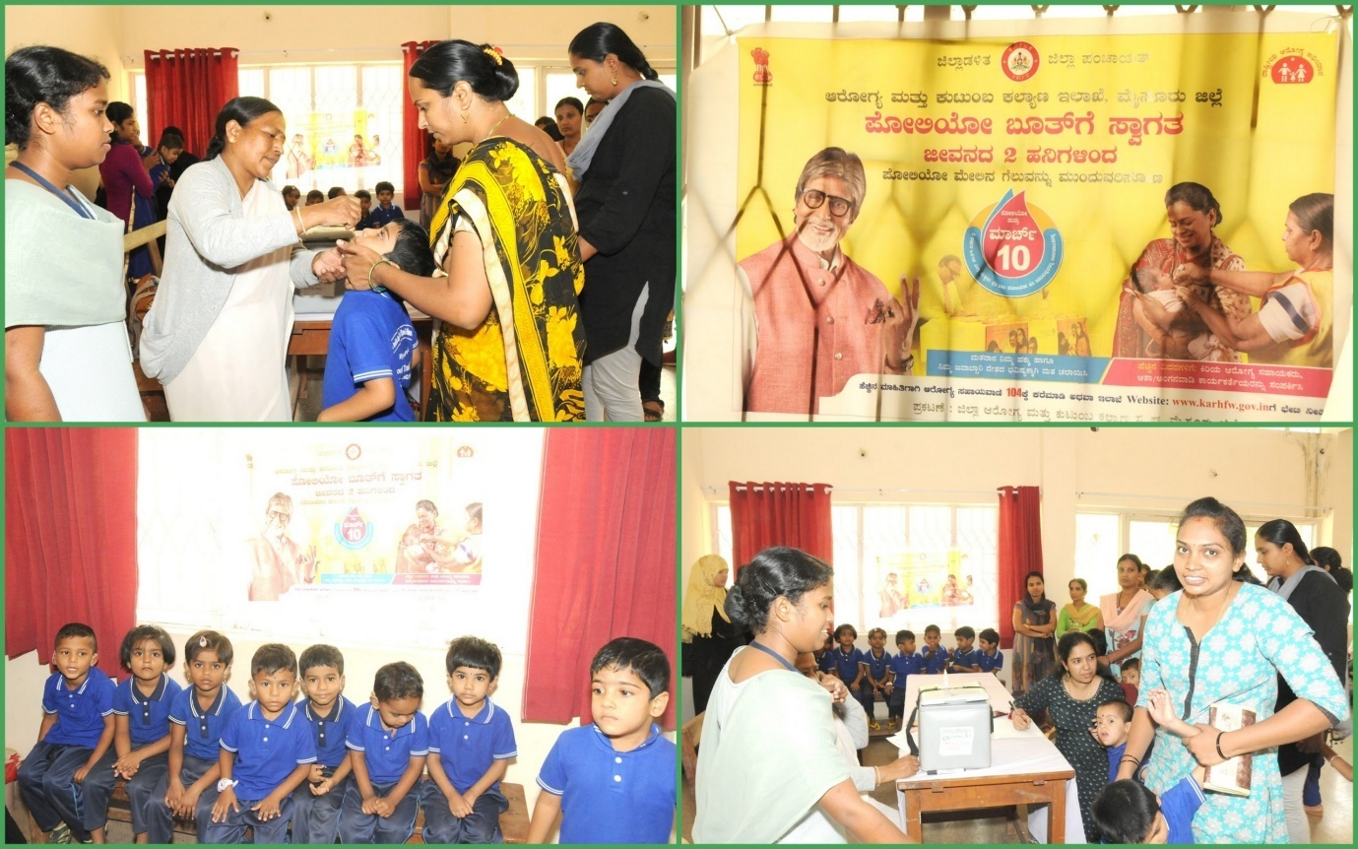

**Event: Holi&Yugadhi Celebration in Dept. of Special Education**

**Date: 28.03.2019**

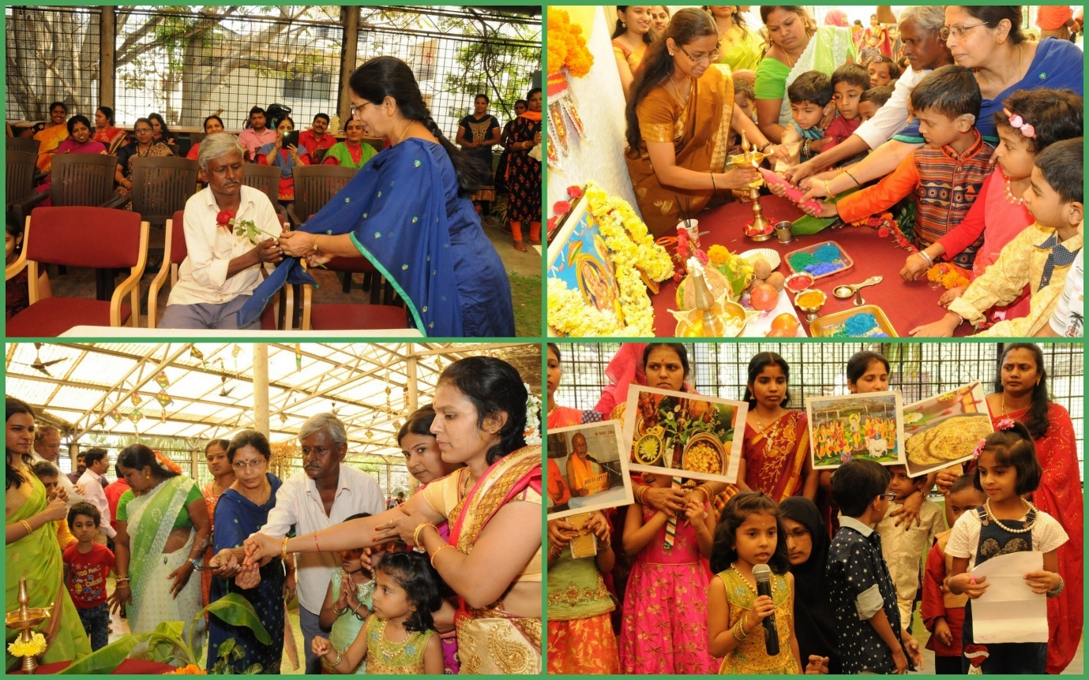

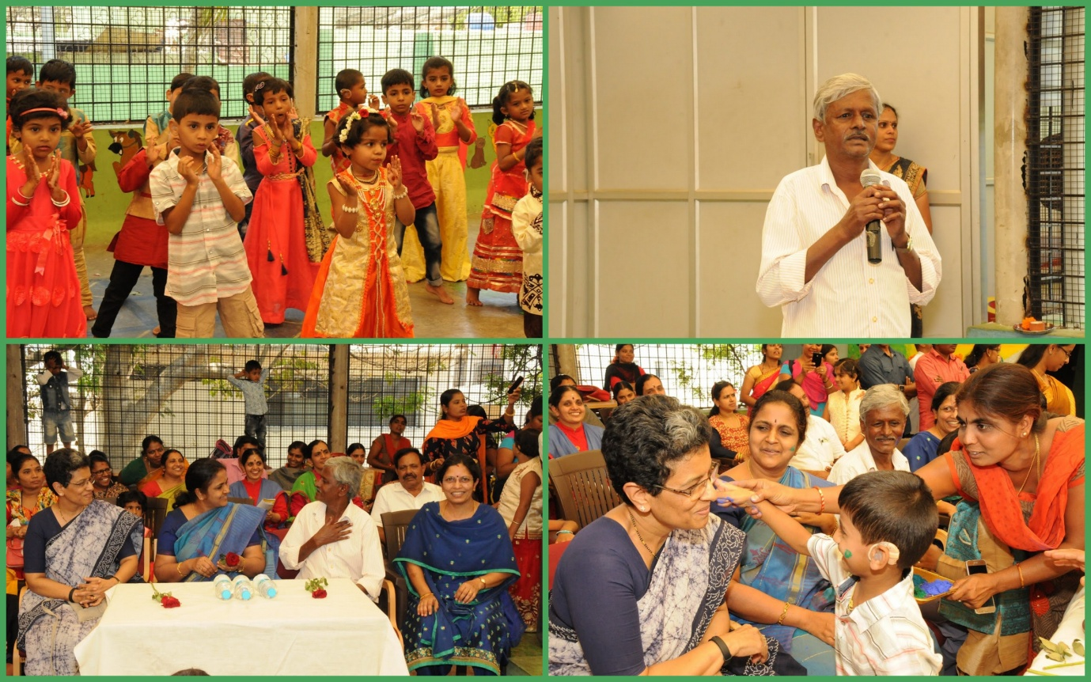

* + - 1. Press Releases and Media Coverage: NIL

**C) Material Development:** The following Teaching Learning Material and Prepare for training children with various communication disorders in preschool.

|  |  |  |  |
| --- | --- | --- | --- |
| **Sl.**  **No.** | **Nature of**  **Teaching-Learning**  **Materials** | **Skill** | **Number** |
| 1. | Flash cards | For all skill areas | 391 |
| 2. | Work Cards | For all skill areas | 247 |
| 3. | Charts | For all skill areas | 22 |
| 4. | PPT | For all skill areas | 31 |
| 5. | Models | For all skill areas | 5 |
| 6. | Sentence strips | For all skill areas | 225 |
| 7. | Story cards | For all skill areas | 150 |
| 7. | U-Safe | For all skill areas | 02 |
| 8. | Others | For all skill areas | -- |

1. **AWARDS AND HONORS RECEIVED BY FACULTY AND STAFF: NIL**
2. EXTRA CURRICULAR ACTIVITIES: Nil
   * + - 1. AIISH Gymkhana
3. **EMINENT VISITORS:** Nil

XI. **ANY OTHER**

* **OfficialLanguage Implementation:**
* Hindi Word a day
* No. of notings/letters (**March 2019**): Hindi: 67, English: 7

Sd/-

HOD- Special Education