**ALL INDIA INSTITUTE OF SPEECH AND HEARING, MYSURU - 6**

**अखिल भारतीय वाक श्रवण संस्थान, मैसूर-६**

**DEPARTMENT OF SPECIAL EDUCATION**

**विशेषशिक्षाविभाग**

**MONTHLY REPORT – February 2019**

1. **ACADEMIC ACTIVITIES**

**Faculty report**

**Therory classes (no. of hours)**

|  |  |  |  |
| --- | --- | --- | --- |
| 1. **SL Faculty name** | **DECSE-HI** | **B.Ed.Spl.Ed. (HI)** | **Total** |
| Dr.Alok Kumar Upadhyay | - | 17 | **17** |
| Dr.Prithi V | 13 | 15 | **28** |
| Dr.PalnatyVijetha | - | 25 | **25** |
| Dr. G. Malar | 4 | 26 | **30** |
| Ms. Lakshmi Prabha | 7 | 11 | **15** |

**Practical Classess (In Hours)**

|  |  |  |  |
| --- | --- | --- | --- |
| **Faculty** | **DECSE-HI** | **B.Ed.Spl.Ed. (HI)** | **Total** |
| Dr.Alok Kumar Upadhyay | - | 3 | **3** |
| Dr.Prithi V | 21 days of postings  (60 hours) | IV Semester: 1 day of supervision in school-St Francis School.  Five days of orientation cum demonstration of Early Developmental Checklist (10 hours) | **70** |
| Dr.PalnatyVijetha | **-** | Supervised One month (140 hours)\* | **140** |
| Dr. G. Malar | 15 | 16 | **31** |
| Ms. Lakshmi Prabha | 20 | 10 | **09** |

* \*Coordinated for B.Ed. Spl. Edn. (HI) II semester trainees postings in St. Francis School (mainstream school) for one month.

1. **AIISH Students in Other Institutes:**

Following are the details of special educational services rendered by II B.Ed.Spl.Ed. (HI) students during their field engagement in mainstream and special schools during IV semester of the programme:

|  |  |  |  |  |  |  |
| --- | --- | --- | --- | --- | --- | --- |
| **Sl. No** | **Nature & Name of Educational Institution** | **Level of Schooling** | **Type of Instruction** | **No. of Beneficiary Children** | | **No. of Sessions** |
| **Without Special Needs** | **With Special Needs** |
| 01. | Mainstream Schools   * Gangogthri Public School, Mysuru * Manasagangothri Higher Primary School, Mysuru * St. Francis School, Mysuru | Primary | Regular Instruction | 55 | 11 | 20 |
| Remedial Instruction | 76 | 3 | 355 |
| Higher Primary | Regular Instruction | 47 | 9 | 60 |
| Remedial Instruction | 17 | 2 | 17 |
| Secondary | Regular Instruction | 102 | 1 | 40 |
| Remedial Instruction | 13 | 1 | 17 |
| 02. | Special Schools   * Seventh Day Adventist School for Speech and Hearing Impaired, Kollegal * Smt. Puttveeramma Residential School for Deaf Girls, Mysuru | Higher Primary | Regular Classroom Instruction | --- | 20 | 54 |
| Secondary | Regular Classroom Instruction | --- | 94 | 166 |

B.Ed.Spl.Ed(HI) students field engagement in mainstream schools. (pictures)

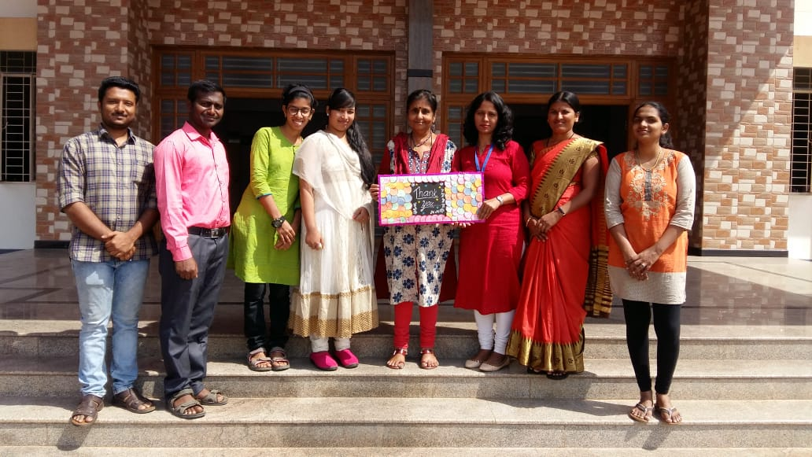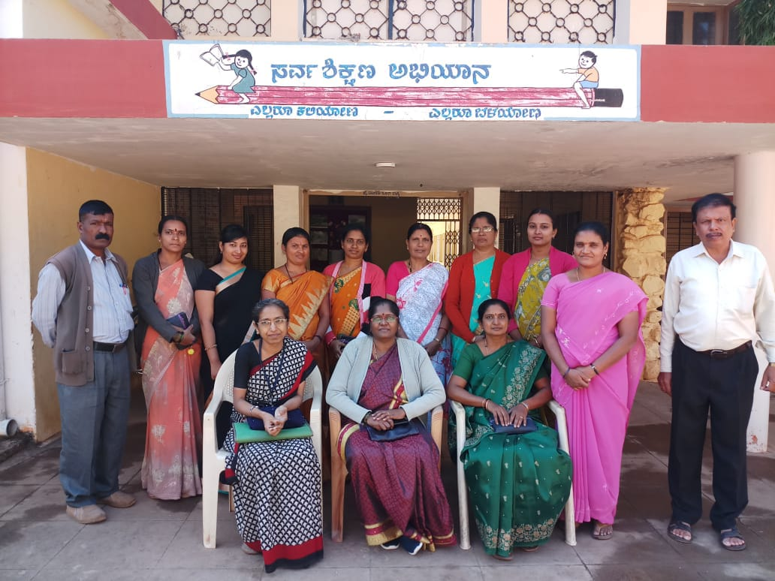

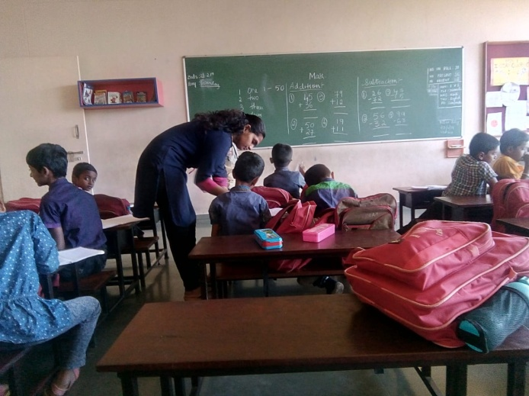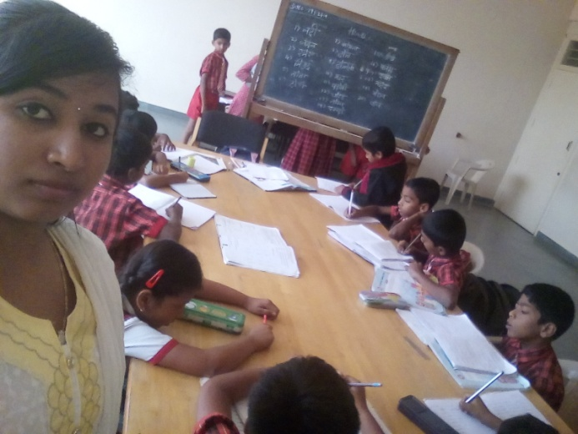

1. Educational Observation Postings of Students from other Institutes:

Following are the details of students posted for observation/ practice teaching

|  |  |  |  |  |
| --- | --- | --- | --- | --- |
| **Sl.No** | **Name of the Institute** | **Programme/Course** | **Number of Students** | **Dates** |
| **1** | S.S Institute of Medical science and Research Center, Davangere. | PG ENT students | 1 | 14.02.2019 |
| **2** | University of Agricultural Sciences, Dharwad | 4th year –Bachelor of Home Science (BHSc) students | 8 | 25.02.2019 to 13.03.2019 |

1. Seminars/Conferences/**Workshops**/Training Programs: 01

|  |  |
| --- | --- |
| **Theme/topic** | National Seminar-cum-Workshop on ‘Importance of Yoga in the Education of Children with Special Needs’ |
| **Coordinator/s** | Dr. Alok Kumar Upadhyay, Dr. Palnaty Vijetha , Ms. P.V.Ramanakumari, Ms. P.V.Manjula |
| **Resource Person** | Dr. Siva Prakash, Dr. P.V.Phanishree, Dr. Lakshmi, Mr. Ashoka, Ms. Devi, Mrs. Madhavi, Mr. Srichitta, Ms. Priyankari, Mr. Gopalakrishna, Ms. P.V.Ramanakumari, Ms. P.V.Manjula, Ms. C.Latha, Ms. Yogini Kaliji |
| **Objectives** | * + 1. To motivate teachers to use the techniques of yoga in training children with special needs.     2. To build up self-awareness and improve communicational, physical, intellectual and emotional well-being and health.     3. To equip teachers to build up focus and attentiveness of children with special needs in order to improve knowledge and accomplishment.     4. To encourage children in discovering pleasure and achievement in physical activities.     5. To assist in the conversion of yoga skills to education. |
| **Targeted Audience** | Special Educators, Allied Professionals, Mainstream school teachers |
| **Number of Participants** | 105 external + 30 internal |
| **Date/s** | 12th to 14th February 2019 |
| **Photo**  **C:\Users\SPL_Edu\Desktop\DSC_0788.JPG** | |

1. Staff Enrichment / **In-house training Programmes***(For own staff members)* : NIL

|  |  |  |  |  |  |
| --- | --- | --- | --- | --- | --- |
| **Theme/Topic** | **Resource Person** | **Coordinator** | **Objectives** | **Targeted Audience** | **Date** |
| Orientation about GeM | Dr. Palnaty Vijetha | Ms. Sreevidya M S | To empower staff of the department regarding Gem and it’s importance | 23 | 26th February 2019 |

1. Guest Lectures : NIL
2. Additional Academic Services rendered by the Faculty and Staff:
3. **Invited Talks:02**

|  |  |  |  |  |
| --- | --- | --- | --- | --- |
| **Sl. No.** | **Name, Designation, Institutional affiliation of Lecturer** | **Organized by Department/ Section/ Unit/ Organisation** | **Topic of Lecture** | **Date/s** |
|  | Dr. Palnaty Vijetha | Rotary Mysore Brindavan | Strategies to mainstream children with hearing impairment | 02.02.2019 |
|  | Dr G. Malar, Reader in Special Education, AIISH | PEaRL Programme organised by LD Clinic at DCS, AIISH | Recognition and remedy for learning disabilities at home | 20.02.19 |

1. **Resource person during interaction program:** NIL
2. **Curriculum Development (in progress):** 01

Dr G. Malar

* Assisted HOD–Special Education in preparing for revisions of B.Ed.Spl.Ed. (HI) syllabus in the process of submitting agenda for BOS- Special Education

.

1. **Development of Material to Support Learning:** NIL
2. **Service in Academic Bodies of other Organizations:**
3. **Dr Alok Kumar Upadhyay**

* Member, Board of Studies (BOS):
* RamkrishnaMission Vivekananda University, Coimbatore: Diploma, U.G & P.G
* N.G.B. University, Allahabad: for U.G & P.G
* J.R.H. University, Chitrakoot: for U.G & P.G
* Member, Board of Examiners (BOE) for UG Special Education of University of Mysore.

1. **Dr. G. Malar**

* Member, BOE–UG Special Education of University of Mysore.

1. **Dr. PrithiVenkatesh**

Member, BOE–UG Special Education of University of Mysore

1. **Dr. PalnatyVijetha**

Member, BOE–UG Special Education of University of Mysore

1. **Participation in Committees/Taskforce and Panels set up by other organizations/agencies**: NIL
2. **Any Others (Please Specify)**

**Parent enrichment programs (PEP): 01- This program aims to enrich knowledge of the caregivers of CWSN by experts from various fields.**

|  |  |  |  |  |
| --- | --- | --- | --- | --- |
| Theme/Topic | Coordinator | Objectives | Targeted Audience | Date |
| ‘**Cochlear Implants**’  Resource person: Dr. Manjula P, Professor in Audiology | Ms. Leena & Ms. Latha | To empower the parents/care givers of children with communication disorders I order to improve the quality of children with communication disorders | 79  parents/care givers | 19.02.19 |
| C:\Users\User\Pictures\Picasa\Collages\Photos3.jpg | | | | |

1. Research Projects (ARF)
2. **Completed – 01 no.**

|  |  |
| --- | --- |
| **Title** | Development and Evaluation of Indigenous Curriculum Oriented Computer Based Tutor for Concept Learning in Preschool Children with Special Needs. |
| **Objectives** | *Phase I:* To develop story boards for 6 concepts viz. My Family, My Body, Things we use, Animals and Birds, Food we eat and My Journey in Kannada.  *Phase II*: To develop indigenous computer based tutor for the 6 concepts based on the story board in Kannada and integrating it with the multimedia content and devising reinforcement mechanism.  *Phase III:* To evaluate the performance of the developed computer based tutor. |
| **Department** | Special Education |
| **Principal Investigator &**  **Co-Investigator** | *Principal Investigator* - Ms.P.V.Ramanakumari, Special Educator  *Co-Investigator* – Dr.Ajish K. Abraham, Professor in Electronics & Ms.P.V.Manjula, Special Educator |
| **Funding Agency** | AIISH |
| **Date of initiation of the project** | 18th January 2017 |
| **Amount** | Rs. 3,85,000/- |
| **Status** | * Data collection is completed. * Analysis to be done. * Report is yet to be submitted. |

1. **New Research Projects – 03 nos.**

**Project 1**

|  |  |
| --- | --- |
| **Title** | Efficacy of Developing Skills through Curricular Activities among Preschool Children with Hearing Impairment at AIISH |
| **Objectives** | To investigate the effectiveness of curricular activities in developing:   * Cognitive skills * Language Arts * Pre-academic skills (pre-reading, pre-writing, pre-arithmetic) among children with hearing impairment |
| **Department** | Special Education |
| **Principal Investigator &**  **Co-Investigator** | **Principal Investigator**  Dr.Alok Kumar Upadhyay  Associate Professor in Special Education  AIISH, Manasagangotri, Mysore: 570 006  **Co-Investigator**  Dr.PalnatyVijetha  Reader in special Education  AIISH, Manasagangothri, Mysore: 570 006 |
| **Funding Agency** | AIISH Research Fund (ARF) |
| **Date of initiation of the project** | 09.10.2018 (approval date) |
| **Amount** | Rs. 3,80,000/- |
| **Status** | Under Process of Initiation |

**Project 2**

|  |  |
| --- | --- |
| **Title** | Development of Grade Level Assessment Tools in Social Science (GLAT-SS) of Karnataka State Education Board. |
| **Objectives** | The Present study is being initiated with the aim to develop and standardize Grade Level Assessment Tool in Social Sciences (GLAT-SS) at GRADE VI of Karnataka State Education Board in English and Kannada. |
| **Department** | Special Education |
| **Principal Investigator &**  **Co-Investigator** | **Principal Investigator**  Dr.PalnatyVijetha  Reader in special Education  AIISH, Manasagangothri, Mysore: 570 006  **Co-Investigators**   1. Dr.Alok Kumar Upadhyay   Associate Professor in Special Education  AIISH, Manasagangotri, Mysore: 570 006   1. Ms.Lakshmi Prabha J.K.   Lecturer in Special Education  AIISH, Manasagangotri, Mysore: 570 006 |
| **Funding Agency** | AIISH Research Fund (ARF) |
| **Date of initiation of the project** | 09.10.2018 (approval date) |
| **Amount** | Rs. 3,85,000/- |
| **Status** | Under Process of Initiation |

**Project 3**

|  |  |
| --- | --- |
| **Title** | Development of grade level Assessment test in Science for Upper Primary School Children (VI-VIII) |
| **Objectives** | The aim of the study is to develop grade level assessment test for upper primary school children (VI-VIII) in science subject.  The study will be taken up with the following objectives in mind:   1. To develop grade level assessment test in Science for upper primary school children (VI-VIII) 2. To verify the reliability and validity of the test 3. To establish the norms for the test 4. To test its applicability with learners with hearing impairment 5. To compare the performance of the learners with hearing impairment on the test. |
| **Department** | Department of Special Education |
| **Principal Investigator &**  **Co-Investigator** | Dr.PrithiVenkatesh  Reader in special Education  AIISH, Manasagangothri, Mysore: 570 006 |
| **Funding Agency** | AIISH Research Fund (ARF) |
| **Date of initiation of the project** | 09.10.2018 |
| **Amount** | Rs.4,00,000/- |
| **Status** | Yet to Initiate the project, recruitment of the staff under progress. |

1. **Ongoing Research Projects - 01**

**Title**: Effect of Resource Material on Impact of Inclusive Education in Children with Intellectual Disabilities (ID) and Learning Disabilities (LD)

Investigators: Dr. G. Malar, Ms. S. Prathima & Mr. D. Gururaj

Duration: 12 months from January 2017

Budget: Rs. 3,85,000/-

Progress: Project recommenced with reappointment of research assistant in December 2018 for two months period till mid 11th February, 2019. Completed field intervention and post-intervention data collection. In the process of analysing data and compiling report.

1. Postgraduate Research Completed: NA
2. C. Postgraduate Research ongoing: NA
3. D**. Research Papers presented at National/International Conferences/Seminars: 01**

Raksha Anand, K Anjana & Subalakshmi (2019). *“Evidence based research in Developing Social Skill in Children with Down’s syndrome–A Case Study”*. Presented at National Conference on Inclusive Rehabilitation: Converging Mental Health & Special Education Needs’ held on 25th & 26th Feb 2019 at the IIC, New Delhi.

K Anjana, B N Shobha & Kadambari N (2019). *Impact of Cross Disability Approach in Enhancing the life skills in children with autism spectrum disorder - A Case Study*. Presented at National Conference on Inclusive Rehabilitation: Converging Mental Health & Special Education Needs’ held on 25th & 26th Feb 2019 at the IIC, New Delhi.

ii) Abstracts published in Conference / Seminar Proceedings**: NIL**

F. Books published (in APA format)

1. *Books published: NIL*

* *Books in press:*

G.**Book chapters published (in APA format): 01**

Malar, G., Antony, F., & Krishan, S. (2019 – reprint with revisions). *Readiness checklist for post-school transition: For screening adolescents with hearing impairment*. Mysuru, India: AIISH. (in press)

H. Books/Manuals/Seminar Proceedings edited: NIL

1. Journal Editorship: NIL

J. **Scholarly Reviewing Activities:**

G. Malar

* Review and validation of research proposal and tools of Ph.D research of Som Krishan titled *Addressing barriers toward implementing UDL in higher education in India* in Ramakrishna Mission Vivekananda Educational and Research Institute (Deemed University), Coimbatore, Tamil Nadu.
* Rating of video material on gesture corpus of nouns, verbs and functional phrases for Ms. C. Anusha and Ms. Safa Shaik’s M.Sc. (SLP) dissertation at AIISH, Mysuru.

1. Special Educational Services Offered through Teacher Trainees Outside Campus: NIL

**III CLINICAL/EDUCATIONAL SERVICES**

1. General Clinical Services: **Not Applicable**
2. Specialized Clinical/ Educational Services
3. **Pre-school Training and Special Education**

**Educational services for children with special needs**

|  |  |  |  |  |  |  |  |  |  |  |  |  |
| --- | --- | --- | --- | --- | --- | --- | --- | --- | --- | --- | --- | --- |
| **S. No.** | **Nature of Services (In charge staff)** | | | | | | | | | | | |
| 1. Special Educational Assessment Unit (SEA-U) | | | | | | | | | | | | |
|  |  | Nature of Special Need  Language | ASD / PDD NOS | Hearing Loss | Intellectual Disability | Learning Disability | Motor Problems | Multiple Disabilities | Others | No. of Clients | No. of Sessions | ***Total No. of Sessions*** |
| 1. | Screening & Referral | Kannada | 1 | 8 | 2 | 2 | 1 | 3 | 3 | ***20*** | ***20*** | ***52*** |
| Malayalam | 1 | 4 | 9 | 0 | 0 | 8 | 2 | ***24*** | ***24*** |
| Hindi | 0 | 2 | 1 | 0 | 0 | 0 | 1 | ***4*** | ***4*** |
| Urdu | 0 | 0 | 0 | 0 | 0 | 0 | 0 | ***0*** | ***0*** |
| English | 0 | 0 | 2 | 0 | 0 | 1 | 0 | ***3*** | ***3*** |
| Telugu | 0 | 0 | 0 | 0 | 0 | 0 | 0 | ***0*** | ***0*** |
| Tamil | 0 | 0 | 0 | 0 | 0 | 1 | 0 | ***1*** | ***1*** |
| Any Other | 0 | 0 | 0 | 0 | 0 | 0 | 0 | ***0*** | ***0*** |
| ***Total No. of Clients*** | ***2*** | ***14*** | ***14*** | ***2*** | ***1*** | ***13*** | ***6*** | ***52*** | ***52*** |
| 2. | Assessment & Report | Kannada | 0 | 1 | 1 | 0 | 0 | 1 | 0 | ***3*** | ***8*** | ***19*** |
| Malayalam | 0 | 0 | 0 | 0 | 0 | 0 | 0 | ***0*** | ***0*** |
| Hindi | 0 | 0 | 0 | 0 | 0 | 0 | 0 | ***0*** | ***0*** |
| Urdu | 0 | 0 | 0 | 0 | 0 | 0 | 0 | ***0*** | ***0*** |
| English | 0 | 0 | 2 | 0 | 0 | 0 | 0 | ***2*** | ***11*** |
| Telugu | 0 | 0 | 0 | 0 | 0 | 0 | 0 | ***0*** | ***0*** |
| Tamil | 0 | 0 | 0 | 0 | 0 | 0 | 0 | ***0*** | ***0*** |
| Any Other | 0 | 0 | 0 | 0 | 0 | 0 | 0 | ***0*** | ***0*** |
| ***Total No. of Clients*** | ***0*** | ***1*** | ***3*** | ***0*** | ***0*** | ***1*** | ***0*** | ***5*** | ***19*** |
| Places from which seen: (1)Karnataka: 24 (2)Kerala: 25 (3)AP: Nil (4)Telangana: Nil (5)TN: 02 (6)Other Parts of India: 01(Uttaranchal) (7)Any other: Nil | | | | | | | | | | | |
| Age groups seen:(1)Birth to 2.5yrs: 07 (2)2.5+ to 6 yrs: 25 (3)6yrs+ to 16 years: 19 (4)16yrs+: 01 | | | | | | | | | | | |
| Total No. of Referrals: (1)Educational Assessment: 07 (2)Educational Guidance: 02 (3)PIP: 09 (4)PPEP/ PBC/ GECS: 30 (5)CSS/IEP/NFE/DET: 08 (6)Any Other Services at AIISH: Nil (7)Any Other Services Outside AIISH: Nil | | | | | | | | | | | |
| No. of Reports Issued/Ready for Issue: (1) School Readiness: Nil (3) Curriculum-Based Assessment: 05 (4) Post-School: Nil | | | | | | | | | | | |

|  |
| --- |
| **Pre-school Training: Preparatory programme for schooling providing training in self-help, cognitive, language and (pre) academic skills, Preschool Supplementary Services (PSS)** |
| |  |  |  |  | | --- | --- | --- | --- | | **Language & Disability** | **No. of Groups** | **No. of Children** | | |  |  | MALE | FEMALE | | Kannada ASD & ID &MD | 15 | 46 | 26 | | Kannada HL | 8 | 37 | 24 | | Malayalam HL | 1 | 3 | 3 | | Malayalam ASD & ID & MD | 9 | 26 | 15 | | Hindi HL | 2 | 12 | 4 | | Hindi MD & ID & ASD | 2 | 9 | 0 | | English ID, ASD | 1 | 1 | 3 | | Telugu ASD & ID & MD& HL | 1 | 5 | 3 | | TOTAL Number of children |  | **139** | **78** | | **TOTAL No. Groups** | **39** | **217** | | | **Sessions** | **3120 ( Group-wise)** | | | |

|  |  |  |  |  |  |
| --- | --- | --- | --- | --- | --- |
| **Curricular Support Services – Supportive training to augment education in mainstream school/ other educational programmes** | **Language** | **No. of children with HL** | **No. of children with ID/CP/ASD/MD/LD/DD** | **Total No. of clients** | **No. Of sessions** |
| Kannada | 6 | 12 | 18 | 86 |
| Malayalam | 1 | - | 1 | 5 |
| Hindi | - | - | - | - |
| English | 1 | 9 | 10 | 38 |
| Telugu | - | 2 | 2 | 10 |
| Tamil | - | 1 | 1 | 6 |
| Total | | | | **32** | **145** |
| |  |  |  |  |  |  | | --- | --- | --- | --- | --- | --- | | **Individualised Educational Programme (IEP) – Training in functional academics for out of school individuals** | **Language** | **No. of children with HL** | **No. of children with ID/CP/ASD/MD/LD/DD** | **Total No. of clients** | **No. Of sessions** | | Kannada | 1 | 5 | 6 | 21 | | Malayalam | 1 | 4 | 5 | 13 | | Hindi | 1 | 1 | 2 | 16 | | English |  | - | - | - | | Telugu | 1 | - | 1 | - | | Tamil | - | - | - | - | | Total | | | **14** | **82** | | | | | | |
| |  |  |  |  |  |  | | --- | --- | --- | --- | --- | --- | | **Demonstration Educational Training – Short-term demonstration to caregivers in any of the above** | **Language** | **No. of children with HL** | **No. of children with ID/CP/ASD/MD/LD/DD** | **Total No. of clients** | **No. Of sessions** | | Kannada | 1 | 1 | 2 | 9 | | Malayalam | - | - | - | - | | Hindi | - | - | - | - | | English | - | 1 | 1 | 6 | | Telugu | - | - | - | - | | Tamil | - | - | - | - | | **Total** | - | - | **3** | **15** | | | | | | |
| **Total clients: 49**  **Old clients:- 47**  **New clients:- 02**  **Discharged (DET):-NIL**  **Discharged (CSS):- NIL**  **Discharged (IEP):- NIL**  **Discontinued (DET):- NIL**  **Discontinued (CSS):- NIL**  **Discontinued (IEP):- NIL** | | | | | |

|  |  |  |  |  |  |  |  |  |  |  |  |
| --- | --- | --- | --- | --- | --- | --- | --- | --- | --- | --- | --- |
| **Pre-school Parent Empowerment Programme – PPEP** | | | | | | | | | | | |
|  | **Language** | **HL** | **ID** | **CP** | **ASD** | **MD** | **LD** | **DD** | **SLD** | **VI** | **Total No. of clients** | **Group** | **No. Of sessions** |
| Kannada | 34 | 27 | 2 | 13 | 7 | - | 4 | 1 | -- | 88 | 11 | 242 |
| Malayalam | 18 | 21 | 2 | 5 | 3 | -- | 8 | -- | -- | 57 | 5 | 110 |
| Hindi | 6 | 5 | -- | 1 | -- | -- | 1 | -- | -- | 13 | 2 | 44 |
| English | -- | 1 | -- | 1 | 1 | -- | -- | -- | -- | 3 | 1 | 22 |
| Telugu | 2 | 2 | -- | 2 | -- | -- | -- | -- | -- | 6 | 1 | 22 |
| Tamil | 2 | 1 | -- | 3 | -- | -- | -- | -- | -- | 6 | 1 | 22 |
| **Total** | | | | | | | | | | **173** | | **21** | **462** |
| No. of clients promoted to the next higher level(Preschool) of service: NIL  No. Of discharged :NIL  No. Of discontinued: 08  No. Of New clients (Feb) : 29  Shifted from PPEP to PIP: NIL | | | | | | | | | | | | | |

|  |  |  |  |  |  |
| --- | --- | --- | --- | --- | --- |
| **Parent-Infant Programme – PIP(Birth to 2 ½ years) February 2019** | | | | | |
| Parent-Infant Programme | **Language** | **HL** | **ID/CP/ASD/MD/LD/DD** | **Total No. of clients** | **Total No. Of sessions** |
| Kannada | 16 | 11 | 27 | 87 |
| Malayalam | 12 | 15 | 27 | 71 |
| Hindi | 01 | 02 | 03 | 03 |
| English | -- | 01 | 01 | 06 |
| Telugu | -- | -- | -- |  |
| Tamil | 01 | 01 | 02 | 02 |
|  | **Total** | | | **60** | **169** |
| No. of Old clients :51  No. of New clients enrolled: 09  Total clients:60  No. discharged :02  No. discontinued:02  No. of Promoted to next level:07  No. of Remaining:49 | | | | | |

|  |  |  |
| --- | --- | --- |
| **Library of Books & Toys** – LiBoToy  Services issuing educational toys & books for home-based training. | Total number of members enrolled: 235  No. of new members: 09  Amount: Rs. 450/-  Total number of sessions: 22 | |
| **Age group** | **Total number** |
| 0 - 2.6 yrs | 10 |
| 2.6 - 4 yrs | 77 |
| 4.0 - 6 yrs | 140 |
| 6 yrs and above | 8 |

|  |  |  |
| --- | --- | --- |
| **Services** | **Number of Clients** | **Number of Sessions** |
| Co-Curricular Training | 217 | 20 |

**Supports for Empowering Caregivers**

|  |  |  |  |
| --- | --- | --- | --- |
| **Name of Training Unit** | **No. of Parent**  **Beneficiaries** | **No. of Sessions** | **Content of Training** |
| Caregiver Computer Training Unit | 85 | 42 | Drawing in paint, Typing |
| Caregiver Literacy Training Unit | -- | -- | -- |

1. Support Services to Clients and Family
2. **Counselling and guidance**

|  |  |
| --- | --- |
| No. of Clients | Sessions |
| 215 | 86 |

1. **U-SAFE**

|  |  |
| --- | --- |
| No. of Clients | Sessions |
| 86 | 12 |

1. **SUMERU**

|  |  |
| --- | --- |
| No. of Clients | Sessions |
| 15 | 10 |

1. Details of Certificates Issued: NIL
2. Financial Aid- NIL
3. Legal advice - NIL
4. Any other(Please Specify):

**Attended workshop/Seminar/Orientation program in AIISH institute 2018-19: NIL**

|  |  |  |
| --- | --- | --- |
| **Name of Staff** | **Attended to workshop title name** | **Date** |
| Dr. Palnaty Vijetha | ISO GFR & GEM Training program | 08.02.2019 |

**Attended workshop/Seminar/Orientation program in Outside institute 2018-19: NIL**

|  |  |  |
| --- | --- | --- |
| **Name of Staff** | **Attended to workshop title name** | **Date** |

EXTENSION ACTIVITIES

1. **Public Lecture Series: 02**

|  |  |  |  |  |
| --- | --- | --- | --- | --- |
| **Sl. No.** | **Name, Designation, Institutional affiliation of Lecturer** | **Organized by Department/ Section/ Unit/ Organisation** | **Topic of Lecture** | **Date/s** |
|  | Ms. Lakshmi Prabha | AIISH (Monthly Public lecture Series) | “Institutional Activities” | 27th February 2019 |
|  | Ms. P.V.Ramanakumari | AIISH (Monthly Public lecture Series) | Communication Disorders and educational needs of children with communication disorders | 27th February 2019 |

* + - 1. TECHNLOGICAL CONSULTANCY SERVICES: NIL
      2. CENTRAL FACILITIES
      3. Library and Information Services
      4. Public Information Activities

**Orientation Programs (For outsiders):** The following orientation programs were conducted to orient about the activities of the department and also to provide knowledge about the educational facilities and welfare measures for children with special needs. : **06**

|  |  |  |  |  |
| --- | --- | --- | --- | --- |
| **SL No.** | **Coordinator** | **Targeted Audience** | **Number**  **of Participants** | **Date** |
| 1 | Dr.Prithi Venkatesh | B.Sc Students of Little flower Institute of Social Science & Health | 47 students + 1 Faculty | 08.02.2019 |
| 2 | Dr.Prithi Venkatesh | B.A.SLP Students of Pratibandhi Kalyan Kendra | 10 + 1 | 15.02.2019 |
| 3 | Dr. Malar G & Ms.Lakshmi Prabha J.K | 1st year B.Ed students, S.M.Lingappa College of Education , K.R Pet | 4 | 04.02.2019 |
| 4 | Ms.Lakshmi Prabha J.K | 2nd year B.Ed students and faculty ,Regional Institute of Education, Mysore | 22 + 4 | 13.02.2019 |
| 5 | Ms.Lakshmi Prabha J.K | 2nd year B.Ed students, RVTC, Bangalore | 3 | 15.02.2019 |
| 6 | Ms.Lakshmi Prabha J.K | B.Ed Students, College of teacher education, Vasanth, Mysore | 95 | 27.02.2019 |
| 7 | G. Malar & B. N. Shobha | B.Ed. students & Faculty from JSS B.Ed. College, Sakleshpur, Hassan District, Karnataka | 64 | 20.02.19 |

* + - 1. Major Events of the Year with a brief account: NIL
      2. Press Releases and Media Coverage:

**C) Material Development :**The following Teaching Learning Material and Prepare for training children with various communication disorders in preschool.

|  |  |  |  |
| --- | --- | --- | --- |
| **Sl.**  **No.** | **Nature of**  **Teaching-Learning**  **Materials** | **Skill** | **Number** |
| 1. | Flash cards | For all skill areas | 61 |
| 2. | Work Cards | For all skill areas | 80 |
| 3. | Charts | For all skill areas | 34 |
| 4. | PPT | For all skill areas | 167 |
| 5. | Models | For all skill areas | 51 |
| 6. | Sentence strips | For all skill areas | 41 |
| 7. | Story cards | For all skill areas | 69 |
| 7. | U-Safe | For all skill areas | 02 |
| 8. | Others | For all skill areas | -- |

1. **AWARDS AND HONORS RECEIVED BY FACULTY AND STAFF: NIL**

EXTRA CURRICULAR ACTIVITIES: Nil

* + - * 1. AIISH Gymkhana

1. **EMINENT VISITORS:** Nil

XI. **ANY OTHER**

* **Official Language Implementation:**
* Hindi Word a day
* No. of notings/letters (**February 2019**): Hindi: 55, English: 12

Sd/-

HOD- Special Education