**ALL INDIA INSTITUTE OF SPEECH AND HEARING, MYSURU - 6**

**अखिल भारतीय वाक श्रवण संस्थान, मैसूर-६**

**DEPARTMENT OF SPECIAL EDUCATION**

**विशेषशिक्षाविभाग**

**MONTHLY REPORT – January 2019**

1. **ACADEMIC ACTIVITIES**

**Faculty report**

**Therory classes (no. of hours)**

|  |  |  |  |
| --- | --- | --- | --- |
| 1. **SL Faculty name** | **DECSE-HI** | **B.Ed.Spl.Ed. (HI)** | **Total** |
| Dr.Alok Kumar Upadhyay | - | 30 | **30** |
| Dr.Prithi V | 0 | 14 | **14** |
| Dr.PalnatyVijetha | - | 32 | **32** |
| Dr. G. Malar | - | 29 | **29** |
| Ms. Lakshmi Prabha | -- | 15 | **15** |

**Practical Classess (In Hours)**

|  |  |  |  |
| --- | --- | --- | --- |
| **Faculty** | **DECSE-HI** | **B.Ed.Spl.Ed. (HI)** | **Total** |
| Dr.Alok Kumar Upadhyay | - | 6 | **6** |
| Dr.Prithi V | **-** | 1 day of supervision in school-Outside postings-Visited to Kollegal , since students were posted their for practice teaching. | **8** |
| Dr.PalnatyVijetha | **-** | 15 | **15** |
| Dr. G. Malar | - | 48 | **48** |
| Ms. Lakshmi Prabha | - | 09 | **09** |

1. Educational Observation Postings of Students from other Institutes:

Following are the details of students posted for observation/ practice teaching

|  |  |  |  |  |
| --- | --- | --- | --- | --- |
| **Sl.No** | **Name of the Institute** | **Programme/Course** | **Number of Students** | **Dates** |
|  | St. Philomena’s College, Mysuru | II year B.A. Psychology | 1 | 21.12.2018 to  10. 01. 2019 |
|  | National Institute for the Empowerment of Persons with Intellectual Disabilities (Divyangjan) | I year M.Phil | 3 | 16.01.2019 |
|  | St.Joseph’s College of Education | I years B.Ed | 2 | 18.01.0219 |

1. Seminars/Conferences/**Workshops**/Training Programs: 01

|  |  |
| --- | --- |
| **Theme/topic** | Regional Seminar on ‘Employment and Vocational Training: Epitome of Rehabilitation of Persons with Communication Disorders’ |
| **Coordinator/s** | Prof. P. Manjula, Dr. Prithi Venkatesh, Dr. G. Malar, Ms. J. K. Lakshmi Prabha & Mr. Rajkumar |
| **Resource Person** | 10 external & 5 internal |
| **Objectives** | * Creating awareness among participants about the practical problems encountered in rehabilitating persons with diverse communication disorders due to– autism spectrum disorders, hearing impairment, intellectual disability and neuromotor problems. * Developing practical knowledge necessary for organising gainful vocational rehabilitation for persons with diverse communication disorders. * Providing useful information about facilities and opportunities available for vocational rehabilitation of persons with diverse communication disorders. |
| **Targeted Audience** | Special educators & other rehabilitators for communication disorders |
| **Number of Participants** | 107 |
| **Date/s** | 10 & 11.01.2019 |
| DSC_9093**Photo** | |

1. Staff Enrichment / **In-house training Programmes***(For own staff members)* : NIL

|  |  |  |  |  |  |
| --- | --- | --- | --- | --- | --- |
| **Theme/Topic** | **Resource Person** | **Coordinator** | **Objectives** | **Targeted Audience** | **Date** |

1. Guest Lectures : NIL
2. Additional Academic Services rendered by the Faculty and Staff:
3. **Invited Talks:05**

|  |  |  |  |  |
| --- | --- | --- | --- | --- |
| **Sl. No.** | **Name, Designation, Institutional affiliation of Lecturer** | **Organized by Department/ Section/ Unit/ Organisation** | **Topic of Lecture** | **Date/s** |
|  | Dr G. Malar, Reader in Special Education, AIISH | National workshop on ‘Multidisciplinary Team-based Assessment and Classroom Management of LLD’ organised by Department of Speech-Language Pathology & LD Clinic | 1. Special Education Management of Children with Language Learning Disability | 09.01.19 |
|  | Dr G. Malar, Reader in Special Education, AIISH | NITTE- Education and Empowerment for Everyone (Ni-EEE); Empowering Special Educators Dealing with Learning Disability (SPELD-2019) organised by NITTE Institute of Speech and Hearing, Mangaluru, Karnataka | 1. Assessment of Specific Learning Disability by Special Educators  2. Special Educators in the Intervention of Specific Learning Disability  3. Human Resource Development, Capacity Building & Vocational Rehabilitation | 23.01.19 |
|  | Dr. Alok kumar Upadhyay,  Associate Professor,AIISH,Mysuru | National Convention of Educators of the Deaf, India –Chennai Chapter  &  Satyabhama (Deemed to be University) Institute, Chennai  Organized National Conference on  Enhancing Quality of education of Students with Hearing Impairment-Needs & Practices | Innovation, best Practices, Success Stories & case studies with respect to Education of Children with Hearing Impairment | 29.01.2019 |

1. **Resource person during interaction program:** NIL
2. **Curriculum Development (in progress):** 01

Dr G. Malar

* Assisted HOD–Special Education in preparing for revisions of B.Ed.Spl.Ed. (HI) syllabus in the process of submitting agenda for BOS- Special Education

.

1. **Development of Material to Support Learning:** NIL
2. **Service in Academic Bodies of other Organizations:**
3. **Dr Alok Kumar Upadhyay**

* Member, Board of Studies (BOS):
* RamkrishnaMission Vivekananda University, Coimbatore: Diploma, U.G & P.G
* N.G.B. University, Allahabad: for U.G & P.G
* J.R.H. University, Chitrakoot: for U.G & P.G
* Member, Board of Examiners (BOE) for UG Special Education of University of Mysore.

1. **Dr. G. Malar**

* Member, BOE–UG Special Education of University of Mysore.

1. **Dr. PrithiVenkatesh**

Member, BOE–UG Special Education of University of Mysore

1. **Dr. PalnatyVijetha**

Member, BOE–UG Special Education of University of Mysore

1. **Participation in Committees/Taskforce and Panels set up by other organizations/agencies**: NIL
2. **Any Others (Please Specify)**

**Parent Help Parents Program (PHPP): 1**

|  |  |
| --- | --- |
| Name of the faculty/ staff | Mrs. Suma B.S, Mother of Ms. Spoorthi.B.S, (HI) |
| Name/Topic of the Program | Parents help parents programme (PHPP) for Parents of children |
| Coordinator | Ms.Leena C C , Ms.Latha C |
| Objectives | * To help instil confidence in the parents/caregivers handling their child. * To train the parents in managing their stress levels while dealing with their child. * To motivate the parents for working more efficiently with their child. * To empower the parents regarding different aspects of training |
| Organized by Department/Section/Unit | Department of Special Education |
| Targeted Audience | Parents of Special Children |
| Date | 11.01.2019 |
| No.of beneficiaries | 71 |
| C:\Users\User\Desktop\PHPP 11.01.2019\Photos\Photos2.jpg | |

1. Research Projects (ARF)
2. **Completed – 01 no.**

|  |  |
| --- | --- |
| **Title** | Development and Evaluation of Indigenous Curriculum Oriented Computer Based Tutor for Concept Learning in Preschool Children with Special Needs. |
| **Objectives** | *Phase I:* To develop story boards for 6 concepts viz. My Family, My Body, Things we use, Animals and Birds, Food we eat and My Journey in Kannada.  *Phase II*: To develop indigenous computer based tutor for the 6 concepts based on the story board in Kannada and integrating it with the multimedia content and devising reinforcement mechanism.  *Phase III:* To evaluate the performance of the developed computer based tutor. |
| **Department** | Special Education |
| **Principal Investigator &**  **Co-Investigator** | *Principal Investigator* - Ms.P.V.Ramanakumari, Special Educator  *Co-Investigator* – Dr.Ajish K. Abraham, Professor in Electronics & Ms.P.V.Manjula, Special Educator |
| **Funding Agency** | AIISH |
| **Date of initiation of the project** | 18th January 2017 |
| **Amount** | Rs. 3,85,000/- |
| **Status** | * Data collection is completed. * Analysis to be done. * Report is yet to be submitted. |

1. **New Research Projects – 03 nos.**

**Project 1**

|  |  |
| --- | --- |
| **Title** | Efficacy of Developing Skills through Curricular Activities among Preschool Children with Hearing Impairment at AIISH |
| **Objectives** | To investigate the effectiveness of curricular activities in developing:   * Cognitive skills * Language Arts * Pre-academic skills (pre-reading, pre-writing, pre-arithmetic) among children with hearing impairment |
| **Department** | Special Education |
| **Principal Investigator &**  **Co-Investigator** | **Principal Investigator**  Dr.Alok Kumar Upadhyay  Associate Professor in Special Education  AIISH, Manasagangotri, Mysore: 570 006  **Co-Investigator**  Dr.PalnatyVijetha  Reader in special Education  AIISH, Manasagangothri, Mysore: 570 006 |
| **Funding Agency** | AIISH Research Fund (ARF) |
| **Date of initiation of the project** | 09.10.2018 (approval date) |
| **Amount** | Rs. 3,80,000/- |
| **Status** | Under Process of Initiation |

**Project 2**

|  |  |
| --- | --- |
| **Title** | Development of Grade Level Assessment Tools in Social Science (GLAT-SS) of Karnataka State Education Board. |
| **Objectives** | The Present study is being initiated with the aim to develop and standardize Grade Level Assessment Tool in Social Sciences (GLAT-SS) at GRADE VI of Karnataka State Education Board in English and Kannada. |
| **Department** | Special Education |
| **Principal Investigator &**  **Co-Investigator** | **Principal Investigator**  Dr.PalnatyVijetha  Reader in special Education  AIISH, Manasagangothri, Mysore: 570 006  **Co-Investigators**   1. Dr.Alok Kumar Upadhyay   Associate Professor in Special Education  AIISH, Manasagangotri, Mysore: 570 006   1. Ms.Lakshmi Prabha J.K.   Lecturer in Special Education  AIISH, Manasagangotri, Mysore: 570 006 |
| **Funding Agency** | AIISH Research Fund (ARF) |
| **Date of initiation of the project** | 09.10.2018 (approval date) |
| **Amount** | Rs. 3,85,000/- |
| **Status** | Under Process of Initiation |

**Project 3**

|  |  |
| --- | --- |
| **Title** | Development of grade level Assessment test in Science for Upper Primary School Children (VI-VIII) |
| **Objectives** | The aim of the study is to develop grade level assessment test for upper primary school children (VI-VIII) in science subject.  The study will be taken up with the following objectives in mind:   1. To develop grade level assessment test in Science for upper primary school children (VI-VIII) 2. To verify the reliability and validity of the test 3. To establish the norms for the test 4. To test its applicability with learners with hearing impairment 5. To compare the performance of the learners with hearing impairment on the test. |
| **Department** | Department of Special Education |
| **Principal Investigator &**  **Co-Investigator** | Dr.PrithiVenkatesh  Reader in special Education  AIISH, Manasagangothri, Mysore: 570 006 |
| **Funding Agency** | AIISH Research Fund (ARF) |
| **Date of initiation of the project** | 09.10.2018 |
| **Amount** | Rs.4,00,000/- |
| **Status** | Yet to Initiate the project, recruitment of the staff under progress. |

1. **Ongoing Research Projects - 01**

**Title**: Effect of Resource Material on Impact of Inclusive Education in Children with Intellectual Disabilities (ID) and Learning Disabilities (LD)

Investigators: Dr. G. Malar, Ms. S. Prathima & Mr. D. Gururaj

Duration: 12 months from January 2017

Budget: Rs. 3,85,000/-

Progress: Project recommenced with reappointment of research assistance in December 2018. Translation of tools into Kannada completed. And video recording of practical demonstrations in progress. Commenced second round of data collection in two schools serving as control fields.

1. Postgraduate Research Completed: NA
2. C. Postgraduate Research ongoing: NA
3. D**.** Research Papers presented at National/International Conferences/Seminars: 05

Prithi, V., & Dhivya D. (2019). *Ensuring Quality Assurance in Vocational and Technical Education*. Presented at 84th NCED- India Annual National Conference on Enhancing Quality of Education of Students with Hearing Impairment – Needs & Practices on 29th January 2019 held at Chennai, Tamil Nadu, 28thto 30th January, 2019.

Prithi, V., & Subramanya K R. (2019). *Strategies for Ensuring Quality Assurance in Vocational and Technical Education*. Poster Presented at 84th NCED- India Annual National Conference on Enhancing Quality of Education of Students with Hearing Impairment – Needs & Practices on 29th January 2019 held at Chennai, Tamil Nadu, 28thto 30th January, 2019.

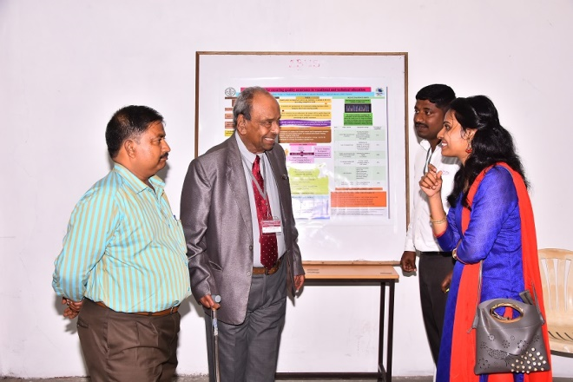

Manjula, P.V., & Ramanakumari, P.V. (2019). *Yoga Augments Holistic Development of Preschool Children with Hearing Impairment*. Presented at 84th NCED- India Annual National Conference on Enhancing Quality of Education of Students with Hearing Impairment – Needs & Practices on 29th January 2019 held at Chennai, Tamil Nadu, 28thto 30th January, 2019.

*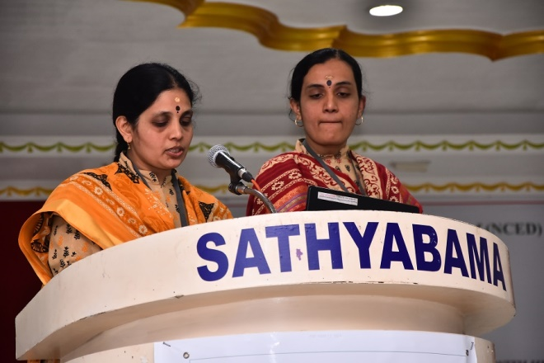*

Ramanakumari, P.V., & Manjula, P.V. (2019). *Effectiveness of developed computer based tutor for concept learning in preschool children with hearing impairment*. Presented at 84th NCED- India Annual National Conference on Enhancing Quality of Education of Students with Hearing Impairment – Needs & Practices on 30th January 2019 held at Chennai, Tamil Nadu, 28thto 30th January, 2019.

Lakshmi Prabha J.K., & Palnaty Vijetha. (2019). *Teachers Knowledge about Hearing Impairment & Referral Services in Mysore.* Presented at 84th NCED- India Annual National Conference on Enhancing Quality of Education of Students with Hearing Impairment – Needs & Practices on 30th January 2019 held at Chennai, Tamil Nadu, 28thto 30th January, 2019.

**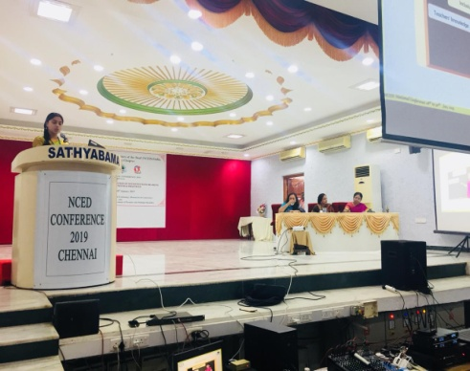**

E. Research Papers Published

i) Papers published in National / International Journals: 01

Vijetha, P. , Malar, G., Rajkumar, & Leelarani, S.B.(2018).  Effectiveness of Adapted Social studies lessons in influencing better learning in children with hearing impairment.  *National Journal of Education, XIII(2).*78-88. ISSN 09729569.

ii) Abstracts published in Conference / Seminar Proceedings**: Scanned books**

|  |  |
| --- | --- |
| **C:\Users\User\Desktop\January report 2019\NCED\20190131150412336_0001.jpg** | |
| **C:\Users\User\Desktop\January report 2019\NCED\20190131143943534_0001.jpg** | **C:\Users\User\Desktop\January report 2019\NCED\Dr. Alok.jpg** |
| **C:\Users\User\Desktop\January report 2019\NCED\Anil MPV RPV.jpg** | **C:\Users\User\Desktop\January report 2019\NCED\MPV & RPV.jpg** |
| **C:\Users\User\Desktop\January report 2019\NCED\PV & DD.jpg** | **C:\Users\User\Desktop\January report 2019\NCED\PV & LP.jpg** |

F. **Books published (in APA format)**

1. *Books published: NIL*

* *Books in press:*

G.Book chapters published (in APA format): NIL

H. Books/Manuals/Seminar Proceedings edited: NIL

1. Journal Editorship: NIL

J. Scholarly Reviewing Activities:

1. Special Educational Services Offered through Teacher Trainees Outside Campus: NIL

**III CLINICAL/EDUCATIONAL SERVICES**

1. General Clinical Services: **Not Applicable**
2. Specialized Clinical/ Educational Services
3. **Pre-school Training and Special Education**

**Educational services for children with special needs**

|  |  |  |  |  |  |  |  |  |  |  |  |  |
| --- | --- | --- | --- | --- | --- | --- | --- | --- | --- | --- | --- | --- |
| **S. No.** | **Nature of Services (In charge staff)** | | | | | | | | | | | |
| 1. Special Educational Assessment Unit (SEA-U) | | | | | | | | | | | | |
|  |  | Nature of Special Need  Language | ASD / PDD NOS | Hearing Loss | Intellectual Disability | Learning Disability | Motor Problems | Multiple Disabilities | Others | No. of Clients | No. of Sessions | ***Total No. of Sessions*** |
| 1. | Screening & Referral | Kannada | 4 | 14 | 8 | 0 | 2 | 4 | 2 | ***34*** | ***34*** | ***66*** |
| Malayalam | 2 | 3 | 2 | 0 | 0 | 2 | 6 | ***15*** | ***15*** |
| Hindi | 0 | 2 | 0 | 0 | 0 | 2 | 1 | ***5*** | ***5*** |
| Urdu | 0 | 0 | 1 | 0 | 0 | 0 | 0 | ***1*** | ***1*** |
| English | 1 | 2 | 3 | 1 | 0 | 0 | 1 | ***8*** | ***8*** |
| Telugu | 1 | 1 | 0 | 0 | 0 | 0 | 0 | ***2*** | ***2*** |
| Tamil | 0 | 0 | 1 | 0 | 0 | 0 | 0 | ***1*** | ***1*** |
| Any Other | 0 | 0 | 0 | 0 | 0 | 0 | 0 | ***0*** | ***0*** |
| ***Total No. of Clients*** | ***8*** | ***22*** | ***15*** | ***1*** | ***2*** | ***8*** | ***10*** | ***66*** | ***66*** |
| 2. | Assessment & Report | Kannada | 0 | 0 | 0 | 0 | 0 | 0 | 0 | ***0*** | ***0*** | ***21*** |
| Malayalam | 0 | 0 | 0 | 0 | 0 | 0 | 0 | ***0*** | ***0*** |
| Hindi | 0 | 0 | 0 | 0 | 0 | 0 | 0 | ***0*** | ***0*** |
| Urdu | 0 | 0 | 0 | 0 | 0 | 0 | 0 | ***0*** | ***0*** |
| English | 0 | 0 | 2 | 3 | 1 | 0 | 0 | ***5*** | ***21*** |
| Telugu | 0 | 0 | 0 | 0 | 0 | 0 | 0 | ***0*** | ***0*** |
| Tamil | 0 | 0 | 0 | 0 | 0 | 0 | 0 | ***0*** | ***0*** |
| Any Other | 0 | 0 | 0 | 0 | 0 | 0 | 0 | ***0*** | ***0*** |
| ***Total No. of Clients*** | ***0*** | ***0*** | ***2*** | ***3*** | ***1*** | ***0*** | ***0*** | ***5*** | ***21*** |
| Places from which seen: (1)Karnataka: 44 (2)Kerala: 18 (3)AP: 02 (4)Telangana: Nil (5)TN: 01 (6)Other Parts of India: 01(Jamshedpur, Jharkhand) (7)Any other: Nil | | | | | | | | | | | |
| Age groups seen:(1)Birth to 2.5yrs: 05 (2)2.5+ to 6 yrs: 41 (3)6yrs+ to 16 years: 20 (4)16yrs+: Nil | | | | | | | | | | | |
| Total No. of Referrals: (1)Educational Assessment: 08 (2)Educational Guidance: Nil (3)PIP: 06 (4)PPEP/ PBC/ GECS: 40 (5)CSS/IEP/NFE/DET: 12 (6)Any Other Services at AIISH: Nil (7)Any Other Services Outside AIISH: Nil | | | | | | | | | | | |
| No. of Reports Issued/Ready for Issue: (1) School Readiness: 03 (3) Curriculum-Based Assessment: 02 (4) Post-School: Nil | | | | | | | | | | | |

|  |
| --- |
| **Pre-school Training: Preparatory programme for schooling providing training in self-help, cognitive, language and (pre) academic skills, Preschool Supplementary Services (PSS)** |
| |  |  |  |  | | --- | --- | --- | --- | | **Language & Disability** | **No. of Groups** | **No. of Children** | | |  |  | MALE | FEMALE | | Kannada ASD & ID &MD | 15 | 48 | 26 | | Kannada HL | 8 | 38 | 24 | | Malayalam HL | 1 | 3 | 3 | | Malayalam ASD & ID & MD | 9 | 28 | 15 | | Hindi HL | 2 | 12 | 4 | | Hindi MD & ID & ASD | 2 | 9 | 1 | | English ID, ASD | 1 | 2 | 3 | | Telugu ASD & ID & MD& HL | 1 | 5 | 3 | | TOTAL Number of children |  | **145** | **79** | | **TOTAL No. Groups** | **39** | **224** | | | **Sessions** | **3432 ( Group-wise)** | | | |

|  |  |  |  |  |  |
| --- | --- | --- | --- | --- | --- |
| **Curricular Support Services – Supportive training to augment education in mainstream school/ other educational programmes** | **Language** | **No. of children with HL** | **No. of children with ID/CP/ASD/MD/LD/DD** | **Total No. of clients** | **No. Of sessions** |
| Kannada | 5 | 8 | 13 | 70 |
| Malayalam | 2 | 1 | 3 | 10 |
| Hindi |  | 2 | 2 | 9 |
| English | 1 | 9 | 10 | 35 |
| Telugu |  | 2 | 2 | 8 |
| Tamil |  |  |  |  |
| Total | | | | **30** | **132** |
| |  |  |  |  |  |  | | --- | --- | --- | --- | --- | --- | | **Individualised Educational Programme (IEP) – Training in functional academics for out of school individuals** | **Language** | **No. of children with HL** | **No. of children with ID/CP/ASD/MD/LD/DD** | **Total No. of clients** | **No. Of sessions** | | Kannada | 2 | 8 | 10 | 50 | | Malayalam | 1 | 2 | 3 | 11 | | Hindi | 1 | 1 | 2 | 18 | | English |  | 1 | 1 | 3 | | Telugu | - | - | - | - | | Tamil | - | - |  | - | | Total | - | - | **16** | **82** | | | | | | |
| |  |  |  |  |  |  | | --- | --- | --- | --- | --- | --- | | **Demonstration Educational Training – Short-term demonstration to caregivers in any of the above** | **Language** | **No. of children with HL** | **No. of children with ID/CP/ASD/MD/LD/DD** | **Total No. of clients** | **No. Of sessions** | | Kannada | 2 | 1 | 3 | 14 | | Malayalam | - | 1 | 1 | 7 | | Hindi | - | - | - | - | | English | - | - | - | - | | Telugu | - | - | - | - | | Tamil | - | - | - | - | | **Total** | - | - | **4** | **21** | | | | | | |
| **Total clients: 50**  **Old clients:- 47**  **New clients:- 08**  **Discharged (DET):-02**  **Discharged (CSS):- NIL**  **Discharged (IEP):- 01**  **Discontinued (DET):- NIL**  **Discontinued (CSS):- 02**  **Discontinued (IEP):- NIL** | | | | | |

|  |  |  |  |  |  |  |  |  |  |  |  |
| --- | --- | --- | --- | --- | --- | --- | --- | --- | --- | --- | --- |
| **Pre-school Parent Empowerment Programme – PPEP** | | | | | | | | | | | |
|  | **Language** | **HL** | **ID** | **CP** | **ASD** | **MD** | **LD** | **DD** | **SLD** | **VI** | **Total No. of clients** | **Group** | **No. Of sessions** |
| Kannada | 34 | 24 | 3 | 4 | 5 | -- | 5 | 3 | -- | 78 | 11 | 242 |
| Malayalam | 14 | 7 | 2 | 5 | 4 | -- | 7 | -- | -- | 39 | 5 | 110 |
| Hindi | 4 | 4 | -- | 1 | -- | -- | 1 | -- | -- | 10 | 2 | 44 |
| English | -- | 4 | -- | 1 | 2 | -- | -- | -- | -- | 7 | 1 | 22 |
| Telugu | 2 | -- | -- | 1 | -- | -- | -- | -- | -- | 3 | 1 | 22 |
| Tamil | 2 | 1 | -- | 2 | 2 | -- | -- | -- | -- | 7 | 1 | 22 |
| **Total** | | | | | | | | | | **129** | | **20** | **462** |
| No. of clients promoted to the next higher level(Preschool) of service: NIL  No. Of discharged :NIL  No. Of discontinued: 09  No. Of New clients (Jan) : 30  Shifted from PPEP to PIP: NIL | | | | | | | | | | | | | |

|  |  |  |  |  |  |
| --- | --- | --- | --- | --- | --- |
| **Parent Infant Programme – PIP (Birth to 2 ½ years)** | | | | | |
| Parent-Infant Programme | **Language** | **No. of children with HL** | **No. of children with ID/CP/ASD/MD/LD/DD** | **Total No. of clients** | **Total No. Of sessions** |
| Kannada | 15 | 13 | 28 | 94 |
| Malayalam | 11 | 10 | 21 | 81 |
| Hindi | 01 | 01 | 02 | 10 |
| English | -- | 01 | 01 | 06 |
| Telugu | -- | -- | 00 | 00 |
| Tamil | 01 | 01 | 02 | 07 |
|  | **Total** | | | **54** | **198** |
| No. of Old clients :48  No. of New clients enrolled: 06  Total clients:54  No. discharged :Nil  No. discontinued:Nil  No. of Promoted to next level:03  No. of Remaining:51 | | | | | |

|  |  |  |
| --- | --- | --- |
| **Library of Books & Toys** – LiBoToy  Services issuing educational toys & books for home-based training. | Total number of members enrolled: 226  No. of new members: 21  Amount: Rs. 1050/-  Total number of sessions: 24 | |
| **Age group** | **Total number** |
| 0 - 2.6 yrs | 10 |
| 2.6 - 4 yrs | 72 |
| 4.0 - 6 yrs | 136 |
| 6 yrs and above | 8 |

|  |  |  |
| --- | --- | --- |
| **Services** | **Number of Clients** | **Number of Sessions** |
| Co-Curricular Training | 226 | 20 |

**Supports for Empowering Caregivers**

|  |  |  |  |
| --- | --- | --- | --- |
| *Name of Training Unit* | *No. of Parent*  *Beneficiaries* | *No. of Sessions* | *Content of Training* |
| Caregiver Computer Training Unit | -- | -- | -- |
| Caregiver Literacy Training Unit | -- | -- | -- |

1. Support Services to Clients and Family
2. **Counselling and guidance**

|  |  |
| --- | --- |
| No. of Clients | Sessions |
| 226 | 96 |

1. **U-SAFE**

|  |  |
| --- | --- |
| No. of Clients | Sessions |
| -- | -- |

1. **SUMERU**

|  |  |
| --- | --- |
| No. of Clients | Sessions |
| -- | -- |

1. Details of Certificates Issued: NIL
2. Financial Aid- NIL
3. Legal advice - NIL
4. Any other(Please Specify):

**Attended workshop/Seminar/Orientation program in AIISH institute 2018-19: NIL**

|  |  |  |
| --- | --- | --- |
| **Name of Staff** | **Attended to workshop title name** | **Date** |

**Attended workshop/Seminar/Orientation program in Outside institute 2018-19: NIL**

|  |  |  |
| --- | --- | --- |
| **Name of Staff** | **Attended to workshop title name** | **Date** |

EXTENSION ACTIVITIES

1. Public Lecture Series: Nil
   * + 1. TECHNLOGICAL CONSULTANCY SERVICES: NIL
       2. CENTRAL FACILITIES
       3. Library and Information Services
       4. Public Information Activities

**Orientation Programs (For outsiders):** The following orientation programs were conducted to orient about the activities of the department and also to provide knowledge about the educational facilities and welfare measures for children with special needs. : **04**

|  |  |  |  |  |
| --- | --- | --- | --- | --- |
| **SL No.** | **Coordinator** | **Targeted Audience** | **Number**  **of Participants** | **Date** |
| 1 | G. Malar | Faculty from DIET, Salem, Tamil Nadu | 4 | 04.01.2019 |
| 2 | Ms.Lakshmi Prabha J.K | National Institute for the Empowerment of Persons with Intellectual Disabilities (Divyangjan) | 3 | 16.01.2019 |
| 3 | Ms.Lakshmi Prabha J.K | St.Joseph’s College of Education | 2 | 18.01.0219 |
| 4 | Ms.Lakshmi Prabha J.K | National Institute of Engineering | 2 | 22.01.2019 |

* + - 1. Major Events of the Year with a brief account: NIL
      2. Press Releases and Media Coverage:
* 11th January 2019- **The Hindu** published regarding Regional Seminar on ‘***Employment and Vocational Training: Epitome of Rehabilitation of Persons with Communication Disorders***’at AIISH

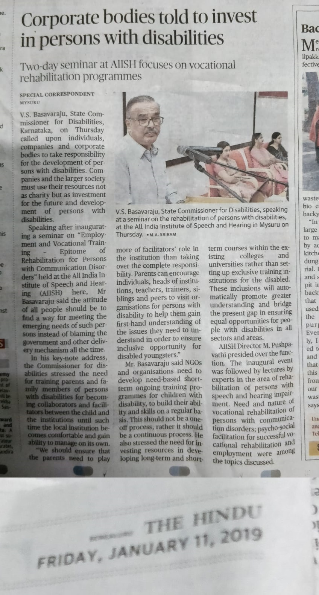

**C) Material Development :**The following Teaching Learning Material and Prepare for training children with various communication disorders in preschool.

|  |  |  |  |
| --- | --- | --- | --- |
| **Sl.**  **No.** | **Nature of**  **Teaching-Learning**  **Materials** | **Skill** | **Number** |
| 1. | Flash cards | For all skill areas | 60 |
| 2. | Work Cards | For all skill areas | 82 |
| 3. | Charts | For all skill areas | 30 |
| 4. | PPT | For all skill areas | 169 |
| 5. | Models | For all skill areas | 53 |
| 6. | Sentence strips | For all skill areas | 47 |
| 7. | Story cards | For all skill areas | 77 |
| 8 | Others | For all skill areas | -- |

1. **AWARDS AND HONORS RECEIVED BY FACULTY AND STAFF:**

Received Smt. Annapurna Memorial Award for best research paper in Special Education as author for the paper titled 'Effectiveness of developed computer based tutor for concept learning in preschool children with hearing impairment' at 84th NCED- India Annual National Conference on Enhancing Quality of Education of Students with Hearing Impairment – Needs & Practices held at Chennai, Tamil Nadu, from 28th to 30th January, 2019.

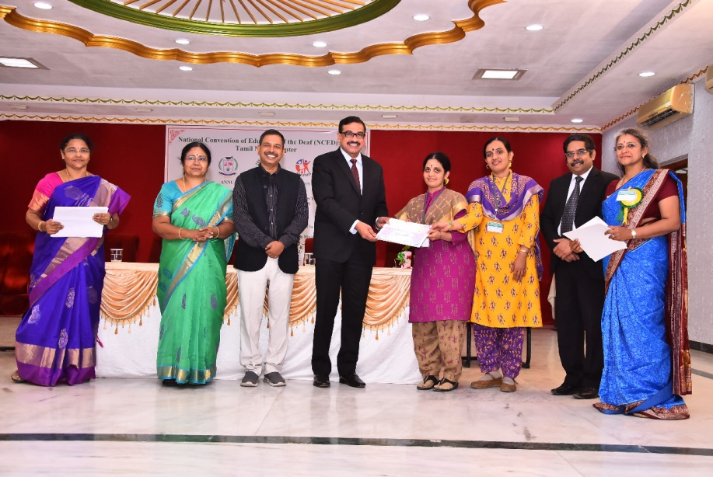

Received ***Dr. Prakash Gathoo -The best young researcher award*** for the research papertitled *‘Teachers Knowledge about Hearing Impairment & Referral Services in Mysore’* presented as co-author in NCED 2019 held in Tamilnadu.

**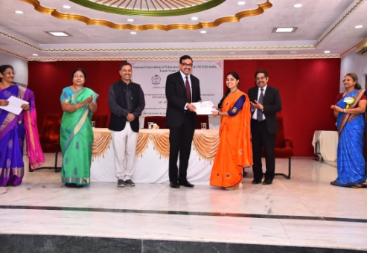**

Received the best poster award –***All India teachers Association for the Deaf-best Poster Award*** at NCED, Chennai (28th -30th January 2019).

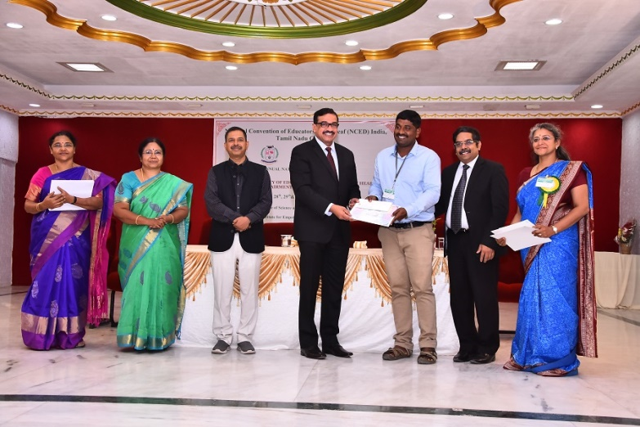

1. EXTRA CURRICULAR ACTIVITIES: Nil
   * + - 1. AIISH Gymkhana
2. **EMINENT VISITORS:** Nil

XI. **ANY OTHER**

* **Official Language Implementation:**
* Hindi Word a day
* No. of notings/letters (**January 2019**): Hindi: 66, English: 11

Sd/-

HOD- Special Education