ALL INDIA INSTITUTE OF SPEECH AND HEARING, MYSURU-6
DEPARTMENT OF CLINICAL SERVICES

MONTHLY REPORT / STATISTICS FOR THE MONTH OF JANUARY 2019 (26.12.2019 to 25.01.2019)

- REGISTRATION AT THE DEPARTMENT

- Number of Clients registered
 | Speech Language OPD | 445
 | Audiology OPD | 1312
 | New Cases | 1757
 | Retrieval of repeat case files | 4631
 | Total Cases | 6388
 | No. of Working days | 22

- Details of Registration

Total requests for new registration | 1925
Total registered as new clients | 1757
*No. of cases Rejected | 168
Case files requested for revisit | 4748
Case files retrieved for revisit | 4631
Case files requested for clinical purpose | 694
Case files retrieved for clinical purpose | 694
Case files requested for research purpose | 616
Case files retrieved for research purpose | 616
Case files requested for academic purpose | 00
Case files retrieved for academic purpose | 00
Case files requested for Legal purpose (Court) | 00
Case files retrieved for Legal purpose (Court) | 00
Total Requests for Medical Records Corrections | 31
Total Corrections done in the Medical Records | 31
Total Case files requested  (Revisit, clinical purpose, research purpose, academic purpose) | 8014
Total Case files retrieved  (Revisit, clinical purpose, research purpose, academic purpose) | 7729

*Rejected – Not reported as communication disorders (Non Sp & Hg problems)

Date wise statistics for the month of January, 2019
Sl. No | Dates | New Cases | Repeat Cases | Total Cases
 | 26 - Dec -18 | 119 | 254 | 373
 | 27- Dec -18 | 102 | 162 | 264
 | 28 - Dec -18 | 72 | 132 | 204
 | 29 - Dec -18 | 00 | 00 | 00
 | 30 - Dec - 18 | 00 | 00 | 00
 | 31 - Dec - 18 | 108 | 233 | 341
 | 01- Jan - 19 | 41 | 150 | 191
 | 02- Jan -19 | 71 | 274 | 345
 | 03- Jan -19 | 79 | 222 | 301
 | 04- Jan -19 | 66 | 158 | 224
 | 05- Jan -19 | 00 | 00 | 00
 | 06- Jan -19 | 00 | 00 | 00
 | 07- Jan -19 | 126 | 306 | 432
 | 08- Jan -19 | 63 | 166 | 229
 | 09- Jan -19 | 50 | 233 | 283
 | 10- Jan -19 | 85 | 174 | 259
 | 11- Jan -19 | 89 | 133 | 222
 | 12- Jan -19 | 00 | 00 | 00
 | 13- Jan -19 | 00 | 00 | 00
 | 14- Jan -19 | 101 | 250 | 351
 | 15- Jan -19 | 00 | 00 | 00
 | 16- Jan -19 | 84 | 263 | 347
 | 17- Jan -19 | 64 | 213 | 277
 | 18- Jan -19 | 64 | 165 | 229
 | 19- Jan -19 | 00 | 00 | 00
 | 20- Jan -19 | 00 | 00 | 00
 | 21- Jan -19 | 114 | 331 | 445
 | 22- Jan -19 | 66 | 228 | 294
 | 23 - Jan -19 | 73 | 282 | 355
 | 24 - Jan -19 | 68 | 163 | 231
 | 25 - Jan - 19 | 52 | 139 | 191
Total |  | 1757 | 4631 | 6388

District wise distribution of cases (Karnataka) registered during the month of January, 2019

Sl. No | Districts Descriptions | Male Cases | Female Cases | Total Cases
 | Bagalkote | 02 | 04 | 06
 | Bangalore | 48 | 25 | 73
 | Belgaum | 05 | 04 | 09
 | Bellary | 03 | 05 | 08
 | Bidar | 01 | 01 | 02
 | Bijapur | 04 | 01 | 05
 | Chamarajanagar | 62 | 41 | 103
 | Chikkaballapur | 02 | 00 | 02
 | Chikkmagalore | 11 | 06 | 17
 | Chitradurga | 02 | 01 | 03
 | Coorg | 17 | 08 | 25
 | Dakshina Kannada | 02 | 01 | 03
 | Davangere | 08 | 05 | 13
 | Dharwad | 02 | 03 | 05
 | Gadag | 03 | 04 | 07
 | Gulbarga | 05 | 01 | 06
 | Hassan | 59 | 33 | 92
 | Haveri | 06 | 03 | 09
 | Kolar | 06 | 07 | 13
 | Koppala | 03 | 00 | 03
 | Mandya | 83 | 54 | 137
 | Mysore City | 398 | 327 | 725
 | Mysore District | 185 | 115 | 300
 | Raichur | 06 | 02 | 08
 | Ramanagara | 24 | 09 | 33
 | Shivamoga | 07 | 03 | 10
 | Tumkur | 15 | 06 | 21
 | Udupi | 01 | 01 | 02
 | Uttar kannada | 03 | 01 | 04
 | Yadagiri | 03 | 02 | 05
 | Total | 976 | 673 | 1649

States wise distribution of cases registered during the month of January, 2019

Sl. No | States Descriptions |  | Male Cases | Female Cases | Total Cases
 | Andra Pradesh |  | 10 | 02 | 12
 | Arunachal Pradesh |  | 00 | 00 | 00
 | Assam |  | 01 | 00 | 01
 | Bihar |  | 00 | 01 | 01
 | Chattisgarh |  | 00 | 00 | 00
 | Delhi |  | 02 | 01 | 03
 | Goa |  | 00 | 00 | 00
 | Gujarat |  | 00 | 00 | 00
 | Hariyana |  | 00 | 01 | 01
 | Himachal Pradesh |  | 00 | 00 | 00
 | Jarkhand |  | 00 | 00 | 00
 | Karnataka |  | 976 | 673 | 1649
 | Kashmir |  | 00 | 00 | 00
 | Kerala |  | 35 | 24 | 59
 | Madhya Pradesh |  | 02 | 00 | 02
 | Maharastra |  | 00 | 00 | 00
 | Manipur |  | 00 | 00 | 00
 | Meghalaya |  | 00 | 00 | 00
 | Nagaland |  | 00 | 00 | 00
 | Mizoram |  | 00 | 00 | 00
 | Orissa |  | 01 | 00 | 01
 | Punjab |  | 00 | 00 | 00
 | Rajasthan |  | 00 | 00 | 00
 | Sikkim |  | 00 | 00 | 00
 | Tamil Nadu |  | 18 | 05 | 23
 | Telangana |  | 00 | 00 | 00
 | Tripur |  | 00 | 00 | 00
 | Union Territories |  | 00 | 00 | 00
 | Uttar Pradesh |  | 03 | 00 | 03
 | Uttaranchal |  | 01 | 01 | 02
 | West Bengal |  | 00 | 00 | 00
Total |  |  | 1049 | 708 | 1757
Sl.No |  | Over Seas | Male Cases | Female Cases | Total
1 |  | - | - | - | -
Total |  |  | 1049 | 708 | 1757

II. DIAGNOSTIC AND THERAPY SERVICES

- SPEECH-LANGUAGE EVALUATIONS

EVALUATIONS |  | PEDIATRIC  (0-15YRS) |  | ADULT  (15-50YRS) |  | GERIATRIC  (50 & ABOVE) |  | TOTAL |  | HINDI CASES
 |  | M | F | M | F | M | F | NEW | REPEAT | HINDI CASES
Language | CLD | 169 | 82 | 00 | 00 | 00 | 00 | 251 | 187 | 41
Language | ALD | 00 | 00 | 20 | 08 | 03 | 01 | 32 | 05 | 41
Articulation |  | 11 | 07 | 02 | 00 | 00 | 00 | 20 | 14 | 41
Voice |  | 03 | 05 | 06 | 14 | 08 | 01 | 37 | 04 | 41
Fluency |  | 14 | 06 | 12 | 01 | 00 | 00 | 33 | 09 | 41
Multiple |  | 00 | 00 | 00 | 00 | 00 | 00 | 00 | 00 | 41
Normal |  | 00 | 00 | 00 | 00 | 00 | 00 | 00 | 00 | 41
TOTAL M/F |  | 197 | 100 | 40 | 23 | 11 | 02 | 373 | 219 | 41
Over all Total New |  | 297 |  | 63 |  | 13 |  | 373 | 219 | 41
Overall Total New |  | 373 |  |  |  |  |  |  |  | 41
Overall Total Repeat |  | 219 |  |  |  |  |  |  |  | 41
Overall Total New & Repeat |  | 592

Evaluations | No. of Clients seeking | No. of Clients successfully completed | Percentage (%)
Speech-Language Evaluation | 393 | 373 | 95%
Re-evaluation | 220 | 219 | 100%
Referrals from OPD:

POCD | 01
TCPD | 05
Internship centers | 16
Others | 15
Case History ( Speech OPD) | 423
Evaluation | 592
Counselling | 221
*Not reported in Speech Language OPD | 22

III. PT/OT EVALUATION

EVALUATION | PEDIATRIC  (0-15 YEARS) | ADULT  (16- 50 YEARS) | GERIATRIC  (50& ABOVE) | TOTAL
Physiotherapy evaluation | 71 | 10 | 07 | 88
Occupational therapy evaluation | 57 | 05 | 00 | 62
TOTAL | 128 | 15 | 07 | 150

Diagnostics | No. of clients seeking evaluation | No. of Clients successfully evaluated | No. of clients recommended for re-evaluation | No. of clients successfully re-evaluated
Physiotherapy | 88 | 88 | 14 | 14
Occupational Therapy | 62 | 62 | 13 | 13

PT/OT THERAPY SESSION
Therapy | Pediatric  (0-15 Years) |  | Adult  (16- 50 Years) |  | Geriatric  (50& Above) |  | Total No. of Case For PT/OT | Total No of Therapy Session
Therapy | Cases | Sessions | Cases | Sessions | Cases | Sessions | Total No. of Case For PT/OT | Total No of Therapy Session
Physiotherapy | 76 | 529 | 03 | 17 | 01 | 09 | 80 | 555
Occupational Therapy | 58 | 350 | 02 | 07 | 02 | 07 | 62 | 364
Preschool PT | 01 | 08 |  |  |  |  | 01 | 08
Preschool OT | 18 | 102 |  |  |  |  | 18 | 102
Total | 153 | 989 | 05 | 24 | 03 | 16 | 161 | 1029

PT – OT | Physiotherapy |  | Occupational therapy
PT – OT | New | Old | New | Old
No. of Clients Seeking therapy | 45 | 53 | 15 | 66
No. of Clients availed therapy | 34 | 46 | 15 | 66
No. of Clients D.N.R | 00 | 00 | 00 | 00
No. of Clients discontinued | 01 | 00 | 01 | 03
No. of Clients successfully discharged | 02 | 01 | 02 | 03
No. of sessions allotted | 593 |  | 483
No. of sessions present | 555 |  | 466
No. of Sessions absent | 38 |  | 17
Percentage PT/OT sessions | 94% |  | 96%
No. of Session – Daily average | 25 |  | 21
Percentage PT/OT sessions average | 95%
No. of Session – over all average | 23

IV. VISITING CONSULTANTS

Plastic Surgeon | 11
Phonosurgeon | 07
Pediatrician | 17
Dietician | 14
Neurologist | -
Prosthodontist | -
Orthodontist | 02
V. Special Clinic/ Units: (Evaluations)
Special Clinic/ Unit |  | PEDIATRIC  (0-15 YEARS) | ADULT  (15-50 YEARS) | GERIATRIC  (50&ABOVE) | Total
AAC | Evaluations | 06 | - | - | 06
*ASD |  | 30 | - | - | 30
Voice Clinic |  | 09 | 29 | 19 | 57
CAEPLD |  | 00 | 01 | 00 | 01
*USOFA |  | 09 | 02 | - | 11
*MSD |  | 09 | - | - | 09
LD Clinic |  | 11 | - | - | 11
Phonology Clinic |  | 04 | - | - | 04
*Also depicted in the activities of Dept. of SLP

VI. SPEECH AND LANGUAGE THERAPY CASES

Summary of speech language therapy statistics

Sl. No | Particulars | Total
 | Total number of cases attended therapy | 634
 | Total number of individual sessions | 2577
 | Daily average sessions | 123
 | Total number of sessions absent | 207
 | Total Number sessions (attended + absent) | 2784
 | A) Percentage sessions attended | 92.5
 | B) Percentage sessions absent | 7.5
 | Total number of Appointment given | 324
 | Therapy appointment on daily average | 15

Details of number of clients attending Speech Language Therapy

Disorders |  | PEDIATRIC  (0-15 YRS) |  | ADULT  (15-50YRS) |  | GERIATRIC  (50 & ABOVE) |  | Total | NEW HINDI  CASE | DT
 |  | M | F | M | F | M | F |  | 17 | 49
Lang | CLD | 370 | 184 | 00 | 00 | 00 | 00 | 554 | 17 | 49
Lang | ALD | 00 | 00 | 08 | 03 | 02 | 02 | 15 | 17 | 49
Articulation/Phonology |  | 15 | 06 | 06 | 00 | 03 | 01 | 31 | 17 | 49
Voice |  | 01 | 06 | 08 | 13 | 02 | 01 | 31 | 17 | 49
Multiple |  | 02 | 01 | 00 | 00 | 00 | 00 | 03 | 17 | 49
Total |  | 388 | 197 | 22 | 16 | 07 | 04 | 634 | 17 | 49
G. Total |  | 585 |  | 38 |  | 11 |  | 634
Over All Total |  | 634
Over All Total New |  | 136
Over All Total Repeat |  | 498
- Holiday on 15th January 2019 (Pongal)
Speech Language Therapy Statistics:

Speech Language Therapy | New | Old | Total | Percentage of New Cases (%) | Percentage of Old Cases (%)
No. of Client Assigned (appointment given) | 136 | 188 | 324 | 41.97 | 58.03
No. of Clients attended therapy sessions | 125 | 509 | 634 | 19.71 | 80.29

Summary of Special Clinics therapy statistics

Sl. No | Particulars | Total
1 | Total number of cases attended therapy | 184
2 | Total number of individual sessions | 903
3 | Daily average sessions | 43
4 | Total number of sessions absent | 54
 | Total Number of sessions Absent + Attended | 957
5 | A) Percentage sessions attended | 94.3
 | B) Percentage sessions absent | 5.7
6 | Total number of Therapy Appointment given | 112
7 | Therapy appointment on daily average (Round off) | 05

SLT | SCT | Total cases
634 | 184 | 818

No. of Clients attending therapy in Special Clinics

Disorders | PEDIATRIC  (0-15 YRS) |  | ADULT  (15-50YRS) |  | GERIATRIC  (50 & ABOVE) |  | Total | HINDI  CASE | DT
Disorders | M | F | M | F | M | F |  | 05 | 17
Fluency disorders | 16 | 03 | 29 | 03 | 00 | 00 | 51 | 05 | 17
Autism | 77 | 17 | 00 | 00 | 00 | 00 | 94 | 05 | 17
U-SOFA | 08 | 08 | 00 | 00 | 00 | 00 | 16 | 05 | 17
AAC | 04 | 06 | 00 | 00 | 00 | 00 | 10 | 05 | 17
ISL | 00 | 02 | 00 | 00 | 00 | 00 | 02 | 05 | 17
Others (ADHD) | 10 | 03 | 00 | 00 | 00 | 00 | 13 | 05 | 17
Total | 115 | 39 | 29 | 03 | 00 | 00 | 186 | 05 | 17
G. Total | 154 |  | 32 |  | 00 |  | 186 | 05 | 17
Over all Total | 186
Over all Total New | 43
Over all Total repeat | 141

Details of number of sessions attended by the clients in Special Units/Clinics

Disorders | PEDIATRIC  (0-15 YRS) |  | ADULT  (15-50YRS) |  | GERIATRIC  (50 & ABOVE) |  | Total
Disorders | M | F | M | F | M | F | Total
Fluency disorders | 70 | 11 | 103 | 23 | 00 | 00 | 207
Autism | 415 | 112 | 00 | 00 | 00 | 00 | 527
Repaired cleft lip and Palate | 34 | 36 | 00 | 00 | 00 | 00 | 70
AAC | 12 | 21 | 00 | 00 | 00 | 00 | 33
ISL | 04 | 05 | 00 | 00 | 00 | 00 | 09
Other (ADHD) | 38 | 28 | 00 | 00 | 00 | 00 | 66
Total | 573 | 213 | 103 | 23 | 00 | 00 | 912
G. Total | 786 |  | 126 |  | 00 |  | 912
Total Sessions: | 912

Special Clinic Therapy Statistics:

Special Clinic Therapy | New | Old | Total | Percentage of New Cases (%) | Percentage of Old Cases (%)
No. of Clients Assigned (appointment given) | 43 | 69 | 112 | 38 | 61
No. of Clients attended | 34 | 150 | 184 | 18 | 81

Number of Clients attending Group Therapy:
Sl. No | Speech Language Group therapy sessions | Total
 | Total groups attended | 39
 | Total number of Children attending group therapy | 215
 | Total number of Children reported | 205
 | Total number of group therapy sessions allotted | 540
 | Total number of group therapy sessions attended | 285
 | Daily average group sessions | 30

Number of Group Therapy Sessions (26th Dec 2018- 25th Jan 2019)
Details of Speech Language Individual Therapy Sessions
Child Language Disorders | Kannada |  | Malayalam |  | Hindi |  | English |  | Telugu
Child Language Disorders | Total groups | Sessions  Attended | Total groups | Sessions  Attended | Total groups | Sessions  Attended | Total groups | Sessions  Attended | Total groups | Sessions  Attended
Hearing Loss | 08 | 74 | 01 | 10 | 02 | 32 | 00 | 00 | 00 | 00
ASD | 04 | 22 | 02 | 18 | 01 | 05 | 01 | 04 | 00 | 00
MR | 09 | 42 | 05 | 46 | 01 | 06 | 00 | 00 | 00
Multiple disability | 02 | 14 | 02 | 08 | 00 | 00 | 00 | 00 | 01 | 05
Total group session |  | 152 |  | 82 |  | 43 |  | 04 |  | 05
Total no of groups | 285
Group therapy sessions allotment and therapy monthly reports are calculated from 27th Dec18 to 25th Jan 2019.
.

VII. Overall statistics of individuals availing therapeutic services in the Dept. of Clinical Services

Sl. No | Particulars | SLT | Special Clinics | PT-OT | Grand Total
1 | Total number of cases who attended therapy | 634 | 184 | 161 | 979
2 | Therapy appointment on daily average | 29 | 08 | 07 | 44
3 | Total number of individual sessions | 2577 | 903 | 1029 | 4509
4 | Daily average (Sessions) | 117 | 41 | 47 | 205

VIII. OTHER ACTIVITIES
- Reports and certificate issued

Sl. No | Particulars | Total
 | Transfer certificate issued | 01
 | Attendance certificates | 00
 | School admission certificate/  Language exemption certificate issued | 06
 | Total certificate issued | 07
 | Evaluation reports issued (English + Hindi) | 30
 | Gen Correspondences (official purpose)(English + Hindi) | 20
 | Correspondence by e-mail in English(official purpose) | 10
 | IST Details:  General correspondence for the public(through email) | 02

- List of Items Condemned:
Samsung VCD player – 02 Nos.
BPL emergency light – 01 No.

- List of items received:
- Almirah (small) – 6 Nos.
- Document scanner – 02 nos
- Barcode scanner – 01 No.
{{{
- Eminent Visitors: Nil {{
- Short Term Training Programs/ Allied professionals (ENT, B.S.Ed etc...)
No. of orientation conducted (for outsiders): Nil

Public Education:

- Visitors: (6 groups, 207 visitors)
Sl. No. | Name of the College | Target Group | No. of students | Dates
 | Govt Teachers training college, Mysuru | D.Ed Sp.Ed students | 14 | 26.12.2018
 | Govt Teachers training college ,Mysuru | D.Ed Sp.Ed students | 15 | 28.12.2018
 | Govt School of Nursing,Dist Hospital,Haveri | Nursing students | 38 | 03.01.2019
 | District Institute of Education and Training Salum Tamilnadu | Teachers | 10 | 04.01.2019
 | MES College Kerala | Architect students | 02 | 16.01.2019
 | Karnatak University Haveri | MSW Students | 19 | 18.01.2019
 | Karnatak University Gadag | MSW Students | 22 | 18.01.2019

Details of Counseling & Guidance carried out by MSW.

Govt Concession /Certificate Counseling | 121
CWF Counseling | 181
Family & Individual Counseling | 17
Referral & Guidance | 381
CWF follow up | 07
Discharge planning | 19

- Follow up of clients who availed DT in SLT:

Follow up | First time
To be followed up | 48
Follow up done (phone) | 36
Follow up of discontinued cases | 07
Counseling regarding school placement | 03

- Discharge planning: Counseled and issued discharge summary reports – 49

- SEEK (Student Enrichment and Expansion of Knowledge) – Gyan Program – Nil

- REACH:

Speaker | Date | Time | Language | Target group
Mr. Sumanth | 18.01.2019 | 10.30-  11.30am | Kannada | SLD with HL  Clarity of speech in Children with Hearing Impairment (Activities to improve speech naturalness)
Ms. Pooja Sreeram | 21.01.2019 | 10.30-  11.30am | Malayalam | SLD with HL  Clarity of speech in Children with Hearing Impairment (Activities to improve speech naturalness)
Ms. Jyothi S | 23.01.2019 | 12.00 -  1:00 pm | Kannada | SLD with HL  Importance of listening training in children with Hearing Impairment

- Revenue generated/collected for the month of January,2019

Charges | Amount
Medical records | 52,650.00
Therapy charges | 65,440.00
Certificate/evaluations | 53,530.00
Payment of Hearing aids | 21,77,531.00
Soft tube/ mould | 91,450.00
Miscellaneous | 16,462.00
Total | 24,57,068.00

- Seminars /Workshops/Invited talk/Guest Lecture/Orientation Program: 02 Nos.
- Ms. Prathima S - Served as a resource person and delivered a lecture on “Speech and Swallowing issues related to ageing” on 11th January 2019 in the “Seminar on Ageing and Elderly care on communication disorders: strategic guidelines” organized by Dept. of POCD, AIISH, Mysuru.
- Mr. Prashanth R - Served as resource person and presented a talk on Govt and non govt welfare measures promoting vocational rehabilitation of persons with communication disorder on 11th Jan 2019

- Staff Enrichment Program: Nil

- Others:

- OLI
Region A | -
Region B | -
Region C | 30
Others | -

- Client Welfare Fund - 13
- Certificate Issued - 07
- CWF 100% Free hearing aid (Volta) - 00
- Display of clinician’s names in Hindi-English bilingual form – 60
- Display of client’s names in Hindi-English bilingual form – 00
- Signing assessment formats - 00

- Material Development: Nil
XI. Research
- Research projects - 8 Nos
Sl. No | Title | Investigator/ Co-Investigator | Funding agency | Remarks
 | Genetics insight of Cerebral palsy using massively parallel sequencing | Dr. N. Sreedevi - PI  Dr. N. Swapna  Dr. K. Srinivas | ARF | Report to be submitted  Term over
 | Motor equivalence and speech kinematics in normal and pathological speech production | Dr. N. Sreedevi - PI  Dr. Ganesh Sinisetty - Co-PI  Dr. Irfana M – Co PI | ARF | Report to be submitted  Term over
 | Frequency of occurrence of phonemes in Hindi | Dr. N. Sreedevi – PI  Dr. Irfana M – Co PI | ARF | Report submitted
 | Effect of combined tactile, thermal and gustatory stimulation on feeding and swallowing in children with cerebral palsy | Dr. Swapna N - PI  Ms. Prathima S Co - PI | ARF | Ongoing
 | Effect of Resource Material on Impact of Inclusive Education in Children with Intellectual Disabilities and Learning Disabilities | Dr. Malar G  Ms. Prathima S Co - PI | ARF | Term completed. However, request for extension is in process
 | Development of a test for Assessment of Prosody in Children | Dr. N. Sreedevi  Dr. Sangeetha M Co-PI | ARF | Ongoing  2018-19
 | Development and Standardization of Reading Passages for Children in Kannada | Dr. Sangeetha M | ARF | Ongoing  2018-19

- Doctoral thesis - Ongoing - 5 nos
Sl. No. | Title | Name of the Candidate | Guide
 | Effect of Phoneme Context and Position on Articulation in Kannada Speaking Children with Speech Sound Disorders | Ms. Amulya P Rao  Submitted | Conducted viva on 05.02.2019  Dr. N Sreedevi  Ongoing
 | Effect of vowel context and phoneme position on correct articulation of phonemes in children with Down syndrome in Malayalam: pre post therapy comparison | Ms. Anita Naitee Abraham | Conducted viva on 05.02.2019  Dr. N Sreedevi  Ongoing
 | Acoustic and articulatory characteristics of cochlear implantees in Malayalam | Ms. Deepthy Anne joy | Conducted viva on 05.02.2019  Dr. N Sreedevi  Ongoing
 | A Comparative study of phonological representations in native Malayalam speaking typically developing children and children with speech sound disorders. | Ms. Ranjitha R | Conducted viva on 05.02.2019  Dr. N Sreedevi  Ongoing
 | Enrolled for Ph.D program (Sp & Hg) | Ms. Seema M | Conducted viva on 05.02.2019  Dr. N Sreedevi  Ongoing

- Dissertation Program – 03

Sl. No. | Title | Name of the Candidate | Guide
 | Phonotactic Development in 2-5 years old Native Malayalam Speaking Children | Ms. Jijina T | Dr. N. Sreedevi
 | Phonetic influences in Adults with Stuttering | Ms. Shishira S | Dr. Sangeetha M
 | Assessment of effective factors in Children with Stuttering | Ms. Krishnendu | Dr. Sangeetha M

Paper Published: Nil

Paper Presentation: Nil

X. CLINIC STAFF ACTIVITIES

Sl. No | Staff | Diagnostics | Therapy |  | CPC  Class
Sl. No | Staff | Diagnostics | Lang | Special Clinic | CPC  Class
 | Dr. N. Sreedevi | 05 | 04 | 01 | NA
 | Dr. Sangeetha M | 08 | 05 | 10 | NA
 | Dr. Preethi. Thomas | 61 | 08 | 04 | NA
 | Ms. Geetha M.P | 19 | 39 | 05 | -
 | Dr. R. Gopi Sankar | 15 | 08 | 28 | -
 | Ms. Seema M | 28 | 18 | 19 | 02
 | Ms. Prathima .S | 32 | 34 | 11 | -
 | Mr. Pradeep Kumar | 20 | 44 | 11 | -
 | Ms. Deepa Anand | 06 | 20 | 22 | -
 | Ms. Aruna Kamath | 06 | - | 22 | 03
 | Ms. Divyashree K.N. | 80 | 27 | NA | NA
 | Ms. Akrithi Kumar |  | - | NA | NA
 | Ms. Reshmitha R | - | 09 | 39 groups | NA
 | Mr. Sumanth P | - | 25 | - | NA
 | Ms. Divya Vinod K | - |  |  | NA
 | Ms. Pooja S | - | 22 | - | NA
 | Staff | Diagnostic | Therapy |  | NA
 | Mr. Sohan Singh | 36 | 38 |  | NA
 | Ms. Vidhathri D S | 52 | 42 |  | NA
 | Ms. Meela P | 38 | 48 |  | NA
 | Ms. Barathi K | 24 | 32 |  | NA
*Not applicable

- Dr. N. Sreedevi - Professor in Speech Sciences and Head- Dept. of Clinical Services

- Has been officiating as HOD- DCS
- Has been serving as Chairperson of Phonology clinic/Voice clinic.
- Serving as chairperson of purchase review committee.
- Nominated member for office council.
- Guiding 5 PhD students.
- Handled 22 classes for M Sc (SLP) A and B sections
- Guiding 1 dissertation student.
- Has been serving as PI for 1 ARF project.
- Served as committee member for research proposal of 12 PhD candidates and as guide for one candidate on 21.12.2018 and 28.12.2018
- Conducted Purchase review committee meeting on 09.01.2019 and 23.01.2019.
- Served as chairperson for the selection committee for clinical supervisor, SLP Gr. I and SLP G.II on 14.01.2019.
- Evaluated and submitted one evaluation report of thesis to University of Thiruvananthapuram.
- Served as examiner for 1 M.Sc (SLP) and 1 B.ASLP paper.
- Coordinated Gymkhana meeting regarding republic day on 21.01.2019.
- Attended viva voce of Ms. Anjana on 22.01.2019.
- Served as member for RAC on 23.01.2019.

- Dr. Sangeetha Mahesh- Clinical Reader

- Theory classes on Fluency and its disorders, I M.Sc SLP II semester 4/week: II B.ASLP IV semester – 4/week
- Serving as mentor for II M.Sc SLP ‘B’ section, conducted meeting with students on 17.01.2019
- Developed videos for practical session on speech sound disorders (Traditional approach, sensory motor program, paired stimuli approach) along with Ms. Sabeena, Reseach officer.
- Served as internal auditor for Dept. of Special Education on 24.01.2019.
- Work orders for play area (concrete floor) and notice boards, resource for notice board were followed up.

- Dr. Preethi T. Thomas – SLP Gr – I

- Member Secretary of the CAEPLD- Special Clinic
- Member of the Anti-Ragging Squad (Ongoing)
- Member of the Library committee
- Member for the development of Therapy Park
- Clinic Mentor for II M.Sc SLP- students
- No. of Reports verified: 16
- Attended meeting with HOD- Preschool Regarding Therapy park on 14th , 16th and 24th January 19.
- Meeting with Director regarding Therapy Park on 23.01.19.
- Prepared documents for ISO audit on 25.01.2019
- Verification of reports on a regular basis.
- General follow up on reports process and procedure
- Follow up on channelizing the OPD payments during assessment
- Follow up on a MLC case- 02
- Follow up on letter correspondence regarding Master Kevin client
- Follow up on the recording of speech sample of client is carried out on a regular basis and Issuing feedback form for clients.
- Follow up on a client Report issuing with disability statement.
- Follow up on the compilation of daily and monthly statistics of OPD, evaluation reports and referral letters, clients referred to other departments like TCPD, POCD, LD clinic, Internship centers and others.
- ISO – files updation (Competency Matrix, List of Staff list, workshops List
- Follow up on ISO coding for 4 Test Materials
- Addition of OPD Test Material from Online Source- MoCA- (Indian languages)
- Follow up and trial of cases files entry for Computerization purpose: Counseling sheet, Reevaluation sheet.
- Preparation of Drafts for Monthly routines- including Student roaster, Student orientation & instructions, Special Units Centralized Appointment schedule.
- Modifications of Monthly report, Patient reports documents
- Preparation of item details for PRF requirements for OPD.
- Monitoring of work being carried out by Ms. Kavya (Management staff) regarding data entry, case file management, preparation and dispatch of reports, Performa and score sheets managements, Maintenance of OPD rooms, stock maintenance, follow ups , work orders and other OPD related activities.

- Ms. Geetha M.P – SLP Gr - I

- Member of Fluency unit.
- Maintenance and Preparation of monthly reports and statistics of Speech-Language Therapy Unit and Special Clinics
- Follow up on the work orders of both SLT and SCT sections
- Prepared PRF for therapy section
- Responsible for preparation of students posing schedule for UG/PG/Interns(regular/vacation)
- Follow up on uploading recorded communication disorders samples from Audio/Video recorder to external hard disk
- Follow up on the module work done by the Junior staff
- Follow up on the work orders of both SLT and SCT sections
- Coordinated 3 REACH program for the month of Jan 19.

- Dr. R. Gopi Sankar – Research Officer

- Serving member secretary for USOFA, Voice Clinic
- Coordinating the ongoing Department Computerization.
- Coordinated the PRF IV quarter of the department.
- Verification of CPC for M.Sc 2016-2018.
- Verification of CPC for B.Sc 2014-2018.
- Reviewed ISHA abstract, conference 2019
- Verified 10 purchase files of the department.
- Nominated to co-ordinate the video recording by director.
- Coordinated internal ISO audit on 25.01.2019
- Verification of internship students’ documents – ongoing.

- Ms. Seema .M – Clinical Supervisor

- Maintenance and Preparation of monthly reports and statistics of and Special Clinics.
- Follow up on uploading recorded communication disorders samples from Audio/Video recorder to external hard disk
- Member of Fluency and ASD unit.
- Follow up on the work orders of both SLT and SCT sections
- Verifying and preparation of 15 discharge summary reports at special unit for the month of Jan - 19
- Follow up on uploading recorded communication disorders samples from Audio/Video recorder to external hard disk.
- In-charge for clinical mentor for I.BASLP.
- Responsible for clinical assessment/supervision (OPD) on every Thursday F/N
- Responsible for clinical assessment/supervision at ASD unit on every Monday F/N
- Counseling and guidelines to the parents of children with communication disorders
- Recording done during the month of 26th Dec 2018- 25th Jan. 2019

Sl.No | Stuttering | voice | USOFA | OTHERS
1. | 11 | 0 | 07 | 05
12. Short Term Training Programs/ Allied professionals (ENT, B.S.Ed etc..)
Sl. No. | Date | Name of the Institute/College | No. of Participants
1. | 01.01.2019 | Astavakrainstof rehabilitation sciences and research ,Delhi | 4
2. | 14.12.18-  08.01.19 | Intern, JIPMER | 1
3. | 24.12.18 – 04.01.19 | Intern, NSCB,Jabalpur | 2
4. | 15.01.19 | B.S.Ed (HI)AIISH | 6
5. | 13.12.18 – 25.01.19 | Guru gobind singh medical college Punjab | 2

- Ms. Rubby

- Details of sign language cases handled for the month of January.
Sl. No. | Case Name | Case No. | Age/Gender | No. of Sessions | Total No.
1. | Sneha | 291723 | 10yrs./Female | 5/22 | 5
2. | Likitha | 384689 | 6yrs 6months./Female | 4/4  One day assessment | 4
 |  |  | Total |  | 9
- Hindi quarterly report work done on 04.01.2019.
- Writing word a day in Hindi on office board.
- On 08.01.2019 prepared two Justification and Indent for computer and Sanako Sign Lab.
- Editing of 2 ISL videos with Ms. N. Kavitha -Artist-cum-photographer (Adjective, Articles) on 03.01.2018 & 23.01.2019.
- ISL workshop work - ongoing.

- +$#- 9
- /.-1AAC Awareness week certificate was sent by e-mail on 22.11.2018 to the Staff/
- Ms. Prathima S - IST

- Verification of work record sheet of III B. Sc (speech and hearing) – 8 Nos.
- Served as a resource person and delivered a lecture on “Speech and Swallowing issues related to ageing” on 11th January 2019 in the “Seminar on Ageing and Elderly care on communication disorders: strategic guidelines” organized by Dept. of POCD, AIISH, Mysuru.
- School visits in Mysore district:
Sl  No. | School address | Date of visit | No. of children followed up | No. of children referred to AIISH | Guidelines given to teachers
 | Gnanavahini Primary School, Srirampura, Mysore | 9.1.2019 | - | 03 | 04
 | IOE school, Saraswathipuram, Mysore | 11.1.2019 | - | - | 1
 | Subhoda Primary School, Kuvempunagar, Mysore | 16.1.2019 | - | 5 | 6
 | Bhavaniswamy primary school, Vishweshvaranagar, Mysore | 18.1.2019 | - | 3 | 5
 | Indira Nursery and Primary School, Sharadadevi Nagar, Mysore | 21.1.2019 | 4 | - | 6
 | Total visits: 5  Total No. of schools visited:5 |  | No. of children followed up: 4 | No. of children referred to AIISH:11 | Teachers: 22

- Mr. Pradeep Kumar– SLP Gr. II

- Attended work shop on language based hearing disability as resource person and presented case studies on LLD, LD and slow learner.
- No. of Reports verified: 14
- Verification of reports on a regular basis.
- General correspondence with the clients regarding complaints of not receiving the reports through mail and post and making alternate arrangements for sending the reports again.
- Filling up of requisition forms and providing acknowledgement slip to the clients approaching for reports.
- Verification of the work record sheet of PG regular postings IBSC ,II BSC And III B.Sc
- Action taken to prevent wastage of Proforma by regular monitoring as well as instructions to the students.
- Providing referral letter to clients.
- Referring clients with academic problems to LD clinics for further evaluations.
- Ensuring that the recording of speech sample of client is carried out on a regular basis.
- Issuing feedback form for clients.

12) Ms. Aruna Kamath – SLP Gr I (Contract)

  - Therapy evaluation report and lesson plan for the clients
  - Preparation of pre-therapy report, lesson plan of new clients
  - Resource material for clients prepared
  - Guidance to B.Sc Intern and B. Sc III students
  - On On 26-12-18 Old case sindhushree had come to AAC Unit. They are admitting her to Karunamayi residential school Mysore
  - 2-1-2019 Old Tobii Pc eye go returned from electronic department without repair.
  - 2-1-2009 New Avaz specification and software details given to chairperson for fresh application to the new director.
  - On 2-1-2019 Discussed with Mr. Vikram (Staff in electronics department AIISH) and demonstrated SPURTY and AVAZ software about new device to be made.
  - On 7-1-2019 Mr. Kunal Naik from Tobii installed Tobii Mini free of cost (came as complementary to SLP’s new communication device) on to the computer along with Tobii communication 5
  - On 11-1-19 prepared justification, and indent for TECEL (test for early communication and emerging Language by Mary Blake Heur, Lynda Millar
  - On 25-1-2019 List of clients coming to AAC Unit who have Mysore District on their aadhar card address for donations may be give by Corporation Bank.

Sl. No. | Date | Client name | Diagnosis | Case NO. | Age/Sex
 | 28-12-18 | Savitha Yellappa | SLD 2◦ Hearing Impairment | 482530 | 14y.5m/F
 | 2-1-2019 | Harshini | SLD 2◦ Mild Intellectual disability | 470965 | 4.8y/F
 | 22-1-19 | Sharana Gowda | DSL DD | 409823 | 7yr/M

- Ms. Deepa Anand – Research Assistant

- Compiled attendance of UG, PG and Internship students attendance until December 28th 2108.
- Was present for Mentor meeting on 16.01.2019 – II MSc A section
- Verification of IA marks of I BSc students

- Mr. Prashanth .R – Medical Social Worker

- Member for Adult and Elderly Persons with Language Disorder.
- Member of Client Welfare fund. (Totally 13 Cases settled for the month of Jan 19) Report
- Follow up calls to the beneficiaries of client welfare fund and maintenance of CWF follow up register (19 Cases)
- Discharge planning : Counseling and client feedback
- General maintenance of the department and monitoring. Various work orders issued
- Compilation, processing & analysis of Overall client feedback forms of the institute.
- Providing referral services to clients : Issuing and referring the client to speech and hearing centers and special school and Govt Organizations
- Compilation, processing & analysis of client Therapy feedback forms(Regular therapy, demonstration therapy, Change Of Therapist ,PT/OT Therapy) of the DCS.
- General letter correspondence
- Attended seminar on Employment & vocational training-Epitome of rehabilitation for persons with communication disorder on 10th and 11th Jan 2019.
- Served as resource person and presented a talk on Govt and non govt welfare measures promoting vocational rehabilitation of persons with communication disorder on 11th Jan 2019
- Drafting and preparation of various letters for internal and external correspondence.
- Attended a talk on Ayurvedic remedies on 31.01.2019 organised by GYMKHANA.
- Serving as member of monthly public lecture series.

Client Welfare Fund for the month of January, 2019
CWF – January, 2019
Clients seeking | 181
Clients rejected | 61
Clients availed | 13

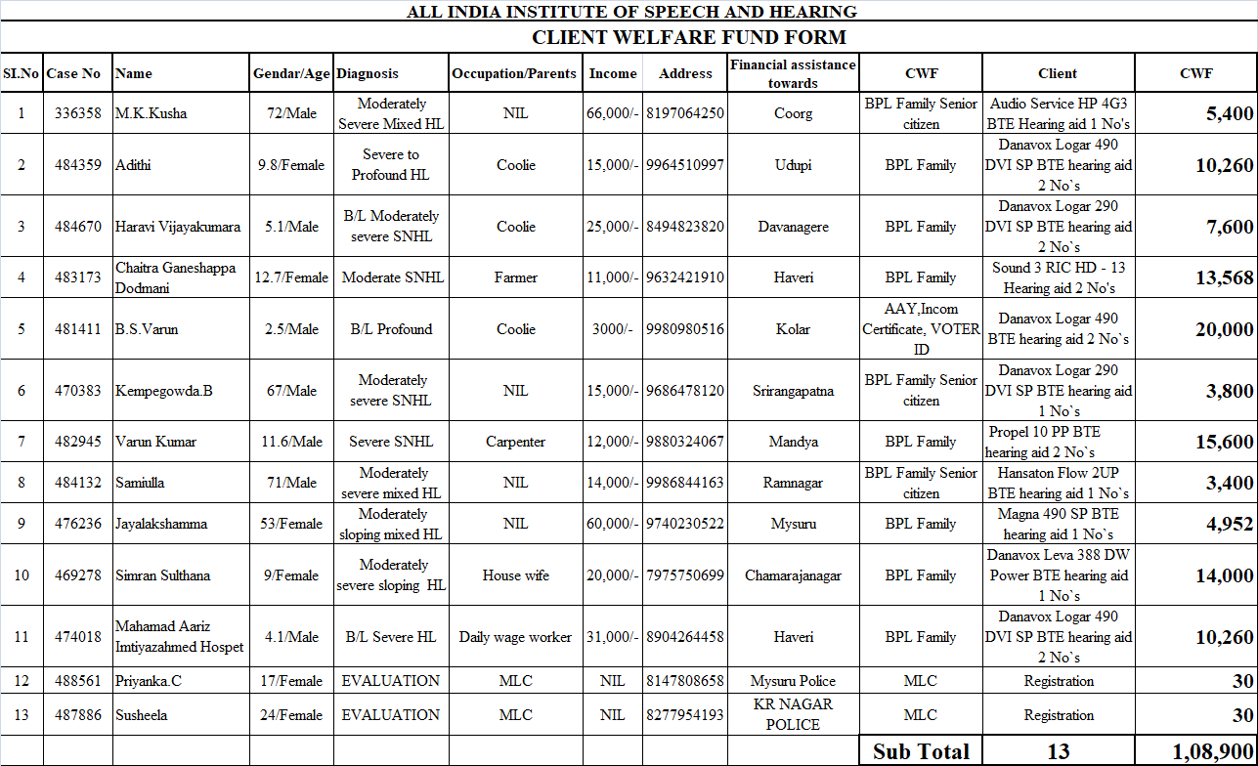

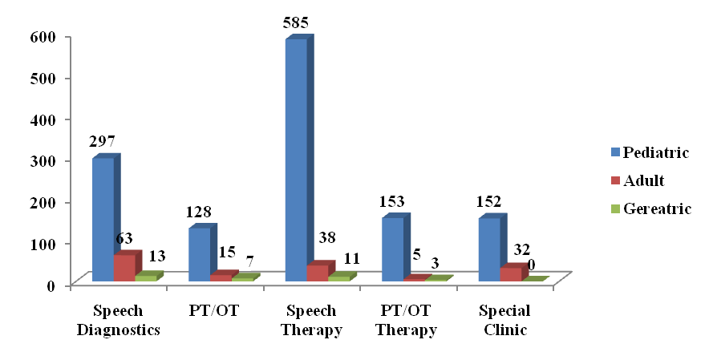
Number of Diagnostic and therapeutic cases seen during the month of January 2019

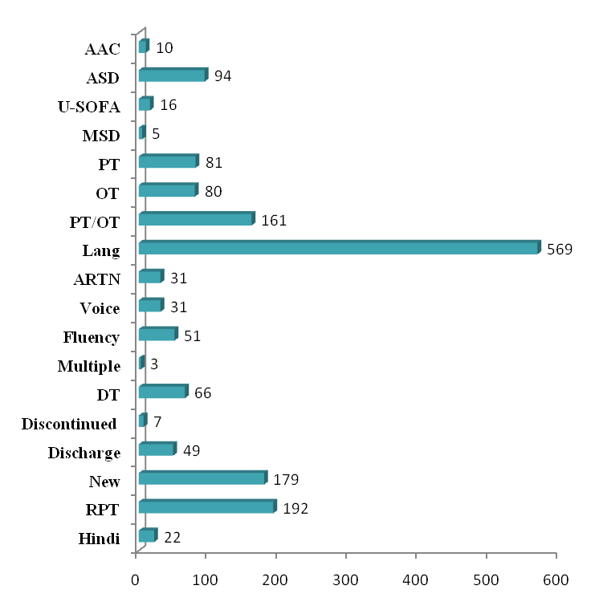
Total number of therapy cases for the month of January 2019

Total Number of Diagnostic cases attended for the month of January 2019
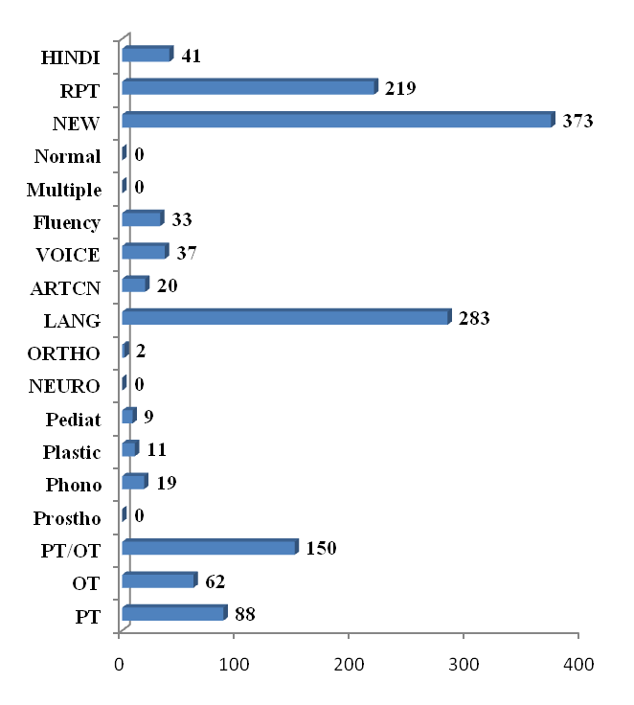

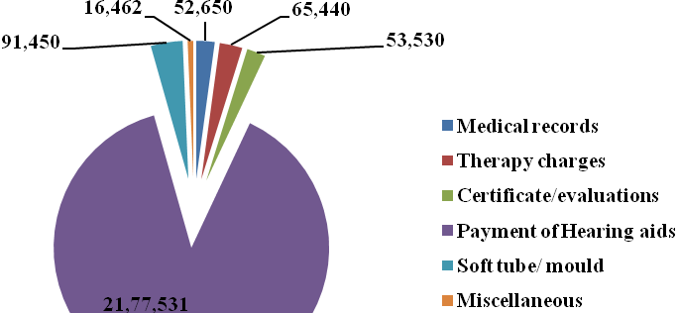
Revenue Generated at DCS

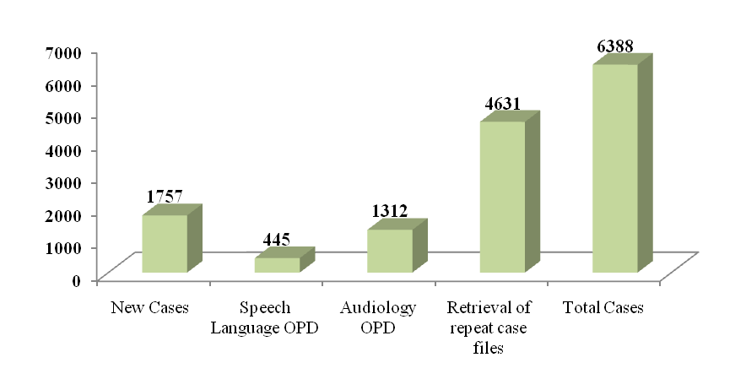
Clinical Services rendered/ No. of Cases registered/files retrieved at AIISH for the month of January 2019

ALL INDIA INSTITUTE OF SPEECH & HEARING: MYSURU- 6
अखिल भारतीय वाक श्रवण संस्थान: मैसूर-६
DEPARTMENT OF CLINICAL SERVICES
चिकित्सा सेवा विभाग
SH/DCS/Monthly-Stat/2018-19 07.02.2019
एसहेच/दिसिस/मासिक रिपोर्ट/२०१८-१९

Submitted to the Director:
निदेशक को प्रस्तुत:

Sub: Monthly Report of January, 2019.
विषय: दिसेम्बर की मासिक विवरण - के बारे में

With reference to the above please find herewith monthly report of Department of Clinical Services for the month of January, 2019. This is placed for your kind information.

Verified by, HOD- Clinical Services
विभागध्यक्ष- चिकित्सा सेवा विभा

