Processing of adjacent and non-adjacent dependencies in persons with Broca’s aphasia

Abstract

Persons with Broca's aphasia (PWBA) are characterized by nonfluent speech, which is reduced in phrase length and grammatical complexity. There are different opinions put forth by authors in the literature, to account for the syntactic deficits observed in PWBA namely, cognitive-based (deficits in executive functions and procedural memory) and linguistic-based (morpho-syntax deficits, trace-deletion hypothesis, syntactic deficit theory, and mapping hypothesis). Studies have concluded poor syntactic processing in PWBA, compared to their neurotypical adults. The ability to track dependencies between the syntactic constituents in a sentence structure (example- subject-verb agreements), is vital for sentence processing. This study aimed to explore the processing of adjacent and non-adjacent dependencies among PWBA, through a sentence processing task. The participants of the study included a total of 15 native Kannada-speaking PWBA, in the age range of 31.6-68 years. There were a total of about 40 Kannada sentences - sentences with adjacent and non-adjacent dependencies in them. The task was computerized, and the stimuli were delivered to the participants, using Psychopy software (version 1.83.00), through laptop. The stimuli were presented auditorily through loudspeakers, attached to the laptop. Participants were instructed to do grammatical judgment of the auditorily presented sentences, by clicking (mouse-click) on to the appropriate icon (tick icon for grammatically correct sentence and wrong icon for a grammatically wrong sentence), which were displayed on the screen. Results revealed poor performance in processing non-adjacent dependencies, compared to adjacent dependencies. This provides insights into deficits in processing of dependencies among PWBA.

Keywords: Broca’s aphasia; Adjacent dependencies; Non-adjacent dependencies; Sentence processing

Introduction
Broca’s aphasia is distinctly identified with markedly reduced fluency in speech. Persons with Broca’s aphasia lack the ability to map thematic relations (eg., agent, action and person) onto parts of speech (eg., subject, verb and object) (Schwartz, Saffran & Martin, 1980b). They are also reported to have impaired word order comprehension which in turn results in poor processing of complex sentences (Caramazza & Zurif, 1976). The verbal utterances of persons with Broca’s aphasia consist of short words/ phrases, which are halting and effortful in nature. The verbal output consists of content words such as nouns and verbs, while functional words such as articles, preposition, auxiliaries, etc tend to be omitted. Such telegraphic way of speech has been named “agrammatic” (Pick, 1913; Isserlin, 1922). Persons with agrammatic aphasia frequently substitute or omit grammatical entities, such as auxiliaries, morphemes (inflectional), pronouns, etc,. There are different opinions put forth by authors in the literature, to account for the syntactic deficits observed in PWBA namely, linguistic-based (morpho-syntax deficits, trace-deletion hypothesis, mapping hypothesis and double dependency hypothesis) and cognitive-based (executive function deficits and deficits in procedural memory).
With respect to the current study, linguistic-based theories are discussed further. Trace Deletion Hypothesis (TDH) (Grodzinsky, 1986; 1990; 1995) explains the process of agrammatic comprehension in persons with aphasia. According to Trace Deletion Hypothesis, persons with agrammatism tend to process active reversible sentences better, when compared to passive reversible sentences. Studies in literature have shown that such patterns of comprehension as assumed by TDH are only present in a subgroup of persons with agrammatism (Berndt, Mitchum, & Haendiges, 1996; Burchert, De Bleser, & Sonntag, 2003; Caramazza, Capitani, Rey, & Berndt, 2001; Caramazza, Capasso, Capitani, & Miceli, 2005; Druks & Marshall, 1995; Luzzatti, Raggi, Zonca, Pistarini, Contardi & Pinna, 2002). On the other hand the Isomorphic Mapping Hypothesis (e.g., Linebarger, 1995) states that persons with agrammatism have deficits in syntactic representation and in mapping these representations with semantic and other levels of representation. Another theory that is widely discussed with reference to agrammatism is the Double Dependency Hypothesis (DDH) (Mauner, Fromkin & Cornell, 1993). According to this theory, the dependency between a noun phrase and its trace is disrupted at syntactic levels. That is, in case of one antecedent-trace dependency, it is assumed that the syntactic representations tend to be incomplete but can be interpreted unambiguously. While in case of two such dependencies, the representation becomes semantically ambiguous as there will be deficits in interpreting as to ‘‘which noun phrase (NP) is coindexed with what” syntactic constituent (Beretta, Schmitt, Halliwell, Munn, Cuetos, & Kim, 2001, p. 410). Sentence processing is severely affected when dependencies are places distantly in a sentence, i.e., in sentences with non-adjacent dependencies. Thus majorly three broad theories which explain about the syntactic deficits in Broca’s aphasia have been put forth by the researchers, though each one has its own pros and cons.
Sentence analysis or processing is generally based on the dependency relations, than based on phrase structure. The ideas of dependency analysis are found more or less in the traditional grammar of many languages. Linguists still have different understandings for what the dependency relation is, but the properties which are generally accepted by linguists as the core features of a syntactic dependency relation (Mel’čuk, 2003; Nivre, 2006; Hudson, 2007) are as follows:
Dependency relation involves a binary link between two linguistic units. It is usually asymmetrical, with one of the two units acting as the governor and the other as dependent. The dependency relations should be distinguished and explicitly labelled in the arc linking the two units.
Dependency is a core operation for any dependency-based grammar (Ninio, 2006). Dependency distance is the linear distance between governor and dependent. The term ‘dependency distance’ was introduced by Hudson (1995). The study of dependency distance (DD) is useful for: (1) Predicting syntactic difficulty (Gibson, 1998); (2) Recognizing the mechanisms of children's language learning (Ninio, 2006); (3) Designing better parsing algorithms for natural language processing (Buch-Kromann, 2006).
The present study has taken support from the double dependency hypothesis, to explore sentence processing with varying complexity of dependencies in persons with Broca’s aphasia. The concept of sentence processing in persons with Broca’s aphasia is briefly discussed in the following section.
Persons with Broca’s aphasia have cognitive impairments such as reduced attention, poor working and procedural memories, which in turn reflect in their poor sentence processing (Duman, Altınok, & Maviş, 2016). Studies have documented obvious cognitive deficits with varied type and severity of aphasia (Gordon, 1983; Hinckley & Nash, 2007; Mariën, Baillieux, De Smet, Engelborghs, Wilssens, Paquier & De Deyn, 2009; Seniów, Litwin & Leśniak, 2009).
Christiansen, Kelly, Shillcock and Greenfield (2010) reported that syntactic deficits observed in agrammatic aphasia result from damage to the domain-general mechanisms. Hence, language operations such as production of grammatically correct sentences, comprehension and production of syntactically complex sentences are reported to be impaired in the target population (Caplan & Futter, 1986; Grodzinsky, 1986, 1995; Schwartz, Saffran, & Marin, 1980). The processing of grammatical dependencies necessitates active tracking of syntactic cues at the sentence level. Hence, the present study is aimed to provide insights in dependency processing among persons with Broca’s aphasia, drawing support from statistical learning and the double dependency hypothesis.
Aim
To explore the processing of adjacent and non-adjacent grammatical dependencies among persons with Broca’s Aphasia (PWBA), through a sentence processing task.
Objective
To investigate the effect of variables such as site of lesion, cause, education and number of languages known on processing grammatical dependencies.

Materials and method

Participants
The participants of the study included a total of 15 native Kannada-speaking PWBA with a mean age of 41.97 years. The participants were diagnosed to have Broca’s aphasia by certified speech language pathologists, based on Western Aphasia Battery - Kannada (WAB-K) (Shyamala & Vijayashree, 2008). The radiological findings from CT scan reports of the participants were noted with respect to the artery involved (Anterior/Middle/ Posterior Cerebral Artery) and lobes which were affected due to the lesion. None of the participants had hemianopia, which was confirmed with findings from ophthalmology and neurology reports. All the participants were reported to have average intelligence quotient (IQ) of 90 by a certified clinical psychologist. Table 1 illustrates the demographic details of the participants.

Stimuli preparation
There were a total of about 40 Kannada sentences, consisting of 20 short and 20 long sentences respectively. The short sentences had an average length of 3-4 words and the long sentences had an average length of 4-5 words. There were twenty sentences in each of the condition. Each set of sentences were sub-divided into two sections: adjacent dependency type (10 sentences: 5 grammatically correct and 5 grammatically incorrect) and non-adjacent dependency type (10 sentences: 5 grammatically correct and 5 grammatically incorrect). The sentences were newly constructed based on the stimuli used in a previous study done on statistical learning among children with Specific Language Impairment (CwSLI) (Veeramani & Rathinaswamy, 2019). The stimuli sentences were recorded by an adult female Kannada speaker, using Computerized Speech Lab (CSL) 4500 model (Kay Pentax, USA) Software in a sound treated room.

Task
The task was computerized using Psychopy software (Pierce, 2009) (version 1.83.00), through a laptop (Lenovo G500) with 15.6” inches (1366X768) screen display. The sentences were presented in auditory mode through loud speakers, connected to the laptop. Participants were instructed to do a syntactic judgement of the stimuli, by clicking on the appropriate icon (‘tick’ for syntactically correct and ‘wrong’ for syntactically incorrect sentences), through an interactive mouse pad. Each participant was instructed to judge the sentences as correct or incorrect, which was presented auditorily for about 2500 milliseconds to 4000 milliseconds (2500 milliseconds for short sentences and 4000 milliseconds for long sentences). The inter-stimuli interval (ISI) was set to 1000 milliseconds.

Procedure & Scoring
Each participant of the study had 3 practice trials, before participating in the actual experiment. The participants were seated comfortably in a quiet room and the laptop was placed at their eye-level. Prior to the presentation of each sentence, a “+” symbol served as a vigilant stimuli for the upcoming stimuli. The scoring was made automatic by the software in such a way that, each correct response was scored as ‘1’ and each incorrect response was scored as ‘0’. The performance of the participants was noted for accuracy and reaction time (RT) automatically by the software.

Analysis
The software SPSS package (Statistical Package for Social Sciences) version 17.0 was used for data analysis. Both accuracy and reaction time data were tabulated and analysed.

Results
Total of 15 native Kannada participants diagnosed as Broca’s aphasia, were considered for the study. The obtained data was subjected to Shapiro Wilks test for normality and revealed non-normal distribution (that is, p<0.05). Table 3 represents the accuracy and reaction time measures of each participant for each dependency condition. From Table 3, it can be inferred that all the participants performed poorer in non-adjacent dependency condition when compared to adjacent dependency condition, irrespective of sentence length, age, gender and radiological findings. The participants also took longer time to perform syntactic judgment for sentences with non-adjacent dependency as observed by the increased reaction time (RT) in Table 3. When comparing the performance of participants in processing short and long sentences, all the participants had greater accuracy and lesser reaction time for short sentences.
The data from the participants were analyzed in terms of their accuracy and reaction time (RT) for each sentence type and dependency type. Friedman’s test revealed significant difference in accuracy, χ² = 30.870; p=0.00<0.05 and RT, χ² = 43.88; p=0.00<0.05. Further Wilcoxon’s signed rank test was carried out in order to determine pair-wise differences among the two dependent variables. The results revealed significant differences in accuracy between short adjacent and long non- adjacent dependency type sentences (A3-A4 condition), z= -3. 432, p<0.05; long non-adjacent dependency type sentences and short adjacent dependency type sentences (A4-A1 condition), z= -3.422, p<0.05 and also between short non-adjacent type sentences and long non-adjacent type sentences (A2-A4), z=-3.191, p<0.05. In terms of RT there was significant differences observed between short adjacent dependency type sentences and short non- adjacent dependency type sentences (RT1-RT2), z=-3.408, p<0.05; short non- adjacent dependency type sentences and long adjacent dependency type sentences (RT2-RT3), z= -3.408, p<0.05; short non- adjacent dependency type sentences and long non-adjacent dependency type sentences (RT3-RT4), z=-3.352, p<0.05; long non-adjacent dependency type sentences and short adjacent dependency type sentences (RT4-RT1), z=-3.408, p<0.05; short non-adjacent dependency type sentences and long non-adjacent dependency type sentences (RT2-RT4), z=-3.408, p<0.05.
The data is described in terms of various dependent variables such as, site of lesion, cause, education and number of languages known in the following section.

Site of lesion
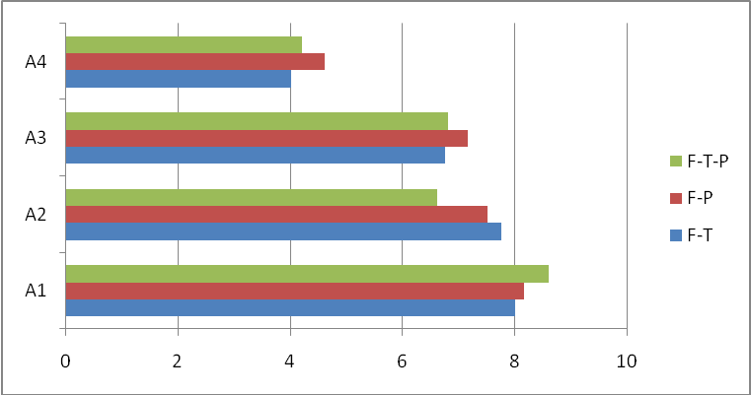
Figure 1. Graphical representation of accuracy scores with respect to site of lesion.
(Note: A1-Accuracy score for short adjacent dependency type sentences, A2- Accuracy score for short non-adjacent dependency type sentences, A3-Accuracy score for long adjacent dependency type sentences and A4- Accuracy score for long non-adjacent dependency type sentences; F-T-P=Fronto-Temporo-Parietal involvement, F-P=Fronto-Parietal involvement and F-T= Fronto-Temporal involvement)

Inferring from Figure 1, it can be observed that participants with lesions involving fronto-parietal regions performed relatively better in processing the stimuli sentences, except in A1 (accuracy score for short adjacent dependency type sentences) and A2 (accuracy score for short non-adjacent dependency type sentences) condition, wherein participants with fronto-temporo-parietal involvement and those with fronto-temporal were more accurate respectively. In processing short adjacent dependency type sentences, participants with fronto-temporo-parietal involvement had greater accuracy while those with fronto-temporal involvement had the least. In processing short non-adjacent dependency type sentences, participants with fronto-temporal involvement had greater accuracy while those with fronto-temporo-parietal involvement were least accurate. Participants with fronto-parietal were more accurate in processing long adjacent dependency & non-adjacent dependency condition while those with fronto-temporal involvement performed poorly.
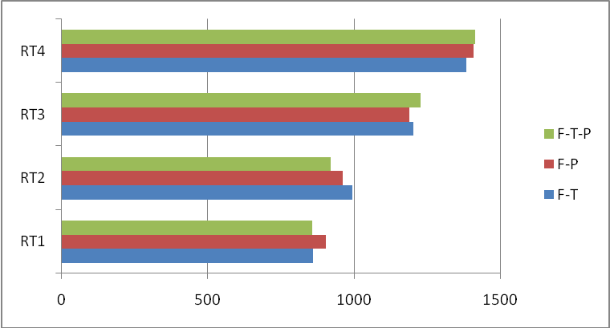
Figure 2. Graphical representation of reaction time with respect to site of lesion.
(Note: RT1-Reaction time for short adjacent dependency type sentences, RT2- Reaction time for short non-adjacent dependency type sentences, RT3-Reaction time for long adjacent dependency type sentences and RT4- Reaction time for long non-adjacent dependency type sentences).
From Figure 2, it can be observed that in RT1 (reaction time for short adjacent dependency type sentences) condition, participants with fronto-temporo-parietal involvement and those with fronto-temporo involvement had lesser/faster reaction time when compared to participants with fronto-parietal involvement. In RT2 (reaction time for short non-adjacent dependency type sentences) condition, participants with fronto-temporo-parietal involvement had faster reaction time, followed by those with fronto-parietal and fronto-temporal involvements respectively. In RT3 (reaction time for long adjacent dependency type sentences) condition, participants with fronto-parietal involvement had faster reaction time, followed by those with fronto-temporal involvement and with fronto-temporo-parietal involvement respectively. In RT4 (reaction time for long non-adjacent dependency type sentences) condition, participants with fronto-temporal involvement had faster reaction time, followed by those with fronto-parietal and fronto-temporo-parietal involvement respectively.

Cause

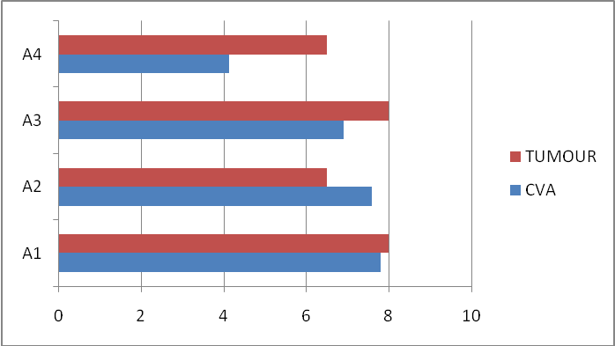
Figure 3. Graphical representation of accuracy scores with respect to cause of aphasia.

It can be observed from Figure 3 that participants with tumour were more accurate in sentence processing than participants with CVA, except in A2 condition, where it was vice versa. Figure 4 indicates that participants with CVA were faster is sentence processing in RT1 and RT2 condition, while participants with tumour were faster in sentence processing in RT3 and RT4 condition.
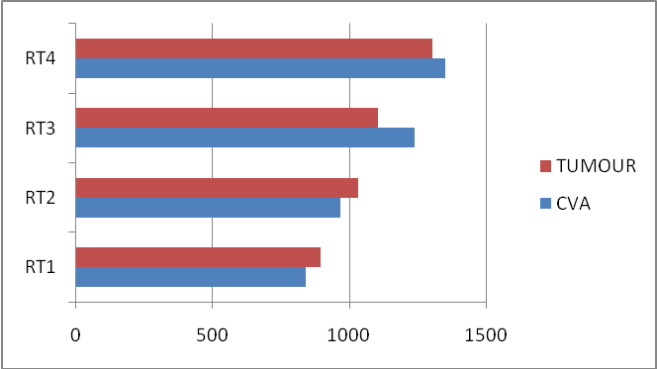
Figure 4. Graphical representation of reaction time with respect to cause of aphasia.

Education
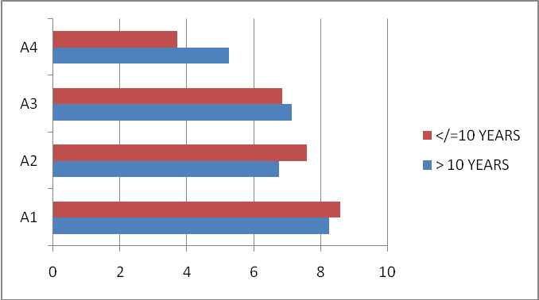
Figure 5. Graphical representation of accuracy scores with respect to education.
Figure 5 suggests that participants with exposure to education greater than 10 years, were more accurate in sentence processing in A3 and A4 condition, whereas in A1 and A2 condition, it was vice versa.

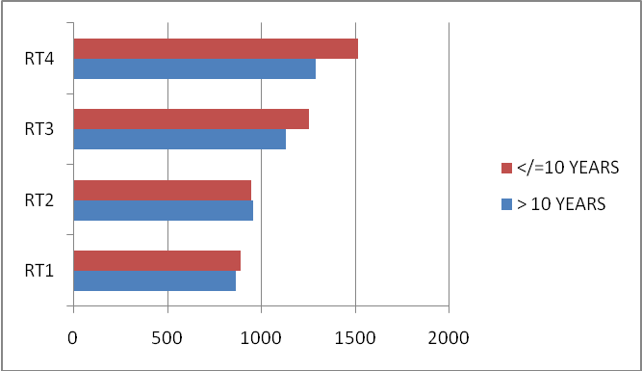
Figure 6. Graphical representation of mean reaction time with respect to education.
From Figure 6, it can be observed that participants with greater than 10 years exposure to education had faster reaction time, except in RT2 condition, in which both groups (>10 years and </=10 years) had almost similar reaction times.

Number of languages known
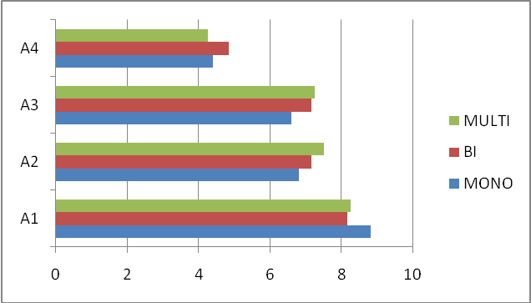
Figure 7. Graphical representation of accuracy scores with respect to number of languages known.
(Note: Multi-Multilingual; Bi-Bilingual; Mono-Monolingual)
From Figure 7, it can be observed that participants who are multi-linguals had greater accuracy, followed by bilinguals and monolinguals respectively. However, in A4 condition, bilinguals had greater accuracy in syntactic judgement.

Discussion
The aim of the study was to explore the processing of adjacent and non-adjacent dependencies among PWBA, through a sentence processing task. The results of the study revealed few insights regarding sentence processing among PWBA, which are discussed in the following section.
PWBA performed poorer in the non-adjacent dependency condition, which reveals that the participants are less sensitive to syntactic-agreement tracking. This finding adds strength to the Double Dependency Hypothesis (DDH) which states impaired processing in sentences with two dependencies, especially in distant/ non-adjacent dependencies. Linguistic aspects are most likely to influence in this case as Kannada a Dravidian language is agglutinative in nature with rich use of morphemes and has more preference for agreement tracking between dependencies in a sentence. Such grammatical details, add on to the processing load, thereby making sentence processing a cognitively taxing task. Hence, the syntactic sequential learning seems to be affected in persons with Broca’s aphasia. This finding is in line with that of a study done by Christiansen, Kelly, Shillcock, and Greenfield (2010), wherein there was no evidence of sequential syntactic processing among agrammatic individuals. Zimmerer, Cowell and Varley (2014) found that artificial grammar learning of dependencies in visual mode is affected in some persons with aphasia and relatively preserved in others. The inconsistencies in findings of the studies done in similar lines, is due to variable inclusion criteria, heterogeneity of deficits among persons with agrammatic aphasia and methodological differences.
It was found that PWBA took more time to judge sentences in non-adjacent dependency condition, than the adjacent dependency condition, especially in long sentences. This reveals poor syntactic agreement tracking especially in long sentences, which can be attributed to deficits in working memory, procedural memory and cognitive-linguistic deficits among them.
When the individual data of the participants were correlated with their demographics, it is observed that multilinguals are better at sentence processing, which is line with previous studies (Halsband 2006; Filippi, Leech, Thomas, Green & Dick, 2012). As the participants of current study were all literate, collecting data among literate and illiterate persons with aphasia, would give an insight into the contribution of literacy in grammatical dependency processing. Thought it is an implicit process, one can explore the facilitatory effect of literacy (if any), which is one of the future direction of this initial investigation. It is also observed that participants with tumours performed better in syntactic judgement than those who had a history of CVA, which supports the literature in aphasia recovery and prognosis. Drawing links between the radiological findings and the results of the sentence processing task, it can be inferred that more the extent of lesion, the performance is relatively spared. Since the lesion is diffused and distributed among the regions, the performance is relatively spared than focal involvements. In the current study participants with fronto-temporal involvement performed poorer than participants with fronto-temporo-parietal. Hence, in addition to considering the extent of lesion structurally, such tasks help in providing insights regarding the lesion distribution and how well the lesion areas are able to compensate for their loss according to the task requirements. From the data obtained, it can be inferred that the participants were not able to track down the syntactic dependencies in sentences. Hence, dependency processing which is a cognitive-linguistic process seems to be affected in the participants of current study. This study focused on persons with Broca’s aphasia and revealed poor sentence processing in non-adjacent dependency condition. However, more data is needed to further investigate the effect of adjacent and non-adjacent dependencies in sentence processing among persons with Broca’s aphasia. The cognitive-linguistic abilities are more likely to be variable among persons with brain damage, than in neurotypical persons. Hence, it is important to account for the variabilities observed and track down the possible causal links, by supporting the findings with imaging and electrophysiological data. Overall, the study is an attempt to explore the syntactic dependency processing in persons with Broca’s aphasia in an agglutinative language like Kannnada. Similar studies can be carried out with artificial grammar learning paradigms and objective Evoked Response Potentials (ERPs), investigating sentence processing and sequential learning across different modalities such as auditory, visual and tactile.etc and correlating it with radiological impressions, which would result in an eclectic structural-functional linkage.
Conclusion
The current study investigated dependency processing among persons with Broca’s aphasia. The findings of the investigation will aid in designing appropriate training material during speech and language rehabilitation (eg. At sentence level, graded stimuli can be used with initial sentences consisting of adjacent dependencies) for persons with Broca’s aphasia. This would lead to development of systematic assessment and treatment protocol for persons with Broca’s aphasia, which would have a positive impact on their quality of life.

Acknowledgement
The authors would like to thank all the participants who participated in the study. We also like to thank Director, All India Institute of Speech and Hearing – Mysuru for providing required facilities to carry out the study.

Source of funding
This research received no specific grant from any funding agency, commercial or not-for-profit sectors.

Conflicts of interest
The authors have no conflicts of interest to disclose.

Ethical standards
Written informed consent was obtained from all the participants.

References
Aslin, R. N., & Newport, E. L. (2012). Statistical learning: From acquiring specific items to forming general rules. Current directions in psychological science, 21(3), 170-176.
Beretta, A., Schmitt, C., Halliwell, J., Munn, A., Cuetos, F., & Kim, S. (2001). The effects of scrambling on Spanish and Korean agrammatic interpretation: why linear models fail and structural models survive. Brain and Language, 79(3), 407-425.
Berndt, R. S., Mitchum, C. C., & Haendiges, A. N. (1996). Comprehension of reversible sentences in “agrammatism”: A meta-analysis. Cognition, 58(3), 289-308.
Buch-Kromann, M. (2006). Discontinuous grammar: A dependency-based model of human parsing and language learning (Doctoral dissertation, CBS Public university, Copenhagen, Denmark).
Burchert, F., De Bleser, R., & Sonntag, K. (2003). Does morphology make the difference? Agrammatic sentence comprehension in German. Brain and Language, 87(2), 323-342.
Caplan, D., & Futter, C. (1986). Assignment of thematic roles to nouns in sentence comprehension by an agrammatic patient. Brain and Language, 27(1), 117-134.
Caramazza, A., & Zurif, E. B. (1976). Dissociation of algorithmic and heuristic processes in language comprehension: Evidence from aphasia. Brain and language, 3(4), 572-582.
Caramazza, A., Capasso, R., Capitani, E., & Miceli, G. (2005). Patterns of comprehension performance in agrammatic Broca’s aphasia: A test of the Trace Deletion Hypothesis. Brain and language, 94(1), 43-53.
Christiansen, M. H., Kelly, M. L., Shillcock, R. C., & Greenfield, K. (2010). Impaired artificial grammar learning in agrammatism. Cognition, 116(3), 382-393.
Druks, J., & Marshall, J. C. (1995). When passives are easier than actives: Two case studies of aphasic comprehension. Cognition, 55(3), 311-331.
Filippi, R., Leech, R., Thomas, M. S., Green, D. W., & Dick, F. (2012). A bilingual advantage in controlling language interference during sentence comprehension. Bilingualism: Language and Cognition, 15(4), 858-872.
Gibson, E. (1998). Linguistic complexity: locality of syntactic dependencies.
Gordon, B. (1983). Lexical access and lexical decision: Mechanisms of frequency sensitivity. Journal of Verbal Learning and Verbal Behavior, 22(1), 24-44.
Grodzinsky, Y. (1986). Language deficits and the theory of syntax. Brain and language, 27(1), 135-159.
Grodzinsky, Y. (1990). Theoretical perspectives on language deficits. MIT press.
Grodzinsky, Y. (1995). Trace deletion, θ-roles, and cognitive strategies. Brain and language, 51(3), 469-497.
Halsband, U. (2006). Bilingual and multilingual language processing. Journal of Physiology-Paris, 99(4-6), 355-369.
Hinckley, J., & Nash, C. (2007). Cognitive assessment and aphasia severity. Brain and Language, 1(103), 195-196.
Hudson, R. A. (1995). Measuring Syntactic Difficulty. Unpublished paper. http://www.phon.ucl.ac.uk/home/dick/difficulty.htm (2007-3-31)
Hudson, R. A. (2007). Language Networks: The New Word Grammar. Oxford: Oxford University Press.
Isserlin, M. (1922). About agrammatisms. Journal of Neurology and Psychiatry , 75 (1), 332-410.
Linebarger, M. C. (1995). Agrammatism as evidence about grammar. Brain and Language, 50(1), 52-91.
Luzzatti, C., Raggi, R., Zonca, G., Pistarini, C., Contardi, A., & Pinna, G. D. (2002). Verb–noun double dissociation in aphasic lexical impairments: The role of word frequency and imageability. Brain and language, 81(1-3), 432-444.
Manner, G., Fromkin, V., & Cornell, T. (1993). Comprehension and acceptability judgments in agrammatism: Disruption in the syntax of referential dependency and the two-chain hypothesis. Brain and Language, 45, 340-370.
Mariën, P., Baillieux, H., De Smet, H. J., Engelborghs, S., Wilssens, I., Paquier, P., & De Deyn, P. P. (2009). Cognitive, linguistic and affective disturbances following a right superior cerebellar artery infarction: a case study. Cortex, 45(4), 527-536.
Mel’cuk, I. (2003). Levels of dependency in linguistic description: Concepts and problems. Dependency and Valency. An International Handbook of Contemporary Research, 1, 188-229.
Ninio, A. (2006). Language and the Learning Curve: A new theory of syntactic development.Oxford: Oxford University Press.
Nivre, J.(2006). Inductive Dependency Parsing. Dordrecht: Springer.
Peirce, J. W. (2009). Generating stimuli for neuroscience using PsychoPy. Frontiers in neuroinformatics, 2, 10.
Pick, A. (1913). The agrammatic speech disorders: Vol. I.
Saffran, J. R. (2002). Constraints on statistical language learning. Journal of Memory and Language, 47(1), 172-196.
Saffran, J. R., Aslin, R. N., & Newport, E. L. (1996). Statistical learning by 8-month-old infants. Science, 274(5294), 1926-1928.
Schwartz, M. F., Saffran, E. M., & Marin, O. S. (1980). The word order problem in agrammatism: I. Comprehension. Brain and language, 10(2), 249-262.
Seniów, J., Litwin, M., & Leśniak, M. (2009). The relationship between non-linguistic cognitive deficits and language recovery in patients with aphasia. Journal of the Neurological Sciences, 283(1-2), 91-94.
Shyamala, K. C. & Vijayashree (2008). Standardization of Western Aphasia Battery-Kannada. A project under AIISH research fund submitted to All India Institute of Speech and Hearing, Mysore.
Veeramani, P., & Rathinaswamy, R. (2019). Statistical learning of dependencies in children with specific language impairment: An exploratory study. International Journal of Research Studies in Language Learning Advance online publication. doi: 1-15. 10.5861/ijrsll.2019.3015.
Yarbay Duman, T., Altınok, N., & Maviş, İ. (2016). Grammar and cognition: deficits comprehending counterfactuals in Turkish individuals with Broca’s aphasia. Aphasiology, 30(7), 841-861.
Zimmerer, V. C., Cowell, P. E., & Varley, R. A. (2014). Artificial grammar learning in individuals with severe aphasia. Neuropsychologia, 53, 25-38.

Figure legends
Figure 1. Graphical representation of accuracy scores with respect to site of lesion.
Figure 2. Graphical representation of reaction time with respect to site of lesion.
Figure 3. Graphical representation of accuracy scores with respect to cause of aphasia.
Figure 4. Graphical representation of reaction time with respect to cause of aphasia.
Figure 5. Graphical representation of accuracy scores with respect to education.
Figure 6. Graphical representation of mean reaction time with respect to education.
Figure 7. Graphical representation of accuracy scores with respect to number of languages known.

Table 1. Demographics of participants.
S.No | Age/  Gender | WAB-K  AQ score | Education  (years) | Mono/  Bi/  Multi-  Lingual | Vocation | Treatment  Period  (If started) | Radiological findings  (CT Scan)
1 | 68/M | 42.4 | 9 | Multi | Carpenter | Not yet | Hypodensities in left hemisphere fronto-parietal cortex and underlying white matter
2 | 40/M | 56 | 5 | Bi | Agriculture | 1 month | Left MCA territory infarct involving fronto-parietal region
3 | 31.6/M | 44 | 7 | Mono | Agriculture | Not yet | Left MCA territory infarct involving fronto-temporo-parietal region
4 | 50/M | 36 | 10 | Mono | Agriculture | 2.5 years | Left MCA infarct involving fronto-temporo-parietal region
5 | 56.6/M | 42 | 8 | Mono | Agriculture | Not yet | Left MCA territory infarct involving fronto-temporal region
6 | 41/M | 46.4 | 12 | Bi | Electrician | Not yet | Left MCA territory infarct involving fronto-parietal region
7 | 28/M | 48 | 12 | Multi | Buiseness | Not yet | Left MCA territory infarct involving fronto-temporo-parietal region
8 | 35/M | 42.8 | 10 | Bi | Agriculture | Not yet | Hypodensities in Left hemisphere infarct involving fronto-temporo-parietal region
9 | 39/M | 42.4 | 25 | Bi | Lecturer | Not yet | Left ACA territory infarct involving fronto-parietal region
10 | 26/M | 34 | 20 | Multi | MBA student | Not yet | Left MCA territory infarct involving fronto-parietal region
11 | 48/M | 38 | 15 | Mono | Agriculture | 2 weeks | Left MCA territory infarct involving fronto-temporal region
12 | 54/M | 42 | 10 | Bi | Business | 1 month | Left MCA territory involving fronto-temporo-parietal region
13 | 37/F | 36 | 12 | Bi | Homemaker | Not yet | Left hemisphere oligodendroglioma involving fronto-parietal region
14 | 33.5/F | 44 | 20 | Multi | Buiseness (Crafts-handloom) | 3 months | Left MCA involving fronto-temporal region
15 | 42/F | 48 | 11 | Mono | Homemaker | 2 months | Left hemisphere oligodendroglioma involving fronto-temporo-parietal region
(Note: Participants 12 and 14 had a history of tumour, and the others were known cases of CVA (Cerebro Vascular Accidents). Adequate motor strength of the dominant hand (all participants were right handed) was ensured with physiotherapist and occupational therapist findings and impression, so as to include them in the study).

Table 2. Example of stimuli sentences.
Set A (Short) |  | Set B (Long)
Adjacent  dependency | Non-adjacent  Dependency | Adjacent  Dependency | Non-adjacent  dependency
/avalʊ/ /nagʊt̪a:le/ | /avanʊ/ /na:le/ /barʊt̪a:ne/ | /Ive/ /kap̂ʊ/ /bɛk̂ʊgalʊ/ | /avarʊ/ /ɪbrʊ/  /tʃana:gI/ /ha:dʊt̪a:re/

Table 3. Accuracy (A) (on a score of 10) and mean reaction time (RT) of each participant for different types of sentences.

S.No | Short sentences |  |  |  | Long sentences
S.No | Adjacent  Dependency |  | Non-adjacent  Dependency |  | Adjacent  Dependency |  | Non-adjacent  Dependency
S.No | A | RT (ms) | A | RT (ms) | A | RT (ms) | A | RT (ms)
1 | 9 | 927.79 | 8 | 952.12 | 6 | 1392.46 | 3 | 1678.61
2 | 8 | 893.22 | 9 | 945 | 9 | 1154.39 | 3 | 1536.56
3 | 8 | 910.47 | 6 | 959.62 | 7 | 1308.72 | 4 | 1541.03
4 | 9 | 883.51 | 7 | 997.39 | 5 | 1472.33 | 3 | 1708.79
5 | 9 | 892.78 | 9 | 937.40 | 7 | 1104.46 | 3 | 1441.11
6 | 9 | 879.18 | 8 | 890.05 | 6 | 1157.62 | 5 | 1296
7 | 9 | 762.90 | 6 | 787.45 | 8 | 996.37 | 4 | 1106.23
8 | 9 | 818.37 | 7 | 842.73 | 7 | 1259.69 | 5 | 1275.19
9 | 8 | 863.11 | 5 | 993.16 | 6 | 1158.01 | 5 | 1314.37
10 | 8 | 886.93 | 8 | 902.11 | 8 | 1107.28 | 6 | 1216.79
11 | 9 | 927.00 | 6 | 1042.36 | 6 | 1144.87 | 5 | 1530.07
12 | 8 | 904.86 | 7 | 1015.92 | 7 | 1098.83 | 5 | 1437.58
13 | 7 | 971.33 | 7 | 1082.78 | 8 | 1160.00 | 6 | 1403.71
14 | 7 | 807.29 | 8 | 997.34 | 7 | 1280.66 | 4 | 1279.55
15 | 9 | 823.00 | 6 | 982.67 | 8 | 1049.81 | 7 | 1207.87

