**All India Institute of Speech and Hearing: Mysuru-06**

**Library and Information Centre**

**Manual for Updating Faculty Profile**

1. Go to [www.aiish.ac.in](http://www.aiish.ac.in) and click **Faculty Profile System** linkavailable on the left side bar
2. Search for your first name by selecting the ‘Expert Name’ field from the pop-down menu of the search box ( Figure 1)

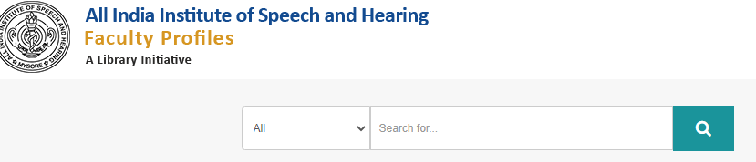

**Figure 1**

1. From the resulting Profile Page (Figure 2), click the tab, **View** **Profile**

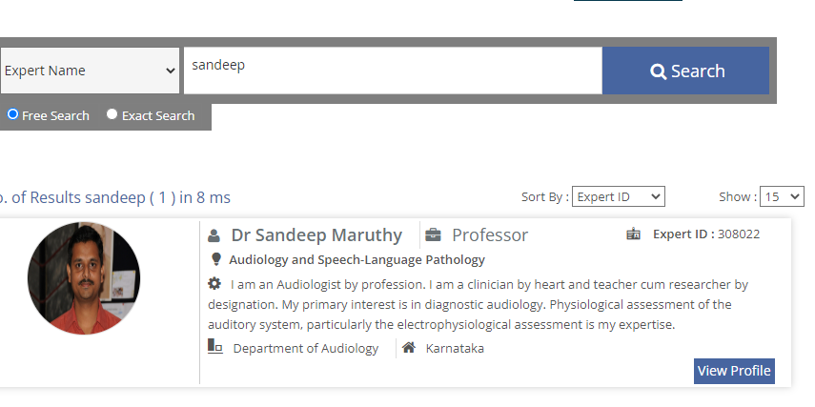

Figure 2

1. From the resulting page (Figure 3), click the tab **Edit Profile**

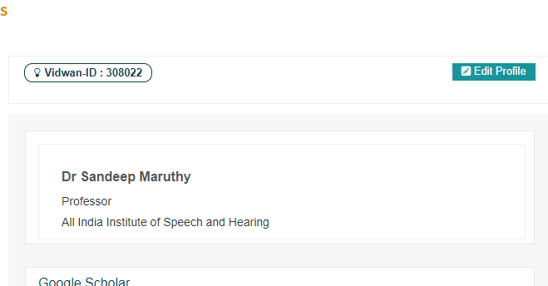

Figure 3

1. Now, the system will prompt for ‘**Username and Password**’ (Figure 4). Click the **Forgot password** option.

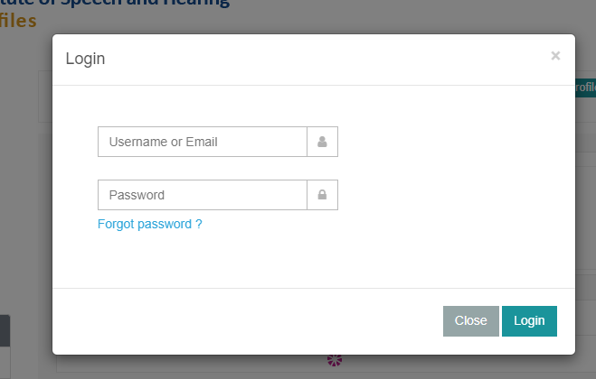

Figure 4

1. In the resulting **Password Recovery** box (Figure 5), enter your AIISH email id

and reset the account using the auto-generated email message

1. Now, login using the new password created and the email id as username and update/edit the required entries.