**ALL INDIA INSTITUTE OF SPEECH AND HEARING, MYSURU-6**

**DEPARTMENT OF CLINICAL SERVICES**

# MONTHLY REPORT / STATISTICS FOR THE MONTH OF AUGUST 2021 (01.08.2021 to 31.08.2021)

1. **REGISTRATION AT THE DEPARTMENT**
2. **Number of Clients registered**

|  |  |  |
| --- | --- | --- |
|  | Speech Language OPD | 402 |
|  | Audiology OPD | 1230 |
|  | New Cases | **1632** |
|  | Retrieval of repeat case files | 2914 |
|  | Total Cases | **4546** |
|  | No. of Working days | 21 |

1. **Details of Registration**

|  |  |
| --- | --- |
| Total requests for new registration | 1677 |
| Total registered as new clients | 1632 |
| *No. of cases Rejected | 45 |
| Case files requested for revisit | 3022 |
| Case files retrieved for revisit | 2914 |
| Case files requested for clinical purpose | 263 |
| Case files retrieved for clinical purpose | 263 |
| Case files requested for research purpose | 72 |
| Case files retrieved for research purpose | 72 |
| Case files requested for academic purpose | 00 |
| Case files retrieved for academic purpose | 00 |
| Case files requested for Legal purpose (Court) | 00 |
| Case files retrieved for Legal purpose (Court) | 00 |
| Total Requests for Medical Records Corrections | 25 |
| Total Corrections done in the Medical Records | 25 |
| Total Case files requested  (Revisit, clinical purpose, research purpose, academic purpose) | 5059 |
| Total Case files retrieved  (Revisit, clinical purpose, research purpose, academic purpose) | 4906 |

*\*Rejected – Not related to Communication Disorders.*

**Date wise statistics for the month of Aug, 2021**

|  |  |  |  |  |  |  |  |  |  |
| --- | --- | --- | --- | --- | --- | --- | --- | --- | --- |
| **Sl. No** | **Dates** | **New Cases** | | | | **Repeat Cases** | | | **Grand total** |
| Walk-in | Tele | Total | Walk-in | | Tele | Total |
|  | 01-Aug-21 | 0 | 0 | 0 | 0 | | 0 | 0 | 0 |
|  | 02- Aug -21 | 120 | 0 | 120 | 163 | | 7 | 170 | 290 |
|  | 03- Aug -21 | 85 | 0 | 85 | 167 | | 3 | 170 | 255 |
|  | 04- Aug -21 | 72 | 0 | 72 | 136 | | 0 | 136 | 208 |
|  | 05- Aug -21 | 81 | 0 | 81 | 101 | | 18 | 119 | 200 |
|  | 06- Aug -21 | 60 | 0 | 60 | 107 | | 3 | 110 | 170 |
|  | 07- Aug 21 | 0 | 0 | 0 | 0 | | 0 | 0 | 0 |
|  | 08- Aug -21 | 0 | 0 | 0 | 0 | | 0 | 0 | 0 |
|  | 09- Aug -21 | 78 | 0 | 78 | 177 | | 8 | 185 | 263 |
|  | 10- Aug -21 | 67 | 1 | 68 | 175 | | 1 | 176 | 244 |
|  | 11- Aug -21 | 79 | 4 | 83 | 150 | | 1 | 151 | 234 |
|  | 12- Aug -21 | 76 | 0 | 76 | 103 | | 2 | 105 | 181 |
|  | 13- Aug -21 | 56 | 0 | 56 | 95 | | 0 | 95 | 151 |
|  | 14- Aug -21 | 0 | 0 | 0 | 0 | | 0 | 0 | 0 |
|  | 15- Aug -21 | 0 | 0 | 0 | 0 | | 0 | 0 | 0 |
|  | 16- Aug -21 | 99 | 1 | 100 | 174 | | 11 | 185 | 285 |
|  | 17- Aug -21 | 85 | 0 | 85 | 166 | | 0 | 166 | 251 |
|  | 18- Aug -21 | 56 | 0 | 56 | 122 | | 2 | 124 | 180 |
|  | 19- Aug -21 | 51 | 0 | 51 | 45 | | 1 | 46 | 97 |
|  | 20- Aug -21 | 0 | 0 | 0 | 0 | | 0 | 0 | 0 |
|  | 21- Aug -21 | 0 | 0 | 0 | 0 | | 0 | 0 | 0 |
|  | 22- Aug -21 | 0 | 0 | 0 | 0 | | 0 | 0 | 0 |
|  | 23- Aug -21 | 110 | 0 | 110 | 164 | | 5 | 169 | 279 |
|  | 24- Aug -21 | 75 | 0 | 75 | 153 | | 0 | 153 | 228 |
|  | 25- Aug -21 | 73 | 3 | 76 | 126 | | 2 | 128 | 204 |
|  | 26- Aug -21 | 65 | 1 | 66 | 92 | | 1 | 93 | 159 |
|  | 27- Aug -21 | 58 | 0 | 58 | 72 | | 1 | 73 | 131 |
|  | 28- Aug -21 | 0 | 0 | 0 | 0 | | 0 | 0 | 0 |
|  | 29- Aug -21 | 0 | 0 | 0 | 0 | | 0 | 0 | 0 |
|  | 30- Aug -21 | 92 | 0 | 92 | 181 | | 2 | 183 | 275 |
|  | 31- Aug -21 | 84 | 0 | 84 | 175 | | 2 | 177 | 261 |
| **Total** | | **1622** | **10** | **1632** | **2844** | | **70** | **2914** | **4546** |

**District wise distribution of cases (Karnataka) registered during the month of Aug, 2021**

|  |  |  |  |  |
| --- | --- | --- | --- | --- |
| **Sl. No** | **Districts Descriptions** | **Male Cases** | **Female Cases** | **Total Cases** |
|  | Bagalkote | 4 | 2 | 6 |
|  | Bangalore | 49 | 19 | 68 |
|  | Belgaum | 5 | 3 | 8 |
|  | Bellary | 12 | 8 | 20 |
|  | Bidar | 1 | 2 | 3 |
|  | Bijapur | 65 | 32 | 97 |
|  | Chamrajanagar | 1 | 0 | 1 |
|  | Chikkaballapur | 15 | 4 | 19 |
|  | Chikkmagalore | 7 | 1 | 8 |
|  | Chitradurga | 22 | 10 | 32 |
|  | Coorg | 2 | 1 | 3 |
|  | Dakshina Kannada | 7 | 2 | 9 |
|  | Davangere | 3 | 2 | 5 |
|  | Dharwad | 1 | 1 | 2 |
|  | Gadag | 0 | 0 | 0 |
|  | Gulbarga | 45 | 22 | 67 |
|  | Hassan | 5 | 2 | 7 |
|  | Haveri | 2 | 0 | 2 |
|  | Kolar | 4 | 0 | 4 |
|  | Koppala | 88 | 56 | 144 |
|  | Mandya | 370 | 269 | 639 |
|  | Mysore City | 228 | 136 | 364 |
|  | Mysore District | 5 | 2 | 7 |
|  | Raichur | 24 | 9 | 33 |
|  | Ramanagara | 11 | 7 | 18 |
|  | Shivamoga | 14 | 8 | 22 |
|  | Tumkur | 0 | 0 | 0 |
|  | Udupi | 2 | 0 | 2 |
|  | Uttar kannada | 1 | 1 | 2 |
|  | Yadagiri | 2 | 0 | 2 |
|  | Total | **995** | **599** | **1594** |

**States wise distribution of cases registered during the month of Aug, 2021**

|  |  |  |  |  |
| --- | --- | --- | --- | --- |
| **Sl. No** | **States Descriptions** | **Male Cases** | **Female Cases** | **Total Cases** |
|  | Andra Pradesh | 4 | 1 | **5** |
|  | Arunachal Pradesh | 0 | 0 | **0** |
|  | Assam | 1 | 0 | **1** |
|  | Bihar | 1 | 0 | **1** |
|  | Chattisgarh | 0 | 0 | **0** |
|  | Delhi | 0 | 0 | **0** |
|  | Goa | 0 | 0 | **0** |
|  | Gujarat | 0 | 0 | **0** |
|  | Hariyana | 0 | 0 | **0** |
|  | Himachal Pradesh | 0 | 0 | **0** |
|  | Jarkhand | 1 | 0 | **1** |
|  | Karnataka | 995 | 599 | **1594** |
|  | Kashmir | 0 | 0 | **0** |
|  | Kerala | 15 | 4 | **19** |
|  | Madhya Pradesh | 1 | 0 | **1** |
|  | Maharastra | 2 | 2 | **4** |
|  | Manipur | 0 | 0 | **0** |
|  | Meghalaya | 0 | 0 | **0** |
|  | Nagaland | 0 | 0 | **0** |
|  | Mizoram | 0 | 0 | **0** |
|  | Orissa | 2 | 0 | **2** |
|  | Punjab | 0 | 0 | **0** |
|  | Rajasthan | 0 | 0 | **0** |
|  | Sikkim | 0 | 0 | **0** |
|  | Tamil Nadu | 3 | 0 | **3** |
|  | Telangana | 0 | 0 | **0** |
|  | Tripur | 0 | 0 | **0** |
|  | Union Territories | 1 | 0 | **1** |
|  | Uttar Pradesh | 0 | 0 | **0** |
|  | Uttaranchal | 0 | 0 | **0** |
|  | West Bengal | 0 | 0 | **0** |
| **Grand Total** | | **1026** | **606** | **1632** |

**II. DIAGNOSTIC AND THERAPY SERVICES**

1. **SPEECH-LANGUAGE EVALUATION:**

**Speech-Language Assessment for Walk-in clients (At Department of Clinical Services)**

|  |  |  |  |  |  |  |  |  |  |  |
| --- | --- | --- | --- | --- | --- | --- | --- | --- | --- | --- |
| Evaluations | | **PEDIATRIC**  **(0-15YRS)** | | **ADULT**  **(15-50YRS)** | | **GERIATRIC**  **(50 & ABOVE)** | | TOTAL | | **HINDI CASES** |
| M | F | M | F | M | F | NEW | REPEAT |
| Language | CLD | 180 | 49 | 00 | 00 | 00 | 00 | 229 | 59 | **20** |
| ALD | 00 | 00 | 26 | 12 | 03 | 03 | 44 | 03 |
| Articulation | | 12 | 02 | 04 | 01 | 03 | 01 | 23 | 10 |
| Voice | | 02 | 03 | 04 | 05 | 06 | 03 | 23 | 06 |
| Fluency | | 23 | 01 | 07 | 01 | 00 | 00 | 32 | 05 |
| Multiple | | 04 | 00 | 01 | 00 | 00 | 00 | 5 | 00 |
| Normal | | 00 | 04 | 01 | 02 | 02 | 01 | 10 | 02 |
| TOTAL M/F | | **221** | **59** | **43** | **21** | **14** | **8** | **366** | **85** |
| Over all Total New | | **280** | | **64** | | **22** | |
| Overall Total New | | **366** | | | | | | | |
| Overall Total Repeat | | **85** | | | | | | | |
| Overall Total New & Repeat | | **451** | | | | | | | | |

**Detailed Speech-Language Evaluation for Walk-in clients**

|  |  |  |  |
| --- | --- | --- | --- |
|  | **No. of New Clients seeking** | **No. of Clients successfully completed** | **Percentage**  **(%)** |
| Speech-Language Evaluation | 463 | 366 | **79** |
| Re-evaluation | 91 | 85 | **93.40** |
| Total | **554** | **451** | **81.40** |

***Note: the no. of clients could not be completed successfully (79%) because: Many clients were sent back if they exhibited symptoms like cold/throat pain and Few clients given appointment because students clinician were not there and only staff did evaluation (only 5-6 staff at a time)***

1. **PT/OT statistics:**

|  |  |  |  |  |  |  |  |
| --- | --- | --- | --- | --- | --- | --- | --- |
| **EVALUATION** | **PEDIATRIC**  **(0-15 YEARS)** | | **ADULT**  **(16- 50 YEARS)** | | **GERIATRIC**  **(50& ABOVE)** | | **TOTAL** |
|  | OPD | Tele | OPD | Tele | OPD | Tele |  |
| Physiotherapy evaluation | 54 | 00 | 04 | 00 | 06 | 00 | **64** |
| Occupational therapy evaluation | 49 | 01 | 01 | 00 | 00 | 00 | **51** |
| **TOTAL** | **103** | **01** | **05** | **00** | **06** | **00** | **115** |

|  |  |  |  |  |  |  |  |  |  |  |  |  |  |  |  |  |  |  |  |  |  |  |  |  |  |  |  |  |  |  |  |  |  |  |  |  |  |  |  |  |  |
| --- | --- | --- | --- | --- | --- | --- | --- | --- | --- | --- | --- | --- | --- | --- | --- | --- | --- | --- | --- | --- | --- | --- | --- | --- | --- | --- | --- | --- | --- | --- | --- | --- | --- | --- | --- | --- | --- | --- | --- | --- | --- |
| **THERAPY** | | **PEDIATRIC**  **(0-15 YEARS)** | | | | | | **ADULT**  **(16- 50 YEARS)** | | | | | | | | | | **GERIATRIC**  **(50& ABOVE)** | | | | | | | | | **Total no. of case for PT/OT** | | | | | | | **Total no of therapy session** | | | | | | | |
| **CASES** | | | **SESSIONS** | | | **CASES** | | | | **SESSIONS** | | | | | **CASES** | | | | **SESSIONS** | | | | | |  | | | | | | |  | | | | | | |
| **R** | **T** | **R** | | **T** | **R** | | **T** | | **R** | | | **T** | | | **R** | | **T** | | **R** | **T** | | | | | **R** | | | | **T** | | | **R** | | | **T** | | | |
| PT | 10 | | 12 | 69 | | 63 | 02 | | 01 | | 20 | | | 06 | | | 01 | | 02 | | 06 | 03 | | | | 13 | | | | 15 | | | | 95 | | | 72 | | |
| OT | 17 | | 6 | 116 | | 34 | 00 | | 00 | | 00 | | | 00 | | | 00 | | 00 | | 00 | 00 | | | | 17 | | | | 06 | | | | 116 | | | 34 | | |
| Preschool PT | 00 | | 00 | 00 | | 00 |  | | | | | | | | | | | | | | | | | | 00 | | | | 00 | | | | 00 | | | 00 | | |
| Preschool OT | 00 | | 02 | 00 | | 09 | 00 | | | | 02 | | | | 00 | | | 09 | | |
| Total | **27** | | **20** | **185** | | **106** | **02** | | | **01** | | | **20** | | **06** | **01** | | | | **02** | **06** | | **03** | **30** | | | | **23** | | | | **211** | | | **115** | | |

|  |  |  |  |  |  |
| --- | --- | --- | --- | --- | --- |
|  | **Physiotherapy** | | **Occupational therapy** | | |
|  | Offline | Online | Offline | | Online |
| **No. of Clients seeking therapy** | 14 | 14 | 17 | | 08 |
| **No. of Clients availed therapy** | 14 | 14 | 17 | | 08 |
| **No. of Clients D.N.R** | 00 | 00 | 00 | | 00 |
| **No. of Clients discontinued** | 02 | 00 | 01 | | 00 |
| **No. of Clients successfully discharged** | 04 | 00 | 06 | | 01 |
| **No. of sessions allotted** | 108 | 93 | 139 | | 51 |
| **No. of sessions present** | 89 | 78 | 116 | | 43 |
| **No. of sessions absent** | 13 | 22 | 23 | | 08 |
| **Total no. of present case** | 167 | | | 159 | |
| **No. of sessions- Daily average** | 08 | | | 20 | |

**ASD OT Statistics:**

|  |  |  |  |  |  |  |  |
| --- | --- | --- | --- | --- | --- | --- | --- |
| **EVALUATION** | **PEDIATRIC**  **(0-15 YEARS)** | | **ADULT**  **(16- 50 YEARS)** | | **GERIATRIC**  **(50& ABOVE)** | | **TOTAL** |
| **OPD** | **TELE** | **OPD** | **TELE** | **OPD** | **TELE** |  |
| Occupational therapy evaluation | **30** | **0** | **0** | **0** | **0** | **0** | **30** |
| TOTAL | **30** | **0** | **0** | **0** | **0** | **0** | **30** |

|  |  |  |  |  |
| --- | --- | --- | --- | --- |
| **THERAPY** | **PEDIATRIC**  **(0-15 YEARS)** | | | |
| **CASES** | | **SESSIONS** | |
|  | **Walk-in** | **TELE** | **Walk-in** | **TELE** |
| Occupational Therapy | 3 | 9 | 17 | 58 |
| Preschool OT | 1 | 0 | 2 | 0 |
| Total | 4 | 9 | 19 | 58 |

|  |  |  |
| --- | --- | --- |
|  | OCCUPATIONAL | |
| OFFLINE | TELE |
| No. of Clients seeking therapy | 4 | 9 |
| No. of Clients availed therapy | 4 | 9 |
| No. of Clients D.N.R | 0 | 0 |
| No. of Clients discontinued | `1 | 0 |
| No. of Clients successfully discharged | 1 | 3 |
| No. of sessions allotted | 28 | 71 |
| No. of sessions present | 19 | 58 |
| No. of sessions absent | 9 | 13 |
| No. of sessions- Daily average | - | 03 |

1. **VISITING CONSULTANTS:**

|  |  |
| --- | --- |
| Pediatrician | 04 |
| Phonosurgeon | 00 |
| Dietician | 00 |
| Plastic Surgeon | 12 |
| Orthodontist | 12 |
| Neurologist | 16 |
| Orthopedician | 00 |

**V. Special Clinic/ Units:(Evaluations)**

|  |  |  |  |  |  |  |
| --- | --- | --- | --- | --- | --- | --- |
| **Special Clinic/ Unit** | | **PEDIATRIC**  **(0-15 YEARS)** | **ADULT**  **(15-50 YEARS)** | **GERIATRIC**  **(50&ABOVE)** | **Total** | |
| AAC | Evaluations | 15 | - | - | 15 | |
| *ASD | | 22 | - | - | 22 | |
| Voice Clinic | | - | - | - | - | |
| CAEPLD | | - | 05 | - | 05 | |
| Fluency | | 04 | - | - | 04 | |
| ISL | | - | | | | |
| *USOFA | | 12 | - | - | | 12 |
| *MSD | | 02 | - | - | | 02 |
| LD Clinic | | 05 | - | - | 05 | |
| Phonology Clinic | | 01 | - | - | 01 | |

*\*Also depicted in the activities of Dept. of SLP*

**VI. SPEECH AND LANGUAGE THERAPY CASES (through tele-mode only)**

# Summary of speech language therapy statistics

|  |  |  |
| --- | --- | --- |
| Sl. No | Particulars | Total |
|  | Total number of cases attended therapy | **429** |
|  | Total number of individual sessions | **1883** |
|  | Daily average sessions | **90** |
|  | Total number of sessions absent | **783** |
|  | Total Number sessions (attended + absent) | **2666** |
|  | A) Percentage sessions attended | **70.63%** |
|  | B) Percentage sessions absent | **29.36%** |
|  | Total number of Appointment given | **46** |
|  | Therapy appointment on daily average | **02** |

**Details of number of clients attending Speech Language Therapy (through tele-mode)**

|  |  |  |  |  |  |  |  |  |  |  |
| --- | --- | --- | --- | --- | --- | --- | --- | --- | --- | --- |
| **Disorders** | | **PEDIATRIC**  **(0-15 YRS)** | | **ADULT**  **(15-50YRS)** | | **GERIATRIC**  **(50 & ABOVE)** | | **Total** | **New Hindi Case** | **New DT** |
| **M** | **F** | **M** | **F** | **M** | **F** |  | **03** | **02** |
| Lang | CLD | 210 | 86 | 00 | 00 | 00 | 00 | **296** |
| ALD | 00 | 00 | 07 | 03 | 04 | 00 | **14** |
| Articulation/Phonology | | 23 | 08 | 05 | 02 | 03 | 00 | 41 |
| Voice | | 01 | 01 | 06 | 01 | 03 | 00 | 12 |
| Multiple | | 32 | 11 | 00 | 00 | 00 | 00 | **43** |
| MSD | | 11 | 01 | 00 | 00 | 00 | 00 | **12** |
| LD | | 06 | 03 | 00 | 02 | 00 | 00 | **11** |
| Total | | **283** | **110** | **18** | **8** | **10** | **00** | **429** |
| **G. Total** | | **413** | | **26** | | **10** | |
| **Total** | | **429** | | | | | | |
| **Over all total new** | | **31** | | | | | | |
| **Overall total repeat** | | **397** | | | | | | |
| **Over all total not reported** | | **49** | | | | | | |

**Speech Language Therapy Statistics:**

|  |  |  |  |  |  |  |
| --- | --- | --- | --- | --- | --- | --- |
| **Speech Language Therapy** | **New** | **Old** | **Total** | **Percentage of New Cases (%)** | **Percentage of Old Cases (%)** | **Remarks** |
| No. of Clients Assigned (Appt. Given) | **39** | **07** | **46** | 84.78% | 15.21% | **-** |
| **No. of Clients** attending therapy(Continued from April 27th) | **31** | **398** | **429** | 7.22% | 92.73% | **-** |
| **Total no of discharged** | **320** | | | | | |
| **Total no of discontinued** | **33** | | | | | |

* *Holiday on 20/08/2021(Moharam),CLD cases were absent due to health and network issues, 82 Students were absent due to personal, health and network issues in the month of August 2021, For IIMSC SLP,IIIBASLP AND IIBASLP Students clinical postings ended on 31/08/2021,for IMSC SLP Students on 13/08/2021,and for INTERNSHIP Students on 5/8/2021.*

|  |  |  |  |  |  |  |
| --- | --- | --- | --- | --- | --- | --- |
| **Cases assigned to students** | **IIMSC-SLP** | **IMSC-SLP** | **INTERNS** | **III BASLP** | **II BASLP** | **Total** |
| **No. of students** | 20 | 20 | 17 | 29 | 30 | **116** |
| **No. of cases assigned to students** | 168 | 96 | 62 | 78 | 74 | **478** |

**Special Clinic statistics: (through Tele-mode)**

|  |  |  |
| --- | --- | --- |
| Sl. No | Particulars | Total |
|  | Total number of cases attended therapy | 182 |
|  | Total number of individual sessions | 707 |
|  | Daily average sessions | 34 |
|  | Total number of sessions absent | 187 |
|  | Total Number of sessions Absent + Attended | 894 |
|  | A) Percentage sessions attended | 78.08% |
|  | B) Percentage sessions absent | 20.91% |
|  | Total number of Therapy Appointment given | 25 |
|  | Therapy appointment on daily average (Round off) | 01 |

**No. of Clients attending therapy in Special Clinics**

|  |  |  |  |  |  |  |  |  |  |
| --- | --- | --- | --- | --- | --- | --- | --- | --- | --- |
| **Disorders** | **PEDIATRIC**  **(0-15 YRS)** | | **ADULT**  **(15-50YRS)** | | **GERIATRIC**  **(50 & ABOVE)** | | **Total** | **NEW**  **HINDI**  **CASE** | **New Demonstration Therapy** |
| **M** | **F** | **M** | **F** | **M** | **F** | **-** | **03** |
| Fluency disorders | 40 | 06 | 16 | 03 | 00 | 00 | **65** |
| Autism | 80 | 15 | 00 | 00 | 00 | 00 | **95** |
| U-SOFA | 04 | 04 | 00 | 00 | 00 | 00 | **08** |
| AAC | 02 | 01 | 00 | 00 | 00 | 00 | **03** |
| Others (ADHD,MD) | 10 | 01 | 00 | 00 | 00 | 00 | **11** |
| ISL | 00 | 00 | 00 | 00 | 00 | 00 | **00** |
| **Total** | 136 | 27 | 16 | 03 | 00 | 00 | **182** |
| **G. Total** | **163** | | **19** | | **00** | |
| **Over all Total** | **182** | | | | | | | | | |
| **Overall total new** | **21** | | | | | | | | | |
| **Overall total repeat** | **161** | | | | | | | | | |
| **Overall total not reported** | **28** | | | | | | | | | |

**Details of number of sessions attended by the clients in Special Units/Clinics**

|  |  |  |  |  |  |  |  |
| --- | --- | --- | --- | --- | --- | --- | --- |
| **Disorders** | **PEDIATRIC**  **(0-15 YRS)** | | **ADULT**  **(15-50YRS)** | | **GERIATRIC**  **(50 & ABOVE)** | | **Total** |
| **M** | **F** | **M** | **F** | **M** | **F** |
| **Fluency disorders** | 161 | 21 | 77 | 06 | 00 | 00 | 265 |
| **Autism** | 294 | 65 | 00 | 00 | 00 | 00 | 359 |
| **Repaired cleft lip and Palate** | 17 | 15 | 00 | 00 | 00 | 00 | 32 |
| **AAC** | 02 | 01 | 00 | 00 | 00 | 00 | 03 |
| **Other (ADHD,MD)** | 46 | 02 | 00 | 00 | 00 | 00 | 48 |
| **ISL** | 00 | 00 | 00 | 00 | 00 | 00 | 00 |
| **Total** | 520 | 104 | 77 | 06 | 00 | 00 | **707** |
| **G. Total** | **624** | | **83** | | **00** | |
| **Total Sessions:** | **707** | | | | | | |

**Special Clinic Therapy Statistics:**

|  |  |  |  |  |  |  |
| --- | --- | --- | --- | --- | --- | --- |
| **Special Clinic Therapy** | **New** | **Repeat** | **Total** | **Percentage of New Cases (%)** | **Percentage of Old Cases (%)** | **Remarks** |
| No. of Clients Assigned (appt. given) | **22** | **03** | **25** | **88%** | **12%** | **-** |
| **No. of Clients** attending therapy | **21** | **161** | **182** | **11.53%** | **88.46%** | **-** |
| **Total no of Discharged** | **203** | | | | | |
| **Total no of Discontinued** | **08** | | | | | |

|  |  |  |  |  |
| --- | --- | --- | --- | --- |
| **Cases assigned to students** | **II M.Sc-SLP** | **I M.Sc.** | **INTERNS** | **Total** |
| **No. of students** | 10 | 10 | 18 | **40** |
| **no of cases assigned to students** | 86 | 60 | 64 | **210** |

**VII. Overall statistics of individuals availing therapeutic services in the Dept. of Clinical Services**

|  |  |  |  |  |  |  |
| --- | --- | --- | --- | --- | --- | --- |
| **Sl. No** | **Particulars** | **SLT** | **Special**  **Clinics** | **PT-OT** | **ASD unit OT** | **Grand Total** |
| 1 | Total number of cases attended therapy | 429 | 182 | 40 | 13 | **664** |
| 2 | Therapy appointment on daily average | 20 | 09 | 02 | 01 | **32** |
| 3 | Total number of individual sessions | 1883 | 707 | 226 | 99 | **2915** |
| 4 | Daily average (Sessions) | 90 | 33 | 11 | 05 | **139** |

**VIII. OTHER ACTIVITIES:**

1. **School visits by Speech Language pathologist (virtual mode)**
2. School details:

|  |  |  |  |  |
| --- | --- | --- | --- | --- |
| **Sl.**  **No.** | **School address** | **Date** | **No. of children followed up** | **Guidelines given to teachers** |
|  | Holy trinity School, Janathanagar, Mysore | 3.8.2021 | 11 | 4 |
|  | Bharatha sevadala, Saraswathipuram, Mysore | 5.8.2021 | 5 | 3 |
|  | Bharatha sevadala, Saraswathipuram, Mysore | 9.8.2021 | 6 | 3 |
|  | Indira school, Sharadadevi Nagar, Mysore | 11.8. 2021 | 4 | 2 |
|  | Govt. school, Jayanagar, Mysore | 17.8.2021 | 4 | 1 |
|  | Orchid school, R K. Nagar, Mysore | 20.8.2021 | 4 | 2 |
|  | **No. of schools followed up: 06** |  | **No. of children followed up: 34** | **Teachers: 15** |

1. Follow up of clients who availed DT in SLT &SCT:

|  |  |
| --- | --- |
| **Follow up** | **First time** |
| Cases follow up for online payment | 688 |
| To be followed up | - |
| Follow up done (phone) | - |
| Follow up of discontinued cases | - |
| Counseling regarding school placement | - |
| General correspondence for the public(through email) | 04 |

1. **Medical Social Services:**
2. Details of Counseling & Guidance carried out by MSW***.***

|  |  |
| --- | --- |
| Govt Concession /Certificate Counseling | *62* |
| CWF Counseling | *71* |
| Family & Individual Counseling | *08* |
| Referral & Guidance | *182* |
| CWF follow up | *02* |
| Discharge planning SLT | *05* |
| PTOT | *10* |

|  |  |  |
| --- | --- | --- |
| Certificate issued | | |
| **Sl. No** | **Issue of Certificates/Reports** | Total |
|  | Transfer certificates | 01 |
|  | Attendance certificates | 02 |
|  | School admission certificate | 01 |
| Language exemption certificate | 09 |
|  | **Total certificates** | **13** |

1. **Official**

|  |  |  |
| --- | --- | --- |
|  | Gen Correspondences (official purpose)(English + Hindi) | 20 |
|  | Correspondence by e-mail in English(official purpose) | 04 |

1. **Client Welfare Fund for the month of August, 2021**

|  |  |
| --- | --- |
| Clients seeking | **71** |
| Clients rejected | **19** |
| Clients availed | **19** |

1. **SEEK (*Student Enrichment and Expansion of Knowledge*) – Gyan Program**

**Webinar conducted: Nil**

2. **Revenue generated/collected for the month of Aug, 2021**

|  |  |
| --- | --- |
| ***Charges*** | ***Amount*** |
| Medical records | 64,680.00 |
| Therapy charges | 4,485.00 |
| Certificate/evaluations | 53,625.00 |
| *Payment of Hearing aids* | *37,59,675.00* |
| *Soft tube/ mould* | *3,13,660.00* |
| *Miscellaneous* | *1,67,240.00* |
| **Total** | **43,63,365.00** |

**4**

1. Seminars /**Invited talk** /Workshops/Guest Lecture/Orientation Program**:**

**(A). Invited Talk:** 02 Nos

1. Ms. Prathima S

* Served as resource person and delivered a lecture on ***“Oral Sensory Motor Issues and its Management”*** for caregivers of AIISH on 16.8.2021 from 2.00pm to 5.30pm organized by ASD unit MSD clinic and Dept. of Clinical Services.
* Served as resource person and delivered a lecture on ***“Overview of Communication Disorders in Kannada”*** on 17.8.2021to MSW students of K.R.Pete in the monthly lecture series

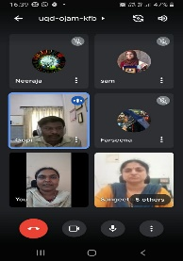

(B). Staff Enrichment Program: 01 No.

1. Ms. Neeraja Sunil – Served as resource person and delivered a talk on Lateral Medullary Syndrome: A case study” on 27.08.2021

**(C). Workshop and seminars attended**:

**Dr. Hema N.**

* Attended a Webinar on a topic “Tonal language Experience induced

functional asymmetric in pitch processing at the cortical and brainstem

level” organized by Department of Audiology, on 9th August 2021.

**Ms. Seema M** -

* Attended webinar on Satwik diet for women by the dietician Dr.Vinutha on 19.08.2021.
* Attended annual day and Graduation day through virtually on 9.8.2021

**Ms. Deepa Anand**

* Attended webinar on Satwik diet for women by the dietician Dr.Vinutha on 19.08.2021.

1. Others:

* OLI

|  |  |
| --- | --- |
| **Region A** | **01** |
| **Region B** | **0** |
| **Region C** | **29** |

1. Display of clinician’s names in Hindi-English bilingual form – 00
2. Display of client’s names in Hindi-English bilingual form –00
3. Evaluation report issued:20

**Material Development:**

1. Ms. Prathima S –

* Video on speech disorders in Kannada submitted to DCS on 19.8.2021

1. New Initiative:
2. **Procured Sensory integration panel for PT-OT section.**

The Sensory Learning Wall Panel is a 3-part board each of width 115 cm, height 115cm and thickness 15 cm. This wall mounted board contains activities that address various sensory issues of the child like tactile sensitivity, auditory sensitivity, visual tracking and scanning. The board also helps to develop hand functions as it encourages the child to explore and manipulate different items on the board. It will also be helpful in establishing the concept of clocks and time for children. This highly interactive board would be beneficial for children on the autism spectrum and with other conditions such as cerebral palsy, ADHD, Down’s syndrome who have sensory difficulties and poor hand functions.

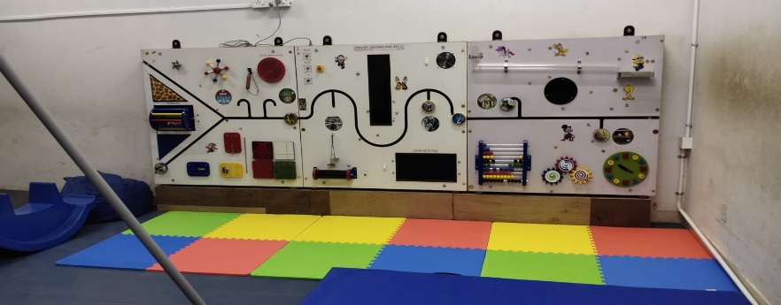

**2**

1. **Battery operated vehicle:**

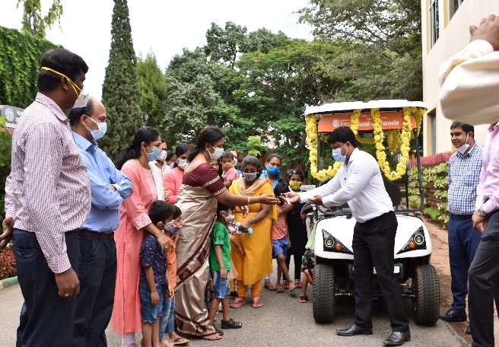All India Institute of speech and hearing, Mysuru caters to varieties of communication disorders. On an average of 600-800 clients avail services from the Department of Clinical Services and Special Education daily, including paediatric to the geriatric population. A newly procured battery-operated vehicle will facilitate the movement of the client availing the services among different sections/departments, hence it was inaugurated on the occasion of the 56th Annual Day celebrations of the Institute.  AIISH acknowledges the financial assistance from the Bank of Baroda in the procurement of the vehicle. This also would aid in eco-friendly and disable friendly environment for individuals with communication disorders.

1. **Public Education:**
2. **Visitors:** Nil
3. **Eminent Visitor:** Nil
4. **Short Term Training Programs/ Allied professionals (ENT, B.S.Ed etc...) –**

|  |  |  |  |
| --- | --- | --- | --- |
| **Sl. No.** | **Date** | **Name of the Institute/College** | **No. of Participants** |
| 1 | 23, 24, 25 August | Srinivas Institute of Medical Sciences and Research Center | 1 |

1. **d. REECH**: Nil
2. **Research**
3. **Research project ongoing: 05 Nos.**

|  |  |  |  |  |
| --- | --- | --- | --- | --- |
| **Sl. No** | **Title** | **Investigator/ Co-Investigator** | **Funding agency** | **Remarks** |
|  | Acoustic and Perceptual Analysis of Speech in Children with Stuttering – pre and post therapy comparison | **Dr. Sangeetha M, PI** | DST-2020 | Ongoing |
|  | Efficacy of Articulation and Prosody Intervention Program for Children with Hearing Impairment using Hearing Aids | **Dr. Sangeetha M ,CO-PI** | DST-2020 | Ongoing |
|  | Treatment Outcome of Group Therapy Program in Adults Who Stutter | **Dr. Sangeetha M, PI** | ARF,2021-22 | Ongoing |
|  | Behavioral and Electrophysiological (P300) correlates for Visual and Auditory Process in Alzheimers Diseases | **Dr. Hema N.** | ARF | Report writing |
|  | Development and Standardization of Western Aphasia Battery in Tamil | ARF | REPORT SUBMITTED on 22nd June 2021 |

**ARF proposal submitted : 03**

|  |  |  |  |  |
| --- | --- | --- | --- | --- |
|  | Development of an automatic speech processing based system for assessment of stuttering in Kannada speaking adults | Dr. Ajish K Abraham Dr. Anil Kumar Vuppala (IIIT Hyderabad)  &  Dr. Sangeetha Mahesh | ARF | Submitted for approval |
|  | Development and Validation of a Mobile Application Solution for Training Contrastive Stress in Kannada | **Ms. Prathima S, Co-PI** | ARF | RP submitted |
|  | Development and checking the effectiveness of training module for preschool parent empowerment program (PPEP) for children with special needs at AIISH | Dr. Alok Kumar Udadya  Dr. Palnaty Vijetha  **Ms. Prathima S.**  Ms. Ramanakumari PV | ARF | Intramural  (Approved and advertised for the post of Research Officer) |

**\**

1. **Doctoral thesis - Ongoing –5 nos.**

|  |  |  |  |
| --- | --- | --- | --- |
| **Sl. No.** | **Title** | **Name of the Candidate** | **Guide** |
|  | Role of Cognition in Developing Speaking Skills through use of multimedia. (Paper presentation is going on) | Ms. Maisaa Jamal Mahmoud Al-Shawawreh | **Dr. Hema. N** |
|  | Yet to decide | Yashaswini. B. C. |
|  | Pooja. C |
|  | Lakshmi priya. S. M. |
|  | A study on impact of Government welfare measures on the quality of life of persons with hearing impairment | **Mr. Prashanth R.** | Dr. Noor Mubashir |

1. **Dissertation Program –08 Nos.**

|  |  |  |  |
| --- | --- | --- | --- |
| **Sl. No.** | **Title** | **Name of the Candidate** | **Guide** |
|  | An overview of cluttering , a clinical tutorial for Speech-Language Pathology students | Joel Joseph | **Dr. Sangeetha M** |
|  | An overview of neurogenic stuttering , a clinical tutorial for Speech-Language Pathology students | Anshabaashiya |
|  | Treatment resource material for group therapy in adults who stutter | Shinsi |
|  | Development and validation of an online technique for Assessment of stuttering in Kannada speaking adults | Veda | **Dr. Sangeetha M (Co-guide)** |
|  | Development of Theory of Mind Activities for Individuals with Right Hemisphere Damage/Traumatic Brain Injury- A Virtual Training Manual | Ashritha M Hegde | **Dr. Hema N** |
|  | Development of Syntactic Linguistic Processing activities for individuals with aphasia- A Virtual Training Manual | Patel Siddhi Deepak |
|  | Development of Visuo-Spatial Organization Activities for Individuals with Right Hemisphere Damage/Traumatic Brain Injury- A Virtual Training Manual | Thirumanjari K |
|  | Adapted tasks and activities in virtual mode for cognitive training in adults with cognitive impairments | Sumathi N. | **Dr. Hema N.**  **(Co-guide)** |

**Papers Published: Nil**

**Paper Presentation: 01 No.**

* 1. Joanna, K. B., & **Prathima, S.** (2021). **Oral-Motor and Speech Therapy for Young Onset Parkinson’s Disease: A Case Study. Paper accepted for** 4th Asia Oceanian Congress on Neuro Rehabilitation (AOCNR 2021) to be held between 6th – 8th August 2021.

1. **CLINIC STAFF ACTIVITIES**

|  |  |  |  |  |  |
| --- | --- | --- | --- | --- | --- |
| **Sl. No** | **Staff** | **Diagnostics** | **Therapy** | | **CPC** |
| Lang | Special Clinic | **Nil** |
|  | Dr. Sangeetha M | 05 | 05 | 10 |
|  | Dr. Hema N | - | 24 | - |
|  | Ms. Geetha M.P | 33 | 03 | - | 01 |
|  | Dr. R. Gopi Sankar | 28 | 33 | - | - |
|  | Ms. Seema M | - | 43 | - | 06 |
|  | Ms. Rubby | ML | | | |
|  | Ms. Prathima S. | 10 | 24 | 02 | - |
|  | Mr. Pradeep Kumar | 74 | 06 | 02 | - |
|  | Ms. Deepa Anand | 12 | 58 | - | 01 |
|  | Ms. Farseena J. | - | 36 | 09 | - |
|  | Ms. Fathima Nida | 75 | 14 | 01 | 01 |
|  | Ms. Hina Fathima | 79 | 14 | 02 | 01 |
|  | Ms. Syeda Sameera Taj | 85 | 25 | 05 | 01 |
|  | Ms. Sivaranjani S | - | 34 | 04 | 09 |
|  | Ms. Neeraja Sunil | - | 50 | 05 | 02 |
|  | **Staff** | **Diagnostic** | **Therapy sessions** | | **-** |
|  | Mr. Santhosh J.R. | 20 | 12 | |
|  | Ms. Barathi K. | 22 | 16 | |
|  | Ms. Deeya C B | 25 | 15 | |
|  | Ms. Reneshiya Leena | 30 | 13 | |
|  | **Total** | **97** | **56** | |

**Academic Related**

**Dr. Sangeetha M**

1. Submitted the confidential work related to entrance examination the softcopy on 04.08.2021.
2. Discussed with four students about finalization of dissertation for the year 2020-21.
3. Submitted C2 marks for fluency disorders for the students of II B.ASLP ‘B’ section

On 23.08.2021

**Dr. Hema N.**

1. Serving as CBCS Coordinator
2. Mentor- II M Sc SLP (B section)
3. Co-ordinator-PG Diploma Programs
4. Member of BOE- Special Education (Combined Board)
5. Nominated as e-attestation Officer for online Scholarship
6. Research Guide for Ph D degree in Speech-Language Pathology
7. Handling classes –ALD – 4 hours/week

**Ms. Geetha M.P.**

1. Clinic Mentor for I M.Sc SLP & II M.Sc SLP (B Section)- students
2. Correction of PG students OPD work record sheets-ongoing
3. Prepared JRF students clinical OPD schedule
4. Submitted clinical IA for 2nd and 3rd B.ASLP students on 05.08.2021
5. Submitted clinical IA marks for 1st MSc SLP students
6. Prepared and finalized and verification of OPD MD work for UG & PG students
7. Served as examiner for clinical practical examination for 8th sem (Internship) students on 11.08.2021 at academic block from 9.00 am to 5.00 pm through virtual mode

**Dr. R. Gopi Sankar**

1. Clinical mentor for Internship & II M.Sc.
2. Conducted CPC classes for II M.Sc.
3. Nominated and served as examiner to conduct clinical practicum examination for VI semester B.ASLP students on 10.08.2021.

**Ms. Seema M**

1. Assigned and compiled C1and C2 marks for I M.Sc and II M.Sc(SLP) and UG students on16.8.2021
2. Orientation about therapy activities and documentation about therapy section for both UG/PG on 11.8.2021, 18.8.2021, 25.08.2021.

**Ms. Prathima S.**

1. Serving as clinic mentor III B. Sc (sec A & sec B)

**Mr. Pradeep Kumar P**

1. Attended II BASLP class mentor meeting

**Ms. Deepa Anand**

1. Clinic mentor for II B. ASLP and coordinating Practical classes.

**Clinical:**

**Dr. Sangeetha M.**

1. Chairperson fluency unit.
2. Attending OPD on every Wednesday A/N.
3. Therapy supervision and guidance to students.

**Dr. Hema N.**

1. Member Secretary of ‘Center for Adult and Elderly Persons with Language Disorders’
2. Attended regular OPD services.
3. Attended all the Clinical Conferences organized every Thursday by JC & CC Coordinator.
4. Group therapy and case assessment in CAEPLD unit on every wednesday.

**Ms. Geetha M.P.**

1. Member of the AAC Unit- Special Clinic
2. OPD Section- In charge
3. Evaluation reports verified :13
4. In charge for OPD direct and tele-assessment
5. Follow up on the compilation and tallying of daily and monthly statistics of OPD
6. Follow up on channelizing the OPD payments and Case history and evaluation management during assessment
7. Follow up on a client Report issuing with disability statement and language exemption.

**Dr. R. Gopi Sankar**

1. Serving as Member for voice clinic.
2. Serving as Member Secretary- USOFA
3. Prepared the CPC for M.Sc (2018-2020) and B. ASLP (2016-2020) &Verification of CPC for both M.Sc and B. ASLP.
4. Prepared the clinical training modules for student clinicians in SLP for publication is under process.

**Ms. Seema M**

1. 8 therapy videos were recorded for UG students training purposes.
2. Attended FU meeting on 3.08.2021.
3. Conducted SLT unit meeting on 5.08.2021 regarding activities

**Ms. Rubby – CCL**

**Mr. Pradeep Kumar P**

1. Counselling: 12
2. Clients evaluated in special clinic/units: 02
3. Evaluation reports issued: 14

**Ms. Prathima S**

1. Serving as Member Secretary- Phonology Clinic
2. Serving as Member Secretary- MSD Clinic

**Ms. Deepa Anand**

1. Tele-guidance to students and counseling to caregivers
2. Supervision of therapy cases through tele-mode
3. Reports (PT/LP/HT) verification
4. Member of ASD unit and Phonology clinic.

**Mr. Prashanth R**

1. Member of all the Special Clinics (9 nos.)
2. Discharge planning: Counseling
3. Compilation of client feedback

**Research:**

**Dr. Sangeetha M.**

1. Submitted AIISH ethical clearance documents related to two projects (DST & ARF) to the chairperson on 11.08.2021

**Administrative/Others**

**Dr. Sangeetha M**

1. Attended meeting with parents of various courses organized by Academic section on 02.08.2021
2. Conducted meeting with fluency unit members and discussed regarding the action plan for the year 2021-22 on 03.08.2021 and submitted the minutes of the meeting to the Director.
3. Coordinated the inauguration of battery operated vehicle, utilization its write up submitted to social media as a part of 56th Annual day Celebration with approval from the Director on 09.08.2021
4. Verified the minutes of the meeting conducted on 03.08.2021 about the action plan from Fluency unit for the year 2021-22, followed up circulation with the staff and submitted to the Director.
5. Served as reviewing officer for the permanent DCS staff, submitted the APAR rating on 12.08.2021
6. Served as reporting officer for Mr. Keerthi, PIO and submitted to the reviewing officer on 12.08.2021.
7. Coordinated the meeting with the DCS staff with the section in-charges regarding the RCI inspection on 23.08.2021
8. Coordinated the department monthly meeting and discussed issues related to OPD, therapy, PT-OT , registration, post COVID safety measures to be followed up with all section in-charges on 25.08.2021
9. Attended the SOP meeting on 27.08.2021
10. Submitted the 52nd SFC agenda from the Dept. of Clinical Services the three finalized one and submitted to the Director on 31.08.2021.

**Dr. Hema N.**

1. Question paper setting for the PG Entrance Exam of 2021-22 on 4th August 2021.
2. Submitted the action plan of the CAEPLD unit to the Department of Clinical Services on 27th August 2021.
3. Attended Department Meeting on 25th August 2021.
4. Updating the information related to DCS in the AIISH Website.
5. Routine clinical activities in the Department of Clinical Services.
6. Coordinate with a clinical summary report of clients with a communication disorder.
7. Attended Department Meeting on 25th August 2021
8. Evaluated the APAR of the staff of Department of Clinical Services

**Ms. Geetha M.P.**

1. Prepared PPT related to statistics for DCS notice board (from annual report 2020-2021)
2. Follow up on OPD test materials calibration – Monthly basis
3. Involved in computerization process of OPD section-on going
4. Follow up on Maintenance of registers of OPD
5. Follow up on Local purchase indents to OPD, Proforma copies to OPD.
6. Monitoring of work being carried out by Ms. Deepa Nimbalkar S (Management staff)/ Contract staff regarding data entry, case file management, preparation and dispatch of reports, Performa and score sheets managements, Maintenance of OPD rooms, stock maintenance, follow ups, work orders and other OPD related activities.
7. Attended meeting HOD-CS discussed regarding documents to be produced from OPD section for RCI inspection on 23.8.2021
8. Attended department meeting on 25.08.2021
9. PRF has been placed for Bayley language test for OPD assessment.

Dr. R. Gopi Sankar

1. Member canteen committee
2. Coordinating computerization- ongoing
3. Co-ordinated and Verified materials/documents submitted for NAAC from DCS.
4. Co-ordinated and Submitted the documents related to the department to academics for RCI inspection.
5. Attended meeting with the Director and U-SOFA chairperson related appointing additional consultant on 04.08.2021.
6. Co-ordinated with bank of Baroda manager with the release/ handing over the e-chart vehicles to the director on 9th August 20201.
7. Nominated to co-ordinate the purchase and distribution of sweet box for all the staffs and students on the account of institute day celebration 2021.
8. Visited various sweets stalls with Mr. Rajesh to get the samples and spot quotations on 5.9.2021 and 6.9.2021.
9. Nominated to co-ordinate the breakfast arrangements for all the staffs and students on the account of Independent day celebration 2021.
10. Visited various caterers with Mr. Rajesh to get the spot quotations on 13.08.2021.
11. Hosted the WebEx meeting for the Oral sensory motor issues & management in children with DD- Training caregiver on 15.08.2021.
12. Attended department meeting on 23.08.2021.
13. Co-ordinated the Zoom meeting with Dr. Subodh Kumar Singh along with the director to discuss the collaborative work in clinical training & clinical research and preparation of formal MOU on 25.08.2021.

Ms. Seema .M

1. Supervised and monitored therapy sessions.
2. Verified observation daily dairy of I BASLP students posted in SCT/SLT.
3. Verified therapeutic module work of II semester, I BASLP (2020-2021) of students posted in SLT/SCT.
4. Verified pool sheets of students completed therapeutic postings related to MD Work, Assignment submission,
5. Verified both online/offline therapy of SLT/SCT monthly statistics for the month of June 2021 accordingly.
6. Sorted and organized Diagnostics and therapeutic materials in 101 and 172 resource room.
7. Documented tele-therapy reports submitted by students in respective files.
8. Updated information’s and suggestions in WhatsApp groups IBASLP, II M.sc, III B. ASLP, II B. ASLP 2020-2021 academic year.
9. Verified therapeutic related works in 101 such as attendance monitoring, movement register maintenance, borrowers register maintenance, locker key maintenance etc.,
10. Follow up of cases regarding Tele therapy and offline therapy.

Ms. Rubby -ML

Ms. Prathima S.

1. Member-Theme based paintings at DCS (Railway station and birthday party)
2. Group B representative-AIISH Gymkhana
3. Phonology clinic meeting on 31.8.2021 and prepared the meeting minutes.
4. Arrangements for III B Sc viva on 10.8.2021
5. Verification of graphs and tables of Annual report before printing.
6. Attended Dept meeting on 25.8.2021
7. Submitted clinical documents related to RCI inspection.

**Ms. Deepa Anand**

1. IA marks compilation of UG and PG students.
2. Compilation of UG and PG attendance of August 2021.
3. In-charge for Speech-Language therapy section.
4. 8 therapy videos were recorded for student training ( for I and II BASLP students)
5. Attended Annual day celebration
6. Attended a talk on Satvika Diet by Dr. Vinutha
7. Verification of Supervisors list and therapy section statistics
8. Data transfer to facilitate upgrading in computerization

**Mr. Prashanth R**

1. Initiation of UDID by adding the professionals for UDID
2. Delivered Lecture on Certification and concession to the 1st Bsc students of AIISH on 11.08.2021
3. Delivered a lecture on welfare measures and RPWD Act for the B.Ed students of AIISH on 17.08.2021
4. Delivered a lecture on welfare measures and the role social worker to the MSW students of K.R Pet Govt. College on 17.08.2021.
5. Nominated on two days for the management of clients and their grievances in DCS
6. Orientation for the public in the waiting area on COVID appropriate behavior.
7. Overall Clients Management
8. Obtained Feedback of Speech therapy and PT-OT therapy
9. Member of AIISH, monthly public lecture series.
10. Compilation, processing& analysis of Overall client feedback forms of the institute.
11. **Providing referral services to clients:** Issuing and referring the client to speech and hearing centers and special school   and Govt Organizations & analysis of client Therapy feedback forms(Regular therapy, demonstration therapy,***Change Of Therapist,***PT/OT Therapy) of the DCS.
12. Received calls for assessment, therapy, and queries - 31
13. Infrastructure In charge Clinical Services.
14. General letter correspondence
15. Pursuing Ph.D in social work under the guidance of Dr.Noor Mubashira,St.Philominas College, University of Mysuru on " A study on impact of Government welfare measures on the quality of life of persons with hearing impairment in Mysuru.

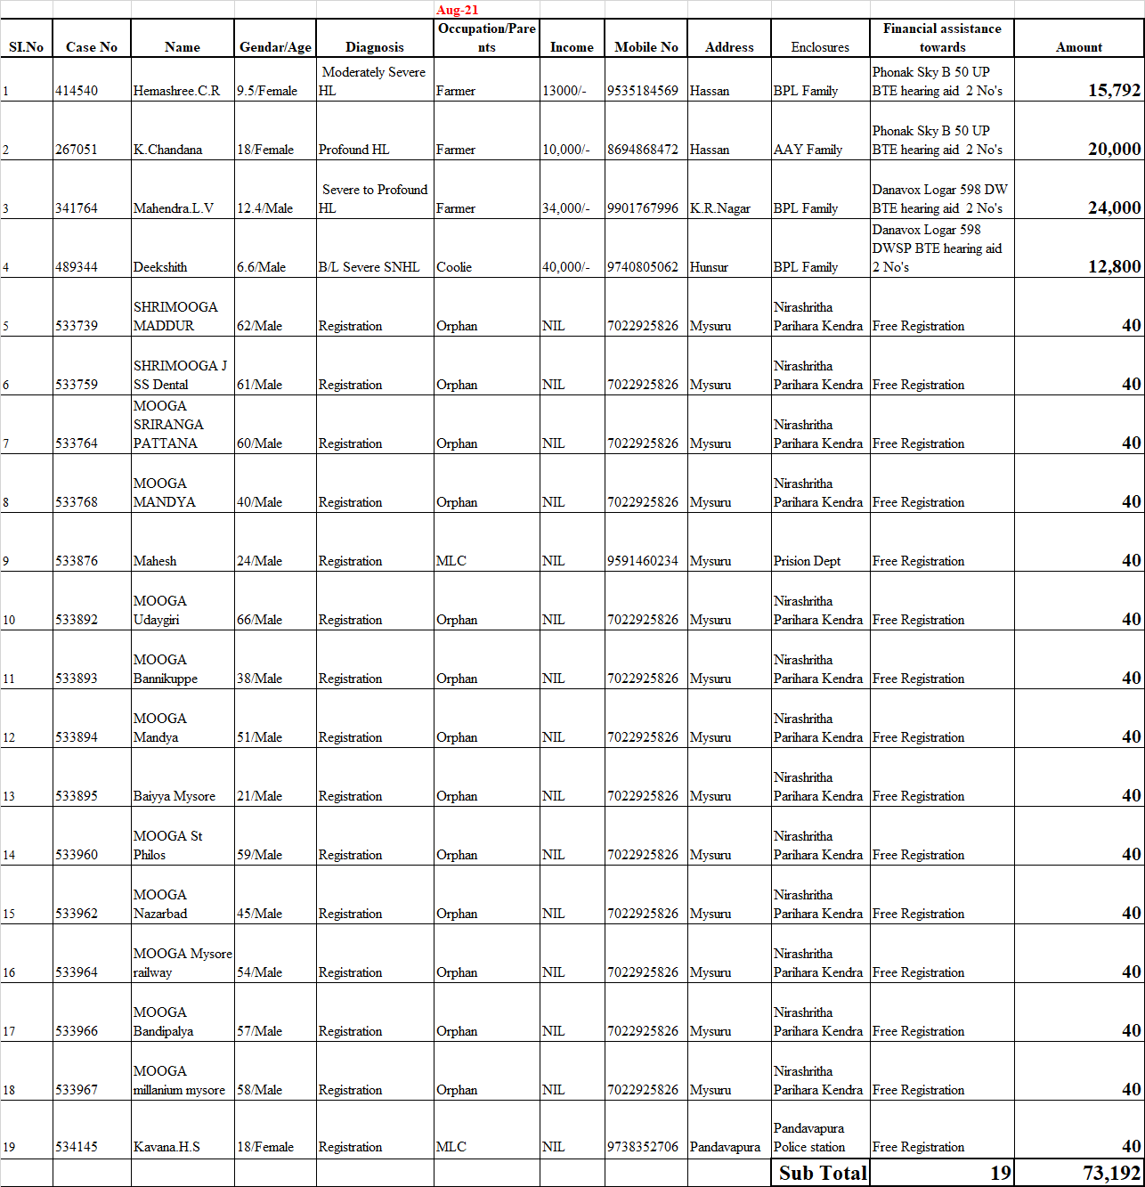

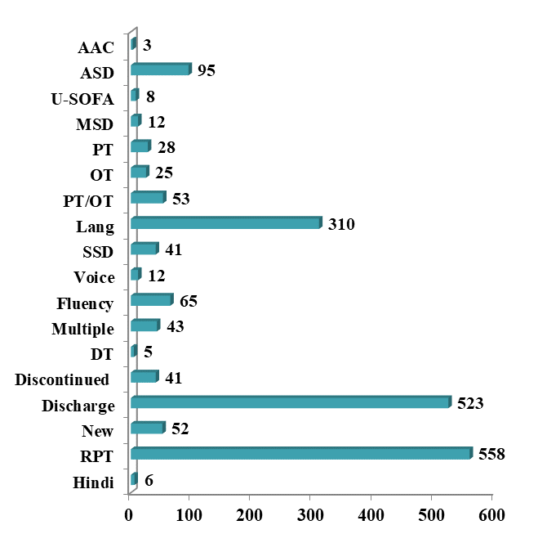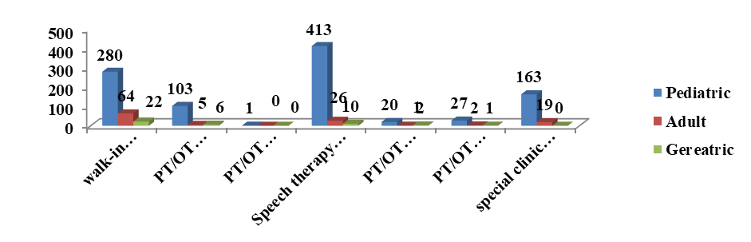

**No. of diagnostic and therapeutic cases seen in the month of August 2021**

**Number of cases availed therapy for the month of August 2021**

**No. of Cases seen in OPD during August 2021**

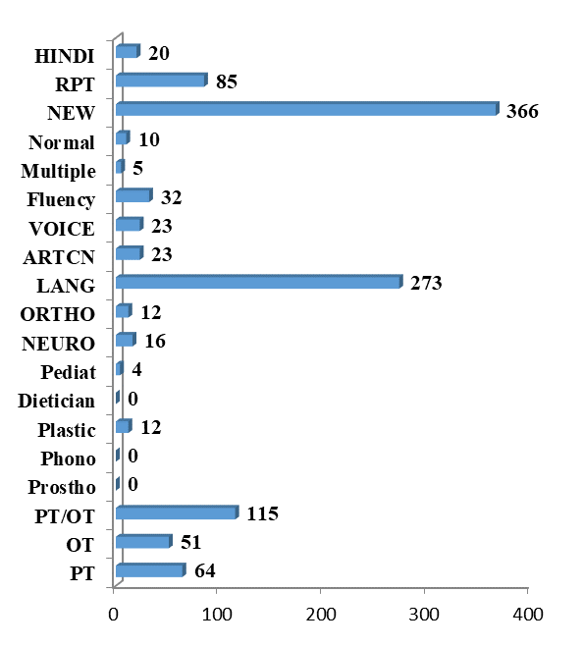

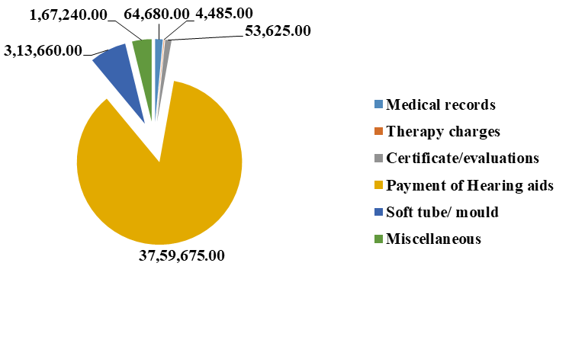

**Revenue Generated**

**Clients Services rendered /No. of cases registred/files retrieved at AIISH for the month of Aug 2021**

**ALL INDIA INSTITUTE OF SPEECH & HEARING: MYSURU- 6**

**अखिल भारतीय वाक श्रवण संस्थान: मैसूर-६**

**DEPARTMENT OF CLINICAL SERVICES**

चिकित्सा सेवा विभाग

SH/DCS/Monthly-Stat/2021-22 07.09.2021

एसहेच/डी.सी.एस/मासिक रिपोर्ट/2021-22

Submitted to the Director:

निदेशकको प्रस्तुत:

*Sub: Monthly Report of August –2021.*

विषय: *जून की* मासिकविवरण–के बारे में

With reference to the above please find herewith monthly report of Department of Clinical Services for the month of August, 2021. This is placed for your kind information.

Verified by,

HOD- Clinical Services

विभागध्यक्ष- चिकित्सा सेवा विभा