संप्रेषणविकृतिरोकथामविभाग
DEPARTMENT OF PREVENTION OF COMMUNICATION DISORDERS
महीनेकेविवरण/ MONTHLY REPORT –July2021
- ACADEMIC ACTIVITIES
A. No. of webinars & Orientations:
As a part of primary prevention activities, orientation/sensitization programs are being conducted regularly. The objective of the orientation programs was to create awareness among the public and various other professionals such as Medical doctors, Nurses, Health-related workers, teachers, school students, etc., on different types of communication disorders, its prevention and early identification methods, and their appropriate referral and timely management. Due to the COVID-19 pandemic condition in the country, some of the orientation programs were carried out through Tele-mode/Webinars. Table 1&2 shows the details of the orientations/webinar’s programs conducted by staff and students of the department of POCD, NBS, and OSC centers.
Table 1: Details of Orientation Programs in July 2021.
I. No. of Orientation Programs at POCD : 21
S.No | Date | Name of the institute/  Hospital | Target group | Total participants | Oriented by
 | 01.07.2021 | Patients waiting area at DCS, AIISH | General public | 8 | Srividya
 | 02.07.2021 | Patients waiting area at DCS, AIISH | General public | 5 | Ranjini
 | 05.07.2021 | Patients waiting area at DCS, AIISH | General public | 10 | Ashiq
 | 06.07.2021 | Patients waiting area at DCS, AIISH | General public | 12 | Ranjini
 | 07.07.2021 | Patients waiting area at DCS, AIISH | General public | 25 | Pauline
 | 08.07.2021 | Patients waiting area at DCS, AIISH | General public | 8 | Merina
 | 09.07.2021 | Patients waiting area at DCS, AIISH | General public | 14 | Christy
 | 12.07.2021 | Patients waiting area at DCS, AIISH | General public | 11 | Reshma
 | 13.07.2021 | Patients waiting area at DCS, AIISH | General public | 23 | Ankitha
 | 14.07.2021 | Patients waiting area at DCS, AIISH | General public | 26 | Ranjini
 | 15.07.2021 | Patients waiting area at DCS, AIISH | General public | 16 | Tanuja
 | 16.07.2021 | Patients waiting area at DCS, AIISH | General public | 8 | Pauline
 | 19.07.2021 | Patients waiting area at DCS, AIISH | General public | 10 | Ashique
 | 20.07.2021 | Patients waiting area at DCS, AIISH | General public | 14 | Ankitha
 | 22.07.2021 | Patients waiting area at DCS, AIISH | General public | 19 | Tanuja
 | 23.07.2021 | Patients waiting area at DCS, AIISH | General public | 20 | Kalaiarsan
 | 26.07.2021 | Patients waiting area at DCS, AIISH | General public | 12 | Srividya
 | 27.07.2021 | Patients waiting area at DCS, AIISH | General public | 21 | Ankitha
 | 27.7.2021  to 29.7.2021 | JSW, Bellary | Factory Workers | 530 | Mr. Arunraj K
 | 28.07.2021 | Patients waiting area at DCS, AIISH | General public | 5 | Ranjini
 | 30.07.2021 | Patients waiting area at DCS, AIISH | General public | 5 | Kalaiarsan
Total (POCD) |  |  |  | 802
II. No. of OrientationPrograms at Outreach Service Centers: 07
 | 05.07.2021 | Kenchanahalli, Bangaluru, Karnataka | Public (Tribal and non tribal) | 03 | Ms. Deepa R
 | 19.07.2021 | GIMS , Kalaburagi, Karnataka | ASHA worker | 01 | Ms. Aneena & Ms. Binusha
 | 22.07.2021 | GIMS , Kalaburagi, Karnataka | medical students | 12 | Ms. Aneena & Ms. Binusha
 | 26.07.2021 | THO Office, Nanjangud, Mysore, Karnataka | ASHA Workers | 13 | Ms. Parnika K M
 | 27.07.2021, 29.07.2021  30.07.2021 | KoIMS hospital, Kodagu, Karnataka | Medical students | 16 | Ms. Sushma C
 | 28.07.2021 | KoIMS hospital, Kodagu, Karnataka | Medical students | 17 | Ms. Sushma C
 | 29.07.2021 | Dadadahalli, H D Kote, Mysuru, Karnataka | Public and Aanganwadi Teacher (Tribal/non tribal) | 20 | Ms. Deepa R
Total (OSC) |  |  |  | 82
III. No. of Orientation Programs at NBS centers: 02
 | 12.07.2021 | JLNMCH Bhagalpur, Bihar | General population | 12 | Sachin B & Thejaswi kumari
 | 29.07.2021 | Fellowship for Physically Handicap, Mumbai, Maharashtra | Staffs of FPH | 50 | Ms. Madhumanti
Total (NBS) |  |  |  | 62
Total (POCD+OSC+NBS) |  |  |  | 946

Table 2: The details of Webinar Programs in July 2021.
Theme/Topic of the program: Prevention & early identification of communication disorders
Coordinators: Dr. N. Sreedevi, Dr. M. Sandeep & Mr. Arunraj K.
I. No. of Webinar Programs at POCD : 03
S.No | Date | Name of the institute/  Hospital | Target group | Total participants | Oriented by
 | 12.07.2021 | Developmental milestones | Parents | 14 | Ms. Ankitha.S
 | 17.07.2021 | Reverends of Pushpashrama and Dhwanyaloka, Mysore | Reverends | 56 | Ms. Merina Thomas  Ms. Reshma. O
 | 20.07.2021 | Cheers Hopsital, Nepal | Doctors, Staff nurse | 17 | Ms. Kranti. Acharya
Total (POCD) |  |  |  | 87
II. No. of Webinar Programs at Outreach Service Centers: 05
 | 07.07.2021 | BIMS,Belgavi, Karnataka | MBBS students | 55 | Ms. Sarah Elsa Abraham
 | 16.06.2021 | IGIMS,Patna, Bihar | General Public | 14 | Ms Rishisha Lyngkhoi
 | 29.07.2021 | PHC Gumballi, Chamarajanagar, Karnataka | General Public | 5 | Ms. Delna
 | 29.07.2021 | PHC Gumballi, Chamarajanagar, Karnataka | Parents of children with communication disorders | 5 | Ms. Delna
 | 27.07.2021 | KIMS, Hubli, Karnataka | Professional course students | 7 | Ms. Hemashree B.M
Total (OSC) |  |  |  | 86
III. No. of Webinar Programs at NBS centers: 03
 | 31/07/2021 | Bhagpat District Hospital. Delhi | Nurses | 4 | Mr. Sachin Sharma (SHT) and Ms. Kristi Kaveri Dutta (Audiologist)
Total (NBS) |  |  |  | 4
TOTAL (POCD+OSC+NBS) |  |  |  | 177

Theme/Topic of the program: Orientation/webinar for expectant mothers
I. POCD : Nil
II. Outreach Service Centers: 01
 | 29.07.2021 | MCH, K R Nagar, Mysuru, Karntaka | Pregnant Women | 20 | Ms. Jasper Princess
Total (OSC) |  |  |  | 20
III. NBS centers: 04
 | 12.07.2021 | JLNMCH Bhagalpur, Bihar | Pregnant Women | 03 | Sachin B & Thejaswi kumari
 | 15.07.2021 | R L Jalappa Hospital, Kolar, Karnataka | Pregnant Women | 02 | Rohith V S/ Vaideshwari
 | 27.07.2021 | IGMC, Shimla | Pregnant Women | 4 | Gowthamvarma. S
 | 29.07.2021 | R L Jalappa Hospital, Kolar, Karnataka | Pregnant Women | 5 | Rohith V S & Basih
Total (NBS) |  |  |  | 14
TOTAL (POCD+OSC+NBS) |  |  |  | 34

Table 3: Total number of participants oriented including Webinars and orientations (Group wise)
S. No | Target group | Total no. of Participants
I | Grass Root Level Workers
 | ASHA Workers | 14
 | Anganwadi Workers | 04
 | Health Facilitator and Supervisors/Program Manager | 50
II | Professionals
 | School Teachers | -
 | Audiologists/Speech language Pathologists | -
 | Hospital staff | 17
 | Medical Doctors | -
 | Nurses | 04
 | Factory Workers | 530
III | Students
 | BASLP/MASLP Students | -
 | DHLS Students | -
 | Diploma Students | -
 | Medical Students | 100
 | Nursing Students/Paramedical Students | -
 | Professional course students | 07
 | School students | -
IV | Public
 | General Public | 378
 | Mothers/Parents of children with communication disorders | 19
 | Post-Partum Mothers | -
 | Expectant mothers | 34
 | Elderly Individuals | -
Total |  | 1157

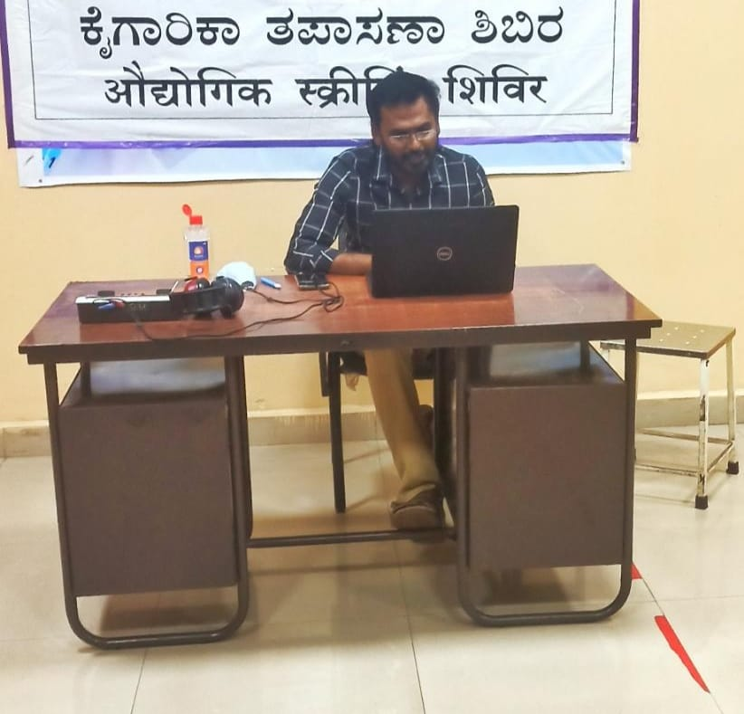
Glimpses of webinar conducted by Mr. Arunraj K to the industrial workers at Bellary steel factory
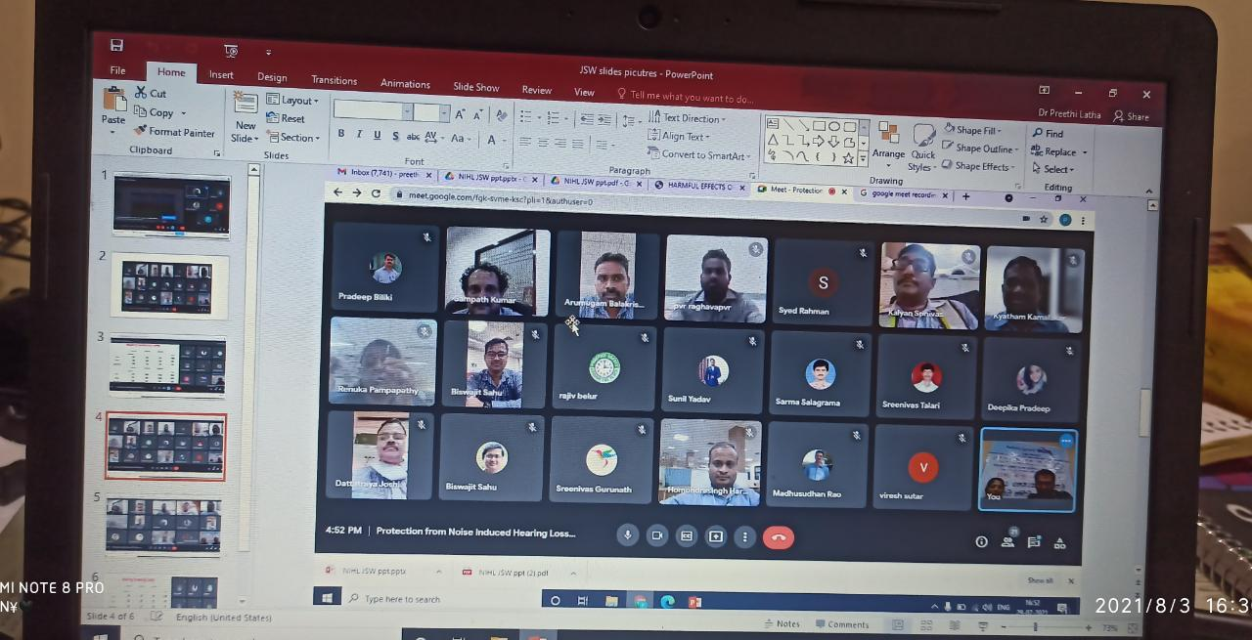
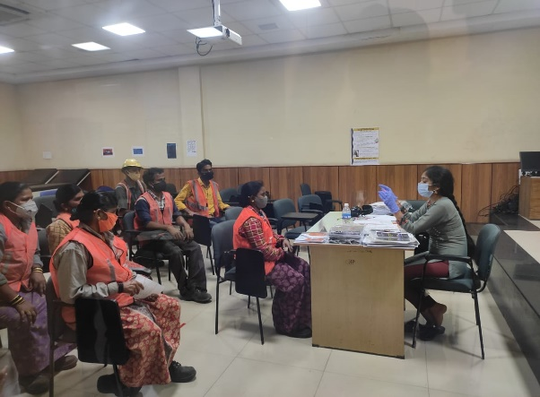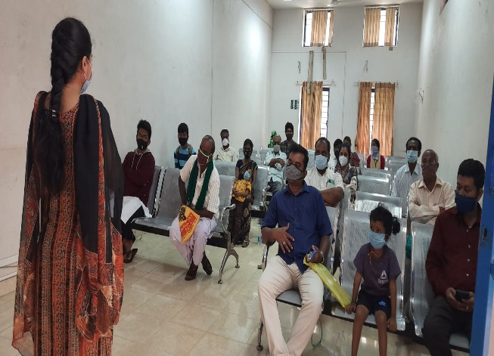
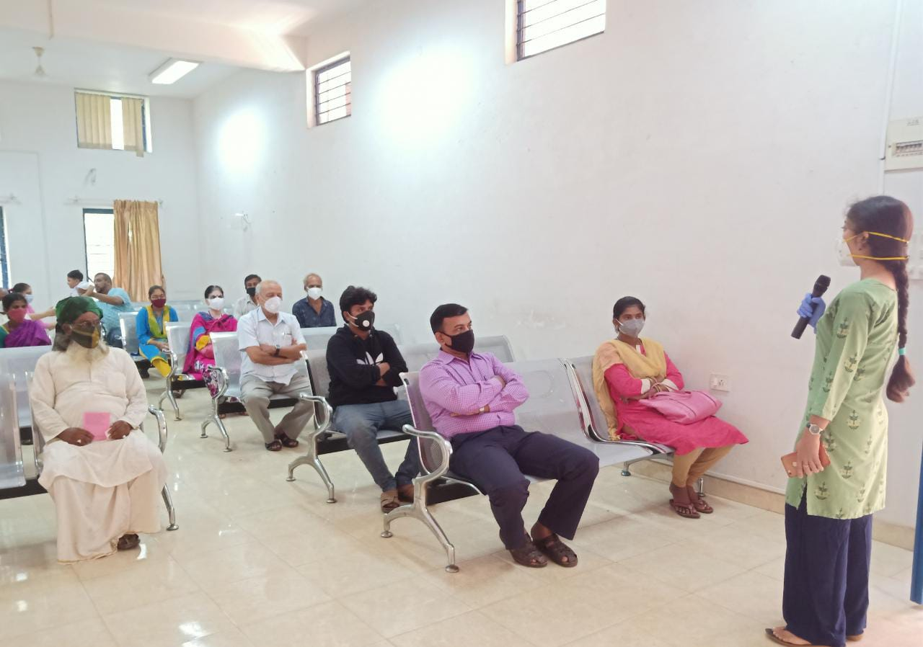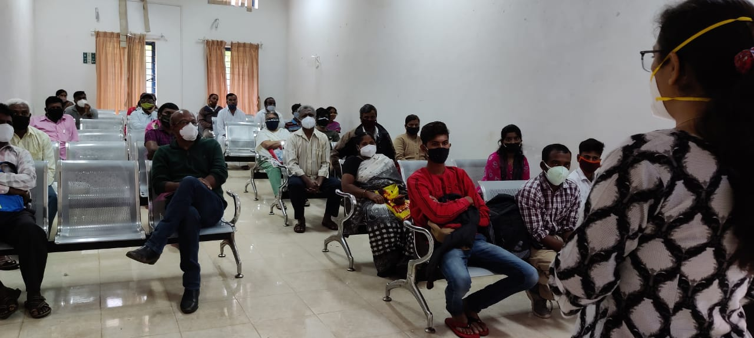
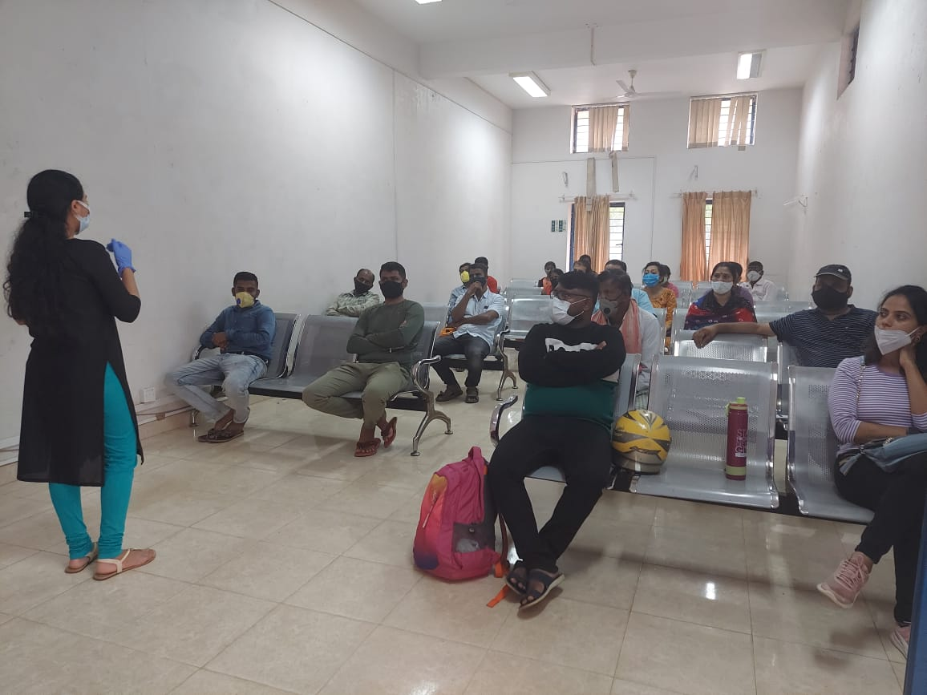
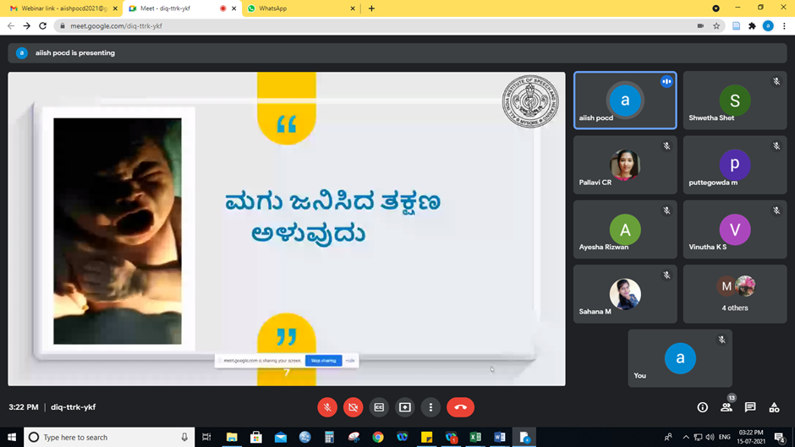
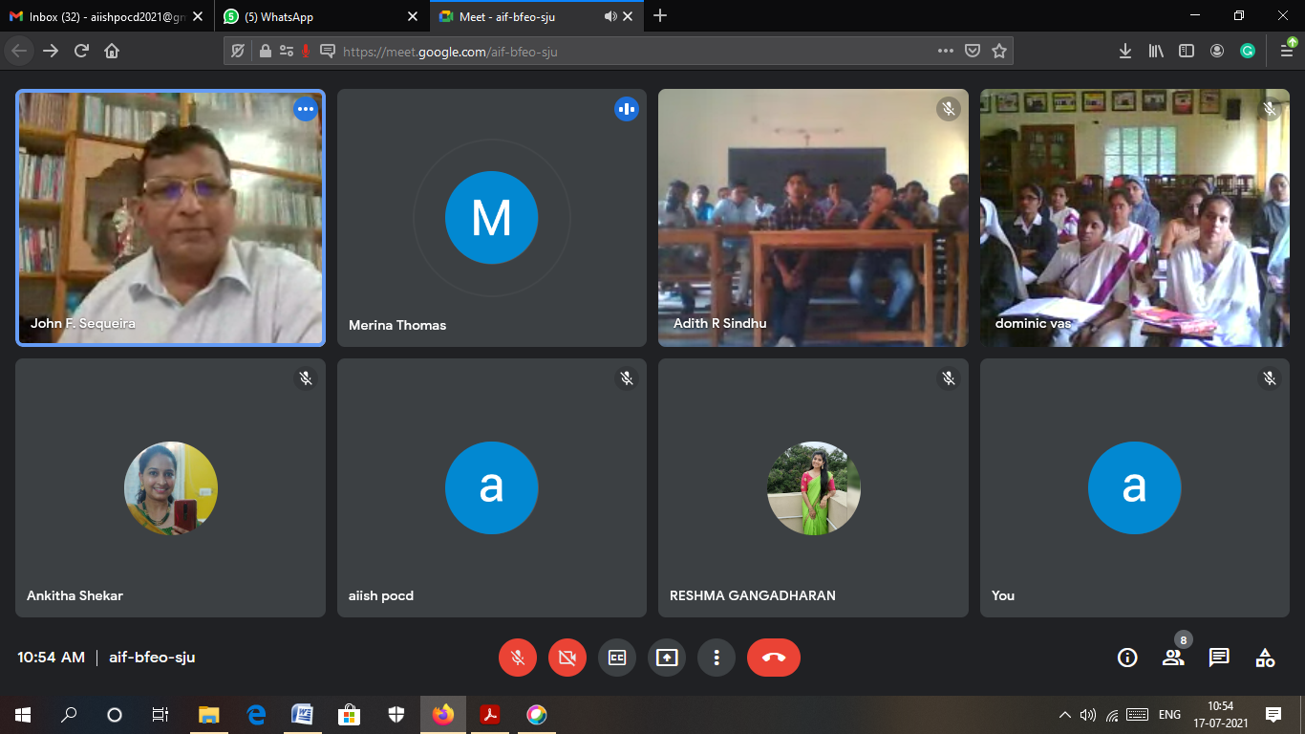
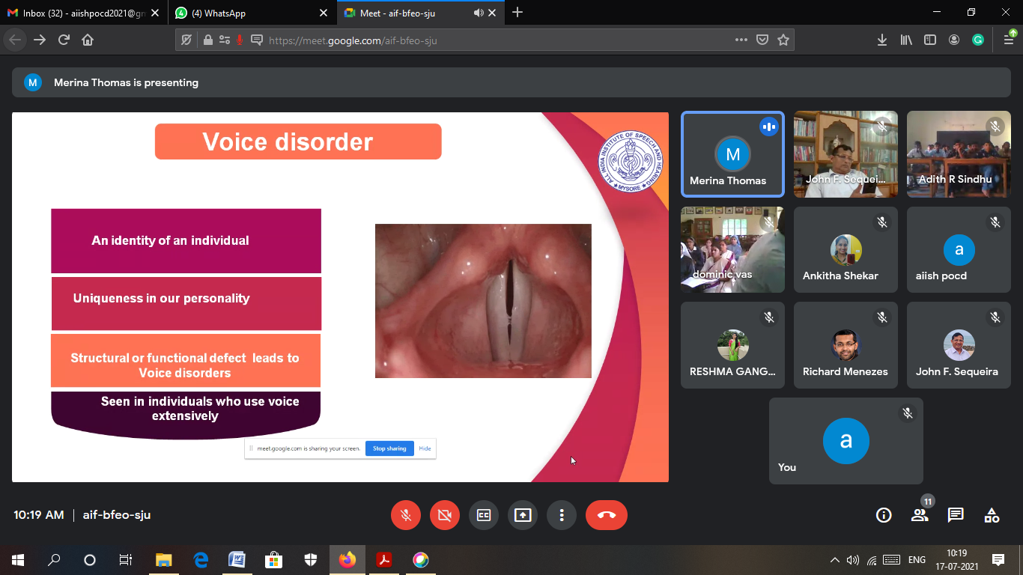
Glimpses of orientation/Webinar program conducted by POCD staff
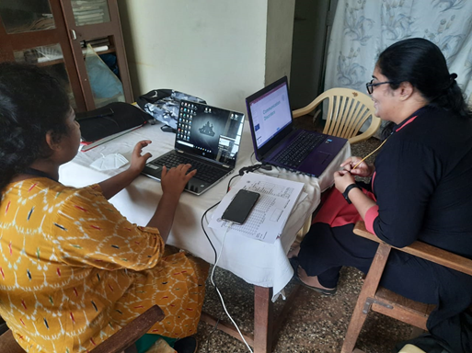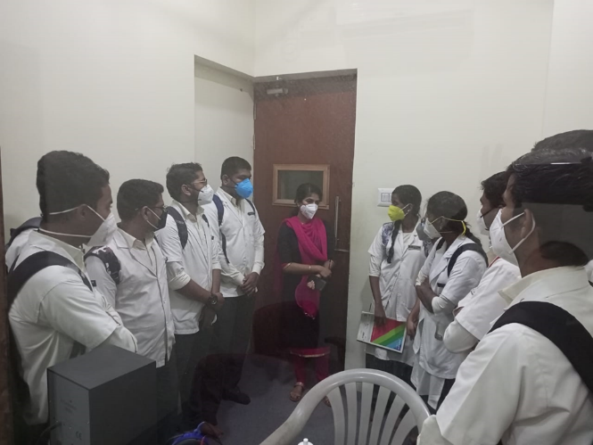
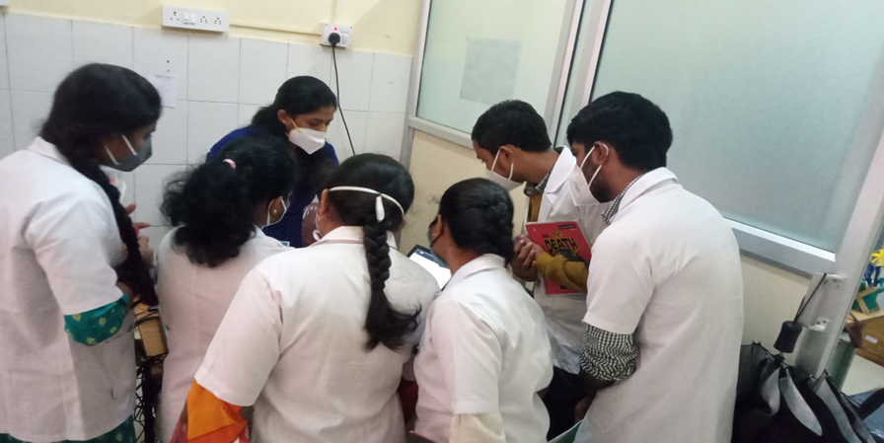
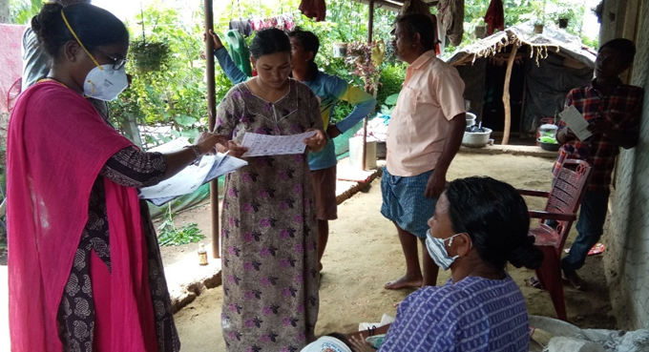
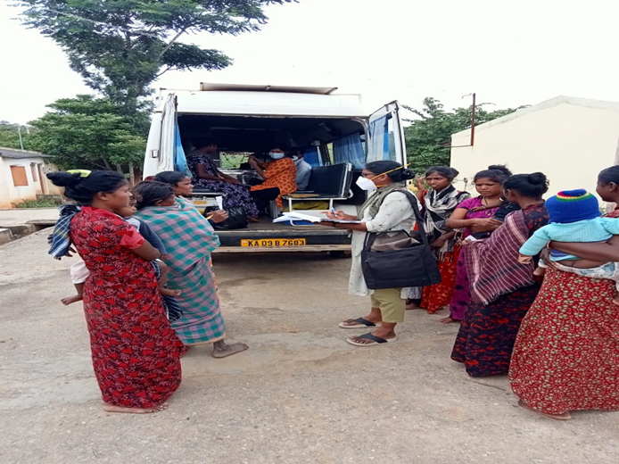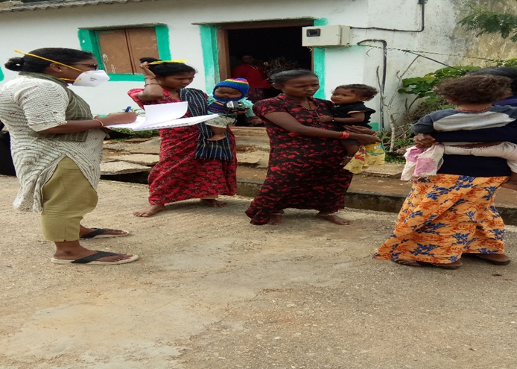
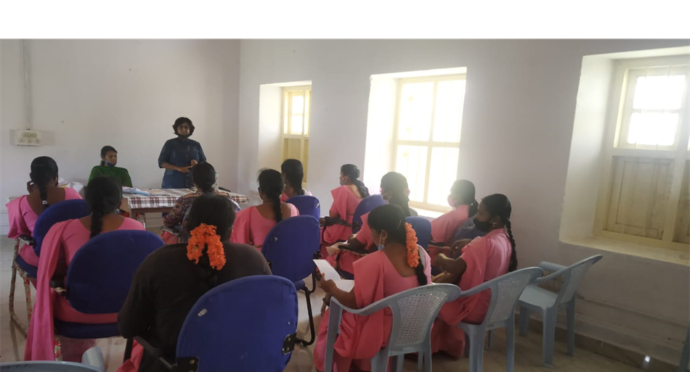
Glimpses of orientation/webinar program conducted in outreach service centers

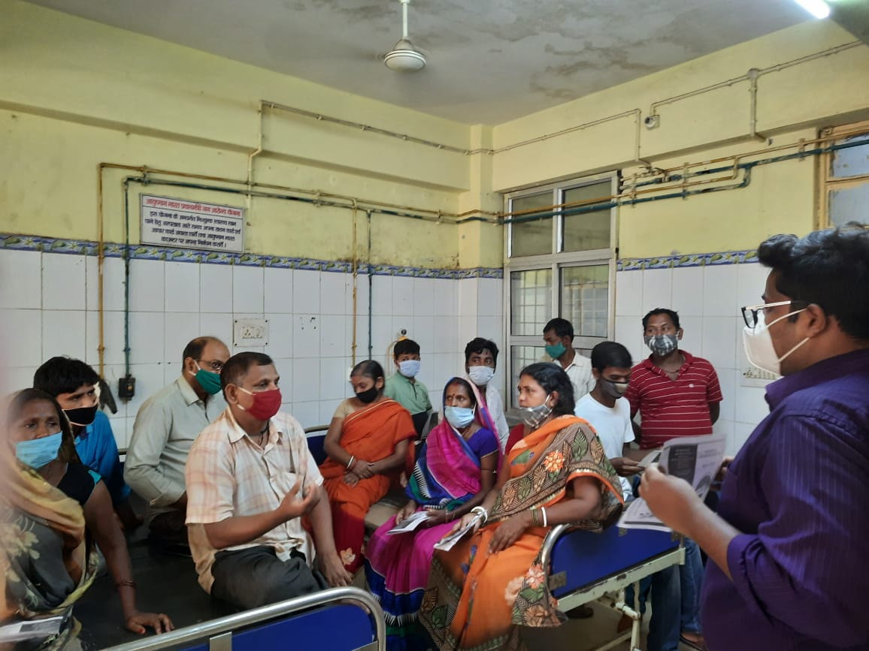
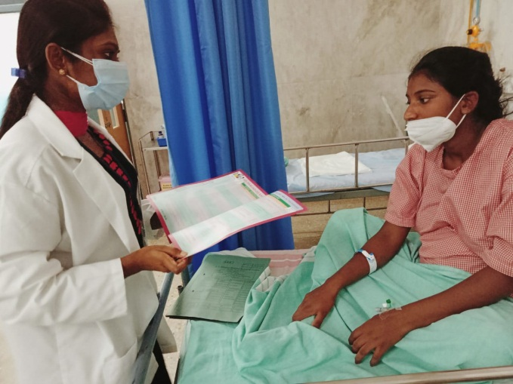
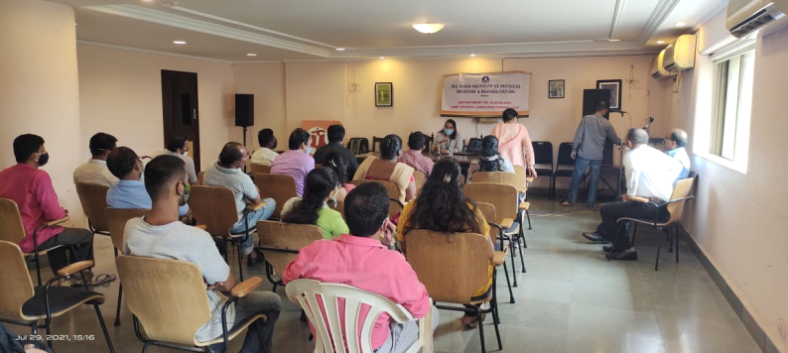

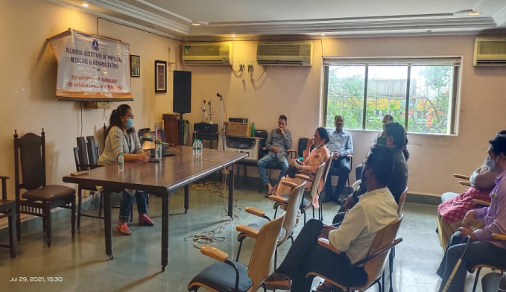
Glimpses of orientation/webinar program conducted in Newborn screening centers
B) Seminars/ Conferences /Lectures /Workshops/Training programs
i) Table 4a: Details of Seminar organized by OSC centre:

Date& venue | 1,2,5,7th July 2021
Topic | Basics Of Audiology
Name of the resource person | Aparna Ravi
Name of the coordinator/s | Aparna, Sarah
Name of the organizers | ENT Dept., BIMS Belgavi Karnataka
Target group | MBBS students- 3rd year
Number of beneficiaries | 205
Objectives | Introduction to the Basics of Audiology

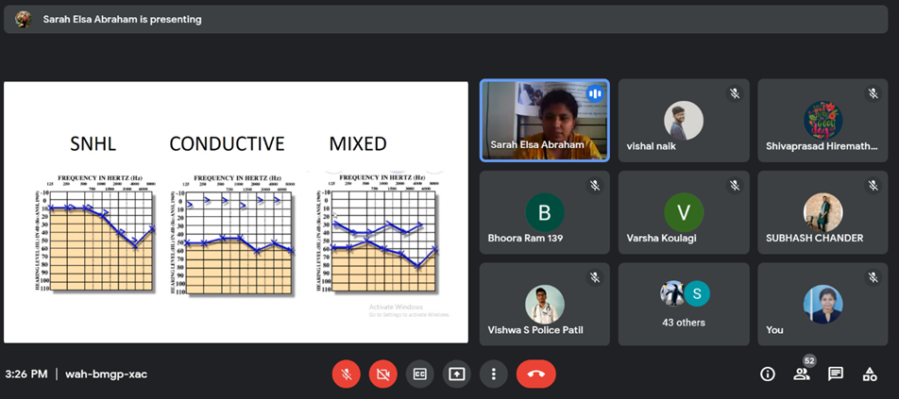
Glimpses of seminar program at BIMS Belgavi

ii) Table 4b: Details of Lectures organized by NBS centre-01

Date& venue | 06.07.2021, AIIMS, Patna
Topic | Role of Audiologist in Health care
Name of the resource person | Mr. Mohammed Basih Thaha
Name of the coordinator/s | Dr. Kranti Bhavana
Name of the organizers | AIIMS, Patna
Target group | Medical Students
Number of beneficiaries | 14
Objectives | Role of audiologist in health care; Different tests carried out by audiologists.

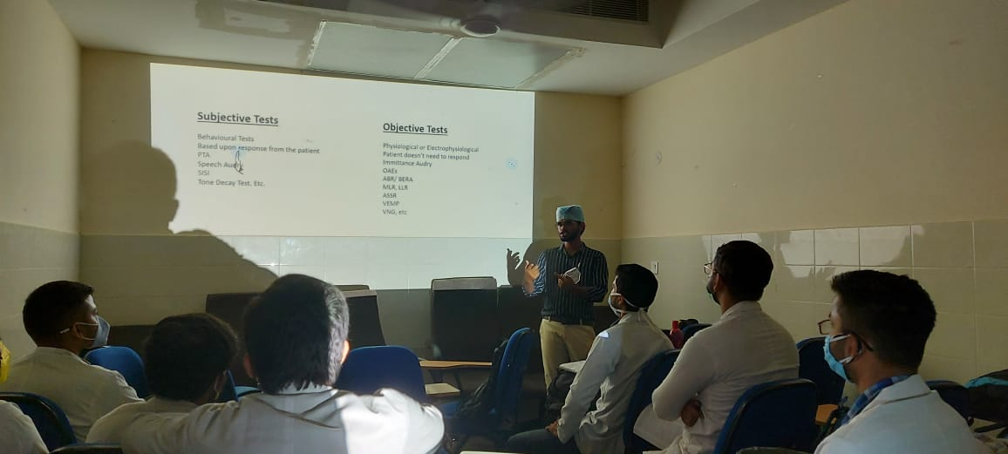
Glimpses of Lecture conducted at AIIMS Patna
- RESEARCH ACTIVITIES:
Research Activities of POCD:
- School screening report - Prepared result and conclusion for school screening report
- Verification and compilation of NBS SPSS data for NBS Mysore and NBS centres by Ranjini & Dibya respectively
- Edited NBS report for the years 2008-2019 by Dibya and Ranjini
- Verification and compilation of SPSS data of OSC centres by Merina & Pauline

Research Activities of OSC:
- Research Activities of OSC GIMS,Kalburgi
  - Research proposal presented in ethical committee of GIMS and waiting for the approval- Awareness , attitude, knowledge among general public, school teacher and medical practitioners towards communication disorder.
- Research Activities of OSC Sagara
  - Study titled, “Teacher’s Awareness and Attitudes towards Inclusive Education of Children with HI” is ongoing. Principle Investigators are M. AjithKumar and M. Roja Rani.
  - A questionnaire has been devised for the same. It is under the process of translation to Kannada Language.
  - Study titled, “Survey on Parents’ Perceptions of Tele-Speech Therapy” is ongoing. The questionnaire which will be used for data collection is under construction. Principle Investigators are M. AjithKumar and M. Roja Rani.*
- Research Activities of OSC Hubli
  - Written RP for “Audiological Profile in Mucromycosis cases”
  - Written RP for “A Comparative study on effectiveness of audiological screening”
  - Written RP for “A case control study of Self-reported Dysphagia and Dysphonia in patients with mucormycosis with type-II Diabetes Mellitus”.

Research Activities of NBS: Nil

III) EXTENSION ACTIVITIES
The department of POCD is actively involved in carrying out various extension activities such as screening, diagnostic and rehabilitation services outside the institute campus. The activities include newborn/infant screening, screening of school children, screening of elderly citizens, screening of industrial workers, conducting camps and also clinical services offered at the outreach service centers of AIISH.
- New-born screening programs for Communication Disorders
a) Table 5: Details of newborn screened in July2021.
S. No | Hospitals/Immunization Centers | Total births | Total screened |  |  | Total No. at risk |  |  | Phone Follow up
 |  |  | Male | Female | Total | Male | Female | Total | Male | Female | Total
I. Mysuru Hospitals
 | Ashwini Nursing Home (ANH) | 12 | 02 | 06 | 08 | 00 | 00 | 00 | 00 | 02 | 02
 | Kamakshi Hospital (KH) | 117 | 35 | 33 | 68 | 01 | 00 | 01 | 08 | 05 | 13
 | CSI Holdsworth-Memorial Hospital | 30 | 12 | 07 | 19 | 02 | 00 | 02 | 03 | 00 | 03
 | Mahadeshwara Nursing Home (MNH) | 30 | 08 | 09 | 17 | 01 | 00 | 01 | 00 | 01 | 01
 | Sigma Hospital (SH) | 39 | 24 | 17 | 41 | 01 | 00 | 01 | 07 | 03 | 10
 | Cheluvamba -KR Hospital (KRH) | 700 | 326 | 247 | 573 | 09 | 03 | 12 | 35 | 34 | 69
 | Shree Devi Nursing Home (SNH) | 23 | 08 | 06 | 14 | 00 | 00 | 00 | 00 | 01 | 01
 | Sri Chamundeshwari nursing home | 12 | 05 | 02 | 7 | 00 | 00 | 00 | 00 | 00 | 00
 | Govt. Jayanagar Maternity Hospital | 96 | 41 | 29 | 70 | 01 | 01 | 02 | 08 | 04 | 12
 | NPC Maternity hospital | 52 | 22 | 11 | 33 | 02 | 00 | 02 | 03 | 02 | 05
 | Makkalakoota Immunization Centre | - | 18 | 12 | 30 | 00 | 00 | 00 | 01 | 04 | 05
 | Kyathmanalli Immunization Centre | - | 35 | 20 | 55 | 00 | 00 | 00 | 03 | 01 | 04
 | Cheluvamba Immunization Centre | - | 19 | 05 | 24 | 00 | 00 | 00 | 06 | 02 | 08
 | Kamala Raman Hospital | 02 | 02 | 00 | 02 | 00 | 00 | 00 | 00 | 00 | 00
Total |  | 1113 | 557 | 404 | 961 | 17 | 04 | 21 | 74 | 59 | 133
II. OSC Centers:
 | Sub-divisional Hospital, Sagara Taluk, Sagara, Karnataka | 307 | 81 | 64 | 145 | 00 | 00 | 00 | 09 | 05 | 14
 | Primary Health centre (Under Karuna trust), Gumballi, Karnataka (OSC) | 37 | 24 | 13 | 37 | 3 | 0 | 3 | 1 | 0 | 1
 | Taluk Hospital, Yelandur, Gumballi, Karnataka | 02 | 02 | 00 | 02 | 00 | 00 | 00 | 00 | 00 | 00
 | Community Health Centre (CHC), Santhemarahalli, Gumballi, Karnataka (Only newborn screening) | 52 | 24 | 15 | 39 | 02 | 00 | 02 | 00 | 00 | 00
 | Vivekananda Memorial hospital, H. D. Kote, Sarguru, Karnataka (OSC) | 20 | 10 | 09 | 19 | 04 | 05 | 09 | 01 | 01 | 02
 | St, Mary’s Hospital, HD kote, Sarguru, Karnataka | 100 | 52 | 37 | 89 | 17 | 09 | 26 | 04 | 01 | 05
 | Taluk Hospital, H. D. Kote- Immunization,Sarguru,Karnataka | 108 | 48 | 46 | 94 | 20 | 10 | 30 | 04 | 03 | 07
 | Taluk Hospital, Nanjangud, Karnataka (OSC) | 93 | 49 | 42 | 91 | 00 | 01 | 01 | 14 | 12 | 26
 | Community Health Centre (CHC), Hullahalli, Karnataka | 10 | 03 | 02 | 05 | 00 | 00 | 00 | 01 | 01 | 02
 | Taluk General Hospital, KR. Pete, Mandya, Karnataka (OSC) | 41 | 18 | 08 | 26 | 00 | 01 | 01 | 00 | 00 | 00
 | Sub-divisional hospital, K R Nagar Taluk, Yadavagiri, Mysore, Karnataka | 184 | 33 | 27 | 60 | 01 | 00 | 01 | 00 | 00 | 00
 | Gulbarga Institute of Medical Sciences, Kalaburgi, Karnataka | 298 | 06 | 12 | 18 | 01 | 02 | 03 | 03 | 11 | 14
 | Kodagu Institute of Medical Science, Kodagu, Karnataka | 216 | 95 | 80 | 175 | 95 | 80 | 175 | 00 | 00 | 00
 | Belagavi Institute of Medical Science, Belagavi, Karnataka | 180 | 12 | 09 | 21 | 06 | 05 | 11 | 00 | 00 | 00
 | Bidar Institute of Medical Sciences (BRIMS), Bidar, Karnatka | 419 | 196 | 159 | 355 | 196 | 159 | 355 | 00 | 00 | 00
 | All India Institute of Medical Sciences (AIIMS), Bhuvaneshwar, Orissa | 108 | 46 | 44 | 90 | 07 | 11 | 18 | 26 | 20 | 46
 | Karnataka Institute of Medical Sciences(KIMS), Hubli, Karnataka | 621 | 07 | 13 | 20 | 04 | 07 | 11 | 03 | 06 | 09
 | Indira Gandhi Institute of Medical Sciences(IGIMS), Patna, Bihar | 04 | 01 | 02 | 03 | 00 | 00 | 00 | 00 | 00 | 00
Total |  | 2800 | 707 | 582 | 1289 | 356 | 290 | 646 | 66 | 60 | 126
III. NBS Centers
 | King George's Medical University KGMU, Lucknow, Uttar Pradesh | 232 | 94 | 92 | 186 | 07 | 07 | 14 | 31 | 35 | 66
 | Jawaharlal Nehru Medical College & Hospital, JLNMCH, Bhagalpur, Bihar | 204 | 70 | 73 | 143 | 03 | 00 | 03 | 13 | 07 | 20
 | Post Graduate Institute of Medical Education and Research (PGIMER), New Delhi | 85 | 47 | 26 | 73 | 7 | 1 | 8 | 3 | 4 | 7
 | Sri Devaraj Urs Academy of Higher Eduction and Research (SDUAHER) Kolar, Karnataka | 180 | 101 | 73 | 174 | - | - | - | 18 | 11 | 29
 | All India Institute of Physical Medicine and Rehabilitation (AIIPMR), Mumbai | 50 | 27 | 19 | 46 | 12 | 05 | 17 | 03 | 01 | 04
 | All India Institute of Medical Sciences (AIIMS), Patna | 57 | 30 | 20 | 50 | 02 | 00 | 02 | 07 | 05 | 12
 | Indira Gandhi Medical College (IGMC), Shimla | 74 | 37 | 23 | 60 | 06 | 01 | 07 | 10 | 06 | 16
Total (NBS centers) |  | 882 | 406 | 326 | 732 | 37 | 14 | 51 | 85 | 69 | 154
Total (POCD+OSC+NBS) |  | 4795 | 1670 | 1312 | 2982 | 410 | 308 | 718 | 225 | 188 | 413

b) Tele screening Programs -
Tele-screening program (virtual mode) was carried out to identify the babies at risk for communication disorders since new-born screening program couldn’t be carried out in many centers. The details including the behavioral responses of the new born to environmental sounds and HRR were collected from the parents through Tele-phone mode. The babies at risk were asked to undergo follow up evaluation in detail.
 | OSC Centre | Total calls made | Total Tele-screened | Mortality | Detailed Evaluation  (Referred) | Total infants at risk  (Screening) | Normal Speech and Language milestones  (Phone Follow up)
 | I. Mysuru Hospitals - Nil
 | II. Outreach Service Centers
 | Sub-divisional Hospital, Sagara Taluk, Sagara, Karnataka | 113 | 62 | 00 | 00 | 10 | 52
 | Gulbarga Institute of Medical Sciences, Kalaburgi, Karnataka | 91 | 47 | 05 | 00 | 03 | 44
 | Belagavi Institute of Medical Science, Belagavi, Karnataka | 134 | 69 | 03 | 00 | 40 | 23
 | Karnataka Institute of Medical Sciences(KIMS), Hubli, Karnataka | 67 | 35 | 04 | 14 | 15 | 06
 | Total | 405 | 213 | 12 | 14 | 68 | 125
 | III. Newborn Screening Centers - Nil

c) Tele- follow-up evaluation
The at-risk babies were monitored regularly through Phone calls by administrating Speech-language & hearing developmental checklist. The babies identified with delay in any of the developmental milestones, were referred to AIISH/concerned center for detailed diagnostic evaluation.
Table 6: Details of Tele-phone follow- up carried out at Hospitals in Mysuru.
 | S. No. |  | Hospitals |  | Total no of calls. |  | Total call attended |  | Number of infants with normal developmental milestones |  | Mortality |  | Total infants at risk
 | I. Mysuru Hospitals
 |  |  | Ashwini Nursing Home (ANH) |  | 07 |  | 07 |  | 07 |  | - |  | -
 |  |  | Kamakshi Hospital (KH) |  | 21 |  | 20 |  | 20 |  | - |  | -
 |  |  | CSI Holdsworth-Memorial Hospital |  | 06 |  | 05 |  | 05 |  | - |  | -
 |  |  | Mahadeshwara Nursing Home (MNH) |  | 01 |  | 01 |  | 01 |  | - |  | -
 |  |  | Sigma Hospital (SH) |  | 07 |  | 06 |  | 06 |  | - |  | -
 |  |  | Cheluvamba -KR Hospital (KRH) |  | 52 |  | 38 |  | 37 |  | 01 |  | -
 |  |  | Shree Devi Nursing Home (SNH) |  | 01 |  | - |  | - |  | - |  | -
 |  |  | Sri Chamundeshwari nursing home |  | - |  | - |  | - |  | - |  | -
 |  |  | Govt. Jayanagar Maternity Hospital |  | 06 |  | 04 |  | 04 |  | - |  | -
 |  |  | NPC Maternity hospital |  | 04 |  | 04 |  | 04 |  | - |  | -
 |  |  | Makkalakoota Immunization Centre |  | 08 |  | 07 |  | 07 |  | - |  | -
 |  |  | Kyathmanalli Immunization Centre |  | 01 |  | - |  | - |  | - |  | -
 |  |  | Total |  | 114 |  | 92 |  | 91 |  | 01 |  | -
II. OSC centers
 |  | Sub-divisional Hospital, Sagara Taluk, Sagara, Karnataka |  | 10 |  | 06 |  | 06 |  | 00 |  | 00
 |  | Vivekananda Memorial hospital, H. D. Kote, Sarguru, Karnataka (OSC) |  | 07 |  | 06 |  | 06 |  | 00 |  | 00
 |  | St, Mary’s Hospital, HD kote, Sarguru, Karnataka |  | 11 |  | 07 |  | 07 |  | 00 |  | 00
 |  | Taluk Hospital, H. D. Kote- Immunization, Sarguru, Karnataka |  | 05 |  | 03 |  | 03 |  | 00 |  | 00
 |  | Gulbarga Institute of Medical Sciences, Kalaburgi, Karnataka |  | 218 |  | 97 |  | 89 |  | 07 |  | 01
 |  | Kodagu Institute of Medical Science, Kodagu, Karnataka |  | 23 |  | 18 |  | 18 |  | 00 |  | 00
 |  | Belagavi Institute of Medical Science, Belagavi, Karnataka |  | 68 |  | 42 |  | 40 |  | 00 |  | 02
 |  | Karnataka Institute of Medical Sciences(KIMS), Hubli, Karnataka |  | 06 |  | 06 |  | 06 |  | 00 |  | 00
 |  | Total |  | 348 |  | 185 |  | 175 |  | 07 |  | 03
III. Newborn Screening Centers
 |  | King George’s Medical  University (KGMU) Lucknow |  | 22 |  | 16 |  | 14 |  | 01 |  | 01
 |  | Jawaharlal Nehru Medical College & Hospital, Bhagalpur, Bihar |  | 12 |  | 12 |  | 12 |  | 00 |  | 00
 |  | Post Graduate Institute of Medical Education and Research (PGIMER), New Delhi |  | 08 |  | 08 |  | 06 |  | 02 |  | 00
 |  | Sri DevarajUrs Academy Of Higher Education and Research (SDUAHER), Kolar |  | 82 |  | 76 |  | 75 |  | 01 |  | 00
 |  | All India Institute of Physical Medicine and Rehabilitation (AIIPMR), Mumbai |  | 15 |  | 08 |  | 08 |  | 00 |  | 00
 |  | All India Institute of Medical Science (AIIMS), Patna |  | 03 |  | 03 |  | 03 |  | 00 |  | 00
 |  | Indira Gandhi Medical College (IGMC), Shimla |  | 24 |  | 18 |  | 17 |  | 00 |  | 01
 |  | Total |  | 166 |  | 141 |  | 135 |  | 04 |  | 02
Total (POCD+OSC+NBS) |  |  |  | 628 |  | 418 |  | 401 |  | 12 |  | 05
Note: The calls not attempted were repeated a minimum of 5 times on consecutive days

d) Newborn follow-up evaluation (Detailed assessment)
The newborns/infants referred during the newborn screening/ Tele-screening were advised for detailed evaluation at AIISH/NBS centers/OSCs. A complete test battery was administered for those babies/infants who came for follow-up.

Table 8: Details of the results of follow-up evaluation
 | Normal | Hearing impairment | Speech Language disorder | Multiple disorder | Total
I. POCD AIISH | 9 | 1 | - | - | 10/51
II. Outreach Service Centers
Taluk General Hospital, KR Pete | 01 | 00 | 00 | 01 | 02
Sub-divisional Hospital (PHC), Sagara | 04 | 00 | 00 | 00 | 04
Vivekananda Memorial Hospital, Sarguru | 04 | 00 | 00 | 00 | 04
Gulbarga Institute of Medical Sciences | 00 | 01 | 00 | 00 | 01
Belagavi institute of medical sciences (BIMS), Belagavi | 19 | 02 | 00 | 00 | 21
KIMS,  Hubli | 02 | 03 | 03 | 00 | 08
Total (OSC) | 30 | 06 | 03 | 01 | 40
III. Newborn Screening Centers
King George’ Medical  University (KGMU) Lucknow | 37 | 20 | - | - | 57
Jawaharlal Nehru Medical College & Hospital, Bhagalpur, Bihar | 02 | 01 | 00 | 00 | 03
Post Graduate Institute of Medical Education and Research (PGIMER), New Delhi | 01 | 11 | 01 | - | 13
All India Institute of Physical Medicine and Rehabilitation (AIIPMR), Mumbai | 01 | 01 | 00 | 00 | 02
All India Institute of Medical Science (AIIMS), Patna | 05 | 04 | 00 | 00 | 09
Total (NBS) | 46 | 37 | 01 | 00 | 84
Total (POCD+OSC+NBS) | 85 | 44 | 04 | 01 | 134

B) Anganawadi /Preschool/School screening program
Screening of Anganawadi, preschool and primary school children was conducted focusing on the early identification of communication disorders and early rehabilitation of children at risk for communication disorders.

Table 10: Total number of children screened for communication disorders and identified.
Date | Name of the Anganawadi/Preschool/ School | Total screened |  |  | Total referred with communication disorders
 |  |  |  |  | Ear related disorder | Hearing loss | Speech language disorders
 |  | Male | Female | Total | - | - | -
07.07.2021 | Anganwadi at Ballehadi, K R.purahadi (H.D Kote taluk, Mysore district), OSC SARGURU | 7 | 11 | 18 | 0 | 1 | 1
13.07.2021 | Anganwadi at Annur (H.D Kote taluk,Mysore district), OSC SARGURU | 9 | 13 | 22 | 0 | 2 | 0
28.07.2021 | Anganwadi at Kiranguru (Hunsur taluk, Mysore district), OSC SARGURU | 16 | 22 | 38 | 0 | 4 | 0
Total |  | 32 | 46 | 78 | 00 | 07 | 01

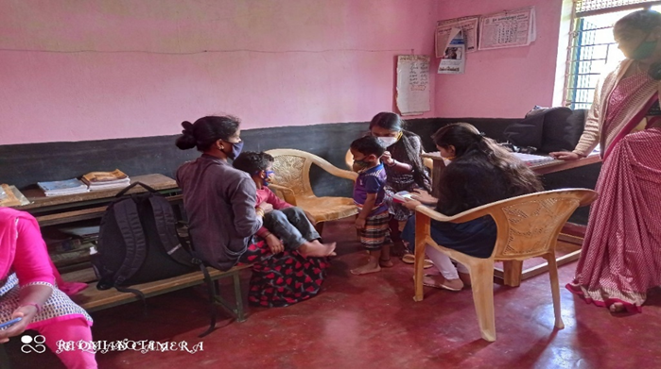
Glimpses of Anganwadi screening
C)a. Industrial Screening–
Industrial screening program was carried out at JSW Energy, Ballary on 27 th , 28 th and29 th July 2021.All the employees were screened for hearing loss and those were referred are advised for detailed evaluation at AIISH. Employees and employers are also oriented on harmful effects of Noise on hearing, importance of hearing conservation program and also use of hearing protective devices in noisy areas.
Table 11: Details of hearing screening done at -----------------------
S. No | Date | Name of the Industry | Conducted center | Total Screened | Total no. of individuals identified with Hearing impairment | Total no. of individuals with normal hearing
 | 27.07.21  28.07.21  29.07.21 | JSW Energy, Toronagallu, Ballary, Karnataka | POCD, AIISH | 493 | 170 | 323
Total |  |  |  | 493 | 170 | 323

b. Follow-up Hearing evaluation of industrial workers at AIISH– Nil
D) Elderly Screening
Date | Name of the place | Total screened | Normal | Total identified with communication disorders |  |  | Total rehabilitated for communication disorders
 |  |  |  | Ear related disorders | Hearing loss | Speech language-cognitive &swallowing disorders
21.07.2021 | Doddamadanahadi Halli, H.D kote taluk, Mysore district(OSC Sarguru) | 17 | 4 | 5 | 8 | 0 | 0
22.07.2021 | VMH palliative care Mysore taluk, Mysore district (OSC Sarguru) | 31 | 11 | 6 | 13 | 3 | 3

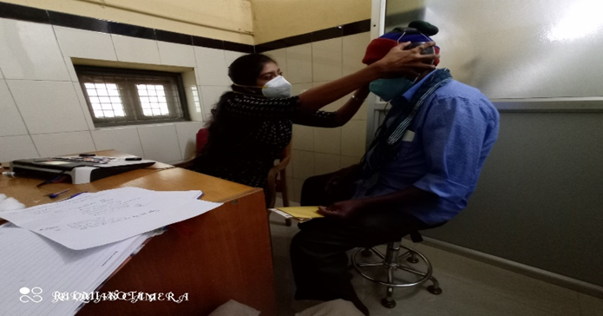
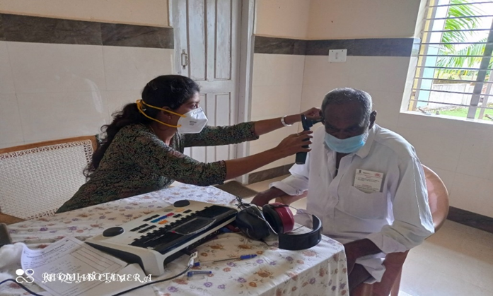
Glimpses of elderly screening

E) Bedside Screening- Nil
F) CLINICAL SERVICES AT OUTREACH SERVICE CENTRES
The clinical activities are not only restricted to in and around Mysuru, but also extended to rural areas where facilities for clinical services for persons with communication disorders are scanty. Currently there are 12 OSCs centres at different part of the country rendering services to unreached population. The details of those who were registered and availed various services/benefits at the OSCs are tabulated below.

- Clients identified and followed up with communication disorders at OSCs

Table 15: Details of clients identified with different types of communication disorders across OSCs
Sl. No | OSC | Normal | ENT | Total  (AUD) | Speech &Language Disorders |  |  |  |  | Total  (S&P) | Total
 |  |  |  |  | Voice | Fluency | Phonological disorders | Language disorders | Dysphagia
 | Taluk Hospital, Nanjangud | 00 | 07 | 07 | 00 | 00 | 00 | 01 | 00 | 01 | 08
 | Community Health Centre (CHC), Hullahalli | 00 | 12 | 02 | 00 | 00 | 00 | 00 | 00 | 00 | 14
 | Taluk General Hospital, KR Pete | 04 | 00 | 14 | 00 | 00 | 00 | 01 | 00 | 01 | 19
 | Primary Health Centre (PHC), Gumballi | 00 | 39 | 39 | 00 | 00 | 00 | 01 | 00 | 01 | 40
 | Sub-divisional Hospital (PHC), Sagara | 03 | 07 | 27 | 00 | 00 | 01 | 00 | 00 | 01 | 31
 | Vivekananda Memorial Hospital, Sarguru | 04 | 03 | 16 | 00 | 00 | 01 | 05 | 00 | 06 | 22
 | Gulbarga Institute of Medical Sciences | 08 | 18 | 65 | 01 | 01 | 03 | 09 | 01 | 15 | 80
 | Belagavi institute of medical sciences (BIMS), Belagavi | 39 | 63 | 102 | 00 | 02 | 02 | 18 | 00 | 22 | 124
 | Kodagu Institute of Medical Sciences, Madikkerri | 06 | 22 | 28 | 01 | 00 | 00 | 03 | 00 | 04 | 32
 | AIIMS, Bhuvaneshwar | 00 | 00 | 00 | 12 | 01 | 00 | 10 | 06 | 29 | 29
 | IGIMS,  Patna | 01 | 00 | 01 | 00 | 00 | 00 | 01 | 00 | 01 | 03
 | KIMS,  Hubli | 13 | 00 | 178 | 09 | 02 | 05 | 18 | 00 | 34 | 215
 | BRIMS, Bidar | 01 | 00 | 05 | 01 | 00 | 00 | 11 | 00 | 12 | 17
Total |  | 79 | 171 | 484 | 24 | 06 | 12 | 78 | 07 | 127 | 634

- Table 16: Details of clients followed up with different types of communication disorders across OSCs.
Sl.No | OSC | Normal | ENT | Total  (AUD) | Speech &Language Disorders |  |  |  |  | Total  (S&P) | Total
 |  |  |  |  | Voice | Fluency | Phonological disorders | Language disorders | Dysphagia
 | Community Health Centre (CHC), Hullahalli | 00 | 07 | 05 | 00 | 00 | 00 | 01 | 00 | 01 | 13
 | Taluk General Hospital, KR Pete | 02 | 00 | 05 | 00 | 00 | 01 | 00 | 00 | 01 | 08
 | Primary Health Centre (PHC), Gumballi | 00 | 19 | 19 | 00 | 00 | 00 | 00 | 00 | 00 | 19
 | Belagavi institute of medical sciences (BIMS), Belagavi | 01 | 04 | 05 | 00 | 00 | 00 | 03 | 00 | 03 | 08
 | AIIMS, Bhuvaneshwar | 00 | 00 | 00 | 03 | 00 | 00 | 00 | 03 | 06 | 06
 | KIMS,  Hubli | 01 | 00 | 00 | 02 | 00 | 00 | 03 | 00 | 05 | 06
Total |  | 04 | 30 | 34 | 05 | 00 | 01 | 07 | 03 | 16 | 60

vi) Rehabilitation services at OSCs.
Table 17: Details of rehabilitation services provided at OSCs in July 2021.
OSC | Hearing Aids Dispensed | Speech-language therapy |  |  | Medical Line of Treatment
 |  | No. of clients | No. of sessions
 |  |  | Regular Therapy | Tele therapy
Sub-divisional Hospital, Sagara Taluk, Sagara, Karnataka | 00 | 13 | 00 | 64 | 00
Primary Health centre (Under Karuna trust), Gumballi, Karnataka (OSC) | 14 | 06 | 13 | 05 | 00
Vivekananda Memorial hospital, H. D. Kote, Sarguru, Karnataka (OSC) | 03 | 10 | 51 | 00 | 00
Taluk Hospital, Nanjangud, Karnataka (OSC) | 01 | 05 | 00 | 22 | 00
Community Health Centre (CHC), Hullahalli, Karnataka | 00 | 03 | 00 | 18 | 00
Taluk General Hospital, KR. Pete, Mandya, Karnataka (OSC) | 05 | 03 | 19 | 00 | 00
Gulbarga Institute of Medical Sciences, Kalaburgi, Karnataka | 00 | 15 | 12 | 24 | 00
Kodagu Institute of Medical Science, Kodagu, Karnataka | 10 | 8 | 16 | 49 | 00
Belagavi Institute of Medical Science, Belagavi, Karnataka | 00 | 02 | 10 | 00 | 00
Bidar Institute of Medical Sciences (BRIMS), Bidar, Karnatka | 00 | 05 | 12 | 06 | 00
All India Institute of Medical Sciences (AIIMS), Bhuvaneshwar, Orissa | 00 | 35 | 71 | 00 | 00
Karnataka Institute of Medical Sciences(KIMS), Hubli, Karnataka | 00 | 09 | 05 | 11 | 00
Indira Gandhi Institute of Medical Sciences (IGIMS), Patna, Bihar | 00 | 01 | 00 | 07 | 00
Total | 33 | 115 | 209 | 206 | 00

v) Table 18: Screening Camps for communication Disorders
Sl No. | Date | Conducted dept./Center | Camp site | Total Screened | Total Referred |  |  |  | Total hearing aid distributed
 |  |  |  |  | Hearing impairment |  | Speech- language disorders
 |  |  |  |  | Male | Female | Male | Female
 | 05.07.2021 | VMH, (Mobile Health Unit) Sarguru. | Kenchanahalli, Moorbanth, Borethevarematti, Jaganekote, Kempahadi, hosahalli hadi, Dhonnemadana hadi. HD kote Taluk, Mysore District. | 13 | 1 | 1 | 1 | 1 | 0
 | 29.07.2021 | VMH, (Mobile Health Unit) Sarguru | Huskoor hadi, Devalapurahadi, Kalla halli hadi (A&B), udugi hadi,Seegodi hadi, kadabegur, Adnahalli hadi, Kurnegala hadi. KHD kote Taluk, Mysore District. | 16 | 3 | 2 | 1 | 0 | 0
Total |  |  |  | 29 | 04 | 03 | 02 | 01 | 00

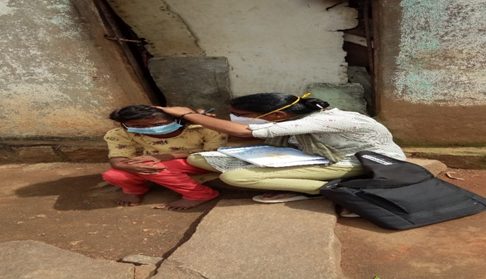
Glimpses of Camps conducted
G) Human Resource Development
a) Student clinical training:
As part of human resource development, clinical training for Undergraduates (B.Sc. Speech & Hearing), Postgraduates (M.Sc. SLP & AUD) & Internship students on early identification, prevention & rehabilitation of communication disorders and Community based rehabilitation at OSCs were carried out. The details on the number of students who had undergone training are given below.
Table 19: Details of the students posted in POCD during July 2021
Internal (AIISH)
Class | No. of students Newly posted | No. of Students continuing
I M.Sc. (SLP) students | 07 | 01
I M.Sc. (Audiology) students | - | -
BASLP Internship students | 10 | 08
Total | 17 | 09

b) Staff/Student Enrichment Programs:

As a part of continued education andupdating of ongoing research and clinical evidences on early identification, prevention &amp; rehabilitation of communication disorders and Community based rehabilitation. Postgraduates students (M.Sc. SLP & AUD) and staffs conduct and attend many presentation and talks. The details on the number of students and staffs who had undergone training are given below.

Table 20: Details of staff/student enrichment programmes
Sl. No. | Date | Title of Presentation | Presenters | No of Staff attended
 | 03.07.2021 | Early screening of autism  spectrum disorder using cry features. | Navya Belpu  Trupthi lata Baral | 12
 | 15.07.2021 | Recent advances and evidence based practice in the clinical management of Speech Sound Disorders | Dr N Sreedevi | 12

IV) TECHNOLOGICAL CONSULTANCY SERVICES: NIL

V) CENTRAL FACILITIES
a) Library and information Services: NIL

VI) MAJOR EVENTS OF THE MONTH:

VII) OTHERS
1. Material development works as part of work from home due to pandemic.
Sl No. | MATERIAL | LANGUAGE | PREPARED BY | VERIFIED BY | STATUS
PUBLIC EDUCATION VIDEOS
 | Comic strips-Autism | English |  | Christy  Kranti  Srividya | Verfied- To be finalized
 | Comic strips- LD | English |  | Christy  Kranti  Srividya | Verfied- To be finalized
 | Comic strips-SSD | English |  | Christy  Kranti  Srividya | Verfied- To be finalized
 | Comic strips- NBS | English |  | Christy  Kranti  Srividya | Verfied- To be finalized
 | Comic strips-Autism | Kannada | Teja  Nethra | Srividya  Tanuja | Verfied- To be edited
 | Comic strips- LD | Kannada | Thejas  Aditi | Srividya | Verfied- To be finalized
 | Comic strips-SSD | Kannada | Supriya  Shreya  Sumanth | Srividya | Verfied- To be finalized
 | Comic strips- NBS | Kannada | Harshitha  Yashas | Srividya | Verfied- To be finalized
 | Comic strips-Autism | Malayalam | Narmeda  Niveditha  Nidha | Christy | Verfied- To be finalized
 | Comic strips- LD | Malayalam | Nahida  Fathima | Christy | Verfied- To be finalized
 | Comic strips-SSD | Malayalam | Hiba  Shana | Christy | Verfied- To be finalized
 | Comic strips- NBS | Malayalam | Febida  Preethi | Christy | Verfied- To be finalized
 | Comic strips-Autism | Tamil | Reshma  Tina  Neena | Pauline | Verfied- To be finalized
 | Comic strips- LD | Tamil | Halima  Teenu  Henna | Pauline | Verfied- To be finalized
 | Comic strips-SSD | Tamil | Shilpa  Mithul  Chelsa | Pauline | Verfied- To be finalized
 | Comic strips- NBS | Tamil | Nadba  Krishnapriya  Kripa | Pauline | Verfied- To be finalized
 | Comic strips-Autism | Hindi | Debyandu  Mehulla  Siri Vandana | Kranti | Verfied- To be finalized
 | Comic strips-SSD | Hindi | Jolene  Ankit | Kranti | Verfied- To be finalized
 | Comic strips- NBS | Hindi | Deepshika  Keerthi  Irene | Kranti | Verfied- To be finalized
 | Comic strips- LD | Hindi |  | Kranti | Verfied- To be finalized
 | Tinnitus | Malayalam | Merina | Christy  Aparna  Basih | Sent for Uploading
 | ADHD | English | Dibya | Kranti  Srividya | Recording done
 | New- born Hearing Screening | English | Ranjini | Kranti  Srividya | Recording done
 | Developmental milestones | Malayalam | Reshma | Christy | Uploaded
 | Developmental milestones | Kannada | Tanuja  Ankitha | Srividya | Editing done.  finalized
 | Spoken language disorder | Tamil | Pauline | Kalayarasan | Recording done
 | Cochlear Implantation | Tamil | Kalayarasan | Pauline | Recording done
 | Vocal Hygiene Tips | English | Delna | Christy  Kranti  Srividya | To be finalized
 | Vocal Hygiene Tips | Kannada | Parnika | Srividya | Script Verifed  To be finalized
 | Stuttering | English | Rishisha | Kranti  Christy  Srividya | Script Verifed  To be finalized
 | Noise | English | Rishisha | Kranti  Christy  Srividya | Verifed  To be finalized
 | Speech stimulation tips | Hindi | Shishira | Kranti  Christy  Srividya | To be finalized
 | Developmental milestones | Tamil | Jasper | Ashique  Pauline | Script Verifed  To be finalized
 | Seating arrangements for online therapy | English | Aparna  Sarah | Christy  Spoorthy | To be finalized
PUBLIC EDUCATION PAMPHLETS
 | FAQs on Aphasia | Kannada | Tanuja | Srividya | Designed  To be uploaded
 | FAQs on Aphasia | Malayalam | Reshma  Laya | Christy | Designed  To be uploaded
 | FAQs on Aphasia | Tamil | Ajith | Pauline | Designed  To be uploaded
 | FAQs on Aphasia | Hindi | Kristi, | Kranti | Designed  To be uploaded
 | FAQs on LD | Kannada | Ankitha | Srividya  Sushma | Designed  To be uploaded
 | FAQs on LD | Malayalam | Reshma | Christy  Basih | Designed  To be uploaded
 | FAQs on LD | Tamil | Pauline | Kalayarasan | Designed  To be uploaded
 | FAQs on LD | Hindi | Anirban(Intern)  Kristi  Mausam kumara | Kranti  Dibya | Designed  To be uploaded
 | FAQ’s on Voice disorder | Kannada | Sushma | Srividya  Tanuja | Designed  To be uploaded
 | FAQ’s on Voice disorder | Malayalam | Aparna  Reshma | Christy  Basih | Designed  To be uploaded
 | FAQ’s on Voice disorder | Tamil | Kalayarasan | Pauline | Designed  To be uploaded
 | FAQ’s on Voice disorder | Hindi | Nayanika  Kristi  Mausam kumari | Kranti  Dibya | Designed  To be uploaded
 | FAQ’s on Stuttering | Kannada | Gowtham | Srividya  Sushma | Designed. To be uploaded.
 | FAQ’s on Stuttering | Malayalam | Basih  Reshma | Christy | Designed  To be uploaded
 | FAQ’s on Stuttering | Tamil | Pauline | Kalayarasan | Designed  To be uploaded
 | FAQ’s on Stuttering | Hindi | Dibya  Kristi  Mausam kumari | Kranti | Designed  To be uploaded
 | FAQ’s on Speech Sound Disorder | Tamil | Kalayarasan | Pauline | Designed  To be uploaded
 | FAQ’s on Speech Sound Disorder | Hindi | Madhumanti  Mausam kumari  Kristi | Kranti  Dibya | Designed  To be uploaded
 | Learning Disability | Tamil |  | Kalayarasan  Ashique  shivaranjini | Designed  To be uploaded
 | Aphasia | Tamil |  | Kalayarasan  Ashique shivaranjini | Designed  To be uploaded
 | Laryngectomy | Tamil |  | Kalayarasan  Ashique  shivaranjini | Designed  To be uploaded
 | Know this to prevent communication disorders | Tamil |  | Kalayarasan  Ashique shivaranjini | Designed  To be uploaded
 | Prevention of developmental disorders | Tamil |  | Kalayarasan  Ashique  shivaranjini | Designed  To be uploaded
 | Voice disorders | Tamil |  | shivaranjini Kalayarasan  Ashique | Designed  To be uploaded
 | Dysarthria | Tamil |  | shivaranjini Kalayarasan  Ashique | Designed  To be uploaded
 | Dementia | Tamil |  | shivaranjini Kalayarasan  Ashique | Designed  To be uploaded
 | Stuttering | Tamil |  | shivaranjini Kalayarasan  Ashique | Designed  To be uploaded
 | Feeding tips | Tamil |  | shivaranjini Kalayarasan  Ashique | Designed  To be uploaded
 | Counselling tips for parents | Malayalam | Sarga  Reshma | Christy  Basih | Verified twice.  To be Finalized
 | Counselling tips for parents | Kannada | Sushma  Hemashree  Anuroopa | Srividya | Verified once
 | Counselling tips for parents | Tamil | Ajith | Pauline  Ashique | To be Finalized
 | ACSLS Modification | English | Reshma  Kranti  Hemashree | Shreyank | Finalized  To be designed
 | Aphasia | Telugu |  | Krupa | Verified once.  To be Finalized
 | Dysarthria | Telugu |  | Krupa | Verified once.  To be Finalized
 | Prevention of developmental disorder | Telugu |  | Krupa | Verified once.  To be Finalized
 | Know this to prevent communication disorders | Telugu |  | Krupa | Verified once.
 | Voice disorder | Telugu |  | Krupa | To be Finalized
 | Remember and Care-check your child for communication skills | odiya | Sarga |  | To be verified
 | Counselling Tips for Spoken language disorder | English | Sarah | Christy  Reshma | Verified, corrections given
 | Counselling Tips for Down syndrome | English | Sarah | Christy  Reshma | Verified, corrections given
 | Counselling Tips for Autism | English | Delna | Christy  Reshma | Verified
 | Counselling Tips for cerebral palsy | English | Delna | Christy | Verified
 | Dementia | Malayalam | Delna | Christy | Verified
POSTERS
 | Prevalence of Hearing loss | English | Aparna | Christy | Finalized
 | Where does an audiologist work? | English | Aparna | Christy | Finalized
 | Psychological effects of hearing loss | English | Aparna | Christy | Finalized
 | Signs and symptoms of hearing loss | English | laya | Ashique | Finalized
 | Myths and facts about hearing loss | English | Mohana Priya | Ashique | Finalized
 | Risk factors for Hearing loss | Hindi | Prajwal | Kranti | Finalized
 | Newborn Screening Program | Kannada | Sushma | Srividya | Finalized
 | Newborn Screening Program | English | Rohith | Srividya | Finalized
 | Role of ASLP | English | Sushma  Anuroopa | Srividya | Correction given
 | Development of Auditory response | Hindi | Sachin | Kranti  Dibya | Content verified .To be designed
 | Newborn Screening Program | Hindi | Gowtham | Kranti  Dibya | Content verified. To be designed
 | High risk factors as per JCIH | Hindi | Madhumanti | Kranti | Designed  To be finalized
 | Causes of Hearing loss | English | Basih | Christy | Correction given
 | Services provided by AIISH, OSC IGIMS, Patna | English | Rishisha | Christy  Kranti | Verified, corrections given
 | Sign and Symptoms Autism | English | Rishisha | Christy  Kranti | Verified, corrections given
 | Importance of NBS | Kannada | Ajith | Ashique | Correction given
 | Major neonatal risk factors | Hindi | Sachin | Kranti | Verified once. Corrections given
 | Cochlear Implant | English | Basih | Christy | Verified once.
 | Cochlear Implant | Hindi | Gowtham | Kranti | Verified once. Corrections given

VII) ACTIVITIES CARRIED OUT BY THE STAFF OF THE DEPARTMENT OF POCD.

Table 16: Details of activities carried out by POCD staff in July 2021.

S. No | Name of the staff | Designation | Activities
 | Dr. N Sreedevi | HOD, Dept. of POCD | - Officiating as HOD-POCD  - Has been coordinating webinars/ orientation on communication disorders 24 nos  - Participated in Purchase Review Committee Meeting on 1.7.2021  - Conducted Dept meeting on 2nd July 2021  - Coordinated 4 OSC centers virtual meeting on 2.7.2021 meeting on 2.7.2021, 7.6.2021  - Gave feedback for survey project on 2.7.2021 during meeting with Director  - Attended student’s presentation on 2.7.2021  - submitted school screening draft data to Director on 2.7.2021  - Served as resource person for recording on AIISH in Malayalam for DD program on 5.7.2021.  - Visited OSCs: Hullalli, Nanjangud, Santhemaralli and Gumballi. on 9.7.2021  - made the RE BE presentation on 12.7.2021  - Coordinated meeting with Dr Vasantha on school screening statistics on 12.7.2021  - served as resource person for POCD staff enrichment program on 15.7.2021  - conducted meeting for revised RE BE on 19.7.2021  - Corrected and edited videos, posters, pamphlets, FAQs on communication disorders prepared by POCD staff  - Attended Kundapur OSC center on 20.7.2021  - coordinated the submission of NAAC details  - Submitted clarification on 58th EC agenda to Director on 24.6.2021  - Attended meeting with Raibareli OSC center staff at Board Room on 29.6.2021
 | Dr. Sandeep M. | Faculty | - Coordinated NBS activities and NBS Report preparation
 | Mr. Arunraj. K | Audiologist/SLP | - Attended purchase review meeting  - Corrections made to industrial screening report  - Corrections made to school screening report  - Corrections made to elderly screening report  - Visited two outreach service centres and submitted minutes  - Submitted EC clarifications  - Coordinated OSC meetings with the current centres  - Coordinated OSC initiation meeting  - Verified revised RE BE  - Coordinated OSC activities  - Coordinated equipment related activities  - Attended industrial screening camp 27,28,29th of July  - Served as resource person for the orientation to the industrial employees at Bellary
 | Ms. Ranjini A | Audiologist Gr. I | - Data was compiled for the month of July of all hospitals in Mysore and the total number of referred and follow up cases were noted down.  - Preparation of draft for the NBS report.  - Corrections were made for the NBS draft.  - Designed cover and back page for NBS report.  - Verified the SPSS data of all Mysuru hospitals.  - Orientation was done for the general public in DCS.  - Follow up were carried out for babies at JC block of DCS.  - Prepared NBS poster for all hospitals in Mysuru.  - Summarised ACSLS for new counselling sheet.  - Prepared questions for pre-natal care for expecting mothers.
 | Ms. Srividya S | Audiologist Gr. I | - Did Tele screening for 35 babies.  - Did detailed Audiological Evaluation for Referred Newborn cases.  - Did orientation for general public in DCS.  - Prepared monthly report of material development for month of june 2021  - Edited the school screening report.  - Created Google meet links for webinars.  - Coordinated with Vasanthalakshmi ma’am regard school screening analysis report.  - Designed posters for webinar on ‘communication disorders’ for Mothers of new-born babies, Reverend’s of Pushpashram and Medical Professionals of CHEERS Hospital.  - Coordinated with DMD section regard designing work of pamphlets and posters.  - Verified different MD works done by staff and students:  - Designing of FAQ’s on Voice disorder, Learning disability, Aphasia.  - Poster on Developmental Milestone in English  - Poster on New Born Screening in kannada and English.  - Verified Kannada translation of counselling tips for parents.  - Conducted online Internal assessment for Interns on 28/07/2021.  - Coordinated and organized webinar on ‘Communication disorders’ for:  - Reverend’s of Pushpashram and Dhvanyaloka on 17/7/2021  - Mothers of newborn babies on 15/7/2021  - Staff of CHEERS Hospital, Kathmandu on 20/7/2021.
 | Ms. Dibya Aryal | Speech Language Pathologist Gr. I | - Compiled and verified monthly report and SPSS data of 7 NBS centres for the month of July  - Designed poster for NBS in English and Hindi  - Edited draft of NBS report  - Designed the cover and back page for NBS report  - Orientation done for general public in DCS  - Summarized ACSLS for new counselling sheet  - Prepared questions for pre-natal care for expecting mothers
 | Ms. Tanuja M.N | Audiologist Gr. II | - Conducted and co-ordinated for below mentioned webinars   Developmental milestones   Reverends of Pushpashrama and Dhwanyaloka,Mysore   Cheers Hospital, Nepal  - Developmental milestones video, DCS Orientation video and FAQs on ENT related problems – given corrections and edited  - Conducted orientation at the patient waiting area of DCS  - Regularly carried out New Born screening, NBS Follow Up activity.  - Verified and monitored NBS follow Up data.  - Finalized NBS follow Up protocol and initiated NBS follow up activity.  - Attended student article presentation and staff enrichment programme.  - Attended Industrial screening for employees of JSW factoryBellary.
 | Ms. Merina Thomas | Audiologist Gr. I | - OSC and NBS SPSS verification for June month 2021  - Coordinated the OSCs activity at 12 centres  - Monthly report correction and compilation of data for June month 2021  - Collected hearing aids from repair section for K.R.PETE, Nanjangud and GUMBALLI  - Attended Student article presentations  - Attended OSC meetings  - Prepared and submitted tinnitus video in malayalam  - Carried out DCS orientation  - Presented on Hearing loss (webinar) for Reverends of Pushpasram on 17th June.  - Prepared introduction part of OSC report  - Visited OSC K.R.PETE,Akkihebbal and K.R.Nagar centres  - Participated in industrial screening at JSW,Bellary  - Carried out detail evaluation for NBS referred babies  - Went for Newborn Hearing Screening on all Monday, Wednesday and Friday at Jayanagar, Ashwini nursing home and Shri Chamundeshwari nursing home.
 | Ms. Christy Sebastian | Audiologist Gr. I | - Organised and conducted industrial screening camp, orientation at JSW Energy, Ballary.  - Prepared report on industrial hearing screening  - Carried out DCS orientation  - Carried out NBS follow up  - Carried out NBS at NPC, Mission, Kyatmarnahalli, MNH, Makkalakota hospitals  - Verification of posters prepared by NBS, OSC centres  - Verification of counselling tips on cerebral palsy in English  - Verification of videos on-  1)Seating arrangements in English  2) Comic strip of LD in English  3)Vocal hygiene tips in English  4)Oto-sclerosis in English  - Translation of the counselling tips to Malayalam on-  1)Spoken language disorder  2)Down syndrome  3)Autism
 | Ms. Pauline Gracia R V | SLP Gr. I | - Attended NBS  - Conducted meetings for new OSC centers-Raebareli, Kundapura.  - Prepared justification for AIIMS, RaebarelliOSC center.  - Visited OSC centers- Nanjangud, Hullahali,Gumaballi.  - Followed up with upcoming new OSC centers  - Submitted video on spoken languagedisorders- Tamil.  - Attended staff enrichment program on15/07/2021  - DCS orientation done.
 | Ms. Kranti Acharya | SLP Gr. I | - Conducted and co-ordinated and Prepared webinar poster of webinar to the Cheers Hospital, Nepal 20.07.2021  - Oriented, Coordinated with students and their posting related issues  - Prepared the attendance and sent to respected department  - Conducted orientation at the patient waiting area of DCS  - Acoustic analysis of infant cry was done  - and entered in SPSS format Corrected and coordinated with DMD to print Hindi poster  - Corrected the material development work sent by OSC and NBS centers  - Organized and attended students article presentation  - Attended staff enrichment activity  - Carried out NBS activities in various hospitals
 | Ms. Ankitha.S | SLP Gr. II | - Conducted and co-ordinated and Prepared webinar poster of below mentioned webinars  - Developmental milestones  - Reverends of Pushpashrama and Dhwanyaloka, Mysore  - Cheers Hopsital, Nepal  - Developmental milestones video – given corrections and edited  - School screening report corrected and listed journals list for publications  - Tele session was taken– case: Thrupti 2 sessions  - Conducted orientation at the patient waiting area of DCS  - Webinar certificate mailed
 | Ms. Reshma O | SLP Gr. I | - Acoustic analysis of infant cry was done and entered in spss format  - Coordinated staff enrichment program done by Dr N Sreedevi on 15/07/21  - Conducted webinar on Communication Disorders for Reverends of Pushpashram on 17-07-21  - Attended Industrial screening camp at Ballari from 27-07-21 to 30-07-21  - Tele-screening was done for 20 babies  - Carried out NBS activities in various hospitals (Kamakshi, Sigma, Shreedevi Nursing home)  - Collected samples for Infant cry analysis from Cheluvamba  - DCS orientation was done  - Translated counselling tips on Autism and Down syndrome to malayalam
 | Mr. Kalaiyarasan R | Aud Gr. I | - NBS activity  - DCS orientation activity  - NBS follow up activity  - Attended purchase meeting with SN mam and AR sir for procuring equipment to 23 OSC’s  - Recorded videos of POCD staff for material development  - Coordinated with Sagara OSC Audiologist regarding installation of audiometric sound booth and desktop issue  - Justification has been sent to purchase section for procuring Wireless ABR equipment  - PA5 equipment got certified and buyback equipment (8 Nos.) sent to purchase section  - Final stock verification for equipment has been done from Stock verification committee  - Telescreening done for cheluvamba hospital (7 babies)  - Coordinated with Bhagalpur NBS Audiologist regarding PA5 equipment issue  - Sent a new PA5 equipment to OSC Sagara as a replacement of not working old equipment  - Prepared list of equipment accessories available in department  - Equipment accessories has been sent to Sarguru, Lucknow, Hubballi centers (as per the center requested)  - Calibration of equipments (Proton DX5, GSI 67 audiometers)  - Coordinated with company person regarding in procuring Beraphone transducer & prepared justification for both Beraphone and Tablet  - Coordinated with incharge for Bellary Industrial camp  - Coordinated with company person regarding procuring desktop for 2 channel diagnostic ABR with OAE
 | Mr. Ashique | Aud Gr. II | - Finalised counselling tip for parents in Tamil.  - Finalised video on spoken language disorder.  - Finalised Tamil pamphlets on voice disorder, stuttering, aphasia, learning disability, laryngectomy, dysarthria, dementia and sent to DMD for designing.  - Finalised Tamil FAQ’s on voice disorder, stuttering, learning disability, SSD, aphasia and sent to DMD for designing.  - Finalised posters on developmental milestones on babies in English and signs and symptoms of aphasia.  - Finalised posters on myths and facts about hearing loss, signs and symptoms of hearing loss in babies and new born hearing screening.  - Attended staff enrichment program done by Dr N Sreedevi on 15/07/21.  - Attended Industrial screening camp at Ballari from 27-07-21 to 30-07-21.  - Carried out NBS activities in various hospitals (Kamakshi, Sigma, Shreedevi Nursing home)  - DCS orientation was done (4 days)
 | Ms. Deepika. R | Office assistant Grade III | - Submitted staff attendance, TA bills, interns attendance  - Assisted in preparing RE BE  - Attended Departmental meetings, RE BE meeting  - Assisted in Coordinating OSC and NBS requests and activities  - Filed the official documents on a daily basis  - Prepared Monthly report June 2021  - Submitted intern’s attendance  - Prepared departmental meeting minutes  - Correspondence to all the mails received in the dept.  - Routine work of indent, work orders, local purchase indents, registers maintaining etc  - Attended OLI Workshop  - Attended OLI quarterly meeting
 | Ms. Deepa Kabbur | Data entry operator | - Carried out phone follow up i.e. February ,July, month Total 186 (including three updates)  - Done phone follow up updating in SPSS Data entry (i.e Julymonth )  - Done SPSS data entry of July Month Mysuru  - Hospitals total entry is 913  - Entered phone no in referral slip around 300 slip  - Attended NBS Chaluvamba hospital, Kamakshi hospital and sigma hospital  - Searching data in DCS and entering data in SPSS totalentered data is 45
 | Ms. Megha.K | Data entry operator | - Assisted in Sorting files as Willing to attendwebinar & Detailed evolution  - Assisted in Cross checking & updating NBSVariable (97 variables) [ Cuttack, Ranchi, Imphal,2016 to 2020, Other dep, NBSJBP other hospital,NBSKBP own hospital ]  - Carried out the Phone follow up of April 2021 ( 3month ) (48 calls)  - Going to DCS for collecting data and entering inSPSS (total 97 cases) (3 days work)  - Assisted in Checking HRR with website data andupdated with SPSS 2017 – 21 NBS files (HRRfound cases 47 out of 111 nos )  - Assisted in Checking Post Diagnosis with websitedata and updated in SPSS 2017-21 files( 13 casesfound out of 50 cases)  - Assisted in OSC Data editing  - Assisted in Translating the New born Screeningposter to Kannadalanguage  - Assisted in Checking NBS files (7) and MysuruData (2 files)  - Assisted in Typing work :Aiish Genesis and Growth(1 Sheet)

Sd/-
Dr. N. Sreedevi
विभागाध्यक्ष पी ओ सी डी -Head, Department of POCD

