**संप्रेषणविकृतिरोकथामविभाग**

**DEPARTMENT OF PREVENTION OF COMMUNICATION DISORDERS**

**महीनेकेविवरण/ MONTHLY REPORT** –**June2021**

1. **ACADEMIC ACTIVITIES**

**A. No. of webinars & Orientations:**

As a part of primary prevention activities, orientation/sensitization programs are being conducted regularly. The objective of the orientation programs was to create awareness among the general public and various other professionals such as Medical doctors, Nurses, Health-related workers, teachers, school students, etc., on different types of communication disorders, its prevention and early identification methods, and their appropriate referral and timely management. Due to the COVID-19 pandemic condition in the country, some of the orientation programs are carried out through Tele-mode/Webinars. Table 1&2 shows the details of the webinar’s programs conducted by staff and students of the department of POCD, NBS, and OSC centers.

Table 1: The details of Orientation Programs in June2021.

|  |  |  |  |  |  |
| --- | --- | --- | --- | --- | --- |
| **S.No** | **Date** | **Name of the institute/**  **Hospital** | **Target group** | **Total participants** | **Oriented by** |
| **I. No. of Orientation Programs at POCD : 00** | | | | | |
| **II. No. of OrientationPrograms at Outreach Service Centers: 04** | | | | | |
|  | 19.06.2021 | Netkalundi, Yeshwanthpura, Sarguru (Reached more than 10 villages) | Public and hospital staffs | 8 | Ms.R.Deepa |
|  | 20.06.2021 | VMH, Sarguru | Pregnant women | 20 | Ms.Layamol T.P & Ms. Mohanapriya R |
|  | 25.06.2021 | Ballehadi,Mahurhadi, Halevanahdi, Sarguru | Tribal group | 24 | Ms.R.Deepa |
|  | 30.06.2021 | Taluk general hospital kr pete, Mandya | General Public | 15 | Ms. Jasper Princess |
| Total (OSC) | | | | 67 | |
| **III. No. of Orientation Programs at NBS centers:06** | | | | | |
|  | 21.06.2021 | RIMS, Ranchi, Jharkhand | Mother of Babies | 12 | ShreekantMahto |
|  | 21/06/2021 | JLNMCH Bhagalpur, Bihar | General public | 8 | Sachin B and Tejaswi kumari |
|  | 23/06/2021 | Dr. Tilak Hospital, Mumbai, Maharashtra | Nurses | 6 | Madhumanti |
|  | 24/06/2021 | JIPMER, Puducherry | Post partum mothers | 13 | Divya |
|  | 28-06-2021 | R L Jalappa Hospital, Kolar, Karnataka | PG Students | 3 | Rohith V S |
|  | 29/6/21 | KGMU,ENT department, Lucknow, Uttar Pradesh | Hospital staff and nurses | 7 | Mr. Prajwal Kumar E |
| Total (NBS) | | | | 49 | |
| **Total (POCD+OSC+NBS)** | | | | **116** | |

Table 2: The details of Webinar Programs in June 2021.

|  |  |  |  |  |  |
| --- | --- | --- | --- | --- | --- |
| **I. No. of Webinar Programs at POCD : 06** | | | | | |
| Theme/Topic of the program: Prevention & early identification of communication disorders  Coordinators: Dr. N. Sreedevi, Dr. M. Sandeep & Mr. Arunraj K. | | | | | |
| **S.No** | **Date** | **Name of the institute/**  **Hospital** | **Target group** | **Total participants** | **Oriented by** |
|  | 09.06.2021 | Neralu team, Mysore | General Public | 69 | Ms. Sreevidya.S  Ms. Ankitha.S |
|  | 09.06.2021 | Weruth company, Mysore | Software engineers | 80 | Dr. N. Sreedevi  Ms. Ranjini Durai |
|  | 12.06.2021 | New Horizon Alumni, Nepal | Teachers | 67 | Ms. Dibya. Aryal |
|  | 23.06.2021 | John’s Central school,  Kanyakumari | Teachers | 22 | Ms. Pauline Gracia  Mr. Kalaiarasan |
|  | 25.06.2021 | St. Stella’s School, Kanyakumari | Teachers | 31 | Ms. Pauline Gracia  Mr. Kalaiarasan |
|  | 29.06.2021 | Bank Of Baroda, Mysore branch | BOB Employees | 80 | Ms. Pauline Gracia  Ms. Tauja.M |
| **Total (POCD)** | | | | 349 | |
| **II. No. of Webinar Programs at Outreach Service Centers: 08** | | | | | |
|  | 16.06.2021 | IGIMS,Patna | Public | 14 | Ms Rishisha Lyngkhoi |
|  | 19.06.2021 | BRIMS, Bidar | General Public & Professional | 22 | Ms.Shishira S |
|  | 19.06.2021 | PHC,Gumballi | Medical Students | 06 | Ms.Delna Dominic |
|  | 24.06.2021 | BRIMS, Bidar | Students | 16 | Mr.Kirubaharane S I |
|  | 25.06.2021 | PHC,Gumballi | Parents of children with communication disorders | 05 | Ms.Delna Dominic |
|  | 26.06.2021 | Vikram College of Nursing, | Nursing Students | 13 | Mr.AjithKumar |
|  | 29.06.2021 | KIMS, Hubli | Nursing students | 06 | Ms. Sivaranjani P |
|  | 30.06.2021 | General Hospital, Nanjangud | Students pursuing bachelors degree in Psychology | 06 | Ms.Parnika K M |
| **Total (OSC)** | | | | **88** | |
| **III. No. of Webinar Programs at NBS centers: 02** | | | | | |
|  | 19.06.2021 | AIIMS, Patna | General Public | 17 | Md. Basih Thaha |
|  | 30.06.2021 | Dr. RML Hospital | Mothers of New-Born Babies and Expecting mothers | 05 | Ms. Kristi Kaveri Dutta – NBS Audiologist |
| Total NBS | | | | 22 | |
| **TOTAL (POCD+OSC+NBS)** | | | | **459** | |

Table 3: Total number of participants oriented including Webinars and orientations (Group wise)

|  |  |  |
| --- | --- | --- |
| **S. No** | **Target group** | **Total no. of Participants** |
| **I** | **Grass Root Level Workers** | |
|  | ASHA Workers |  |
|  | Anganwadi Workers |  |
|  | Health Facilitator and Supervisors/Program Manager |  |
| **II** | **Professionals** | |
|  | School Teachers | 120 |
|  | Audiologists/Speech language Pathologists | 03 |
|  | Hospital staff | 13 |
|  | Medical Doctors | 03 |
|  | Nurses | 08 |
|  | Factory Workers |  |
| **III** | **Students** | |
|  | BASLP/MASLP Students |  |
|  | DHLS Students |  |
|  | Diploma Students |  |
|  | Medical Students | 25 |
|  | Nursing Students/Paramedical Students | 21 |
|  | Professional course students | 06 |
|  | School students |  |
| **IV** | **Public** | |
|  | General Public | 323 |
|  | Mothers/Parents of children with communication disorders | 05 |
|  | Post-Partum Mothers | 26 |
|  | Expectant mothers | 22 |
|  | Elderly Individuals |  |
| **Total** | | **575** |

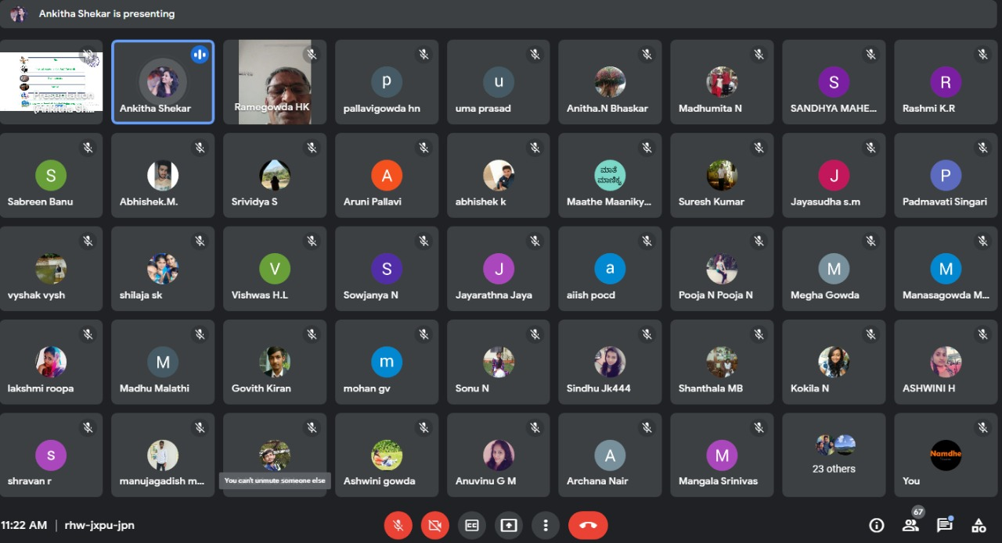

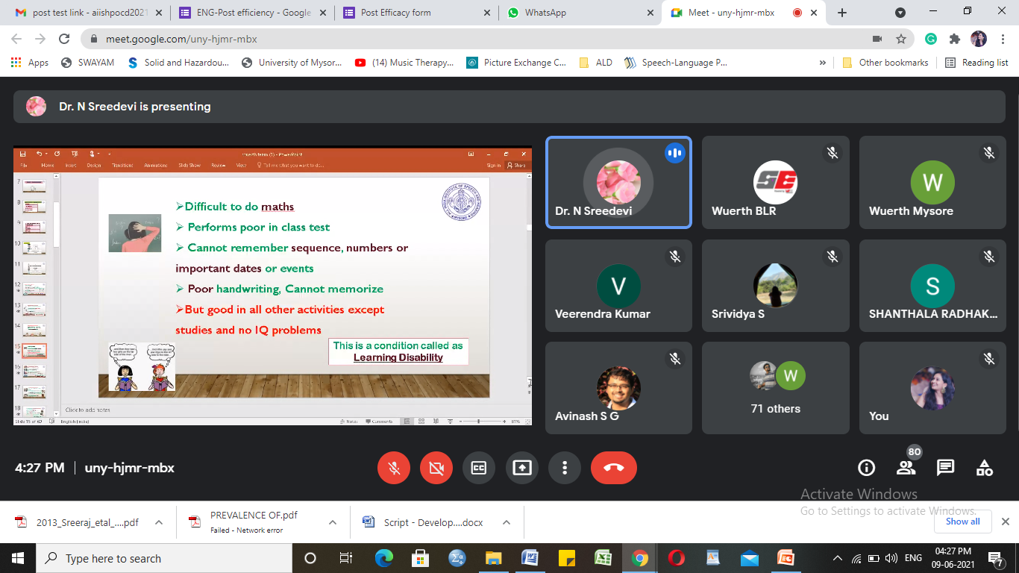

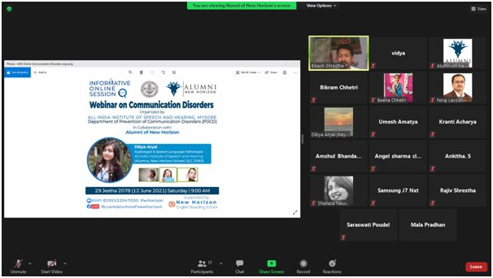

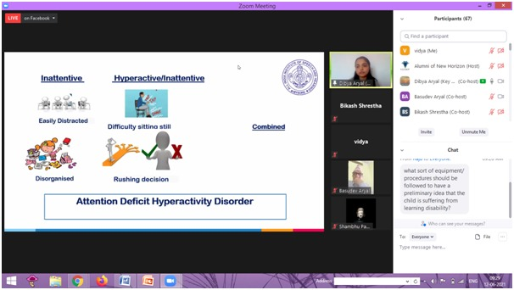

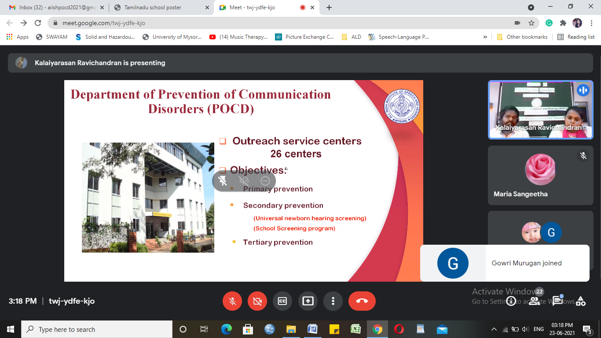

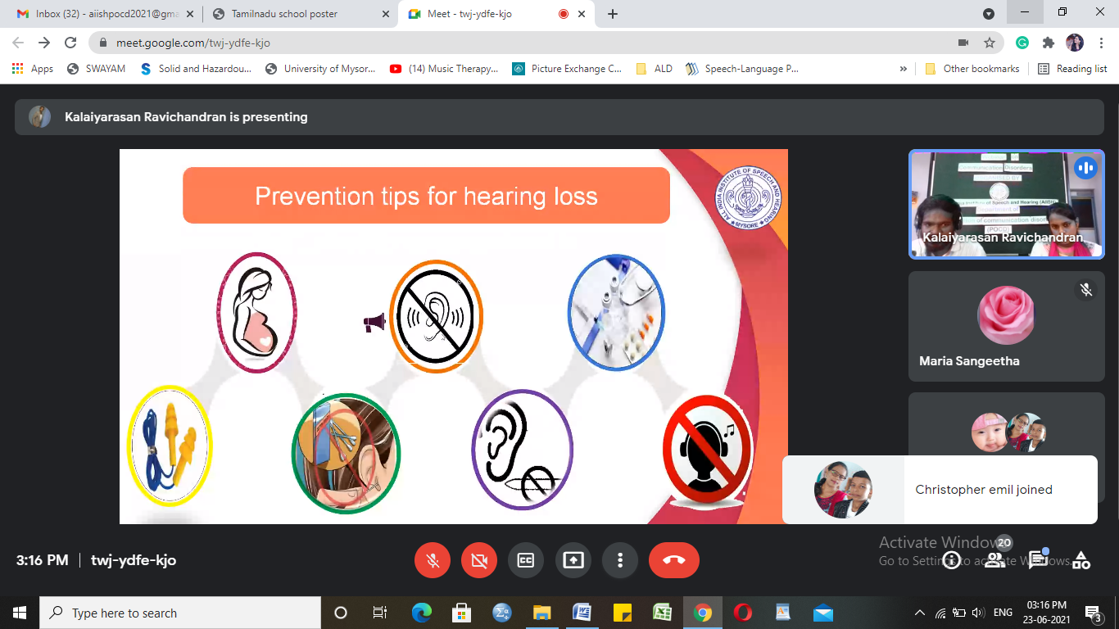

Glimpses of orientation/Webinar programme conducted by POCD staff

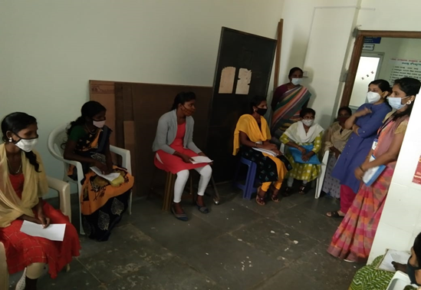

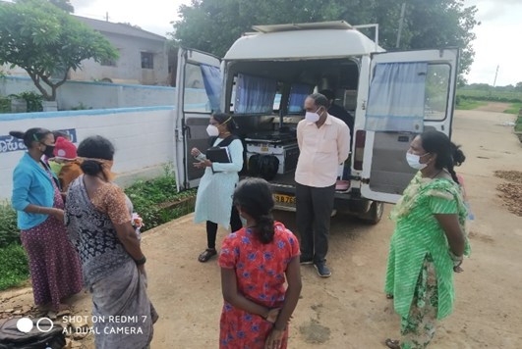

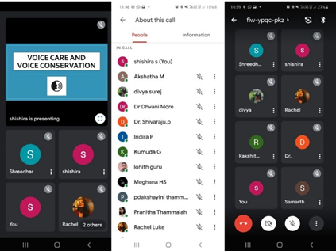

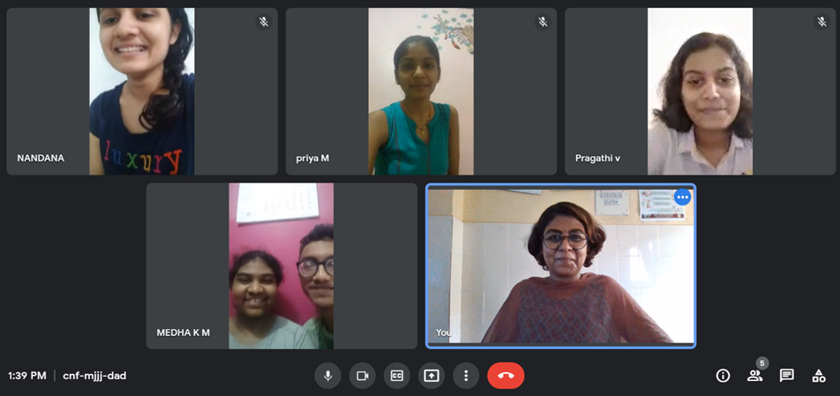

Glimpses of orientation/webinar programme conducted in outreach service centers

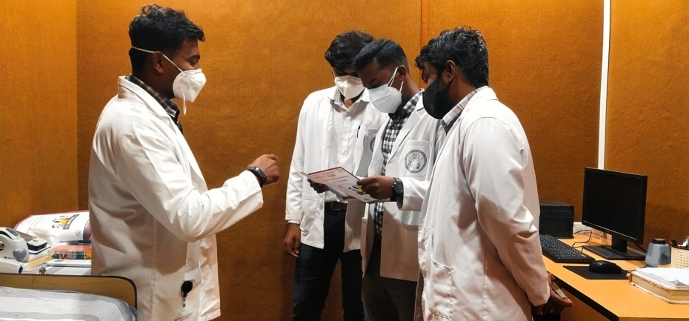

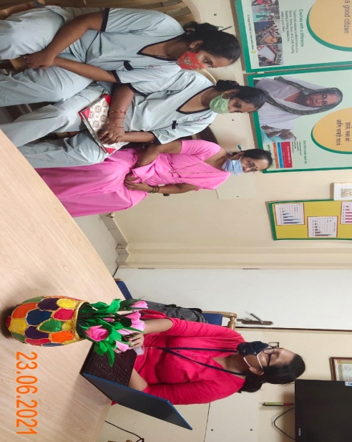

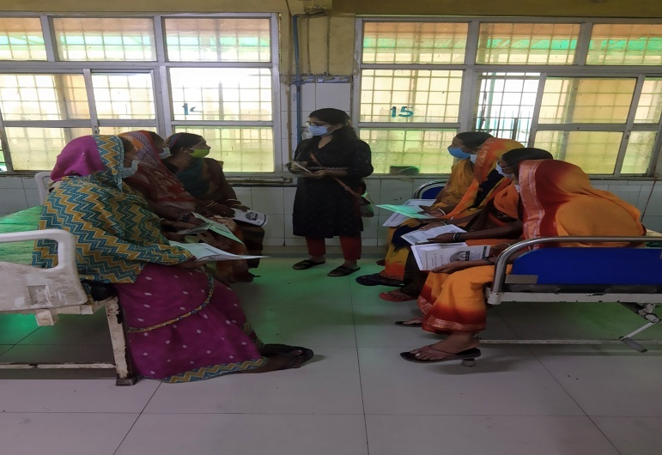

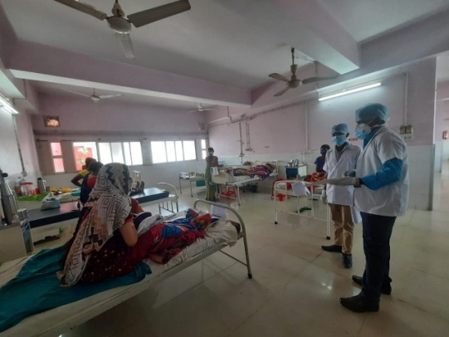

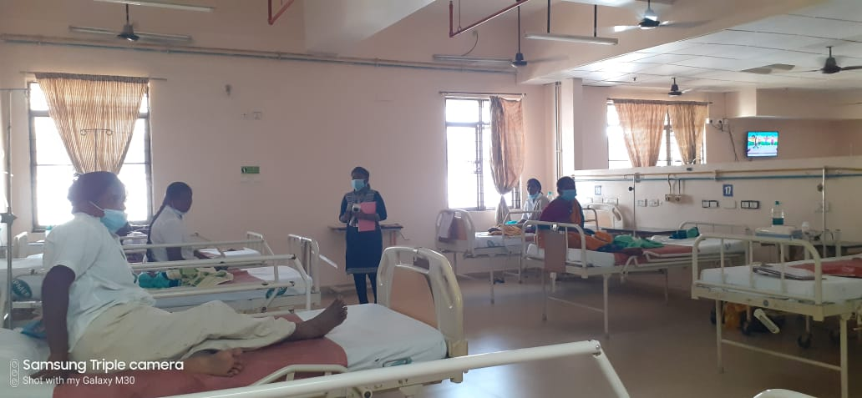

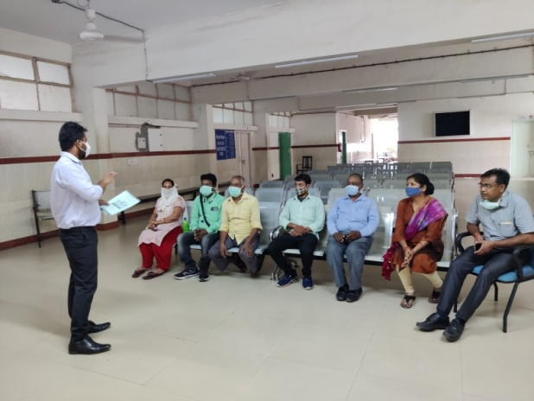

Glimpses of orientation/webinar programmes conducted in outreach service centers

**B) Seminars/ Conferences /Lectures /Workshops/Training programs - Nil**

1. **RESEARCH ACTIVITIES:**

Research Activities of POCD:

1. Verification and compilation of NBS SPSS data for NBS Mysore, NBS and OSC centres by Ranjini & Dibya
2. Prepared introduction for NBS report for the years 2008-2019 by Dibya and Ranjini
3. Verification and compilation of OSC SPSS data for all OSC centres by Merina and Pauline
4. Prepared introduction for OSC report by Merina and Pauline
5. Verification and compilation of School screening SPSS data by Srividya and Ankitha
6. Prepared introduction and method for school screening report by Srividya and Ankitha
7. Verification and compilation of Industrial screening SPSS data by Christy
8. Prepared introduction for Industrial screening report by Christy and Kalaiarasan

Research Activities of OSC: Nil

Research Activities of NBS:

1. OSC BELAGAVI
   1. Researched articles on the same.
   2. Created case history and audiological evaluation proforma.
   3. Pre evaluation of 28 cases was done for the same.
   4. Created SPSS format for the same (Variable entry)
2. OSC Kalburgi
   1. Research proposal submitted to ethical committee of GIMS- Title-Awareness, knowledge and attitude towards communication disorders among general public, medical practitioners: A comparative study
   2. Corrected draft submitted to POCD department- Title- Prevalence of communication disorder among patients reporting to the department of the ENT.

**III) EXTENSION ACTIVITIES**

The department of POCD is actively involved in carrying out various extension activities such as screening, diagnostic and rehabilitation services outside the institute campus. The activities include newborn/infant screening, screening of school children, screening of elderly citizens, screening of industrial workers, conducting camps and also clinical services offered at the outreach service centers of AIISH.

1. **New-born screening programs for Communication Disorders**

a) Table 5: Details of newborn screened in June2021.

|  |  |  |  |  |  |  |  |  |  |  |  |
| --- | --- | --- | --- | --- | --- | --- | --- | --- | --- | --- | --- |
| S. No | Hospitals/Immunization Centers | Total births | Total screened | | | Total No. at risk | | | Phone Follow up | | |
|  |  |  | Male | Female | Total | Male | Female | Total | Male | Female | Total |
| **I. Mysuru Hospitals – Nil due to pandemic** | | | | | | | | | | | |
| **II. OSC Centers:** | | | | | | | | | | | |
|  | Vivekananda Memorial hospital, H. D. Kote, Sarguru, Karnataka (OSC) | 18 | 06 | 11 | 17 | 02 | 00 | 02 | 02 | 05 | 07 |
| St, Mary’s Hospital, HD kote, Sarguru, Karnataka | 143 | 69 | 59 | 128 | 24 | 20 | 44 | 05 | 06 | 11 |
| Taluk Hospital, H. D. Kote- Immunization,Sarguru,Karnataka | 91 | 32 | 41 | 73 | 09 | 09 | 18 | 02 | 03 | 05 |
|  | Taluk Hospital, Nanjangud, Karnataka (OSC) | 80 | 15 | 15 | 30 | 00 | 00 | 00 | 01 | 05 | 06 |
|  | Taluk General Hospital, KR. Pete, Mandya, Karnataka (OSC) | 26 | 17 | 08 | 25 | 00 | 00 | 00 | 00 | 00 | 00 |
|  | Kodagu Institute of Medical Science, Kodagu, Karnataka | 235 | 104 | 91 | 195 | 105 | 90 | 195 | 00 | 00 | 00 |
|  | Bidar Institute of Medical Sciences (BRIMS), Bidar, Karnatka | 320 | 147 | 131 | 278 | 147 | 131 | 278 | 00 | 00 | 00 |
|  | All India Institute of Medical Sciences (AIIMS), Bhuvaneshwar, Orissa | 91 | 40 | 54 | 94 | 05 | 06 | 11 | 25 | 36 | 61 |
|  | Karnataka Institute of Medical Sciences(KIMS,Hubli, Karnataka | 594 | 07 | 03 | 10 | 02 | 01 | 03 | 04 | 02 | 06 |
|  | Indira Gandhi Institute of Medical Sciences(IGIMS), Patna, Bihar | 04 | 01 | 02 | 03 | 00 | 00 | 00 | 00 | 00 | 00 |
| Total | | **1602** | **438** | **415** | **853** | **294** | **257** | **551** | **39** | **57** | **96** |
| **III. NBS Centers** | | | | | | | | | | | |
|  | Rajendra Institute of Medical Sciences (RIMS), Ranchi* | 193 | 48 | 39 | 87 | 01 | 03 | 04 | 01 | 02 | 03 |
|  | Jawaharlal Institute of Postgraduate Medical Education and Research JIPMER, Puducherry * | 497 | 207 | 194 | 401 | 18 | 10 | 28 | 11 | 19 | **30** |
|  | King George's Medical University KGMU, Lucknow, Uttar Pradesh | 277 | 39 | 42 | 81 | 10 | 11 | 21 | 05 | 05 | 10 |
|  | Jawaharlal Nehru Medical College & Hospital, JLNMCH, Bhagalpur, Bihar | 96 | 35 | 32 | 67 | 05 | 01 | 06 | 03 | 03 | 06 |
|  | Post Graduate Institute of Medical Education and Research (PGIMER), New Delhi | 84 | 38 | 33 | 71 | 01 | 04 | 05 | 05 | 01 | **06** |
|  | Sri Devaraj Urs Academy of Higher Eduction and Research (SDUAHER) Kolar, Karnataka | 168 | 76 | 68 | 144 | 00 | 00 | 00 | 16 | 14 | **30** |
|  | All India Institute of Physical Medicine and Rehabilitation (AIIPMR), Mumbai | 37 | 16 | 16 | 32 | 00 | 06 | 06 | 05 | 02 | 07 |
|  | All India Institute of Medical Sciences (AIIMS), Patna | 43 | 22 | 10 | 32 | 01 | 00 | 01 | 05 | 02 | 07 |
|  | Indira Gandhi Medical College (IGMC), Shimla | **73** | 21 | 19 | 40 | 02 | 00 | 02 | 01 | 02 | 03 |
| Total (NBS centers) | | **1468** | **502** | **453** | **955** | **38** | **35** | **73** | **52** | **50** | **102** |
| **Total (POCD+OSC+NBS)** | | **2476** | **940** | **868** | **1808** | **332** | **292** | **624** | **91** | **107** | **198** |

**b) Tele screening Programs**

Tele-screening program (virtual mode) was carried out to identify the babies at risk for communication disorders since new born screening program couldn’t be carried out in many centers. The details including the behavioral responses of the new born to environmental sounds and HRR were collected from the parents through Tele-phone mode. The babies at risk were asked to undergo follow up evaluation in detail.

Table 7: Details of Tele-screening

|  |  |  |  |  |  |  |  |
| --- | --- | --- | --- | --- | --- | --- | --- |
|  | **OSC Centre** | **Total calls made** | **Total Tele-screened** | **Mortality** | **Detailed Evaluation**  **(Referred)** | **Total infants at risk**  **(Screening)** | **Normal Speech and Language milestones**  **(Phone Follow up)** |
|  | **I. Mysuru Hospitals** | | | | | | |
|  | Ashwini Nursing Home (ANH) | 00 | 00 | 00 | 00 | 00 | 00 |
|  | Kamakshi Hospital (KH) | 75 | 56 | 00 | 03 | 09 | 44 |
|  | CSI Holdsworth-Memorial Hospital | 32 | 27 | 00 | 03 | 07 | 17 |
|  | Mahadeshwara Nursing Home (MNH) | 10 | 10 | 00 | 00 | 02 | 08 |
|  | Sigma Hospital (SH) | 19 | 13 | 00 | 01 | 05 | 07 |
|  | Cheluvamba -KR Hospital (KRH) | 100 | 69 | 00 | 03 | 09 | 57 |
|  | Shree Devi Nursing Home (SNH) | 30 | 27 | 00 | 01 | 07 | 19 |
|  | Sri Chamundeshwari nursing home | 00 | 00 | 00 | 00 | 00 | 00 |
|  | Govt. Jayanagar Maternity Hospital | 51 | 43 | 00 | 03 | 07 | 33 |
|  | NPC Maternity hospital | 30 | 26 | 00 | 01 | 00 | 25 |
|  | Makkalakoota Immunization Centre | 00 | 00 | 00 | 00 | 00 | 00 |
|  | Kyathmanalli Immunization Centre | 00 | 00 | 00 | 00 | 00 | 00 |
|  | **Total** | **347** | **271** | 00 | **15** | **46** | **210** |
|  | **II. Outreach Service Centers** | | | | | | |
|  | Sub-divisional Hospital, Sagara Taluk, Sagara, Karnataka | 253 | 178 | 03 | 15 | 15 | 160 |
|  | Primary Health centre (Under Karuna trust), Gumballi, Karnataka (OSC) | 30 | 13 | 00 | 00 | 04 | 00 |
|  | Taluk Hospital, Nanjangud, Karnataka (OSC) | 70 | 70 | 01 | 00 | 20 | 49 |
|  | Gulbarga Institute of Medical Sciences, Kalaburgi, Karnataka | 263 | 139 | 07 | 00 | 49 | 90 |
|  | Karnataka Institute of Medical Sciences(KIMS), Hubli, Karnataka | 148 | 43 | 04 | 00 | 17 | 26 |
|  | **Total** | 764 | 443 | 15 | 15 | 105 | 325 |
|  | **III. Newborn Screening Centers** | | | | | | |
|  | Rajendra Institute of Medical Sciences, Baritayu, Ranchi | 75 | 75 | 00 | 01 | 01 | 02 |
|  | King George’ Medical  University (KGMU) Lucknow | 130 | 99 | 14 | 23 | 07 | 69 |
|  | Total (NBS) | 205 | 174 | 14 | 24 | 8 | 71 |
|  | **Total (POCD+OSC+NBS)** | **1316** | **888** | **29** | **54** | **159** | **606** |

**c) Tele- follow-up evaluation**

The at-risk babies were monitored regularly through Phone calls by administrating Speech-language & hearing developmental checklist. The babies identified with delay in any of the developmental milestones, were referred to AIISH/concerned center for detailed diagnostic evaluation.

Table 6: Details of Tele-phone follow- up carried out at Hospitals in Mysuru.

|  |  |  |  |  |  |  |  |  |  |  |  |  |  |
| --- | --- | --- | --- | --- | --- | --- | --- | --- | --- | --- | --- | --- | --- |
| **S. No.** | | **Hospitals** | | **Total no of calls.** | | **Total call attended** | | **Number of infants with normal developmental milestones** | | **Mortality** | | **Total infants at risk** | |
| **I. Mysuru Hospitals** | | | | | | | | | | | | | |
|  | | Ashwini Nursing Home (ANH) | | 07 | | 06 | | 06 | | 00 | | 00 | |
|  | | Kamakshi Hospital (KH) | | 26 | | 22 | | 22 | | 00 | | 00 | |
|  | | CSI Holdsworth-Memorial Hospital | | 12 | | 09 | | 09 | | 00 | | 00 | |
|  | | Mahadeshwara Nursing Home (MNH) | | 05 | | 05 | | 05 | | 00 | | 00 | |
|  | | Sigma Hospital (SH) | | 14 | | 09 | | 09 | | 00 | | 00 | |
|  | | Cheluvamba -KR Hospital (KRH) | | 159 | | 104 | | 99 | | 00 | | 03 | |
|  | | Shree Devi Nursing Home (SNH) | | 12 | | 11 | | 11 | | 00 | | 00 | |
|  | | Sri Chamundeshwari nursing home | | 06 | | 05 | | 05 | | 00 | | 00 | |
|  | | Govt. Jayanagar Maternity Hospital | | 21 | | 15 | | 15 | | 00 | | 00 | |
|  | | NPC Maternity hospital | | 01 | | 01 | | 01 | | 00 | | 00 | |
|  | | Makkalakoota Immunization Centre | | 01 | | 01 | | 01 | | 00 | | 00 | |
|  | | Kyathmanalli Immunization Centre | | 01 | | 00 | | 00 | | 00 | | 00 | |
|  | | Combined Hospital | | 00 | | 00 | | 00 | | 00 | | 00 | |
|  | | Brindhavan Hospital | | 03 | | 02 | | 01 | | 00 | | 00 | |
|  | | SMTDH | | 02 | | 01 | | 01 | | 00 | | 00 | |
|  | | Gopal Gowda ( GG) | | 01 | | 00 | | 00 | | 00 | | 00 | |
|  | | **Total** | | **271** | | **191** | | **185** | | 00 | | **03** | |
| **II. OSC centers** | | | | | | | | | | | | | |
|  | | Vivekananda Memorial hospital, H. D. Kote, Sarguru, Karnataka (OSC) | | 00 | | 00 | | 00 | | 00 | | 00 | |
| St, Mary’s Hospital, HD kote, Sarguru, Karnataka | | 08 | | 05 | | 05 | | 00 | | 00 | |
| Taluk Hospital, H. D. Kote- Immunization, Sarguru, Karnataka | | 12 | | 09 | | 09 | | 00 | | 00 | |
|  | | Gulbarga Institute of Medical Sciences, Kalaburgi, Karnataka | | 253 | | 131 | | 131 | | 00 | | 00 | |
|  | | Kodagu Institute of Medical Science, Kodagu, Karnataka | | 36 | | 27 | | 27 | | 00 | | 00 | |
|  | | Belagavi Institute of Medical Science, Belagavi, Karnataka | | 60 | | 48 | | 48 | | 00 | | 00 | |
|  | | Karnataka Institute of Medical Sciences(KIMS), Hubli, Karnataka | | 15 | | 13 | | 13 | | 00 | | 00 | |
|  | | **Total** | | **384** | | **233** | | 233 | | 00 | | 00 | |
| **III. Newborn Screening Centers** | | | | | | | | | | | | | |
|  | | Rajendra Institute of Medical Sciences, Baritayu, Ranchi | | 07 | | 07 | | 07 | | 00 | | 00 | |
|  | | Jawaharlal Institute of Postgraduate Medical Education and Research, Puducherry | | 26 | | 19 | | 19 | | 00 | | 00 | |
|  | | King George’s Medical  University (KGMU) Lucknow | | 25 | | 17 | | 15 | | 00 | | 02 | |
|  | | Post Graduate Institute of Medical Education and Research (PGIMER), New Delhi | | 18 | | 13 | | 12 | | 00 | | 01 | |
|  | | Sri DevarajUrs Academy Of Higher Education and Research (SDUAHER), Kolar | | 40 | | 38 | | 38 | | 00 | | 00 | |
|  | | All India Institute of Physical Medicine and Rehabilitation (AIIPMR), Mumbai | | 06 | | 03 | | 03 | | 00 | | 00 | |
|  | | All India Institute of Medical Science (AIIMS), Patna | | 10 | | 09 | | 09 | | 00 | | 00 | |
|  | | **Total** | | **132** | | **106** | | **103** | | **00** | | **03** | |
| **Total (POCD+OSC+NBS)** | | | | **787** | | **530** | | **521** | | **00** | | **06** | |

Note: The calls not attempted were repeated a minimum of 5 times on consecutive days

**d) Newborn follow-up evaluation (Detailed assessment)**

The newborns/infants referred during the newborn screening/ Tele-screening were advised for detailed evaluation at AIISH/NBS centers/OSCs. A complete test battery was administered for those babies/infants who came for follow-up.

Table 8: Details of the results of follow-up evaluation

|  |  |  |  |  |  |
| --- | --- | --- | --- | --- | --- |
|  | Normal | Hearing impairment | Speech Language disorder | Multiple disorder | Total |
| **POCD AIISH** |  |  |  |  |  |
| **II. Outreach Service Centers** | | | | | |
| Vivekananda Memorial Hospital, Sarguru | 17 | 00 | 00 | 00 | 17 |
| **III. Newborn Screening Centers** | | | | | |
| Rajendra Institute of Medical Sciences, Baritayu, Ranchi | 02 | 02 | 03 | 00 | 07 |
| JIPMER, Puducherry | 01 | 01 | 00 | 00 | 02 |
| King George’ Medical  University (KGMU) Lucknow | 11 | 03 | 00 | 00 | 14 |
| Jawaharlal Nehru Medical College & Hospital, Bhagalpur, Bihar | 01 | 00 | 00 | 00 | 01 |
| Post Graduate Institute of Medical Education and Research (PGIMER), New Delhi | 00 | 07 | 00 | 00 | 07 |
| All India Institute of Physical Medicine and Rehabilitation (AIIPMR), Mumbai | 03 | 00 | 00 | 00 | 03 |
| Total (NBS) | **18** | **13** | **03** | **00** | **34** |
| **Total (POCD+OSC+NBS)** | **35** | **13** | **3** | **00** | **51** |

**B) Anganawadi /Preschool/School screening program**

Screening of Anganawadi, preschool and primary school children was conducted focusing on the early identification of communication disorders and early rehabilitation of children at risk for communication disorders.

Table 10: Total number of children screened for communication disorders and identified.

|  |  |  |  |  |  |  |  |
| --- | --- | --- | --- | --- | --- | --- | --- |
| Date | Name of the Anganawadi/Preschool/ School | Total screened | | | Total referred with communication disorders | | |
| Ear related disorder | Hearing loss | Speech language disorders |
| Male | Female | Total | - | - | - |
| 19.06.2021 | Netkalundi, Yeshwanthpura  OSC SARGURU | 08 | 09 | 17 | 01 | 01 | 02 |
| 25.06.2021 | Ballehadi,Mahurhadi, Halevanahdi,  OSC SARGURU | 09 | 15 | 24 | 00 | 01 | 01 |
| **Total** | | **17** | **24** | **41** | **01** | **02** | **03** |

**C)a. Industrial Screening– Currently stopped due to Pandemic**

**b.**Follow-up Hearing evaluation of industrial workers at AIISH– Nil

**D)Table 13: Elderly Screening– Currently stopped due to Pandemic**

**E)Bedside Screening- Currently stopped due to Pandemic**

**F)CLINICAL SERVICES AT OUTREACH SERVICE CENTRES**

The clinical activities are not only restricted to in and around Mysuru, but also extended to rural areas where facilities for clinical services for persons with communication disorders are scanty. Currently there are 12 OSCs centres at different part of the country rendering services to unreached population. The details of those who were registered and availed various services/benefits at the OSCs are tabulated below.

1. **Clients identified and followed up with communication disorders at OSCs**

Table 15: Details of clients identified with different types of communication disorders across OSCs

|  |  |  |  |  |  |  |  |  |  |  |  |
| --- | --- | --- | --- | --- | --- | --- | --- | --- | --- | --- | --- |
| Sl.No | OSC | Normal | ENT | Total  (AUD) | Speech &Language Disorders | | | | | Total  (S&P) | Total |
| Voice | Fluency | Phonological disorders | Language disorders | Dysphagia |
|  | Taluk General Hospital, KR Pete | 03 | 00 | 11 | 00 | 00 | 00 | 02 | 00 | 02 | 16 |
|  | Sub-divisional Hospital (PHC), Sagara | 03 | 08 | 05 | 00 | 00 | 00 | 01 | 00 | 01 | 09 |
|  | Vivekananda Memorial Hospital, Sarguru | 01 | 00 | 07 | 00 | 00 | 01 | 03 | 00 | 04 | 12 |
|  | Gulbarga Institute of Medical Sciences | 02 | 04 | 03 | 00 | 00 | 00 | 01 | 00 | 01 | 04 |
|  | Kodagu Institute of Medical Sciences, Madikkerri | 16 | 00 | 10 | 00 | 00 | 00 | 00 | 00 | 00 | 26 |
|  | AIIMS, Bhuvaneshwar | 00 | 00 | 00 | 03 | 00 | 01 | 04 | 02 | 10 | 10 |
|  | IGIMS,  Patna | 01 | 00 | 01 | 00 | 00 | 00 | 01 | 00 | 01 | 03 |
|  | KIMS,  Hubli | 01 | 00 | 42 | 02 | 01 | 01 | 01 | 00 | 05 | 48 |
|  | BRIMS, Bidar | 00 | 00 | 04 | 00 | 00 | 01 | 00 | 00 | 01 | 05 |
| **Total** | | **27** | **12** | **83** | **05** | **01** | **04** | **13** | **02** | **25** | **133** |

1. Table 16:Details of clients followed up with different types of communication disorders across OSCs.

|  |  |  |  |  |  |  |  |  |  |  |  |
| --- | --- | --- | --- | --- | --- | --- | --- | --- | --- | --- | --- |
| Sl.No | OSC | Normal | ENT | Total  (AUD) | Speech &Language Disorders | | | | | Total  (S&P) | Total |
| Voice | Fluency | Phonological disorders | Language disorders | Dysphagia |
|  | Taluk General Hospital, KR Pete | 00 | 00 | 01 | 00 | 00 | 00 | 01 | 00 | 01 | 02 |
|  | Kodagu Institute of Medical Sciences, Madikkerri | 00 | 00 | 02 | 00 | 00 | 00 | 00 | 00 | 00 | 02 |
|  | AIIMS, Bhuvaneshwar | 00 | 00 | 00 | 01 | 00 | 00 | 00 | 03 | 04 | 04 |
| **Total** | | 00 | 00 | 03 | 01 | 00 | 00 | 01 | 03 | 05 | 08 |

vi) **Rehabilitation services at OSCs.**

Table 17: Details of rehabilitation services provided at OSCs in June2021.

|  |  |  |  |  |
| --- | --- | --- | --- | --- |
| **OSC** | **Hearing Aids Dispensed** | **Speech-language therapy** | | |
| No. of clients | No. of sessions | |
| Regular Therapy | Tele therapy |
| Sub-divisional Hospital, Sagara Taluk, Sagara, Karnataka | 00 | 12 | 00 | 59 |
| Primary Health centre (Under Karuna trust), Gumballi, Karnataka (OSC) | 00 | 05 | 00 | 32 |
| Vivekananda Memorial hospital, H. D. Kote, Sarguru, Karnataka (OSC) | 02 | 10 | 20 | 12 |
| Taluk Hospital, Nanjangud, Karnataka (OSC) | - | 04 | - | 45 |
| Community Health Centre (CHC), Hullahalli, Karnataka | - | 01 | - | 15 |
| Taluk General Hospital, KR. Pete, Mandya, Karnataka (OSC) | - | 03 | 06 | 07 |
| Gulbarga Institute of Medical Sciences, Kalaburgi, Karnataka |  | 18 | - | 144 |
| Kodagu Institute of Medical Science, Kodagu, Karnataka | 06 | 08 | - | 42 |
| Belagavi Institute of Medical Science, Belagavi, Karnataka | 00 | 05 | 00 | 28 |
| Bidar Institute of Medical Sciences (BRIMS), Bidar, Karnatka | 00 | 02 | 00 | 12 |
| All India Institute of Medical Sciences (AIIMS), Bhuvaneshwar, Orissa | 00 | 12 | 64 | 00 |
| Karnataka Institute of Medical Sciences(KIMS), Hubli, Karnataka | 00 | 03 | 00 | 12 |
| Indira Gandhi Institute of Medical Sciences (IGIMS), Patna, Bihar | 00 | 01 | 00 | 07 |
| **Total** | 08 | 84 | 90 | 415 |

**v) Table 18: Screening Camps for communication Disorders**

|  |  |  |  |  |  |  |  |  |  |
| --- | --- | --- | --- | --- | --- | --- | --- | --- | --- |
| **Sl No.** | **Date** | **Conducted dept/Center** | **Camp site** | **Total Screened** | **Total Referred** | | | | **Total hearing aid distributed** |
| **Hearing impairment** | | **Speech- language disorders** | |
| **Male** | **Female** | **Male** | **Female** |
|  | 20.06.2021 | OSC Sarguru | VMH, Sarguru | 20 | 0 | 0 | 0 | 0 | 0 |
| **Total** | | | | 20 | 0 | 0 | 0 | 0 | 0 |



Glimpses of Camps conducted

**G) Human Resource Development**

**a) Student clinical training**:

As part of human resource development, clinical training for Undergraduates (B.Sc. Speech & Hearing), Postgraduates (M.Sc. SLP & AUD) & Internship students on early identification, prevention & rehabilitation of communication disorders and Community based rehabilitation at OSCs were carried out. The details on the number of students who had undergone training are given below.

Table 19: Details of the students posted in POCD during June2021

|  |  |  |
| --- | --- | --- |
| **Internal (AIISH)** | | |
| **Class** | **No. of students Newly posted** | **No. of Students continuing** |
| I M.Sc. (SLP) students | 07 | 01 |
| I M.Sc. (Audiology) students | 00 | 00 |
| BASLP Internship students | 00 | 00 |
| **Total** | **07** | **01** |

**b) Staff/Student Enrichment Programs**:

As a part of continued education and updating of ongoing research and clinical evidences on early identification, prevention &amp; rehabilitation of communication disorders and Community based rehabilitation. Postgraduates students (M.Sc. SLP &amp; AUD) and staffs conduct and attend many presentation and talks. The details on the number of students and staffs who had undergone training are given below.

Table 20: Details of staff/student enrichment programmes

|  |  |  |  |  |
| --- | --- | --- | --- | --- |
| **Sl. No.** | **Date** | **Title of Presentation** | **Presenters** | **No of Staff attended** |
|  | 03.06.2021 | Methodological aspects of testing VEMP ininfants at UHSP | Sandeep Kumar  Teja G | 13 |
|  | 04.06.20221 | Hearing aid programming | Ms. Merina | 09 |
|  | 08.06.2021 | Cry features of healthy neonates who passed their new born hearing screening vs those who did not” on | Nayana T Y  Nethra R | 12 |
|  | 10.06.2021 | Verbal task and motor response for adults during hearing screening” | Sahana MB | 12 |
|  | 23.06.2021. | “Well-Being and Resilience inChildren With Speech andLanguage Disorders” | Prerna  Darshitha S | 12 |

**IV) TECHNOLOGICAL CONSULTANCY SERVICES: NIL**

**V) CENTRAL FACILITIES**

**a) Library and information Services: NIL**

**VI) MAJOR EVENTS OF THE MONTH**:

1. On the occasion of National Aphasia awareness month. We conducted a week long quiz on instagram handle of Kodagu Institute of Medical Sciences for students and staffs of the institute. And, we received about 80 – 100 responses every day. At the end of the awareness month, a instagram live talk was carried out on the importance of early intervention in rehabilitation of Aphasia And there were more than 300 views for the same.

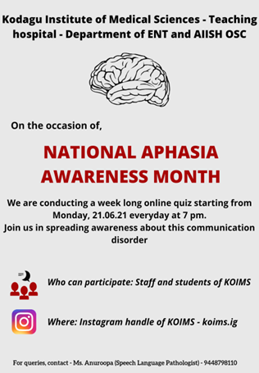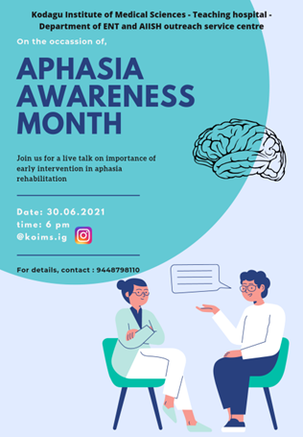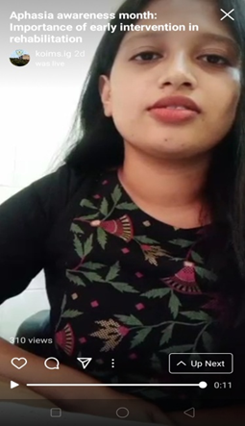

1. R. DEEPA (Speech language pathologist) conducted Food Kit Distribution for physically challenged and tribals more than 10 villages (Hebbalaguppe, Jakkalli, Belethur) on Jun 05th, 08th 2021

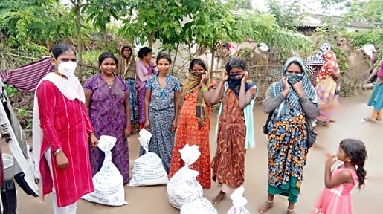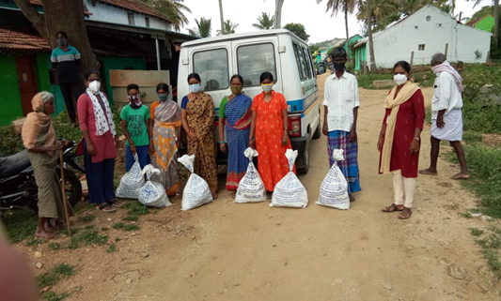

**VII) OTHERS**

1. Submitted Hindi Quarterly Report

2. Submitted Annual Report 2020-21

3. Submitted NAAC details

4. Material development works as part of work from home due to pandemic.

|  |  |  |  |  |  |
| --- | --- | --- | --- | --- | --- |
| **Sl No.** | **MATERIAL** | **LANGUAGE** | **PREPARED BY** | **VERIFIED BY** | **STATUS** |
| **PUBLIC EDUCATION VIDEOS** | | | | | |
|  | Tips for speech & language stimulation at home | Hindi | Ms.Shishira & Mr.KirubaharaneSI | Ms.Krupa Bai | Submitted |
|  | Animated video of LD | English | Edited by Mr.Kirubaharane | MD incharges | Correction going on |
|  | Animated video of SSD | English | Edited by Mr.Kirubaharane | MD incharges | Correction going on |
|  | Animated video of ASD | English | Edited by Mr.Kirubaharane | MD incharges | Correction going on |
|  | Developmental milestones | Malayalam | Edited by Mr.Kirubaharane | MD incharges | Completed |
|  | Animated video of SSD | Tamil | Edited by Mr.Kirubaharane | MD incharges | Correction going on |
|  | Animated video of ASD | Tamil | Edited by Mr.Kirubaharane | MD incharges | Correction going on |
|  | Language milestones video | Tamil | Prepared by Ms.Jasper | MD incharges | Correction going on |
|  | Vocal Hygiene Program | Kannada | Ms.Parnika K M | Ms.Srividya | Voice over to be completed and submitted |
|  | Video on noise awareness | English | Ms.Rishisha and Ms.Krupa | Ms.Sarah and Ms.Shishira | In process |
|  | Video on stuttering | English | Ms.Rishisha | Ms.Sarah | In process |
|  | Vocal hygiene | English | Ms.Delna | Ms.Swaliha |  |
|  | Speech and Hearing Milestones | Assamese | Ms. Kristi Kaveri Dutta | Ms. Kranti | Script under verification. Audio recorded. |
| **PUBLIC EDUCATION PAMPHLETS** | | | | | |
|  | Communication disorders | English | Ms.Sarah | Ms.Rishisha | Completed |
|  | Counseling tips- Autism | English | Ms.Delna | Md incharges | completed |
|  | Tips for speech therapy that parents can use at home | English | Ms.Rishisha | Ms.Sarah | In process |
|  | Pamphlet on dysphagia | Malayalam | Ms.Delna | Ms.Swaliha | Correction going on |
|  | Pamphlet on dementia | Malayalam | Ms.Delna | Ms.Swaliha | Correction going on |
| **POSTERS** | | | | | |
|  | Psychological effects of hearing Loss | English | Ms.Aparna | Mr.Basih | Completed |
|  | Prevalence of hearing loss | English | Ms.Aparna | Mr.Basih | Completed |
|  | Tips for feeding mother | English | Ms.Aparna | Mr.Basih | Completed |
|  | Where does an audiologist work. | English | Ms.Aparna | Mr.Basih | Completed |
|  | Importance of Home training poster. | English | Ms.Sarah | Ms.Rishisha | Completed |
|  | Speech language milestones- Poster | English | Ms.Anurupa | MD incharges | Corrections received- to be corrected |
|  | Importance of newborn hearing screening- Poster | English | Ms.Sushma | MD incharges | Poster to be made in Kannada as per the corrections |
|  | Role of speech language pathologist | English | Ms.Anurupa | MD incharges | Corrections received- to be corrected |
|  | Vocal Hygiene poster | English | Ms.Anurupa | MD incharges | To be corrected |
|  | Poster on developmental chart | English | Ms.Rishisha | Ms.Sarah | Completed |
|  | Poster on services provided by OSC center | English | Ms.Rishisha | Ms.Sarah | Completed |
|  | Poster on speech sound disorder | English | Ms.Rishisha | Ms.Sarah | Completed |
|  | Poster on Autism | English | Ms.Rishisha | Ms.Sarah | Completed |
|  | Poster on early identification and intervention | English | Ms.Rishisha | Ms.Sarah | Completed |
|  | Poster on causes of hearing loss | English | Ms.Krupa | Ms.Shishira | Completed |
|  | Poster on 5 steps of Hearing Safety | English | Ms.Krupa | Ms.Shishira | Completed |
|  | Poster on 8 signs u may have a Hearing loss | English | Ms.Krupa | Ms.Shishira | Completed |
|  | Poster on New born Hearing Screening Awareness | English | Ms.Krupa | Ms.Shishira | Completed |
|  | Poster on Aphasia and its symptoms | English | Ms.Swaliha | MD incharges | Correction going on |
|  | Poster on Developmental milestones | English | Ms.Sarga | MD incharges | Submitted. |
|  | Importance of Newborn Hearing | English | Ms.Roja and Mr.Ajith | MD incharges | Correction going on |
|  | Causes of Hearing Loss | English | Md. Basih Thaha | Aparna | Submitted |

**VII) ACTIVITIES CARRIED OUT BY THE STAFF OF THE DEPARTMENT OF POCD.**

Table 16: Details of activities carried out by POCD staff in June 2021.

|  |  |  |  |
| --- | --- | --- | --- |
| **S. No** | **Name of the staff** | **Designation** | **Activities** |
|  | Dr. N Sreedevi | HOD, Dept. of POCD | * Officiating as HOD-POCD * Has been coordinating webinars/ orientation on communication disorders to teachers 06 nos * Conducted Dept meeting on 4th, 11th, 18th, 25th 13th, 21st and 28th May 2021 * Conducted RE BE meeting on 2.7.2021, 7.6.2021 * Submitted RE BE revised on 7.6.2021 * Delivered two talks on POCD activities to BASLP students 7.6.2021 * Attended student presentation on 3.6.2021, 8.6.21, 23rd, * Served as resource person for WURTH Company webinar on 9.6.2021 * Conducted OSC meeting on 9.6.2021,16th, * Recorded Academic courses of AIISH in Malayalam * Attended Purchase Commiittee meeting on 18.6.2021 * Coordinated the purchase files discussion * Carried out trial recording for DD on 18.6.2021 * Submitted status of newly initiated centers to Director on 21.6.2021 * Attended and provided feedback on NBS report Draft1 on 22.6.2021 * Submitted status of with-drawl centers to Director on 23.6.2021 * Submitted clarification on 58th EC agenda to Director on 24.6.2021 * Attended meeting with Raibareli OSC center staff at Board Room on 29.6.2021 * Conducted meeting with NBS staff on 29.6.2021 * Coordinated the MD work of POCD |
|  | Dr. Sandeep M. | Faculty | * Coordinating NBS activities of the Dept. |
|  | Mr. Arunraj. K | Audiologist/SLP | * Coordinated OSC activities * Coordinated equipment related works in the department * Prepared RE BE – budget proposal * Attended SPPS meeting * Verified SPSS variables * Conducted all NBS & OSC meetings * Attended departmental meetings * Attended RE BE meeting * Verified and corrected SPSS variable * Verified and corrected Reports of industrial, school screening and OSC * Coordinated school screening analysis * Drafted letters for OSC communications * Drafted EC proposal revision * Conducted meeting with GMCH Chandigarh |
|  | Ms. Ranjini A | Audiologist Gr. I | * Compiled and verified tele-screening report of Mysuru NBS centres * Edited HRR form according to new SPSS format * Made certificates for statistician * Attended staff enrichment program on Hearing aid fitting on 04/06/21 * Recorded the video for MD on the topic of NBS * Details for tele-screening was obtained from CHELUVAMBA, KAMAKSHI, SNH, CHAMUNDESHWARI, MNH,SIGMA, JAYANAGAR hospitals in Mysuru * Tele-screening was done for 70 babies forMysuru hospitals. * Corrections were made for the NBS draft |
|  | Ms. Srividya S | Audiologist Gr. I | * Did Tele-screening for 50 cases from CH, Jayanagara, MNH and Sigma hospital. * Edited the school screening report. * Did Stock Verification of Equipment’s. * Created Google meet links for webinars for kala Neralu team, John’s Central School, St. Stella Matriculation school, and Bank of Baroda Employees. * Coordinated with Vasanthalakshmi ma’am regard school screening analysis report. * Edited slides for webinar on ‘communication disorders for children’. * Designed posters for webinar on ‘communication disorders’ for Neralu team, Wuerth team, John’s Central School, St. Stella Matriculation school and Bank of Baroda Employees. * Coordinated and verified MD works of staff doing work from home. * Coordinated with DMD section regard designing work * Verified different MD works done by staff and students:   1. Designing of FAQ’s on Stuttering,Voice disorder.  2. Poster on Developmental Milestone  3. Poster on New Born Screening.  4. Video script on NBS  5. Video on ADHD  6. Video script on Vocal Hygiene tips  7. Comic videos on LD, NBS, ASD andSSD  8. Verification of FAQ’s Aphasia and LD   * Coordinated and organized webinar on ‘Communication disorders’ for:   1. Neralu team on 9/6/2021  2. Wuerth team on 9/6/2021  3. New Horizon Alumni Group on12/6/2021  4. St. Stella Matriculation school on23/6/2021  5. John’s Central School on25/6/2021  6. Bank of Baroda Employees on29/6/2021   * Prepared and circulated certificates for participants of webinar. * Attended staff enrichment programme about Hearing aid programming on 04/06/2021. * Attended student article presentation on 3rd , 8th , 10th , and 23rd . |
|  | Ms. Dibya Aryal | Speech Language Pathologist Gr. I | * Compiled and verified monthly report and SPSS data of outside NBS centres * Verified SPSS data and did data cleansing for five NBS centres for the year 2020 * Organized and conducted webinar on Communication disorders for New Horizon Alumni group, Nepal on 12/06/2021 * Verified and edited Hindi version of FAQ’s on aphasia, voice, learning disability * Verified posters on auditory development and NBS in Hindi language * Edited NBS report for the year 2008-2019 * Edited HRR form according to new SPSS format * Made certificates for statisticians * Compiled phone follow up data of NBS centres for the year 2020 * Follow up data for NBS centres from 2016-2019 was collected and merged. * Attended staff enrichment program on Hearing aid fitting on 04/06/21 |
|  | Ms. Tanuja M.N | Audiologist Gr. II | * Translated FAQs on ENT related problems from English to Kannada. * Attended student article presentation on 3,8,10, 23 of June. * Attended staff enrichment program. * Verified and completed phone follow up for the month of March (3 months), December (6 month) & January (6 months). * Edited the referral details on Tele assessment for babies at risk for Communication Disorders and followed up with TCPD in charge. * Cross checked the Phone follow up data entered in SPSS. * Verified the referral case phone follow up of the month of January, February, March, April, May, June, July. * Completed Tele screening for the newborn babies Cheluvamba and MNH Hospital &Jaynagar Hospital. * Verified and mailed correction for the translation work ‘Speech stimulation tips for children at home. * Verified for the stuttering pamphlets and suggested correction. * Coordinated for the webinar on communication disorders for Johns central school on 23.6.21. * Coordinated for the webinar on communicationdisorders for ST Stellas on 25.6.21. * Presented webinar on communication disorders for BOB staff on 29.6.21. * Coordinated for the webinar on communication disorders for Neralu team on 9.6.21. * Attended a meeting about the webinar with coordinator Santosh Shetty of Wuerth Company. * Oriented about SPSS variable to deepa, Megha and Ashique. * Prepared certificate * Edited video of DCS orientation. * Monitored video on FAQs on ENT related problems. * Monitored phone follow-up calls of Deepa. * Edited pre and post test google form. * Prepared webinar schedule. * Suggested correction for webinar poster. * Attended student article presentation. * Coordinated for the webinar on communication disorders for Neralu team. * Attended webinar on communication disorders for employees of Wuerth Company. * Telescreeening of the babies (N=8) born in June in the MNH Hospital. * Mailed 9 high risk cases to TCPD for tele-assesment. * Followed up with the high risk cases referred for TCPD. * Enquired about the status of the video on developmental milestones. * Prepared certificate for the participants of webinar on communication disorders in children. * Coordinated for the webinar on communication disorders for St Johnes school. * Recorded video of FAQ on ENT related problems. * Mailed content letter to send participant certificate for participants from thrissur. * Verified data entry of follow up details from 2008- 2021 in the SPSS. * Verified total referral cases not turned up for the follow up evaluation from January 2020 to march 2021. * Searched old records of follow up assessment. * Cross checked the data entry of the follow up details(2008-2021) which were entered by Megha and Deepa . * Cross checked and calculated the total follow cases completed in the old records and also SPSS data. * Cross checked the Follow up SPSS variables of 2017, 2017-19 and 2021. * Edited and finalized PPT of webinar on Communication disorders. * Mailed requisition letter to principal of Delhi public school. * Edited orientation data and calculated total participants in AIISH, OSC & NBS centre for the Orientation Annual report. * Contacted JNV staff nurse clarified the doubt. |
|  | Ms. Merina Thomas | Audiologist Gr. I | * OSC and NBS SPSS verification for May month 2021 * Coordinated the OSCs activity at 12 centres * Monthly report correction and compilation of data for May month 2021 * Tele-screening of 30 babies * Collected hearing aids from repair section for K.R.PETE * Verification of SPSS data of newly formatted OSC SPSS (May and April month). * Prepared video for Tinnitus in Malayalam * Attended Student article presentations * Attended weekly department meetings * Presented on Hearing aid programming for staff enrichment program * Attended OSC meetings regarding finalizing new OSC SPSS variables * Corrected developmental milestones in Malayalam and suggested corrections * Recoded and added new variable for Akkihebalu,Hullahali and Gumballi OSC data from initation till december 2020 * Combined and merged OSC data of Sagara,Sarguru,Kalburgi,Gumballi,Nanjangud,Kodagu,K.R.Pete,Akkkihebalu,Hullahalli and Belgavi since initiation till December 2020 |
|  | Ms. Christy Sebastian | Audiologist Gr. I | * Draft on the industrial report (Introduction and methods chapter) has been submitted. * Merged diagnostic and screening industrial data, applied OSHA age correction values and the data sent to statistician. * Contacted Dr. Preethi at JSW steel factory, Bellary for organising industrial screening. * Verification of videos on- * 1)Tinnitus in Malayalam * 2)Developmental milestones in Malayalam * 3)Vocal hygiene tips in English * 4)Comic strip of LD in English * 5)Comic strip of SSD in English * 6)Seating arrangement in English * 7)Otosclerosis in English * • Verification of the counselling tips in   Malayalam on-  1)voice  2)learning disability  3)speech sound disorder  4)stuttering  5)hearing loss  6)Apraxia  7)Social communication disorder  8)Intellectual disability   * Verification of the counselling tips inEnglish on-   1)Spoken language disorder  2)Down syndrome  3)Autism   * Translation of the counselling tips in English on spoken language disorder * Allotment of work from home and verification of materials sent by NBS and OSC. * Tele-screening done for 50 new-born screening * Attended the student presentations. * Updated research corner. |
|  | Ms. Pauline Gracia R V | SLP Gr. II | * POCD- Website content updated * Tele-screening done for 30 new-borns. * Prepared a Tamil video on Spoken language disorders- Material development. * Gave corrections to Tamil videos done by Mohana and Jasper. * Gave details about camps to Ms. Deepika. * Verified 8 Tamil pamphlets. * 3 Webinars for school teachers. * Read and gave input for elderly report. * Made intro and method part of OSC report. * OSC data of all centers from its beginning were cleansed. * OSC data weremerged center-wise and overall. * Attended follo0w up meeting with OSCs. * Worked on new OSC SPSS format. * Updated the status of new 23 centers. |
|  | Ms. Kranti Acharya | SLP Gr. I | * Organized and attended student article presentation on “Methodological aspects of testing VEMP in infants at UHSP” on 3.06.2021 * Organized and attended student article presentation on “Cry features of healthy neonates who passed their new born hearing screening vs those who did not” on 08.06.2021 * Organized and attended student article presentation on “Verbal task and motor response for adults during hearing screening” on 10.06.2021 * Analysed and entered 25 infant cry samples in SPSS * Online orientation to students regarding the activities of POCD and instructions to be followed in department posting. * Conducted online test (google form) for students attending POCD posting since May. * Cronbach’s alpha test was performed for infant cry sample to check reliability * Corrected PowerPoint slides of article presentation of MSc students. * Updated research corner * Compilation of student’s attendance posted in POCD dept. * Attended regular POCD meeting each Friday * Prepared the list of important days to be remembered by ASLP. * Had meeting with HoD and NBS staffs regarding their activities and material development * Corrected and verified the FAQ on Learning disability, stuttering and voice disorder, sent to DMD for designing after correction. * Final correction of pamplets of Aphaisa, Stuttering and learning disability in Hindi sent for designing. * Corrected and verified videos made by staff at OSC center on – Voice Disorder * Corrected and verified videos made by staff at OSC center on Speech stimulation techniques * Attended ED-Med Webinar on 22.06.21 * Corrected the script and ppt for the video on – ADHD and Newborn Hearing Screening prepared by Dibya and Ranjini. * Organized and attended student article presentation on “Well-Being and Resilience in Children With Speech and Language Disorders” on 23.06.2021 |
|  | Ms. Ankitha.S | SLP Gr. II | * Prepared webinar poster – Wuerth team, Mysore and New Horizon school, Nepal * Attended webinar on Leveraging cochlear programming approach for patient-focused care * Prepared webinar pre and post-test Google form (both English and Kannada) and feedback form(Kannada)Prepared Wuerth team ppt * Attended webinar on Sound foundation for children * Prepared webinar PPt for Neralu team * Prepared Certificate templates and contents * Google meeting trail session with –Wuerth team coordinator * Corrected Wuerth team webinar PPT * Discussed and corrected Milestones script –with Spoorthy ma’am and Nithya ma’am * Conducted and presented –Neralu team, webinar on communication disorderon 09.06.2021 * Conducted and coordinated-Wuerth team webinar on communication disorder 09.06.2021 * Conducted and coordinated- webinar on communication disorder for New Horizon school, Nepal. On 12.06.2021 * Tele screening was done -3 cases * Attended Student’s presentation on Verbal task and motor response (VTMR)for adult in Hearing screening * General feedback form and pre-post link was modified * General ppt for webinar on communication disorders was corrected and finalized * Prepared webinar certificate content and template * Instruments verification was done * Attended Webinar: Management of late implanted children in India. * Attended ERMD consortium webinar on 22.06.2021 and student’s presentation on 3 rd , 8th, 10th and 23rd June. * Attended staff enrichment program on 04.06.2021 * Prepared school screening work flow draft * Conducted and co-ordinated webinar of John’s central school, teachers on 23.06.2021 * Prepared Milestone ppt and finalised * Tele session was taken– case: Thrupti (goals- Vocalization of /a/,/e/,/u/ and identification of common objects. * Conducted and co-ordinated webinar of St. Stella’s school, teachers on 25.06.2021 * Conducted and co-ordinated webinar of BOB employees, Mysore on 29.06.2021 * DCS video re-recorded and edited * Attended school screening meeting * Attended webinar on understanding auditory hierarchy * Conducted orientation at the patient waiting area of DCS * Correction was given for Milestone video editing |
|  | Ms. Reshma O | SLP Gr. I | * Acoustic analysis of infant cry was done * Trimming of samples and acoustic analysis of infant cry was done * Translation of developmental milestones to Malayalam * Cronbach’s alpha test was performed for infant cry samples * Attended student article presentation on Methodological aspects of testing of VEMP for infants in UNHS * Attended regular POCD meeting * Coordinated staff enrichment program done by Ms Merina on Hearing aid programming * Correction of counselling tips for parents in Malayalam- Stuttering and Learning disability was done * Correction of counselling tips for parents in Malayalam- Vocal hygiene tips and Intellectual Disability was done * Correction of counselling tips for parents in Malayalam- Social Communication Disorder * Correction of counselling tips for parents in Malayalam- Hearing loss and Apraxia of Speech * Corrections done for developmental milestones in Malayalam(script) * Corrected the Malayalam pamphlet on Dysphagia by Ms Delna * Attended student article presentation * Prepared slides for developmental milestones, recording done for video. * Introduction to comic videos were done and recording was done for the same. * Proof reading of elderly report done * Updated research corner * Verification done for Tinnitus script by Ms Merina * Corrected the Malayalam pamphlet on Dementia by Ms Delna * Verified counselling tips in English on SLD, DS, Autism by Ms Sarah and Ms Delna * Verified counselling tips in Malayalam on SLD * References for elderly report was done in APA 7 format * Tele-screening for new born babies(38) done |
|  | Mr. Kalaiyarasan R | Aud Gr. I | * Telescreening done for Kamakshi Hospital, Chamundeshwari Hospital, Mahadeshwara, Sreedevi Nursing Home & Mission Hospital (Total No. of babies– 69) * Worked on Industrial screening report and submitted the second draft of the report * Coordinated with K.R.Pete OSC SLP regarding AA222 equipment functioning * Proof read for 10 tamizh pamphlets * Worked on newspaper article about telescreening * Reply mail has been sent to purchase section regarding POCD consolidated pending list 2020-21 * Mail has been sent to Bhagalpur NBS center regarding desktop issue * Coordinated with Sagara OSC Audiologist regarding desktop issue * Mail has been sent to purchase and stores section regarding the pending of PA5 accessories * Started the stock verification of POCD equipment; got corrections from AR in DSR list and cross checked with stock registers * Video making work for NS mam * Attended OSC monthly meeting * Submitted the script work for Cochlear Implantation and AVT in Tamizh * Prepared a list of POCD equipment in excel format for easy sorting * Arranged the equipment in POCD stores based on different categories * Accessories has been sent to Hubballi & Sarguru OSC centers * Attended purchase committee meeting for procuring 2 channel Diag. ABR with OAE * Drafted letter for upgrading OAE+AABR screener with beraphone facility * Coordinated with Auditivo hearing company person for upgrading the AABR equipment with beraphonefacility * Prepared the address list for delivering diagnostic ABR equipment to various NBS/OSC centers * Physical stock verification done in POCD stores * Prepared comparative statement for procuring AABR+OAE, Portable Immittance, Wireless ABR, Screening audiometer, Audiometer+Immittance and files has been sent to Purchase section * Did orientation webinar program on Communication disorders for school teachers in tamilnadu * Video recorded for POCD staff for their material development work * Stock verification done for Puducherry NBS center – No dues purpose * Coordinated with stock verification committee member for physical stock verification * Coordinated with Deepika forfurniture stock verification |
|  | Mr. Ashique C | Aud Gr. II | * Correction given for Tamil NBS and LD video. * SSD and autism video finalised given for editing. * Corrected and verified counselling tip for parents in Tamil. * Verified draft for spoken language disorder video. * Verified and finalised Tamil pamphlets on voice disorder, stuttering, aphasia, learning disability, laryngectomy, dysarthria, dementia. * Corrected Tamil FAQ’s on voice disorder, stuttering, learning disability, SSD, aphasia. * Finalised poster on developmental milestones on babies in English. * Verified posters on myths and facts about hearing loss, signs and symptoms of hearing loss in babies and new born hearing screening. * Finalised Tamil pamphlets and FAQ’s and sent to DMD for designing. * Tele-screening of 10 new-born. * Attended ED-Med Webinar on 22.06.2021 * Attended student article presentation on “Well-Being and Resilience in Children With Speech and LanguageDisorders” on 23.06.2021. |
|  | Ms. Deepika. R | Office assistant Grade III | * Submitted staff attendance, TA bills, interns attendance * Assisted in preparing RE BE * Attended Departmental meetings, RE BE meeting * Assisted in Coordinating OSC and NBS requests and activities * Filed the official documents on a daily basis * Prepared Monthly report June 2021 * Submitted intern’s attendance * Prepared departmental meeting minutes * Correspondence to all the mails received in the dept. * Routine work of indent, work orders, local purchase indents, registers maintaining etc * Attended OLI Workshop * Attended OLI quarterly meeting * Submitted Hindi target report * Submitted annual report clarifications * Assisted in preparing EC Clarifications |
|  | Ms. Deepa Kabbur | Data entry operator | * Carried out phone follow up i.e. March , January, December total 349 (including three updates) * Done phone follow up updating in SPSS Data entry (i.e June and March month total Data is 73) * Done data entry of referral card (i.e yellow card) entry around 52 cards * Done follow up of referred case 83 In that 3 risk babies * Helping in making school certificate * Helping in making KSIC Data entry * Cross checking of Kannada Pamplate * Done SPSS data entry analysis year by year * SPSS data have been done in the year of 2008,2009,2010,2011,2014,2015,2016,2017till August Total data is 926) * Done Thrissur webinar certificate sending through mail total 39 certificates * Done calculation of expired babies in the year of 2008 to 2012 total 38 babies * Analyse of hospital wise normal babies and riskbabies. And also referred babies |
|  | Ms. Megha.K | Data entry operator | * Preparing Name list to certificate For Trissur webinar * Copying phone followup files of December 2019, February 2020 and march 2021 work given by Tanuja * Kannada Translated correction work * Tele screening file sorting ( total 131 member found for seminar ) * Referral cases ( coping the files ) (December 2019, January 2020, February, March, May, June, July, August, September ,October, November, December 2020, Jan 2021, Feb, April, March 2021) * Major & Minor HRR sorting (according to new major &minor HRR protocol) in SPSS work given by Dibya (Lockdown Jan- March 2020) * Data entry in KSIC (Age correction R&L 1k, 2k, 3k, 4k, 6k : work given by Christy Sebastian * Data entry in KSIC Cross checking with Deepa (Age correction R&L 1k, 2k, 3k, 4k, 6k : work given by Christy Sebastian) * 2017 & 2018 case entry follow up sorting month wise. * School sorting Pvt & govt school ( In excel sorted 1 for Govt. and 2 for pvt. school) work given by Sri vidya * School sorting data entered in SPSS format (Govt. as 1 and Pvt as 2) * Helping Deepa in entering 2016 case entry follow up. * 2020 & 21 followup cases entry (42entries) (missed data entries work given by Tanuja * Helping deepa for 2017 followup cases entry (60 entry) and 2016 follow up (12 entry) * yellow card entry searching in SPSS ( 2015, 2016, 2017, 2018, 2019) * Yellow card missing data entry in SPSS ( 2015,16,17,18,19,20 except 2014) * yellow card missing data entry in SPSS ( 25 entries) * Google Certificate generation training by Sri vidya * Google Certificate generation of Trissur webinar ( total 44 nos.) * Sending google certificates for participants ( 5 members only) * Helping deepa entry of SPSS * Cross checking Kannada material |

Sd/-

Dr. N. Sreedevi

विभागाध्यक्ष पी ओ सी डी **-**Head, Department of POCD