**संप्रेषण विकृति रोकथामविभाग**

**DEPARTMENT OF PREVENTION OF COMMUNICATION DISORDERS**

**महीनेकेविवरण/ MONTHLY REPORT** **MAY 2021**

1. **ACADEMIC ACTIVITIES**

**A. No. of webinars & Orientations: 13 nos.**

As a part of primary prevention activities, orientation/sensitization programs are being conducted regularly. The objective of the orientation programs was to create awareness among the public and various other professionals such as Medical doctors, Nurses, Health-related workers, teachers, school students, etc., on different types of communication disorders, its prevention and early identification methods, and their appropriate referral and timely management. Due to the COVID-19 pandemic condition in the country, some of the orientation programs are carried out through Tele-mode/Webinars. Table 1&2 shows the details of the webinar’s programs conducted by staff and students of the department of POCD, NBS, and OSC centers.

Table 1: The details of Orientation Programs in May 2021.

|  |  |  |  |  |  |
| --- | --- | --- | --- | --- | --- |
| **I. No. of Orientation Programs at POCD : Nil** | | | | | |
| **II. No. of Orientation Programs at Outreach Service Centers: 01** | | | | | |
|  | 07.05.2021 | Karnataka Institute of Medical Sciences, Hubli | ENT Professors, Doctors and ENT PG students | 24 | Ms. Hemashree B.M |
| Total (OSC) | | | | 24 | |
| **III. No. of Orientation Programs at NBS centers: Nil** | | | | | |
| **Total (POCD+OSC+NBS)** | | | | 24 | |

Table 2: The details of Webinar Programs in May 2021.

|  |  |  |  |  |  |
| --- | --- | --- | --- | --- | --- |
| **I. No. of Webinar Programs at POCD : 02** | | | | | |
| Theme/Topic of the program: Prevention & early identification of communication disorders | | | | | |
| **S.No** | **Date** | **Name of the institute/**  **Hospital** | **Target group** | **Total participants** | **Oriented by** |
|  | 13.05.2021 | Post office Kuvempu nagar, Mysore | Post office employees | 16 | Ms. Sreevidya.S |
|  | 20.05.2020 | B.Ed college , Thrissur , Kerala | B.Ed students | 58 | Ms.Christy  Ms. Reshma.O |
| **Total (POCD)** | | | | 74 |  |
| **II. No. of Webinar Programs at Outreach Service Centers: 00** | | | | | |
|  | 17.05.2021 | OSC, Nanajangud | Students pursuing Bachelors in Psychology | 05 | Ms. Parnika K M |
|  | 25.05.2021 | PHC Gumballi | General Public | 07 | Ms. Delna |
|  | 25.05.2021 | Taluk General Hospital – KR Pete | General Public | 10 | Ms. Jasper Priences |
|  | 27.05.2021 | IGIMS, Patna | Public | 17 | Ms. Rishisha Lyngkhoi |
|  | 28.05.2021 | Taluk General Hospital – KR Pete | Singers | 10 | Ms. Jasper Priences |
|  | 29.05.2021 | PHC Gumballi | Anganwadi Workers& Teachers | 10 | Ms. Delna |
|  | 29.05.2021 | BIMS OSC Belgavi | Psychology Students | 09 | Ms. Aparna Ravi  Ms. Sarah Elsa Abraham |
|  | 29.05.2021 | IGIMS, Patna | Public | 08 | Mr. KrupaBai B |
|  | 29.05.2021 | SDH, Sagara | Rehabilitative professionals (physiotherapists) and students | 11 | Ms. Roja Rani M  Mr. Ajith Kumar M |
|  | 31.05.2021 | KoIMS, Kodagu | General Population | 08 | Ms. Sushma C  Ms. Anuroopa K S |
| **Total (OSC)** | | | | **95** |  |
| **III. No. of Webinar Programs at NBS centers: Nil** | | | | | |
| **TOTAL (POCD+OSC+NBS)** | | | | **169** | |

Table 3: Total number of participants oriented including Webinars and orientations (Group wise)

|  |  |  |
| --- | --- | --- |
| **S. No** | **Target group** | **Total no. of Participants** |
| **I** | **Grass Root Level Workers** | |
|  | ASHA Workers | - |
|  | Anganwadi Workers | 10 |
|  | Health Facilitator and Supervisors/Program Manager | - |
| **II** | **Professionals** | |
|  | School Teachers | 68 |
|  | Audiologists/Speech language Pathologists | 02 |
|  | Hospital staff | 08 |
|  | Medical Doctors | 06 |
|  | Nurses | - |
|  | Factory Workers | - |
| **III** | **Students** | |
|  | BASLP/MASLP Students | - |
|  | DHLS Students | - |
|  | Diploma Students | - |
|  | Medical Students | 16 |
|  | Nursing Students/Paramedical Students | 03 |
|  | Professional course students | 14 |
|  | School students | - |
| **IV** | **Public** | |
|  | General Public | 66 |
|  | Mothers/Parents of children with communication disorders | - |
|  | Post-Partum Mothers | - |
|  | Expectant mothers | - |
|  | Elderly Individuals | - |
| **Total** | | **193** |

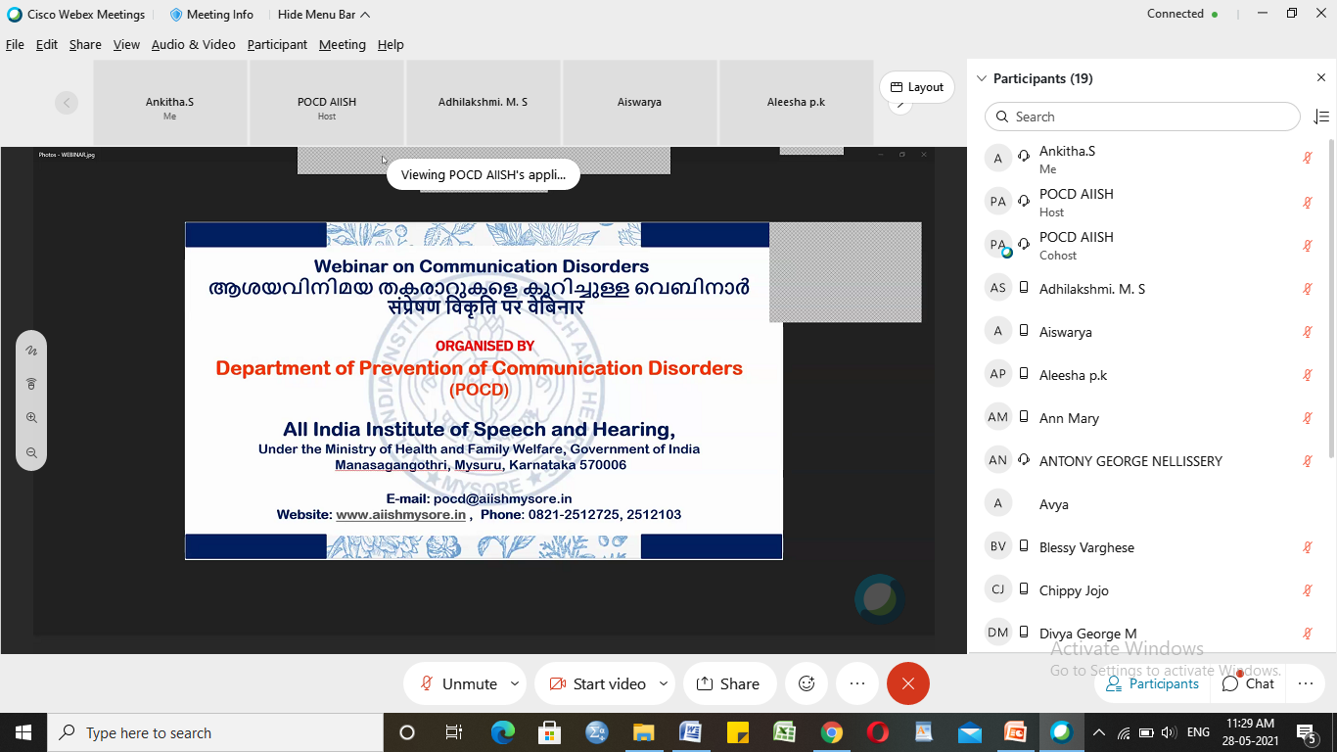

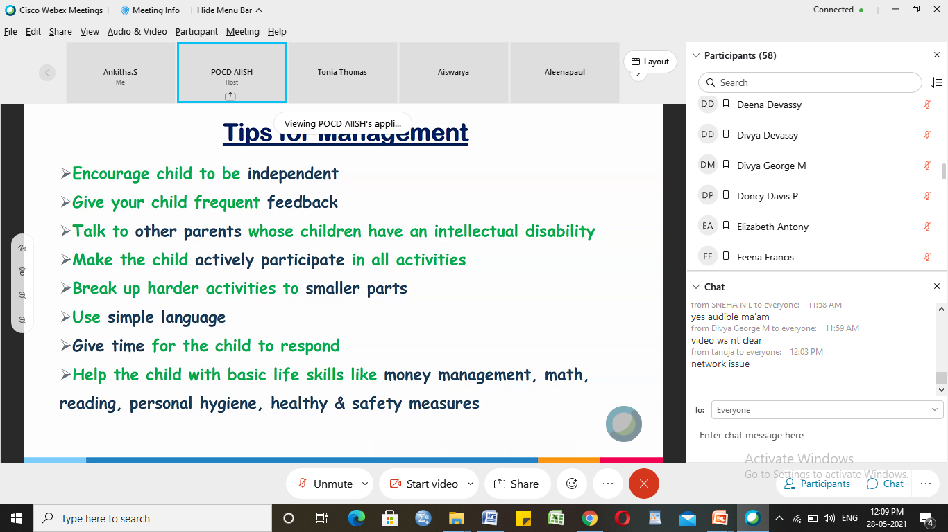

Glimpses of orientation/Webinar programme conducted by POCD staff

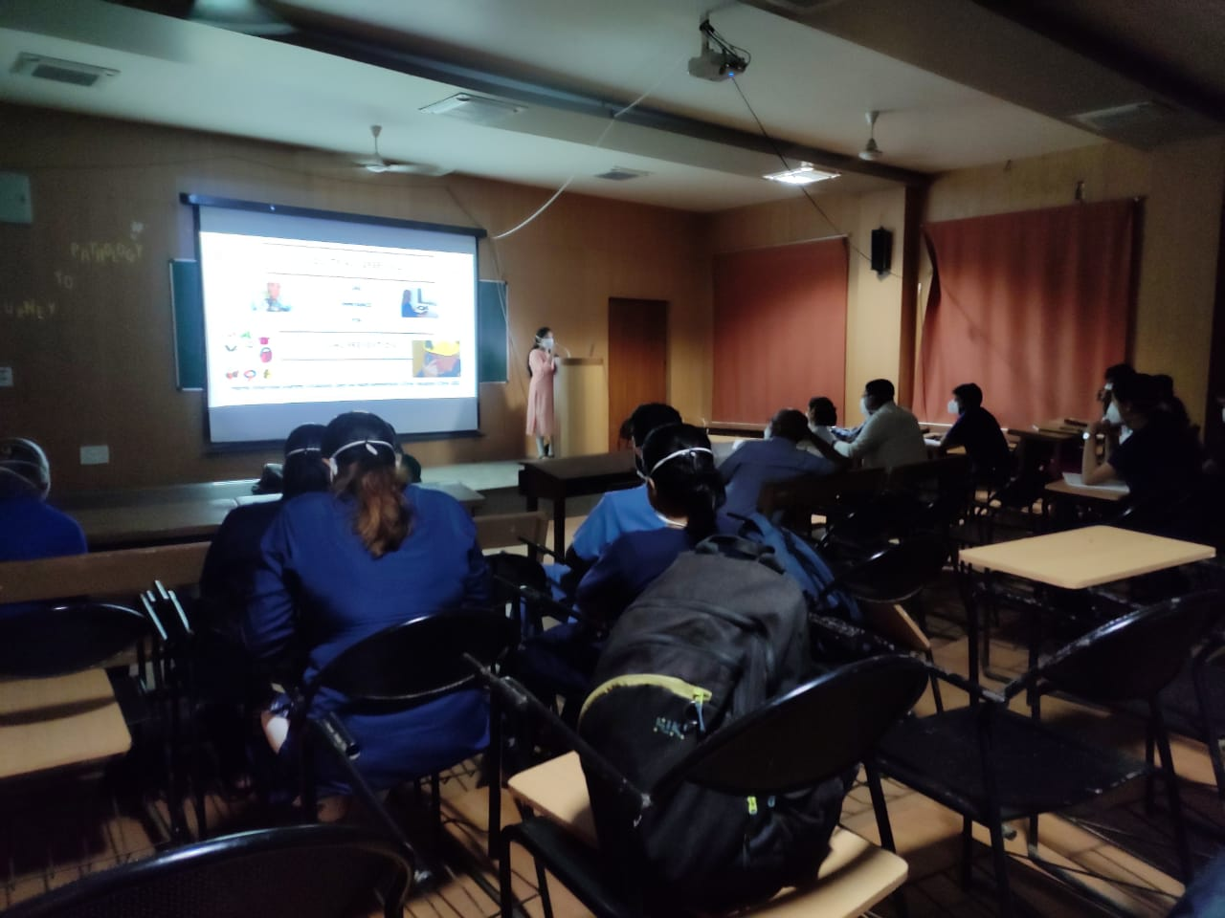 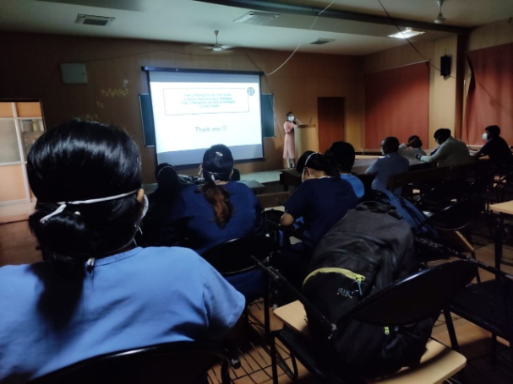

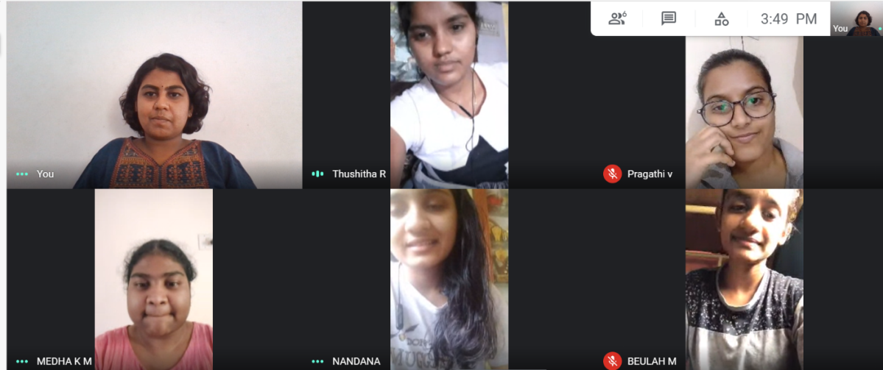

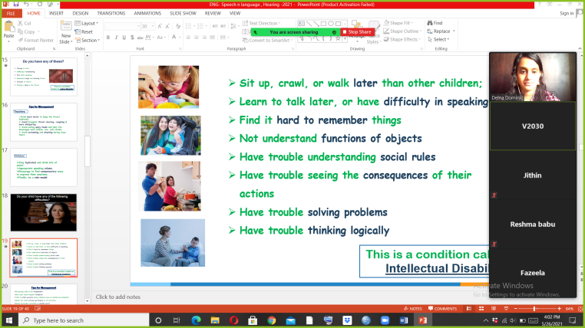 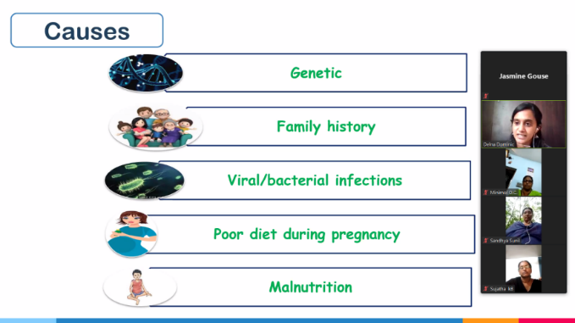

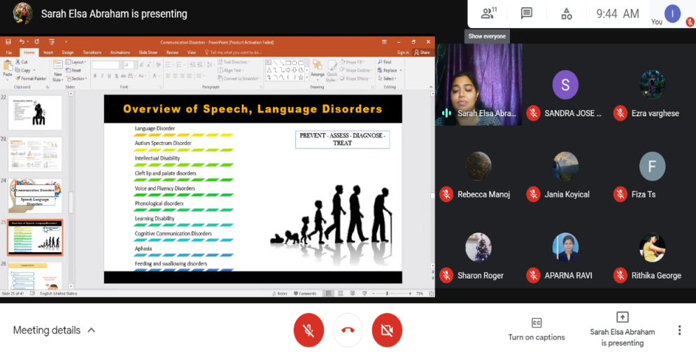

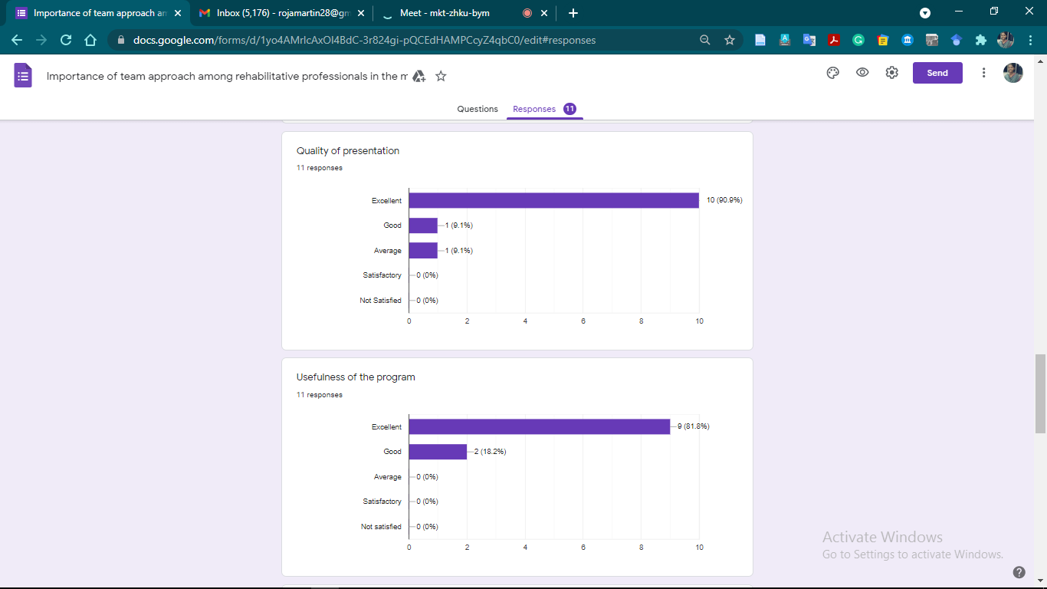

Glimpses of orientation/webinar programme conducted in outreach service centers

**B) Seminars/ Conferences /Lectures /Workshops/Training programs - Nil**

1. **RESEARCH ACTIVITIES:**

Research Activities of POCD:

1. Reports of school screening, industrial screening, NBS and OSC are in progress.

Research Activities of OSC:

1. At OSC Sagara:
   1. A research hypothesis, which was formulated earlier, **“There is a low awareness rate among the school teachers regarding hearing impaired students and the academic, legal and rehabilitative privileges available for them”,** is being worked upon. As planned, a questionnaire for the survey has been prepared and sent.
2. OSC Kalburgi
   1. Prevalence of communication disorder at GIMS Hospital - Final draft has to verify and submit to journal.
   2. Voice profile of patients taking antituberculosis treatment- data collection done, writing in progress.

Research Activities of NBS: Nil

**III) EXTENSION ACTIVITIES**

The department of POCD is actively involved in carrying out various extension activities such as screening, diagnostic and rehabilitation services outside the institute campus. The activities include newborn/infant screening, screening of school children, screening of elderly citizens, screening of industrial workers, conducting camps and also clinical services offered at the outreach service centers of AIISH.

1. **New-born screening programs for Communication Disorders**

a) Table 5: Details of newborn screened in May 2021.

|  |  |  |  |  |  |  |  |  |  |  |  |
| --- | --- | --- | --- | --- | --- | --- | --- | --- | --- | --- | --- |
| S. No | Hospitals/ Immunization Centers | Total births | Total screened | | | Total No. at risk | | | Phone Follow up | | |
|  |  |  | Male | Female | Total | Male | Female | Total | Male | Female | Total |
| **I. Mysuru Hospitals – Nil (Due to pandemic lockdown)** | | | | | | | | | | | |
| **II. OSC Centers:** | | | | | | | | | | | |
|  | Taluk Hospital, Nanjangud, Karnataka (OSC) | 101 | 07 | 15 | 22 | 00 | 00 | 00 | 01 | 03 | 04 |
| Community Health Centre (CHC), Hullahalli, Karnataka | 12 | 00 | 01 | 01 | 00 | 00 | 00 | 00 | 00 | 00 |
|  | Taluk General Hospital, KR. Pete, Mandya, Karnataka (OSC) | 19 | 05 | 03 | 08 | 00 | 00 | 00 | 00 | 00 | 00 |
| Sub-divisional hospital, K R Nagar Taluk, Yadavagiri, Mysore, Karnataka | 152 | 25 | 17 | 42 | 00 | 00 | 00 | 00 | 00 | 00 |
|  | Gulbarga Institute of Medical Sciences, Kalaburgi, Karnataka | 627 | 00 | 01 | 01 | 00 | 00 | 00 | 00 | 00 | 00 |
|  | Kodagu Institute of Medical Sciences, Kodagu, Karnataka | 218 | 79 | 73 | 152 | 74 | 70 | 144 | 03 | 00 | 03 |
|  | Belagavi Institute of Medical Sciences, Belagavi, Karnataka | - | 16 | 18 | 34 | 04 | 04 | 08 | 12 | 14 | 26 |
|  | Bidar Institute of Medical Sciences (BRIMS), Bidar, Karnatka | 189 | 75 | 82 | 157 | 75 | 82 | 157 | 00 | 00 | 00 |
|  | All India Institute of Medical Sciences (AIIMS), Bhuvaneshwar, Orissa | 72 | 49 | 22 | 71 | 06 | 06 | 12 | 25 | 04 | 29 |
|  | Indira Gandhi Institute of Medical Sciences (IGIMS), Patna, Bihar | 00  Covid hospital | - | - | - | - | - | - | - | - | - |
| Total | | 1390 | 256 | 232 | 488 | 159 | 162 | 321 | 41 | 21 | 62 |
| **III. NBS Centers** | | | | | | | | | | | |
|  | Jawaharlal Institute of Postgraduate Medical Education and Research JIPMER, Puducherry * | 462 | 189 | 200 | 389 | 19 | 18 | 37 | 7 | 8 | 15 |
|  | Jawaharlal Nehru Medical College & Hospital, JLNMCH, Bhagalpur, Bihar | 37 | 6 | 10 | 16 | 0 | 0 | 0 | 1 | 1 | **2** |
|  | Post Graduate Institute of Medical Education and Research (PGIMER), New Delhi | 86 | 39 | 25 | 64 | 1 | 0 | 1 | 4 | 3 | **7** |
|  | Sri Devaraj Urs Academy of Higher Eduction and Research (SDUAHER) Kolar, Karnataka | 153 | 76 | 77 | 153 | 0 | 0 | 0 | 14 | 21 | **35** |
|  | All India Institute of Physical Medicine and Rehabilitation (AIIPMR), Mumbai | 32 | 16 | 16 | 32 | 2 | 1 | 3 | 0 | 0 | 0 |
|  | All India Institute of Medical Sciences (AIIMS), Patna | 32 | 13 | 14 | 27 | 3 | 0 | 3 | 0 | 1 | 1 |
|  | Indira Gandhi Medical College (IGMC), Shimla | 50 | 28 | 14 | 42 | 2 | 0 | 2 | 5 | 5 | 10 |
| Total (NBS centers) | | **-** | **367** | **356** | **723** | **27** | **19** | **46** | **31** | **39** | **70** |
| **Total (POCD+OSC+NBS)** | | **-** | **623** | **588** | **1211** | **186** | **181** | **367** | **72** | **60** | **132** |

**b) Tele - follow-up evaluation**

The at-risk babies were monitored regularly through Phone calls by administrating Speech-language & hearing developmental checklist. The babies identified with delay in any of the developmental milestones, were referred to AIISH/concerned center for detailed diagnostic evaluation.

Table 6: Details of phone follow- up carried out at Hospitals in Mysuru.

|  |  |  |  |  |  |
| --- | --- | --- | --- | --- | --- |
| **S. No.** | **Hospitals** | **Number of infants with normal developmental milestones.** | **Total infants at risk** | **Total call attended** | **Total no of calls** |
| **I. Mysuru Hospitals** | | | | |  |
|  | Ashwini Nursing Home (ANH) | 3 | 0 | 3 | 4 |
|  | Kamakshi Hospital (KH) | 21 | 2 | 23 | 24 |
|  | CSI Holdsworth-Memorial Hospital | 4 | 0 | 4 | 6 |
|  | Mahadeshwara Nursing Home (MNH) | 1 | 0 | 1 | 2 |
|  | Sigma Hospital (SH) | 7 | 0 | 7 | 10 |
|  | Cheluvamba - KR Hospital (KRH) | 77 | 2* | 82 | 121 |
|  | Shree Devi Nursing Home (SNH) | 0 | 0 | 0 | 1 |
|  | Sri Chamundeshwari nursing home | 0 | 0 | 0 | 0 |
|  | Govt. Jayanagar Maternity Hospital | 3 | 1 | 4 | 6 |
|  | NPC Maternity hospital | 3 | 0 | 0 | 3 |
|  | Makkalakoota Immunization Centre | 2 | 0 | 2 | 3 |
|  | Kyathmanalli Immunization Centre | 0 | 0 | 0 | 0 |
|  | Combined Hospital | 0 | 1 | 1 | 1 |
|  | Brindhavan Hospital | 3 | 0 | 3 | 3 |
|  | SMTDH | 4 | 0 | 4 | 4 |
|  | **Total** | **128** | **06** | **134** | **188** |
| **II. OSC centers** | | | | |  |
|  | Sub-divisional Hospital, Sagara Taluk, Sagara, Karnataka | 07 | 00 | 07 | 12 |
|  | Vivekananda Memorial hospital, H. D. Kote, Sarguru, Karnataka (OSC) | 06 | 00 | 06 | 09 |
| St, Mary’s Hospital, HD kote, Sarguru, Karnataka | 12 | 00 | 12 | 16 |
| Taluk Hospital, H. D. Kote- Immunization, Sarguru, Karnataka | 06 | 00 | 06 | 09 |
|  | Gulbarga Institute of Medical Sciences, Kalaburgi, Karnataka | 140 | 00 | 140 | 172 |
|  | Kodagu Institute of Medical Science, Kodagu, Karnataka | 30 | 00 | 30 | 38 |
|  | All India Institute of Medical Sciences (AIIMS), Bhuvaneshwar, Orissa | 20 | 00 | 20 | 47 |
|  | Karnataka Institute of Medical Sciences(KIMS), Hubli, Karnataka | 14 | 01 | 15 | 24 |
|  | **Total** | **235** | **01** | **236** | **327** |
| **III. Newborn Screening Centers** | | | | |  |
|  | Rajendra Institute of Medical Sciences, Baritayu, Ranchi | 25 | 00 | 25 | 25 |
|  | Jawaharlal Institute of Postgraduate Medical Education and Research, Puducherry | 18 | 00 | 18 | 26 |
|  | King George’s Medical  University (KGMU) Lucknow | 13 | 02 | 15 | 17 |
|  | Jawaharlal Nehru Medical College & Hospital, Bhagalpur, Bihar | 08 | 00 | 08 | 08 |
|  | Sri DevarajUrs Academy Of Higher Education and Research (SDUAHER), Kolar | 38 | 0 | 38 | 40 |
|  | All India Institute of Physical Medicine and Rehabilitation (AIIPMR), Mumbai | 5 | 0 | 5 | 5 |
|  | **Total** | **107** | **02** | **109** | **121** |
| **Total** | | **470** | **09** | **479** | **636** |

Note: The calls not attempted were repeated a minimum of 5 times on consecutive days

**c) Tele screening Programs**

Tele-screening program (virtual mode) was carried out to identify the babies at risk for communication disorders since newborn screening program couldn’t be carried out in many centers. The details including the behavioral responses of the new born to environmental sounds and HRR collected from the parents through Tele-phone mode. The babies at risk were asked to undergo follow up evaluation in detail.

Table 7: Details of Tele-screening

|  |  |  |  |  |  |  |  |
| --- | --- | --- | --- | --- | --- | --- | --- |
|  | **OSC Centre** | **Total calls made** | **Total Tele-screened** | **Mortality** | **Detailed Evaluation**  **(Referred)** | **Total infants at risk**  **(Screening)** | **Normal Speech and Language milestones**  **(Phone Follow up)** |
|  | **I. Mysuru Hospitals** | | | | | | |
|  | Kamakshi Hospital (KH) | 84 | 76 | 00 | 02 | 11 | 63 |
|  | CSI Holdsworth-Memorial Hospital | 02 | 02 | 00 | 00 | 01 | 01 |
|  | Mahadeshwara Nursing Home (MNH) | 01 | 01 | 00 | 00 | 00 | 01 |
|  | Sigma Hospital (SH) | 17 | 13 | 00 | 01 | 02 | 10 |
|  | Cheluvamba - KR Hospital (KRH) | 165 | 145 | 00 | 13 | 30 | 102 |
|  | Shree Devi Nursing Home (SNH) | 11 | 10 | 00 | 01 | 03 | 06 |
|  | Sri Chamundeshwari nursing home | 06 | 06 | 00 | 00 | 00 | 06 |
|  | Govt. Jayanagar Maternity Hospital | 39 | 31 | 00 | 02 | 02 | 27 |
|  | **Total** | **-** | **284** | **00** | **19** | **49** | **216** |
|  | **II. Outreach Service Centers** | | | | | | |
|  | Sub-divisional Hospital, Sagara Taluk, Sagara, Karnataka | 227 | 146 | 00 | 04 | 00 | 142 |
|  | Primary Health centre (Under Karuna trust), Gumballi, Karnataka (OSC) | 20 | 06 | 00 | 00 | 04 | 02 |
| Taluk Hospital, Yelandur, Gumballi, Karnataka | 06 | 04 | 00 | 00 | 00 | 04 |
| Community Health Centre (CHC), Santhemarahalli, Gumballi, Karnataka | 18 | 16 | 00 | 00 | 04 | 12 |
|  | Vivekananda Memorial hospital, H. D. Kote, Sarguru, Karnataka (OSC) | - | - | - | - | - | - |
| St, Mary’s Hospital, HD kote, Sarguru, Karnataka | 74 | 74 | 00 | 00 | 15 | 59 |
| Taluk Hospital, H. D. Kote- Immunization, Sarguru, Karnataka | 91 | 91 | 00 | 00 | 18 | 73 |
|  | Taluk Hospital, Nanjangud, Karnataka (OSC) | 60 | 42 | 01 | 00 | 10 | 31 |
| Community Health Centre (CHC), Hullahalli, Karnataka | - | - | - | - | - | - |
|  | Gulbarga Institute of Medical Sciences, Kalaburgi, Karnataka | 166 | 127 | 01 | 00 | 00 | 126 |
|  | Karnataka Institute of Medical Sciences(KIMS), Hubli, Karnataka | 101 | 46 | 07 | 05 | 29 | 05 |
|  | Indira Gandhi Institute of Medical Sciences (IGIMS), Patna, Bihar | 00 | - | - | - | - | - |
|  | **Total** | **763** | **552** | **09** | **09** | **80** | **454** |
|  | **III. Newborn Screening Centers** | | | | | | |
|  | Rajendra Institute of Medical Sciences, Baritayu, Ranchi | 196 | 188 | 04 | 02 | 13 | 169 |
|  | King George’ Medical  University (KGMU) Lucknow | 214 | 211 | 18 | 31 | 25 | 137 |
|  | Jawaharlal Nehru Medical College & Hospital, Bhagalpur, Bihar | 16 | 14 | 00 | 01 | 01 | 12 |
|  | Total (NBS) | 426 | 413 | 22 | 34 | 39 | 318 |
| **Total (POCD+OSC+NBS)** | | **1514** | **1249** | **31** | **62** | **168** | **988** |

**d) Newborn follow-up evaluation (Detailed assessment)**

The newborns/infants referred during the newborn screening/ Tele-screening were advised for detailed evaluation at AIISH/NBS centers/OSCs. A complete test battery was administered for those babies/infants who came for follow-up.

Details of the results of follow-up evaluation at POCD - Nil

Details of the results of follow-up evaluation at OSC Centers - Nil

Details of the results of follow-up evaluation carried out at NBS centers.

|  |  |  |  |  |  |
| --- | --- | --- | --- | --- | --- |
| **Categories** | **Age range** | | **PUDUCHERI** | **MUMBAI** | **Total** |
| **Normal** | Newborn  (0-2 months) | Male | - | - | **-** |
| Female | - | 02 | **02** |
| Infants  (2-12 months) | Male | 01 | 02 | **03** |
| Female | 01 |  | **01** |
| Toddlers  (1 year to 4years) | Male | - | - | - |
| Female | - | - | - |
| Children  (above 4years) | Male | - | - | - |
| Female | - | - | - |
| **Hearing impairment** | Newborn  (0-2 months) | Male | - | - | - |
| Female | - | - | - |
| Infants  (2-12 months) | Male | 1 | - | 01 |
| Female | 1 | - | 01 |
| Toddlers  (1 year to 4years) | Male | - | 1 | **01** |
| Female | - | - | - |
| Children  (above 4years) | Male | - | - | - |
| Female | - | - | - |
| **Speech & language disorder** | Newborn  (0-2 months) | Male | - | - | - |
| Female | - | - | - |
| Infants  (2-12 months) | Male | - | - | - |
| Female | - | - | - |
| Toddlers  (1 year to 4years) | Male | - | - | - |
| Female | - | **01** | **01** |
| Children  (above 4years) | Male | - | - | - |
| Female | - | - | - |
| **Multiple Disorder/ Syndromes** | Newborn  (0-2 months) | Male | - | - | - |
| Female | - | - | - |
| Infants  (2-12 months) | Male | - | - | - |
| Female | - | - | - |
| Toddlers  (1 year to 4years) | Male | - | - | - |
| Female | - | - | - |
| Children  (above 4years) | Male | - | - | - |
| Female | - | - | - |
| **Total** | - | - | **04** | **06** | **10** |

**B) Anganawadi /Preschool/School screening program - Nil**

**C) a. Industrial Screening – Nil**

**b.** Follow-up Hearing evaluation of industrial workers at AIISH – Nil

**D) Elderly Screening – Nil**

**E) Bedside Screening - Nil**

**F)** **CLINICAL SERVICES AT OUTREACH SERVICE CENTRES**

The clinical activities are not only restricted to in and around Mysuru, but also extended to rural areas where facilities for clinical services for persons with communication disorders are scanty. Currently there are 08 OSCs centres at different part of the country rendering services to unreached population. The details of those who registered and availed various services/benefits at the OSCs are given below.

1. **Clients identified and followed up with communication disorders at OSCs**

Table 15: Details of clients identified and followed up with communication disorders at OSCs.

|  |  |  |  |  |  |  |  |  |  |
| --- | --- | --- | --- | --- | --- | --- | --- | --- | --- |
| **S. No** | **OSC Centre** | **Total registered** | | **ENT Evaluation** | | **Hearing Evaluation** | | **Speech & Language Evaluation** | |
| Normal | Disorder | Normal | Disorder | Normal | Disorder |
|  | Taluk General Hospital, KR Pete | New cases | 03 | - | - | 01 | 03 | 00 | 01 |
| F/u Old | - | - | - | - | - | - | - |
|  | Vivekananda Memorial Hospital, Sarguru | New cases | 13 | 00 | 00 | 00 | 12 | 00 | 01 |
| F/u Old | - | - | - | - | - | - | - |
|  | Gulbarga Institute of Medical Sciences | New cases | 04 | 04 | 00 | 08 | 00 | 00 | 00 |
| F/u Old | - | - | - | - | - | - | - |
|  | Belagavi institute of medical sciences (BIMS), Belagavi | New cases | 04 | 00 | 00 | 08 | 00 | 00 | 00 |
| F/u Old | - | - | - | - | - | - | - |
|  | Kodagu Institute of Medical Sciences, Madikkerri | New cases | 06 | - | - | 04 | 08 | 00 | 00 |
| F/u Old | - | - | - | - | - | - | - |
|  | AIIMS,  Bhuvaneshwar | New cases | 12 | - | - | - | - | - | 12 |
| F/u Old | 01 | - | - | - | - | - | 01 |
|  | KIMS,  Hubli | New cases | 12 | 00 | 00 | 08 | 16 | 00 | 00 |
| F/u Old | 01 | 00 | 00 | 00 | 00 | 00 | 01 |
|  | BRIMS, Bidar | New cases | 07 | 00 | 00 | 01 | 13 | 00 | 00 |
| F/u Old | - | - | - | - | - | - | - |

1. Table 16: Details of clients identified with different types of communication disorders across OSCs

|  |  |  |  |  |  |  |  |  |  |  |  |  |  |  |
| --- | --- | --- | --- | --- | --- | --- | --- | --- | --- | --- | --- | --- | --- | --- |
| **Type of Disorders** | |  |  | **OSC** | | | |  |  |  |  |  |  |  |
| Taluk Hospital Nanjangud | Primary Health Centre (PHC), Hullahalli | Taluk General Hospital, KR Pete | Primary Health Centre (PHC), Gumballi | Sub-divisional Hospital,  Sagara(PHC) Taluk | VMH, Sarguru | Belagvi institute of medical sciences BIMS | GIMS, Kalburgi | KoIMS-TH, MadikeriTaluk,Kodagu | AIIMS,Bhuvaneshwar | KIMS,Hubli | BRIMS,BidaR | IGIMS,Patna |
| **Hearing disorders** | | | | | | | | | | | | | | |
| Normal | | - | - | - | - | - | 00 | 04 | 04 | 02 | - | 04 | - | - |
| **Aud-Total** | **U/L** |  |  | 01 |  |  | - | - | - | - | - | - | 01 |  |
| **B/L** |  |  | 01 |  |  | 06 | - | - | 04 | - | 08 | 06 |  |
| **Aud-Total (Individuals)** | | - | - | 02 | - | - | 06 | 04 | 04 | 06 | - | 12 | 07 | - |
|  | |  |  | | | | | |  |  |  |  |  |  |
| Voice | | - | - | 00 | - | - | 00 | - | - | - | 10 | - | - | - |
| Fluency | | - | - | 01 | - | - | 00 | - | - | - | 00 | - | - | - |
| Articulation disorders | | - | - | 00 | - | - | 00 | - | - | - | 00 | - | - | - |
| Language disorders | | - | - | 00 | - | - | 01 | - | - | - | 2 | - | - | - |
| **Sp&Lg -Total (Individuals)** | | - | - | 01 | - | - | 01 | - | - | - | 12 | - | - | - |

iii) Table 17: Details of clients followed up with different types of communication disorders across OSCs.

|  |  |  |  |  |  |  |  |  |  |  |  |  |  |  |
| --- | --- | --- | --- | --- | --- | --- | --- | --- | --- | --- | --- | --- | --- | --- |
| **Type of Disorders** | |  |  |  |  |  | **OSC** |  |  |  |  |  |  |  |
| Taluk Hospital Nanjangud | Primary Health Centre (PHC), Hullahalli | Taluk General Hospital, KR Pete | Primary Health Centre (PHC), Gumballi | Sub-divisional Hospital,  Sagara  (PHC) Taluk | VMH, Sarguru | Belagvi institute of medical sciences BIMS | GIMS, Kalburgi | KoIMS-TH, MadikeriTaluk,Kodagu | AIIMS,Bhuvaneshwar | KIMS,Hubli | BRIMS,BidaR | IGIMS,Patna |
| **Hearing disorders** | | | | | | | | | | | | | | |
| Normal | | - | - | - | - | - | - | - | - | - | - | - | - | - |
| **Aud-Total** | **U/L** | - | - | - | - | - | - | - | - | - | - | - | - | - |
| **B/L** |
| **Aud-Total (Individuals)** | | - | - | - | - | - | - | - | - | - | - | - | - | - |
|  | | | | | | | | | | | | | | |
| Voice | | - | - | - | - | - | - | - | - | - | 01 | 00 | - | - |
| Fluency | | - | - | - | - | - | - | - | - | - | 00 | 00 | - | - |
| Articulation disorders | | - | - | - | - | - | - | - | - | - | 00 | 00 | - | - |
| Language disorders | | - | - | - | - | - | - | - | - | - | 00 | 00 | - | - |
| **Sp&Lg -Total (Individuals)** | |  |  |  |  |  |  |  |  |  | **01** | **01(swallowing)** |  |  |

vi) **Rehabilitation services at OSCs.**

Table 18: Details of rehabilitation services provided at OSCs in May 2021.

|  |  |  |  |  |  |
| --- | --- | --- | --- | --- | --- |
| **OSC** | **Hearing Aids Dispensed** | **Speech-language therapy** | | | **Medical Line of Treatment** |
| No. of clients | No. of sessions | |
| Regular Therapy | Tele therapy |
| Sub-divisional Hospital, Sagara Taluk, Sagara, Karnataka | 00 | 10 | 00 | 50 | 00 |
| Primary Health centre (Under Karuna trust), Gumballi, Karnataka (OSC) | 00 | 05 | 00 | 28 | 00 |
| Vivekananda Memorial hospital, H. D. Kote, Sarguru, Karnataka (OSC) | 02 | 14 | 00 | 63 | 00 |
| Taluk Hospital, Nanjangud, Karnataka (OSC) | 00 | 04 | 08 | 40 | 00 |
| Community Health Centre (CHC), Hullahalli, Karnataka | 00 | 01 | 02 | 13 | 00 |
| Taluk General Hospital, KR. Pete, Mandya, Karnataka (OSC) | 02 | 03 | 03 | 14 | 00 |
| Gulbarga Institute of Medical Sciences, Kalaburgi, Karnataka | 00 | 12 | 00 | 102 | 00 |
| Kodagu Institute of Medical Science, Kodagu, Karnataka | 04 | 10 | 00 | 47 | 00 |
| Belagavi Institute of Medical Science, Belagavi, Karnataka | 00 | 06 | 00 | 52 | 00 |
| Bidar Institute of Medical Sciences (BRIMS), Bidar, Karnatka | 00 | 01 | 00 | 12 | 00 |
| All India Institute of Medical Sciences (AIIMS), Bhuvaneshwar, Orissa | 00 | 12 | 36 | 00 | 00 |
| Karnataka Institute of Medical Sciences(KIMS), Hubli, Karnataka | 00 | 06 | 01 | 18 | 00 |
| Indira Gandhi Institute of Medical Sciences (IGIMS), Patna, Bihar | 00 | 02 | 00 | 03 | 00 |
| **Total** | **08** | **86** | **50** | **442** | **00** |

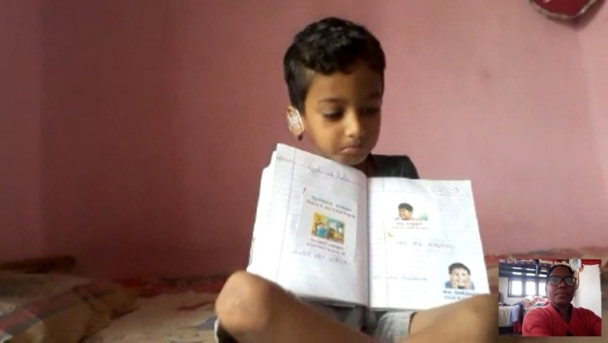 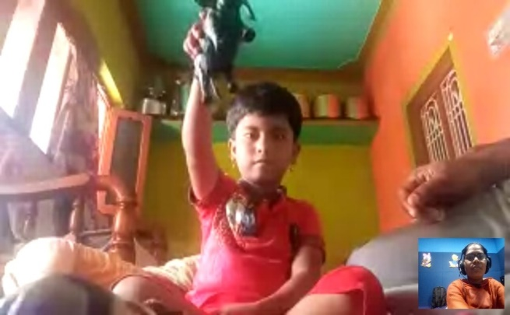

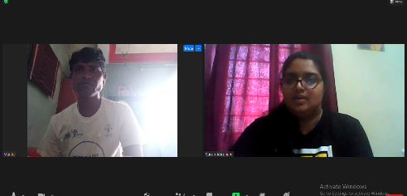 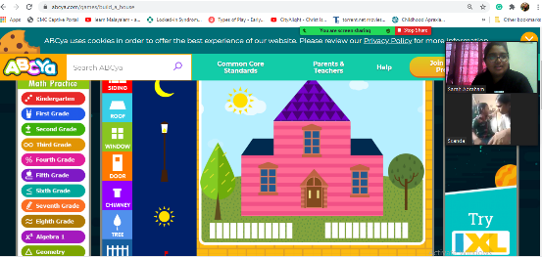

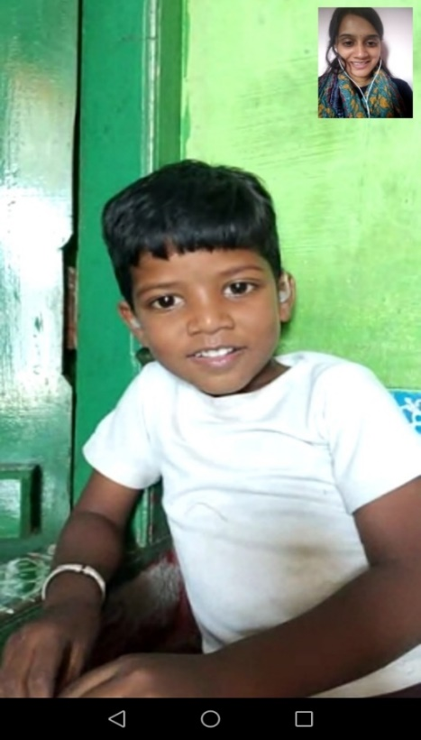 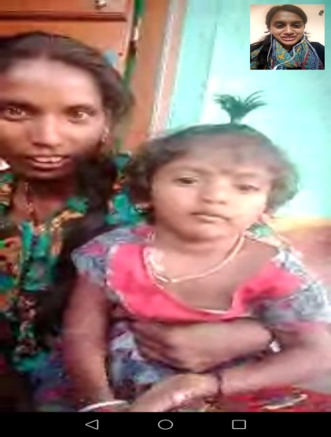 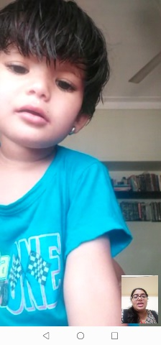

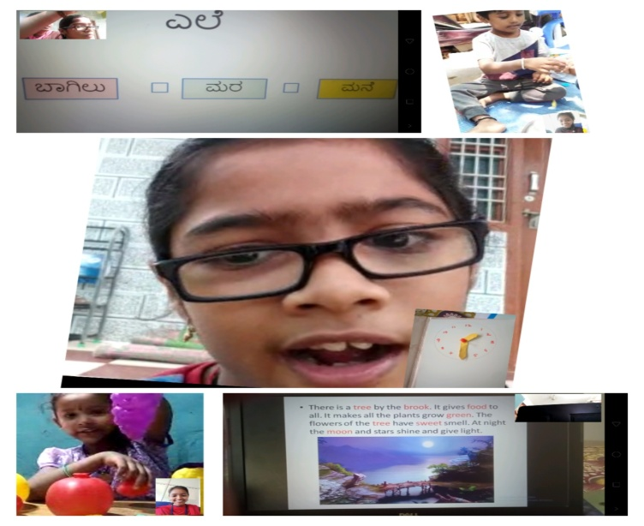 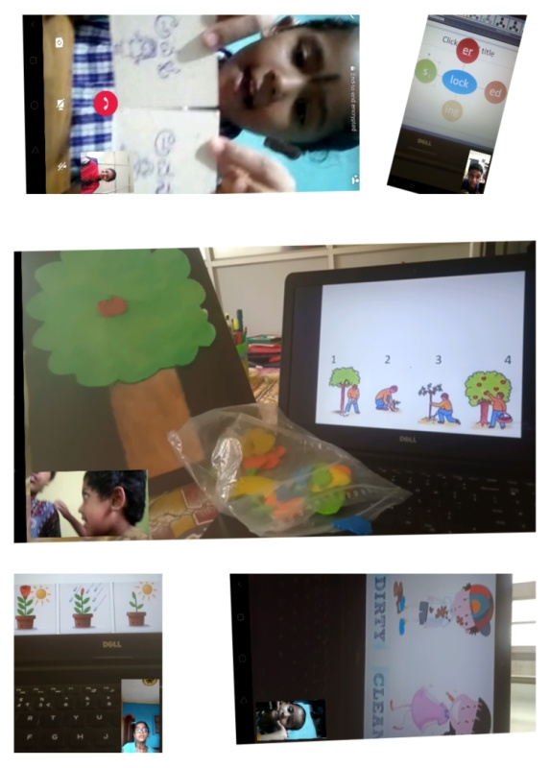

Glimpses of tele-sessions

**v) Table 19: Screening Camps for communication Disorders - Nil**

**G) Human Resource Development**

**a) Student clinical training**:

As part of human resource development, clinical training for Undergraduates (B.Sc. Speech & Hearing), Postgraduates (M.Sc. SLP & AUD) & Internship students on early identification, prevention & rehabilitation of communication disorders and Community based rehabilitation at OSCs were carried out. The details on the number of students who had undergone training are given below.

Table 20: Details of the students posted in POCD during April 2021

|  |  |  |
| --- | --- | --- |
| **Internal (AIISH)** | | |
| **Class** | **No. of students Newly posted** | **No. of Students continuing** |
| I M.Sc. (SLP) students | 5 | 1 |
| I M.Sc. (Audiology) students | 0 | 0 |
| BASLP Internship students | 0 | 0 |
| **Total** | **5** | **1** |
| **External** | | |
| BASLP Student (Intern) | 0 | 0 |
| B.Sc. (Spl.Ed) students of AIISH | 0 | 0 |
| PG ENT Students | 0 | 0 |
| **Total** | **0** | **0** |

**b) Staff/Student Enrichment Programs**: 03

As a part of continued education and updating of ongoing research and clinical evidences on early identification, prevention & rehabilitation of communication disorders and Community based rehabilitation. Post-graduates students (M.Sc. SLP & AUD) and staffs conduct and attend many presentation and talks. The details on the number of students and staffs who had undergone training are given below.

Table 21: Details of staff/student enrichment programmes

|  |  |  |  |  |
| --- | --- | --- | --- | --- |
| **Sl. No.** | **Date** | **Title of Presentation** | **Presenters** | **No of Staff attended** |
|  | 12.05.2021 | “Effect of delivery modes on  Hearing screening results”. | Mr. Mali Harshada Pramod  Ms. Monisha C  Ms. N.Aishwarya | 13 |
|  | 24.05.2021 | The Caregiver Reported Autistic Symptoms in Preschool Children: Findings of Chandigarh Autism Screening Instrument (CASI) Linked Screening from North India | Ms. Yasha | 13 |
|  | 25.05.2021 | Detection Test for Language Impairments in Adults and the Aged—A New Screening Test for Language Impairment Associated with Neurodegenerative Diseases: Validation and Normative Data | Mr. Delvin  Ms. Chandana | 13 |
|  | 31.05.2021 | Bedside assessment | Ms Kranti | 12 |

**IV) TECHNOLOGICAL CONSULTANCY SERVICES: NIL**

**V) CENTRAL FACILITIES**

**a) Library and information Services: NIL**

**VI) MAJOR EVENTS OF THE MONTH**:

1. Conducted radio program on the Topic **Speech therapy guidelines for the parents with special children in this pandemic situation on May 31st 2021**

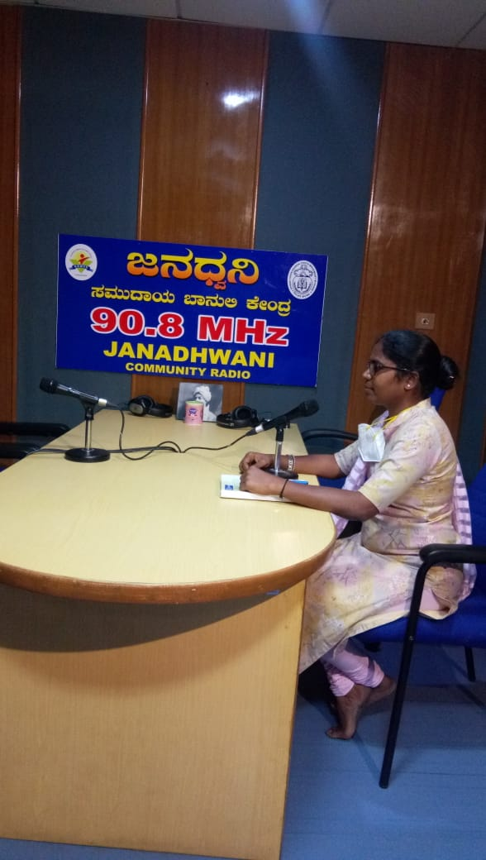

**VII) OTHERS**

1. Presented department peer evaluation by Dr.N.Sreedevi, HOD, POCD on 12.05.2021

2. Submitted RE BE – 2021-22-23

3. Material development works as part of work from home due to pandemic.

|  |  |  |  |  |  |
| --- | --- | --- | --- | --- | --- |
| **Sl No.** | **MATERIAL** | **LANGUAGE** | **PREPARED BY** | **VERIFIED BY** | **STATUS** |
| **Public education videos** | | | | | |
| 1 | Comic strips-Autism | English | Prepared by previous batch | Christy  Kranti  Srividya | Verfied- To be finalized |
| 2 | Comic strips- LD | English | Prepared by previous batch | Christy  Kranti  Srividya | Verfied- To be finalized |
| 3 | Comic strips-SSD | English | Prepared by previous batch | Christy  Kranti  Srividya | Verfied- To be finalized |
| 4 | Comic strips- NBS | English | Prepared by previous batch | Christy  Kranti  Srividya | Verfied- To be finalized |
| 5 | Comic strips-Autism | Kannada | Teja  Nethra | Srividya  Tanuja | Verfied- To be edited |
| 6 | Comic strips- LD | Kannada | Thejas  Aditi | Srividya | Verfied- To be finalized |
| 7 | Comic strips-SSD | Kannada | Supriya  Shreya  Sumanth | Srividya | Verfied- To be finalized |
| 8 | Comic strips- NBS | Kannada | Harshitha  Yashas | Srividya | Verfied- To be finalized |
| 9 | Comic strips-Autism | Malayalam | Narmeda  Niveditha  Nidha | Christy | Verfied- To be finalized |
| 10 | Comic strips- LD | Malayalam | Nahida  Fathima | Christy | Verfied- To be finalized |
| 11 | Comic strips-SSD | Malayalam | Hiba  Shana | Christy | Verfied- To be finalized |
| 12 | Comic strips- NBS | Malayalam | Febida  Preethi | Christy | Verfied- To be finalized |
| 13 | Comic strips-Autism | Tamil | Reshma  Tina  Neena | Pauline | Verfied- To be finalized |
| 14 | Comic strips- LD | Tamil | Halima  Teenu  Henna | Pauline | Verfied- To be finalized |
| 15 | Comic strips-SSD | Tamil | Shilpa  Mithul  Chelsa | Pauline | Verfied- To be finalized |
| 16 | Comic strips- NBS | Tamil | Nadba  Krishnapriya  Kripa | Pauline | Verfied- To be finalized |
| 17 | Comic strips-Autism | Hindi | Debyandu  Mehulla  Siri Vandana | Kranti | Verfied- To be finalized |
| 18 | Comic strips-SSD | Hindi | Jolene  Ankit | Kranti | Verfied- To be finalized |
| 19 | Comic strips- NBS | Hindi | Deepshika  Keerthi  Irene | Kranti | Verfied- To be finalized |
| 20 | Comic strips- LD | Hindi |  | Kranti | Verfied- To be finalized |
| 21 | Tinnitus | Malayalam | Merina | Christy  Aparna  Basih | Content- verified |
| 22 | ADHD | English | Dibya | Kranti  Srividya | Content-verified |
| 23 | New- born Hearing Screening | English | Ranjini | Kranti  Srividya | Content-verified |
| **Public education pamphlets** | | | | | |
|  | FAQ’s on Aphasia | Kannada | Tanuja | Srividya | Verified twice.  To be Designed |
|  | FAQ’s on Aphasia | Malayalam | Reshma  Laya | Christy | Finalized  To be designed |
|  | FAQ’s on Aphasia | Tamil | Ajith | Pauline | Verified twice.  To be Finalized |
|  | FAQ’s on Aphasia | Hindi | Kristi, | Kranti | Verified twice.  To be Finalized |
|  | FAQ’s on LD | Kannada | Ankitha | Srividya  Sushma | To be designed. |
|  | FAQ’s on LD | Malayalam | Reshma | Christy  Basih | Finalized  To be designed |
|  | FAQ’s on LD | Tamil | Pauline | Kalayarasan | Verified twice.  To be Finalized |
|  | FAQ’s on LD | Hindi | Anirban(Intern)  Kristi  Mausam kumara | Kranti  Dibya | Verified twice.  To be Finalized |
|  | FAQ’s on Voice disorder | Kannada | Sushma | Srividya  Tanuja | Sent for designing. |
|  | FAQ’s on Voice disorder | Malayalam | Aparna  Reshma | Christy  Basih | Finalized  To be designed |
|  | FAQ’s on Voice disorder | Tamil | Kalayarasan | Pauline | Verified twice.  To be Finalized |
|  | FAQ’s on Voice disorder | Hindi | Nayanika  Kristi  Mausam kumari | Kranti  Dibya | Verified twice.  To be Finalized |
|  | FAQ’s on Stuttering | Kannada | Gowtham | Srividya  Sushma | Sent for designing. |
|  | FAQ’s on Stuttering | Malayalam | Basih  Reshma | Christy | Verified twice.  To be Finalized |
|  | FAQ’s on Stuttering | Tamil | Pauline | Kalayarasan | Verified twice.  To be Finalized |
|  | FAQ’s on Stuttering | Hindi | Dibya  Kristi  Mausam kumari | Kranti | Verified twice.  To be Finalized |
|  | FAQ’s on Speech Sound Disorder | Tamil | Kalayarasan | Pauline | Verified twice.  To be Finalized |
|  | FAQ’s on Speech Sound Disorder | Hindi | Madhumanti  Mausam kumari  Kristi | Kranti  Dibya | Verified twice.  To be Finalized |
|  | Communication disorders in elderly | Marathi | Harshada (I M.Sc) |  | To be Verified |
|  | FAQ’s on NBS | Marathi | Harshada (I M.Sc) |  | To be Verified |
|  | FAQ’s on NBS | Gujarathi | Yasha (I M.Sc) |  | To be Verified |
|  | Communication disorders in elderly | Hindi | Sandeep(I Msc) | Kranti | Verified once. |
|  | Communication disorders in elderly | Tamil | Monisha , Aishwarya | Mohana | Verified once. |
|  | Prevention of developmental disorders | Tamil | Aishwarya | Pauline | Verified twice.  To be Finalized |
|  | Beware of noise | Malayalam | Reshma | Christy | Finalized  To be designed |
|  | FAQs on NIHL | Malayalam | Reshma | Christy | Finalized  To be designed |
|  | OSHA noise levels | Malayalam | Reshma | Christy | Finalized  To be designed |
|  | Counselling tips for parents | Malayalam | Sarga  Reshma | Christy  Basih | Verified twice.  To be Finalized |
|  | Counselling tips for parents | Kannada | Sushma  Hemashree | Srividya | Verified once |
|  | Counselling tips for parents | Tamil | Ajith | Pauline | Verified twice.  To be Finalized |
|  | FAQ’s on Ototoxicity | English | Kristi Kaveri | Christy | Verified once.  To be Finalized |
|  | ACSLS Modification | English | Reshma  Kranti | Shreyank | Finalized  To be designed |
|  | Learning Disability | Tamil | Prepared by previous batch | Kalayarasan | Verified once.  To be Finalized |
|  | Aphasia | Tamil | Prepared by previous batch | Kalayarasan | Verified once.  To be Finalized |
|  | Laryngectomy | Tamil | Prepared by previous batch | Kalayarasan | Verified once.  To be Finalized |
|  | Know this to prevent communication disorders | Tamil | Prepared by previous batch | Kalayarasan | Verified once.  To be Finalized |
|  | Prevention of developmental disorders | Tamil | Prepared by previous batch | Kalayarasan | Verified once.  To be Finalized |
|  | Voice disorders | Tamil | Prepared by previous batch | Kalayarasan | Verified once.  To be Finalized |
|  | Dysarthria | Tamil | Prepared by previous batch | Kalayarasan | Verified once.  To be Finalized |
|  | Dementia | Tamil | Prepared by previous batch | Kalayarasan | Verified once.  To be Finalized |
|  | Stuttering | Tamil | Prepared by previous batch | Kalayarasan | Verified once.  To be Finalized |
|  | Feeding tips | Tamil | Prepared by previous batch | Kalayarasan | Verified once.  To be Finalized |
|  | Aphasia | Telugu | Prepared by previous batch | Krupa | Verified once.  To be Finalized |
|  | Dysarthria | Telugu | Prepared by previous batch | Krupa | Verified once.  To be Finalized |
|  | Prevention of developmental disorder | Telugu | Prepared by previous batch | Krupa | Verified once.  To be Finalized |
|  | Know this to prevent communication disorders | Telugu | Prepared by previous batch | Krupa | Verified once. |
|  | Voice disorder | Telugu | Prepared by previous batch | Krupa | To be Finalized |
| **POSTERS** | | | | | |
|  | Importance of speech stimulation | Kannada | Roja, Ajith, Girish | Megha  Tanuja |  |
|  | Role of audiologist and SLP | English | Aparna, Sarah | Srividya  Christy |  |
|  | Myths and facts about hearing loss | English | Mohana |  | To be verified |
|  | Signs and symptoms of hearing loss in babies | English | Laya |  | To be verified |
|  | Speech Language therapy | English | Delna | Christy  Kranti | Verified  To be finalised |
|  | Developmental milestones of speech, listening and motor skills | English | Sarga  Swaliha | Srividya  christy | Verified  To be finalised |
|  | Developmental milestones of speech, listening and motor skills | Kannada | Hemashree  shivaranjini | Srividya | Verified  To be finalized |
|  | Importance of new born screening | Kannada | Sushma, Rohith | Srividya | Verified  Yet to be finalized |
|  | Vocal Hygiene poster | English | Anuroopa | Srividya | Corrections given |
|  | Development of auditory response in children | Hindi | Sachin | Kranti | Corrections given |
|  | Risk factors for hearing loss | Hindi | Prajwal | Kranti | Verified  To be finalised |
|  | High risk factors-JCIH | Hindi | Madhumanti | Kranti | Verified  To be finalised |
|  | Causes of hearing loss | English | Basih | Christy  Srividya | Corrections given |
|  | Types of hearing aid | English | Basih | Christy  Srividya | Corrections given |
|  | Importance of new born screening | Hindi | Gowtham | Kranti  Dibya | Corrections given |

**VII) ACTIVITIES CARRIED OUT BY THE STAFF OF THE DEPARTMENT OF POCD.**

Table 16: Details of activities carried out by POCD staff in ------- 2021.

|  |  |  |  |
| --- | --- | --- | --- |
| **S. No** | **Name of the staff** | **Designation** | **Activities** |
|  | Dr. N Sreedevi | HOD, Dept. of POCD | * Officiating as HOD-POCD * Has been coordinating webinars/ orientation on communication disorders to teachers 13 nos * Conducted Dept. meeting on 7th, 13th, 21st and 28th May 2021 * Coordinated school screening data analysis meeting on 4.5.2021, 5.5.2021, 25.5.2021 * Coordinated the OSC data analysis meeting on 10th, 12th, 13th, 21st may 2021 * Attended HODs meeting on 8.5.2021 * Attended webinar on covid precautions by Dr. Swathi on 10.5.2021 * Presented DPE on POCD on 12.5.2021 * Attended student presentation on 12th, 25th, * Submitted missing details for annual report on 18.5.2021 * Submitted data collection guidelines to Dept. of Psychology on 19.5.2021 * Coordinated the detailed assessment of 8 cases at DCS * Attended webinar on Clinical Assessment and Rehabilitation of Aphasia And Biomedical Waste Management On 20.5.2021 * Carried out trial recording for DD * Served as chairperson for staff selection meeting for POCD and SERB project on 24.5.2021 * Compiled the information on prevalence of communication disorders and submitted to Director on 26.5.2021 * Worked on recording of Malayalam video on Academic courses at AIISH. * Coordinated the compilation of RE BE 2021-22 * Attended staff enrichment program on 31.5.2021 * Coordinated the MD work of POCD * Coordinated updation of website content of POCD |
|  | Dr. Sandeep M. | Faculty | * Coordinating NBS activities of the Dept. |
|  | Mr. Arunraj. K | Audiologist/SLP | * Coordinated OSC activities * Coordinated equipment related works in the department * Prepared RE BE – budget proposal * Assisted in DPE PPT finalisation * Attended SPPS meeting * Verified SPSS variables * Conducted all NBS & OSC meetings * Attended departmental meetings * Attended RE BE and DPE meeting * Verified and corrected SPSS variable * Verified and corrected Reports of industrial, school screening and OSC * Coordinated school screening analysis * Verified monthly report of April 2021 * Drafted letters for OSC communications * Prepared topics for clinical practicum classes for BASLP classes * Verified DPE PPT * Drafted EC proposal |
|  | Ms. Ranjini A | Audiologist Gr. I | * Procedural Manual for NBS was prepared. Unique codes were made for all the hospitals inside Mysore, outside NBS centers and OSC centers and incorporated in SPSS. New SPSS format was sent to all NBS and OSC centers. * Data was compiled for the month of April of all hospitals in Mysuru and the total number of referred and follow up cases were noted down. * Details for tele-screening was obtained from CHELUVAMBA, KAMAKSHI, SNH, CHAMUNDESHWARI, MNH, SIGMA, JAYANAGAR hospitals in Mysuru. * Preparation of draft for the NBS report. * Prepared google form for tele-screening at Mysuru hospitals. * Wrote script for video on newborn hearing screening as a part of Material Development. * Tele-screening was done for 50 babies for Mysuru hospitals. * Verified and provided feedback for 3 kannada videos on SSD, NBS and LD. * Analyzed and found out the starting month and year of NBS at 4 hospitals (Apollo, Srinivasa, Immunisation Chelluvamba, Gopal Gowda) of Mysuru from the SPSS spreadsheet data of 10 years. * Found out the total number of follow up of NBS Mysuru hospitals and detailed evaluation done at AIISH for the annual year March 2020 to April 2021. * Corrections were made for the NBS draft. * Voicing was recorded for a video on Autism. * Voicing was recorded reciting the address of AIISH. |
|  | Ms. Srividya S | Audiologist Gr. I | * Prepared monthly report of material development for month of april 2021 * Coordinated and verified MD works of staff doing work from home * Coordinated and verified MD works of NBS and OSC staff * Attended department meeting 7th,13th, 21st,28th of May 2021. * Did error correction and preliminary output analysis of school screening data. * Prepared Google forms for ‘Webinar Registration’ * Attended webinar about the ‘COVID safety measures’ on 10/05/2021. * Prepared pre and post test google forms for the webinars. * Attended student presentation (Effect of delivery modes on newborn hearing screening results) on 12/5/21. * Edited kannada slides on communication disorders, for Postal Department Employees * Organized and conducted Webinar on Communication Disorders for Postal Department Employees on 13/5/21 * Verified kannada translation of FAQ’s on Stuttering, Voice disorder, Aphasia, learning Disability, counselling tips for parents. * Verified and suggested corrections for kannada and hindi comic videos submitted by intern students. * Attended webinar on ‘demo session of OptiMaser-treatment and management of biomedical waste’ on 20/5/21 * Attended Student presentation on article ‘Caregiver reported symptoms in preschool children’ on 24/5/21. * Attended Student presentation on article ‘Detection Test for Language Impairments in Adults and the Aged—A New Screening Test for Language Impairment Associated With Neurodegenerative Diseases: Validation and Normative Data’ on 25/5/21 * Created Webinar link and circulated to B.Ed students, Thrissur * Carried out Tele screening for 40 cases of CH,SNH, Sigma hospitals * Prepared and Edited draft of School screening report. * Attended meeting regard school screening report. |
|  | Ms. Dibya Aryal | Speech Language Pathologist Gr. I | * Compiled and verified monthly report and SPSS data of outside NBS centres * Verified SPSS data and data cleansed for NBS centres for the financial year 2020 * Prepared procedural manual for new born screening * Assisted in preparation of NBS report for year 2008-2019 * Compiled tele-screening data of NBS centres for the year 2020 * Prepared google form for tele-screening for NBS centres * Carried out tele-screening for 10 babies * Verified and edited Hindi version of FAQ’s on stuttering * Attended staff enrichment program on Dysphagia * Attended webinar on best practices on UNHS and clinical neuro rehabilitation on aphasia |
|  | Ms. Tanuja M.N | Audiologist Gr. II | * Verified and completed phone follow up for the month of December (6 month) ,February(3 months),May(1 year), November(6 month) & June (1 year). * Completed Tele screening for the newborn babies of Jaynagar hospital and Cheluvamba Hospital. * Enquired about the status of the high-risk cases which were referred to Mandya center for detailed audiological evaluation. * Informed about an error in the SPSS variables for the follow up evaluation. * Compiled orientation data and Prepared graphs for the Orientation Annual report. * Edited the referral letter on Tele Assessment for babies at risk for Communication Disorders. * Verified and suggested correction for the Comic script on New Born Hearing Screening. * Co-Ordinated for the webinar on communication disorders for the staff of the post office on 13.5.21. * Prepared slides for the webinar on communication disorders for the staff of the post office. * Accessed and calculated the total number of high risk cases from 2019-2020. * Provided materials of the webinar to the OSC staff and clarified doubts regarding the webinar. * Prepared and edited script for a video on DCS orientation. * Edited and translated script for a video on developmental milestones. * Oriented regarding phone follow up work to both Deepa and Megha. * Verified and monitored the phone follow up work of Deepa and Megha. * Oriented about counselling and professionals to both deepa and megha. * Sent information about the Institute and resource person of the webinar to the Co- Ordinator of NLI Navodaya. * Verified Voice over work for autism comic script on Autism. * Compiled the list of Material development work from OSC staff doing work from home. * Cross checked the Phone follow up data entered in SPSS. * Attended student article presentation. * Verified poster of the webinar on communication disorders for B.Ed students. * Attended webinar on “Tips on speech and language stimulation for parents”. * Attended webinar on Hearing Disability certification for individuals with hearing Impairment. * Attended webinar on Disruption in hearing aid dispensing – How can private practitioners embrace the change? * Attended staff enrichment programme on 31.5.2021 |
|  | Ms. Merina Thomas | Audiologist Gr. I | * OSC and NBS SPSS verification * Coordinated the OSCs * Monthly report correction and compilation * Tele-screening of 34 babies * Collected hearing aids from repair section * Distributed 54 hearing aids (29 Danavox and 25 Starkey), cables, programming shoe to K.R.Pete centre. * Visited K.R.Pete centre for hearing aid programming on 5/5/21 * Prepared Google form for tele-screening in OSCs. * Verification of SPSS data of newly formatted NBS SPSS. * Prepared script for Tinnitus in Malayalam * Attended Student article presentations * Attended weekly department meetings * Attended staff enrichment program on dysphagia * Attended OSC meetings regarding finalizing new OSC SPSS variables and OSC report preparation * Collected and convert old OSC data from excel to SPSS * Cleansed and merged 2016 OSC data * Cleansed and merged OSC data of Akkiheballu (2014-2016),Gumballi(2013 to 2017) * Prepared new OSC SPSS format * Assisted in collecting and preparing geo-tagged photos of OSCs * Verified Noise pamphlet and brochure in Malayalam * Combined OSC data regarding phone followup and speech disorders for annual report. |
|  | Ms. Christy Sebastian | Audiologist Gr. I | * Verification of the Malayalam translations and making the suggested corrections for:  1. FAQs on Aphasia 2. FAQs on LD 3. FAQs on stuttering 4. FAQs on voice 5. Brochure on NIHL 6. Beware of noise  * Verification of the comic strips of Autism, LD, SSD in English and verification of the comic strips in Malayalam * Allotment of work from home and verification of materials sent by NBS and OSC. * Writing the report on Industrial screening and diagnosis. Had discussions with Vasanthlakshmi maám and Arun raj sir regarding the same * Organised and presented the webinar on communication disorders for B.Ed. students on 28-05-2021. * Attended the webinar on precautions to be taken during covid-19 on 10-05-2021. * Carried out tele-screening of 44 new-born babies. * Attended the staff enrichment programme on dysphagia and on hearing aids. * Verification of the content for video on tinnitus (Malayalam). * Attended the student presentations. |
|  | Ms. Pauline Gracia R V | SLP Gr. II | * Tele-screening of 48 new-born. * SPSS and monthly report verification of all 12 OSC centres of April month. * Collected geo-tagged photos of every OSC centre. * Issued hearing aid (Baby. Trupthi) at K R Pete OSC centre. Worked on speech variables for OSC SPSS. * MOU of Indore and Chandigarh centres are signed by both parties. * Prepared OSC checklist for Andaman and Nicobar centre. * Followed up with Bhubaneshwar MOU. * OSC data cleansing for entire data of Sagara, Nanjagud, Belgavi centres. * Attended OSC 5 meetings. * Prepared method part for OSC report. * OSC report discussion and compilation of it. * Material development: Correction given for Tamil Autism, NBS, LD comic. LD comic is finalised. * Gave corrections for feeding tips and developmental milestones in Tamil. * Started preparing draft for spoken language disorder video. * Webinars & Presentations: Attended covid orientation meeting. * Attended webinar on Clinical assessment and neuro-rehabilitation of aphasia and related neuro-communication disorders- Indian scenario by Ms. Sonal * Attended webinar on Optimaster treatment and management of biomedical waste. * Attended 4 student article presentation. * Attended staff enrichment program * Website & Social media: Updated website content. * Followed with social media committee. |
|  | Ms. Kranti Acharya | SLP Gr. I | * Orientated Ms Reshma about Infant cry * Corrections made to the materials prepared by NBS and OSC staffs * Discussion regarding Infant cry analysis was done with Dr. Sreedevi mam and Arun sir * Attended webinar on Covid by ENT Dr.Swathi * Read and discussed Infant cry project: Development and validation of computerized screening tool for infant cry * Prepared the report of Student and staffs enrichment from 0ct 2019-March 2021 * Prepared student feedback report from 0ct 2019-March 2021 * Corrected pamphlets of Aphasia, Stuttering and learning disability in Hindi * Correction and verification of comic videos on SSD, Autism, NBS in Hindi * Attended webinar on Clinical assessment and rehabilitation of aphasia by Sonal Chitis * Attended webinar on Optimaser treatment and biomedical waste management * Trimming of infant cry samples * Acoustic analysis of infant cry was done * Gave assignment and verified the same of students posted in POCD. * Re-correction of voice, aphasia, LD, stuttering pamphlet done * Organized and attended article presented by students on topic “Effect of delivery modes on hearing screening results” * Reviewed article on infant cry * Discussion with Dr Sreedevi mam regarding icry * Organized and attended article presented by students on topic “The Caregiver Reported Autistic Symptoms in Preschool Children: Findings of Chandigarh Autism Screening Instrument (CASI) Linked Screening from North India” * Attended article presented by students on topic “Detection Test for Language Impairments in Adults and the Aged—A New Screening Test for Language Impairment Associated with Neurodegenerative Diseases: Validation and Normative Data”. * Final correction of NIHL brochure, voice, aphasia, LD pamphlet done * Prepared report on incidence and prevalence of communication disorder * Conducted staff enrichment program "Bedside Assessment of dysphagia" * Prepared student attendance for the month of May |
|  | Ms. Ankitha.S | SLP Gr. II | * Translated milestones script into Kannada, corrected DCS script * Prepared list of FAQ on hearing related problems * Tele session was taken - client Name: Thripti * Prepared DCS orientation script * Recorded DCS orientation video. * Prepared webinar poster * Prepared webinar Slides for postal officers * Attended students article presentation on ‘Effect of delivery modes on hearing screening results’. * Corrected webinar slides on “Elderly population” * Attended webinar On ‘clinical assessment and neuro rehabilitation of Aphasia & related neuro communication disorder ’ part 1- Sonal chitnis * Organized and conducted webinar on ‘communication disorders’ for Post officers on 13/05/2021. * Suggestion given for comic video voice over on ‘Learning disability’ in Kannada Milestones video edited * School screening report correction * Attended webinar On ‘clinical assessment and neuro rehabilitation of Aphasia & related neuro communication disorder ’ part 2- Sonal chitnis * Attended webinar on CI fitting in infants and children with bilateral implants. * Attended webinar on “Building Life Skills in Children with Intellectual Disabilities during Pandemic: Paradigm Shift &amp; Evolving Strategies” * Attended student’s article presentation-“the caregiver reported Autistic symptoms in preschool children”-(presenter-Chheda yesha and Athira) * Tele screening was done for 40 cases * Attended webinar on “tips on speech and language stimulation for Parents’-”-(presenter-Chandana and Delvin) * Attended Student’s presentation on Detection Test for Language Impairments in Adults and the Aged * Conducted webinar on communication disorder for B.Ed students, thrissur , Kerala (28/05/2021) |
|  | Ms. Reshma O | SLP Gr. I | * Attended orientation about Infant cry done by Ms Kranti * Discussion regarding Infant cry analysis was done with Dr. Sreedevi mam and Arun sir * Attended webinar on Covid by ENT Dr Swathi * Read and discussed Infant cry project: Development and validation of computerized screening tool for infant cry * Correction of counselling tips in Malayalam * Correction of aphasia pamphlet in Malayalam * Attended webinar on Clinical assessment and rehabilitation of aphasia * Attended webinar on Optimaser treatment and biomedical waste management * Tele-screening for new born babies done (30) * Trimming of samples * Acoustic analysis of infant cry was done * Allotted staffs for staff enrichment program for the month of May * Re-correction of NIHL brochure, voice, aphasia, LD, stuttering pamphlet done * Attended article presented by students on topic “Effect of delivery modes on hearing screening results” * Reviewed article on infant cry * Translation of developmental milestones into Malayalam for making video * Discussion with Dr Sreedevi mam and Ms Kranti regarding the acoustic analysis and parameters to be taken for infant cry analysis was done * Attended article presented by students on topic “The Caregiver Reported Autistic Symptoms in Preschool Children: Findings of Chandigarh Autism Screening Instrument (CASI) Linked Screening from North India” * Attended article presented by students on topic “Detection Test for Language Impairments in Adults and the Aged—A New Screening Test for Language Impairment Associated with Neurodegenerative Diseases: Validation and Normative Data”. * Final correction of NIHL brochure, voice, aphasia, LD pamphlet done * Prepared report on incidence and prevalence of communication disorder * Conducted webinar on Communication Disorders for B.Ed students Thrissur, Kerala * Coordinated staff enrichment program done by Ms Kranti |
|  | Mr. Kalaiyarasan R | Aud Gr. I | * Newborns details collected from Cheluvamba, SNH, Jayanagara Hospitals for telescreening * Coordinated with Audiologists & Auditivo hearing company person regarding issues with OAE equipment in Kodagu, Kalaburagi OSC * Coordinated with Sagara OSC Audiologist regarding issues with Otoscope and desktop * Reply mail has been sent to purchase section regarding the query raised for AABR equipment by Sohum company * AA222 audiometer with immittance combo model equipment has been sent to K.R.Pete OSC * Calibration & equipment list has been updated * Equipment specifications – corrections made, rechecked and sent to purchase section for tender * Searched articles for writing industrial screening report * Attended purchase committee meeting to procure ABR equipment for 23 OSC’s * Video shoot done for DCS orientation * Worked on script for developing material (cochlear implantation and AVT) * Attended article presentation by I M.Sc. students * Stock verification done for: OSC: Sagara, Kodagu, Sargur, Kalaburagi & NBS: Cuttack, Puducherry, Delhi, Mumbai, Patna, Kolar, Lucknow, Shimla, Bhaglapur * Coordinated with Carelife technologies company person regarding PA5 equipment delivery and supply of accessories * Attended departmental RE & BE meeting * First draft of industrial screening report submitted and still working on the report * Attended webinar conducted by DCS * Telescreening done for 10 babies (Cheluvamba, MNH) * Proof reading of tamil translation works from Sarguru and K.R.Pete OSC and given corrections to concerned ASLP * Telescreening done for 22 babies (Kamakshi & Chamundeshwari Hospital) * Coordinated with Bhagalpur NBS audiologist regarding issues with desktop and rectified the issue * Attended staff enrichment program – bedside assessment for swallowing |
|  | Mr. Ashwath K | SHT | * Cleansing and merging other NBS centrs(Ajmer,Kolar, puduchery and Cuttack * Telescreening of Jayanagar babies (28 nos) and updated in Google form * Updated one year phone follow up data of November in SPSS. |
|  | Ms. Deepika. R | Office assistant Grade III | * Submitted contract staff attendance, TA bills, interns attendance * Assisted in preparing DPE PPT * Prepared Annual report 2020-21 corrections * Assisted in preparing RE-BE * Attended Departmental meetings, RE BE meeting, DPE of POCD * Prepared letters for orientations and webinars * Assisted in Coordinating OSC and NBS requests and activities * Filed the official documents on a daily basis * Prepared Monthly report April 2021 * Submitted intern’s attendance * Prepared departmental meeting minutes * Correspondence to all the mails received in the dept. * Routine work of indent, work orders, local purchase indents, registers maintaining etc. |
|  | Ms. Deepa Kabbur | Data entry operator | * Updated leave statement * Prepared tv programme details for the annual report. * Carried out NBS April month Data entry for 05 Mysuru hospitals * Attended phone follow up training. * Drafted one Kannada letter. * Done Phone follow up update -250 calls * Done hospital wise normal and risk babies’ statement analysis. * Assisted to carry out tele screening of Mysuru Hospital – 29 nos. * Prepared one year phone follow up report (December 2019, January 2020, February 2020, March 2020, May 2020, June 2020,) |
|  | Ms. Megha.K | Data entry operator | * Assisted in preparing April month report * Attended phone follow up training. * Carried out phone follow up - Total 137 calls * Typing work - MOU ministry of Health & Family and state Government (total 5 pages ) * 2019 Lucknow file copied to SPSS software (12 months) * Prepared Detailed Evalution report( Risk babies found Feb2021, May2020, June2020) * Converted excel files to spss ( Bhagalpur-jan & Feb2021, Puduchery – feb 2021, August, October, November, December) * 2 days Deputation work in Director Office * Typing work (Measuring the brain) * School names Sorting as govt. or Private * Preparing Message and informing Risk babies parents regarding online Tele Assessment * Prepared Excel format with formulae for Annual report for all months |

Sd/-

Dr. N. Sreedevi

विभागाध्यक्ष पी ओ सी डी **-**Head, Department of POCD