ALL INDIA INSTITUTE OF SPEECH AND HEARING, MYSURU-6
DEPARTMENT OF CLINICAL SERVICES

MONTHLY REPORT / STATISTICS FOR THE MONTH OF MAY 2021 (01.05.2021 to 31.05.2021)
Due to COVID -19 pandemic crisis, the institute was lockdown from 10.05.2021 to 14.05.2021 and 29.05.2021 to 31.05.2021. Hence, tele-services were provided to clients availing clinical services. Therefore, there is decrease in the number of cases availed clinical services.
- REGISTRATION AT THE DEPARTMENT

- Number of Clients registered
 | Speech Language OPD | 35
 | Audiology OPD | 112
 | New Cases | 147
 | Retrieval of repeat case files | 323
 | Total Cases | 470
 | No. of Working days | 14

- Details of Registration

Total requests for new registration | 150
Total registered as new clients | 147
*No. of cases Rejected | 03
Case files requested for revisit | 323
Case files retrieved for revisit | 323
Case files requested for clinical purpose | 581
Case files retrieved for clinical purpose | 581
Case files requested for research purpose | 30
Case files retrieved for research purpose | 30
Case files requested for academic purpose | 402
Case files retrieved for academic purpose | 402
Case files requested for Legal purpose (Court) | 00
Case files retrieved for Legal purpose (Court) | 00
Total Requests for Medical Records Corrections | 00
Total Corrections done in the Medical Records | 00
Total Case files requested  (Revisit, clinical purpose, research purpose, academic purpose) | 1486
Total Case files retrieved  (Revisit, clinical purpose, research purpose, academic purpose) | 1483

*Rejected – Not related to Communication Disorders.

Date wise statistics for the month of May, 2021
Sl. No | Dates | New Cases |  |  |  | Repeat Cases |  |  |  | Grand total
 | Dates | Walk-in | Tele | Total | Walk-in |  | Tele | Total
 | 01-May-21 | 0 | 0 | 0 | 0 |  | 0 | 0 | 0
 | 02- May -21 | 0 | 0 | 0 | 0 |  | 0 | 0 | 0
 | 03- May -21 | 1 | 1 | 2 | 0 |  | 9 | 9 | 11
 | 04- May -21 | 0 | 1 | 1 | 0 |  | 10 | 10 | 11
 | 05- May -21 | 0 | 2 | 2 | 1 |  | 17 | 18 | 20
 | 06- May -21 | 0 | 1 | 1 | 0 |  | 8 | 8 | 9
 | 07- May 21 | 0 | 3 | 3 | 1 |  | 21 | 22 | 25
 | 08- May -21 | 0 | 0 | 0 | 0 |  | 0 | 0 | 0
 | 09- May -21 | 0 | 0 | 0 | 0 |  | 0 | 0 | 0
 | 10- May -21 | 0 | 0 | 0 | 0 |  | 0 | 0 | 0
 | 11- May -21 | 0 | 0 | 0 | 0 |  | 0 | 0 | 0
 | 12- May -21 | 0 | 0 | 0 | 0 |  | 0 | 0 | 0
 | 13- May -21 | 0 | 0 | 0 | 0 |  | 0 | 0 | 0
 | 14- May -21 | 0 | 0 | 0 | 0 |  | 0 | 0 | 0
 | 15- May -21 | 0 | 0 | 0 | 0 |  | 0 | 0 | 0
 | 16- May -21 | 0 | 0 | 0 | 0 |  | 0 | 0 | 0
 | 17- May -21 | 5 | 4 | 9 | 5 |  | 24 | 29 | 38
 | 18- May -21 | 12 | 0 | 12 | 9 |  | 22 | 31 | 43
 | 19- May -21 | 7 | 5 | 12 | 11 |  | 26 | 37 | 49
 | 20- May -21 | 17 | 0 | 17 | 9 |  | 13 | 22 | 39
 | 21- May -21 | 13 | 3 | 16 | 7 |  | 11 | 18 | 34
 | 22- May -21 | 0 | 0 | 0 | 0 |  | 0 | 0 | 0
 | 23- May -21 | 0 | 0 | 0 | 0 |  | 0 | 0 | 0
 | 24- May -21 | 22 | 0 | 22 | 11 |  | 17 | 28 | 50
 | 25- May -21 | 14 | 0 | 14 | 8 |  | 26 | 34 | 48
 | 26- May -21 | 0 | 0 | 0 | 0 |  | 0 | 0 | 0
 | 27- May -21 | 16 | 8 | 24 | 18 |  | 16 | 34 | 58
 | 28- May -21 | 12 | 0 | 12 | 5 |  | 18 | 23 | 35
 | 29- May -21 | 0 | 0 | 0 | 0 |  | 0 | 0 | 0
 | 30- May -21 | 0 | 0 | 0 | 0 |  | 0 | 0 | 0
 | 31-May-2021 | 0 | 0 | 0 | 0 |  | 0 | 0 | 0
Total |  | 119 | 28 | 147 | 85 |  | 238 | 323 | 470

District wise distribution of cases (Karnataka) registered during the month of May, 2021

Sl. No | Districts Descriptions | Male Cases | Female Cases | Total Cases
 | Bagalkote | 0 | 0 | 0
 | Bangalore | 9 | 1 | 10
 | Belgaum | 0 | 0 | 0
 | Bellary | 0 | 0 | 0
 | Bidar | 0 | 0 | 0
 | Bijapur | 2 | 4 | 6
 | Chamrajanagar | 1 | 0 | 1
 | Chikkaballapur | 0 | 0 | 0
 | Chikkmagalore | 1 | 0 | 1
 | Chitradurga | 1 | 0 | 1
 | Coorg | 2 | 0 | 2
 | Dakshina Kannada | 0 | 0 | 0
 | Davangere | 2 | 0 | 2
 | Dharwad | 0 | 0 | 0
 | Gadag | 0 | 0 | 0
 | Gulbarga | 0 | 2 | 2
 | Hassan | 0 | 0 | 0
 | Haveri | 0 | 0 | 0
 | Kolar | 0 | 0 | 0
 | Koppala | 3 | 4 | 7
 | Mandya | 39 | 37 | 76
 | Mysore City | 16 | 6 | 22
 | Mysore District | 0 | 0 | 0
 | Raichur | 3 | 1 | 4
 | Ramanagara | 0 | 0 | 0
 | Shivamoga | 1 | 0 | 1
 | Tumkur | 0 | 0 | 0
 | Udupi | 0 | 0 | 0
 | Uttar kannada | 0 | 0 | 0
 | Yadagiri | 0 | 0 | 0
 | Total | 80 | 55 | 135

States wise distribution of cases registered during the month of May, 2021

Sl. No | States Descriptions | Male Cases | Female Cases | Total Cases
 | Andra Pradesh | 1 | 0 | 1
 | Arunachal Pradesh | 0 | 0 | 0
 | Assam | 0 | 0 | 0
 | Bihar | 1 | 0 | 1
 | Chattisgarh | 0 | 0 | 0
 | Delhi | 1 | 0 | 1
 | Goa | 0 | 0 | 0
 | Gujarat | 1 | 0 | 1
 | Hariyana | 0 | 0 | 0
 | Himachal Pradesh | 0 | 0 | 0
 | Jarkhand | 0 | 0 | 0
 | Karnataka | 80 | 55 | 135
 | Kashmir | 0 | 0 | 0
 | Kerala | 2 | 1 | 3
 | Madhya Pradesh | 0 | 0 | 0
 | Maharastra | 1 | 0 | 1
 | Manipur | 0 | 0 | 0
 | Meghalaya | 0 | 0 | 0
 | Nagaland | 0 | 0 | 0
 | Mizoram | 0 | 0 | 0
 | Orissa | 0 | 0 | 0
 | Punjab | 0 | 1 | 1
 | Rajasthan | 0 | 0 | 0
 | Sikkim | 0 | 0 | 0
 | Tamil Nadu | 1 | 0 | 1
 | Telangana | 0 | 0 | 0
 | Tripur | 0 | 0 | 0
 | Union Territories | 0 | 0 | 0
 | Uttar Pradesh | 2 | 0 | 2
 | Uttaranchal | 0 | 0 | 0
 | West Bengal | 0 | 0 | 0
Total |  | 90 | 57 | 147

II. DIAGNOSTIC AND THERAPY SERVICES

- SPEECH-LANGUAGE EVALUATIONS:

Speech-Language Assessment for Walk-in clients (At Department of Clinical Services)

Evaluations |  | PEDIATRIC  (0-15YRS) |  | ADULT  (15-50YRS) |  | GERIATRIC  (50 & ABOVE) |  | TOTAL |  | HINDI CASES
 |  | M | F | M | F | M | F | NEW | REPEAT | HINDI CASES
Language | CLD | 04 | 00 | 00 | 00 | 00 | 00 | 04 | 00 | 00
Language | ALD | 00 | 00 | 01 | 00 | 01 | 00 | 02 | 00 | 00
Articulation |  | 00 | 00 | 00 | 00 | 00 | 00 | 00 | 00 | 00
Voice |  | 00 | 00 | 00 | 00 | 00 | 00 | 00 | 00 | 00
Fluency |  | 00 | 00 | 00 | 00 | 00 | 00 | 00 | 00 | 00
Multiple |  | 00 | 00 | 00 | 00 | 00 | 00 | 00 | 00 | 00
Normal |  | 00 | 00 | 00 | 00 | 00 | 00 | 00 | 00 | 00
TOTAL M/F |  | 04 | 00 | 01 | 00 | 01 | 00 | 06 | 00 | 00
Over all Total New |  | 04 |  | 01 |  | 01 |  | 06 | 00 | 00
Overall Total New |  | 06 |  |  |  |  |  |  |  | 00
Overall Total Repeat |  | 00 |  |  |  |  |  |  |  | 00
Overall Total New & Repeat |  | 06

Detailed Speech-Language Evaluations for Walk-in clients
 | No. of New Clients seeking | No. of Clients successfully completed | Percentage  (%)
Speech-Language Evaluation | 07 | 06 | 85.71
Re-evaluation | 00 | 00 | 00
Total | 07 | 06 | 85.71

- Speech-Language Evaluation: Tele-Assessment

Detailed Speech-Language Tele-Assessment (At DCS OPD rooms):
 | No. of New Clients seeking | No. of Clients successfully completed | Percentage (%)
Speech-Language Evaluation | 34 | 29 | 85.29
Re evaluation | 72 | 70 | 97.22
Total | 106 | 99 | 93.39

Evaluations |  | PEDIATRIC  (0-15YRS) |  | ADULT  (15-50YRS) |  | GERIATRIC  (50 & ABOVE) |  | TOTAL |  | HINDI CASES
 |  | M | F | M | F | M | F | NEW | REPEAT | HINDI CASES
Language | CLD | 17 | 02 | 00 | 00 | 00 | 00 | 19 | 42 | 11
Language | ALD | 00 | 00 | 00 | 00 | 00 | 00 | 00 | 04 | 11
Articulation |  | 01 | 00 | 01 | 00 | 01 | 00 | 03 | 09 | 11
Voice |  | 00 | 00 | 00 | 00 | 01 | 00 | 01 | 01 | 11
Fluency |  | 03 | 00 | 01 | 00 | 00 | 00 | 04 | 04 | 11
Multiple |  | 01 | 00 | 00 | 00 | 00 | 00 | 01 | 10 | 11
Normal |  | 01 | 00 | 00 | 00 | 00 | 00 | 01 | 00 | 11
TOTAL M/F |  | 23 | 02 | 02 | 00 | 02 | 00 | 29 | 70 | 11
Over all Total New |  | 25 |  | 02 |  | 02 |  | 29 | 70 | 11
Overall Total New |  | 29 |  |  |  |  |  |  |  | 11
Overall Total Repeat |  | 70 |  |  |  |  |  |  |  | 11
Overall Total New & Repeat |  | 99
Note: Network issues at client end and Poor awareness about digital payment

- PT/OT statistics:

EVALUATION | PEDIATRIC  (0-15 YEARS) |  | ADULT  (16- 50 YEARS) |  | GERIATRIC  (50& ABOVE) |  | TOTAL
 | OPD | Tele | OPD | Tele | OPD | Tele
Physiotherapy evaluation | 02 | 07 | 00 | 01 | 00 | 00 | 10
Occupational therapy evaluation | 03 | 11 | 00 | 00 | 00 | 00 | 14
TOTAL | 05 | 18 | 00 | 01 | 00 | 00 | 24

Diagnostics | No. of clients seeking | No. of Clients successfully completed | NO. of clients recommended for re-evaluation | NO. of clients successfully re-evaluated
Physiotherapy | 10 | 10 | 06 | 06
Occupational therapy | 14 | 14 | 04 | 04

Tele-Therapy
THERAPY | PEDIATRIC  (0-15 YEARS) |  | ADULT  (16- 50 YEARS) |  | GERIATRIC  (50& ABOVE) |  | Total no. of case for PT/OT | Total no of therapy session
THERAPY | Cases | Sessions | Cases | Sessions | Cases | Sessions | Total no. of case for PT/OT | Total no of therapy session
PT | 25 | 156 | 01 | 10 | 03 | 20 | 29 | 186
OT | 44 | 333 | 00 | 00 | 000 | 00 | 44 | 333
Preschool PT | 02 | 11 |  |  |  |  | 02 | 11
Preschool OT | 01 | 03 |  |  |  |  | 01 | 03
Total | 72 | 503 | 01 | 10 | 03 | 20 | 76 | 533

 | Physiotherapy | Occupational therapy
No. of Clients seeking therapy | 35 | 45
No. of Clients availed therapy | 31 | 45
No. of Clients D.N.R | 00 | 00
No. of Clients discontinued | 02 | 04
No. of Clients successfully discharged | 15 | 22
No. of sessions allotted | 226 | 396
No. of sessions present | 197 | 336
No. of sessions absent | 29 | 60
Total no. of present case | 76
No. of sessions- Daily average | 28

- VISITING CONSULTANTS:

Pediatrician | Nil
Phonosurgeon | Nil
Dietician | Nil
Plastic Surgeon | Nil
Orthodontist | Nil
Neurologist | Nil
Orthopedician | Nil

V. Special Clinic/ Units:(Evaluations)
Special Clinic/ Unit |  | PEDIATRIC  (0-15 YEARS) | ADULT  (15-50 YEARS) | GERIATRIC  (50&ABOVE) | Total
AAC | Evaluations | 04 | - | - | 04
*ASD |  | 22 | - | - | 22
Voice Clinic |  | - | - | - | -
CAEPLD |  | - | 08 | - | 08
Fluency |  | 04 | - | - | 04
ISL |  | Nil
*USOFA |  | - | - | - |  | -
*MSD |  | - | - | - |  | -
LD Clinic |  | - | - | - | -
Phonology Clinic |  | - | - | - | -
*Also depicted in the activities of Dept. of SLP

VI. SPEECH AND LANGUAGE THERAPY CASES (through tele-mode only)

Summary of speech language therapy statistics

Sl. No | Particulars | Total
 | Total number of cases attended therapy | 414
 | Total number of individual sessions | 2175
 | Daily average sessions | 114
 | Total number of sessions absent | 536
 | Total Number sessions (attended + absent) | 2711
 | A) Percentage sessions attended | 80.22%
 | B) Percentage sessions absent | 19.77%
 | Total number of Appointment given | 77
 | Therapy appointment on daily average | 04

Details of number of clients attending Speech Language Therapy (through tele-mode)

Disorders |  | PEDIATRIC  (0-15 YRS) |  | ADULT  (15-50YRS) |  | GERIATRIC  (50 & ABOVE) |  | Total | New Hindi Case | New DT
 |  | M | F | M | F | M | F |  | 01 | 01
Lang | CLD | 190 | 99 | 00 | 00 | 00 | 00 | 289 | 01 | 01
Lang | ALD | 00 | 00 | 04 | 04 | 02 | 01 | 11 | 01 | 01
Articulation/Phonology |  | 25 | 05 | 03 | 02 | 02 | 00 | 37 | 01 | 01
Voice |  | 01 | 01 | 03 | 02 | 02 | 01 | 10 | 01 | 01
Multiple |  | 00 | 00 | 00 | 00 | 00 | 00 | 00 | 01 | 01
MSD |  | 41 | 16 | 00 | 00 | 00 | 00 | 57 | 01 | 01
LD |  | 05 | 05 | 00 | 00 | 00 | 00 | 10 | 01 | 01
Total |  | 262 | 126 | 10 | 8 | 6 | 2 | 414 | 01 | 01
G. Total |  | 388 |  | 18 |  | 08 |  | 414 | 01 | 01
Total |  | 414 |  |  |  |  |  |  | 01 | 01
Over all total new |  | 15 |  |  |  |  |  |  | 01 | 01
Overall total repeat |  | 399 |  |  |  |  |  |  | 01 | 01
Over all total not reported |  | 68 |  |  |  |  |  |  | 01 | 01

Speech Language Therapy Statistics:

Speech Language Therapy | New | Old | Total | Percentage of New Cases (%) | Percentage of Old Cases (%) | Remarks
No. of Clients Assigned (Appt. Given) | 16 | 61 | 77 | 20.77% | 79.22% | -
No. of Clients attending therapy(Continued from April 27th) | 15 | 399 | 414 | 3.63% | 96.36% | -
Total no of discharged | 07
Total no of discontinued | 72

- Holidays on 14/05/2021(Ed milad),26/05/2021(Buddha poornima).34 Students were absent for few days during May 2021 month due to health issues and Some of the CLD cases were absent for days due to health and network issues.

Special Clinic statistics: (through Tele-mode)

Sl. No | Particulars | Total
 | Total number of cases attended therapy | 165
 | Total number of individual sessions | 936
 | Daily average sessions | 49
 | Total number of sessions absent | 181
 | Total Number of sessions Absent + Attended | 1117
 | A) Percentage sessions attended | 83.79%
 | B) Percentage sessions absent | 16.20%
 | Total number of Therapy Appointment given | 20
 | Therapy appointment on daily average (Round off) | 01

No. of Clients attending therapy in Special Clinics

Disorders | PEDIATRIC  (0-15 YRS) |  | ADULT  (15-50YRS) |  | GERIATRIC  (50 & ABOVE) |  | Total | NEW  HINDI  CASE | New Demonstration Therapy
Disorders | M | F | M | F | M | F |  | 00 | 00
Fluency disorders | 35 | 06 | 13 | 02 | 00 | 00 | 56 | 00 | 00
Autism | 77 | 17 | 00 | 00 | 00 | 00 | 94 | 00 | 00
U-SOFA | 02 | 02 | 00 | 00 | 00 | 00 | 04 | 00 | 00
AAC | 02 | 01 | 00 | 00 | 00 | 00 | 03 | 00 | 00
Others (ADHD,MD) | 07 | 01 | 00 | 00 | 00 | 00 | 08 | 00 | 00
ISL | 00 | 00 | 00 | 0 | 00 | 00 | 00 | 00 | 00
Total | 123 | 27 | 13 | 02 | 00 | 00 | 165 | 00 | 00
G. Total | 150 |  | 15 |  | 00 |  | 165 | 00 | 00
Over all Total | 165
Overall total new | 08
Overall total repeat | 158
Overall total not reported | 15

Details of number of sessions attended by the clients in Special Units/Clinics

Disorders | PEDIATRIC  (0-15 YRS) |  | ADULT  (15-50YRS) |  | GERIATRIC  (50 & ABOVE) |  | Total
Disorders | M | F | M | F | M | F | Total
Fluency disorders | 190 | 36 | 67 | 12 | 00 | 00 | 305
Autism | 428 | 109 | 00 | 00 | 00 | 00 | 537
Repaired cleft lip and Palate | 15 | 06 | 00 | 00 | 00 | 00 | 21
AAC | 12 | 06 | 00 | 00 | 00 | 00 | 18
Other (ADHD,MD) | 48 | 07 | 00 | 00 | 00 | 00 | 55
ISL | 00 | 00 | 00 | 00 | 00 | 00 | 00
Total | 693 | 164 | 67 | 12 | 00 | 00 | 936
G. Total | 857 |  | 79 |  | 00 |  | 936
Total Sessions: | 936

Special Clinic Therapy Statistics:

Special Clinic Therapy | New | Repeat | Total | Percentage of New Cases (%) | Percentage of Old Cases (%) | Remarks
No. of Clients Assigned (appt. given) | 09 | 11 | 20 | 45% | 55% | -
No. of Clients attending therapy | 08 | 157 | 165 | 4.84% | 95.15% | -
Total no of Discharged | 04
Total no of Discontinued | 14

Cases assigned to students | II M.  SC-SLP | I M.Sc | INTERNS | Total
No. of students | 10 | 10 | 20 | 40
no of cases assigned to students | 91 | 21 | 69 | 180

VII. Overall statistics of individuals availing therapeutic services in the Dept. of Clinical Services

Sl. No | Particulars | SLT | Special  Clinics | PT-OT | Grand Total
1 | Total number of cases attended therapy | 414 | 165 | 76 | 655
2 | Therapy appointment on daily average | 28 | 09 | 04 | 41
3 | Total number of individual sessions | 2175 | 936 | 533 | 3644
4 | Daily average (Sessions) | 115 | 49 | 28 | 192

VIII. OTHER ACTIVITIES:
- School visits by Speech Language pathologist
- School details: Nil

b) Follow up of clients who availed DT in SLT &SCT:

Follow up | First time
To be followed up | Nil
Follow up done (phone) | Nil
Follow up of discontinued cases | Nil
Counseling regarding school placement | 00
General correspondence for the public(through email) | 01

- Medical Social Services:

- Details of Counseling & Guidance carried out by MSW.

Govt Concession /Certificate Counseling | 12
CWF Counseling | 10
Family & Individual Counseling | 01
Referral & Guidance | 28
CWF follow up | 00
Discharge planning | 23

Certificate issued
Sl. No | Issue of Certificates/Reports | Total
 | Transfer certificates | 02
 | Attendance certificates | 00
 | School admission certificate | 00
 | Language exemption certificate | 00
 | Total certificates | 02

- Official

 | Gen Correspondences (official purpose)(English + Hindi) | 20
 | Correspondence by e-mail in English(official purpose) | 04
- Client Welfare Fund for the month of May, 2021
Clients seeking | 10
Clients rejected | 05
Clients availed | 02

- SEEK (Student Enrichment and Expansion of Knowledge) – Gyan Program:
Webinar conducted: 02 Nos.
- Clinical Assessment of Aphasia & related Neuro-communication disorders - Indian scenario- Part I” on 13.05.2021 by Ms. Sonal V Chitnis.
- Clinical Neuro-rehabilitation of Aphasia & related Neuro-communication disorders - Indian scenario - Part II” on 20.05.2021 by Ms. Sonal V Chitnis.

- (a) Teaching materials: Articulation book in Hindi (2 Nos.) and English (04 Nos.) received.

- Revenue generated/collected for the month of May, 2021

Charges | Amount
Medical records | 4,760.00
Therapy charges | 220.00
Certificate/evaluations | 3,020.00
Payment of Hearing aids | 29,760.00
Soft tube/ mould | 32,240.00
Miscellaneous | 2,17,881.00
Total | 2,87,881.00

- Seminars /Invited talk /Workshops/Guest Lecture/Orientation Program:

(A). Invited Talk: 01 No.

- Ms. Prathima S - Served as a resource person and delivered a lecture on “Classroom adaptations for children with Learning Disabilities” to special educators of AIISH on 6.5.2021 organized by dept. of Special education, AIISH, Mysore.
- Dr.R. Gopi sankar – presented about the department to the newly joined staff on 12.05.2021 and oriented about DCS on 27.05.2021.

(B). Staff Enrichment Program: 01 No.
Ms. Manasa A.S – Served as resource person and delivered a lecture on “Tele-practice as a Reaction to the COVID -19 Crisis: In-sight from Croatian SLP Settings” on 28.05.2021.

(C).Workshop and seminars attended: Department staff attended following programs in the month of May 2021.
- Attended orientation on Covid-19 safety measures by Dr. Swathi Chandresh, Dept. ENT, AIISH, Mysore, on 10.05.2021, from 2.00 pm to 3.00 pm (virtual mode)
- Attended Webinar on “Clinical Neuro-rehabilitation of Aphasia & related Neuro-communication disorders – Indian scenario- Part I on 14.05.2021 from 9.00am to 10.00am by Ms. Sonal V Chitnis, Organized by DCS, AIISH, Mysore.
- Attended the webinar on OptiMaser, Biomedical waste management on 20.5.2021 from 2.00pm to 3.00 pm organized by Dept. of Clinical Services.
- Mr. Prashanth R - Attended seminar on "Hearing Disability certification for individuals with hearing impairment" on 30th May 2021, 10.30 am to 12.30 pm (virtual mode)

- Others:

- OLI
Region A | -
Region B | -
Region C | 01

- Display of clinician’s names in Hindi-English bilingual form – 00
- Display of client’s names in Hindi-English bilingual form –00
- Evaluation report issued: 01

Material Development:
- Prepared video and edited on Opposites and submitted for public education purpose
- Prepared the public education video on “Improving biting and chewing skills” for caregivers of children with communication disorders.
- Developed PPT video on “Importance of Physio therapy for the persons with movement disorders associated with the communication disorders” for the Video display unit.

- Public Education:

- Visitors: Nil

- Eminent Visitor: Nil

- Short Term Training Programs/ Allied professionals (ENT, B.S.Ed etc...) – Nil

- d. REECH: 01 No.
Speaker | Date | Time | Language | Topic
Ms. Srishti Hegde | 07.05.2021 | 10.00 to 11.00 | Kannada/English | Role of Occupational Therapy in Management of Autism Spectrum Disorder

- Research

- Research project ongoing: 05 Nos.

Sl. No | Title | Investigator/ Co-Investigator | Funding agency | Remarks
 | Acoustic and Perceptual Analysis of Speech in Children with Stuttering – pre and post therapy comparison | Dr. Sangeetha M, PI | DST-2020 | Ongoing
 | Efficacy of Articulation and Prosody Intervention Program for Children with Hearing Impairment using Hearing Aids | Dr. Sangeetha M ,CO-PI | DST-2020 | Ongoing
 | Treatment Outcome of Group Therapy Program in Adults Who Stutter | Dr. Sangeetha M, PI | ARF,2021-22 | Staff reported on 18.05.2021
 | Behvioural and Electrophysiological (P300) correlates for Visual and Auditory Process in Alzheimers Diseases | Dr. Hema N. | ARF | Report writing
 | Development and Standardization of Western Aphasia Battery in Tamil | Dr. Hema N. | ARF | Report writing

ARF proposal submitted : 01

 | Development and Validation of a Mobile Application Solution for Training Contrastive Stress in Kannada | Ms. Prathima S, Co-PI | ARF | RP submitted

- Doctoral thesis - Ongoing –5 nos.

Sl. No. | Title | Name of the Candidate | Guide
 | Role of Cognition in Developing Speaking Skills through use of multimedia. (Paper presentation is going on) | Ms. Maisaa Jamal Mahmoud Al-Shawawreh | Dr. Hema. N
 | Yet to decide | Yashaswini. B. C. | Dr. Hema. N
 | Yet to decide | Pooja. C | Dr. Hema. N
 | Yet to decide | Lakshmi priya. S. M. | Dr. Hema. N
 | A study on impact of Government welfare measures on the quality of life of persons with hearing impairment | Mr. Prashanth R. | Dr. Noor Mubashir

- Dissertation Program –08 Nos.
Sl. No. | Title | Name of the Candidate | Guide
 | An overview of cluttering , a clinical tutorial for Speech-Language Pathology students | Joel Joseph | Dr. Sangeetha M
 | An overview of neurogenic stuttering , a clinical tutorial for Speech-Language Pathology students | Anshabaashiya | Dr. Sangeetha M
 | Treatment resource material for group therapy in adults who stutter | Shinsi | Dr. Sangeetha M
 | Development and validation of an online technique for Assessment of stuttering in Kannada speaking adults | Veda | Dr. Sangeetha M (Co-guide)
 | Development of Theory of Mind Activities for Individuals with Right Hemisphere Damage/Traumatic Brain Injury- A Virtual Training Manual | Ashritha M Hegde | Dr. Hema N
 | Development of Syntactic Linguistic Processing activities for individuals with aphasia- A Virtual Training Manual | Patel Siddhi Deepak | Dr. Hema N
 | Development of Visuo-Spatial Organization Activities for Individuals with Right Hemisphere Damage/Traumatic Brain Injury- A Virtual Training Manual | Thirumanjari K | Dr. Hema N
 | Adapted tasks and activities in virtual mode for cognitive training in adults with cognitive impairments | Sumathi N. | Dr. Hema N.  (Co-guide)

Papers Published: Nil

Paper Presentation: Nil
Book /Chapter: Dr. R.Gopi Sankar - Written and submitted a book chapter titled “Referral sources, medical examination and team approach; Protocol for voice assessment: components and philosophies (ICF, ICD); principles of instrumental measurements” to ISHA.

- CLINIC STAFF ACTIVITIES

Sl. No | Staff | Diagnostics | Therapy |  |  | CPC
Sl. No | Staff | Diagnostics | Lang | Special Clinic |  | Nil
 | Dr. Sangeetha M | - | 06 | 21 |  | Nil
 | Dr. Hema N | - | 25 | - |  | Nil
 | Ms. Geetha M.P | 13 | 03 | - |  | 00
 | Dr. R. Gopi Sankar |  | 28 | - |  | -
 | Ms. Seema M | - | 43 | - | 02
 | Ms. Rubby | ML
 | Ms. Prathima S. | 01 | 36 | - |  | 01
 | Mr. Pradeep Kumar | 13 | - |  |  | -
 | Ms. Deepa Anand | - | 50 | -
 | Ms. Manasa A.S. | - | 10 | - |  | -
 | Ms. Farseena J. | 04 | 40 | 04 |  | -
 | Ms. FathimaNida | 04 | 13 | 04 |  | -
 | Ms. HinaFathima | 02 | 18 | 0 |  | 03
 | Ms. SyedaSameera Taj | 25 | 20 | 08 |  | -
 | Ms. Sivaranjani S | - | 28 | 04 |  | -
 | Ms. Neeraja Sunil | - | 20 | - |  | 02
 | Staff | Diagnostic | Therapy sessions |  |  | -
 | Mr. Santhosh J.R. | 07 | 15 |  |  | -
 | Ms. Barathi K | 04 | 16 |  |  | -
 | Ms. SrushtiHegde | 06 | 16 |  |  | -
 | Ms. Deeya C B | 03 | 16 |  |  | -
 | Ms. ReneshiyaLeena | 04 | 13 |  |  | -
 | Total | 24 | 76 |  |  | -

Academic Related

Dr. Sangeetha M
- As a part of clinical training, coordinated the lectures by staff of Department of Special Education for the under graduate students and taken approval from the Director and submitted to HOD Special Education.
- For II B.ASLP ‘B’ section students classes on Fluency and fluency disorders for 4 hours per week.
- I M.SLP for both sections Fluency and its disorders classes was initiated from 17-05-2021, 4 hours per week.
- Coordinated clinical practicum classes the schedule for I, II, & III B.ASLP and finalized in coordination with clinical mentors based on the clinical module.
- Coordinated webinar by Ms. Sonal V Chitnis, Asst. Prof. in Speech Language Pathology BBKDU, Pune in 2 phases on 13-5-2021 and 20-5-2021.
- Allotted presentations to I M.SLP ‘A’ & ‘B’ section for subject Fluency and its disorders 2021-2022
Dr. Hema N.
- Mentor- II M Sc SLP (B section)
- Co-ordinator-PG Diploma Programs
- Member of BOE- Special Education (Combined Board)
- Nominated as e-attestation Officer for online Scholarship
- Research Guide for Ph D degree in Speech-Language Pathology
- Serving as CBCS coordinator
- Handling UG classes title Adult Language Disorder – 4 hours per week and Neurosciences in Speech-Language Sciences – 4 hours per week.
Ms. Geetha M.P.
- Clinic Mentor for I M.Sc SLP & II M.Sc SLP (B Section)- students
- Correction of PG students OPD work record sheets-ongoing
- Submitted 2nd MSc SLP clinical IA marks (8th wk)
- Prepared 1st MSc SLP regular posting schedule (2nd semester) for the academic year 2021-2022
- Prepared list of topics for 1st MSc SLP clinical practicum class

Dr. R. Gopi Sankar

- Clinical mentor for Internship & II M.Sc.
- Written and submitted a book chapter titled “Referral sources, medical examination and team approach; Protocol for voice assessment: components and philosophies (ICF, ICD); principles of instrumental measurements” to ISHA.

Ms. Seema M

  - Clinic mentor for I B.ASLP

Ms. Prathima S.

- Serving as clinic mentor III B. Sc (sec A & sec B)
- Coordinated 9 orientation programs to students of I BASLP, II BALSP in the forenoon and III B ASLP in the afternoon on every Mondays and Fridays from Dept.of special education and Dept. of TCPD.

Sl. No | Names of the faculty & Special Educators | Topics | Class | Date | Timings
1 | Dr. Alok Kumar Upadhyay | Services & Facilities at Department of Special Education | I BALSP  II BASLP  III BASLP | 10.5.2021  10.5.2021  10.5.2021 | 9.00-10.00am  9.00-10.00am  2.00-3.00 pm
2 | Dr. Palnaty Vijetha | Importance of Adaptation technique in teaching lessons to children with hearing impairment | I BALSP  II BASLP  III BASLP | 17.5.2021  17.5.2021  17.5.2021 | 9.00-10.00am  9.00-10.00am  2.00-3.00 pm
3 | Ms. Ramanakumari P.V. | Integration of Early childhood Education of children with communication disorders with allied services like yoga and music for better inclusion | I BALSP  II BASLP | 21.5.2021  21.5.2021 | 9.00-10.00am  9.00-10.00am
4 | Dr. Prithi Venkatesh | Error analysis & remedial instruction for Special children | III BASLP | 21.5.2021 | 2.00-3.00 pm
5 | Ms. Sumana H.P. | Learning through story rhyme skill | I BALSP  II BASLP | 24.5.2021  24.5.2021 | 9.00-10.00am  9.00-10.00am
6 | Dr. Kadambari N. | Improving Reading & writing skills among children with special needs | III BASLP | 24.5.2021 | 2.00-3.00 pm
7 | Ms. Vijaylakshmi S. | Importance of Co-curricular activities for children with special needs | I BALSP  II BASLP | 28.5.2021  28.5.2021 | 9.00-10.00am  9.00-10.00am
8 | Ms. Shashi Mishra | Improving Pre-arithmetic skills among children with special needs | III BASLP | 28.5.2021 | 2.00-3.00 pm

- Coordinated 2 clinical practicum classes for IIIBASLP students on every Wednesdays.

Mr. Pradeep Kumar P

- Attended II BASLP class mentor meeting

Ms. Deepa Anand
- Tele-assessment and supervision; skill training of II M.Sc. student clinicians posted at ASD unit on 24.05.2021.
- Verification of reports submitted by student clinicians (PT, LP, PR, HT).
- Meeting with II BASLP CR’s to discuss any issues related to clinical training
- Coordinating II BASLP clinical practical’s on every Wednesday.

Clinical:

Dr. Sangeetha M.
- Chairperson fluency unit.
- Attending OPD on every Wednesday A/N.
- Therapy supervision and guidance to students.
Dr. Hema N.
- Member Secretary of ‘Center for Adult and Elderly Persons with Language Disorders’
- Attended regular OPD services.
- Attended all the Clinical Conferences organized every Thursday by JC & CC Coordinator.
Ms. Geetha M.P.
- Member of the AAC Unit- Special Clinic
- Follow up on channelizing the OPD payments and Case history and evaluation management during assessment
- Follow up on a client Report issuing with disability statement and language exemption.
- In charge for OPD direct and tele-assessment

Dr. R. Gopi Sankar
- Serving as Member for voice clinic.
- Serving as Member Secretary- USOFA
- Verification of CPC for both M.sc and B.ASLP
Ms. Seema M

- Verified observation daily dairy of I BASLP students posted in SCT/SLT.
- Verified therapeutic module work of II semester, I BASLP of students posted in SLT/SCT.
- Verified pool sheets of students completed therapeutic postings related to MD Work, Assignment submission
- Prepared and assigned cases both DHLS and Spl ed students who posted at DCs through online

Ms. Rubby – ML from 07.12.2020
Ms. Prathima S
- Serving as Member Secretary- Phonology Clinic
- Serving as Member Secretary- MSD Clinic

Ms. DeepaAnand
- Tele supervision of therapy sessions
- Tele-guidance to students and counseling to caregivers

Mr. Prashanth R

- Member of all the Special Clinics (9 nos.)
- Discharge planning : Counseling
- Compilation of client feedback

Administrative/Others

Dr. Sangeetha M

- Seat approval for the theme based painting in 2-3 rooms of Dept. of Clinical Services.
- Discussed with the Director regarding the EC Agenda 21-22 to be placed from DCS on 06-05-2021.
- Submitted 58th EC agenda 2021-2022 from the Dept. of Clinical Services (2 agenda points on 07-05-2021).
- Attended meeting with the Director and HODs to discuss the issues related to the current scenario of COVID19, closure of AIISH offline services completely and to continue online clinical & classes from 10-05-2021 till the weekend.
- Coordinated the formation of tele guidance group from the DCS including Speech Language Pathologist and Physio therapist/Occupational therapist and submitted to HOD Special Education for further needful on 10-05-2021.
- Attended to a medico legal case (Ms. Sannamma, 529711) as professional witness at mandya jail on 11-05-2021.
- Attended Peer evaluation by the Dept. of POCD on 12-05-2021.
- Coordinated the list of activities related to work from home from all the DCS staff from 10-5-21 to 14-5-21.
- Assigned C1 clinical marks to II M.SLP students and submitted to CBCS coordinator. Also coordinated the submission of compiled C1 marks from the Dept. of Clinical Services.
- Coordinated the joining of Mr.Prasanth, Software developer through outsourcing agency, discussed with CADO and the Director.
- Search ARF project staff, the research officer Ms. Manasa A.S. joined on 17-05-2021 and a brief orientation about the project to the research officer was done.
- Assigned C1 marks for 3 Dissertation students and submitted.
- Coordinated the demo session by Mazer technology on the product optimizer, the technology used for pre-treating on sight lab based on 20-5-2021.
- Reply letters submitted to the Director in the response to the complaint received from the anonymous person after verification on 27-05-2021.

Public Education :
- Verified and suggested corrections for PPT video to be displayed at the video display unit on the topic importance of Physio therapy for the persons with movement disorders associated with the communication disorders.
Member:
- Scrutiny of the applications for the post of research associate for SERB sub project titled “Efficacy of Articulation and Prosody Intervention program” for children with hearing impairment using hearing aids on 24-05-2021.

Dr. Hema N.
- Nominated as member secretary to scrutinize the application submitted for the post of Speech-Language Pathologist Grade II in the admisitrative section on 3rd May 2021.
- Attended an Orientation on Covid-19 safelty measures by Dr. Rajeshwari. G. Professor in ENT and Dr. Swathi Chandresh. Lecturer in ENT organized by Department of ENT on 7th and 10th May 2021 respectively.
- Attended Dept of SLS meeting to discuss EC agenda on 11th May 2021.
- Co-ordinated in conduction of Webinar on “Clinical Assessment & Neuro-rehabilitation of Aphasia & related Neuro-communication disorders- Indian Scenario” in Dept of Clinical Services on 13th and 20th May 2021.
- Attended the Webinar on “Clinical Assessment & Neuro-rehabilitation of Aphasia & related Neuro-communication disorders- Indian Scenario” in Dept of Clinical Services on 13th and 20th May 2021.
- Attended a demo session of OptiMaser-treatment and management of biomedical waste organized by Department of Clinical Services on 20th May 2021.
- Nominated as member in the committee to formulate guidelines / criteria for Dr. Shyamala & Mrs. Ravathi Chengappa endowment award for candidate securing highest marks in “Language Pathology” paper of M.Sc. (SLP) on 27th May 2021.
- As part of CAEPLD unit, submitted the RE-BE on 28th May 2021.
- Corrected the DCS related website information and suggested corrections to be incorporated in the AIISH website.
- Coordinate with a clinical summary report of clients with a communication disorder.
- Routine clinical activities in the Department of Clinical Services.

Ms. Geetha M.P.

- Prepared pamphlet for OPD notice board
- Involved in computerization process of OPD section-on going
- Follow up on Maintenance of registers of OPD
- Follow up on Local purchase indents to OPD, Proforma copies to OPD.
- Monitoring of work being carried out by Ms. Kavya (Management staff)/ Contract staff regarding data entry, case file management, preparation and dispatch of reports, Performa and score sheets managements, Maintenance of OPD rooms, stock maintenance, follow ups, work orders and other OPD related activities.
- Complied 5 years OPD statistics for notice board purpose
- Compiled OPD staff work from home and submitted to HOD-CS for the duration of 10.05.2021 to 21.05.2021
- Involved in computerization process of OPD section-on going
- Follow up on Maintenance of registers of OPD
- Follow up on Local purchase indents to OPD, Proforma copies to OPD.
- Monitoring of work being carried out by Ms. Kavya (Management staff)/ Contract staff regarding data entry, case file management, preparation and dispatch of reports, Performa and score sheets managements, Maintenance of OPD rooms, stock maintenance, follow ups, work orders and other OPD related activities.

Dr. R. Gopi Sankar

- Member canteen committee
- Coordinating computerization- ongoing
- Co-ordinated and Verified materials/documents submitted for NAAC from DCS.
- Written script on speech sound disorders for DD translating the same in Tamil.
- Nominated as Centre Superintendent or Coordinator to conduct the Hindi examinations at AIISH.
- Prepared the EC agenda and submitted from department.
- Coordinating the NAAC related document details of DCS
- Initiated and coordinating the conduction of internal stock verification of equipments.
- Coordinated and prepared the RE-BE for DCS.

Ms. Seema .M

- Coordinated the REECH program in May 2021
- Updating online resource materials for tele session (ongoing)
- Obtained feedback from clients regarding teleservices.
- Assisted in online and offline tele therapy case assignment and preparing statistics of tele therapy services.
- Verified and submitted March SLT unit Supervisors list and Monthly statistics
- Co-ordinated in referral of OPD and teleassessment cases for therapy.
- Provided tele guidance to cases regarding communication disorders

Ms. Rubby -ML

Ms. Prathima S.

- Verification of NAAC related details of DCS
- Member-Theme based paintings at DCS. pictures on the theme cognitive skills and picture description task
- Group B representative-AIISH Gymkhana
- Member Secretary-Stock verification of Dept. of ENT and library.
- Prepared REBE-2021-23 of phonology clinic.

Ms. Deepa Anand
- Preparation of video script – video on AAC myths and facts in Kannada.
- Compiling therapy data from annual reports from 2015 -2020 (therapy statistics in graphs)
- Coordinate overall activities of therapy section (101)
- Compilation of UG and PG attendance of May 2021.
Mr. Prashanth R
- Attended orientation on optimizer utilization on 20.05.2021 (virtual mode)
- Attended seminar on "Hearing Disability certification for individuals with hearing impairment" on 30th May 2021, 10.30 am to 12.30 pm (virtual mode)
- Validated the questionnaire on "School administrations knowledge of rights of CWD'S and readiness to inclusion" for 2nd MSc student.
- Coordinated for information on UDID
- Preparation of PPT on welfare measures for DCS
- Overall Clients Management
- Obtained Feedback of Speech therapy and PT-OT therapy
- Member of AIISH, monthly public lecture series.
- Compilation, processing & analysis of Overall client feedback forms of the institute.
- Providing referral services to clients: Issuing and referring the client to speech and hearing centers and special school and Govt. Organizations
- & analysis of client Therapy feedback forms (Regular therapy, demonstration therapy, Change Of Therapist, PT/OT Therapy) of the DCS.Received calls for assessment, therapy, and queries - 30
- Infrastructure In charge Clinical Services.
- General letter correspondence
- Pursuing Ph.D in social work under the guidance of Dr. Noor Mubashira, St. Philominas College, University of Mysuru on " A study on impact of Government welfare measures on the quality of life of persons with hearing impairment in Mysuru.
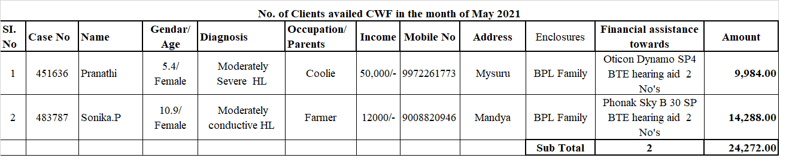

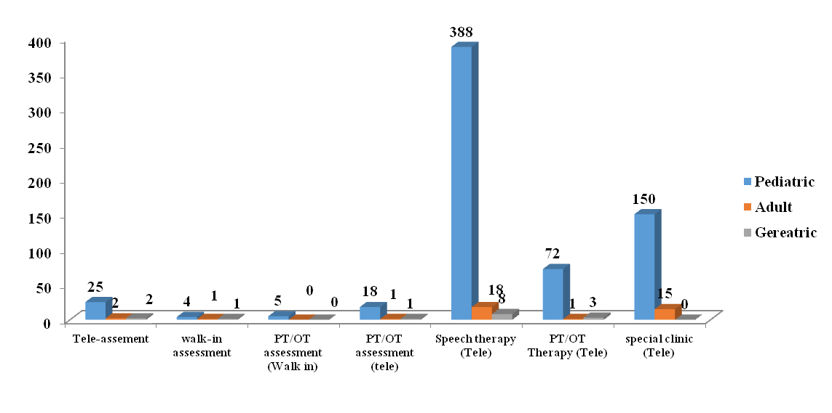
No. of diagnostic and therapeutic cases seen in the month of May 2021
Number of cases availed therapy for the month of May 2021

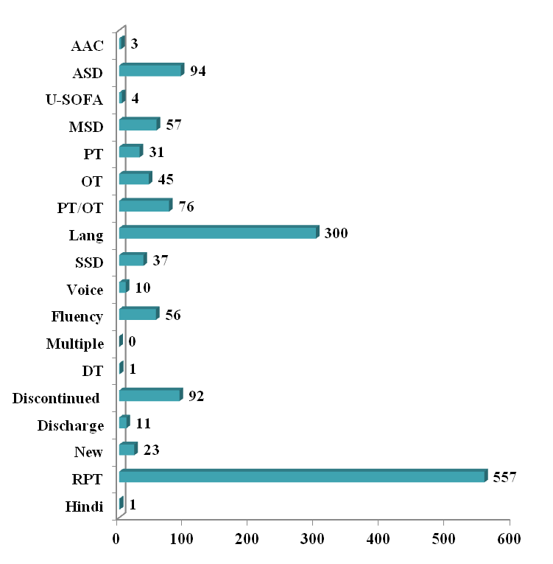

No. of clients evaluated in OPD for the month of May 2021

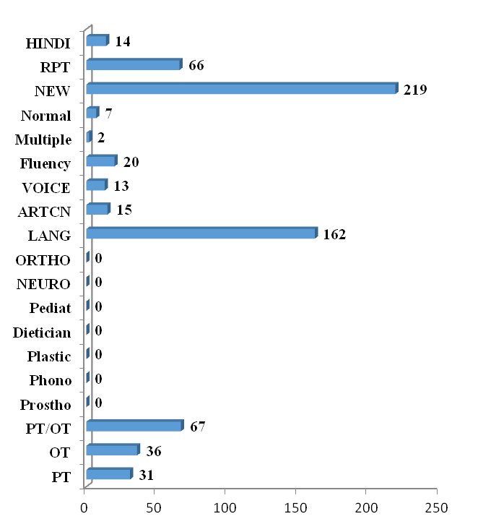

Revenue Generated at DCS

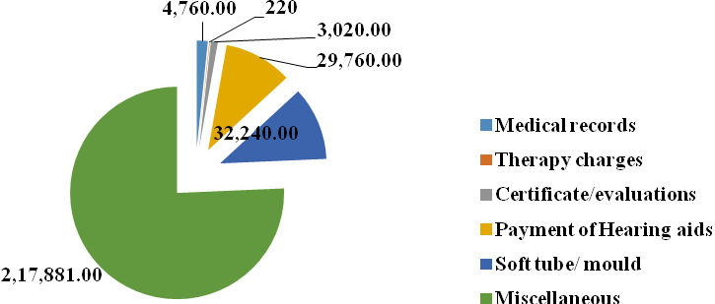

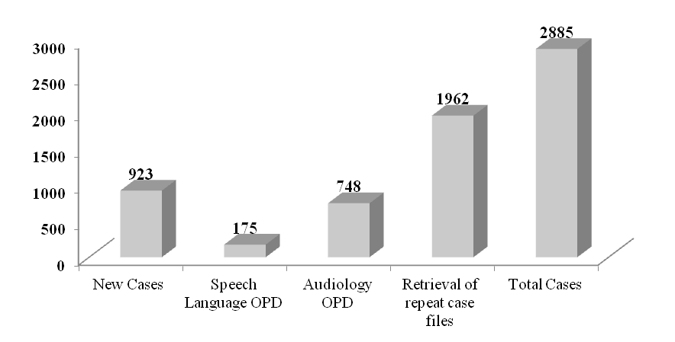
Clients Services rendered /No. of cases registred/files retrieved at AIISH for the month of May 2021

ALL INDIA INSTITUTE OF SPEECH & HEARING: MYSURU- 6
अखिल भारतीय वाक श्रवण संस्थान: मैसूर-६
DEPARTMENT OF CLINICAL SERVICES
चिकित्सा सेवा विभाग
SH/DCS/Monthly-Stat/2021-22 09.06.2021
एसहेच/डी.सी.एस/मासिक रिपोर्ट/2021-22

Submitted to the Director:
निदेशकको प्रस्तुत:

Sub: Monthly Report of May–2021.
विषय:मार्चकी मासिकविवरण–के बारे में

With reference to the above please find herewith monthly report of Department of Clinical Services for the month of May, 2021. This is placed for your kind information.

Verified by,
checked on 09 06 2021 GS HOD- Clinical Services
विभागध्यक्ष- चिकित्सा सेवा विभा

