संप्रेषण विकृति रोकथामविभाग
DEPARTMENT OF PREVENTION OF COMMUNICATION DISORDERS
महीनेकेविवरण/ MONTHLY REPORT –APRIL 2021
- ACADEMIC ACTIVITIES
A. No. of webinars & Orientations:
As a part of primary prevention activities, orientation/sensitization programs are being conducted regularly. The objective of the orientation programs was to create awareness among the general public and various other professionals such as Medical doctors, Nurses, Health-related workers, teachers, school students, etc., on different types of communication disorders, its prevention and early identification methods, and their appropriate referral and timely management. Due to the COVID-19 pandemic condition in the country, some of the orientation programs are carried out through Tele-mode/Webinars. Table 1&2 shows the details of the webinar’s programs conducted by staff and students of the department of POCD, NBS, and OSC centers.
Table 1: The details of Orientation Programs in April, 2021.
I. No. of Orientation Programs at POCD : 00
II. No. of Orientation Programs at Outreach Service Centers: 5
 | 02/04/2021 | GIMS Hospital | MBBS 3rd year | 12 | Ms. Aneena  Ms.Sheetal
 | 03/04/2021 | Leeds Asian School, Patna | Teachers | 21 | Ms Rishisha Lyngkhoi
 | 06/04/2021 | GIMS Hospital, Kalaburgi | VRW | 02 | Ms. Aneena  Ms.Sheetal
 | 22/04/2021 | Karnataka Institute of Medical Sciences, Hubli | BASLP Students | 06 | Hemashree B.M
 | 30/04/2021 | MCH – KR NAGAR | Caretakers of new moms | 09 | Ms. Jasper Priences
Total (OSC) |  |  |  | 50
III. No. of Orientation Programs at NBS centers: 01
 | 19/04/2021 | R L Jallapa Hospital, Kolar | Nursing Students | 05 | Rohith V S
Total (NBS) |  |  |  | 05
Total (POCD+OSC+NBS) |  |  |  | 55

Table 2: The details of Webinar Programs in April, 2021.
I. No. of Webinar Programs at POCD : 03
Theme/Topic of the program: Prevention & early identification of communication disorders
Coordinators: Dr. N. Sreedevi, Dr. M. Sandeep & Mr. Arunraj K.
S.No | Date | Name of the institute/  Hospital | Target group | Total participants | Oriented by
 | 21.04.2021 | T. Narasipura Taluk schools | Teachers | 166 | Ms. Ankitha.S  Ms. Tanuja. M
 | 22.04.2021 | JNV’s (Puri, Udaipur, Amritsar, Noida) regions | Staff nurses and TGT in science | 492 | Ms. Kranti . Acharya  Ms. Ranjini
 | 23.04.2021 | JNV’s( Goa, Kamrup) regions | Staff nurses and TGT in science | 387 | Ms. Christy. Sebastian  Ms. Dibya
Total |  |  |  | 1,045
II. No. of Webinar Programs at Outreach Service Centers: Nil
III. No. of Webinar Programs at NBS centers: Nil
Total (POCD+OSC+NBS) |  |  |  | 1045

Table 3: Total number of participants oriented including Webinars and orientations (Group wise)
S. No | Target group | Total no. of Participants
I | Grass Root Level Workers
 | ASHA Workers | -
 | Health Facilitator and Supervisors/Program Manager | 2
II | Professionals
 | School Teachers | 187
 | Audiologists/Speech language Pathologists | -
 | Hospital staff | -
 | Medical Doctors | -
 | Nurses | 879
 | Factory Workers | -
III | Students
 | BASLP/MASLP Students | 6
 | DHLS Students | -
 | Diploma Students | -
 | Medical Students | -
 | Nursing Students/Paramedical Students | 17
IV | Public
 | General Public | 09
 | Mothers/Parents of children with communication disorders | -
 | Post-Partum Mothers | -
 | Expectant mothers | -
 | Elderly Individuals | -
Total |  | 1100

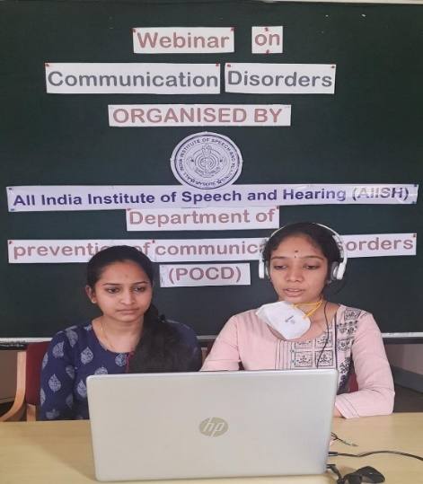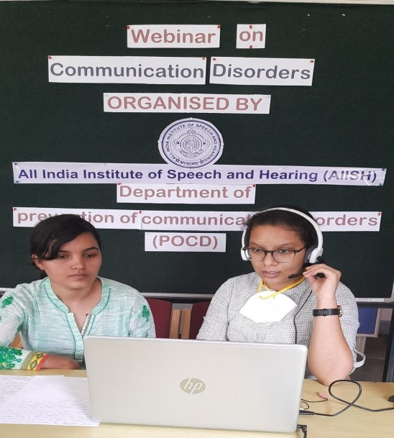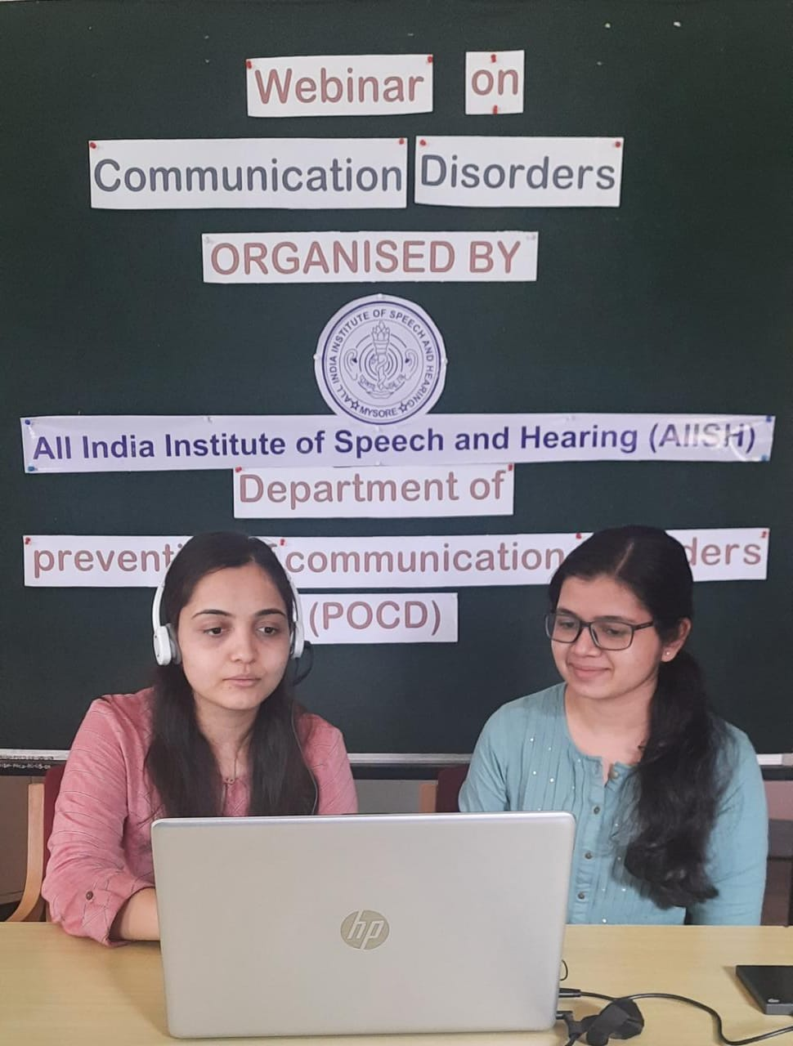
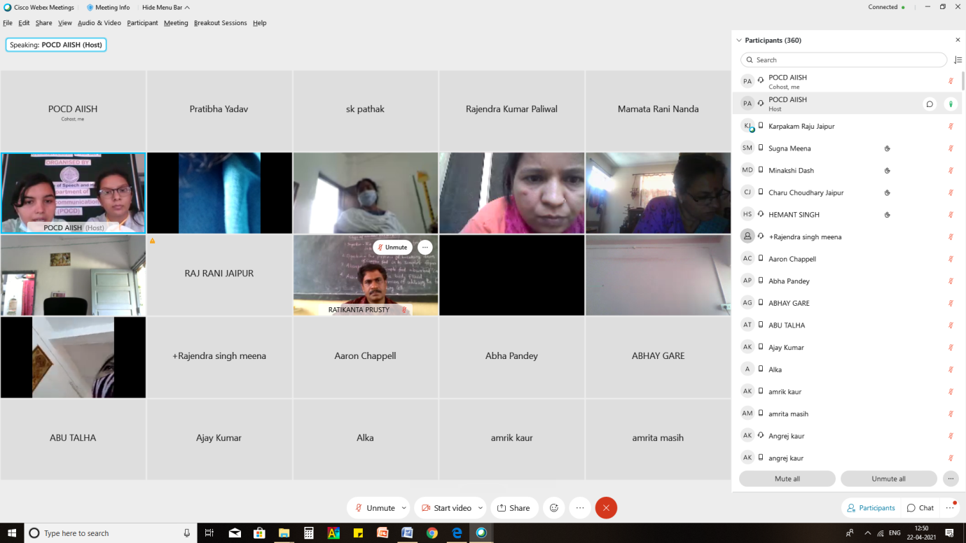
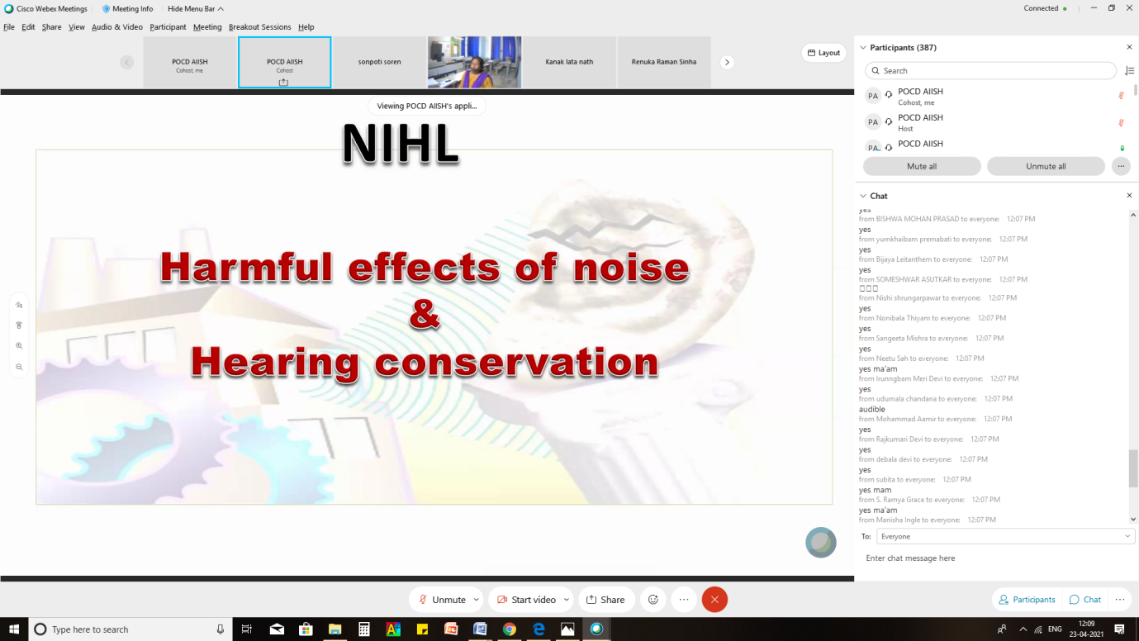
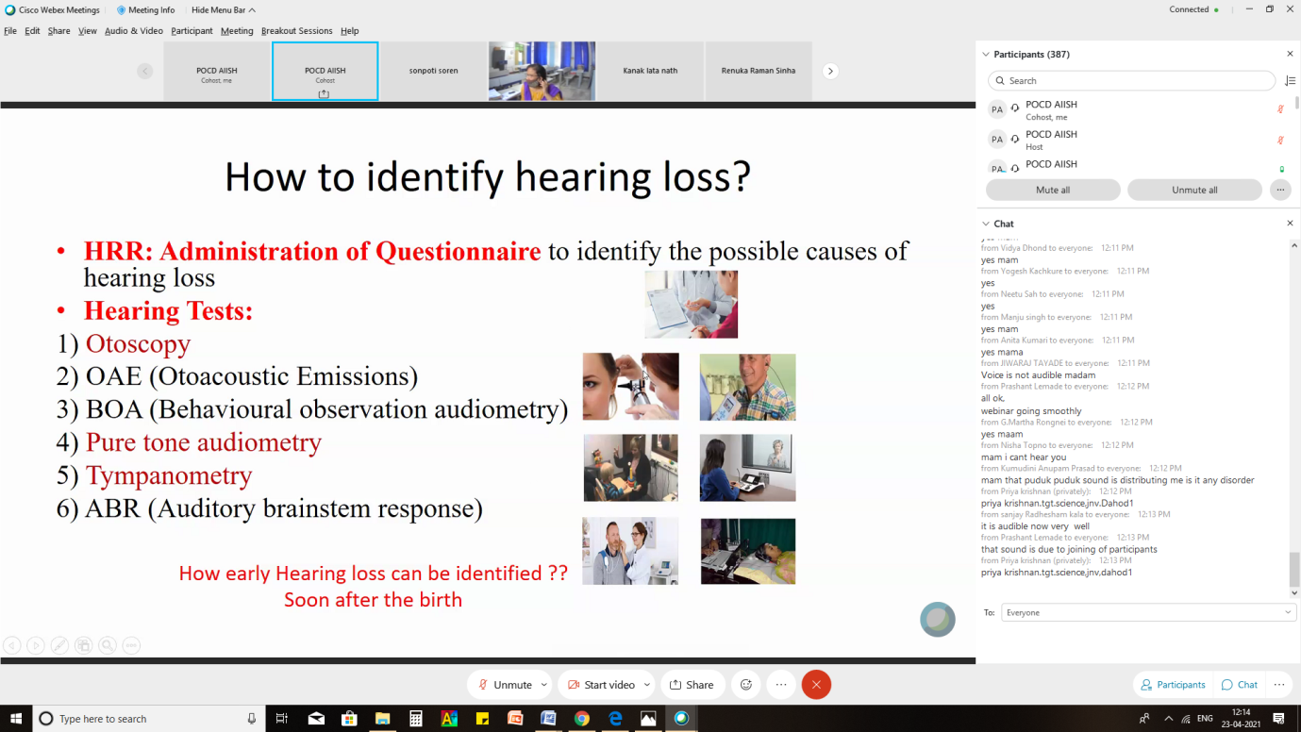
Glimpses of orientation/Webinar programme conducted by POCD staff
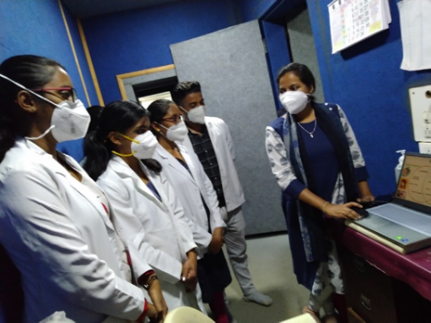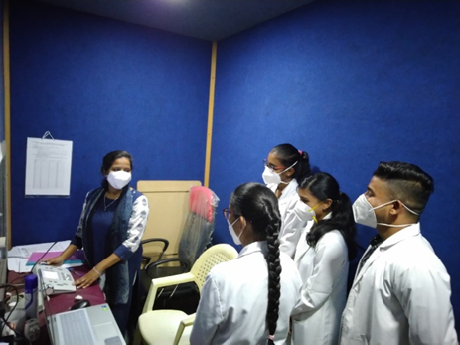
Glimpses of orientation programme conducted in outreach service center KIMS Hubli
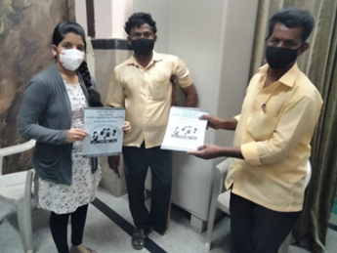
Glimpses of orientation programme conducted in outreach service center GIMS Hospital, Kalburgi
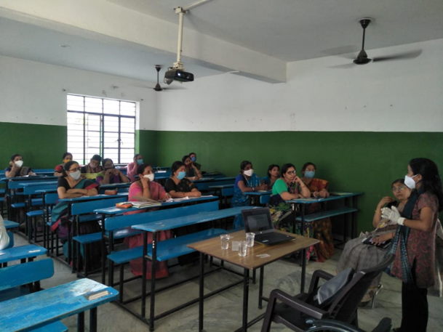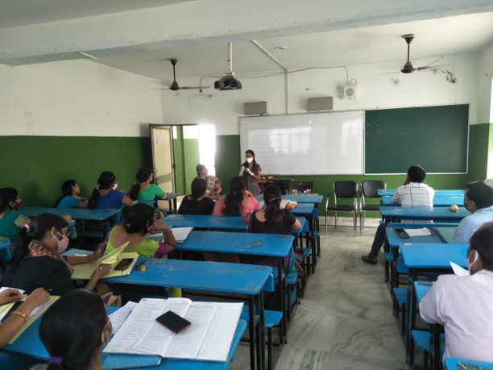
Glimpses of orientation programme conducted in Leeds Asian School, Patna
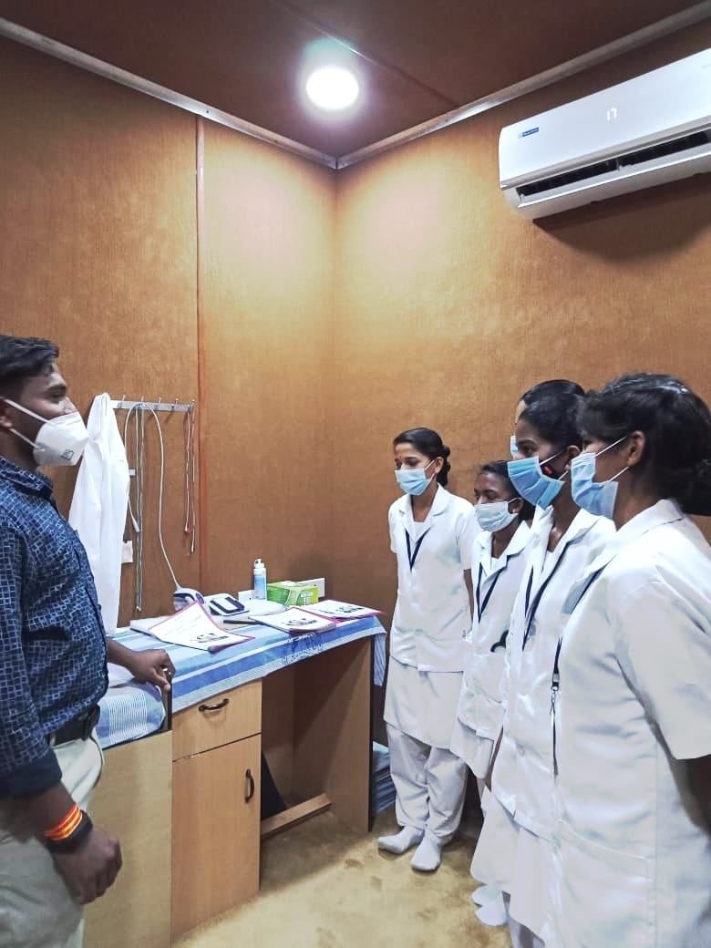
Glimpses of orientation programme conducted NBS Kolar: Nursing students orientation about new born screening and its importance on April 19th 2021
B) Seminars/ Conferences /Lectures /Workshops/Training programs
i) Table 4: Details of Seminar/ Conferences /Lectures /Workshop organized by OSC centre.

Date& venue | 16/04/2021, Kodagu Institute of Medical Sciences
Topic | Vocal Hygiene and voice care tips for teachers
Name of the resource person | Ms Anuroopa K S
Name of the coordinator/s | Dr, Shwetha
Name of the organizers | Ms Sushma C, Ms Anuroopa K S
Target group | Students and Professors of KoIMS
Number of beneficiaries | 67
Objectives | 1. Awareness on various vocal pathology in professional voice users  2. Awareness on vocal misuse and abuse  3. Awareness on vocal hygiene and voice care tips for teachers  4. Demonstration of vocal warm up exercises

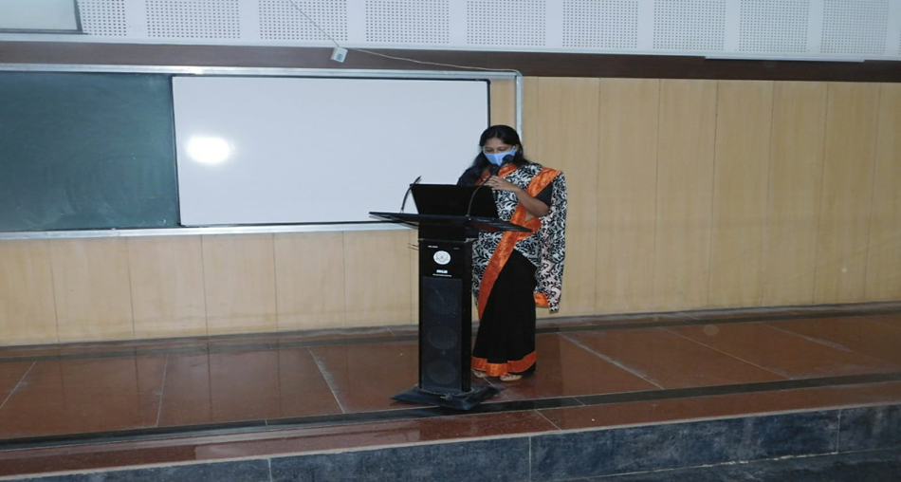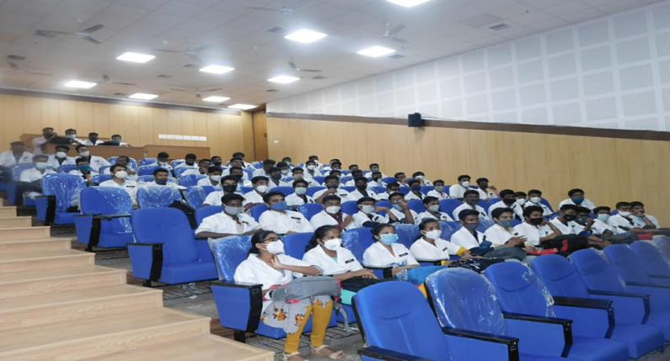
Glimpses of seminar program at Kodagu Institute of Medical Sciences
ii) Details of Seminar/Conferences/Lectures/Workshop organized by NBS centre.-Nil

- RESEARCH ACTIVITIES:
Research Activities of OSC
- Voice profile of patients taking antituberculosis treatment.- Baseline data collection obtained. Report writing started from 2nd week of April 2021.
- Prevalence of the communication disorders among OPD patients reporting to the department of E.N.T. at GIMS, Kalaburagi.- Got approval from GIMS ethical committee. Data collection started from first week of April 2021.
- Prevalence of hearing impairment in newborn babies with high risk factors at GIMS hospital, Kalaburagi.- Got approval from GIMS ethical committee.

III) EXTENSION ACTIVITIES
The department of POCD is actively involved in carrying out various extension activities such as screening, diagnostic and rehabilitation services outside the institute campus. The activities include newborn/infant screening, screening of school children, screening of elderly citizens, screening of industrial workers, conducting camps and also clinical services offered at the outreach service centers of AIISH.
- New-born screening programs for Communication Disorders
a) Table 5: Details of newborn screened in OSC and NBS centers in April 2021.
S. No | Hospitals/ Immunization Centers | Total births | Total screened |  |  | Total No. at risk |  |  | Phone Follow up
 |  |  | Male | Female | Total | Male | Female | Total | Male | Female | Total
I. Mysuru Hospitals
 | KR Hospital (KRH) - Cheluvamba | - | 213 | 184 | 397 | 3 | 0 | 3 | 12 | 10 | 22
 | Kamakshi Hospital (KH) | - | 22 | 21 | 43 | 0 | 0 | 0 | 5 | 2 | 7
 | Mission Hospital (MH) | - | 6 | 11 | 17 | 1 | 0 | 1 | 1 | 1 | 2
 | Chamundeshwari nursing home | - | 1 | 1 | 2 | 0 | 0 | 0 | 0 | 0 | 0
 | Ashwini Nursing Home (ANH) | - | 8 | 2 | 10 | 0 | 0 | 0 | 2 | 3 | 5
 | Shree Devi Nursing Home (SNH) | - | 7 | 8 | 15 | 0 | 0 | 0 | 0 | 0 | 0
 | Mahadeshwara Nursing Home (MNH) | - | 6 | 4 | 10 | 1 | 0 | 1 | 0 | 0 | 0
 | Sigma Hospital (SH) | - | 8 | 8 | 16 | 1 | 0 | 1 | 0 | 2 | 2
 | Jayanagar Maternity Hospital | - | 24 | 26 | 50 | 0 | 0 | 0 | 0 | 2 | 2
 | NPC Maternity hospital | - | 6 | 9 | 15 | 0 | 0 | 0 | 0 | 1 | 1
 | Makkalakoota Immunization Centre | - | 6 | 9 | 15 | 0 | 0 | 0 | 3 | 3 | 6
 | Kyathmanalli Immunization Centre | - | 4 | 0 | 4 | 0 | 0 | 0 | 1 | 0 | 1
Total |  | - | 311 | 283 | 594 | 6 | 0 | 6 | 24 | 24 | 48
II. OSC Centers:
 | Sub-divisional hospital, K R Nagar Taluk | 204 | 50 | 43 | 93 | - | 1 | 1 | 1 | 0 | 1
 | Sub-divisional Hospital, SagaraTaluk | 283 | 106 | 95 | 201 | 2 | 3 | 5 | 10 | 7 | 17
 | St,Mary’s Hospital, HD kote | 152 | 49 | 33 | 82 | 13 | 9 | 22 | 10 | 7 | 17
 | Vivekananda Memorial hospital, H. D. Kote Sarguru | 24 | 9 | 15 | 24 | 3 | 5 | 8 | 1 | 8 | 9
 | Taluk Hospital, H. D. Kote- Immunization | 107 | 34 | 22 | 56 | 6 | 4 | 10 | 2 | 7 | 9
 | Gulbarga Institute of Medica Sciences , Kalaburagi | 642 | 73 | 60 | 133 | 11 | 9 | 20 | 62 | 51 | 113
 | Taluk General Hospital, KR. Pete | 56 | 19 | 19 | 38 | 1 | - | 1 | 1 | 0 | 1
 | Community Health Centre (CHC), Santhemarahalli | - | - | - | - | - | - | - | - | - | -
 | Taluk Hospital, Yelandur | - | - | - | - | - | - | - | - | - | -
 | Primary Health centre (Under karuna trust), Gumballi | 18 | 11 | 7 | 18 | 1 | 1 | 2 | 0 | 0 | 0
 | Taluk Hospital, Nanjangud | 119 | 49 | 43 | 92 | 0 | 0 | 0 | 13 | 11 | 24
 | Community Health Centre (CHC), Hullahalli | 12 | 1 | 3 | 4 | 0 | 0 | 0 |  |  | 0
 | Belagavi Institute of Medical Science, Belagavi | 383 | 144 | 191 | 335 | 7 | 13 | 20 | 15 | 14 | 29
 | Kodagu Institute of Medical Science ,Kodagu | 230 | 81 | 72 | 153 | 0 | 2 | 2 | 8 | 3 | 11
 | AIIMS,Bhuvaneshwar | 96 | 66 | 73 | 139 | 14 | 20 | 34 | 26 | 22 | 48
 | KIMS,Hubli | 743 | 8 | 15 | 23 | 2 | 6 | 8 | 4 | 6 | 10
 | IGIMS,Patna | 12 | 6 | 6 | 12 | 5 | 4 | 9 | - | - | -
 | BRIMS,Bidar | 316 | 146 | 133 | 279 | 146 | 133 | 279 | - | - | -
Total |  | 3397 | 852 | 830 | 1682 | 211 | 210 | 421 | 153 | 136 | 289
III. NBS Centers
 | All India Institute of Physical Medicine and Rehabilitation (AIIPMR), Mumbai | 45 | 18 | 21 | 39 | 3 | 5 | 8 | 10 | 4 | 14
 | Janana Hospital & JLNMCH, Ajmer | - | - | - | - | - | - | - | - | - | -
 | Jawaharlal Nehru Medical College & Hospital, Bhagalpur, Bihar | - | 40 | 39 | 79 | 16 | 4 | 20 | - | - | -
 | JIPMER, Puducherry | 548 | 226 | 205 | 431 | 38 | 30 | 68 | 16 | 18 | 34
 | King George’s Medical  University (KGMU) Lucknow | - | 40 | 36 | 76 | 1 | 1 | 2 | 7 | 10 | 17
 | NetajiSubhash Chandra Bose Medical College (NSCB), Jabalpur | - | - | - | - | - | - | - | - | - | -
 | Post Graduate Institute of Medical Education and Research (PGIMER), New Delhi | 75 | 18 | 22 | 40 | 2 | 1 | 3 | 0 | 1 | 1
 | Rajendra Institute of Medical Sciences, Baritayu, Ranchi | 165 | 71 | 52 | 123 | 1 | 2 | 3 | 4 | 4 | 8
 | Regional Institute of Medical Sciences (RIMS), Imphal | - | - | - | - | - | - | - | - | - | -
 | Sri DevarajUrs Academy Of Higher Education and Research (SDUAHER), Kolar | 175 | 94 | 71 | 165 | 0 | 0 | 0 | 12 | 11 | 23
 | Sri Ramachandra Bhanj Medical College and Hospital (SCB MCH), Cuttack | - | - | - | - | - | - | - | - | - | -
 | All India Institute of Medical Science (AIIMS), Patna | 35 | 9 | 19 | 28 | 1 | 1 | 2 | 1 | 2 | 3
 | Indira Gandhi Medical College (IGMC), Shimla | - | 44 | 29 | 73 | 4 | 2 | 6 | 5 | 4 | 9
Total (NBS centers) |  | - | 560 | 494 | 1054 | 66 | 46 | 112 | 55 | 54 | 109
Total (POCD+OSC+NBS) |  | - | 1723 | 1607 | 3330 | 283 | 256 | 539 | 232 | 214 | 446

b) Tele- follow-up evaluation
The at-risk babies were monitored regularly through Phone calls by administrating Speech-language & hearing developmental checklist. The babies identified with delay in any of the developmental milestones, were referred to AIISH/concerned center for detailed diagnostic evaluation.
Table 6: Details of Tele-phone follow- up carried out at Hospitals in Mysuru.
S. No. | Hospitals | Number of infants with normal developmental milestones. | Total infants at risk | Total call attended/ Total no of calls
I. Mysuru Hospitals
 | Ashwini Nursing Home | 04 | 00 | 4/4
 | Brindavan Hospital | 01 | 00 | 1/3
 | Cheluvamba Hospital (KRH) | 37 | 1 | 38/76
 | GopalaGowdaShanthaveri Memorial Hospital | 02 | 00 | 2/3
 | Kamakshi Hospital | 11 | 00 | 11/17
 | Mahadeshwara Nursing Home | - | - | 0/1
 | Mission Hospital | - | - | 0/1
 | S.M.T.D.H Hospital | 01 | 00 | 1/1
 | Shree Devi Nursing Home | - | - | 0/1
 | Sigma Hospitall | 04 | 00 | 4/7
 | Combined Hospital | - | - | -
 | Chamundeshwari Hospital | - | - | 0/1
 | Jaynagar Hospital | 02 | 00 | 2/2
 | Makkalakoota Immunization Centre | - | - | 0/1
 | Total | 62 | 01 | 63/118
II. OSC centers
 | Sub-divisional hospital, K R Nagar Taluk | - | - | -
 | Subdivision hospital , Sagara | 7 | - | 7/12
 | St. Mary’s Hospital , HD Kote | 15 | 0 | 15/27
 | Vivekananda Memorial Hospital, Sarguru | 4 | 0 | 4/6
 | Taluk Hospital, H. D. Kote- | 6 | 0 | 6/12
 | GIMS, Kalaburgi | 123 | 0 | 123/149
 | Taluk General Hospital, KR. Pete | - | - | -
 | Primary Health Centre (PHC), Akkihebbalu | - | - | -
 | Community Health Centre (CHC), Santhemarahalli | - | - | -
 | Taluk Hospital, Yelanduru | - | - | -
 | Primary Health centre, Gumballi | - | - | -
 | BIMS, Belagavi | 48 | 2 | 50/68
 | KoIMS, Madikkeri | 36 | 0 | 36 / 47
 | AIIMS, Bhuvaneshwar | - | - | -
 | KIMS, Hubli | 9 | 0 | 9/15
 | IGIMS, Patna | - | - | -
 | BRIMS,Bidar | - | - | -
 | Total | 248 | 02 | 250/336
III. Newborn Screening Centers
 | Ajmer | - | - | -
 | Bhagalpur | 08 | 00 | 8/8
 | Cuttack | - | - | -
 | Delhi
 | Imphal | - | - | -
 | Jabalpur | - | - | -
 | Kolar | 49 | 00 | 49/55
 | Lucknow | 35 | - | 35/48
 | Mumbai | _ | _ | _
 | Patna | _ | _ | _
 | Puducherry | 17 | 00 | 17/25
 | Ranchi | 05 | 00 | 5/5
 | Shimla
 | Total | 114 | - | 114/141

Note: The calls not attempted were repeated a minimum of 5 times on consecutive days
c) Tele screening Programs
Tele-screening program (virtual mode) was carried out to identify the babies at risk for communication disorders since new born screening program couldn’t be carried out in many centers. The details including the behavioral responses of the new born to environmental sounds and HRR were collected from the parents through Tele-phone mode. The babies at risk were asked to undergo follow up evaluation in detail.

Table 7: Details of Tele-screening* at POCD.
OSC Centre | Total Tele-screened / Total calls made | Mortality | Detailed Evaluation  (Referred) | Total infants at risk  (Screening) | Normal Speech and Language milestones  (Phone Follow up)
I. Mysuru Hospitals
Kamakshi, Mysore | 46/46 | 0 | 1 | 4 | 41
Jayanagar, Mysore | 16/34 | 0 | 2 | 0 | 14
Total | 62/80 | 0 | 3 | 4 | 55
II. Outreach Service Centers
GIMS, Kalaburgi | - | - | - | - | -
Taluk General Hospital, KR. Pete | 22/33 | 0 | 0 | 0 | 22
Primary Health Centre, Gumballi
Taluk Hospital, Yelandur | 2/2 | 0 | 2 | 0 | 0
Total | 24/35 | 0 | 2 | 0 | 22

d) Newborn follow-up evaluation (Detailed assessment)
The newborns/infants referred during the newborn screening/ Tele-screening were advised for detailed evaluation at AIISH/NBS centers/OSCs. A complete test battery was administered for those babies/infants who came for follow-up.

Table 8: Details of the results of follow-up evaluation at OSC Centers
Categories | Age range |  | AIISH | OSC- Akkihebbalu | OSC- Belagavi | OSC-Hullahalli | OSC-Kalburgi | OSC- Kodagu | OSC-Gumballi | OSC-K.R.Pete | OSC- Nanjangudu | OSC- Sagara | OSC- Sarguru | OSC-Bhubaneswar | OSC-Patna | OSC-Bidar | OSC-Hubli | Total
Normal | Newborn  (0-2 months) | Male | - | - | 10 | - | - | - | - | - | - | 1 | 6 | - | - | - | 1 | 18
 |  | Female | - | - | 15 | - | - | 1 | - | - | - | - | 12 | - | - | - | 1 | 29
 | Infants  (2-12 months) | Male | - | - | 1 | - | - | - | 2 | - | - | - | 4 | - | - | - | - | 07
 |  | Female | - | - | 1 | - | - | - | 2 | - | - | - | - | - | - | - | - | 03
 | Toddlers  (1 year to 4years) | Male | - | - | 1 | - | - | - | - | - | - | - | - | - | - | - | - | 01
 |  | Female | - | - | - | - | - | - | - | - | - | - | - | - | - | - | - | -
 | Children  (above 4years) | Male | - | - | - | - | - | - | - | - | - | - | - | - | - | - | - | -
 |  | Female | - | - | - | - | - | - | - | - | - | - | - | - | - | - | - | -
Hearing impairment | Newborn  (0-2 months) | Male | - | - | 1 | - | - | - | 01 | - | - | - | - | - | - | - | - | 02
 |  | Female | - | - |  | - | - | - | - | - | - | - | - | - | - | - | - | -
 | Infants  (2-12 months) | Male | - | - |  | - | - | - | - | - | - | - | - | - | - | - | - | -
 |  | Female | - | - |  | - | - | - | - | - | - | - | - | - | - | - | - | -
 | Toddlers  (1 year to 4years) | Male | - | - |  | - | - | - | - | - | - | - | - | - | - | - | - | -
 |  | Female | - | - | - | - | - | - | - | - | - | - | - | - | - | - | - | -
 | Children  (above 4years) | Male | - | - | - | - | - | - | - | - | - | - | - | - | - | - | - | -
 |  | Female | - | - | - | - | - | - | - | - | - | 01 | - | - | - | - | - | 01
Speech &language disorder | Newborn  (0-2 months) | Male | - | - | - | - | - | - | - | - | - | - | - | - | - | - | - | -
 |  | Female | - | - | - | - | - | - | - | - | - | - | - | - | - | - | - | -
 | Infants  (2-12 months) | Male | - | - | - | - | - | - | - | - | - | - | - | - | - | - | - | -
 |  | Female | - | - | - | - | - | - | - | - | - | - | - | - | - | - | - | -
 | Toddlers  (1 year to 4years) | Male | - | - | - | - | - | - | - | - | - | - | - | - | - | - | - | -
 |  | Female | - | - | - | - | - | - | - | - | - | - | - | - | - | - | - | -
 | Children  (above 4years) | Male | - | - | - | - | - | - | - | - | - | - | - | - | - | - | - | -
 |  | Female | - | - | - | - | - | - | - | - | - | 01 | - | - | - | - | - | 01
Multiple Disorder/Syndromes | Newborn  (0-2 months) | Male | - | - | - | - | - | - | - | - | - | - | - | - | - | - | - | -
 |  | Female | - | - | - | - | - | - | - | - | - | - | - | - | - | - | - | -
 | Infants  (2-12 months) | Male | - | - | - | - | - | - | - | - | - | - | - | - | - | - | - | -
 |  | Female | - | - | - | - | - | - | - | - | - | - | - | - | - | - | - | -
 | Toddlers  (1 year to 4years) | Male | - | - | - | - | - | - | - | - | - | - | - | - | - | - | - | -
 |  | Female | - | - | - | - | - | - | - | - | - | - | - | - | - | - | - | -
 | Children  (above 4years) | Male | - | - | - | - | - | - | - | - | - | - | - | - | - | - | - | -
 |  | Female | - | - | - | - | - | - | - | - | - | - | - | - | - | - | - | -
Total |  |  | - | - | 29 | - | - | 01 | 05 | - | - | 03 | 22 | - | - | - | 02 | 62

Table 9: Details of the results of follow-up evaluation carried out at NBS centers.
Categories | Age range |  | AJMER | BHAGALPUR | CUTTACK | DELHI | IMPHAL | JABALPUR | KOLAR | LUCKNOW | MUMBAI | PATNA | PUDUCHERI | RANCHI | SHIMLA | Total
Normal | Newborn  (0-2 months) | Male | - | - | - | - | - | - | - | 10 | 1 | 0 | - | - | - | 11
 |  | Female | - | - | - | - | - | - | - | 06 | 02 | 01 | - | - | - | 09
 | Infants  (2-12 months) | Male | - | - | - | - | - | - | - | - | 03 | 01 | 1 | - | - | 05
 |  | Female | - | - | - | - | - | - | - | 01 | 01 | - | 2 | - | - | 04
 | Toddlers  (1 year to 4years) | Male | - | - | - | - | - | - | - | 02 | - | - | - | - | - | 02
 |  | Female | - | - | - | - | - | - | - | 01 | - | - | - | - | - | 01
 | Children  (above 4years) | Male | - | - | - | - | - | - | - | - | - | - | - | - | - | -
 |  | Female | - | - | - | - | - | - | - | - | - | - | - | - | - | -
Hearing impairment | Newborn  (0-2 months) | Male | - | - | - | - | - | - | - | 1 | - | - | - | - | - | 1
 |  | Female | - | - | - | - | - | - | - | 0 | - | - | - | - | - | -
 | Infants  (2-12 months) | Male | - | - | - | - | - | - | - | - | - | - | 1 | - | - | 1
 |  | Female | - | - | - | - | - | - | - | - | - | - | 2 | - | - | 2
 | Toddlers  (1 year to 4years) | Male | - | - | - | - | - | - | - | 01 | - | - | - | - | - | 01
 |  | Female | - | - | - | - | - | - | - | 02 | - | - | - | - | - | 02
 | Children  (above 4years) | Male | - | - | - | - | - | - | - | 02 | - | - | - | - | - | 02
 |  | Female | - | - | - | - | - | - | - | - | - | - | - | - | - | -
Speech & language disorder | Newborn  (0-2 months) | Male | - | - | - | - | - | - | - | - | - | - | - | - | - | -
 |  | Female | - | - | - | - | - | - | - | - | - | - | - | - | - | -
 | Infants  (2-12 months) | Male | - | - | - | - | - | - | - | - | - | - | - | - | - | -
 |  | Female | - | - | - | - | - | - | - | - | - | - | - | - | - | -
 | Toddlers  (1 year to 4years) | Male | - | - | - | - | - | - | - | - | 01 | - | - | - | - | 01
 |  | Female | - | - | - | - | - | - | - | - | 01 | - | - | - | - | 01
 | Children  (above 4years) | Male | - | - | - | - | - | - | - | - | - | - | - | - | - | -
 |  | Female | - | - | - | - | - | - | - | - | - | - | - | - | - | -
Multiple Disorder/ Syndromes | Newborn  (0-2 months) | Male | - | - | - | - | - | - | - | - | - | - | - | - | - | -
 |  | Female | - | - | - | - | - | - | - | - | - | - | - | - | - | -
 | Infants  (2-12 months) | Male | - | - | - | - | - | - | - | - | - | - | - | - | - | -
 |  | Female | - | - | - | - | - | - | - | - | - | - | - | - | - | -
 | Toddlers  (1 year to 4years) | Male | - | - | - | - | - | - | - | - | - | - | - | - | - | -
 |  | Female | - | - | - | - | - | - | - | - | - | - | - | - | - | -
 | Children  (above 4years) | Male | - | - | - | - | - | - | - | - | - | - | - | - | - | -
 |  | Female | - | - | - | - | - | - | - | - | - | - | - | - | - | -
Total | - | - | - | - | - | - | - | - | - | 26 | 09 | 02 | 06 | - | - | 43

B) Anganawadi /Preschool/School screening program
Screening of Anganawadi, preschool and primary school children was conducted focusing on the early identification of communication disorders and early rehabilitation of children at risk for communication disorders.

Table 10: Total number of children screened for communication disorders and identified.

Date | Name of the Anganawadi/Preschool/ School | Total screened |  |  | Total referred with communication disorders
 |  |  |  |  | Ear related disorder | Hearing loss | Speech language disorders
 |  | Male | Female | Total | - | - | -
07.04.2021 | Periyapatana- Sarguru OSC | 22 | 33 | 55 | 5 | 6 | 3
Total |  | 22 | 33 | 55 | 5 | 6 | 3

C) a. Industrial Screening - Nil
b. Follow-up Hearing evaluation of industrial workers at AIISH – Nil

D) Elderly Screening – Nil

E) Bedside Screening
Table 11: Details of the bedside screening carried out in April 2021
Hospital | Total screened | Total referred |  |  |  |  | Clinically Normal
 |  | Cognitive Communication disorder(CCD) | Language disorder | Motor Speech disorder(MSD) | Swallowing disorder(SD) | Multiple disorders
K R Hospital | 05 | 0 | 0 | 02 | 0 | 03 | 0
Total | 05 | 0 | 0 | 02 | 0 | 03 | 0

F) CLINICAL SERVICES AT OUTREACH SERVICE CENTRES
The clinical activities are not only restricted to in and around Mysuru, but also extended to rural areas where facilities for clinical services for persons with communication disorders are scanty. Currently there are 08 OSCs centres at different part of the country rendering services to unreached population. The details of those who were registered and availed various services/benefits at the OSCs are tabulated below.
- Clients identified and followed up with communication disorders at OSCs
Table 12: Details of clients identified and followed up with communication disorders at OSCs.
S. No | OSC Centre | Total registered |  | ENT Evaluation |  | Hearing Evaluation |  | Speech & Language Evaluation
 |  |  |  | Normal | Disorder | Normal | Disorder | Normal | Disorder
 | Taluk Hospital, Nanjangud | New cases | 18 | - | 18 | 8 | 24 | - | 2
 |  | F/u Old | - | - | - | - | - | -
 | Community Health Centre (CHC), Hullahalli | New cases | 15 | - | 15 | - | - | - | -
 |  | F/u Old | 13 | - | 13 | - | - | - | -
 | Primary Health Centre (PHC), Akkihebbalu | New cases | - | - | - | - | - | - | -
 |  | F/u Old | - | - | - | - | - | - | -
 | Taluk General Hospital, KR Pete | New cases | 25 | - | - | 8 | 34 | 2 | 2
 |  | F/u Old | 2 | - | - | 1 | 3 | - | -
 | Primary Health Centre (PHC), Gumballi | New cases | 33 | 0 | 29 | 0 | 6 | 0 | 1
 |  | F/u Old | 13 | 0 | 12 | 0 | 2 | 0 | 0
 | Sub-divisional Hospital (PHC), Sagara | New cases | 14 |  |  | 5 | 21 | - | 2
 |  | F/u Old | 3 |  |  | 2 | 2 | - | 1
 | Vivekananda Memorial Hospital, Sarguru | New cases | 8 | 0 | 0 | 0 | 8 | 0 | 4
 |  | F/u Old
 | Gulbarga Institute of Medical Sciences | New cases | 44 | - | - | 10 | 52 | - | 5
 |  | F/u Old | 2 | - | - | - | 4
 | Belagavi institute of medical sciences (BIMS), Belagavi | New cases | 161 | - | - | 189 | 93 | 5 | 15
 |  | F/u Old | 1 | - | - |  |  |  | 1
 | Kodagu Institute of Medical Sciences, Madikkerri | New cases | 39 | - | - | 12 | 28 |  | 1
 |  | F/u Old | 1 | - | - | 0 | 1 |  | 3
 | AIIMS,  Bhuvaneshwar | New cases | 83 | - | - | - | - | 0 | 83
 |  | F/u Old | 2 | - | - | - | - | 0 | 2
 | IGIMS,  Patna | New cases | 4 | - | - | - | - | - | 4
 |  | F/u Old |  | - | - | - | - | - | -
 | KIMS,  Hubli | New cases | 127 | - | - | 23 | 185 | 1 | 22
 |  | F/u Old | 10 | - | - | 1 | 13 | 1 | 2
 | BRIMS, Bidar | New cases | 15 | - | - | 3 | 23 | - | 2
 |  | F/u Old |  | - | - | - | - | - | -

- Table 13: Details of clients identified with different types of communication disorders across OSCs
Type of Disorders |  |  | OSC
 | Taluk Hospital Nanjangud | Primary Health Centre (PHC), Hullahalli | Taluk General Hospital, KR Pete | Primary Health Centre (PHC), Gumballi | Sub-divisional Hospital,  Sagara (PHC) Taluk | VMH, Sarguru | Belagvi institute of medical sciences BIMS | GIMS, Kalburgi | KoIMS-TH, MadikeriTaluk,Kodagu | AIIMS,Bhuvaneshwar | KIMS,Hubli | BRIMS,BidaR | IGIMS,Patna
Hearing disorders (Ear-wise data)
Normal | 8 | - | 8 |  | 5 |  | 189 | 10 | 24 | - | 24 | 05 | -
Conductive | 16 | - | 9 |  | 12 | 2 | 39 | 18 | 11 | - | 92 | 00 | -
Sensori- neural | 3 | - | 16 | 6 | 7 | 4 | 45 | 24 | 33 | - | 75 | 21 | -
Mixed | 5 | - | 9 |  | 2 | 2 | 3 | 10 | 12 | - | 25 | 00 | -
Aud-Total (ears) | 32 | - | 42 | 6 | 26 | 8 | 276 | 62 | 80 | - | 216 | 26 | -
Aud-Total (Individuals) | 16 | - | 21 | 03 | 13 | 4 | 138 | 31 | 40 | - | 108 | 13 | -
Voice | 2 | - | - | - | - | - | 1 | - | - | 33 | 7 | - | 3
Fluency | - | - | 1 | - | - | - | - | - | 1 | 8 | 2 | - | -
Articulation disorders | - | - | - | - | 1 | 1 | 2 | 1 | - | 14 | 4 | - | 1
Language disorders | - | - | 3 | 1 | 1 | 3 | 12 | 4 | - | 30 | 9 | 2 | -
Sp&Lg -Total (Individuals) | 02 | 00 | 04 | 01 | 02 | 04 | 15 | 05 | 01 | 85 | 22 | 02 | 04

iii) Table 14: Details of clients followed up with different types of communication disorders across OSCs.
Type of Disorders |  |  | OSC
 | Taluk Hospital Nanjangud | Primary Health Centre (PHC), Hullahalli | Primary Health Centre (PHC), Akkihebbalu | Taluk General Hospital, KR Pete | Primary Health Centre (PHC), Gumballi | Sub-divisional Hospital,  Sagara  (PHC) Taluk | VMH, Sarguru | Belagvi institute of medical sciences BIMS | GIMS, Kalburgi | KoIMS-TH, MadikeriTaluk,Kodagu | AIIMS,Bhuvaneshwar | KIMS,Hubli | BRIMS,BidaR | IGIMS,Patna
 |  | Hearing disorders (Ear-wise data)
Normal | - | - | - | 01 |  | 02 | - | - | - | - | - | 01 | - | -
Conductive | - | - | - | - |  |  | - | - | 01 | - | - | 09 | - | -
Sensori- neural | - | - | - | 03 | 02 | 02 | - | - | 03 | - | - | 01 | - | -
Mixed | - | - | - | - |  |  | - | - | - | 02 | - | 01 | - | -
Aud-Total (ears) | - | - | - | 04 | 02 | 04 | - | - | 04 | 02 | - | 12 | - | -
Aud-Total (Individuals) | - | - | - | 02 | 01 | 02 | - | - | 02 | 01 | - | 06 | - | -
Voice | - | - | - | - | - | - | - | - | - | 01 | - | - | - | -
Fluency | - | - | - | - | - | - | - | - | - | - | - | - | - | -
Articulation disorders | - | - | - | - | - | - | - | - | - | - | - | 02 | - | -
Language disorders | - | - | - | - | - | 01 |  | 01 |  | 02 | 02 | 01 | - | -
Sp&Lg -Total (Individuals) | - | - | - | - | - | 01 |  | 01 |  | 03 | 02 | 03 | - | -
vi) Rehabilitation services at OSCs.
Table 15: Details of rehabilitation services provided at OSCs in April 2021.
OSC | Hearing Aids Dispensed | Speech-language therapy |  | Medical Line of Treatment
 |  | No. of clients | No. of sessions
Taluk Hospital, Nanjangud | 6 | 4 | 22 | -
Primary Health Centre (PHC), Hullahalli | - | 1 | 6 | -
Taluk General Hospital, KR Pete | - | 3 | 10 | -
Primary Health Centre (PHC), Gumballi | 0 | 6 | Regular Therapy-15  Tele therapy- 4 | -
Sub-divisional Hospital, Sagara (PHC) Taluk | 1 | 20 | Regular Therapy-46  Tele therapy- 22 | 7
VMH, Sarguru | 1 | 6 | 22 | -
Belagavi institute of medical sciences BIMS | - | 8 | Regular Therapy-23  Tele therapy- 7 | -
GIMS, Kalburgi | - | 5 | 32 | -
KoIMS-TH, MadikeriTaluk | 4 | 10 | 33 | -
AIIMS, Bhuvaneshwar | - | 8 | 30 | -
KIMS, Hubli | - | 12 | 25 | -
IGIMS, Patna | - | 3 | 12 | -
BRIMS, Bidar | - | 2 | 18 | -
Total | 12 | 88 | 327 | 7

v) Table 16: Screening Camps for communication Disorders
Date | Camp site | Total Screened | Total Referred |  |  |  | Total hearing aid distributed
 |  |  | Hearing impairment |  | Speech- language disorders
 |  |  | Male | Female | Male | Female
03.04.2021 | KSRTC staff, Kolar | 54 | - | - | - | - | -
20.04.2021 | Lanke, Sarguru | 15 | 09 | 06 | - | - | -
28.04.2021 | Bidrahalli, Sarguru | 12 | 06 | 06 | - | - | -
30.04.2021 | Mullur, Sarguru | 07 | 05 | 02 | - | - | -
Total |  | 34 | 20 | 14 | - | - | -

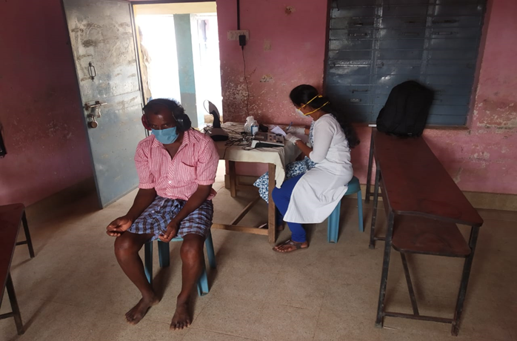

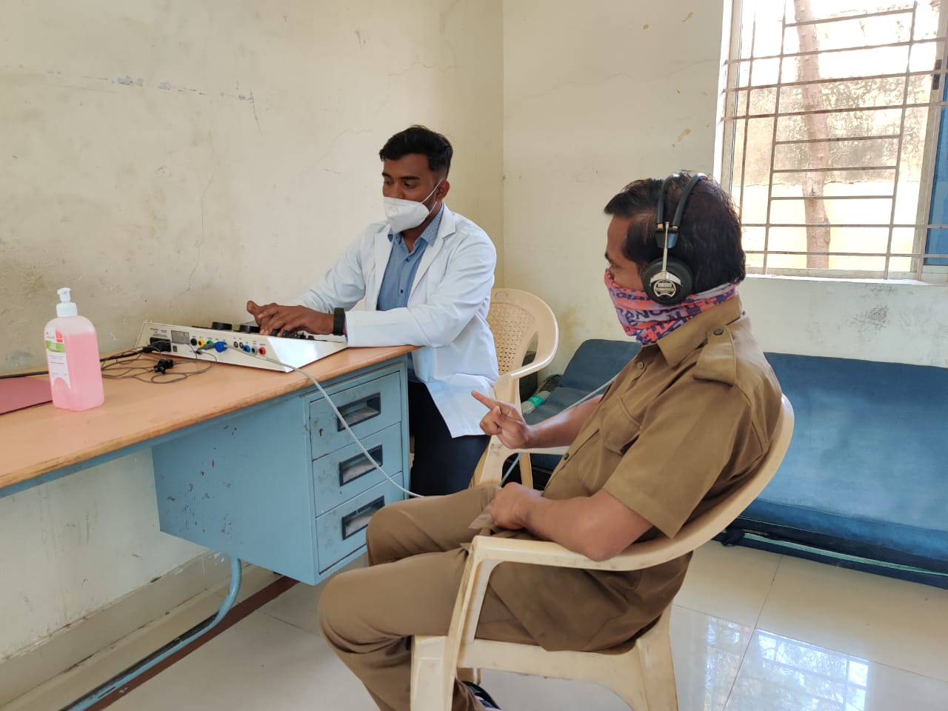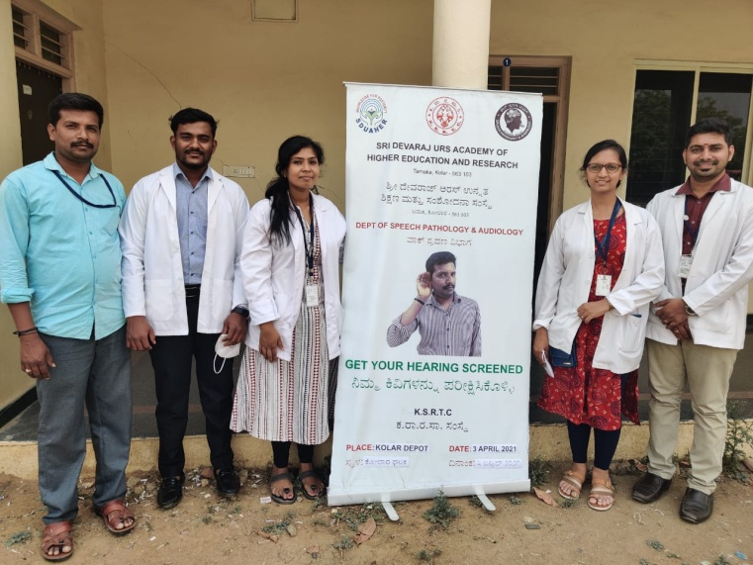

G) Human Resource Development
a) Student clinical training: As part of human resource development, clinical training for Undergraduates (B.Sc Speech & Hearing), Postgraduates (M.Sc SLP & AUD) & Internship students on early identification, prevention & rehabilitation of communication disorders and Community based rehabilitation at OSCs were carried out. The details on the number of students who had undergone training are given below.
Table 19: Details of the students posted in POCD during April 2021
Internal (AIISH)
Class | No of students Newly posted | No of Students continuing
II BASLP students | 00 | 00
I M.Sc (Speech ) students | 04 | 00
I M.Sc (Audiology) students | 07 | 00
B.ASLP Internship students | 11 | 09
Total | 22

b) Staff/Student Enrichment Programs: 01

As a part of continued education and updating of ongoing research and clinical evidences on early identification, prevention &amp; rehabilitation of communication disorders and Community based rehabilitation. Postgraduates students (M.Sc. SLP &amp; AUD) and staffs conduct and attend many presentation and talks. The details on the number of students and staffs who had undergone training are given below.

Table 20: Details of staff/student enrichment programmes
Sl. No. | Date | Title of Presentation | Presenters | No of Staff attended
1. | 05.04.2021 | Thinking outside the diagnostic box: risk factors for communication impairment | Bhavani  Swathi | 10

IV) TECHNOLOGICAL CONSULTANCY SERVICES: NIL

V) CENTRAL FACILITIES
a) Library and information Services: NIL

VI) MAJOR EVENTS OF THE MONTH:
- OSC Gumballi:
Prepared Awareness poster on Speech & Language Therapy
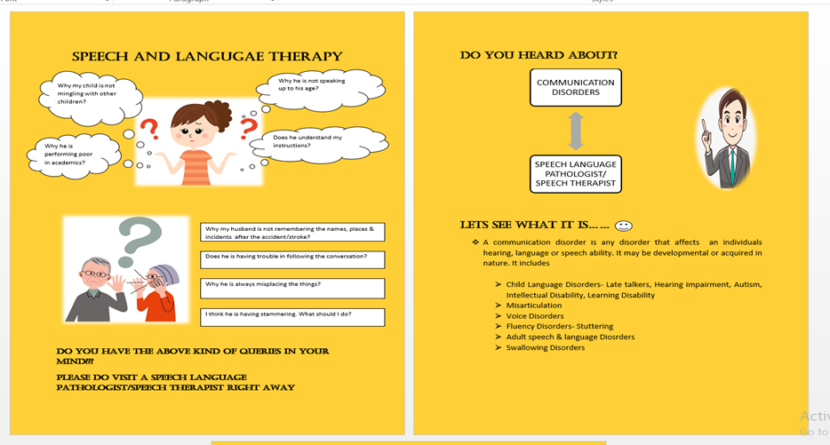

2) OSC Kodagu:
- World voice day was celebrated in Kodagu Institute of Medical Sciences- Teaching hospital on 16.04.2021. Activity reported is submitted.
- On the occasion of world voice day, a competition titled “Voice your opinion” was organised for staffs and students of Kodagu Institute of Medical Sciences and prize distribution for the same was carried out in the presence of dignitaries.
- “Guess the voice” game was organised for students and staffs of KoIMS
- A Talk on “Vocal hygiene and voice care tips for teachers” was carried out by Speech Language Pathologist for professors and students of KoIMS
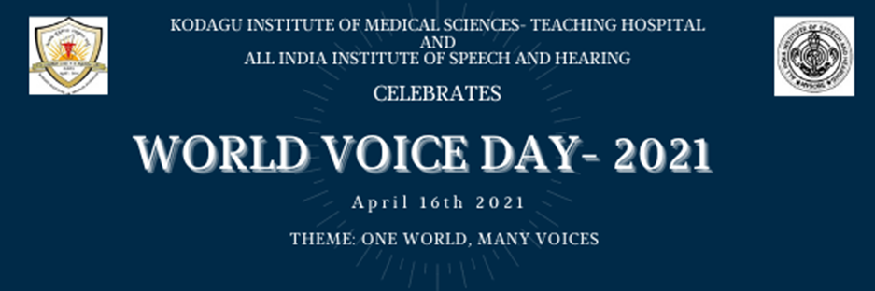

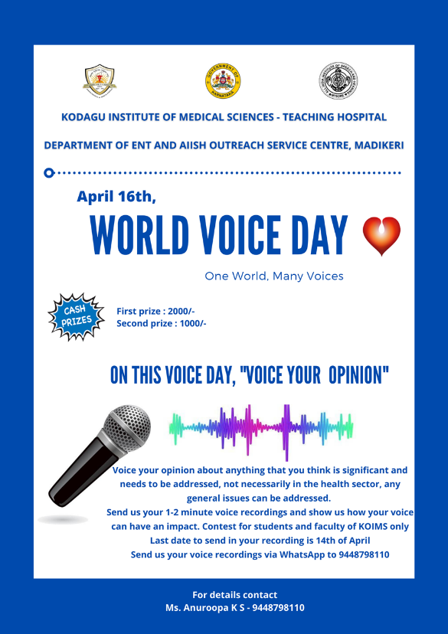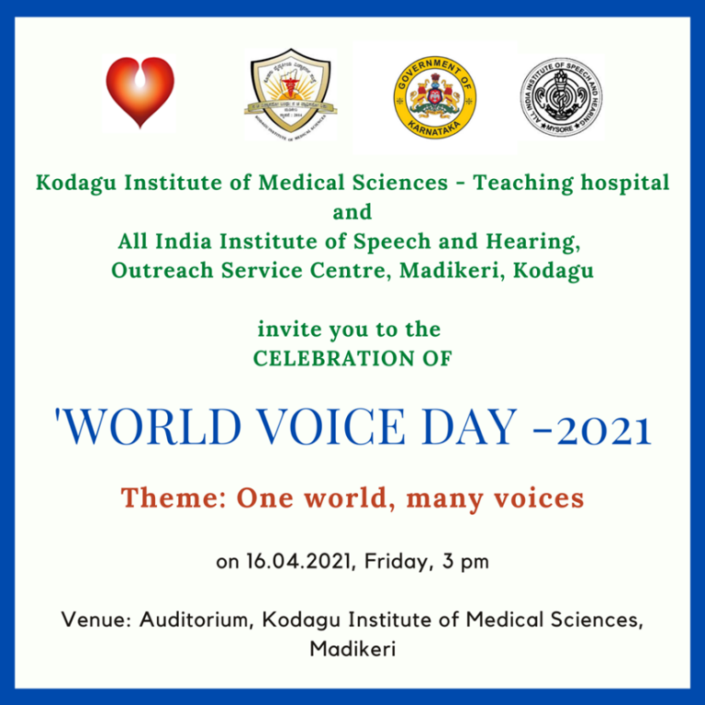
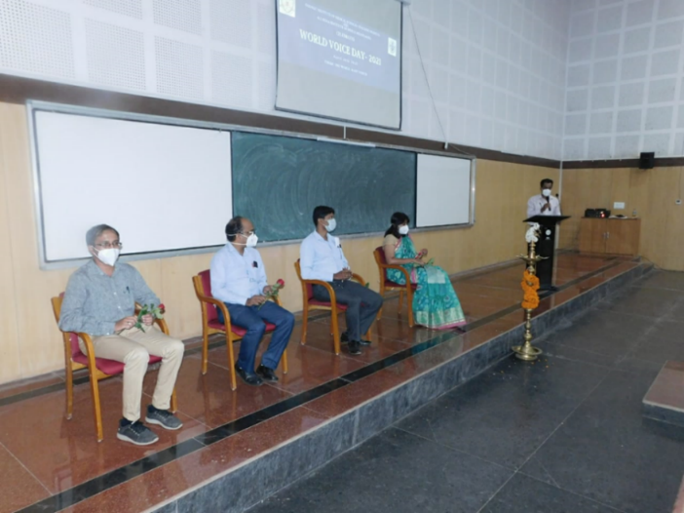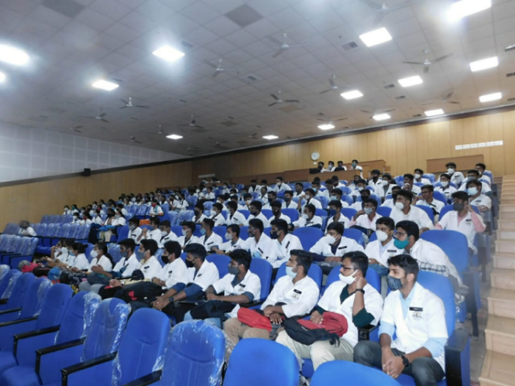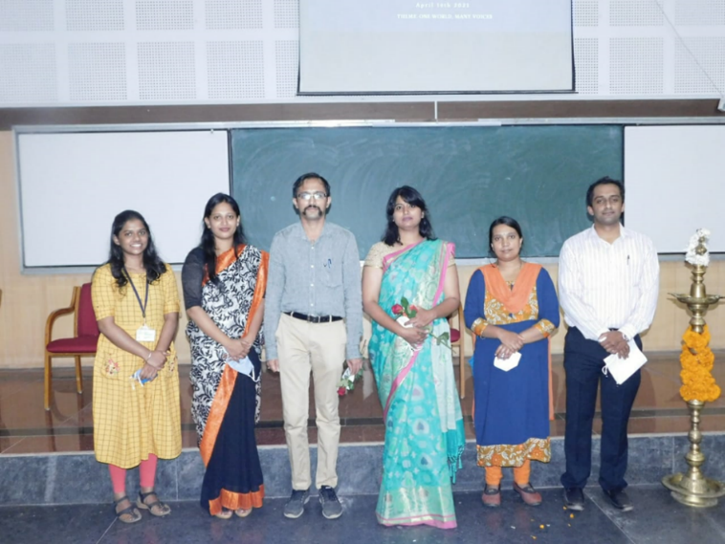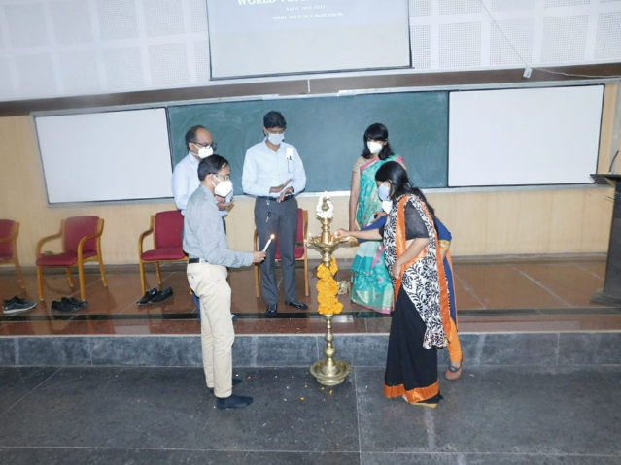

OSC Sarguru: Field visit pictures
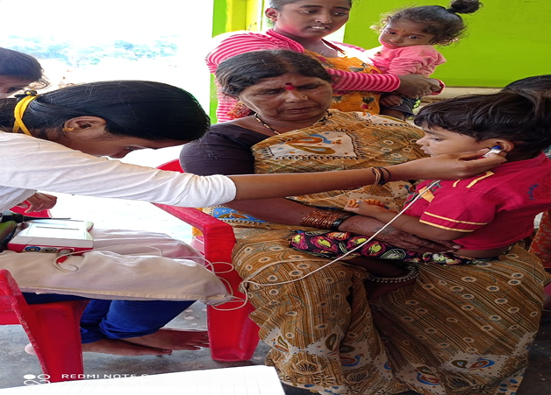

VII) OTHERS
1. Submitted Hindi Quarterly Report
2. Submitted Annual Report 2020-21
3. Submitted NAAC details
4. Material development works as part of work from home due to pandemic.
Sl No. | MATERIAL | LANGUAGE | STATUS
1 | FAQ’s on Aphasia | Kannada | Verified twice. To be Finalized
2 | FAQ’s on Aphasia | Malayalam | Verified twice. To be Finalized
3 | FAQ’s on Aphasia | Tamil | Verified twice. To be Finalized
4 | FAQ’s on Aphasia | Hindi | Verified twice. To be Finalized
5 | FAQ’s on LD | Kannada | Verified twice. To be Finalized
6 | FAQ’s on LD | Malayalam | Verified twice. To be Finalized
7 | FAQ’s on LD | Tamil | Verified twice. To be Finalized
8 | FAQ’s on LD | Hindi | Verified twice. To be Finalized
9 | FAQ’s on Voice disorder | Kannada | Verified twice. To be Finalized
10 | FAQ’s on Voice disorder | Malayalam | Verified twice. To be Finalized
11 | FAQ’s on Voice disorder | Tamil | Verified twice. To be Finalized
12 | FAQ’s on Voice disorder | Hindi | Verified twice. To be Finalized
13 | FAQ’s on Stuttering | Kannada | Verified twice. To be Finalized
14 | FAQ’s on Stuttering | Malayalam | Verified twice. To be Finalized
15 | FAQ’s on Stuttering | Tamil | Verified twice. To be Finalized
16 | FAQ’s on Stuttering | Hindi | Verified twice. To be Finalized
17 | FAQ’s on Speech Sound Disorder | Tamil | Verified twice. To be Finalized
18 | FAQ’s on Speech Sound Disorder | Hindi | Verified twice. To be Finalized
19 | Communication disorders in elderly | Marathi | To be Verified
20 | FAQ’s on NBS | Marathi | To be Verified
21 | FAQ’s on NBS | Gujarathi | To be Verified
22 | Communication disorders in elderly | Hindi | Verified once. To be Finalized
23 | Communication disorders in elderly | Tamil | Verified once. To be Finalized
24 | Prevention of developmental disorders | Tamil | Verified once. To be Finalized
25 | Beware of noise | Malayalam | Verified once. To be Finalized
26 | FAQs on NIHL | Malayalam | Verified once. To be Finalized
27 | OSHA noise levels | Malayalam | Verified once. To be Finalized
28 | Poster on JCIH | English | Finalized
29 | Counselling tips for parents | Malayalam | Verified once. To be Finalized
30 | Counselling tips for parents | Kannada | Half done
31 | Counselling tips for parents | Tamil | Verified once. To be Finalized
32 | FAQ’s on Ototoxicity | English | Verified once. To be Finalized
33 | ACSLS Modification | English | Finalized

VII) ACTIVITIES CARRIED OUT BY THE STAFF OF THE DEPARTMENT OF POCD.

Table 16: Details of activities carried out by POCD staff in April 2021.

S.No. | Name of the staff | Designation | Activities
 | Dr. N Sreedevi | HOD, Dept. of POCD | - Officiating as HOD-POCD  - Has been coordinating webinars/ orientation on communication disorders to teachers - 2 nos  - Conducted Dept. meeting on 19.4.2021  - Coordinated the OSC data analysis meeting on 21.4.2021  - Revised the POCD webinar PPT  - Conducted Dept. meeting on 23.4.2021  - Attended HODs meeting on 27.4.2021  - Conducted meeting on NBS variables and SPSS format with Dept. staff and statisticians on 28.4.2021, 29.4.2021 and 30.4.2021  - Coordinated the finalization of NBS data entry format on SPSS
 | Dr. Sandeep M. | Head, Dept. of POCD (i/c) | - Officiated as HOD POCD in-charge  - Coordinated department, OSC and NBS activities
 | Mr. Arunraj. K | Audiologist/SLP | - Coordinated OSC activities  - Coordinated equipment related works in the department  - Assisted in 100 OSC proposal preparation  - Assisted in DPE PPT preparation  - Attended SPPS meeting  - Verified SPSS variables  - Conducted all NBS & OSC meeting  - Attended departmental meetings
 | Ms. Ranjini A | Audiologist Gr. I | - Called phone follow-up infants enquiring about their developmental milestones (10 calls).  - Did detailed Audiological Evaluation for Referred Newborn cases.  - Compilation of referred cases and follow-up cases of all hospitals of April month.  - Prepared monthly NBS report for April month.  - Cleansed and merged NBS Mysuru data from January 2020 to March 2021.  - Crosschecked SPSS NBS data of all Mysore hospitals from January 2020 to March 2021.  - Attended meeting with Director regarding NBS and OSC centres data as on 29/04/2021.  - Mailed all the NBS Mysuru hospitals regarding the stop of Newborn Screening for 2 weeks as a result of lockdown and the same was informed to all the hospitals over the phone call.  - Collected details regarding the newly delivered mothers (name and phone number) at all NBS Mysuru hospitals (effective from 24th April 2021).  - Finalised and corrected the SPSS variables for the upcoming financial year.
 | Ms. Srividya S | Audiologist Gr. I | - Did detailed Audiological Evaluation for Referred Newborn cases.  - Attended staff enrichment programme about Dementia on 22/04/2021.  - Attended meeting with statistician regard school screening report on 26/04/2021.  - Entered and Analysed data of different school screening camps conducted in month of February and March.  - Verified Kannada translation of ‘Counselling tips for parents’.  - Entered data of Kargal and Jog camp in SPSS.  - Designed poster for webinar on ‘communication disorders in school going children’ held on 21/04/2021.  - Organised webinar and oriented school teachers of T.Narsipura region about communication disorders in school going children on 21/4/2021.  - Co-ordinated webinar for TGT’s and staff nurse of JNVabout communication disorders in school going children on 23/4/2021.  - Verified assignments of Students.  - Prepared Script for DCS orientation.  - Assigned different material development works to students.  - Assigned different material development works to staff’s in OSC and NBS centres
 | Ms. Dibya Aryal | Speech Language Pathologist Gr. I | - Compiled and verified outside NBS centres’ monthly report and SPSS data  - Editing of New SPSS format done  - Finalised New SPSS format for NBS with statisticians’ and HOD’s approval  - Verified SPSS data of the year 2020 for NBS Centres  - Edited HRR sheet in word document and got it designed from DMD  - Conducted meeting with all the NBS centre staffs regarding the issues faced due to pandemic.  - Oriented staff nurses and TGT in science for JNV school on 23rd april
 | Ms. Tanuja M.N | Audiologist Gr. II | - NBS Follow up: Updated the findings of the backlog referral cases from june 15th to March which were referred to the nearby Out Reach Centres of AIISH (Sarguru, Kodagu, K.R Pete, Gumballi, and Sarguru) for detailed audiological Evaluation.  - Allotted Follow up assessment for the high risk babies of the month February and March.  - Completed phone follow up for the month of December (3 month) ,January(3 month),March(1 year), October (6 month).  - Attended Webinar on Identification and Intervention of Childhood Communication Disorder on 26th April 2021.  - Regularly carried out new born hearing screening and detailed Audiological Evaluation for NBS follow up.  - Attended Bedside Screening in K R Hospital.  - Co- Ordinated with Mr.Aziz for organizing webinar on Communication Disorders for Staff nurses and TGT Science Navodaya) of of NLI (Puri, Udaipur, Amritsar ) region on 22.4.21  - Co- Ordinated with Mr.Aziz and Dr. K Sajeevan for organizing webinar on Communication Disorders for Staff nurses and TGT Science Navodaya of of NLI (Goa , Kamrup and Shillong) region on 23.4.21  - Prepared requisition letter to BEO, T. Narsipura to conduct webinar program for Teachers of T. Narsipura region on 21.4.21.  - Prepared poster of webinar program for Teachers of T. Narsipura region.  - Oriented about Phone Follow up work to new staff Ms.Deepa.  - Prepared FAQ questions for ENT related problems in order to make video purpose.  - Prepared letter for Director requesting smart phone for the follow up work.  - Modified Audio part in the Orientation slides on communication disorders in both kannada and English language.  - Material development work of Autism comic script kannada under process.  - Attended clinical postings in the JC Bock on 17.4.21  - Prepared content for Video on DCS Orientation.  - Initiated layout for Video on Developmental milestones.  - Coordinated webinar program for Primary Teachers of T Narsipura region on 21.4.21
 | Ms. Merina Thomas | Audiologist Gr. I | - Verified SPSS and compiled monthly report work of all 12 OSC  - Issued 30 hearing aids,2 starkey cables,1 universal cable ,2 danavox shoe and HiPro to Kodagu OSC on 23/4/2021 and 10 hearing aids to Nanjangud.  - Newborn Hearing Screening on 10/4/21 and 17/4/21.  - Carried out NBS phone follow up  - Prepared MoU and MoM format for upcoming 6 OSC (Indore,Noida,Rishikesh,Jodhpur,Chandigarh,Andaman &Nicobar)  - Repaired hearing aids were collected and were distributed to Gumballi,, Akkihebalu and Nanjangud centres.  - Purchased ear tips and battery from electronics for OSC.  - I.D cards were distributed to 12 OSC.  - Sent materials required for K.R.Pete and Sarguru centres  - Attended meeting regarding NBS SPSS variables on 28/4/2021.  - Attended POCD meeting on 29/4/2021 with director  - Submitted data for peer evaluation.  - Compiled SPSS data from initiation of all the 8 OSC.  - Attended Online meeting with Vasanthalekshmi Maám regarding OSC SPSS (Jan to March data)  - Finalized OSC SPSS variables along with Spoorthy maám  - Carried out phone followup with all 12 OSC regarding working of the centres during the pandemic  - Organised and attended NBS-OSC meeting on 26/4/2021.
 | Ms. Christy Sebastian | Audiologist Gr. I | - Did SPSS entry of the data from KPCL.  - Oriented TGTs and Nurses during the webinar conducted on 23rd April 2019.  - Sent the hard copy of the audiological reports of KSIC employees.  - Had discussion with Dr. Vasanthlakshmi through zoom regarding the industrial data.  - Carried out data compilation of Industrial data from October 2019 to March 2021  - Contacted Mr. Krishnamurthy for organizing webinar for employees of Bannari sugar factory.  - Contacted Ms. Bharathi for organizing webinar for employees of KSIC.  - Contacted Dr. Kavitha for organizing webinar for employees of Visvesvaraya Iron and Steel Limited, Bhadravathi.  - Material development- Following materials has been corrected and verified:  - Translation of “Beware of noise” to Malayalam.  - Translation of FAQs of NIHL to Malayalam.  - Translation of NIHL Brochure to Malayalam.  - Translation of FAQs about learning disability to Malayalam.  - Translation of FAQs about Aphasia to Malayalam  - FAQs about ototoxicity in English  - Translation of “Tips for better communication” in Malayalam.  - Collected the data for making of the industrial report.  - Allotted material development works to all NBS, OSC centers.  - Allotted works for staffs working from home.  - Carried out phone follow-up of infants, enquiring about their developmental milestones for the month of April.  - Carried out Audiological Evaluation for Referred New-born cases.
 | Ms. Pauline Gracia R V | SLP Gr. II | - SPSS verification of all 12 OSC centres.  - Attended NBS  - NBS phone follow up  - Hearing evaluation (NBS)  - Speech materials to OSC centres  - Material developed for DD-Pothigai show.  - Translated 3 (Voice disorders, Learning Disability, Stuttering) Tamil pamphlets.  - Verified 3 Tamil pamphlets ( Aphasia, Speech Sound Disorder, counselling guidelines for speech and language disorders)  - Compiled and calculated number of cases in each OSC centres from the initiation of the centres.  - Attended NBS SPSS format finalising meeting on 28/04/2021  - Attended POCD meeting with Dr. Pushpavathi on 29/04/2021.  - Sent required essentials to Sarguru.  - Sent ID cards to 12 OSC centres.  - Made name list and estimation of speech instruments to be bought for OSC centres.  - Attended OSC & NBS meeting with all centres on 26/04/2021
 | Ms. Kranti Acharya | SLP Gr. I | - Attended student’s article presentation on 22.04.21.  - Orientation to students regarding the activities of POCD and instructions to be followed in department posting.  - Checked and verified the overall log sheets of students.  - Corrected PowerPoint slides of article presentation of MSc students.  - Compilation of student’s attendance posted in POCD dept.  - Called phone follow-up infants enquiring about their developmental milestones.  - Conducted webinar for TDT’S and Nurses of JNV school team on 23.04.2021  - Entered data on SPSS for Kargal jog camp.  - Prepared student report from October 2019 to March 2021.  - Prepared write up for Infant cry analysis database.  - Collected and analysed Infant cry samples.  - Assigned voice over to students.  - Assigned work and followed up with staffs working from home of various OSC and NBS centres.  - Carried out bedside screening program  - Carried out New-born Hearing Screening.
 | Ms. Ankitha.S | SLP Gr. II | - Done monthly report of individual and orientation  - Arranged of pamphlets  - NBS follow up have been done in the month of March  - Helped in making student roster for NBS follow up  - Bedside test was done for 2 days in KR Hospital.  - Helped in packing ID cards to all the OSC centres.  - Student attendance register maintained  - Prepared webinars requesting letter to T.Narasipura BEO  - Prepared slides and poster of webinar for T.Narasipura thaluk School teacher’s and JNV’s Staff nurses and TGT science  - Corrected Voice disorders FAQ document  - Prepared DCS script and speech and hearing milestone content translation  - Conducted Webinar on 21.04.2021 for T.Narasipura thaluk School teacher’s and on 23.04.2021 JNV’s Staff nurses and TGT science  - Corrected communication disorders webinar PPT in both Kannada and English  - Compiled Response sheet of JNV’s Staff nurses and TGT science and mailed webinar ppt and school screening checklist.  - School screening data merged  - Attended students article presentation
 | Ms. Reshma O | SLP Gr. I | - Carried out NBS  - Carried out Bedside screening programme  - Carried out phone follow up  - Verification of Malayalam Voice pamphlet  - Verification of Malayalam Aphasia pamphlet  - Verification of Malayalam Learning Disability pamphlet  - Verification of Malayalam Stuttering pamphlet  - Prepared poster on 1 2 3 principle  - Translated FAQs on NIHL to Malayalam  - Translated NIHL brochure to Malayalam  - Translated Beware of noise to Malayalam  - IPA translation was done for ch and /d/ sounds  - Prepared script for developmental milestones  - Screened data for peer evaluation
 | Mr. Kalaiyarasan R | Aud Gr. I | - Calibration of equipment’s  - NBS Screening  - NBS Follow up  - Worked on POCD Annual Report and compiled Industrial screening camp data in the report  - Updating POCD equipment list  - Technical specifications of newly indented equipment’s for 23 new OSC’s has been sent to purchase section  - Stock verification of Imphal (withdrawing NBS centre) has been done  - Covering letter, equipment service report copies and DSR of POCD were sent for NAAC  - Stock verification work has been started for the year 2020-21; an official mail sent regarding this to OSC and NBS centres of AIISH  - Coordinated with Patna NBS centre Audiologist to rectify the impedance issue with Beraphone equipment  - Comparative statement has been made for Diagnostic ABR equipment  - Coordinated with Sagara OSC centre Audiologist to rectify the otoscope lens issue  - Industrial screening camp data were started to analyse for publication  - Stock verification done for Belgavi OSC centre  - Collected contact details from Cheluvamba Hospital for Telescreening.
 | Mr. Ashwath K | SHT | - Merging and cleansing of Mysuru Data of all hospital  - Updated Screening and phone follow up data in SPSS  - Corrected and merged Lucknow Data  - HRR sheet edited and finalised  - Tele-screening of Kamakshi hospital
 | Ms. Deepika. R | Office assistant Grade II | - Submitted contract staff attendance, TA bills, interns attendance  - Prepared hindi quarterly report  - Assisted in preparing DPE PPT  - Prepared Annual report 2020-21  - Attended OLIC meeting  - Submitted NAAC details  - Prepared letters for orientations and webinars  - Settled suppliers advance and Imprest cash  - Assisted in Coordinating OSC and NBS requests and activities  - Filed the official documents on a daily basis  - Prepared Monthly report March 2021  - Submitted intern’s attendance  - Prepared departmental meeting minutes  - Submitted C1 and C2 marks  - Correspondence to all the mails received in the dept.  - Routine work of indent, work orders, local purchase indents, registers maintaining etc.
 | Ms. Deepa Kabbur | Data entry operator | - Data entry  - Annual Report  - Phone Follow up  - Monthly report  - Taking screen shots of chandana Tv program
 | Ms. Megha.K | Data entry operator | - Data entry  - Annual Report with Deepa

Sd/-
Dr. N. Sreedevi
विभागाध्यक्ष पी ओ सी डी -Head, Department of POCD

