**संप्रेषणविकृतिरोकथामविभाग**

**DEPARTMENT OF PREVENTION OF COMMUNICATION DISORDERS**

**महीनेकेविवरण/ MONTHLY REPORT** –**MARCH2021**

1. **ACADEMIC ACTIVITIES**

**A. No. of webinars & Orientations:**

As a part of primary prevention activities, orientation/sensitization programs are being conducted regularly. The objective of the orientation programs was to create awareness among the general public and various other professionals such as Medical doctors, Nurses, Health-related workers, teachers, school students, etc., on different types of communication disorders, its prevention and early identification methods, and their appropriate referral and timely management. Due to the COVID-19 pandemic condition in the country, some of the orientation programs are carried out through Tele-mode/Webinars. Table 1&2 shows the details of the webinar’s programs conducted by staff and students of the department of POCD, NBS, and OSC centers.

Table 1: The details of webinar Programs in March, 2021.

|  |  |  |  |  |  |
| --- | --- | --- | --- | --- | --- |
| **I. No. of Orientation/Webinar Programs at POCD :** | | | | | |
| Theme/Topic of the program: Prevention & early identification of communication disorders  Coordinators: Dr. M. Sandeep & Mr. Arunraj K. | | | | | |
| **S.No** | **Date** | **Name of the institute/**  **Hospital** | **Target group** | **Total participants** | **Oriented by** |
|  | 03.03.2021 | JSW Energy Limited;  Toranagallu  Ballari District | Factory workers | 26 | Ms. Christy |
|  | 24.03.2021  And  25.03.2021 | Jog and kargal, Sagara | KPCL employees | 191 | Ms. Ankitha.S  Ms. Srividya. S |
|  | 31.03.2021 | North part of Mysore schools | Teachers | 83 | Ms. Ankitha .S  Ms. Srividya .S |
| Total | | | | 300 |  |
| **II. No. of Orientation/Webinar Programs at Outreach Service Centers:** | | | | | |
|  | 03.03.2021 | Taluk General Hospital KR Pete, Mandya | ASHA HEALTH WORKERS | 24 | Ms. Jasper Priences |
|  | 03.03.2021 | BIMS (NPPCD) | ASHA workers & ANM nursing students | 200 | Aparna Ravi & Sarah Elsa Abraham |
|  | 03.03.2021 | Sub-divisional Hospital, Sagara | Doctors, Medical staffs, ASHA Workers, Nurses, Patients and the general public | 75 | Dr.Suma, ENT Surgeon,  Mr.Ajithkumar. M, Audiologist,  Ms.Roja Rani. M, SLP. |
|  | 10.03.2021 | GIMS Hospital | VRW | 2 | Ms. Aneena  Ms.Shital |
|  | 17.03.2021 | GIMS Hospital | ASHA WORKER | 1 | Ms. Aneena  Ms.Shital |
|  | 19.03.2021 | AIIMS-BBSR | Dept. of Neonatology  Dept. of pediatrics | 16 | Sarga K and SwalihaShahama K A |
|  | 22.03.2021 | IGIMS, Patna | Doctors | 8 | MsRishishaLyngkhoi |
|  | 24.03.2021 | GIMS Hospital | Nursing students | 7 | Ms. Aneena  Ms.Shital |
|  | 25.3.21 | Primary Health Centre, Hadinaru | ASHA workers, doctor ,nurses | 26 | Parnika K M |
|  | 25-03-2021 and 27.03.2021 | VMH | Public health training students | 2 | R.Deepa  Layamol,  Mohanapriya |
|  | 26.03.2021 | DAV Public School, IGIMS Campus, Patna | Teachers | 16 | MsRishishaLyngkhoi |
|  | 27.03.2021 | Delhi Public School, Patna | Teachers | 87 | MsRishishaLyngkhoi |
| Total | | | | 464 |  |
| **III. No. of Orientation/Webinar Programs at NBS centers:** | | | | | |
|  | 07.03.2021 | Netarhat School | School students | 400 | Mr. Yashwanth kumar |
|  | 03.03.2021 | IGMC | Medical students and doctors | 40 | S.Gowthamvarma |
|  | 03.03.2021 | Dr. RML Hospital | DHLS students, Patients | 20 | Ms. Kristi Kaveri Dutta |
|  | 03.03.2021 | SDUMC | Teachers & P U Students | 30 | Rohith V S |
|  | 10.03.2021 | JLNMCH Bhagalpur | DHLS students | 14 | Sachin B |
|  | 03.03.2021 | AIIMS, Patna | General public and medical students | 74 | Mr. Mohammed Basih Thaha T |
| Total (NBS) | | | | 578 | |
| **Total (POCD+OSC+NBS)** | | | | **1342** | |

Table 3: Total number of participants oriented including Webinars and orientations (Group wise)

|  |  |  |
| --- | --- | --- |
| **S. No** | **Target group** | **Total no. of Participants** |
| **I** | **Grass Root Level Workers** | |
|  | ASHA Workers | 160 |
|  | Health Facilitator and Supervisors/Program Manager | 5 |
| **II** | **Professionals** | |
|  | School Teachers | 83 |
|  | Audiologists/Speech language Pathologists | 2 |
|  | Hospital stafff | 15+2 |
|  | Medical Doctors | 16+43 |
|  | Nurses | 5 |
|  | Factory Workers | 214 |
|  | School Teachers | 103+14 |
| **III** | **Students** | |
|  | BASLP/MASLP Students |  |
|  | DHLS Students | 17 |
|  | Diploma Students | 10 |
|  | Medical Students | 11 |
|  | Nursing Students/Paramedical Students | 109 |
|  | School students | 416 |
| **IV** | **Public** | |
|  | General Public | 40+10 |
|  | Mothers/Parents of children with communication disorders |  |
|  | Post-Partum Mothers |  |
|  | Expectant mothers |  |
|  | Elderly Individuals |  |
| **Total** | | **1342** |

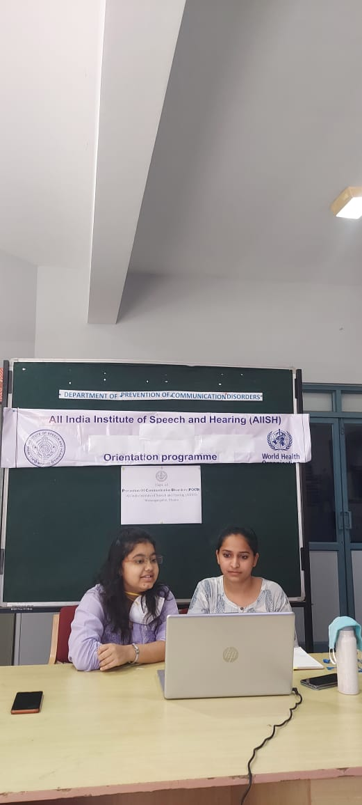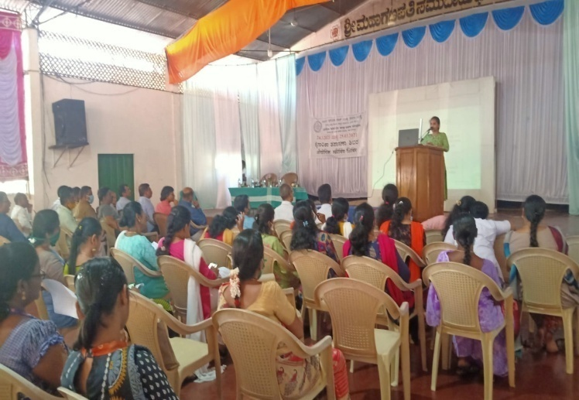

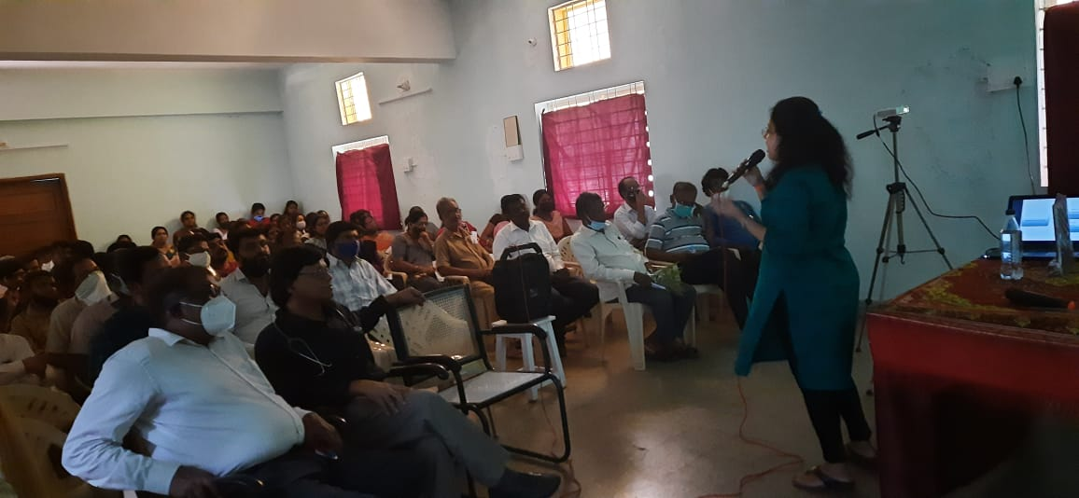

Glimpses of orientation programme conducted by POCD staff

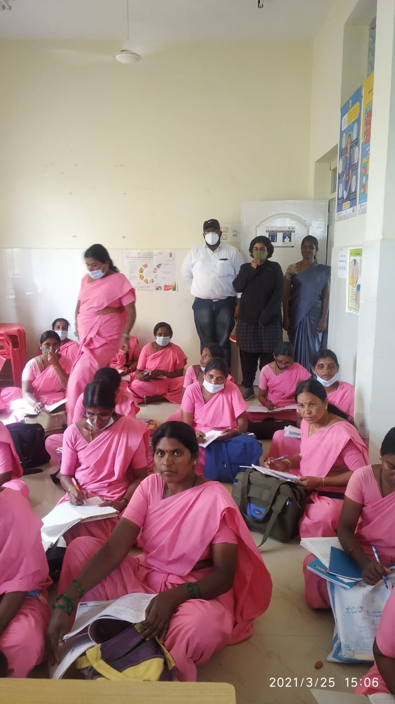

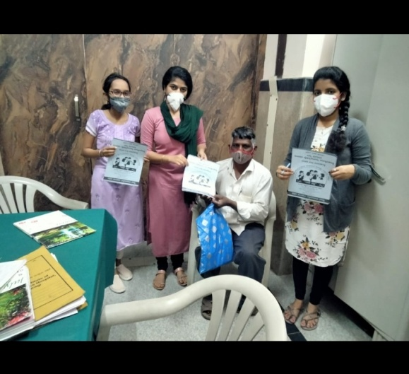

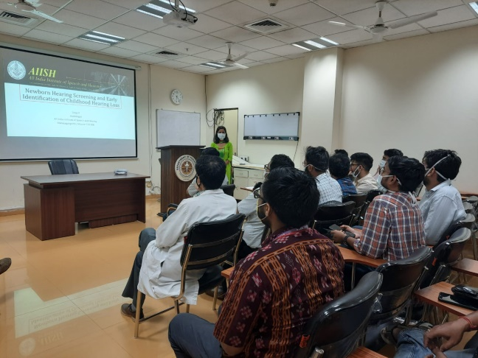

Glimpses of orientation programme conducted in various outreach service centers

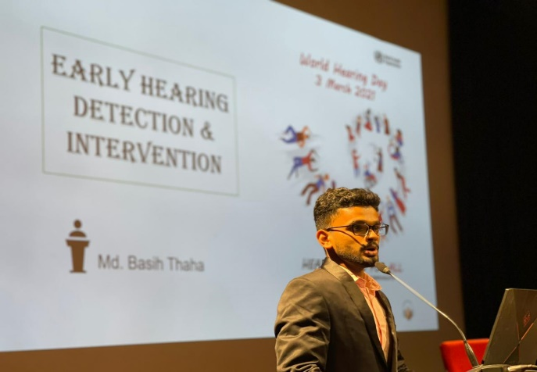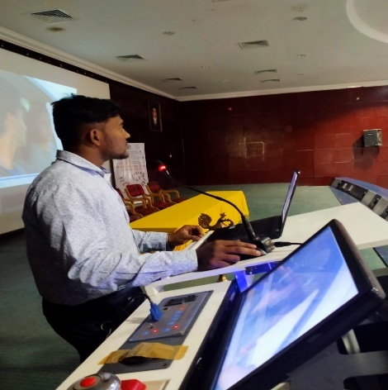

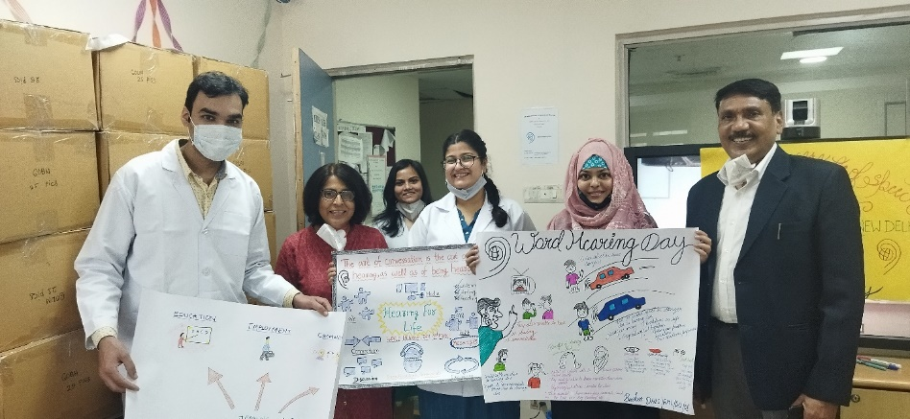

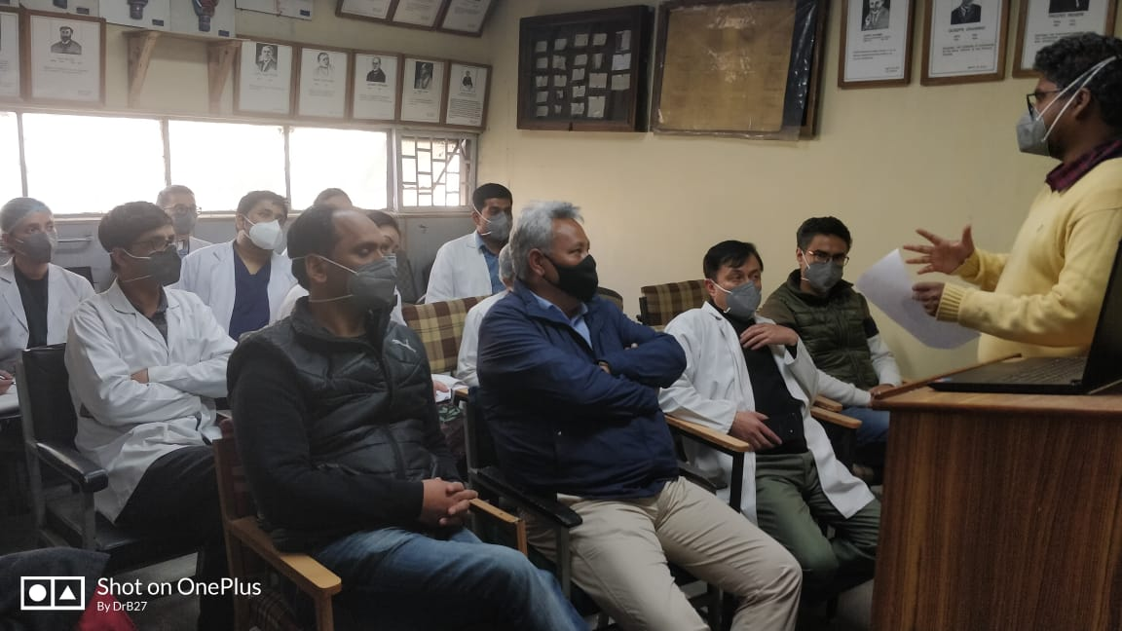

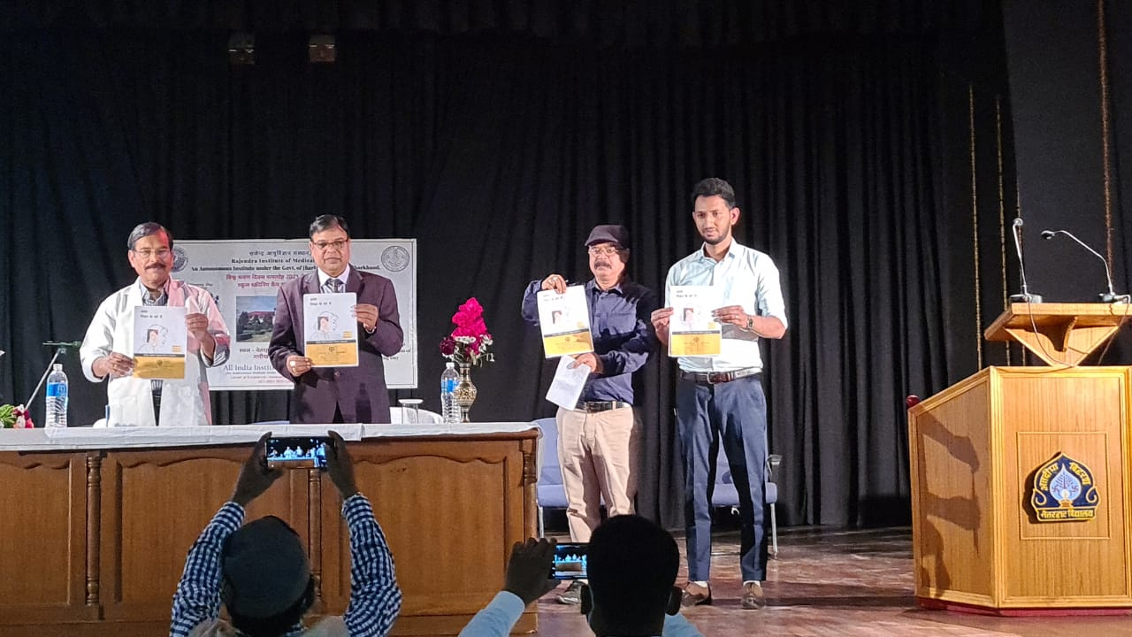

Glimpses of orientation programme conducted in various NBS centers

Table 3: Details of **Seminar**/ Conferences /Lectures /Workshop organized by OSC center.

|  |  |
| --- | --- |
| **Date& venue** | 25.03.21 |
| **Topic** | Clinical discussion of Pediatric fluctuating Sensorineural hearing loss |
| **Name of the resource person** | Sarga K |
| **Name of the co-ordinator/s** | DrPradipta Kumar Parida, Dr. PreetamChappity |
| **Name of the organizers** | Dept of ENT |
| **Target group** | Medical students |
| **Number of beneficiaries** | 18 |
| **Objectives** | Case discussion |

|  |  |
| --- | --- |
| **Date& venue** | 25.03.21 |
| **Topic** | Clinical discussion of Velopharyngeal dysfunction |
| **Name of the resource person** | SwalihaShahama K A |
| **Name of the co-ordinator/s** | DrPradipta Kumar Parida, Dr. PreetamChappity |
| **Name of the organizers** | Dept of ENT |
| **Target group** | Medical students |
| **Number of beneficiaries** | 18 |
| **Objectives** | Case discussion |

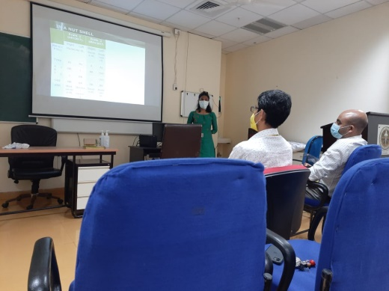

1. **RESEARCH ACTIVITIES:**

At Outreach Service Centers

1) Voice profile of patients taking antituberculosis treatment.- Baseline data collection obtained.

2) Prevalence of the communication disorders among OPD patients reporting to the department of E.N.T. at GIMS, Kalaburagi.- Corrected research proposal submitted to the GIMS ethical committee.

3) Prevalence of hearing impairment in newborn babies with high risk factors at GIMS hospital, Kalaburagi.-Corrected research proposal submitted to the GIMS ethical committee

**III) EXTENSION ACTIVITIES**

The department of POCD is actively involved in carrying out various extension activities such as screening, diagnostic and rehabilitation services outside the institute campus. The activities include newborn/infant screening, screening of school children, screening of elderly citizens, screening of industrial workers, conducting camps and also clinical services offered at the outreach service centers of AIISH.

A. **New-born screening programs for Communication Disorders**

Table 6: Details of newborn screened in OSC and NBS centers in March 2021.

|  |  |  |  |  |  |  |  |  |  |  |  |
| --- | --- | --- | --- | --- | --- | --- | --- | --- | --- | --- | --- |
| S. No | Hospitals/Immunization Centers | Total births | Total screened | | | Total No. at risk | | | Phone Follow up | | |
|  |  |  | Male | Female | Total | Male | Female | Total | Male | Female | Total |
| I. Mysuru Hospitals | | | | | | | | | | | |
|  | KR Hospital (KRH) - Cheluvamba | 878 | 362 | 341 | 703 | 8 | 6 | 14 | 23 | 30 | 53 |
|  | Kamakshi Hospital (KH) | 106 | 40 | 40 | 80 | 0 | 0 | 0 | 7 | 5 | 12 |
|  | Mission Hospital (MH) |  | 10 | 2 | 12 | 2 | 1 | 3 | 0 | 3 | 3 |
|  | Chamundeshwari nursing home | 22 | 6 | 6 | 12 | 0 | 0 | 0 | 3 | 2 | 5 |
|  | Ashwini Nursing Home (ANH) | 13 | 5 | 3 | 8 | 0 | 0 | 0 | 0 | 1 | 1 |
|  | Shree Devi Nursing Home (SNH) | 40 | 10 | 15 | 25 | 0 | 0 | 0 | 5 | 6 | 11 |
|  | Mahadeshwara Nursing Home (MNH) | 37 | 3 | 4 | 7 | 0 | 0 | 0 | 2 | 3 | 5 |
|  | Sigma Hospital (SH) | 42 | 12 | 22 | 34 | 0 | 0 | 0 | 4 | 2 | 6 |
|  | Jayanagar Maternity Hospital | 100 | 37 | 36 | 73 | 0 | 0 | 0 | 11 | 6 | 17 |
|  | NPC Maternity hospital | 55 | 13 | 11 | 24 | 2 | 0 | 2 | 0 | 0 | 0 |
|  | Makkalakoota Immunization Centre | - | 4 | 0 | 4 | 0 | 0 | 0 | 0 | 0 | 0 |
|  | Kyathmanalli Immunization Centre | - | 9 | 11 | 20 | 0 | 0 | 0 | 1 | 0 | 1 |
| Total | | **1293** | **511** | **491** | **1002** | **12** | **07** | **19** | **56** | **58** | **114** |
| II. OSC Centers | | | | | | | | | | | |
|  | Sub-divisional hospital, K R Nagar Taluk | 212 | 64 | 48 | 112 | - | - | - | 4 | 3 | 7 |
|  | Sub-divisional Hospital, SagaraTaluk | 276 | 98 | 102 | 200 | 2 | - | 2 | 5 | 4 | 9 |
|  | St,Mary’s Hospital, HD kote | 165 | 66 | 42 | 108 | 14 | 9 | 23 | 14 | 11 | 25 |
|  | Vivekananda Memorial hospital, H. D. Kote Sarguru | 27 | 14 | 13 | 27 | 6 | 1 | 7 | 2 | 4 | 6 |
|  | Taluk Hospital, H. D. Kote- Immunization | 119 | 26 | 37 | 63 | 6 | 1 | 7 | 7 | 5 | 12 |
|  | Gulbarga Institute of Medica Sciences , Kalaburagi | 616 | 100 | 103 | 203 | 29 | 16 | 45 | 22 | 27 | 49 |
|  | Taluk General Hospital, KR. Pete | 95 | 43 | 41 | 84 | - | - | - | 2 | 4 | 6 |
|  | Community Health Centre (CHC), Santhemarahalli | 36 | 24 | 6 | 30 | 0 | 1 | 1 | 1 | 0 | 1 |
|  | Taluk Hospital, Yelandur | 16 | 11 | 0 | 11 | 2 | 0 | 2 | 1 | 0 | 1 |
|  | Primary Health centre (Under karuna trust), Gumballi | 10 | 3 | 7 | 10 | 0 | 1 | 1 | 1 | 1 | 2 |
|  | Taluk Hospital, Nanjangud | 74 | 57 | 34 | 91 | - | - | - | 11 | 9 | 20 |
|  | Community Health Centre (CHC), Hullahalli | 10 | 1 | 1 | 2 | - | - | - | - | - | - |
|  | Belagavi Institute of Medical Science, Belagavi | 391 | 169 | 167 | 336 | 7 | 20 | 27 | 32 | 33 | 65 |
|  | Kodagu Institute of Medical Science ,Kodagu | 255 | 115 | 88 | 203 | 7 | 2 | 9 | 15 | 5 | 20 |
|  | AIIMS,Bhuvaneshwar | 86 | 3 | 10 | 13 | 3 | 4 | 7 | - | - | - |
|  | KIMS,Hubli |  | 48 | 46 | 94 | 28 | 21 | 49 | 7 | 9 | 16 |
|  | IGIMS,Patna | 7 | 5 | 2 | 7 | 5 | 2 | 7 | - | - | - |
|  | BRIMS,Bidar | 72 | 30 | 23 | 53 | 22 | 16 | 38 | - | - | - |
| Total | | **2467** | **877** | **770** | **1647** | **131** | **94** | **225** | **124** | **115** | **239** |
| NBS Centers | | | | | | | | | | | |
|  | All India Institute of Physical Medicine and Rehabilitation (AIIPMR), Mumbai | 45 | 21 | 22 | 43 | 3 | 6 | 9 | 0 | 0 | 0 |
|  | Janana Hospital & JLNMCH, Ajmer | 897 | 160 | 181 | 341 | 3 | 2 | 5 | 0 | 0 | 0 |
|  | Jawaharlal Nehru Medical College & Hospital, Bhagalpur, Bihar | 229 | 91 | 83 | 174 | 12 | 8 | 20 | 3 | 5 | 8 |
|  | JIPMER, Puducherry | 683 | 282 | 254 | 536 | 16 | 14 | 30 | 19 | 22 | 41 |
|  | King George’s Medical  University (KGMU) Lucknow | 337 | 129 | 121 | 250 | 18 | 11 | 29 | 24 | 23 | 47 |
|  | NetajiSubhash Chandra Bose Medical College (NSCB), Jabalpur | 553 | 310 | 256 | 566 | 52 | 28 | 80 | 65 | 37 | 102 |
|  | Post Graduate Institute of Medical Education and Research (PGIMER), New Delhi | **110** | 43 | 51 | **94** | 4 | 5 | **9** | **5** | **3** | **8** |
|  | Rajendra Institute of Medical Sciences, Baritayu, Ranchi | **251** | 111 | 95 | **206** | 4 | 5 | **9** | 2 | 1 | **3** |
|  | Regional Institute of Medical Sciences (RIMS), Imphal | **-** | 27 | 26 | **53** | 2 | 3 | **5** | **-** | **-** | **-** |
|  | Sri DevarajUrs Academy Of Higher Education and Research (SDUAHER), Kolar | **190** | 93 | 91 | 184 | 0 | 0 | **0** | **17** | **23** | **40** |
|  | Sri Ramachandra Bhanj Medical College and Hospital (SCB MCH), Cuttack | **263** | 47 | 34 | **81** | 03 | 02 | **05** | **-** | **-** | **-** |
|  | All India Institute of Medical Science (AIIMS), Patna | **38** | 22 | 14 | **36** | 1 | 0 | **1** | **5** | **5** | **10** |
|  | Indira Gandhi Medical Hospital, Shimla | **115** | 29 | 30 | **59** | 9 | 1 | **10** | **9** | **5** | **14** |
| Total (NBS centers) | | **3711** | **1365** | **1258** | **2623** | **127** | **85** | **212** | **149** | **124** | **273** |
| Total (POCD+OSC+NBS) | | **7471** | **2753** | **2519** | **5272** | **270** | **186** | **456** | **329** | **297** | **626** |

**Tele- follow-up evaluation**

The at-risk babies were monitored regularly through Phone calls by administrating Speech-language & hearing developmental checklist. The babies identified with delay in any of the developmental milestones, were referred to AIISH/concerned center for detailed diagnostic evaluation.

Details of Tele-phone follow- up carried out at Hospitals in Mysuru.

|  |  |  |  |  |
| --- | --- | --- | --- | --- |
| **S. No.** | **Mysuru Hospitals** | **Number of infants with normal developmental milestones.** | **Total infants at risk** | **Total call attended/ Total no of calls** |
|  | Ashwini Nursing Home | 02 | - | 02/02 |
|  | Brindavan Hospital | 05 | - | 5/8 |
|  | Cheluvamba Hospital (KRH) | 27 | 1 | 28/62 |
|  | GopalaGowdaShanthaveri Memorial Hospital | 1 | - | 1/1 |
|  | Kamakshi Hospital | 02 | - | 2/04 |
|  | Mahadeshwara Nursing Home | - | - | - |
|  | Mission Hospital | - | - | 0/2 |
|  | S.M.T.D.H Hospital | - | - | - |
|  | Shree Devi Nursing Home | 1 | - | 1/01 |
|  | Shree Lakshmi DevammaShankarshetty Maternity Hospital | - | - | - |
|  | Sigma Hospital | 1 | - | 1/1 |
|  | Combined Hospital | - | - | 0/1 |
|  | **Total** | **39** | **01** | **40/82** |

Table 7: Details of Tele-phone follow- up carried out at OSCs in February 2021

|  |  |  |  |
| --- | --- | --- | --- |
| **OSC centers** | **Number of infants with normal developmental milestones.** | **Total infants at risk** | **Total call attended/ Total no of calls** |
| Sub-divisional hospital, K R Nagar Taluk | 2 | - | 2/3 |
| Subdivision hospital , Sagara | 4 | - | 4/10 |
| St. Mary’s Hospital , HD Kote | 5 | 0 | 5/7 |
| Vivekananda Memorial Hospital, Sarguru | 3 | 0 | 3/4 |
| Taluk Hospital, H. D. Kote- | 2 | 0 | 2/4 |
| GIMS, Kalaburgi | 49 | 5 | 54/84 |
| Taluk General Hospital, KR. Pete | 2 | - | 2/2 |
| Primary Health Centre (PHC), Akkihebbalu | - | - | - |
| Community Health Centre (CHC), Santhemarahalli | 2 | 0 | 2/2 |
| Taluk Hospital, Yelanduru | 1 | 0 | 1/1 |
| Primary Health centre, Gumballi | 3 | 0 | 3/6 |
| BIMS, Belagavi | 52 | 2 | 54/66 |
| KoIMS,Madikkeri | 20 | 0 | 20/32 |
| **Total** | **145** | **7** | **152/221** |

*Note: The calls not attended were repeated a minimum of 5 times on consecutive days*

Table 7: Details of Tele-follow up carried out at NBS centers in February 2020

|  |  |  |  |
| --- | --- | --- | --- |
| **NBS Centres** | **Number of infants with normal developmental milestones.** | **Total infants at risk** | **Total call attended/ Total no of calls** |
| Ajmer | - | - | - |
| Bhagalpur | **3** | **-** | **3/4** |
| Cuttack | - | - | - |
| Delhi | - | - | - |
| Imphal | 2 | 3 | 5/5 |
| Jabalpur | 33 | 2 | 40/62 (5 expired) |
| Kolar | 20 | 0 | 20/23 |
| Luknow | 22 | - | 22/42 |
| Mumbai | 4 | - | 4/4 |
| Patna | - | - | - |
| Puducherry | 18 | - | 18/26 |
| Ranchi | 12 | - | 12/12 |
| Shimla | - | - | - |
| **Total** | **114** | **5** | **124/178** |

Note: The calls not attempted were repeated a minimum of 5 times on consecutive days

**c) Tele screening Programs**

Tele-screening program (virtual mode) was carried out to identify the babies at risk for communication disorders since new born screening program couldn’t be carried out in many centers. The details including the behavioral responses of the new born to environmental sounds and HRR were collected from the parents through Tele-phone mode. The babies at risk were asked to undergo follow up evaluation in detail.

Table 8: Details of Tele-screening* at OSCs.

|  |  |  |  |  |  |
| --- | --- | --- | --- | --- | --- |
| **OSC Centre** | **Total Tele-screened / Total calls made** | **Mortality** | **Detailed Evaluation**  **(Referred)** | **Total infants at risk**  **(Screening)** | **Normal Speech and Language milestones**  **(Phone Follow up)** |
| Taluk General Hospital, KR. Pete | 5/7 | 0 | 0 | 0 | 5 |
| **Total** | 5/7 | 0 | 0 | 0 | 5 |

*Note:* for babies missed out during the pandemic situation for testing*

**B) Anganawadi /Preschool/School screening program**

Screening of Anganawadi, preschool and primary school children was conducted focusing on the early identification of communication disorders and early rehabilitation of children at risk for communication disorders.

Table 7: Total number of children screened for communication disorders and identified.

|  |  |  |  |  |  |  |  |  |
| --- | --- | --- | --- | --- | --- | --- | --- | --- |
| Date | Name of the Anganawadi/Preschool/ School | Total screened | | | Total referred with communication disorders | | | |
| Ear related disorder | Hearing loss | Speech language disorders | |
| Male | Female | Total | - | - | - |
| 17/03/2021 | Maraduru | 15 | 19 | 34 | - | 2 | 3 |
| 17/03/2021 | Hosuru | 10 | 4 | 14 | - | 0 | 1 |
| 24/03/2021 | Periyapatna | 26 | 34 | 60 | - | 6 | 5 |
| 31/03/2021 | Hunsur | 20 | 13 | 33 | - | 2 | 4 |
| Total | | **71** | **70** | **141** | **-** | **10** | **13** |

**C) Industrial Screening**

1. Industrial screening program was carried out at Karnataka Power Corporation Limited, Jog and Kargal on 24th and 25th march 2021. All the employees were screened for hearing loss and those were referred are advised for detailed evaluation at AIISH. Employees and employers are also oriented on harmful effects of Noise on hearing, importance of hearing conservation program and also use of hearing protective devices in noisy areas.

Table: Details of hearing screening done at Karnataka Power Corporation Limited, Jog and Kargal.

|  |  |  |  |  |  |
| --- | --- | --- | --- | --- | --- |
| **S. No** | **Date** | **Name of the Industry** | **Total Screened** | **Total no. of individuals ears identified with Hearing impairment** | **Total no. of individuals with normal ears** |
| 1 | 24.03.2021  25.03.2021 | Karnataka Power Corporation Limited(KPCL) | 207 | 67 | 140 |
| **Total** | | | **207** | **67** | **140** |

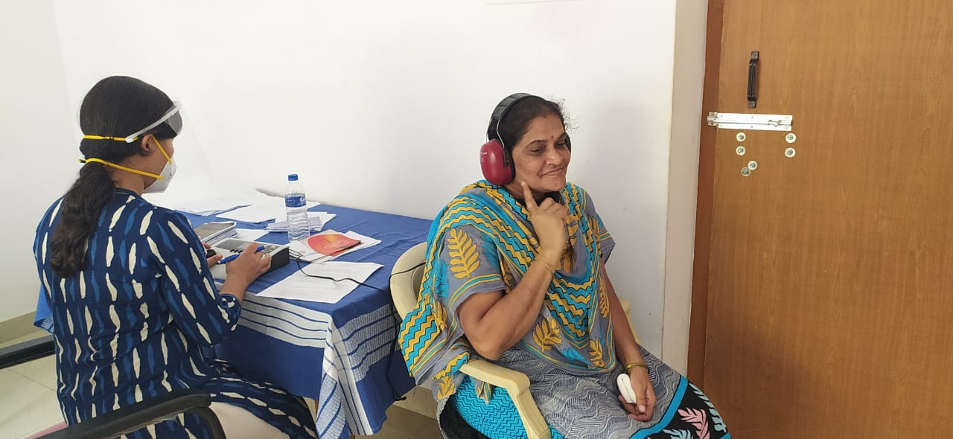

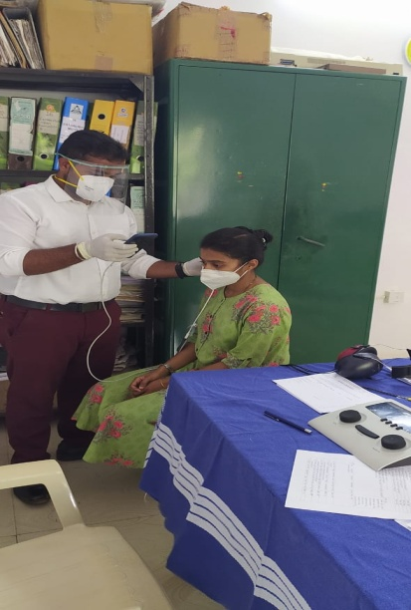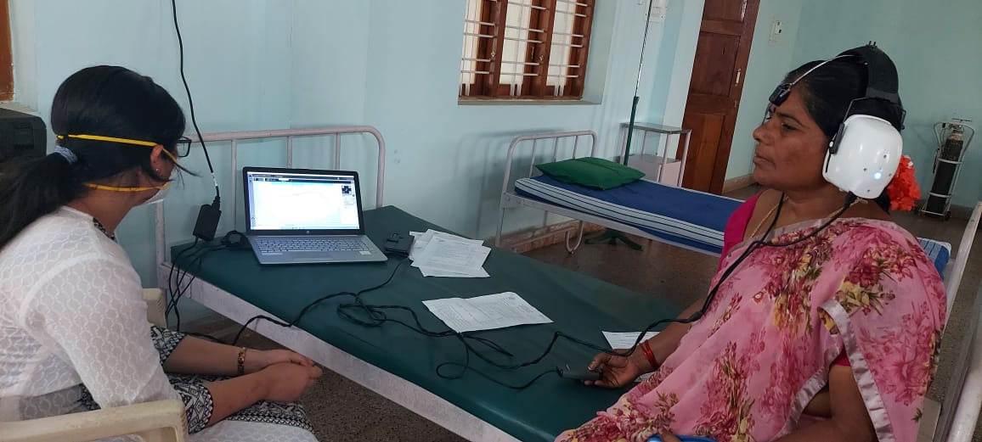Glimpses of Orientation program and hearing screening conducted for employees of KPCL

**b)** Follow-up Hearing evaluation of industrial workers at AIISH

Table: Details of industrial employees followed-up for hearing evaluation in March month.

|  |  |  |  |
| --- | --- | --- | --- |
| **Name of the industry** | **Total Evaluated** | **Total Number of ears with** | |
| **Normal hearing**  **(Ear wise)** | **Hearing loss**  **(Ear wise)** |
| Karnataka Silk Industries Corporation Limited (KSIC**)** | 76 | 17 | 135 |

**D) New born follow-up evaluation (Detailed assessment)**

The newborns/infants referred during the newborn screening/ Tele-screening were advised for detailed evaluation at AIISH/NBS centers/OSCs. A complete test battery was administered for those babies/infants who came for follow-up.

Table 8: Details of the results of follow-up evaluation at OSC Centers

|  |  |  |  |  |  |  |  |
| --- | --- | --- | --- | --- | --- | --- | --- |
| **Categories** | **Age range** | | **OSC- Akkihebbalu** | **OSC- Belagavi** | **OSC-K.R.Pete** | **OSC- Sagara** | **OSC- Sarguru** |
| **Normal** | Newborn  (0-2 months) | Male | 01 | 25 |  | 3 | **15** |
| Female |  | 13 | 1 |  | **20** |
| Infants  (2-12 months) | Male |  |  |  | 1 |  |
| Female |  |  |  |  |  |
| Toddlers  (1 year to 4years) | Male |  |  |  |  |  |
| Female |  |  |  |  |  |
| Children  (above 4years) | Male |  |  |  |  |  |
| Female |  |  |  |  |  |
| **Hearing impairment** | Newborn  (0-2 months) | Male |  | 2 |  |  |  |
| Female |  | 0 |  |  |  |
| Infants  (2-12 months) | Male |  |  |  |  |  |
| Female |  |  |  |  |  |
| Toddlers  (1 year to 4years) | Male |  |  |  |  |  |
| Female |  |  |  |  |  |
| Children  (above 4years) | Male |  |  |  |  |  |
| Female |  |  |  |  |  |
| **Speech &language disorder** | Newborn  (0-2 months) | Male |  |  |  |  |  |
| Female |  |  |  |  |  |
| Infants  (2-12 months) | Male |  |  |  |  |  |
| Female |  |  |  |  |  |
| Toddlers  (1 year to 4years) | Male |  |  |  |  |  |
| Female |  |  |  |  |  |
| Children  (above 4years) | Male |  |  |  |  |  |
| Female |  |  |  |  |  |
| **Multiple Disorder/Syndromes** | Newborn  (0-2 months) | Male |  |  |  |  |  |
| Female |  |  |  |  |  |
| Infants  (2-12 months) | Male |  |  |  |  |  |
| Female |  |  |  |  |  |
| Toddlers  (1 year to 4years) | Male |  |  |  |  |  |
| Female |  |  |  |  |  |
| Children  (above 4years) | Male |  |  |  |  |  |
| Female |  |  |  |  |  |
| **Total** |  |  | **01** | **40** | **01** | **04** | **35** |

evaluation (Referred from other depts.)

|  |  |  |  |  |  |  |
| --- | --- | --- | --- | --- | --- | --- |
| **Categories** | **Age range** | | **OSC-K.R.Pete** | **OSC- Sagara** | | |
| **Normal** | Newborn  (0-2 months) | Male | 1 |  | | |
| Female |  |  | | |
| Infants  (2-12 months) | Male |  |  | | |
| Female |  |  | | |
| Toddlers  (1 year to 4years) | Male |  |  | | |
| Female |  |  | | |
| Children  (above 4years) | Male |  |  | | |
| Female |  |  | | |
| **Hearing impairment** | Newborn  (0-2 months) | Male |  |  | | |
| Female |  |  | | |
| Infants  (2-12 months) | Male |  |  | | |
| Female |  |  | | |
| Toddlers  (1 year to 4years) | Male |  |  | | |
| Female |  |  | | |
| Children  (above 4years) | Male |  | 3 | | |
| Female |  | 3 | | |
| **Speech &language disorder** | Newborn  (0-2 months) | Male |  |  |
| Female |  |  |
| Infants  (2-12 months) | Male |  |  |
| Female |  |  |
| Toddlers  (1 year to 4years) | Male |  |  |
| Female |  |  |
| Children  (above 4years) | Male |  |  |
| Female |  |  |
| **Multiple Disorder** | Newborn  (0-2 months) | Male |  |  | |
| Female |  |  | |
| Infants  (2-12 months) | Male |  |  | |
| Female |  |  | |
| Toddlers  (1 year to 4years) | Male |  |  | |
| Female |  |  | |
| Children  (above 4years) | Male |  |  | |
| Female |  |  | |
| **Total** |  |  | **01** | **06** | |

Table 9: Details of the results of follow-up evaluation carried out at NBS centers.

|  |  |  |  |  |  |  |  |
| --- | --- | --- | --- | --- | --- | --- | --- |
| Categories | Age range | | **BHAGALPUR** | **IMPHAL** | **LUCKNOW** | **MUMBAI** | **RANCHI** |
| Normal | Newborn  (0-2 months) | Male |  |  | 06 |  | 03 |
| Female | 01 |  | 04 | 01 | 03 |
| Infants  (2-12 months) | Male |  |  |  |  |  |
| Female | 01 | 01 |  |  |  |
| Toddlers  (1 year to 4years) | Male |  | 01 |  |  |  |
| Female |  |  |  |  |  |
| Children  (above 4years) | Male |  |  |  |  |  |
| Female |  |  |  |  |  |
| Hearing impairment | Newborn  (0-2 months) | Male |  |  | 02 |  |  |
| Female |  |  | 01 |  |  |
| Infants  (2-12 months) | Male |  |  |  |  |  |
| Female |  |  |  |  |  |
| Toddlers  (1 year to 4years) | Male |  | 01 |  |  |  |
| Female |  | 02 |  |  |  |
| Children  (above 4years) | Male |  |  |  |  |  |
| Female |  |  |  |  |  |
| Speech & language disorder | Newborn  (0-2 months) | Male |  |  |  |  |  |
| Female |  |  |  |  |  |
| Infants  (2-12 months) | Male |  |  |  |  |  |
| Female |  |  |  |  |  |
| Toddlers  (1 year to 4years) | Male |  |  |  |  |  |
| Female |  |  |  |  |  |
| Children  (above 4years) | Male |  |  |  |  |  |
| Female |  |  |  |  |  |
| Multiple Disorder/Syndroms | Newborn  (0-2 months) | Male |  |  |  |  |  |
| Female |  |  |  |  |  |
| Infants  (2-12 months) | Male |  |  |  |  |  |
| Female |  |  |  |  |  |
| Toddlers  (1 year to 4years) | Male |  |  |  |  |  |
| Female |  |  |  |  |  |
| Children  (above 4years) | Male |  |  |  |  |  |
| Female |  |  |  |  |  |
| Total | | | **02** | **05** | **13** | **01** | **06** |

Table 10 Details of the results of detailed follow-up evaluation (**Referred from other depts.)**

|  |  |  |  |  |  |  |  |
| --- | --- | --- | --- | --- | --- | --- | --- |
| Categories | Age range | | BHAGALPUR | LUCKNOW | MUMBAI | RANCHI | Total |
| Normal | Newborn  (0-2 months) | Male |  | 2 |  | 5 |  |
| Female |  | 3 |  | 5 |  |
| Infants  (2-12 months) | Male | 01 | 2 |  | 3 |  |
| Female |  | 4 |  | 3 |  |
| Toddlers  (1 year to 4years) | Male |  | 25 |  | 1 |  |
| Female |  | 15 |  | 1 |  |
| Children  (above 4years) | Male |  | 7 |  | 1 |  |
| Female |  | - |  |  |  |
| Hearing impairment | Newborn  (0-2 months) | Male |  | - |  |  |  |
| Female |  | 1 |  |  |  |
| Infants  (2-12 months) | Male |  | 2 |  |  |  |
| Female |  | 2 |  |  |  |
| Toddlers  (1 year to 4years) | Male |  | 34 |  | 9 |  |
| Female |  | 18 |  | 4 |  |
| Children  (above 4years) | Male |  | 9 |  | 7 |  |
| Female |  | 7 |  | 4 |  |
| Speech & language disorder | Newborn  (0-2 months) | Male |  |  |  |  |  |
| Female |  |  |  |  |  |
| Infants  (2-12 months) | Male |  |  |  |  |  |
| Female |  |  |  |  |  |
| Toddlers  (1 year to 4years) | Male |  |  | 02 | **12** |  |
| Female |  |  | 03 | **1** |  |
| Children  (above 4years) | Male |  |  |  | **1** |  |
| Female |  |  |  | **1** |  |
| Multiple Disorders/Syndroms | Newborn  (0-2 months) | Male |  |  |  |  |  |
| Female |  |  |  |  |  |
| Infants  (2-12 months) | Male |  |  |  |  |  |
| Female |  |  |  |  |  |
| Toddlers  (1 year to 4years) | Male |  |  |  |  |  |
| Female |  |  |  |  |  |
| Children  (above 4years) | Male |  |  |  |  |  |
| Female |  |  |  |  |  |
| Total |  |  | **01** | **131** | **05** | **58** |  |

**D) Anganawadi /Preschool/School screening program**

Screening of preschool, primary school children was conducted focusing on the early identification of communication disorders and early rehabilitation of children at risk for communication disorders.

|  |  |  |  |  |  |
| --- | --- | --- | --- | --- | --- |
| **Date** | **Name of the School** | **Total screened** | **Total identified with communication disorders** | | |
| **Ear related disorder** | **Hearing loss** | **Speech language disorders** |
|  |  |  |  |  |  |
|  |  |  |  |  |  |
|  |  |  |  |  |  |
|  |  |  |  |  |  |
|  |  |  |  |  |  |
|  |  |  |  |  |  |
|  |  |  |  |  |  |
| **Total** | |  |  |  |  |

**E) Clinical Services at Outreach Service Centers (OSCs)**

The clinical activities are not only restricted to in and around Mysuru, but also extended to rural areas where facilities for clinical services for persons with communication disorders are scanty. Currently there are 08 OSCs centres at different part of the country rendering services to unreached population. The details of those who were registered and availed various services/benefits at the OSCs are tabulated below.

1. **Clients identified and followed up with communication disorders at OSCs**

Table 11: Details of clients identified and followed up with communication disorders at OSCs.

|  |  |  |  |  |  |  |  |  |  |
| --- | --- | --- | --- | --- | --- | --- | --- | --- | --- |
| **S. No** | **OSC Centre** | **Total registered** | | **ENT Evaluation** | | **Hearing Evaluation** | | **Speech & Language Evaluation** | |
| Normal | Disorder | Normal | Disorder | Normal | Disorder |
|  | Taluk Hospital, Nanjangud | New cases | 28 | - | 23 | 10 | 36 | - | 5 |
| F/u Old | - | - | - | - | - | - |  |
|  | Community Health Centre (CHC), Hullahalli | New cases | 21 | - | 19 | 0 | 4 | - | 2 |
| F/u Old | 24 | - | 16 | - | 2 | - | 5 |
|  | Primary Health Centre (PHC), Akkihebbalu | New cases | 8 | - | 6 | - | 2 | - | 1 |
| F/u Old | 1 | - | - | - | 2 | - | - |
|  | Taluk General Hospital, KR Pete | New cases | 47 | - | - | 31 | 59 | - | 2 |
| F/u Old | 5 | - | - | - | 10 | - | - |
|  | Primary Health Centre (PHC), Gumballi | New cases | 85 | 0 | 59 | 0 | 46 | 0 | 3 |
| F/u Old | 37 | 0 | 31 | 0 | 12 | 0 | 0 |
|  | Sub-divisional Hospital (PHC), Sagara | New cases | 36 |  |  | 5 | 51 | - | 11 |
| F/u Old | 3 |  |  | - | 6 | - | - |
|  | Vivekananda Memorial Hospital, Sarguru | New cases | 23 |  |  | 2 | 36 | - | 4 |
| F/u Old | 1 |  |  |  |  |  | 1 |
|  | Gulbarga Institute of Medical Sciences | New cases | 187 | 70 | 117 | 59 | 207 | - | 34 |
| F/u Old | 1 | - | 1 | - | 2 | - | - |
|  | Belagavi institute of medical sciences (BIMS), Belagavi | New cases | 226 |  |  | 125 | 249 |  | 39 |
| F/u Old | 1 |  |  |  | 2 |  |  |
|  | Kodagu Institute of Medical Sciences, Madikkerri | New cases | 96 |  |  | 58 | 120 | 0 | 7 |
| F/u Old | 6 |  |  | 1 | 5 | 0 | 0 |
|  | AIIMS,  Bhuvaneshwar | New cases | 110 | 38 | 15 | 4 | 102 | 1 | 55 |
| F/u Old |  |  |  |  |  |  |  |
|  | IGIMS,  Patna | New cases | 4 |  |  |  |  | 1 | 3 |
| F/u Old |  |  |  |  |  |  |  |
|  | KIMS,  Hubli | New cases | 170 |  |  | 23 | 251 |  | 33 |
| F/u Old | 1 |  |  |  |  |  | 1 |
|  | BRIMS,  Bidar | New cases | 44 |  |  | 2 | 74 |  | 6 |
| F/u Old |  |  |  |  |  |  |  |

1. **Table 12: Clients identified with different types of communication disorders across OSCs**

|  |  |  |  |  |  |  |  |  |  |  |  |  |  |  |
| --- | --- | --- | --- | --- | --- | --- | --- | --- | --- | --- | --- | --- | --- | --- |
| **Type of Disorders** | **OSC** | | | | | | | | | |  |  |  |  |
| Taluk Hospital, Nanjangud | Primary Health Centre (PHC), Hullahalli | Primary Health Centre (PHC), Akkihebbalu | Taluk General Hospital, KR Pete | Primary Health Centre (PHC), Gumballi | Sub-divisional Hospital, Sagara (PHC) Taluk | VMH,  Sarguru | BIMS Belagavi | GIMS, Kalburgi | KoIMS,  Kodagu | AIIMS,Bhuvaneshwar | KIMS,Hubli | BRIMS,BidaR | IGIMS,Patna |
|  |  | **Hearing disorders (Ear-wise data)** | | | | |  |  |  |  |  |  |  |  |
| Normal | 10 | - | 1 | 31 | 0 | 5 | 2 | 125 | 59 | 58 | 4 | 23 | 2 |  |
| Conductive | 5 | - | - | 10 | 2 | 14 | 2 | 13 | 20 | 15 | 4 | 61 | 2 |  |
| Sensori- neural | 14 | 4 | 5 | 15 | 28 | 9 | 13 | 129 | 78 | 46 | 12 | 72 | 48 |  |
| Mixed | 11 | - | 4 | 14 | 8 | 6 | 9 | 19 | 47 | 17 | 5 | 43 | 12 |  |
| No type (Minimal & Profound) | 6 | - | - | 20 | 8 | 22 | 12 | 72 | Min-35  Pro-29 | 42 | 25 | 71 | 6 |  |
| **Aud-Total (ears)** | **-** | - | - | - | 0 | 6* |  | **8 (16 ears)** | Cases-32  Ears-64 |  | 56 | 4 | 6 |  |
| **Aud-Total (Individuals)** | **46** | **4** | **10** | **90** | **46** | **56** | **38** | **374** | **332** | **178** | **106** | **274** | **76** |  |
|  |  |  | | | | | |  |  |  |  |  |  |  |
| Voice | 1 | - | - | - |  | - | 1 | 1 | 2 | 0 | 17 | 13 |  | 1 |
| Fluency | - | - | - | - |  | 1 |  | 1 | - | 1 | 2 | 4 |  |  |
| Articulation disorders | 1 | - | - | - |  | 3 | 2 | 3 | 4 | 4 | 15 | 4 |  | 1 |
| Language disorders | 3 | 2 | 1 | 2 | 3 | 7 | 1 | 34 | 28 | 2 | 21 | 12 | 6 | 1 |
| **Total (Individuals)** | **5** | **2** | **1** | **2** | **3** | **11** | **4** | **39** | **34** | **7** | **55** | **33** | **6** | **3** |

1. **Table 13: Clients followed up with different types of communication disorders at OSCs**

|  |  |  |  |  |  |  |  |  |  |  |  |  |  |  |
| --- | --- | --- | --- | --- | --- | --- | --- | --- | --- | --- | --- | --- | --- | --- |
| **Type of Disorders** |  |  | **OSC** | | | |  |  |  |  |  |  |  |  |
| Taluk Hospital Nanjangud | Primary Health Centre (PHC), Hullahalli | Primary Health Centre (PHC), Akkihebbalu | Taluk General Hospital, KR Pete | Primary Health Centre (PHC), Gumballi | Sub-divisional Hospital,  Sagara  (PHC) Taluk | VMH,Sarguru | Belagvi institute of medical sciences BIMS | GIMS, Kalburgi | KoIMS-TH, MadikeriTaluk,Kodagu | AIIMS,Bhuvaneshwar | KIMS,Hubli | BRIMS,BidaR | IGIMS,Patna |
|  |  | **Hearing disorders (Ear-wise data)** | | | | |  |  |  |  |  |  |  |  |
| Normal | - | - | - | - |  |  |  | 0 |  | 1 |  |  |  |  |
| Conductive | - | - | - | - |  | 1 |  | 0 |  | 0 |  |  |  |  |
| Sensori- neural | - | - | 2 | 5 | 6 | 3 |  | 0 | 1 | 8 |  |  |  |  |
| Mixed | - | 2 | - | 3 | 2 |  |  | 0 |  | 0 |  |  |  |  |
| No type (Minimal & Profound) | - | - | - | 2 | 4 |  |  | 2 | 1 | 3 |  |  |  |  |
| Incomplete  (cases)  (ears) | - | - | - | - |  | 2 |  | 2 |  |  |  |  |  |  |
| **Aud-Total (ears)** | - | **2** | 2 | 10 | 12 | 6 |  | 1 | 2 | 12 |  |  |  |  |
| **Aud-Total (Individuals)** | - | **1** | 1 | 5 | 6 | 3 |  |  | 1 | 6 |  |  |  |  |
|  |  |  | | | | | | - | - |  |  |  |  |  |
| Voice | - | - |  |  |  |  |  |  |  |  |  |  |  |  |
| Fluency | - | - |  |  |  |  |  |  |  |  |  |  |  |  |
| Articulation disorders | - | 1 |  |  |  |  |  |  |  |  |  |  |  |  |
| Language disorders | - | 4 |  |  |  |  | 1 |  |  |  |  | 1 |  |  |
| **Sp&Lg -Total (Individuals)** | **-** | **5** |  |  |  |  | **1** | 0 |  |  |  | **1** |  |  |

1. **Rehabilitation services at OSCs.**

Table 14: Details of rehabilitation services provided at OSCs in February 2020.

|  |  |  |  |  |
| --- | --- | --- | --- | --- |
| **OSC** | **Hearing Aids Dispensed** | **Speech-language therapy** | | **Medical Line of Treatment** |
| No. of clients | No. of sessions |
| Taluk Hospital, Nanjangud |  | 7 | 22 | - |
| Primary Health Centre (PHC), Hullahalli |  | 7 | 7 | - |
| Primary Health Centre (PHC), Akkihebbalu |  |  |  |  |
| Taluk General Hospital, KR Pete | 2 | No therapy cases due to corona treatment |  |  |
| Primary Health Centre (PHC), Gumballi | 12 | 6 | 25 | - |
| Sub-divisional Hospital, Sagara (PHC) Taluk | 2 | 19 | 94 | - |
| VMH, Sarguru | 62 | 9 | 39 |  |
| Belagavi institute of medical sciences BIMS |  | 10 | 36 |  |
| GIMS, Kalburgi |  | 10 | 80 |  |
| KoIMS-TH, MadikeriTaluk | 12 | 12 | 43 |  |
| AIIMS,  Bhuvaneshwar |  | 5 | 12 |  |
| KIMS,  Hubli |  | 6 | 10 |  |
| IGIMS,  Patna |  | 4 | 2 |  |
| BRIMS,  Bidar |  | 6 | 15 |  |
| **Total** | **90** | **101** | **385** | **0** |

**d) Table 15: Screening Camps for communication Disorders**

|  |  |  |  |  |  |  |  |  |
| --- | --- | --- | --- | --- | --- | --- | --- | --- |
| Date | Camp site | Total Screened | Total Referred | | | | Total hearing aid distributed | Total |
| Hearing impairment | | Speech- language disorders | |
| Male | Female | Male | Female |  |  |
|  |  |  |  |  |  |  |  |  |
| 3/3/21 | KGMU | 54 | 40 | 07 | - | - | - | 47 |
| 20/03/21 | Vivekananda Tribal Health Centre, B.R Hills | 14 | 12 | 2 | 0 | 0 | 1 | 14 |
| 08/03/2021 | H.D Kote | 26 | 18 | 8 |  |  | 14 | 26 |
| 10/03/2021 | Hunsur | 38 | 20 | 16 |  |  | 21 | 36 |
| 1/3/2021-13/3/2021 | VMH Sarguru | 60 | 41 | 19 |  |  | 27 | 60 |
| Total | | **192** | **131** | **52** | **00** | **00** | **63** | **183** |

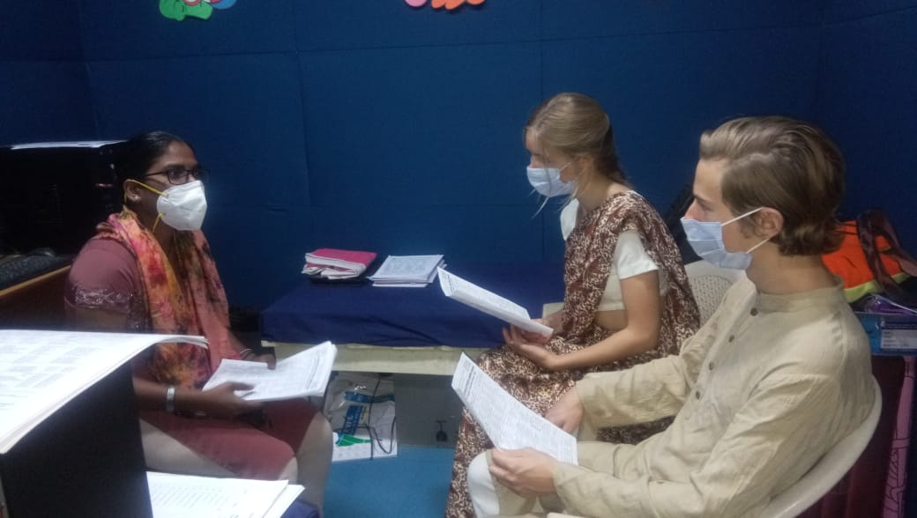

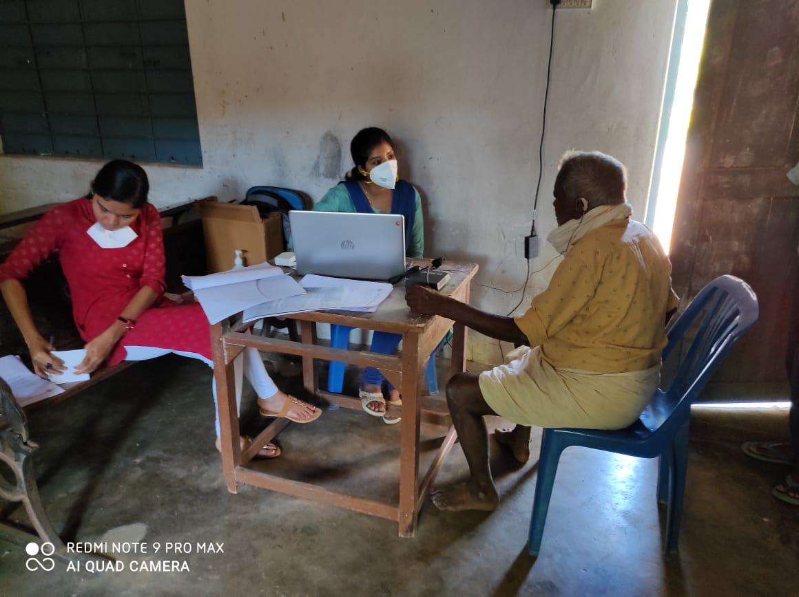

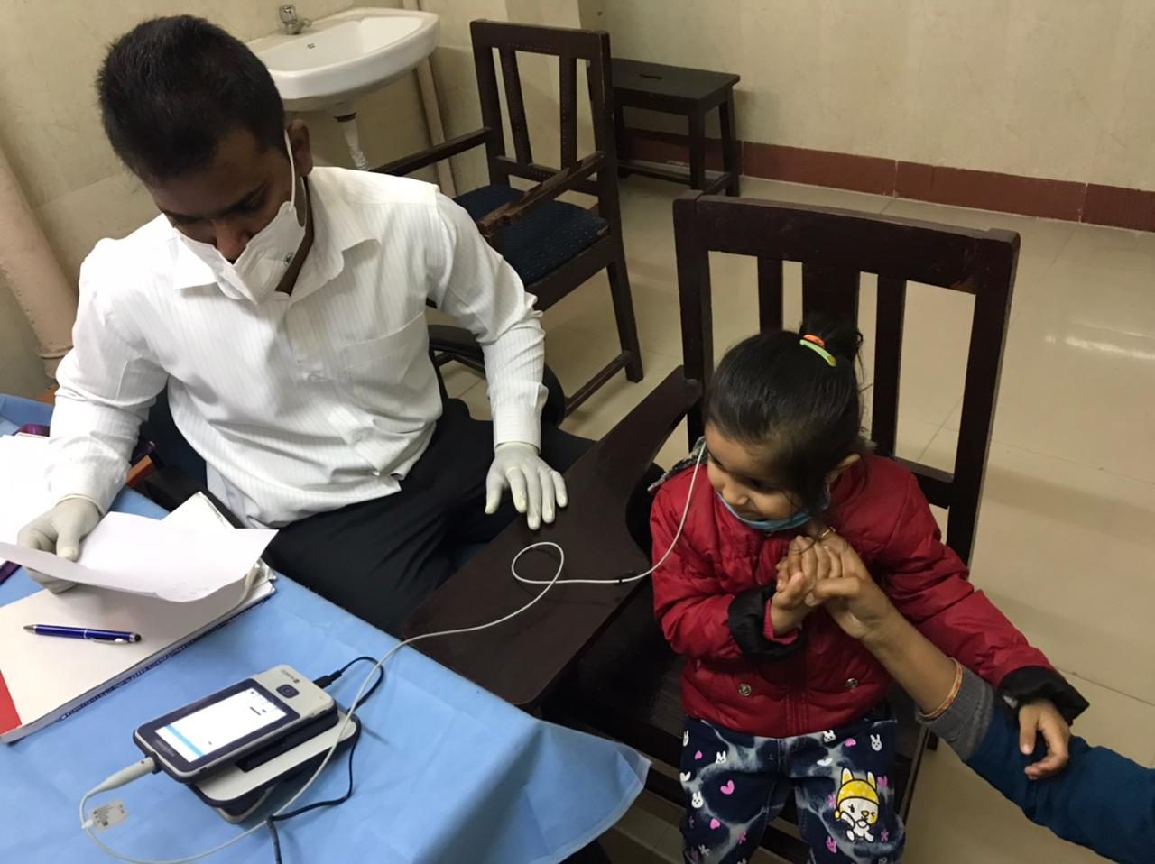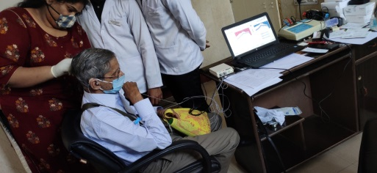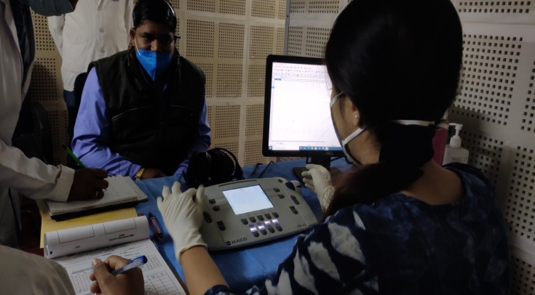

**IV) TECHNOLOGICAL CONSULTANCY SERVICES: NIL**

**V) CENTRAL FACILITIES**

**a) Library and information Services: NIL**

VI) **MAJOR EVENTS OF THE MONTH**:

**On 3rd mar.ch 2021, Cyclothon was conducted and street play regarding early identification,noise induced hearing loss at OSC Sarguru**

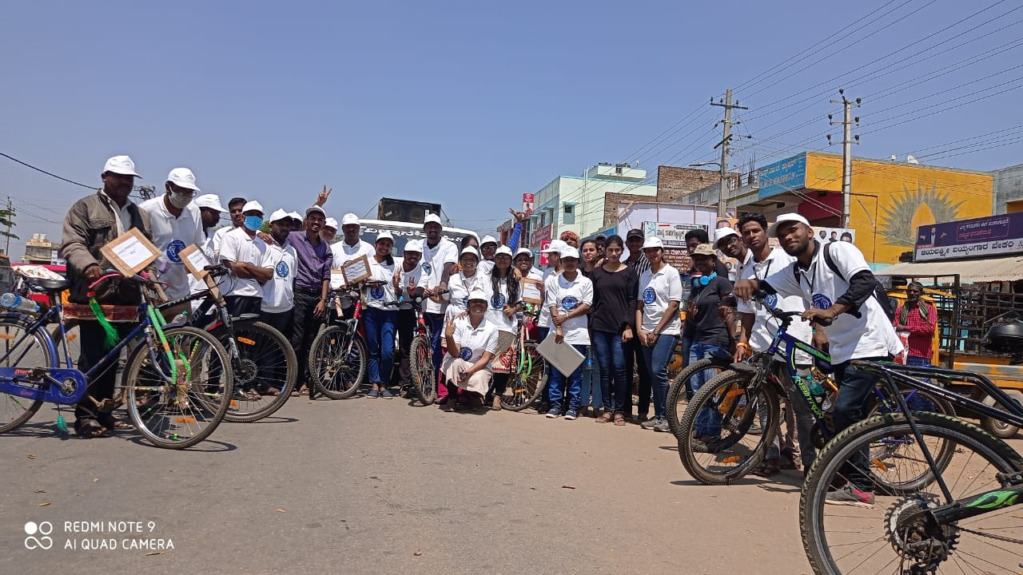

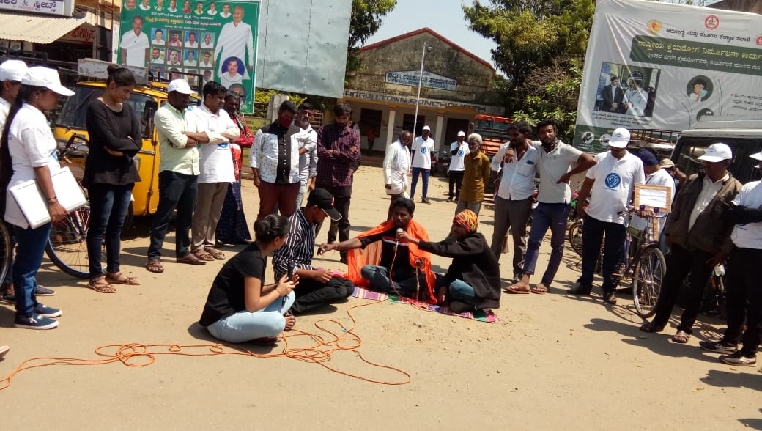

1. **Conducted world hearing day celebration on 19th march 2021.**

**Distributed 100 free hearing aids and counselled regarding hearing aid usage,maintanence. Mime show was done regarding hearing loss and rehabilitation at OSC Sarguru**

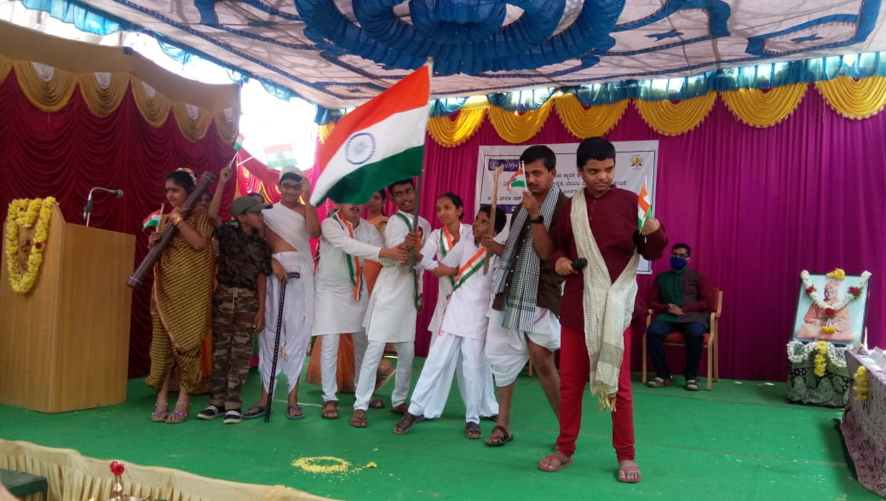

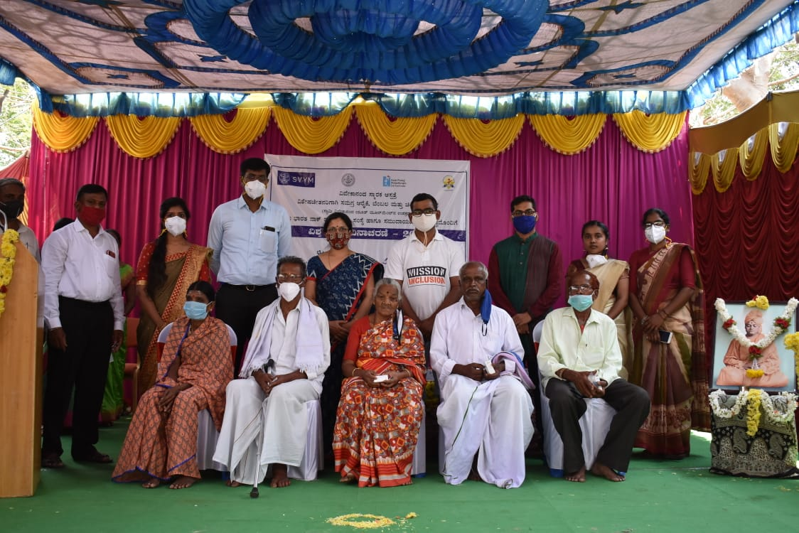

**OSC Kodagu**

* World hearing day was celebrated in Kodagu Institute of Medical Sciences- Teaching hospital on 03.03.2021. Activity reported is submitted.
* On the occasion of world hearing day, free digital hearing aids were provided to the beneficiaries in the presence of dignitaries.
* The celebration was reported in the local newspapers.

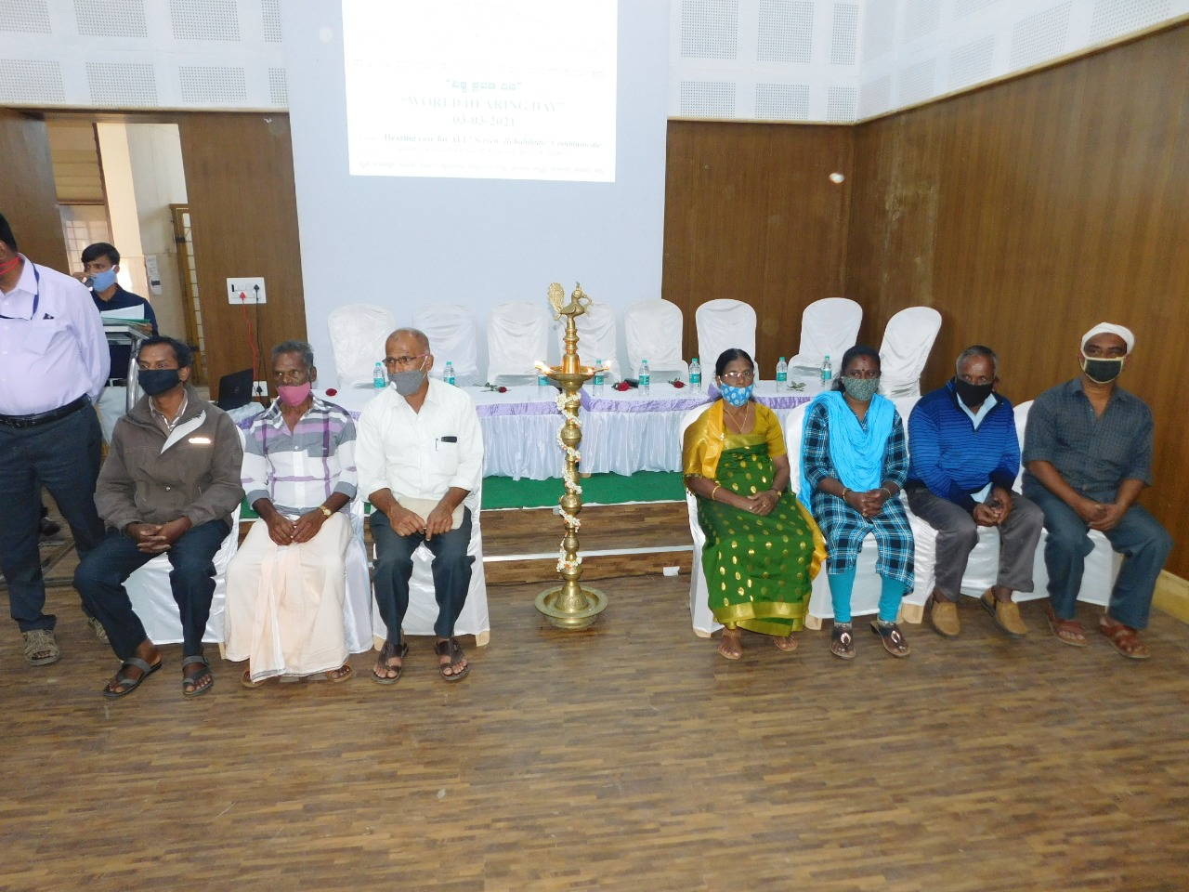

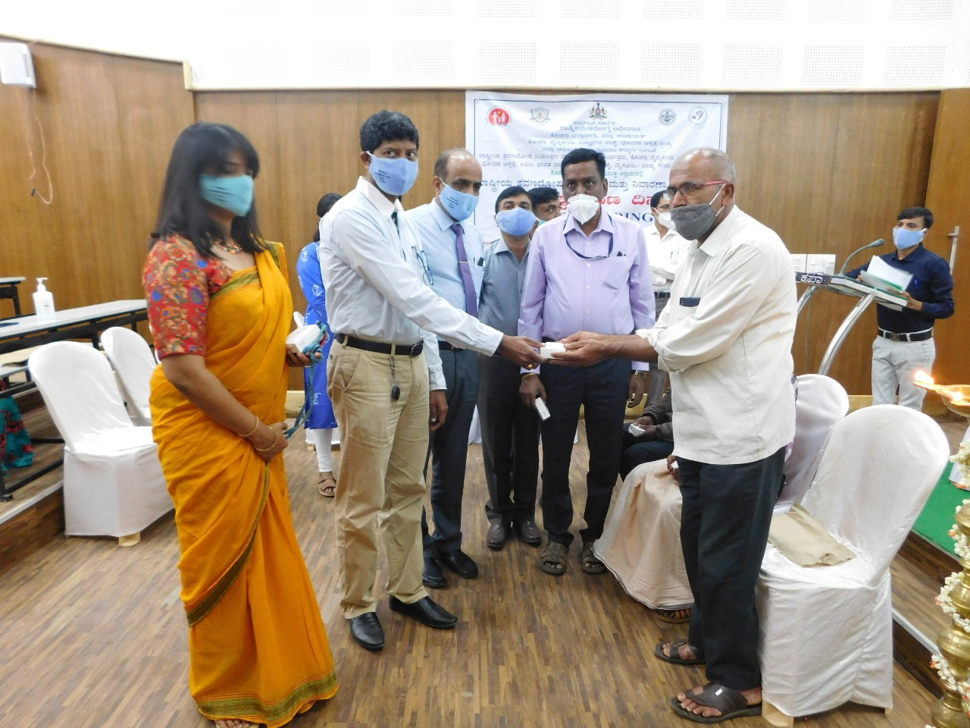

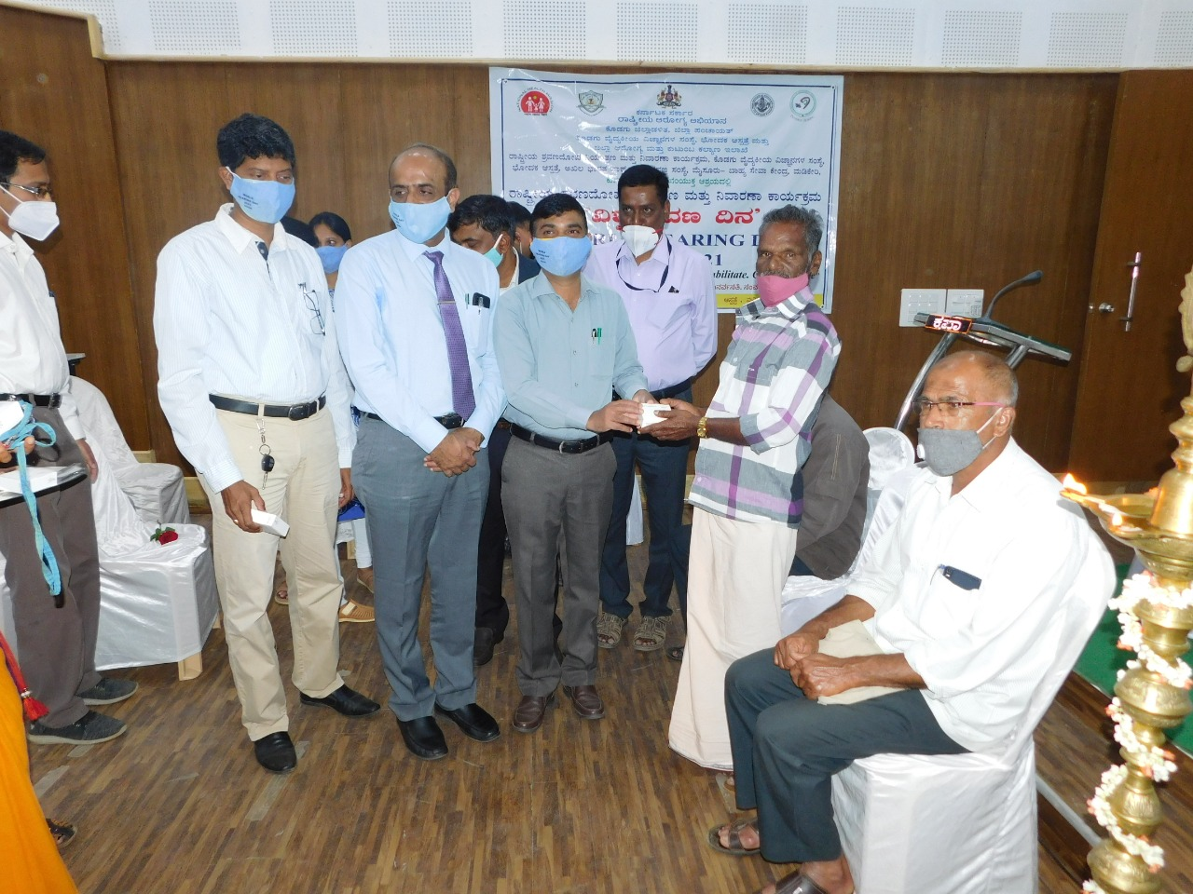

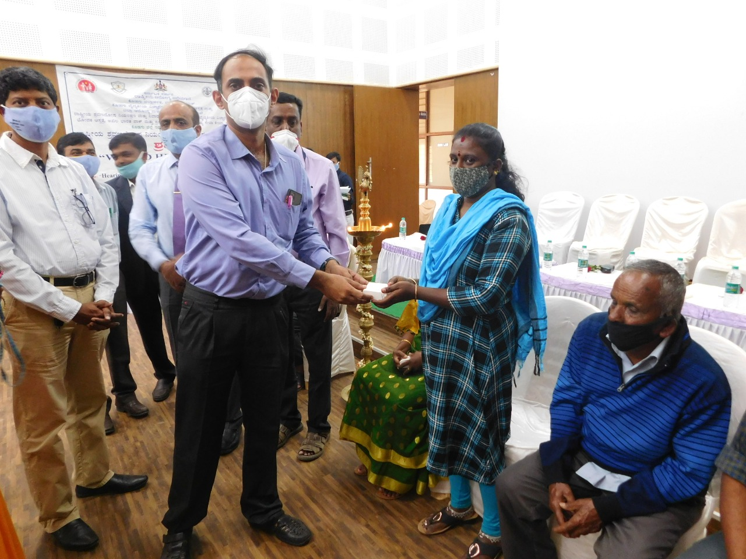

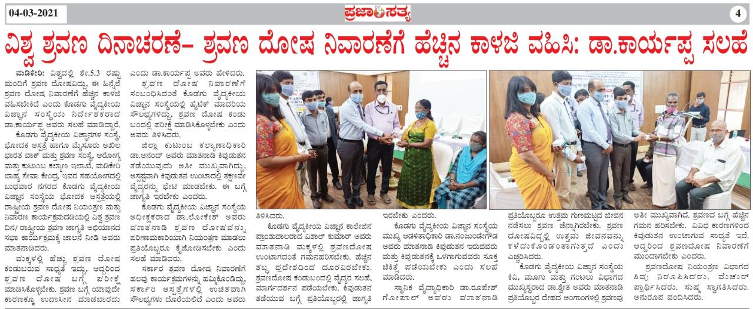

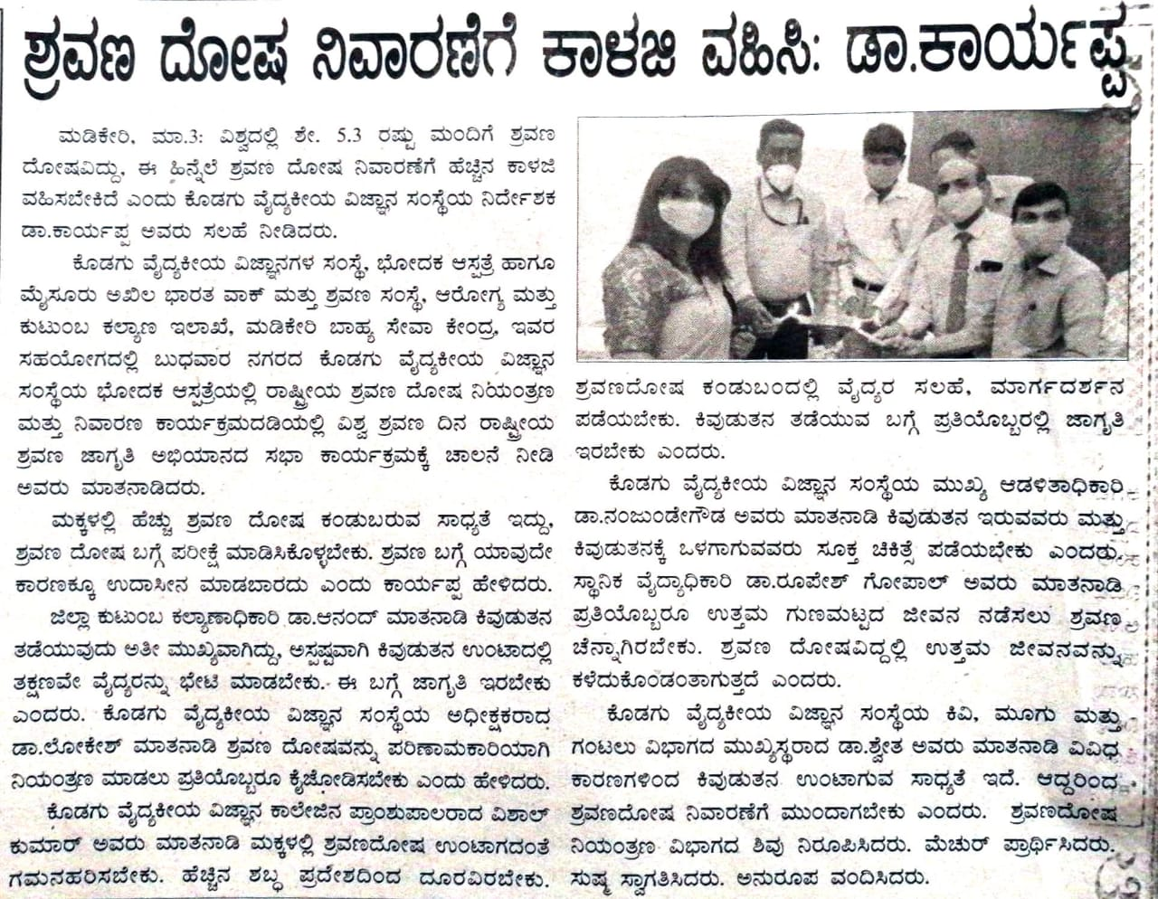

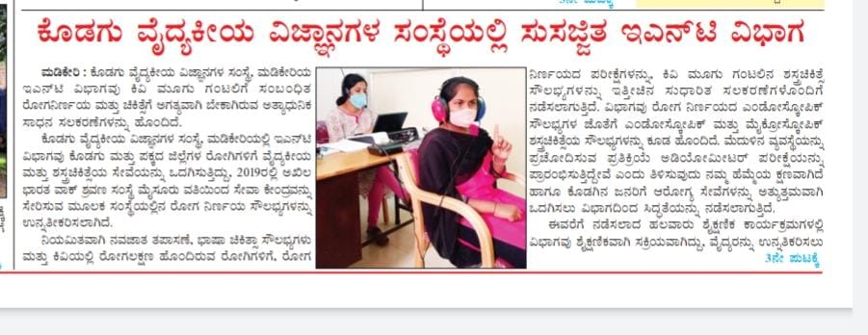

**VII) OTHERS**

**VII) ACTIVITIES CARRIED OUT BY THE STAFF OF THE DEPARTMENT OF POCD.**

Table 16: Details of activities carried out by POCD staff in October 2020.

|  |  |  |  |
| --- | --- | --- | --- |
| **S.No.** | **Name of the staff** | **Designation** | **Activities** |
|  | Dr. Sandeep M. | * Head, Dept. of POCD (i/c) | * Officiating as HOD-POCD incharge * Coordinated all OSC NBS activities * Coordinated World Hearing Day activities. |
|  | Mr. Arunraj. K | Audiologist/SLP | * Coordinated Outreach Service Centre activities * Coordinated computerisation activities * Coordinated for sending equipments to the all OSC and NBS centers based on the requirement * Verified MoU and minutes for new OSC centers * Coordinated initiation of new OSCs in various parts of the country. |
|  | Ms. Ranjini A | Audiologist Gr. I | * Called phone follow-up infants enquiring about their developmental milestones (14 calls). * Did detailed Follow up Audiological Evaluation for for 6 KSIC Industrial Workers. * Did detailed Audiological Evaluation for Referred Newborn cases. * Compilation of referred cases and follow-up cases of all hospitals of February month. * Prepared monthly NBS report for Feruary month. * Prepared a report for World Hearing Day regarding the talk at Community Radio Stations. * Wrote emails to community radio stations attaching the recorded talk show and seeking the total population coverage. * Crosschecked SPSS NBS data of all Mysore hospitals for the year 2020. * Crosschecked SPSS OSC data of KR Nagar and Nanjangud for the year 2019. * Attended AABR orientation by Kalai on 09/03/2021. * Attended ABR orientation by Tanuja on 10/03/2021. * Attended SPSS orientation by Shreyank sir on 11/03/2021. * Attended SPSS orientation by Vasanthlakshmi ma’am and Srinivas sir on 18/03/2021. * Corrected the missing SPSS data of all NBS and OSC centres for the year 2018. |
|  | Ms. Srividya S | Audiologist Gr. I | * Did detailed Audiological Evaluation for Referred Newborn cases. * Prepared Google forms for pre and post- orientation and feedback response for webinar on harmful effects of noise. * Organised webinars for industrial workers of JSW, Bellary on harmful effects of noise on 3/3/2021. * Attended free hearing aid distribution camp organised on 5/03/2021 as a part of world hearing day. * Attended staff enrichment programme about A-ABR on 9/03/2021. * Attended staff enrichment programme about ABR on 10/03/2021. * Verified the Computerized version of school screening data entry. * Attended staff enrichment programme about SPSS on 11/03/2021. * Analysed data of different school screening camps conducted in month of February. * Verified Kannada translation of Industrial screening Questionnaire. * Attended industrial screening camp on 24/03/2021 and 25/03/2021 held in KPCL, Jog and Kargal region. * Oriented industrial workers of KPCL, kargal region about ‘harmful effects of noise’ on 25/3/2021. * Verified Kannada translation of Counselling tips for parents. * Designed poster for webinar on ‘communication disorders in school going children’ held on 31/03/2021. * Organised webinar and oriented school teachers of Mysore north region about communication disorders in school going children on 31/03/2021. |
|  | Ms. Dibya Aryal | Speech Language Pathologist Gr. I | * Compilation of referred cases and follow-up cases of all hospitals of February month. * Prepared monthly NBS report for February month. * Participated in hearing screening camp at Mysore City Corporation on 01.03.21 as part of World Hearing Day * Participated in hearing screening camp at University of Mysore on 03.03.21 as part of World Hearing Day * Prepared report for World Hearing Day regarding the webinar conducted for expecting mothers * Called phone follow-up infants enquiring about their developmental milestones (7 calls). * Did detailed Follow up Audiological Evaluation for for 6 KSIC Industrial Workers. * Did detailed Audiological Evaluation for Referred Newborn cases. * Attended ABR orientation by Tanuja on 10/03/2021. * Attended SPSS orientation by Vasanthalakshmi ma’am and Srinivas sir on 18/03/2021. * Corrected the missing SPSS data of all NBS and OSC centres for the year 2018. * Participated in Speech and Hearing Screening Camp at Bharuch, Gujarat from 21.03.21 to 23.03.21. |
|  | Ms. Tanuja M.N | Audiologist Gr. II | * Attended Hearing screening camp at UOM on 3.3.21. * Co-ordinated for ‘world Hearing Day’ free hearing aid distribution programme on 5th march 2021. * Attended Elderly hearing screening camp at BR Hills on 20.3.2021. * Attended staff enrichment programme about AABR on 9.3.21. * Presented about ABR protocol and Interpretation in the Staff enrichment programme on 10.3.21. * Verified Industrial follow up Audiological Evaluation reports. * NBS Follow up: Assigned backlog referral cases from june to 15th march to the nearby Out Reach Centres of AIISH and Government Hospitals for detailed audiological Evaluation. * Completed follow up assessment for the high risk babies November, December, January. * Completed phone follow up for the month of February and September. * Carried out data entry of the discrepancy in the Outside NBS data of Mysore, Santhemaralli, K R Nagar. * Regularly carried out New born hearing screening and detailed Audiological Evaluation for NBS follow up. * Attended SPSS Webinar on 18.3.21 * Contacted Gopal Krishna for organizing webinar on Communication Disorders for Staff nurses and TGT on 22.4.21 &23.4.21. * Prepared Poster for webinar on communication disorders for staff nurses & TGTs Science. * vvInitiated material development work of Autism comic script kannada. * Verified computerization data entry for the NBS Follow up section. * Coordinated webinar program for mysore north teachers on 31.3.21 |
|  | Ms. Merina Thomas | Audiologist Gr. I | * Verified and compiled monthly report work of all OSC * Distributed 28 free hearing aids on 5/3/21 in occasion with World Hearing day. * Compiled hearing aid beneficiary list for the annual year 2020-2021. * Went for Newborn Hearing Screening on all Monday, Wednesday and Fridays. * Went for Industrial follow up hearing evaluation * Went for Newborn hearing detailed evaluation on all Tuesdays. * Carried out NBS phone follow up * Prepared new MoU format for OSC * Prepared MoU for KIMS,Hubli;AIIMS,Bhuvaneshwar;BRIMS,Bidar;and IGIMS ,Patna. * Prepared MoU and MoM format to be send for 16 new upcoming OSCs. * Repaired hearing aids were collected and were distributed to Gumballi,Sagara,Akkihebalu and Nanjangud centres. * Purchased ear tips and battery from electronics for OSC. * Carried out auditing of Hearing aid documents in 6 OSCs. * Sent the required essentials to Sarguru, Gumballi,Nanjangud and K.R Pete. * Orientation for newly initated OSC was carried out on 17/3/21. * Distributed a total of 23 hearing aids to 2 * OSCs(12-Nanjangud,11-Gumballi) * Attended SPSS webinar on 18/3/2021 on fundamentals of NBS data processing |
|  | Ms. Pauline Gracia R V | SLP Gr. II | * WHD activities - Content made and sent to for social media updation * WHD programs updation on WHO page – Hearthon2021. * Attended 1 camp * Attended NBS * Attended bedside screening * NBS phone follow up * Hearing evaluation (NBS &Industrial follow up) * SPSS format for camp- industrial, hearing screening camp, elderly, school ( not yet finalised) * WHD – notice board * Staff name board for POCD * Data entry for industrial follow up * 2014- NBS SPSS data entry * Speech materials to OSC centres * List made for Audiology and Speech language pathology setup for other centres. * Districts of Bhuvaneshwar and Bihar updated in OSC SPSS. * Material developed for DD-Pothigai show. |
|  | Ms. Kranti Acharya | SLP Gr. I | * Attended webinar by world health organization “World Hearing Report” - 3rd March 2021 * Prepared the report of the webinar “World Hearing Report “- 3rd March 2021 * Organized and attended industrial hearing screening camp at KPCL, at Kargal and Jog regions from 23.3.2021 to 25.03.2021. * Attended staff enrichment programme about AABR on 9.3.21. * Attended staff enrichment programme about AABR on 10.3.21. * Attended SPSS Webinar on 18.3.21 * Collected 150 infant cry samples * Analysed and entered 101 infant cry samples in excel sheet and submitted. * Orientation to students regarding the activities of POCD and instructions to be followed in department posting. * Checked and verified the overall log sheets of students. * Corrected PowerPoint slides of article presentation of MSc students. * Compilation of student’s attendance posted in POCD dept. * Called phone follow-up infants enquiring about their developmental milestones. * Did detailed Follow up Audiological Evaluation for for KSIC Industrial Workers. * Did detailed Audiological Evaluation for Referred Newborn cases. * Verified SPSS data from 2008- 2013. * Corrected and verified the FAQ on Learning disability. |
|  | Ms. Ankitha.S | SLP Gr. II | * Arranged of pamphlets * Prepared inauguration ppt of new OSC and NBS centres . * Edited Celebrities videos of WHD * Prepared NBS orientation and webinar reports * Industrial and NBS follow up have been done in the month of March * WHD activities report (K. R Nagar ) and WHOmeeting minutes (Dr. Harsha Vardhan) * Student attendance register maintained * Made list of NBS and School screening orientation and noted counts of feedback form * Prepared overall table of number of employee screened and referred of industrial screening(L&T. Bangalore ) * Computerization of school screening * Prepared list of conducting upcoming orientation program and school screening * Submitted NBS Travel allowance * Entered missed out SPSS data of previous years * School screening data entered in register of all school camp conducted as a part of WHD * Corrected 1 st MSc students presentation ppt and selected article for presentation * Translated FAQ- LD in Kannada and helped formatting industrial questioner * Prepared banner for industrial screening camp * Attend industrial screening camp at Jog and Kargal from 23.03.2021 to 25.03.2021 * Entered referred and screened data of industrial screening camp(Jog and kargal) in report as well in register * Prepared slides and poster of webinar for Mysore North part School teacher’s and industrial employees ( jog and Kargal ). * Conducted Webinar on 31.03.2021 for Mysore North part School teacher’s and oriented KPCLworkers at JOG, Sagara on 24.03.2021 |
|  | Ms. Reshma O | SLP Gr. I | * Attended camp at Mysore city cooperation on 01.03.2021 * Attended free hearing aid distribution program at Seminar hall, AIISH on 03/03/21 * Carried out NBS * Hearing evaluation done( NBS follow up and industrial follow up) * Carried out phone follow up * Conducted elderly screening camp at B R Hills on 20.03.21 * Met Medical Superintendent and Head of Neurology, MMC &amp;RI at K R hospital * Re initiated bedside screening program at KR Hospital on 30.03.2021 * Planning to initiate bedside screening at other hospitals started * Planning to conduct elderly screening camp atNanjangud started |
|  | Ms. Deepika. R | Office assistant Grade II | * Submitted contract staff attendance, TA bills, interns attendance * Assisted in preparing and communicating camps reports * Assisted in WHD activities paper works * Prepared letters for orientations and webinars * Settled suppliers advance and Imprest cash * Assisted in Coordinating OSC and NBS requests and activities * Filed the official documents on a daily basis * Prepared Monthly report January 2020 * Submitted intern’s attendance * Prepared departmental meeting minutes * Submitted C1 and C2 marks * Correspondence to all the mails received in the dept. * Prepared inauguration letters for all new OSCs * Prepared and communicated camp letters and staff deputation letters * Routine work of gate pass, indent, work orders, local purchase indents, registers maintaining etc. |

Sd/-

Dr. Sandeep M

विभागाध्यक्ष पी ओ सी डी **-**Head, Department of POCD(i/c)