**संप्रेषणविकृतिरोकथामविभाग**

**DEPARTMENT OF PREVENTION OF COMMUNICATION DISORDERS**

**महीनेकेविवरण/ MONTHLY REPORT** –**FEBRUARY 2021**

1. **ACADEMIC ACTIVITIES**

**A. No. of webinars & Orientations:**

As a part of primary prevention activities, orientation/sensitization programs are being conducted regularly. The objective of the orientation programs was to create awareness among the general public and various other professionals such as Medical doctors, Nurses, Health-related workers, teachers, school students, etc., on different types of communication disorders, its prevention and early identification methods, and their appropriate referral and timely management. Due to the COVID-19 pandemic condition in the country, some of the orientation programs are carried out through Tele-mode/Webinars. Table 1&2 shows the details of the webinar’s programs conducted by staff and students of the department of POCD, NBS, and OSC centers.

Table 1: The details of webinar Programs in February, 2021.

|  |  |  |  |  |  |
| --- | --- | --- | --- | --- | --- |
| **I. No. of Orienation/Webinar Programs at POCD : 08** | | | | | |
| Theme/Topic of the program: Prevention & early identification of communication disorders  Coordinators: Dr. M. Sandeep & Mr. Arunraj K. | | | | | |
| **S.No** | **Date** | **Name of the institute/**  **Hospital** | **Target group** | **Total participants** | **Oriented by** |
|  | 03.02.2021 | Ashwini Nursing home, Mysore | Staff nurses | 11 | Ms. Tanuja |
|  | 04.02.2021 | NPC, Mysore | Staff nurses | 6 | Ms. Srividya.S |
|  | 12.02.2021 | Chamundeshwari nursing home , Mysore | Staff nurses | 6 | Ms. Kranti Acharya |
|  | 26.02.2021 | JNVs, Hyderabad region | Staff nurses and TGT in science | 151 | Ms. Nayanika.Ghosh & Ms. Merina. Thomas |
|  | 15.02.2021 | Kamakshi hospital, Mysore | Staff nurses | 31 | Ms. Thanuja |
|  | 18.02.2021 | Mahadeshwara nursing hospital, Mysore | Staff nurses | 5 | Ms. Pauline. Gracia |
|  | 21.02.2021 | AIISH | Expecting mothers | 60 | Ms. Dibya |
|  | 23.02.2021 | Kyathmanalli hospital, Mysore | Staff nurses | 11 | Ms. Srividya.S |
| Total | | | | 281 |  |
| **II. No. of Orientation Programs at Outreach Service Centers: 12** | | | | | |
|  | 08.02.2021 | BIMS,Belgavi | students | 50 | Sarah Elsa Abraham |
|  | 16.02.2021 | BIMS (NPPCD),Belgavi | Medical Officers | 200 | Aparna Ravi  And Sarah Elsa Abraham |
|  | 26.02.2021 | GIMS,Hospital | Nursing staff | 20 | Ms Aneena  And Ms.Sheetal |
|  | 25.02.2021 | GIMS, Hospital | Pregnant ladies and care givers | 16 | Ms Aneena  Ms.Sh  eetal  Ms.Pooja |
|  | 25.02.2021 | Community Health Center, Hullahalli | ASHA workers, Program manager | 16 | Parnika K M |
|  | 25.02.2021 | Government High School, Bidaragudu | Teachers | 7 | Parnika K M |
|  | 24.02.2021 | Primary Health Centre, Avinahalli | ASHA workers, Nurses | 18 | M. Ajithkumar  M. Roja Rani |
|  | 10.02.2021 | Taluk General Hospital KR Pete, Mandya | General public | 13 | Ms. Jasper Priences |
|  | 18.02.2021 | VMH, Sarguru | Public | 30 | R Mohanapriya |
|  | 25.02.2021 | VMH, Sarguru | Staffs | 35 | Layamol T P |
|  | 19.02.2021 | VMH, Sarguru | Students | 40 | Mohanapriya, Layamol |
|  | 23.02.2021 | Kodagu Institute of Medical sciences and Teaching hospital | Medical students | 20 | Sushma C |
| Total | | | | 465 |  |
| **III. No. of Webinar Programs at NBS centers: 07** | | | | | |
|  | 9.02.21 | RIMS, Imphal | BASLP Students | 5 | M**s.** Vishali |
|  | 23.2.2021 | KGMU, Lucknow | 3rd year medical students | 33 | Prajwal Kumar E |
|  | 24.02.2021 | Ruxmani Lying in Hospital | Nurses | 05 | Ms. Madhumanti Chakraborty |
|  | 24.02.2021 | Ruxmani Lying in Hospital | DHLS students | 01 | Ms. Madhumanti Chakraborty |
|  | 26.02.2021 | SDUMC, Kolar | 1st BASLP Students | 12 | Mr. Rohith |
|  | 27.02.21 | AIIMS, Patna | Professionals | 16 | Md. Basih Thaha |
| Total (NBS) | | | | 72 | |
| **Total (POCD+OSC+NBS)** | | | | **818** | |

Table 3: Total number of participants oriented including Webinars and orientations (Group wise)

|  |  |  |
| --- | --- | --- |
| **S. No** | **Target group** | **Total no. of Participants** |
| **I** | **Grass Root Level Workers** | |
|  | ASHA Workers | 25 |
|  | Health Facilitator and Supervisors/Program Manager | 3 |
| **II** | **Professionals** | |
|  | School Teachers | 158 |
|  | Audiologists/Speech language Pathologists | 1 |
|  | Hospital stafff | 38 |
|  | Medical Doctors | 216 |
|  | Nurses | 97 |
|  | Factory Workers |  |
| **III** | **Students** | |
|  | BASLP/MASLP Students | 17 |
|  | DHLS Students | 1 |
|  | Diploma Students |  |
|  | Medical Students | 103 |
|  | Nursing Students | 40 |
| **IV** | **Public** | |
|  | General Public | 14 |
|  | Mothers/Parents of children with communication disorders |  |
|  | Post-Partum Mothers |  |
|  | Expectant mothers | 75 |
|  | Elderly Individuals | 30 |
| **Total** | | **818** |

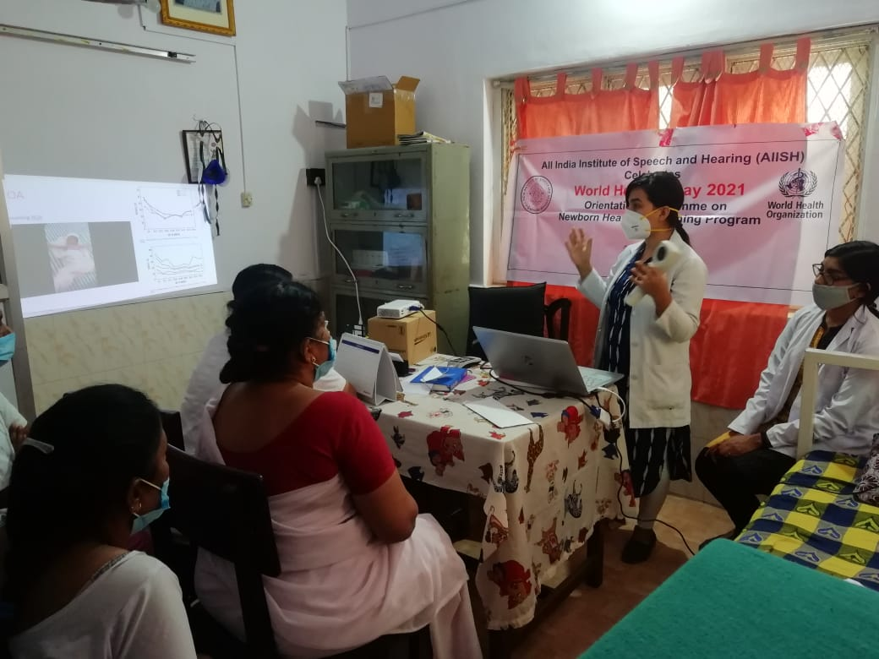

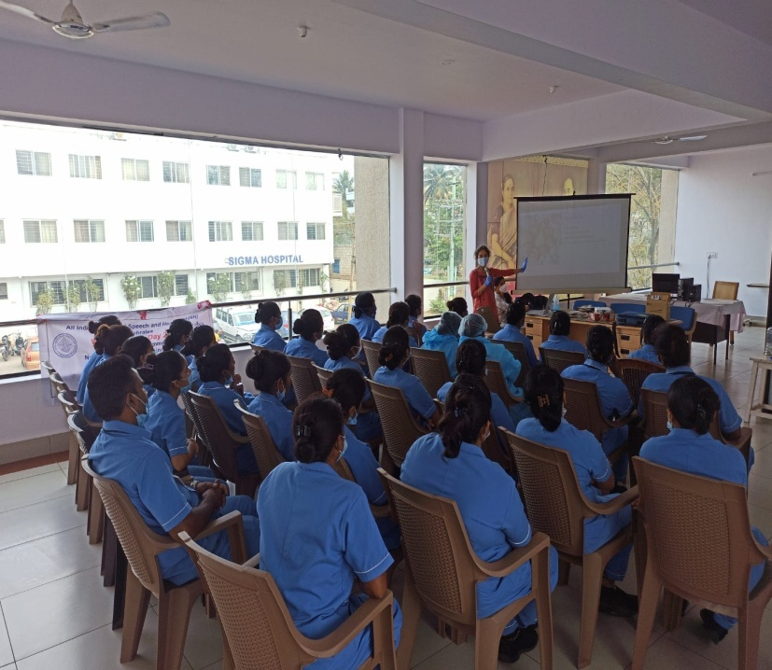

Glimpses of orientation programme conducted by POCD staff

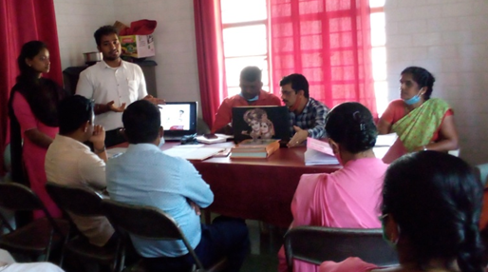

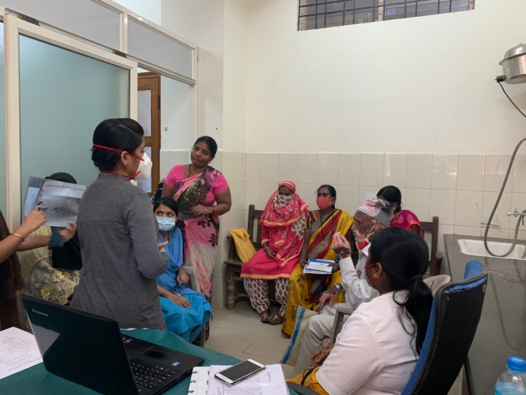

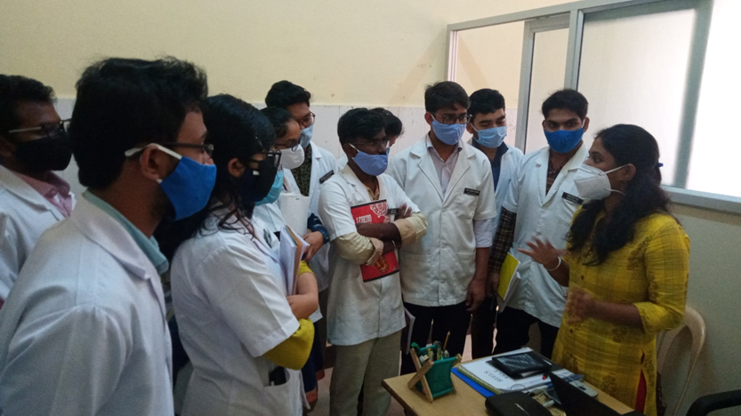

Glimpses of orientation programme conducted in various outreach service centers

1. **RESEARCH ACTIVITIES:**
2. Revision of epidemiological data sheet is in process

**III) EXTENSION ACTIVITIES**

The department of POCD is actively involved in carrying out various extension activities such as screening, diagnostic and rehabilitation services outside the institute campus. The activities include newborn/infant screening, screening of school children, screening of elderly citizens, screening of industrial workers, conducting camps and also clinical services offered at the outreach service centers of AIISH.

A. **New-born screening programs for Communication Disorders**

Table 6: Details of newborn screened in OSC and NBS centers in February2020.

|  |  |  |  |  |  |  |  |  |  |  |  |
| --- | --- | --- | --- | --- | --- | --- | --- | --- | --- | --- | --- |
| S. No | Hospitals/Immunization Centers | Total births | Total screened | | | Total No. at risk | | | Phone Follow up | | |
|  |  |  | Male | Female | Total | Male | Female | Total | Male | Female | Total |
| I. Mysuru Hospitals | | | | | | | | | | | |
|  | KR Hospital (KRH) - Cheluvamba | 709 | 234 | 196 | 430 | 17 | 13 | 30 | 19 | 11 | 30 |
|  | Kamakshi Hospital (KH) | 97 | 44 | 31 | 75 | 0 | 0 | 0 | 8 | 3 | 11 |
|  | Mission Hospital (MH) | 32 | 4 | 9 | 13 | 4 | 6 | 10 | 2 | 2 | 4 |
|  | Chamundeshwari nursing home | - | 3 | 1 | 4 | 0 | 0 | 0 | 0 | 0 | 0 |
|  | Ashwini Nursing Home (ANH) | 17 | 6 | 4 | 10 | 0 | 0 | 0 | 1 | 1 | 2 |
|  | Shree Devi Nursing Home (SNH) | 34 | 16 | 13 | 29 | 0 | 0 | 0 | 0 | 1 | 1 |
|  | St. Joseph’s Hospital | - | - | - | - | - | - | - | - | - | - |
|  | Mahadeshwara Nursing Home (MNH) | - | 8 | 4 | 12 | 2 | 0 | 2 | 0 | 1 | 1 |
|  | Sigma Hospital (SH) | 35 | 17 | 13 | 30 | 0 | 0 | 0 | 3 | 1 | 4 |
|  | Jayanagar Maternity Hospital | 105 | 55 | 41 | 96 | 1 | 0 | 1 | 3 | 2 | 5 |
|  | NPC Maternity hospital | 42 | 7 | 6 | 13 | 0 | 1 | 1 | 3 | 0 | 3 |
|  | Makkalakoota Immunization Centre | - | 10 | 10 | 20 | 0 | 0 | 0 | 1 | 1 | 2 |
|  | Kyathmanalli Immunization Centre | - | 3 | 3 | 6 | 0 | 0 | 0 | 0 | 0 | 0 |
| Total | | - | 407 | 331 | 738 | 24 | 20 | 44 | 40 | 23 | 63 |
| II. OSC Centers | | | | | | | | | | | |
|  | Sub-divisional hospital, K R Nagar Taluk | 184 | 17 | 16 | 33 | 1 | 1 | 2 | - | 1 | 1 |
|  | Sub-divisional Hospital, SagaraTaluk | 213 | 87 | 71 | 158 | 2 | 3 | 5 | 8 | 4 | 12 |
|  | St,Mary’s Hospital, HD kote | 90 | 49 | 36 | 85 | 19 | 13 | 32 | 2 | 5 | 7 |
|  | Vivekananda Memorial hospital, H. D. Kote Sarguru | 48 | 14 | 27 | 41 | 10 | 14 | 24 | 0 | 0 | 0 |
|  | Taluk Hospital, H. D. Kote- Immunization | 94 | 27 | 46 | 73 | 3 | 8 | 11 | 2 | 6 | 8 |
|  | Gulbarga Institute of Medica Sciences , Kalaburagi | 672 | 50 | 39 | 89 | 22 | 14 | 36 | 28 | 25 | 53 |
|  | Taluk General Hospital, KR. Pete | 60 | 28 | 22 | 50 | - | 2 | 2 | 1 | - | 1 |
|  | Community Health Centre (CHC), Santhemarahalli | 43 | 26 | 17 | 43 | 4 | 2 | 6 | 1 | 1 | 2 |
|  | Taluk Hospital, Yelandur | 14 | 7 | 7 | 14 | 1 | 1 | 2 | 1 | 0 | 1 |
|  | Primary Health centre (Under karuna trust), Gumballi | 32 | 18 | 14 | 32 | 0 | 1 | 1 | 3 | 3 | 6 |
|  | Taluk Hospital, Nanjangud | 114 | 56 | 60 | 116 | - | - | - | 14 | 19 | 33 |
|  | Community Health Centre (CHC), Hullahalli | 8 | 1 | 1 | 2 | - | - | - | - | - | - |
|  | Belagavi Institute of Medical Science, Belagavi | 321 | 131 | 120 | 251 | 18 | 21 | 39 | 0 | 1 | 1 |
|  | Kodagu Institute of Medical Science ,Kodagu | 276 | 115 | 108 | 223 | 2 | 1 | 3 | 16 | 9 | 25 |
| Total | | 2169 | 626 | 584 | 1210 | 82 | 81 | 163 | 76 | 74 | 150 |
| NBS Centers | | | | | | | | | | | |
|  | All India Institute of Physical Medicine and Rehabilitation (AIIPMR), Mumbai | 21 | 12 | 9 | 21 | 1 | 1 | 2 | 3 | 5 | 8 |
|  | Janana Hospital & JLNMCH, Ajmer | 743 | 284 | 165 | 449 | 5 | 6 | 11 | 11 | 4 | 15 |
|  | Jawaharlal Nehru Medical College & Hospital, Bhagalpur, Bihar | 242 | 88 | 67 | 155 | 11 | 11 | 22 | 3 | 1 | 4 |
|  | JIPMER, Puducherry | 478 | 199 | 206 | 405 | 30 | 26 | 56 | 27 | 18 | 45 |
|  | King George’s Medical  University (KGMU) Lucknow | 351 | 130 | 111 | 241 | 12 | 12 | 24 | 27 | 18 | 45 |
|  | NetajiSubhash Chandra Bose Medical College (NSCB), Jabalpur | 464 | 248 | 202 | 450 | 49 | 19 | 68 | 35 | 24 | 59 |
|  | Post Graduate Institute of Medical Education and Research (PGIMER), New Delhi | 93 | 51 | 36 | 87 | 9 | 5 | 14 | 7 | 1 | 8 |
|  | Rajendra Institute of Medical Sciences, Baritayu, Ranchi | 238 | 122 | 88 | 210 | 3 | 3 | 6 | 3 | 1 | 4 |
|  | Regional Institute of Medical Sciences (RIMS), Imphal | 185 | 71 | 98 | 169 | 4 | 5 | 9 | 2 | - | 2 |
|  | Sri DevarajUrs Academy Of Higher Education and Research (SDUAHER), Kolar | 173 | 76 | 57 | 133 | 0 | 0 | 0 | 22 | 18 | 40 |
|  | Sri Ramachandra Bhanj Medical College and Hospital (SCB MCH), Cuttack | 270 | 97 | 79 | 176 | 4 | 3 | 7 | 0 | 0 | 0 |
|  | All India Institute of Medical Science (AIIMS), Patna | 26 | 6 | 7 | 13 | 1 | 0 | 1 | 3 | 0 | 3 |
| Total (NBS centers) | | 3284 | 1384 | 1125 | 2509 | 129 | 91 | 220 | 143 | 90 | 233 |
| **Total (POCD+OSC+NBS)** | | **-** | **2417** | **2040** | **4457** | **235** | **192** | **427** | **259** | **187** | **446** |

**B) Tele- follow-up evaluation**

The at-risk babies were monitored regularly through Phone calls by administrating Speech-language & hearing developmental checklist. The babies identified with delay in any of the developmental milestones, were referred to AIISH/concerned center for detailed diagnostic evaluation.

Details of Tele-phone follow- up carried out at Hospitals in Mysuru.

|  |  |  |  |  |
| --- | --- | --- | --- | --- |
| **S. No.** | **Mysuru Hospitals** | **Number of infants with normal developmental milestones.** | **Total infants at risk** | **Total call attended/ Total no of calls** |
|  | Ashwini Nursing Home | 02 | - | 02/02 |
|  | Brindavan Hospital | 07 | 01 | 08/12 |
|  | Cheluvamba Hospital (KRH) | 28 | 04 | 32/54 |
|  | GopalaGowdaShanthaveri Memorial Hospital | - | - | - |
|  | Kamakshi Hospital | 03 | - | 03/04 |
|  | Mahadeshwara Nursing Home | 01 | - | 01/02 |
|  | Mission Hospital | - | - | - |
|  | S.M.T.D.H Hospital | 02 | - | 02/03 |
|  | Shree Devi Nursing Home | - | - | 00/01 |
|  | Shree Lakshmi DevammaShankarshetty Maternity Hospital | - | - | - |
|  | Sigma Hospital | 03 | - | 03/03 |
|  | Combined Hospital | 02 | - | 02/02 |
|  | **Total** | 48 | 05 | 53/83 |

Table 7: Details of Tele-phone follow- up carried out at OSCs in February 2021

|  |  |  |  |
| --- | --- | --- | --- |
| **OSC centers** | **Number of infants with normal developmental milestones.** | **Total infants at risk** | **Total call attended/ Total no of calls** |
| St. Mary’s Hospital , HD Kote | 27 | 0 | 27/42 |
| Vivekananda Memorial Hospital, Sarguru | 15 | 0 | 15/26 |
| Taluk Hospital, H. D. Kote- | 8 | 0 | 8/15 |
| GIMS, Kalaburgi | 74 | (Expired 6 babies) | 80/120  (Expired 6 babies) |
| Taluk General Hospital, KR. Pete | 2 | - | 2/2 |
| BIMS, Belagavi | 181 | (Expired 1 baby) | 182/257 |
| KoIMS,Madikkeri | 16 | 0 | 16/28 |
| **Total** | 323 | Expired babies – 07) | 329/490 |

*Note: The calls not attended were repeated a minimum of 5 times on consecutive days*

Table 7: Details of Tele-follow up carried out at NBS centers in February 2020

|  |  |  |  |
| --- | --- | --- | --- |
| **NBS Centres** | **Number of infants with normal developmental milestones.** | **Total infants at risk** | **Total call attended/ Total no of calls** |
| Ajmer | - | - | - |
| Bhagalpur | - | - | - |
| Cuttack | 05 | 00 | 05/05 |
| Delhi | - | - | - |
| Imphal | 04 | 02 | 06/06 |
| Jabalpur | 83 | 00 | 89/107 (6 died) |
| Kolar | 25 | 00 | 25/28 |
| Luknow |  |  |  |
| Mumbai | 08 | 00 | 8/8 |
| Patna |  |  |  |
| Puducherry | 17 | 00 | 17/23 |
| Ranchi | 10 | 00 | 10/10 |
| Shimla | - | - | - |
| **Total** | 152 | 02 | 160/187 |

Note: The calls not attempted were repeated a minimum of 5 times on consecutive days

**c) Tele screening Programs**

Tele-screening program (virtual mode) was carried out to identify the babies at risk for communication disorders since new born screening program couldn’t be carried out in many centers. The details including the behavioral responses of the new born to environmental sounds and HRR were collected from the parents through Tele-phone mode. The babies at risk were asked to undergo follow up evaluation in detail.

Table 8: Details of Tele-screening* at OSCs.

|  |  |  |  |  |  |
| --- | --- | --- | --- | --- | --- |
| **OSC Centre** | **Total Tele-screened / Total calls made** | **Mortality** | **Detailed Evaluation**  **(Referred)** | **Total infants at risk**  **(Screening)** | **Normal Speech and Language milestones**  **(Phone Follow up)** |
| Taluk General Hospital, KR. Pete | 5/5 | 0 | 0 | 0 | 5 |
| **Total** | 5/5 | 0 | 0 | 0 | 5 |

*Note:* for babies missed out during the pandemic situation for testing*

**C) Anganawadi /Preschool/School screening program**

Screening of Anganawadi, preschool and primary school children was conducted focusing on the early identification of communication disorders and early rehabilitation of children at risk for communication disorders.

Table 7: Total number of children screened for communication disorders and identified.

|  |  |  |  |  |  |  |  |  |
| --- | --- | --- | --- | --- | --- | --- | --- | --- |
| Date | Name of the Anganawadi/Preschool/ School | Total screened | | | Total referred with communication disorders | | | |
| Ear related disorder | Hearing loss | Speech language disorders | |
| Male | Female | Total | - | - | - |
| 03.02.2021 | Hearing screening at Anganawadi Hunsur(TK) | 19 | 21 | 40 | - | 7 | - |
| 10.02.2021 | Hearing screening at Hunsur | 18 | 15 | 33 | - | 5 | - |
| 24.02.2021 | Hearing screening at Anganwaadi Bhuvanahalli, Periyapatna(TK) | 26 | 11 | 37 | - | 1 | - |
| Total | | **63** | **47** | **110** | - | 13 | - |

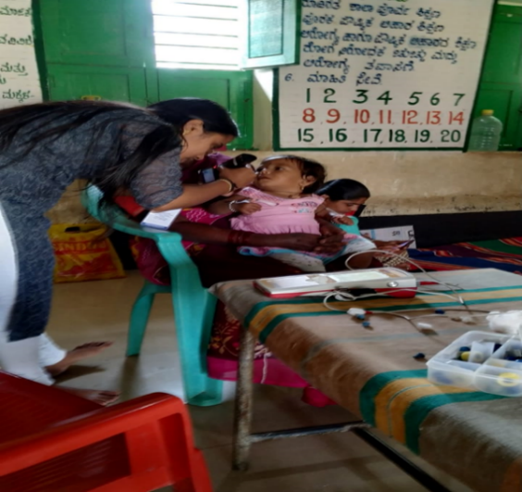

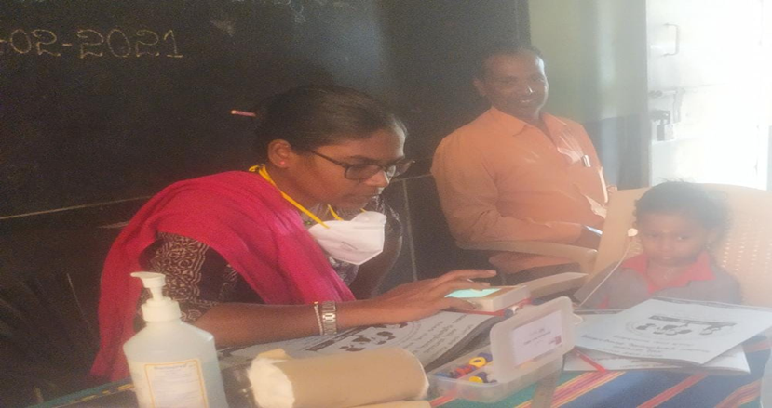

**D) New born follow-up evaluation (Detailed assessment)**

The newborns/infants referred during the newborn screening/ Tele-screening were advised for detailed evaluation at AIISH/NBS centers/OSCs. A complete test battery was administered for those babies/infants who came for follow-up.

Table 8: Details of the results of follow-up evaluation at OSC Centers

|  |  |  |  |  |  |  |  |  |
| --- | --- | --- | --- | --- | --- | --- | --- | --- |
| **Categories** | **Age range** | | **OSC- Akkihebbalu** | **OSC- Belagavi** | **OSC-K.R.Pete** | **OSC- Sagara** | **OSC- Sarguru** | **Total** |
| **Normal** | Newborn  (0-2 months) | Male | - | 18 | **-** | - | **9** | **27** |
| Female | - | 18 | 1 | - | **7** | **26** |
| Infants  (2-12 months) | Male | - | - |  | 1 | - | **1** |
| Female | - | - | - | - | - | - |
| Toddlers  (1 year to 4years) | Male | - | - | - | - | - | - |
| Female | - | - | - | - | - | - |
| Children  (above 4years) | Male | 1 | - | - | - | - | **1** |
| Female | - | - | - | - | - | - |
| **Hearing impairment** | Newborn  (0-2 months) | Male | - | 0 | - | - | - | - |
| Female | - | 1 | - | - | - | **1** |
| Infants  (2-12 months) | Male | - | - | - | - | - | - |
| Female | - | - | - | - | - | - |
| Toddlers  (1 year to 4years) | Male | - | - | - | - | - | - |
| Female | - | - | - | - | - | - |
| Children  (above 4years) | Male | - | - | - | - | - | - |
| Female | - | - | - | - | - | - |
| **Speech &language disorder** | Newborn  (0-2 months) | Male | - | - | - | - | - | - |
| Female | - | - | - | - | - | - |
| Infants  (2-12 months) | Male | - | - | - | - | - | - |
| Female | - | - | - | - | - | - |
| Toddlers  (1 year to 4years) | Male | - | - | - | - | - | - |
| Female | - | - | - | - | - | - |
| Children  (above 4years) | Male | - | - | - | - | - | - |
| Female | - | - | - | - | - | - |
| **Multiple Disorder/Syndromes** | Newborn  (0-2 months) | Male | - | - | - | - | - | - |
| Female | - | - | - | - | - | - |
| Infants  (2-12 months) | Male | - | - | - | - | - | - |
| Female | - | - | - | - | - | - |
| Toddlers  (1 year to 4years) | Male | - | - | - | - | - | - |
| Female | - | - | - | - | - | - |
| Children  (above 4years) | Male | - | - | - | - | - | - |
| Female | - | - | - | - | - | - |
| **Total** |  |  | 01 | **37** | **01** | **01** | **16** | **56** |

Table 9: Details of the results of follow-up evaluation carried out at NBS centers.

|  |  |  |  |  |  |  |  |  |
| --- | --- | --- | --- | --- | --- | --- | --- | --- |
| Categories | Age range | | IMPHAL | LUCKNOW | MUMBAI | PUDUCHERRY | RANCHI | Total |
| Normal | Newborn  (0-2 months) | Male | - | 02 | - | 01 | 02 | 05 |
| Female | - | 02 | - |  | 03 | 05 |
| Infants  (2-12 months) | Male | - | - | - | - | - | - |
| Female | - | - | - | 01 | - | 01 |
| Toddlers  (1 year to 4years) | Male | - | - | - | 02 | - | 02 |
| Female | 01 | - | - | 01 | - | 02 |
| Children  (above 4years) | Male | - | - | - |  | - | - |
| Female | - | - | - |  | - | - |
| Hearing impairment | Newborn  (0-2 months) | Male | - | - | - | 02 | - | 02 |
| Female | - | - | - | 01 | - | 01 |
| Infants  (2-12 months) | Male | - | - | - | 01 | - | 01 |
| Female | - | - | - | - | - |  |
| Toddlers  (1 year to 4years) | Male | 02 | - | - | - | - | 02 |
| Female | - | - | - | - | - | - |
| Children  (above 4years) | Male | - | - | - | - | - | - |
| Female | - | - | - | - | - | - |
| Speech & language disorder | Newborn  (0-2 months) | Male | - | - | - | - | - | - |
| Female | - | - | - | - | - | - |
| Infants  (2-12 months) | Male | - | - | 01 | - | - | 01 |
| Female | - | - | - | - | - |  |
| Toddlers  (1 year to 4years) | Male | 01 | - | 03 | - | - | 04 |
| Female | - | - |  | - | - |  |
| Children  (above 4years) | Male | - | - | 05 | - | - | 05 |
| Female | - | - | - | - | - | - |
| Multiple Disorder/Syndroms | Newborn  (0-2 months) | Male | - | - | - | - | - | - |
| Female | - | - | - | - | - | - |
| Infants  (2-12 months) | Male | - | - | - | - | - | - |
| Female | - | - | - | - | - | - |
| Toddlers  (1 year to 4years) | Male | - | - | - | - | - | - |
| Female | - | - | - | - | - | - |
| Children  (above 4years) | Male | - | - | - | - | - | - |
| Female | 01 | - | - | - | - | 01 |
| Total | | | 05 | 04 | 09 | 09 | 05 | 32 |

Table 10 Details of the results of detailed follow-up evaluation (**Referred from other depts.)**

|  |  |  |  |  |  |  |
| --- | --- | --- | --- | --- | --- | --- |
| Categories | Age range | | BHAGALPUR | LUCKNOW | RANCHI | Total |
| Normal | Newborn  (0-2 months) | Male | - | 02 | 03 | 05 |
| Female | - | 04 | 02 | 06 |
| Infants  (2-12 months) | Male | 01 | 02 | 01 | 04 |
| Female | - | 03 | - | 03 |
| Toddlers  (1 year to 4years) | Male | 03 | 14 | - | 17 |
| Female | 01 | 08 | - | 09 |
| Children  (above 4years) | Male | - | 01 | - | 01 |
| Female | - | 02 | - | 02 |
| Hearing impairment | Newborn  (0-2 months) | Male | - | 01 | - | 01 |
| Female | - | - | - | - |
| Infants  (2-12 months) | Male | - | 05 | - | 05 |
| Female | - | 01 | - | 01 |
| Toddlers  (1 year to 4years) | Male | - | 23 | 07 | 30 |
| Female | - | 16 | - | 16 |
| Children  (above 4years) | Male | - | 04 | 05 | 09 |
| Female | - | 07 | 04 | 11 |
| Speech & language disorder | Newborn  (0-2 months) | Male | - | - | - | - |
| Female | - | - | - | - |
| Infants  (2-12 months) | Male | - | - | - | - |
| Female | - | - | - | - |
| Toddlers  (1 year to 4years) | Male | - | - | 09 | 09 |
| Female | - | - | 02 | 02 |
| Children  (above 4years) | Male | - | - | 02 | 02 |
| Female | - | - | 03 | 03 |
| Multiple Disorders/Syndroms | Newborn  (0-2 months) | Male | - | - | - | - |
| Female | - | - | - | - |
| Infants  (2-12 months) | Male | - | - | - | - |
| Female | - | - | - | - |
| Toddlers  (1 year to 4years) | Male | - | - | - | - |
| Female | - | - | - | - |
| Children  (above 4years) | Male | - | - | 01 | 01 |
| Female | - | - | - | - |
| Total |  |  | 05 | 93 | 39 | 137 |

**D) Anganawadi /Preschool/School screening program**

Screening of preschool, primary school children was conducted focusing on the early identification of communication disorders and early rehabilitation of children at risk for communication disorders.

|  |  |  |  |  |  |
| --- | --- | --- | --- | --- | --- |
| **Date** | **Name of the School** | **Total screened** | **Total identified with communication disorders** | | |
| **Ear related disorder** | **Hearing loss** | **Speech language disorders** |
| 5/2/2021 | Government High school  Varuna Hobli  Mysore | 294 | 0 | 40 | 5 |
| 9/2/2021 | Government High school  Belavadi Taluk  Mysore | 97 | 0 | 10 | 10 |
| 10/2/2021 | JP Hindusthan First grade College, Mysore | 136 | 0 | 25 | 03 |
| 12/2/2021 | Adarsha Vidyalaya Government school, Mysore | 264 | 36 | 02 | 13 |
| 16/02/2021  & 17/2/2021 | Sree Nataraja Public School, Mysore | 204 | 24 | 01 | 01 |
| 19/2/2021 | Government High school  Varakodu  Varuna Hobli  Mysore | 174 | 27 | 03 | 09 |
| 26/2/2021 | Government High school  Hommaragalli  HD Kote Taluk | 362 | 05 | 16 | 06 |
| **Total** | | **1,531** | **92** | **97** | **47** |

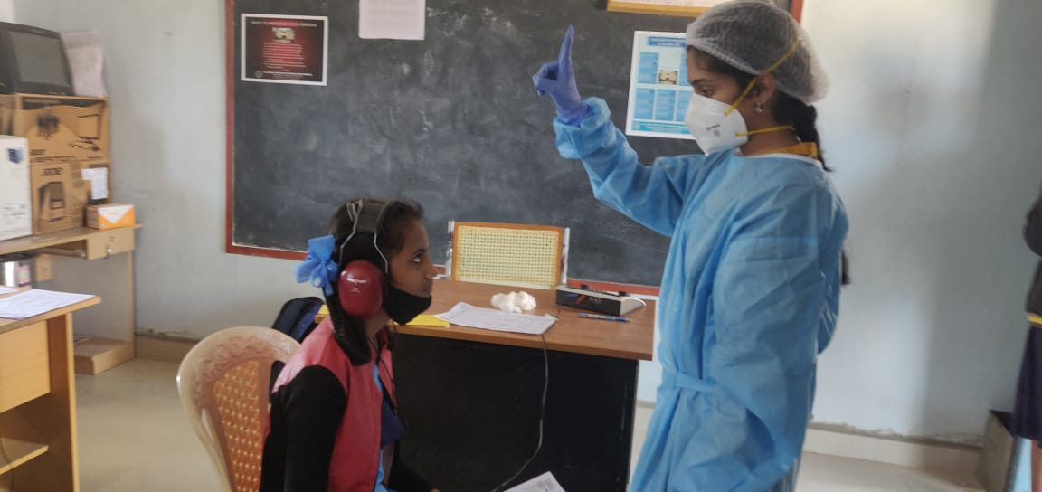

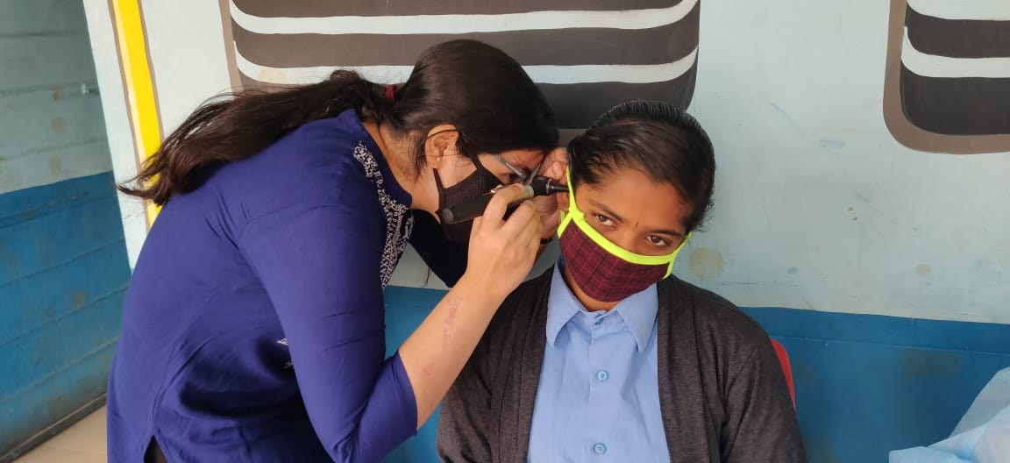

**E) Clinical Services at Outreach Service Centers (OSCs)**

The clinical activities are not only restricted to in and around Mysuru, but also extended to rural areas where facilities for clinical services for persons with communication disorders are scanty. Currently there are 08 OSCs centres at different part of the country rendering services to unreached population. The details of those who were registered and availed various services/benefits at the OSCs are tabulated below.

1. **Clients identified and followed up with communication disorders at OSCs**

Table 11: Details of clients identified and followed up with communication disorders at OSCs.

|  |  |  |  |  |  |  |  |  |  |
| --- | --- | --- | --- | --- | --- | --- | --- | --- | --- |
| **S. No** | **OSC Centre** | **Total registered** | | **ENT Evaluation** | | **Hearing Evaluation** | | **Speech & Language Evaluation** | |
| Normal | Disorder | Normal | Disorder | Normal | Disorder |
|  | Taluk Hospital, Nanjangud | New cases | 26 | - | 22 | 10 | 34 | - | 4 |
| F/u Old | - | - | - | - | - | - |  |
|  | Community Health Centre (CHC), Hullahalli | New cases | 20 | - | 18 | 2 | 10 | - | 2 |
| F/u Old | 15 | - | 13 | 2 | 10 | - | 2 |
|  | Primary Health Centre (PHC), Akkihebbalu | New cases | 15 | - | 14 | - | 6 | 2 | - |
| F/u Old | 6 | - | 4 | - | 4 | - | - |
|  | Taluk General Hospital, KR Pete | New cases | 48 | - | - | 33 | 65 | - | 6 |
| F/u Old | 8 | - | - | - | 16 | - | - |
|  | Primary Health Centre (PHC), Gumballi | New cases | 67 | 0 | 49 | 0 | 24 | 0 | 6 |
| F/u Old | 29 | 0 | 23 | 0 | 12 | 0 | 0 |
|  | Sub-divisional Hospital (PHC), Sagara | New cases | 12 | - | - |  | 18 |  | 4 |
| F/u Old | 4 | - | - | 2 | 2 |  | 3 |
|  | Vivekananda Memorial Hospital, Sarguru | New cases | 22 | - | - | 19 | 25 | - | 4 |
| F/u Old | - | - | - | - | - | - | - |
|  | Gulbarga Institute of Medical Sciences | New cases | 262 | 80 | 182 | 51 | 339 | - | 55 |
| F/u Old | - | - | - | - | - | - | - |
|  | Belagavi institute of medical sciences (BIMS), Belagavi | New cases | 212 | - | - | 282 | 108 | - | 17 |
| F/u Old | 3 | - | - | 0 | 6 | - |  |
|  | Kodagu Institute of Medical Sciences, Madikkerri | New cases | 138 | - | - | 117 | 159 | 0 | 11 |
| F/u Old | 2 | - | - | 2 | 2 | 0 | 1 |

1. **Table 12: Clients identified with different types of communication disorders across OSCs**

|  |  |  |  |  |  |  |  |  |  |  |
| --- | --- | --- | --- | --- | --- | --- | --- | --- | --- | --- |
| **Type of Disorders** | **OSC** | | | | | | | | | |
| Taluk Hospital, Nanjangud | Primary Health Centre (PHC), Hullahalli | Primary Health Centre (PHC), Akkihebbalu | Taluk General Hospital, KR Pete | Primary Health Centre (PHC), Gumballi | Sub-divisional Hospital, Sagara (PHC) Taluk | VMH,  Sarguru | BIMS Belagavi | GIMS, Kalburgi | KoIMS,  Kodagu |
|  |  | **Hearing disorders (Ear-wise data)** | | | | |  |  |  |  |
| Normal | 10 | 02 | 01 | 33 | 00 | 02 | 19 | 282 | 51 | 117 |
| Conductive | 15 | - | - | 4 | 00 | 01 | 11 | 17 | 42 | 11 |
| Sensori- neural | 10 | 02 | 05 | 14 | 20 | 08 | 03 | 49 | 119 | 64 |
| Mixed | 02 | - | 04 | 23 | 04 | 04 | 02 | 06 | 49 | 13 |
| No type (Minimal & Profound) | 07 | - | - | 24 | 00 | 07 | 09 | 10 | Minimal- 53  Profound-76 | 71 |
| **Aud-Total (ears)** | 44 | 12 | 10 | 98 | 24 | 22 | 44 | 390 | 470 | 276 |
| **Aud-Total (Individuals)** | 22 | 06 | 05 | 49 | 12 | 11 | 22 | **195** | 235 | 138 |
|  |  |  | | | | | |  |  |  |
| Voice | - | - | - | - |  |  |  | - | 04 | 01 |
| Fluency | - | - | - | 01 |  |  |  | 01 | 02 | 03 |
| Articulation disorders | - | 01 | - | - | 01 |  |  | 02 | 06 | 03 |
| Language disorders | 04 | 01 | 02 | 05 | 05 | 07 | 04 | 14 | 43 | 04 |
| **Total (Individuals)** | 04 | 02 | 02 | 06 | 06 | **07** | **04** | 17 | **55** | **11** |

1. **Table 13: Clients followed up with different types of communication disorders at OSCs**

|  |  |  |  |  |  |  |  |  |  |  |  |
| --- | --- | --- | --- | --- | --- | --- | --- | --- | --- | --- | --- |
| **Type of Disorders** |  |  | | **OSC** | | | |  |  |  |  |
| Taluk Hospital Nanjangud | Primary Health Centre (PHC), Hullahalli | Primary Health Centre (PHC), Akkihebbalu | | Taluk General Hospital, KR Pete | Primary Health Centre (PHC), Gumballi | Sub-divisional Hospital,  Sagara  (PHC) Taluk | VMH,  Sarguru | Belagvi institute of medical sciences BIMS | GIMS, Kalburgi | KoIMS-TH, MadikeriTaluk,Kodagu |
|  | **Hearing disorders (Ear-wise data)** | | | | | | | | | | |
| Normal | - | 02 | - | | - | - | - | - | 00 | - | 02 |
| Conductive | - | - | - | | - | 02 | - | - | 00 | - | 01 |
| Sensori- neural | - | 04 | 01 | | 05 | 04 | - | - | 01 | - | - |
| Mixed | - | 01 | 03 | | 10 | 06 | - | - | 00 | - | - |
| No type (Minimal & Profound) | - | 01 | - | | 01 | - | - | - | 05 | - | 01 |
| **Aud-Total (ears)** | - | 12 | 04 | | 16 | 06 | **-** | - | 06 | - | 04 |
| **Aud-Total (Individuals)** | - | 06 | 02 | | 08 | - | **-** | - | 03 | - | 02 |
|  |  |  | | | | | | |  |  |  |
| Voice | - | - | - | | - | - | - | - | - | - | - |
| Fluency | - |  | - | | - | - | - | - | - | - | - |
| Articulation disorders | - | 1 | - | | - | - | - | - | - | - | - |
| Language disorders | - | 1 | - | | - | - | - | - | - | - | 1 |
| **Sp&Lg -Total (Individuals)** | - | 2 | - | | - | - | - | - | - | - | **1** |

1. **Rehabilitation services at OSCs.**

Table 14: Details of rehabilitation services provided at OSCs in February 2020.

|  |  |  |  |
| --- | --- | --- | --- |
| **OSC** | **Hearing Aids Dispensed** | **Tele-Speech-language therapy** | |
| No. of clients | No. of sessions |
| Taluk Hospital, Nanjangud | 10 | 6 | 21 |
| Primary Health Centre (PHC), Hullahalli | - | 2 | 2 |
| Primary Health Centre (PHC), Akkihebbalu |  |  |  |
| Taluk General Hospital, KR Pete | 10 | 2 | 10 |
| Primary Health Centre (PHC), Gumballi |  |  |  |
| Sub-divisional Hospital, Sagara (PHC) Taluk |  | 14 | 67 |
| VMH, Sarguru |  | 7 | 36 |
| Belagavi institute of medical sciences BIMS |  | 9 | 30 |
| GIMS, Kalburgi |  | 12 | 76 |
| KoIMS-TH, MadikeriTaluk |  | 10 | 47 |
| **Total** | **20** | **62** | **289** |

**d) Table 15: Screening Camps for communication Disorders**

|  |  |  |  |  |  |  |  |  |
| --- | --- | --- | --- | --- | --- | --- | --- | --- |
| Date | Camp site | Total Screened | Total Referred | | | | Total hearing aid distributed | Total |
| Hearing impairment | | Speech- language disorders | |
| Male | Female | Male | Female |  |  |
| 02.02.21 | Primar Health Centre, Hadinaru | 108 | 45 | 15 | 11 | 14 | 18 | - |
| 18.02.21 | Yamkanamaradi | 290 | 09 | 10 |  | - | - | - |
| 18.02.21 | Gulbarga | 29 | 17 | 14 | 07 | - | - | - |
| 15-20.02.21 | VMH,Sarguru | 43 | 28 | 15 |  | - | 07 | - |
| 22.02.21 | Pachapur | 328 | 09 | 02 |  | - | - | - |
| 22.02.21 | Gulbarga | 30 | 28 | 20 | 02 | - | - | - |
| 22.02.21 | Primary Health Centre, Gumballi | 19 | 13 | 06 | 00 | - | 19 | - |
| 22-27.02.21 | VMH,Sarguru | 20 | 11 | 09 | - | - | 18 | - |
| 23.02.21 | Hudali | 367 | 19 | 08 | 03 | - | - | - |
| 23.02.21 | Ward 11, Sagara Taluk | 48 | 04 | 03 | - | - | - | - |
| 24.02.21 | Hebal | 412 | 10 | 14 | 01 | 01 | - | - |
| Total | | 1694 | 193 | 116 | 24 | 15 | 62 |  |

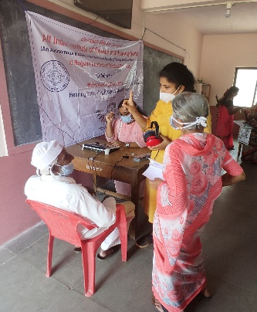

**IV) TECHNOLOGICAL CONSULTANCY SERVICES: NIL**

**V) CENTRAL FACILITIES**

**a) Library and information Services: NIL**

VI) **MAJOR EVENTS OF THE MONTH**:

1. MOU was signed between the two parties (All India Institute of Physical Medicine and Rehabilitation and Lokmanya Tilak Hospital) in Mumbai. Screening in Poddar and Tilak hospital will be started from 1st March, 2021.

**VII) OTHERS**

1. Submitted details for the NAAC committee
2. Conducted various activities as part of the World Hearing Day **VII) ACTIVITIES CARRIED OUT BY THE STAFF OF THE DEPARTMENT OF POCD.**

Table 16: Details of activities carried out by POCD staff in October 2020.

|  |  |  |  |
| --- | --- | --- | --- |
| **S.No.** | **Name of the staff** | **Designation** | **Activities** |
|  | Dr. Sandeep M. | * Head, Dept. of POCD (i/c) | * Officiating as HOD-POCD incharge * Coordinated all OSC NBS activities * Coordinated World Hearing Day activities. |
|  | Mr. Arunraj. K | Audiologist/SLP | * Coordinated Outreach Service Centre activities * Coordinated computerisation activities * Coordinated for sending equipments to the all OSC and NBS centers based on the requirement * Verified MoU and minutes for new OSC centers * Coordinated initiation of new OSCs in various parts of the country. |
|  | Ms. Ranjini A | Audiologist Gr. I | * Called phone follow-up infants enquiring about their developmental milestones (10 calls). * Did detailed Follow up Audiological Evaluation for for 10 KSIC Industrial Workers. * Did detailed Audiological Evaluation for Referred Newborn cases. * Listed out 100 restaurants in India to distribute pamphlets as part of World Hearing Day. * Designed standees for World Hearing Day. * Prepared slides for video as part of World Hearing Day. * Compilation of referred cases and follow-up cases of all hospitals of January month. * Prepared monthly NBS report for January month. * Participated and oriented teachers in School screening at Varakodu on 19.02.21 as part of World Hearing Day. * Participated in School screening at Hommaragalli, HD Kote on 26.02.21 as part of World Hearing Day. * Recorded radio talk as a part of World Hearing Day. |
|  | Ms. Srividya S | Audiologist Gr. I | * Did detailed Follow up Audiological Evaluation for KSIC Industrial Workers. * Did detailed Audiological Evaluation for Referred Newborn cases. * Organised orientation Programme and Oriented nurses of NPC Maternity Hospital about Newborn Screening Programme on 4.02.21 as part of World Hearing Day. * Organised and attended School screening camp on 05/02/21 held in Govt. High school, Varuna Hobli, Mysore. * Edited slides for orientation of teachers, nurses on communication disorders. * Edited slides for orientation of teachers, nurses &amp; industrial employees on communication disorders. * Organised and attended School screening camp on 10/02/21 held in J.P.Hindusthan P.U College, Mysore. * Organised and attended School screening camp on 17/02/21 held in Nataraja Public School, Mysore. * Recorded and Edited videos regard ‘prevention of Hearing loss’. * Organised orientation Programme for nurses of Mahadeshwara Nursing Hospital about Newborn Screening Programme on 18.02.21 as part of World Hearing Day. * Organised orientation Programme and Oriented nurses of Kyathmarnahalli about Newborn Screening Programme on 23.02.21 as part of World Hearing Day. * Designed poster for webinar on ‘Noise and its Harmful Effects’ held as a part of World Hearing Day. * Organised and attended School screening camp on 26/02/21 held in Govt. High School, Homragalli , H.D. Kote , Mysore. * Analysed data of all school screening camps held on 5 th , 9 th , 10 th , 12 th , 16th, 17th, 19th and 26 th in different schools around Mysore. * Recorded radio talk as a part of World Hearing Day. |
|  | Ms. Dibya Aryal | Speech Language Pathologist Gr. I | * Compilation of referred cases and follow-up cases of all hospitals of January month. * Prepared monthly NBS report for January month. * Participated in hearing screening camp at Hadinaru PHC on 02.02.21 as part of World Hearing Day. * Participated in School screening camp at Adarsha Vidyalaya on 12.02.21 as part of World Hearing Day. * Organized and conducted webinar for expecting mothers on 21.02.2021 as a part of World Hearing Day. * Called phone follow-up infants enquiring about their developmental milestones (7 calls). * Did detailed Follow up Audiological Evaluation for for 10 KSIC Industrial Workers. * Did detailed Audiological Evaluation for Referred Newborn cases. * Translated FAQs on voice disorders to Hindi langauge |
|  | Ms. Tanuja M.N | Audiologist Gr. II | * Oriented teachers about communication disorders at varuna Government high school varuna on 5.2.2021. * Attended school screening camp at Government high school varuna on 5.2.2021. * Attended school screening camp at Government high school belvadi on 9.2.2021. * Attended school screening camp at Nataraja Public School on 16.2.2021. * Oriented staff nurses of kamakshi about new born hearing screening and early identification of childhood hearing loss on 15.2.2021. * Oriented staff nurses of Ashwini nursing home about new born hearing screening and early identification of childhood hearing loss on 3.2.2021. * Prepared Script for DCS orientation * Finalised PPT about hearing disorder of orientation for navodaya staff nurses. * Finalised poster for webinar on communication disorders for staff nurses & TGTs Science. * Organized webinar on communication disorders for staff nurses &amp; TGTs Science on 26.2.2021. * Completed phone follow up for the month January. |
|  | Ms. Nayanika Ghosh | SLP Gr. I | * Presented Webinar to Navodaya TGTs and Staff nurses- Hyderabad division – 26.02.21 * Outside NBS centres monthly report and SPSS data verified and compiled * Completed orientation for Kamakshi Hospital nurses on 15.02.21 as part of World Hearing Day * Participated in University of Mysore Camp at Senate Bhavan on as part of World Hearing Day on 23.02.21. * Participated in Railways Camp as part of World Hearing Day on 25.02.21. * Phone follow-up done * Did detailed Audiological Evaluation for Referred Newborn cases. * Did detailed Follow up Audiological Evaluation for KSIC Industrial Workers. * WHD Fun Facts finalised – Saturday (20.02.21) * Helped to design WHD Standee * Helped to edit and launch AIISH webpage on World Hearing Day * List of 100 restaurants for collaboration for World Hearing Day compiled, and email sent for the same * FAQ on Voice Disorders translated to Hindi |
|  | Ms. Merina Thomas | Audiologist Gr. I | * Verified and compiled monthly report work of all OSC * Went for Newborn Hearing Screening on all Monday, Wednesday and Fridays. * Went for Industrial follow up hearing evaluation on 11.02.21 * Carried out NBS phone follow up on 23.02.21 * Prepared minutes and MOU for Agartala,3 centres in Delhi and Jodhpur. * Repaired hearing aids were collected and were distributed to Gumballi and Nanjangud centres. * Carried out auditing of instruments in 8 OSCs. * Send the required essentials to Sarguru, Gumballi, Nanjangud and K.R Pete. * Individual meeting with the OSCs were carried out. * Distributed a total of 193 hearing aids to 6 OSCs(29-Nanjangud,24-Gumballi,10- K.R.Pete,20-Kodagu,10-Sagara and 100-Sarguru) * Prepared reply letter for upcoming OSCs (Nilambur,Patna,Bidar,Hubli) * Participated in School Screening Camp at Belvadi Government Higher Secondary school on 9.02.21 as part of World Hearing Day. * Organised Nurses orientation in Shri Chamundeshwari Nursing Home on 12.02.21 as part of World Hearing Day. * Organised and Participated in free hearing aid distribution program at Primary Health Centre, Gumballi and Taluk Government hospital,K.R.Pete. * Carried out orientation program for Navodya teachers on Hearing and related disorders on 26.02.21. * Participated in Hearing screening and Hearing Aid Fine Tuning camp at Audiology block, AIISH on 28.02.21 |
|  | Ms. Christy Sebastian | Audiologist Gr. I | * Data entry and analysis of Industrial Screening of L & T, Bangalore. Report of Screening camp was made and the list of referral cases sent to the company. * Organized industrial follow up for KSIC industrial workers. * conducted detailed Audiological Evaluation for KSIC Industrial Workers. * Made audiological reports of the follow up cases from KSIC. * Conducted detailed Audiological Evaluation for Referred Newborn cases. * Organised and attended hearing screening and hearing aid distribution camp 02/02/21 held at Haddinaru, Nanjangud. * Organised orientation Programme at NPC Maternity Hospital about Newborn Screening Programme on 4.02.21 as part of World Hearing Day. * Organised and attended screening camp on 10/02/21 held in J.P.Hindusthan P.U College, Mysore. * Did orientation at J.P.Hindusthan P.U College, Mysore for students and staffs on 10/02/2021. * Organised and attended School screening camp on 17/02/21 held in Nataraja Public School, Mysore. * Organised orientation Programme for nurses of Mahadeshwara Nursing Hospital about Newborn Screening Programme on 18.02.21 as part of World Hearing Day. * Organized orientation Programme at Kyathmarnahalli about Newborn Screening on 23.02.21 as part of World Hearing Day. * Organised and attended School screening camp on 19/02/21 held in Govt. High School, Varakodu, Mysore. * Contacted Manager of Jockey factory, KR Pete, for Industrial hearing screening camp. * Contated Dr. Preeti for organizing the webinar and Industrial Hearing screening at Ballari. * Organised and attended Hearing screening and Hearing aid distribution camp on 22/02/21 held in Gumballi, Chamrajanagara. * Attended Hearing screening and Hearing aid distribution camp on 28/02/21 held in AIISH, Mysore. |
|  | Ms. Pauline Gracia R V | SLP Gr. II | * Faculty name list updated. * Voice over for comic * Designed 2 boards for OSCs * Designed poster for NBS * WHD activities - Content made and sent for social media updation * WHD programs updation on WHO page – Hearthon2021. * POCD portal updation. * Attended 4 camps * Attended NBS * NBS phone follow up * Hearing evaluation (NBS &Industrial follow up) * SPSS format for camp- industrial, elderly, school (not yet finalised) * Nurses orientation |
|  | Ms. Kranti Acharya | SLP Gr. I | * Called phone follow-up infants enquiring about their developmental milestones. * Did detailed Follow up Audiological Evaluation for KSIC Industrial Workers. * Did detailed Audiological Evaluation for Referred Newborn cases. * Listed out 30 restaurants in India to distribute pamphlets as part of World Hearing Day. * Orientation to students regarding the activities of POCD and instructions to be followed in department posting. * Checked and verified the overall log sheets of students. * Corrected PowerPoint slides of article presentation of Msc students. * Compilation of student’s attendance posted in POCD dept. * Corrected and verified the FAQ on Stuttering and Voice disorder. * Organised orientation Programme and Oriented nurses of Shree Chamundeshwori Nursing home about Newborn Screening Programme on 12.02.21 as part of World Hearing Day. * Listed 30 restaurants name and contact details to circulate the information of world hearing day. * Participated and oriented teachers and students in School screening at Nataraja School on 16.02.21 as part of World Hearing Day. * Participated in Hearing screening at University of Mysore (UOM) 23.02.21 as part of World Hearing Day. * Participated in Hearing screening at Railway Division Mysore 25.02.21 as part of World Hearing Day. |
|  | Ms. Ankitha.S | SLP Gr. II | * Organised and attended school screening camp on 09.02.2021 at Belavadi, Mysore * Organised and attended Hearing screening and Hearing aid distribution camp at Gumbali on 22.02.2021 * Did detail Audiological evaluation for KSIC workers, Mysore. * Did detail Audiological evaluation for referred newborn cases. * Conducted Webinar on 26.02.2021 for Staff nurses and TGTs of JNVs, Hyderabad region * Prepared google form of school screening check list (FAQ) and orientation pre- post form for Webinar (JNVs). * Prepared slides and poster of webinar for JNVs, Hyderabad region and industrial employees (Bellary). * School screening data and orientation feedback form data analysed. * Organised orientation for Chamundeshwari * Hospital Staff Nurse on 12.02.2021,Mysore. |
|  | Ms. Reshma O | SLP Gr. I | * Orientation done for nurses at ANH hospital on 03/02/2021 * Orientation done for nurses at Kamakshi hospital on 15/02/2021 * Attended camp at Hadinaru on 02/02/21 * Conducted free hearing aid distribution program at K R Pete in the OSC centre on 24/02/21 * Carried out NBS at various hospitals in Mysuru * Hearing evaluation done (NBS follow up and industrial follow up) * Initiated elderly screening camp at B R Hills paper works * Carrying out paper works for resuming bedside screening at K R hospital * Followed up at risk babies (12nos.) |
|  | Mr. Kalaiyarasan R | Aud Gr. I | * Coordinated with the Railways department to conduct an hearing screening camp on 25th Feb 2021as a part of WHD 2021 * Coordinated with the company person to rectify the issues in Neuroaudio ascreen – smartphone based oae screener * Equipments pending report prepared (asked from stores section) * PA5 equipment has been sent to NBS centers (Patna, Shimla, Imphal, Pondichery) * NBS follow up and Industrial follow up * Interview script work done in Tamil for WHD 2021 |
|  | Mr. Ashwath K | SHT | * Standees placing as part of WHD 2021 * Industrial screening data entry * Follow up data updation |
|  | Ms. Deepika. R | Office assistant Grade II | * Submitted contract staff attendance, TA bills, interns attendance * Assisted in preparing and communicating camps reports * Assisted in WHD activities paper works * Prepared letters for orientations and webinars * Settled suppliers advance and Imprest cash * Assisted in Coordinating OSC and NBS requests and activities * Filed the official documents on a daily basis * Prepared Monthly report January 2020 * Submitted intern’s attendance * Prepared departmental meeting minutes * Submitted C1 and C2 marks * Correspondence to all the mails received in the dept. * Prepared inauguration letters for all new OSCs * Prepared and communicated camp letters and staff deputation letters * Routine work of gate pass, indent, work orders, local purchase indents, registers maintaining etc. |

Sd/-

Dr. Sandeep M

विभागाध्यक्ष पी ओ सी डी **-**Head, Department of POCD(i/c)