DEPARTMENT OF SPECIAL EDUCATION
विशेषशिक्षाविभाग
MONTHLY REPORT: February 2021

- ACADEMIC ACTIVITIES
- Orientation Programs (For outsiders): NIL
- Clinical /Special Educational postings and/or Observation Postings
- Students from Other Institutes: NIL
- AIISH Students in Other Institutes:NIL
- Seminars/Conferences/Workshops/Training Programs:
Theme/topic | Webinar on “ Role of multidisciplinary team approach in successful rehabilitation of children with communication disorder”
Coordinators | Dr. Alok Kumar Upadhayay, Ms. K. Anjana, Dr. Kadambari N.
Resource Persons | - Dr. S. P. Goswami  Professor & Head, Dept of Speech-Language Pathology  - Dr. Prawin Kumar  Associate Professor and HOD, Audiology  - Dr. Sanjeev Kumar Gupta  Clinical Psychologist  - Dr. Prithi Venkatesh  Reader in Special Education
Objectives | Webinar will be creating awareness of how to combine the following in classroom settings:  - Speech Therapy goals,  - Listening Therapy goals,  - Educational goals, and  - Giving an insight on managing behaviour problems in the classroom with the help of behaviour therapists.  - The participants will also be able to enhance their knowledge and skills to handle children with special needs in an inclusive set-up.
Targeted Audience | Special Educators and Allied professionals
Number of Participants | 100
Date | 4-5, February 2021
Accreditation | AIISH, Mysuru
Photo
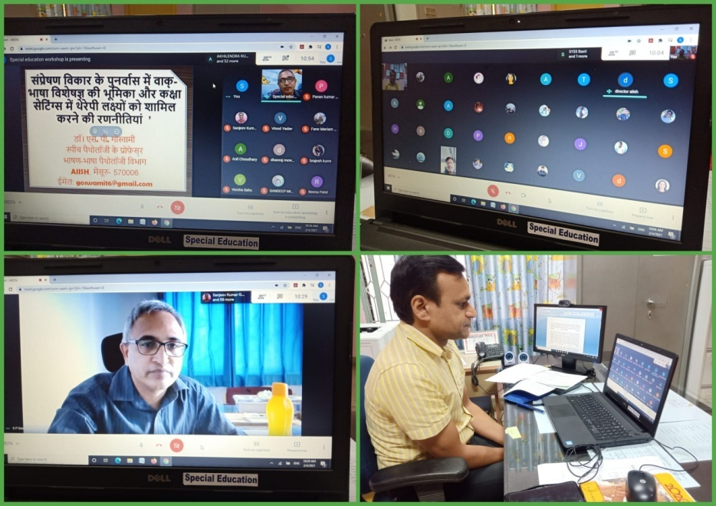

- Staff enrichment / In-house training programs: 01
SL No. | Coordinator | Targeted Audience | Number  of Participants | Date
1 | P.V.Ramanakumari | Special Educators Organised and attended orientation by Mr. Arjun Singh from globus regarding DTDS. | 15 | 23.02.2021
 | 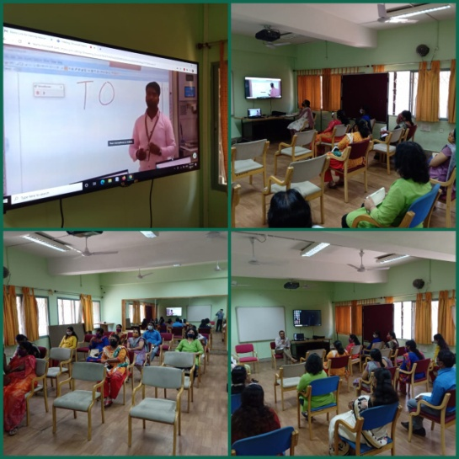

- Staff Enrichment Programs (For own staff members): NIL
- Guest Lectures: NIL
- Additional Academic Services rendered by the Faculty and Staff:

- Invited Talks: 06
S.no. | Name, Designation, Institutional affiliation of Speaker | Organized by | Programme | Topic of Lecture | Date
 | Dr. Kadambari N, Special Educator, Served as Anchor | AIISH | Doordarshan | Information decimation on Special Education | 03.02.2021
 | Dr.Prithi Venkatesh  Reader  Special Education | Department of Special Education, All India Institute of Speech and Hearing  Mysuru-570006 |  | Role Of Special Educators In Educational Rehabilitation Of Children With Communication Disorders And Strategies To Include Therapy Goal In Thier Classroom Teaching | 05.02.2021
 | Dr.Prithi Venkatesh  Reader  Special Education | Regional Institute of Education, Mysuru |  | Adaptation for Children with Hearing Impairment | 10.02.2021
 | Ms. Shobha B. N, Special Educator Served as resource person | AIISH | Doordarshan | Information decimation on Special Education | 12.02.2021
 | Ms. Ramanakumari P V, Served as resource person for Janadwani radio phone in program. | AIISH | Janadwani radio | Mainstreaming of children with intellectual disability | 24.02.2021
 | Dr. Alok Kumar Upadhyay,Associate Professor,AIISH,  Mysore | IIRD,Agra(U.P) | National Webinar | Teaching Strategies for Functional Writings | 26.02.2021
 | Ms. Subalakshmi J, Special Educator, Served Resource person | Dr.NanduRadhakrishnan  Associate Professor, Speech and Hearing Sciences, Director, Voice Lab and Vocology Clinic, Lamar University, Beaumont, Texas. | You Tube  https://youtu.be/CWv-9vdKO3Y | Art and Craft in Education | 28.02.2021
- Development of Material to Support Learning: NIL
- Curriculamdevelopment:NIL
- Academic Classes: By faculty–
- Theory classes (no. of hours):
Name of the Faculty | No. of hours of theory classes
 | DECSE-HI | B.Ed.Spl.Ed. (HI) | Total
Dr.Alok Kumar Upadhyay | -- | 20 | 20
Dr.Prithi V | 15 | 20 | 35
Dr.PalnatyVijetha | -- | 22 | 22
Total no. of hours |  |  | 77

- Practical Classess (no. of hours):

Name of the Faculty | No. of hours of practical classes
 | DECSE-HI | B.Ed.Spl.Ed. (HI) | Total
Dr.Alok Kumar Upadhyay | -- | 28 | 28
Dr.Prithi V | 56 | 28 | 84
Dr.PalnatyVijetha | -- | 14 | 14
Total no. of hours |  |  | 126

- Service in Academic Bodies of other Organizations:
- Dr.Alok Kumar Upadhyay

- Member, Board of Studies (BOS):
    - RamkrishnaMission Vivekananda University, Coimbatore: for Diploma, U.G & P.G.
    - N.G.B. University, Allahabad: for U.G & P.G.
    - J.R.H. University, Chitrakoot: for U.G & P.G.
    - Mysore University,Mysuru :for U.G & P.G.

- Member, Board of Examiners (BOE):
    - UG Special Education of University of Mysore.

- Dr. PrithiVenkatesh
    - Member, BOE–UG Special Education of University of Mysore

- Dr.PalnatyVijetha
    - Member of BOS in special education, University of Mysore
    - Member of BOS in Human development (CB & PG), University of Mysore.
    - Member of BOEin special education, University of Mysore
- Participation in Committees/Taskforce and Panels setup by other organizations/agencies:NIL
- Any Others (Please Specify):

- Preschool In-charge:-

- Coordinating activities pertaining to preschool, safety measures during COVID-19, drafting of letter for requesting additional staff.
- Providing Pre-school Statistics to Director madam on a weekly basis regarding online and offline class

Inclusive Therapy Park
- Coordinating activities and attending meeting with Dean –Infrastructure.
- Preparation and submission of minutes of the meeting held on 22nd February 2021.

Serving as DHLS Mumbai Centre Coordinator
- Coordinating activities with Mumbai Centre for regarding procurement of Computer and other essential equipments.
- Followed up regarding the total number of admissions for the academic year 2021.
- Conducted meeting with DHLS Staff and Students (Mumbai Centre) on 25th February 2021).
- Discussed issue regarding repairing of headphones etc.

Model Preschool:
- Serving as member secretary for the Model Preschool at Varuna Campus.
- Drafted and submitted letters to external experts for the purpose of constitution of committee.
- Coordinating other works pertaining to development of Model Preschool.
- Attended meeting with Director, AIISH , Mysuru on 25th February 2021 and did a presentation regarding 23rd February 2021.

World Hearing Day
- Coordinated video –recording at EMMRC as a part of the ‘World Hearing Day’.
- Prepared and submitted budget approval letters.
- Attended meeting and provided updates regarding the completion of work.
- Coordinating with resource persons and anchors for script writing.

Dr. Palnaty Vijetha

- Research Coordination section in charge:
- Coordinating the receipt and process of New Research proposals between the Director, Dean and the Investigators.
- Compiled and submitted relevant information for NAAC steering committee
- Compiling extramural projects list
- Compiling Pending ARF projects list
- Follow up with internal and external reviewers
- Sent initial reports for review.
- Attended to completion certificates.
- Submission of monthly report

Others in the department
- ISO in-charge at the department. Coordinating with Mr. Karthik, Dept. of Electronics for customer feedback of parents and students.
- As SEA-U in-charge following up with new cases and their allotment process.
- Worked on PPTs of Peer Review of the Department.
- Conducted PTMs for preschool groups.
- On 16th February 2021, attended Theme based concepts meeting with HOD and staff.

- Inchargeship:-

- Dr.PalnatyVijetha
- In charge - AIISH Research Coordination Section.
- Member secretary - AIISH Ethical Committee.

- Dr. Prithi Venkatesh
- DHLS Mumbai Centre Coordinator .
- CBSC Coordinator.
- In charge – MPLS (Monthly Public Lecture Series).

- Dr. Kadmbari N
- Anti-Ragging Squad.
- Committee for Making of Short Movies on Disability.
- Member of committee for implementation of Official Language.
- Member of Committee for Garden and landscaping Plan at AIISH.
- Member of Virtual Film Festival.

- Research Projects (ARF)
- Completed
Project 1
Title | ARF No. 02: Development of Grade Level Assessment Tools in Social Science (GLAT-SS) of Karnataka State Education Board.
Objectives | The present study is being initiated with the aim to develop and standardize Grade Level Assessment Tool in Social Sciences (GLAT-SS) at GRADE VI of Karnataka State Education Board in English and Kannada.
Department | Special Education
Principal Investigator &  Co-Investigator | Principal Investigator  Dr.PalnatyVijetha  Reader in Special Education  AIISH, Manasagangothri, Mysore: 570006  Co-Investigators  - Dr.Alok Kumar Upadhyay  Associate Professor in Special Education  AIISH, Manasagangotri, Mysore: 570006  - Ms.LakshmiPrabha J.K.  Lecturer in Special Education  AIISH, Manasagangotri, Mysore: 570006  Research Officer:  - Mr. Anil Abbur, AIISH, Mysuru
Funding Agency | AIISH Research Fund (ARF)
Date of initiation of the project | 09.10.2018 (approval date)
Amount | Rs. 3,85,000/-
Status | Completed

Project 2
Title | ARF No. 01:Efficacyof Developing Skills through Curricular Activities among Preschool Children with Hearing Impairment at AIISH
Objectives | To investigate the effectiveness of curricular activities in developing:  - Cognitive skills  - Language Arts  - Pre-academic skills (pre-reading, pre-writing, pre-arithmetic) among children with hearing impairment
Department | Special Education
Principal Investigator &  Co-Investigator | Principal Investigator  Dr.Alok Kumar Upadhyay  Associate Professor in Special Education  AIISH, Manasagangotri, Mysore: 570006  Co-Investigator  Dr.PalnatyVijetha  Reader in Special Education  AIISH, Manasagangothri, Mysore: 570006  Research officer  Mr.Subramanya K R
Funding Agency | AIISH Research Fund (ARF)
Date of initiation of the project | 09.10.2018 (approval date)
Amount | Rs. 3,80,000/-
Status | Completed

- New Research Projects – 01
- Ongoing Research Projects – 01

Project 3

Title | ARF No. 03:Development of grade level Assessment test in Science for Upper Primary School Children (VI-VIII)
Objectives | The aim of the study is to develop grade level assessment test for upper primary school children (VI-VIII) in science subject.  The study will be taken up with the following objectives in mind:  - To develop grade level assessment test in Science for upper primary school children (VI-VIII)  - To verify the reliability and validity of the test  - To establish the norms for the test  - To test its applicability with learners with hearing impairment  - To compare the performance of the learners with hearing impairment on the test.
Department | Department of Special Education
Principal Investigator &  Co-Investigator | Dr.PrithiVenkatesh  Reader in Special Education  AIISH, Manasagangothri, Mysore: 570 006  Research Officer:  Ms.Dhivya D
Funding Agency | AIISH Research Fund (ARF)
Date of initiation of the project | 09.10.2018
Amount | Rs.4,00,000/-
Status | Ongoing

- Postgraduate /Ph.DResearch Completed: NIL
- Postgraduate Research ongoing: NA
- Research Papers presented at National/International Conferences/Seminars: - NIL
- Research Papers published:-
- Papers published in National / International Journals: 01
Upadhyay, A.K., Vijetha, P., & Subramanya, K. S. (2020). Efficacy of Developing Skills through Curricular Activities among Preschool Children with Hearing Impairment. Journal of Disability Management and Rehabilitation,6(2),23-32.

- Papers published in Conference / Seminar Proceedings (Abstract):-NIL
- Books published (in APA format):NIL
- Books published
- Books in press
- Book chapters published (in APA format): NIL
- Articles Published: NIL
- Books/Manuals/Seminar Proceedings edited: NIL
- Journal Editorship: NIL
- Scholarly Reviewing Activities: NIL
- Special Educational Services Offered through Teacher Trainees Outside Campus: NIL

III CLINICAL/ SPECIAL EDUCATIONAL SERVICES
- General Clinical Services: Not Applicable
- Specialized Clinical / Educational Services :
- Pre-school Training and Special Educational services for children with special needs
S. No. | Nature of Services
- Special Educational Assessment Unit (SEA-U): NIL
 |  | Nature of Special Need  Language | ASD / PDD NOS | Hearing Impairment (HI) | Intellectual Disability (ID) | Learning Disability (LD) | Motor Problems/ Cerebral Palsy (CP) | Multiple Disabilities (MD) | Others | No. of Clients | No. of Sessions
1. | Screening &Referral | Kannada | 6 | 18 | 8 | 4 | -- | -- | 16 | 52 | 52
 |  | Malayalam | -- | 3 | 2 | -- | 2 | -- | 2 | 9 | 9
 |  | Hindi | 1 | 4 | 3 | -- | -- | -- | 2 | 10 | 10
 |  | Urdu | -- | -- | -- | -- | -- | --
 |  | English | 1 |  |  | 1 | -- | -- | 1 | 3 | 3
 |  | Telugu | -- | 1 | 1 | -- | -- | -- | 1 | 3 | 3
 |  | Tamil | 1 | -- | -- | -- | -- | -- | -- | 1 | 1
 |  | Any Other | -- | -- | -- | -- | -- | -- | -- | -- | --
 |  | Total No. of Clients | 9 | 26 | 14 | 5 | 2 |  | 22 | 78 | 78
2. | Assessment &Report | Kannada | -- | -- | -- | 1 | -- | -- | -- | 1 | --
 |  | Malayalam | -- | -- | -- | -- | -- | -- | -- | -- | --
 |  | Hindi | 1 | -- | 2 | 1 | -- | 1 | -- | 5 | --
 |  | Urdu | -- | -- | -- | -- | -- | -- | -- | -- | --
 |  | English | -- | -- | -- | -- | -- | -- | -- | -- | --
 |  | Telugu | -- | -- | -- | -- | -- | -- | -- | -- | --
 |  | Tamil | -- | -- | -- | -- | -- | -- | -- | -- | --
 |  | Any Other | -- | -- | -- | -- | -- | -- | 1 | 1 | --
 |  | Total No. of Clients | -- | -- | -- | -- | -- | -- | -- | 7
3. | Report issued: 03

Pre-school Training:Preparatory programme for schooling by providing training in self-help, cognitive, language and (pre-) academic skills, Preschool Supplementary Services (PSS)

Language & Disability | No. of Groups | No. of Children
 |  | MALE | FEMALE
Kannada; ASD & ID &MD | 14 | 53 | 15
Kannada HL | 06 | 14 | 11
Malayalam HL | 02 | 08 | 04
Malayalam ASD & ID &MD | 06 | 21 | 06
Hindi HL | 01 | 04 | 00
Hindi MD & ID & ASD | 03 | 07 | 05
Telugu HL&ASD & ID & MD | 02 | 10 | 02
Total number of children | 34 | 117 | 43
Total number of clients availing services |  | 160
Total sessions taken | 696 (As mentioned by teachers)
Total Children Discontinue | 05

Curricular Support  Services (CSS) –  Supportive training  to augment  education in  mainstream school/  other educational  programmes | Language | No. of children with HL | No. of children with ID/CP/ASD/MD/LD/DD | Total No. of clients | No. of sessions
 | Kannada | 5 | 8 | 13 | 91
 | Malayalam | 0 | 3 | 3 | 15
 | Hindi | 0 | 1 | 1 | 6
 | English | 1 | 5 | 6 | 37
 | Telugu | 0 | 0 | 0 | 0
 | Tamil | 0 | 0 | 0 | 0
Total |  |  |  | 23 | 149
Individualised Educational Programme (IEP) – Training in functional academics for out of school individuals | Language | No. of children with HL | No. of children with ID/CP/ASD/MD/LD/DD | Total No. of clients | No. of sessions
 | Kannada | 0 | 2 | 2 | 6
 | Malayalam | 0 | 1 | 1 | 8
 | Hindi | 0 | 0 | 0 | 0
 | English | 0 | 2 | 2 | 8
 | Telugu | 0 | 0 | 0 | 0
 | Tamil | 0 | 0 | 0 | 0
 | Total |  |  | 5 | 22

Demonstration Educational Training: Short-term demonstration to caregivers in any of the above | Language | No. of children with HL | No. of children with ID/CP/ASD/MD/LD/DD | Total No. of clients | No. of sessions
 | Kannada | - | - | - | -
 | Malayalam | 2 | - | 2 | 2
 | Hindi | - | - | - | -
 | English | - | - | - | -
 | Telugu | - | - | - | -
 | Tamil | - | - | - | -
 | Total |  |  | 2 | 2

Total no. of clients:30
Old clients:27
New clients: 03
Total Sessions: 173

Pre-school Parent Empowerment Programme – PPEP
 | Language groups of children | HL | ID | CP | ASD | MD | LD | DD | SLD | ADHD | DS | Total No. of clients | Group | No. of sessions
 | Kannada | 25 | 16 | - | 14 | 01 | - | 05 | 02 | 04 | 03 | 70 | 7 | 133
 | Malayalam | 06 | 04 | 05 | 03 | 03 | - | 09 | - | - | 02 | 32 | 5 | 95
 | Hindi | 06 | - | - | 04 | - | - | - | - | 01 | - | 11 | 1 | 19
 | English | - | - | - | 11 | - | - | 01 | 01 | - | - | 13 | 1 | 19
 | Telugu | 01 | 01 | - | - | 01 | - | - | - | - | - | 03 | 1 | 19
 | Tamil | - | - | - | 02 | - | - | - | - | - | - | 02 | 1 | 19
Total |  |  |  |  |  |  |  |  |  |  |  | 131 | 16 | 304
No. of clients promoted to the next higher level(Preschool) of service: NIL
No. of old clients: 102
No. of total clients: 131
No. Of discharged: NIL
No. Of discontinued: 11
No. Of New clients (February): 29
Shifted from PPEP to PIP: NIL
No. of Long leaves: NIL

ParentInfant Programme – PIP(Birth to 2 ½ years):
 | Language groups of children | HL | ID/CP/ASD/  MD/LD/DD | Total No. of clients | Total No. of sessions
 | Kannada | 5 | 7 | 12 | 64
 | Malayalam | 2 | 2 | 4 | 23
 | Hindi | - | - | -- | --
 | English | - | 1 | 1 | 06
 | Telugu= | - | 1 | 1 | 04
 | Tamil | - | 1 | 1 | 07
 | Total |  |  | 19 | 104
No. of Old clients :17
No. of New clients enrolled: 03
Total clients: 19
No. discharged : NIL
No. discontinued: NIL
No. of Promoted to next level: NIL

Library of Books & Toys – LiBoToy  Services: issuing educational toys & books for home-based training. | Total number of members enrolled during 2020-21:131  No. of new members: NIL  Amount: NIL  Total number of sessions:NIL
 | Age group | Total number
 | 0-2.5yrs | 5
 | 2.5- 3yrs | 37
 | 2.5-6yrs | 85
 | 6 yrs and above | 4

Services | Number of Clients | Number of Sessions
Co-Curricular Training | -- | --

- Support for Empowering Caregivers:
Name of Training Unit | No. of Parent  Beneficiaries | No. of Sessions
Caregiver Computer Training Unit | - | -
Caregiver Literacy Training Unit | - | -
Caregiver yoga training unit  (from 14.3.2019 onwards) | - | -

- Clinical/ Educational Support Services to Parents and Family
- Educational guidance
No. of Clients | Sessions
4 | 12
- U-SAFE
No. of Clients | Sessions
- | -

- SUMERU (Special Use of Music for Educational Readiness and Upbuilding)
Activity | No. of Clients | Sessions
Taining for Drum | - | -
Traning for Choir group | - | -

- Details of Certificates Issued: Bonafide Certificates : 02
Diagnosis | Number of certificates issued | Purpose
ID  HI | 1  1 | Leave  Scholarship

- Specialized Clinical/ Educational Services: NIL
- Financial Aid: NIL
- Legal advice: NIL
- Any other(Please Specify):
NAME:NAYANA K S KARAT
DESIGNATION: SPEECH LANGUAGE PATHOLOGIST
DEPUTED IN THE DEPARTMENT OF SPECIAL EDUCATION

- She is on Leave
NAME:SREERENTHU S VISWAN
DESIGNATION: SPEECH LANGUAGE PATHOLOGIST
DEPUTED IN THE DEPARTMENT OF SPECIAL EDUCATION

Speech and Language Therapy
- Offline Speech and Language therapy sessions were given.

Group Details | No. of Sessions
Chembarathi: Gauri P Nath | 6session
- 1st, 2nd, and 3rd BASLP students (New batches) were oriented regarding their postings in the Dept of Special Education.
- Student clinicians were assigned with the groups and were monitored during their offline and online therapy sessions. Clinicians were given feedback about their sessions.
- Pre-therapy assessments were carried out and speech and language goals were taken up for the different groups. Counselled the student clinicians about the goals which has to be worked on.
- Students were given guidance to prepare materials for speech and language therapy.
- Conducted meetings with parents to address the issues in the speech and language therapy being provided.
- Translated material for World Hearing Day from English to Malayalam with Ms. Sreevidya (Special Educator).

Group Therapy Statistics- 1st February to 28th February, 2021
LANGUAGE | DISABILITY | NO. OF GROUPS | NO. OF CHILDREN |  | NO. OF SESSIONS ATTENDED
 |  |  | M | F
KANNADA | HEARING LOSS | 06 | 20 | 06 | 82
 | ASD | 05 | 20 | 03 | 67
 | INTELLECTUAL DISABILITY | 07 | 26 | 07 | 120
 | MULTIPLE DISABILITY | 02 | 09 | 01 | 37
MALAYALAM | HEARING LOSS | 02 | 07 | 05 | 33
 | ASD | 02 | 08 | 01 | 36
 | INTELLECTUAL DISABILITY | 02 | 09 | 00 | 38
 | MULTIPLE DISABILITY | 02 | 05 | 05 | 34
HINDI | HEARING LOSS | 01 | 05 | 00 | 20
 | ASD | 01 | 04 | 00 | 21
 | INTELLECTUAL DISABILITY | 02 | 02 | 05 | 34
 | MULTIPLE DISABILITY | - | - | - | -
TELUGU | HEARING LOSS | 0 | 0 | 0 | -
 | ASD | 01 | 03 | 01 | 12
 | INTELLECTUAL DISABILITY | 0 | 0 | 0 | -
 | MULTIPLE DISABILITY | 01 | 04 | 02 | 18
TOTAL |  | 34 | 122 | 36 | 552
 |  |  | 158
Daily Average Group Sessions |  | 36
Total sessions attended/allotted |  | 552/652
Note: As the children coming for offline pre-school classes are being given offline Speech and language therapy sessions, most of the groups are divided and are allotted 2 sessions (offline and online) in a day.

- Attended workshop/Seminar/Orientation program in AIISH 2020-21: NIL
- Attended workshop/Seminar/Orientation program outside institute 2020-21:- NIL
IV. EXTENSION ACTIVITIES
- Public Lecture Series:NIL
V. TECHNLOGICAL CONSULTANCY SERVICES: NIL
VI. CENTRAL FACILITIES:
      - Library and Information Services

      - Public Information Activities:

Mr. Rajkumar R, Special Educator was interpreted into Indian Sign Language AIISH Facebook Live programmes:
- Success story of a child with a hearing impairment the story of Spandana that proves disability is not an obstacle to success. The program is moderated by Dr. Sangeetha Mahesh with resource person Dr Animesh Barman to throw light on the success story of Spandana and her parents who set an example to society on 26/02/2021
- focussing on the causes and consequences of ear infections and its associated conditions and how it affects a child’s academic performance. The program is moderated by Mr Anoop B J with resource persons Dr. Jayashree C Shanbal and Dr. Chandni Jain to address all the hearing-related concerns and raise awareness on hearing loss this 19th of February at 2 PM. On 19/02/2021
- Globalisation and technology has influenced our lifestyle impacting our overall health. “Lifestyle and hearing loss” with Dr. Prawin Kumar, Associate Professor and HOD, Audiology and Dr. Sreeraj K Assistant Professor in Audiology as we discuss the causes, consequences of lifestyle on hearing and its associated conditions and talk about the care and the preventive measures to be taken to overcome the condition.

      - Major Events with a brief account:
      - Press Releases and Media Coverage:

- Material Development:The following Teaching Learning Material wereprepared for training children with various communication disorders in preschool.

Sl.  No. | Nature of  Teaching-Learning  Materials | Skill | Number
1. | Flash cards | For all skill areas | 456
2. | Work Cards | For all skill areas | 373
3. | Charts | For all skill areas | 2
4. | PPT | For all skill areas | 25
5. | Models | For all skill areas | 40
6. | Sentence strips | For all skill areas | 258
7. | Story cards | For all skill areas | 259
8. | Others | For all skill areas | 10

Material Development:The following materials were prepared by the B.ASLP students for teaching various speech and language concepts in children with various communication disorders in preschool.
Sl.  No. | Nature of  Speech and Language Therapy  Materials | Number
1. | Activities to improve Articulatoryskills  - Puzzles for /p/ sound (Kannada)  - Matching activity for /th/ sound (Kannada)  - Puzzles for /th/ sound (Malayalam)  - Matching activity for /p/ sound (Malayalam) | 1  1  1  1
2. | Activities to improve Cognitive/Cognitive-linguistic Skills (Softcopies)  - Reasoning Skills  - Odd one out  - Spot the Difference  - Visual attention and concentration | 1  1  1  1
3. | Reading Materials  - Play Behaviours in Children and activities to improve them  - Echolalia  - Pragmatic Skills and activities to improve them  - Picture Exchange Communication System (PECS)  - Oro-motor Exercises | 1  1  1  1  1
4. | Activities to improve Linguistic skills  - Daily Routine (Hindi)  - Personal Pronouns (Kannada)  - Regular and Irregular Plurals (Malayalam)  - MLU (Hindi)  - Polar Questions (Kannada)  - Paradigmatic Relations (M) and Syntagmatic relations (M & K) | 1  1  1  2  1  3

- AWARDS AND HONORS RECEIVED BY FACULTY AND STAFF: NIL
- EXTRA CURRICULAR ACTIVITIES:
        - AIISH Gymkhana: NIL
- EMINENT VISITORS:
- ANY OTHER:
- Official Language Implementation:

- No. of notings/letters:-

Bilingual ( Hindi and English ) | 37
E-mail (Hindi and English) | 35
English | 12

- Dr. Kadambari N organised 2 days webinar on role of multidisciplinary team approach in rehabilitation of children with Communication Disorders.

Sd/-
HOD- Special Education

