**संप्रेषणविकृतिरोकथामविभाग**

**DEPARTMENT OF PREVENTION OF COMMUNICATION DISORDERS**

**महीनेकेविवरण/ MONTHLY REPORT** –**JANUARY 2021**

1. **ACADEMIC ACTIVITIES**

**A. No. of webinars & Orientations:**

As a part of primary prevention activities, orientation/sensitization programs are being conducted regularly. The objective of the orientation programs was to create awareness among the general public and various other professionals such as Medical doctors, Nurses, Health-related workers, teachers, school students, etc., on different types of communication disorders, its prevention and early identification methods, and their appropriate referral and timely management. Due to the COVID-19 pandemic condition in the country, some of the orientation programs are carried out through Tele-mode/Webinars. Table 1&2 shows the details of the webinar’s programs conducted by staff and students of the department of POCD, NBS, and OSC centers.

Table 1: The details of webinar Programs in January, 2020.

|  |  |  |  |  |  |
| --- | --- | --- | --- | --- | --- |
| **I. No. of Orienation/Webinar Programs at POCD : 06** | | | | | |
| Theme/Topic of the program: Prevention & early identification of communication disorders  Coordinators: Dr. N. Sreedevi, Dr. M. Sandeep & Mr. Arunraj K. | | | | | |
| **S.No** | **Date** | **Name of the institute/**  **Hospital** | **Target group** | **Total participants** | **Oriented by** |
|  | 15.01.2021 | K R Nagara school teachers (webinar) | Teachers | 41 | Ms. Tanuja M N  Ms. Pauline Gracia |
|  | 16.01.2021 | Vedvysa yoga foundation, Mysore | Yoga Practioners | 77 | Ms .Revathi |
|  | 21.01.2021 | K R Nagara school teachers (webinar) | Teachers | 101 | Ms. Ankitha.S  Ms. Ranjini |
|  | 28.01.2021 | L & T Wipro IT SEZ project, Banglore | Factory Workers | 28 | Ms. Madhumanti |
|  | 28.01.2021 | Sigma Hospital, Mysore | Staff Nurse | 07 | Ms. Srividya .S |
|  | 29.01.2021 | Deveeramanahalli panchayath, Nanjangud | Elderly population | 50 | Ms. Ankitha.S |
| Total | | | | 304 |  |
| **II. No. of Orientation Programs at Outreach Service Centers: 15** | | | | | |
|  | 28.01.2021 | Mother and Child Hospital (MCH), Sagara | Hospital Nurses | 09 | Mr. M.Ajithkumar Ms. M.RojaRani |
|  | 30.01.2021 | Sub-Divisional Hospital, Sagara | Mothers/Parents of children with communication disorders | 05 | Ms. M.RojaRani |
|  | 28.01.2021 | Primary Health Centre, Gumballi | New born babies mothers/ family members | 12 | Delna |
|  | 18.01.2021 | BIMS,Belgavi | Medical students | 50 | Sarah Elsa Abraham |
|  | 13.01.2021 | Vivekananda Memorial Hospital | Nursing students | 18 | Ms. Deepa R |
|  | 07.01.2021 | GIMS,Hospital | VRW | 2 | Ms. Aneena & Ms. Shital |
|  | 11.01.2021 | GIMS,Hospital | VRW | 1 | Ms. Aneena & Ms. Shital |
|  | 12.01.2021 | GIMS,Hospital | Nursing Students | 3 | Ms. Aneena |
|  | 12.01.2021 | GIMS,Hospital | MBBS III year | 14 | Ms. Aneena & Ms. Shital |
|  | 25.01.2021 | GIMS,Hospital | VRW | 01 | Ms. Aneena & Ms. Shital |
|  | 28.01.2021 | GIMS,Hospital | VRW | 01 | Ms. Aneena & Ms. Shital |
|  | 19.01.2021 | Kodagu Institute of Medical sciences and Teaching hospital | Nursing students | 11 | Sushma C |
|  | 29.01.2021 | Taluk General Hospital KR Pete, Mandya | General public | 12 | Ms. Jasper Priences |
|  | 25.01.2021 | Primary Health Center, Hadinaru | ASHA workers, Nurses, Program manager | 30 | Parnika K M |
|  | 28.01.2021 | Taluk Health Office, Nanjangud | ASHA Facilitator workers | 13 | Parnika K M |
| Total | | | | 182 |  |
| **III. No. of Webinar Programs at NBS centers: 07** | | | | | |
|  | 06.01.2021 | Rims | BASLP | 08 | Ms. Vishali.P |
|  | 11.01.2021 | KGMU | JR&SR(doctors) | 02 | Prajwal Kumar E |
|  | 15.01.2021 | KGMU | Medical doctors | 02 | Prajwal Kumar E |
|  | 15.01.2021 | KGMU | Medical doctors | 02 | Prajwal Kumar E |
|  | 21.01.2021 | R L Jallapa Hospital | Nurses | 05 | Rohith V S |
|  | 25.01.2021 | KGMU | DHLS students | 09 | Prajwal Kumar E |
|  | 29.01.2021 | RIMS, Ranchi | Diploma | 14 | Yashwanth Kumar |
| Total | | | | 42 | |
| Total (POCD+OSC+NBS) | | | | 528 | |

Table 2: The details of orientation programs at AIISH DCS in January 2020.

|  |  |  |  |  |  |
| --- | --- | --- | --- | --- | --- |
| **Orientation Programs by POCD staff at DCS** | | | | | |
| Theme/Topic of the program: Prevention & early identification of communication disorders  Coordinators: Dr. N. Sreedevi, Dr. M. Sandeep & Mr. Arunraj K. | | | | | |
|  | **Date** | **Name of the institute/**  **Hospital** | **Target group** | **Total participants** | **Oriented by** |
|  | 01.1.2021 | AIISH, Mysuru | General Public | 6 | Ms. Ankitha and Ms. Tanuja |
|  | 04.1.2021 | AIISH, Mysuru | General Public | 51 | Ms. Madumanti and Ms. Parnika |
|  | 05.1.2021 | AIISH, Mysuru | General Public | 69 | Ms Srividya and Ms Christy |
|  | 06.1.2021 | AIISH, Mysuru | General Public | 34 | Ms Ranjini and Ms Reshma , Ms. Pauline |
|  | 7.1.2021 | AIISH, Mysuru | General Public | 19 | Ms.Nayanika and Ms.Dibya |
|  | 8.1.2021 | AIISH, Mysuru | General Public | 24 | Ms.Tanuja and Ms. Pauline. |
|  | 11.1.2021 | AIISH, Mysuru | General Public | 44 | Ms. Srividya, Ms. Pauline |
|  | 12.1.2021 | AIISH, Mysuru | General Public | 54 | Ms. Ankita, Ms. Kranti& Ms. Merina |
|  | 13.1.2021 | AIISH, Mysuru | General Public | 16 | Ms Christy & Ms Reshma |
|  | 15.1.2021 | AIISH, Mysuru | General Public | 16 | Ms Tanuja& Ms  Nayanika |
|  | 18.1.2021 | AIISH, Mysuru | General Public | 53 | Ms. Pauline, Ms. Srividya& Ms. Christy |
|  | 19.1.2021 | AIISH, Mysuru | General Public | 46 | Ms. Ranjini, Ms. Nayanika& Ms. Madhumanti |
|  | 20.1.2021 | AIISH, Mysuru | General Public | 58 | Ms. Ankita, Ms. Kranti& Ms. Merina |
|  | 21.1.2021 | AIISH, Mysuru | General Public | 36 | Ms Christy & Ms Reshma |
|  | 22.1.2021 | AIISH, Mysuru | General Public | 26 | Ms Tanuja& Ms Nayanika |
|  | 27.1.2021 | AIISH, Mysuru | General Public | 41 | Ms. Pauline, Ms. Srividya & Ms. Christy |

Table 3: Total number of participants oriented including Webinars and orientations (Group wise)

|  |  |  |
| --- | --- | --- |
| **S. No** | **Target group** | **Total no. of Participants** |
| **I** | **Grass Root Level Workers** | |
| a) | ASHA Workers | 48 |
| b) | Health Facilitator and Supervisors/Program Manager |  |
| **II** | **Professionals** | |
|  | School Teachers | 142 |
|  | Audiologists/Speech language Pathologists |  |
|  | Medical Doctors | 06 |
|  | Nurses | 21 |
|  | Factory Workers | 28 |
| **III** | **Students** | |
|  | BASLP/MASLP Students | 08 |
|  | DHLS Students | 09 |
|  | Diploma Students | 14 |
|  | Medical Students | 64 |
|  | Nursing Students | 32 |
| **IV** | **Public** | |
|  | General Public | 605 |
|  | Mothers/Parents of children with communication disorders | 05 |
|  | Post-Partum Mothers | 12 |
|  | Yoga Practioners | 77 |
|  | Elderly Individuals | 50 |
| **Total** | | **1121** |

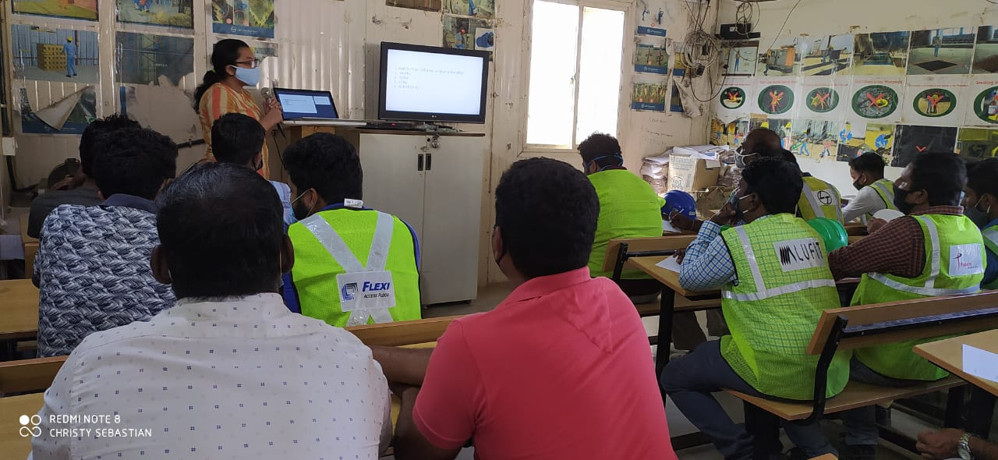Glimpses of orientation programme conducted at L & T Bangalore

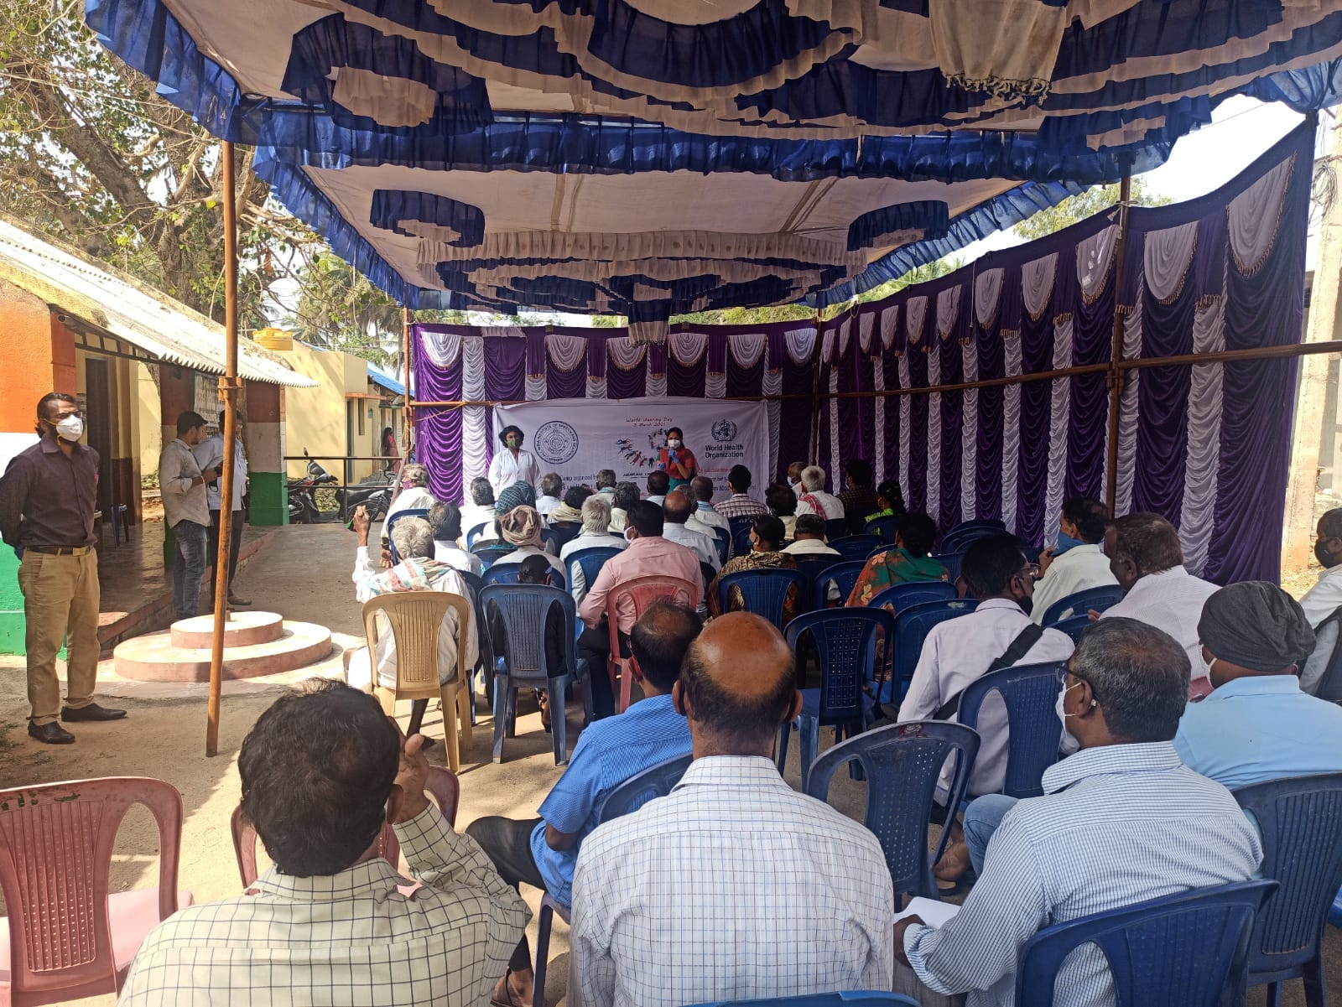

Glimpses of orientation programme conducted in the Deveeramanahalli panchayat

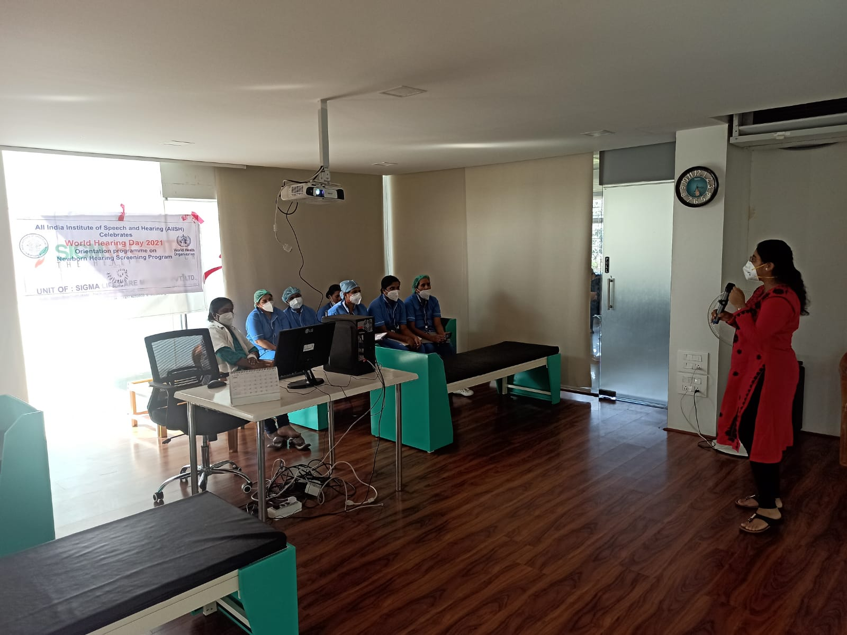

Glimpses of orientation programme conducted in the Sigma hospital

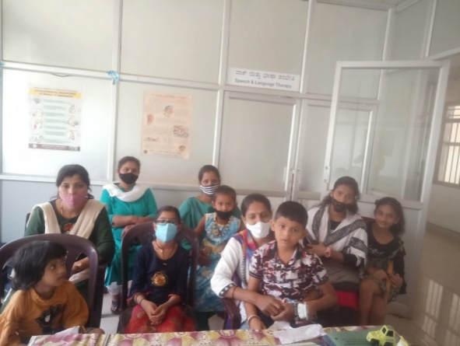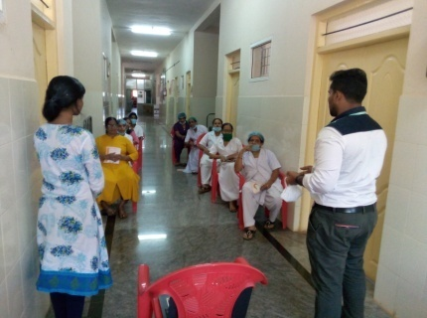

Figure : Glimpses of orientation program at Mother and Child Hospital (MCH), Sagara and Sub-Divisional Hospital, Sagara

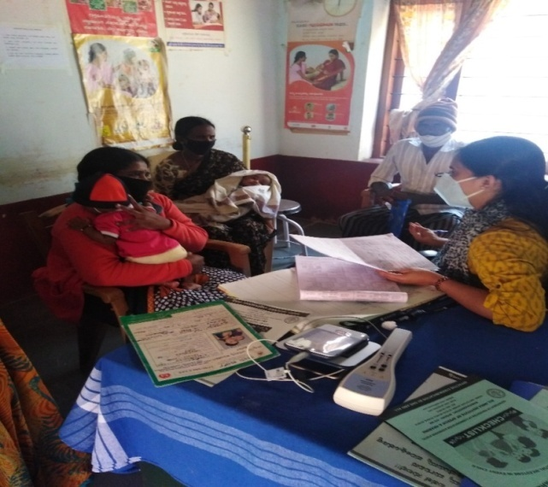Figure : Glimpse of orientation program Primary Health Centre, Gumballi

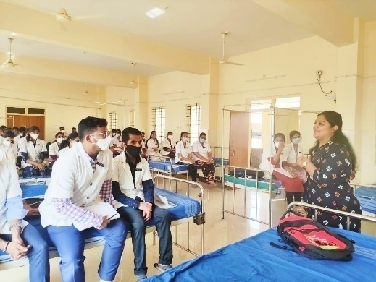Figure : Glimpse of orientation program BIMS, Belgavi

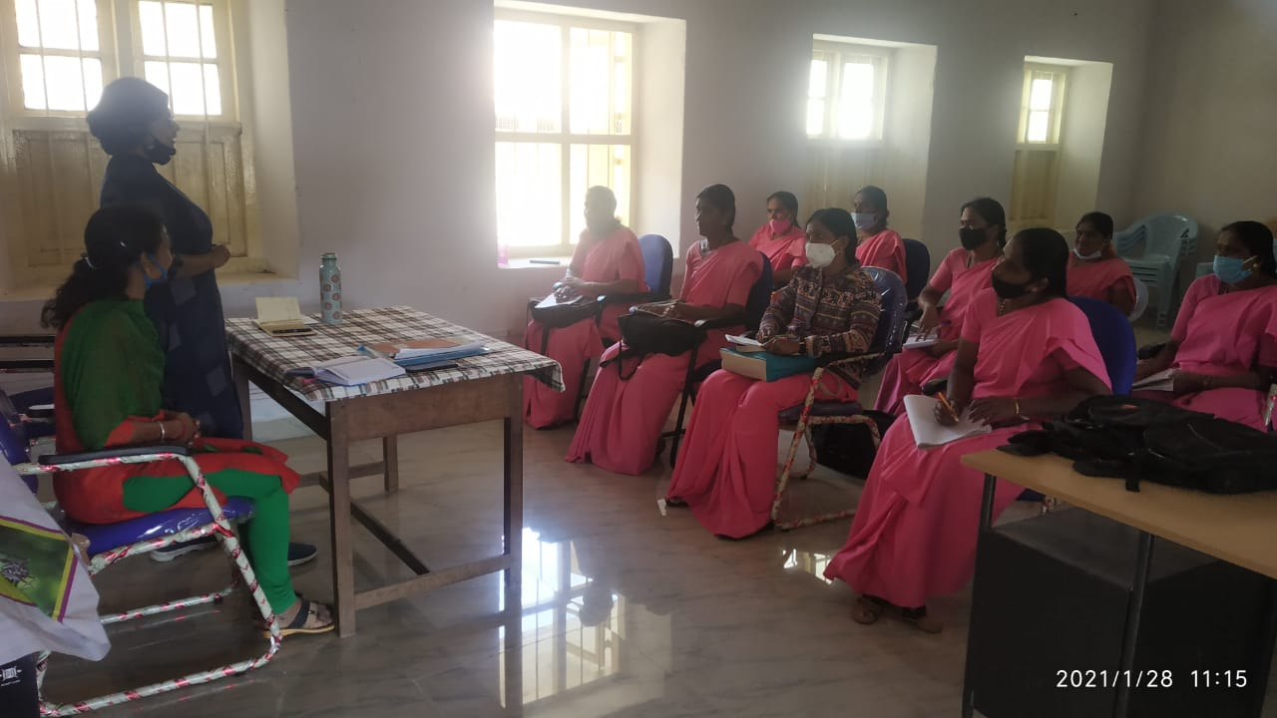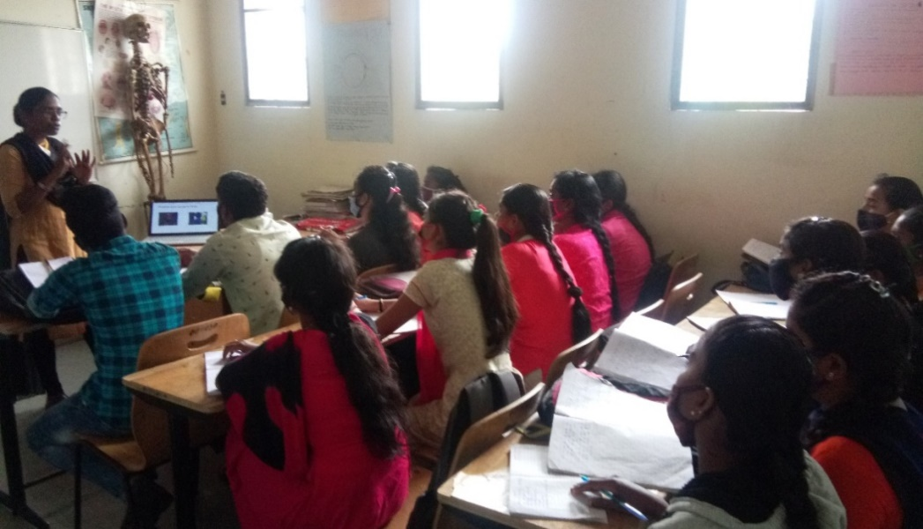

Figure: Glimpses of orientation program at Vivekananda Memorial Hospital, Sarguru

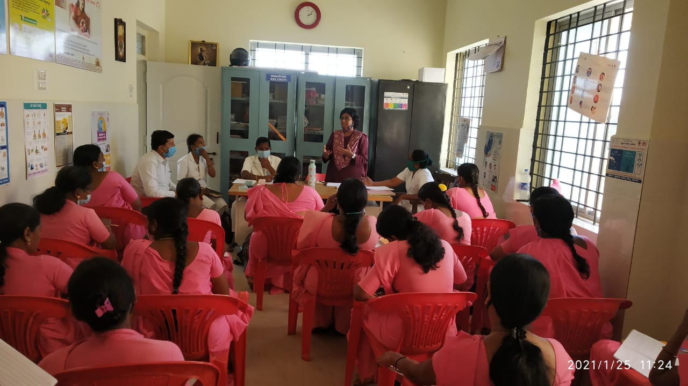

Figure: Glimpses of orientation program at Primary Health Center, Hadinaru and Taluk Health Office, Nanjangud

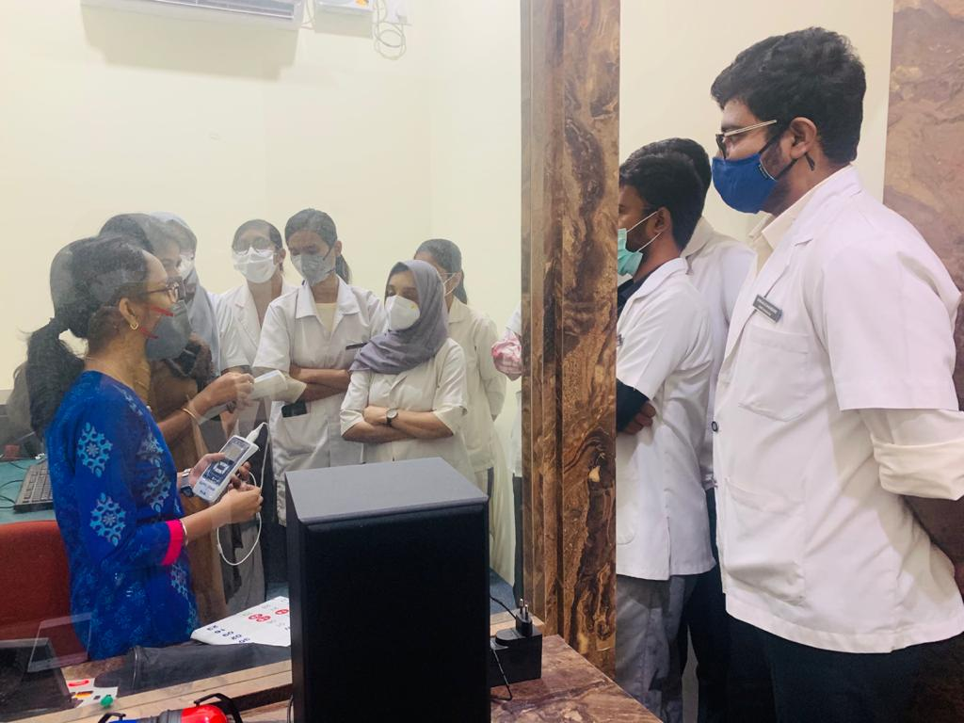 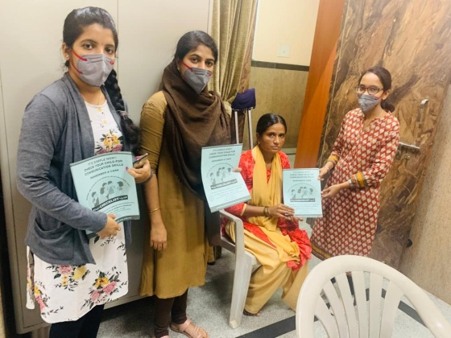

Figure: Glimpses of orientation program at GIMS, Hospital, Kalburgi

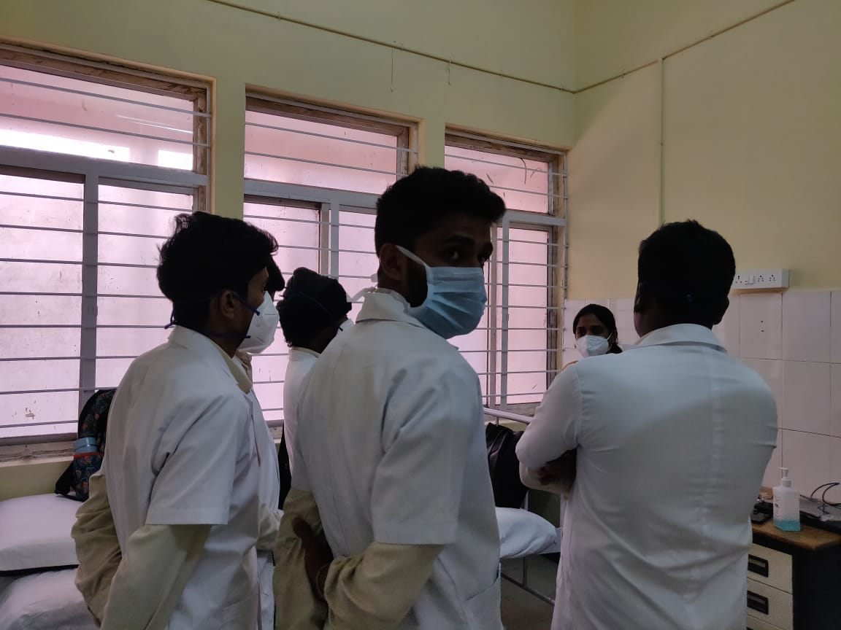

Figure: Glimpses of orientation program at Kodagu Institute of Medical sciences and teaching hospital

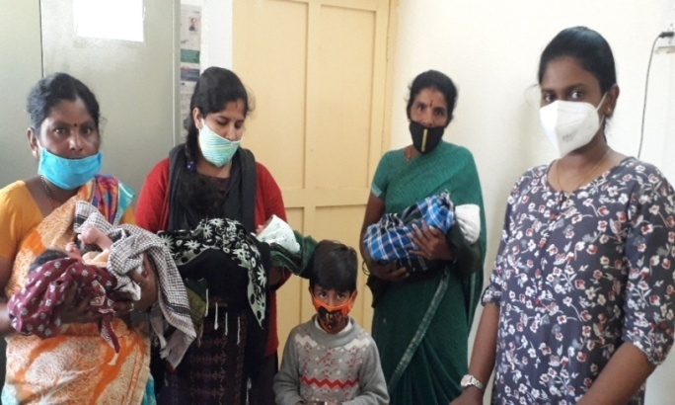

Figure: Glimpses of orientation program at Taluk General Hospital KR Pete, Mandya

**B) Seminars/ Conferences /Lectures /Workshops/Training programs**

1. **No. of Seminars/ Conferences /Lectures /Workshops attended by OSC centers:**

Table 4: Details of seminar attended by OSC center

|  |  |
| --- | --- |
| **Date& venue** | 18.01.2021 |
| **Topic** | Basics of Audiology |
| **Name of the resource person** | Aparna Ravi |
| **Name of the co-ordinator/s** | Dr. Satish Bagewadi |
| **Name of the organizers** | Dept of ENT |
| **Target group** | Medical students |
| **Number of beneficiaries** | 50 |
| **Objectives** | Teaching of basic audiogram patterns tuning fork tests, and their interpretations |

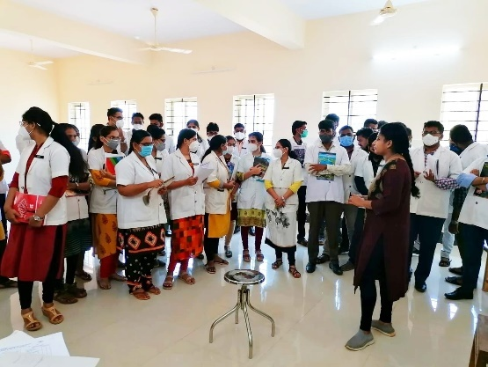Glimpses of seminar conducted at OSC Belgavi

1. **RESEARCH ACTIVITIES:**
2. Revision of epidemiological data sheet is in process
3. Verified the uniformity of codes assigned to each of the variables across the year and centre wise
4. Added and re-coded the variables to make it uniform for merging

Research activities at OSC :

* + 1. Research proposal presented in the GIMS Ethical committee on 16/12/2020 Research topic: Effect of drugs used in MDR-TB on voice quality.
    2. Submitted corrected research proposal draft to the GIMS Ethical committee on 28/12/2020.
    3. Research proposal for a paper titled “Clinico- Epidemiological Profile of Patients Receiving Speech- Language Therapy at a Tertiary Health Care Centre” was sent to the Scientific Research Committee of Kodagu Institute of Medical Sciences, Madikeri for approval.

**III) EXTENSION ACTIVITIES**

The department of POCD is actively involved in carrying out various extension activities such as screening, diagnostic and rehabilitation services outside the institute campus. The activities include newborn/infant screening, screening of school children, screening of elderly citizens, screening of industrial workers, conducting camps and also clinical services offered at the outreach service centers of AIISH.

A. **New-born screening programs for Communication Disorders**

Table 6: Details of newborn screened in OSC and NBS centers in January2020.

|  |  |  |  |  |  |  |  |  |  |  |  |
| --- | --- | --- | --- | --- | --- | --- | --- | --- | --- | --- | --- |
| S. No | Hospitals/Immunization Centers | Total births | Total screened | | | Total No. at risk | | | Phone Follow up | | |
|  |  |  | Male | Female | Total | Male | Female | Total | Male | Female | Total |
| I. Mysuru Hospitals | | | | | | | | | | | |
|  | KR Hospital (KRH)- Cheluvamba | 412 | 239 | 192 | 431 | 7 | 14 | 21 | 20 | 16 | 36 |
|  | Kamakshi Hospital (KH) | 92 | 30 | 15 | 45 | 0 | 0 | 0 | 6 | 5 | 11 |
|  | Mission Hospital (MH) | 23 | 3 | 5 | 8 | 3 | 4 | 7 | 2 | 1 | 3 |
|  | Chamundeshwari nursing home | 16 | 6 | 2 | 8 | 0 | 0 | 0 | 1 | 0 | 1 |
|  | Ashwini Nursing Home (ANH) | - | 1 | 4 | 5 | 0 | 0 | 0 | 2 | 1 | 3 |
|  | Shree Devi Nursing Home (SNH) | 36 | 10 | 7 | 17 | 0 | 0 | 0 | 0 | 1 | 1 |
|  | St. Joseph’s Hospital | - | 1 | 0 | 1 | 0 | 0 | 0 | 0 | 0 | 0 |
|  | Mahadeshwara Nursing Home (MNH) | 26 | 2 | 3 | 5 | 0 | 0 | 0 | 0 | 0 | 0 |
|  | Sigma Hospital (SH) | 45 | 17 | 14 | 31 | 1 | 0 | 1 | 1 | 2 | 3 |
|  | Jayanagar Maternity Hospital | 111 | 44 | 26 | 70 | 1 | 0 | 1 | 3 | 1 | 4 |
|  | NPC Maternity hospital | 58 | 09 | 07 | 16 | 0 | 0 | 0 | 0 | 1 | 1 |
|  | Makkalakoota Immunization Centre | - | 11 | 12 | 23 | 0 | 0 | 0 | 0 | 0 | 0 |
|  | Kyathmanalli Immunization Centre | - | 3 | 6 | 9 | 0 | 0 | 0 | 0 | 3 | 3 |
| Total | |  | 376 | 293 | 669 | 12 | 18 | 30 | 35 | 31 | 66 |
| II. OSC Centers | | | | | | | | | | | |
|  | Sub-divisional Hospital, SagaraTaluk | 209 | 64 | 57 | 121 | - | - | - | 2 | 1 | 3 |
|  | St,Mary’s Hospital, HD kote | 111 | 42 | 51 | 93 | 19 | 20 | 39 | 3 | 0 | 3 |
|  | Vivekananda Memorial hospital, H. D. Kote Sarguru | 35 | 17 | 17 | 34 | 7 | 7 | 14 | 1 | 0 | 1 |
|  | Taluk Hospital, H. D. Kote- Immunization | 101 | 29 | 38 | 67 | 11 | 15 | 26 | 0 | 1 | 1 |
|  | Gulbarga Institute of Medica Sciences , Kalaburagi | 718 | 23 | 16 | 39 | 23 | 16 | 39 | 30 | 22 | 52 |
|  | Taluk General Hospital, KR. Pete | 53 | 28 | 25 | 53 | - | - | - | 1 | 5 | 6 |
|  | Community Health Centre (CHC), Santhemarahalli | 16 | 9 | 7 | 16 | 3 | 2 | 5 | 2 | 0 | 2 |
|  | Taluk Hospital, Yelandur | 8 | 6 | 2 | 8 | 1 | 0 | 1 | 1 | 0 | 1 |
|  | Primary Health centre (Under karuna trust), Gumballi | 17 | 10 | 7 | 17 | 5 | 2 | 7 | 2 | 0 | 2 |
|  | Taluk Hospital, Nanjangud | 103 | 47 | 44 | 91 | - | - | - | 6 | 7 | 13 |
|  | Community Health Centre (CHC), Hullahalli | 20 | 2 | 2 | 4 | - | - | - | 1 | - | 1 |
|  | Belagavi Institute of Medical Science, Belagavi | 246 | 141 | 126 | 267 | 23 | 20 | 43 | 5 | 0 | 5 |
|  | Kodagu Institute of Medical Science ,Kodagu | 267 | 113 | 115 | 228 | 1 | 2 | 3 | 12 | 19 | 31 |
| Total | | 1904 | 531 | 507 | 1038 | 93 | 84 | 177 | 66 | 55 | 121 |
| NBS Centers | | | | | | | | | | | |
|  | All India Institute of Physical Medicine and Rehabilitation (AIIPMR), Mumbai | - | - | - | - | - | - | - | - | - | - |
|  | Janana Hospital & JLNMCH, Ajmer | **829** | 309 | 253 | **562** | 12 | 6 | **18** | **1** | **0** | **1** |
|  | Jawaharlal Nehru Medical College & Hospital, Bhagalpur, Bihar | **-** | 98 | 89 | **187** | 8 | 12 | **20** | **-** | **-** | **-** |
|  | JIPMER, Puducherry | **695** | 282 | 278 | **560** | 28 | 23 | **51** | 22 | 18 | **40** |
|  | King George’s Medical  University (KGMU) Lucknow | - | 98 | 91 | **189** | 21 | 16 | **37** | 5 | 4 | **9** |
|  | NetajiSubhash Chandra Bose Medical College (NSCB), Jabalpur | **-** | 209 | 232 | **441** | 24 | 14 | **38** | 12 | 12 | **24** |
|  | Post Graduate Institute of Medical Education and Research (PGIMER), New Delhi | **105** | 40 | 31 | **71** | 3 | 0 | **2** | **2** | **1** | **3** |
|  | Rajendra Institute of Medical Sciences, Baritayu, Ranchi | **272** | 123 | 107 | **230** | 3 | 1 | **4** | 1 | 2 | **3** |
|  | Regional Institute of Medical Sciences (RIMS), Imphal | **75** | 34 | 41 | **75** | 3 | 1 | **-** | **2** | **-** | **-** |
|  | Sri DevarajUrs Academy Of Higher Education and Research (SDUAHER), Kolar | **168** | 56 | 53 | 109 | 0 | 0 | **0** | **29** | **30** | **59** |
|  | Sri Ramachandra Bhanj Medical College and Hospital (SCB MCH), Cuttack | **278** | 129 | 80 | **209** | 05 | 03 | **08** | **278** | 129 | 80 |
|  | Total (NBS centers) | **2422** | 1378 | 1255 | 2633 | 107 | 76 | 178 | 352 | 196 | 219 |
| Total (POCD+OSC+NBS) | | **-** | **2285** | **2055** | **4340** | **212** | **178** | **385** | **453** | **282** | **406** |

**B) Tele- follow-up evaluation**

The at-risk babies were monitored regularly through Phone calls by administrating Speech-language & hearing developmental checklist. The babies identified with delay in any of the developmental milestones, were referred to AIISH/concerned center for detailed diagnostic evaluation.

Details of Tele-phone follow- up carried out at Hospitals in Mysuru.

|  |  |  |  |  |
| --- | --- | --- | --- | --- |
| **S. No.** | **Mysuru Hospitals** | **Number of infants with normal developmental milestones.** | **Total infants at risk** | **Total call attended/ Total no of calls** |
|  | Ashwini Nursing Home | 01 | - | 1/1 |
|  | Brindavan Hospital | - | - | - |
|  | Cheluvamba Hospital (KRH) | 103 | - | 103/151 |
|  | GopalaGowdaShanthaveri Memorial Hospital | 04 | - | 4/4 |
|  | Kamakshi Hospital | 16 | - | 16/24 |
|  | Mahadeshwara Nursing Home | 01 | - | 1/2 |
|  | Mission Hospital | 05 | - | 5/6 |
|  | S.M.T.D.H Hospital | 06 | - | 6/7 |
|  | Shree Devi Nursing Home | **01** | - | **1/1** |
|  | Shree Lakshmi DevammaShankarshetty Maternity Hospital | **01** | - | **1/1** |
|  | Sigma Hospital | **05** | - | **5/9** |
|  | Jayanagara Hospital | **02** | - | **2/2** |
|  | **Total** | **145** | **-** | **145/208** |

Table 7: Details of Tele-phone follow- up carried out at OSCs in January 2020

|  |  |  |  |
| --- | --- | --- | --- |
| **OSC centers** | **Number of infants with normal developmental milestones.** | **Total infants at risk** | **Total call attended/ Total no of calls** |
| St. Mary’s Hospital , HD Kote | 37 | 1 | 38/52 |
| Vivekananda Memorial Hospital, Sarguru | 19 | - | 19/33 |
| Taluk Hospital, H. D. Kote- | 13 | - | 13/18 |
| GIMS, Kalaburgi | 45  Expired babies 9 | 107 | 53/125 |
| Taluk General Hospital, KR. Pete | 1 | - | 1/1 |
| KoIMS,Madikkeri | 14 | 0 | 14/27 |
| **Total** | 129  Expired babies 9 | 108 | 138/256 |

*Note: The calls not attended were repeated a minimum of 5 times on consecutive days*

Table 7: Details of Tele-follow up carried out at NBS centres in January 2020

|  |  |  |  |
| --- | --- | --- | --- |
| **NBS Centres** | **Number of infants with normal developmental milestones.** | **Total infants at risk** | **Total call attended/ Total no of calls** |
| Ajmer | 28 | 0 | 28/48 |
| Bhagalpur | - | - | - |
| Cuttack | 9 | 0 | 9/9 |
| Delhi | NIL | NIL | NIL |
| Imphal | 3 | 1 | 4/4 |
| Jabalpur | 34 | 0 | 3452 |
| Kolar | 19 | 0 | 19/25 |
| Luknow | _ | _ | _ |
| Mumbai | _ | _ | _ |
| Patna | NIL | NIL | NIL |
| Puducherry | 21 | 0 | 21/27 |
| Ranchi | 11 | 0 | 11/11 |
| Shimla | - | - | - |
| **Total** |  |  |  |

Note: The calls not attempted were repeated a minimum of 5 times on consecutive days

**c) Tele screening Programs**

Tele-screening program (virtual mode) was carried out to identify the babies at risk for communication disorders since new born screening program couldn’t be carried out in many centers. The details including the behavioral responses of the new born to environmental sounds and HRR were collected from the parents through Tele-phone mode. The babies at risk were asked to undergo follow up evaluation in detail.

Table 8: Details of Tele-screening* at OSCs.

|  |  |  |  |  |  |
| --- | --- | --- | --- | --- | --- |
| **OSC Centre** | **Total Tele-screened / Total calls made** | **Mortality** | **Detailed Evaluation**  **(Referred)** | **Total infants at risk**  **(Screening)** | **Normal Speech and Language milestones**  **(Phone Follow up)** |
| Taluk General Hospital, KR. Pete | 3/4 | 0 | 0 | 0 | 3 |
| **Total** | 3/4 | 0 | 0 | 0 | 3 |

*Note:* for babies missed out during the pandemic situation for testing*

**C) Anganawadi /Preschool/School screening program**

Screening of Anganawadi, preschool and primary school children was conducted focusing on the early identification of communication disorders and early rehabilitation of children at risk for communication disorders.

Table 7: Total number of children screened for communication disorders and identified.

|  |  |  |  |  |  |  |  |  |
| --- | --- | --- | --- | --- | --- | --- | --- | --- |
| Date | Name of the Anganawadi/Preschool/ School | Total screened | | | Total referred with communication disorders | | | |
| Ear related disorder | Hearing loss | Speech language disorders | |
| Male | Female | Total |  |  |  |
| 06-1-2021 | Hearing screening at Arvey,Anganawadi, Hunsur(TK) | 4 | 6 | 10 | - | - | 1 |
| 13-1-2021 | Hearing screening at channakesavapura,Anganwadi, Periyapatna(TK) | 7 | 9 | 16 | - | - | - |
| 20-1-2021 | Hearing screening at Halekere, Anganwaadi Periyapatna(TK) | 26 | 10 | 36 | - | - | - |
| 27-1-2021 | Hearing screening at Ichooru,Anganwadi- Periyapatna(TK) | 9 | 12 | 21 | - | 1 | 1 |
| Total |  | 46 | 37 | 83 | - | 1 | 2 |

**D) New born follow-up evaluation (Detailed assessment)**

The newborns/infants referred during the newborn screening/ Tele-screening were advised for detailed evaluation at AIISH/NBS centers/OSCs. A complete test battery was administered for those babies/infants who came for follow-up.

Table 8: Details of the results of follow-up evaluation at OSC Centers

|  |  |  |  |  |  |  |  |  |
| --- | --- | --- | --- | --- | --- | --- | --- | --- |
| **Categories** | **Age range** | | **OSC- Belagavi** | | **OSC- Sagara** | | **OSC- Sarguru** | **Total** |
| **Normal** | Newborn  (0-2 months) | Male | 09 | | 01 | | **06** | **16** |
| Female | 06 | | - | | **05** | **11** |
| Infants  (2-12 months) | Male | - | | 01 | | **-** | **01** |
| Female | - | | - | | - | - |
| Toddlers  (1 year to 4years) | Male | - | | - | | - | - |
| Female | - | | - | | - | - |
| Children  (above 4years) | Male | - | | - | | - | - |
| Female | - | | - | | - | - |
| **Hearing impairment** | Newborn  (0-2 months) | Male | 01 | | - | | - | 01 |
| Female | - | | - | | - | - |
| Infants  (2-12 months) | Male | - | | - | | - | - |
| Female | - | | - | | - | - |
| Toddlers  (1 year to 4years) | Male | - | | - | | - | - |
| Female | - | | - | | - | - |
| Children  (above 4years) | Male | - | | - | | - | - |
| Female | - | | - | | - | - |
| **Speech &language disorder** | Newborn  (0-2 months) | Male | - | | - | | - | - |
| Female | - | | - | | - | - |
| Infants  (2-12 months) | Male | - | | - | | - | - |
| Female | - | | - | | - | - |
| Toddlers  (1 year to 4years) | Male | - | | - | | - | - |
| Female | - | | - | | - | - |
| Children  (above 4years) | Male | - | | - | | - | - |
| Female | - | | - | | - | - |
| **Multiple Disorder/Syndromes** | Newborn  (0-2 months) | Male | - | | - | | - | - |
| Female | - | | - | | - | - |
| Infants  (2-12 months) | Male | - | | - | | - | - |
| Female | - | | - | | - | - |
| Toddlers  (1 year to 4years) | Male | - | | - | | - | - |
| Female | - | | - | | - | - |
| Children  (above 4years) | Male | - | | - | | - | - |
| Female | - | | - | | - | - |
| **Total** |  |  | 16 | **02** | | **11** | | **29** |

Table 9: Details of the results of detailed follow-up evaluation (Referred from other depts.)

|  |  |  |  |  |
| --- | --- | --- | --- | --- |
| **Categories** | **Age range** | | **OSC- Belagavi** | **Total** |
| **Normal** | Newborn  (0-2 months) | Male | 03 | **03** |
| Female | 05 | **05** |
| Infants  (2-12 months) | Male | 01 | **01** |
| Female | 01 | **01** |
| Toddlers  (1 year to 4years) | Male | - | - |
| Female | - | - |
| Children  (above 4years) | Male | - | - |
| Female | - | - |
| **Hearing impairment** | Newborn  (0-2 months) | Male | - | - |
| Female | - | - |
| Infants  (2-12 months) | Male | - | - |
| Female | - | - |
| Toddlers  (1 year to 4years) | Male | - | - |
| Female | - | - |
| Children  (above 4years) | Male | - | - |
| Female | - | - |
| **Speech &language disorder** | Newborn  (0-2 months) | Male | - | - |
| Female | - | - |
| Infants  (2-12 months) | Male | - | - |
| Female | - | - |
| Toddlers  (1 year to 4years) | Male | - | - |
| Female | - | - |
| Children  (above 4years) | Male | - | - |
| Female | - | - |
| **Multiple Disorder** | Newborn  (0-2 months) | Male | - | - |
| Female | - | - |
| Infants  (2-12 months) | Male | - | - |
| Female | - | - |
| Toddlers  (1 year to 4years) | Male | - | - |
| Female | - | - |
| Children  (above 4years) | Male | - | - |
| Female | - | - |
| **Total** | | | 10 | 10 |

Table 9: Details of the results of follow-up evaluation carried out at NBS centers.

|  |  |  |  |  |  |  |  |
| --- | --- | --- | --- | --- | --- | --- | --- |
| Categories | Age range | | IMPHAL | LUCKNOW | PUDUCHERRY | RANCHI | Total |
| Normal | Newborn  (0-2 months) | Male | - | 05 | - | 02 | 07 |
| Female | - | 04 | - | 03 | 07 |
| Infants  (2-12 months) | Male | - | 01 | 02 |  | 03 |
| Female | - | - | - | - | - |
| Toddlers  (1 year to 4years) | Male | 01 | 07 | - | - | 08 |
| Female | 01 | 02 | - | - | 03 |
| Children  (above 4years) | Male | - | 01 | - | - | 01 |
| Female | - | - | - | - | - |
| Hearing impairment | Newborn  (0-2 months) | Male | - | 01 | - | - | 01 |
| Female | - | 01 | - | - | 01 |
| Infants  (2-12 months) | Male | - | 01 | 01 | - | 02 |
| Female | - | - | - | - | - |
| Toddlers  (1 year to 4years) | Male | 02 | 12 | - | - | 14 |
| Female | - | 04 | - | - | 04 |
| Children  (above 4years) | Male | - | 01 | - | - | 01 |
| Female | - | 01 | - | - | 01 |
| Speech & language disorder | Newborn  (0-2 months) | Male | - | - | - | - | - |
| Female | - | - | - | - | - |
| Infants  (2-12 months) | Male | 02 | - | - | - | 02 |
| Female | - | - | - | - | - |
| Toddlers  (1 year to 4years) | Male | - | - | - | - | - |
| Female | - | - | - | - | - |
| Children  (above 4years) | Male | - | - | - | - | - |
| Female | - | - | - | - | - |
| Multiple Disorder/Syndroms | Newborn  (0-2 months) | Male | - | - | - | - | - |
| Female | - | - | - | - | - |
| Infants  (2-12 months) | Male | - | - | - | - | - |
| Female | - | - | - | - | - |
| Toddlers  (1 year to 4years) | Male | - | - | - | - | - |
| Female | - | - | - | - | - |
| Children  (above 4years) | Male | - | - | - | - | - |
| Female | - | - | - | - | - |
| Total | | | 06 | 41 | 03 | 05 | 55 |

Table 10 Details of the results of detailed follow-up evaluation (**Referred from other depts.)**

|  |  |  |  |  |
| --- | --- | --- | --- | --- |
| Categories | Age range | | RANCHI | Total |
| Normal | Newborn  (0-2 months) | Male | 04 | 04 |
| Female | 01 | 01 |
| Infants  (2-12 months) | Male | - | - |
| Female | 01 | 01 |
| Toddlers  (1 year to 4years) | Male | 02 | 02 |
| Female | - | - |
| Children  (above 4years) | Male | - | - |
| Female | - | - |
| Hearing impairment | Newborn  (0-2 months) | Male | - | - |
| Female | - | - |
| Infants  (2-12 months) | Male | - | - |
| Female | - | - |
| Toddlers  (1 year to 4years) | Male | 08 | 08 |
| Female | 08 | 08 |
| Children  (above 4years) | Male | 01 | 01 |
| Female | 02 | 02 |
| Speech & language disorder | Newborn  (0-2 months) | Male | - | - |
| Female | - | - |
| Infants  (2-12 months) | Male | - | - |
| Female | - | - |
| Toddlers  (1 year to 4years) | Male | 01 | 01 |
| Female | - |  |
| Children  (above 4years) | Male | - |  |
| Female | - | - |
| Multiple Disorders/Syndroms | Newborn  (0-2 months) | Male | - | - |
| Female | - | - |
| Infants  (2-12 months) | Male | - | - |
| Female | - | - |
| Toddlers  (1 year to 4years) | Male | - | - |
| Female | - | - |
| Children  (above 4years) | Male | - | - |
| Female | - | - |
| Total |  |  | 28 | 28 |

**D) Anganawadi /Preschool/School screening program : Nil**

**E) Clinical Services at Outreach Service Centers (OSCs)**

The clinical activities are not only restricted to in and around Mysuru, but also extended to rural areas where facilities for clinical services for persons with communication disorders are scanty. Currently there are 08 OSCs centres at different part of the country rendering services to unreached population. The details of those who were registered and availed various services/benefits at the OSCs are tabulated below.

1. **Clients identified and followed up with communication disorders at OSCs**

Table 11: Details of clients identified and followed up with communication disorders at OSCs.

|  |  |  |  |  |  |  |  |  |  |
| --- | --- | --- | --- | --- | --- | --- | --- | --- | --- |
| **S. No** | **OSC Centre** | **Total registered** | | **ENT Evaluation** | | **Hearing Evaluation** | | **Speech & Language Evaluation** | |
| Normal | Disorder | Normal | Disorder | Normal | Disorder |
|  | Taluk Hospital, Nanjangud | New cases | 14 | - | 14 | 9 | 13 | 0 | 3 |
| F/u Old | - | - | - | - | - | - | - |
|  | Community Health Centre (CHC), Hullahalli | New cases | 10 | - | 10 | - | - | - | - |
| F/u Old | 11 | - | 11 | - | 10 | - | - |
|  | Primary Health Centre (PHC), Akkihebbalu | New cases | 3 | - | 2 | - | 2 | - | - |
| F/u Old | 0 | - | - | - | - | - | - |
|  | Taluk General Hospital, KR Pete | New cases | 45 | - | - | 13 | 69 |  | 4 |
| F/u Old | 1 | - | - | - | - | 1 | - |
|  | Primary Health Centre (PHC), Gumballi | New cases | 30 | 0 | 30 | 0 | 4 | 0 | 1 |
| F/u Old | 19 | 0 | 19 | 0 | 2 | 0 | 0 |
|  | Sub-divisional Hospital (PHC), Sagara | New cases | 28 | - | - | 4 | 46 | - | 3 |
| F/u Old | 2 | - | - | - | - | - | 2 |
|  | Vivekananda Memorial Hospital, Sarguru | New cases | 14 | - | - | 9 | 19 | 1 | - |
| F/u Old | 13 | - | - | 22 | 4 | - | 1 |
|  | Gulbarga Institute of Medical Sciences | New cases | 177 | - | 139 | 45 | 211 | - | 38 |
| F/u Old | - | - | - | - | - | - | - |
|  | Belagavi institute of medical sciences (BIMS), Belagavi | New cases | 287 | - | - | 377 | 143 | - | 27 |
| F/u Old | 6 | - | - | 1 | 11 | - | - |
|  | Kodagu Institute of Medical Sciences, Madikkerri | New cases | 148 | - | - | 135 | 143 | 1 | 8 |
| F/u Old | - | - | - | 0 | 0 | 0 | 0 |

1. **Table 12: Clients identified with different types of communication disorders across OSCs**

|  |  |  |  |  |  |  |  |  |  |  |
| --- | --- | --- | --- | --- | --- | --- | --- | --- | --- | --- |
| **Type of Disorders** | **OSC** | | | | | | | | | |
| Taluk Hospital, Nanjangud | Primary Health Centre (PHC), Hullahalli | Primary Health Centre (PHC), Akkihebbalu | Taluk General Hospital, KR Pete | Primary Health Centre (PHC), Gumballi | Sub-divisional Hospital, Sagara (PHC) Taluk | VMH,  Sarguru | BIMS Belagavi | GIMS, Kalburgi | KoIMS,  Kodagu |
|  |  | **Hearing disorders (Ear-wise data)** | | | | |  |  |  |  |
| Normal | 9 | - | - | 17 | 0 | 4 | 9 | 377 | 45 | 135 |
| Conductive | 1 | - | - | 10 | 0 | 17 | 2 | 17 | 33 | 7 |
| Sensori- neural | 9 | 6 | 2 | 26 | 4 | 11 | 9 | 57 | 54 | 69 |
| Mixed | 3 | 1 | - | 20 | 0 | 7 | 4 | 22 | 41 | 19 |
| No type (Minimal & Profound) | - | 1 | - | 4 | 0 | 11 | 4 | 33 | Minimal- 36  Profound-47 | 54 |
| **Aud-Total (ears)** | **22** | **10** | **2** | **80** | **4** | **50** | **28** | 520 | **278** | **278** |
| **Aud-Total (Individuals)** | **11** | 5 | **1** | **40** | **2** | **25** | **14** | **260** | **139** | **139** |
|  |  |  | | | | | |  |  |  |
| Voice | - | - | - | - | - | - | - | 1 | 1 | 0 |
| Fluency | 2 | - | - | 2 | - | 1 | - | 7 | 4 | 0 |
| Articulation disorders | 1 | - | - | - | - | 1 | - | - | 15 | 1 |
| Language disorders | - | - | - | 3 | - | 3 | 1 | 19 | 15 | 7 |
| **Total (Individuals)** | **3** | - | **0** | **5** | **-** | **5** | **1** | **27** | **35** | **8** |

1. **Table 13: Clients followed up with different types of communication disorders at OSCs**

|  |  |  |  |  |  |  |  |  |  |  |  |
| --- | --- | --- | --- | --- | --- | --- | --- | --- | --- | --- | --- |
| **Type of Disorders** |  |  | | **OSC** | | | |  |  |  |  |
| Taluk Hospital Nanjangud | Primary Health Centre (PHC), Hullahalli | Primary Health Centre (PHC), Akkihebbalu | | Taluk General Hospital, KR Pete | Primary Health Centre (PHC), Gumballi | Sub-divisional Hospital,  Sagara  (PHC) Taluk | VMH,  Sarguru | Belagvi institute of medical sciences BIMS | GIMS, Kalburgi | KoIMS-TH, MadikeriTaluk,Kodagu |
|  | **Hearing disorders (Ear-wise data)** | | | | | | | | | | |
| Normal | - | - | - | | - | - | - | 22 | 01 | - | - |
| Conductive | - | - | - | | - | - | - | - | 02 | - | - |
| Sensori- neural | - | 06 | - | | 02 | 02 |  | 02 | 09 | - | - |
| Mixed | - | 01 | - | | - |  |  |  | 00 | - | - |
| No type (Minimal & Profound) | - | 01 | - | | - | - | - | 02 | 00 | - | - |
| **Aud-Total (ears)** | - | **10** | - | | 02 | 02 |  | 26 | 12 | - | - |
| **Aud-Total (Individuals)** | - | 05 | - | | 01 | 01 |  | 13 | 06 | - | - |
|  |  |  | | | | | | |  |  |  |
| Voice | - | - | - | | - | - | - | - | - | - | - |
| Fluency | - | - | - | | 01 | - | - | - | - | - | - |
| Articulation disorders | - | - | - | | - | - | - | - | - | - | - |
| Language disorders | - | - | - | | - | 01 | - | 01 | - | - | - |
| **Sp&Lg -Total (Individuals)** | **-** | **00** | **00** | | **01** | 01 | - | **01** | - | - | - |

1. **Rehabilitation services at OSCs.**

Table 14: Details of rehabilitation services provided at OSCs in January 2020.

|  |  |  |  |
| --- | --- | --- | --- |
| **OSC** | **Hearing Aids Dispensed** | **Tele-Speech-language therapy** | |
| No. of clients | No. of sessions |
| Taluk Hospital, Nanjangud | 01 | 03 | 18 |
| Taluk General Hospital, KR Pete | - | 02 | 07 |
| Primary Health Centre (PHC), Gumballi | - | 05 | 15 |
| Sub-divisional Hospital, Sagara (PHC) Taluk | - | 10 | 72 |
| VMH, Sarguru | - | 09 | 31 |
| Belagavi institute of medical sciences BIMS | - | 05 | 14 |
| GIMS, Kalburgi | - | 07 | 64 |
| KoIMS-TH, MadikeriTaluk | - | 01 | 13 |
| **Total** | **01** | **42** | **234** |

**d) Table 15: Screening Camps for communication Disorders**

|  |  |  |  |  |  |  |  |  |
| --- | --- | --- | --- | --- | --- | --- | --- | --- |
| Date | Camp site | Total Screened | Total Referred | | | | Total hearing aid distributed | Total |
| Hearing impairment | | Speech- language disorders | |
| Male | Female | Male | Female |  |  |
| 19-22/1/2021 | Nanjangud | 24 | 0 | 0 | 14 | 10 | 0 | 24 |
| 25/1/2021 | Sargur (school screening) | 56 | - | 1 | - | - | - | 56 |
| 29.01.2021 | DEVIRAMMANAHALLI | 50 | 41 | 9 | - | - | 10 | 50 |
| Total | | 130 | 41 | 10 | 14 | 10 | 10 | 130 |

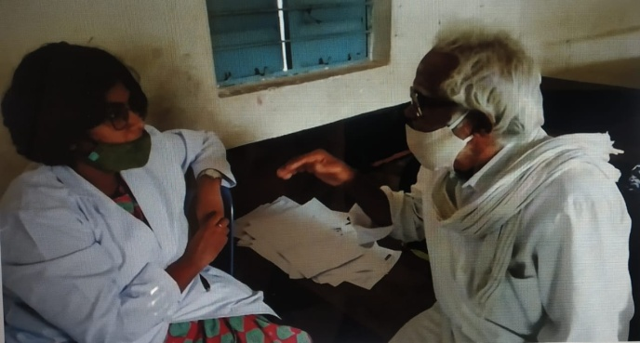 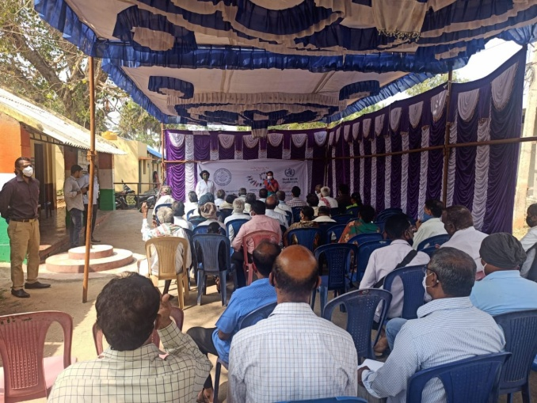

**Figure: Residential camp (pictures) for children with Cerebral Palsy (19-1-2021 to 22-1-2021)**

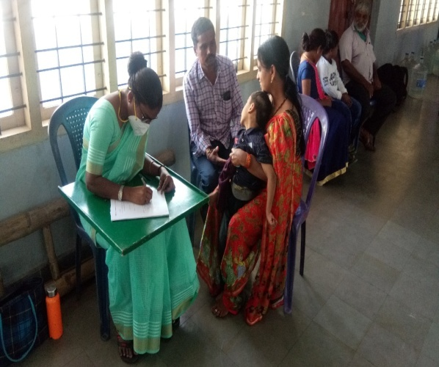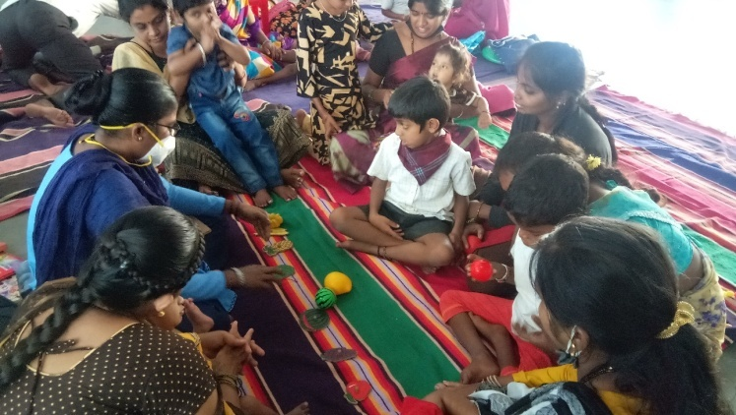

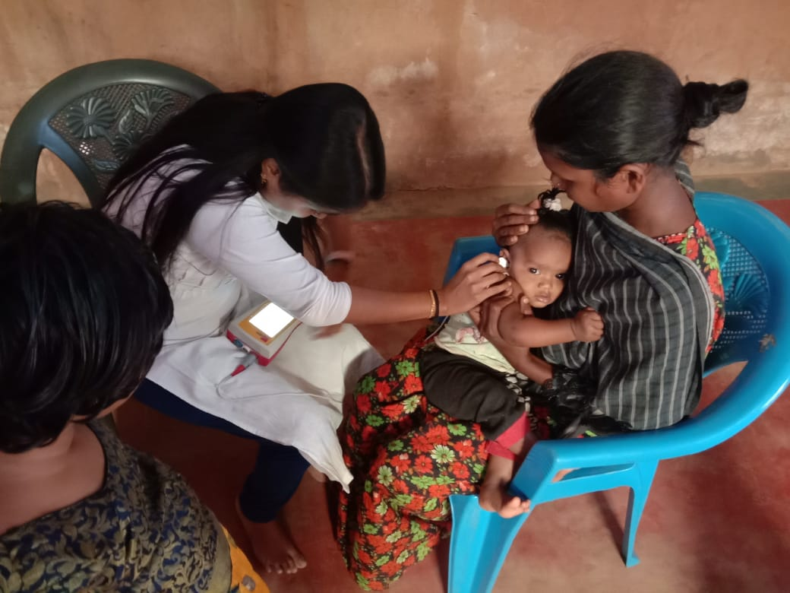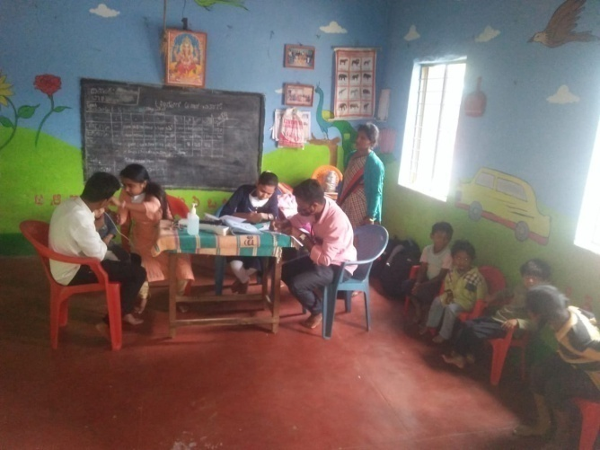

**Glimpses of field visits by the OSC staff**

**IV) TECHNOLOGICAL CONSULTANCY SERVICES: NIL**

**V) CENTRAL FACILITIES**

**a) Library and information Services: NIL**

VI) **MAJOR EVENTS OF THE MONTH**:

* + - 1. MOU was signed between the two parties (All India Institute of Physical Medicine and Rehabilitation and Ruxmani lying-in hospital ) in Mumbai on 18th January, 2021 for a period of next 4 years for NBS.

**VII) OTHERS**

1. Submitted Hindi quarterly report
2. Submitted details for the NAAC committee
3. Initiated World Hearing Day activities

**VII) ACTIVITIES CARRIED OUT BY THE STAFF OF THE DEPARTMENT OF POCD.**

Table 16: Details of activities carried out by POCD staff in October 2020.

|  |  |  |  |
| --- | --- | --- | --- |
| **S.No.** | **Name of the staff** | **Designation** | **Activities** |
|  | Dr. Sandeep M. | * Head, Dept. of POCD (i/c) | * Officiating as HOD-POCD incharge * Coordinated webinars, DCS campus orientations * Verified orientation posters * Attended WHD meeting on 19.01.2021 * Conducted departmental meetings on 21.01.2021 and 29.01.2021 * Coordinated all departmental activities * Coordinated WHD activities |
|  | Mr. Arunraj. K | Audiologist/SLP | * Oriented new batch of staff regarding departmental activities and related work * Coordinated Outreach Service Centre activities * Coordinated computerisation activities * Coordinated for sending equipments to the all OSC and NBS centers based on the requirement * Verified MoU and minutes for new OSC centers Bidar * Verified intern’s attendance * Submitted pending GRN list * Coordinated Industrial screening at L & T, Bangalore * Drafted and verified various office correspondence letters * Attended departmental meeting on 221.01.2021 and 29.01.2021 and WHD meeting on 19.01.2021 * Verified handing over report of 2019-20 batch * Coordinated for i-cry server host * Drafted RBSK letter and followed up * Attended WHD orientation committee meeting on 17.12.2021 |
|  | Ranjini A | Audiologist Gr. I | * Called phone follow-up infants enquiring about their developmental milestones (10 calls). * Orientation for the general public in front of clinical services. * Compilation of referred cases and follow-up cases of all hospitals of December month. * Prepared monthly NBS report for December month. * Participated in Industrial screening at Bangalore on 28.01.21 as part of world hearing day. * Listed out the community radio stations in Karnataka. * Designed photo booth for world hearing day. |
|  | Ms. Srividya S | Audiologist Gr. I | * Prepared pre and post-test questionnaires (google forms) for teachers. * Attended SPSS orientation on 12/01/2021. * Stock verification completed * Organised webinars for K R Nagara school teachers on 15/01/2021 and 21/01/2021. * Designed posters for different webinars held as a part of World Hearing Day. * Prepared google forms for orientation pre post-test and feedback response. * Attended hearing screening camp on 16/01/21 held in Ved Vyasa Yoga foundation, Mysore. * Analysed data of camp held on 16/01/2021. * Verified kannada translation of FAQ’s on Learning Disability, Voice disorder, and Stuttering. * Analysed DCS orientation data on 25/01/2021. * Oriented I B.Sc students about Dept. of POCD. * Designed banners for Elderly screening, Industrial Screening and nusrse orientation programme. * Oriented Sigma nurses on 28.01.21 as part of World Hearing Day. * Participated in Elderly Screening Camp at Nanjangud on 29.01.21 as part of World Hearing Day. |
|  | Ms. Dibya Aryal | Speech Language Pathologist Gr. I | * Prepared monthly NBS report of December month * Compilation of referred cases and follow up cases of all the hospitals of December month * Participated in Industrial Screening Camp at Bengaluru on 28.01.2021 as a part of World Hearing day. * Conducted DCS orientation on Thursday every week. * Translated FAQs on stuttering to Hindi * Done phone follow up of infants enquiring about their developmental milestones(10 calls) |
|  | Ms. Tanuja M.N | Audiologist Gr. II | * Prepared Orientation pre – post test forms * Translated FAQs on Aphasia from English to kannada. * Orientation for general public infront of AIISH DCS on every week. * Validated the outcome of Orientation pre – post-test for general public infront of AIISH DCS for the month of January. * Translated Screening feedback form from English to kannada * Finalised Screening feedback form from English to Hindi * Finalised Orientation and sensitization feedback form from English to Hindi * Finalised PPT about hearing disorder. * Initiated follow up evaluation for the referral cases. * Completed phone follow up for the month June, December, September, October and November. * Orientation was conducted for school teachers about communication disorders on 15.1.2021 * Attended elderly hearing screening camp on 29.1.2021. |
|  | Ms. Nayanika Ghosh | SLP Gr. I | * SPSS orientation conducted on 12.01.21 * NBS OSC online orientation on 04.01.21 * POCD orientation attended on 01.01.21 * Outside NBS centres monthly report verified and compiled * HRR editing done on Corel Software based on Arunraj sir’s recommendations * New SPSS format editing done with Arunraj sir, Srinivas sir, Merina, Spoorthy maam and Madhumanti on 22.01.21. Edited format sent to Sandeep sir and Shreyank sir for feedback * Coordinated with OSC incharge and proposed possible air route for Arunraj sir’s visit to Patna- Bhubaneswar and Indore-Bhopal NBS/OSC centres New Delhi NBS centre received PC * Kolar NBS centre received new Immittance instrument * Completed orientation for Sigma nurses on 28.01.21 as part of World Hearing Day * Participated in Elderly Screening Camp at Nanjangud on 28.01.21 as part of World Hearing Day. * For World Hearing Day, visited 8 local eateries for possible collaborations and got verbal confirmation * Talked to admins of some popular Instagram pages for possible collaboration for World Hearing Day * Shot some trial clips for WHD promo video |
|  | Ms. Merina Thomas | Audiologist Gr. I | * Attended POCD department orientation on 1.01.2021 * Verified and compiled monthly report work of all OSC * DCS orientation carried out on all Wednesday mornings. * Orientation was arranged with all the OSC and NBS centres on 4.01.2021 * Went for Newborn Hearing Screening on all Monday, Wednesday and Fridays. * SPSS orientation conducted on 12.01.21 * Orientation on hearing aid programming carried out for KR Pete and Gumbali bond staff. * New SPSS format editing done with Arunraj sir, Srinivas sir, Spoorthy maam, Nayanika and Madhumanti on 22.01.21 * Coordinated with NBS incharge and proposed possible air route for Arunraj sir’s visit to Patna- Bhubaneswar and Indore-Bhopal NBS/OSC centres * Prepared minutes and MOU for Bidar,3 centres in Chattisgarh ,Nilambur and Patna. * Repaired hearing aids were collected and were distributed to Gumballi and Nanjangud centre. * Prepared instrument stock list for all the OSCs * Send the required essentials to Sarguru, Gumballi, Nanjangud and K.R Pete. * Monthly meeting with the OSCs were carried out on 27.01.21 * Participated in Elderly Screening Camp at Nanjangud on 29.01.21 as part of World Hearing Day. |
|  | Ms. Christy Sebastian | Audiologist Gr. I | * Organised and conducted Industrial hearing screening for 283 employees at L & T Construction Company, Bangalore on 28/01/21. * Organised Orientation program for employees of L & T. * Contacted KSIC for the hearing follow up of their employees. * Collected information about various industries and contacted them for industrial hearing screening. * Conducted DCS orientations once every week. * Conducted new born Screening on Tuesdays and Thursdays. * Translated FAQs in stuttering to Malayalam * Translated FAQs in voice disorders to Malayalam. * Attended orientation regarding the camp in Hadinaru, Nanjangod on 29/01/21. * Attended SPSS orientation on 12 th of January. |
|  | Ms. Pauline Gracia R V | SLP Gr. II | * Prepared new faculty name list for website updating. * Translated few titles to respective language in website. * Designed 2 boards for OSCs * Designed poster for NBS * Co-organiser and participant in elderly screening camp, Nanjangud. * Conducted one orientation program for school teachers (15/01/2021). * Translated 3 pamphlets to tamil. * Did phone follow up * Followed up with social media in-charge and DMD regarding updation. * Oriented public in DCS once a week. * Attended NBS |
|  | Ms. Kranti Acharya | SLP Gr. I | * Attended SPSS orientation conducted on 12.01.21 * Orientations of students about POCD activities, verified attendance, verifying the materials developed by students * Concise format of ACSLS and listen learn and talk * Participated in Industrial hearing Screening Camp at Banglore on 28.01.21 as part of World Hearing Day. * For World Hearing Day, photo booth finalization ongoing. * Collecting new born infant cry. * Attended NBS screening alternate days at various hospitals of mysore * Conducted DCS orientation once a week * Translated and verified materials in Hindi language FAQ on Aphasia. |
|  | Ms. Ankitha.S | SLP Gr. II | * Attended OSC meeting on 04.01.2021 * Attended SPSS orientation on 12.01.2021 * Conducted Webinar on 15.01.2021 and 21.01.2021 – K.R. Nagar School Teachers orientation * Prepared poster of rescheduled webinar- District Police, Mysore-07.01.2021 * Participated Hearing screening camp at Sri Vedavysa Yoga foundation, Mysore on 16.01.2021 * Analysed DCS Orientation data on 25.01.2021 * Participated in Elderly Screening Camp at Nanjangud on 28.01.21 and orientated 50 clients as a part of world hearing day * Attended OSC weekly meeting on 27.01.2021 * Translated Orientation slides- Kannada * Translated list of Staff name- Kannada * Prepared google form of school screening check list (FAQ) and orientation pre- post form. * Orientated 1st BSc students about activities carry out in POCD department. * Translated Learning Disability (FAQ)-Kannada |
|  | Ms. Reshma O | SLP Gr. I | * Organised elderly screening camp on 29/01/2021 at Nanjangud * Orientation done for nurses at Sigma hospital on 28/01/2021. * Oriented public at DCS once a week. * Attended NBS. * Translated pamphlets to Malayalam * Contacted old age homes for elderly screening. |
|  | Mr. Kalaiyarasan R | Aud Gr. I | * Verification of equipments in stores * DCS Orientation program * Installation of equipments done in POCD Dept. - GSI Corti (DOAEP+TEOAE), Neurosoft Portable smarphone based OAE screener, Interacoustics immittance (AT235), Titan Immittance (IMP440), Interacoustics PA5, Path senterio desktop model immittance meter (100497-6) – 3 Nos, Maico OAE with AABR screener – 3 Nos * Path senterio desktop model immittance meter and Maico OAE with AABR screener sent to following OSC (Sagara, Kalaburgi, Nanjangud, Mandya, Gumballi) and NBS (Patna, Lucknow, Bhagalpur, New delhi, Shimla, Kolar) centers * Coordinated with industrial screening in-charge to conduct the industrial screening camp at L&T Industry, Bengaluru |
|  | Mr. Ashwath K | SHT | * Made up to date data entry * Carried out phone follow up and tele screening * Cleansed data of 5 OSC centres |
|  | Ms. Deepika. R | Office assistant Grade II | * Submitted bond staff attendance, TA bills, interns attendance * Submitted NAAC report * Assisted in preparing and communicating camps reports * Assisted in WHD activities paper works * Prepared minutes and MoU of Bidar and Hubli * Prepared letters for orientations and webinars * Settled suppliers advance and Imprest amount * Assisted in Coordinating OSC and NBS requests and activities * Filed the official documents on a daily basis * Prepared Monthly report January 2020 * Submitted intern’s attendance * Prepared departmental meeting minutes * Prepared and communicated camp letters and staff deputation letters * Routine work of gate pass, indent, work orders, local purchase indents, registers maintaining etc |

***Sd/-***

Dr. Sandeep M

विभागाध्यक्ष पी ओ सी डी **-**Head, Department of POCD(i/c)