**January**

**POCD**

* + - 1. MOU was signed between the two parties (All India Institute of Physical Medicine and Rehabilitation and Ruxmani lying-in hospital ) in Mumbai on 18th January, 2021 for a period of next 4 years for NBS.

1. **Battery operated vehicle:**

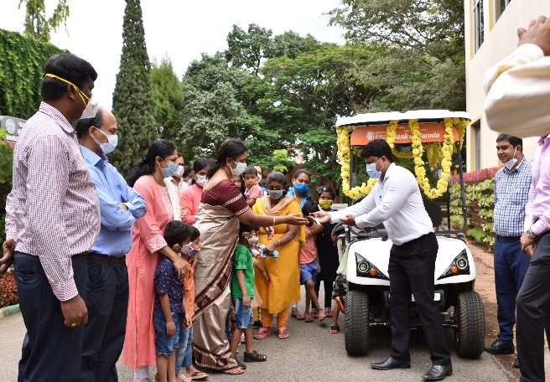All India Institute of speech and hearing, Mysuru caters to varieties of communication disorders. On an average of 600-800 clients avail services from the Department of Clinical Services and Special Education daily, including paediatric to the geriatric population. A newly procured battery-operated vehicle will facilitate the movement of the client availing the services among different sections/departments, hence it was inaugurated on the occasion of the 56th Annual Day celebrations of the Institute.  AIISH acknowledges the financial assistance from the Bank of Baroda in the procurement of the vehicle. This also would aid in eco-friendly and disable friendly environment for individuals with communication disorders

**In August 2021**