**All India Institute of Speech and Hearing (AIISH), Mysore**

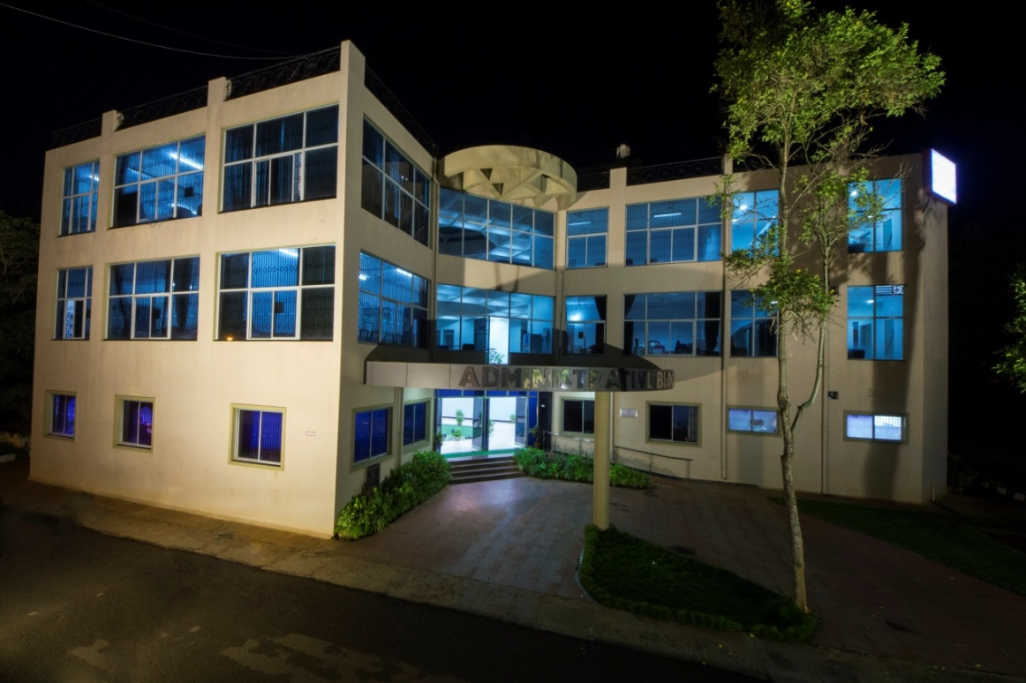

ALL INDIA INSTITUTE OF SPEECH AND HEARING

The All India Institute of Speech and Hearing (AIISH) is a premier educational establishment pertaining to communication and its disorders in the country providing training, research, clinical care and public education in communication disorders. The Institute successfully completed its fifty years of dedicated service to the nation in 2015. The activities carried out by the institute during the year till November, 2015 are given below.

**Academic Activities:** The institute offered 16 academic programmes and 480 students were admitted to various programmes. Activities such as guest lectures by eminent personalities, orientation/ short-term training programmes, journal club and clinical conference presentations, were organized during the period. These include a guest lecture on Evidence Based Practice by Prof. M.N. Hegde, Professor Emeritus of Speech Language Pathology, California State University, USA. In addition, faculty calibration was performed in accordance with ISO 9001-2008 standard.

**Research Accomplishments:** Totally, three funded research projects were completed and 24 projects were newly initiated at the institute during the period. Also, 47 projects were progressing in different departments. The funding for the research projects were provided by organizations such as the Department of Science and Technology, Govt. of India and Indian Council of Medical Research, in addition to the funding given by the Institute. A Next Generation Sequencing Lab to determine the nucleotide sequence of DNA in a massively parallel way was opened in the Human Genetic Lab of the Institute during the period. Also, a meet of IEEE India Special Interest Group on Communications Disability was organized to orient the faculty of engineering colleges about the technology needs for persons with communication disorders and encourage them to initiate research projects to support technology development. In addition, the Institute organized seven seminars and workshops on various aspects of communication disorders including an International Symposium on Neuro-cognitive Communication Disorders.

**Clinical Services:** The institute offered a wide variety of clinical services to a total number of 40380 persons with communication disorders. The clinical services offered include assessment and rehabilitation pertaining to speech, language and hearing disorders, psychological and otorhinolaryngological disorders related to communication disorders. In addition, specialized clinical services were also rendered on augmentative and alternative communication, autism spectrum disorders, cleft lip palate and other craniofacial anomalies, fluency, learning disability, listening training, motor speech disorders, neuropsychological disorders, professional voice care, voice disorders and vertigo. The details of the core clinical services from April to November, 2015 are given below.

|  |  |  |
| --- | --- | --- |
| **Core Clinical Services** | **No. of Clients** | **Therapy Sessions** |
| Hearing Evaluation/ Listening Training | 8300 | 6105 |
| Speech and Language Assessment | 5261 | 20350 |

**Outreach Clinical Services:** The Institute opened three new Newborn Screening (NBS) Centers at JIPMER, Puducherry; Netaji Subhash Chandra Bose Medical College (NSCB), Jabalpur; and Rajendra Institute of Medical Sciences, Baritayu, Ranchi during the period. Also, a new Outreach Service Center (OSC) was inaugurated at the Sub-divisional hospital, Sagara Taluk, Shivamogga, Karnataka. Diagnostic services were provided to 1369 clients at the four outreach clinical centers. In addition, 1099 school children in Mysore and 22682 newborn/infants at 15 hospitals and three immunization centres in Mysore, four outreach service centres and the three newborn screening centres were screened for communication disorders. Four screening camps were conducted. The Institute also offered tele-intervention service at the nine DHLS centres of the Institute located across the country.

**Public Education Activities:** Public education activities such as organization of Public Lectures, Noise Awareness Rally, observation of commemorative days such as World Voice Day, Autism Day and World Alzheimer’s Day, and preparation and dissemination of public education materials on prevention and control of communication disorders were carried out.

**Other Activities and Events**:The Institute celebrated its Golden Jubilee Year of establishment on 9th August, 2015. Three newborn screening centres of the Institute were inaugurated on the occasion. Also, a Golden Jubilee video and research publications and clinical tests/tools developed at the Institute were released, and Ph.D awardees, meritorious students, retired employees, and best employees of the Institute were felicitated. The Institute received Karyalaya Darpana Smrithi Chinn Puraskar from Rajbhasha Sansthan*,*New Delhi for the publication of Best Annual Report in Hindi.

**Fiscal Matters:** The financial status of the institute during the period is given below.

|  |  |  |
| --- | --- | --- |
| **Type of grant** | **Grants allocated under BE 2015-16** | **Amount released** |
| **Plan**  Rs. in lakhs | | |
| Grant- in-Aid General | 1725.00 | 698.93 |
| Grant- in-Aid Capital | 2584.00 | 0.00 |
| Grant- in-Aid Salaries | 1191.00 | 503.00 |
| **Non-Plan** | | |
| Grant- in-Aid General | 663.00 | 271.89 |
| Grant- in-Aid Salaries | 1137.00 | 541.15 |
| **Total** | **7300.00** | **2014.97** |