DEPARTMENT OF PREVENTION OF COMMUNICATION DISORDERS (POCD)

MONTHLY REPORT – APRIL 2013

1. **ACADEMIC ACTIVITIES**
2. **Long-term academic programs:**

The department carried out long-term training activities. Training and supervision of students posted for various clinical activities of the department was carried out. Table 1 gives the number of students supervised by the staff of the department.

*Table 1: No. of hours of clinical supervision of students*

|  |  |  |
| --- | --- | --- |
| *Class* | *Infant screening* | *Clinical activity in*  *OSCs* |
| II BASLP | 84 hrs | - |
| Interns | - | 168 hrs |
| I M.Sc. (SLP) | 84 hrs | - |
| B.S.Ed (HI) | 20 hrs | - |

1. **Short-term training programs:** Nil
2. **Orientation programs / Workshop conducted:**

Eleven orientation programs on prevention, early identification and management of communication disorders were conducted. The target groups included school teachers (from 8 schools from both rural and urban areas), elder citizens (2 centres), industrial workers (1 centre). Table 2 indicates the details of the orientation programs.

*Table 2: Details of the orientation program.*

|  |  |  |  |  |  |
| --- | --- | --- | --- | --- | --- |
|  | *Date* | *Resource persons* | *Topic (Language)* | *Target group* | *Venue* |
|  | 1.4.13 | Ms. Raheela & Ms. Sahana P | Prevention and early identification of communication disorders  (English) | 25 Postgraduate students of Social Work (MSW) -University of Mysore | AIISH Seminar hall |
|  | 19.4.13 | Ms. Raheela & Ms. Sahana P | Prevention and early identification of communication disorders  (English)  C:\Users\user\Downloads\IMG-20130422-WA0006.jpg  C:\Users\user\Downloads\IMG-20130422-WA0004.jpg | 30 Postgraduate students of Social Work (MSW), Mahajana Post Graduate Centre | Dept. of POCD, AIISH, Mysore |

1. **Clinical observation posting of students from other institutes:** Nil
2. **Seminars/ Conferences /Lectures /Workshops:**

* Mr. Adithya Karthik & Ms. Sushma R attended the National seminar on “Rehabilitation of Oral Cancer” on 17.4.13 and the National Seminar on “National seminar on recent advances in voice care” on 18.4.2013 and 19.4.2013.
* Mr. Anoop & Ms. Raheela attended the National seminar on “Unraveling the mysteries of Cognitive Neurophysiological Assessment & management in Dementia” on 10.04.13.

1. **Lectures:** Nil
2. **Additional Academic Services by Faculty and Staff:**

* **Prof. P.Manjula**

**-** Served as Chairperson of Entrance Exam committee.

**-** Mentor for III BSc B section

* **Dr. Jayashree**
* Mentor for III BSc A section

1. **RESEARCH ACTIVITIES**
2. **Research projects:** Nil
3. **Research Papers Published:** Nil
4. **Research papers in press:** Nil
5. **Book Published:** Nil
6. **Book Chapters Published:** Nil
7. **Books in press:** Nil
8. **Books / Seminar proceedings Edited:** Nil
9. **Scholarly Reviewing Activities:** Nil
10. **CLINICAL SERVICES**
11. **General Clinical Services:**

The department carried out screening, diagnostic and rehabilitation activities, both within and outside AIISH (in Mysore and outside Mysore). The details are as follows:

1. Screening of new born infants and children for communication disorders was carried out in the following centres:

* 12 hospitals and 2 immunization centres in Mysore city
* 2 PHC/CHC centres (CHC centre of Santhemaralli, Yelandur Taluk & PHC Hullahalli, Nanjangud Taluk, PHC Akkihebbalu).
* 2 Govt. Hospitals (KR Nagar and T. Narsipura).

1. Diagnostic and rehabilitation services were rendered to those unreached at the Outreach Service Centres (OSCs) of the POCD Department. The services included evaluation and intervention activities at the following centres:

* PHC centre, Hullahalli, Nanjangud Taluk, Mysore district
* PHC centre, Akkihebbalu, K.R. Pete Taluk, Mandya district
* PHC centre, Gumballi, Yelandur Taluk, Chamarajanagar district

The details of these clinical services are given below.

1. **Screening new born infants and children for communication disorders:**

In this program, neonates and infants are screened for communication disorders using the following tools to identify children with communication disorders. Those who do not pass the If they do not pass the screening, they are referred them for detailed evaluation and management:

* High Risk Register (HRR) for communication disorders
* Behavioural Observation Audiometry (BOA)
* Oto Acoustic Emission screening (OAE)
* Screening Checklists.

1. **Screening in Mysore city**

In the report month, screening program was carried in 12 hospitals and 2 immunization centres in Mysore. These centres include Apollo BGS Hospital (AH), Basappa Memorial Hospital (BMH), Combined Hospital (CH), Employees State Insurance (ESI), Harsha Hospital (HH), Kamakshi Hospital (KH), KR Hospital (KRH), Makkalakoota Immunization Center (MIC), Mission Hospital (MH), Immunization Centre at Mission Hospital (ICMH), N.P.C Hospital (NPC), S.M.T.D.H Hospital (SMTDH), Sreenivasa Maternity Home (SMH) and Railway Hospital (RH).

The number of infants screened and referred for detailed evaluations in Mysore is given in Table 3. Figures 1 gives the details of the infant screening including the number of infants referred for detailed evaluations.

*Table 3: Total number of infants screened and referred in 14 hospitals/immunization centers in Mysore city*

|  |  |  |  |  |  |  |  |
| --- | --- | --- | --- | --- | --- | --- | --- |
| *SN* | *Hospitals/ Immunization centres* | *No. Screened* | | | *No. Referred* | | |
| *Male* | *Female* | *Total* | *Male* | *Female* | *Total* |
|  | AH | 22 | 16 | 38 | 0 | 0 | 0 |
|  | BMH | 18 | 05 | 23 | 0 | 0 | 0 |
|  | CH | 05 | 07 | 12 | 0 | 1 | 1 |
|  | ESI | 09 | 03 | 12 | 0 | 0 | 0 |
|  | HH | 07 | 03 | 10 | 0 | 0 | 0 |
|  | KH | 36 | 32 | 68 | 0 | 0 | 0 |
|  | KRH | 456 | 500 | 956 | 2 | 0 | 2 |
|  | MIC | 10 | 08 | 18 | 0 | 0 | 0 |
|  | MH | 41 | 33 | 74 | 0 | 0 | 0 |
|  | ICMH | 5 | 3 | 8 | 0 | 0 | 0 |
|  | NPC | 10 | 07 | 17 | 0 | 0 | 0 |
|  | SMTDH | 17 | 19 | 36 | 0 | 0 | 0 |
|  | SMH | 05 | 06 | 11 | 0 | 0 | 0 |
|  | RH | 0 | 02 | 2 | 0 | 0 | 0 |
|  | **Total** | **641** | **644** | **1285** | **2** | **1** | **3** |

*Figure 1: No. of male and female infants passed / referred to AIISH for detailed evaluation at 14 hospitals / immunization centers during April 2013*

1. **In Outreach Service Centre**

In the report month, infant screening program was carried out in 3 Government Hospitals (at K R Nagar, Santhemaralli, T Narsipura), and at Outreach Service Centres (at Hullahalli & Akkihebbalu). A detail of this is provided in Table 4.

*Table 4: No. of infants screened at Hullahalli, Akkihebbalu, KR Nagar, Santhemaralli and T Narsipura*

|  |  |  |  |  |  |  |
| --- | --- | --- | --- | --- | --- | --- |
| *Infant Screening at* | *No. Screened* | | | *No. Referred* | | |
| *M* | *F* | *Total no. of infants*  *screened* | *M* | *F* | *Total no. referred to AIISH* |
| Akkihebbalu | 5 | 4 | 9 | 0 | 0 | 0 |
| K R Nagar | 7 | 10 | 17 | 0 | 0 | 0 |
| Hullahalli | 17 | 09 | 26 | 0 | 0 | 0 |
| Santhemarahalli | 18 | 07 | 25 | 0 | 0 | 0 |
| T Narsipura | 17 | 13 | 30 | 0 | 0 | 0 |
| **Total** | **64** | **43** | **107** | **0** | **0** | **0** |

1. **In NBS Centre**

*New born screening (NBS) at Cuttack, Imphal and Ajmer centres*: Table 6 gives the details of the infants screened at Cuttack, Imphal and Ajmer centres respectively.

*Table 6: No. of infants screened and referred (Male & Female) in NBS centres*

|  |  |  |  |  |  |  |
| --- | --- | --- | --- | --- | --- | --- |
| *Hospital* | *No. screened* | | | *No. Referred* | | |
| *Male* | *Female* | *Total*  *screened* | *Male* | *Female* | *Total*  *Referred* |
| SNCU, SCB MCH,  Cuttack | 125 | 80 | 205 | 10 | 07 | 17 |
| Regional Institute of medical Sciences (RIMS), Imphal | 170 | 109 | 279 | 2 | 3 | 5 |
| Janana Hospital (Rajakiya Mahila Chikitsalaya), Ajmer | 271 | 260 | 531 | 13 | 7 | 21 |
| **TOTAL** | **566** | **449** | **1015** | **25** | **17** | **43** |

All the parents/caregivers of children who were screened were counseled regarding identification of any delay or deviancies in normal developmental milestones of hearing, speech, language, motor and other related domains that affect the development of communication skills in children. They were provided a checklist (i.e., Remember and Care) to help them to monitor the development of the infant. They were advised to visit the institute for a detailed investigation and further management in case if there is any delay / deviation noted in the development of the child.

* + 1. **Follow-up activities of POCD Department:**

The adults and infants referred during the screening activity outside AIISH were followed up at AIISH and at Ajmer NBS centre through telephone calls and individual letters written to client / parents / caregivers of infants. A complete test battery was administered for those clients who came for follow-up. Table 5 depicts the statistics related to this activity.

*Table 5: Findings on detailed evaluation of infants who were followed up at AIISH and NBS centres April 2013*

|  |  |  |  |  |
| --- | --- | --- | --- | --- |
|  | *No. of children followed up* | | | |
| *Categories* | *AIISH* | *Ajmer* | *Cuttack* | *Imphal* |
| No. of clients with normal hearing | 8 | 4 | 4 | - |
| No. of clients with hearing impairment | 5 | 8 | 3 | 2 |
| No. of clients with incomplete testing | 1 | 1 | 1 | - |
| No. of clients with Speech & Language problems | - | 1 | - | - |
| **Total** | **14** | **14** | **8** | **2** |

1. **Specialized Clinical Services:** NA
2. **Clinical Support Services to Patients and Family:** Nil
3. **Clinical Electronic Services:**

The clinical activity carried out by the internship students at OSCs was monitored through video conferencing at Hullahalli and through landline telephone at Akkihebbalu by the staff of the department.

**Total Hours of Connectivity:**

|  |  |  |
| --- | --- | --- |
| **Sl. No** | **Conditions** | **Total Duration** |
| 1 | A+V | 9 hrs 15 mins |

**No. of Cases:**

**Diagnostic – 08**

**Therapy - 01**

1. **EXTENSION ACTIVITIES**
2. **Rehabilitation & Education through Distance Mode:** NA
3. **Evaluation of senior citizens for communication disorders conducted by POCD department**

The Department of POCD conducted a Speech-Language and Hearing camp for the elderly individuals residing at “Sri Vasavi Shanthidhama" on 23-04-2013. A total of 34 participants were registered.

*Table 7: Total number of senior citizens tested and prescribed hearing aids in Sri Vasavi Shanthidhama Public Charitable trust, Alanahalli Extension, Mysore.*

|  |  |  |  |  |  |  |  |  |  |
| --- | --- | --- | --- | --- | --- | --- | --- | --- | --- |
| *Old age Home* | *Speech- Language evaluation* | | | *Hearing evaluation* | | | *Hearing aid Distribution* | | |
| *Male* | *Female* | ***Total*** | *Male* | *Female* | ***Total*** | *Male* | *Female* | ***Total*** |
| *Sri Vasavi Shanthidhama Public Charitable trust,* | 2 | 0 | **2** | 12 | 15 | **27** | 7 | 6 | **13** |

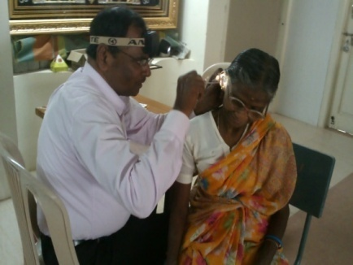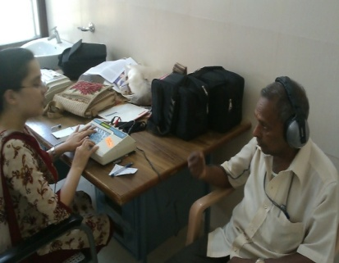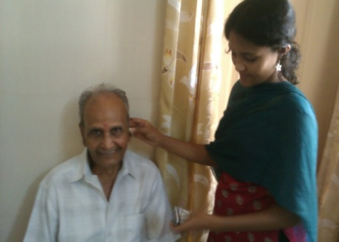

1. **Industrial Screening for hearing disorders conducted by POCD department**

A hearing screening program was conducted at AMW-MGM Forgings Pvt. Ltd., Mysore for industrial employees and employers on 4th, 5th and 8th of April, 2013. A total of 188 individuals were screened. Ms Deepthi and Ms Sahana carried out the screening activities.

|  |  |  |  |
| --- | --- | --- | --- |
| *Industry* | *Hearing Screening* | | |
| *Pass* | *Refer* | ***Total*** |
| AMW-MGM Forgings Pvt. Ltd. | 134 | 54 | **188** |

*Table 8: Total number of employees screened in* AMW-MGM Forgings Pvt. Ltd.

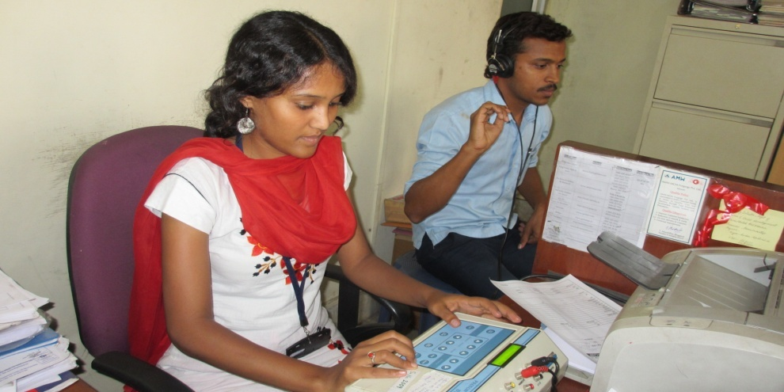

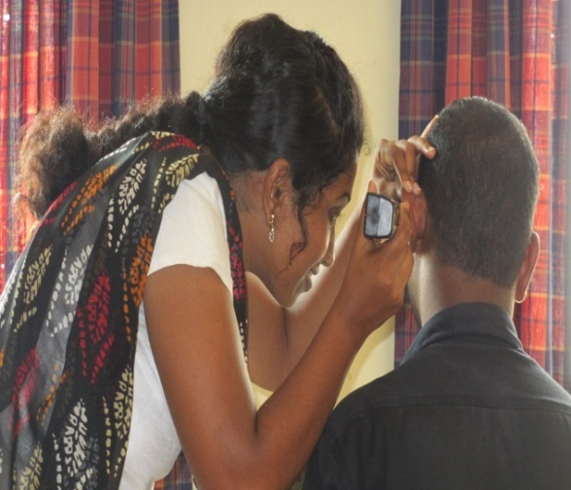

1. Clinical activities were also being carried out in the Outreach Service Centres (OSC) at PHC centre, Hullahalli; PHC centre, Akkihebbalu; and PHC centre, Gumballi.

The objective of the Outreach Service Centers (OSCs) is to provide diagnostic and therapeutic facilities for persons residing in rural areas, in and around the three Outreach Service Centers. Routinely, the following clinical activities are carried out in these Outreach Service Centers:

* E.N.T evaluation
* Infant screening
* Audiological evaluation
* Hearing aid trial and distribution of hearing aids & ear moulds under ADIP Scheme
* Speech-Language evaluation
* Listening, Speech-Language therapy
* Counseling and Guidance services

*Table 9: Number of ears with different degree and type of hearing loss at Hullahalli (HH), Akkihebbalu (AK) and Gumballi (GB) OSCs*

|  |  |  |  |  |
| --- | --- | --- | --- | --- |
| *Type of hearing loss* | *Degree of hearing loss* | **HH** | **AK** | **GB** |
| *Conductive* | *Minimal* | 2 | 1 | 4 |
| *Mild* | 6 | - | - |
| *Moderate* | 1 | - | 1 |
| *Mod Severe* | - | - | - |
| *SNHL* | *Minimal* | 1 | 1 | - |
| *Mild* | 12 | 2 | - |
| *Moderate* | 16 | 11 | 4 |
| *Mod Severe* | 38 | 10 | 2 |
| *Severe* | 25 | 6 | - |
| *Profound* | 14 | 7 | - |
| *Mixed* | *Minimal* | 1 | - | - |
| *Mild* | 1 | 3 | 1 |
| *Moderate* | 9 | 3 | 1 |
| *Mod Severe* | 1 | 7 | 2 |
| *Severe* | 2 | 3 | - |
| *Profound* | 0 | 1 | - |
| *Normal* | | 2 | 3 | 1 |
| **Total** | | **131** | **58** | **15** |

|  |  |  |  |  |  |  |  |
| --- | --- | --- | --- | --- | --- | --- | --- |
| *ENT Problems* | *Wax* | *Otitis Externa and other outer ear disorders* | *TM related Problems* | *ET Dysfunction* | *ASOM* | *CSOM* | *Others* |
| ***HH*** | 4 | 5 | 3 | 5 | 2 | 44 | 10 |
| ***AK*** | 5 | 8 | 2 | - | 1 | 12 | 9 |
| ***GB*** | 4 | 9 | - | 1 | 1 | 13 | 9 |

*Table 10: Details of number of ears having different ENT problem at Hullahalli (HH), Akkihebbalu (AK) and Gumballi (GB) OSCs*

*Table 11:* *Details of clients having Speech and Language problem at Hullahalli (HH), Akkihebbalu (AK) and Gumballi (GB) OSCs*

|  |  |  |  |  |  |  |  |  |  |  |  |  |
| --- | --- | --- | --- | --- | --- | --- | --- | --- | --- | --- | --- | --- |
|  | **HH** | | | | **AK** | | | | **GB** | | | |
| **Type** | *M* | | *F* | | *M* | | *F* | | *M* | | *F* | |
| *Paed.* | *Adult* | *Paed.* | *Adult* | *Paed.* | *Adult* | *Paed.* | *Adult* | *Paed.* | *Adult* | *Paed.* | *Adult* |
| *Language* | 5 |  |  |  | 2 |  |  |  |  |  |  |  |
| *Fluency* | 1 |  |  |  |  |  |  |  | 1 |  |  |  |
| *Voice* |  |  |  |  |  |  |  |  |  |  |  |  |
| *Articulation* | 1 |  |  |  |  |  | 1 |  |  |  |  |  |
| *Multipledisoreders* |  |  |  |  |  |  |  |  |  |  |  |  |
| *Normal* |  |  |  |  |  |  |  |  |  |  |  |  |
| ***Total*** | **7** |  |  |  | **2** |  | **1** |  | **1** |  |  |  |

*Table 12: Details of hearing aids dispensed at Hullahalli (HH), Akkihebbalu (AK) and Gumballi (GB) OSCs*

|  |  |  |  |  |  |  |  |  |  |
| --- | --- | --- | --- | --- | --- | --- | --- | --- | --- |
| *Hearing aid details* | *Category of hearing aids* | | | | | | | | |
| *Mild*  *(Arphi 333 Super)* | | *Moderate*  *(Arphi Excellent)* | | *Strong*  *(Arphi 333 Super)* | | *Extra strong (Arphi 660PP)* | | ***Total*** |
| *S cord* | *V cord* | *S cord* | *V cord* | *S cord* | *V cord* | *S cord* | *V cord* |
| ***Hullahalli*** | - | - | 12 | 11 | 8 | 3 | - | 2 | ***36*** |
| ***Akkihebbalu*** | 1 | 1 | 9 | 9 | 3 | 1 | 3 | ***-*** | 27 |
| ***Gumballi*** | ***-*** | ***-*** | 3 | - | 1 | 1 | - | *-* | 5 |
| ***Total*** | **1** | **1** | **24** | **20** | **12** | **4** | **3** | **5** | **68** |

*Table 13: Details of therapy given at Hullahalli (HH), Akkihebbalu (AK) and Gumballi (GB) OSCs*

|  |  |  |  |  |
| --- | --- | --- | --- | --- |
| **OSCs** |  | ***Male*** | ***Female*** | ***No. of sessions*** |
| **HH** | *Hearing disorder* | - | - | - |
| *Speech disorder* | 1 | - | 2 |
| *Language disorder* | 2 | - | 8 |
| **AK** | *Hearing disorder* | 1 | - | 7 |
| *Speech disorder* | 1 | - | 2 |
| *Language disorder* | - | - | - |
| **GB** | *Hearing disorder* | - | - | - |
| *Speech disorder* | 1 | - | 2 |
| *Language disorder* | - | - | - |
| **TOTAL** | | **3** | **-** | **11** |

1. **Camps for Communication Disorders: Nil**
2. **Public Lecture Series: Nil**
3. **Others: Nil**
4. **TECHNOLOGICAL CONSULTANCY SERVICES:** Nil
5. **CENTRAL FACILITIES**
6. Library and information services – Nil
7. Participation in expo to educate public and staff/students from college: Nil
8. Material Development: Nil
9. **AWARDS AND HONOURS RECEIVED BY FACULTY AND STAFF -**
10. **EXTRA CURRICULAR ACTIVITIES**
11. AIISH GYMKHANA: Nil
12. NSS: Nil
13. **OTHERS:** Nil

DEPARTMENT OF PREVENTION OF COMMUNICATION DISORDERS (POCD)

MONTHLY REPORT –MAY 2013

1. **ACADEMIC ACTIVITIES**
2. **Long-term academic programs:**

The department carried out long-term training activities. Training and supervision of students posted for various clinical activities of the department was carried out. Table 1 gives the number of students supervised by the staff of the department.

*Table 1: No. of hours of clinical supervision of students*

|  |  |  |
| --- | --- | --- |
| *Class* | *Infant screening* | *Clinical activity in*  *OSCs* |
| II BASLP | 12 hrs | - |
| Interns | - | 96 hrs |
| I M.Sc. (SLP) | 32 hrs | - |

1. **Short-term training programs:** Nil
2. **Orientation programs /Workshop conducted: Nil**
3. **Clinical observation posting of students from other institutes: Nil**
4. **Seminars/ Conferences /Lectures/Workshops:**
5. **Lectures:** Nil
6. **Additional Academic Services by Faculty and Staff:**

* **Prof. P. Manjula**

**-** Mentor for III BSc B section

1. **RESEARCH ACTIVITIES**
2. **Research projects:** Nil
3. **Research Papers Published:** Nil
4. **Research papers in press:** Nil
5. **Book Published:** Nil
6. **Book Chapters Published:** Nil
7. **Books in press:** Nil
8. **Books / Seminar proceedings Edited:** Nil
9. **Scholarly Reviewing Activities:** Nil
10. **CLINICAL SERVICES**
11. **General Clinical Services:**

The department carried out screening, diagnostic and rehabilitation activities, both within and outside AIISH (in Mysore and outside Mysore). The details are as follows:

1. Screening of new born infants and children for communication disorders was carried out in the following centres:

* 12 hospitals and 2 immunization centres in Mysore city
* 2 PHC/CHC centres (CHC centre of Santhemaralli, Yelandur Taluk & PHC Hullahalli, Nanjangud Taluk, PHC Akkihebbalu).
* 2 Govt. Hospitals (KR Nagar and T.Narsipura).

1. Diagnostic and rehabilitation services were rendered to those unreached at the Outreach Service Centres (OSCs) of the POCD Department. The services included evaluation and intervention activities at the following centres:

* PHC centre, Hullahalli, Nanjangud Taluk, Mysore district
* PHC centre, Akkihebbalu, K.R. Pete Taluk, Mandya district
* PHC centre, Gumballi, Yelandur Taluk, Chamarajanagar district

The details of these clinical services are given below.

1. **Screening new born infants and children for communication disorders:**

In this program, neonates and infants are screened for communication disorders using the following tools to identify children with communication disorders. Those who do not pass the If they do not pass the screening, they are referred them for detailed evaluation and management:

* High Risk Register (HRR) for communication disorders
* Behavioural Observation Audiometry (BOA)
* Oto Acoustic Emission screening (OAE)
* Screening Checklists.

1. **Screening in Mysore city**

In the report month, screening program was carried in 12 hospitals and 2 immunization centres in Mysore. These centres include Apollo BGS Hospital (AH), Basappa Memorial Hospital (BMH), Combined Hospital (CH), Employees State Insurance (ESI), Harsha Hospital (HH), Kamakshi Hospital (KH), KR Hospital (KRH), Makkalakoota Immunization Center (MIC), Mission Hospital (MH), Immunization Centre at Mission Hospital (ICMH),N.P.C Hospital (NPC), S.M.T.D.H Hospital (SMTDH), Sreenivasa Maternity Home (SMH) and Railway Hospital (RH).

The number of infants screened and referred for detailed evaluations in Mysore is given in Table2. Figures 1 gives the details of the infant screening including the number of infants referred for detailed evaluations.

*Table 2: Total number of infants screened and referred in 14 hospitals/immunization centers in Mysore city*

|  |  |  |  |  |  |  |  |
| --- | --- | --- | --- | --- | --- | --- | --- |
| *SN* | *Hospitals/Immunization centres* | *No. Screened* | | | *No. Referred* | | |
| *Male* | *Female* | *Total* | *Male* | *Female* | *Total* |
|  | AH | 38 | 21 | 59 | 0 | 0 | 0 |
|  | BMH | 12 | 12 | 24 | 0 | 0 | 0 |
|  | CH | 14 | 11 | 25 | 0 | 0 | 0 |
|  | ESI | 05 | 08 | 13 | 0 | 0 | 0 |
|  | HH | 09 | 11 | 20 | 0 | 0 | 0 |
|  | KH | 27 | 24 | 51 | 0 | 0 | 0 |
|  | KRH | 424 | 412 | 836 | 0 | 0 | 0 |
|  | MIC | 10 | 12 | 22 | 1 | 0 | 1 |
|  | MH | 31 | 40 | 71 | 0 | 0 | 0 |
|  | ICMH | 02 | 0 | 02 | 0 | 0 | 0 |
|  | NPC | 18 | 08 | 26 | 0 | 0 | 0 |
|  | SMTDH | 23 | 14 | 37 | 0 | 0 | 0 |
|  | SMH | 04 | 03 | 07 | 0 | 0 | 0 |
|  | RH | 01 | 01 | 02 | 0 | 0 | 0 |
|  | **Total** | **618** | **577** | **1195** | **1** | **0** | **1** |

1. **In Outreach Service Centre**

In the report month, infant screening program was carried out in 3 Government Hospitals (at K R Nagar, Santhemaralli, T Narsipura), andat Outreach Service Centres (at Hullahalli & Akkihebbalu).A detail of this is provided in Table 3.

*Table 3: No. of infants screened at hospitals in Hullahalli, Akkihebbalu, KR Nagar, Santhemaralli and T Narsipura*

|  |  |  |  |  |  |  |
| --- | --- | --- | --- | --- | --- | --- |
| *Infant Screening at* | *No. Screened* | | | *No. Referred* | | |
| *M* | *F* | *Total no. of infants*  *screened* | *M* | *F* | *Total no. referred to AIISH* |
| Akkihebbalu | - | - | - | - | - | - |
| K R Nagar | 34 | 34 | 68 | - | - | - |
| Hullahalli | 08 | 07 | 15 | 01 | 01 | 02 |
| Santhemarahalli | 19 | 20 | 39 | - | - | - |
| T Narsipura | 23 | 22 | 45 | - | - | - |
| **Total** | **83** | **83** | **167** | - | - | 02 |

1. **In NBS Centre**

*New born screening (NBS) at Cuttack, Imphal and Ajmer centres*: Table 4 gives the details of the infants screened at Cuttack, Imphal and Ajmer centres respectively.

*Table 4: No. of infants screened and referred (Male & Female) in NBS centres*

|  |  |  |  |  |  |  |
| --- | --- | --- | --- | --- | --- | --- |
| *Hospital* | *No. screened* | | | *No. Referred* | | |
| *Male* | *Female* | *Total*  *screened* | *Male* | *Female* | *Total*  *Referred* |
| SNCU, SCB MCH,  Cuttack | 74 | 45 | 119 | 07 | 02 | 09 |
| Regional Institute of medical Sciences (RIMS), Imphal | 210 | 180 | 390 | 4 | 3 | 7 |
| Janana Hospital (Rajakiya Mahila Chikitsalaya), Ajmer | 235 | 195 | 430 | 8 | 3 | 11 |
| **TOTAL** | **519** | **420** | **939** | **19** | **8** | **27** |

All the parents/caregivers of children who were screened were counseled regarding identification of any delay or deviancies in normal developmental milestones of hearing, speech, language, motor and other related domains that affect the development of communication skills in children. They were provided a checklist (i.e., Remember and Care) to help them to monitor the development of the infant. They were advised to visit the institute for a detailed investigation and further management in case if there is any delay / deviation noted in the development of the child.

* + 1. **Follow-up activities of POCD Department:**

The adults and infants referred during the screening activity outside AIISH were followed up at AIISH and at 3 NBS centres through telephone calls and individual letters written to client/ parents / caregivers of infants. A complete test battery was administered for those clients who came for follow-up. Table 5 depicts the statistics related to this activity.

*Table 5: Findings on detailed evaluation of individuals who were followed up at AIISH and NBS centres*

|  |  |  |  |  |
| --- | --- | --- | --- | --- |
| *Categories* | *No. of individuals followed up* | | | |
| *AIISH* | | *Ajmer* | *Cuttack* |
| *Infants* | *Adults* |
| No. of clients with normal hearing | 3 | - | 6 | - |
| No. of clients with hearing impairment | 2 | 22 | 8 | 7 |
| No. of clients with incomplete testing | - | - | 3 | - |
| No. of clients with Speech &Language problems | - | - | - | - |
| **Total** | **5** | **22** | **17** | **7** |

1. **Specialized Clinical Services:** NA
2. **Clinical Support Services to Patients and Family:** Nil
3. **Clinical Electronic Services:**

The clinical activity carried out by the internship students at OSCs was monitored through video conferencing at Hullahalli and through landline telephone at Akkihebbalu by the staff of the department.

**Total Hours of Connectivity:**

|  |  |  |
| --- | --- | --- |
| **Sl. No** | **Conditions** | **Total Duration** |
| 1 | A+V | 15 hrs 10 mins |

**No. of Cases:**

**Diagnostic –** 14

**Therapy -** 04

1. **EXTENSION ACTIVITIES**
2. **Rehabilitation & Education through Distance Mode:** NA
3. Clinical activities were also being carried out in the Outreach Service Centres (OSC) at PHC centre, Hullahalli; PHC centre, Akkihebbalu; and PHC centre, Gumballi.

The objective of the Outreach Service Centers (OSCs) is to provide diagnostic and therapeutic facilities for persons residing in rural areas, in and around the three Outreach Service Centers. Routinely, the following clinical activities are being carried out in these Outreach Service Centres:

* E.N.T evaluation
* Infant screening
* Audiological evaluation
* Hearing aid trial and distribution of hearing aids& ear moulds under ADIP Scheme
* Speech-Language evaluation
* Listening, Speech-Language therapy
* Counseling and Guidance services

*Table6: Number of ears with different type and degree of hearing loss at Hullahalli (HH), Akkihebbalu (AK) and Gumballi (GB) OSCs*

|  |  |  |  |  |
| --- | --- | --- | --- | --- |
| *Type of hearing loss* | *Degree of hearing loss* | *HH* | *AK* | *GB* |
| *Conductive* | *Minimal* | - | - | 2 |
| *Mild* | 2 | 2 | 1 |
| *Moderate* | 2 | 2 | - |
| *Mod Severe* | - | - | - |
| *SNHL* | *Minimal* | 1 | - | 1 |
| *Mild* | 1 | - | 3 |
| *Moderate* | - | 6 | 11 |
| *Mod Severe* | 3 | 1 | 4 |
| *Severe* | 1 | 3 | - |
| *Profound* | - | - | - |
| *Mixed* | *Minimal* | - | - | - |
| *Mild* | - | - | - |
| *Moderate* | 2 | - | 1 |
| *Mod Severe* | 7 | - | 3 |
| *Severe* | 5 | - | - |
| *Profound* | 3 | - | 2 |
| **Total** | | **29** | **14** | **28** |

*Note:* 2 ears had hearing within normal limits

|  |  |  |  |  |  |  |  |
| --- | --- | --- | --- | --- | --- | --- | --- |
| *ENT Problems* | *Wax* | *Otitis Externa and other outer ear disorders* | *TM related Problems* | *ET Dysfunction* | *ASOM* | *CSOM* | *Others* |
| ***HH*** | 8 | 7 | - | 2 | 6 | 10 | 17 |
| ***AK*** | 3 | 6 | 1 | - | 4 | 7 | 11 |
| ***GB*** | 5 | 7 | - | - | 4 | 16 | 14 |

*Table 7: Number of ears having different ENT problems at Hullahalli (HH), Akkihebbalu (AK) and Gumballi (GB) OSCs*

*Note: 36 ears had normal findings on ENT examination*

*Table 8: Number of clients having Speech and Language problem at Hullahalli (HH), Akkihebbalu (AK) and Gumballi (GB) OSCs*

|  |  |  |  |  |  |  |  |  |  |  |  |  |
| --- | --- | --- | --- | --- | --- | --- | --- | --- | --- | --- | --- | --- |
|  | **HH** | | | | **AK** | | | | **GB** | | | |
| **Type** | *M* | | *F* | | *M* | | *F* | | *M* | | *F* | |
| *Paed.* | *Adult* | *Paed.* | *Adult* | *Paed.* | *Adult* | *Paed.* | *Adult* | *Paed.* | *Adult* | *Paed.* | *Adult* |
| *Language* | 1 | - | - | - | 1 | - | 2 | - | 1 | - | - | - |
| *Fluency* | - | - | - | - | 1 | - | - | - | - | - | - | - |
| *Voice* | - | - | - | - | - | - | - | - | - | - | - | - |
| *Articulation* | - | 1 | - | - | - | - | - | - | - | - | - | - |
| *Multiple* | - | - | - | - | - | - | - | - | - | - | 1 | - |
| *Normal* | - | - | - | - | - | - | - | - | - | - | - | - |
| ***Total*** | **1** | **1** | **-** | **-** | **2** | **-** | **2** | **-** | **1** | **-** | **1** | **-** |

*Table 9: Number of hearing aids dispensed at Hullahalli (HH), Akkihebbalu (AK) and Gumballi (GB) OSCs*

|  |  |  |  |  |  |  |  |  |  |
| --- | --- | --- | --- | --- | --- | --- | --- | --- | --- |
| *Hearing aid details* | *Category of hearing aids* | | | | | | | | |
| *Mild*  *(Arphi 333 Super)* | | *Moderate*  *(Arphi Excellent)* | | *Strong*  *(Arphi 333 Super)* | | *Extra strong (Arphi 660PP)* | | ***Total*** |
| *S cord* | *V cord* | *S cord* | *V cord* | *S cord* | *V cord* | *S cord* | *V cord* |
| ***Hullahalli*** | - | - | 7 | 1 | - | 1 | - | - | ***9*** |
| ***Akkihebbalu*** | 6 | - | - | - | 1 | - | - | ***-*** | **7** |
| ***Gumballi*** | 7 | 4 | - | - | - | 1 | - | *-* | **12** |
| ***Total*** | **13** | **4** | **7** | **1** | **1** | **2** | **-** | **-** | **28** |

*Table 10: Details of therapy given at Hullahalli (HH), Akkihebbalu (AK) and Gumballi (GB) OSCs*

|  |  |  |  |  |
| --- | --- | --- | --- | --- |
| *OSCs* | *Therapy given for individuals with* | *Male* | *Female* | *No. of sessions* |
| **HH** | *Hearing disorder* | - | - | - |
| *Speech disorder* | - | - | - |
| *Language disorder* | 3 | - | 6 |
| **AK** | *Hearing disorder* | 1 | - | 2 |
| *Speech disorder* | 1 | - | 1 |
| *Language disorder* | - | - | - |
| **GB** | *Hearing disorder* | - | 2 | 5 |
| *Speech disorder* | - | - | - |
| *Language disorder* | 1 | - | 3 |
| **TOTAL** | | **5** | **2** | **16** |

1. **Camps for Communication Disorders:**

Speech and hearing camp was conducted focusing on the diagnosis, treatment, and rehabilitation of the individuals with communication disorders at Vyasarajapura on 18th May 2013. Ms. Priyanka and Mr. Chandan attended the camp. A total of 35 clients were evaluated (Table 11).

*Table 11: Details of the clinical services provided at camps*

|  |  |  |
| --- | --- | --- |
| *Sl. No.* | *Clinical services rendered* | *No. of individuals assessed* |
| 1. | Speech language evaluation | DSL with MR-2  DSL with HL-1 |
| 3. | Audiological testing | 25 |
| 4. | Counseling | 25 |

1. **Public Lecture Series: Nil**
2. **Others: Nil**
3. **TECHNOLOGICAL CONSULTANCY SERVICES:**

Mr. Arunraj gave information on Hearing conservation for industrial employees to Dr. Bharathi, Medical officer, KSIC over Telephone on 21.05.2013.

1. **CENTRAL FACILITIES**
2. Library and information services–Nil
3. Participation in expo to educate public and staff/students from college: Nil
4. Material Development: Nil
5. **AWARDS AND HONOURS RECEIVED BY FACULTY AND STAFF-**
6. **EXTRA CURRICULAR ACTIVITIES**
7. AIISH GYMKHANA: Nil
8. NSS: Nil
9. **OTHERS:**

* The following staff member resigned from the Department of POCD:

|  |  |  |
| --- | --- | --- |
| **Contract Staff** | **Designation** | **Resigned on** |
| Mr. Adithya Karthik | SLP Grade | 24.05.13 |

* Prof. P. Manjula attended HODs meeting in the Board room on 2.05.13.
* Prof P. Manjula served as RCI expert and conducted inspection on 7.05.13
* MASLP program at SRC, AYJNIHH, Secundrabad.
* BASLP program and MASLP program at HKCRR, Secundrabad.
  + Prof P. Manjula attended meeting to vet the II drafts of ISO material submitted by the departments on 10.05.13, in Dr. K.S. Prema’s chamber
  + Prof P. Manjula attended meeting regarding the academic related work on 13.05.13 in the Board room.
* Prof P. Manjula attended AIISH Alumni meet on 28.05.13 in the Board room.

DEPARTMENT OF PREVENTION OF COMMUNICATION DISORDERS (POCD)

MONTHLY REPORT – JUNE 2013

1. **ACADEMIC ACTIVITIES**
2. **Long-term academic programs:** Nil
3. **Short-term training programs:** Nil
4. **Orientation programs /Workshop conducted:**

An orientation program on prevention, early identification and management of communication disorders was conducted for Nursing Trainees of Raman Institute of Nursing, Mysore on 05-06-2013. Pre- and post- tests were administered to evaluate the efficacy of the program. Table 2 indicates the details of the orientation program.

*Table 2: Details of the orientation program.*

|  |  |  |  |  |
| --- | --- | --- | --- | --- |
| *Resource persons* | *Topic* | *Target group* | *Venue* | *Mean Score (Max score = 10 )* |
| Ms. Priyanka & Ms. Sahana. P | Prevention and early identification of communication disorders | 34 students + 2 faculty | Dept of POCD, AIISH | **Pre -**test = **3.5**  **Post**- test = **9** |

1. **Clinical observation posting of students from other institutes:** Nil
2. **Seminars/ Conferences /Lectures/Workshops:**

* Mr. Arun Raj attended a Workshop on “Designing Software on Corel Draw” organized by the Department of Material development on 20.06.13 at AIISH, Mysore.
* Mr. Anoop B J & Ms. Shobhashree attended a Workshop on ‘Hindi creative writing’; & on 25.06.2013 and a Competition on Creative writing in Hindi on 26.06.13 at Central Institute of Hindi, Siddhartha Nagar, Mysore.
* **Cycle Rally for Noise Awareness**

The department conducted a Cycle Rally on 08.06.2013 to mark the International Noise Awareness Day (on 24.04.2013) and World Environment Day (on 05.06.2013). The rally intended to create awareness among the public regarding noise, its ill effects and guidelines for its control. A total of 12 staff members and more than 30 students from the Institute participated in the rally. Dr. Anand. V. Patil, Assistant Director of All India Radio (AIR, Mysore Station), Mysore inaugurated the rally by releasing a pamphlet named ‘Protect your Ears from Noise’ developed by Dr. P. Manjula. He then flagged off the Cyclists at 9.30 a.m near Ayurvedic College Hospital, Mysore. Around 500 pamphlets on noise awareness were distributed amongst the public during the rally. The rally was concluded at Ballal circle, Mysore by 11.30 p.m. The rally got wide coverage in the print media.

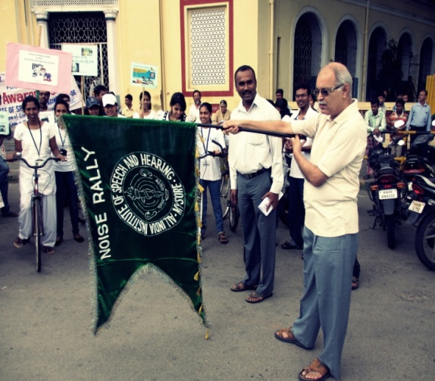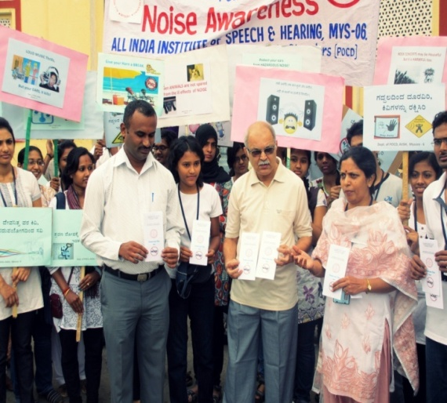

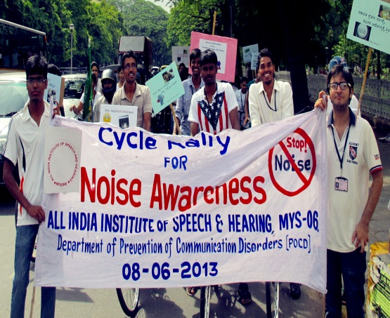 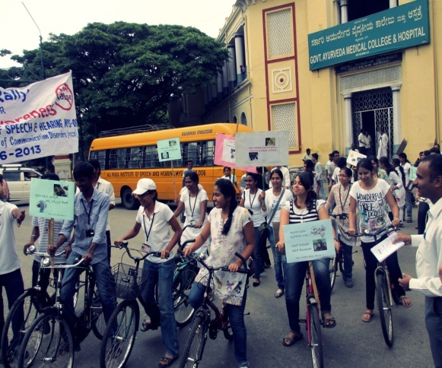

1. **Lectures:** Nil
2. **Additional Academic Services by Faculty and Staff:**
3. *Invited Talks - Nil*
4. *Curriculum Development: Nil*
5. *Development of material to support learning: Nil*
6. *Service in Academic bodies of other organizations:*

**Dr. Manjula P**

* Member, UG & PG BOE (Speech & Hearing), UOM
* Member, BOE (Special Education), UOM
* Member, BOE Bangalore University
* Examiner UOM

1. *Membership in professional organizations:Nil*
2. *Participation in committees/Taskforces and Panels set up by other organizations/agencies: Nil*
3. *Any other: Nil*
4. **RESEARCH ACTIVITIES**
5. **Research projects:** Nil
6. **Research Papers Published:** Nil
7. **Research papers in press:** Nil
8. **Book Published:** Nil
9. **Book Chapters Published:** Nil
10. **Books in press:** Nil
11. **Books / Seminar proceedings Edited:** Nil
12. **Scholarly Reviewing Activities:** Nil
13. **CLINICAL SERVICES**
14. **General Clinical Services:**

The department carried out screening, diagnostic and rehabilitation activities, both within and outside AIISH (in Mysore and outside Mysore). The details are as follows:

1. Screening of new born infants and children for communication disorders was carried out in the following centres:

* 12 hospitals and 2 immunization centres in Mysore city
* 2 PHC/CHC centres (CHC centre of Santhemaralli, Yelandur Taluk; & PHC Hullahalli, Nanjangud Taluk; PHC Akkihebbalu, K R Pete Taluk).
* 2 Govt. Hospitals (KR Nagar and T.Narsipura).

1. Diagnostic and rehabilitation services were rendered to those unreached at the Outreach Service Centres (OSCs) of the POCD Department. The services include evaluation and intervention activities at the following centres:

* PHC centre, Hullahalli, Nanjangud Taluk, Mysore district
* PHC centre, Akkihebbalu, K.R. Pete Taluk, Mandya district
* PHC centre, Gumballi, Yelandur Taluk, Chamarajanagar district

The details of these clinical services are given below.

1. **Screening new born infants and children for communication disorders:**

In this program, neonates and infants are screened for communication disorders. Infants who did not pass the screening were referred for a detailed evaluation and management to AIISH or respective OSC. The following tools were used to screen children with communication disorders.

* High Risk Register (HRR) for communication disorders
* Behavioural Observation Audiometry (BOA)
* Oto Acoustic Emission screening (OAE)
* Screening Checklists.

1. **Screening in Mysore city**

In the report month, screening program was carried in 12 hospitals and 2 immunization centres in Mysore. These centres include Apollo BGS Hospital (AH), Basappa Memorial Hospital (BMH), Combined Hospital (CH), Employees State Insurance (ESI), Harsha Hospital (HH), Kamakshi Hospital (KH), KR Hospital (KRH), Makkalakoota Immunization Center (MIC), Mission Hospital (MH), Immunization Centre at Mission Hospital (ICMH), N.P.C Hospital (NPC), S.M.T.D.H Hospital (SMTDH), Sreenivasa Maternity Home (SMH) and Railway Hospital (RH).

The number of infants screened and referred for detailed evaluations in Mysore is given in Table 2. Figures 1 gives the details of the infant screening including the number of infants referred for detailed evaluations.

*Table 2: Total number of infants screened and referred in 14 hospitals/immunization centers in Mysore city*

|  |  |  |  |  |  |  |  |
| --- | --- | --- | --- | --- | --- | --- | --- |
| *SN* | *Hospitals / Immunization centres* | *No. Screened* | | | *No. Referred* | | |
| *Male* | *Female* | *Total* | *Male* | *Female* | *Total* |
|  | AH | 17 | 18 | **35** | 0 | 0 | **0** |
|  | BMH | 8 | 7 | **15** | 0 | 0 | **0** |
|  | CH | 2 | 4 | **6** | 0 | 0 | **0** |
|  | ESI | 4 | 9 | **13** | 0 | 0 | **0** |
|  | HH | 1 | 4 | **5** | 0 | 0 | **0** |
|  | KH | 18 | 17 | **35** | 0 | 0 | **0** |
|  | KRH | 298 | 281 | **579** | 0 | 01 | **01** |
|  | MIC | 8 | 6 | **14** | 1 | 0 | **1** |
|  | MH | 23 | 29 | **52** | 0 | 0 | **0** |
|  | ICMH | 5 | 1 | **6** | 0 | 0 | **0** |
|  | NPC | 8 | 8 | **16** | 0 | 0 | **0** |
|  | SMTDH | 17 | 20 | **37** | 0 | 0 | **0** |
|  | SMH | 2 | 1 | **3** | 0 | 0 | **0** |
|  | RH | 1 | 2 | **3** | 0 | 0 | **0** |
|  | **Total** | **412** | **407** | **819** | **1** | **1** | **2** |

1. **Infant screening in and around Outreach Service Centres**

In the report month, infant screening program was carried out in 3 Government Hospitals (at K R Nagar, Santhemaralli, T Narsipura), and at Outreach Service Centres (at Hullahalli & Akkihebbalu). A detail of this is provided in Table 3.

*Table 3: No. of infants screened at hospitals in Hullahalli, Akkihebbalu, KR Nagar, Santhemaralli and T Narsipura*

|  |  |  |  |  |  |  |
| --- | --- | --- | --- | --- | --- | --- |
| *Infant Screening at* | *No. Screened* | | | *No. Referred* | | |
| *M* | *F* | *Total no. of infants*  *screened* | *M* | *F* | *Total no. referred to AIISH* |
| Akkihebbalu | - | - | - | - | - | - |
| K R Nagar | 67 | 71 | 138 | - | - | - |
| Hullahalli | 9 | 6 | 15 | - | - | - |
| Santhemarahalli | 15 | 12 | 27 | - | - | - |
| T Narsipura | 19 | 23 | 42 | - | - | - |
| **Total** | **110** | **112** | **212** | - | - | - |

1. **In NBS Centre**

*New born screening (NBS) at Cuttack, Imphal and Ajmer centres*: Table 4 gives the details of the infants screened at Cuttack, Imphal and Ajmer centres respectively.

*Table 4: No. of infants screened and referred (Male & Female) in NBS centres*

|  |  |  |  |  |  |  |
| --- | --- | --- | --- | --- | --- | --- |
| *Hospital* | *No. screened* | | | *No. Referred* | | |
| *Male* | *Female* | *Total*  *screened* | *Male* | *Female* | *Total*  *Referred* |
| SNCU, SCB MCH,  Cuttack | 163 | 93 | **256** | 5 | 4 | **9** |
| Regional Institute of medical Sciences (RIMS), Imphal | 184 | 146 | **330** | 1 | 1 | **2** |
| Janana Hospital (Rajakiya Mahila Chikitsalaya), Ajmer | 187 | 162 | **349** | 6 | 0 | **6** |
| **TOTAL** | 534 | 401 | **935** | 12 | 5 | **17** |

All the parents/caregivers of children who were screened were counseled regarding identification of any delay or deviancies in normal developmental milestones of hearing, speech, language, motor and other related domains that affect the development of communication skills in children. They were provided a checklist (i.e., Remember and Care) to help them to monitor the development of the infant. They were advised to visit the institute for a detailed investigation and further management in case if there was any delay / deviation noted in the development of the child.

* + 1. **Follow-up activities of POCD Department:**

1. *Detailed audiological evaluation of referred infants during screening activity*

The infants referred during the screening activity outside AIISH were followed up at AIISH and at 3 NBS centres through telephone calls and individual letters written to client/ parents / caregivers of infants. A complete test battery was administered for those clients who came for follow-up. Table 5 depicts the statistics related to this activity.

*Table 5: Findings on detailed evaluation of individuals who were followed up at AIISH and NBS centres*

|  |  |  |  |
| --- | --- | --- | --- |
| *Categories* | *AIISH* | *Ajmer* | *Cuttack* |
| No. of clients with normal hearing | 5 | 4 | 6 |
| No. of clients with hearing impairment | 3 | 5 | 8 |
| No. of clients with incomplete testing | - | - | 2 |
| No. of clients with Speech & Language problems | - | - |  |
| **Total** | **8** | **9** | **16** |

*Hearing evaluation of industrial workers*

A total of 130 employees from Karnataka Silk Industries Co. (KSIC) visited AIISH. A complete test battery was administered for those clients to test their hearing abilities. Out of them, 125 employees had hearing impairment ranging from minimal to severe hearing loss. Most of the employees of this industry had high frequency sloping sensorineural hearing loss due to exposure to high noise level. The employees were counseled regarding the need to use hearing protective devices to protect their hearing ability. The details of the hearing evaluation of the employees are represented in Table 6.

*Table 6: Findings on detailed evaluation of KSIC employess*

|  |  |
| --- | --- |
| *Categories* | *No. of employees* |
| No. of clients with normal hearing | 3 |
| No. of clients with hearing impairment | 125 |
| No. of clients with incomplete testing | 2 |
| **Total** | **130** |

1. **Specialized Clinical Services:** NA
2. **Clinical Support Services to Patients and Family:** Nil
3. **Clinical Electronic Services:**

The clinical activity carried out at OSCs was monitored through video conferencing at Hullahalli and through landline telephone at Akkihebbalu by the staff of the department.

**Total Hours of Connectivity:**

|  |  |  |  |
| --- | --- | --- | --- |
| **Sl. No** | **Conditions** | **Total Duration** | **No. of Cases supervised** |
| 1 | Audio+Video connectivity  (Hullahalli) | 11 hrs, 35 mins | Diagnostic – 18 Therapy - 04 |

1. **EXTENSION ACTIVITIES**
2. **Rehabilitation & Education through Distance Mode:** NA
3. Clinical activities were also being carried out in the Outreach Service Centres (OSC) at PHC centre, Hullahalli; PHC centre, Akkihebbalu; and PHC centre, Gumballi.

The objective of the Outreach Service Centers (OSCs) is to provide diagnostic and therapeutic facilities for persons residing in rural areas, in and around the three Outreach Service Centers. Routinely, the following clinical activities are being carried out in these Outreach Service Centres:

* E.N.T evaluation
* Infant screening
* Audiological evaluation
* Hearing aid trial and distribution of hearing aids& ear moulds under ADIP Scheme
* Speech-Language evaluation
* Listening, Speech-Language therapy
* Counseling and Guidance services

*Table 7: Number of ears with different type and degree of hearing loss at Hullahalli (HH), Akkihebbalu (AK) and Gumballi (GB) OSCs*

|  |  |  |  |  |
| --- | --- | --- | --- | --- |
| *Type of hearing loss* | *Degree of hearing loss* | *Hullahalli* | *Akkihebbalu* | *Gumballi* |
| *Conductive* | *Minimal* | 1 | - | 2 |
| *Mild* | - | 1 | - |
| *Moderate* | - | 1 | 1 |
| *Mod Severe* | - | - | - |
| *SNHL* | *Minimal* | - | - | 7 |
| *Mild* | 4 | 2 | 11 |
| *Moderate* | 11 | 9 | 10 |
| *Mod Severe* | 25 | 8 | 14 |
| *Severe* | 22 | 2 | 2 |
| *Profound* | 12 | - | 4 |
| *Mixed* | *Minimal* | - | - | - |
| *Mild* | - | - | - |
| *Moderate* | 4 | - | - |
| *Mod Severe* | 4 | - | - |
| *Severe* | 10 | 1 | - |
| *Profound* | 11 | 4 | - |
| **Total** | | **104** | **28** | **51** |

*Note:* 4, 0 & 1 ears had hearing within normal limits in HH, AK & GB.

|  |  |  |  |  |  |  |  |
| --- | --- | --- | --- | --- | --- | --- | --- |
| *ENT Problems* | *Wax* | *Otitis Externa and other outer ear disorders* | *TM related Problems* | *ET Dysfunction* | *ASOM* | *CSOM* | *Others* |
| *Hullahalli* | 13 | 14 | - | - | 02 | 41 | 29 |
| *Akkihebbalu* | 3 | 8 | 7 | 4 | - | 14 | 9 |
| *Gumballi* | 6 | 16 | - | - | 6 | 16 | 14 |

*Table 8: Number of ears having different ENT problems at Hullahalli (HH), Akkihebbalu (AK) and Gumballi (GB) OSCs*

*Note: 20, 10 & 15 ears had normal findings on ENT examination in HH, AK & GB respectively.*

*Table 9: Number of clients having Speech and Language problem at Hullahalli (HH), Akkihebbalu (AK) and Gumballi (GB) OSCs*

|  |  |  |  |  |  |  |  |  |  |  |  |  |
| --- | --- | --- | --- | --- | --- | --- | --- | --- | --- | --- | --- | --- |
|  | **HH** | | | | **AK** | | | | **GB** | | | |
| **Type** | *M* | | *F* | | *M* | | *F* | | *M* | | *F* | |
| *Paed.* | *Adult* | *Paed.* | *Adult* | *Paed.* | *Adult* | *Paed.* | *Adult* | *Paed.* | *Adult* | *Paed.* | *Adult* |
| *Language* | 4 | - | 3 | - | 2 | - | 1 | - | 4 | - | 3 | - |
| *Fluency* | 5 | - | 1 | - | - | - | - | - | - | - | - | - |
| *Voice* | - | - | - | - | - | - | - | - | - | - | - | - |
| *Articulation* | - | - | 1 | - | - | - | 1 | - | 1 | - | 2 | - |
| *Multiple* | - | - | - | - | - | - | - | - | - | - | - | - |
| ***Total*** | **9** | **-** | **5** | **-** | **2** | **-** | **2** | **-** | **5** | **-** | **5** | **-** |

*Note:* Age range: Paed.: <18 years; Adults: >18 years

*Table 10: Number of hearing aids dispensed at Hullahalli (HH), Akkihebbalu (AK) and Gumballi (GB) OSCs*

|  |  |  |  |  |  |  |  |  |  |
| --- | --- | --- | --- | --- | --- | --- | --- | --- | --- |
| *Hearing aid details* | *Category of hearing aids* | | | | | | | | |
| *Mild*  *(Arphi 333 Super)* | | *Moderate*  *(Arphi Excellent)* | | *Strong*  *(Arphi 333 Super)* | | *Extra strong (Arphi 660PP)* | | ***Total*** |
| *S cord* | *V cord* | *S cord* | *V cord* | *S cord* | *V cord* | *S cord* | *V cord* |
| *Hullahalli* | 0 | 0 | 14 | 12 | 8 | 2 | 2 | 2 | **40** |
| *Akkihebbalu* | 0 | 1 | 4 | 2 | 6 | 0 | 0 | 0 | **13** |
| *Gumballi* | 2 | 0 | 9 | 3 | 0 | 1 | 0 | 0 | **15** |
| ***Total*** | **2** | **1** | **27** | **17** | **14** | **3** | **2** | **2** | **68** |

*Table 11: Details of therapy given at Hullahalli (HH), Akkihebbalu (AK) and Gumballi (GB) OSCs*

|  |  |  |  |  |
| --- | --- | --- | --- | --- |
| *OSCs* | *Therapy given for individuals with* | *Male* | *Female* | *No. of sessions* |
| **HH** | *Hearing disorder* | - | - | - |
| *Speech disorder* | 5 | 1 | 6 |
| *Language disorder* | 2 | - | 4 |
| **AK** | *Hearing disorder* | 1 | - | 2 |
| *Speech disorder* | 2 | - | 4 |
| *Language disorder* | - | - | - |
| **GB** | *Hearing disorder* | - | - | - |
| *Speech disorder* | - | 1 | 2 |
| *Language disorder* | - | - | 2 |
| **TOTAL** | | **10** | **2** | **10** |

1. **Camps for Communication Disorders:**

Speech and hearing camp was conducted focusing on the diagnosis, treatment, and rehabilitation of individuals with communication disorders at H. D. Kote on 25th June 2013. Mr. Chandan attended the camp. A total of 32 clients were evaluated (Table 12).

*Table 12: Details of the clinical services provided at camps*

|  |  |  |
| --- | --- | --- |
| *Sl. No.* | *Clinical services rendered* | *No. of individuals assessed* |
| 1. | Audiological testing | 32 |

1. **Public Lecture Series:** Nil
2. **Others:** Nil
3. **TECHNOLOGICAL CONSULTANCY SERVICES:**

Dr. P. Manjula gave technical consultation on hearing aid technology with Mr. Sashi Nambiar of Cadential Technologies, Bangalore on 26.6.13

1. **CENTRAL FACILITIES**
2. **Library and information services**:Nil
3. **Participation in expo to educate public and staff/students from college**: Nil
4. **Material Development:** Corrections and modifications suggested in Phase II of the Workshop were incorporated into the revised pamphlets. Final copy of the pamphlet was translated to Kannada.

*Table 13: List of Public education pamphlets*

|  |  |  |
| --- | --- | --- |
| *Sl. No* | *Name of the material* | *Languages* |
|  | *Material under preparation and field testing* | |
| 1. | Aphasia | English, Kannada |
| 2. | Laryngectomy | English, Kannada |
| 3. | Dementia | English, Kannada |
| 4. | Cleft lip & palate | English, Kannada |
| 5. | Feeding tips to mothers/caregivers for infants/children with cleft lip/palate to prevent communication Disorders | English, Kannada |
| 6. | Voice disorders | English, Kannada |
| 7. | Stuttering | English, Kannada |
| 8. | Prevention of Developmental Delay | English, Kannada |
| 9. | Cerebral Palsy | English, Kannada |
| 10. | Autism | English, Kannada |
| 11. | Young to be married girls | English, Kannada |
| 12. | Mental retardation | English, Kannada |
| 13. | Specific Language Impairment | English, Kannada |
| 14. | Fluency disorders | English, Kannada |
| 15. | Learning disability (LD) | English, Kannada |
| 16. | Dysarthria | English, Kannada |
| 17. | Articulation disorder | English, Kannada |
| 18. | Hearing impairment | English, Kannada |
| 19. | Ear discharge-How to prevent it | English, Kannada |
| 20. | NIHL-FAQs | English, Kannada |
| 21. | Newborn screening | English, Kannada |

1. **AWARDS AND HONOURS RECEIVED BY FACULTY AND STAFF-** Nil
2. **EXTRA CURRICULAR ACTIVITIES**
3. AIISH GYMKHANA: Nil
4. NSS: Nil
5. **MAJOR EVENTS OF THE MONTH:**

* Cycle Rally for Noise Awareness on 08.06.2013 to mark the International Noise Awareness Day (24.04.2013) and World Environment Day (05.06.2013).

1. **EMINENT VISITORS:**

National visitors include mock NAAC peer committee

|  |  |  |
| --- | --- | --- |
| Dr. Venkatramaiah  Dr.Shakunthala Katre | VC, Kuvempu Univ.  Ex-registrar, Bangalore University | 05.06.13  05.06.13 |
| Dr. Y M Jayaraj  Dr. Balasubramaniam | Prof. of Microbiology, Gulbarga Univ.  Prof., Dept. Of Bio-Chemistry, UOM | 05.06.13  05.06.13 |

1. **ANY OTHERS:**

* Dr. P. Manjula attended Purchase committee meeting on 7.6.13.
* The staff of the department (Dr. P. Manjula, Dr. Jayashree, Mr. Arunraj, Ms. Sushma, Ms. Sunitha, Ms. Chandni, Ms. Raheela, Ms. Priyanka) attended a meeting to discuss regarding the feedback from the MOCK NAAC Peer committee visit on 11.06.13
* Dr. Sandeep M did the stock verification of equipment of POCD department on 14.06.13.
* Prof P. Manjula, Ms. Raheela Qudsiya and Ms. R Sushma attended the Annual General Body meeting of AIISH Alumni Association on 18.06.13 in AIISH seminar hall.
* Dr. P. Manjula attended a lecture by Welcome Trust DBT India Alliance about fellowships offered by the company, organized by AIISH alumni association on 22.06.13.
* Prof. P. Manjula served as a member of the ISO Core Committee

DEPARTMENT OF PREVENTION OF COMMUNICATION DISORDERS (POCD)

MONTHLY REPORT – JULY 2013

1. **ACADEMIC ACTIVITIES**
2. **Long-term academic programs:**

The department carried out long-term training activities. Clinical supervision of students posted for various activities of the department was carried out. Table 1 gives the number of students supervised by the staff of the department.

*Table 1: No. of hours of clinical supervision of students*

|  |  |  |
| --- | --- | --- |
| *Class* | *Infant screening* | *Clinical activity in*  *Outreach service centers* |
| II BASLP | 72 hrs | - |
| Interns | - | 184 hrs |
| I MSc (SLP) | - | - |

1. **Short-term training programs:** Nil
2. **Orientation programs /Workshop conducted:**

i) Four orientation programs on ‘Prevention, early identification and management of communication disorders’ was conducted for different target groups. Pre- and post- tests were administered to evaluate the efficacy of the program. Table 2 gives the details of the orientation programs.

*Table 2: Details of the orientation program.*

|  |  |  |  |  |  |  |  |
| --- | --- | --- | --- | --- | --- | --- | --- |
| *Date* | *Resource persons* | *Target group* | *Statistics* | | | | *Venue* |
| *Conditions* | *Mean* | *S D* | *Median* |
| 03-07-13 | Ms. Raheela Qudsiya & Ms. Sahana. P | **20 no.,** Postgraduate students of Social Work,  St.Philomena’s College | Pre- Test | 2.3 | 1.7 | 2 | Dept of POCD, AIISH |
| Post-Test | 7.8 | 1.7 | 8.5 |
| 22-07-13 | Mr. Chandan HS & Ms. Sunitha E | **15 no.,** Senior citizens | - | | | | Belaku Vathsalya Dhama,  Srirampura, Mysore |
| 23-07-13 | Ms. Raheela Qudsiya & Ms. Chandni M | **53 no.,** ASHA & Anganwadi workers | Pre- Test | 4.98 | 1.1 | 5 | PHC, Akkihebbalu |
| Post-Test | 6.40 | 1.0 | 7 |
| 26-07-13 | Mr. Anoop B J & Ms. Priyanka | **35 no.,** Anganwadi workers | - | | | | PHC, Hullahalli |

**ii)** Development & Translation of Public Education for POCD (Phase III) workshop was held

during 29.07.13 to 02.08.13. The following Resource Persons from National Translation Mission (NTM) of Central Institute for Indian Languages (CIIL) participated.

|  |  |  |
| --- | --- | --- |
| **Sl No.** | **Resource Persons** | **Designation** |
| 1 | Dr. Manjulakshi. L | Senior Consultant, Kannada |
| 2 | Dr. Geetha Kumary V | Senior Consultant, Malayalam |
| 3 | Ms. Sunetra Sholapurkar | Consultant, Hindi |
| 4 | Mr. Suresh Kumar S | Consultant, Tamil |
| 5 | Ms. Jhuni Mallick | Consultant, Oriya |

1. **Clinical observation posting of students from other institutes:** Nil
2. **Seminars/ Conferences /Lectures/Workshops:**

* Ms. Raheela Qudsiya attended a Workshop on ‘Application of Augmentative and Alternative communication (AAC) methods in children with special needs’ organized by the Speech Language Pathology on 16.07.13 at AIISH, Mysore.
* Mr. Arun Raj attended a Workshop on ‘Theory and practice of epidemiology and Bio-statistics’ from 22.07.13 to 31.07.13 held at St. Johns Hospital, Bangalore.

1. **Additional Academic Services by Faculty and Staff:**
2. *Invited Talks - Nil*
3. *Curriculum Development: Nil*
4. *Development of material to support learning: Nil*
5. *Service in Academic bodies of other organizations:*

**Dr. Manjula P**

* Member, UG & PG BOE (Speech & Hearing), UOM
* Member, BOE (Special Education), UOM
* Member, BOE Bangalore University
* Examiner UOM
* Chairperson of the MSc (Aud/SLP) entrance exam committee
* Attended two meetings as a member of Selection Committee for PG programs (MSc Aud/ALP) on 16.7.13 and 29.07.13.

1. *Membership in professional organizations:*

**Dr. Manjula P**

* Life member of ISHA
* Life member of CIGI
* Life member of AAA

1. *Participation in committees/Taskforces and Panels set up by other organizations/agencies:*

**Dr. Manjula P**

* Attended a meeting to develop a screening tool for developmental disabilities in collaboration with National Trust as part of the Rashtriya Bal Swasthya Karyakram (RBSK) of NRHM at National Institute of Health & Family Welfare, N Delhi from 24th – 25th July 2-013.

1. *Any other: Nil*
2. **RESEARCH ACTIVITIES**
3. **Research projects:** Nil
4. **Research Papers Published:** Nil
5. **Research papers in press:** Nil
6. **Book Published:** Nil
7. **Book Chapters Published:** Nil
8. **Books in press:** Nil
9. **Books / Seminar proceedings Edited:** Nil
10. **Scholarly Reviewing Activities:** Nil
11. **CLINICAL SERVICES**
12. **General Clinical Services:**

The department carried out screening, diagnostic and rehabilitation activities, both within and outside AIISH (in Mysore and outside Mysore). The details are as follows:

1. Screening of new born infants and children for communication disorders was carried out in the following centres:

* 12 hospitals and 2 immunization centres in Mysore city
* 2 PHC/CHC centres (CHC centre of Santhemaralli, Yelandur Taluk; & PHC Hullahalli, Nanjangud Taluk; PHC Akkihebbalu, K R Pete Taluk).
* 2 Govt. Hospitals (KR Nagar and T.Narsipura).

1. Diagnostic and rehabilitation services were rendered to those unreached at the three Outreach Service Centres (OSCs) of the POCD Department. The services include evaluation and intervention activities at the following centres:

* PHC centre, Hullahalli, Nanjangud Taluk, Mysore district
* PHC centre, Akkihebbalu, K.R. Pete Taluk, Mandya district
* PHC centre, Gumballi, Yelandur Taluk, Chamarajanagar district

The details of these clinical services are given below.

1. **Screening new born infants and children for communication disorders:**

In this program, neonates and infants are screened for communication disorders. Infants who did not pass the screening were referred for a detailed evaluation and management to AIISH or respective OSC. The following tools were used to screen children with communication disorders.

* High Risk Register (HRR) for communication disorders
* Behavioural Observation Audiometry (BOA)
* Oto Acoustic Emission screening (OAE)
* Screening Checklists.

1. **Screening in Mysore city**

In the report month, screening program was carried in 12 hospitals and 2 immunization centres in Mysore. These centres include Apollo BGS Hospital (AH), Basappa Memorial Hospital (BMH), Combined Hospital (CH), Employees State Insurance (ESI), Harsha Hospital (HH), Kamakshi Hospital (KH), KR Hospital (KRH), Makkalakoota Immunization Center (MIC), Mission Hospital (MH), Immunization Centre at Mission Hospital (ICMH), N.P.C Hospital (NPC), S.M.T.D.H Hospital (SMTDH), Sreenivasa Maternity Home (SMH) and Railway Hospital (RH).

The number of infants screened and referred for detailed evaluations in Mysore is given in Table 3. Figures 1 gives the details of the infant screening including the number of infants referred for detailed evaluations.

*Table 3: Total number of infants screened and referred in 14 hospitals/immunization centers in Mysore city*

|  |  |  |  |  |  |  |  |
| --- | --- | --- | --- | --- | --- | --- | --- |
| *SN* | *Hospitals / Immunization centres* | *No. Screened* | | | *No. Referred* | | |
| *Male* | *Female* | *Total* | *Male* | *Female* | *Total* |
|  | AH | 18 | 20 | 38 | 0 | 0 | 0 |
|  | BMH | 9 | 8 | 15 | 0 | 0 | 0 |
|  | CH | 14 | 13 | 27 | 0 | 0 | 0 |
|  | ESI | 3 | 8 | 11 | 0 | 0 | 0 |
|  | HH | 2 | 6 | 8 | 0 | 0 | 0 |
|  | KH | 19 | 20 | 39 | 0 | 0 | 0 |
|  | KRH | 392 | 402 | 794 | 1 | 2 | 3 |
|  | MIC | 5 | 10 | 15 | 0 | 0 | 0 |
|  | MH | 27 | 30 | 57 | 0 | 0 | 0 |
|  | ICMH | 3 | 4 | 7 | 0 | 0 | 0 |
|  | NPC | 2 | 11 | 13 | 0 | 0 | 0 |
|  | SMTDH | 29 | 26 | 55 | 0 | 0 | 0 |
|  | SMH | 0 | 3 | 3 | 0 | 0 | 0 |
|  | RH | 2 | 3 | 5 | 0 | 0 | 0 |
|  | **Total** | 525 | 564 | 1087 | 1 | 2 | 3 |

1. **Infant screening in and around Outreach Service Centres**

In the report month, infant screening program was carried out in 3 Government Hospitals (at K R Nagar, Santhemaralli, T Narsipura), and at Outreach Service Centres (at Hullahalli & Akkihebbalu). A detail report of this is provided in Table 4.

*Table 4: No. of infants screened at hospitals in Hullahalli, Akkihebbalu, KR Nagar, Santhemaralli and T Narsipura*

|  |  |  |  |  |  |  |
| --- | --- | --- | --- | --- | --- | --- |
| *Infant Screening at* | *No. Screened* | | | *No. Referred* | | |
| *Male* | *Female* | *Total no. of infants*  *screened* | *Male* | *Female* | *Total no. referred to AIISH* |
| Akkihebbalu | - | - | - | - | - | - |
| K R Nagar | 67 | 51 | 118 | - | - | - |
| Hullahalli | 14 | 14 | 28 | - | - | - |
| Santhemarahalli | 15 | 16 | 31 | - | - | - |
| T Narsipura | 19 | 13 | 32 | - | - | - |
| **Total** | **115** | **94** | **209** | - | - | - |

1. **In NBS Centre**

New born screening (NBS) is also being carried out at Cuttack, Imphal and Ajmer centres: Table 5 gives the details of infants screened at Cuttack, Imphal and Ajmer centres.

*Table 5: No. of infants screened and referred (Male & Female) in NBS centres*

|  |  |  |  |  |  |  |
| --- | --- | --- | --- | --- | --- | --- |
| *Hospital* | *No. screened* | | | *No. Referred* | | |
| *Male* | *Female* | *Total*  *screened* | *Male* | *Female* | *Total*  *Referred* |
| SNCU, SCB MCH, Cuttack | 123 | 78 | 201 | 21 | 15 | 36 |
| Regional Institute of medical Sciences(RIMS), Imphal | 120 | 131 | 251 | 2 | 1 | 3 |
| Janana Hospital (Rajakiya Mahila Chikitsalaya), Ajmer | 372 | 296 | 668 | 4 | 3 | 7 |
| **TOTAL** | **615** | **505** | **1120** | **27** | **19** | **46** |

All the parents/caregivers of children who were screened were counseled regarding identification of any delay or deviancies in normal developmental milestones of hearing, speech, language, motor and other related domains that affect the development of communication skills in children. They were provided a checklist (i.e., Remember and Care) to help them to monitor the development of the infant. They were advised to visit the institute for a detailed investigation and further management in case if there was any delay / deviation noted in the development of the child.

* + 1. **Follow-up activities of POCD Department:**

1. *Detailed Audiological evaluation of referred infants during screening activity*

The infants referred during the screening activity outside AIISH were followed up at AIISH and at three NBS centres through telephone calls and individual letters written to client/ parents / caregivers of infants. A complete test battery was administered for those clients who came for follow-up. Table 6 depicts the statistics related to this activity.

*Table 6: Findings on detailed evaluation of individuals who were followed up at AIISH and NBS centres*

|  |  |  |  |
| --- | --- | --- | --- |
| *Categories* | *AIISH* | *Ajmer* | *Cuttack* |
| No. of clients with normal hearing | 2 | - | 3 |
| No. of clients with hearing impairment | - | 4 | 8 |
| No. of clients with incomplete testing | - | - | 1 |
| No. of clients with Speech & Language problems | - | 2 | - |
| **Total** | **2** | **6** | **12** |

*Hearing evaluation of industrial workers*

A total of 24 employees from Karnataka Silk Industries Co. (KSIC) visited AIISH. A complete test battery was administered for those clients to test their hearing abilities. Out of them, 19 employees had hearing impairment ranging from minimal to severe hearing loss. Most of the employees of this industry had a high frequency sloping sensorineural hearing loss probably due to exposure to high noise level. The employees were counseled regarding the need to use hearing protective devices to protect their hearing ability. The details of the hearing evaluation of the employees are represented in Table 7.

*Table 7: Findings on detailed evaluation of KSIC employess*

|  |  |
| --- | --- |
| *Categories* | *No. of employees* |
| No. of clients with normal hearing | 5 |
| No. of clients with hearing impairment | 19 |
| **Total** | **24** |

1. **Specialized Clinical Services:** NA
2. **Clinical Support Services to Patients and Family:** Nil
3. **Clinical Electronic Services:**

The clinical activity carried out at OSCs was monitored through video conferencing at Hullahalli and through landline telephone at Akkihebbalu by the staff of the department. The details of video conferencing are given in Table 8.

Table 8: Total Hours of Connectivity through video conferencing (Hullahalli OSC)

|  |  |  |  |
| --- | --- | --- | --- |
| *Sl. No* | *Conditions* | *Total Duration* | *No. of Cases supervised for different activities* |
| 1 | Audio + Video connectivity  (OSC at Hullahalli) | 22 hours | Diagnostic - 32 Therapy -14 |

The video conferencing link to hullahalli had good audio and video connectivity throughout the month, except from 03/07/13 to 09/07/13 (5 days).

1. **EXTENSION ACTIVITIES**
2. **Rehabilitation & Education through Distance Mode:** NA
3. **Evaluation of senior citizens for communication disorders conducted by POCD department**

The Department of POCD conducted a Speech-Language and Hearing camp for the elderly individuals residing at “Belaku Vathsalya dhama" on 22-07-2013. A total of 11 participants were registered. Details of the activities carried out in the camp are given in Table 9.

*Table 9: Total number of senior citizens tested and prescribed hearing aids at Belaku Vathsalya dhama, Srirampura Mysore.*

|  |  |  |  |  |  |  |  |  |  |
| --- | --- | --- | --- | --- | --- | --- | --- | --- | --- |
| *Old age Home* | *Speech- Language evaluation* | | | *Hearing evaluation* | | | *Hearing aid Distribution* | | |
| *Male* | *Female* | ***Total*** | *Male* | *Female* | ***Total*** | *Male* | *Female* | ***Total*** |
| Belaku Vathsalya Dhama | - | - | **-** | - | 11 | **11** | - | 4 | **4** |

1. Clinical activities were also being carried out in the Outreach Service Centres (OSC) at PHC centre, Hullahalli; PHC centre, Akkihebbalu; and PHC centre, Gumballi.

The objective of the Outreach Service Centers (OSCs) is to provide diagnostic and therapeutic facilities for persons residing in rural areas, in and around the three Outreach Service Centers. Routinely, the following clinical activities are being carried out in these Outreach Service Centres (Tables 10, 11, 12):

* E.N.T evaluation
* Infant screening
* Audiological evaluation
* Hearing aid trial and distribution of hearing aids& ear moulds under ADIP Scheme
* Speech-Language evaluation
* Listening, Speech-Language therapy
* Counseling and Guidance services

*Table 10: Number of ears with different type and degree of hearing loss at Hullahalli (HH), Akkihebbalu (AK) and Gumballi (GB) OSCs*

|  |  |  |  |  |
| --- | --- | --- | --- | --- |
| *Type of hearing loss* | *Degree of hearing loss* | *Hullahalli* | *Akkihebbalu* | *Gumballi* |
| *Conductive* | *Minimal* | 2 | - | 1 |
| *Mild* | 2 | - | - |
| *Moderate* | - | - | 1 |
| *Mod Severe* | - | - | - |
| *SNHL* | *Minimal* | 3 | - | 2 |
| *Mild* | 8 | 7 | 14 |
| *Moderate* | 33 | 10 | 23 |
| *Mod Severe* | 13 | 6 | 34 |
| *Severe* | 23 | 3 | 15 |
| *Profound* | 2 | 1 | 8 |
| *Mixed* | *Minimal* | - | 1 | 1 |
| *Mild* | - | 1 | 3 |
| *Moderate* | 3 | 5 | 10 |
| *Mod Severe* | 4 | 2 | 13 |
| *Severe* | 19 | 2 | 12 |
| *Profound* | 4 | 4 | 04 |
| **Total** | | **116** | **42** | **141** |

*Note:* 3, 4 & 1 ears had hearing within normal limits in HH, AK & GB.

*Table 11: Number of ears having different ENT problems at Hullahalli (HH), Akkihebbalu (AK) and Gumballi (GB) OSCs*

|  |  |  |  |  |  |  |  |
| --- | --- | --- | --- | --- | --- | --- | --- |
| *ENT Problems* | *Wax* | *Otitis Externa and other outer ear disorders* | *TM related Problems* | *ET Dysfunction* | *ASOM* | *CSOM* | *Others* |
| *Hullahalli* | 3 | 10 | 1 | - | 4 | 20 | 35 |
| *Akkihebbalu* | 6 | 4 | - | - | 1 | 29 | 24 |
| *Gumballi* | 22 | 8 | 8 | - | 1 | 36 | 15 |

*Note: 11, 15 & 31 ears had normal findings on ENT examination in HH, AK & GB respectively.*

*Table 12: Number of clients having Speech and Language problem at Hullahalli (HH), Akkihebbalu (AK) and Gumballi (GB) OSCs*

|  |  |  |  |  |  |  |  |  |  |  |  |  |
| --- | --- | --- | --- | --- | --- | --- | --- | --- | --- | --- | --- | --- |
| *Type of communication disorders* | *HH* | | | | *AK* | | | | *GB* | | | |
| *M* | | *F* | | *M* | | *F* | | *M* | | *F* | |
| *Paed.* | *Adult* | *Paed.* | *Adult* | *Paed.* | *Adult* | *Paed.* | *Adult* | *Paed.* | *Adult* | *Paed.* | *Adult* |
| *Language* | 5 | 1 | - | 1 | 1 | - | 1 | - | - | - | - | - |
| *Fluency* | 2 | 1 | - | - | 1 | - | 1 | 1 | - | - | 2 | - |
| *Voice* | - | - | - | - | - | - | - | - | - | - | - | 1 |
| *Articulation* | 1 | - | - | - | - | 1 | 3 | - | - | - | 1 | - |
| *Multiple* | 1 | - | 2 | - | 1 | - | 2 | - | - | - | - | - |
| ***Total*** | **9** | **2** | **2** | **1** | **3** | **1** | **7** | **1** | **-** | **-** | **3** | **1** |

*Note:* Age range: Paed.: <18 years; Adults: >18 years

A total of 101 body level hearing aids were issued to clients (Table 12) at the three outreach service centres. Table 13 provides the details of therapy given at the three OSCs.

*Table 12: Number of hearing aids dispensed at Hullahalli (HH), Akkihebbalu (AK) and Gumballi (GB) OSCs*

|  |  |  |  |  |  |  |  |  |  |
| --- | --- | --- | --- | --- | --- | --- | --- | --- | --- |
| *Hearing aid details* | *Category of hearing aids* | | | | | | | | |
| *Mild*  *(Arphi 333 Super)* | | *Moderate*  *(Arphi Excellent)* | | *Strong*  *(Arphi 333 Super)* | | *Extra strong (Arphi 660PP)* | | ***Total*** |
| *S cord* | *V cord* | *S cord* | *V cord* | *S cord* | *V cord* | *S cord* | *V cord* |
| *Hullahalli* | - | - | 9 | 4 | 2 | 6 | 1 | 2 | **24** |
| *Akkihebbalu* | - | 2 | 7 | 2 | 1 | 2 | 1 | 1 | **16** |
| *Gumballi* | 1 | 3 | 18 | 17 | 11 | 7 | 1 | 3 | **61** |
| ***Total*** | **1** | **5** | **34** | **23** | **14** | **15** | **3** | **6** | **101** |

*Table 13: Details of therapy given at Hullahalli (HH), Akkihebbalu (AK) and Gumballi (GB) OSCs*

|  |  |  |  |  |
| --- | --- | --- | --- | --- |
| *OSCs* | *Therapy given for individuals with* | *Male* | *Female* | *No. of sessions* |
| **HH** | *Hearing disorder* | - | - | - |
| *Speech disorder* | 1 | 1 | 4 |
| *Language disorder* | 2 | - | 6 |
| **AK** | *Hearing disorder* | - | - | - |
| *Speech disorder* | 1 | 1 | 6 |
| *Language disorder* | - | 1 | 6 |
| **GB** | *Hearing disorder* | - | - | - |
| *Speech disorder* | - | 2 | 5 |
| *Language disorder* | - | 2 | 5 |
| **TOTAL** | | **4** | **7** | **32** |

1. **Camps for Communication Disorders:**

Speech and hearing camp was conducted focusing on the diagnosis, treatment, and rehabilitation of individuals with communication disorders. The details are given I Table 14.

Camp at Talakadu on 2nd July 2013. Ms. P Sahana & Ms. Priyanka attended the camp. A total of 60 clients were evaluated (Table 14).

Camp at B R Hills on 6th July 2013. Mr. H S Chandan & Ms. M Deepthi attended the camp. A total of 160 clients were evaluated (Table 14).

Camp at Sri Sai Ranga Special School on 14th July 13. Mr. H S Chandan & Ms. R Sushma attended the camp. A total of 94 clients were evaluated (Table 14).

*Table 14: Details of the clinical services provided at camps*

|  |  |  |  |  |
| --- | --- | --- | --- | --- |
| *Sl. No.* | *Clinical services rendered* | *No. of individuals assessed in Talakadu Camp* | *No. of individuals assessed in BR Hills Camp* | *No. of individuals assessed in Sri Sai Ranga Special School* |
| 1. | **Audiological testing**   * Mild hearing loss * Moderate hearing loss * Moderately severe hearing loss * Severe hearing loss * Profound hearing loss * Referred to AIISH | **33**  1  1  1  6  6  18 | **111**  12  18  11  11  14  45 | **94**  -  -  1  6  87  - |
| 2. | **Speech- Language evaluation**   * Misarticulation * DSL with CP with MR * ISL with MR | **27**  3  2  22 | **22**  -  -  22 | **-**  -  -  - |
| **3.** | **ENT** | **-** | **27** | **-** |

1. **Public Lecture Series:** Nil
2. **Others:** Nil
3. **TECHNOLOGICAL CONSULTANCY SERVICES:** Nil

|  |  |  |  |  |  |  |  |
| --- | --- | --- | --- | --- | --- | --- | --- |
| **Sl. No** | **Pamphlet** | **Languages** | | | | | |
| **Kan** | **Hindi** | **Malayalam** | **Tamil** | **Oriya** | **Manipuri** |
| 1 | FAQs on Hearing Impairment in Children |  |  |  |  |  |  |
| 2 | Feeding tips to mothers/caregivers of Children with cleft lip/palate |  |  |  |  |  |  |
| 3 | Hearing Impairment in adults |  |  |  |  |  |  |
| 4 | Mental Retardation |  |  |  |  |  |  |
| 5 | Specific Language Impairment |  |  |  |  |  |  |
| 6 | Ear Discharge: How to prevent it |  |  |  |  |  |  |
| 7 | Cerebral Palsy |  |  |  |  |  |  |
| 8 | Voice Disorders |  |  |  |  |  |  |
| 9 | Aphasia |  |  |  |  |  |  |

1. **CENTRAL FACILITIES**
2. **Library and information services**: Nil
3. **Participation in expo to educate public and staff/students from college**: Nil
4. **Material Development:** The following pamphlets were translated to Hindi, Kannada, Tamil, Malayalam and Oriya in Phase III workshop (Table 15) by the resource persons from CIIL, Mysore.

Table 15: Pamphlets translated into different languages during the workshop

1. **AWARDS AND HONOURS RECEIVED BY FACULTY AND STAFF:**

Mr. B. J. Anoop and Ms. Shobha Shree participated in a Workshop and a Competition on Creative writing in Hindi on 26.06.13 at Central Institute of Hindi, and were awarded 2nd prize and Consolation prize respectively.

1. **EXTRA CURRICULAR ACTIVITIES**
2. AIISH GYMKHANA: Nil
3. NSS: Nil
4. Others: Nil
5. **MAJOR EVENTS OF THE MONTH**: Development & Translation of Public Education for POCD ( Phase III) workshop was held during 29.07.13 to 02.08.13
6. **EMINENT VISITORS:**

|  |  |  |
| --- | --- | --- |
| **Sl No.** | **Resource Persons** | **Designation** |
| 1 | Dr. Manjulakshi. L | Senior Consultant, Kannada |
| 2 | Dr. Geetha Kumary V | Senior Consultant, Malayalam |
| 3 | Dr. Sunetra Sholapurkar | Consultant, Hindi |
| 4 | Mr. Suresh Kumar | Tamil Consultant |
| 5  6 | Ms. Jhuni Mallick  Dr. Soibam Rebika Devi | Consultant, Oriya  Resource Person, Manipuri |

1. **ANY OTHERS:**

* Dr. Jayashree, Mr. Arunraj and Ms. Sushma drafted students’ assignment for Internship and the same was verified by Dr. Manjula P on 15.07.13
* Purchase indents were submitted for the following:
* Wide band Reflectance and Automated ABR Equipments on 16.07.13.
* Otoread Spare Probe tip and Proton DX-5 spares.
* Dr. Manjula attended a lecture on Wide band reflectance in the seminar hall on 29.07.13.

HOD-POCD

DEPARTMENT OF PREVENTION OF COMMUNICATION DISORDERS (POCD)

MONTHLY REPORT – AUGUST 2013

1. **ACADEMIC ACTIVITIES**
2. **Long-term academic programs:**

The department carried out long-term training activities. Clinical supervision of students posted for various activities of the department was carried out. Table 1 gives the number of students supervised by the staff of the department.

*Table 1: No. of hours of clinical supervision of students*

|  |  |  |
| --- | --- | --- |
| *Class* | *New born screening* | *Clinical activity in*  *Outreach service centers* |
| II BASLP | 78 hrs | - |
| Interns | - | 160 hrs |
| I M.Sc (SLP) | 33 hrs | - |

1. **Short-term training programs:** Nil
2. **Orientation programs /Workshop conducted:**

i) Two orientation programs on ‘Prevention, early identification and management of communication disorders’ were conducted for different target groups. Pre- and post- tests were administered to evaluate the efficacy of the program. Table 2 gives the details of the orientation programs.

*Table 2: Details of the orientation program.*

|  |  |  |  |  |  |  |  |
| --- | --- | --- | --- | --- | --- | --- | --- |
| *Date* | *Resource persons* | *Target group* | *Statistics* | | | | *Venue* |
| *Pre- / post-* | *Mean* | *S D* | *Median* |
| 12-08-13 | Ms. Sunitha E &  Ms. Priyanka | **21 no.,** Senior citizens | **-** | | | | JSS old age home, Aravind Nagar, Srirampura, Mysore |
| 21-08-13 | Ms. Deepthi M & Ms. Priyanka | **17 no.,** ASHA workers | Pre- Test | 6.25 | 1.18 | 6.00 | PHC, Hullahalli |
| Post-Test | 8.06 | 1.12 | 8.00 |

1. **Clinical observation posting of students from other institutes:** Nil
2. **Seminars/ Conferences /Lectures/Workshops:**

Dr. P. Manjula, Dr Jayashree S, Mr. Arunraj, Ms. Deepthi, Ms. Priyanka, Ms. Raheela, Ms. Sushma and Ms. Sahana attended a Workshop on “Intellectual Property Rights” organized by the Technology Development and IPR Cell on 23.08.13 at AIISH, Mysore.

1. **Additional Academic Services by Faculty and Staff:**
2. *Invited Talks -* Nil
3. *Curriculum Development:* Nil
4. *Development of material to support learning:* Nil
5. *Service in academic bodies of other organizations:*

**Dr. Manjula P**

* Member, UG & PG BOE (Speech & Hearing), UOM
* Member, BOE (Special Education), UOM
* Member, BOE Bangalore University
* Examiner UOM

1. *Membership in professional organizations:*

**Dr. Manjula P**

* Life member of ISHA
* Life member of CIGI
* Life member of AAA

1. *Participation in committees/Taskforces and Panels set up by other organizations/agencies:*
2. *Any other: Nil*
3. **RESEARCH ACTIVITIES**
4. **Research projects:** Nil
5. **Research Papers Published:** Nil
6. **Research papers in press:** Nil
7. **Book Published:** Nil
8. **Book Chapters Published:** Nil
9. **Books in press:** Nil
10. **Books / Seminar proceedings Edited:** Nil
11. **Scholarly Reviewing Activities:**

Dr. P. Manjula served as a Reviewer of APSCI 2013 conference abstracts related to Habilitation.

1. **CLINICAL SERVICES**
2. **General Clinical Services:**

The department carried out screening, diagnostic and rehabilitation activities, both within and outside AIISH (in Mysore and outside Mysore). The details are as follows:

1. Screening of new born infants and children for communication disorders was carried out in the following centres:

* 16 hospitals and 2 immunization centres in Mysore city
* Two PHC and one CHC centres (CHC centre of Santhemaralli, Yelandur Taluk; & PHC Hullahalli, Nanjangud Taluk; PHC Akkihebbalu, K R Pete Taluk).
* 2 Govt. Hospitals (KR Nagar and T.Narsipura).

1. Diagnostic and rehabilitation services were rendered to those unreached at the three Outreach Service Centres (OSCs) of the POCD Department. The services include evaluation and intervention activities at the following centres:

* PHC centre, Hullahalli, Nanjangud Taluk, Mysore district
* PHC centre, Akkihebbalu, K.R. Pete Taluk, Mandya district
* PHC centre, Gumballi, Yelandur Taluk, Chamarajanagar district

The details of these clinical services are given below.

1. **Screening new born infants and children for communication disorders:**

In this program, neonates and infants are screened for communication disorders. Infants who did not pass the screening were referred for a detailed evaluation and management to AIISH or respective OSC. The following tools were used to screen children with communication disorders.

* High Risk Register (HRR) for communication disorders
* Behavioural Observation Audiometry (BOA)
* Oto Acoustic Emission screening (OAE)
* Screening Checklists.

1. **New born screening for communication disorders in Mysore city**

In the report month, screening program was carried in 12 hospitals and 2 immunization centres in Mysore. These centres include Apollo BGS Hospital (AH), Basappa Memorial Hospital (BMH), Combined Hospital (CH), Employees State Insurance (ESI), Harsha Hospital (HH), Kamakshi Hospital (KH), KR Hospital (KRH), Makkalakoota Immunization Center (MIC), Mission Hospital (MH), Immunization Centre at Mission Hospital (ICMH), N.P.C Hospital (NPC), S.M.T.D.H Hospital (SMTDH), and Railway Hospital (RH),

In the report month, four centres were added for new born screening - Shree Devi Nursing Home (SNH), Ashwini Nursing Home (ANH), Gopala Gowda Shanthaveri Memorial Hospital (GGSMH) and Family Planning Association Immunization (FPAI) centre.

The number of infants screened and referred for detailed evaluations in Mysore is given in Table 3. Figures 1 gives the details of the infant screening including the number of infants referred for detailed evaluations.

*Table 3: Total number of infants screened and referred in 14 hospitals/immunization centers in Mysore city*

|  |  |  |  |  |  |  |  |
| --- | --- | --- | --- | --- | --- | --- | --- |
| *SN* | *Hospitals / Immunization centres* | *No. Screened* | | | *No. Referred* | | |
| *Male* | *Female* | *Total* | *Male* | *Female* | *Total* |
|  | AH | 16 | 15 | 31 | 0 | 0 | 0 |
|  | BMH | 10 | 13 | 23 | 0 | 0 | 0 |
|  | CH | 15 | 6 | 21 | 0 | 0 | 0 |
|  | ESI | 3 | 7 | 10 | 0 | 1 | 1 |
|  | HH | 0 | 2 | 2 | 0 | 0 | 0 |
|  | KH | 17 | 15 | 32 | 0 | 0 | 0 |
|  | KRH | 357 | 343 | 700 | 4 | 1 | 5 |
|  | MIC | 11 | 6 | 17 | 0 | 0 | 0 |
|  | MH | 25 | 15 | 40 | 0 | 0 | 0 |
|  | ICMH | 2 | 1 | 3 | 0 | 0 | 0 |
|  | NPC | 9 | 6 | 15 | 0 | 1 | 1 |
|  | SMTDH | 18 | 19 | 37 | 0 | 0 | 0 |
|  | RH | 2 | 3 | 5 | 0 | 0 | 0 |
|  | ANH | 4 | 3 | 7 | 0 | 0 | 0 |
|  | SNH | 7 | 1 | 8 | 0 | 0 | 0 |
|  | GGSMH | 1 | 1 | 2 | 0 | 0 | 0 |
|  | FPAI | 7 | 7 | 14 | 0 | 0 | 0 |
|  | **Total** | 504 | 463 | 967 | 4 | 3 | 7 |

1. **New born screening for communication disorders - in and around Outreach Service Centres**

In the report month, new born screening program was carried out in three Government Hospitals (at K R Nagar, Santhemaralli, T Narsipura), and at two Outreach Service Centres (at Hullahalli & Akkihebbalu). A detail report of this is provided in Table 4.

*Table 4: No. of infants screened at hospitals in Hullahalli, Akkihebbalu, KR Nagar, Santhemaralli and T Narsipura*

|  |  |  |  |  |  |  |
| --- | --- | --- | --- | --- | --- | --- |
| *Screening at* | *No. Screened* | | | *No. Referred* | | |
| *Male* | *Female* | *Total no. of infants*  *screened* | *Male* | *Female* | *Total no. referred to AIISH* |
| Akkihebbalu | 1 | 1 | 2 | 0 | 0 | 0 |
| K R Nagar | 24 | 27 | 51 | 0 | 0 | 0 |
| Hullahalli | 6 | 4 | 10 | 0 | 0 | 0 |
| Santhemarahalli | 12 | 10 | 22 | 0 | 0 | 0 |
| T Narsipura | 13 | 18 | 31 | 0 | 0 | 0 |
| **Total** | **56** | **60** | **116** | 0 | 0 | 0 |

1. **In NBS Centre**

New born screening (NBS) is also being carried out at Cuttack, Imphal and Ajmer centres. Table 5 gives the detail of infants screened at Cuttack, Imphal and Ajmer centres.

*Table 5: No. of infants screened and referred (Male & Female) in NBS centres*

|  |  |  |  |  |  |  |
| --- | --- | --- | --- | --- | --- | --- |
| *Hospital* | *No. screened* | | | *No. Referred* | | |
| *Male* | *Female* | *Total*  *screened* | *Male* | *Female* | *Total*  *Referred* |
| Srirama Chandra Bhanj MCH (SCBMCH), Cuttack | 177 | 92 | 269 | 27 | 16 | 43 |
| Regional Institute of medical Sciences (RIMS), Imphal | 141 | 165 | 306 | 1 | 1 | 2 |
| Janana Hospital (Rajakiya Mahila Chikitsalaya), Ajmer | 353 | 310 | 663 | 12 | 5 | 17 |
| **TOTAL** | 671 | 567 | 1238 | 40 | 22 | 62 |

All the parents/caregivers of children who were screened were counseled regarding identification of any delay or deviancies in normal developmental milestones of hearing, speech, language, motor and other related domains that affect the development of communication skills in children. They were provided a checklist (i.e., Remember and Care) to help them to monitor the development of the infant. Those who did not pass the screening were advised to visit the institute/hospital for a detailed investigation and further management, in case if there was any delay / deviation noted in the development of the child.

* + 1. **Follow-up activities of POCD Department:**

1. *Detailed audiological evaluation of referred infants during screening activity*

The infants referred during the screening activity outside AIISH were followed up at AIISH and at three NBS centres through telephone calls and individual letters written to client/ parents / caregivers of infants. A complete test battery was administered for those clients who came for follow-up. Table 6 depicts the statistics related to this activity.

*Table 6: Findings on detailed evaluation of individuals who were followed up at AIISH and NBS centres*

|  |  |  |  |
| --- | --- | --- | --- |
| *Categories* | *AIISH* | *Ajmer* | *Cuttack* |
| No. of clients with normal hearing | 2 | 1 | 10 |
| No. of clients with hearing impairment | 3 | 9 | 4 |
| No. of clients with incomplete testing | - | - | 2 |
| No. of clients with Speech & Language problems | 1 | - | - |
| **Total** | **6** | **10** | **16** |

1. **Specialized Clinical Services:** NA
2. **Clinical Support Services to Patients and Family:** Nil
3. **Clinical Electronic Services:**

The clinical activity carried out at OSCs was monitored through video conferencing at Hullahalli and through landline telephone at Akkihebbalu by the staff of the department. The details of video conferencing are given in Table 8.

Table 8: Total Hours of Connectivity through video conferencing (Hullahalli OSC)

|  |  |  |  |
| --- | --- | --- | --- |
| *Sl. No* | *Conditions* | *Total Duration* | *No. of Cases supervised for different activities* |
| 1 | Audio + Video connectivity  (OSC at Hullahalli) | 19 hours, 16 mins | Diagnostic - 12 Therapy - 06 |

The video conferencing link to Hullahalli had good audio and video connectivity throughout the month.

1. **EXTENSION ACTIVITIES**
2. **Rehabilitation & Education through Distance Mode:** NA
3. **Evaluation of senior citizens for communication disorders conducted by POCD department**

The Department of POCD conducted a Speech-Language and Hearing camp for the elderly individuals residing at JSS old age home on 12-08-2013, and follow-up was also done on 30.08.13 to monitor the hearing aid usage. A total of 21 participants were registered. Details of the activities carried out in the camp are given in Table 9. Photos of this activity is also given.

*Table 9: Total number of senior citizens tested and prescribed hearing aids at* ***JSS old age*** ***home.***

|  |  |  |  |  |  |  |  |  |  |
| --- | --- | --- | --- | --- | --- | --- | --- | --- | --- |
| *Old age Home* | *Speech- Language evaluation* | | | *Hearing evaluation* | | | *Hearing aid Distribution* | | |
| *Male* | *Female* | ***Total*** | *Male* | *Female* | ***Total*** | *Male* | *Female* | ***Total*** |
| JSS old age home, Aravind Nagar. | - | - | **-** | 8 | 13 | **11** | 1 | 5 | **6** |

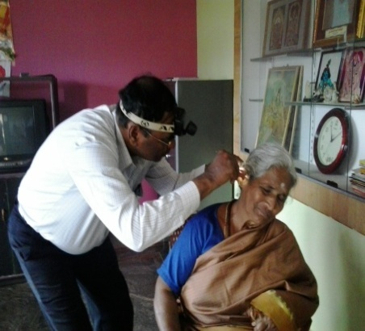 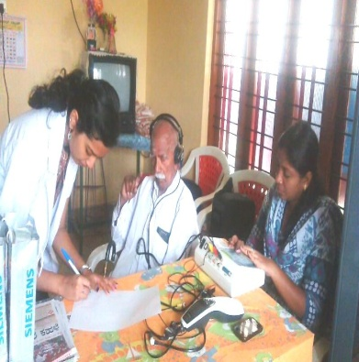 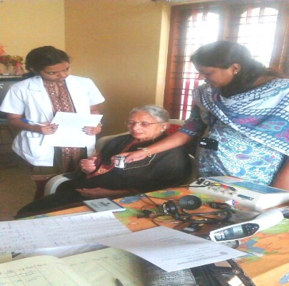

1. Clinical activities were also being carried out in the Outreach Service Centres (OSC) at PHC centre, Hullahalli; PHC centre, Akkihebbalu; and PHC centre, Gumballi.

The objective of the Outreach Service Centers (OSCs) is to provide diagnostic and therapeutic facilities for persons residing in rural areas, in and around the three Outreach Service Centers. Routinely, the following clinical activities are being carried out in these Outreach Service Centres (Tables 10, 11, 12):

* E.N.T evaluation
* Infant screening
* Audiological evaluation
* Hearing aid trial and distribution of hearing aids & ear moulds under ADIP Scheme
* Speech-Language evaluation
* Listening, Speech-Language therapy
* Counseling and Guidance services

*Table 10: Number of ears with different type and degree of hearing loss at Hullahalli (HH), Akkihebbalu (AK) and Gumballi (GB) OSCs*

|  |  |  |  |  |
| --- | --- | --- | --- | --- |
| *Type of hearing loss* | *Degree of hearing loss* | *Hullahalli* | *Akkihebbalu* | *Gumballi* |
| *Conductive* | *Minimal* | 1 | 2 | 4 |
| *Mild* | 1 | 5 | 0 |
| *Moderate* | 3 | 0 | 0 |
| *Mod Severe* | 0 | 0 | 0 |
| *SNHL* | *Minimal* | 2 | 2 | 0 |
| *Mild* | 4 | 5 | 20 |
| *Moderate* | 19 | 17 | 10 |
| *Mod Severe* | 25 | 15 | 25 |
| *Severe* | 7 | 10 | 3 |
| *Profound* | 1 | 0 | 0 |
| *Mixed* | *Minimal* | 1 | 0 | 0 |
| *Mild* | 3 | 0 | 2 |
| *Moderate* | 2 | 2 | 8 |
| *Mod Severe* | 5 | 10 | 5 |
| *Severe* | 3 | 6 | 9 |
| *Profound* | 3 | 2 | 5 |
| **Total** | | **80** | **71** | **91** |

*Note:* 4, 3 & 3 ears had hearing within normal limits in HH, AK & GB.

*Table 11: Number of ears having different ENT problems at Hullahalli (HH), Akkihebbalu (AK) and Gumballi (GB) OSCs*

|  |  |  |  |  |  |  |  |  |
| --- | --- | --- | --- | --- | --- | --- | --- | --- |
| *ENT Problems* | *No. of ears with* | | | | | | | |
| *Normal hearing* | *Wax* | *Otitis Externa and other outer ear disorders* | *TM related problems* | *ET Dysfunction* | *ASOM* | *CSOM* | *Others* |
| *Hullahalli* | 26 | 9 | 10 | - | 2 | 7 | 25 | 24 |
| *Akkihebbalu* | 7 | 6 | 4 | 8 | 2 | 6 | 12 | 7 |
| *Gumballi* | 14 | 22 | 16 | 3 | 2 | 2 | 29 | 8 |

*Table 12: Number of clients having Speech and Language problem at Hullahalli (HH), Akkihebbalu (AK) and Gumballi (GB) OSCs*

|  |  |  |  |  |  |  |  |  |  |  |  |  |
| --- | --- | --- | --- | --- | --- | --- | --- | --- | --- | --- | --- | --- |
| *Type of communication disorders* | *HH* | | | | *AK* | | | | *GB* | | | |
| *M* | | *F* | | *M* | | *F* | | *M* | | *F* | |
| *Paed.* | *Adult* | *Paed.* | *Adult* | *Paed.* | *Adult* | *Paed.* | *Adult* | *Paed.* | *Adult* | *Paed.* | *Adult* |
| *Language* | 1 |  |  |  | 1 |  | 1 |  | 1 |  | 1 |  |
| *Fluency* |  |  | 1 |  |  |  |  |  |  |  |  |  |
| *Voice* |  |  |  |  |  |  |  |  |  |  |  |  |
| *Articulation* |  |  | 1 |  | 1 |  |  |  |  |  |  |  |
| *Multiple* |  |  |  |  |  |  |  |  |  |  |  |  |
| ***Total*** | **1** |  | **2** |  | **2** |  | **1** |  | **1** |  | **1** |  |

*Note:* Age range: Paed.: <18 years; Adults: >18 years

A total of 89 body level hearing aids were issued to clients (Table 12) at the three outreach service centres. Table 13 provides the details of therapy given at the three OSCs.

*Table 12: Number of hearing aids dispensed at Hullahalli (HH), Akkihebbalu (AK) and Gumballi (GB) OSCs*

|  |  |  |  |  |  |  |  |  |  |
| --- | --- | --- | --- | --- | --- | --- | --- | --- | --- |
| *Hearing aid details* | *Category of hearing aids* | | | | | | | | |
| *Mild*  *(Arphi 333 Super)* | | *Moderate*  *(Arphi Excellent)* | | *Strong*  *(Arphi 333 Super)* | | *Extra strong (Arphi 660PP)* | | ***Total*** |
| *S cord* | *V cord* | *S cord* | *V cord* | *S cord* | *V cord* | *S cord* | *V cord* |
| *Hullahalli* | - | - | 11 | 10 | 8 | 5 | 1 | 1 | **36** |
| *Akkihebbalu* | - | - | 8 | 6 | 6 | 7 | - | - | **27** |
| *Gumballi* | - | - | 3 | 10 | 3 | 5 | 3 | 2 | **26** |
| ***Total*** | **-** | **-** | **22** | **26** | **17** | **17** | **4** | **3** | **89** |

*Table 13: Details of therapy given at Hullahalli (HH), Akkihebbalu (AK) and Gumballi (GB) OSCs*

|  |  |  |  |  |
| --- | --- | --- | --- | --- |
| *OSCs* | *Therapy given for individuals with* | *Male* | *Female* | *No. of sessions* |
| **HH** | *Hearing disorder* |  | 2 | 2 |
| *Speech disorder* | 1 |  | 2 |
| *Language disorder* | 2 |  | 4 |
| **AK** | *Hearing disorder* | 2 |  | 4 |
| *Speech disorder* |  | 2 | 8 |
| *Language disorder* |  |  | - |
| **GB** | *Hearing disorder* |  | 1 | 4 |
| *Speech disorder* | 2 |  | 6 |
| *Language disorder* |  | 2 | 4 |
| **TOTAL** | | **7** | **7** | **34** |

1. **Camps for Communication Disorders:**

A camp was conducted for conducting hearing evaluation of school / college children from Worth Trust School, Katpadi, Tamilnadu on 23rd and 24th of August 2013. Ms. Chandni Mallik & Ms. Sunitha E attended the camp along with two internship students. The details are given in Table 14. A total of 141 clients were evaluated (Table 14). Also note 9 clients could not be conditioned for the pure tone audiometry.

*Table 14: Number of ears with different type and degree of hearing loss*

|  |  |
| --- | --- |
| *Clinical services rendered* | *No. of ears assessed* |
| **Audiological testing**   * Mild hearing loss * Moderate hearing loss * Moderately severe hearing loss * Severe hearing loss * Profound hearing loss | **-**  06  16  56  186 |
| **Total no. of ears** | **264** |

1. **Public Lecture Series:** Nil
2. **Others:** Nil
3. **TECHNOLOGICAL CONSULTANCY SERVICES:** Nil
4. **CENTRAL FACILITIES**
5. **Library and information services**: Nil
6. **Participation in expo to educate public and staff/students from college**: Nil
7. **Material Development:** Nil
8. **AWARDS AND HONOURS RECEIVED BY FACULTY AND STAFF:** Nil
9. **EXTRA CURRICULAR ACTIVITIES**
10. AIISH GYMKHANA: Ms. Sahana received IIPrize in Hair Dressing competition held at the Institute.
11. NSS: Nil
12. Others: Nil
13. **MAJOR EVENTS OF THE MONTH**:
14. Inauguration of Epidemiology Unit by Prof. M G Krishnan, Vice Chancellor, KSOU, Mysore as part of Annual Day celebration on 9th Aug. 2013.

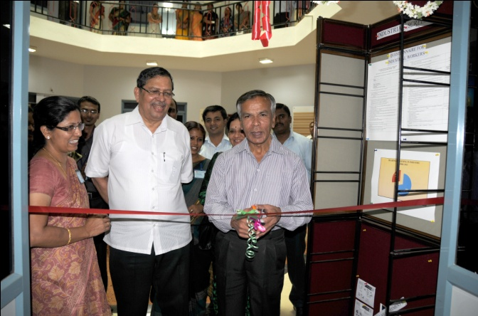 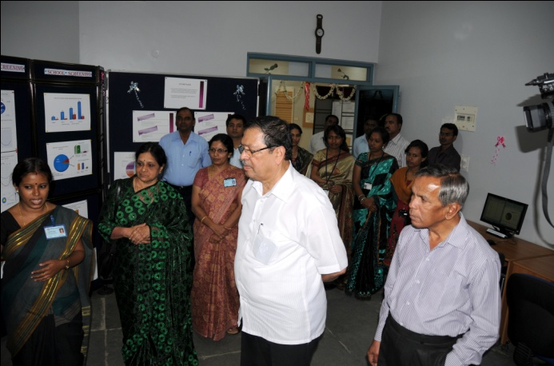

1. Launching Newborn screening programme by Justice Santhosh Hedge, Former Judge, Supreme Court of India, as part of Annual Day celebration on 9th Aug. 2013.

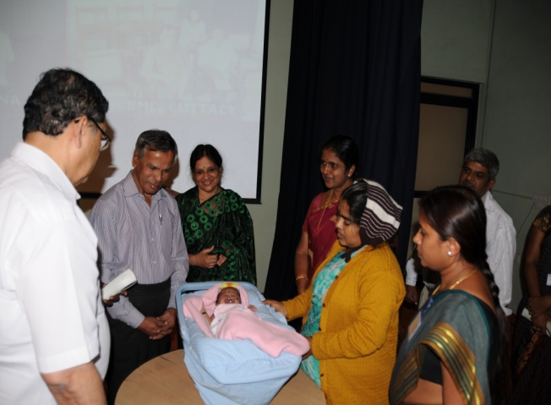 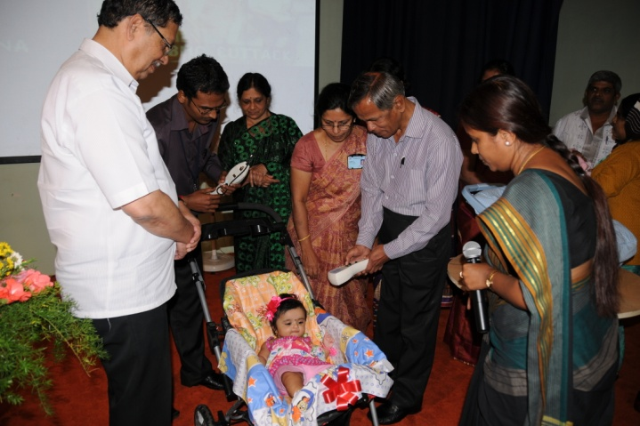

1. **EMINENT VISITORS:**

|  |  |  |
| --- | --- | --- |
| **Sl No.** | **Resource Persons** | **Designation** |
| 1 | Justice Santhosh Hedge | Former Judge, Supreme Court of India |
| 2 | Prof. M . G Krishnan | Vice Chancellor, KSOU, Mysore |

1. **ANY OTHERS:**

The contract period of the following staff members was completed, but services extended till NAAC visit:

|  |  |  |
| --- | --- | --- |
| **Contract Staff** | **Designation** | **Relieved on** |
| Ms. Sahana P | Audiologist Grade I | 29.08.13 |
| Ms. Deepthi M | Audiologist Grade I | 30.08.13 |

HOD-POCD