DEPARTMENT OF PREVENTION OF COMMUNICATION DISORDERS (POCD)

ANNUAL REPORT APRIL 2013 TO SEPTEMBER 2013

**I. MANPOWER DEVELOPMENT**

1. **ACADEMIC ACTIVITIES**
2. **No. of short-term training programs organized:** Nil
3. **No. of orientation programs organized:**

Several orientation programs were conducted in AIISH and outside AIISH on ‘Prevention, early identification and management of communication disorders’ for different target groups. The objective of these orientation programs was to create awareness among the target groups on prevention and early identification of communication disorders. Table 1 gives the details of the orientation programs conducted at AIISH.

*Table 1: Orientation Programs conducted by the department of POCD at AIISH*

*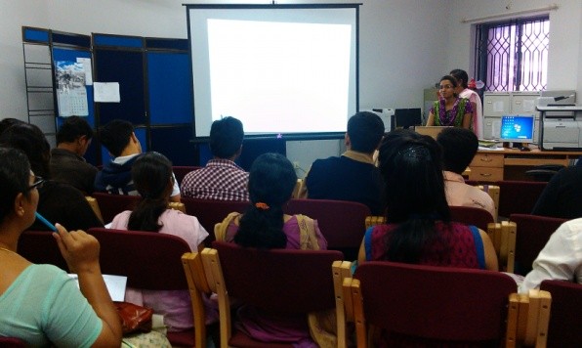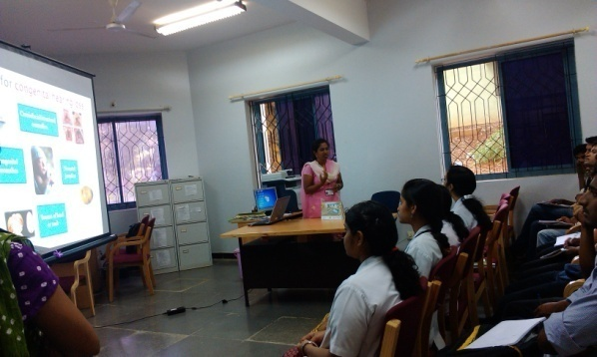*

|  |  |  |  |  |  |
| --- | --- | --- | --- | --- | --- |
| *Sl No.* | *Date* | *Staff who gave the orientation* | *Topic* | *Target group* | *No. of participants* |
| At AIISH, Mysore | | | | | |
| 1. | 1.4.2013 | Ms. Raheela & Ms. Sahana P | Prevention and early identification of communication disorders | Postgraduate students of Social Work (MSW) -University of Mysore | 25 |
| 2. | 5.6.2013 | Ms. Priyanka & Ms. Sahana. P | Prevention and early identification of communication disorders | Nursing Trainees | 34 students + 2 faculty |
| 3. | 3.7.2013 | Ms. Raheela Qudsiya& Ms. Sahana. P | Prevention, early identification and management of communication disorders | Postgraduate students of Social Work (MSW), St. Philomena’s College | 20 |
| 4. | 23.7.2013 | Ms. Raheela Qudsiya & Ms. Chandni M | Prevention, early identification and management of communication disorders | ASHA & Anganwadi workers | 53 |
| 5. | 26.7.2013 | Mr. Anoop B J & Ms. Priyanka | Prevention, early identification and management of communication disorders | Anganwadi workers | 35 |

1. **No. of students from other Institutes posted for Clinical Observation: Nil**
2. **No. of Seminars/ Conferences /Lectures /Workshop organized/attended:**

**(a) Organized**

* Workshop on Development & Translation of Public Education material (Phase III) was held during 29.07.13 to 02.08.13. Five Resource Persons from National Translation Mission (NTM) of Central Institute for Indian Languages (CIIL) participated.
* **Cycle Rally for Noise Awareness**

The department conducted a Cycle Rally on 08.06.2013 to mark the International Noise Awareness Day (on 24.04.2013) and World Environment Day (on 05.06.2013). The rally intended to create awareness among the public regarding noise, its ill effects and guidelines for its control. A total of 12 staff members and more than 30 students from the Institute participated in the rally. Dr. Anand. V. Patil, Assistant Director of All India Radio (AIR, Mysore Station), Mysore inaugurated the rally by releasing a pamphlet named ‘Protect your Ears from Noise’ developed by Dr. P. Manjula. He then flagged off the Cyclists at 9.30 a.m near Ayurvedic College Hospital, Mysore. Around 500 pamphlets on noise awareness were distributed amongst the public during the rally. The rally was concluded at Ballal circle, Mysore by 11.30 p.m. The rally got wide coverage in the print media.

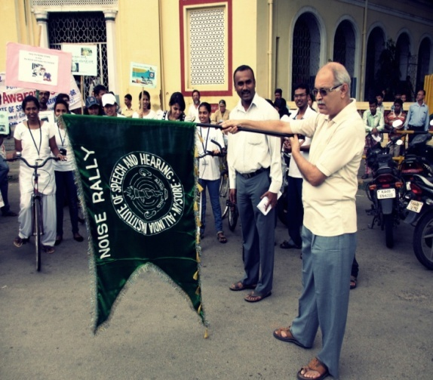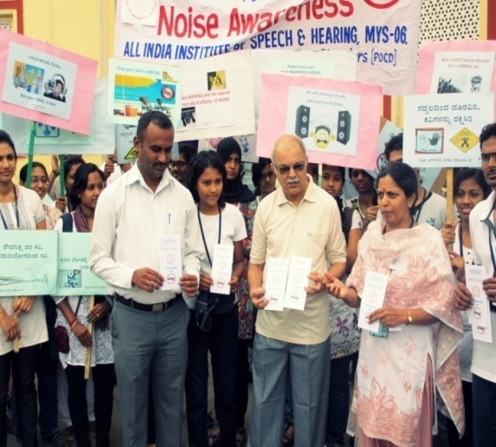

**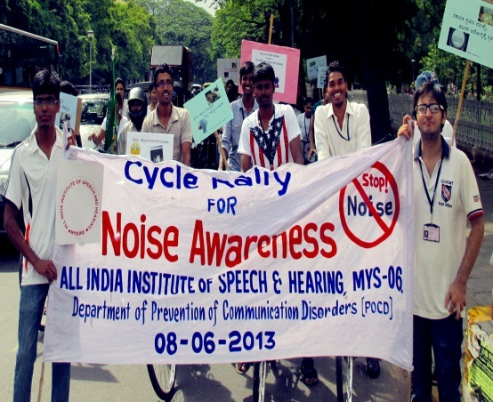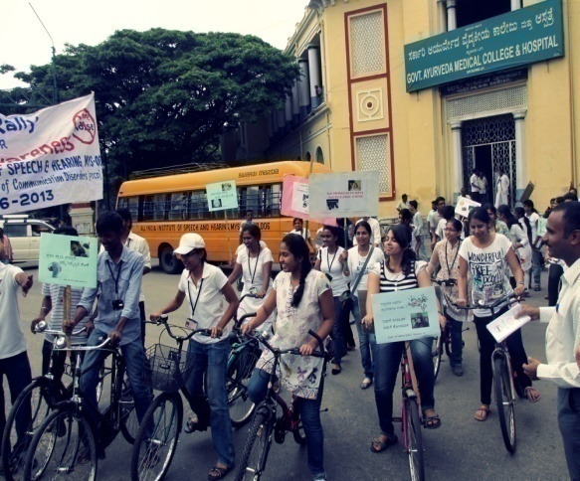**

**(b) Attended:**

The staff of the department attended different programs conducted both at AIISH and outside, details are provided in Table 2.

*Table 2: Seminars/ Conferences /Lectures/Workshops attended by staff of POCD department in the report year*

|  |  |  |  |  |
| --- | --- | --- | --- | --- |
| *Sl. No.* | *Date* | *Title of the program* | *Organized by* | *Staff deputed* |
| 1. | 17.4.13 | National seminar on “Rehabilitation of Oral Cancer” | Department of Speech Lang. Sciences | Mr. Adithya Karthik & Ms. Sushma R |
| 2 | 18.4.13 | “National seminar on recent advances in voice care” | Department of Speech Lang. Sciences | Mr. Adithya Karthik & Ms. Sushma R |
| 2 | 18.4.13 | National seminar on “Unraveling the mysteries of Cognitive Neurophysiological Assessment & management in Dementia” | Department of Speech Lang.Pathology | Mr. Anoop & Ms. Raheela |
| 4 | 20.06.13 | Workshop on “Designing Software on Corel Draw” | Department of Material development | Mr. Arun Raj k |
| 5 | 25.06.13 & 26.06.13 | Workshop on ‘Hindi creative writing’; & Competition on Creative writing in Hindi | Central Institute of Hindi, Siddhartha Nagar, Mysore. | Mr. Anoop B J & Ms. Shobhashree |
| 6. | 16.07.13 | Workshop on ‘Application of Augmentative and Alternative communication (AAC) methods in children with special needs’ | Department of Speech Lang.Pathology | Ms. Raheela Qudsiya |
| 7 | 22.07.13 to 31.07.13 | Workshop on ‘Theory and practice of epidemiology and Bio-statistics’ | St. Johns Hospital, Bangalore | Mr. Arun Raj K |
| 8. | 23.08.13 | Workshop on “Intellectual Property Rights” | Technology Development and IPR Cell | Dr. P. Manjula  Dr Jayashree S  Mr. Arunraj  Ms. Deepthi  Ms. Priyanka  Ms. Raheela Q Ms. Sushma R  Ms. Sahana P |
| 9. | 24.09.13 and 25.09.13 | Workshop on “Advancements in Electro-acoustic measurements” | Department of Electronics | Mr. Arunraj K |

1. **No. of Guest Lectures organized :** Nil
2. **No. of Invited Talks delivered by faculty and staff:** Nil
3. **Any other:** Nil
4. **RESEARCH ACTIVITIES**
5. **Research projects:** Nil (Include only if the Principal Investigator is from the Department)
6. **Doctoral and Post-Doctoral Programs :** Nil
7. Degree Awarded
8. Thesis Submitted
9. Under Progress
10. **Research papers presented at National /International conferences/seminars:** Nil
11. **Research Papers Published:** Nil
12. Papers published in National / International Journals: Nil
13. Papers published in Conference/Seminar Proceedings: Nil
14. **Book / Chapters Published:** Nil
15. **Books / Manuals/ Seminar proceedings Edited:** Nil
16. **Scholarly Reviewing Activities:**

* Dr. P. Manjula served as a Reviewer of APSCI 2013 conference abstracts related to Habilitation.
* Dr. P. Manjula served as Reviewer of ARF project report.

1. **CLINICAL SERVICES**
2. **General Clinical Services:**
3. **Hearing Evaluation at AIISH**
4. *Hearing evaluation of industrial workers*

A total of 152 employees from Karnataka Silk Industries Co. (KSIC) visited AIISH for hearing evaluation. A complete audiological test battery was administered for those clients to test their hearing abilities. Out of them, 144 employees had hearing impairment ranging from minimal to severe hearing loss. Most of the employees of this industry had high frequency sloping sensorineural hearing loss due to exposure to high noise level. The employees were counseled regarding the need to use hearing protective devices to protect their hearing ability. The details of the hearing evaluation of the employees are represented in Figure 1.

*Figure 1:* Total Number of Industrial employees visited AIISH for detailed evaluation

1. *Detailed audiological evaluation of referred infants during screening activity*

The infants referred during the screening activity outside AIISH were followed up at AIISH through telephone calls and individual letters written to client/ parents / caregivers of infants. A complete test battery was administered for those clients who came for follow-up. Table 3 depicts the statistics related to this activity.

*Table 3: Findings on detailed evaluation of individuals who were followed up at AIISH*

|  |  |
| --- | --- |
| *Categories* | *AIISH* |
| No. of clients with normal hearing | 24 |
| No. of clients with hearing impairment | 14 |
| No. of clients with incomplete testing | 1 |
| No. of clients with Speech & Language problems | 1 |
| **Total** | **40** |

1. **Specialized Clinical services:** Nil
2. **Clinical Support Services to Patients and Family:** Nil
3. **Clinical Electronic Services:**

The clinical activity carried out at OSCs was monitored through video conferencing at Hullahalli and through landline telephone at Akkihebbalu by the staff of the department.

Table 4: Total no. of hours of connectivity through video conferencing (Hullahalli OSC)

|  |  |  |  |
| --- | --- | --- | --- |
| *Sl. No* | *Conditions* | *Total Duration* | *No. of Cases supervised for different activities* |
| 1 | Audio+Video connectivity  (OSC at Hullahalli) | 99 hours, 26 min | Diagnostic - 100 Therapy - 32 |

The video conferencing link to OSC at Hullahalli had good audio and video connectivity throughout except for the following days:

* + From 03/07/13 to 09/07/13 (5 days).
  + On 16/9/13, 17/09/13 and 30/09/13 (3 days)

The problem was rectified by the staff of Electronics department

**IV. EXTENSION ACTIVITIES**

1. **Rehabilitation and Education through Distant Mode:**

New born Screening Programs are conducted at the Sri Ramachandra Bhanj Medical College and Hospital (SCB MCH), Cuttack; Regional Institute of Medical Sciences (RIMS), Imphal and also at the Janana Hospital & Jawaharlal Nehru Medical College and Hospital (JLNMCH), Ajmer. One Grade I/II staff member (Audiologist & Speech Language Pathologist Grade I/II) and one SH assistant carry out the activities at these centres.

*Table 5: No. of infants screened and referred (Male & Female) in NBS centres*

|  |  |  |  |  |
| --- | --- | --- | --- | --- |
| *Hospital* | *No. screened* | | | *Total referred for follow-up* |
| *Male* | *Female* | *Total*  *screened* |
| Sri Ramachandra Bhanj Medical College and Hospital (SCB MCH), Cuttack | 819 | 480 | 1299 | 150 |
| Regional Institute of Medical Sciences (RIMS), Imphal | 965 | 887 | 1852 | 22 |
| Janana Hospital (Rajakiya Mahila Chikitsalaya) & JLNMCH, Ajmer | 1775 | 1528 | 3303 | 71 |
| TOTAL | **3559** | **2895** | **6454** | **243** |

1. *Detailed audiological evaluation of referred infants during screening activity*

The infants referred during the screening activity at the 3 NBS centres were followed up through telephone calls and individual letters written to client/ parents / caregivers of infants. A complete test battery was administered for those clients who came for follow-up. Table 6 depicts the statistics related to this activity.

*Table 6: Findings on detailed evaluation of individuals who were followed up at NBS centres*

|  |  |  |  |
| --- | --- | --- | --- |
| *Categories* | *Ajmer* | *Cuttack* | *Imphal* |
| No. of clients with normal hearing | 15 | 29 | 16 |
| No. of clients with hearing impairment | 34 | 41 | 18 |
| No. of clients with incomplete testing | 4 | 8 | 5 |
| No. of clients with Speech & Language problems | 3 | 0 | 0 |
| **Total** | **56** | **78** | **39** |

1. **Prevention of Communication Disorders**

The department carried out screening, diagnostic and rehabilitation activities both within the institute and outside (in Mysore and outside Mysore). The details are as follows:

1. Screening new born infants and children for communication disorders:

* 16 hospitals and 3 Immunization centers in Mysore city
* 2 Government Hospitals, one each at KR Nagar, Mysore and T. Narsipura, Mysore
* 3 PHC/CHC centres (CHC centre of Santhemaralli, Yelandur Taluk, Chamarajnagar district; PHC Centre of Hullahalli, Nanjangud Taluk, Mysore District; and PHC centre, Akkihebbalu, K.R. Pete Taluk, Mandya district).

1. Hearing screening of industrial workers: Hearing screening of industrial workers exposed to high level noise was carried out at their premises and Audiological evaluation of the industrial workers was done at the institute.
2. Evaluation of senior citizens for communication disorders: The Senior citizens are evaluated for communication disorders at different old age homes located in Mysore city.
3. Clinical Services at Outreach Service Centres of the POCD Department:

* PHC centre, Hullahalli, Nanjangud Taluk, Mysore district
* PHC centre, Akkihebbalu, K.R. Pete Taluk, Mandya district
* PHC centre, Gumballi, Yelandur Taluk, Chamarajanagar district

**1. Screening new born infants and children for communication disorders:**

Screening newborn for communication disorders focuses on neonates and infants. In this program, neonates and infants are screened for communication disorders using the following tools to identify the risk factors that could lead to communication disorders:

* High Risk Register for communication disorders
* Behavioral Observation Audiometry (BOA)
* Oto Acoustic Emission screening (OAE)
* Primitive reflexes
* Screening Checklists.

In the report year, screening program was carried out throughout the year in 19 hospitals/immunization centers in Mysore. These centres include Apollo BGS Hospital (AH), Basappa Memorial Hospital (BMH), Combined Hospital (CH), Harsha Hospital (HH), Kamakshi Hospital (KH), KR Hospital (KRH), Makkalakoota Immunization Center (MIC), Mission Hospital (MH), Immunization centre at Mission Hospital (ICMH), N.P.C Hospital (NPC), Nazarbad, S.M.T.D.H Hospital (SMTDH), Vidyaranyapuram, Railway Hospital (RH), Vontikoppal, Sreenivasa Maternity Home (SMH), & Employees State Insurance (ESI) Hospital.

In the month of August, four more centres were added for new born screening - Shree Devi Nursing Home (SNH), Ashwini Nursing Home (ANH), Gopala Gowda Shanthaveri Memorial Hospital (GGSMH) and Family Planning Association Immunization (FPAI) centre.

Details of the number of infants screened and referred for detailed evaluations are given in Table 7. Figure 2 gives the details of the total number of infants screened and referred.

*Table 7: Total number of infants screened and referred in 19 hospitals/immunization centers in Mysore city*

|  |  |  |  |  |
| --- | --- | --- | --- | --- |
| *Months (2013)* | *No. Screened*  *Male Female* | | *Total no. of infants screened* | *Total Referred for follow-up* |
| April | 641 | 644 | 1285 | 3 |
| May | 618 | 577 | 1195 | 1 |
| June | 412 | 407 | 819 | 2 |
| July | 525 | 564 | 1089 | 3 |
| August | 504 | 463 | 967 | 7 |
| September | 562 | 465 | 1027 | 5 |
| **Total** | **3262** | **3120** | **6382** | **21** |

*Figure 2:* Total number of screened and referred in the report year 

In the report year, infant screening program was carried out in five Government Hospitals (at K.R.Nagar, Santhemaralli, T Narsipura, and Outreach Service Centres at Hullahalli & Akkihebbalu). The details are provided in Table 8.

*Table 8: No. of infants screened and referred at Hullahalli, Akkihebbalu, KR Nagar, Santhemaralli and T.Narsipura*

|  |  |  |  |  |
| --- | --- | --- | --- | --- |
| *Infant Screening at* | *No. Screened* | | | *No. referred* |
| *M* | *F* | *Total no. of infants*  *screened* |
| Akkihebbalu | 6 | 5 | **11** | **0** |
| K R Nagar | 223 | 211 | **434** | **0** |
| Hullahalli | 59 | 47 | **106** | **2** |
| Santhemarahalli | 81 | 79 | **160** | **0** |
| T Narsipura | 113 | 110 | **223** | **0** |

The parents/caregivers were counseled regarding identification of any delay or deviancies in normal developmental milestones of speech, language, hearing, motor and other related domains that affect the development of communication skills in children. They were provided checklist to help them to monitor the development of the infant. In case of any delay / deviations, they were advised to visit the institute for a detailed investigation and further management (if required).

**2**. H**earing Screening for Industrial Employees**

Hearing screening program was conducted at AMW-MGM Forgings Pvt. Ltd., and KSIC, Mysore for industrial employees on 4th, 5th and 8th of April, 2013 and 20th September 2013 respectively. Ms. Deepthi M and Ms. Sahana P carried out the screening activities. Details of the hearing screening program are depicted in Table 9. Employees who failed in pure tone screening program were referred to AIISH for detailed evaluation.

*Table 9: Total number of employees screened for hearing ability*

|  |  |  |  |
| --- | --- | --- | --- |
| *Industry* | *Hearing Screening* | | |
| *Pass* | *Refer* | ***Total*** |
| AMW-MGM Forgings Pvt. Ltd. | 134 | 54 | **188** |
| KSIC, Mysore | 10 | 17 | **27** |
| **Total** | **144** | **71** | **215** |

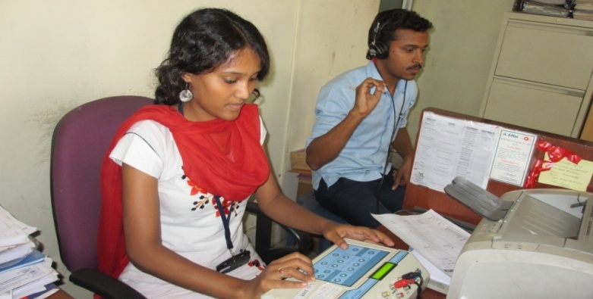 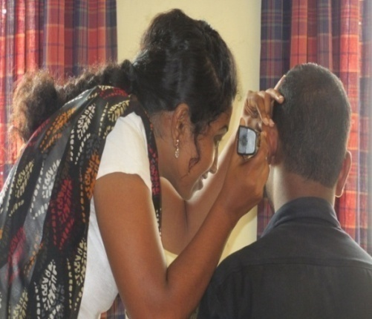

**3. Evaluation of senior citizens for communication disorders**

The Department of POCD conducted a Speech-Language and Hearing camp for the elderly individuals residing at different old age homes located in Mysore. A total of 23 hearing aids were provided for the senior citizens who had hearing problem. Follow-up was done to monitor hearing aid usage. Details are given in Table 10.

*Table 10: Total number of senior citizens tested and issued hearing aids in different old age homes.*

|  |  |  |  |  |  |  |  |  |  |
| --- | --- | --- | --- | --- | --- | --- | --- | --- | --- |
| **OLD AGE HOMES** | *Speech- Language evaluation* | | | *Hearing evaluation* | | | *Hearing aid Distribution* | | |
| *Male* | *Female* | ***Total*** | *Male* | *Female* | ***Total*** | *Male* | *Female* | ***Total*** |
| *Sri Vasavi Shanthidhama Public Charitable trust* | 2 | 0 | **2** | 12 | 15 | **27** | 7 | 6 | **13** |
| *Belaku Vathsalya Dhama* | 0 | 0 | **0** | 0 | 11 | **11** | 0 | 4 | **4** |
| *JSS old age home* | 0 | 0 | **0** | 8 | 13 | **21** | 1 | 5 | **6** |
| *TOTAL* | 2 | 0 | **2** | 20 | 39 | **59** | 8 | 15 | **23** |

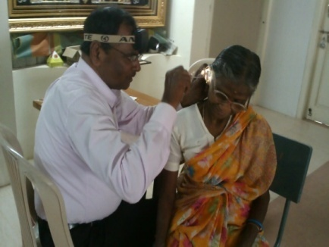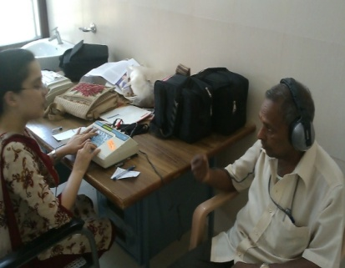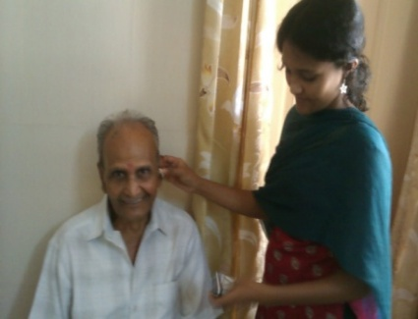

**4. Clinical Services at Outreach Service Centres**

The clinical activities are carried out at three Outreach Service Centres of the department. The centres include

* PHC centre, Hullahalli, Nanjangud Taluk, Mysore district – Initiated from 23rd November 2009
* PHC centre, Akkihebbalu, K.R. Pete Taluk, Mandya district – Initiated from 24thNovember 2009
* PHC centre, Gumballi, Yelandur Taluk, Chamarajanagar district – Initiated from 28th July 2010

The objective of the Outreach Service Centres (OSCs) is to provide diagnostic and therapeutic facilities for persons residing in the rural unreached areas nearby the selected Outreach Service Centres.

The following activities were carried out in the OSCs during the report year:

* Infant screening
* School screening
* Speech-Language evaluation
* E.N.T evaluation
* Audiological evaluation
* Hearing aid trial and distribution of hearing aids/earmolds under ADIP Scheme
* Hearing, Speech-Language therapy
* Counseling and Guidance services

*Table 11: Details of Cases seen for different communication disorders at the OSCs.*

|  |  |  |  |
| --- | --- | --- | --- |
| *OSC* | **Speech and Language Evaluation** | **ENT** | **Hearing Evaluation** |
| *Hullahalli, PHC* | 47 | 552 | 591 |
| *Akkihebbalu, PHC* | 30 | 305 | 284 |
| *Gumballi, PHC* | 26 | 441 | 389 |
| *Total* | **103** | **1266** | **1264** |

A total of 422 body level hearing aids were issued to clients who required them; Table 12 provides the details of total no. of hearing aids dispensed and therapy sessions provided for individuals with communication disorders at the three outreach service centres.

Table 12**:** Rehabilitation services provided at outreach service centres

|  |  |  |
| --- | --- | --- |
| *OSC* | **Hearing Aids Dispensed** | **No. of therapy sessions/cases** |
| *Hullahalli, PHC* | 166 | 48/12 |
| *Akkihebbalu, PHC* | 117 | 51/13 |
| *Gumballi, PHC* | 139 | 47/11 |
| *Total* | 422 | 146/34 |

1. **Communication Disorders in Camps**

Several camps were conducted at various places within Karnataka and outside Karnataka in the report year by the institute to cater clinical services to those unreached.Speech and hearing camp was conducted focusing on the diagnosis, treatment, and rehabilitation of the individuals with communication disorders. Mr. Chandan, Ms. Chandni, Ms. Deepthi, Ms. Priyanka Ms. Sahana, Ms. Sunitha and Ms. Sushma R attended these camps. A total of 519 clients were evaluated in the camps held in the report year. Table 13 gives information on the various places where the camp was held and the evaluations carried out.

*Table 13: Details of the clinical services provided at camps*

|  |  |  |  |  |
| --- | --- | --- | --- | --- |
| ***Camps*** | ***Date*** | ***Speech- language evaluation*** | ***Audiological evaluation*** | ***ENT*** |
| *Vyasarajanapura* | 18/5/13 | 3 | 25 | - |
| *H D kote* | 25/06/13 | - | 32 | - |
| *Talakadu* | 02/07/13 | 27 | 33 | - |
| *B R hills* | 06/07/13 | 22 | 111 | 22 |
| *Sri Sai Ranga Special school* | 14/07/13 | 9 | 94 | - |
| *Worth trust school, Katpadi, Tamil Nadu* | 23/08/13 & 24/08/13 | - | 141 | - |
| **Total** |  | **61** | **436** | **22** |

1. **Orientation Programs**

|  |  |  |  |  |  |  |
| --- | --- | --- | --- | --- | --- | --- |
| *Sl No.* | *Date* | *Staff who gave the orientation* | *Topic* | *Target group* | *No. of participants* | *Venue* |
| 1. | 22.7.2013 | Mr. Chandan HS &  Ms. Sunitha E | Prevention, early identification and management of communication disorders | Senior citizens | 15 | Belaku Vasthsalya dhama, Mysore |
| 2. | 12.8.2013 | Ms. Sunitha E &  Ms. Priyanka | Prevention, early identification and management of communication disorders | Senior citizens | 21 | JSS old age home, Mysore |
| 3. | 21.8.2013 | Ms. Deepthi M & Ms. Priyanka | Prevention, early identification and management of communication disorders | ASHA workers | 17 | Hullahalli, PHC |
| 4. | 20.9.2013 | Mr. Arunraj K | Prevention, early identification and management of communication disorders | KSIC industrial workers | 100 | KSIC, Mysore |
| 5. | 25.9.2013 | Ms. Deepthi M & Ms. Raheela Q | Prevention, early identification and management of communication disorders  C:\Users\pocd-2\Downloads\IMG_09252013_161822.jpg | Doctors | 68 | District Training centre, Mandya |

1. **Public Lecture Series:** Nil
2. **TECNOLOGICAL CONSULTANCY SERVICES:**

* Dr. P. Manjula and Mr. Arunraj gave information on Hearing conservation for industrial employees to Dr. Bharathi, Medical officer, KSIC over Telephone on 21.05.2013.
* Dr. P. Manjula gave technical consultation on hearing aid technology with Mr. Sashi Nambiar of Cadential Technologies, Bangalore on 26.6.13.
* Dr. P. Manjula and Mr. Arunraj gave information on Hearing conservation for industrial employees and on terms and conditions for conducting hearing screening program to Mr. Reddappa, Production Manager and Mr. Krishnappa, Senior Manager, TATA Global Beverages Limited, Bangalore.

1. **CENTRAL FACILITIES**
2. **Library and information services - Nil**
3. **Public Information Activities – Nil**
4. **Major Events of the year with a brief account: Nil**

|  |  |  |  |  |  |  |  |
| --- | --- | --- | --- | --- | --- | --- | --- |
| **Sl. No** | **Pamphlet** | **Languages** | | | | | |
| **Kan** | **Hindi** | **Malayalam** | **Tamil** | **Oriya** | **Manipuri** |
| 1 | *FAQs on Hearing Impairment in Children* |  |  |  |  |  |  |
| 2 | *Feeding tips to mothers/caregivers of Children with cleft lip/palate* |  |  |  |  |  |  |
| 3 | *Hearing Impairment in adults* |  |  |  |  |  |  |
| 4 | *Mental Retardation* |  |  |  |  |  |  |
| 5 | *Specific Language Impairment* |  |  |  |  |  |  |
| 6 | *Ear Discharge: How to prevent it* |  |  |  |  |  |  |
| 7 | *Cerebral Palsy* |  |  |  |  |  |  |
| 8 | *Voice Disorders* |  |  |  |  |  |  |
| 9 | *Aphasia* |  |  |  |  |  |  |

1. **Press Releases and Media Coverage**

* Mr. Anand. V. Patil, Assistant Director of All India Radio (AIR), Mysore inaugurated the rally by releasing a pamphlet named ‘Protect your Ears from Noise’ developed by the Department of POCD

1. **Material Development**

* Pamphlet named ‘Protect your Ears from Noise’ is developed by Dr. P. Manjula was released during the Cycle Rally for noise awareness.
* Epidemiology Brochure release on Annual Day celebration on 9th Aug. 2013.

The following pamphlets were translated to, Kannada, Hindi, Malayalam, Tamil, Oriya and Manipuri in Phase III workshop (Table 14) by the resource persons from CIIL, Mysore.

*Table 14: Pamphlets translated into different languages during the workshop*

1. **AWARDS AND HONOURS RECEIVED BY FACULTY AND STAFF**

* Mr. B. J. Anoop participated in a Workshop and a Competition on Creative writing in Hindi on 26.06.13 at Central Institute of Hindi, and was awarded 2nd prize.
* Ms. Shobha Shree participated in a Workshop and a Competition on Creative writing in Hindi on 26.06.13 at Central Institute of Hindi, and was awarded Consolation prize.
* Ms. Priyanka got I Prize in Hindi Grammar competition during Hindi week held at the Institute.

1. **EXTRA CURRICULLAR ACTIVITIES**
2. **NSS:** Nil
3. **AIISH Gymkhana:**

* Ms. Sahana received II Prize in Hair Dressing competition held at the Institute**.**

1. **MAJOR EVENTS OF THE YEAR**:

* Cycle Rally for Noise Awareness was conducted on 08.06.2013 to mark the International Noise Awareness Day (24.04.2013) and World Environment Day (05.06.2013).
* Mock NAAC team visited the department on 05.06.13
* Development & Translation of Public Education for POCD ( Phase III) workshop was held during 29.07.13 to 02.08.13
* Inauguration of Epidemiology Unit by Prof. M G Krishnan, Vice Chancellor, KSOU, Mysore as part of Annual Day celebration on 9th Aug. 2013.
* Formal launching of the ‘Newborn screening for communication disorders’ programme by Justice Santhosh Hedge, Former Judge, Supreme Court of India, as part of Annual Day celebration on 9th Aug. 2013.
* NAAC peer team visited the department on 24.09.13

1. **EMINENT VISITORS:**

|  |  |  |
| --- | --- | --- |
| *Name* | *Designation* | *Date* |
| *Dr. Venkatramaiah* | VC, Kuvempu Univ. | 05.06.13 |
| *Dr.Shakunthala Katre* | Ex-registrar, Bangalore University | 05.06.13 |
| *Dr. Y M Jayaraj* | Prof. of Microbiology, Gulbarga Univ. | 05.06.13 |
| *Dr. Balasubramaniam* | Prof., Dept. Of Bio-Chemistry, UOM | 05.06.13 |
| *Dr. Manjulakshi. L* | Senior Consultant, Kannada | 29.07.13 to 02.08.13 |
| *Dr. Geetha Kumary V* | Senior Consultant, Malayalam | 29.07.13 to 02.08.13 |
| *Dr. Sunetra Sholapurkar* | Consultant, Hindi | 29.07.13 to 02.08.13 |
| *Mr. Suresh Kumar* | Tamil Consultant | 29.07.13 to 02.08.13 |
| *Ms. Jhuni Mallick* | Consultant, Oriya | 29.07.13 to 02.08.13 |
| *Dr. Soibam Rebika Devi* | Resource Person, Manipuri | 29.07.13 to 02.08.13 |
| *Justice Santhosh Hedge* | Former Judge, Supreme Court of India | 09.08.13 |
| *Prof. M . G Krishnan* | Vice Chancellor, KSOU, Mysore | 09.08.13 |
| *Mr. Jens Karasawa Christensen* | Product manager, M/s Bruel & Kjaer, Denmark | 24.09.13 |
| *D.Ed students (26 in No.) and DHLS students (15 in No.)*  *Prof. G N V Brahmam*  *Dr. Samuel N Mathew*  *Dr. Ramesh Oza* | Ali Yavar Jung National Institute Janla, Bhuvaneshwar, Odissa.  Scientist F, National Institute of Nutrition, Hyderabad  Executive Director, National Institute of Speech and Hearing, Trivandrum, India  Callipsonic, Anderi West, Mumbai | 20.09.13  24.09.13  24.09.13  24.09.13 |

1. **OTHERS:**

The following staff members completed their contract term and were relieved of their duties from the Department of POCD:

|  |  |  |
| --- | --- | --- |
| **Staff on contract basis** | **Designation** | **Reported on** |
| Mr. Adithya K | SLP Gr I | 24.05.2013 |
| Mr. H.S. Chandan | Audiologist Gr I | 29.8.2013 |
| Mr. Anoop B J | Audiologist Grade I | 10.09.2013 |
| Ms. P. Sahana | Audiologist Gr I | 27.9.2013 |
| Ms. Deepthi. M | Audiologist Grade I | 27.9.2013 |
| Ms. Raheela Q | SLP Gr I | 27.9.2013 |
| Ms. Priyanka | SLP Gr I | 27.9.2013 |
| Ms. Sushma. R | SLP Gr I | 27.9.2013 |
| Ms. Sunitha E. | Audiologist and Speech Language Pathologist Grade II | 27.9.2013 |

The following staff members were recruited as staff working on contract basis in the Department of POCD**:**

|  |  |  |
| --- | --- | --- |
| **Staff on contract basis** | **Designation** | **Reported on** |
| Ms. Amulya P Rao | SLP Gr I | 30.09.2013 |
| Mr. Madhu Sudarshan Reddy | SLP Gr I | 30.09.2013 |
| Ms. Sushma Manjunath | SLP Gr I | 30.09.2013 |
| Mr. Sandeep Mohan | Audiologist Gr I | 30.09.2013 |
| Ms. Gagana M S | Audiologist Gr I | 30.09.2013 |

**Dr. Manjula.P**

* Attended HODs meeting in the Board room on 2.05.13.
* Served as RCI expert and conducted inspection on 7.05.13
  + MASLP program at SRC, AYJNIHH, Secundrabad.
  + BASLP program and MASLP program at HKCRR, Secundrabad.
* Attended meeting to vet the drafts of ISO material submitted by the departments on 10.05.13, in Dr. K.S. Prema’s chamber
* Attended meeting regarding the academic related work on 13.05.13 in the Board room.
* Attended AIISH Alumni meet on 28.05.13 in the Board room.
* Attended two meetings as a member of Selection Committee for PG programs (MSc Aud/ALP) on 16.7.13 and 29.07.13.
* Attended a meeting to develop a screening tool for developmental disabilities in collaboration with National Trust as part of the Rashtriya Bal Swasthya Karyakram (RBSK) of NRHM at National Institute of Health & Family Welfare, N Delhi from 24th – 25th July 2013.
* Attended a lecture on Wide band reflectance in the seminar hall on 29.07.13.
* Attended ISO meeting on 03.09.13 in the academic section
* Nominated as member for Obama Singh Initiative (OSI) grant, under the United States India Education Foundation (UNICEF). In this connection Skype meeting was attended on 4.09.13 at 6.30 pm in the Board room.

**Dr. Jayashree Shanbal**

* Nominated as member for Obama Singh Initiative (OSI) grant, under the United States India Education Foundation (UNICEF). In this connection Skype meeting was attended on 4.09.13 at 6.30 pm in the Board room.

**HOD - POCD**