# ALL INDIA INSTITUE OF SPEECH AND HEARING, MYSORE-6

**DEPARTMENT OF CLINICAL SERVICES**

SH/DCS/Annual Report/2013-14 Date: 22.10.2013

**Submitted to the Director:**

Sub: Submission of Annual report 2013-2014 reg.

Ref: No.SH/LIC/HR/2013-14 dated 10.10.2013

With reference to the above, please find herewith the Annual report of Department of Clinical services from ***April 2013 to September 2013***. This is placed for your kind information.

**HOD Clinical Services**

1. ACADEMIC ACTIVITIES
2. Short-term Training Programs- Nil

* Theme /Topic
* Coordinator
* Objectives
* Target Audience
* Number of Participants
* Date

1. Orientation Programs – 1

* Theme /Topic : ***Rising to the Dementia challenge: Caring for minds that cannot remember***
* Coordinator : Ms. Preethi T. Thomas
* Objectives : The objectives of the orientation include awareness to the general public and students of social work on the nature of holistic problems in persons with Alzheimer’s from various professionals prospective involved in the diagnosis and management of persons with Alzheimer’s and dementia.
* Target Audience: Medical Social worker students, volunteers for the home care of persons with dementia and general public
* Number of Participants: 80
* Date: 26.09.2013

1. Clinical Observation Posting of Students/ Visitors from Other Institutes

|  |  |  |  |  |
| --- | --- | --- | --- | --- |
| **Sl. No** | **Number of Students** | **Course** | **Institute** | **Date** |
| 1 | 25 | UG Students | JSS Polytechnic for Differently abled college | 10.04.2013 |
| 2 | 3 | PG Students | JSS Polytechnic for Differently abled college |
| 3 | 13 | PG students | Dr. S.R. CISH, Bangalore | 17.04.2013 |
| 4 | 25 | UG Students | J.S.S Polytechnic, Mysore | 06.05.2013 |
| 5 | 2 | Special Educators | Dept of Special Education, Vagdevi School, Bangalore | 09.05.2013 |
| 6 | 10 | Nursing Students | School of behavioral sciences, Kannur | 15.05.2013 |
| 7 | 33 | Asha Workers | Mysore | 15.05.2013 |
| 8 | 28 | Asha Workers | Nanjungud, Mysore | 16.05.2013 |
| 9 | 17 | Nursing Students | Govt. School of Nursing, Mysore | 23.05.2013 |
| 10 | 29 | B.Sc Students | Belgaum | 28.05.2013 |
| 11 | 44 | B. Sc Nursing | J.S.S college of Nursing, Mysore | 16.07.2013 |
| 12 | 23 | Diploma | RIE college, Mysore | 23.08.2013 |

1. Seminars/Conferences/Workshops

|  |  |  |  |  |  |  |
| --- | --- | --- | --- | --- | --- | --- |
| **Sl. No** | **Them/Topic** | **Coordinator** | **Objectives** | **Target Audience** | **Number of Participants** | **Date** |
| 1 | National Seminar on *“Unravelling the mysteries of Cognitive Neuropsychological Assessment & Management in Dementia”* | Dr. S.P. Goswami and Ms. Preethi T. Thomas | The objectives of the seminar include discussions on the nature of problems in persons with dementia, issues and concerns in its cognitive neuropsychological assessment and its management. | Post graduation students | 100 | *10.04.2013* |

1. Guest Lectures - Nil
2. Additional Academic Services by the Faculty and Staff
3. Invited Talks

Dr. N. Sreedevi - Delivered a guest lecture on “An insight into assessment and management strategies for articulation and phonological disorders” at Father Muller College of Speech and Hearing, Mangalore on 27.9.2013

Ms. Preethi T. Thomas - Delivered a lecture on “Resolving the challenges in communicating with persons with Dementia” in the orientation program on ***Rising to the Dementia challenge: Caring for minds that cannot remember*** organized by Department of Clinical Services on 26.09.2013.

Mr. Prashanth R. - Delivered a lecture on “Role of Social Worker in the Management of persons with Dementia” in the orientation program on ***Rising to the Dementia challenge: Caring for minds that cannot remember*** organized by Department of Clinical Services on 26.09.2013.

1. Curriculum Development - Nil
2. Development of Materials to Support Learning- Nil
3. Service in Academic bodies of other organizations-

**Dr. S.P. Goswami**

* Served as Editor – JISHA
* Served as a chair person for the B. Sc (Sp & Hg) entrance examination

1. Participation in Committees/ Taskforces and Panels set up by other organizations/agencies.
2. **Dr. S.P. Goswami:**
3. Served as HOD, Clinical services
4. Served as Member – Fluency, AAC, ASD, SOFA, LD, MSD, Voice clinic units
5. Serving as Editor – JISHA.
6. Serving as Member, Anti ragging squad.
7. Served as member for the computerization of Dept. of Clinical Services
8. Served as a member for the Client welfare fund committee
9. Organized one day seminar on ***“Unravelling the mysteries of Cognitive Neuropsychological Assessment & Management in Dementia”*** on10.04.2013
10. Serving as treasurer for AAA
11. Serving as Joint secretary ARDSI, Mysore chapter
12. Serving as a chair person for CAEPLD
13. Prepared the documents and arranged for the visit of Mock peer team for NAAC accreditation
14. Prepared form 1 and 2 details for DCS to the NAAC
15. Suggested modification to be incorporated in the brochure on DCS.
16. Prepared the modifications in the website information about the department
17. Served as a chair person for the B. Sc (Sp & Hg) entrance examination
18. Served as a member for DPC in view of Group ‘B’ & ‘C’ staffs
19. Served as member for recruiting for the post of SLP- Gr II
20. Served as external examiner at Dr. MVST, Mangalore
21. Organized a seminar on Wellcome Trust group -Biomedical Fellowship in Seminar Hall- 22nd June 2013
22. Attended the Annual General Body meeting of AAA
23. Participated in the ARDSI-Mysore Chapter inauguration function on 16th June 2013
24. Preparation of NAAC & ISO- draft and material preparations for Department of Clinical Services
25. Handed over the charges of the Department of Clinical Services to Dr. N. Sreedevi
26. Handed over the charges of DHLS-Ranchi centre to Ms. Chandini Jain
27. Preparation of NAAC & ISO- draft and material preparations for Department of Clinical Services
28. **Dr. N. Sreedevi**
29. Serving as HOD, Clinical services from 01.08.2013
30. Serving as Member – Fluency, AAC, ASD, SOFA, LD, MSD
31. Serving as Member for Library committee
32. Serving as a member for the Client welfare fund committee
33. Serving as chair person for Voice Clinic
34. Serving as chair person for unit for human genetics
35. Coordinated the activities for the inauguration of unit for human genetics
36. Serving as chair person for Phonology lab
37. Coordinated preparation of NAAC & ISO- draft and material preparations for Department of Clinical Services
38. Attended research proposal presentation of II M. Sc-SLP from 21st to 23rd, Aug, 2013
39. Coordinated the activities for the visit of NAAC peer team to Dept of clinical services
40. Coordinated the activities for the visit of NAAC peer team to unit for human genetics and phonology lab at the dept of SLS
41. Coordinated activities for the conduction of orientation program on 26.09.2013 in view of World Alzheimer’s month celebrations
42. Initiated the ARF project “Study of co-articulation using F2 Locus equation as a metric” on 16.9.2013

Examiner for

* University of Mysore
* SRMC, Porur
* MAHE, Manipal
* Mangalore University, Karnataka
* Kerala University of Health Sciences, Kerala
* Kannur University, Kerala
* Kerala University, Thiruvananthapuram
* Bharatiya Vidyapeeth, Pune.

1. **Ms. Sangeetha Mahesh:**
2. Serving as Member secretary for Fluency unit
3. Served as Internal examiner for conducting viva for I semester on Speech Language Pathology
4. Presented the methodology of Ph. D proposal for ethical clearance and the same was received
5. Visited as inspection expert (letter from RCI) for assessment of training institute for extension of ongoing training course at Pratiken College of special education, Nagpur, M.P on 25.05.2013
6. Prepared the documents and arranged for the visit of Mock peer team for NAAC accreditation
7. Invigilator to conduct entrance examination for B.Sc (Sp & Hg) course at Mysore centre
8. Attended conference on cognitive and communicative disorders: Epilepsy and Stroke on 15th to 16th June, 2013 at ICCONS
9. Prepared form 1 and 2 details for DCS to the NAAC
10. Attended meetings related to NAAC on 4/6/2013 (technical staff), 6/6/2013 (member of AAA), 11/06/2013 (NAAC suggestions)
11. Suggested modification to be incorporated in the brochure on DCS.
12. Prepared the modifications in the website information about the department
13. Attended meeting with chairperson and members – fluency unit on 03.07.2013
14. Preparation of public education material on ‘Stuttering’ and ‘Fluency unit’ is in process
15. Attended meeting with HOD-CS, staff and personnel involved in digitization of old medical records on 09.07.2013
16. Attended meeting with Mr. Chandramouli, Mr. Bharth, Clinical staff to finalize formats required for ISO on 23.07.2013
17. Attended workshop on Intellectual property rights on 24.08.13
18. Attended research proposal presentation of II M. Sc-SLP from 21st to 23rd, Aug, 2013
19. Guided Ms. Beena, II M. Sc-SLP in preparation of research proposal titled “Language abilities in preschool children with stuttering”
20. Internal examiner for 2 dissertations (Ms. Deepika D. and Ms. Neethu T.)
21. Attended public grievances committee meeting on 27.08.13 with the chairperson and members
22. Discussed with Ms. Padmini regarding the work related to digitalization of medical records
23. Assisted HOD-CS in finalizing the PPT to be presented before NAAC committee
24. Prepared posters on stuttering and fluency unit and followed up the finalization of 4 postures including Cluttering and Neurogenic stuttering for fluency unit
25. Conducted a oral quiz on Hindi films, as a part of celebrating Hindi week at the institute
26. Assisted HOD-CS during the visit of NAAC committee members to Dept. of Clinical Services on 23.09.13
27. Attended NAAC committee exit meet on 25.09.13
28. Attended an half day orientation program on ‘Dementia’ conducted in the Dept. of Clinical Services
29. Conducted C1 viva and submitted C1- Clinical marks for I M.sc- SLP, on 27.09.13
30. **Ms. Vijayashree. S:**
31. Overall diagnostic work record verification of students
32. **Ms. Preethi T. Thomas:**
33. Monitor for the New-Born screening Program for Imphal Centre
34. In-charge of the monitoring of the applications of inmates to the Single- Officers accommodation
35. Member of the Library committee
36. Committee member of the CAEPLD
37. Preparation of ISO- draft for Department of Clinical Services
38. Coordinator for one day seminar on ***“Unravelling the mysteries of Cognitive Neuropsychological Assessment & Management in Dementia”*** on10.04.2013
39. Preparation of NAAC & ISO- draft for Department of Clinical Services
40. Preparation of NAAC & ISO- draft and material preparations for Department of Clinical Services
41. Served as room invigilation officer for B.Sc Entrance Exam on 8th June 2013
42. Stock verification officer for WHO, DANISH and camp equipments
43. Attended meeting of NAAC mock committee visit to Department on 4th June 2013
44. Attended NAAC meeting with AIISH Alumni on 6th June 2013
45. Review meet about NAAC visit with Director in Seminar Hall on 11th June 2013
46. Annual GB meet of AAA in Seminar Hall- 18th June 2013
47. Seminar on Wellcome Trust group -Biomedical Fellowship in Seminar Hall- 22nd June 2013
48. Participated in the ARDSI-Mysore Chapter inauguration function on 16th June 2013
49. Member of the blog committee for the AIISH Alumni Association
50. Member of the Cultural Committee for the AIISH Annual Day celebration
51. Served as Judge for the singing completion for staff on 25th July 2013
52. Meeting with Dr. Jayshree S for the Cultural committee- on 8th July 2013
53. Orientation on activities of Clinical Services to 1st B.Sc on 9th July 2013
54. Meeting with Chairperson – Library committee on 9th July 2013
55. Orientation on Clinical Code of Conduct of Clinical Services to 1st M. Sc on 5thth August 2013
56. Organized the orientation programme on dementia on 26th September 2013
57. NAAC & ISO material preparations & modifications (Process manual and Competency Matrix)
58. Participated in the interaction of NAAC team with technical staff on 24.09.2013.
59. Attended orientation lecture by Dr. K. S. Prema given to technical staff of the institute on 19.09.2013 with regard to NAAC team visit.
60. **Mr. Gopi Sankar:**
61. Serving as Member - Canteen Committee
62. Serving as Member secretary - U-Sofa unit
63. Serving as District coordinator for NPPCD, Tumkur, Karnataka, India
64. Serving as Member for Voice Clinic
65. Served as a stock verification officer for technical equipments, Dept. of Audiology
66. Served as room invigilation officer for B.Sc Entrance Exam on 8th June 2013
67. Prepared and Suggested modification to be incorporated in the brochure on DCS for NAAC.
68. Seminar on Welcome Trust group -Biomedical Fellowship in Seminar Hall- 22nd June 2013
69. Prepared form 1 and 2 details for DCS to the NAAC
70. Prepared the documents and arranged for the visit of Mock peer team for NAAC accreditation
71. Preparation ISO QM- draft and material preparations for Department of Clinical Services
72. Verified the department materials for handing over.
73. Attended ISO Auditor’s Training from 4th July to 5th July.
74. Prepared and finalized the public education posters & hanging boards for the department.
75. Checked and verified the CPC of M.Sc-SLP and Interns
76. Attended workshop on Intellectual property rights on 24.08.13
77. Preparation of posters 10 Nos
78. Member-Digitization and database creation of old client records
79. Participated in the interaction of NAAC team with technical staff on 24.09.2013.
80. Attended orientation lecture by Dr. K. S. Prema given to technical staff of the institute on 19.09.2013 with regard to NAAC team visit.
81. **Ms. Suchitra M.G:**
82. Clinical clock hours completion and calculation for II BASLP
83. Browning details about ASD as in DSMV
84. Correction of reports and modules of II B. Sc students
85. Coordinated in preparing of REBE 2013-15 of the Dept. of Clinical Services
86. Participated in the interaction of NAAC team with technical staff on 24.09.2013.
87. Attended meeting on orientation for NAAC PEER team visit for technical staff on 20th Sep, 2013
88. **Ms. Priya M.B:**
89. Compiled documents of staff members of DCS for NAAC - SSR.
90. Compilation of information and documents for NAAC- Supplementary records from DCS.
91. Attended orientation lecture by Dr. K. S. Prema given to technical staff of the institute on 19.09.2013 with regard to NAAC team visit.
92. Participated in the interaction of NAAC team with technical staff on 24.09.2013.
93. Participated in Hindi oral quiz competition on 17.09.2013 observed as part of Hindi week celebrations.
94. Furnished details required from DCS to update databases of Public Funded Research Institutions for availing customs/central Excise Duty exemption.
95. Serving as Nodal Officer for Official Language Implementation in DCS.
96. Prepared minutes of department meeting held on 25.09.13.
97. Attended orientation program “Rising to the Dementia Challenge: Caring for minds that cannot remember” held on 26.09.13 in view of World Alzheimer’s month celebration.
98. **Ms. Geetha M.P:**
99. Module correction for 1 MSc students
100. Clinical hours calculation of Speech Language Therapy postings for I MSc students
101. Supervision of Audio and Video recording of all the clients with fluency disorders
102. Correction of daily dairies of 1st MSc and II MSc Students and Assignments of 1st BSc and Interns
103. Compilation of therapy and assessment materials for fluency disorders
104. Participated in one day seminar on ***“Unravelling the mysteries of Cognitive Neuropsychological Assessment & Management in Dementia”*** on10.04.2013
105. Attended NAAC orientation meeting which was held at AIISH
106. Organized the Fluency Unit for NAAC purpose
107. Preparation of posters for Fluency Unit for NAAC purpose
108. Oriented 1st MSc students regarding DCS and clinical activities on 05/08/2013
109. Served as member in Catering Committee for Annual Day
110. Participated in one day workshop on “Intellectual Property Rights at AIISH on 24/08/2013
111. Participated in the interaction of NAAC team with technical staff on 24.09.2013.
112. **Ms. Sujatha V. Shasthry**

* 1. Overall diagnostic work record verification of students

1. Participated in the interaction of NAAC team with technical staff on 24.09.2013.
2. Attended meeting on orientation for NAAC PEER team visit for technical staff on 20th Sep, 2013
3. **Ms. Prathima S:**
4. Stock verification of furniture at Academic Block (I Floor), All India Institute of Speech & Hearing
5. Deputed to attend a National Seminar On Rehabilitation Of Oral Cancer, organized by the Department of Speech Language Pathology on 17/04/2013
6. Participated in one day seminar on ***“Unravelling the mysteries of Cognitive Neuropsychological Assessment & Management in Dementia”*** on10.04.2013
7. Attended workshop on *“Managing apraxia of speech in children”* at Bangalore. Organized by Dr. Vani Rupela, Octave Speech and Hearing Clinic, Bangalore
8. Attended guest lecture on “*Research funding opportunity: Fellowship from the Welcome Trust/ DBT India Alliance*” by Welcome Trust BPT India Alliance at Seminar hall on 22/06/2013, organized by Department of Clinical Services and AIISH Alumni Association (AAA).
9. Compiled data on rare cases (NAAC suggestion)
10. Workshop/seminars/guest lecture attended: Deputed to attend National Seminar on *“Application of Augmentative and Alternative communication (AAC) methods in children with special needs: A practical orientation”* on 16th July 2013.
11. Attended Seminar on *“Intellectual property rights”*on 24th August 2013.
12. Serving as Member-Motor Speech Disorders (MSD) Clinic
13. Serving as Member-Digitization and database creation of old client records
14. Attended Seminar on *“Rising to the dementia challenge: caring for minds that cannot remember”*on 26th September 2013.
15. **Ms. Seema M.S**

1. Correction of Module (Therapy and Diagnostic) for Internees (Sp & Hg)
2. Uploaded recorded fluency sample
3. Verified and corrected special unit discharge summary reports
4. Participated in one day seminar on ***“Unravelling the mysteries of Cognitive Neuropsychological Assessment & Management in Dementia”*** on10.04.2013
5. Supervision of Audio and Video recording of clients with Fluency Disorders
6. Correction of daily dairies of the students posted in the Special Clinic and in the language unit.
7. Preparation of posters, other document related prints and cleaning of fluency unit rooms for Pre NAAC inspection
8. Settled up all the special clinic therapy rooms for Mock NAAC inspection
9. Attended Post mock NAAC meeting on 11th June -2013
10. Attended AAA general body meeting on 18th June-2013 F/N
11. Attended guest lecture by Dr. Sanyukta Jaiswal on 11th June- 2013
12. Oriented PGDCL students regarding DCS and clinical activities.
13. Attended one day workshop on “Intellectual Property Rights at AIISH on 24/08/2013.
14. **Mr. Varun Uthappa**
15. Assisted in organizing the ‘National Seminar on Assessment and Management of Dementia’ held on 10.04.13
16. Master of Ceremony and Session Announcement at the ‘National Seminar on Assessment and Management of Dementia’ held on 10.04.13
17. Prepared ARF project abstract and sent to ethical committee; presentation was made on the same; clearance was obtained
18. Provided suggestive list of seminars/workshops for DCS (2 of which were chosen for the following year)
19. Submitted the APAR to the HOD
20. Proof reading of Public Education Posters – Adult Dysarthria, Learning Disability, Facilities for PWD, Assessment and Management of Aphasia, Laryngectomy and Voice, Cerebral Palsy, Communication Disorders & Stuttering
21. Proof read the Clinical Services segment of the summary report of DCS for NAAC
22. Arrangement of the Special Clinic office and Fluency Unit for mock NAAC visit
23. Assistance in the arrangement of DCS – therapy rooms for mock NAAC visit
24. Correction of daily dairy’s of the students posted in the Special Clinic
25. Prepared presentation and Assisted in NAAC mock preparation
26. Exam duty as Invigilator for B. Sc (Sp & Hg) Entrance Exam
27. Attended meeting of AAA. Nominated as member of blog and recording teams
28. Attended ISO Auditor’s Training from 4th July to 5th July
29. Prepared poster on Neurogenic Stuttering for Fluency Unit
30. Attended meeting of blog committee of AAA
31. Attended orientation on Weblink for attendance
32. Member of Cultural Committee Annual Day 2013, In-charge- Master of Ceremony
33. Attended Board Room Meeting reg. NAAC Exit Meeting
34. Made arrangements for NAAC Exit Meeting reg. master of ceremony, stage, invocation and thank you song
35. Master of Ceremony for NAAC Exit Meeting
36. Member of Cultural Committee NAAC Visit 2013, In-charge- Fashion Show
37. Prepared New Case History format and MLC clientele documentation/reporting protocol, and submitted draft to Mrs. Sangeetha M.
38. Attended ISO Meeting with Mr. Bharat
39. Attended department meeting regarding NAAC & Clinical documentation for students
40. Presented message of Shri. Ghulam Nabi Azad on Hindi Week Valedictory
41. Attended Hindi Week Programs
42. Judge for Student 1 minute game – Hindi week
43. Participated in Antakshari and Solo song competitions, won III prize in the latter – Hindi Week
44. Submitted a research paper for 46th ISHA CON
45. **Ms. Hema .N**
46. Updating of Supervisors files
47. Updating of Speech and Hearing centers
48. **Mr. Reuben Thomas Varghese**
49. Updating of Supervisors files
50. Correction of reports and modules of II B. Sc students
51. Participated in one day seminar on ***“Unravelling the mysteries of Cognitive Neuropsychological Assessment & Management in Dementia”*** on10.04.2013
52. **Ms. Sara**
    * 1. Updating of Supervisors files
53. Correction of reports and modules of I B. Sc students
54. Participated in one day seminar on ***“Unravelling the mysteries of Cognitive Neuropsychological Assessment & Management in Dementia”*** on10.04.2013
55. **Mr. Pradeep Kumar**
56. MSD clinics prepared for NAAC
57. Feed Assessment were done along with clinicians
58. Room Inventory prepared for all therapy room
59. Prepared Corrected Home training for articulation, Cleft lip and palate and hard of hearing.
60. Attended disability Camp (H.D Kote & T. Narasipura)
61. Prepared Corrected Home training for CP, MSD, and aphasia.
62. **Ms. Sheela S.**
63. Updating of Supervisors files
64. Updating of Speech and Hearing centers
65. **Ms. Deepa Anand**
66. Correction of reports and modules of II M. Sc students and Interns
67. Workshop/seminars/guest lecture attended: Deputed to attend National Seminar on *“Application of Augmentative and Alternative communication (AAC) methods in children with special needs: A practical orientation”* on 16th July 2013.
68. Audio and Video recording of clients attending AAC unit
69. Developing user’s manual of instruments available in U-Sofa
70. Serving as Member secretary for AIISH AAA blog
71. Assessment and management of clients attending USOFA and AAC Units
72. Material development – Nasometer and NVS manual; Therapy resource material
73. Attended PECS workshop at Hyderabad (17-18th aug, 2013)
74. Participated in the interaction of NAAC team with technical staff on 24.09.2013.
75. Attended orientation lecture by Dr. K. S. Prema given to technical staff of the institute on 19.09.2013 with regard to NAAC team visit.
76. **Mr. Prashanth .R**
77. Member for Adult and Elderly Persons with Language Disorder (CAEPLD)
78. Serving as patient welfare fund officer
79. Member of Client Welfare fund
80. Serving as Kuteera Allotment In charge officer
81. Follow up calls to the beneficiaries of client welfare fund.
82. Discharge planning: Counseling and client feedback taken 93 cases
83. Participated in one day seminar on *“Unravelling the mysteries of Cognitive Neuropsychological Assessment & Management in Dementia”* on10.04.2013
84. Orientation about the Clinical Services Activities to visitors
85. Any Other

* ***Dr. S.P. Goswami Handed over the charges of the Department of Clinical Services to Dr. N. Sreedevi on 01.08.2013***

**II.** **Research Activities**

1. ***Research Projects under ARF Completed – Nil***
2. ***New ARF projects initiated***

|  |  |  |  |  |
| --- | --- | --- | --- | --- |
| **Sl. No** | **Title** | **Investigator/ Coordinator** | **Funding agency** | **Remarks** |
|  | Study of co-articulation using F2 Locus equation as a metric | Dr. N Sreedevi & Dr. Vasanthalakshmi M S | ARF | Ongoing |

1. ***ARF projects- Ongoing***

|  |  |  |  |  |
| --- | --- | --- | --- | --- |
| **Sl. No** | **Title** | **Investigator/ Coordinator** | **Funding agency** | **Remarks** |
|  | Frequency of occurrence of phonemes in Malayalam | Dr. N. Sreedevi | ARF | Report Submitted |
|  | Computerized version of Manual for Adult Fluent and Non-Fluent Aphasia therapy in Kannada | Dr. S.P. Goswami | ARF, AIISH, Mysore | Report Submitted |
|  | Computerized assessment of Phonological processes in Kannada (CAPP-K) | Dr. N. Sreedevi | ARF | Ongoing |
|  | Development of Verbal Test of Attention in Children -Phase 1 | Ms. Priya M. B.,  Ms.Sangeetha Mahesh,  Dr. S. Venkatesan | ARF | Ongoing |
|  | Word Naming: The Influence of Syllable Structure and Prime Duration on Intra-word Constituent Processing in Adult Speakers of English as Second Language | Mr. Varun Uthappa A. G. & Mrs. Priyanka Shailat | ARF | Ongoing |
|  | Validation of electroglottographic patterns in voice disorders using stroboscopy | Dr. N. Sreedevi, Mr. Gopi Kishore & Dr. T. Prakash | ARF | Sanctioned |
|  | Clinical Evaluation of Language Fundamentals- Preschool (2nd Edition) for Kannada- speaking, English Language Learners | Ms. Priya M.B | ARF | Sanctioned |

1. **Extramural projects completed- nil**
2. **New extramural projects initiated – nil**
3. **Extramural project- ongoing**

|  |  |  |  |  |
| --- | --- | --- | --- | --- |
| **Sl. No** | **Title** | **Investigator/ Coordinator** | **Funding agency** | **Remarks** |
|  | Development of Cognitive and linguistic Intervention Manual: Malayalam Speaking Persons with Dementia (DCLIM:MPD) | Prof. S.P. Goswami & Ms. Preethi T. Thomas | Indian Council of Medical Research (ICMR) | Report Submitted |
|  | Development of Manual for adult non-fluent and fluent aphasia therapy in Hindi, English, Tamil, Malayalam, Telegu and Marathi | Prof. S.P. Goswami & Ms. Preethi T. Thomas | Department of Science and Technology  (DST) | Ongoing |

1. **Doctoral and Post Doctoral Programs**

1. **Degree awarded – nil**

ii) **Thesis submitted**

|  |  |  |  |
| --- | --- | --- | --- |
| **Sl. No** | **Title** | **Candidate** | **Guide** |
| 1 | Development and Standardization of comprehension test in Hindi Language for Persons with Aphasia | Mr. Santhosh Kumar | Dr. S.P. Goswami |
| 2 | Semantic Judgment in Monolingual & Bilingual persons with Broca’s Aphasia: An ERP study | Mr. L. Sampath Kumar | Dr. S.P. Goswami |

iii) **Under Progress**

|  |  |  |  |
| --- | --- | --- | --- |
| **Sl. No** | **Title** | **Candidate** | **Guide** |
| 1 | Linguistic variability in Mono lingual and bilingual children with stuttering | Ms.Sangeetha Mahesh | Dr. Y.V.Geetha |
| 2 | Some Acoustic and perceptual parameters in Cleft Palate Speech: A Pre-post operative condition | Mr.Gopi Sankar | Dr. M.Pushpavathi |
| 3 | A comparative study on content and processes of Semantic memory in Malayalam Speaking persons with Dementia & Aphasia | Ms. Preethi T | Dr. S.P. Goswami |
| 4 | Test battery for Phonological Representations in Kannada Speaking Children | Ms. Priya M.B | Dr. R.Manjula |
| 5 | Comparison of Cognitive Linguistic Demand in Persons with Traumatic Brain Injury and Cerebro-Vascular Accident using Discourse | Ms. Mithila Poonacha | Dr. S.P. Goswami |
| 6 | Effect of Speech Language Therapy on Activity and Participation in Persons with Aphasia due to Cerebro Vascular Accidents | Ms. Archana .G | Dr. S.P. Goswami |
| 7 | Emerging phonetic behaviors of Hindi and Malayalam speaking children in the age range of 4-12 months: A cross-sectional study | Ms. Reeny Roy | Dr. N. Sreedevi |

1. Research Papers Presented at National/International. Conferences /Seminars

**National Conferences**

|  |  |  |  |  |  |
| --- | --- | --- | --- | --- | --- |
| Date | Authors | Title | Name of the Conference | Organizers | Place |
| 23-24 Aug 2013 | N Sreedevi, Merin J & Sindusha, C | Computerized assessment of phonological processes in Malayalam (CAPP- K) | GHTC SAS 2013 | IEEE Kerala Section, Region 6 & Seattle Section | Trivandrum |
| 20-22 June 2013 | Sindusha, C,. Irfana,M. & N Sreedevi | A cross linguistic comparison of angle of retroflexion using ultrasound imaging | 41st All India Conference of Dravidian Linguists | Dept of Telugu, Chennai, DLA, TVM & CIIL, Mysore | Chennai |
| 20-22 June 2013 | N.Sreedevi & Irfana, M | Frequency of phonemes in Malayalam | 41st All India Conference of Dravidian Linguists | Dept of Telugu, Chennai, DLA, TVM & CIIL, Mysore | Chennai |

**International Conferences - Nil**

1. **Research Papers Published**
2. **Papers Published in National Journals**
3. **Gopi Sankar.R** &Pushpavathi M (2012). Some temporal characteristics of speech in children with unoperated cleft lip and palate. *Journal of the All India Institute of Speech and Hearing. Vol.31,76-81*.
4. Dhatri S.D, Vrinda R, Jayashree C.S, Mamatha N.M, & **Gopi Sankar.R** (2012). Lexical processing in 8-10year old children: Evidence through behavioral and ERP measures. *Journal of the All India Institute of Speech and Hearing. Vol.31, 130-138.*
5. **Geetha M. P.,** Shwetha, C., **Sangeetha M.** & **Sheela S. (**2012). Pre-post comparison of stuttering awareness program among prospective teachers: A preliminary study. *Journal of the All India Institute of Speech and Hearing. Vol.31, 68-75.*
6. Goswami, S.P., Bhutada. A., & **Jayachandran. K (**2012). Telepractice in a person with aphasia. *Journal of the All India Institute of Speech and Hearing. Vol.31, 159-167.*
7. Sangeetha, M. & Geetha, Y. V. (2013).Phonetic Context in Disfluencies of Children with Stuttering*. Language in India, 13:5,* ISSN 1930-2940. 545-565.
8. Reeny Roy & N. Sreedevi (2013). Emergence of syllable patterns in Babbling*. Language in India, 13:9.* ISSN 1930-2940. <http://language> inindia.com/sep2013/reenybabblingfinal.htm.
9. **Papers Published in Conference/Seminar Proceedings**
10. Gopi Sankar, R., & Pushpavathi, M., (2013). Some temporal characteristics speech of children with cleft lip and palate: a pre and post operative conditions. *Transactions of the 12th International congress on Cleft lip/palate and related craniofacial Anomalies*, *Transactions no 2423*.
11. **Research Papers in Press - Nil**
12. **Books Published – Nil**
13. Bijoyaa M. & S. P. Goswami (2012). Revised Token test - Oriya (RTT-O). A Publication of the All India Institute of Speech & Hearing, (ISBN No. 978-93-81-584-39-2)
14. Goswami S.P., & Gopi Sankar, R. (2013) Code of Clinical Conduct (CCC). Publication of All India Institute of Speech and Hearing, 1-15
15. **Book Chapters Published - Nil**

1. **Books in Press - Nil**
2. **Books/Seminar Proceedings Edited - Nil**
3. **Scholarly Reviewing Activities**
4. Reviewer for Scholarly Journals-

**Dr. S.P Goswami**- Served as reviewer for JISHA

**Dr**. N. Sreedevi - Served as Reviewer for JISHA

1. Reviewer for Scholarly Conference Papers
2. Reviewer for Research Projects

**III.Clinical Services**

General Clinical Services

**Clinical services:**

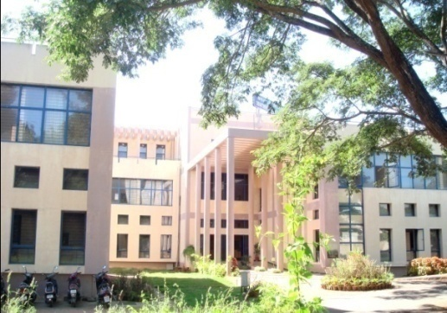A total of **26,897** persons (Table.3) have been registered during the year with various types of speech, hearing and language disorders. This includes **10,721** ***new persons*** and **16,176** persons who have made ***repeat visits*** for the evaluation of their problems. A total of **4,277** and **6,424** persons (Table 4) were seen in speech and language OPD and audiology OPD respectively.

A total of **4,277** persons were evaluated in detail for various speech, language problems. The needy persons were also evaluated for associated ENT and psychological problems by the faculty and staff from the respective departments.

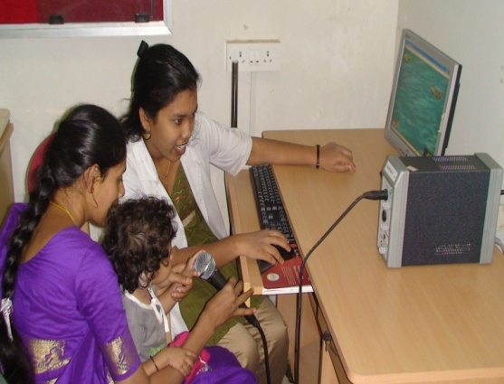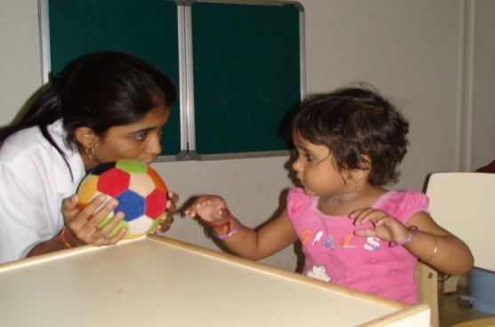Persons requiring further management were given various Speech-Language therapies for a period of 45 minutes every day. A total of **5, 957** persons (Table.10) attended various speech and language therapy and Special Clinics (Fluency, ASD, U-Sofa, LTU and MSD) for the year April-13 to September -13.A total of **35, 937** sessionswhich includes individual speech and language therapy sessions and Special Clinics (Fluency, ASD, U-Sofa and MSD) therapy sessions given in the year April-13 to September -13. The faculty and clinical staff provide supervision and counseling along with support and guidance to parents for home training.

In addition, the persons were referred for various other therapy programs (for e.g. Physiotherapy, Occupation therapy, Autism therapy, etc) by the concerned supervisors.

Following tables and figures depict the statistics of persons registered in the department and other related statistics.

**Table 1: State wise distribution of persons registered from April-13 to September -13**

|  |  |  |  |
| --- | --- | --- | --- |
| **States** | **Male** | **Female** | **Total** |
| Andra Pradesh | 76 | 33 | 109 |
| Arunachal Pradesh | 1 | 1 | 2 |
| Assam | 2 | 1 | 3 |
| Bangladesh | 0 | 0 | 0 |
| Bihar | 13 | 1 | 14 |
| Chattisgarh | 0 | 2 | 2 |
| Delhi | 4 | 1 | 5 |
| Goa | 1 | 1 | 2 |
| Gujarat | 2 | 1 | 3 |
| Hariyana | 3 | 0 | 3 |
| Himachal Pradesh | 0 | 0 | 0 |
| Jarkhand | 3 | 1 | 4 |
| Karnataka | 6180 | 3869 | 10049 |
| Kashmir | 1 | 0 | 1 |
| Kerala | 215 | 140 | 355 |
| Madhya Pradesh | 4 | 1 | 5 |
| Maharastra | 12 | 10 | 22 |
| Malaya | 0 | 0 | 0 |
| Maldives | 1 | 0 | 1 |
| Manipur | 0 | 0 | 0 |
| Meghalaya | 1 | 0 | 1 |
| Mizoram | 0 | 0 | 0 |
| Orissa | 9 | 3 | 12 |
| Over Seas (Nepal) | 4 | 2 | 6 |
| Punjab | 2 | 0 | 2 |
| Rajasthan | 4 | 2 | 6 |
| Tamil Nadu | 68 | 31 | 99 |
| Tripur | 0 | 0 | 0 |
| Union Territories | 2 | 2 | 4 |
| Uttar Pradesh | 4 | 0 | 4 |
| Uttaranchal | 0 | 0 | 0 |
| West Bengal | 5 | 2 | 7 |
| **Total** | **6617** | **4104** | **10721** |

**Figure 1:State wise distribution of persons registered from April-13 to September -13**

**Table 2: Age wise statistics of persons registered from April-13 to September -13**

|  |  |  |  |
| --- | --- | --- | --- |
| **Age Group** | **Male** | **Female** | **Total** |
| 0-5 | 963 | 638 | 1601 |
| 5-10 | 729 | 462 | 1191 |
| 10-20 | 1067 | 649 | 1716 |
| 20-40 | 1623 | 1144 | 2767 |
| 40-60 | 1253 | 741 | 1994 |
| 60-80 | 888 | 430 | 1318 |
| 80+ | 94 | 40 | 134 |
| ***Total*** | **6617** | **4104** | **10721** |

**Figure 2 : Age wise statistics of persons registered from April-13 to September -13**

**Table 3: Total Number of Persons registered at Medical records, from April-13 to September -13**

|  |  |  |  |  |
| --- | --- | --- | --- | --- |
| **Months** | **New Persons** | **Repeat Persons** | **Total Persons** | **No of Working Days** |
| April | 1876 | 2505 | 4381 | 20 |
| May | 2039 | 2796 | 4835 | 23 |
| June | 1764 | 2773 | 4537 | 20 |
| July | 2000 | 3227 | 5227 | 23 |
| August | 1497 | 2296 | 3793 | 20 |
| September | 1545 | 2579 | 4124 | 20 |
| **Total** | **10721** | **16176** | **26897** | **126** |

**Table 4: Statistics of persons seen in Speech & Audiology OPD from April-13 to September -13**

|  |  |  |  |  |  |  |  |  |
| --- | --- | --- | --- | --- | --- | --- | --- | --- |
| **Particulars** | | **Apr** | **May** | **June** | **July** | **Aug** | **Sep** | **Total** |
| Total diagnostic cases | New | 577 | 607 | 794 | 685 | 487 | 380 | **3530** |
| Repeat | 144 | 133 | 131 | 132 | 128 | 79 | **747** |
| Total | 721 | 740 | 925 | 817 | 615 | 459 | **4277** |
| Speech Lang. OPD | | 721 | 740 | 925 | 817 | 615 | 459 | **4277** |
| Audiology OPD | | | | | | | | **6424** |

**Figure 3 : Statistics of persons registered in Medical records, and seen in Speech & Audiology from OPD from April-13 to September -13**

**Table 5: Persons seen in Diagnostic OPD (Speech-Language) disorder wise from April-13 to September -13**

|  |  |  |  |  |  |  |  |  |  |  |  |  |  |  |  |  |  |  |  |  |  |  |
| --- | --- | --- | --- | --- | --- | --- | --- | --- | --- | --- | --- | --- | --- | --- | --- | --- | --- | --- | --- | --- | --- | --- |
| **Disorders** | **Language disorders** | | | **Voice**  **disorders** | | | **Fluency disorders** | | | **Articulation disorders** | | | **Multiple** | | | **Normal** | | | | **Total** | **Hindi** | |
| **Months** | **Child** | **Adult** | **Geriatric** | **Child** | **Adult** | **Geriatric** | **Child** | **Adult** | **Geriatric** | **Child** | **Adult** | **Geriatric** | **Child** | **Adult** | **Geriatric** | **Child** | | **Adult** | **Geriatric** |
| April | 395 | 71 | 00 | 21 | 26 | 07 | 53 | 14 | 00 | 49 | 04 | 00 | 34 | 6 | 00 | 34 | | 07 | 00 | 721 | 25 | |
| May | 360 | 87 | 06 | 30 | 25 | 12 | 48 | 18 | 00 | 56 | 11 | 01 | 27 | 11 | 00 | 31 | | 17 | 00 | 740 | 60 | |
| June | 462 | 154 | 07 | 22 | 30 | 07 | 37 | 31 | 02 | 40 | 14 | 01 | 58 | 22 | 01 | 18 | | 18 | 01 | 925 | 21 | |
| July | 346 | 139 | 08 | 12 | 36 | 09 | 26 | 27 | 03 | 32 | 10 | 02 | 119 | 10 | 00 | 20 | | 14 | 04 | 817 | 45 | |
| Aug | 309 | 90 | 08 | 11 | 16 | 02 | 24 | 16 | 00 | 33 | 10 | 01 | 34 | 22 | 02 | 19 | | 18 | 00 | 615 | 32 | |
| Sep | 278 | 39 | 00 | 11 | 24 | 10 | 16 | 19 | 00 | 22 | 04 | 01 | 14 | 00 | 00 | 13 | | 06 | 02 | 459 | 34 | |
| Total | ***2150*** | ***580*** | ***29*** | ***107*** | ***157*** | ***47*** | ***204*** | ***125*** | ***05*** | ***232*** | ***53*** | ***06*** | ***286*** | ***71*** | ***03*** | ***135*** | | ***80*** | ***07*** | ***4277*** | ***217*** | |
| Disorder wise | **2759** | | | **311** | | | **334** | | | **291** | | | **360** | | | **222** | | | |  | |
| Overall | **4277** | | | | | | | | | | | | | | | | | | |
|  | | | | |

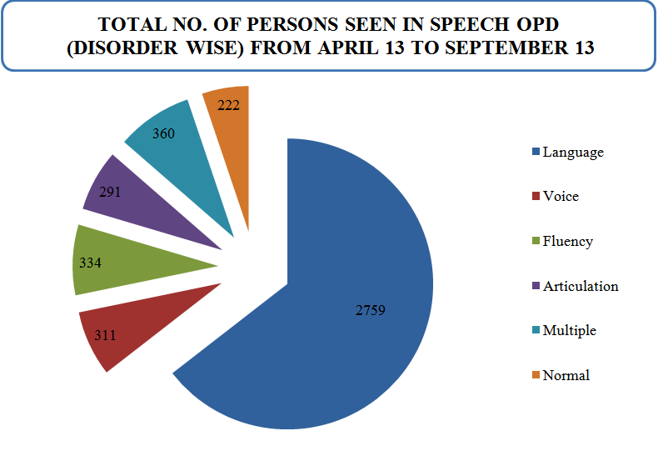

**Figure 4: Disorders-wise distribution of diagnostic persons seen in OPD- Speech/ language April-13 to September -13**

|  |  |  |  |  |  |  |  |  |  |  |  |  |  |  |  |  |
| --- | --- | --- | --- | --- | --- | --- | --- | --- | --- | --- | --- | --- | --- | --- | --- | --- |
| **Disorders-wise distribution of Therapy persons from April-13 to September -13** | | | | | | | | | | | | | | | | |
| **Disorders** | **Language Disorders** | | | | **Voice**  **Disorders** | | | **Fluency Disorders** | | | **Articulation Disorders** | | | **Multiple**  **Disorders** | |  |
| **Months** | **Child** | **Adult** | | **Geriatric** | **Child** | **Adult** | **Geriatric** | **Child** | **Adult** | **Geriatric** | **Child** | **Adult** | **Geriatric** | **Child** | **Adult** | **Total** |
| April | 469 | 11 | | 08 | 06 | 13 | 03 | 42 | 13 | 00 | 21 | 00 | 00 | 74 | 00 | 660 |
| May | 285 | 14 | | 03 | 03 | 16 | 05 | 27 | 09 | 00 | 31 | 00 | 00 | 43 | 00 | 436 |
| June | 248 | 08 | | 02 | 01 | 14 | 02 | 17 | 25 | 00 | 14 | 03 | 00 | 35 | 00 | 369 |
| July | 402 | 15 | | 03 | 03 | 17 | 04 | 15 | 33 | 00 | 07 | 01 | 00 | 50 | 00 | 550 |
| Aug | 393 | 10 | | 05 | 03 | 13 | 05 | 13 | 23 | 00 | 06 | 00 | 00 | 59 | 00 | 530 |
| Sep | 393 | 16 | | 09 | 02 | 17 | 07 | 14 | 28 | 00 | 06 | 00 | 00 | 61 | 00 | 553 |
| Total | 2190 | 74 | | 30 | 18 | 90 | 26 | 128 | 131 | 00 | 85 | 04 | 00 | 322 | 00 | **3098** |
| Disorder wise | **2294** | | | | **134** | | | **259** | | | **89** | | | **322** | |
| Overall total | **3098** | | | | | | | | | | | | | | |
|  | | | | | | | | | | | | | | |

**Table 6: Statistics of Rehabilitation Services provided in the Department of Clinical Services April-13 to September -13**

**Table 7: Details regarding Persons attending Therapy from April-13 to September -13**

|  |  |  |  |  |  |  |  |
| --- | --- | --- | --- | --- | --- | --- | --- |
| **Details regarding Person’s attending Therapy, April 13 to September 13** | | | | | | | |
| **Particulars** | **Apr** | **May** | **June** | **July** | **Aug** | **Sep** | **Total** |
| No. of Cases | 1101 | 813 | 680 | 826 | 952 | 964 | **5336** |
| No. of Sessions | 6663 | 2946 | 3710 | 5834 | 5642 | 4980 | **29775** |
| Therapy New Cases | | | | | | | **1423** |
| Therapy Repeat Cases | | | | | | | **3913** |
| Demo therapy Cases | 147 | 154 | 109 | 115 | 109 | 88 | **722** |
| Cases discharged | 90 | 124 | 52 | 63 | 47 | 52 | **428** |
| No. of Hindi Cases | 49 | 30 | 40 | 41 | 40 | 40 | **240** |
| Parent Counseling | 22 | 24 | 16 | 19 | 12 | 12 | **105** |
| Correspond. (email/ FU) | 10 | 12 | 12 | 09 | 08 | 06 | **57** |
| Certificates Issued | 23 | 27 | 27 | 21 | 10 | 12 | **120** |
| Case report Issued | 62 | 87 | 52 | 60 | 67 | 35 | **363** |

**DISORDERS**

**Figure 5: Disorders-wise distribution of therapy persons from April-13 to September -13**

|  |  |  |  |  |  |  |  |  |  |  |  |  |  |  |  |  |  |  |  |  |  |
| --- | --- | --- | --- | --- | --- | --- | --- | --- | --- | --- | --- | --- | --- | --- | --- | --- | --- | --- | --- | --- | --- |
| **Disorders** | **Fluency unit** | | | **Autism Spectrum Disorder** | | | **U- Sofa** | | | **MSD** | | | **Others** | | **Total** | **Sessions** | | | | | **Total Sessions** |
| **Months** | **Child** | **Adult** | **Geriatric** | **Child** | **Adult** | **Geriatric** | **Child** | **Adult** | **Geriatric** | **Child** | **Adult** | **Geriatric** | **Child** | **Adult** | **FU** | **ASD** | **U-Sofa** | **MSD** | **Others** |
| **April** | 42 | 13 | 00 | 75 | 00 | 00 | 17 | 01 | 00 | 43 | 01 | 00 | 00 | 01 |  | 315 | 463 | 97 | 301 | **01** | **1176** |
| **May** | 27 | 09 | 00 | 56 | 00 | 00 | 09 | 06 | 00 | 27 | 02 | 00 | 03 | 01 |  | 116 | 184 | 46 | 83 | **19** | **448** |
| **June** | 17 | 25 | 00 | 57 | 00 | 02 | 10 | 02 | 00 | 11 | 00 | 00 | 11 | 00 |  | 172 | 161 | 38 | 41 | **29** | **441** |
| **July** | 15 | 33 | 00 | 64 | 00 | 00 | 09 | 04 | 00 | 28 | 03 | 00 | 07 | 00 |  | 239 | 391 | 56 | 190 | **28** | **904** |
| **Aug** | 13 | 23 | 00 | 63 | 01 | 00 | 11 | 02 | 00 | 19 | 02 | 00 | 00 | 00 |  | 75 | 321 | 45 | 105 | **00** | **546** |
| **Sep** | 14 | 28 | 00 | 77 | 01 | 00 | 19 | 03 | 00 | 26 | 04 | 00 | 00 | 00 |  | 223 | 477 | 108 | 180 | **00** | **988** |
| **Total** | **128** | **131** | **00** | **392** | **02** | **02** | **65** | **18** | **00** | **154** | **12** | **00** | **21** | **02** |  | **1140** | **1997** | **390** | **900** | **77** | **4504** |
| **Disorder wise** | **259** | | | **396** | | | **83** | | | **166** | | | **23** | | **4504** | | | | |
| **Overall total** | **927** | | | | | | | | | | | | | | |

**Table 8: Clinical Services in the Special Clinic from April-13 to September -13**

**Others - SLT**

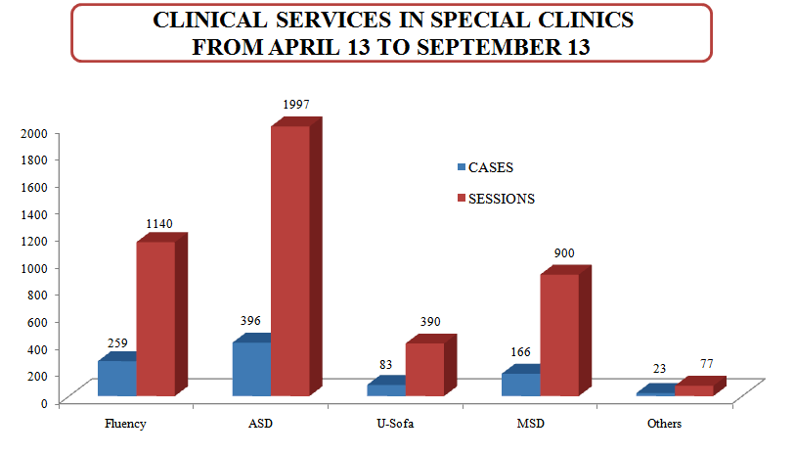

**Figure 6: Clinical Services in the Special Clinics from April-13 to September -13**

**Consultancy Services:**

Allied professionals such as Pediatrician, Neurologist, Plastic surgeon, Prosthodontist, Phonosurgeon, physiotherapist and occupational therapists provide consultancy services for better patient care and management. The detailed statistics regarding the specialized clinical services provided during the months April 2013-September 2013 are given in Table: 8

**Table 9: Persons seen by consultant specialists from April-13 to September -13**

|  |  |  |  |  |  |  |  |  |
| --- | --- | --- | --- | --- | --- | --- | --- | --- |
|  | | **Apr** | **May** | **June** | **July** | **Aug** | **Sep** | **Total** |
| PT | Cases | 49 | 35 | 44 | 35 | 20 | 32 | 215 |
| OT | Cases | 30 | 59 | 39 | 50 | 47 | 34 | 259 |
| Neurologist | | 50 | 42 | 76 | 66 | 40 | 64 | 338 |
| Pediatrician | | 22 | 52 | 23 | 33 | 27 | 26 | 183 |
| Phonosurgeon | | 47 | 11 | 00 | 35 | 13 | 17 | 123 |
| Plastic surgeon | | 19 | 13 | 18 | 11 | 12 | 06 | 79 |
| Prosthodontist | | 00 | 00 | 00 | 00 | 01 | 02 | 03 |
| Orthodontist | | 01 | 07 | 03 | 02 | 06 | 02 | 21 |

**PERSONS SEEN IN SPECIALIZED CLINICAL SERVICES FROM**

**APR 13 - SEP 13**

**Figure 8: Persons seen in PT/OT from April-13 to September -13**

**Table 10: Persons seen in specialized clinical services April-13 to September -13**

|  |  |  |  |  |  |  |  |  |
| --- | --- | --- | --- | --- | --- | --- | --- | --- |
|  | | **Apr** | **May** | **June** | **July** | **Aug** | **Sep** | **Total** |
| **PT** | **Cases** | 81 | 61 | 72 | 69 | 59 | 69 | **411** |
| **Session** | 565 | 569 | 729 | 538 | 451 | 542 | **3394** |
| **OT** | **Cases** | 48 | 56 | 64 | 61 | 73 | 73 | **375** |
| **Session** | 339 | 318 | 442 | 595 | 468 | 606 | **2768** |

**REPORTS AND CERTIFICATE ISSUED**

|  |  |  |
| --- | --- | --- |
| **Sl. No** | **Particulars** | Total |
| 1 | Transfer certificate | 28 |
| 2 | Evaluation reports | 363 |
| 3 | Attendance certificates | 37 |
| 4 | School admission certificate/  Language exemption certificate | 55 |
| 5 | Gen Correspondences Letter English | 58 |
| Gen Correspondences Letter Hindi | 00 |
| 6 | Correspondence by e-mail in English | 57 |
| Correspondence by letters in English | 89 |

**Assistance provided to the needy persons under Client Welfare Fund (CWF):**

|  |  |  |
| --- | --- | --- |
| ***Month*** | ***No of Cases*** | ***Amount Sanctioned in CWF*** |
| **April** | 38 | 1,58,816 |
| **May** | 17 | 1,12,275 |
| **June** | 28 | 2,48,429 |
| **July** | 22 | 1,73,416 |
| **August** | 11 | 1,15,773 |
| **September** | 09 | 65,045 |
| **Total** | ***125*** | ***8,73,754*** |

**Revenue generated from April-13 to September -13**

|  |  |
| --- | --- |
| ***Revenue generated from*** | ***Amount in `*** |
| **Medical records** | 2,61,350 |
| **Therapy charges** | 3,26,585 |
| **Certificate /evaluations** | 1,56,495 |
| **Kuteera/dharmasala** | 70,090 |
| **Miscellaneous-handout and books** | 1,33,961 |
| **Total** | **9,48,481** |

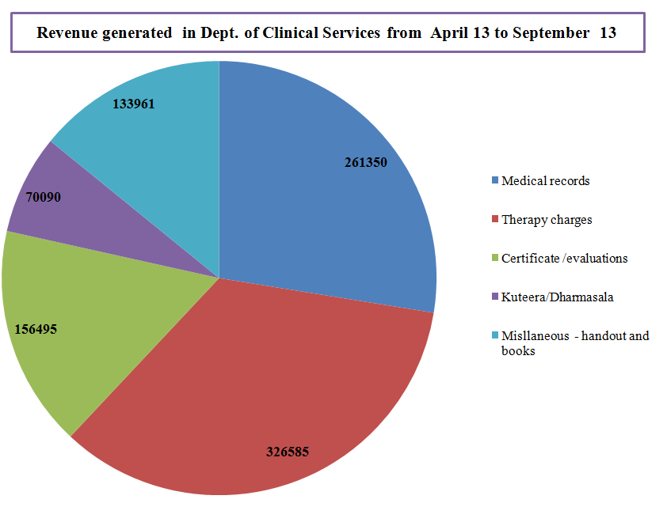

**Figure 9: Revenue generated in Dept of Clinical Services from April-13 to September -13**

VI.Central Facilities

1. Library and Information Services- Nil
2. Public Information Activities

* RCI education programs telecasted from 10.00 am to 4.30 pm daily in the Dept of Clinical Services.

VII.Awards and Honors Received by Faculty and Staff

* Dr. S.P. Goswamiwas awarded ‘Raman’ fellowship to pursue post-doctoral fellowship at U.S.A by UGC, New Delhi
* N Sreedevi, Merin J & Sindhusha, C. (Aug 2013). Received the best paper award for the paper titled “Computerized assessment of phonological processes in Malayalam (CAPP-M) at GHTC SAS 2013 organized by IEEE Kerala Section, Region 6 & Seattle Section, Trivandrum.

VIII.Extra Curricular Activities- Nil

1. AIISH GYMKHANA
2. NSS
3. OTHERS

Ix.MAJOR EVENTS OF THE YEAR

x. Eminent Visitors

* Visit by NAAC Peer team on 23.09.2013