INDIA INSTITUTE OF SPEECH AND HEARING, MYSURU-6
अखिल भारतीय वाक श्रवण संस्थान, मैसूर-६
DEPARTMENT OF SPECIAL EDUCATION
विशेषशिक्षाविभाग
MONTHLY REPORT: September 2020

- ACADEMIC ACTIVITIES
- Orientation Programs (For outsiders): NIL
- Clinical /Special Educational postings and/or Observation Postings
- Students from Other Institutes: NIL
- AIISH Students in Other Institutes:NIL
- Seminars/Conferences/Workshops/Training Programs: 01
Theme/topic | Two Days In-house workshop on ‘Standardization of Preschool modules on Concept based pre-literacy skills, cognitive skills & pre-number skills for Children with Hearing Impairment’
Objectives | Group discussion about each skill from the developed preschool module.
Convener | Dr. Alok Kumar Upadhyay
Resource Persons | - Dr. Alok Kumar Upadhyay  - Dr. Prithi Venkatesh  - Ms. Ramanakumari P V  - Dr. Palnaty Vijetha
Co-ordinators | Dr. Palnaty Vijetha and Mr. Subramanya K R
Targeted Audience | Special Educators
Number of Participants | 18
Date | 24.09.2020 to 25.09.2020
Photo
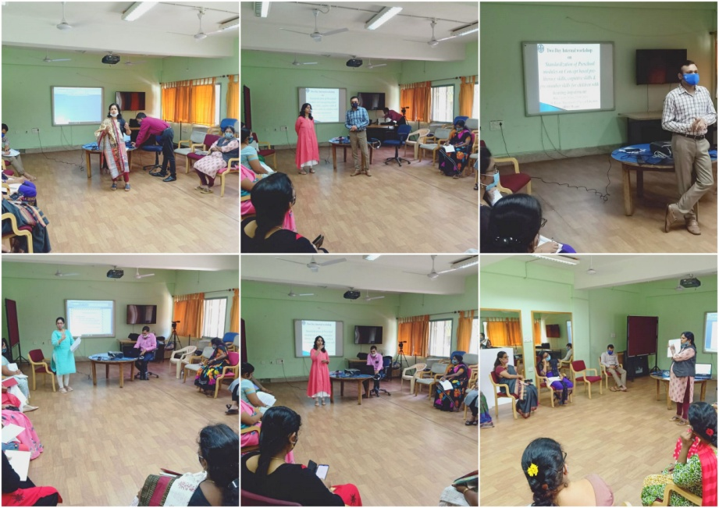

- Staff enrichment / In-house training programs: NIL
- Staff Enrichment Programs (For own staff members): NIL
- Guest Lectures: NIL
- Additional Academic Services rendered by the Faculty and Staff:
- Invited Talks:
Name, Designation, Institutional affiliation of Speaker | Organized by | Programme | Topic of Lecture | Date
Dr. Palnaty Vijetha, Reader | TCPD, AIISH | Project Reach-out | Educational challenges and counselling for adolescents with communication disorders | 02.09.2020
Ms. Shobha B N, Special Educator Served as resource person and delivered a talk | SVYM teachers training center, mysuru | Certificate course | Children with specual needs at class room | 20.09.2020
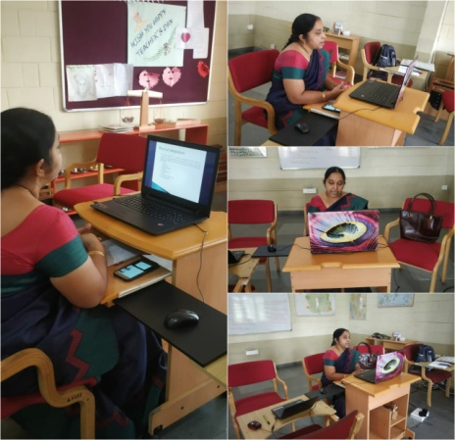
Ms. Shobha B N, Special Educator Served as resource person and delivered a talk | Swamy Vivekananda youth moment teachers training institute, Mysuru |  | Children with Special Needs (CWSN) | 20.09.2020
Ms. Shobha B N, Special Educator Served as resource person and delivered a talk | AIISH, Mysuru | Online training program for Government teachers of Kodagu district (through  SVYM, Sarguru) 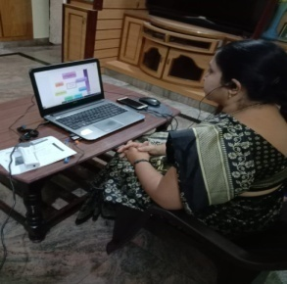 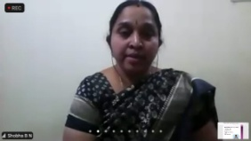 | “Educational difficulties of children with learning disabilities” | 26.09.2020
Ms. Sumana H P  Special Educator Served as resource person and delivered a talk | AIISH, Mysuru | Online training program for Government teachers of Kodagu district (through  SVYM, Sarguru)  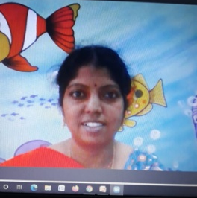 | Understanding problems of children with learning disabilities | 23.09.2020
Mr. Rajkumar R  Special Educator Served as resource person and delivered a talk | AIISH, Mysuru` | International Day of Sign Languages (Department of Clincal Services-AAC Unit)  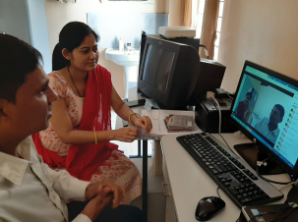 | Importance and objectives of IDSL-2020 | 23.09.2020

- Development of Material to Support Learning: NIL
- Curriculamdevelopment:NIL
- Academic Classes: By faculty–
- Theory classes (no. of hours):
Name of the Faculty | No. of hours of theory classes
Name of the Faculty | DECSE-HI | B.Ed.Spl.Ed. (HI) | Total
Dr.Alok Kumar Upadhyay | -- | 02 | 02
Dr.Prithi V | -- | 10 | 10
Dr.PalnatyVijetha | -- | 11 | 11
Total no. of hours |  |  | 23

- Practical Classess (no. of hours):

Name of the Faculty | No. of hours of practical classes
Name of the Faculty | DECSE-HI | B.Ed.Spl.Ed. (HI) | Total
Dr.Alok Kumar Upadhyay | -- | -- | --
Dr.Prithi V | -- | -- | --
Dr.PalnatyVijetha | -- | 12 | 12
Total no. of hours |  |  | 12

- Service in Academic Bodies of other Organizations:
- Dr.Alok Kumar Upadhyay

- Member, Board of Studies (BOS):
    - RamkrishnaMission Vivekananda University, Coimbatore: for Diploma, U.G & P.G.
    - N.G.B. University, Allahabad: for U.G & P.G.
    - J.R.H. University, Chitrakoot: for U.G & P.G.
    - Mysore University,Mysuru :for U.G & P.G.

- Member, Board of Examiners (BOE):
    - UG Special Education of University of Mysore.

- Dr. PrithiVenkatesh
    - Member, BOE–UG Special Education of University of Mysore

- Dr.PalnatyVijetha
    - Member of BOS in special education, University of Mysore
    - Member of BOS in Human development (CB & PG), University of Mysore.
    - Member of BOEin special education, University of Mysore
- Participation in Committees/Taskforce and Panels setup by other organizations/agencies:NIL
- Any Others (Please Specify):
Dr. Palnaty Vijetha
- Research Coordination section in charge:
- Compiled NAAC information for five years.
- Email sent to all the PIs on 8th September 2020 on status of ARF projects pending from 2014-15 to till date.
- AREC compilation of AREC recommendations.
- Attended to Extension letters of the ARF projects.
- Coordinating between the Director and the Investigators.
- Organizing all the project files and documents.
- Attended to completion certificate.
- Submitted information for Suo-motto purpose on 14th September 2020.
- AIISH Ethical Committee- Member secretary
- Attended to Ethical clearance certificates.
- ISO in-charge at the department
- Compiled NAAC information of the department and submitted on 4th September 2020.
- Compiled research information for Suo-Motto and submitted on 14th September 2020.
- Attended Guest lecture on "AIISH training Medico Legal Cases: Practice Parameters A Session by Dr. Shekhar Seshadri, NIMHANS" on 3rd September 2020
- On 12th & 24th September 2020, carried out invigilation duty for UG & PG exams.

- Inchargeship:-

- Dr.PalnatyVijetha
- In charge - AIISH Research Coordination Section.
- Member secretary - AIISH Ethical Committee.

- Dr. Prithi Venkatesh
- DHLS Mumbai Centre Coordinator .
- CBSC Coordinator.
- In charge – MPLS (Monthly Public Lecture Series).

- Research Projects (ARF)
- Completed –
Project 1
Title | ARF No. 02: Development of Grade Level Assessment Tools in Social Science (GLAT-SS) of Karnataka State Education Board.
Objectives | The present study is being initiated with the aim to develop and standardize Grade Level Assessment Tool in Social Sciences (GLAT-SS) at GRADE VI of Karnataka State Education Board in English and Kannada.
Department | Special Education
Principal Investigator &  Co-Investigator | Principal Investigator  Dr.PalnatyVijetha  Reader in Special Education  AIISH, Manasagangothri, Mysore: 570006  Co-Investigators  - Dr.Alok Kumar Upadhyay  Associate Professor in Special Education  AIISH, Manasagangotri, Mysore: 570006  - Ms.LakshmiPrabha J.K.  Lecturer in Special Education  AIISH, Manasagangotri, Mysore: 570006  Research Officer:  - Mr. Anil Abbur, AIISH, Mysuru
Funding Agency | AIISH Research Fund (ARF)
Date of initiation of the project | 09.10.2018 (approval date)
Amount | Rs. 3,85,000/-
Status | Completed
Summary of work done | On 21st September 2020, submitted the initial report
- New Research Projects – 01
ARF Project- Submitted new project proposal titled ‘Adaptation of Science textbook for Children studying in Grade V and VI and Studying its Effectiveness’

- Ongoing Research Projects - 02

Project 2
Title | ARF No. 01:Efficacyof Developing Skills through Curricular Activities among Preschool Children with Hearing Impairment at AIISH
Objectives | To investigate the effectiveness of curricular activities in developing:  - Cognitive skills  - Language Arts  - Pre-academic skills (pre-reading, pre-writing, pre-arithmetic) among children with hearing impairment
Department | Special Education
Principal Investigator &  Co-Investigator | Principal Investigator  Dr.Alok Kumar Upadhyay  Associate Professor in Special Education  AIISH, Manasagangotri, Mysore: 570006  Co-Investigator  Dr.PalnatyVijetha  Reader in Special Education  AIISH, Manasagangothri, Mysore: 570006  Research officer  Mr.Subramanya K R
Funding Agency | AIISH Research Fund (ARF)
Date of initiation of the project | 09.10.2018 (approval date)
Amount | Rs. 3,80,000/-
Status | Ongoing (extension for two months)
Summary of work done | Writing of Final Report

Project 3

Title | ARF No. 03:Development of grade level Assessment test in Science for Upper Primary School Children (VI-VIII)
Objectives | The aim of the study is to develop grade level assessment test for upper primary school children (VI-VIII) in science subject.  The study will be taken up with the following objectives in mind:  - To develop grade level assessment test in Science for upper primary school children (VI-VIII)  - To verify the reliability and validity of the test  - To establish the norms for the test  - To test its applicability with learners with hearing impairment  - To compare the performance of the learners with hearing impairment on the test.
Department | Department of Special Education
Principal Investigator &  Co-Investigator | Dr.PrithiVenkatesh  Reader in Special Education  AIISH, Manasagangothri, Mysore: 570 006  Research Officer:  Ms.Dhivya D
Funding Agency | AIISH Research Fund (ARF)
Date of initiation of the project | 09.10.2018
Amount | Rs.4,00,000/-
Status | Ongoing
Summary of work done | - Visited schools for permission for data collection  - Collected data from seven regular schools (total number of children:415 from Grade VI, VII and VIII) for the final study  - Evaluated the response of the participants of Grade VI for further statistical analysis  - Completed data entry for Grade VI in the prescribed format for further analysis.

- Postgraduate /Ph.DResearch Completed: NIL
- Postgraduate Research ongoing: NA
- Research Papers presented at National/International Conferences/Seminars: - NIL
- Research Papers published:-
- Papers published in National / International Journals:
- Papers published in Conference / Seminar Proceedings (Abstract):-NIL
- Books published (in APA format):NIL
- Books published
- Books in press
- Book chapters published (in APA format): NIL
- Articles Published: NIL
- Books/Manuals/Seminar Proceedings edited: NIL
- Journal Editorship: NIL
- Scholarly Reviewing Activities: NIL
- Special Educational Services Offered through Teacher Trainees Outside Campus: NIL

III CLINICAL/ SPECIAL EDUCATIONAL SERVICES
- General Clinical Services: Not Applicable
- Specialized Clinical / Educational Services :
- Pre-school Training and Special Educational services for children with special needs
S. No. | Nature of Services
- Special Educational Assessment Unit (SEA-U): NIL
 |  | Nature of Special Need  Language | ASD / PDD NOS | Hearing Impairment (HI) | Intellectual Disability (ID) | Learning Disability (LD) | Motor Problems/ Cerebral Palsy (CP) | Multiple Disabilities (MD) | Others | No. of Clients | No. of Sessions | Total No. of Sessions
1. | Screening &Referral | Kannada | -- | -- | -- | 1 | -- | -- | 3 | 4 | 4 | 10
1. | Screening &Referral | Malayalam | 1 | -- | 1 | -- | 1 | 2 | 1 | 6 | 6 | 10
1. | Screening &Referral | Hindi | -- | -- | -- | -- | -- | -- | -- | -- | -- | 10
1. | Screening &Referral | Urdu | -- | -- | -- | -- | -- | -- | -- | -- | -- | 10
1. | Screening &Referral | English | -- | -- | -- | -- | -- | -- | -- | -- | -- | 10
1. | Screening &Referral | Telugu | -- | -- |  | -- | -- | -- | -- | -- | -- | 10
1. | Screening &Referral | Tamil | -- | -- | -- | -- | -- | -- | -- | -- | -- | 10
1. | Screening &Referral | Any Other | -- | -- | -- | -- | -- | -- | -- | -- | -- | 10
1. | Screening &Referral | Total No. of Clients | -- | -- | -- | -- | -- | -- | -- | 10 | 10 | 10
2. | Assessment &Report | Kannada | -- | -- | -- | -- | -- | -- | -- | -- | -- | -
2. | Assessment &Report | Malayalam | -- | -- | -- | -- | -- | -- | -- | -- | -- | -
2. | Assessment &Report | Hindi | -- | -- | -- | -- | -- | -- | -- | -- | -- | -
2. | Assessment &Report | Urdu | -- | -- | -- | -- | -- | -- | -- | -- | -- | -
2. | Assessment &Report | English | -- | -- | -- | -- | -- | -- | -- | -- | -- | -
2. | Assessment &Report | Telugu | -- | -- | -- | -- | -- | -- | -- | -- | -- | -
2. | Assessment &Report | Tamil | -- | -- | -- | -- | -- | -- | -- | -- | -- | -
2. | Assessment &Report | Any Other | -- | -- | -- | -- | -- | -- | -- | -- | -- | -
2. | Assessment &Report | Total No. of Clients | -- | -- | -- | -- | -- | -- | -- | -- | -- | -
3. | Report issued: NIL

Online Pre-school Training:Preparatory programme for schooling by providing training in self-help, cognitive, language and (pre-) academic skills, Preschool Supplementary Services (PSS)

Language & Disability | No. of Groups | No. of Children
Language & Disability | No. of Groups | MALE | FEMALE
Kannada; ASD & ID &MD | 14 | 50 | 17
Kannada HL | 6 | 25 | 08
Malayalam HL | 2 | 7 | 5
Malayalam ASD & ID &MD | 6 | 23 | 6
Hindi HL | 1 | 6 | 1
Hindi MD & ID & ASD | 3 | 6 | 4
Telugu HL  &ASD & ID & MD | 2 | 9 | 2
Total number of children |  | 126 | 43
Total number of clients availing online services | 34 | 169
Total online sessions taken | 680 (As mentioned by teachers)

Curricular Support  Services (CSS) –  Supportive training  to augment  education in  mainstream school/  other educational  programmes | Language | No. of children with HL | No. of children with ID/CP/ASD/MD/LD/DD | Total No. of clients | No. of sessions
 | Kannada | 5 | 12 | 17 | 69
 | Malayalam | 0 | 2 | 2 | 11
 | Hindi | 0 | 1 | 1 | 0
 | English | 0 | 2 | 2 | 14
 | Telugu | 0 | 0 | 0 | 0
 | Tamil | 0 | 0 | 0 | 0
Total |  |  |  | 22 | 94
Individualised Educational Programme (IEP) – Training in functional academics for out of school individuals | Language | No. of children with HL | No. of children with ID/CP/ASD/MD/LD/DD | Total No. of clients | No. of sessions
 | Kannada | 0 | 1 | 1 | 1
 | Malayalam | 0 | 1 | 1 | 6
 | Hindi | 0 | 0 | 0 | 0
 | English | 0 | 1 | 1 | 5
 | Telugu | 0 | 0 | 0 | 0
 | Tamil | 0 | 0 | 0 | 0
 | Total |  |  | 3 | 12

Demonstration Educational Training: Short-term demonstration to caregivers in any of the above | Language | No. of children with HL | No. of children with ID/CP/ASD/MD/LD/DD | Total No. of clients | No. of sessions
 | Kannada | - | - | - | -
 | Malayalam | - | - | - | -
 | Hindi | - | - | - | -
 | English | - | - | - | -
 | Telugu | - | - | - | -
 | Tamil | - | - | - | -
 | Total |  |  | - | -

Total no. of clients:25
Old clients:23
New clients: 05
Discontinued (CSS): 03

Pre-school Parent Empowerment Programme – PPEP
Taken classes Through Online Class

 | Language groups of children | HL | ID | CP | ASD | MD | LD | DD | SLD | ADHD | Total No. of clients | Group | No. of sessions
 | Kannada | 04 | 08 | 02 | 02 | - | - | - | - | - | 16 | 06 | 132
 | Malayalam | 06 | 02 | 02 | 03 | 01 | - | 04 | - | 01 | 19 | 2 | 44
 | Hindi | 02 | - | - | 01 | - | - | - | - | - | 03 | 1 | 22
 | English | - | - | - | - | - | - | - | - | 01 | 01 | 1 | 22
 | Telugu | - | - | - | - | - | - | - | - | - | 00 | 0 | 00
 | Tamil | - | - | - | - | - | - | 01 | - | - | 01 | 0 | 00
Total |  |  |  |  |  |  |  |  |  |  | 40 | 10 | 220
No. of clients promoted to the next higher level(Preschool) of service: NIL
No. Of discharged: NIL
No. Of discontinued: 02
No. Of New clients (September): 05
Shifted from PPEP to PIP: NIL
No. of Long leaves: NIL

ParentInfant Programme – PIP(Birth to 2 ½ years):
Online Class
 | Language groups of children | HL | ID/CP/ASD/  MD/LD/DD | Total No. of clients | Total No. of sessions
 | Kannada | 3 | 3 | 6 | 32
 | Malayalam | 2 | 4 | 6 | 21
 | Hindi | 1 | - | 1 | 06-
 | English | - | - | - | -
 | Telugu |  | 1 | 1 | 04
 | Tamil | - | - | - | -
 | Total |  |  | 14 | 63
No. of Old clients :14
No. of New clients enrolled: NIL
Total clients: 14
No. discharged : NIL
No. discontinued: NIL
No. of Promoted to next level:01

Library of Books & Toys – LiBoToy  Services: issuing educational toys & books for home-based training. | Total number of members enrolled during 2020-21:131  No. of new members: NIL  Amount: NIL  Total number of sessions:NIL
 | Age group | Total number
 | 0-2.5yrs | 5
 | 2.5- 3yrs | 37
 | 2.5-6yrs | 85
 | 6 yrs and above | 4

Services | Number of Clients | Number of Sessions
Co-Curricular Training | -- | --

- Support for Empowering Caregivers:
Name of Training Unit | No. of Parent  Beneficiaries | No. of Sessions
Caregiver Computer Training Unit | - | -
Caregiver Literacy Training Unit | - | -
Caregiver yoga training unit  (from 14.3.2019 onwards) | - | -

- Clinical/ Educational Support Services to Parents and Family
- Educational guidance
No. of Clients | Sessions
- | -
- U-SAFE
No. of Clients | Sessions
- | -

- SUMERU (Special Use of Music for Educational Readiness and Upbuilding)
Activity | No. of Clients | Sessions
Taining for Drum | - | -
Traning for Choir group | - | -

- Details of Certificates Issued: Bonafide Certificates : 01
Diagnosis | Number of certificates issued | Purpose
ID | 1 | Scholarship
- Specialized Clinical/ Educational Services: NIL
- Financial Aid: NIL
- Legal advice: NIL
- Any other(Please Specify):
NAME: KHYATHI G JAIN
DESIGNATION: SPEECH LANGUAGE PATHOLOGIST
DEPUTED IN THE DEPARTMENT OF SPECIAL EDUCATION
- Cognitive communication material for therapy on requirements for different situations was prepared for the future use in Pre school.
- Providing tele-guidance through phone calls.
- Posted in OPD in the Department of clinical services. Detailed assessment and counselling was done to the in patients.

- Attended workshop/Seminar/Orientation program in AIISH 2020-21:
Name of Staff | Attended to workshop title name | Date
Ms. Sreevidya M. S | International Day of Sign Languages (Department of Clincal Services-AAC Unit) | 23.09.2020
- Attended workshop/Seminar/Orientation program outside institute 2020-21:-
Name of Staff | Attended to workshop title name | Date
All Special Educators | Webinar titled “Medico Legal Approach” to children with special needs | 03.09.2020
Ms. Shobha B N &  Mr. Rajkumar | National level Webinar On “Intervention for specific learning disability” | 28.09.2020
IV. EXTENSION ACTIVITIES
- Public Lecture Series:NIL
V. TECHNLOGICAL CONSULTANCY SERVICES: NIL
VI. CENTRAL FACILITIES:NIL
      - Library and Information Services
      - Public Information Activities
      - Major Events with a brief account:
      - Press Releases and Media Coverage:

- Material Development:The following Teaching Learning Material wereprepared for training children with various communication disorders in preschool.

Sl.  No. | Nature of  Teaching-Learning  Materials | Skill | Number
1. | Flash cards | For all skill areas | 253
2. | Work Cards | For all skill areas | 168
3. | Charts | For all skill areas | 21
4. | PPT | For all skill areas | 21
5. | Models | For all skill areas | 7
6. | Sentence strips | For all skill areas | 321
7. | Story cards | For all skill areas | 108
8. | Others | For all skill areas | 0

Material Development:The following materials were prepared by the B.ASLP students for teaching various speech and language concepts in children with various communication disorders in preschool.
Sl.  No. | Nature of  Speech and Lnguage Therapy  Materials | Number
1. | Short Story Books | -
2. | Memory Game | -
3. | Model of Railway Station | -
4. | Model of Restaurant | -
5. | Odd one out Game | -
6. | Reasoning skills | -

- AWARDS AND HONORS RECEIVED BY FACULTY AND STAFF: NIL
- EXTRA CURRICULAR ACTIVITIES:
        - AIISH Gymkhana: NIL
- EMINENT VISITORS:
- ANY OTHER:
- OfficialLanguage Implementation:

- No. of notings/letters:-

Bilingual ( Hindi and English ) | 127
E-mail (Hindi and English) | 45
English | 10

- Dr. Palnaty Vijetha conducted Hindi Essay competition as a part of Hindi week on 9th September 2020.

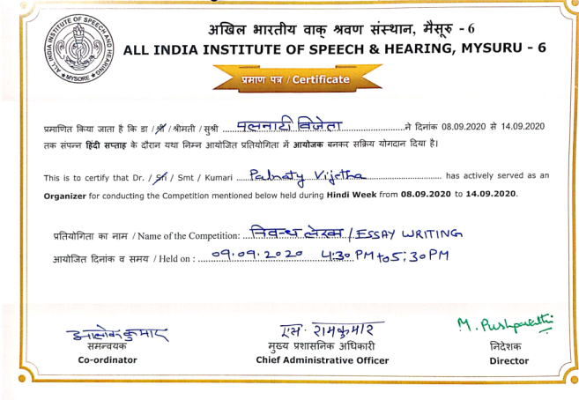

Sd/-
HOD- Special Education

