संप्रेषणविकृतिरोकथामविभाग
DEPARTMENT OF PREVENTION OF COMMUNICATION DISORDERS
महीनेकेविवरण/ MONTHLY REPORT –SEPTEMBER 2020

- ACADEMIC ACTIVITIES
A. No. of webinars & Orientations: 45
As a part of primary prevention activities, orientation/sensitization programs are being conducted regularly. The objective of the orientation programs was to create awareness among the general public and various other professionals such as Medical doctors, Nurses, Health-related workers, teachers, school students, etc., on different types of communication disorders, its prevention and early identification methods, and their appropriate referral and timely management. Due to the COVID-19 pandemic condition in the country, the orientation programs are carried out through Tele-mode/Webinars. Table 1&2 shows the details of the webinar’s programs conducted by staff and students of the department of POCD, NBS, and OSC centers.
Table 1: The details of webinar Programs in September 2020.
I. No. of Webinar Programs at POCD : 17
Theme/Topic of the program: Prevention & early identification of communication disorders
Coordinators: Dr. N. Sreedevi, Dr. M. Sandeep & Mr. Arunraj K.
S.No | Date | Name of the institute/  Hospital | Target group | Total participants | Oriented by
 | 04.09.2020 | SSK Alappuzha, Kerala | School Teachers | 25 | Ms. Aparna & Ms Krishnendu
 | 04.09.2020 | SSK Alappuzha, Kerala | School Teachers | 33 | Ms. Aparna & Ms Krishnendu
 | 07.09.2020 | SSK Thrissur, Kerala | School Teachers | 20 | Ms. Krishnendu & Ms. Aparna
 | 07.09.2020 | SSK Thrissur, Kerala | School Teachers | 40 | Ms. Krishnendu & Ms. Aparna
 | 08.09.2020 | SSK Wayanad, Kerala | School Teachers | 70 | Dr. N Sreedevi & Mr. Jim Winston
 | 10.09.2020 | Mahila Samyaka Sangha, Karnataka | Community social workers | 40 | Ms. Ritu & Ms. Spoorthy
 | 12.09.2020 | ONGC, Mangalore | Industrial workers | 42 | Mr. Harish & Ms. Anusha
 | 15.09.2020 | ONGC, Mangalore | Industrial workers | 20 | Mr. Kishore & Ms.Spoorthy
 | 23.09.2020 | Government school teachers, Mysuru | School teachers | 74 | Mr. Harish & Ms. Anusha
 | 24.09.2020 | Government school teachers, Mysuru | School teachers | 102 | Ms. Sharanya & Ms. Spoorthy
 | 25.09.2020 | Government school teachers, Mysuru | School teachers | 61 | Ms. Spoorthy & Ms. Ritu Venkatesh
 | 28.09.2020 | Government school teachers, Mysuru | School teachers | 78 | Mr. Gowtham & Mr. Kishore
 | 29.09.2020 | Government school teachers, Mysuru | School teachers | 21 | Mr. Gowtham & Mr. Advaith
 | 25.09.2020 | KAPL, Bangalore | Industrial workers | 10 | Ms. Faheema & Ms. Susan
 | 28.09.2020 | ONGC, Mangalore | Industrial workers | 18 | Mr. Advaith & Mr. Gowtham
 | 29.09.2020 | HD Kote | School teachers | 37 | Ms. Anusha & Mr. Harish
 | 30.09.2020 | HD Kote | School teachers | 45 | Mr. Gowtham & Ms. Sharanya
II. No. of Webinar Programs at OSC centers: 04
 | 17.09.2020 | Kodagu Institute of Medical Sciences | Traffic Police | 13 | Ms. Kavitha.G.S.
 | 19.09.2020 | Sagara, Shivamoga | School teachers | 38 | Ms.Durga, S Mr.Monish V
 | 21.09.2020 | Kodagu Institute of Medical Sciences | Traffic Police | 5 | Ms. Kavitha.G.S.
 | 26.09.2020 | KR Pete Taluk hospital | General Public | 06 | Ms. Minu Lalu
III. No. of Webinar Programs at NBS centers: 03
 | 04.09.2020 | AIIPMR, Mumbai | Caregivers of individual with speech and hearing disorders | 05 | Ms. Suman Penwal
 | 14.09.2020 | AIIPMR, Mumbai | Caregivers of individual with speech and hearing disorders | 05 | Ms. Suman Penwal
 | 21.09.2020 | AIIPMR, Mumbai | Caregivers of individual with speech and hearing disorders | 05 | Ms. Suman Penwal

Table 2: The details of orientation programs at AIISH DCS in SEP 2020.
 | 02.08.2020 | 25 | Ms. Sharanya Kumar & Ms. Krishnendu
 | 03.09.2020 | 33 | Ms. Anusha C & Ms. Aparna U
 | 04.08.2020 | 20 | Mr. Harish Kumar & Ms. Faheema
 | 07.09.2020 | 40 | Mr. Kishore & Ms. Ameena
 | 08.09.2020 | 70 | Mr. Kishore, Mr. Harish & Ms. Ritu
 | 09.09.2020 | 65 | Ms. Spoorthy C, Mr. Harish & Ms. Ritu
 | 10.09.2020 | 50 | Mr. Gowtham, Mr. Harish & Ms. Ritu
 | 11.09.2020 | 40 | Mr. Advaith, Ms. Krishnendu S & Ms. Ritu
 | 14.09.2020 | 43 | Ms. Aparna & Ms. Anusha
 | 15.09.2020 | 33 | Ms. Ritu & Ms. Faheema
 | 16.09.2020 | 80 | Mr. Kishore & Mr. Advaith
 | 17.09.2020 | 22 | Mr. Harish Kumar & Ms. Priya
 | 18.09.2020 | 20 | Ms. Spoorthy & Ms. Susan
 | 21.09.2020 | 45 | Mr. Advaith & Ms. Ritu
 | 22.09.2020 | 40 | Ms. Sharanya & Ms. Krishnendu
 | 23.09.2020 | 87 | Ms. Aparna & Ms. Anusha
 | 24.09.2020 | 67 | Ms. Ritu & Ms. Faheema
 | 25.09.2020 | 68 | Mr. Kishore & Ms. Abhinaya
 | 28.09.2020 | 26 | Mr. Harish Kumar & Ms. Priya
 | 29.09.2020 | 52 | Ms. Sharanya & Ms. Abhinaya
 | 30.09.2020 | 54 | Mr. Advaith & Ms. Ritu
Total |  | 1739

Table 2: Total number of participants oriented including Webinars and orientations (Group wise
S. No | Target group | Total no. of Participants
I | Grass Root Level Workers
a) | Community social workers | 40
II | Professionals
 | School Teachers | 644
 | Traffic Police | 18
 | Industrial Employees | 90
III | Public
a) | General Public | 932
c) | Caregivers of individual with speech and hearing disorders | 15
Total |  | 1739

Figure 1: Glimpses of webinar programs organized at Dept. of POCD
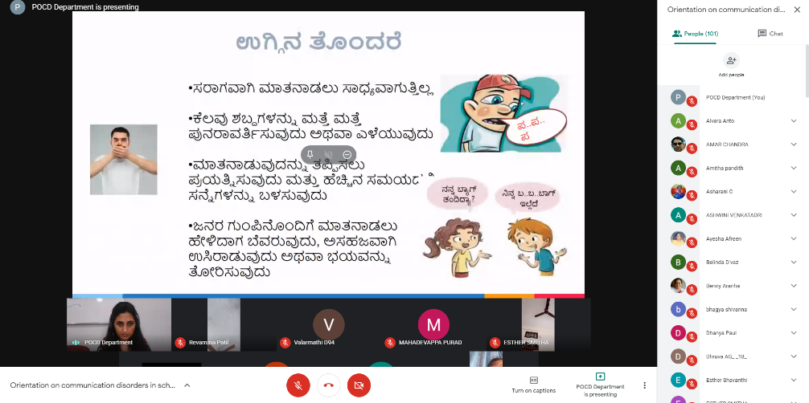
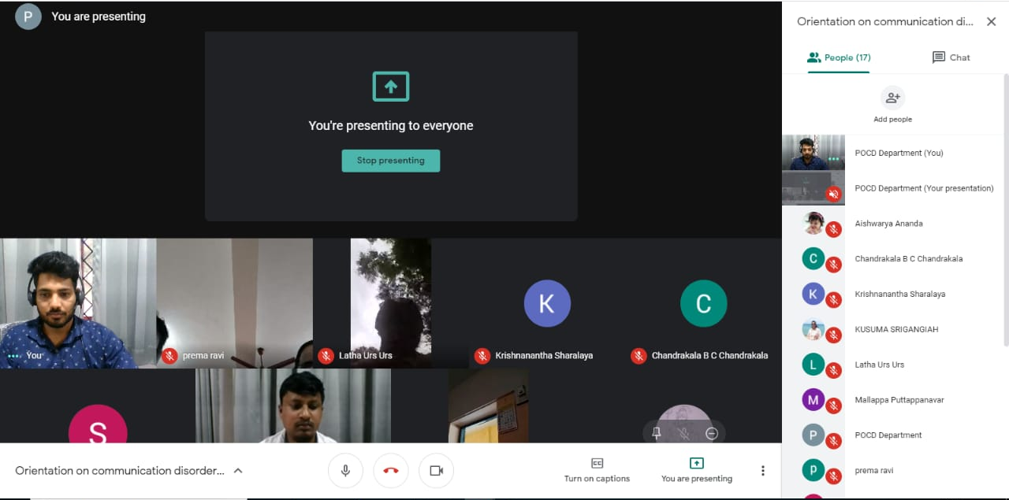
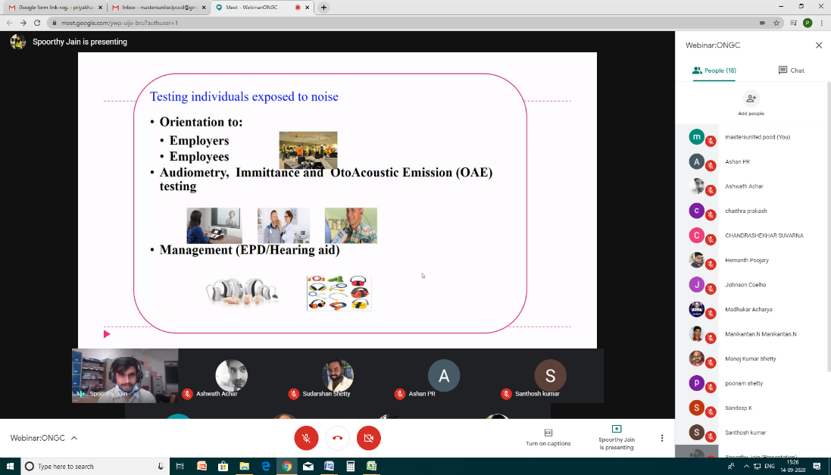

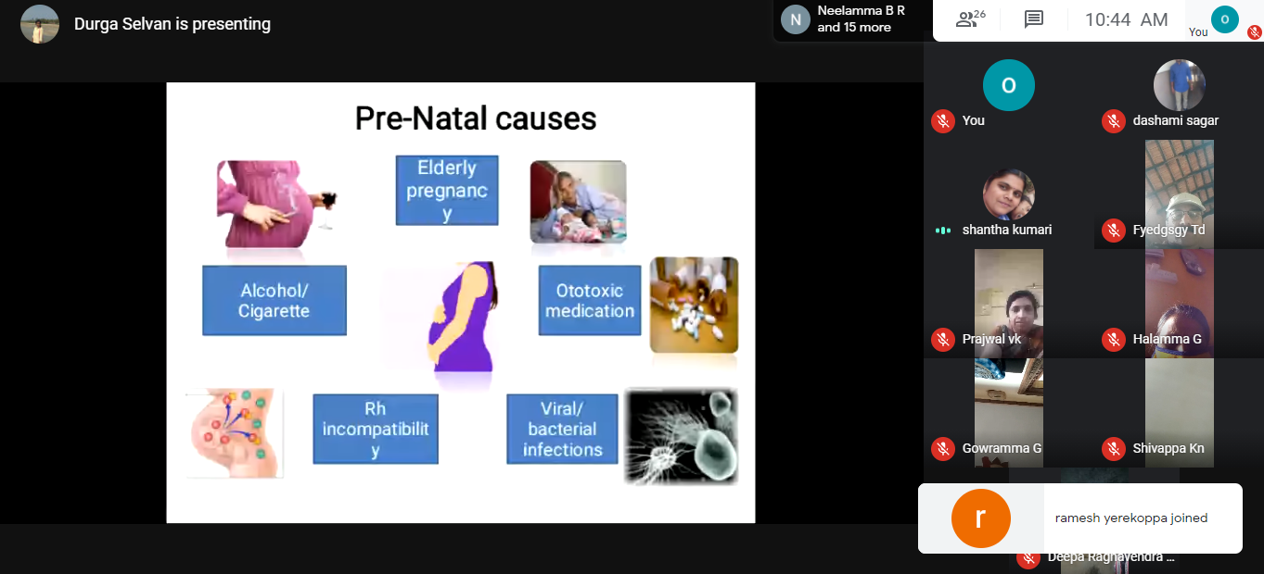
Figure 2: Glimpses of webinar program at OSC Sagara.

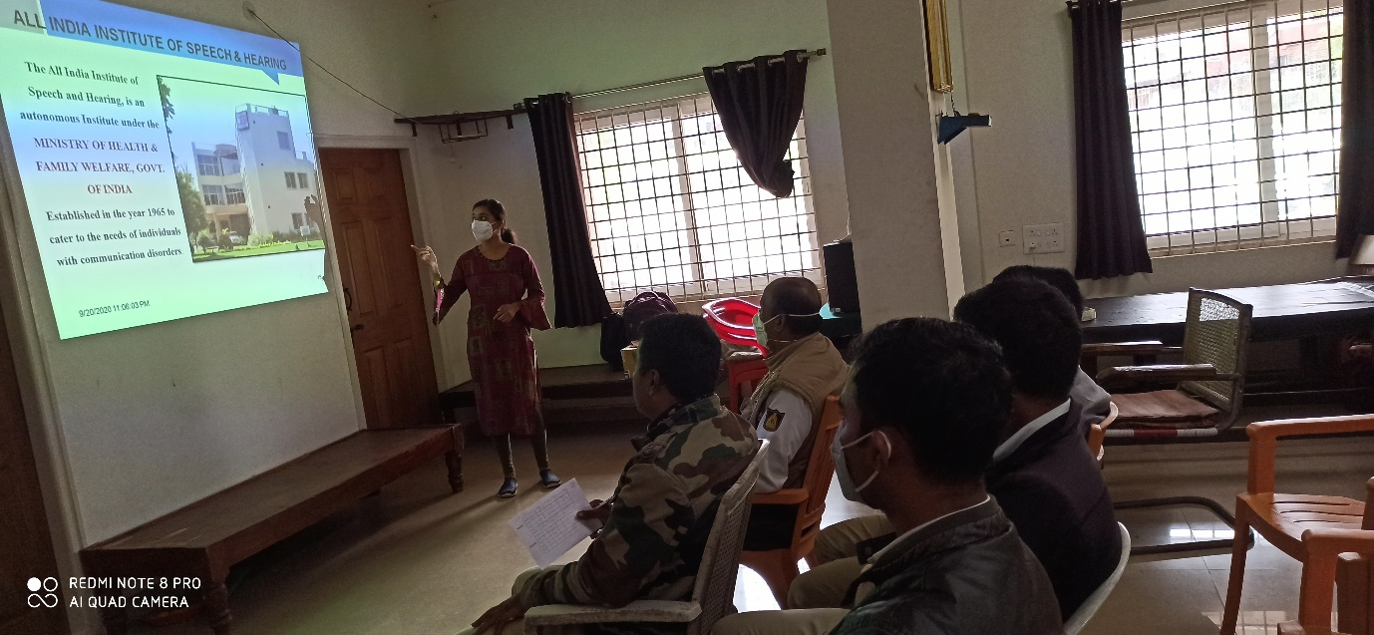
Figure 3: Glimpses of webinar program at OSC KoIMS, Madikkerri.

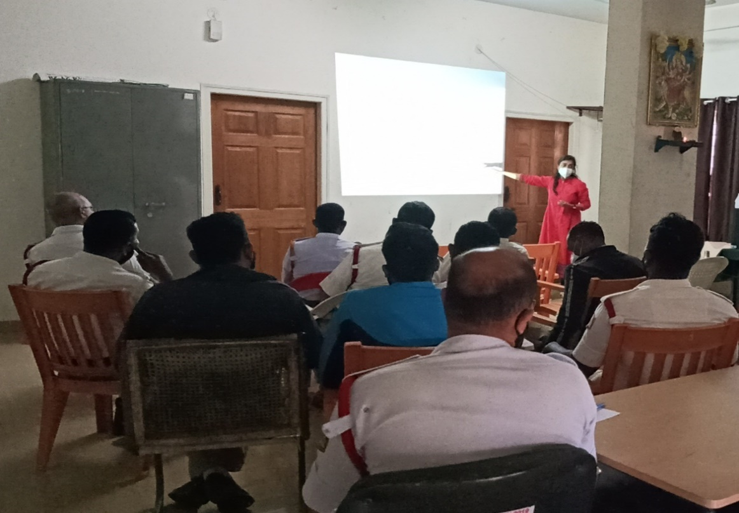

Figure 3: Glimpses of webinar program at OSC KoIMS, Madikkerri.

- RESEARCH ACTIVITIES:
- Verified the uniformity of variables across the year and centre wise
- Verified the uniformity of codes assigned to each of the variables across the year and center wise
- Added and re-coded the variables to make it uniform for merging
- Merged all data on year wise followed by center wise for data analysis

III) EXTENSION ACTIVITIES
The department of POCD is actively involved in carrying out various extension activities such as screening, diagnostic and rehabilitation services outside the institute campus. The activities include newborn/infant screening, screening of school children, screening of elderly citizens, screening of industrial workers, conducting camps and also clinical services offered at the outreach service centers of AIISH. Due to the outbreak of COVID-19, limited activities were carried out in August 2020.
- New-born screening programs for Communication Disorders
Table 4: Details of newborn screened in OSC and NBS centers in August 2020.
S. No | Hospitals/Immunization Centers | Total births | Total screened |  |  | Total No. at risk |  |  | Phone Follow up
 |  |  | Male | Female | Total | Male | Female | Total | Male | Female | Total
I. Mysuru Hospitals
 | KR Hospital (KRH)- Cheluvamba | - | 144 | 140 | 284 | 2 | 1 | 3 | 11 | 9 | 20
 | Kamakshi Hospital (KH) | 131 | 17 | 24 | 41 | 0 | 0 | 0 | 1 | 0 | 1
 | Mission Hospital (MH) | 24 | 1 | 1 | 2 | 0 | 0 | 0 | 0 | 0 | 0
 | S.M.T.D.H Hospital | 60 | 8 | 5 | 13 | 0 | 0 | 0 | 0 | 0 | 0
 | Ashwini Nursing Home (ANH) | - | 3 | 3 | 6 | 0 | 0 | 0 | 0 | 1 | 1
 | Shree Devi Nursing Home (SNH) | 45 | 7 | 4 | 11 | 0 | 0 | 0 | 1 | 0 | 1
 | Mahadeshwara Nursing Home (MNH) | - | 5 | 5 | 10 | 0 | 0 | 0 | 0 | 0 | 0
 | Sigma Hospital (SH) | 48 | 10 | 7 | 17 | 0 | 0 | 0 | 0 | 0 | 0
 | Jayanagar maternity hospital | 27 | 6 | 5 | 11 | 0 | 0 | 0 | 0 | 0 | 0
Total |  | - | 201 | 194 | 395 | 2 | 1 | 3 | 13 | 10 | 23
II. OSC Centers
1. | St,Marry’s Hospital, HD kote | 128 | 57 | 64 | 121 | 3 | 4 | 7 | 16 | 11 | 27
2. | Vivekananda Memorial hospital, H. D. Kote Sarguru | 61 | 30 | 23 | 53 | 4 | 2 | 6 | 3 | 5 | 8
3. | Taluk Hospital, H. D. Kote- Immunization | 108 | 41 | 65 | 106 | 1 | 0 | 1 | 2 | 8 | 10
4. | Taluk General Hospital, KR. Pete | 18 | 9 | 9 | 18 | 2 | 0 | 2 | 0 | 0 | 0
5. | Kodagu Institute of Medical Science , Kodagu | 234 | 100 | 84 | 184 | 3 | 2 | 5 | 4 | 1 | 5
Total |  | 549 | 237 | 245 | 482 | 13 | 8 | 21 | 25 | 25 | 50
NBS Centers
 | Sri Ramachandra Bhanj Medical College and Hospital (SCB MCH), Cuttack | 249 | 127 | 42 | 169 | 04 | 02 | 06 | 0 | 0 | 0
 | Jawaharlal Nehru Medical College & Hospital, Bhagalpurr | - | 103 | 80 | 183 | 13 | 11 | 24 | 01 | 01 | 02
 | JIPMER, Puducherry | 465 | 183 | 151 | 334 | 19 | 7 | 26 | 8 | 6 | 14
 | NetajiSubhash Chandra Bose Medical College (NSCB), Jabalpur | - | 215 | 202 | 417 | 16 | 21 | 37 | 4 | 2 | 6
 | Post Graduate Institute of Medical Education and Research (PGIMER), New Delhi | 116 | 65 | 44 | 109 | 1 | 1 | 2 | 24 | 11 | 35
 | Rajendra Institute of Medical Sciences, Baritayu, Ranchi | 239 | 27 | 18 | 45 | 00 | 00 | 12 | 08 | 00 | 00
 | Rajendra Institute of Medical Sciences, Baritayu, Ranchi | 258 | 121 | 85 | 206 | 12 | 10 | 22 | 7 | 2 | 9
 | Sri DevarajUrs Academy Of Higher Education and Research (SDUAHER), Kolar | 127 | 63 | 63 | 126 | 0 | 0 | 0 | 0 | 0 | 0
 | JLNMCH, Ajmer | 809 | 342 | 279 | 621 | 11 | 8 | 19 | 8 | 4 | 12
 | Total | 2263 | 1246 | 964 | 2210 | 76 | 60 | 148 | 60 | 26 | 78
Total (NBS centers) |  | 2812 | 1684 | 1403 | 3087 | 91 | 69 | 172 | 98 | 61 | 151

B) Tele- follow-up evaluation
The at-risk babies were monitored regularly through Phone calls by administrating Speech-language & hearing developmental checklist. The babies identified with delay in any of the developmental milestones, were referred to AIISH/concerned center for detailed diagnostic evaluation.

Table5: Details of Tele-phone follow- up carried out at Hospitals in Mysuru.
S. No. | Mysuru Hospitals | Number of infants with normal developmental milestones. | Total infants at risk | Total call attended/ Total no of calls
 | Ashwini Nursing Home | 1 | - | 1/1
 | Brindavan Hospital | 2 | - | 2/3
 | Cheluvamba Hospital (KRH) | 15 | - | 15/26
 | GopalaGowdaShanthaveri Memorial Hospital | - | - | 0/1
 | Mahadeshwara Nursing Home | - | - | 0/1
 | Total | 18 | 0 | 18/32

Table 6: Details of Tele-phone follow- up carried out at OSCs in September 2020

OSC centers | Number of infants with normal developmental milestones. | Total infants at risk | Total call attended/ Total no of calls
Subdivision hospital, Sagara | 16 | 0 | 16/25
St. Mary’s Hospital, HD Kote | 10 | 0 | 10/15
Vivekananda Memorial Hospital, Sarguru | 5 | 0 | 5/9
Taluk Hospital, H. D. Kote- | 10 | 0 | 10/16
GIMS, Kalaburgi | 58 | 03  Mortality-02 | 63/70
Taluk General Hospital, KR. Pete | 6 | 0 | 6/6
Community Health Centre (CHC), Santhemarahalli | 8 | 0 | 8/9
Taluk Hospital, Yelanduru | 0 | 0 | 0
Primary Health centre, Gumballi | 0 | 0 | 0
Taluk Hospital, Nanjangudu | 18 | 0 | 18/20
Community Health Centre (CHC), Hullahalli | 2 | 0 | 2/2
BIMS, Belagavi | 67 | 0 | 45/67
KoIMS, Madikkeri | 20 | 1 | 21/40
Total | 172 | 09 | 178/265
Note: The calls not attempted were repeated a minimum of 5 times on consecutive days

Table 7: Details of Tele-phone follow- up carried out at NBS centers in September 2020.
NBS centers | Number of infants with normal developmental milestones. | Total infants at risk | Total call attended/ Total no of calls
Ajmer | 46 | 3 | 49/66
Bhagalpur | 18 | 0 | 18/32
Cuttack | 9 | 0 | 13
Delhi | 13 | 0 | 13/17
Imphal | 2 | 10 | 12/12
Jabalpur | 29 | 2 | 38/55
Kolar | 1 | 1 | ¼
Puducherry | 15 | 0 | 15/22
Total | 133 | 16 | 159/208

c) Tele screening Programs
Tele-screening program (virtual mode) was carried out to identify the babies at risk for communication disorders since new born screening program couldn’t be carried out in many centers. The details including the behavioral responses of the new born to environmental sounds and HRR were collected from the parents through Tele-phone mode. The babies at risk were asked to undergo follow up evaluation in detail.
Table 8: Details of Tele-screening carried out at NBS Centers in Mysuru in September 2020
Mysore Hospitals | Total Tele-screened | Mortality | Detailed Evaluation (Referred) | Total infants at risk (Phone Follow up) | Normal Speech and Language milestones
Kamakshi Hospital | 162 | 0 | 2 | 18 | 142
Jayanagar Maternity Hospital | 132 | 0 | 0 | 6 | 126
Total | 59 | 00 | 01 | 03 | 43

Table 10: Details of Tele-screening at OSCs.
OSC Centre | Total Tele-screened / Total calls made | Mortality | Detailed Evaluation  (Referred) | Total infants at risk  (Screening) | Normal Speech and Language milestones  (Phone Follow up)
Subdivision Hospital, Sagara | 115/190 | 3 | 10 | 5 | 97
GIMS, Kalaburgi | 108/124 | 13 | 0 | 95 | 58
Primary Health Centre, Gumballi | 36/42 | 2 | 0 | 4 | 13
Taluk Hospital, Nanjangud/ Community Health Centre (CHC), Hullahalli | 117/ | 16 | 133/145 | 117 | 16
BIMS, Belagavi | 208 | 15 | 208/323 | 208 | 15
Total | 376/356 | 49 | 351 | 429 | 199
Note: Those babies who missed out during the pandemic situation for testing
Note: No tele-screening activity carried out at NBS centers in September 2020.
D) New born follow-up evaluation (Detailed assessment)
The newborns/infants referred during the newborn screening/ Tele-screening were advised for detailed evaluation at AIISH/NBS centers/OSCs. A complete test battery was administered for those babies/infants who came for follow-up.

Table 12: Details of the results of follow-up evaluation carried out at OSCs
Categories |  | OSC- Sagara | OSC- Sarguru
Normal | Newborn  (0-2 months) |  | 1
Normal | Infants  (2-12 months) |  | 4
Normal | Toddlers  (1 year to 4years) | 1
Normal | Children  (above 4years) | 0
Hearing impairment | Newborn  (0-2 months)
Hearing impairment | Infants  (2-12 months)
Hearing impairment | Toddlers  (1 year to 4years)
Hearing impairment | Children  (above 4years)
Speech &language disorder | Newborn  (0-2 months)
Speech &language disorder | Infants  (2-12 months)
Speech &language disorder | Toddlers  (1 year to 4years)
Speech &language disorder | Children  (above 4years)
Multiple Disorder | Newborn  (0-2 months)
Multiple Disorder | Infants  (2-12 months)
Multiple Disorder | Toddlers  (1 year to 4years)
Multiple Disorder | Children  (above 4years)
Total |  | 1 | 5

Table 13: Details of the results of follow-up evaluation carried out at NBS centers.
Categories |  | AJMER | IMPHAL |  | RANCHI | JABALPUR
Normal | Newborn  (0-2 months) | 06 | 10 |  | 05
Normal | Infants  (2-12 months) |  |  |  | 02
Normal | Toddlers  (1 year to 4years) | - | - |  | 04 | 01
Normal | Children  (above 4years) | - | - |  | 01
Hearing impairment | Newborn  (0-2 months) | - | - |  | 01
Hearing impairment | Infants  (2-12 months) | - | - |  | - | 01
Hearing impairment | Toddlers  (1 year to 4years) | - | 02 |  | 01
Hearing impairment | Children  (above 4years) | - | - |  | -
Speech & language disorders | Newborn  (0-2 months) | - | - |  | -
Speech & language disorders | Infants  (2-12 months) | - | - |  | -
Speech & language disorders | Toddlers  (1 year to 4years) | - | - |  | -
Speech & language disorders | Children  (above 4years) | - | - |  | -
Multiple Disorder/ Syndromes | Newborn  (0-2 months) | - | - |  | -
Multiple Disorder/ Syndromes | Infants  (2-12 months) | - | - |  | -
 |  |  |  |  | -
Multiple Disorder/ Syndromes | Toddlers  (1 year to 4years) | - | - |  | -
Multiple Disorder/ Syndromes | Toddlers  (1 year to 4years) | - | - |  | -
Multiple Disorder/ Syndromes | Children  (above 4years) | - | - |  | -
Multiple Disorder/ Syndromes | Children  (above 4years) | - | - |  | -
Total |  | 06 |  | 12 | 14 | 02

D) Anganawadi /Preschool/School screening program
Screening of preschool, primary school children and Anganawadi was conducted focusing on the early identification of communication disorders and early rehabilitation of children at risk for communication disorders.
Table 14: Details of Anganawadi/Preschool/School screening program in September 2020
Date | Name of the Anganawadi/Preschool/ School | Total screened |  |  | Total referred with communication disorders
Date | Name of the Anganawadi/Preschool/ School |  |  |  | Ear related disorder | Hearing loss | Speech language disorders
Date | Name of the Anganawadi/Preschool/ School | Male | Female | Total
02-09-2020 | Newborn hearing screening at Dharmapura,Anganawadi, hunsur(TK) | 15 | 16 | 31 | - | - | -
9-09-2020 | Newborn hearing screening at Chowthi, Anganwadi, Periyapatna (TK) | 14 | 16 | 30 | - | - | -
16-09-2020 | Newborn hearing screening at Kittur, Anganwadi, Periyapatna (TK) | 12 | 19 | 31 | - | - | -
23-09-2020 | Newborn hearing screening at Anganwadi, Hunsur (TK) | 12 | 17 | 29 | - | - | -
30-09-2020 | Newborn hearing screening at seegur, Anganwadi, Periyapatna (TK) | 20 | 11 | 31 | - | - | -

E) Industrial Screening Program.

Department of POCD is conducting hearing screening program at various industry across the country. All the industrial employees are screened for hearing loss, referred and advised for detailed evaluation at AIISH, Mysuru if needed. Due to the COVID-19 pandemic condition in the country, the industrial hearing screening program is suspended, but screening programs and orientation programs to employees and employers were carried out in Tele-mode/Webinars. The table () indicates the details of the webinars programs conducted for industrial employees by Dept. of POCD.

Table (): Details of Webinar programs for industrial employees in September 2020
S. No | No. of Webinars | No. of participants
1. | 4 | 83

Table (): Details of Tele-screening programs for industrial employees in September 2020
S. No | Calls made | Tele-guidance | Referred
1 | 5 | 5 | 1

E) Clinical Services at Outreach Service Centers (OSCs)

The clinical activities are not only restricted to in and around Mysuru, but also extended to rural areas where facilities for clinical services for persons with communication disorders are scanty. Currently there are 08 OSCs centres at different part of the country rendering services to unreached population. The details of those who were registered and availed various services/benefits at the OSCs are tabulated below.
- Clients identified and followed up with communication disorders at OSCs

Table 15: Details of clients identified and followed up with communication disorders at OSCs.
S. No | OSC Centre | Total registered |  | ENT Evaluation |  | Hearing Evaluation |  | Speech & Language Evaluation
S. No | OSC Centre |  |  | Normal | Disorder | Normal | Disorder | Normal | Disorder
 | Taluk Hospital, Nanjangud  No services offered in Sep 2020 | New cases | 0 | 0 | 0 | 0 | 0 | 0 | 0
 | Taluk Hospital, Nanjangud  No services offered in Sep 2020 | F/u Old | 0 | 0 | 0 | 0 | 0 | 0 | 0
 | Community Health Centre (CHC), Hullahalli | New cases | 22 | 0 | 20 | 0 | 2 | 0 | 0
 | Community Health Centre (CHC), Hullahalli | F/u Old | 11 | 0 | 11 | 0 | 0 | 0 | 0
 | Taluk General Hospital, KR Pete | New cases | 18 | 0 | 1 | 0 | 12 | 0 | 05
 | Taluk General Hospital, KR Pete | F/u Old | 1 | 0 | 0 | 0 | 1 | 0 | 0
 | Primary Health Centre (PHC), Gumballi | New cases | 53 | 0 | 53 | 2 | 11 | 0 | 1
 | Primary Health Centre (PHC), Gumballi | F/u Old | 47 | 0 | 47 | 0 | 6 | 0 | 0
 | Sub-divisional Hospital (PHC), Sagara | New cases | 11 | 0 | 0 | 0 | 9 | 0 | 2
 | Sub-divisional Hospital (PHC), Sagara | F/u Old | 0 | 0 | 0 | 0 | 0 | 0 | 0
 | Vivekananda Memorial Hospital, Sarguru | New cases | 17 | 0 | 0 | 5 | 2 | 0 | 10
 | Vivekananda Memorial Hospital, Sarguru | F/u Old | 2 | 0 | 0 | 0 | 1 | 0 | 1
 | Gulbarga Institute of Medical Sciences | New cases | 0 | 0 | 0 | 17 | 49 | 0 | 03
 | Gulbarga Institute of Medical Sciences | F/u Old | 0 | 0 | 0 | 0 | 0 | 0 | 0
 | Kodagu Institute of Medical Sciences, Madikkerri | New cases | 0 | 0 | 0 | 3 | 24 | 0 | 4
 | Kodagu Institute of Medical Sciences, Madikkerri | F/u Old | 0 | 0 | 0 | 0 | 0 | 0 | 2

- Table 16: Clients identified with different types of communication disorders across OSCs
Type of Disorders | OSC
Type of Disorders | Taluk Hospital, Nanjangud | Primary Health Centre (PHC), Hullahalli | Primary Health Centre (PHC), Akkihebbalu | Taluk General Hospital, KR Pete | Primary Health Centre (PHC), Gumballi | Sub-divisional Hospital, Sagara (PHC) Taluk | VMH,  Sarguru | BIMS Belagavi | GIMS, Kalburgi | KoIMS,  Kodagu
 |  | Hearing disorders (Ear-wise data)
Normal | - | 0 | - | 4 | 2 | 1 | 10 | - | 09 | 7
Conductive | - | 0 | - | 5 | 0 | 1 | 1 | - | 01 | 4
Sensori- neural | - | 6 | - | 4 | 18 | 2 | 2 | - | 16 | 24
Mixed | - | 0 | - | 6 | 0 | 3 | 1 | - | 18 | 7
No type (Minimal & Profound) | - | 0 | - | 5 | 6 | 11 |  | - | Minimal-08 &  Profound-14 | 12
Aud-Total (ears) | - | 6 | - | 24 | 26 | 18 | 14 | - | - | 54
Aud-Total (Individuals) | - | 3 | - | 12 | 13 | 9 | 7 | - | 66 | 27
Voice | - | 0 | - | 0 | 0 | 0 | 1 | - | - | 0
Fluency | - | 0 | - | 0 | 0 | 0 | - | - | - | 1
Articulation disorders | - | 0 | - | 2 | 0 | 0 | - | - |  | 1
Language disorders | - | 0 | - | 3 | 1 | 2 | 9 | - | 03 | 2
Total (Individuals) |  | 0 | - | 5 | 1 | 2 | 10 | - | 03 | 4

- Table 17: Clients followed up with different types of communication disorders at OSCs
Type of Disorders |  |  |  | OSC
Type of Disorders | Taluk Hospital Nanjangud | Primary Health Centre (PHC), Hullahalli | Primary Health Centre (PHC), Akkihebbalu |  | Taluk General Hospital, KR Pete | Primary Health Centre (PHC), Gumballi | Sub-divisional Hospital,  Sagara  (PHC) Taluk | VMH,  Sarguru | Belagvi institute of medical sciences BIMS | GIMS, Kalburgi | KoIMS-TH, MadikeriTaluk,Kodagu
 | Hearing disorders (Ear-wise data)
Normal | - | 0 | - |  | 0 | 0 | - | 0 | - | - | 0
Conductive | - | 0 | - |  | 0 | 0 | - | 0 | - | - | 0
Sensori- neural | - | 0 | - |  | 0 | 10 | - | 2 | - | - | 0
Mixed | - | 0 | - |  | 0 | 0 | - | 0 | - | - | 0
No type (Minimal & Profound) | - | 0 | - |  | 2 | 2 | - | 0 | - | - | 0
Aud-Total (ears) | - | 0 | - |  | 2 | 12 | - | 2 | - | - | 0
Aud-Total (Individuals) | - | 0 | - |  | 1 | 6 | - | 1 | - | - | 0
Voice | - | 0 | - |  | 0 | 0 | - | 0 | - | - | 1
Fluency | - | 0 | - |  | 0 | 0 | - | 0 | - | - | 0
Articulation disorders | - | 0 | - |  | 0 | 0 | - | 0 | - | - | 0
Language disorders | - | 0 | - |  | 0 | 0 | - | 1 | - | - | 1
Sp&Lg -Total (Individuals) | - | 0 | - |  | 0 | 0 | - | 1 | - | - | 2

- Rehabilitation services at OSCs.

Table 18: Details of rehabilitation services provided at OSCs in September 2020.
OSC | Hearing Aids Dispensed | Tele-Speech-language therapy
OSC | Hearing Aids Dispensed | No. of clients | No. of sessions
Taluk Hospital, Nanjangud | 00 | 03 | 12
Primary Health Centre  (PHC), Hullahalli | 03 | 00 | 00
Primary Health Centre  (PHC), Akkihebbalu | 00 | 01 | 14
Taluk General Hospital, KR Pete | 04 | 09 | 62
Primary Health Centre (PHC), Gumballi | 00 | 03 | 14
Sub-divisional Hospital,  Sagara (PHC) Taluk | 02 | 12 | 81
VMH, Sarguru | 03 | 05 | 18
Belagavi Institute of  Medical Sciences BIMS | 00 | 02 | 08
GIMS, Kalburgi | 00 | 07 | 83
KoIMS-TH, Madikeri Taluk | 00 | 10 | 64
Total | 11 | 52 | 356

IV) TECHNOLOGICAL CONSULTANCY SERVICES: NIL

V) CENTRAL FACILITIES
a) Library and information Services: NIL
VI) MAJOR EVENTS OF THE MONTH: AIISH AISIRI Programs
S.NO | Date | Staff | Topic details
1. | 06.09.2020 | Dr. Abhishek BP  (Lecturer in Speech Sciences) | Dementia
2. | 13.09.2020 | Dr. Devi N | Need for early rehabilitation and listening training in children with hearing impairment
2. | 20.09..2020 | Dr. Geetha C  (Reader in Audiology) | Importance of early rehabilitation for individuals with hearing loss
3. | 27.09.2020 | Dr. Prashanth Prabhu (Assistant Professor in Audiology) | Tinnitus and loudness discomfort

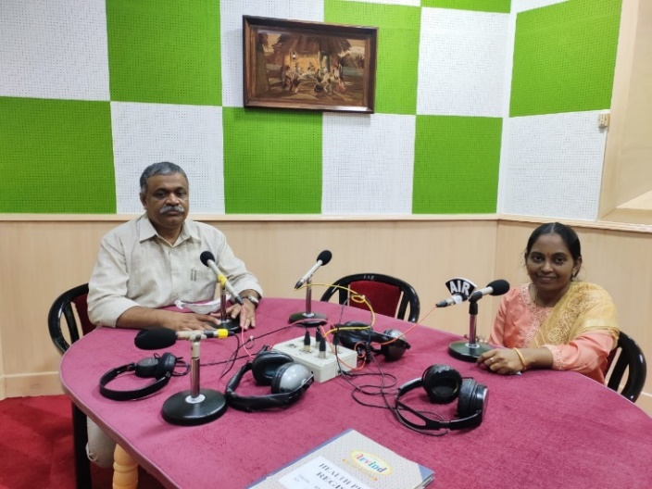
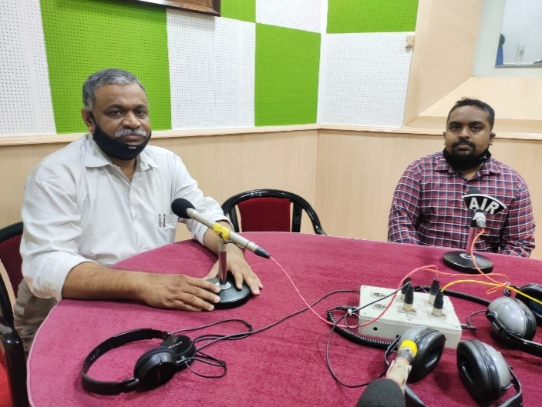
Figure 4: Glimpses of AIISH AISIRI Programs by AIISH staff, Mysuru.

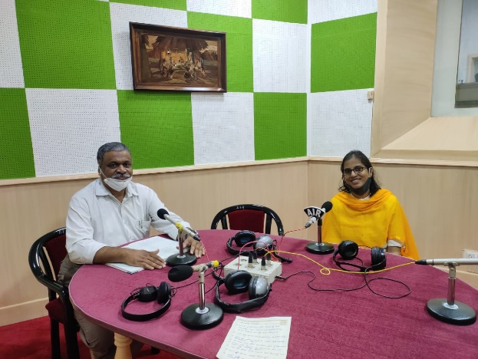

VII) OTHERS
- Submitted the following for the year
- Write-up for Best Institution Award
- Details for research update in website
- Details for NAAC updation

- Computerisation activities: An online meeting was conducted regarding the hosting in server.
- NBS related activities: Procedure for initiation of NBS centre to 06 AIIMS hospitals were on processes.
- Initiated DD Chandana TV programme to spread awareness among the public
- Initiated activities to withdraw AIIISH services from 6 NBS centres as the tenure of 5 years getting completed on December 2020.

VII) ACTIVITIES CARRIED OUT BY THE STAFF OF THE DEPARTMENT OF POCD.

Table 17: Details of activities carried out by POCD staff in August 2020.
S.No. | Name of the staff | Designation | Activities
 | Dr. N Sreedevi | Head, Dept. of POCD | - Officiating as HOD-POCD  - Has been coordinating webinars/ orientation on communication disorders to general public, teachers and Industrial workers: 17 nos  - Coordinated DCS campus orientations 21 Nos.  - Coordinated submission of updates for NAAC and material for Best Institute award  - Coordinated the modification of KIOSK functioning  - Coordinated with statistician and dept staff reg data retrieval and data compilation.  - Attended webinar on child sexual abuse on 3.9.2020  - Coordinated the meeting on computerization on 4.9.2020  - Conducted a meeting on NBS data analysis on 7.9.2020  - Attended SPC meeting on 7.9.2020  - Coordinated the preparation of Internship module  - Conducted a meeting on SOP for POCD NBS on 11.9.2020  - Conducted a meeting on withdrawal of NBS and WHD 2021 on 14.9.2020  - Coordinated virtual meeting with 6 NBS centers due for with drawl on 18.9.2020  - Worked on correction of Kannada and Malayalam pamphlets, videos and other public education materials  - Initiated the official procedures for Chandana TV program  - Attended webinar on child sexual abuse on 3.9.2020  - Attended CC on 24.9.2020  - Attended webinar on Grammarly on 24.9.2020  - Attended webinar on Digital Evaluation by UOM on 24.9.2020  - Attended webinar on Task sharing by WHO on 24.9.2020  - Attended meeting on thermal screening on 24.9.2020
 | Dr. Sandeep M | Associate Professor in Audiology | - Coordinated OSC and NBS centre activities  - Coordinated with statistician on regarding the data retrieval, data entry and data compilation  - Attended the department meeting regarding SOP for NBS program on 11.09.2020.  - Attended the Ear &amp; Hearing care in WHO South East Asia Region on 16.09.2020.  - Attended the Task sharing orientation by WHO on 24.09.2020.
 | Mr. Arunraj. K | Clinical Assistant | - Coordinated the installation of KIOSK and the modifications required  - Coordinated with statistician on regarding the data retrieval, data entry and data compilatioCoordinated submission of updates for NAAC and material for Best Institute award  - Attended the computerization meeting on 04.09.2020.  - Attended the department meeting regarding SOP for NBS program on 11.09.2020.  - Attended a meeting on withdrawal of NBS and WHD 2021on 14.9.2020  - Attended the Ear &amp; Hearing care in WHO South East Asia Region on 16.09.2020.  - Attended virtual meeting with 6 NBS centers due for with drawl on 18.9.2020  - Prepared the Suo-Motu Disclosure  - Attended the Task sharing orientation by WHO on 24.09.2020.  - Drafted letters for:  a) NBS initiation Uttarkhand  b) Sarguru data compilation regarding
 | Ms. Ameena Subhakani S. | Speech Language Pathologist Grade I | - Orientation on Speech, Language and hearing disorders to general public in front of DCS  - Information Kiosk meeting on 01.09.2020.  - Information update for NAAC  - Drafted letters for:  - NBS initiation Uttarkhand  - Sarguru data compilation regarding  - Orientation program for teachers to the minister  - Prepared the Suo-Motu Disclosure  - Attended the computerization meeting on 04.09.2020.  - OSC school data entry (4 schools)  - Prepared graphs for WHO talk  - Attended the department meeting regarding SOP for NBS program on 11.09.2020.  - Attended the Ear &amp; Hearing care in WHO South East Asia Region on 16.09.2020.  - Attended data management and data cleansing orientation on 18.09.2020  - Prepared a summary report for the NBS program (2008-2019)  - Attended the grammarly orientation program on 24.09.2020  - Attended the Task sharing orientation by WHO on 24.09.2020.
 | Mr. Harish Kumar M.K. | Audiologist Grade I | - Posted in academics for one week for BASLP entrance exam work  - Orientation for general public in front of AIISH DCS on 4th, 17th & 28th September  - Administered Orientation pre – post test for general public in front of AIISH DCS  - Orientation for Industrial workers on 12.09.2020  - Orientation for Mysuru school teachers on 23.09.2020  - Orientation for HD Kote school teachers on 29.09.2020  - Designed FAQs on Aphasia  - Edited Malayalam animated video on SSD  - Prepared Internship POCD module  - Tele-screening for NBS.  - Verified HRR for medical professionals Kannada pamphlet.  - Value coding, data label of Ajmer NBS data
 | Mr. Kishore KumarBharshetty | Audiologist Grade I | - Prepared indents for Revised Estimate  - Carried out orientation for general public in DCS, AIISH  - Assisted in installation of KIOSK  - Monitoring of purchase files  - Attended virtual meeting regarding computerisation.
 | Ms. Krishnendu S. | Speech Language Pathologist Grade I | - School Screening data entry  - School screening data compilation  - SSK Webinar organization.  - Served as resource person in 9 SSK Webinars  - Material development: FAQ  - Autism English and Malayalam  - Tele screening for NBS
 | Ms. Priya Abdul Khader M. T. | Audiologist Grade I | - Tele screening  - Total number: 63, Total received:42, Normal development:36, Phone follow up: 5, Referred :1  - Organisation of Webinar - 08.09.2020 - SSK Wayanad and Thrissur, 12.09.2020 – ONGC, 14.09.2020 – ONGC, 28.09.2020 – ONGC, 25.09.2020 – KAPL  - Preparation of posters for Webinar (for ONGC and KAPL)  - Contacted industries for organising webinar -Telephonic- 5, Mail – 4, Post – 4  - Carried out NBS- 4 days  - Prepared Manual for Industrial hearing, screening program  - Prepared content for E-certificate for Webinar for SSK teachers  - Correction made for public education materials in Malayalam, Tinnitus- FAQ, Ototoxicity
 | Ms. Ritu A Venkatesh | Audiologist Grade I | - Prepared Orientation pre – post-test google forms  - Orientation for general public infront of AIISH DCS on 15th, 21st and 24th September  - Administered Orientation pre – post test for general public in front of AIISH DCS  - Orientation for Community social workers on 10.09.2020  - Orientation for school teachers on 25.09.2020  - Finalized FAQs on different speech disorders.  - Tele-screening for NBS.  - Finalized Ototoxicity English pamphlet.
 | Ms. Sharanya K. Kumar | Audiologist – Grade I | - Tele-screening.  - Data cleansing with respect to variables and value coding of Ranchi from 2015 to 2019  - Data cleansing with respect to variables and value coding of Puducherry from 2015 to 2019  - Correction of FAQs on tinnitus pamphlet  - Correction of FAQs on tinnitus pamphlet to Kannada  - Collected phone numbers for tele-screening from Jayanagar Hospital.  - Called phone follow-up infants enquiring about their developmental milestones.  - Orientation for the general public in front of clinical services.  - Orientation for resource teachers of Mysuru District on 24.09.2020 (103 participants)  - Orientation for resource teachers of H D Kote district on 30.09.2020 (44 Participants)  - SOP for resuming NBS activity  - Designed poster for Webinar on 07.10.2020
 | Ms. Abinaya R | Speech-Language Pathologist Grade I | - Collected NBS screening and follow up data since 2011  - Organized web meeting with all NBS Staffs regarding NBS data  - Verified 10 Tamil pamphlets  - Prepared animated video on hearing loss in Tamil  - Translated Ototoxicity public education pamphlet in Tamil  - Tamil Script prepared for an animated video in the topic of Ear Discharge
 | Ms. Aparna U. | Audiologist – Grade II | - Prepared Monthly report of August 2020.  - Verified 04 Malayalam pamphlets  - Carried out tele-screening  - Prepared compiled Monthly report  - Prepared ppt for performance analysis for June, July &August month.
 | Ms. Anusha C. | Speech Language Pathologist – Grade II | - Proofread FAQs on LD and Stuttering in English.  - Prepared and compiled write up and data for the best institution award.  - Translated Research activities 2020 list into Hindi.  - Attended a webinar about expanding paediatric dysphagia practice in NICU on 04.09.2020 conducted by NITTE institute.  - Attended esophageal speech webinar on 05.09.2020.  - Attended a departmental meeting regarding resumption of NBS activity on 11.09.2020.  - Conducted a webinar on “speech and language disorders in adults” for staffs of ONGC, Mangalore on 12.09.2020.  - Prepared list of variables and value labels for NBS and phone follow up for Jabalpur data from 2015-2019  - Conducted orientation program for Mysuru school teachers regarding “speech and language disorders in children” on 23.09.2020.  - Attended OLI meeting on 25.09.2020.  - Conducted orientation program for H D Kote school teachers regarding “speech and language disorders in children” on 29.09.2020.  - Conducted tele screening by contacting the mothers/fathers of the new-borns.  - Finalizing the designs of Bedside handouts (6 no.) and 4 PEPs.
 | Ms. Faheema Luquman Ali | Audiologist – Grade II | - 28.08.2020- OSC Sarguru Annual report compiled for a letter sent to the coordinator  - 28.08.2020-04.09.2020 Write up for ‘Best Institute Award’  - 07.09.2020-08.09.2020-Hearing Aids Issued by OSC centres 2019-2020 information compiled. (Aadhar card number, BPL number and Hearing aid serial number) for all 8 centres.  - 08.09.2020 OSC number of cases take before and after lockdown compiled for a write up.  - 09.10.2020 Hearing Aids Distributed to OSC Kodagu, KR pete, Sarguru and Sagara.  - 11.09.2020 Compiled NBS P F/up and Refer List of all OSC centres.  - 11.09.2020 –OSC Data Variables Discussed and Sent.  - 14.09.2020-15.09.2020- Telescreening  - 16.09.2020- Started NBS activity and Worked on OSC Manual.  - 17.09.2020-Data Value Lable Coding  - 19.09.2020- 23.09.2020 –Worked on OSC manual and Data Value coding  - 25.09.2020- Presented Webinar KAPL Bangalore  - 26.09.2020- Telescreening  - OSC Manual and OSC Plan
 | Ms. Deepika. R | Office assistant Grade II | - Assisted in Monthly report preparation  - Drafted office correspondence letters (Internal & external)  - Compilation and preparation of tentative plan for world hearing day  - Preparation letters for orientation/webinars, mailing and posting  - Attended meeting regarding NBS withdrawal on 18.09.2020  - Attended departmental meeting on 11.09.2020  - Prepared minutes for 2 meetings

Sd-
Dr. N Sreedevi
विभागाध्यक्ष, विभाग-पिओसिडि- Head, Dept. Of POCD

