**संप्रेषणविकृतिरोकथामविभाग**

**DEPARTMENT OF PREVENTION OF COMMUNICATION DISORDERS**

**महीनेकेविवरण/ MONTHLY REPORT** –**AUGUST 2020**

1. **ACADEMIC ACTIVITIES**

**A. No. of webinars/Orientations: 32**

As a part of primary prevention activities, orientation/sensitization programs are being conducted regularly. The objective of the orientation programs was to create awareness among the general public and various other professionals such as Medical doctors, Nurses, Health-related workers, teachers, school students, etc., on different types of communication disorders, its prevention and early identification methods, and their appropriate referral and timely management. Due to the COVID-19 pandemic condition in the country, the orientation programs are carried out through Tele-mode/Webinars. Table 1&2 shows the details of the webinars programs conducted by staff and students of the department of POCD, NBS, and OSC centers.

Table 1: The details of webinar Programs in August 2020.

|  |  |  |  |  |  |
| --- | --- | --- | --- | --- | --- |
| **I. No. of Orientation Programs atPOCD : 24** | | | | | |
| Theme/Topic of the program: Prevention & early identification of communication disorders  Coordinators: Dr. N. Sreedevi, Dr. M. Sandeep & Mr. Arunraj K. | | | | | |
| **S.No** | **Date** | **Name of the institute/**  **Hospital** | **Target group** | **Total participants** | **Oriented by** |
|  | 10.08.2020 | SSK, Thiruvananthapuram, Kerala | Resource Teachers | 100 | Dr. N Sreedevi &  Dr. Jithin  (Clinical Audiologist) |
|  | 10.08.2020 | SSK, Thiruvananthapuram, Kerala | Resource Teachers | 100 | Mr. Reuben Thomas (Scientist-B)  & Dr. Jithin Raj  (Clinical Audiologist) |
|  | 12.08.2020 | SSK, Ernakulam, Kerala | Resource Teachers | 100 | Dr. N Sreedevi & Mr. Jim Winston (JRF) |
|  | 12.08.2020 | SSK, Ernakulam, Kerala | Resource Teachers | 100 | Mr. Reuben Thomas (Scientist-B) &  Mr. Jim Winston (JRF) |
|  | 13.08.2020 | SSK, Idukki, Kerala | Resource Teachers | 100 | Dr. N Sreedevi &  Ms. Priya Khader |
|  | 13.08.2020 | SSK, Idukki, Kerala | Resource Teachers | 100 | Ms. Krishnendu S&  Ms. Priya Khader |
|  | 14.08.2020 | SSK, Kannur, Kerala | Resource Teachers | 100 | Ms. Krishnendu S&  Ms. Durga S Kumar (Aud gr I) |
|  | 14.08.2020 | SSK, Kannur, Kerala | Resource Teachers | 100 | Ms. Krishnendu S&  Ms. Durga S Kumar(Aud gr I) |
|  | 17.08.2020 | SSK, Kasaragod, Kerala | Resource Teachers | 100 | Mr. Reuben Thomas Varghese  (Scientist-B)&  Ms. Indira CP (JRF) |
|  | 17.08.2020 | SSK, Kasaragod, Kerala | Resource Teachers | 100 | Mr. Reuben Thomas Varghese(SLP) &  Ms. Indira CP (JRF) |
|  | 18.08.2020 | SSK, Kollam, Kerala | Resource Teachers | 100 | Ms. Krishnendu S&  Ms. Priya Khader |
|  | 18.08.2020 | SSK, Kollam, Kerala | Resource Teachers | 100 | Ms. Krishnendu S&  Ms. Priya Khader |
|  | 19.08.2020 | SSK, Kottayam, Kerala | Resource Teachers | 100 | Dr N Sreedevi&  Ms. Sreena (JRF) |
|  | 19.08.2020 | SSK, Kottayam, Kerala | Resource Teachers | 100 | Mr. Reuben Thomas Varghese  (Scientist-B)&  Ms. Sreena(JRF) |
|  | 20.08.2020 | SSK, Kozhikode, Kerala | Resource Teachers | 100 | Ms. Krishnendu S&  Ms. Jumana Mithlaj(Aud Gr II) |
|  | 20.08.2020 | SSK, Kozhikode, Kerala | Resource Teachers | 100 | Ms. Krishnendu S&  Ms. Jumana Mithlaj Aud Gr II) |
|  | 21.08.2020 | SSK, Malappuram, Kerala | Resource Teachers | 100 | Ms. Krishnendu S&Ms. Priya Khader |
|  | 21.08.2020 | SSK, Malappuram, Kerala | Resource Teachers | 100 | Ms. Krishnendu S&Ms. Priya Khader |
|  | 24.08.2020 | SSK, Palakkad, Kerala | Resource Teachers | 100 | Mr. Reuben Thomas Varghese  (Scientist-B)&  Ms. Sreena (JRF) |
|  | 24.08.2020 | SSK, Palakkad, Kerala | Resource Teachers | 100 | Mr. Reuben Thomas Varghese  (Scientist-B) &  Ms.Sreena (JRF) |
|  | 25.08.2020 | SSK, Pathanamthitta, Kerala | Resource Teachers | 100 | Mr. Reuben Thomas Varghese  (Scientist-B)& Ms. Krupa(JRF) |
| **II. No. of Webinar Programs at OSC centers: 06** | | | | | |
|  | 24.08.2020 | SSA, Sagara | School teachers | 22 | Ms. Durga S &  Mr. Monish |
|  | 26.08.2020 | KR Pete Taluk hospital | General Public | 08 | Ms. Minu Lalu |
|  | 14.08.2020 | Vivekananda Memorial Hospital | Nurses, Hospital staff | 10 | Mr. Kamalakannan K |
|  | 29.08.2020 | GIMS, Kalaburagi | General Public | 37 | Mr Sanket B |
|  | 29.08.2020 | GIMS, Kalaburagi | General Public | 37 | Ms Shital J |
|  | 11.08.2020 | Junior College, Madikeri | Teachers | 58 | Ms. Anita Jose |
| **III. No. of Webinar Programs at NBS centers: 02** | | | | | |
|  | 25.8.2020 | Dr. RML Hospital, | Nurses | 06 | Ms. Sneha Uttakalika |
|  | 12.08.2020 | AIIPMR, Mumbai | General Public | 05 | Ms. Suman Penwal |

Table 2: The details of orientation programs in August 2020.

|  |  |  |  |  |  |
| --- | --- | --- | --- | --- | --- |
|  | 11.08.2020 | AIISH, Mysuru | General Public | 20 | Mr. Kishore Kumar |
|  | 12.08.2020 | AIISH, Mysuru | General Public | 10 | Ms. Ritu Venkatesh & Ms. Sharanya Kumar |
|  | 13.08.2020 | AIISH, Mysuru | General Public | 15 | Ms. Ritu Venkatesh & Ms. Sharanya Kumar |

Table 2: Total number of participants oriented (Group wise) from POCD

|  |  |  |
| --- | --- | --- |
| **S. No** | **Target group** | **Total no. of Participants** |
|  | **Professionals** | |
|  | Resource Teachers | 2100 |
|  | Hospital Staff | 04 |
|  | Nurses | 12 |
|  | School Teachers | 80 |
|  | **Public** | |
| a) | General Public | 45 |
| **Total** | | **2241** |

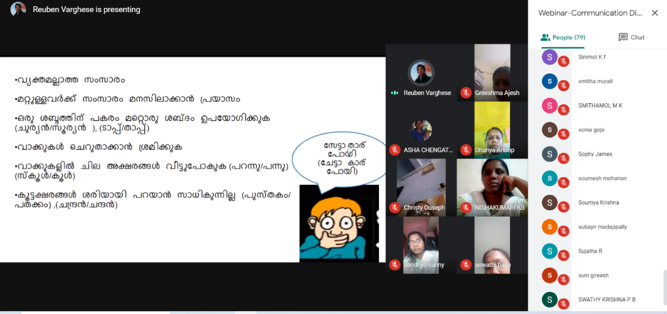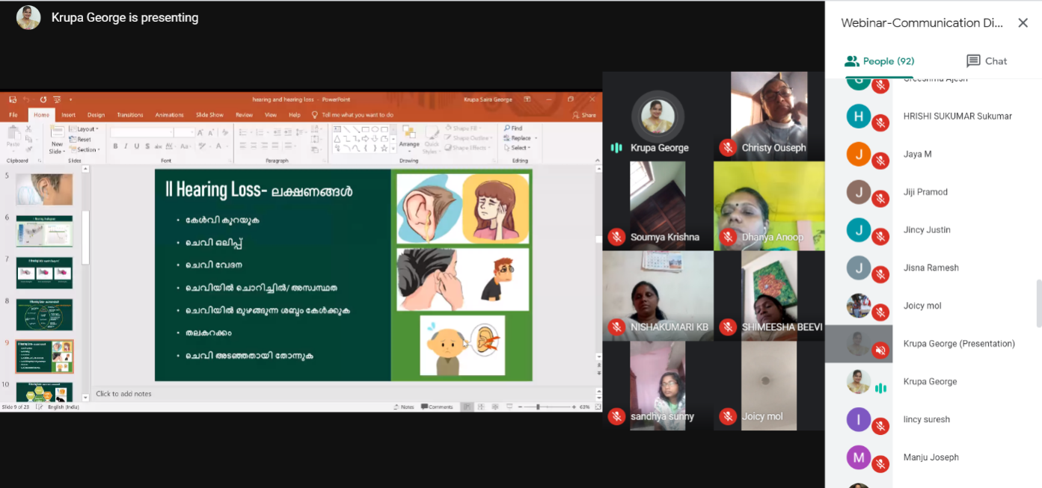

Figure 1: Glimpses of webinars programs in coordination with SSK-Kerala.

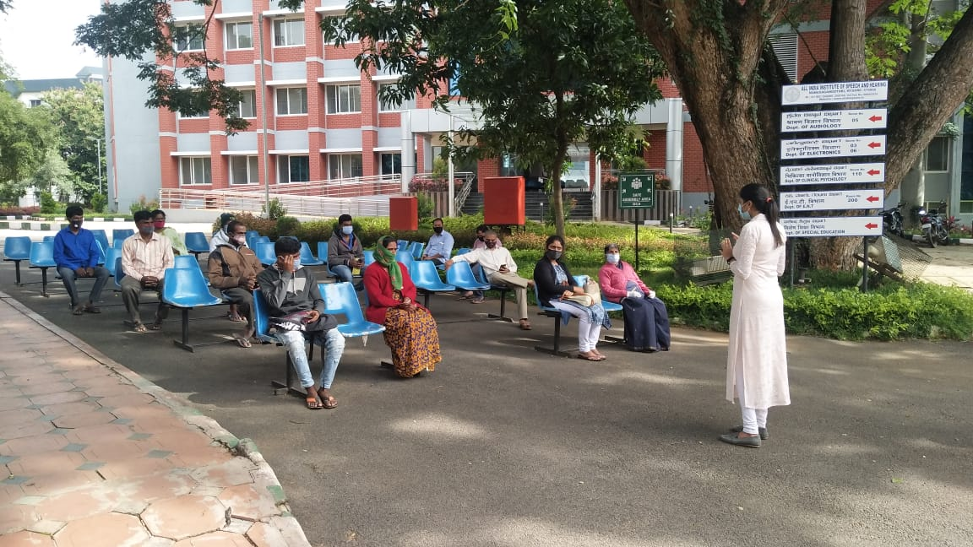

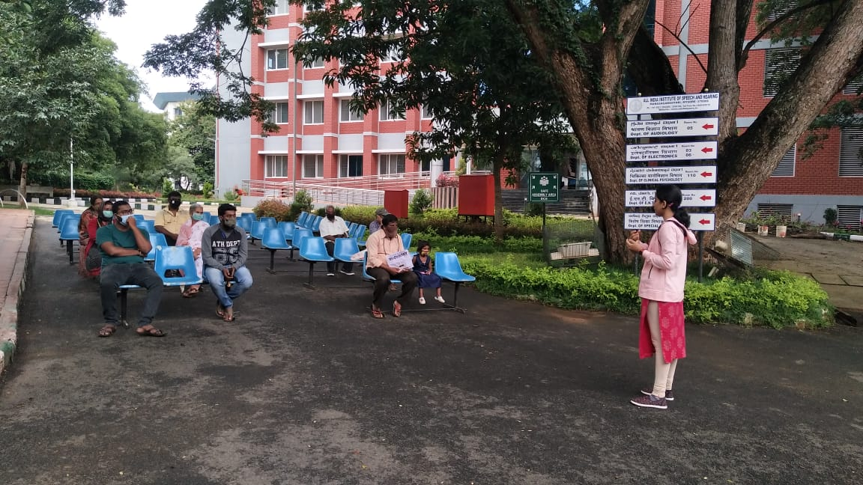

Figure 2: Glimpses of Orientation programs for general public in front of Dept of clinical services, AIISH, Mysuru.

**B. Additional Academic Services rendered by the Faculty and Staff:**

**a) No. of Invited Talks delivered by faculty and staff: 01**

Table 3: Details of invited talks (Webinars) delivered by POCD staff.

|  |  |  |  |  |
| --- | --- | --- | --- | --- |
| **S. No** | **Date** | **Faculty/Staff**  **& Centre** | **Topic Presented** | **Organizer& Venue** |
|  | 13.08.2020 | Dr. Sandeep M | NBS Protocol at AIISH | Meenakshi Venkataraman Foundations |
|  | 17.08.2020 | Dr. Sandeep M | Behavioral v/s objective tests for new born hearing screening. | Meenakshi Venkataraman Foundations |
|  | 30.08.2020 | Mr. Arun Raj K | New Born Hearing screening protocol. | Sahasra ENT Foundations |

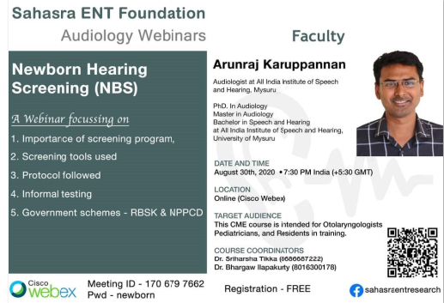

Figure 3: Poster of Webinar on New Born Hearing screening protocol.

**II) RESEARCH ACTIVITIES:** Data entry, merging and coding of NBS data of all 8 OSC centers, 11 NBS centers carried out.

**III) EXTENSION ACTIVITIES**

The department of POCD is actively involved in carrying out various extension activities such as screening, diagnostic and rehabilitation services outside the institute campus. The activities include newborn/infant screening, screening of school children, screening of elderly citizens, screening of industrial workers, conducting camps and also clinical services offered at the outreach service centers of AIISH. Due to the outbreak of COVID-19, limited activities were carried out in August 2020.

1. **New-born screening programs for Communication Disorders**

Table 4: Details of newborn screened in OSC and NBS centers in August 2020.

|  |  |  |  |  |  |  |  |  |  |  |  |
| --- | --- | --- | --- | --- | --- | --- | --- | --- | --- | --- | --- |
| S. No | Hospitals/Immunization Centers | Total births | Total screened | | | Total No. at risk | | | Phone Follow up | | |
|  |  |  | Male | Female | Total | Male | Female | Total | Male | Female | Total |
| 1. **OSC Centers** | | | | | | | | | | | |
|  | Sub-divisional  Hospital,  SagaraTaluk | - | - | - | - | - | - | - | - | - | - |
|  | St. Mary’s Hospital, HD Kote | 12 | 52 | 31 | 83 | 02 | 01 | 03 | 11 | 04 | 15 |
|  | Vivekananda Memorial Hospital, H. D. Kote Sarguru | 48 | 22 | 21 | 43 | 00 | 01 | 01 | 06 | 03 | 09 |
| Taluk Hospital, H. D. Kote- Immunization | 95 | 47 | 43 | 90 | 01 | 02 | 03 | 08 | 08 | 16 |
|  | Primary Health center (Under Karuna trust), Gumballi | - | - | - | - | - | - | - | - | - | - |
|  | Belagavi Institute of  Medical Science,  Belagavi | - | - | - | - | - | - | - | - | - | - |
|  | Kodagu Institute of Medical Sciences,Kodagu | 247 | 97 | 94 | 191 | 02 | 07 | 09 | 05 | 04 | 09 |
|  | Taluk General Hospital, KR. Pete | 34 | 18 | 16 | 34 | 02 | 03 | 05 | 00 | 00 | 00 |
|  | Taluk Hospital, Nanjangud | - | - | - | - | - | - | - | - | - | - |
| **Total (OSCs)** | | 424 | 218 | 189 | 407 | 05 | 11 | 16 | 30 | 19 | 49 |
| **II. NBS centers** | | | | | | | | | | | |
|  | Sri Ramachandra Bhanj Medical College and Hospital (SCB MCH), Cuttack | 216 | 70 | 41 | 111 | 05 | 01 | 06 | 00 | 00 | 00 |
|  | JIPMER, Puducherry | 463 | 168 | 157 | 325 | 24 | 20 | 44 | 04 | 03 | 07 |
|  | NetajiSubhash Chandra Bose Medical College (NSCB), Jabalpur | - | 155 | 152 | 307 | 21 | 17 | 38 | - | - | - |
|  | Post Graduate Institute of Medical Education and Research (PGIMER), New Delhi | 118 | 42 | 45 | 87 | 01 | 00 | 01 | 03 | 00 | 03 |
|  | Rajendra Institute of Medical Sciences, Baritayu, Ranchi | 239 | 27 | 18 | 45 | 00 | 00 | 12 | 08 | 00 | 00 |
|  | Regional Institute of Medical Sciences (RIMS), Imphal | - | - | - | - | - | - | - | - | - | - |
|  | SDUAHER, Kolar | 107 | 57 | 48 | 105 | 00 | 00 | 00 | 00 | 01 | 01 |
|  | JLNMCH, Ajmer | 853 | 313 | 246 | 559 | 08 | 07 | 15 | 17 | 08 | 25 |
| **Total (NBS centers)** | | **1996** | **832** | **707** | **1539** | **59** | **45** | **116** | **32** | **12** | **36** |
| **Overall Total(I+II)** | | **2420** | **1050** | **896** | **1946** | **64** | **56** | **132** | **62** | **31** | **85** |

*Note: The newborn hearing screening programs at Mysuru Hospitals, and few other NBS centers haven’t resumed back due to threat of COVID-19.*

**B) Tele- follow-up evaluation**

The at-risk babies were monitored regularly through Phone calls by administrating Speech-language & hearing developmental checklist. The babies identified with delay in any of the developmental milestones, were referred to AIISH/concerned center for detailed diagnostic evaluation.

Table5: Details of Tele-phone follow- up carried out at Hospitals in Mysuru.

|  |  |  |  |  |
| --- | --- | --- | --- | --- |
| **S. No.** | **Mysuru Hospitals** | **Number of infants with normal developmental milestones.** | **Total infants at risk** | **Total call attended/ Total no of calls** |
|  | Ashwini Nursing Home | 03 | 00 | 03/05 |
|  | Brindavan Hospital | 10 | 00 | 10/19 |
|  | Cheluvamba Hospital (KRH) | 61 | 00 | 61/108 |
|  | GopalaGowdaShanthaveri Memorial Hospital | 01 | 00 | 01/01 |
|  | Kamakshi Hospital | 06 | 00 | 06/08 |
|  | Mahadeshwara Nursing Home | 01 | 00 | 01/02 |
|  | Mission Hospital | 00 | 00 | 00/02 |
|  | S.M.T.D.H Hospital | 03 | 00 | 03/03 |
|  | Shree Devi Nursing Home | 00 | 00 | 00/01 |
|  | Shree Lakshmi DevammaShankarshetty Maternity Hospital | 02 | 00 | 02/03 |
|  | Sigma Hospital | 04 | 00 | 04/05 |
|  | **Total** | **91** | **00** | **91/ 157** |

Table 6: Details of Tele-phone follow- up carried out at OSCs in August 2020

|  |  |  |  |
| --- | --- | --- | --- |
| **OSC centers** | **Number of infants with normal developmental milestones.** | **Total infants at risk** | **Total call attended/ Total no of calls** |
| Subdivision hospital , Sagara | - | - | - |
| St. Mary’s Hospital , Sagara | 07 | 00 | 07/09 |
| Vivekananda Memorial Hospital, Sarguru | 09 | 00 | 09/12 |
| Taluk Hospital, H. D. Kote- | 06 | 00 | 06/07 |
| GIMS, Kalaburgi | 110 | Mortality-03 | 113/150 |
| Taluk General Hospital, KR. Pete | 01 | 05 | 06/06 |
| Primary Health Centre (PHC), Akkihebbalu | 01 | 00 | 01/01 |
| Primary Health centre, Gumballi | 01 | 01 | 01/01 |
| KoIMS, Madikkeri | 37 | 00  Mortality-04 | 42/86 |
| **Total** | **172** | **09** | **178/265** |

*Note: The calls not attempted were repeated a minimum of 5 times on consecutive days*

Table 7: Details of Tele-phone follow- up carried out at NBS centers in August 2020.

|  |  |  |  |
| --- | --- | --- | --- |
| **NBS centers** | **Number of infants with normal developmental milestones.** | **Total infants at risk** | **Total call attended/ Total no of calls** |
| Cuttack | 09 | 00 | 13/15 |
| Delhi | 15 | 00 | 15/25 |
| Jabalpur | 22 | 02 | 24/34 |
| Pondicherry | 19 | 00 | 19/27 |
| Kolar | 13 | 00 | 13/25 |
| **Total** | **78** | **02** | **84/126** |

**c) Tele screening Programs**

Tele-screening program (virtual mode) was carried out to identify the babies at risk for communication disorders since new born screening program couldn’t be carried out in many centers. The details including the behavioral responses of the new born to environmental sounds and HRR were collected from the parents through Tele-phone mode. The babies at risk were asked to undergo follow up evaluation in detail.

Table 8: Details of Tele-screening carried out at NBS Centers in Mysuru in August 2020

|  |  |  |  |  |  |
| --- | --- | --- | --- | --- | --- |
| **Mysore Hospitals** | **Total Tele-screened** | **Mortality** | **Detailed Evaluation(Referred)** | **Total infants at risk(Phone Follow up)** | **Normal Speech and Language milestones** |
| Ashwini Nursing Home | 18 | 00 | 00 | 00 | 18 |
| Mahadeshwara Nursing Home | 41 | 00 | 01 | 02 | 25 |
| **Total** | **59** | **00** | **01** | **03** | **43** |

Table 9: Details of referred carried out at Hospitals in Mysuru in August 2020

|  |  |  |  |  |
| --- | --- | --- | --- | --- |
| **S. No** | **Mysuru Hospitals** | **Infants followed up** | **Infants with hearing impairment** | **Total call attended/ Total no of calls** |
|  | Ashwini Nursing Home | 01 | - | 08/12 |
|  | Cheluvamba Hospital (KRH) | - | - | 02/02 |
|  | Kamakshi Hospital | - | - | 03/03 |
|  | Sigma Hospital | - | - | 00/01 |
|  | AIISH,Mysuru | 01 | - | 01/01 |
|  | **Total** | **02** | **00** | **13/ 18** |

Table 10: Details of Tele-screening at OSCs.

|  |  |  |  |  |  |
| --- | --- | --- | --- | --- | --- |
| **OSC Centre** | **Total Tele-screened / Total calls made** | **Mortality** | **Detailed Evaluation**  **(Referred)** | **Total infants at risk**  **(Screening)** | **Normal Speech and Language milestones**  **(Phone Follow up)** |
| Subdivision Hospital , Sagara | 105/196 | 02 | 03 | 08 | 92 |
| GIMS, Kalaburgi | 50/70 | 04 | 00 | 50 | 110 |
| Taluk General Hospital, KR. Pete | 07/08 | 01 | 00 | 00 | 07 |
| Primary Health Centre, Gumballi | 16/19 | 01 | 00 | 01 | 01 |
| BIMS, Belagavi | 154/197 | 08 | 00 | 08 | 138 |
| **Total** | **332/490** | **16** | **03** | **67** | **348** |

*Note: Those babies who missed out during the pandemic situation for testing*

Table 11: Details of Tele-screening carried out at NBS Centers in August 2020.

|  |  |  |  |  |  |
| --- | --- | --- | --- | --- | --- |
| **NBS Centre** | **Total Tele-screened / Total calls made** | **Mortality** | **Detailed Evaluation**  **(Referred)** | **Total infants at risk**  **(Screening)** | **Normal Speech and Language milestones**  **(Phone Follow up)** |
| Bhagalpur | 105/129 | 07 | 04 | 21 | 80 |
| Ranchi | 155/155 | 04 | 02 | 02 | 153 |
| **Total** | **260/284** | **12** | **06** | **22** | **233** |

**D) New born follow-up evaluation (Detailed assessment)**

The newborns/infants referred during the newborn screening/ Tele-screening were advised for detailed evaluation at AIISH/NBS centers/OSCs. A complete test battery was administered for those babies/infants who came for follow-up.

Table 12: Details of the results of follow-up evaluation carried out at OSCs

|  |  |  |  |
| --- | --- | --- | --- |
| **Categories** |  | **OSC Gumballi** | **OSC- Akkihebbalu** |
| **Normal** | Newborn  (0-2 months) | 00 | 06 |
| Infants  (2-12 months) | 01 | 00 |
| Toddlers  (1 year to 4years) | - | - |
| Children  (above 4years) | - | - |
| **Hearing impairment** | Newborn  (0-2 months) | - | - |
| Infants  (2-12 months) | - | - |
| Toddlers  (1 year to 4years) | - | - |
| Children  (above 4years) | - | - |
| **Speech &language disorder** | Newborn  (0-2 months) | - | - |
| Infants  (2-12 months) | - | - |
| Toddlers  (1 year to 4years) | - | - |
| Children  (above 4years) | - | - |
| **Multiple Disorder** | Newborn  (0-2 months) | - | - |
| Infants  (2-12 months) | - | - |
| Toddlers  (1 year to 4years) | - | - |
| Children  (above 4years) | - | - |
| **Total** |  | **01** | **06** |

Table 13: Details of the results of follow-up evaluation carried out at NBS centers.

|  |  |  |  |  |  |
| --- | --- | --- | --- | --- | --- |
| **Categories** |  | **IMPHAL** | **JABALPUR** | | **PUDUCHERI** |
| **Normal** | Newborn  (0-2 months) | - | - | | - |
| Infants  (2-12 months) | - | 02 | | 01 |
| Toddlers  (1 year to 4years) | **-** | **-** | | **-** |
| Children  (above 4years) | **-** | **-** | | **-** |
| **Hearing impairment** | Newborn  (0-2 months) | **-** | - | | **02** |
| Infants  (2-12 months) | **-** | **-** | | **-** |
| Toddlers  (1 year to 4years) | **01** | **0** | | **-** |
| Children  (above 4years) | **-** | **-** | | **-** |
| **Speech & language disorders** | Newborn  (0-2 months) | **-** | **-** | | **-** |
| Infants  (2-12 months) | **-** | **-** | | **-** |
| Toddlers  (1 year to 4years) | **-** | **-** | | **-** |
| Children  (above 4years) | **-** | **-** | | **-** |
| **Multiple Disorder/ Syndromes** | Newborn  (0-2 months) | **-** | **-** | | **-** |
| Infants  (2-12 months) | **-** | **-** | | **-** |
| **-** |
| Toddlers  (1 year to 4years) | - | - | | **-** |
| **-** | **-** | | **-** |
| Children  (above 4years) | **-** | **-** | | **-** |
| **-** | **-** | | **-** |
| **Total** | | **01** | | **01** | **02** |

**D) Anganawadi/Preschool/School screening program**

Screening of preschool, primary school children and Anganawadi was conducted focusing on the early identification of communication disorders and early rehabilitation of children at risk for communication disorders.

Table 14: Details of Anganawadi/Preschool/School screening program in August 2020

|  |  |  |  |  |  |  |  |  |
| --- | --- | --- | --- | --- | --- | --- | --- | --- |
| **Date** | **Name of the Anganawadi/Preschool/ School** | **Total screened** | | | **Total referred with communication disorders** | | | |
| **Ear related disorder** | **Hearing loss** | **Speech language disorders** | |
| **Male** | **Female** | **Total** |  | | |
| 11.08.2020 | Hemmige Anganawadi, Periyapatna (TK) | 12 | 23 | 35 | 00 | 00 | 01 |
| 19.08.2020 | Gaddige Anganawadi, Hunsur Taluk | 12 | 12 | 24 | 00 | 00 | 02 |
| 26.08.2020 | Thattekere,PHCHHunsur Taluk | 22 | 21 | 43 | 00 | 00 | 01 |

**E) Clinical Services at Outreach Service Centers (OSCs)**

The clinical activities are not only restricted to in and around Mysuru, but also extended to rural areas where facilities for clinical services for persons with communication disorders are scanty. Currently there are 08 OSCs centres at different part of the country rendering services to unreached population. The details of those who were registered and availed various services/benefits at the OSCs are tabulated below.

1. **Clients identified and followed up with communication disorders at OSCs**

Table 15: Details of clients identified and followed up with communication disorders at OSCs.

|  |  |  |  |  |  |  |  |  |  |  |
| --- | --- | --- | --- | --- | --- | --- | --- | --- | --- | --- |
| **S. No** | **OSC Centre** | **Total registered** | | **ENT Evaluation** | | | **Hearing Evaluation** | | **Speech & Language Evaluation** | |
| Normal | Disorder | Others | Normal | Disorder | Normal | Disorder |
|  | Community Health Centre (CHC), Hullahalli | New cases | 06 | **-** | 06 | **-** | **-** | **-** | **-** | 06 |
| F/u Old | 01 | **-** | 01 | **-** | **-** | **-** | **-** | 01 |
|  | Taluk General Hospital, KR Pete | New cases | - | - | - | - | - | -- | - | - |
| F/u Old | - | - | - | - | - | - | - | - |
|  | Sub-divisional Hospital (PHC), Sagara | New cases | 06 |  |  |  | 03 |  | 03 | 06 |
| F/u Old | **--** | **--** | **--** | **--** | **--** | **--** | **--** | **--** |
|  | Vivekananda Memorial Hospital, Sarguru | New cases | 06 | **-** |  | **-** | **-** | **-** | **-** | 06 |
| F/u Old | 08 | **-** |  | **-** | 02 | **-** | **-** | 08 |
|  | Gulbarga Institute of Medical Sciences | New cases | 05 | **-** | **-** | **-** | 01 | **-** | 01 | 05 |
| F/u Old | 01 | **-** | **-** | **-** |  | **-** | 01 | 01 |
|  | Belagavi institute of medical sciences (BIMS), Belagavi | New cases | 11 | **-** | **-** | **-** | 07 | **-** | 02 | 11 |
| F/u Old | 02 | **-** | **-** | **-** | 02 | **-** | **--** | 02 |
|  | Kodagu Institute of Medical Sciences, Madikeri | New cases | **-** | **-** | **-** | - | 19 | **-** | 03 | **--** |
| F/u Old | **--** | **--** | **--** | **--** | **--** | **-** | **--** | **--** |

1. **Table 16: Clients identified with different types of communication disorders across OSCs**

|  |  |  |  |  |  |  |  |  |  |  |  |  |
| --- | --- | --- | --- | --- | --- | --- | --- | --- | --- | --- | --- | --- |
| **Type of Disorders** |  |  | | **OSC** | | | | |  |  |  |  |
| Taluk Hospital, Nanjangud | Primary Health Centre (PHC), Hullahalli | | | Primary Health Centre (PHC), Akkihebbalu | Taluk General Hospital, KR Pete | Primary Health Centre (PHC), Gumballi | Sub-divisional Hospital, Sagara (PHC) Taluk | VMH,  Sarguru | BIMS Belagavi | GIMS, Kalburgi | KoIMS,  Kodagu |
|  |  | | **Hearing disorders (Ear-wise data)** | | | | | |  |  |  |  |
| Normal | **--** | **--** | | | **--** | **--** | **--** | 06 | 05 | **--** | 02 | **--** |
| Conductive | **--** | **--** | | | **--** | 04 | **--** | **--** | **--** | **--** | 03 | **--** |
| Sensori- neural | **--** | **--** | | | **--** | 02 | **--** | **--** | 01 | **--** | 04 | **--** |
| Mixed | **--** | **--** | | | **--** |  | **--** | **--** | 00 | **--** | 02 | **--** |
| No type (Minimal & Profound) | **--** | **--** | | | **--** | **--** | **--** | 02 | 12 |  | Minimal-01 &  Profound-10 | **--** |
| Incomplete | **--** | **--** | | | **--** | **--** | **--** |  |  |  | 02 | **--** |
| **Aud-Total (ears)** | **--** | **--** | | | **--** | 06 |  | 08 | 18 |  | 24 | **--** |
| **Aud-Total (Individuals)** | **--** | **--** | | | **--** | 03 |  | 04 | 09 |  | 12 | **--** |
|  |  | |  | | | | | | |  |  |  |
| Voice | **--** | **--** | | | **--** | **--** | **--** | **--** | **--** | **--** | **--** | **--** |
| Fluency | **--** | **--** | | | **--** | **--** | **--** | **--** | **--** | **--** | **--** | **--** |
| Articulation disorders | **--** | **--** | | | **--** | **--** | **--** | **--** | **--** | **--** | 01 | -- |
| Language disorders | **--** | **--** | | | **--** | 03 | **--** | 01 | 02 | **--** | 02 | 02 |
| **Total (Individuals)** | **--** | **--** | | | **--** | 03 | **--** | 01 | 02 | -- | 03 | 02 |

1. **Table 17: Clients followed up with different types of communication disorders at OSCs**

|  |  |  |  |  |  |  |  |  |  |  |  |
| --- | --- | --- | --- | --- | --- | --- | --- | --- | --- | --- | --- |
| **Type of Disorders** |  |  | | **OSC** | | | |  |  |  |  |
| Taluk Hospital Nanjangud | Primary Health Centre (PHC), Hullahalli | Primary Health Centre (PHC), Akkihebbalu | | Taluk General Hospital, KR Pete | Primary Health Centre (PHC), Gumballi | Sub-divisional Hospital,  Sagara  (PHC) Taluk | VMH,  Sarguru | Belagvi institute of medical sciences BIMS | GIMS, Kalburgi | KoIMS-TH, MadikeriTaluk,Kodagu |
|  | **Hearing disorders (Ear-wise data)** | | | | | | | | | | |
| Normal | -- | -- | -- | | -- | -- | -- | -- | -- | -- | -- |
| Conductive | -- | -- | -- | | -- | -- | -- | -- | -- | -- | -- |
| Sensori- neural | -- | -- | -- | | -- | 03 | -- | -- | -- | -- | -- |
| Mixed | -- | -- | -- | | -- | 00 | -- | -- | -- | -- | -- |
| No type (Minimal & Profound) | -- | -- | -- | | -- | 01 | -- | -- | -- | -- | -- |
| **Aud-Total (ears)** | -- | -- | -- | | -- | 04 | -- | -- | -- | -- | -- |
| **Aud-Total (Individuals)** | -- | -- | -- | | -- | 02 | -- | -- | -- | -- | -- |
|  |  |  | | | | | | |  |  |  |
| Voice | -- | -- | -- | | -- | -- | -- | -- | -- | -- | -- |
| Fluency | -- | -- | -- | | -- | -- | -- | -- | -- | -- | -- |
| Articulation disorders | -- | -- | -- | | -- | -- | -- | -- | -- | -- | -- |
| Language disorders | -- | -- | -- | | -- | -- | -- | -- | -- | -- | 02 |
| **Sp&Lg -Total (Individuals)** | -- | -- | -- | | -- | -- | -- | -- | -- | -- | **02** |

1. **Rehabilitation services at OSCs.**

Table 18: Details of rehabilitation services provided at OSCs in August 2020.

|  |  |  |
| --- | --- | --- |
| **OSC** | **Speech-language therapy** | |
| No. of clients | No. of sessions |
| Taluk Hospital, Nanjangud | 04 | Tele-therapy: 24 |
| Primary Health Centre (PHC), Akkihebbalu | 01 | Tele-therapy: 12 |
| Taluk General Hospital, KR Pete | 03 | Teletherapy:36 |
| Primary Health Centre (PHC), Gumballi | 03 | Tele-therapy: 15 |
| Sub-divisional Hospital, Sagara (PHC) Taluk | 12 | Tele-therapy: 83 |
| Belagavi institute of medical sciences BIMS | 02 | Tele-therapy: 12 |
| GIMS, Kalburgi | 06 | Tele-therapy: 66 |
| KoIMS-TH, Madikeri Taluk | 05 | Tele-therapy:44 |
| **Total** | **36** | **292 Tele-Sessions** |

Note: No Hearing aids were distributed in August 2020

**IV) TECHNOLOGICAL CONSULTANCY SERVICES: NIL**

**V) CENTRAL FACILITIES**

**a) Library and information Services: NIL**

VI) **MAJOR EVENTS OF THE MONTH**: Initiated second series of AIISH AISIRI Programs on 16 August 2020.

|  |  |  |  |
| --- | --- | --- | --- |
| **S.NO** | **Date** | **Staff** | **Topic details** |
| 1. | 02.08.2020 | Dr. Hema N  (Assistant Professor in Speech Language Science) | Adult Language disorders |
| 2. | 09.08..2020 | Dr. S Venkatesan (Professor & HOD, Dept. of Clinical Psychology) | Psychological problems in children &Parents |
| 3. | 16.08.2020 | Dr. Rajeshwari G (Professor and HOD, E.N.T) | Ear discharge causes, Do’s &Don’ts |
| 4. | 23.08.2020 | Dr. T K Prakash (Associate professor E.N.T) | Diseases causing voice changes |
| 5. | 30.08.2020 | Dr. Santosh M(Associate Professor in Speech Language Science) | Myths and facts about stuttering. |

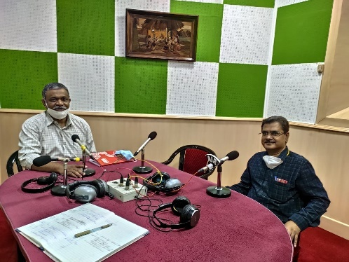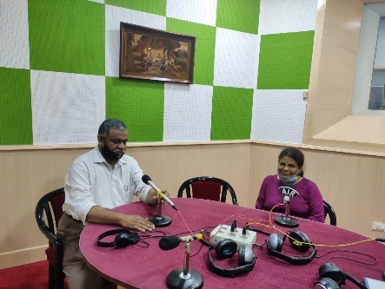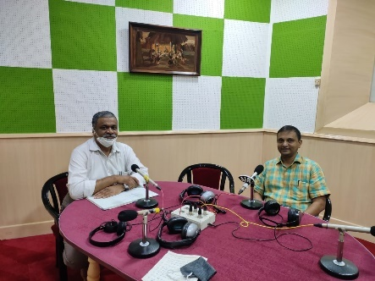

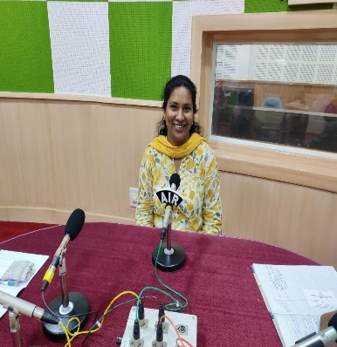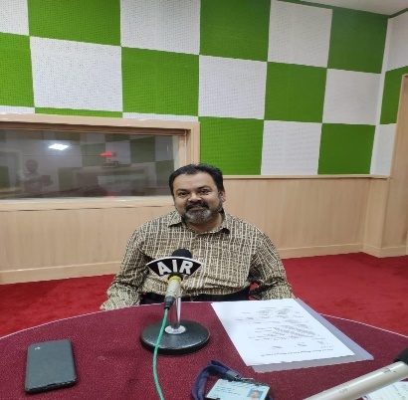

Figure 4: Glimpses of AIISH AISIRI Programs by AIISH staff, Mysuru.

**VII) OTHERS**

1. Submitted the following for the year
2. Revised estimate and Budget estimate for 2021-22
3. Completed and submitted 1st quarterly indent.
4. Prepared submitted the thrust area for research from the department of POCD.
5. Computerisation activities: An online meeting was conducted regarding the hosting in server. Discussion was carried out about the requirement for hosting the global server on 26.08.2020.
6. NBS related activities: Procedure for initiation of NBS centre to 06 AIIMS hospitals were on processes.
7. Initiated AIISH AISIRI Program at All India Radio at Dharwad 16.08.2020

**VII) ACTIVITIES CARRIED OUT BY THE STAFF OF THE DEPARTMENT OF POCD.**

Table 17: Details of activities carried out by POCD staff in August 2020.

|  |  |  |  |
| --- | --- | --- | --- |
| **S.No.** | **Name of the staff** | **Designation** | **Activities** |
|  | Dr. N Sreedevi | Head, Dept. of POCD | * Officiating as HOD-POCD * Has been coordinating webinars on communication disorders to special teachers of all 14 Districts of Kerala under SSK Program * Coordinated submission of revised RE-BE * Coordinated with statistician and dept staff reg data retrieval and data compilation. * Coordinated the installation of KIOSK and the modifications required * Worked on correction of Kannada and Malayalam pamphlets, videos and other public education materials * Attended webinar titled “Impediments of Sexual Persecution at the Place of Work;” on 27.8.2020 * Attended webinar titled “New Born Hearing Screening” by Mr.Arun Raj on 30.8.2020 * Attended the RE-BE purchase meeting on 13th August 2020. * Coordinated the submission of 1st quarterly indent and thrust area for research from the department of POCD * Coordinated the initiation of AIISH AISIRI Programat All India Radio, Dharwad. |
|  | Dr. Sandeep M | Associate Professor in Audiology | * Coordinated OSC and NBS centre activities * Coordinated with statistician on regarding the data retrieval, data entry and data compilation * Carried out Webinars on NBS Protocol at AIISH organized by Meenakshi Venkatraman Foundationon 13.08.2020 * Carried out Webinar on Behavioural v/s objective tests for new born hearing screening organized by Meenakshi Venkatraman Foundationon 17.08.2020 |
|  | Mr. Arunraj. K | Clinical Assistant | * Coordinated submission of RE-BE * Coordinated the installation of KIOSK and the modifications required * Coordinated with statistician on regarding the data retrieval, data entry and data compilation * Attended the Webinar series on Newborn Hearing Screening organized by Meenakshi Venkatraman Foundation on 10th, 13th and 17th August 2020. * Attended the RE-BE purchase meeting on 13th August 2020. * Attended a webinar on Newborn screening organized by the Sahasra ENT foundation on 30th August 2020. * Assisted in preparation of submission of additional Research details of POCD * Carried out Webinar on New Born Hearing screening protocol organized by Meenakshi Venkatraman Foundationon 30.08.2020 |
|  | Ms. Ameena Subhakani S. | Speech Language Pathologist Grade I | * Provided feedback for Information KIOSK. * Video editing   + Hearing loss and Cleft-lip and Palate: Kannada   + Dysarthria and Aphasia (Malayalam) * Translation of FAQs on Speech Sound Disorder in Tamil * Attended the Webinar series on Newborn Hearing Screening organized by Meenakshi Venkatraman Foundation on 10th, 13th and 17th August 2020. * Attended online awareness program on access to e-resources under N-LIST organized by the Library and Information center, AIISH on 10th August 2020. * Modified the RE-BE. * Attended the RE-BE purchase meeting on 13th August 2020. * School screening data entry of 2 schools * Verification of July monthly report 2020. * Attended a webinar on Rehabilitation of Laryngectomee on 14th August 2020. * Oriented the II BASLP students (51 students) on NBS protocol and program on 25th August 2020. * Organized and conducted an orientation program for the teachers (47 teachers) of St. Patrick’s Anglo Indian School, Chennai on 26th August 2020. * Drafted letters for orientation programs and other administrative works. * Attended a webinar on Rehabilitation of Aphasia organized by the DISHA on 29th August 2020. * Attended a webinar on Newborn screening organized by the Sahasra ENT foundation on 30th August 2020. |
|  | Mr. Harish Kumar M.K. | Audiologist Grade I | * Carried out school screening data entry * Voicing for stuttering video * Tinnitus pamphlet verification(kannada) * Finalizing Articulation pamphlet(Kannada) * Video editing (CLP Kannada) * Video editing (Hearing loss kannada) * Video editing stuttering English * Video editing Ear discharge Malayalam * conducted computerization meeting. * Carried out orientation to general public(DCS) * Attended NBS webinar * Carried out tele screening (11 nos) |
|  | Mr. KishoreKumarBharshetty | Audiologist Grade I | * Prepared indents for Revised Estimate * Carried out orientation for general public in DCS, AIISH * Assisted in installation of KIOSK * Monitoring of purchase files * Attended virtual meeting regarding computerisation. |
|  | Ms. Krishnendu S. | Speech Language Pathologist Grade I | * School Screening data entry * School screening data * compilation * SSK Webinar organization. * Served as resourceperson in 9 * SSK Webinars * Material development: FAQ * Autism English and Malayalam * Tele screening for NBS |
|  | Ms. Priya Abdul Khader M. T. | Audiologist Grade I | * Data entry of School screening: 4 schoolscompleted * Carried out orientation for SSK teachers   Presented: 7 sessions  Monitored: 10 sessions  Organized:12 sessions   * Tele-screening- NBS (15) * contacted industries for Webinar/checklist   Telephonic:5  Mail: 5  Post: 5 |
|  | Ms. Ritu A Venkatesh | Audiologist Grade I | * School screening data entry * Stuttering English animated video script correction * Tinnitus English animated video script correction * Finalized Tinnitus & * Corrected Presbycusis English * Attended webinar on NBS * Telecreening for NBS * Corrected Kannada Tinnitus video script * Corrected English write ups prepared by OSC staffs. * Orientation for General Public on 12.08 2020 * Orientation for General Public on 13.08 2020 * NBS follow up on 31.08.2020 * Attended the Webinar series on Newborn Hearing Screening organized by Meenakshi Venkatraman Foundation on 10th, 13th and 17th August 2020 |
|  | Ms. Sharanya K. Kumar | Audiologist – Grade I | * Tele-screening. * Follow up of referral cases * SPSS entry of follow data of Mysuru NBS * SPSS entry of school screening data (6 schools) * Merging and Recoding of OSC data in SPSS (K R Nagar, T N Pura and Santemarahalli) * Attended the Webinar series on Newborn Hearing Screening organized by Meenakshi Venkatraman Foundation on 10th, 13th and 17th August 2020. * Detailed evaluation of referred case. * Voicing to Hearing loss video in Kannada * Prepared FAQs on tinnitus pamphlet * Translated FAQs on tinnitus pamphlet to Kannada * Collected phone numbers for tele-screening from Kamakshi Hospital. * Called phone follow-up infants enquiring about their developmental milestones. * Orientation for the general public in front of clinical services (12.08.2020 and 13.08.2020). |
|  | Ms. Abinaya R | Speech-Language Pathologist Grade I | * Collected NBS screening and follow up data since 2011 * Organized web meeting with all NBS Staffs regarding NBS data * Verified 10 Tamil pamphlets * Prepared animated video on hearing loss in Tamil * Translated Ototoxicity public education pamphlet in Tamil * Tamil Script prepared for an animated video in the topic of Ear Discharge |
|  | Ms. Aparna U. | Audiologist – Grade II | * Prepared Monthly report of July 2020. |
|  | Ms. Anusha C. | Speech Language Pathologist – Grade II | * Edited FAQs on SSD in English and Kannada. * Edited slides of Speech and Language orientation in Kannada. * Translated FAQs on Autism to Kannada. * Attended a webinar about NBS on 10.8.20 conducted by Meenakshi Venkataraman Foundation. * Attended the day 2 of the NBS webinar on 13.08.20 conducted by Meenakshi Venkataraman Foundation. * Completed entry of school screening data of 4 schools in SPSS spreadsheet. * Attended a webinar “Rehabilitation of Total “Laryngectomy” on 14.07.20. * Prepared and finalised the content for the OSCs notice board. * Prepared a write up on Swallowing disorders in English and translation of same into Kannada. * Proofread and edited FAQs on Autism. * Collected contact numbers for tele- screening from Kamakshi Hospital on 26.08.2020 * Conducted tele-screening by contacting the mothers/fathers of the new-borns. |
|  | Ms. Faheema Luquman Ali | Audiologist – Grade II | * Tele screening of newborn (Mysore Hospitals (No. 38) * Attended Webinars (2) on Newborn Hearing Screening * OSC data merging and coding * Weekly OSC reports verification * Powtoon video –Malayalam (corrected) * World hearing day activities for the year 2021. * Updated OSC data on KIOSK * Carried out school screening data entry for 6 schools |
|  | Mr. Ullas N Bhargav | MTS (Data entry operator) | * Conversion of KR nagar data, OSC Kodagu, Puducherry follow up * Attendance certificate * Merging of Sagara OSC data * Conversion of OSC kalburgi, KR pete data. * TA bill of staff(mahadevappa sir) * Phone follow up (80nos) * Decoding of NBS data * Attended orientation on decoding of NBS data by Mr. Srinivasa R (biostatistician) |
|  | Ms. Deepika. R | Office assistant Grade II | * Assisted in Monthly report preparation * Assisted in preparation of submission of additional Research details of POCD * Drafted office correspondence letters (Internal & external) * Assisted in revision of RE BE * Assisted in notice board updation * Compilation and preparation of tentative plan for world hearing day |

***Sd-***

**Dr. N Sreedevi**

**विभागाध्यक्ष, विभाग-**पिओसिडि- Head, Dept. Of POCD