**संप्रेषण विकृति रोकथाम विभाग**

**DEPARTMENT OF PREVENTION OF COMMUNICATION DISORDERS**

**महीनेके विवरण/ MONTHLY REPORT** –**July 2020**

1. **ACADEMIC ACTIVITIES**

**A. No. of webinars: 21**

As a part of primary prevention activities, several orientation/sensitization programs are being conducted regularly. The objective of the orientation programs was to create awareness among general public and various other professionals such as Medical doctors, Nurses, Health related workers, teachers, school students etc., on different types of communication disorders, its prevention and early identification methods and their appropriate referral and timely management. Due to COVID-19 pandemic condition in the country the orientation programs are carried out in Tele-mode/Webinars. Table 1&2 shows the details of the orientation programs conducted by staff and students of department of POCD, NBS and OSC centers.

Table 1: The details of orientation program (Webinars) in July 2020.

|  |  |  |  |  |  |
| --- | --- | --- | --- | --- | --- |
| **I. Orientation Programs at POCD : 14** | | | | | |
| Theme/Topic of the program: Prevention & early identification of communication disorders  Coordinators: Dr. N. Sreedevi, Dr. M. Sandeep & Mr. Arunraj K. | | | | | |
| **S. No** | **Date** | **Name of the institute/**  **Hospital** | **Target group** | **Total participants** | **Oriented by**  **POCD Staff** |
|  | 01.07.2020 | Little Flower Institute of Social Science and Health, Kerala | Lecturers | 50 | Ms. Krishnendu |
|  | 06.07.2020 | HOK Kids play school, Kannur | Teachers | 05 | Ms. Faheema |
|  | 07.07.2020 | Vidyavardhaka college, Mysore | Teachers | 15 | Ms. Ameena &  Mr. Harish Kumar |
|  | 11.07.2020 | Majestic Maritime Pvt Ltd, Tamil Nadu | General Public | 17 | Ms. Ameena |
|  | 16.07.2020 | Chayadevi College, Mysuru | Teachers | 15 | Ms. Abinaya & Ms. Krishnendu |
|  | 17.07.2020 | Government teachers of Mysuru | Teachers | 30 | Ms. Anusha & Mr.Harish Kumar |
|  | 18.07.2020 | Jeppiar SRR college of Engineering, Chennai, Tamil Nadu | Lectures | 23 | Ms. Ameena |
|  | 21.07.2020 | - | Industrial workers | 15 | Ms. Abinaya, Mr. Harish Kumar & Ms.Ameena |
|  | 22.07.2020 | Kerala | Special Educators | 35 | Ms. Krishnendu &  Ms. Aparna |
|  | 23.07.2020 | Mysuru | Elderly population | 30 | Ms. Ritu & Ms. Sharanya |
|  | 23.07.2020 | Kerala | Lecturers | 104 | Ms. Priya |
|  | 23.07.2020 | Government Primary school, Bidar | Teachers | 39 | Mr. Kishore |
|  | 27.07.2020 | Mysuru | General Public | 20 | Mr. Harish Kumar |
|  | 29.07.2020 | JPT Teachers, Kalaburgi | Teachers | 46 | Ms. Ritu & Ms. Anusha |
| **II. Orientation Programs at NBS Centers : 01** | | | | | |
| **S. No** | **Date** | **Name of the institute/**  **Hospital** | **Target group** | **Total participants** | **Oriented by Staff** |
| 1. | 30.07.2020 | AIIPMR, Mumbai | Parents of children with speech language disorders | 4 | Ms. Suman Penwal |
| **III. Orientation/Webinar Programs at OSC Centres: 6** | | | | | |
| **S. No** | **Date** | **Name of the institute/**  **Hospital** | **Target group** | **Total participants** | **Oriented by Staff** |
|  | 24/07/20 | OSC- Nanjangud | House wives | 20 | Ms. Spoorthy |
|  | 30/07/20 | OSC- Nanjangud | College Students | 15 |
|  | 27/07/2020 | OSC Belagavi | Students | 6 | Mr. Advaith.B |
|  | 31/07/2020 | OSC KR Pet | College Students | 8 | Ms Minu Lalu |
|  | 31/07/2020 | OSC Gumballi | Activists | 6 | Ms Susan |
|  | 20/07/2020 | Vivekananda Memorial Hospital, sarguru | Nursing Students | 15 | Arpitha V  Kamalakannan K |

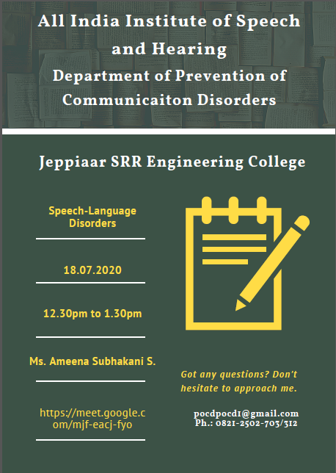

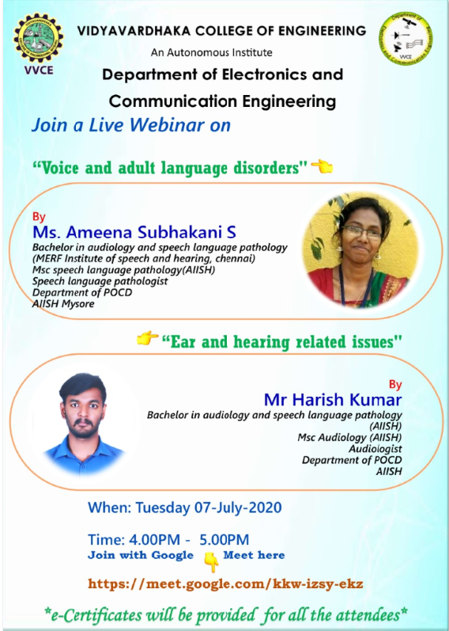

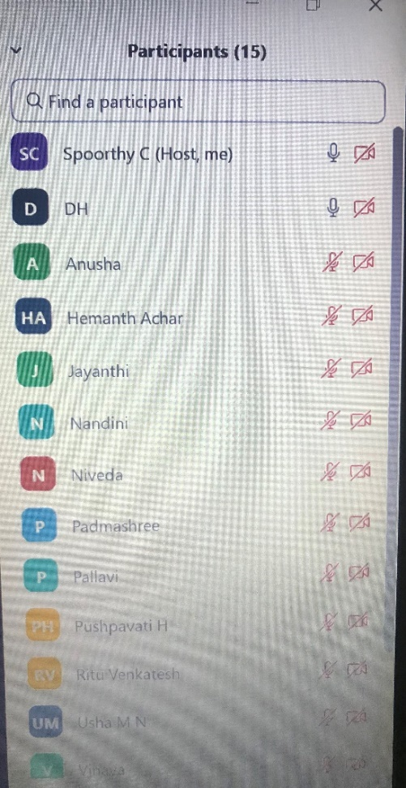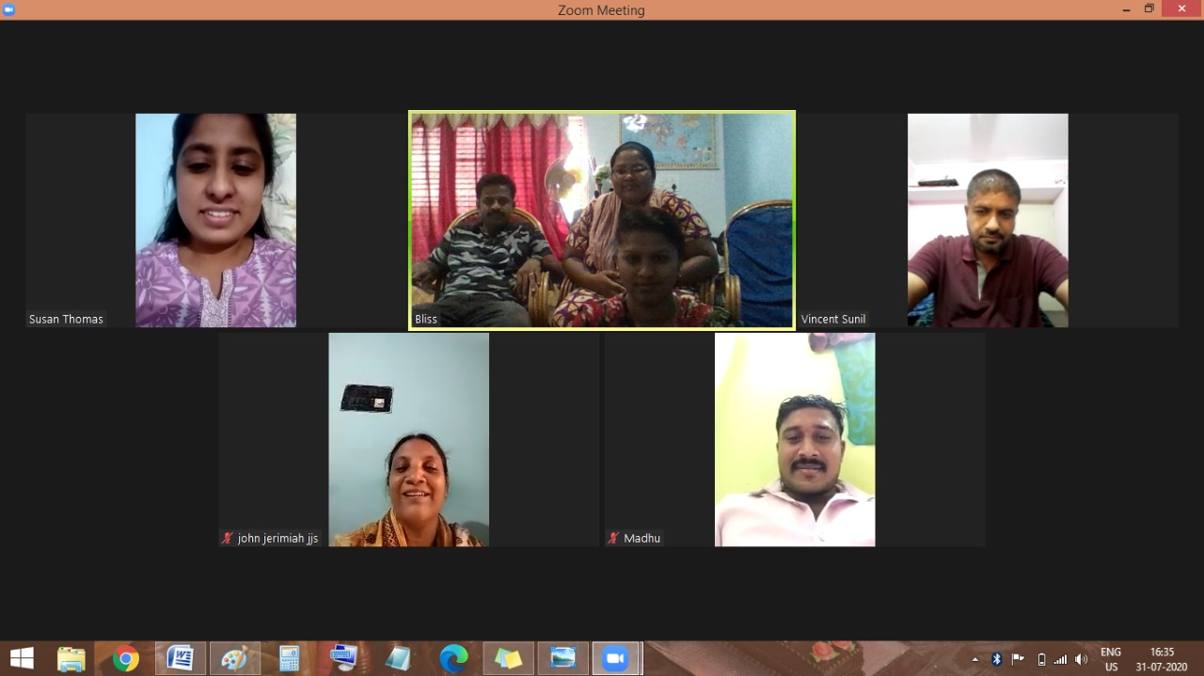

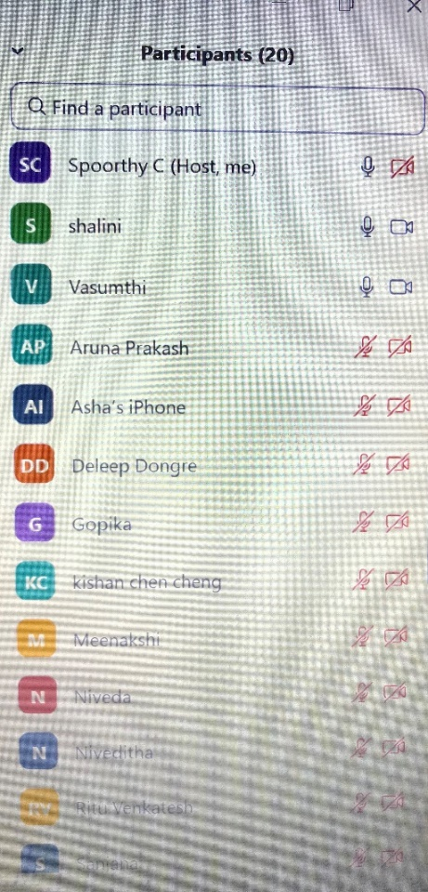

Picture: orientation through webinars

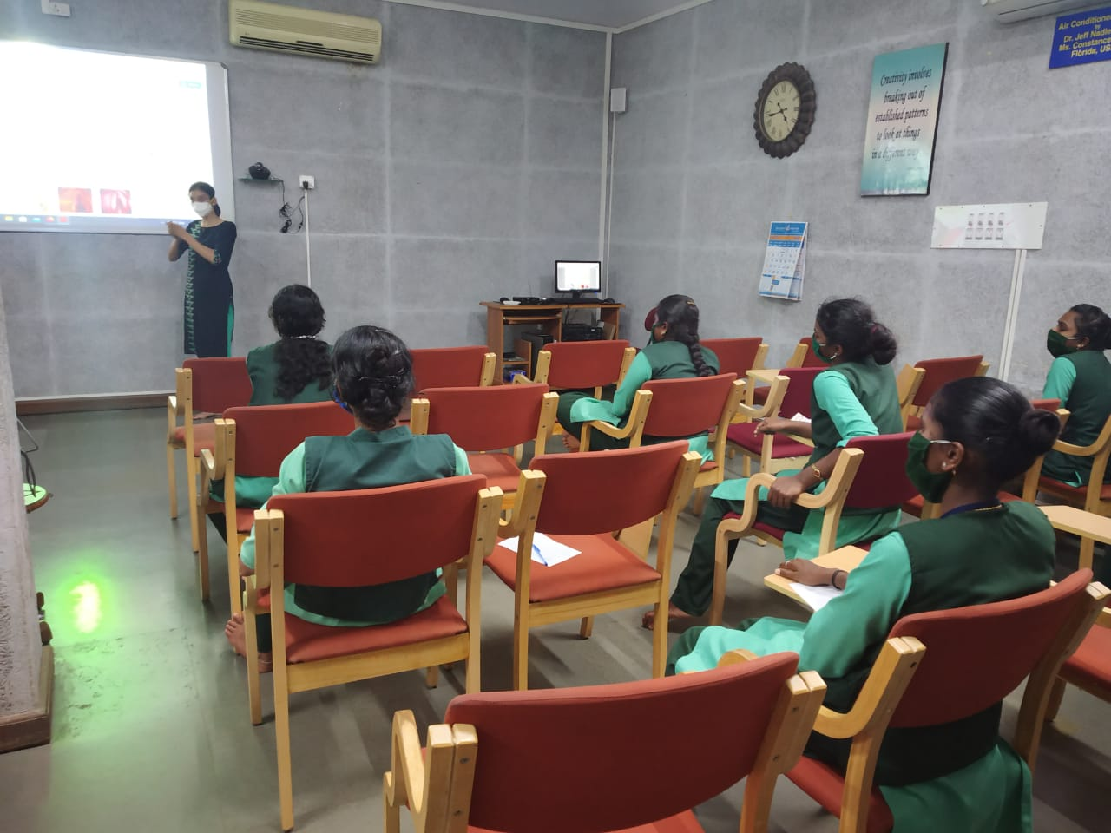

Picture: Mr Kamala Kannan and Ms Arpitha Vasudev conducted orientation program on Communication disorders and role of an Audiologist and Speech and language pathologist for Home nursing student of SVYM on 20/07/2020. 15 participants attended the program.

Table 2: Total number of participants oriented (Group wise) from POCD

|  |  |  |
| --- | --- | --- |
| **Sl.No** | **Target group** | **Total number of Participants** |
|
|  | Teachers/Lectures/ Special educators | 362 |
|  | Industrial workers | 15 |
|  | Elderly people | 30 |
|  | Parents / House wives | 37 |
| **Total** | | **444** |

Table 3: Total number of participants oriented (Group wise) from OSC and NBS centres in the month of July 2020.

|  |  |  |
| --- | --- | --- |
| **Sl.No** | **Target group** | **Total number of Participants** |
|
| I | **Grass Root Level Workers** | |
|  | Health Facilitator and Supervisors/Program Manager | 6 |
| II. | **Students** | |
|  | NursingStudents/Paramedical Students | 15 |
|  | School Students | 23 |
| III. | **Public** | |
|  | House wives | 20 |
|  | Parents | 04 |
|  | Activists | 06 |
| **Total** | | **74** |

B. **Seminars/ Conferences /Lectures /Workshop/Training programs.**

1. **No. of Workshop organized by OSC centers: Nil**

**II) RESEARCH ACTIVITIES: Data entry of 11 centers and statistical coding in progress**

**III) EXTENSION ACTIVITIES**

The department of POCD is actively involved in carrying out various extension activities such as screening, diagnostic and rehabilitation services outside the institute campus. The activities include newborn/infant screening, screening of school children, screening of elderly citizens, screening of industrial workers, conducting camps and also clinical services offered at the outreach service centers of AIISH. Due to the outbreak of COVID-19, limited activities were carried out in July 2020.

1. **New-born screening programs for Communication Disorders**

Table 4: Details of newborn screened in Hospitals in Mysuru, OSC and NBS centers in July 2020.

|  |  |  |  |  |  |  |  |  |  |  |  |
| --- | --- | --- | --- | --- | --- | --- | --- | --- | --- | --- | --- |
| **S. No** | **Hospitals/Immunization Centers** | **Total births** | **Total screened** | | | **Total No. at risk** | | | **Phone Follow up** | | |
| **I. Mysuru Hospitals** | | | | | | | | | | | |
|  |  |  | Male | Female | Total | Male | Female | Total | Male | Female | Total |
| 1. 1. | KR Hospital (KRH)- Cheluvamba | **-** | **-** | **-** | **-** | **-** | **-** | **-** | **-** | **-** | **-** |
| 1. 2. | Kamakshi Hospital (KH) | **-** | **19** | **14** | **33** | **2** | **0** | **2** | **2** | **0** | **2** |
|  | Lakshmidevamma Shankarshetty Maternity Hospital | **-** | **-** | **-** | **-** | **-** | **-** | **-** | **-** | **-** | **-** |
|  | Mission Hospital (MH) | **30** | **-** | **-** | **-** | **-** | **-** | **-** | **-** | **-** | **-** |
|  | S.M.T.D.H Hospital |  | **1** | **4** | **5** | **0** | **0** | **0** | **0** | **0** | **0** |
|  | Ashwini Nursing Home (ANH) | **20** | **2** | **0** | **2** | **0** | **0** | **0** | **0** | **0** | **0** |
|  | Shree Devi Nursing Home (SNH) | **68** | **-** | **-** | **-** | **-** | **-** | **-** | **-** | **-** | **-** |
|  | GopalaGowdaShanthaveri Memorial Hospital (GGSMH) | **21** | **3** | **2** | **5** | **0** | **0** | **0** | **0** | **2** | **2** |
|  | Mahadeshwara Nursing Home (MNH) | **41** | **1** | **2** | **3** | **0** | **0** | **0** | **0** | **0** | **0** |
|  | Sigma Hospital (SH) |  | **14** | **5** | **19** | **0** | **0** | **0** | **0** | **1** | **1** |
|  | Brindavan Hospital | **-** | **1** | **0** | **1** | **0** | **0** | **0** | **0** | **0** | **0** |
|  | Jayanagar maternity hospital | **-** | **8** | **2** | **10** | **0** | **0** | **0** | **0** | **0** | **0** |
|  | **Total (Mysuru Hospitals)** |  | **49** | **29** | **78** | **2** | **0** | **2** | **2** | **3** | **5** |
| **II. Outreach Service Centers** | | | | | | | | | | | |
|  | Sub-divisional  Hospital,  SagaraTaluk | **-** | **-** | **-** | **-** | **-** | **-** | **-** | **-** | **-** | **-** |
|  | St. Mary’s Hospital, HD Kote | **111/129** | **54** | **57** | **111** | **2** | **1** | **3** | **4** | **5** | **9** |
|  | Vivekananda Memorial Hospital, H. D. Kote Sarguru | **37/43** | **19** | **18** | **37** | **1** | **0** | **1** | **6** | **6** | **12** |
| Taluk Hospital, H. D. Kote- Immunization | **94/111** | **59** | **35** | **94** | **1** | **1** | **2** | **5** | **2** | **7** |
|  | Primary Health centre (Under karuna trust), Gumballi | **-** | **-** | **-** | **-** | **-** | **-** | **-** | **-** | **-** | **-** |
|  | Belagavi Institute of  Medical Science,  Belagavi | **311** | **29** | **21** | **50** | **3** | **2** | **5** | **3** | **2** | **5** |
|  | Kodagu Institute of Medical Sciences,Kodagu | **239** | **37** | **46** | **83** | **1** | **2** | **3** | **2** | **1** | **3** |
|  | Taluk General Hospital, KR. Pete | **14/21** | **5** | **9** | **14** | **0** | **0** | **0** | **1** | **1** | **2** |
|  | **Total** |  | **203** | **186** | **389** | **8** | **6** | **14** | **21** | **17** | **38** |
| **III. NBS centers** | | | | | | | | | | | |
|  | Sri Ramachandra Bhanj Medical College and Hospital (SCB MCH), Cuttack | **207** | 76 | 29 | **105** | 4 | 4 | **8** | **6** | **3** | **9** |
|  | JIPMER, Puducherry | **473** | 176 | 209 | **385** | 4 | 7 | **11** | 16 | 15 | **31** |
|  | NetajiSubhash Chandra Bose Medical College (NSCB), Jabalpur | **NA** | 60 | 62 | **122** | 19 | 10 | **29** | **7** | **4** | **11** |
|  | Post Graduate Institute of Medical Education and Research (PGIMER), New Delhi | **25** | 16 | 9 | **25** | 0 | 1 | **1** | **3** | **2** | **5** |
|  | Rajendra Institute of Medical Sciences, Baritayu, Ranchi | **222** | 19 | 20 | **39** | 0 | 0 | **0** | **0** | **1** | **0** |
|  | Regional Institute of Medical Sciences (RIMS), Imphal | **150** | 16 | 26 | **42** | 1 | 0 | **0** | **1** | **0** | **0** |
| **Total (NBS centers)** | |  | **363** | **355** | **718** | **28** | **22** | **49** | **33** | **25** | **56** |
| **Overall Total(I+II+III)** | |  | **615** | **570** | **1185** | **38** | **28** | **65** | **56** | **45** | **99** |

Note: The newborn screening programs at various NBS centers are yet to resume due to threat of COVID-19.

**B) Tele- follow-up evaluation**

The at-risk babies were monitored regularly through Phone calls by administrating Speech-language & hearing developmental checklist. The babies identified with delay in any of the developmental milestones, were referred to AIISH/concerned center for detailed diagnostic evaluation.

Table 5: Details of Tele-phone follow- up carried out at Hospitals in Mysuru.

|  |  |  |  |  |
| --- | --- | --- | --- | --- |
| **Sl no.** | **Mysuru Hospitals** | **Number of infants with normal developmental milestones.** | **Total infants at risk** | **Total call attended/ Total no of calls** |
|  | Ashwini Nursing Home | - | - | - |
|  | Brindavan Hospital | - | - | - |
|  | Cheluvamba Hospital (KRH) | 8 | 2 | 10/10 |
|  | GopalaGowdaShanthaveri Memorial Hospital | - | - | - |
|  | Kamakshi Hospital | - | - | - |
|  | Mahadeshwara Nursing Home | - | - | - |
|  | Mission Hospital | - | - | - |
|  | S.M.T.D.H Hospital | - | - | - |
|  | Shree Devi Nursing Home | - | - | - |
|  | Shree Lakshmi DevammaShankarshetty Maternity Hospital | - | - | - |
|  | Sigma Hospital | - | - | - |
|  | **Total** | **8** | **2** | **10/10** |

Table 6: Details of Tele-phone follow- up carried out at OSCs in July 2020

|  |  |  |  |
| --- | --- | --- | --- |
| **OSC centers** | **Number of infants with normal developmental milestones.** | **Total infants at risk** | **Total call attended/ Total no of calls** |
| Subdivision hospital , Sagara | 13 | 0 | 13/25 |
| St. Mary’s Hospital , Sagara | 11 | 0 | 11/21 |
| Vivekananda Memorial Hospital, Sarguru | 7 | 0 | 7/14 |
| Taluk Hospital, H. D. Kote- | 6 | 0 | 6/9 |
| GIMS, Kalaburgi | 110 | 0 | 110 / 200 |
| Taluk General Hospital, KR. Pete | 0 | 0 | 0 |
| Primary Health Centre (PHC), Akkihebbalu | 0 | 0 | 0 |
| Community Health Centre (CHC), Santhemarahalli | - | - | - |
| Taluk Hospital, Yelanduru | 1 | 0 | 1/1 |
| Primary Health centre, Gumballi | 7 | 0 | 7/10 |
| Taluk Hospital, Nanjangudu | 19 | 0 | 19/19 |
| Community Health Centre (CHC), Hullahalli | - | - | - |
| BIMS, Belagavi | 0 | 0 | 0 |
| KoIMS, Madikkeri | 10 | 0 | 10/10 |
| **Total** | 184 | 0 | 184/309 |

Note: The calls not attempted were repeated a minimum of 5 times on consecutive days

Table 7: Details of Tele-phone follow- up carried out at NBS centers in July 2020.

|  |  |  |  |
| --- | --- | --- | --- |
| **NBS centers** | **Number of infants with normal developmental milestones.** | **Total infants at risk** | **Total call attended/ Total no of calls** |
| Bhagalpur | 10 | 00 | 10/16 |
| Cuttack | 9 | 00 | 9/13 |
| Delhi | 10 | 00 | 10/15 |
| Jabalpur | 49 | 03 | 52/ 104 |
| Pondicherry | 16 | 00 | 16/21 |
| **Total** | **94** | **03** | **97/169** |

**c) Tele screening Programs**

Tele-screening program (virtual mode) was carried out to identify the babies at risk for communication disorders since new born screening program couldn’t be carried out in many centers. The details including the behavioral responses of the new born to environmental sounds and HRR were collected from the parents through Tele-phone mode. The babies at risk were asked to undergo follow up evaluation in detail.

In Mysuru tele-screening has not been done due to the unavailability of contact details of the newborn babies from the hospitals.

**Table 8: statistics of Tele-screening for NBS activities at OSCs \***

|  |  |  |  |  |  |
| --- | --- | --- | --- | --- | --- |
| **OSC Centre** | **Total Tele-screened / Total calls made** | **Mortality** | **Detailed Evaluation**  **(Referred)** | **Total infants at risk**  **(Screening)** | **Normal Speech and Language milestones**  **(Phone Follow up)** |
| Subdivision Hospital , Sagara | **117/187** | **02** | **3** | **10** | **104** |
| Vivekananda Memorial Hospital, Sarguru | **207/232** | **01** | **0** | **0** | **207** |
| GIMS, Kalaburgi | **65/91** | **05** | **0** | **65** | **0** |
| Taluk General Hospital, KR. Pete | **64/68** | **02** | **0** | **0** | **64** |
| Primary Health Centre, Gumballi | **66/74** | **03** | **0** | **13** | **53** |
| Taluk Hospital, Nanjangud/ Community Health Centre (CHC), Hullahalli | **90/153** | **0** | **0** | **9** | **81** |
| BIMS, Belagavi | **259/297** | **14** | **0** | **12** | **247** |
| KoIMS | **35/50** | **01** | **0** | **2** | **33** |
| **Total** | **903/1152** | **28** | **3** | **111** | **789** |

*. Those babies who missed out during the pandemic situation for testing

Table 09: Details of Tele-screening carried out at NBS Centers in July 2020.

|  |  |  |  |  |  |
| --- | --- | --- | --- | --- | --- |
| **NBS Centre** | **Total Tele-screened / Total calls made** | **Mortality** | **Detailed Evaluation**  **(Referred)** | **Total infants at risk**  **(Screening)** | **Normal Speech and Language milestones**  **(Phone Follow up)** |
| Ajmer | 514/569 | 0 | 11 | 22 | 481 |
| Bhagalpur | 117/126 | 7 | 0 | 15 | 104 |
| Delhi | 25/40 | 2 | 0 | 3 | 22 |
| Jabalpur | 236/305 | 19 | 0 | 46 | 190 |
| Kolar | 14/19 | 0 | 0 | 0 | 14 |
| Ranchi | 131/172 | 4 | 8 | 2 | 117 |
| **Total** | **1037/1231** | **32** | **19** | **88** | **928** |

**D) New born follow-up evaluation (Detailed assessment)**

The newborns/infants referred during the newborn screening/ Tele-screening were advised for detailed evaluation at AIISH/NBS centers/OSCs. A complete test battery was administered for those babies/infants who came for follow-up.

Table 10: Details of the results of follow-up evaluation at NBS Centers in July 2020

|  |  |  |  |  |  |
| --- | --- | --- | --- | --- | --- |
| **Categories** | **Age range** | | **IMPHAL** | **JABALPUR** | **PUDUCHERI** |
| **Normal** | Newborn  (0-2 months) | Male | - | - | - |
| Female | **-** | **-** | - |
| Infants  (2-12 months) | Male | - | 01 | - |
| Female | **-** | - | **-** |
| Toddlers  (1 year to 4years) | Male | **-** | **-** | **-** |
| Female | **-** | **-** | **-** |
| Children  (above 4years) | Male | **-** | **-** | **-** |
| Female | **-** | **-** | **-** |
| **Hearing impairment** | Newborn  (0-2 months) | Male | **-** | - | **02** |
| Female | **-** | - | **-** |
| Infants  (2-12 months) | Male | **-** | **-** | **-** |
| Female | **-** | **-** | **-** |
| Toddlers  (1 year to 4years) | Male | **01** | - | **-** |
| Female | **-** | **-** | **-** |
| Children  (above 4years) | Male | **-** | **-** | **-** |
| Female | **-** | **-** | **-** |
| **Speech & language disorders** | Newborn  (0-2 months) | Male | **-** | **-** | **-** |
| Female | **-** | **-** | **-** |
| Infants  (2-12 months) | Male | **-** | **-** | **-** |
| Female | **-** | **-** | **-** |
| Toddlers  (1 year to 4years) | Male | **-** | **-** | **-** |
| Female | **-** | **-** | **-** |
| Children  (above 4years) | Male | **-** | **-** | **-** |
| Female | **-** | **-** | **-** |
| **Multiple Disorder/ Syndromes** | Newborn  (0-2 months) | Male | **-** | **-** | **-** |
| Female | **-** | **-** | **-** |
| Infants  (2-12 months) | Male | **-** | **-** | **-** |
| Female | **-** | **-** | **-** |
| Toddlers  (1 year to 4years) | Male | - | - | **-** |
| Female | **-** | **-** | **-** |
| Children  (above 4years) | Male | **-** | **-** | **-** |
| Female | **-** | **-** | **-** |
| **Total** | | | **01** | **01** | **02** |

Table 11: New born follow up evaluation at OSC centres

|  |  |  |  |  |  |  |  |  |  |  |  |  |  |  |  |  |  |  |  |  |
| --- | --- | --- | --- | --- | --- | --- | --- | --- | --- | --- | --- | --- | --- | --- | --- | --- | --- | --- | --- | --- |
| **Categories** | **Age range** | | **OSC Gumballi** | **OSC- Akkihebbalu** | **OSC- Belagavi** | | **OSC-Hullahalli** | | **OSC-Kalburgi** | **OSC- Kodagu** | | **OSC-K.R.Pete** | | **OSC- Nanjangudu** | **OSC- Sagara** | | | | **OSC- Sarguru** | **Total** |
| **Normal** | Newborn  (0-2 months) | Male | - | - | - | | - | | - | - | | - | | - | **6** | | | | - | **6** |
| Female | - | - | - | | - | | - | - | | - | | - | **3** | | | | - | **3** |
| Infants  (2-12 months) | Male | - | - | - | | - | | - | - | | - | | - | - | | | | - |  |
| Female | - | - | - | | - | | - | - | | - | | - | - | | | | - |  |
| Toddlers  (1 year to 4years) | Male | - | - | - | | - | | - | - | | - | | - | - | | | | - |  |
| Femal | - | - | - | | - | | - | - | | - | | - | - | | | | - |  |
| Children  (above 4years) | Male | - | - | - | | - | | - | - | | - | | - | - | | | | - |  |
| Female | - | - | - | | - | | - | - | | - | | - | - | | | | - |  |
| **Hearing impairment** | Newborn  (0-2 months) | Male | - | - | - | | - | | - | - | | - | | - | - | | | | - |  |
| Female | - | - | - | | - | | - | - | | - | | - | - | | | | - |  |
| Infants  (2-12 months) | Male | - | - | - | | - | | - | - | | - | | - | - | | | | - |  |
| Female | - | - | - | | - | | - | - | | - | | - | - | | | | - |  |
| Toddlers  (1 year to 4years) | Male | - | - | - | | - | | - | - | | - | | - | - | | | | - |  |
| Female | - | - | - | | - | | - | - | | - | | - | - | | | | - |  |
| Children  (above 4years) | Male | - | - | - | | - | | - | - | | - | | - | - | | | | - |  |
| Female | - | - | - | | - | | - | - | | - | | - | - | | | | - |  |
| **Speech &language disorder** | Newborn  (0-2 months) | Male | - | - | - | | - | | - | | - | - | | - | | | - | - | | - |
| Female | - | - | - | | - | | - | | - | - | | - | | | - | - | | - |
| Infants  (2-12 months) | Male | - | - | - | | - | | - | | - | - | | - | | | - | - | | - |
| Female | - | - | - | | - | | - | | - | - | | - | | | - | - | | - |
| Toddlers  (1 year to 4years) | Male | - | - | **02** | | - | | - | | - | - | | - | | | - | - | | 02 |
| Female | - | - | **01** | | - | | - | | - | - | | - | | | - | - | | 01 |
| Children  (above 4years) | Male | - | - | - | | - | | - | | - | - | | - | | | - | - | | - |
| Female | - | - | - | | - | | - | | - | - | | - | | | - | - | | - |
| **Multiple Disorder** | Newborn  (0-2 months) | Male | - | - | - | | - | | - | | - | - | - | | | - | | - | | - |
| Female | - | - | - | | - | | - | | - | - | - | | | - | | - | | - |
| Infants  (2-12 months) | Male | - | - | - | | - | | - | | - | - | - | | | - | | - | | - |
| Female | - | - | - | | - | | - | | - | - | - | | | - | | - | | - |
| Toddlers  (1 year to 4years) | Male | - | - | - | | - | | - | | - | - | - | | | - | | - | | - |
| Female | - | - | - | | - | | - | | - | - | - | | | - | | - | | - |
| Children  (above 4years) | Male | - | - | - | | **-** | | - | | - | - | - | | | - | | - | | - |
| Female | - | - | - | | **-** | | **-** | | **-** | **-** | **-** | | | **-** | | **-** | | **-** |
| **Total** |  |  | - | **-** | **03** | **-** | | - | | **-** | | **-** | **-** | | | **09** | | **-** | | **12** |

**E) Clinical Services at Outreach Service Centers (OSCs)**

The clinical activities are not only restricted to in and around Mysuru, but also extended to rural areas where facilities for clinical services for persons with communication disorders are scanty. Currently there are 08 OSCs centres at different part of the country rendering services to unreached population. The details of those who were registered and availed various services/benefits at the OSCs are tabulated below.

1. **Follow-up evaluation- Detailed evaluation**

The new-borns/infants referred during the new-born hearing screening were followed up through telephone calls to parents/caregivers of infants. A complete test battery was administered for those clients who came for follow-up. Due to this pandemic situation no babies referred from the other departments

1. **Clients identified and followed up with communication disorders at OSCs**

Table 12: Details of clients identified and followed up with communication disorders at OSCs.

|  |  |  |  |  |  |  |  |  |  |  |
| --- | --- | --- | --- | --- | --- | --- | --- | --- | --- | --- |
| **S. No** | **OSC Centre** | **Total registered** | | **ENT Evaluation** | | | **Hearing Evaluation** | | **Speech & Language Evaluation** | |
| Normal | Disorder | Others | Normal | Disorder | Normal | Disorder |
|  | Taluk Hospital, Nanjangud | New cases | **03** | **00** | **00** | **00** | **01** | **02** | **00** | **00** |
| F/u Old | **07** | **00** | **00** | **00** | **00** | **07** | **00** | **00** |
|  | Community Health Centre (CHC), Hullahalli | New cases | **05** | **00** | **05** | **00** | **00** | **00** | **00** | **05** |
| F/u Old | **00** | **00** | **00** | **00** | **00** | **00** | **00** | **00** |
|  | Taluk General Hospital, KR Pete | New cases | **02** | **00** | **00** | **00** | **02** | **00** | **00** | **02** |
| F/u Old | **02** | **00** | **00** | **00** | **00** | **00** | **02** | **02** |
|  | Sub-divisional Hospital (PHC), Sagara | New cases | **02** | **00** | **00** | **00** | **01** | **00** | **01** | **02** |
| F/u Old | **00** | **00** | **00** | **00** | **00** | **00** | **00** | **00** |
|  | Vivekananda Memorial Hospital, Sarguru | New cases | **10** | **00** | **00** | **01** | **05** | **00** | **04** | **10** |
| F/u Old | **01** | **00** | **00** | **00** | **01** | **00** | **00** | **01** |
|  | Gulbarga Institute of Medical Sciences | New cases | **09** | **00** | **00** | **04** | **04** | **00** | **01** | **00** |
| F/u Old | **00** | **00** | **00** | **00** | **00** | **00** | **00** | **00** |
|  | Belagavi institute of medical sciences (BIMS), Belagavi | New cases | **07** | **00** | **00** | **00** | **02** | **02** | **00** | **03** |
| F/u Old | **00** | **00** | **00** | **00** | **00** | **00** | **00** | **00** |
|  | Kodagu Institute of Medical Sciences, Madikeri | New cases | **01** | **00** | **00** | **01** | **00** | **00** | **02** | **01** |
| F/u Old | **00** | **00** | **00** | **00** | **00** | **00** | **00** | **00** |

1. **Table 13: Clients identified with different types of communication disorders across OSCs**

|  |  |  |  |  |  |  |  |  |  |  |
| --- | --- | --- | --- | --- | --- | --- | --- | --- | --- | --- |
| **Type of Disorders** | **OSC** | | | | | | | | | |
| Taluk Hospital, Nanjangud | Primary Health Centre (PHC), Hullahalli | Primary Health Centre (PHC), Akkihebbal | Taluk General Hospital, KR Pete | Primary Health Centre (PHC), Gumballi | Sub-divisional Hospital, Sagara (PHC) Taluk | VMH,  Sarguru | BIMS Belagavi | GIMS, Kalburgi | KoIMS,  Kodagu |
| **Hearing disorders (Ear-wise data)** | | | | | | | | | | |
| Normal | 04 | 00 | 00 | 00 | 00 | 00 | 01 | 04 | 04 | 00 |
| **Conductive** | 00 | 00 | 00 | 01 | 00 | 00 | 03 | 00 | 01 | 00 |
| **Sensori- neural** | 01 | 00 | 00 | 01 | 00 | 00 | 03 | 04 | 01 | 00 |
| **Mixed** | 00 | 00 | 00 | 00 | 00 | 02 | 01 | 00 | 02 | 00 |
| **No type (Minimal & Profound)** | 01 | 00 | 00 | 00 | 00 | 00 | 04 | 00 | Minimal: 02 | 00 |
| **Aud-Total (ears)** | **06** | **00** | **00** | **02** | **00** | **02** | **12** | **08** | **10** | **00** |
| **Aud-Total (Individuals)** | **03** | **00** | **00** | **01** | **00** | **01** | **06** | **04** | **05** | **00** |
| Speech-Language Disorders | | | | | | | | | | |
| Voice | 00 | 00 | 00 | 00 | 00 | 0 | 00 | 00 | 00 | 00 |
| **Fluency** | 01 | 00 | 00 | 00 | 00 | 0 | 00 | 00 | 00 | 01 |
| **Articulation disorders** | 00 | 00 | 00 | 00 | 00 | 01 | 00 | 00 | 00 | 01 |
| **Language disorders** | 01 | 00 | 00 | 00 | 00 | 0 | 04 | 03 | 01 | 00 |
| **Total (Individuals)** | **02** | **00** | **00** | **00** | **00** | **01** | **04** | **03** | **01** | **02** |

1. **Table 14: Clients followed up with different types of communication disorders at OSCs**

|  |  |  |  |  |  |  |  |  |  |  |
| --- | --- | --- | --- | --- | --- | --- | --- | --- | --- | --- |
| **Type of Disorders** |  |  | **OSC** | | | |  |  |  |  |
| Taluk Hospital Nanjangud | Primary Health Centre (PHC), Hullahalli | Primary Health Centre (PHC), Akkihebbalu | Taluk General Hospital, KR Pete | Primary Health Centre (PHC), Gumballi | Sub-divisional Hospital,  Sagara  (PHC) Taluk | VMH,  Sarguru | Belagvi institute of medical sciences BIMS | GIMS, Kalburgi | KoIMS-TH, MadikeriTaluk, Kodagu |
|  |  | **Hearing disorders (Ear-wise data)** | | | | |  |  |  |  |
| Normal | 0 | 0 | 0 | 0 | 0 | 0 | 0 | 0 | 0 | 0 |
| Conductive | 0 | 0 | 0 | 0 | 0 | 0 | 0 | 0 | 0 | 0 |
| Sensori- neural | 14 | 0 | 0 | 0 | 0 | 0 | 2 | 0 | 0 | 0 |
| Mixed | 0 | 0 | 0 | 0 | 0 | 0 | 0 | 0 | 0 | 0 |
| No type (Minimal & Profound) | 0 | 0 | 0 | 0 | 0 | 0 | 0 | 0 | 0 | 0 |
| **Aud-Total (ears)** | **14** | **0** | **0** | **0** | **0** | **0** | **2** | **0** | **0** | **0** |
| **Aud-Total (Individuals)** | **7** | **0** | **0** | **0** | **0** | **0** | **1** | **0** | **0** | **0** |
| Speech-Language Disorders | | | | | | | | | | |
| Voice | 0 | 0 | 0 | 0 | 0 | 0 | 0 | 0 | 0 | 0 |
| Fluency | 0 | 0 | 0 | 0 | 0 | 0 | 0 | 0 | 0 | 0 |
| Articulation disorders | 0 | 0 | 0 | 0 | 0 | 0 | 0 | 0 | 0 | 0 |
| Language disorders | 0 | 0 | 0 | **2** | 0 | 0 | 0 | 0 | 0 | 0 |
| **Sp&Lg -Total (Individuals)** | **0** | **0** | **0** | **2** | **0** | **0** | **0** | **0** | **0** | **0** |

1. **Rehabilitation services at OSCs.**

Table 15: Details of rehabilitation services provided at OSCs in July 2020.

|  |  |  |  |
| --- | --- | --- | --- |
| **OSC** | **Hearing Aids Dispensed** | **Speech-language therapy** | |
| No. of clients | No. of sessions |
| Taluk Hospital, Nanjangud | 7 | 5 | 41(Tele sessions) |
| Primary Health Centre (PHC), Hullahalli | 0 | 0 | 0 |
| Primary Health Centre (PHC), Akkihebbalu | 0 | 01 | 15 (Tele sessios) |
| Taluk General Hospital, KR Pete | 0 | 03 | 43(Telesessions) |
| Primary Health Centre (PHC), Gumballi | 0 | 3 | 23 (Tele session) |
| Sub-divisional Hospital, Sagara (PHC) Taluk | 0 | 10 | 87(Tele sessions) |
| VMH, Sarguru | 0 | 9 | 33 |
| Belagavi institute of medical sciences BIMS | 0 | 3 | 22(Tele sessions) |
| GIMS, Kalburgi | 0 | 4 | 43(Tele sessions) |
| KoIMS-TH, Madikeri Taluk | 0 | 7 | 66(Tele-sessiosn) |
| **Total** | **7** | **45** | **373** |

**F) Anganawadi/Preschool/School screening program**

Screening of Anganawadi, preschool and primary school children was conducted focusing on the early identification of communication disorders and early rehabilitation of children at risk for communication disorders. The preschool children were screened for communication disorders at different PHCs and Anganawadi in Sarguru by OSC staff during July 2020.

Table 16: Anganawadi/Preschool/School screening program in July 2020 from Sarguru

|  |  |  |  |  |  |  |  |  |
| --- | --- | --- | --- | --- | --- | --- | --- | --- |
| **Date** | **Name of the Anganawadi/Preschool/ School** | **Total screened** | | | | **Total referred with communication disorders** | | |
| **Ear related disorder** | **Hearing loss** | **Speech language disorders** |
| **Male** | | **Female** | **Total** |  |  |  |
| 1/7/2020 | N. Belthuru & Koolya | | 10 | 4 | 14 | - | - | - |
| 1/7/2020 | Itna hebbal PHC | | 27 | 35 | 62 | - | - | - |
| 10/7/2020 | Kothegala PHC | | 15 | 17 | 32 | - | - | - |
| **Total** | | | 52 | 56 | 108 | - | - | - |

**IV) TECHNOLOGICAL CONSULTANCY SERVICES: NIL**

**V) CENTRAL FACILITIES**

**a) Library and information Services: NIL**

**b) Public information activities: Nil**

**c) Material development: Nil**

VI) **MAJOR EVENTS OF THE MONTH: NIL**

**VII) OTHERS**

1. Submitted the following for the year
2. Revised estimate for 2020-21 and Budget estimate for 2021-22
3. Computerisation activities.

**VII) ACTIVITIES CARRIED OUT BY THE STAFF OF THE DEPARTMENT OF POCD.**

Table 17: Details of activities carried out by POCD staff in July 2020.

|  |  |  |  |
| --- | --- | --- | --- |
| **S.No.** | **Name of the staff** | **Designation** | **Activities** |
|  | Dr. N Sreedevi | * Head, Dept. of POCD | * Officiating as HOD-POCD * Visited Jayanagar CHC for initiating one more NBS Govt set up in Mysore on 6.7.2020 * Presented at MRM meeting on 14.7.2020 * Attended Purchase orientation on 15.7.2020 * Coordinated 14 nos. of webinars from POCD * Coordinated meeting on epidemiology related factors in HRR on 22.7.2020 * Coordinated data retrieval of NBS/Mysore * Conducted department meeting on 26.7.2020 regarding purchase projection for 3- 5 years * Coordinated the meeting with statistician on 27.7.2020 * Coordinated the meeting regarding KIOSK modifications on 27.7.2020 * Worked on correction of Kannada and Malayalam pamphlets, videos and other public education materials * Attended webinar titled Empowering parents of Children with ASD through the eyes of the child |
|  | Dr. Sandeep M | Associate Professor in Audiology | * Coordinated OSC and NBS centre activities * Attended Purchase orientation on 15.7.2020 * Coordinated data retrieval of NBS/Mysore * Coordinated with statistician on regarding the data retrieval and data entry |
|  | Mr. Arunraj. K | Clinical Assistant | * Assisting in Drafting letters for all the correspondence * Projection of purchase related works * Assisted data retrieval of NBS/Mysore * KIOSK related activities * Attended Purchase orientation on 15.7.2020 * Attended at MRM meeting on 14.7.2020 * Preparation of indents for 1 st quarter, 2020 * Preparation of Comparative statements of IIIrd and IVth quarter, 2019 |
|  | Ms. Ameena Subhakani S. | Speech Language Pathologist Grade I | * Video recording of Myths and Misconceptions of speech, language and hearing disorders for facebook update in English * Video editing: (Ear care, Ear discharge, Vocal Hygiene, Dysarthria, Cleft lip & palate and Cerebral palsy). * Attended the webinar on Wiley online resources e-course on 2nd July 2020. * Preparation and updating the activities of POCD on the display board. * Oriented the faculty of the Department of Electronics and Communication Engineering, Vidhyavardhaka College of Engineering on 7th July 2020 about “Voice & adult language disorders”. * Prepared the list of AIIMS hospital and its details. * Prepared the Measures of Performance (Oct’19 – Jun’20) and the quality objectives of the department from 2017-2020. * Oriented the faculty of Jeppiaar SRR College of engineering, Chennai on 11 th July 2020 about “Voice & associated conditions”. * Attended the Management review meeting on 14 th July 2020. * Prepared the corrective action plan for the 12 th Internal ISO audit, verified the ISO graphs for the POCD MOPs and its targets. * Oriented the staff of the Majestic Maritime Pvt. Ltd. on 18 th July 2020 about “Voice & related disorders”. * Oriented the borewell workers (Industry employees) about Noise Induced Hearing Loss and speech-language disorders in Tamil on 21st July 2020. * Attended the orientation on data coding on 27 th July 2020 by Mr. Srinivas. * Provided feedback on Information kiosk * Drafted letter for conducting webinar for St. Patrick’s Anglo Indian School, Chennai. |
|  | Mr. Harish Kumar M.K. | Audiologist Grade I | * Oriented the borewell workers (Industry employees) about Noise Induced Hearing Loss and speech-language disorders in Tamil on 21st July 2020. * Oriented the faculty of the Department of Electronics and Communication Engineering, Vidhyavardhaka College of Engineering on 7th July 2020 about “Voice & adult language disorders”. * Conducted a tele-orientation regarding “Communication disorders in children” for Government teachers of Mysuru on 17.07.2020. * Follow up of referral cases * Tele screening * Mysore NBS center – SPSS data coding * Prepared ISO graphs for the 12th internal audit * Video recording in Malayalam – dysarthria * NBS Ajmer data combining * Provided voice for aphasia video in kannada * Write up on vestibular management and assessment * Orientation pre n post google form |
|  | Mr. Kishore Kumar Bharshetty | Audiologist Grade I | * Updating the equipment details in excel sheet * Preparation of indents for 1 st quarter, 2020 – completed * Preparation of Comparative statements of IIIrd and IVth quarter, 2019 – still in process * Conducted orientation on Vocal hygiene for teachers of Govt. Primary School, Bidar * Translation and Video preparation for CP and NIHL in Kannada- still in process of corrections * Calibration of equipment from electronics dept. |
|  | Ms. Krishnendu S. | Speech Language Pathologist Grade I | * Organized orientation on Vidyavardhaka college of engineering Mysuru on 7/07/2020 * Orientation given for Kerala teachers on 22/07/2020 * Orientation given to Chayadevi School Teachers(English) on 22/7/2020 * Orientation given to LISSAH Kozhikode for college lectures 1/7/2020 * Oreintation given to kerala special educators * Organized webinar for school teachers Kannada on 17/7/2020 * Corrections done on stuttering and fluency disorder Malayalam pamphlet   i) Stuttering  ii) Fluency  iii) Aphasia  iv) Voice  v) Laryngectomy  vi) ID  vii) NIHL  viii)Feeding  xi) Know with this pic |
|  | Ms. Priya Abdul Khader M. T. | Audiologist Grade I | * Translation(Malayalam) - Ototoxicity * Verification/write up- hearing protective devices * Voicing in Malayalam- Ear Discharge * voicing in Malayalam- Cerebral palsy * Scheduled and conducted online orientation on Vocal care for Professional voice for Kuriokose Elias College, Kottayam Kerala * Prepared e-certificate * Tele screening 10 newborns for the month of April - * Tele screening for 20 numbers of Industrial workers who completed google forms * Data compilation- Industrial screening * Preparation of posters for online orientation * Translation of video content- Hearing loss * Prepared ISO graph/report of industrial screening data * Prepared graphs for industrial screening and diagnostic data for notice board |
|  | Ms. Ritu A Venkatesh | Audiologist Grade I | * Orientation for elderly people on 23.07.2020 * Orientation for school teachers on 29.07.2020 * Updating notice board * Translating Dos and Don’ts on Hearing care in kannada * Cleft lip and Palate animated video in Kannada * Prepared Google form for orientation pre and post test. * Write up on development of hearing in children |
|  | Ms. Sharanya K. Kumar | Audiologist – Grade I | * Conducted orientation to retired teachers on 23.07.2020 * Tele-screening. * Follow up of referral cases * Complying data for monthly report. * Compilation of NBS data (Ranchi) * SPSS entry of follow data of Mysuru NBS * Drafted letters for suspension of NBS activity and starting of Tele-screening for different hospitals of Mysuru * Voicing to Hearing loss video in Kannada * Translated ototoxicity pamphlet to Kannada |
|  | Ms. Abinaya R | Speech-Language Pathologist Grade I | * NBS Data compilation from 2011-12 and * Orientation done   o Teachers of Chayadevi College in the topic of Speech and hearing Disorders in English  o Industry employees in the topic of Noise Induced Hearing Loss in Tamil language   * Public Awareness Video in the topic of Management Options for Children With Communication Disorders in Tamil * Translation of Ototoxicity pamphlet in Tamil Language * Verified 10 Tamil pamphlets * Cartoon video made in the topic Hearing loss in Tamil Language * NBS monthly report compilation |
|  | Ms. Aparna U. | Audiologist – Grade II | * Monthly report preparation * Conducted one orientation * Letter drafted for permission to conduct orientation * Video preparation |
|  | Ms. Anusha C. | Speech Language Pathologist – Grade II | * Modification of pamphlets:   i. Specific Language Impairment  ii. Prevention of Developmental Disorders   * Formatting of Hindi pamphlets (8 no.) * Preparation of pre-post questionnaire for “Voice Care and Vocal Hygiene” for teachers & preparation of Google Form for the same. * Conducted a tele-orientation regarding “Communication disorders in children” for Government teachers of Mysuru on 17.07.2020. * Conducted a tele-orientation regarding “Communication disorders in children” for Government teachers of Kalburgi on 29.07.2020. * Organized a tele-orientation for elderly adults regarding “Speech and Hearing problems in adults” on 23.07.2020 (Presenters: Sharanya &amp; Ritu) * voice over for 2 animated videos on Facebook:   i. Dysarthria  ii. Speech Sound Disorder/ Pronunciation errors   * Preparation of FAQs on Speech Sound Disorders and translation of the same into Kannada. * Preparation of material for SSD video. * Attended webinar on Central Auditory Processing Disorders. * Attended webinar on “Ignored Aspects of Early Rehabilitation: Reality &amp; Advocacy” on 25.07.2020. |
|  | Ms. Faheema Luquman Ali | Audiologist – Grade II | * Cleft Lip & Cleft Palate translation and making of powtoon video. * Hearing Loss translation and making of powtoon video. * Write up on Daily Listening Check for HAs and CI users. * Weekly report of OSC centres. * Quarterly and Biannual ISO Graphs-Customer feedback, Hearing aids distributed, Therapy sessions and OSC Clinical. * Compilation of OSC and NBS data since initiation for 8 different centres. * Compilation of OSC monthly reports * Attended webinar of CAPD |
|  | Mr. Ullas N Bhargav | MTS (Data entry operator) | * NBS data entry of Mysore hospitals * Compilation of NBS data (Mysore hospitals and Outside NBS centres) * Verification of  NBS data (Mysore hospitals and Outside NBS centres) * Phone follow up – 20 number of calls |
|  | Ms. Deepika. R | Office assistant Grade II | * Assisted in Monthly report preparation * Assisted in preparation of submission of additional Research details of POCD * Carried out data entry of OSC sarguru * Drafted office correspondence letters (Internal & external) * Attended 2 office meetings and prepared minutes * Attended the orientation on SPSS coding on 27 th July 2020 by Mr. Srinivas. * ISO related work |

***Sd-***

**Dr. N Sreedevi**

**विभागाध्यक्ष, विभाग-**पिओसिडि- Head, Dept. Of POCD