**संप्रेषणविकृतिरोकथामविभाग**

**DEPARTMENT OF PREVENTION OF COMMUNICATION DISORDERS**

**महीनेकेविवरण/ MONTHLY REPORT-March 2020**

1. **ACADEMIC ACTIVITIES**
2. No. of orientations: 22

As a part of primary prevention activities towards World Hearing Day celebrations several orientation/sensitization programs were conducted in March 2020.The objective of the orientation programs was to create awareness regarding hearing health care among general public and various other professionals such as Medical doctors, Nurses, Health related workers, teachers, school students etc. Table 1a, 1b, 1c shows the details of the orientation programs conducted by staff and students of department of POCD, staff of NBS, OSC centers respectively.

Table1(a): Details of orientation Programs at Department of POCD in March 2020

|  |  |  |  |  |  |
| --- | --- | --- | --- | --- | --- |
| 1. **Number of Orientation Programs atPOCD:10** | | | | | |
| Theme/Topic of the program: General hearing health care & Prevention and early identification of communication disorders.  Coordinators: Dr. N. Sreedevi, Dr. M. Sandeep & Mr. Arunraj K. | | | | | |
| **S.No** | **Date** | **Name of the institute/**  **Hospital/Place** | **Target group** | **Total participants** | **Oriented by** |
| 1. | 01.03.2020 | Live phone in program with Vijay Karnataka news paper, Bengaluru. | General Public | >100000 | Dr. Pushpavathi M (Director, AIISH)  Dr. Sreedevi N (Professor in Speech language pathology)  Dr. Sandeep M (Associate Professor in Audiology)  Mr. Arun raj K (Clinical Assistant) |
| 2. | 02.03.2020 | ESI Hospital, Brindavan Extension. Mysuru | General Public | 60 | Ms. Sharanya K Kumar (Aud Gr I)  Ms. Anusha C (SLP Gr II)  Mr. Kishore Kumar B (Aud Gr I) |
| 3. | 02.03.2020 | Cheluvamba, Hospital, Mysuru | Expectant Mothers | 06 | Dr. Devi N  (Reader in Audiology) |
| 4. | 02.03.2020 | A radio talk on hearing health care and WHD-2020 at All India Radio | General public | Approx. 1000000 | Dr. Sandeep M (Associate Professor in Audiology) |
| 5. | 03.03.2020 | KR Hospital, Mysuru | General public | Approx. 350000 | New born hearing screening program carried out by celebrities (Dr. Nanjaraj (Dean of MMC &RI), Ms. Amulya Jagadeesh (Cine-serial actress), Dr.Venkatesh (District health officer) and Mr. Abdulla Moydeen (Beneficiary of hearing aids) along with AIISH staff. |
| 6. | 06.03.2020 | A street play on hearing health care and early identification and management of communication disorder at Hole-narasipura and Sakleshpura | General public | >600 | Internship students |
| 7. | 06.03.2020 | Cheluvamba, Hospital, Mysuru | Expectant Mothers | 07 | Dr. Rajalakshmi K  (Professor in Audiology) |
| 8. | 08.03.2020 to 29.03.2020 | AIISH AISIRI Program at All India Radio-4 programs (Broadcasted speech on early identification and prevention of different communication) at All India Radio. | General public | Approx. 1000000 | AIISH faculty. |
| 9. | 17.03.2020 | Akkihebbalu, Mandya | General Public | 10 | Ms. Ameera, Ms. Sruthi &Ms.Aishwarya  (Internship students) |
| 10. | 02.03.2020 to 09.03.2020 | Schools of Mysuru  **(13 orientations)** | Students and Teachers | 1000 | AIISH staff |

Table 1(b): Orientation Programs conducted by staff at different NBS centers in March 2020.

|  |  |  |  |  |  |
| --- | --- | --- | --- | --- | --- |
| 1. **Number of Orientation Programs at OSC center:07** | | | | | |
| Theme/Topic of the program: General hearing health care &prevention & early identification of communication disorders | | | | | |
| **S. No** | **Date** | **Name of the institute/**  **Hospital** | **Target group** | **Total participants** | **Oriented by** |
| 1. | 03.03.2020 | Ambedhkar Residential School, Sagara | Students and teachers | 150 | Dr. Suma( ENT Surgeon)  Mr. Monish. V (SLP Gr I)  Ms. Durga. S (Aud Gr I) |
| 2. | 03.03.2020 | Taluk general hospital, K.R.Pete, Taluk, Mandya | General Public | 13 | Ms. Minu Lalu (SLP Gr I) |
| 3. | 3.03.2020 | Gulbarga Institute of Medical Sciences (GIMS), Kalaburagi. | General public | 300 | Dr. Renuka Melkundi (ENT Surgeon)  Mr. Bhalerao Sanket Satish (Aud Gr I) |
| 4. | 3.03.2020 | Belagavi Institute of Medical Science. Belagavi | Doctors & Medical students | 120 | Mr. Advaith.B (Aud Gr I)  Mr.Gowtham.H.S (SLP Gr I) |
| 5. | 03.03.2020 | Belagavi Institute of Medical Science , Belagavi | Parents of hearing impaired individuals | 20 | Mr. Advaith.B (Aud Gr I)  Mr.Gowtham.H.S (SLP Gr I) |
| 6. | 03.03.2020 | Kodagu Institute of Medical science, Madikkeri | Medical students and Individual with hearing impairment. | 220 | Ms Anita J (SLP Gr I)  Ms Kavitha HK (Aud Gr I) |
| 7. | 03.03.2020 | Taluk hospital, Yelandur | Doctors and Nurses | 18 | Ms Susan Abi Thomas (SLP Gr I) |
| 8. | 03.03.2020 | Taluk Hospital, Nanjangud | Hospital staff | 25 | Ms Spoorthi C (SLP Gr I) |
| 9.. | 03.03.2020 | Swami Vivekananda memorial hospital Sarguru, | General public | 200 | Mr. Kamala Kannan (Aud Gr I)  Ms Arpita V (SLP Gr I) |
| 10. | 13.03.2020 | Swami Vivekananda memorial hospital, Sarguru, | Teachers | 16 | Mr. Vishnu Mohan (Aud Gr I) |

Table 1(c): Details of Orientation Programs conducted at different OSC center in March 2020.

|  |  |  |  |  |  |
| --- | --- | --- | --- | --- | --- |
| **III. Number of orientation Programs at NBS center :05** | | | | | |
| Theme/Topic of the program: General hearing health care &Prevention & early identification of communication disorders | | | | | |
| **S. No** | **Date** | **Name of the institute/**  **Hospital** | **Target group** | **Total participants** | **Oriented by** |
| 1. | 03.03.2020 | Dr. Ram Manohar Lohya hospital, Delhi, | Doctors and Medical students | 50 | Ms Sneha Uttakalika  (Aud Gr I)  Ms Vijaya varsha (SLP Gr I)  Ms Neha Banerjee (Aud Gr I) |
| 2. | 03.03.2020 | Netaji Subash Chandra Bose Medical Collage, Jabalpur | Hospital staff &Parents of cochlear implanted children. | 100 | Ms. Kriti Arora  (Aud Gr.I)  Mr. Rajiv Tiwari ( Lecturer in speech language pathology in NSCBMC-Jabalpur)  Ms.Shilpi (Clinical Audiologist)  Ms.Tripti (Clinical speech language pathologist) |
| 1. 3. | 03.03.2020 | A street play on hearing health care and early identification and management of communication disorder at Jabalpur | General public | 100 | BASLP students |
| 4. | 04.03.2020 | Grant Medical College and Sir Jamshed jee Group of Hospitals, Mumbai | Nursing students | 30 | Ms. Suman Penwal (Aud Gr I) |
| 5. | 12.03.2020 | All India Institute of Physical Medicine and Rehabilitation,  Mumbai | MASLP students | 03 | Ms. Suman Penwal (Aud Gr I) |
| **Overall Total oriented (I+II+III)** | | | | **>2453400** | |

Table 1(d): Combined Total number of participants oriented in March 2020.

|  |  |  |  |  |
| --- | --- | --- | --- | --- |
| **S. No** | **Target group** | **Gender** | | **Total number of Participants** |
| **Male** | **Female** |
| 1. | School students | 480 | 470 | **950** |
| 2. | School teachers | 95 | 121 | **216** |
| 3. | General public | -- | -- | **> 2450900** |
| 4. | Expectant mothers | 00 | 13 | **13** |
| 5. | Doctors | 24 | 11 | **26** |
| 6. | Nurses | 2 | 13 | **15** |
| 7. | Hospital Staff | 53 | 52 | **105** |
| 6. | Medical students | 152 | 168 | **320** |
| 7. | Nursing students | 08 | 22 | **30** |
| 8. | MASLP students | 02 | 01 | **03** |
| 9. | Parents of hearing impaired. | 36 | 44 | **80** |
| **TOTAL** | | **\*** | **\*** | **>2453400** |

*Note: The exact number of female and male participants separatelyis not available since some of the orientation programs were done through digital media.*

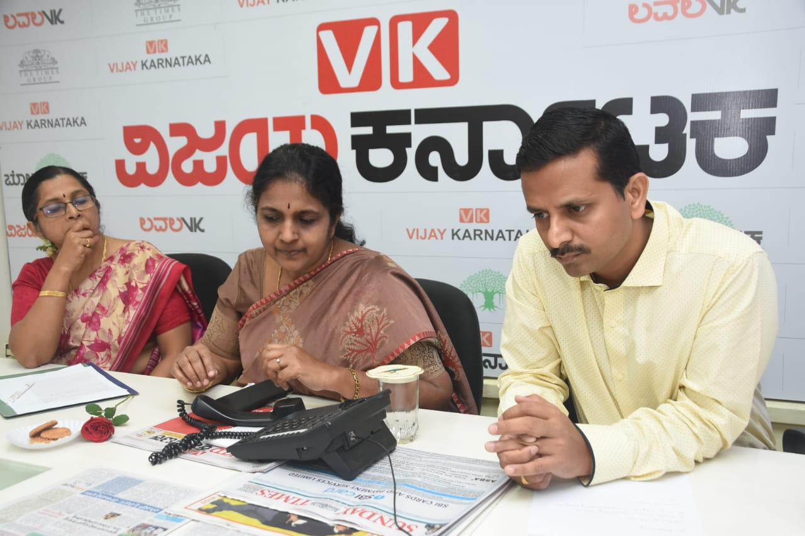

Figure 01**:** A glimpse of live phone in program by Dr. M Pushpavathi (Director, AIISH),Dr. N. Sreedevi and Dr. Sandeep.M with Vijay Karnataka news paper.

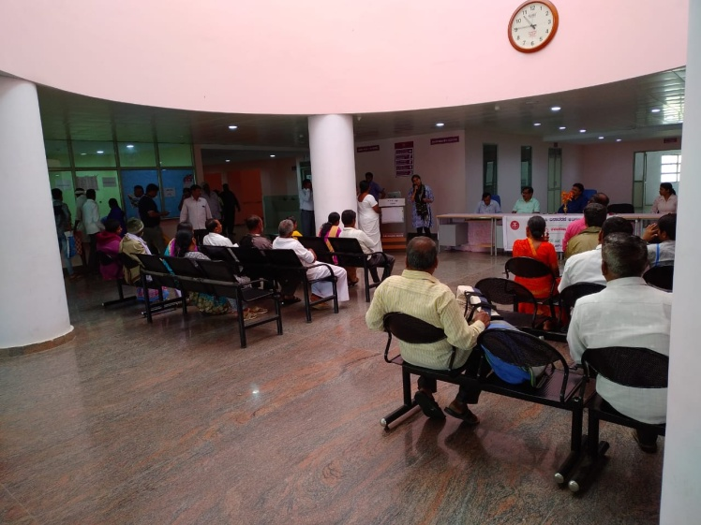

Figure 02**:** Orientation Program to general public at ESI Hospital, Mysuru by POCD staff.

.

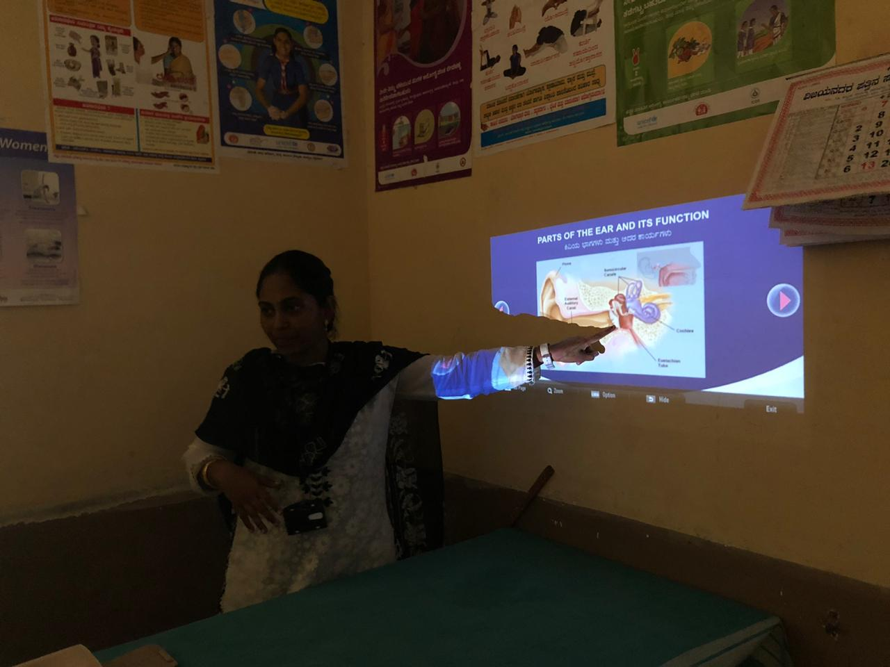

Figure 03: Orientation to expectant mothers at Cheluvambahospital,MysurubyAIISH staff.

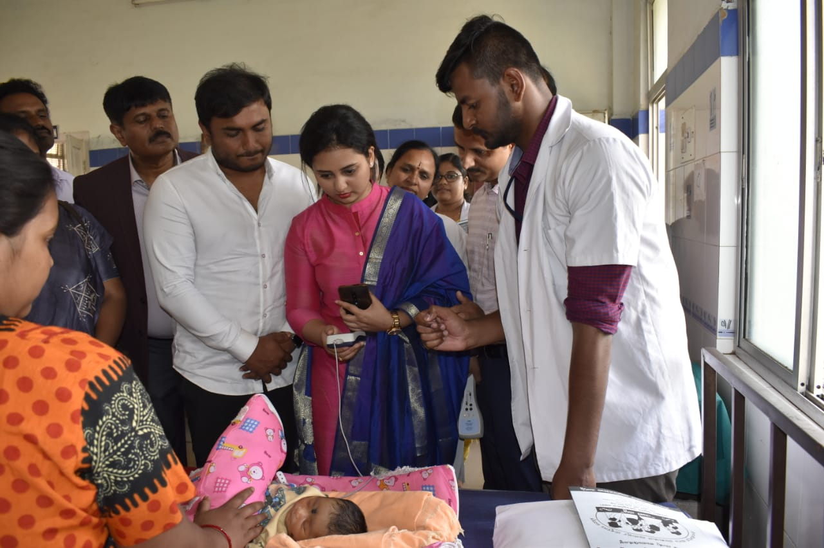

Figure:04: A glimpse of new born hearing screeningcarried out by Dean of KR hospital, Ms. Amulya Jagadeesh (Cine-serial actress), Dr.Venkatesh (District health officer) and Mr. Abdulla Moydeen) along with POCD staff at Cheluvamba hospital, Mysuru.

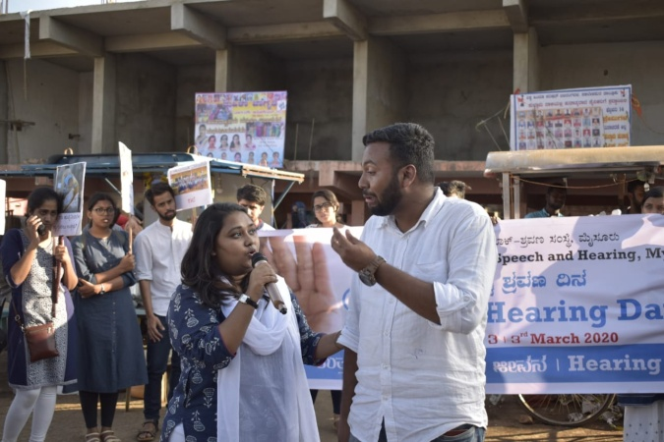

Figure 05: Glimpse of street paly by internship students at Hole-narasipura and Sakleshpura.

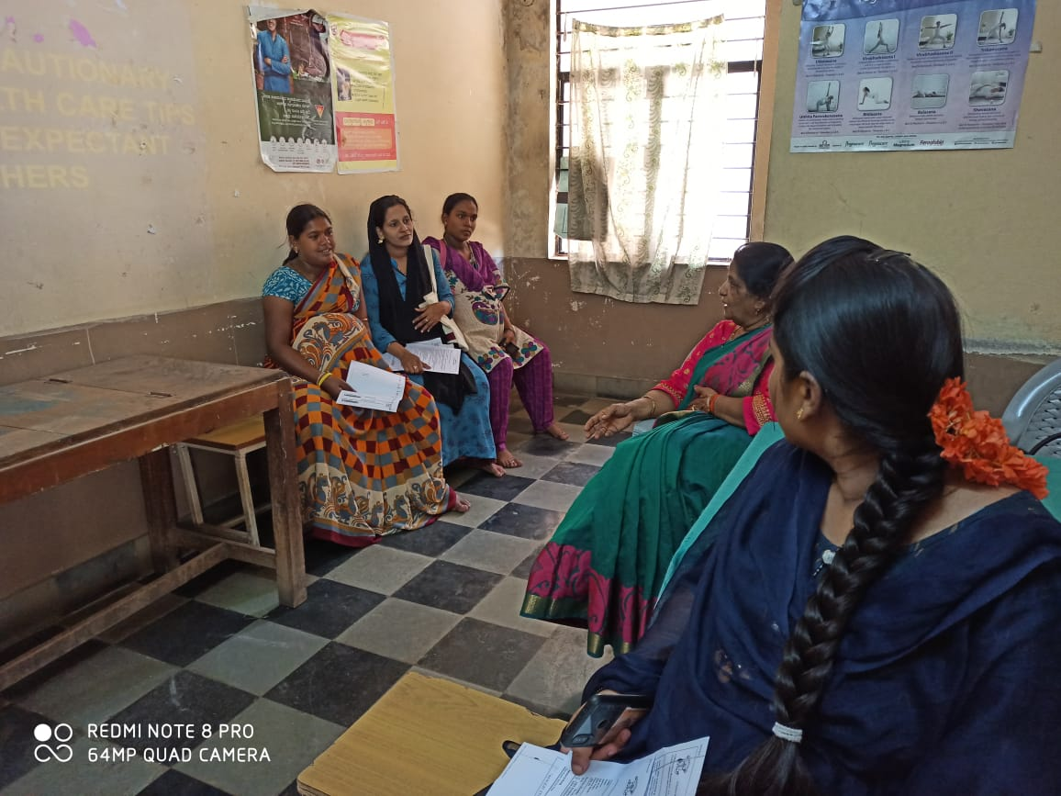

Figure 06: Orientation to expectant mothers at Cheluvambahospital,Mysuru by AIISH staff.

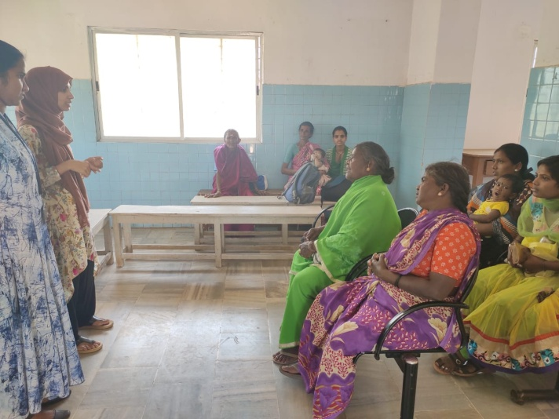

Figure 07: Orientation Program to general public at Akkihebbalu, Mandya by intern students

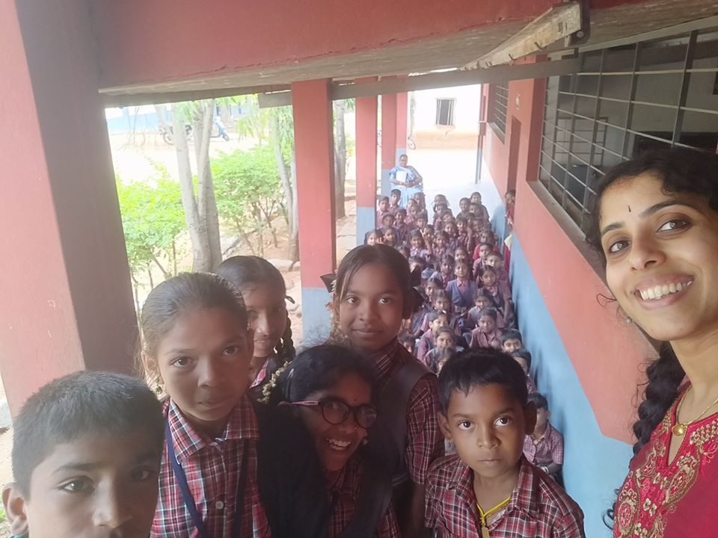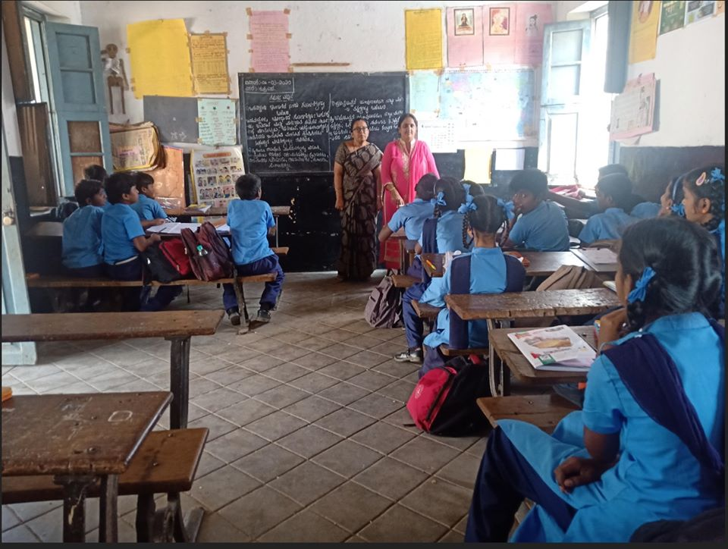

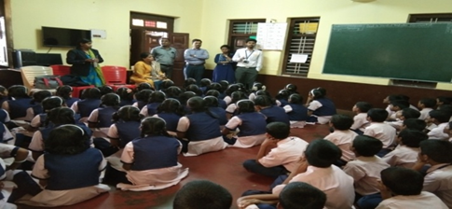Figure 08: Orientation Program to school students at different schools in Mysuru, by AIISH staff.

Figure 09: Orientation to students and teachers atAmbedhkar Residential School, Sagara by OSC Staff.

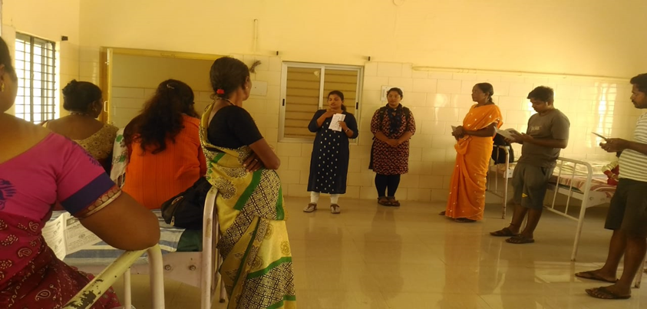

Figure 10: Orientation to General public at KR Pete, Mandya by OSC staff.

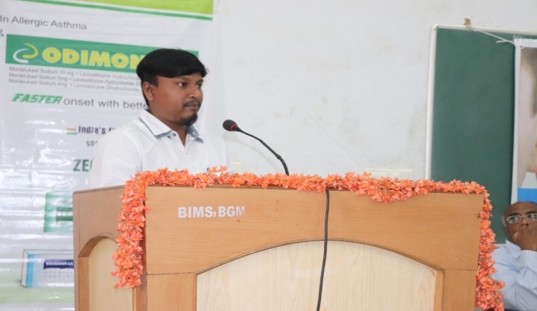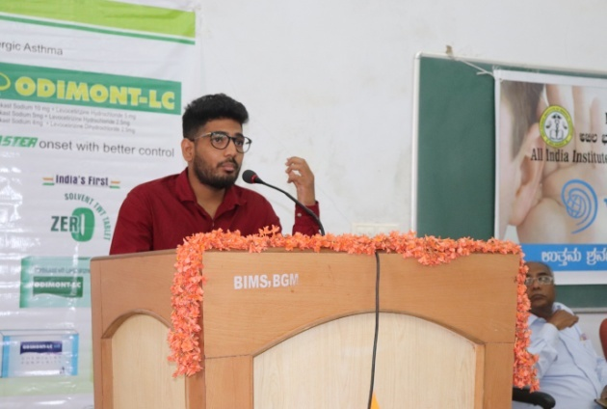

Figure 11: Orientation to Doctors and medical students at Belagavi institute of medical science, Belgravia by OSC staff

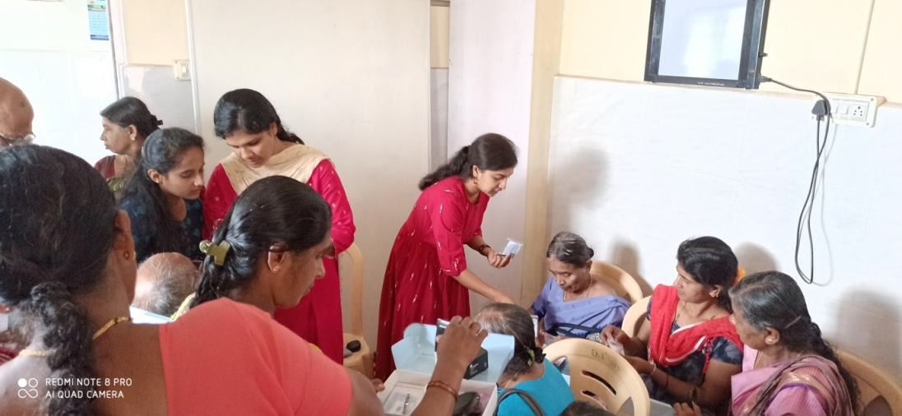

Figure 12: Orientation to individual with hearing impairment at Kodagu institute of medical science by OSC staff.

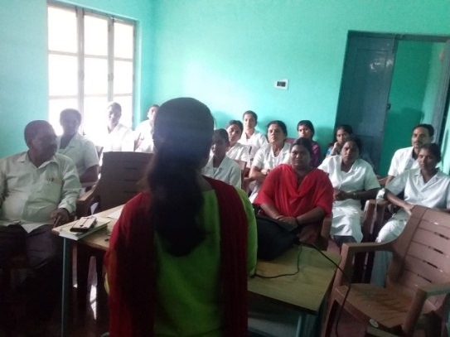

Figure 13: Orientation to doctors and nurses at Taluk hospital Yalendur by OSC staff.

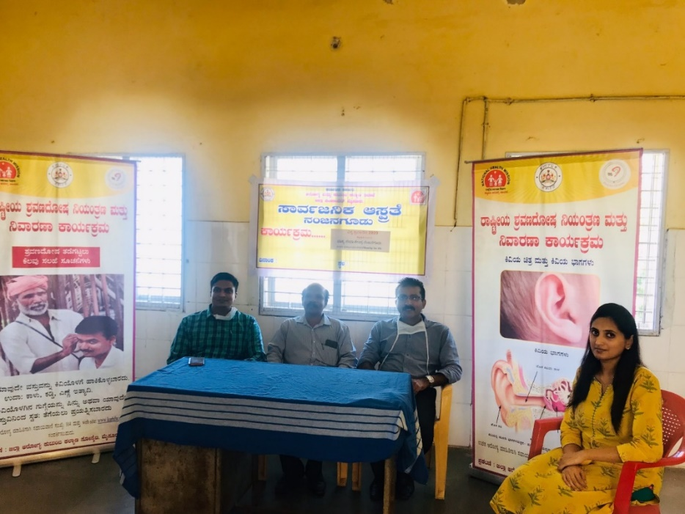

Figure 14: Orientation to the hospital staff at Nanjangud taluk hospital by OSC staff.

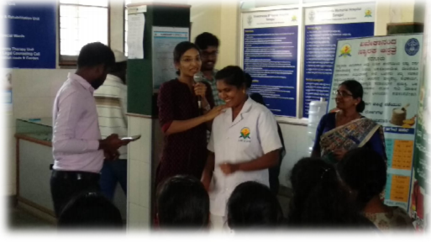

Figure 15: Orientation to General public at Swami Vivekanandamemorial hospital, Sarguru by OSC staff.

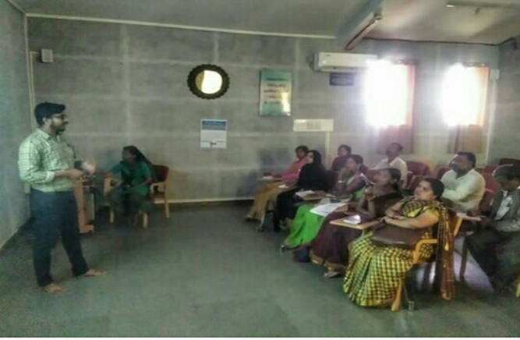

Figure 16: Orientation to school teachers at Swami Vivekananda memorial hospital, Sarguru by OSC staff.

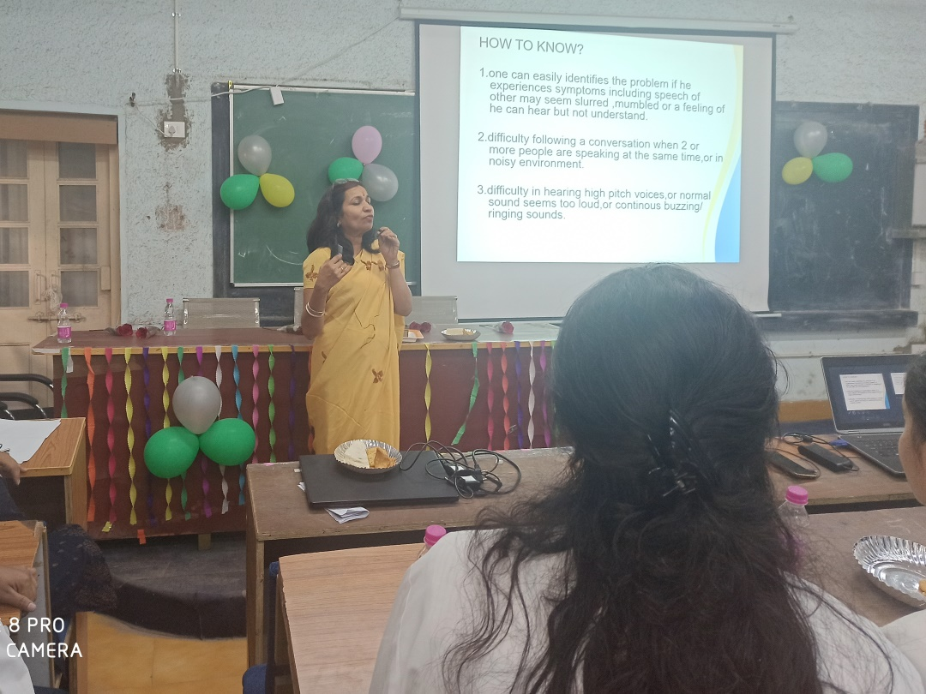

Figure 17: Orientation to Medical students at Netaji Subash Chandrabose medical college by staff.

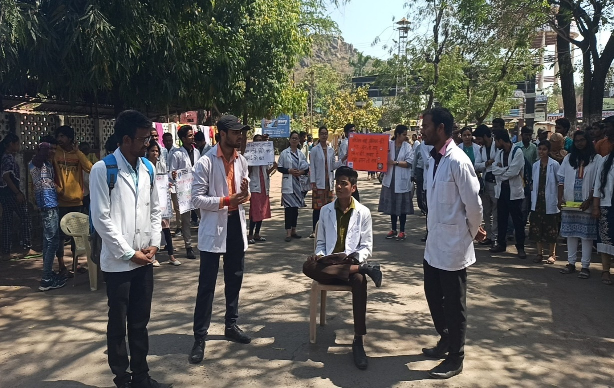

Figure 18: Glimpse of street play by BASPL students at Jabalpur.

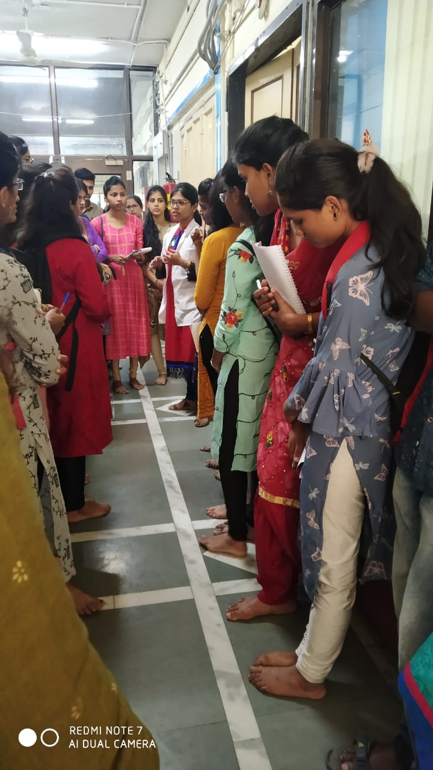

Figure 19: Orientation to nursing students at Grant Medical College and Sir JamshedjeeGroup of Hospitals, Mumbai by NBS staff.

1. No. of Seminars/ Conferences /Lectures /Workshop organized by the Dept:NIL
2. No. of Seminars/Conferences/Workshop attended by the staff of the Dept: 01

Table 1(e): Details of Seminars/ Conferences /Lectures /Workshop attended by staff of Dept. Of POCD

|  |  |  |  |
| --- | --- | --- | --- |
| S.No | Title of the program | Organizer /Date | Attended by |
|  | South India Regional Review Meeting,NPPCD Programme | NPPCD Program, Ministry of Health and Family Welfare 12.03.2020 & 13.03.2020 | Dr.N. Sreedevi(Professor of speech Sciences and Head, Dept of POCD) |

1. Any other:

Student clinical training: As part of human resource development, clinical training for Undergraduates [BASLP (Speech & Hearing)], Postgraduates [M.Sc. (SLP) &M.Sc. (AUD)] &BASLP (Interns) students on early identification, prevention &rehabilitation of communication disorders and Community based rehabilitation at OSCs were carried out. The details on the number of students who had undergone training are given below.

Table 1(f): Details of student clinical training program at Dept. of POCD

|  |  |
| --- | --- |
| **Internal (AIISH)** | |
| Class | No. of students posted |
| II BASLP students | 08 |
| I M.Sc. (SLP) students | 04 |
| I M.Sc. (Audiology) students | 10 |
| BASLP Internship students | 11 |
| **Total** | **33** |

External students: No students from other institute were posted in March 2020.

1. Staff/Student Enrichment Programs:02’

Table 1(g): The details of staff enrichment programs at Dept.of POCD in March 2020

|  |  |  |  |
| --- | --- | --- | --- |
| S.No | Date | Subject of the program | Presented by |
|  | 19.03.2020 | Recent Advancements in Hearing Aids | Mr. Yashwanth  (Aud Gr.I) |
|  | 20.03.2020 | Management of vestibular disorders. | Mr. Harish Kumar MK  (Aud Gr.I) |

1. Books / Manuals/**Pamphlets**published in the department: 08

Table 1(g):The details of pamphlets prepared at Dept of POCD in March 2020.

|  |  |  |  |  |
| --- | --- | --- | --- | --- |
| **S.No** | **Pamphlet Name** | **Language** | **Translated / Prepared By** | **Verification by POCD/ NBS/ OSC staff** |
| 1. | Articulation | Kannada | Internship students | Mr. Harish Kumar(Aud Gr.I) |
| 2. | Dementia | Kannada | Internship students | Ms. Ritu Venkatesh  (Aud Gr.I) |
| 3. | Dysarthria | Kannada | Internship students | Ms. Ritu Venkatesh  (Aud Gr.I) |
| 4. | Fluency disorders | Kannada | Internship students | Mr. Harish Kumar  (Aud Gr.I) |
| 5. | Intellectual Disability | Kannada | Internship students | Ms. Ritu Venkatesh(Aud Gr.I) |
| 6. | Know this to prevent communication disorders | Kannada | Internship students | Ms. Ritu Venkatesh(Aud Gr.I) |
| 7. | Stuttering | Kannada | Internship students | Mr. Harish Kumar (Aud Gr.I) |
| 8 | Autism | Kannada | Internship students | Ms. Anusha C (SLP Gr.I) |

1. **CLINICAL SERVICES**
2. General Clinical Services
3. Follow-up evaluation- Detailed evaluation

The newborns/infants referred during the newborn screening were followed up through telephone calls to parents/caregivers of infants. A complete test battery was administered for those clients who came for follow-up. The at-risk babies were monitored regularly by administering the speech-language & hearing checklist through phone call. The babies who are identified with delay in the milestones were referred to AIISH/concern NBS center for detailed evaluation.

Table 2 (a): Details of follow-up evaluation for communication disorders at Dept. of POCD, OSCand NBS centers.

|  |  |  |  |  |  |  |  |  |  |  |  |  |  |  |  |  |  |  |  |  |  |  |  |
| --- | --- | --- | --- | --- | --- | --- | --- | --- | --- | --- | --- | --- | --- | --- | --- | --- | --- | --- | --- | --- | --- | --- | --- |
| **Categories** | **AIISH + Cheluvamba** | **OSC-Sarguru** | **OSC-Sagara** | **OSC-Kalburgi** | **OSC-Hullahalli** | **OSC-Nanjanagudu** | **OSC-Akkihebbalu** | **OSC-K.R.Pete** | **OSC-Belagavi** | **OSC-Gumballi** | **OSC Kodagu** | **Lucknow** | **Cuttack** | **Imphal** | **Puducherry** | **Ranchi** | **Jabalpur** | **Ajmer** | **New Delhi** | **Mumbai** | **Kolar** | **Bhagalpur** | **Total** |
| **Normal** | 12 | 14 | 3 | 0 | - | 0 | - | - | 0 | - | 0 | - | - | 0 | - | - | - | - | - | 0 | - | - | - |
| **ENT disorders** | 0 | 0 | 0 | 0 | - | 0 | - | - | 0 | - | 0 | - | - | 0 | - | - | - | - | - | 0 | - | - | - |
| **Auditory Maturation delay** | 0 | 0 | 0 | 0 | - | 0 | - | - | 0 | - | 0 | - | - | 0 | - | - | - | - | - | 0 | - | - | - |
| **Hearing impairment** | 0 | 0 | 0 | 0 | - | 0 | - | - | 0 | - | 0 | - | - | 0 | - | - | - | - | - | 0 | - | - | - |
| **Multiple Disorder** | 0 | 0 | 0 | 0 | - | 0 | - | - | 0 | - | 0 | - | - | 0 | - | - | - | - | - | 0 | - | - | - |
| **Incomplete testing** | 0 | 0 | 0 | 0 | - | 0 | - | - | 0 | - | 0 | - | - | 0 | - | - | - | - | - | 0 | - | - | - |
| **Total** | **0** | 14 | **3** | 0 | **-** | **0** | **-** | **-** | **0** | **-** | **0** | - | - | **0** | - | - | - | - | - | **0** | - | - | - |

*Note: Details of Follow-up evaluation at OSC Centers and NBS Centers are not available because of lockdown due to the outbreak of COVID 19*

|  |  |  |  |  |  |  |  |  |  |  |  |  |  |  |  |  |  |  |  |  |  |  |  |
| --- | --- | --- | --- | --- | --- | --- | --- | --- | --- | --- | --- | --- | --- | --- | --- | --- | --- | --- | --- | --- | --- | --- | --- |
| **Categories** | **AIISH + Cheluvamba** | **OSC-Sarguru** | **OSC-Sagara** | **OSC-Kalburgi** | **OSC-Hullahalli** | **OSC-Nanjanagudu** | **OSC-Akkihebbalu** | **OSC-K.R.Pete** | **OSC-Belagavi** | **OSC-Gumballi** | **OSC Kodagu** | **Lucknow** | **Cuttack** | **Imphal** | **Puducherry** | **Ranchi** | **Jabalpur** | **Ajmer** | **New Delhi** | **Mumbai** | **Kolar** | **Bhagalpur** | **Total** |
| **Speech and language disorders** | 0 | 0 | 0 | 0 | - | 0 | - | - | 0 | - | 0 | - | - | 0 | - | - | - | - | - | - | - | - | - |
| **Total** | **0** | 0 | **0** | 0 | **-** | **0** | **-** | **-** | **0** | **-** | **0** | - | - | **0** | - | - | - | - | - | - | - | - | - |

Table 2(b): Details of follow-up evaluation for speech and language disorders at Dept. of POCD, OSC and NBS centers

*Note: Details of Follow-up evaluation-at OSC Centers and NBS Centers are not available because of lockdown due to the outbreak of COVID 19*

Table 2(c): Details of Phone follow-up done at Mysuru Centre (POCD), OSC Centers and NBS Centers in March 2020.

|  |  |  |  |
| --- | --- | --- | --- |
| **Categories** | **Mysuru Centre (POCD)** | **OSC Centres** | **NBS Centres** |
| Normalspeech, language & hearing milestones | 40 | 14 | 03 |
| Referred for detailed evaluation | 01 | 00 | 00 |
| **Total Phone follow up** | **41** | **14** | **03** |

*Note: Details of Follow-up evaluation- Phone follow-up at Mysuru Centre (POCD), OSC Centers and NBS Centers are not available because of lockdown due tothe outbreak of COVID 19*

1. Specialized Clinical services: Bedside screening for speech, language, cognition & swallowing disorders

Table 2(d): Details of bedside screening at KR Hospital in March 2020

|  |  |  |  |  |  |  |  |  |
| --- | --- | --- | --- | --- | --- | --- | --- | --- |
| **Hospital** | **Total screened** | | | **Total referred** | | | | **Clinically Normal** |
| **Male** | **Female** | **Total** | **Cognitive Communication disorders(CCD)** | **Motor Speech disorders(MSD)** | **Swallowing disorders(SD)** | **Multiple disorders** |
| **K R Hospital** | 01 | 01 | 02 | 02 | 00 | 00 | 00 | 00 |
| **Total** | 01 | 01 | 02 | 02 | 00 | 00 | 00 | 00 |
| **Grand total** | **02** | | | **02** | | | |  |

*Note: Bedside evaluation has been temporarily halted from 09.03.2020 due to the outbreak of COVID 19.The data given above the table are only till 09.03.2020.*

1. **EXTENSION ACTIVITIES**
2. Newborn screening for Communication Disorders

The department of POCD is actively involved in carrying out various extension activities such as screening, diagnostic and rehabilitation services outside the institute campus. The activities include newborn/infant screening, screening of school children, screening of elderly citizens, screening of industrial workers, conducting camps and also clinical services offered at the outreach service centers of AIISH.

Table 3(a): Details of the newborn hearing screening at Mysuru hospitals, OSC and NBS centers(only 11 days due to Lock down)

|  |  |  |  |  |  |  |  |  |
| --- | --- | --- | --- | --- | --- | --- | --- | --- |
| **SN** | **Hospitals/Immunization Centers** | **Total births** | **Total No. Screened** | | | **Total No. at risk** | | |
| **Male** | **Female** | **Total** | **Male** | **Female** | **Total** |
|  |  | **AIISH- Mysuru** | | | | | |  |
|  | KR Hospital (KRH)- Cheluvamba | -- | 165 | 143 | 308 | 04 | 05 | 09 |
|  | Kamakshi Hospital (KH) | -- | 33 | 29 | 62 | 02 | 01 | 33 |
|  | Combined Hospital (CH) | -- | 12 | 17 | 29 | 00 | 00 | 12 |
|  | Mission Hospital (MH) | -- | 10 | 07 | 17 | 00 | 00 | 10 |
|  | S.M.T.D.H Hospital | -- | 11 | 09 | 20 | 00 | 00 | 11 |
|  | Ashwini Nursing Home (ANH) | -- | 01 | 03 | 04 | 00 | 00 | 01 |
|  | Shree Devi Nursing Home (SNH) | -- | 04 | 03 | 07 | 00 | 00 | 04 |
|  | Gopala Gowda Shanthaveri Memorial Hospital (GGSMH) | -- | 00 | 04 | 04 | 00 | 00 | 00 |
|  | Mahadeshwara Nursing Home (MNH) | -- | 08 | 05 | 13 | 00 | 00 | 08 |
|  | Sigma Hospital (SH) | -- | 14 | 10 | 24 | 00 | 00 | 14 |
|  | Brindavan Hospital | -- | 09 | 09 | 18 | 00 | 00 | 09 |
|  | **Total (Mysuru hospitals)** | **--** | **267** | **239** | **506** | **06** | **06** | **111** |
| **Screening at OSC Centers** | | | | | | | | |
| 1. 18. | Sub-divisional hospital, K R Nagar Taluk | **--** | **--** | **--** | **--** | **--** | **--** | **--** |
| 1. 19. | Sub-divisional hospital, T NarsipuraTaluk | **--** | **--** | **--** | **--** | **--** | **--** | **--** |
| 1. 20. | Sub-divisional Hospital, SagaraTaluk | 210 | 87 | 77 | 164 | 02 | 02 | 04 |
|  | Vivekananda Memorial hospital, NBS, H. D. kote Sarguru | 206 | 60 | 72 | 132 | 05 | 04 | 09 |
| Taluk Hospital, H. D. Kote- Immunization | - | 22 | 26 | 48 | 02 | 01 | 03 |
|  | District Hospital, Kalaburagi | **--** | **--** | **--** | **--** | **--** | **--** | **--** |
|  | Taluk Hospital, Nanjangud | **--** | **--** | **--** | **--** | **--** | **--** | **--** |
| Community Health Centre (CHC), Hullahalli | 01 | 00 | 01 | 01 | 00 | 00 | 00 |
| 1. 22. | Karuna Trust Hopital, Gumballi | 07 | 03 | 04 | 07 | 00 | 00 | 00 |
| Community Health Centre (CHC), Santhemarahalli | 02 | 01 | 01 | 02 | 00 | 00 | 00 |
| 19 | Yelandur, Taluk Hospital | 15 | 08 | 07 | 15 | 00 | 00 | 00 |
| 1. 23. | Taluk General Hospital, KR. Pete | 00 | 18 | 14 | 32 | 00 | 00 | 00 |
| Primary Health Centre (PHC), Akkihebbalu | 178 | 100 | 78 | 178 | 02 | 05 | 07 |
|  | Kodagu Institute of Medical Science ,Kodagu | **--** | **--** | **--** | **--** | **--** | **--** | **--** |
|  | Belagavi Institute of Medical Science, Belagavi | 210 | 87 | 77 | 164 | 02 | 02 | 04 |
|  | **Total (OSCs)** | **829** | **386** | **357** | **743** | **13** | **14** | **27** |
| **Screening at NBS Centers** | | | | | | | | |
| 1. 25. | Sri Ramachandra Bhanj Medical College and Hospital (SCB MCH), Cuttack | **--** | **--** | **--** | **--** | **--** | **--** | **--** |
| 1. 26. | Regional Institute of Medical Sciences (RIMS), Imphal | 155 | 55 | 44 | 155 | 00 | 00 | 00 |
| 27. | Janana Hospital & JLNMCH, Ajmer | **--** | **--** | **--** | **--** | **--** | **--** | **--** |
| 1. 28. | JIPMER, Puducherry | **--** | **--** | **--** | **--** | **--** | **--** | **--** |
| 1. 29. | Netaji Subhash Chandra Bose Medical College (NSCB), Jabalpur | **--** | **--** | **--** | **--** | **--** | **--** | **--** |
| 1. 30. | Rajendra Institute of Medical Sciences, Baritayu, Ranchi | **--** | **--** | **--** | **--** | **--** | **--** | **--** |
| 1. 31. | Kings George’s Medical University, Lucknow | **--** | **--** | **--** | **--** | **--** | **--** | **--** |
|  | JLNMCH, Bhagalpur | **--** | **--** | **--** | **--** | **--** | **--** | **--** |
|  | All India Institute of Physical Medicine and Rehabilitation (AIIPMR), Mumbai | 03 | 03 | 00 | 03 | 00 | 00 | 00 |
|  | Post Graduate Institute of Medical Education and Research (PGIMER), New Delhi | **--** | **--** | **--** | **--** | **--** | **--** | **--** |
|  | **Total (NBS centres)** | **158** | **58** | **44** | **158** | **00** | **00** | **00** |
|  | **Overall Total (Mysuru+OSC+NBS)** | **987** | **711** | **640** | **1407** | **19** | **20** | **138** |

**\****New born hearing screening program has been temporary suspended from 17.03.2020 due to the outbreak of COVID 19. The NBS data of various OSC and NBS centers are not available due to lockdown.*

1. **School screening:**

Table 3 (b): Screening for communication disorders at schools/Anganwadi by OSC staff.

|  |  |  |  |  |  |  |
| --- | --- | --- | --- | --- | --- | --- |
| **S.No** | **Date** | **Name of the School/Anganwadi** | **Total screened** | **Total identified with communication disorders** | | |
| **Ear related disorders** | **Hearing loss** | **Speech language disorders** |
| 1. | 03.03.2020 | Ambedhkar Residential school –OSC Sagara | 142 | 08 | 03 | 11 |
| 2. | 04.03.2020 | BavaliAnganwadi OSC Sarguru | 36 | 00 | 00 | 00 |
| 3. | 04.03.2020 | PeriyapatnaAnganwadiOSC Sarguru | 37 | 01 | 00 | 00 |
| 4. | 04.03.2020 | Anganwadi, Hunsuru, Sarguru | 50 | 00 | 00 | 00 |
|  | **Total** | | **265** | **09** | **03** | **11** |

*Note:the data done of school screening done at Nanjangud school are not available because of the lockdown due to outbreak of COVID-19*

**4) CLINICAL SERVICES AT OUTREACH SERVICE CENTERS (OSCs)**

The clinical activities are not only restricted to in and around Mysore, but also extended to rural areas where facilities for clinical services for persons with communication disorders were comparatively less. Currently,08 OSCs (01-VMH, Sarguru, HD Kote; 02-Sub-divisional taluk hospital at Sagarataluk, Shivamogga District; 03-Nanjangudu, Mysuru district; 04-K.R.Pete, Mandya district, 05-Karuna trust, Gumballi, Chamarajanagara district, 06-GIMS, Kalburgi, 07-BIMS, Belagavi and 08-KOIMS, Kodagu were initiated to meet the objective of extending the services of the institute to rural areas. The OSCs are functioning as a well-equipped unit for screening, diagnostics and therapeutic services for persons with communication disorders. The services include screening, diagnostic and rehabilitation which includes newborn/infant screening, screening of school children, Speech and Language evaluation, Audiological evaluation, ENT evaluation, Speech-Language therapy, issue of free body level hearing aids and ear molds, and counseling and guidance to individuals with communication disorders.

Table 4 (a): Details of clients identified with communication disorders at the OSCs

|  |  |  |  |  |  |  |
| --- | --- | --- | --- | --- | --- | --- |
| **OSC** | **Total Registered** | **ENT Evaluation**  **Registered=37** | | | **Hearing Evaluation**  **Registered=236** | |
| **Normal (Ear Wise)** | **Disorder (Ear wise)** | **ENT related**  **Others** | **Normal (Ear Wise)** | **Disorder (Ear wise)** |
| Sub-divisional hospital, K R Nagar Taluk | -- | -- | -- | -- | -- | -- |
| Sub-divisional hospital,  T-NarsipuraTaluk | -- | -- | -- | -- | -- | -- |
| Taluk Hospital, Nanjangud | 29 | -- | -- | -- | 26 | 28 |
| Primary Health Centre (PHC), Hullahalli | 37 | 13 | 41 | 10 | 02 | 08 |
| Primary Health Centre (PHC), Akkihebbalu | **--** | **--** | **--** | **--** | **--** | **--** |
| Taluk General Hospital, KR Pete | 11 | 00 | 00 | 00 | 02 | 06 |
| Primary Health Centre (PHC), Gumballi | **--** | **--** | **--** | **--** | **--** | **--** |
| Community Health Centre (CHC), Santhemarahalli | -- | -- | -- | -- | -- | -- |
| Sub-divisional Hospital (PHC), Sagara | 17 | 00 | 00 | 00 | 06 | 10 |
| VMH, Sarguru | 20 | 00 | 00 | 00 | 04 | 20 |
| Belgavi institute of medical sciences BIMS | 110 | **--** | **--** | **--** | 74 | 94 |
| Gulberga Institute of medical science, Kalburgi | -- | -- | -- | -- | 56 | 110 |
| KoIMS-TH, Madikeri,Kodagu | 00 | 00 | 00 | 00 | 10 | 15 |
| **Total** | **224** | **13** | **41** | **10** | **180** | **291** |

*Note: The Assessment and managementactivities at OSC centers have been temporarily suspended from the second week March 2020;due to the outbreak of COVID 19*.*Hence the data are not available due to lockdown.*

Table 4(b): Details of clients identified withspeech disorders at the OSCs

|  |  |  |
| --- | --- | --- |
| **OSC** | **Speech & Language Evaluation**  **Registered= 64** | |
| **Normal (Individuals)** | **Disorder (Individuals)** |
| Sub-divisional hospital, K R Nagar Taluk | **--** | **--** |
| Sub-divisional hospital, T NarsipuraTaluk | -- | -- |
| Taluk Hospital, Nanjangud | 00 | 02 |
| Primary Health Centre (PHC), Hullahalli | 00 | 00 |
| Primary Health Centre (PHC), Akkihebbalu | -- | -- |
| Taluk General Hospital, KR Pete | 00 | 07 |
| Primary Health Centre (PHC), Gumballi | -- | -- |
| Community Health Centre (CHC), Santhemarahalli | -- | -- |
| Sub-divisional Hospital (PHC), Sagara | 00 | 09 |
| VMH, Sarguru | 01 | 07 |
| Belgavi institute of medical sciences BIMS | 00 | 26 |
| GIMS, Kalburgi | 00 | 07 |
| KoIMS-TH, Madikeri, ,Kodagu | 00 | 05 |
| **Total** | **01** | **63** |

*Note: The Assessment and management activities at OSC centers have been temporarily suspended from the second week of March 2020; due to the outbreak of COVID 19*.*Hence the data are not available due to lockdown.*

Table 4 (c): Details ofclients followed up for hearing evaluation at OSCs.

|  |  |  |  |  |  |  |
| --- | --- | --- | --- | --- | --- | --- |
| **OSC** | **Total Follow up** | **ENT Evaluation =14** | | | **Hearing Evaluation=15** | |
| **Normal (Ear Wise)** | **Disorder (Ear wise)** | **ENT related**  **Others** | **Normal (Ear Wise)** | **Disorder (Ear wise)** |
| Sub-divisional hospital, K R Nagar Taluk | -- | -- | -- | -- | -- | -- |
| Sub-divisional hospital, T NarsipuraTaluk | -- | -- | -- | -- | -- | -- |
| Taluk Hospital, Nanjangud | 14 | -- | -- | -- | 00 | 14 |
| Primary Health Centre (PHC), Hullahalli | 14 | 04 | 20 | 02 | 00 | 02 |
| Primary Health Centre (PHC), Akkihebbalu | -- | -- | -- | -- | -- | -- |
| Taluk General Hospital, KR Pete | 02 | 00 | 00 | 00 | 00 | 02 |
| Primary Health Centre (PHC), Gumballi | -- | -- | -- | -- | -- | -- |
| Community Health Centre (CHC), Santhemarahalli | -- | -- | -- | -- | -- | -- |
| Sub-divisional Hospital (PHC), Sagara | 01 | 00 | 00 | 00 | 00 | 02 |
| VMH, Sarguru | 03 | 00 | 00 | 00 | 01 | 03 |
| Belgavi institute of medical sciences BIMS | 00 | 00 | 00 | 00 | 00 | 00 |
| GIMS, Kalburgi | 04 | -- | -- | -- | -- | 04 |
| KoIMS-TH, MadikeriTaluk,Kodagu | 00 | 00 | 00 | 00 | 01 | 00 |
| **Total** | **38** | **04** | **20** | **02** | **02** | **27** |

*Note: The Assessment and management activities at OSC centers have been temporarily suspended from the second week March 2020; due to the outbreak of COVID 19*.*Hence the data are not available due to lockdown*

Table 4(d): Details of clients followed up for speech and language disorders at OSCs in March 2020.

|  |  |  |
| --- | --- | --- |
| **OSC** | **Speech & Language Evaluation=02** | |
| **No. of Normal individual** | **No. of Disordered Individuals** |
| Sub-divisional hospital, K R Nagar Taluk | -- | -- |
| Sub-divisional hospital, T NarsipuraTaluk | -- | -- |
| Taluk Hospital, Nanjangud | 00 | 00 |
| Primary Health Centre (PHC), Hullahalli | 00 | 00 |
| Primary Health Centre (PHC), Akkihebbalu | -- | -- |
| Taluk General Hospital, KR Pete | 00 | 01 |
| Primary Health Centre (PHC), Gumballi | -- | -- |
| Community Health Centre (CHC), Santhemarahalli | -- | -- |
| Sub-divisional Hospital (PHC), Sagara | 00 | 00 |
| VMH, Sarguru | 00 | 01 |
| Belgavi institute of medical sciences BIMS | 00 | 00 |
| GIMS, Kalburgi | -- | -- |
| KoIMS-TH, MadikeriTaluk,Kodagu | 00 | 00 |
| **Total** | **00** | **02** |

*Note: The Assessment and management activities at OSC centers have been temporarily suspended from the second week due to the outbreak of COVID 19*.*Hence the data are not available due to lockdown*

Table 4 (e): Total number ofclients identified with different types of communication disorders at OSCs in March 2020.

|  |  |  |  |  |  |  |  |  |  |  |  |  |
| --- | --- | --- | --- | --- | --- | --- | --- | --- | --- | --- | --- | --- |
| **Type of Disorders** |  |  | | **OSC** | | | | |  |  |  |  |
| TalukHospital,Nanjangud | Primary Health Centre (PHC), Hullahalli | | | Primary Health Centre (PHC), Akkihebbalu | Taluk General Hospital, KR Pete | Primary Health Centre (PHC), Gumballi | Sub-divisional Hospital, Sagara (PHC) Taluk | VMH,  Sarguru | BIMS Belgavi | GIMS, Kalburgi | KoIMS,  Kodagu |
|  |  | | **Hearing disorders (Ear-wise data)** | | | | | | | | | |
| Normal | 26 | -- | | | -- | 04 | -- | 06 | 04 | 74 | 56 | 10 |
| Conductive | 04 | -- | | | -- | 04 | -- | 02 | 20 | 28 | 11 | 02 |
| Sensori- neural | 20 | -- | | | -- | 04 | -- | 06 | 12 | 68 | 57 | 16 |
| Mixed | 04 | -- | | | -- | 04 | -- | 01 | 05 | 15 | 14 | 01 |
| Profound | 00 | -- | | | -- | 00 | -- | 01 | 01 | 11 | 28 | 01 |
| Incomplete | 00 | -- | | | -- | 00 | -- | 00 | 00 | 168 | 32 | 18 |
| **Aud-Total (ears)** | 54 | **--** | | | **--** | 16 | **--** | 16 | 42 | 74 | 198 | 48 |
| **Aud-Total (Individuals)** | 27 | **--** | | | **--** | 08 | **--** | 08 | 21 | 37 | 99 | 24 |
|  |  | | **Speech- Language disorders** | | | | | | | | | |
| Voice | 00 | -- | | | -- | 02 | -- | 00 | 01 | 01 | 02 | 02 |
| Fluency | 00 | -- | | | -- | 00 | -- | 00 | 01 | 03 | 02 | 00 |
| Articulation disorders | 00 | -- | | | -- | 00 | -- | 00 | 01 | 03 | 01 | 02 |
| Language disorders | 02 | -- | | | -- | 05 | -- | 09 | 04 | 19 | 02 | 01 |
| Normal | 02 | -- | | | -- | 07 | -- | 09 | 07 | 84 | 07 | 05 |
| **Total (Individuals)** | **04** | **--** | | | **--** | **14** | **--** | **18** | **14** | **110** | **14** | **02** |

*Note: The Assessment and management activities at OSC centers have been temporarily suspended from the second week due to the outbreak of COVID 19*.*Hence the data are not available due to lockdown.*

Table 4(f): Details of clients followed up with different types of communication disorders across OSCs.

|  |  |  |  |  |  |  |  |  |  |  |  |
| --- | --- | --- | --- | --- | --- | --- | --- | --- | --- | --- | --- |
| **Type of Disorders** |  |  | | **OSC** | | | |  |  |  |  |
| Taluk Hospital Nanjangud | Primary Health Centre (PHC), Hullahalli | Primary Health Centre (PHC), Akkihebbalu | | Taluk General Hospital, KR Pete | Primary Health Centre (PHC), Gumballi | Sub-divisional Hospital,  Sagara  (PHC) Taluk | VMH,  Sarguru | BIMS | GIMS, Kalburgi | KoIMS  Kodagu |
|  |  | **Hearing disorders (Ear-wise data)** | | | | | |  |  |  |  |
| Normal | 00 | -- | -- | | 00 | -- | 00 | 01 | 00 | 00 | 00 |
| Conductive | 00 | -- | -- | | 00 | -- | 00 | 03 | 00 | 00 | 00 |
| Sensori- neural | 24 | -- | -- | | 02 | -- | 02 | 00 | 00 | 02 | 02 |
| Mixed | 00 | -- | -- | | 00 | -- | 00 | 00 | 00 | 02 | 00 |
| Profound | 00 | -- | -- | | 00 | -- | 00 | 00 | 00 | 00 | 00 |
| **Aud-Total (ears)** | **24** | **--** | **--** | | **02** | **--** | **02** | **04** | **00** | **04** | **02** |
| **Aud-Total (Individuals)** | **12** | **--** | **--** | | **01** | **--** | **01** | **02** | **00** | **02** | **01** |
|  |  | **Speech-language disorders** | | | | | | |  |  |  |
| Voice | 00 | -- | -- | | 01 | -- | 00 | 00 | 00 | 00 | 00 |
| Fluency | 00 | -- | -- | | 00 | -- | 00 | 00 | 00 | 00 | 00 |
| Articulation disorders | 00 | -- | -- | | 00 | -- | 00 | 00 | 00 | 00 | 00 |
| Language disorders | 00 | -- | -- | | 00 | -- | 00 | 01 | 00 | 00 | 00 |
| **Sp&Lg -Total (Individuals)** | **00** | **--** | **--** | | **01** | **--** | **00** | **01** | **0000** | **00** | **00** |

*Note: The Assessment and management activities at OSC centers have been temporarily suspended from the second week due to the outbreak of COVID 19*.*Hence the data are not available due to lockdown.*

1. **Rehabilitation services at OSCs.**

Table 4 (g): Details ofRehabilitation services provided at Outreach service centers in March 2020.

|  |  |  |  |  |
| --- | --- | --- | --- | --- |
| **OSC** | **Hearing Aids Dispensed** | **Speech-language therapy** | | **Medical Line of Treatment** |
| No. of clients | No. of sessions |
| Taluk Hospital, Nanjangud | 10 | 07 | 15 | 00 |
| Primary Health Centre (PHC), Hullahalli | 07 | 00 | 00 | 00 |
| Primary Health Centre (PHC), Akkihebbalu | -- | -- | -- | -- |
| Taluk General Hospital, KR Pete | 01 | 03 | 17 | 00 |
| Primary Health Centre (PHC), Gumballi | -- | -- | -- | -- |
| Community Health Centre (CHC), Santhemarahalli | -- | -- | -- | -- |
| Sub-divisional Hospital, Sagara (PHC) Taluk | 00 | 14 | 42 | 00 |
| VMH, Sarguru | 02 | 09 | 24 | 00 |
| Belagavi institute of medical sciences BIMS | 00 | 03 | 15 | 00 |
| GIMS, Kalburgi | 00 | 00 | 00 | 00 |
| KoIMS-TH, Madikeri,Kodagu | 00 | 10 | 29 | 00 |
| **Total** | **20** | **46** | **142** | **00** |

*Note: The Assessment and management activities at OSC centers have been temporarily suspended from the second week due to the outbreak of COVID 19*.*Hence the data are not available due to lockdown.*

**5) SPECIAL ACTIVITIES**

1. Library and information services:Dr. Sandeep Maruthy has been serving as the chairperson of Library committeeand Dr. N Sreedevi (Head of the Dept. of POCD) is a member of library committee.
2. Awards and honors received by staff of POCD: 1) AIISH has received certificate for appreciationin contribution for the World hearing day observation from International association of communication science and disorders, Switzerland.

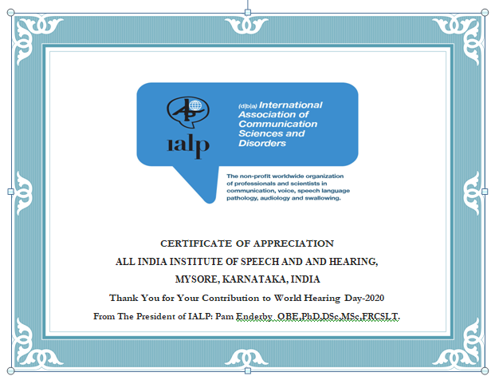

Figure (20): The certificate of appreciation for the contribution for the World hearing day observation from International association of communication science and disorders,Switzerland

1. AIISH has received certificate for appreciation in contribution for the World hearing day observation from WHO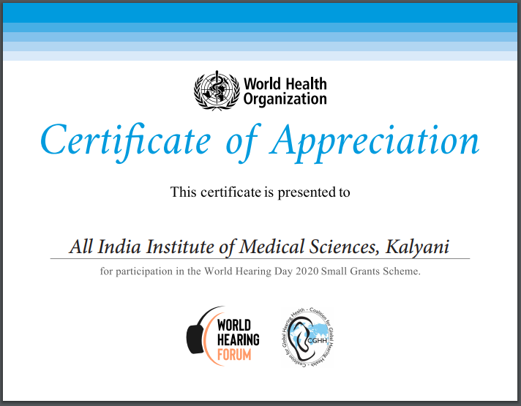

Figure (21): The certificate of appreciation for the contribution for the World hearing day observation from World health organization.

**6) MAJOR EVENTS OF THE MONTH:** Observed world hearing day on 3.3.2020 with a series of month long various programs.

1. A new born hearing screening program was conducted at Cheluvamba hospital, Mysuru byDR Nanjaraj, Dean of KR Hospital,MS. AmulyaJagadeesh( Cine actress),Dr.Venkatesh(District health officer) and Mr.AbdullaMoydeen, successfully rehabilitated candidate of AIISH, along with AIISH staff on 03.03.2020

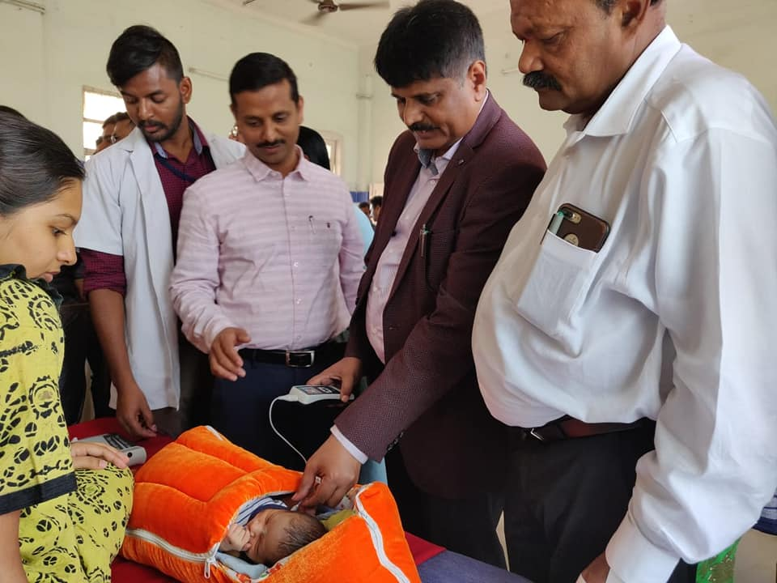

Figure (22): A glimpse of new born hearing screening program conducted at Cheluvamba hospital

1. Radio broadcast of speech on early identification and prevention of different communication disorders by AIISH staff Mysore Akashavani, 100.6 MHz

Table 6(a): Details of speech broadcasted by AIISH faculty at All India Radio.

|  |  |  |  |
| --- | --- | --- | --- |
| S.NO | Date | Topic of the speech | Delivered by |
| 1. | 08.03.2020 | Introduction to Speech and Hearing Disorders | Dr. M Pushpavathi ( Director, AIISH)&Dr. M Sandeep ( Associateprofessor in Audiology) |
| 2. | 15.03.2020 | Hearing loss in school children | Dr.K Rajalakshmi(Professor in Audiology) |
| 3. | 22.03.2020 | Cochlear implants and welfare schemes | Dr.P Manjula(Professor in Audiology) |
| 4. | 29.03.2020 | Early identification of hearing loss | Dr. Ajith Kumar U(Professor in Audiology) |

1. Interview program of Dr. M. Pushpavathi(Director, AIISH) and Dr. Sandeep M (Associate professor in Audiology) were released in TV-9 TV channel on 02.03.2020 and 06.02.2020.

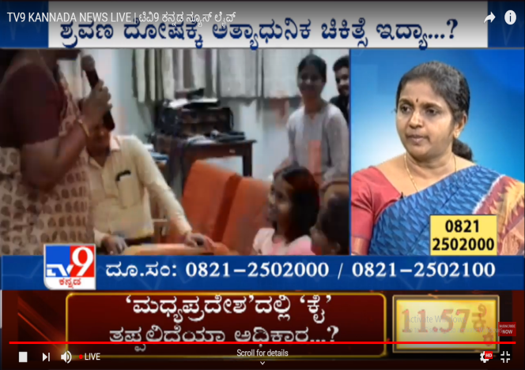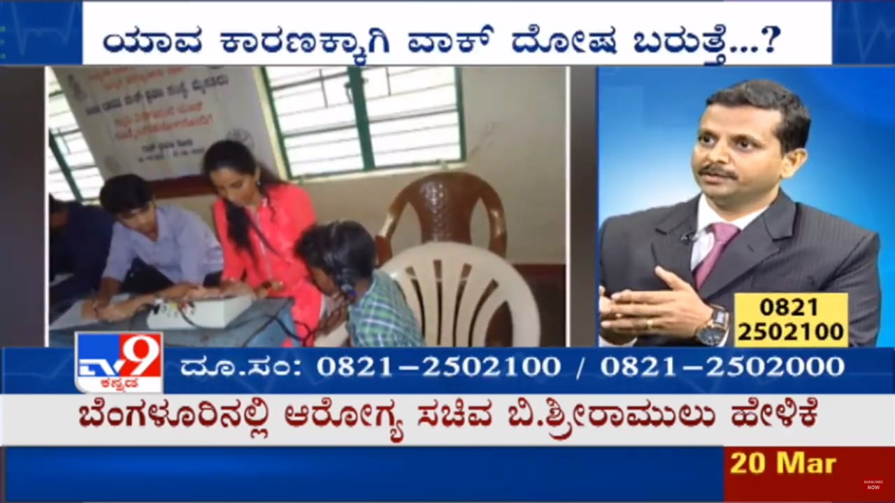

Figure (23): The glimpse of interview of Dr. M. Pushpavathi (Director, AIISH) and Dr. Sandeep M (Associate professor in Audiology) at TV-9 Tv channel.

1. A digital multiplex advertisement was shown at all the INOX film theatre across India from 26.02.2020 to 03.03.2020.

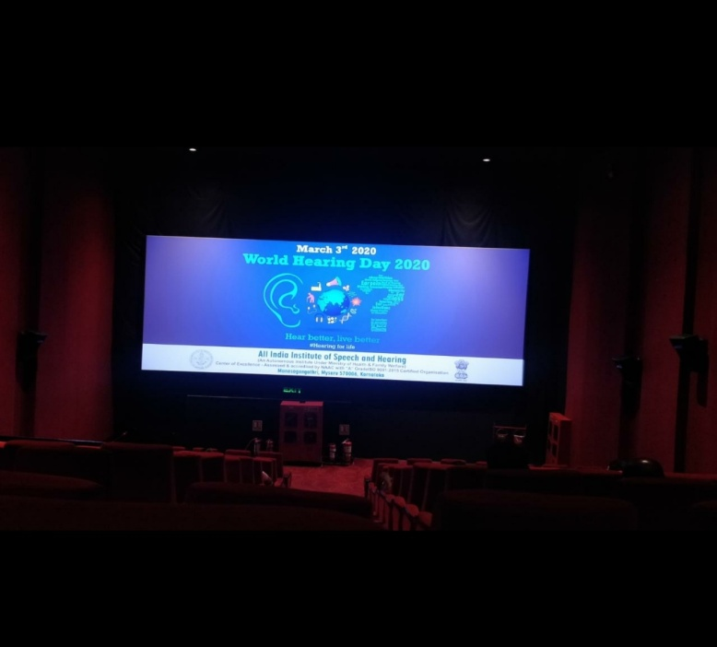

Figure (24): The advertisement on world hearing day put up on INOX Film theatre at INOX Mysuru.

1. The video clips of eminent personalities of across India were released to promote world hearing day from 18.02.2020 to 03.03.2020.
2. A food customization program was carried out with the co-operation of eminent resturants(Fairies touch, Mysuru, and Barsta coffee, and stoned monkey restaurant, Mysuru).

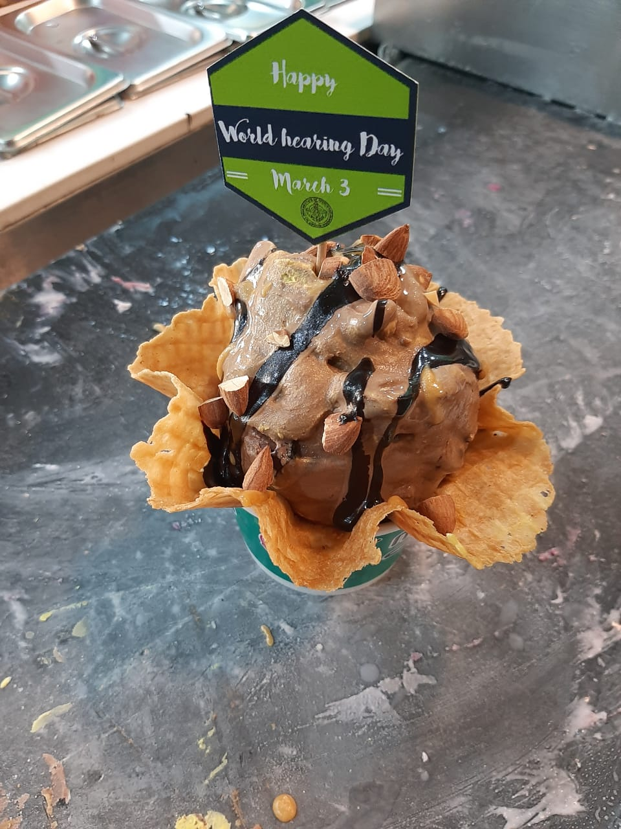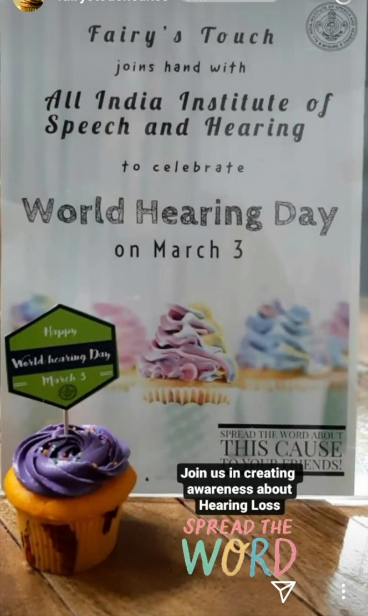

Figure (25): Glimpse of food customization program done at Fairies touch restaurantMysuru.

d) Released advertisements in different national dailies on hearing health care and importance of World hearing day on 03.03.2020

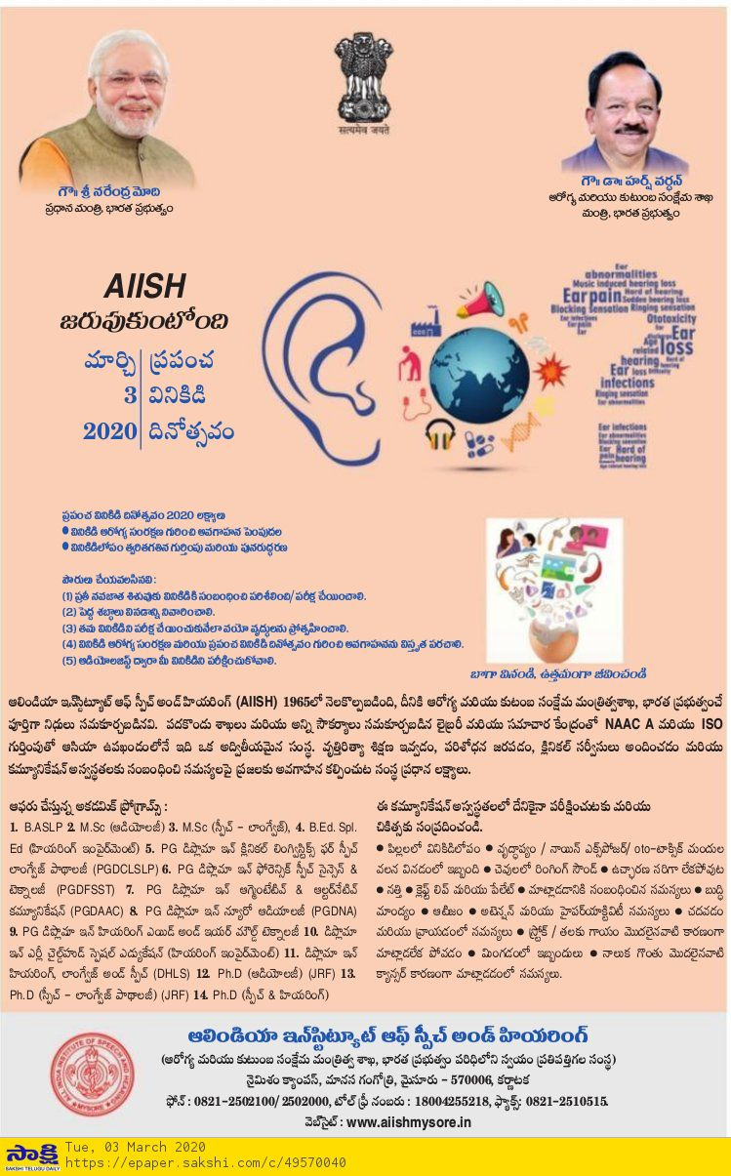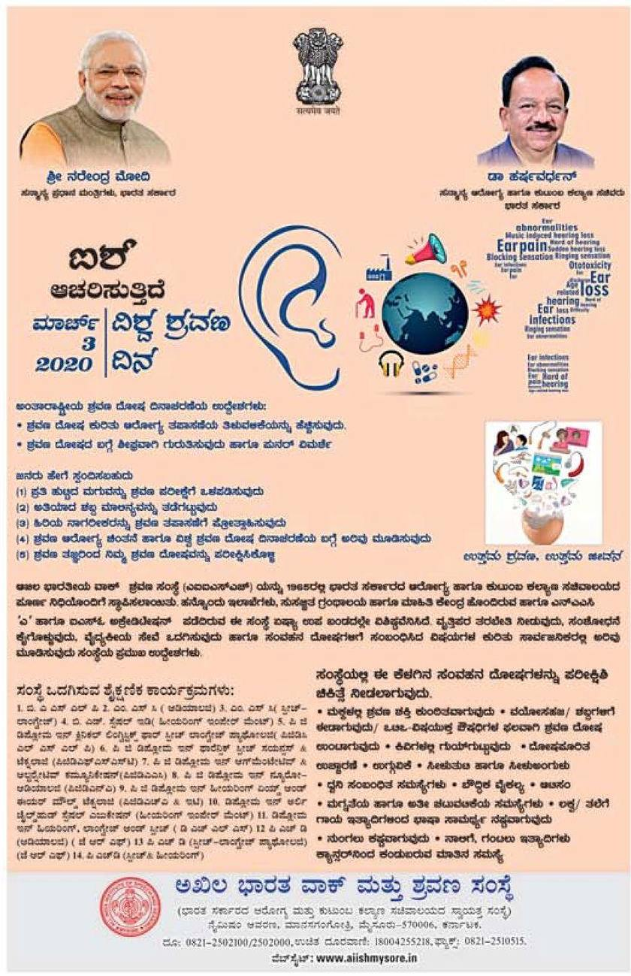

Figure (26): Advertisements on hearing health care and importance of World hearing day released in different newspaper on 03.03.2020

e) Staff of POCD attended the walk-thon program organized by Dept. of Audiology on 03.03.2020

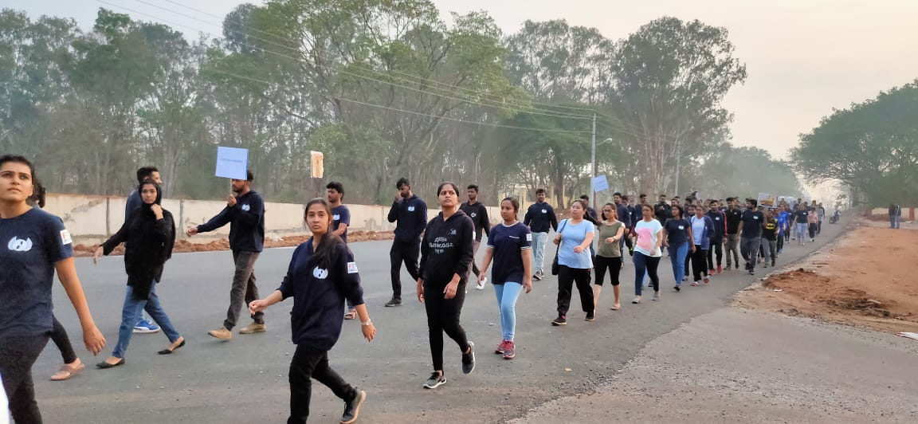

Figure (27): Glimpse of walkthon program conducted on 03.02.2020

f) A street play on early identification and management of communication disorder was carried out at Holenarasipura and Sakleshpura on 06.03.2020.

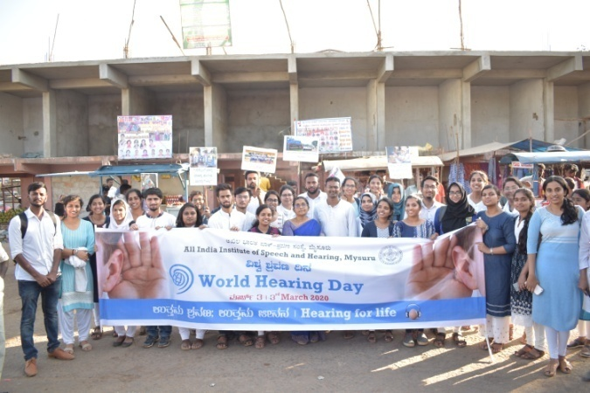

Figure (28): Glimpse of street play activity done at atHolenarasipura and Sakleshpura by Intern students.

1. **Others:**
2. Computerization activities:: Computerization of OSC is in process
3. Activities carried out by the staff of the department:

Table 7 (a): Details of activities of staff of POCD in January month.

|  |  |  |  |
| --- | --- | --- | --- |
| **S.No.** | **Name of the staff** | **Designation** | **Activities** |
|  | Dr N. Sreedevi | HEAD, POCD | * Coordinated the department activities as the Head of the Department * Coordinated the various activities at OSC and NBS centres * Coordinated the overall activities for world hearing day * Conducted two staff enrichment programs on Recent Advancements in Hearing Aids and Vestibular Rehabilitation on 19.03.2020 and 20.03.2020 respectively * Delivered a talk on Outreach service centres and other activities of Dept of POCD at the National Programme for Prevention and Control of Deafness organised by South India Regional Review Meeting under NPPCD Programme on 12.03.2020 and 13.03.2020 * Participated in National Programme for Prevention and Control of Deafness organised by South India Regional Review Meeting under NPPCD Programme on 12.03.2020 and 13.03.2020 * coordinated and attended Street Play on 06.03.2020 * Participated in live phone in program in Vijay Karnataka on 01.03.2020. |
|  | Dr. Sandeep M | Associate Professor in Audiology | * Organized the new born hearing screening program done as a part of observing world hearing day at 03.03.2020. * Coordinated food customization program on 03.03.2020. * Given interview in TV-9 channel regarding new born hearing screening programs. * Broadcasted speech on hearing health care on 02.02.2020. * Conducted live phone in program in Vijay Karnataka on 01.03.2020. |
|  | Mr. Arunraj. K | Clinical Assistant | * Assisted HoD in World hearing day activities and verified its report. * Assisted HoD in assigning assignments to POCD staff. * Conducted ISO audit to security office on 02.03.2020 * Organized the new born hearing screening program done as a part of observing world hearing day at 03.03.2020. * Coordinated the various activities at OSC and NBS centres * Attended staff enrichment program on Recent Advancements in Hearing Aids and Vestibular Rehabilitation on 19.03.2020 and 20.03.2020 respectively * Coordinated food customization program on 03.03.2020. |
|  | Ms. AmeenaSubhakani S. | Speech Language Pathologist Grade I | * Served as the resource person and delivered talk on clinical and community based practice in rural setup for III BASLP students on 11.03.2020 * Compiled OSC,NBS,School screening data since 2008 * Attended a meeting with the in charge for computerization of activities of POCD. * Attended staff enrichment program on Recent Advancements in Hearing Aids and Vestibular Rehabilitation on 19.03.2020 and 20.03.2020 respectively. |
|  | Mr. Harish Kumar M.K. | Audiologist Grade I | * Attended Walkathon organized by Dept. of Audiology on 03.03.2020 * Attended staff enrichment program on Recent Advancements in Hearing Aids and Vestibular Rehabilitation on 19.03.2020 and 20.03.2020 respectively * Organised and attended Street Play on 06.03.2020 |
|  | Mr.KishoreKumarBharshetty | Audiologist Grade I | * Attended Walkathon organized by Dept. of Audiology on 03.03.2020 * Carried out verification of pamphlets * Prepared contents for information KIOSK. * Attended staff enrichment program on Recent Advancements in Hearing Aids and Vestibular Rehabilitation on 19.03.2020 and 20.03.2020 respectively |
|  | Ms. Krishnendu S. | Speech Language Pathologist Grade I | * Attended school screening in Nanjangud on 4/03/2020 * Developed parents counselling tips as part of school screening material development (Stuttering, Speech sound Disorder, Learning Disability, Intellectual Disability) * Corrections made on school screening checklist for teachers * Data entry for NBS School * Data verification of dysphagia data entry. * School screening data entry verification-Mesco School * Developed hand out for bedside screening * Developed oro-motor exercise hand out for bedside screening |
|  | Ms. Priya Abdul Khader M. T. | Audiologist Grade I | * Participated Walkathon organized by Dept. of Audiology * Prepared AIISH hand out. * Attended staff enrichment program on Recent Advancements in Hearing Aids and Vestibular Rehabilitation on 19.03.2020 and 20.03.2020 respectively. |
|  | Ms. Ritu A Venkatesh | Audiologist Grade I | * Drafted World Hearing Day 2020 report. * Uploaded World Hearing Day report 2020 on WHO website. * Attended Walkathon organized by Dept. of Audiology * Organised and attended Street Play on 06.03.2020 * Attended staff enrichment program on 19th and 20th March. * Translated English Voice disorder pamphlet into Kannada. * Verified Dementia Kannada pamphlet * Attended staff enrichment program on Recent Advancements in Hearing Aids and Vestibular Rehabilitation on 19.03.2020 and 20.03.2020 respectively |
|  | Ms. Sharanya K. Kumar | Audiologist – Grade I | * Participated in walkathon on 03.03.2020 as part of world hearing day. * Carried out newborn hearing screening at Cheluvamba hospital on world hearing day (03.03.2020) with high citizens of Mysuru District. * Conducted and attended street play activity in Holenarasipura and Sakleshpura on 06.03.2020. * Attended staff enrichment program on Recent Advancements in Hearing Aids and Vestibular Rehabilitation on 19.03.2020 and 20.03.2020 respectively |
|  | Ms. Abinaya R | Speech-Language Pathologist Grade I | * Prepared POCD hand out * Verified NBS data of different NBS centres. |
|  | Ms. Aparna U. | Audiologist – Grade II | * Attended Walkathon organized by Dept. of Audiology on 03.03.2020 * Attended staff enrichment program on Recent Advancements in Hearing Aids and Vestibular Rehabilitation on 19.03.2020 and 20.03.2020 respectively * Prepared Monthly report of February 2020 |
|  | Ms. Anusha C. | Speech Language Pathologist – Grade II | * Gave an orientation and co-organized hearing screening program at ESI Hospital on 02.03.2020. * Visited (and followed up) various cafes and eatery places in Mysuru which agreed to participate in World Hearing Day through food customization, displaying the posters and posting regarding the same on social media on 02.03.2020. * Participated in Walkathon conducted by Department of Audiology on the occasion of world hearing day, on 03.03.2020. * Participated and conducted school screening at Nanjangudu on 04.03.2020. * Monitored interns’ street play practice on 02.03.2020, 04.03.2020 and 05.03.2020. * Attended street play, orientation and mini screening program held at T Narasipura and Sakaleshpura on 06.03.2020. * Completed Bedside data entry from 24.12.2019 to 05.03.2020. * Drafted various handouts and referral card for Bedside Evaluation.  Attended staff enrichment program on Recent Advancements in Hearing Aids and Vestibular Rehabilitation on 19.03.2020 and 20.03.2020 respectively |
|  | Ms. FaheemaLuquman Ali | Audiologist – Grade II | * Carried out data verification of OSC centres. * Carried out translation and verification of Public education pamphlets * Attended staff enrichment program on Recent Advancements in Hearing Aids and Vestibular Rehabilitation on 19.03.2020 and 20.03.2020 respectively * Participated in Walkathon conducted by Department of Audiology on the occasion of world hearing day, on 03.03.2020. * Completed compilation of feedback forms from different OSC centres |
|  | Mr, Ullas N Bhargav | MTS (Data entry operator) | * Completed and verified NBS data entry of Mysuru hospitals * Attended staff enrichment program on Recent Advancements in Hearing Aids and Vestibular Rehabilitation on 19.03.2020 and 20.03.2020 respectively |
|  | Ms.Asha G | Office assistant | * Carried out phone follow up of Mysuru hospitals * Drafted office correspondence letters |
|  | Ms.Deepika. R | Office assistant Grade II | * Carried out data entry of NBS and OSC centres * Drafted office correspondence letters |

***Sd-***

**विभागाध्यक्ष, विभाग-**पिओसिडि- Head, Dept. Of POCD